HARDGOOD (MERCH) VENDOR REQUIREMENTS

A completed application and the additional requirements below does NOT GUARANTEE acceptance of your booth at our event. If you are not accepted, there will be no charge. If accepted, all payments made are NON-REFUNDABLE.

As a food vendor at Country Jam USA®, you are required to provide the following items to be considered:

- Completed application, please indicate any extra needs electric, camping, storage, etc.
- 50 percent of total booth fee is due 10 days after accepted application and full payment must be accepted by May 31st, 2018. If payment is not received on time, your space will be released.
- Current Wisconsin Sales Tax number.
- Wisconsin Temporary Event Operator and Seller Information Form
  - (https://wwww.revenue.wi.gov/forms/sales/s-240f.pdf)
- Proof of insurance coverage, minimum $1,000,000 (one million) liability. Must be in the form of a Certificate of Liability showing Country Jam USA® as the certificate holder and having the event dates listed (July 19th-21st, 2018).
- Picture of your booth set-up.
- Complete list of retail items you would like considered for the event.
  - Note: all items may not be approved; you will be contacted for any changes, if needed.

Payment Deadline: May 31st, 2018

WHAT YOU CAN EXPECT

Our food vendor space is limited, competitive and fills quickly. The sooner you return your materials, the better chance you have of being accepted.

If approved, you will receive a confirmation via email along with specific event information and detailed rules and regulations.

All camping and access materials will be available for pick-up when you arrive at vendor check in.

PROVISIONALS

As an accepted food vendor at Country Jam USA®, we will provide you with the following:

- Concession space located with the outlined festival area for sales of your product(s).
- One (1) 20-amp circuits of electricity. If additional is required, it must be requested and paid for.
- Event access for you and your workers. Number of employees is subject to management approval. Depending on your booth size, you will receive the following number of weekend vendor passes
FREE of charge. Any additional passes must be requested and paid for before the day of the event at the price of $65 a ticket.
  - 10 x 10 space = Up to three (3) weekend vendor passes, and two (2) parking passes
  - 20 x 20 space = Up to four (4) weekend vendor passes, and two (2) parking passes
  - 30 x 20 space = Up to six (6) weekend vendor passes, and three (2) parking passes
    - Vendor vehicle access to the grounds for set-up and daily restocking.
    - Ice is available for purchase if requested. Price will be available at set-up prior to the event.
        - Knowledgeable staff providing answers to your questions and quality customer service.

WHAT WE EXPECT

Because we value all our vendors, and often have them return on a yearly basis, we do have expectations.

We expect that deadlines will be followed and requested materials will be submitted in a timely manner. If deadlines are not met, your space will be released, and no refunds will be given.

Sorry we DO NOT allow pets on the festival grounds or in any of our camping areas. This applies to BOTH vendors and festival attendees. NO exceptions will be made!

NO other modes of transportation allowed on the grounds or in camping areas, i.e. golf carts or scooters. All vehicles MUST be off of the festival grounds by 11:00a.m. NO vehicles will be allowed up or down the hill starting one (1) hour before gate open.

We expect you will keep your booth open until the last act takes the stage each night: approximately
9:30p.m. Early closure of your booth (on any day) will result in lack of future consideration.

New to Country Jam USA® in 2018 the festival will be going RFID and all patrons will be using a cashless system. See pages 3-5 for more details.

Although you may be working, we hope that you will enjoy the event and have a good time!



VENDOR INFORMATION –THE CASHLESS EXPERIENCE

Welcome to Cashless!

We are taking the guest experience to the next level with Intellitix’s world class, bank-certified cashless payment system. Cashless technology provides a fast, convenient, and secure method of payment for guests to make purchases at the event.

If you have any questions, please contact: Full Name, Phone #, Email Address

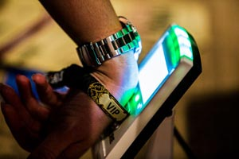 | 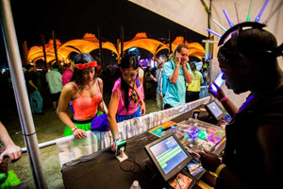 | 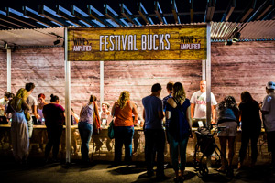

You Can Expect:



Your Festival Contact will provide you with:

- Menu Submission Form
- Equipment Allocation
- Sales Reporting Data
- Point of Contact During the Event

Intellitix will provide you with:

- POS Terminal(s) Setup: Each POS station is equipped with a POS unit and RFID Smart Reader(s)
- Installation & Configuration: Including your custom menu
- Vendor PIN Code: To unlock your POS terminal
- POS Training: There will be a mandatory onsite training

Here is a cashless introduction video to get you started (http://youtu.be/c97s7LT3-qY).

Top 5 Benefits of Cashless

- FASTER TRANSACTION TIMES
No waiting for guests to fumble with cash or wait for credit card transactions to process (which requires a reliable network connection). By drawing funds directly from a guest’s cashless account, transactions are processed immediately.

- REDUCED WAIT TIME & LINE-UPS
Faster transaction times significantly reduce queues, allowing vendor staff to focus their efforts on delivering exceptional customer service.

- INCREASED GUEST SPENDING AND SALES BY 15-30%
In combination with faster transaction times and reduced line-ups, guests spend more per head purchasing what they want, when they want it!

- FASTER VENDOR RECONCILIATION POST-EVENT
No need to count tokens at the end of the night. All transactions are recorded electronically in the cashless payment system.

- VALUABLE SALES DATA & INSIGHT
Discover real-time reporting of your sales data (unit price, amount sold, $ sales) searchable by product category, product item, festival date, and individual POS terminals. Find out what your bestselling items are to boost sales.

What Others Are Saying About Cashless

Hear first-hand from vendors, guests and event organizers on how cashless payment technology has enhanced their event experience.

The Vendor Cashless Experience
https://youtu.be/5YXzdvsOEzw

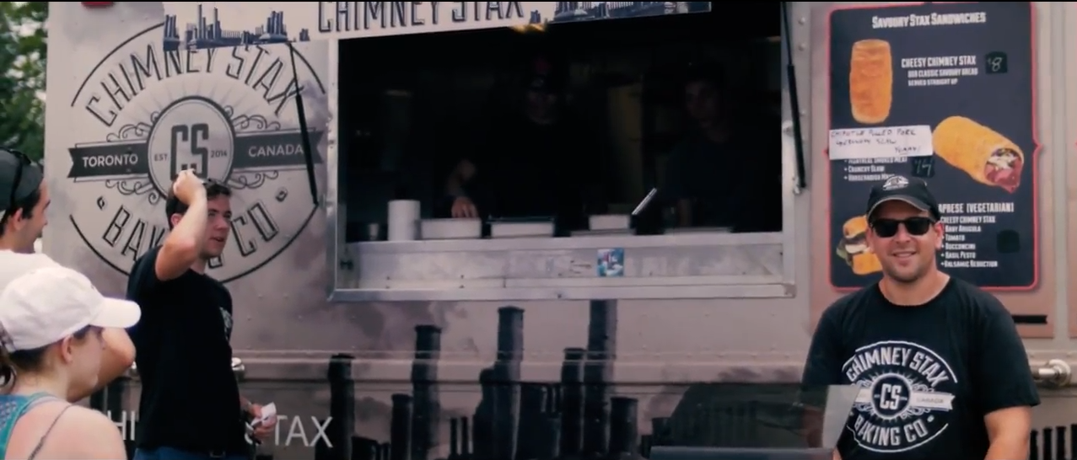

How Cashless Works

- GUEST RFID WRISTBANDS
Guests will receive their personalized RFID wristband in the mail or at the event. They will use this wristband as their ticket to enter the event grounds, as well as to make cashless purchases at your vendor station.

- TOP-UP ACCOUNTS
Guests will need to “top-up” or purchase event credit into their cashless accounts. Guests can top-up online from their desktop or smartphone, or at Top-up Stations located throughout the event.

- MAKING ONSITE PURCHASES
To make a purchase at your vendor station, guests will:
  - Tap their wristband on an RFID Smart Reader
  - Place their order with your vendor staff
  - Tap their wristband a second time to confirm the transaction

The funds are drawn from the guest’s existing cashless account balance. Guests can top-up as often as they want to re-fill their balance and keep making purchases throughout the event. All leftover funds are refunded to the guest after the event (less a refund processing fee).

The transaction is processed immediately in Intellitix’s robust cashless platform, featuring bank grade security. Intellitix’s technology uniquely runs on a closed-loop system, which means it can operate in both online and offline mode, ensuring your vendor station is operational 100% of the time.

For more information on Intellitix’s cashless payment system, please visit:
http://www.intellitix.com/services/cashless/

Welcome to the World of Cashless!

