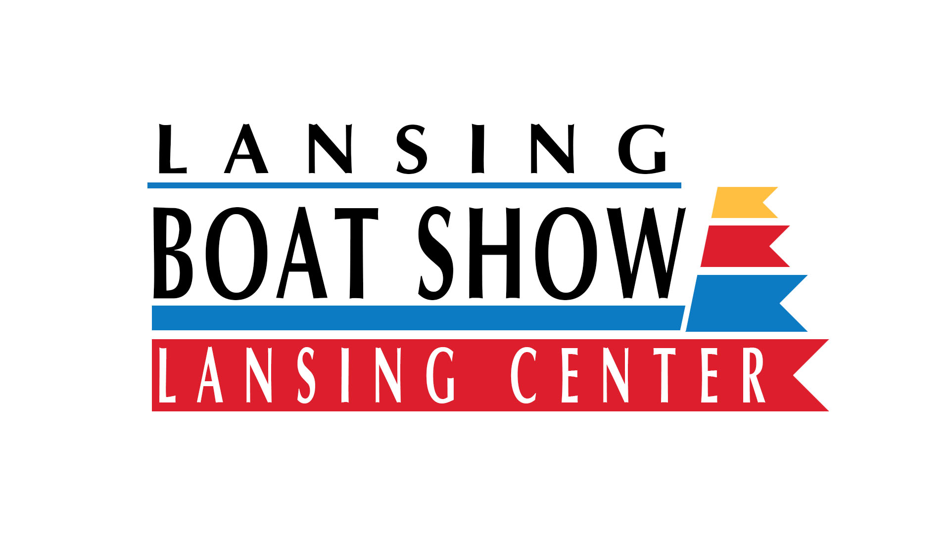
EXHIBIT SPACE APPLICATION

Application and contract for exhibit space in the
Lansing Boat Show “H20-18”

Lansing Center, Lansing, Michigan
Coordinated by WLNS TV-6
2820 East Saginaw Hwy Lansing, Michigan 48912 (517) 372-8282 f (517) 374-7610
Show Coordinator: Ernie Hedberg, ehedberg@wlns.com

Show Dates and Times:

Friday Noon-8PM Saturday 10AM-8PM Sunday 11AM-4PM

January 5-6-7, 2018

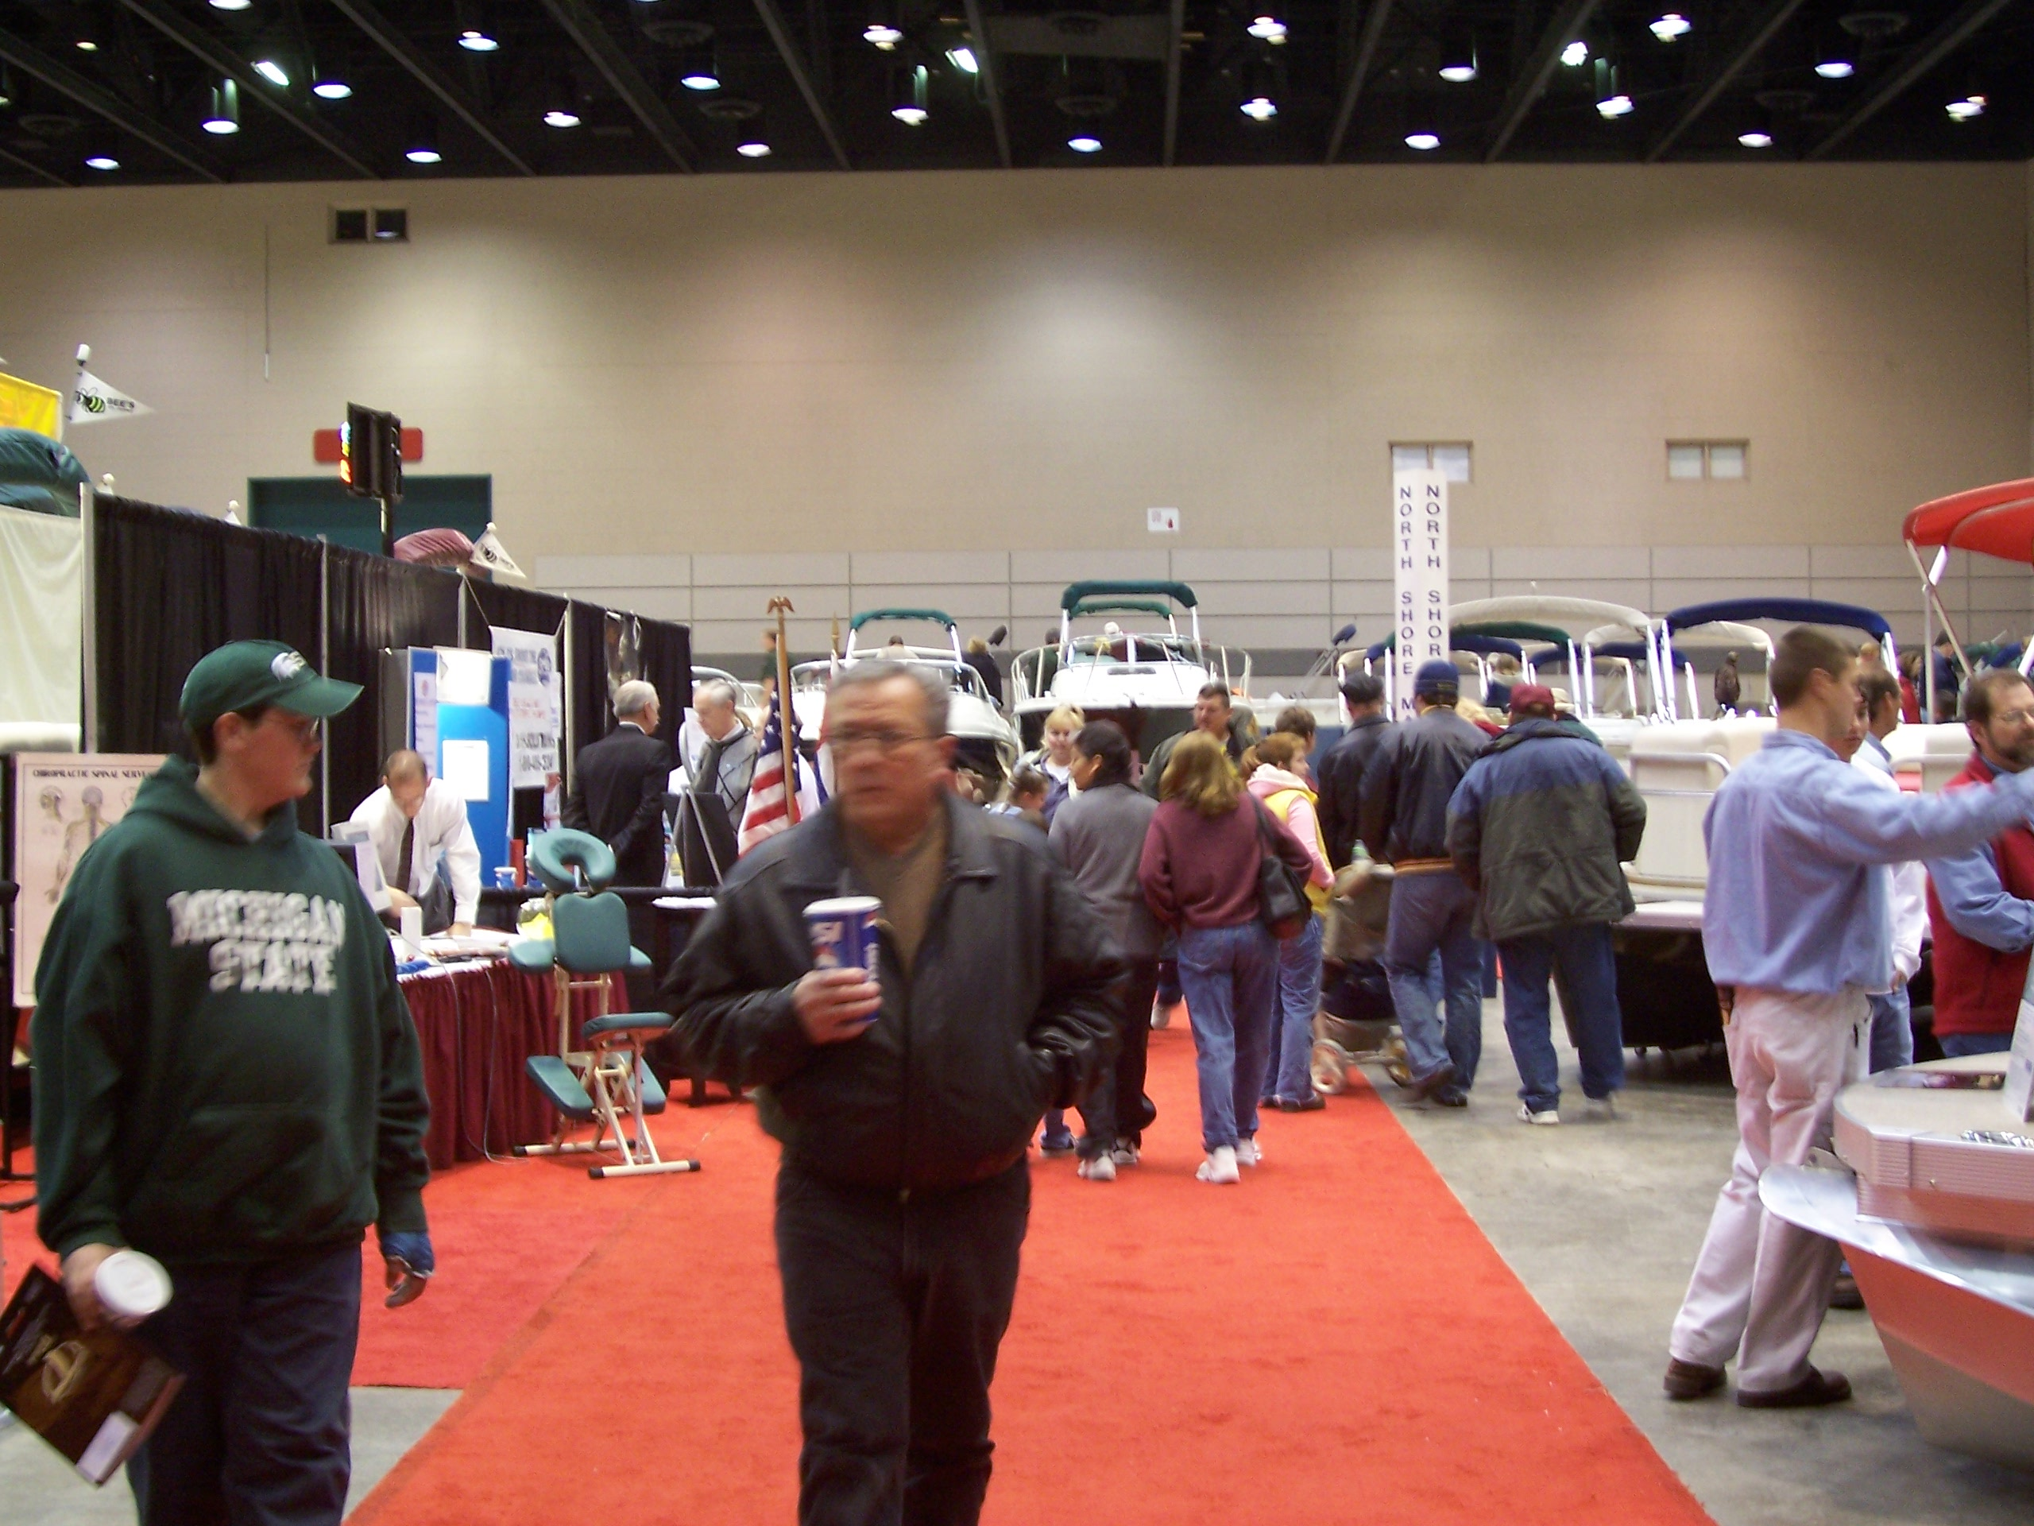
10x10………………………$500

10x20……………………...$800__________________

20x20……………………...$1200__________________

Booth space applicant = $

*Carpeted Exhibit Space Included:
10X10 and 10X20 Booth Space Exhibit spaces as indicated on initial floor
Plan will be carpeted at no additional cost to Exhibitors
*Pipe and Drape Included:
8’ Pipe and drape backdrop to be provided for all Booth Space Exhibitors
*Tables and Chairs Available upon Request
Linen and skirted 6’ and 8’ tables available upon Request

All exhibitors must pay the balance in full prior to the boat show.

Please makes checks payable to WLNS TV-6
2828 East Saginaw Hwy
Lansing Michigan 48912
(517) 372-8282

Pay by Credit Card by Calling Event Coordinator Ernie Hedberg Direct at (517) 372-8282 during regular business hours

Company Phone

Contact Person Fax

Address city/state/zip

Contact Cell E-mail

The undersigned exhibitor certifies that the information on this contract is accurate and agrees to comply with all rules and regulations set forth in good faith

Exhibitor Signature Date
(Please fill out, scan and email this document to ehedberg@wlns.com or Fax to (517) 374-7610

