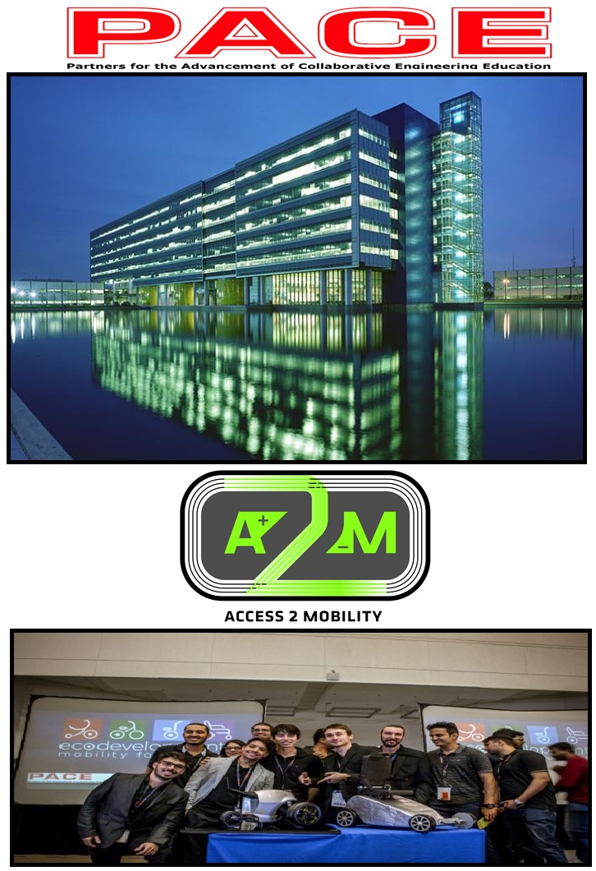

General Motors Global Technical Center
Warren, MI

July 22-27, 2018

PACE 2018 Global Annual Forum
Table of Contents

Item Page(s)

Contact Numbers 3

Guest Internet Access Instructions 3

Welcome from the PACE Core Team 4

Detailed Forum Agenda 5-7

Campus Rules and Regulations 8

Forum Agenda “At-a-Glance” 9

Campus Locations 10-12

Competition Tips for PACE PUMA Teams 13

General Tips for Students at the PACE Annual Forum 14-15

PRE-Conference Training 16-21

PACE Forum Hosts 22

PACE Forum Sponsors 23

Contact Numbers

Emergency, Hotels, Forum Hosts & GM PACE Office Contacts

Emergency | 911
GM Tech Center Emergency Number | (586) 986-6112
Vass Theodoracatos (PACE Office) | (586) 291-8001
Linda Duronio (PACE Office) | (586) 289-2418
Marriot Hotel, Warren, MI | (586) 751-5777
Residence Inn, Warren, MI | (586) 558-8050

Wi-Fi Internet Access

GM-Guest Wifi is the wireless network provided to allow visitors to the GM Tech Center a means of connecting to the internet wirelessly.

*Please note: Each time you log in, you will need to provide authentication.

We invite you to the
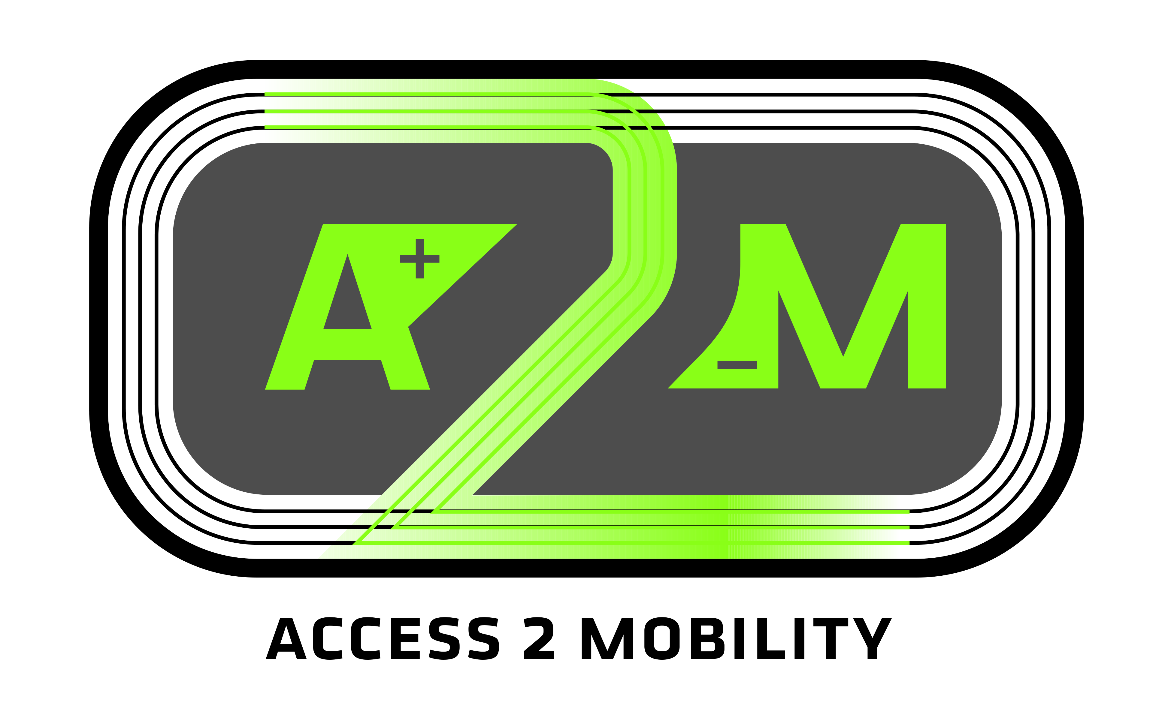
2018 PACE Global Annual Forum!
General Motors Technical Center
Warren, Michigan, USA
July 22 – 25, 2018
Hosted by Siemens PLM Software and the General Motors PACE Team

- The PACE Annual Forum brings together industry representatives with faculty and students from all 65 PACE Institutions in 12 countries around the world for face-to-face collaboration, networking and innovation. Delegates report progress, share curriculum advancements and development, and discuss new technologies.
- Session presentations by industry and university representatives encompass a variety of topics relevant to the PACE mission and conference theme, including global challenges, the latest industry trends, new technologies, PACE projects, and curriculum advancements.
- The PACE global project competitions to be highlighted at this year’s forum:
Personal Urban Mobility Access (PUMA) Project Competition – In the first phase of the competition, industrial design, engineering and manufacturing students from 40 PACE Institutions in ten countries present design solutions that will address the first mile/last mile transportation needs for the aging population in a specific target market. The challenge: Global PACE Teams will create a first mile/last mile solution that is buildable and theoretically producible for mass-production using current or emerging technology within the delivery time of the project. Each team will be evaluated on how well they understand the social, economic and convenience issues of their chosen market and how well their proposed mobility solution(s) address those issues within the aging population.

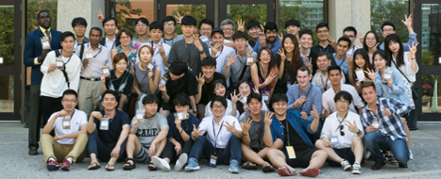
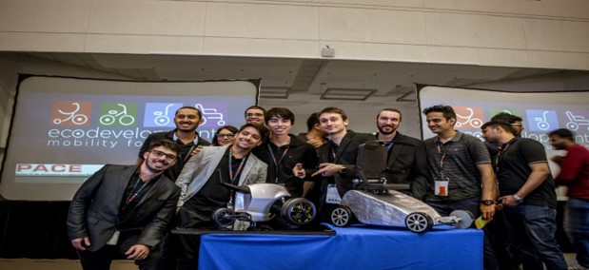
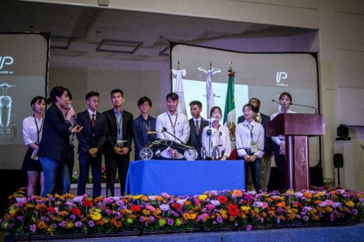

2018 PACE Annual Forum
Delegate Information Guide

Forum Theme | “Access to Mobility”
Forum Dates | Sunday, July 22 – Wednesday, July 25, 2018  Refer to the “Traveling to the 2018 PACE Annual Forum” Guide for detailed Information on airports, transportation, electricity, weather, etc. The guide is also available on the PACE Website.
Pre-Forum Training  Optional | Monday, July 16 – Friday, July 20, 2018  Wayne State University  42 W. Warren Ave,  Detroit, Michigan 48202  (Campus map, page)
Forum Location | General Motors Technical Center Campus  Alternative Energy Center Auditorium (AEC)  30003 Fisher Brothers Road  Warren, Michigan 48093-2350 USA  (Campus map, page)
Forum Registration | March 1 through June 1, 2018  www.pacepartners.org  Use registration code: PACE@Warren  Thanks to the generosity of the PACE Forum Sponsors, the Forum admission fee is waived for PACE Institution faculty, staff, and students.
The Welcome Reception - All delegates are invited! | Sunday, July 22, 2018  GM Heritage Center  6400 Center Dr,  Sterling Heights, MI 48312  4:30pm check-in – Event starts at 5:00pm  A shuttle bus between the hotels and the welcome reception will be provided at the start/end times. Details will be provided, as available, via the PACE website and email.  The Welcome Reception is an opportunity to meet faculty and students from other PACE Institutions, meet your PUMA teammates, and reconnect with old friends.
Forum Sessions and PUMA Competition | Monday, July 23 – Tuesday, July 24  Alternative Energy Center Auditorium (AEC)  Conference check-in, project displays and and Company Display Expo will be AEC auditorium.
Cultural Day/Tours/Fun | Wednesday, July 25, 2018  Sign-up Options available on the PACE Forum Registration Website
PUMA Awards Dinner | Wednesday, July 25, 2018  5:00pm  Transportation departs at 5:00 pm  The Henry Ford Museum  Dearborn, Michigan  Transportation will be provided from the hotel to the Awards Dinner and back after the event.
GM Tech Center Transportation | - Gate Locations and Hours  - Shuttle Map  - Maven Shuttle App  - Zagster Bike Share  - Bicycle Policy for WTC  - VEC Handicap Parking  - GM & Non-GM Vehicle Parking near VEC  - VOLT Charging Locations  - Numbered Parking Lots  - VEC Valet Procedures  - Valet Process - Guest Instructions
Parking on Campus | - All visitors driving a vehicle into the campus must register at the entrance to the campus with a security officer. They will need the identification of the driver, vehicle license number and location for the meeting. Tell the officer you are attending the PACE Annual Forum.  - Anyone bringing equipment (laptop, etc.) into the campus are responsible for the safety of their items.
WIFI Internet Access | - “Select GM Guest WIFI as the SSID”. GM WIFI is available in all GM buildings.
GM Campus Rules and Policies | - As visitors to the campus, all PACE Forum attendees are expected to abide by the policies and rules governing use and occupancy of the GM facilities.  - Visitors to the campus must register each time they enter the campus. Identification (passport, drivers license or student ID) will be required.  - You are responsible for your personal belongings when on campus. GM will not be responsible for any loss or damage to your equipment inside the facilities.
GM Security Clearance | - Check in with Security at each building  - Wear GM Visitor Badge at all times  - No Walking and Talking on phone  - Pic Patch phones for Non GM guest and employees  - GM Escort (mandatory)  - Security Emergency Phone # (586) 986-6112
Lodging/  Accommodations | - The following accommodations options are recommended for the convenience of PACE Delegates, with different price categories. The 2 hotels are providing special discounted rates for PACE Forum attendees.  - REMINDER: Hotels require the name of the guest, the dates of the stay (check-in and check-out), and the payment information (i.e., credit card number and expiration) in order to confirm a reservation.
Option 1 | Marriott Courtyard Warren  30190 Van Dyke, Warren, MI 48093  (586) 751-5777  http://www.marriott.com/hotels/travel/dttwr-courtyard-detroit-warren/
Option 2 | Residence Inn Warren  30120 N Civic Center Dr, Warren, MI 48093  (586) 558-8050  Residence Inn link

Campus Rules and Regulations

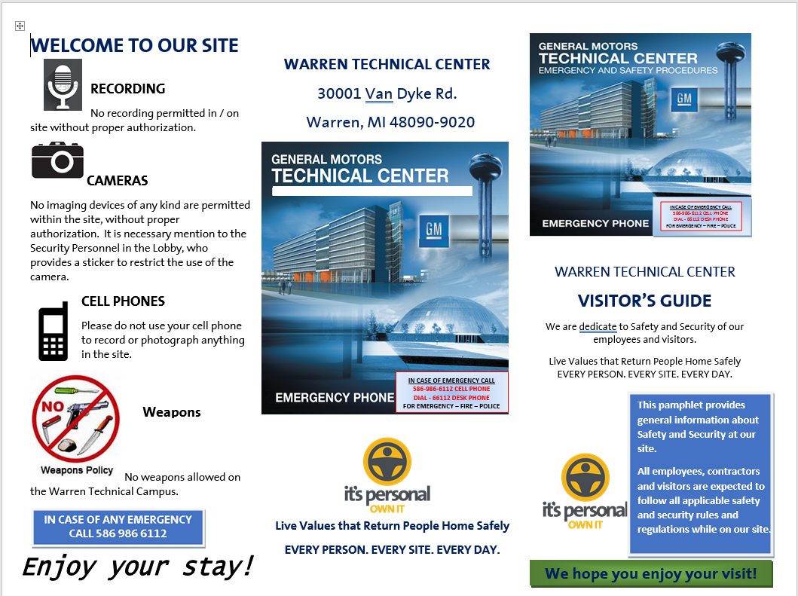

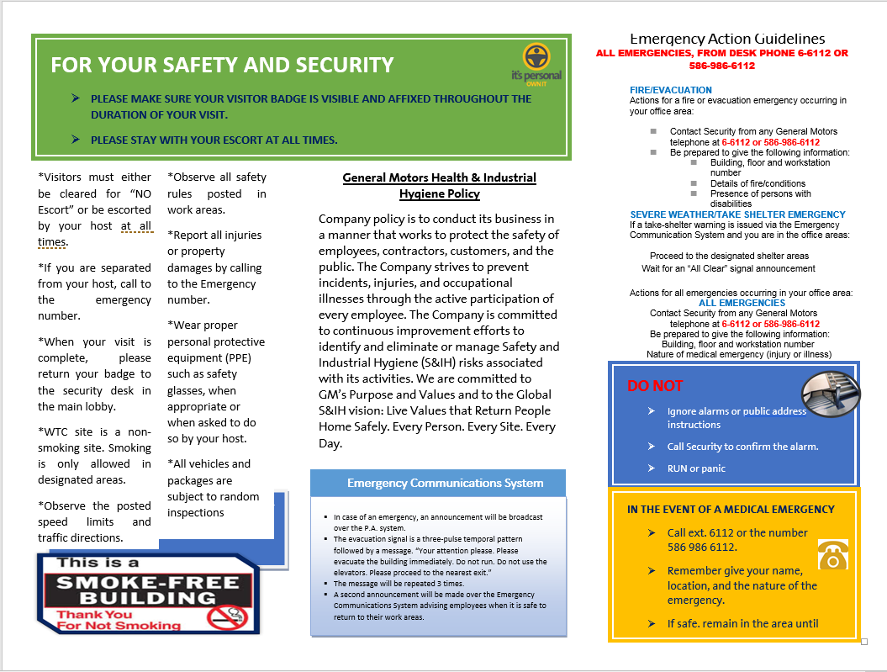
Cultural Day/Tours/Fun
Wednesday, July 25, 2018
8am-3pm

PACE Cultural Day: Make plans with your new PACE friends to visit one of the nearby points of interest in the area before you leave for home.

Detroit City Downtown and Beyond Bus Tour

On this tour, one of our knowledgeable tour guides will provide a fun and interactive history of Detroit plus some information on it's current state, providing an exciting and honest narrative of the city. We will be able to drive through most of the Downtown core as well as some of it's closely outlying neighborhoods (Eastern Market, Midtown, Rivertown, Indian Village, etc.), making 3-4 stops along the way, giving you and your group the opportunity to get out and experience some of the city's gems. This Experience typically takes between two-three hours.

Our typical stops include:
- The Guardian Building
- Rivard Plaza at the Riverwalk
- Midtown Retail Corridor (shops, small businesses, cafes, etc.)

PACE Global Forum Itinerary

2018 PACE Global Annual Forum
Sunday  July 16 | Monday  July 17 | Tuesday  July 18 | Wednesday  July 19
PRE-Conference Training
Monday  July 24 | Tuesday  July 25 | Wednesday  July 26 | Thursday  July 27
2018 PACE Global Annual Forum
- PUMA Prep  - Pre-Comp Road Test  - Welcome Reception | - Registration  - Keynote Presentation  - PUMA Presentation | - Announcements  - PUMA Competition Key Note Presentation  - PACE Recruiting Event  - PACE Company Display  - PUMA Q & A | - Cultural Day  - GM Tour  - Detroit City Tour  - Awards Dinner

Consult the PACE website at www.pacepartners.org for itinerary updates. A detailed itinerary will be distributed to attendees at conference check-in.

GM Technical Center Campus Map

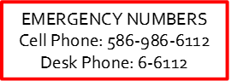

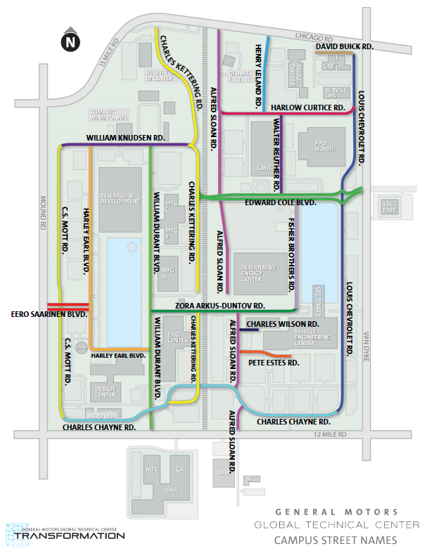
Forum
AEC Auditorium
Training
GM Knowledge Center

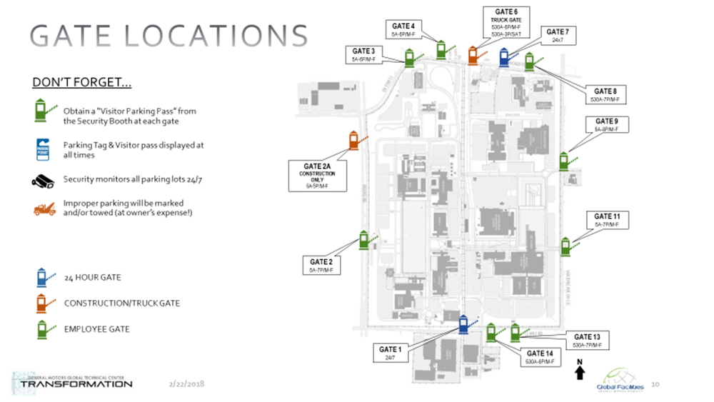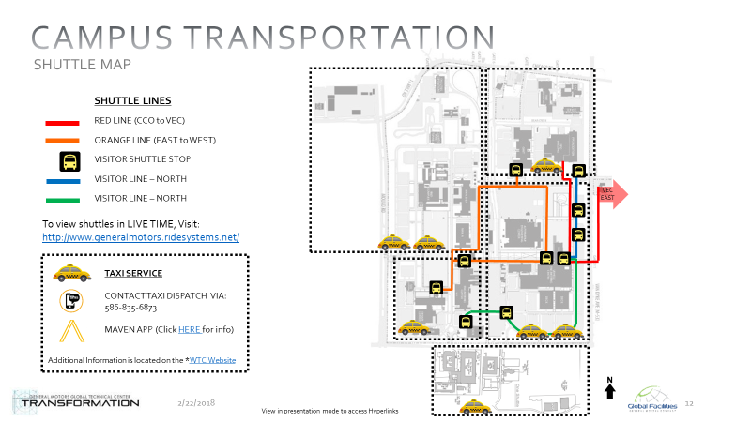

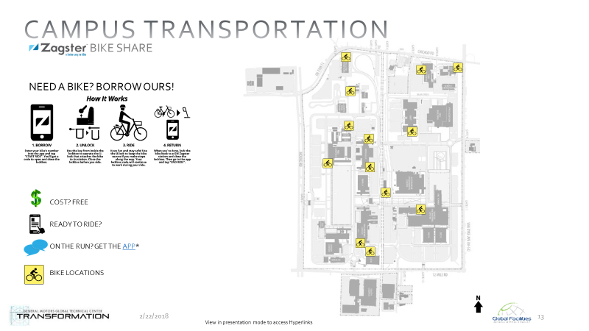

Forum and Competition Room Locations
Alternative Energy Center Auditorium (AEC)
30003 Fisher Brothers Road
Warren, Michigan 48093-2350 USA

Monday- July 23rd and Tuesday July 24th

Sessions will be held in the AEC Auditorim
- PUMA teams will meet with the Judges for their Q&A session at their scheduled time in 122-21, 122-17, and 133-22

- Recruitment Event will be held in 125-14 and 126-14

- Company Display Expo is located in 128-14 and 129-14
- Daily - lunch will be served in the VEC Cafeteria

Best of Luck in the Competition, PACE PUMA Teams!

Competition Tips for PACE PUMA Teams

PACE extends a special welcome to all of the PUMA team members attending this year’s PACE Annual Forum!

We hope you are excited to be part of the PACE Annual Forum, and we want you to enjoy the PUMA competition and the PACE conference. Here are a few reminders and tips for the competition:

- PUMA Models: Each team will have one table for their models during the PACE Forum conference Monday and Tuesday. Teams need to bring their PUMA models on Monday, July 23rd to the Registration table. You will be shown where your team table will be located.

- Welcome Reception & Team Presentation Drawing: At least one representative from each PUMA team should attend the Welcome Reception on Sunday, July 22nd for the drawing of PUMA Team presentation order. The Welcome Reception is a wonderful opportunity to meet and visit with your PUMA teammates from the other schools. There will be a team activity as well.

- PUMA Competition – Team Oral Presentations: Each PUMA team has 30-minutes to give their comprehensive oral presentation to the PUMA judges and the PACE Forum attendees.

- PUMA Competition – Final Q&A with Judges: Each PUMA team will meet face-to-face with judges for a question and answer session on Tuesday, July 24 in 122-21, 122-17, and 133-22.

- PACE Global Annual Forum: All PUMA team members are expected to attend the conference sessions on Monday and Tuesday. Attendance is required for grant funding reimbursement to the teams for travel and model development.

- PACE Awards Dinner: Competition winners will be announced at the Awards Dinner on Wednesday, July 25th. A ticket is required to attend, as seating is limited and pre-registration is required. The Awards Dinner will be held at the Henry Ford Museum, Dearborn, Michigan. Shuttle busses will pick up attendees at the hotels.

General Tips for Students at the PACE Annual Forum

PACE extends a special welcome to each student at this year’s PACE Annual Forum!

We hope you are excited to be part of the PACE Annual Forum, and we want you to enjoy the conference. Here are a few suggestions to help you make the most of the experience, and take advantage of the opportunities that are available.

- Join us for the Welcome Reception on Sunday, July 22nd at 5:00 pm at the GM Heritage Center. Registration will begin at 4:30 pm. This casual gathering is a great opportunity to meet students and faculty from other schools around the world, and to meet representatives from the PACE companies. Come enjoy the food and friendship.

- Take time to meet and talk with the other people at the conference. Network with the students, faculty, and industry experts.

- Monday, the 23rd and Tuesday the 24th are primarily dedicated to the PUMA project competition. If you are not part of a project team, we recommend that you attend the team presentations and learn how each group met the challenge to design a Personal Urban Mobility Access vehicle.

- Come to the PACE Company Expo and Recruiting Session on Tuesday, July 24 at the AEC from 2:00-6:30pm to learn more about opportunities at some of the PACE companies.

- Please bring your resume for this event!

- Company contacts can also provide guidance on resume building and your future fulltime or internship job search!

- As a PACE 2018 Global Forum attendee, you will be given the chance to network with the companies that sponsor PACE. General Motors, Siemens PLM Software, Autodesk, Oracle will give you the opportunity to speak with their professionals and/or recruiters about possible career opportunities and what it is like to work for their companies.

- Executives from the PACE companies will be present. Plan to attend their presentations, ask questions during Q&A, and even talk with them during lunch or breaks. What is the latest news from their company, how did they succeed in their career, what do they look for in new employees?

- Wednesday, July 25 is “PACE Cultural Day.” Join other PACE delegates to visit GM Facilities, local places of interest, and get to know each other better before everyone heads home. You may want to make plans with the students from another PACE school to sightsee or dine together.

- Have fun! The Welcome Reception, Awards Dinner, and Cultural Tours are opportunities to relax a little and enjoy yourself in the presence of friends.

We look forward to seeing you at the 2018 PACE Annual Forum!

Pre-Conference Training Week Classrooms – Wayne State University

Monday, July 16 – Friday, July 20, 2018

Wayne State University
42 W. Warren Ave.
Detroit, Michigan 48202

The software training will take place at Wayne State University.

Training seats are limited and pre-registration is required.

Please register for training sessions, between March 1st to June 1st using the PACE Annual Forum online registration. Selecting a training session in the online registration does NOT guarantee you a place in that class. Confirmation of your successful enrollment in the requested training sessions will be emailed by July 1st. Attendees must arrange their own transportation and meals during training.

Training Option 3: | Siemens Tecnomatix
Dates: | July 16-17 (Monday-Tuesday) 2 days Instructor:
Location: | Wayne State University
 | Course Description: Day 1 and Day 2: Digital Factory Planning, Validation, Optimization using Tecnomatix Process Simulate and Plant Simulation: Tecnomatix Process Simulate and Plant Simulation are digital manufacturing tools for planning, simulating, analyzing, and optimizing manufacturing processes. Using Process Simulate you can simulate operation sequences, as well as design and validate robotic operations and human operations in a 3Dd virtual environment. Using Plant Simulation, you can plan, optimize, and analyze the scheduling, part flow, and logistics of a large process, entire plant, or network of plants. This course introduces users to the basics of Tecnomatix Process Simulate and Plant Simulation. After completing this course, you can use Process Simulate to plan, simulate, and optimize a digital factory of human and robotic operations and use Plant Simulation to plan, optimize, and analyze the flow of materials, down times, scheduling, and logistics.
Training Option 4: | Altair Solid Thinking Inspire
Dates: | July 16 (Monday) 1 day Instructor:
Location: | Wayne State University
 | Course Description: Inspire is an easy to use concept design software that generates the lightest weight designs earlier in the product design process and at the same time helps eliminate structural design problems. Whether you are trying to reduce the weight of an existing structure or designing a completely new structure, Inspire can help every designer and design engineer quickly create dramatically lighter, optimal structures.  Topics include:  - Import or sketch a design space  - Run an optimization for maximum stiffness or minimum mass  - Apply stress constraints with a minimum safety factor  - Set a deflection limits for an optimized part  - Apply manufacturing constraints including the new extrude draw direction  - Validate results with FE analysis  - Generate Geometry from Inspire concept design  - Export the design proposal for refinement

Training Option 5: | Altair HyperMesh Introduction
Dates: | July 17-18 (Tuesday & Wednesday) 2 days Instructor:
Location: | Wayne State University
Course Description: An introductory course for using HyperMesh to create and set up finite element models for analysis. A combination of lectures and demos will familiarize students to the HyperMesh environment, process, and suite of tools needed to start using HyperMesh in their work. Includes a second day which will give an introduction to HyperView for Post-Processing. The second day will provide an introduction to HyperView for Post-Processing. A basic knowledge of finite element analysis is recommended as a pre-requisite.
Topics include:
- Basic interaction with HyperMesh: User interface, Opening/saving files, Working with panels, Model organization, Display control
- Shell meshing: Automeshing (meshing on surface geometry), Checking and editing mesh, Batch meshing
- Preparing models for analysis: Creating boundary conditions, Formatting for solvers
- Preparing geometry for meshing: Repairing surface topology, Midsurfaces, Defeaturing models, Refining surface topology
- Creating hexa and penta mesh: Creating & editing solid geometry, Creating hex mesh with the solid map panel
- Tetra meshing – 3 methods: Standard, Volume, Quick
- Assemblies: Welding and Swapping Parts, Spot Connectors, Area Connectors, Bolt Connectors, Part Replacement
Training Option 6: | Altair Optistruct for Linear Analysis
Dates: | July 19 (Thursday) 1 day Instructor:
Location: | Wayne State University
Course Description: This is an introductory course for using OptiStruct to solve static linear problems. This class will focus on understanding how to solve structural problems using a high level finite elemento solver, the theoretical and practical aspects of these problems are presented to provide the attendees a very good base to start using OptiStruct on their own models. Attendees should have a basic knowledge of finite elemento analysis and Pre/Post processing finite elemento models.
Topics include:
- Hand editing the cards without a preprocesor
- Submitting jobs and reviewing the results files from Optistruct
- Debugging models
- Creating materials, properties, componentes and BCs
- Model organization in HyperMesh
- Bending and torsion of a channel bracket assembly
- Thermal stress analysis of a printed circuit board
- Model Analysis
- Inertia relief Analysis
- Buckling Analysis

Training Option 7: | Altair Optimization using Optistruct
Dates: | July 20× (Friday) 1 day Instructor:
Location: | Wayne State University
Course Description: This is an introductory course for using OptiStruct for optimization in the product design process. Students will learn optimization concepts and do hands-on exercises for topology, topography, size, and shape optimizations. Attendees should have completed HyperMesh Introduction and OptiStruct for Lineaqr Analysis.
Topics include:
- Topology, topography, size and shape optimization concepts
- Pre-processing for OptiStruct using HyperMesh
- Linear static and normal mode analysis with OptiStruct prior to optimization
- Results visualization with HyperMesh and HyperView
- Topology optimization with manufacturing constraints
- Combined topology and topography optimization
- Geometric data generation of new design concept using OSSmooth which is part of OptiStruct
- Shape generation using HyperMorph which is a part of HyperMesh
- 2D and 3D shape optimization
- 1D and 2D size optimization
Training Option 11: | Introduction to Multibody Dynamics with Adams
Dates: | July 16 (Monday) 1 day Instructor:
Location: | Wayne State University
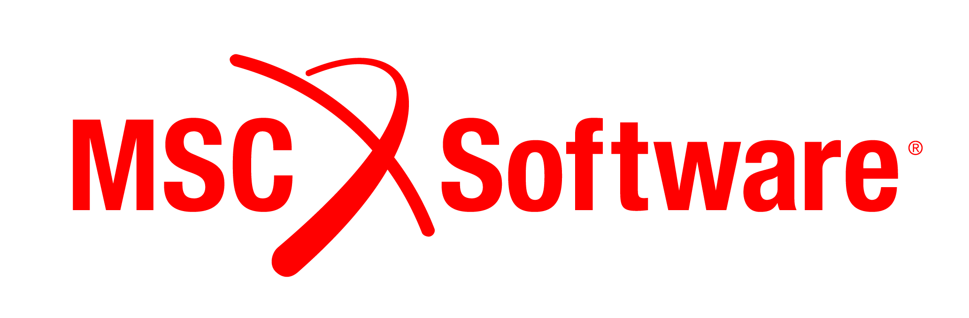 | Course Description: Multibody dynamics (MBD) simulation is among the most frequently used and valuable computer aided engineering (CAE) disciplines within the automotive industry. Get introduced to MBD simulation with this introductory one-day class based on the most broadly used MBD software package in the industry, Adams. This one-day course will combine an overview of MBD and the Adams software, industry case studies, live demonstrations and hands-on exercises. Students will learn about how automotive engineers improve their designs by applying MBD in various areas of vehicle development: powertrain, durability, safety, NVH/ride, handling and drivetrain. The hands-on exercises are geared toward new Adams users; so, no experience necessary. Those already familiar with Adams are also encouraged to attend.
Training Option 14: | Electrical Systems Design for Automotive – Schematics with Mentor’s Capital Logic Software
Dates: | July 17 (Tuesday) 1 day Instructor:
Location: | Wayne State University
 | Course Description: In this course, you will learn how to conceptualize an electrical system design including schematics in the automotive domain. You will learn to use Mentor’s Capital Logic software suíte, which offers powerful graphical wiring design authoring and editing for both logical connectivity designs (signals), and physical wiring designs (wires, splices, multicore wires, etc.). You will progress from basic schematics through to more complex automotive wiring designs using lab examples.  Prerequisite: Basics of electrical principles and schematics. Note:This course is a prerequisite to the Automotive Electrical Wire Harness Design on 7/19/17.
Training Option 15: | Automotive Electrical Wire Harness Design – with Mentor’s Capital Harness XC Software
Dates: | July 18 (Wednesday) 1 day Instructor:
Location: | Wayne State University
 | Course Description: This course introduces you to automotive harness design by transforming the schematics from the Electrical Systems Design for Automotive class into a harness design with connectors and other basic and more complex functionality within the Capital Harness XC Product. This tool provides a seamless transition of data from Capital Logic or Integrator into Capital Harness XC. Harness XC offers integration with Siemens NX MCAD software as well.

Training Option 16: | VRED
Dates: | July 21 (Friday) 1 day Instructor:
Location: | Wayne State University
 | Course Description: Autodesk, this course will guide through the first steps of doing high-end visualization using VRED Professional software and will explore the capabilities of the software..
Training Option 17: | Collaborative Product Design with Primavera P6
Dates: | July 19-20 (Thursday-Friday) 2 days Instructor:
Location: | Wayne State University
 | Oracle’s Primavera P6 Enterprise Project Portfolio Management is the most powerful, robust and easy-to-use solution for prioritizing, planning, managing and evaluating projects, programs and portfolios. It has been used to manage enormous projects including the design of the Hubble Telescope, the rebuilding of the Panama Canal and the design of the 777 and many, many more. Learn about how Primavera P6 EPPM is integral to how an organization can design its future products and bring them to the market.  This is an introductory course for using Oracle’s Primavera P6 Enterprise Project Portfolio Management. The class will focus on the principles of project management and how this is accomplished within the software. Each student will have hands-on access to the software. Attendees should have a basic understanding of Project Management and an interest in the value of it brings to an organization.  Subject Areas include:  - Project Management Lifecycle  - Building Blocks of Project Management  - Overview and Navigation in P6  - Activity Interdependency  - Using Calendars and Constraints  - Critical Path Management (CPM)  - Resource Capacity vs. Allocation  - Schedule Optimization  - Project Execution  - Analyzing the Updated Project  More about Oracle Primavera P6: this application is available as a cloud based Software As a Service as well as an on premises solution and is backed by a global network of Oracle Project Portfolio Management professionals and the assured security, scalability, performance and support from one of the world’s largest cloud vendors. It provides a 100% web-based, solution for managing projects of any size, adapts to varying levels of complexity across projects and intelligently scales to meet the needs of all roles, functions, or skill levels in your organization and on your project team.

***DO NOT BE A "NO SHOW" for training classes!! Only sign up for the training class that you definitely will attend. Seating is limited; “no shows” prevent others from benefiting from the training. To change or cancel your training selection after June 1st, you MUST email the PACE Office (Linda Duroino) no later than July 7th.

Our sincere thanks to the PACE Companies who are providing the training sessions for the 2018 PACE Annual Forum!

These PACE Companies provide this convenient opportunity for the PACE Faculty and Students to attend the training sessions with no tuition fees.

________________________________________________

Our sincere thanks to Wayne State University
for hosting the training!

Our sincere thanks to the…

2018 PACE Annual Forum
5 Sponsors

Platinum Level Sponsor: 
Gold Level Sponsor:

Silver Level Sponsor:
Bronze Level Sponsor: 

Due to the generous sponsorship of the PACE Annual Forum by these PACE companies, there is no conference fee for PACE institution faculty and student attendees. Company sponsorships fund the conference breaks, lunches, welcome reception, and awards dinner.

