


2019
Softball Queensland Masters
Tournament Information

It’s that time of year again- get excited, SQI Masters is back for 2019!!

Welcome to the
20th Softball Queensland Masters Tournament!!!
2nd - 4th August 2019.

The SQ Masters Tournament website, http://qld.softball.org.au/about/sq-masters/ and Facebook page will again be used to keep participants up-to-date on the latest happenings. If you haven’t “liked” the Facebook page, you can become a friend by searching ‘Softball Queensland Masters Tournament’ and clicking on the ‘Like’ button.

Listed below are the details of the 2019 Softball Queensland Masters Tournament. Make sure you get your team registration in early so you don’t miss out! If you have any queries, please don’t hesitate to contact Kate at the SQ Office on (07) 3391 2447 or email events@softballqld.asn.au.

We are looking forward to seeing you at Redcliffe in August for some great softball and socialising.

Tournament Details
Dates: 2nd – 4th August 2019
Venues: Talobilla Park
Redcliffe Leagues Softball Association, PCYC Redcliffe,
Redcliffe Padres Baseball club, Redcliffe Leagues Club
Klingner Road
REDCLIFFE

Process for registering your team
Registration fees for nine (9) players must be paid for when submitting Team Expression of Intent to Participate Form online for a team to be registered. Team Co-ordinators MUST make certain that players are registered online and have paid their fees through their online profiles. Teams will not be accepted unless 9 players have paid the registration fee by the due date.

Please note: Nine (9) players must be paid for in full before Friday, 17th of May. This is to ensure teams confirmed their attendance, therefore allowing Softball Queensland to create a draw in good time. Any team without 9 players paid for in full by the 17th May will not be included on the draw.

Team Co-ordinators who complete the Team Expression of Intent to Participate Form will be given admin access to edit their online team list and will consistently need to link players to their team.

Once team registration is completed and the payments are confirmed, the team contact will be sent a link for individual registration by all team members (excluding umpires) and the team list form will be sent shortly after. Please note, individual registration is required as it is now the online team list. A hardcopy team list will NOT need to be submitted as per previous years.

Team Entry

Team Expression of Intent to Participate Form  Paid and online registration of 9 players (minimum) | Before 5.00pm 17 May 2019
ALL participants paid and registered online  Team Co-ordinator to ensure players are under team online | Before 5.00pm 5 July 2019

Registration Fees – Players

Early Bird Registration Fee | Before 5.00pm 17 May 2019 | $115.00 per participant
Registration Fee | After 5.00pm 17 May 2019 | $130.00 per participant

Registration Fees – Non Playing Officials (Coach, Manager, Scorer)

Early Bird Registration Fee | Before 5.00pm 17 May 2019 | $75.00 per participant
Registration Fee | After 5.00pm 17 May 2019 | $90.00 per participant

Refund Policy
No refunds will be given after the 5th of July 2019. Registration fees can be transferred to a new participant if a team member withdraws after that date. If the fee is not transferred, the person who withdraws still receives their tournament pack.

Note: SQI orders and pays tournament expenses based on the team list information and therefore cannot provide refunds after 5 July 2019.

Individual Online Registrations
Team members are required to register online individually for the tournament. This will be known as a persons’ ‘profile’. This system allows direct online payments and is a more effective way of strengthening our communication with each person. Each person will then be able to access the tournament forms and flyers, information, draws and updates through their ‘profile’.
- Existing Profiles (This is for all participants who created an online profile in 2018)
  - You will need to log in to the website. If you have forgotten your password, select ‘forgot login details?’
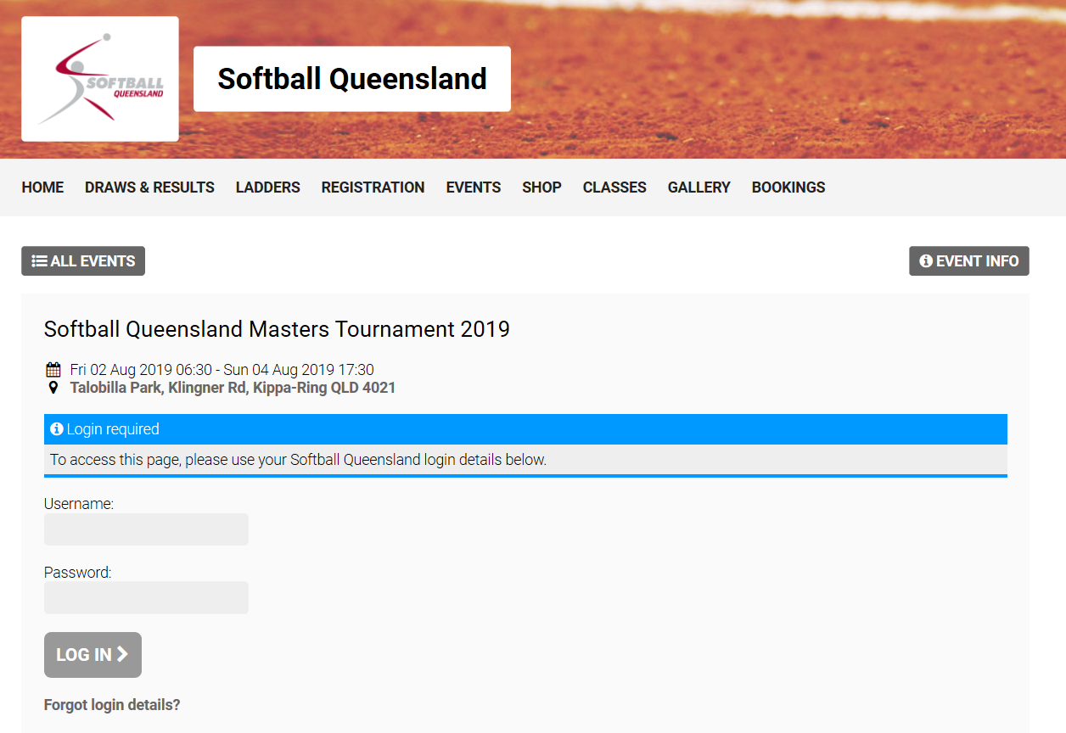
  - Alternatively, Softball Queensland will be able to resend your login details.
  - Once you have logged in, the next step is to register for this year’s event.

After selecting next step, you will need to fill in your details and then click ‘Register Now’. On

‘Thank you for submitting your registration! Your registration is now pending approval. You will be notified of your approval status soon.’ Please note this is only the online stage. Registration fees will still need to be selected.
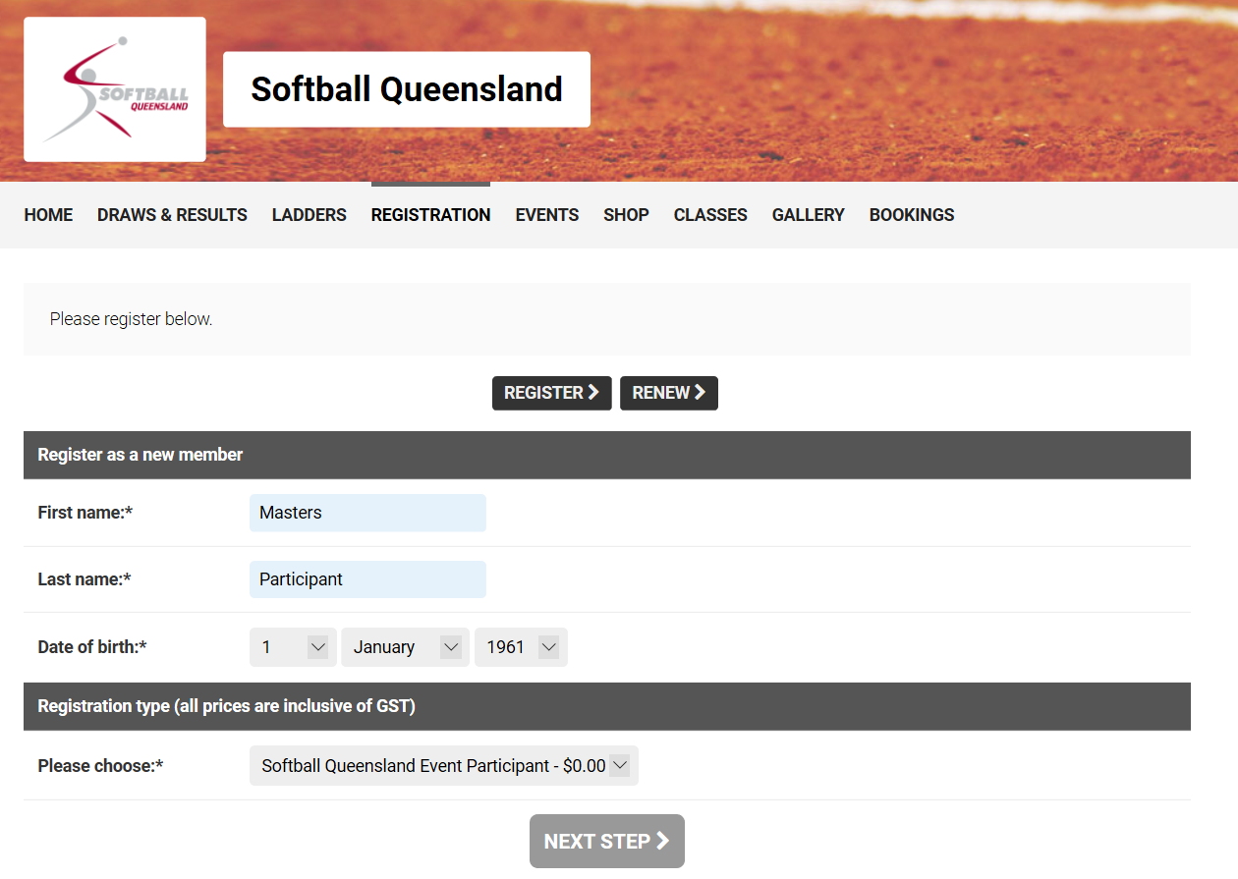
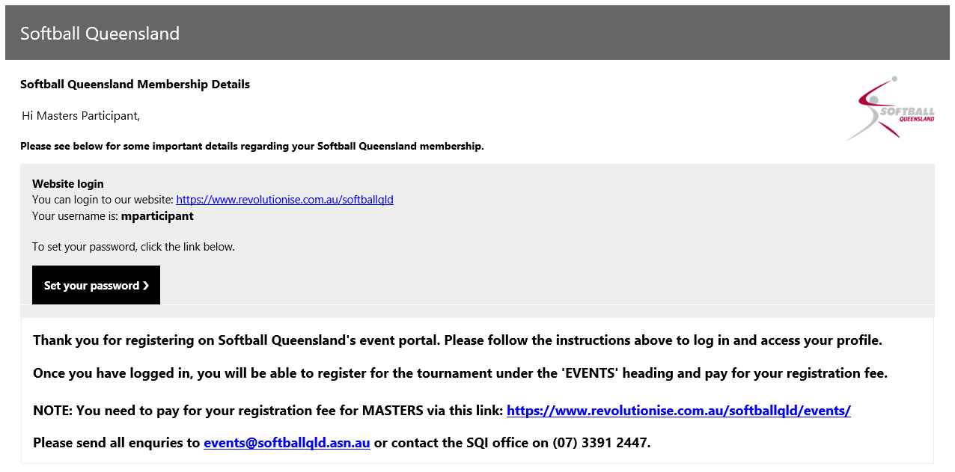

If you have any queries, please don’t hesitate to contact Kate at the SQI Office on (07) 3391 2447 or email events@softballqld.asn.au.

Checklist for Team Contact
- Forward the registration link through to all players and officials in team (excluding umpire) for them to complete their own registration.
- Submit the online team expression of intent to participate form and ensure early-bird registration fee payment of 9 players before Friday, 10th May 2019.
- Regularly check your online team list (admin access) and follow up with all players and officials in team to confirm they are registered online and have made their payment.
- Remind all registrations (payments included) are to be completed by 5.00pm 5 July 2019.

Payments
It is recommended that all payments be made online at the time of registration as this is the best method to guarantee your payment has been received. Payment may also be made by direct deposit, credit card or cheque. A reminder to team members: when depositing money into the SQI bank account please ensure you include a clear description in the reference section i.e your surname and team name and send an email with details of the deposit to events@softballqld.asn.au. Any payments without a clear reference will not be assigned to a player.

Direct Deposit
Bank NAB
BSB 084 391
Account 557 965 352
Account Name Softball Queensland Inc
Reference Your name AND team name

Note: Team Co-ordinators are asked to please encourage your team members to pay their registration prior to the early bird cut-off date. Registrations on Friday morning will only be available for late team list additions. e.g. replacements due to injury.
Conditions of Entry
- Registration fees for nine (9) players paid with Team Expression of Intent to Participate Form before 5pm on 10 May, 2019.
- All payments received by 5pm on May 10, 2019 are at the Early Bird rate.
- All payments received after 5pm on May 10, 2019 are at the regular registration rate.
- All participants paid and registered online by July 5, 2019. Team Co-ordinator to ensure players are linked and visible under team online.
- All payments made prior to and including July 5, 2019 are transferable and refundable.
- Any non-playing team official (that is Coach, Manager and Scorer) pays a reduced fee.
- Teams MUST supply a minimum of 1 full time umpire (ie. available to umpire every day)
- Each team member (including umpires) MUST sign in prior to the first game in which they participate.
- All participants MUST abide by the SQI Codes of Ethic/Conduct and Zero Tolerance Policy. A copy of these documents is available on the SQI website, www.qld.softball.org.au.
- All teams must abide by the liquor licences of each venue and NO alcohol is to be brought onto ANY venue.
- Teams must supply their own Easton 888 (12”) game balls which must be of good quality. These will be on sale at the registration desks and merchandise tent during the tournament.

Umpires
- The tournament cannot go ahead if we don’t have enough competent umpires. For a tournament to be successfully conducted, ideally 1½ umpires per team are needed.
- Acceptance of team entry is conditional upon the team supplying an umpire who is available to umpire every day of the tournament. The nominated team umpire MUST be competent in umpiring both as a plate and base umpire, at least for the division that their team is playing in.
- If needed, teams will be penalised for failure to provide an umpire for any allocated timeslot.
- No participation fee is required for umpires registered with SQI.
- Umpires not registered with SQI must pay an event fee of $30.00.
- Umpires must be listed on the original team list.
Umpire Uniform:
- All accredited umpires are required to wear their official umpiring uniform
- All non-accredited umpires, or team members performing umpiring duties, are required to wear a light blue polo shirt with dark trousers.

In 2018, two additional requirements have been placed upon umpires attending SQI sanctioned tournaments, including the SQI Masters Tournament. These additional requirements are not restrictive as they are current requirements of all umpires in Queensland already. These two requirements are:
- The umpire must hold the Play by the Rules certificates (issued after 1/1/2017) for completion of the modules covering:
  - Child Protection; and
  - Harassment and Discrimination.
- All umpires over 18 must also hold a current Blue Card.
  - It is acknowledged that many umpires at the SQI Masters Tournament are juniors. If they are under the age of 18, they are unable to apply for a blue card so this requirement does not apply to them.

We also recognise that non-accredited umpires are often nominated by teams, but it is reasonable to expect they have a basic understanding of playing rules.

Umpire On-line Registration:

The Queensland Umpiring Technical Directorate has developed a nomination form for umpires attending the 2019 SQ Masters, that will confirm these requirements are held, or enable us to assist your umpires to gain them.

Please ensure this process is effective, by ensuring your Masters team umpire (listed on the team sheet) has completed the electronic nomination form which is available at the following link. https://www.surveymonkey.com/r/LSFYQDP

Please note:
- regardless of whether your umpire is a team playing member or not, they must complete the umpire registration form vis the link above.
- Umpire nominations are due at the same time as team nominations.
If there are any questions regarding umpires, please contact the State Director of Umpiring, Darren Sibraa, on 0400 716 924.

Further information will be distributed in the coming months:

For further information or general enquiries please contact:

Softball Queensland Inc
Ph: (07) 3391 2447
Email: events@softballqld.asn.au
SQI Website: www.qld.softball.org.au
Masters Website: http://qld.softball.org.au/about/sq-masters/
(Version 2 Updated 24.04.19)

