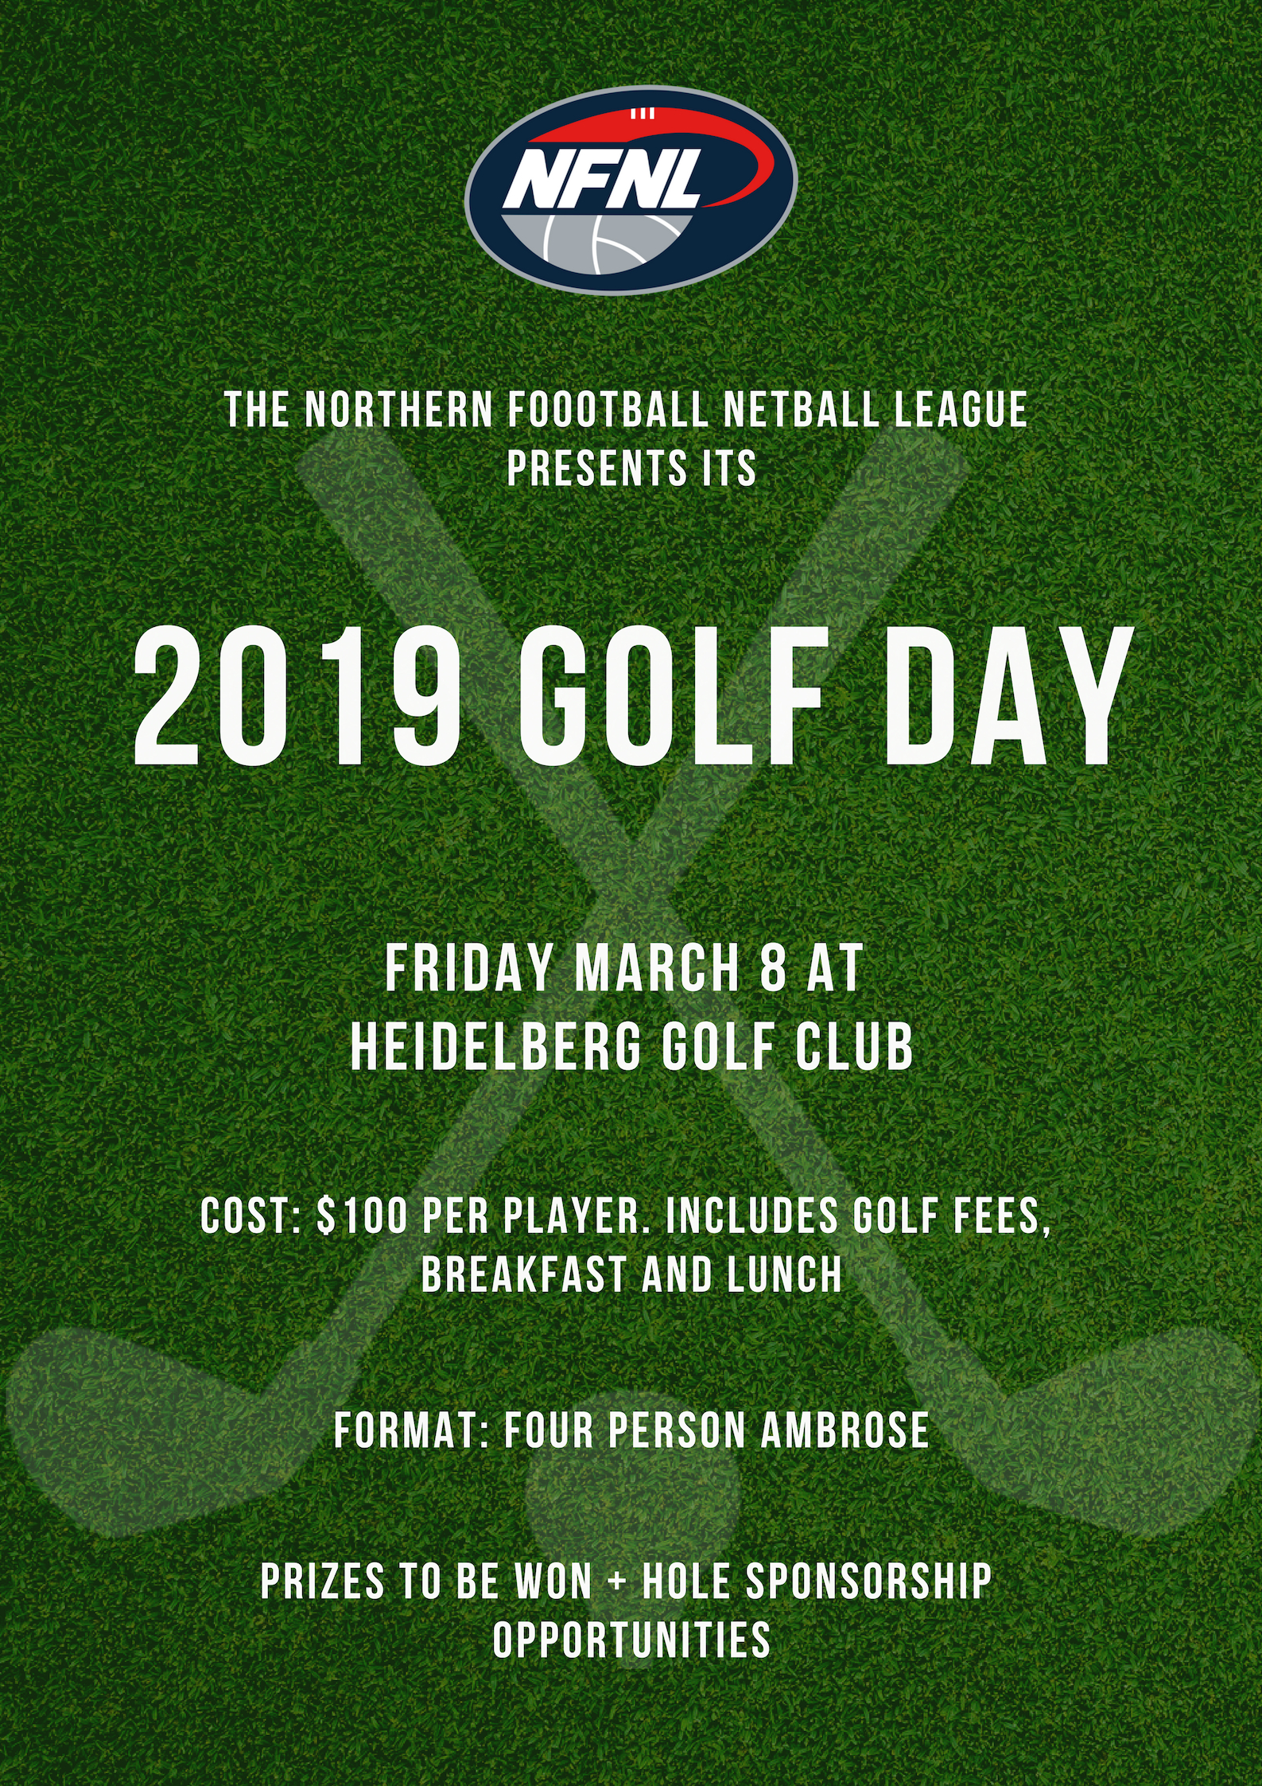
EVENT INFORMATION

EVENT
2019 NFNL Golf Day

DATE
Friday March 8, 2019

LOCATION
Heidelberg Golf Club – 8 Main Rd, Lower Plenty

FORMAT
Four Person Ambrose

ENTRY FEES
$400 for team of four players. This includes green fees, breakfast and lunch for all members of the team.

MATCH-DAY REGISTRATION
Registration from 7:00am. Shotgun start at 8:00am

BREAKFAST
Bacon and egg rolls, tea and coffee available from 7:00 am at registration in Bryn Teg Room.

LUNCH
Gourmet BBQ lunch from 12:00pm in Eaglemont Room. Prizes will be presented at lunch.

GOLF CARTS
Limited numbers available. $35 per cart.

INFORMATION
For further information about hole sponsorship and playing opportunities, please contact Delwyn Berry.

Phone: 9435 8228
Email dberry@nfnl.org.au

SPONSORSHIP

We are pleased to offer members and business partners an opportunity to become a hole sponsor.

SPONSORSHIP BENEFITS

· Banner, flag or corflute signage to be displayed on your allocated hole. Please note: sponsors are to provide their own signage.

· Breakfast, on-course refreshments, BBQ lunch.

SPONSORSHIP PACKAGES

· Longest Drive sponsor – Minimum $100 or item to value of. This applies to both the front 9 and back 9.

· Closest to Pin sponsor – Minimum $100 or item to value of. This applies to both the front 9 and back 9.

· Hole sponsorship – Minimum $250 per hole. Includes signage with company logo/name on tee box. Company logo/name displayed throughout the day, including at the clubrooms and on course arrival.

· Major Hole Sponsor (1st, 10th & 18th) – Minimum $550 per hole. Includes signage with company logo/name; opportunity for special offer to be recognised and promoted throughout the day; introduction of company when groups are announced; 2x free players on the day; 10x drink vouchers; one of the awards named after the company name.

REGISTRATION FORM

Please complete player and payment details and return to dberry@nfnl.org.au

PLAYER 1 (CAPTAIN) | PLAYER 3
Name | Name
Email | Email
Telephone | Telephone
Golf Link / Hcp | Golf Link / Hcp
PLAYER 2 | PLAYER 4
Name | Name
Email | Email
Telephone | Telephone
Golf Link / Hcp | Golf Link / Hcp

ENTRY FEES (tick required boxes below)

 | Team Green Fees - $400 (4 players x $100) | $
 | Hole Sponsorship - $250 | $
 | Major Hole Sponsorship - $550 | $
 | Longest Drive Sponsorship - $100 | $
 | Closest to Pin Sponsorship - $100 | $
 | Golf Cart - $35 per cart | $
 | Total | $
PAYMENT OPTIONS
There are several payment methods which can be accepted. Please note: payment must be made upon submission of entry form.

Cheques payable to Northern Football Netball League

Bank Deposit: Northern Football Netball League
BSB 013 128 Account 467 527 041
Reference: Surname of Player 1 (captain)
Please also email entry form and remittance to dberry@nfnl.org.au

Credit Card - Visa or Mastercard

Card No: __ __ __ __ /__ __ __ __ /__ __ __ __ /__ __ __ __ Expiry __ __/__ __ CCV __ __ __ (last 3 digits on back of card)

Name on Card ______________________________________________ Amount: $___________

Authorised Signature _______________________________________________________________

