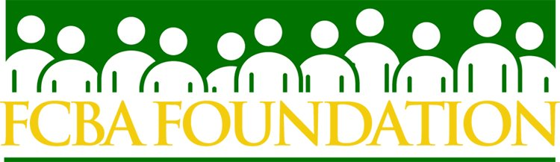

30th Annual FCBA Foundation Charity Auction
Thursday, November 7, 2019

Sponsorship Commitment Form

To confirm your sponsorship, please send this form with your credit card information or a check made payable to the “FCBA Foundation” to FCBA, 1020 19th Street, NW, Suite 325, Washington, DC 20036; fax: 202-203-4317; or email: janeen@fcba.org. If you would like an invoice sent to you, please email this form and the request to janeen@fcba.org.

Sponsorship Fee: $2,000.00

Please Print

Contact: ___________________________________________________________________________________

Organization: ______________________________________________________________________________

Address: __________________________________________________________________________________

City: _____________________________ State: __________________ Zip: ___________________________

Phone: _________________________________ E-mail: ___________________________________________

If paying by check: Make all checks payable to the FCBA Foundation.

If paying by credit card:  MasterCard  Visa  American Express  Discover

Card Number: ____________________________________________________________________________

Expiration: ______________________________________ CVV Security Code: _____________________

Name on Card: ___________________________________________________________________________

Signature: _______________________________________________________________________________

*If you would like an invoice, please fill out the form and let Janeen know.

Thank you for your donation to the FCBA Foundation. The FCBA Foundation is a charitable organization qualified under Section 501(c)(3) of the Internal Revenue Code. Your donation may be deducted from your federal income taxes to the extent permitted by law.

