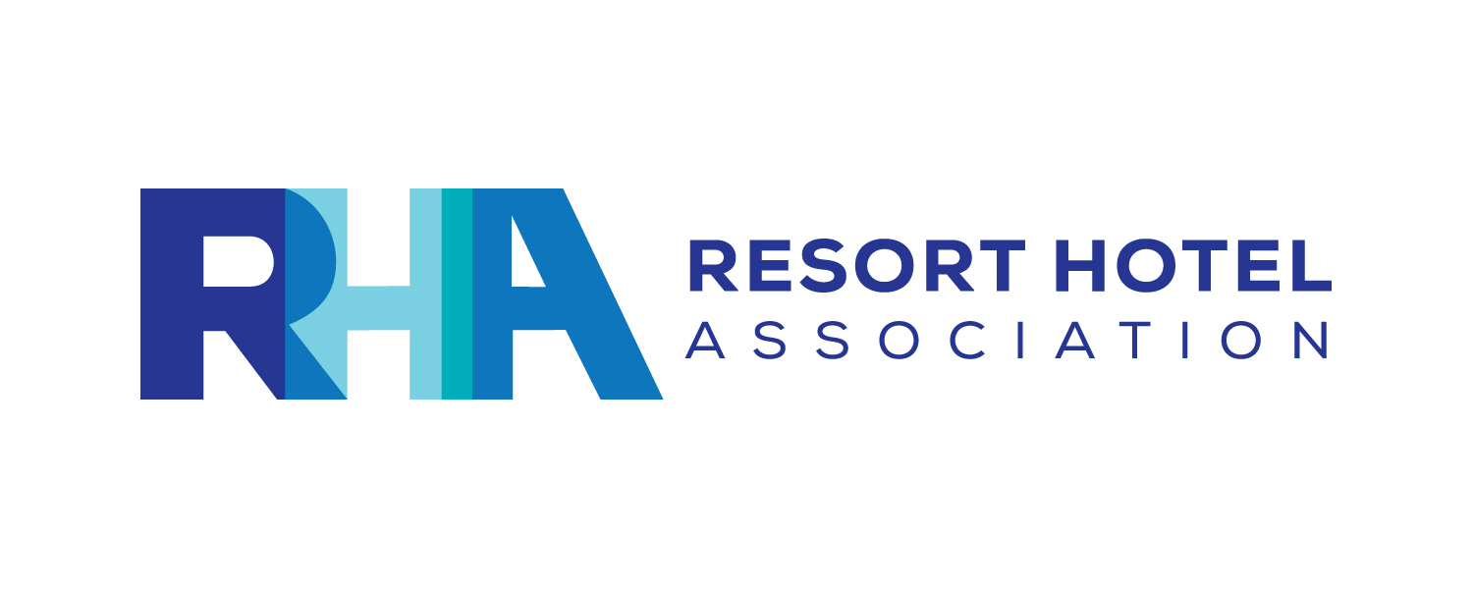
2019 STAY RHA: An Employee Rate Lodging Program
Effective Dates: January 1 to December 31, 2019
----------------------------------------------------------------------------------------------------------------------------------------------------------------------------------------------------------
RULES FOR PARTICIPATION

- Properties must be RHA Members in good standing to participate.
- Properties MUST offer one of the following discounts:
- Offer at least 50% off BAR
- Offer a rate of $89, EP per room, single or double, plus taxes
- Properties may elect to accept or decline reservation requests, based upon availability.
- Member properties may define various restrictions. Please identify these in the Terms & Conditions section of the Application Form. Examples: blackout dates, holidays, days of the week, length of stay, etc. to allow for seasonality, special events, etc.
- Properties will respond to reservations requests directly to the employee within 48 hours of receipt of the request.
- Employees will make reservation requests using the online Reservation Request Form directly with the property, not via a travel agent or through RHA. Upon submitting the form, a copy will be emailed to both the property and the employee making the request. Again, properties must respond to requests within 48 hours of receipt of the request.
- The valid dates of the program are January 1 through December 31, 2019.
- All charges must be disclosed in the Terms and Conditions section (See: Rate) of the Application Form.
- Properties agree to actively promote the availability of the program to employees. RHA will have information available to all members and their employees on the RHA website.
- Meals are not included unless specified. EP or MAP rates must be specified.
- If a property does not participate in the program, its employees cannot obtain the discounts offered by other member resorts that are enrolled in the program.
- The program is offered to employees of participating hotels and RHA staff only and only for their personal use. Employees must be present on the days requested.
- Reservations requests cannot be made any more than sixty (60) days in advance of the requested dates.
- Incidentals, food & beverage, taxes, resort fees, and any applicable service charges will be paid by the employee.
- Standard credit card guarantees and cancellation policies apply.
- RHA is not responsible for agreements entered into between employees and the properties or resolving disputes arising between the parties.

