June, 2001



BE-2110i VF/WIDEBAND TRANSMISSION TEST SET

Operator’s Manual

Sales/Marketing email: don.brehm@itcmail.net Customer Service/Manufacturing
11640 Arbor Street WEB: www.berrytestsets.com 26 First Avenue, SE
Suite 100 New London, MN 56273
Omaha, NE 68144 TEL: 320-354-5825
TEL: 402-498-8400 FAX: 320-354-5875
FAX: 402-493-5100

THANK YOU!!

You have just purchased another high quality, easy to use test set from Berry Test Sets. We thank you for that.

We also suggest that you review this manual thoroughly before attempting any live testing. In particular, read the section
entitled "Controls and Indicators" to become familiar with the operation of the keys.

If you have any questions of any kind, please feel free to contact us at any of the following:

BERRY TEST SETS
Sales/Marketing Customer Service/Manufacturing
11640 Arbor Street 26 First Avenue SE
Suite 100 New London, MN 56273
Omaha, NE 68144
Tel: 402-498-8400 TEL: 320-354-5825
Fax: 402-493-5100 FAX: 320-354-5827

WEB: www.berrytestsets.com
email: don.brehm@itcmail.net

BE-2110i VF/WIDEBAND TRANSMISSION TEST SET
TABLE OF CONTENTS

General Information about, and description of the Test Set 3
Battery Information 3
Warranty Information 3
Repair & Return and Technical Assistance 3
Specifications 4
Faceplate Description 6
Controls and Indicators 6
Set Up the test set 11
Set the Time and Date 11
Set the System Functions 13
Set Sweep Stop and Start frequencies and Step Rate 14
Set the Sweep Frequency Rate (Fast & Slow Sweeps) & Mode (LOG) 15
Set Receive Options 18
Set the Beep Controls 18
Battery Status 19
Test Set Information 20
Test #1 - Send & Receive Tone - 2W 22
Test #2 - Send & Receive Tone - 4W 23
Test #3 - 2 Wire Dial Up 24
Test #4 - Double 2 Wire Dial Up 25
Test #5 - Measure Frequency, Level and Noise - 2W 26
Test #6 - Measure Frequency, Level and Noise - 4W 27
Test #7 - Measure Impulse Noise 2W or 4W 28
Test #8 - Signal to Noise (SNR) Measurements 30
Test #9 - Relative Measurements 31
Test #10 - Send Tone, Sweep function 32
Test #11 - Apply Quiet Termination for Far End Noise Measurements 33
Miscellaneous Screen Definitions 34

BE-2110i Voice and Data

VF & Wideband Test Set

TEST INSTRUMENT DESCRIPTION

The BE-2110i Test Set is a portable, battery operated, voice frequency (with wideband capability) transmission test set for use in trouble shooting and maintaining telecommunications equipment. It provides calibrated test signals while simultaneously making frequency, level and noise measurements on communications systems.

Among the features included in the test set are input impedances of 100, 135, 150, 600, 900, 1200, 1500 Ohms,
dual electronic hold circuits, seven different noise weighting filters, full duplex operation, automatic send frequency sweep (two speeds) and simultaneous digital read out of both send and receive level and frequency.

Fixed frequencies of 404, 1004, 2804 and 2713 kHz are also included in the tone generator.

The wideband function sends and measures frequencies from 200 Hz to 125 kHz. Levels can be measured and sent from -40 dBm to +10 dBm. Noise measurements can be made across this entire frequency spectrum, providing a test set to quickly and easily pre-qualify ISDN BRI and most other special services type of circuits.

GENERAL INFORMATION
Battery Charging Information
The BE-2110i Test Set is powered with a rechargeable sealed lead acid battery. When the battery is fully charged, the test set will operate in excess of 6 hours under normal operating conditions. The test set contains circuitry for both low battery detection and automatic test set shut off (to avoid complete discharge damage to the battery).
When the low battery symbol is visible in the lower, left corner of the display, the test set will continue to operate for approximately 45 minutes. After approximately 45 minutes of operation with the low battery symbol visible, the test set will automatically shut the power off.

To recharge the test set's battery, insert the cable plug on the supplied AC adapter into the 12VDC, 500mA jack on the test set side panel. Plug the AC adapter into a 100V to 240V AC outlet. The green LED next to the DC power jack on the side panel will flash on/off, and will continue to do so until the battery is completely charged. Once the battery has a full charge the green LED will be left on until external power is removed. If no LEDs are visible after connecting external power, the unit is not receiving power. If the red LED turns on after connecting external power, a charge fault has occurred, and external power should be removed. A completely discharged test set will require 6 hours of charging with the power off to regain full battery power.

Under normal operating conditions, battery life in excess of 1000 charge/discharge cycles can be expected.

Back to Index

Warranty Information

BERRY TEST SETS, products are warranted against defects in materials and workmanship. This warranty applies for two years following date of shipment. BERRY will repair or replace products which prove to be defective during the warranty period. NO OTHER WARRANTY IS EXPRESSED OR IMPLIED. BERRY TEST SETS IS NOT LIABLE FOR CONSEQUENTIAL DAMAGES. THIS WARRANTY POLICY APPLIES ONLY TO EQUIPMENT FAILURES WHICH RESULTED DUE TO NORMAL OPERATION AND HANDLING, AND ARE NOT A RESULT OF BUYER'S NEGLECT OR MISUSE.

If the BE-2110i requires factory maintenance during the warranty period, it should be shipped in the original carton to Berry Test Sets. Please be sure to include the following information:

1)- RTA Number 2)- Ship-to address 3)- Description of problem

Please call our Sales Office at 402-498-8400 or our Customer Service Department at 320-354-5825 to obtain the Return Transaction Authorization (RTA) Number, or Email us at dbrehm@technologies.coxatwork.com.

REPAIR AND RETURN AND TECHNICAL ASSISTANCE

If, for any reason, a Berry Test Set product fails to perform as expected, contact Berry Test Sets, Inc. A Return
Transaction Authorization (RTA) number must be obtained before any equipment is returned. To obtain the RTA No.
call Customer Service at 320-354-5825, Sales Office at 402-498-8400 or Email dbrehm@technologies.coxatwork.com.

Please be sure to include all the following information:
SEND THE TEST SET TO:
- RTA Number Berry Test Sets
- Billing Authorization (Purchase Order, Credit Card, etc.) 26 First Avenue Southeast
- Bill-to address New London, MN 56273
- Ship-to address and person to contact
- Description of problem

Equipment shipped air freight will be repaired within four working days. Equipment shipped by surface freight will be repaired within 10 working days.

In the event of an emergency out-of-service condition and the need for technical support, call our Customer Service Department at 320-354-5825 (New London, Minnesota).

Back to Index
SPECIFICATIONS
GENERAL
Capabilities
Measurements: Level (dBm), Noise (dBrn), Impulse Noise (Counts), Frequency (Hz)
Configuration Readout: Full Duplex Send & Receive on a 2.8" X 1.5" Graphic Liquid Crystal Display with digital contrast control and EL Backlight
Monitor: Speaker, Send or Receive with digital volume control and off
Dial/Hold: Full 2W/4W capability, Dual Electronic Hold

Input/Output
Controls: 29 Key Membrane keypad with separate impedance and function controls for Send/Receive
Impedances: 100, 135, 150, 600, 900, 1200, 1500 Ohm and Bridged (Balanced)
The Bridged Selection also has selectable reference impedances.
Protection: DC & Transient

Environment
Case High Impact fiber-plastic, with soft-sided carrying case
Size 7.5" w X 10.75" h X 2" d
Weight Approximately 4.0 lbs.
Power: Rechargeable Sealed Lead Acid Battery with Low Battery indicator and user selectable timed auto shutoff
AC Adapter Input: 100-240V ~ 47-63 Hz, 0.4A
Output: +12VDC, 1500 mA
Optional: Cords, Conversion 310/Alligator clips
Operating Temperature: 0° to +40° C (32° to 104° F)
Storage Temperature: -10° to +60° C (14° to 140° F)
Humidity: 10 to 90%, non-condensing

RECEIVER

Frequency Measurement

Range: 200 Hz to 125 kHz
Level: +10 dBm to -40 dBm
Accuracy: +/- 2 Hz
Resolution: 1Hz (200Hz to 99.999kHz)
10Hz (100kHz to 125kHz)

Level Measurements
Frequency Range: 200Hz to 125kHz
Measurement Range: +10dBm to -40dBm, with Full Auto Ranging

Accuracy: +/-0.1dB at 1000Hz for levels between 0 and - 19dBm
+/-0.2dB all other levels
Resolution: 0.1dB
Relative Level Measurement: +10 to -30 Adjust Range
S/N Measurement: 20 to 50 dB Range

Noise Measurements
Weighting: D Filter, 1kHz Notch, C Message, C Message Notch,
3.4kHz Flat, 15kHz Flat, and E Filter
Measurement Range:
Message Circuit Noise: 20 to 90dBrn
Noise with Tone: 30 to 90dBrn
Accuracy: +/-1dB
Resolution: 0.1 dB
Detector Type: True RMS

SPECIFICATIONS
RECEIVER (Cont.)
Impulse Noise
Type: Single level
Measurement Threshold: 50 to 85 dBrn, continuously adjustable
Threshold Accuracy +/-1dBrn
Timer : User selectable 5, 15, 60 minutes or continuous
Defaults to 5 minutes
Count Range: 0 to 99999 counts
Count Rate: 8 per second nom.

TRANSMITTER

Characteristics
Level: -40.0 dBm to +10 dBm in 0.1 dB steps
Range: 200 Hz to 125 kHz
Accuracy:
Frequency: 1 Hz
Level: +10 dB to -10 dB: +/- 0.05 dB/dB
-10 dB to -40 dB +/-.5 dB Max.
Flatness: +/-0.25 dB
Impedances: 135; 150; 430; 600; 900; 1200; 1500 Ohm
Type Oscillator: DDS
Modes:
Manual: 200 Hz to 99.999 kHz in 1 Hz Steps
100 kHz to 125 kHz in 10 Hz Steps
Fixed Freqs: 404; 1004; 2804; 2713 Hz
Sweep: 2 Speeds, Automatic I00 Hz Steps with S.F. Skip
User Selectable sweep rate and step size
Quiet Termination: Line Terminated in Characteristic Impedance

Back to Index
BE-2110i Faceplate


`
F2
F3
F1
F4
F5
F6
SEND
RECEIVE
BE-2110i
WIDEBAND ANALOG TEST SET
POWER
HOLD
DIAL
2W
4W
OFF
MONITOR
WIDE
BAND
SEND
REC
NORMAL
REVERSE
IMPULSE
TEST
SELECT
SLOW
SWEEP
FAST
SWEEP
VAR
FREQ
QUIET
TERM
404
1004
2713
2804
900
Ω
1200
Ω
600
Ω
430
Ω
150
Ω
135
Ω
BRIDGE
1500
Ω
ABS
SNR
FLAT
FLAT
CMSG
NOTCH
FLTR
CMSG
D
LEVEL
E
ISDN
3.4
KHz
FLTR
1
KHz
NOTCH
15
KHz
1500
Ω
900
Ω
1200
Ω
600
Ω
430
Ω
150
Ω
135
Ω
REL
DELTA
R
1
2
4
3
7
6
10
11
14
9
8
5
13
12
17
21
15
16
22
20
19
18

CONTROLS AND INDICATORS

This section contains a description of the functions of each of the keys, jacks, displays and monitor found on the front and side panels of the BE-2110i Test Set.

All keys are of the membrane type, requiring only a light touch to change the function.

KEY FUNCTION
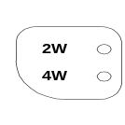
1 2W/4W Provides testing of a 2 wire or a 4 wire circuit. In the 4W position, both the send
and receive line interface jacks are connected to the test set. When 2W is selected, only the
SEND/2W/4W jack is connected to the test set. A corresponding LED lights to indicate the
selection. Default setting at POWER ON is 2W, RECEIVE, REVERSE, BRIDGED.

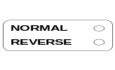
2 NORMAL/REVERSE In the NORMAL position the SEND/2W/4W jack is the send jack and the
REC/4W jack is the receive jack. In the REVERSE position, the functions of the jacks are
reversed. A corresponding LED lights to indicate the selection.

3 HOLD/DIAL In the DIAL position, the REC jacks are disconnected from the REC side HOLD circuit and connected to the BUTT-SET jack, allowing dialing on the circuit from another location or a butt-set. While in the DIAL position, the test set is bridged onto the REC jacks, allowing the operator to use the test set's monitor if needed. In the HOLD position, the REC jacks are connected to the test set's selected REC impedance and HOLD circuit, which will hold the connection of a dialed up circuit. A corresponding LED lights to indicate the selection.
DIAL
HOLD

Back to Index

CONTROLS AND INDICATORS

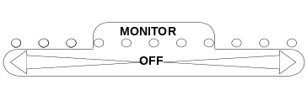
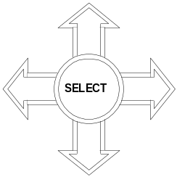
4 This key selects the MONITOR function via the built in speaker for either the SEND
output or REC input of the test set. Volume is controlled by pressing the right arrow for
REC monitoring volume or the left arrow for SEND monitoring volume. Maximum is far
right for input (REC) and far left for output (SEND). The relative monitoring level is
indicated by the corresponding LEDs. The MONITOR function can be turned off by
pressing either arrow until the LED above OFF lights.
1500
Ω
900
Ω
1200
Ω
600
Ω
150
Ω
135
Ω
100
Ω
5 The bottom key in the SEND panel is used to select the SEND impedance. Pressing the
right curved arrow in this key moves the selection clockwise. Pressing the left curved
arrow in this key moves the selection counter clockwise.
A corresponding LED lights to indicate the selection.

6 This key controls level and frequency output. Frequency output is selected by the middle
key in this panel. Pressing SELECT places a cursor in the dBm or Hz area of the SEND
Screen (left panel). The dBm or Hz selection can be changed by pressing SELECT a
second time.

This key is also used to adjust test set default settings and other functions such as date,
time and so forth.

The cursor will be located under one of the digits. By pressing the up or down arrow on the SELECT key, the value of this digit (and corresponding level or frequency) is changed. Pressing the left or right arrow on the SELECT key moves the cursor under the next digit to the right or left. This value can then be changed as desired with the up or down arrows on the SELECT key.

The cursor will disappear from the screen if no values are changed in approximately 10
seconds. Press the SELECT key again to bring the cursor into view. The cursor will
reappear where it was located at time out.

7 The middle key in the SEND Panel selects one of four fixed frequencies, or VARiable
SLOW
SWEEP
FAST
SWEEP
VAR
FREQ
QUIET
TERM
404
1004
2713
2804
FREQuency, or FAST or SLOW SWEEP or QUIET TERM.

The frequency selected is shown by an LED, and in the Hz area of the SEND Screen.

To send use the VARiable FREQuency function, press one of the right or left curved arrows until the VAR FREQ LED lights. Press SELECT. The frequency to be transmitted is now shown in the Hz area of the screen. Press SELECT until the cursor is under one of the FREQuency digits. Pressing the up or down arrow of the SELECT key will change this value. Pressing the right or left arrows of the SELECT key will move the cursor to the right or left allowing the value of that digit to be changed.

NOTE: The fixed frequencies of 404, 1004, 2713 and 2804 cannot be changed.

Back to Index

CONTROLS AND INDICATORS

7 -(Cont.) FAST SWEEP. The test set will sweep initially from 204 Hz to 4004 Hz

in 100 Hz steps. The test set will automatically skip over the single frequencies of 2604 Hz and 2704 Hz. After 4004 Hz is sent the test set will return to 204 Hz and
SLOW
SWEEP
FAST
SWEEP
VAR
FREQ
QUIET
TERM
404
1004
2713
2804

start the sweep over. The frequencies are changed every 4 seconds.
This is the default setting for the test set. START and STOP frequencies are fully
adjustable throughout the spectrum of the test set. The STEP function is adjustable
from 100 Hz to 10 kHz. The 4 second sweep time can also be adjusted.

SLOW SWEEP. The test set will sweep initially from 204 Hz to 4004 Hz
in 100 Hz steps steps. The test set will automatically skip over the single frequencies of
2604 Hz and 2704 Hz. After 4004 Hz is sent, the test set will return to 204 Hz and
start the sweep over. The frequencies are changed every 8 seconds.
This is the default setting for the test set. START and STOP frequencies are fully
adjustable throughout the spectrum of the test set. The STEP function is adjustable
from 100 Hz to 10 kHz. The 8 second sweep time can also be adjusted.

WIDEBAND SWEEP. Sweep frequencies of up to 125 kHz can be adjusted by
going to the MAIN MENU (F1) and selecting the desired start and stop frequencies.
Sweep RATE can also be adjusted from 5 to 60 seconds.

QUIET TERM. Selecting this position automatically terminates the 2 wire line or
the SEND side of a 4 wire line in the characteristic impedance of the line so noise
measurements can be made from the far end.

8 This key selects one of 7 terminating impedances or BRIDGE for the REC portion of the
900
Ω
1200
Ω
600
Ω
150
Ω
135
Ω
100
Ω
BRIDGE
1500
Ω
test set. In the BRIDGE position, the test set is connected directly across the receive line
without a terminating impedance. Pressing the right curved arrow in this key moves the
selection clockwise. Pressing the left curved arrow moves the selection counter
clockwise. A corresponding LED lights to indicate the selection.
NOTE: The internal BRIDGE reference impedance is adjustable through the
MAIN MENU (F1).

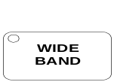
IMPULSE
TEST
FLAT
FLAT
CMSG
NOTCH
FLTR
CMSG
D
LEVEL
E
ISDN
3.4
KHz
FLTR
1
KHz
NOTCH
15
KHz
9 This key selects the type of measurement to be made by the test set: LEVEL; 5 choices
of Voice Band Noise measurements; 15 kHz FLAT, E FILTER (for pre-qualifying a Basic Rate ISDN Circuit). When 15 kHz FLAT or E ISDN FLTR is selected, the test set automatically goes into the WIDEBAND mode as indicated by the LED in the WIDEBAND key area.

10 When the IMPULSE TEST button is pressed the first time, the test set prepares itself to run a test for a five minute period. The IMPULSE TEST LED lights solid to indicate that the impulse test mode has been entered. The RECEIVE Screen will show 0 Counts and 70.0 dBrn (both are default values, which can be changed). Pressing the key a second time starts the test. Press the key during the test to stop the test.

11 This key sets up the test set for wideband measurements (up to 125 kHz). When the
LED lights, wideband measurements (up to 125 kHz) can be made. Normal "voice
band" measurements are up to 4 kHz. If a filter with frequencies greater than 4 kHz is
selected, the unit will automatically enable the wideband function.

Back to Index

CONTROLS AND INDICATORS

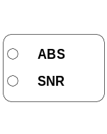

12 This key selects the RELative measurement function. When tone is received at any
level, pressing the REL/DELTA key (the LED will light) will set that received level as 0.0 dB. The test set will now show all received levels relative to 0.0 dB. Any changes in the Received Level will now be displayed as a + or - value relative to the set level.
This function is of value when performing frequency slope measurements on a circuit.

13 In the ABS mode, all level measurements are displayed in dBm.
All noise measurements are displayed in dBrn.

In the SNR mode, the 1 kHz Notch filter is automatically enabled and the user has the
ability to enable another voice band filter in conjunction with the 1 kHz Notch filter.
Now all measurements are displayed in dB.

14 Turns the test set on and off. When turning the test set on, a SELF TEST routine is
started, which requires 10 seconds to complete. A message on the screen indicates "PERFORMING SELF TEST" during this process. At the end of the self test
routine, all LED's light, and a message appears on the screen "SELF TEST PASSED".
The test set is now ready to set up for measurements.

Pressing this key a second time while ON will light the display back light. Due to power consumption, the back light should not be left on for extended periods.

In order to turn the test set off, the POWER key must be pressed and held for 2 seconds.

LOW BAT - Indicates that the internal battery needs charging and that the test set will shut down after about 1 hour of additional use. This indicator appears in the lower
left corner of the display. A beep will also be heard when it appears.

15 16 17 18 19 20
F2
F3
F4
F5
F6
F1

These keys bring up the MAIN MENUs of the test set SYSTEM SET UP functions. In this area, Date, Time, and other System Parameters and thresholds are set. These keys will also serve to set up other functions as yet undefined.

NOTE: Pressing the key the first time serves to make the selection you wish to change. Pressing the key a second time serves as the enter function, which enters your selection in the test set software.
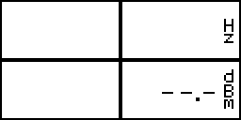
SEND
RECEIVE

The Screen Display has two areas, one to display the SEND values
(frequency and level) outlined in Black, and one to display the received
values (frequency, level, noise, impulse noise) outlined in Red.

21 22

The side panel of the test set contains the connection jack field.
REC/4W - 310 jack for connection to the REC side of a 4W circuit.
REC SEND
4W 2W/4W


SEND/2W/4W - 310 jack for connection to the SEND side of a 4W circuit,
or to a 2W circuit.

T568A - RJ45 jack for Send & Receive modular connections.
BUTT-SET - RJ45 jack for connection of a Technicians talk set (butt-set).

Back to Index

CONTROLS AND INDICATORS

 12VDC 500mA - Connect the supplied external AC adapter to the test set.
NOTE: Although the test set will operate correctly with the adapter connected, the adapter is NOT a battery eliminator. The test set requires a battery to operate correctly.

BATT LED's

Flashing Green LED - Indicates that external power is applied to the test set, and the battery is charging normally.

Solid Green LED - Indicates that external power is a applied to the test set, and the battery is fully charged.

Solid Red LED - Indicates that a charging fault has occurred, and external power should be remove from the test set.

No LEDs illuminated - Indicates that no external power is present.
SERIAL PORT

The RS-232C Serial Port on the Side Panel is unused at the present time, and is reserved for features currently under development.

Back to Index

SET UP THE TEST SET


STEP ACTION RESULT

1. Test Set powers up, performs self test.
POWER
The Self Test takes about 10 sec.



This screen appears at completion of Self Test.

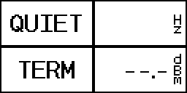

Default Screen appears.

You are now ready to test, or to set up the test set parameters.

Back to Index

SET THE TIME & DATE

STEP ACTION RESULT

To set the TIME:
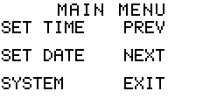
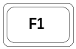
1. Brings up MAIN MENU.

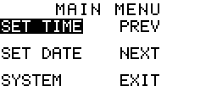
2. Selects SET TIME function (highlighted).

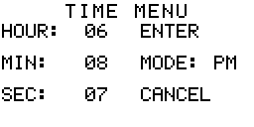
3. Brings up TIME MENU.

Back to Index
SET UP TEST SET PARAMETERS
SET THE TIME

STEP ACTION RESULT
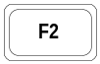
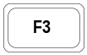
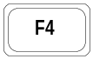
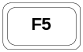
SELECT
4. To select HOUR (highlighted).

To select MINute, (highlighted).

To select SECond, (highlighted).

To select MODE, (AM, PM or 24hr) (highlighted).

5. Up Arrow raises HOUR, MIN or SEC or changes AM, PM or 24 hr (depending on selection).
Down Arrow lowers HOUR, MIN or SEC. Changes to AM, PM or 24 hr.

6. To select ENTER (ENTER highlighted).

7. Selected HOUR, MIN, SEC or MODE is now entered in Test Set software.
Returns to MAIN MENU.

Back to Index

SET THE DATE
STEP ACTION RESULT

To set the DATE (start at the MAIN MENU):
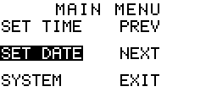
1. To select SET DATE (highlighted).

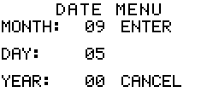
2. DATE MENU comes up.

To select MONTH (highlighted).
To select DAY (highlighted).

To select YEAR (highlighted).

Back to Index

SET UP TEST SET PARAMETERS
SET THE TIME & DATE

STEP ACTION RESULT
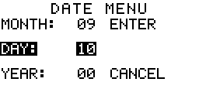
3. Up or Down Arrow changes MONTH, DAY or YEAR
SELECT
(depending on selection) up or down.

4. To select ENTER (highlighted).

5. Selected MONTH, DAY or YEAR is now entered into test set software.
Returns to MAIN MENU.

F6
NOTE: Pressing at any time will cancel any changes. Previous settings will remain.

Back to Index

SET SYSTEM FUNCTIONS

STEP ACTION RESULT
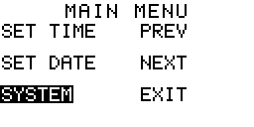
To set the SYSTEM FUNCTIONS (Start at the MAIN MENU):
F3
1. To select SYSTEM MENU (highlighted).

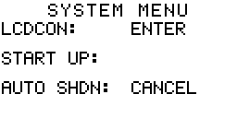
F3
2. SYSTEM MENU comes up.

On the SYSTEM MENU screen:
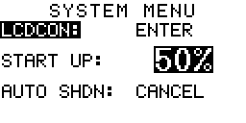
3. LCDCON - Adjusts screen brightness/contrast.
-Default setting is 50%

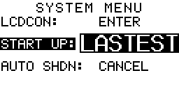
F2
4. Selects screens to appear at Power ON:
-DEFAULT: The QUIET TERM Screen.
-LASTEST: All settings in place at last shutdown.

Back to Index
SET UP THE TEST SET
SET SYSTEM FUNCTIONS

STEP ACTION RESULT

5. AUTO SHDN: Selects time for automatic power down after
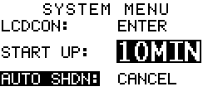
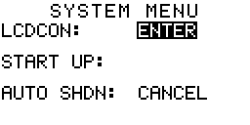
no keys have been pressed.
SELECT
F3
Options range from OFF (no shutdown) to 60 minutes.
Default is 10 minutes.

Use the SELECT up or down arrows to change any of the values in the LCDCON, START UP
or AUTO SHDN screens.

6. Select ENTER (highlighted) after adjustments are completed.

7. Press F4 a second time to actually enter the selections
into the Test Set software. Returns to MAIN MENU screen.

Cancels any activity in the current setup screen. Press once to select CANCEL (highlighted). Press F6 a second time to actually cancel current activity. Last settings are retained.
F6
Returns to MAIN MENU Screen.

Back to Index

SET SWEEP STOP AND START FREQUENCIES AND STEP RATE.

STEP ACTION RESULT

At the MAIN MENU:

1. Press F5 (next).
F5
SWEEP FREQ, SWEEP RATE, REC OPTNS
Screen comes up.

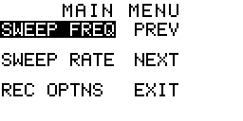
2. Select SWEEP FREQ (highlighted).

3. SWEEP FREQUENCY screen comes up.
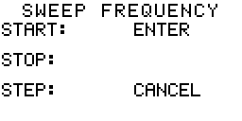

Back to Index

SET UP THE TEST SET
SET SWEEP STOP AND START FREQUENCIES AND STEP RATE.

STEP ACTION RESULT

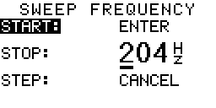
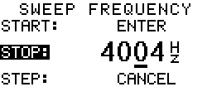
Set the START frequency of the SWEEP.
SELECT
SELECT
F2

4. Select START (highlighted) frequency.
Default is 204 Hz.

Use SELECT arrows to change frequencies as follows:
-Left arrow moves the cursor to the Left.
-Right arrow moves the cursor the Right.
-Up arrow raises the number over the cursor.
-Down arrow lowers the number over the cursor.

Set the STOP frequency of the SWEEP.

5. Selects STOP (highlighted) frequency.
Default is 4004 Hz.

Use SELECT arrows to change frequencies as follows:
-Left arrow moves the cursor to the Left.
-Right arrow moves the cursor the Right.
-Up arrow raises the number over the cursor.
-Down arrow lowers the number over the cursor.

Set the frequency SWEEP STEP RATE

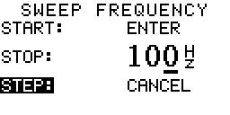
6. Select STEP (highlighted).
F3
The default is to run the sweep in 100 Hz steps.
NOTE: Be sure that the LOG function is adjusted to
OFF in the SWEEP RATE Screen.
That adjustment sets FREQUENCY STEPS
SELECT
automatically.

Use SELECT arrows to change the step rate as follows:
-Left arrow moves the cursor to the Left.
-Right arrow moves the cursor the Right.
-Up arrow raises the number over the cursor.
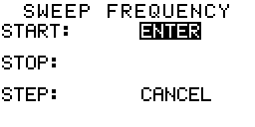
-Down arrow lowers the number over the cursor.
F4
7. Select ENTER (highlighted) when the START, STOP
and STEP frequency adjustments are finished.

F4
8. Enters the selected START, STOP and STEP frequencies in the test set software.
Returns to SWEEP MAIN MENU.

Back to Index
SET UP THE TEST SET
SET SWEEP FREQUENCY RATE (FAST & SLOW SWEEPS) & MODE (LOG)

STEP ACTION RESULT
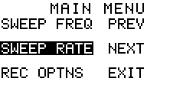
F2
1. Select SWEEP RATE (highlighted).

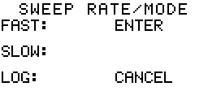
F2
2. SWEEP RATE/MODE screen comes up.

To set the FAST SWEEP RATE (speed of the sweep):

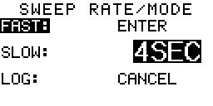
3. FAST (highlighted) screen comes up.
F1
4 SEConds is the default.
The FAST rate can be set from 1 second
to 59 seconds.
The lowest rate (highest number) is always
SELECT
1 second lower than the SLOW SWEEP RATE
lowest rate (highest number).

Use SELECT arrows to change the SWEEP RATE as follows:
-Up arrow raises the rate.
-Down arrow lowers the rate.

F2
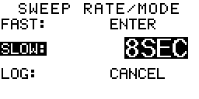
4. Select SLOW SWEEP RATE (highlighted).
8 SEConds is the default.
This rate is adjustable from 2 to 60 seconds.
The highest rate (lowest number) is always
SELECT
1 second higher than the FAST SWEEP RATE
highest rate (lowest number) rate.

Use SELECT arrows to change the SWEEP RATE as follows:
-Up arrow raises the rate.
-Down arrow lowers the rate.

To set the LOG function of the SWEEP:

The LOG function, when ON, automatically sets the step function of the sweep rate at 100 Hz between 200 and 1000 Hz, 1 kHz steps between 1 kHz and 10 kHz and 10 kHz steps between 10 kHz and 125 kHz, regardless of the step setting
selected in the SWEEP FREQUENCY screens. The SWEEP will START and STOP at the selected frequencies.
The SWEEP RATE (speed or time) will operate as selected. The LOG function only affects the frequency step size.

NOTE: The Test Set default for this function is OFF. If the default STEP functions are satisfactory, no further action
is required. If the automatic adjustments of the LOG function are desired, proceed to the next step.

Back to Index

SET UP THE TEST SET
SET SWEEP FREQUENCY RATE (FAST & SLOW SWEEPS) & MODE (LOG)

STEP ACTION RESULT
F3
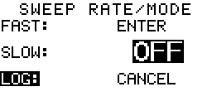
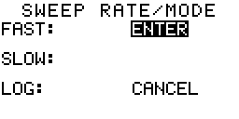
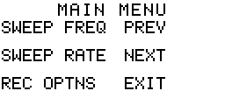5. Selects LOG (highlighted)
SELECT

6. Use the SELECT up or down arrows to change
the setting from OFF to ON or vice versa.
The default is OFF.

F4
7. Select ENTER after desired SWEEP RATE and
MODE settings are selected.

F4
8. Enters the SWEEP RATE and LOG selections into
the Test Set software.
Returns to the SWEEP MAIN MENU.
F6
9. Select EXIT.

F6
10. Default screen or test screen previously selected comes up.

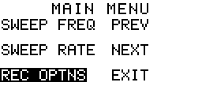
At the SWEEP MAIN MENU:
F3
1. To select REC OPTIONS (highlighted).

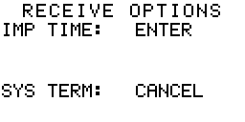
F3
2. RECEIVE OPTIONS Screen comes up.

3. Select IMP TIME (highlighted).
F1

SELECT
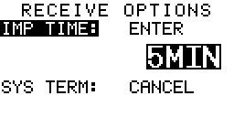

4. Select CONT, 5, 15 and 60 min option,
depending on your requirements.
Default is 5 minutes.

Back to Index
SET UP THE TEST SET
SET RECEIVE OPTIONS (Impulse Noise Test Time & System Impedance)

STEP ACTION RESULT
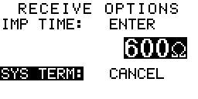
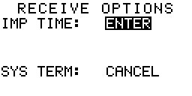
F3
5. Select SYS TERM (highlighted).
Use the SELECT Up or Down arrow to select the
desired bridge measurement impedance.
The default is 600 Ohms.

NOTE: The actual BRIDGE impedance is 200,000 Ohms balanced.
The REFERENCE impedance of the test set must be the same as the circuit under test for the most accurate measurements. The selected measurement impedance is identified by a flashing LED when the
REC IMPEDANCE key is set to BRIDGE.

F4
6. Select ENTER (highlighted) to enter changes.

F4
7. Actually enters adjustments into Test Set software.
Returns to SWEEP MAIN MENU screen.

Back to Index

CONTROL BEEP, ADJUST BEEP VOLUME

STEP ACTION RESULT

At the MAIN MENU:
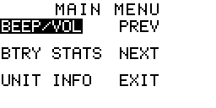
F4
F5
1. or PREV or NEXT until the BEEP/VOL MAIN MENU
screen appears.
F1
2. Selects BEEP/VOL (highlighted).

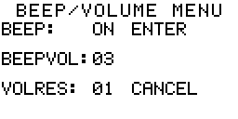
F1
3. Brings up BEEP/VOL MENU screen

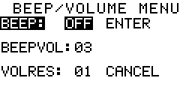
F2
4. Select BEEP OFF or ON, using the SELECT
up or down arrows.

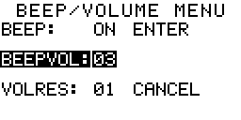

5. Select BEEPVOL (highlighted).

Back to Index
SET UP THE TEST SET
CONTROL BEEP, ADJUST BEEP VOLUME

STEP ACTION RESULT
F3
6. Select VOLRES (highlighted). This function adjusts the difference in volume with each step
change in the MONITOR selector. Normally, you will have no need to change the current setting.

SELECT
Use the SELECT up or down arrows to change the BEEP, BEEPVOL or VOLRES values.

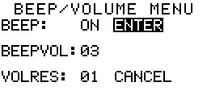

F4
7. Select ENTER after adjustments are completed.

F4
8. Enters selections into Test Set software. Returns to BEEP VOL MAIN MENU screen.

F6
9. Select EXIT (highlighted).

F6
10. Exits BEEP/VOL screen. Brings up default screen to begin testing.

Back to Index

BATTERY STATUS
To check battery status (at the BEEP/VOL MAIN MENU):

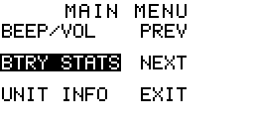
STEP ACTION RESULT
F2
1. Select BTRY STATS (highlighted).

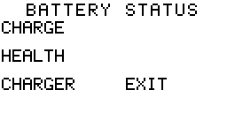
F2
2. BATTERY STATUS menu comes up.

F1
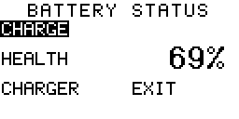
3. Select CHARGE. Shows charge level of the battery.

NOTE: To check BATTERY STATUS - CHARGE while in a testing screen:
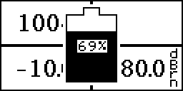
F6
The battery symbol appears with a numerical value
showing the remaining charge.

Back to Index

BATTERY STATUS

STEP ACTION RESULT
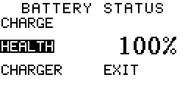
F2
4. Select HEALTH. Shows the relative remaining life
of the battery. When this number reaches 75% or lower,
(after an anticipated 1,000 charge cycles - or about two
years) the battery should be replaced.
NOTE: Due the to unique nature of every sealed lead acid's
charging characteristics, the health will tend to drift either high
or low over time. If you feel that the battery's health is in
question, completely discharge the test set and recharge.
Once the battery is fully charged the health will be updated with
an accurate percentage.
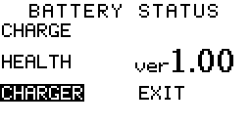
F3
5. Select CHARGER. Shows the software version of the
the CHARGER circuit in the Test Set software.

F6
6. Select EXIT (highlighted).

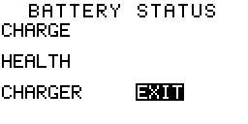
F6
7. Exits BATTERY STATUS. Returns to BEEP/VOL
MAIN MENU.

Back to Index

TEST SET INFORMATION

STEP ACTION RESULT

Displays pertinent information about this test set. Start at the BEEP/VOL MAIN MENU.
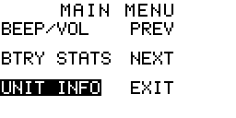
F3
1. Select UNIT INFO (highlighted).

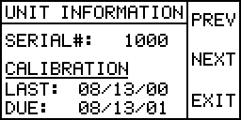
F3
2. SERIAL #, CALIBRATION screen comes up.

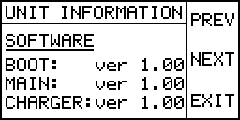
F5
3. Moves to SOFTWARE information screen.

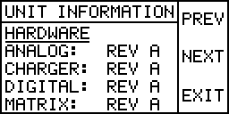
F5
4. Moves to HARDWARE information screen.

Back to Index

TEST SET INFORMATION

STEP ACTION RESULT
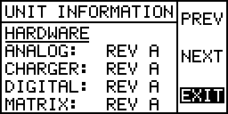
F6
5. Select EXIT (highlighted).

F6
6. Exits UNIT INFORMATION function.
Returns to BEEP/VOL MAIN MENU.

F6
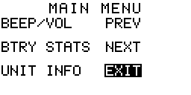
7. Select EXIT (highlighted).

F6
8. To return to testing or default screen.

Back to Index

TEST #1 - SEND AND RECEIVE TONE, 2 WIRE

STEP KEY ACTION

2W
4W
1. Set the 2W/4W selection to the 2W position.

HOLD
DIAL
2. Set the HOLD/DIAL selection to the HOLD position.

NORMAL
REVERSE
3. Set the NORMAL/REVERSE selection to REVERSE. This key is also used to
switch from send to receive.

ABS
SNR
4. Set the ABS/SNR selector to ABS (default).

1500
Ω
900
Ω
1200
Ω
600
Ω
150
Ω
135
Ω
100
Ω

5. Set the SEND Impedance selection to match the line impedance.

900
Ω
1200
Ω
600
Ω
150
Ω
135
Ω
100
Ω
BRIDGE
1500
Ω
6. Set the REC Impedance selection to match the line impedance, or BRIDGE.
If BRIDGE is used, the reference impedance will be shown by a flashing LED.

REC SEND
4W 2W/4W
7. Connect the line under test to the SEND/2W/4W jack on the side of the case.

SEND frequency and level are shown on the SEND (black) side of the screen. RECEIVE frequency and level are shown on the RECEIVE (red) side of the screen.

Back to Index

TEST #2 - SEND AND RECEIVE TONE - 4 WIRE

STEP KEY ACTION
2W
4W
1. Set the 2W/4W selection to the 4W position.

HOLD
DIAL
2. Set the HOLD/DIAL selection to the HOLD position.

NORMAL
REVERSE
3. Set the NORMAL/REVERSE selection to REVERSE. This key is also used to
switch from send to receive.

ABS
SNR
4. Set the ABS/SNR selector to ABS (default).

1500
Ω
900
Ω
1200
Ω
600
Ω
150
Ω
135
Ω
100
Ω

5. Set the SEND Impedance selection to match the line impedance.

900
Ω
1200
Ω
600
Ω
150
Ω
135
Ω
100
Ω
BRIDGE
1500
Ω
6. Set the REC Impedance selection to the desired termination, or BRIDGE.
If BRIDGE is used, the reference impedance will be shown by a flashing LED.

7. Connect the SEND line to the SEND 2W/4W jack.
REC SEND
4W 2W/4W

8. Connect the REC line to the REC/4W jack.

SEND frequency and level are shown on the SEND (black) side of the screen. RECEIVE frequency and level are shown on the RECEIVE (red) side of the screen.

Back to Index

TEST #3 - 2 WIRE DIAL UP
STEP KEY ACTION
To dial-up and then hold a single 2 wire line, proceed as follows:
2W
4W
1. Set the 2W/4W selection to the 2W position.

HOLD
DIAL
2. Set the HOLD/DIAL selection to the DIAL position.

NORMAL
REVERSE
3. Set the NORMAL/REVERSE selection to REVERSE.

ABS
SNR
4. Set the ABS/SNR selector to ABS (default).

1500
Ω
900
Ω
1200
Ω
600
Ω
150
Ω
135
Ω
100
Ω

5. Set the SEND impedance selection to match the line impedance.

900
Ω
1200
Ω
600
Ω
150
Ω
135
Ω
100
Ω
BRIDGE
1500
Ω
6. Set the REC impedance selection to match the line impedance.

REC SEND
4W 2W/4W

7. Connect the 2-wire line under test to the SEND/2W/4W jack.

BUTT SET


8. Connect a butt-set to the BUTT-SET jack.


9. Go off-hook with the butt-set.

10. Listen for a dial tone from the handset, then dial the desired number.

HOLD
DIAL
11. When the call is answered, set the HOLD/DIAL selection to the HOLD position,
and go ON-HOOK with the handset.

NORMAL
REVERSE

12. Set the NORMAL/REVERSE selection to NORMAL to send or REVERSE to receive.

Back to Index

TEST #4 - DOUBLE 2-WIRE DIAL-UP
STEP KEY ACTION
To dial-up and then hold two separate 2 wire lines, proceed as follows:
2W
4W
1. Set the 2W/4W selection to the 4W position.

HOLD
DIAL
2. Set the HOLD/DIAL selection to the DIAL position.

NORMAL
REVERSE
3. Set the NORMAL/REVERSE selection to REVERSE.

ABS
SNR
4. Set the ABS/SNR selector to ABS (default).

REC SEND
4W 2W/4W
5. Connect the first 2-wire line under test to the SEND/2W/4W jack.

BUTT SET

6. Connect a Butt-Set to the BUTT SET jack.

7. Go off-hook with the butt set.

NORMAL
REVERSE
8. When the call is answered, set the NORMAL/REVERSE selection to NORMAL.

REC SEND
4W 2W/4W
9. Connect the second 2-wire line to the REC/4W jack.

10. Repeat steps 5 and 6.

HOLD
DIAL
11. When the call is answered, set the HOLD/DIAL selection to the HOLD position.

12. Both lines are now independently held. The BE-2110i Test Set will send on the first line
NORMAL
REVERSE
and receive on the second.

If the user wishes, the NORMAL/REVERSE selector can be used to reverse the SEND/REC function of each line without dropping the connections.

Back to Index

TEST #5 - MEASURE FREQUENCY, LEVEL & NOISE - 2W

STEP KEY ACTION
2W
4W
1. Set the 2W/4W selection to the 2W position.

HOLD
DIAL
2. Set the HOLD/DIAL selection to the HOLD position.

ABS
SNR
3. Set the ABS/SNR selector to ABS.

NORMAL
REVERSE
4. Set the NORMAL/REVERSE selection to REVERSE.

900
Ω
1200
Ω
600
Ω
150
Ω
135
Ω
100
Ω
BRIDGE
1500
Ω

5. Set the REC Impedance selection to match the line impedance.

FLAT
FLAT
CMSG
NOTCH
FLTR
CMSG
D
LEVEL
E
ISDN
3.4 KHz
FLTR
1
KHz
NOTCH
15
KHz

6. Set the Receive Function selector to LEVEL.

REC SEND
4W 2W/4W
7. Connect the line under test to the SEND/2W/4W jack.
SEND
RECEIVE

Received frequency and level are shown on the
RECEIVE (red-right) side of the screen.
The receive level is shown in dBm.
The frequency is shown in Hertz.

To perform Message Circuit Noise or Noise with Tone measurements, proceed as follows:

8. Set the Receive Function selector to the desired noise measurement.
D FLTR - D filter without tone
1 kHz NOTCH - 1 kHz filter with tone.
FLAT
FLAT
CMSG
NOTCH
FLTR
CMSG
D
LEVEL
E
ISDN
3.4 KHz
FLTR
1
KHz
NOTCH
15
KHz
CMSG - Message filter without tone
C MSG NOTCH - Message filter with tone
3.4 kHz FLAT - 3.4 kHz filter without tone
15 kHz FLAT - 15 kHz filter without tone
E ISDN FLTR - E filter

9. The RECEIVE display will indicate the noise level in dbrn.

The FREQ display will be blank during noise measurements.

Back to Index
TEST #6 - MEASURE FREQUENCY, LEVEL & NOISE - 4W
STEP KEY ACTION
2W
4W
1. Set the 2W/4W selection to the 4W position.

HOLD
DIAL
2. Set the HOLD/DIAL selection to the HOLD position.

ABS
SNR
3. Set the ABS/SNR selector to ABS.

NORMAL
REVERSE
4. Set the NORMAL/REVERSE selection to NORMAL.

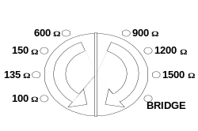

5. Set the REC Impedance selection to match the line impedance.

FLAT
FLAT
CMSG
NOTCH
FLTR
CMSG
D
LEVEL
E
ISDN
3.4 KHz
FLTR
1
KHz
NOTCH
15
KHz

6. Set the Receive Function selector to LEVEL.

REC SEND
4W 2W/4W
7. Connect the line under test to the SEND/2W/4W and REC/4W jacks.
SEND
RECEIVE

Received frequency and level are shown on the RECEIVE (red-right) side
of the screen.

The receive level is shown in dBm.

The frequency is shown in Hertz.

To perform Message Circuit Noise or Noise with Tone measurements, proceed as follows:

8. Set the Receive Function selector to the desired noise measurement.
D FLTR - D filter without tone
FLAT
FLAT
CMSG
NOTCH
FLTR
CMSG
D
LEVEL
E
ISDN
3.4 KHz
FLTR
1
KHz
NOTCH
15
KHz
1 kHz NOTCH - 1 kHz filter with tone
CMSG - Message filter without tone
C MSG NOTCH - Message filter with tone
3.4 kHz FLAT - 3.4 kHz filter without tone
15 kHz FLAT - 15 kHz filter without tone
E ISDN FLTR - E Filter

The RECEIVE display will indicate the noise level in dbrn.
The FREQ display will be blank during noise measurements.

Back to Index
TEST #7 - MEASURE IMPULSE NOISE - 2W or 4W

STEP KEY ACTION
2W
4W
1. Set the 2W/4W selection to the 2W or 4W position.

HOLD
DIAL
2. Set the HOLD/DIAL selection to the HOLD position.

ABS
SNR
3. Set the ABS/SNR selector to ABS.

NORMAL
REVERSE
4. Set the NORMAL/REVERSE selection to NORMAL.

5. Set the REC Impedance selection to match the line impedance.

REC SEND
4W 2W/4W

6. Connect the 2W line or SEND side of a 4W line under test to the SEND/2W/4W jack.
Connect the REC side of a 4W line under test to the REC/4W jack.

7. Set the Receive Function selector to the desired noise measurement.
FLAT
FLAT
CMSG
NOTCH
FLTR
CMSG
D
LEVEL
E
ISDN
3.4 KHz
FLTR
1
KHz
NOTCH
15
KHz
D FLTR - D filter without tone
1 kHz NOTCH - 1 kHz filter with tone
CMSG - Message filter without tone
C MSG NOTCH - Message filter with tone
3.4 kHz FLAT - 3.4 kHz filter without tone
15 kHz FLAT - 15 kHz filter without tone
E ISDN FLTR - E Filter
IMPULSE
TEST
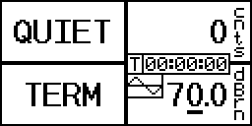8. Press the IMPULSE TEST button to enter the
Impulse Noise Test mode. The IMPULSE TEST
LED lights solid. The RECEIVE Screen will show
0 Counts and 70.0 dBrn.
IMPULSE
TEST
9. After verifying or adjusting the threshold, and that
holding tone is present for the 1 kHz or CMSG NOTCH tests,
press the IMPULSE TEST key to start the test.

The IMPULSE TEST LED begins flashing to indicate that a test is in progress.
The number of impulse noise counts recorded is displayed in the COUNTS display.
IMPULSE
TEST
10. Press to stop the test at any time during the test duration. The count and time info
will be lost unless the test finishes itself.
SEE THE TEST NOTES ON THE NEXT PAGE.

Back to Index
TEST #7 - MEASURE IMPULSE NOISE- 2W or 4W-NOTES ABOUT IMPULSE NOISE TESTING WITH THE BE-2110i:
A. When the IMPULSE TEST button is pressed the first time, the test set prepares itself to run a test for a five minute period. The IMPULSE TEST LED lights solid to indicate that the impulse test mode has been
entered. The RECEIVE Screen will show 0 Counts and 70.0 dBrn.

B. The Test Time of 5 minutes is the default in the test set. This can be changed by going to the MAIN MENU,
REC OPTIONS function in the test set.

C. 70.0 dBrn is the test set default threshold. All noise spikes greater than this value will be counted. Those less than this value will not be counted. This threshold value can be changed with the SELECT key and the associated arrows.

D. If a holding tone is present (1 kHz and CMSG NOTCH), the box under the time (T or C) display will show a sine wave. If no holding tone is present, the box will contain a straight line. If the holding tone was present and lost, the sine wave box will be "animated" with a disappearing sine wave. The sine wave box will continue to be
animated after the tone is restored, unless a new test is started with the tone present. If a holding tone is present while conducting this test in any filter weighting other than 1 kHz and CMSG NOTCH filters, erroneous results will occur.

E. The test is started after verifying or adjusting the threshold, and that tone is present for the 1 kHz or CMSG NOTCH test filters. Press the IMPULSE START key to start a 5 minute test. The IMPULSE START LED begins
flashing to indicate that a test is in progress.

G. The test may be stopped at any time during the 5 minute interval. The IMPULSE START LED will go out.
The Display will show standard noise levels. Any displayed impulse noise information is lost.

H. At the end of the test duration the test will stop automatically. The number of counts over the threshold observed in that time will be displayed in the COUNTS display.

Back to Index

TEST # 8 - SIGNAL TO NOISE (SNR) MEASUREMENTS

STEP KEY ACTION
2W
4W
1. Set the 2W/4W selection to the 2W or 4W position, depending on the circuit under test.

HOLD
DIAL
2. Set the HOLD/DIAL selection to the HOLD position.

NORMAL
REVERSE
3. Set the NORMAL/REVERSE selection to NORMAL.

4. Set the REC Impedance selection to match the line impedance.

FLAT
FLAT
CMSG
NOTCH
FLTR
CMSG
D
LEVEL
E
ISDN
3.4 KHz
FLTR
1
KHz
NOTCH
15
KHz

5. Set the Receive Function selection to the desired filter position.

ABS
SNR
6. Set the ABS/SNR selector to SNR.

REC SEND
4W 2W/4W
7. Connect the line under test to the SEND/2W/4W jack for 2W or 4W SEND.
Connect the 4W receive side of the line under test to the REC/4W jack.

The REC LEVEL display will now indicate the SNR of the received 1004Hz tone.

Back to Index

TEST #9 - RELATIVE MEASUREMENTS
The relative measurement feature of the BE-2110i Test Set allows the user to make level measurements in terms of plus or minus dB from a known or starting level. To perform relative level measurements, proceed as follows:
STEP KEY ACTION
2W
4W
1. Set the 2W/4W selection to the 2W or 4W position.

HOLD
DIAL
2. Set the HOLD/DIAL selection to the HOLD position.

NORMAL
REVERSE
3. Set the NORMAL/REVERSE selection to NORMAL.

ABS
SNR
4. Set the ABS/SNR key to the SNR position.

FLAT
FLAT
CMSG
NOTCH
FLTR
CMSG
D
LEVEL
E
ISDN
3.4 KHz
FLTR
1
KHz
NOTCH
15
KHz
5. Set the Receive Function selector to LEVEL.

6. Apply the known or starting level and frequency to the test set.

NOTE: The REL DELTA function can be used with any filter selection, any SNR selection, or any LEVEL selection. The SNR function can't be selected when LEVEL is active. The SNR function only works while a voice band filter is active.

REL
DELTA
7. Press the REL/DELTA key. The LED lights. The reference level is automatically
set to 0.0 dB.

The test set will now show all received levels relative to 0.0 dB. Any changes in the Received Level will now be displayed as a + or - value relative to the set level.

The FREQ display will indicate the receive frequency in Hertz when in the LEVEL mode.

Back to Index

TEST #10 - SEND TONE, SWEEP FUNCTION

This section describes the procedures for setting up the BE-2110i Test Set Sweep function.

To set up SEND testing functions, proceed as follows:

STEP KEY ACTION
2W
4W
1. Set the 2W/4W selection to the 2W or 4W position.

HOLD
DIAL
2. Set the HOLD/DIAL selection to the HOLD position.

NORMAL
REVERSE
3. Set the NORMAL/REVERSE selection to NORMAL.

ABS
SNR
4. Set the ABS/SNR selector to ABS (default).

SELECT

5. Set the desired send level in dBm using the SELECT key.
Default setting is 00.0 dBm.

6. Set the SEND function selector to one of the four fixed frequencies (404, 1004, 2804 or
2713 Hz), the VAR position, or one of the two sweep positions.
SLOW
SWEEP
FAST
SWEEP
VAR
FREQ
QUIET
TERM
404
1004
2713
2804

a. If the VAR position is chosen, use the SELECT key to set the desired frequency in
1 Hz Steps from 200 Hz to 99.999 kHz and in 10 Hz Steps from 100 kHz to 125 kHz.

b. In the SWEEP FAST or SWEEP SLOW positions, the test set will sweep from
204 Hz to 4004 Hz in 100 Hz steps. The test set will automatically skip over the
S.F. frequencies of 2604 Hz and 2704Hz. In the SWEEP FAST position the test set will step to a new frequency every 4 seconds and in the SWEEP SLOW position,
once every 8 seconds.

Any of these values can be changed through the MAIN MENU.

When either of the sweep functions are used, the send frequency of the generator will be
displayed in the FREQ display.

NOTE: Refer to Pages 27 to 32 also, to set up SWEEP functions.

Back to Index

TEST #11 - APPLY QUIET TERMINATION
FOR FAR END NOISE MEASUREMENTS
STEP KEY ACTION
2W
4W
1. Set the 2W/4W selection to the 2W or 4W position.

HOLD
DIAL
2. Set the HOLD/DIAL selection to the HOLD position.

NORMAL
REVERSE
3. Set the NORMAL/REVERSE selection to NORMAL.

ABS
SNR
4. Set the ABS/SNR selector to ABS (default).

SLOW
SWEEP
FAST
SWEEP
VAR
FREQ
QUIET
TERM
404
1004
2713
2804
5. Set the SEND function selector to the QUIET TERM position.
The 2 wire line, or the SEND side of a 4 wire line is terminated so that noise
measurements can be made from the far end.

REC SEND
4W 2W/4W
6. Connect the line under test to the SEND/2W/4W jack for 2W or 4W SEND.
Connect the 4W REC side of the line under test to the REC/4W jack.

The Far End can now take the noise measurement.

Back to Index
MISCELLANEOUS SCREEN DEFINITIONS
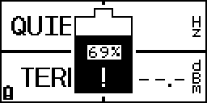
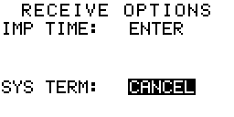
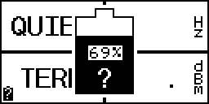
Shows Battery Charge Level - To check the battery charge level from the main measurement screen, press F6. The battery charge symbol will appear on the display with a graphical and numerical representation of the battery's charge.

A question mark on either battery symbol indicates that the battery charger has placed
the battery's charge level at a default position and does not have an accurate account of how much charge is in the battery. Under normal operating conditions, this should never occur. If this event should happen to occur, discharge the test set completely. Once the
warning "LOW BAT SHUT DOWN" is flashed on the display, the battery charger has an accurate account of how much charge is in the battery.

If an exclamation mark ever appears on either battery symbol, a charge fault has occurred. External power should be remove from the test set.

F6
Press (CANCEL) twice during any set up operation to delete changes. The Test Set will return to the previous settings.


The Test Set will shut down in 30 seconds, because no buttons have been pushed
for a specified time, as set up in the SYSTEM MAIN MENU.

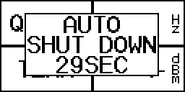

Counts down to SHUT DOWN

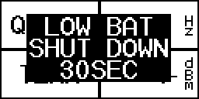
The Battery is low and needs to be recharged. The Test Set will shut down in
30 seconds.

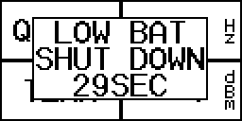

Counts down to SHUT DOWN

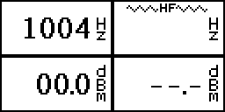
The HF (high frequency) indicator will flash on the screen when a large out of band frequency is detected. Thus, when the unit is in NORMAL mode (200 to 4000 Hz) with
no in band frequency present and a frequency above 4 kHz is present, the indicator will flash.

Back to Index

