---- Towards Better Qualification ----

Japan Automobile Glass association President Yoshiaki Yoshimura

Outline
We have 7.2 million of automobiles in Japan now and it may be safe to say that around 1 million cases of damage of windshields occur in a year.
Automotive glass sales and repair firms which are members of JAGU, amount to 250 firms and 460 operations in Japan, employing about 3,000 employees in total.

Environment
It is said that the number of the automotive glass sales and repair firms in Japan exceeds 800.
The market environment of the auto glass sales and repair industry, has been suffering from severe competition intensified by the increase of in-house repair of automobile sales companies, changing of logistics on glass products, invasion by major repair parts sales companies into the repair industry, with a low recognition level of safety and repair standards.
If this situation continues, we are afraid that we might be forced to employ inappropriate application procedure and materials to secure our business profit.
This leads to the business activity that might ignore the due level of safety, which is retrogression against the expectation of the societies and our association.

Conventional technology acquisition
The automotive glass sales and repair industry has the history of about 60 years and reaches to the present situation with a sharp increase of possession number of a car because of postwar high economical growth. As for the history of this 60 years, much improvement is added to performance of a car, specifications, structure side, and also much improvement were done in automotive glass to secure safety, from straight flat glass to tempered glass and use of laminated glass is obliged to in a windshield now. As for installation methods of automotive glass, to secure passenger safety and stiffness of car body, it was shifted to a direct adhesion type from gasket type.
A car manufacturer regards safety as the greatest problem, but may be connected for strength and a fall of safety when appropriate repair is not performed in a stage of glass repair.
Furthermore, latest safety technology is adopted and installation method is different every maker and models, installation methods and materials are not unified since each firm makes trial and error individually to follow improvement of specifications and structure.

Importance and necessity of an official examination system of technical skill
An association policy 〔Provide safety and security for stability〕
An association policy

〔To get trust from a customer, we always provide state-of-the-arts technology and service to uplift customer’s satisfaction. 〕
Concept
We are also conscious of correspondence to recycling society and try to handle eco-friendly materials.
To meet an association policy and to achieve "the best guarantee of quality" and "high work of safety " for the automotive glass repair, an important safety component, "Standardization of Work" becomes necessary.
We are able to get nationwide unified "higher quality" and "higher safety" works by systematizing materials satisfying a safety level, an appropriate tool, application procedure with consistency.
To develop this system in the industry, adoption of an official examination system of technical skill is indispensable, and we think that knowledge as an expert and the technical acquisition lead to ability development of worker and activation of a working place and finally it connected to trust from a customer.
Therefore, we plan substantiality of education in an association by adoption of an official examination system of technical skill, and must be able to connect it to qualification improvement of the whole industry.

An employment evaluation standard of an employer
Current evaluation standard of an employee by an employer is global paralysis includes the year of experience, but appropriate evaluation becomes possible if we adopt examination system of technical skill in which an evaluation item was subdivided such as technical aspect, knowledge side and morals. Employee can self-development by each subsidized appraisal standard and it can tie to life improvement of toward the future.

Correspondence for recycling society
Corresponding to "Automobile Recycling Law" and based on legal treating method of organic/inorganic material, an eco-friendly products and materials setting and connection such as use and processing and unification for imposition are enabled.

Social status and employment promotion
Our members can gain social recognition on the job with expert knowledge, high technology, reliance from customers, clarification of evaluation standard of an employee and this status will enhance the stability of our industry and we can expect enhancement of employment.

Expert knowledge and high skill lead to our success responding to our slogan [Provide a stable safety and security. ] for a customer and will be able to get solid reliance. This manual discusses the necessary matters from various angles widely, but would not lead to "qualification improvement" and "improvement of social status" of the whole industry if we did not put our acquired knowledge into action. Therefore I appreciate that all members of our association utilize this manual effectively.
January 2005

------ Table of Contents -------

Towards Better Qualification Japan Automobile Glass Association P 1
President Yoshiaki Yoshimura

Content P 4
Chapter 1 Safety management -------- For safety work P 7
1----1 How to use electric tools safely.
1----2 Safety management when using electric tool.
1----3 Tool for individuals protection.
1----4 The safety handling, transportation and storage of glass.
1----5 Dangerous actions.
1----6 How to handle the hazardous material.
1----7 Basic emergency measures, first aid measures (first-aid kit)
1----8 Automobile service management
1----9 Safety workshop places

Chapter 2 Basic knowledge of automobile P 34
2----1 Structure of an automobile.
2----2 A kind of automobile and a name of glass

Chapter 3 Basic knowledge of auto glass P 37
3----1 What is a glass
3----2 Safety glass for automobile
3----3 Laminated glass
3----4 Tempered glass
3----5 Windshields
3----6 Door glass
3----7 Side glass・Rear glass

Chapter 4 Repair of auto glass P 52
4----1 A repair method of auto glass
4----2 From front end work of auto glass repair to actual repair.
4----3 A tool for glass repair
4----4 Adhesive
4----5 The seal materials
4----6 Support product
4----7 A tool for automobile protection and a protection procedure

Chapter 5 Corrosion
P 79
Chapter 6 The other technology necessary for auto glass worker.
6----1 Glass repair (glass repair)
6----2 The removal of water spot
6----3 Glass work of a construction machine

Chapter 7 Customer service P 86
7----1 What is a service
7----2 A flow of work (service)
7----3 Customer’s service
7----4 Identification of glass
7----5 Work instructions (Develop a table for before and after work.)
7----6 Claim management
7----7 Rain leak repair

Chapter 8 Consideration for environment P 104
8----1 With regard to on disposal of waste glass
8----2 With regard to disposal of glass-related products.
Chapter 9 Correspondence to insurance----- With regard to on accident insurance P 106
9----1 What is an accident insurance
9----2 Structure of auto insurance
9----3 Structure of the auto glass damage and auto insurance accident processing
9----4 An accident insurance necessary for auto glass industry.

Summary "10 items of JAGU" P 109
A post face A Chairperson of education information committee P 111
qualification system section Hidemi Nakanishi
A list of draw up people P 112

Reference materials
- A law of “Road automobile transportation”
- Glass Japanese Industrial Standards
＊ JISR 3211
＊ JISR 3212
3. An adhesive JASO standard
References "Auto Glass Technician Reference Manual"
Manual for NGA auto glass worker
(Edited by National Glass Association)

Chapter 1 Security Management
----For safety work----

Safety management is the most important items for both employer (manager) and the personal (a customer and a worker) with an aspect of living and a work.
Work of the auto glass worker is always accompanied with danger since they use tools or hazardous substance. A worker may roll up in an automotive accident through business trip. When a worker handles daily various duties, it is necessary to confirm all rules about an individual, a place of work, security of hazardous materials.
An employer of an auto glass firm cannot overlook dangerous duties. With incompleteness of safety management, may cause a trouble to worker , a client and customers. In addition, if the worker, who is an employee of firm, does not obey a rule of a company, he may injure himself, and there could be rolled up another person. It cannot say in such a case that it need not to be charged by a case.
It is the most important items through daily work that an employer develops a safety management manual and get across to worker, and all of them must study and follow company safety policy.
General common sense and judgment are needed and important for safety management.
* Do appropriate judgment of tool for use.
* Use a protection safety ingredient for individuals such as gloves, goggles and safety boots as much as possible.
* Have precise loading technique.
* Understand dangerousness caused by careless handling of the glass and avoid the dangerous situation and action.
* Understand a procedure and measure of the handling of hazardous materials and understand method of first aid and measures caused by such materials.
* Understand operation check, safety drive and driving management of working automobile.
* Secure safety working place.
In this chapter, we learn about a safety of worker, working place and customer.
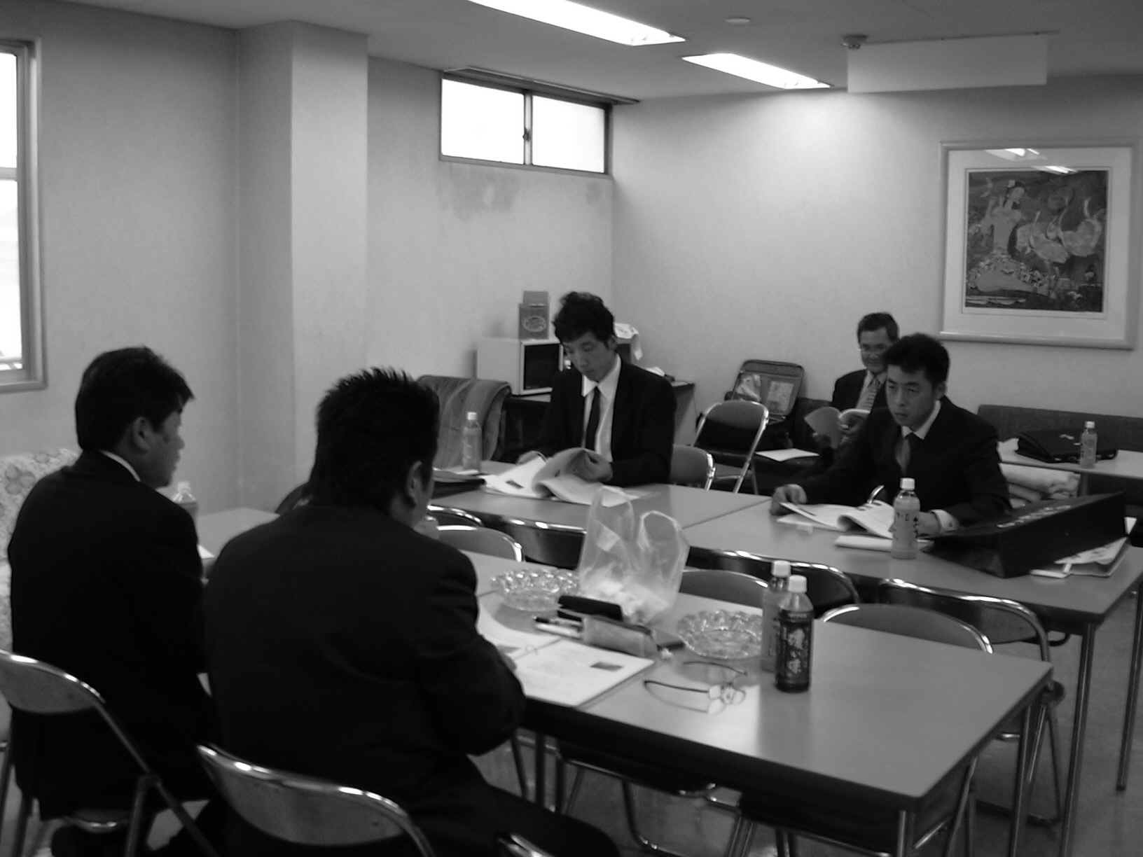

1―1 How to use electric tools safely
－Guide on an electric tool－

The following shows the guide line of caution items for electric tools during in use and for storage.
* If there is an instruction or specification of a maker, follow it.
* Perform safety check, maintenance of a tool before use. In addition, apply inspection, check periodically for safety use.
* Prepare a first-aid kit, extinguisher for unexpected accident or injury that can happen with a tool by any chance.
* Do not use tools which we do not take training of how to use.
* Confirm whether a tool of dangerous evasion is prepared.
* Confirm whether we can use it in same condition as check time.
* Use the tool which was suitable for each works.
* A tool must use only in the designated purpose.
* Turn off power supply of all machine or electric tool when not in use.
* Turn off power supply or lock of tools when maintenance, clear up, adjustment and lubrication.
* Attach a cover and put into tool box or a belt for tool for sharp edged tool when in use. Do not put it into a pocket by mistake with bare condition.
* Do not climb on a ladder or stepladder with having had a tool. Use protection tool or a belt for tool or put it into a tool box beforehand so that a tool does not fall from high place or footing.
* Do not leave tool at workshop or on passage.
* Perform inspection and check of a tool periodically. In addition, appropriate grind shall apply to cutlery.
* When using an electric tool, wear a protective mask, safe glasses with side protection.
* When using an electric tool, remove accessories and a button.
* When using an electric tool, use earthquake-proof grove if vibration is intense and there might be possible of white finger disease.
* Decide a person in charge and do not neglect a periodic inspection of compressors located in office.
Note:As for air tool, follow same instruction as electric tool expect for drive system.
1―2 Safety management of electric tool when in use
－Guide for safety－

An electric tool can cause an unexpected accident and injury. Follow the items which mentioned below to avoid such accident.
* Do not perform electric repair without a qualification of
specialist personnel.
* Confirm there shall not be any exposed or concealed
electric circuit which you may touch to tool or machine.
* Arrange an electric cord properly in a work area.
* Confirm all electric apparatuses must be grounded which does not indicate as "double insulation" . (Confirmation of a ground)
* When standing and working on water, never use an electric tool.
* Do not overload to an outlet.

1―3 Protection tool for individual
－Safety management for individual－

Safety management must be top priority when working. Even if you have enough personal protection tools, you can not protect yourself without using.
It is important to wear appropriate cloth while working. Never work with long hair , too big cloths or accessories in the body which might be caught on an object.
We recommend the following safety protection tools for auto glass worker.
* Plastic gloves : Protect a hand from a solvent, adhesive.
* Gloves made by cloth. (So called “cotton work gloves”) This is enough for general work.
* Safety gloves：Made of skin with strength or cutting processing resistance law material.
Use this type when transportation of a sharp material, or using knife or scraper while operating electric tools.
* Rubber gloves：Use this type or gloves for building glass when transport of automotive glass since a part of a palm of this gloves is made by rubber.
* Barrier cream (a hand cream type)：There are rare chances to suffer a burn by chemicals and solvent or resin used for repair while changing auto glass. In addition, there are a few workers having an allergic reaction for those chemicals. Barrier cream can protect from those danger.
* Long grove, leather apron, main-de-fir；These shall be used for glass handling, when using of sharp pointed tool, cutting work of glass and they will protect a shoulder, the front of a body and a wrist.
* Safety eyeglass：A lens of safety eyeglasses shall be used always crash-proof type with side protection. The worker who always puts on glasses shall prepares for slightly bigger size that seems to be wear from the top. Do not mind to wear crash-proof type plastic goggles. These protect a worker from a piece of glass, dust, mine dust, chemical agent. When a worker, other than glass worker, cuts off glass, metal and other material besides glass worker, and if they drilling, assembling, grinding and filling, they shall be also worn.
* When you use a UV lamp, use safety glasses of 100% UV cut and never directly face to a UV lamp.
* Safety boots：Boots with metal in a toe reduce an injury even if toe was stepped on when loading and unloading. We offer to use it when handling of glass and in auto-repair shop.
* Protection mask：Use it when working at dark place or grinding of glass. In addition, put it on if any chance of in halting glass dust or poisonous substance. A worker who using a mask is well trained and shall obey a company rules. Materials of glass is silica acid (SiO2 silica) Silica may undermine lungs slowly. When you work at dusty place, use a mask, but you must take training and follow strictly about suitable use, an advantage, disadvantage, the choice, conformity, purpose and care of the mask. You must immediately report to a manager if an effect of a mask is insufficient.
Note：When you use an electromotive / an air tool, a large quantity of dust could be appeared. It is necessary to confirm mask is very useful to protect from dust or mine dust of silica for definite protection. In addition use safety glass together as mentioned above.
* Safety belt：Use it when working at high place. Use it together with waist belt to put a tool in.
* Safety hat (helmet)：Use it glass execution work at construction site, workplace where may injure head or material handling / storage on a head.
(It is recommended to use all the time, but when you work in a hood of an automobile and if any problem anticipate, you can substitute for light safety hat)
* Grove of resistance to vibration ：Among an electric tool, there could be generate big vibration. If such a case, use it as protection for circulatory failure. (Measures for white finger disease)
* Working clothes：Wear cloths which fitted to a body as much as possible. Recommend to wear a cloths which zipper and button were hidden with a cover. (Recommend to wear "All in one type" which top and bottom together but if you wear separate type, don’t forget to cover the belt.
* A first-aid kit：Put into a tool box or first-aid kit to prepare emergency use such as styptic, hydrogen, an adhesive plaster, a bandage and eyewash. (Store at cool and dark place)
* A hearing protective device (an earplug)：When you work at noisy place, use an earplug, but you must take training and follow strictly about appropriate use, an advantage, disadvantage, the choice, conformity, purpose and care. You must immediately report to a manager if an effect of a mask is insufficient.
* An athletic supporter：When a back is bad, submit to medical treatment and use this supporter. Always wear an athletic supporter when you carry heavy items after taking appropriate training on how to use.
Note：The above-mentioned safety equipments is for protect oneself. You may think that "they are trouble and hard to use". However you shall be recognized that it is you that protect your body.

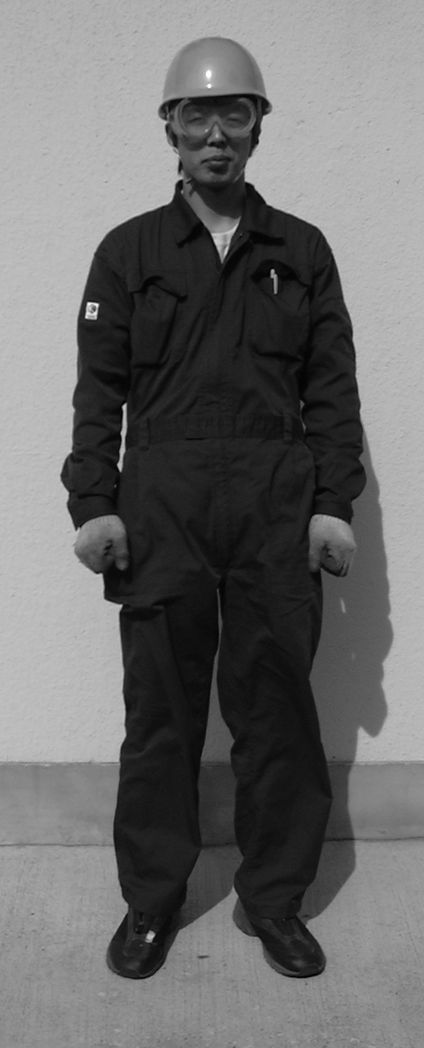
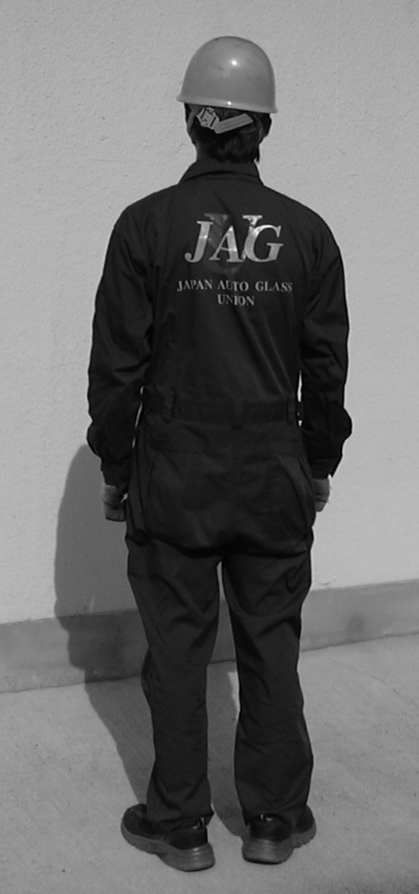

1―4 Safety Handling, Transportation, and Storage of Glass
－How to use Sucker－
Whenever you handle or transport of glass, always be careful and keep in your mind that a whether a person is in your moving range or not, and if someone is there whether he can turn attention to you or not. Glass has considerable weight and sharp cutting face which can become an edged tool. If something wrong happened, glass could be turned into weapon which injures yourself and your surrounding people. To avoid such a danger, we will study safety handling, transportation and storage of glass in this section.

We describe instructions and information during handling of glass.
* When you hold glass, use the appropriate gloves which matched for a use.
* Always confirm whether there should not be any crazing before handling glass.
* Basically hold glass up and down, and do not move while putting glass to your arm.
* You must separate your hand from glass immediately when you fall down or slipped during transportation. Do not try to hold the glass when seems to have come to fall from top of the stand.
(Glass is an important property for automotive glass sales and repair firm. However, most important thing is your own bodies. Never overdo it.)
* You must not walk over broken glass.
* Use an exclusive container, a trash box for the disposal and take out of glass.
* Clean up broken glass early as much as possible.
* Never throw glass into trash box.
* Treat broken glass as possible carefully and confirm whether it's not jump out from the trash box because even broken glass, a piece can be scattered.
* When you returned to your office from business trip, sort out individual waste such as glass, adhesive.
* Especially be careful to bigger pieces of glass for injuring on that occasion.

Next, we describe instructions and information during transportation of glass. Most safety method to carry glass is to minimize quantity. You must think about some items which mentioned below beforehand.
* At first put on individual protection tools securely as mentioned previous section.
* Judge precisely whether you can carry yourself or the supporting personnel required considering actual weight of the glass.
* Check whether glass does not have a scratch, chip or crack. It's very dangerous break and damage which was caused by missing part of edge. If glass is cracked, carry it with two persons because when you lift up a crack could be prolonged and may cause a big break, (Carry with two people is desirable.) In addition remove water and fat of glass.
* Think carefully before action, and confirm final destination firmly. In addition, confirm the following, whether setting stand is arranged, whether the stand can bear weight of glass, whether stopper is attached if stand is mobile type, whether security is secured, whether spruce-up is done on passage to there.

We describe instructions during transportation of glass, next.
* Do hardheaded and reliable work.
* Work with two people for bulky goods. (Work with two people is desirable.)
* Square up and open a foot to the width of the shoulders and step with a foot firmly.
* Bend a knee if glass is below waist and identify the location.
When lift it up, lift a power of a foot not an errand back using palm , and approach to body and keep glass perpendicularly as much as possible while carrying, and hold it with a bottom side of hand which palm was turned to outward and hold the tip with other hand which was taken out before a chest. You can keep glass horizontally to carrying direction if you hold the glass with this posture.
* Be careful to hunker down, to bend forward, twisting a body while carrying glass. These acts lead to hurt a body including a waist or an arm. Use the whole body as much as possible and must not apply unbalanced force to partial body.
* Confirm stability and balance when you use a stepladder or footing.
* When take out glass from the top of a head, work with two people. (Work with two people is desirable.) Of course do not forget to put on a safety hat.

The following table indicates weight of glass. (Calculated gravity of 2.5 kg/ m²)
(Volume x Gravity = Weight)
Thickness of glass (mm) | Estimated weight (kg/m²)
2.5 | 6.25
3.0 | 7.50
4.0 | 10.00
5.0 | 12.50
6.0 | 15.00
10.0 | 25.00
12.0 | 30.00
16.0 | 40.00
19.0 | 47.50
25.0 | 62.50
Weight of windshield estimate as follows by the above table.
Compact automobile ; around 10kg, Full-size ; around 15kg, Truck ; 15～20kg
These figures are very important in a clause of sucker to mention later.
Calculating formula ; W x H x T x Specific gravity (2.5kg/ m²) = Weight of glass
Note; It is multiplication of a rectangle glass.

Will describe a guideline of working stand for glass, next. Minimum required standard of the stand is whether endure weight of glass to handle, stability, whether can fix the glass with stopper. When you put a glass on a stand, put the glass at bottom side first using border as support, and turns upper part to a glass on stand completely. Cover the border with soft cloth so glass does not damage the border on that occasion. When you carry glass out of a work stand, do it in a reverse procedure.

Will describe a guideline about a sucker, next. The most important thing is to confirm that sucker should be perfect condition without having any crack or break at rubber part of sucker.
Defective sucker can lead to a big accident. Even if an accident does not happen to you, it may damage an automobile. In addition, use different sucker to suite the weight of glass. Will not mind with a normal sucker till weight of glass around 10kg. Use a one which raising adsorption power automatically in the case of heavy glass than this. These suckers are enough for the normal work stand. But, use an electric-type sucker or the one that multiple pieces installed when you work for a trailer bus or glass of which weight is around 20kg. You can use a diversified products with crane or a forklift at the same time. A worker must take training and the official approval that conformed to a law at this time. In addition, apply periodic maintenance and must make record. The following shows the point that you should check before using sucker.
* Confirm a condition of sucker.
* A sucker and both sides of glass to be dry and no dirty place.
* Confirm that glass does not have crazing, and do not put a sucker on a sticker (a seal) of glass if it is recycling one or at the time of desorption.
Keep the sucker where dry and clean place if possible.
Will describe information and instructions of glass storage, last.
When store auto glass, generally use an exclusive shelf called a rack. Enough angles (declined slope) are required to avoid falling of glass from the rack when shock was added to it. Fix the rack with ceiling or wall to avoid falling down of rack itself since Japan is particularly land of earthquakes.

A main cause of damage caused by falling down in a rack is existence of gap between a rack and glass. Prepare a spacer and use it or burry the gap. Use a sponge spacer with slightly bigger size and burry from the top to a bottom.
Will describe main instruction, next.
* Decide the number of sheets to use at every stack and do not put more than required number of sheets.
* Always keep in your mind weight of glass and do not exceed that weight.
* When you keep it on a high position shelf, calculate weight of glass and carrying people; use the ladder or stepladder which can bear it always considering "Safety First".
* Attach protection material to corners not to touch and damage in case of module or assembled glass.
* When there are storage instructions from maker, follow it strictly.
* Apply protection tape to all corners of glass for prevention of damages.
* Set up protection fence to prevent slips and fall of small glass.
* Set up a rope to prevent falls down of high glass such as windshields glass.
*As a reference, keep flammable raw materials (organic solvent) on a fireproof-related shelf and follow the guideline that a maker and administration decided about storing and processing. In addition, with regard to storage of adhesive, should follow instructions of a maker.
Solvents (a medicine) such as resins for repair should follow instructions of a maker, too.
When refrigerators are necessary to keep in a cool and dark place, prepare for an exclusive one, and write as "Medicine only" so that to prevent mistake.
In addition, perform inventory once in a half term for strict inventory control.
It does not need to say that be careful to loss of such dangerous materials then.
Note; Use a crane, a forklift as much as possible when working for a special automobile such as trailer or buses.


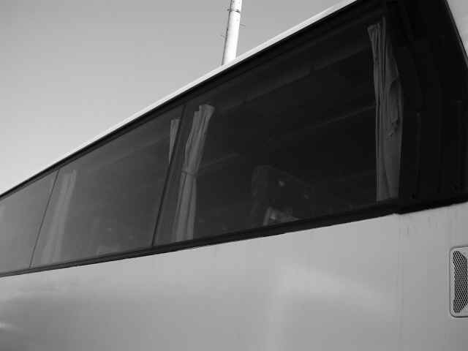

1ー5 Dangerous action
In a working place, there are various dangerous situations side by side.
At auto glass repair place, alcoholic beverages and a medicine are strictly prohibited.
If you abusing these things, not only you may loose your job but also judgments deteriorates and may jeopardize all people who are working in your place.
It is your duty to conform to follow common sense, a model, a policy of a company, and a rule to achieve your job safely.

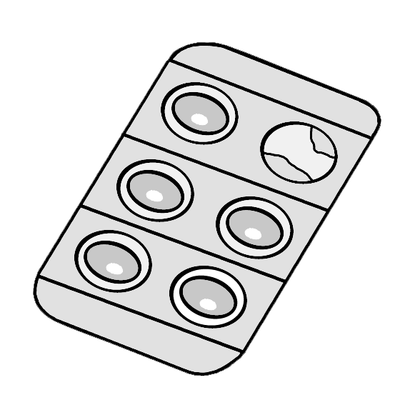
A kind of an abuse drug

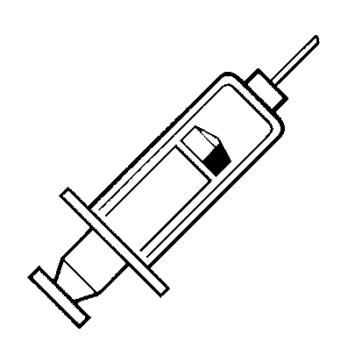
* A stimulant
* Toluene, thinner, glue
* Cocaine, Methane, Phetamine、
* Narcotics
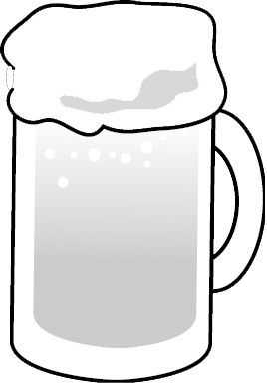
* Heroin
* LSD
* Cannabis (marijuana)

Note：You should realize your limit of alcoholic
Beverages and be careful not to get addicted
To alcoholic beverages
Will show a table of kind and property of an abuse drug in the following page.
(cf. see the photograph of a color page)



 | Use ・ Influence
Kind | Original purpose of use | Abuse purpose | Method of  abuse | Adverse effect by abuse | After effect | Others
Stimulant  (So called:  S speed) | Excite the central nerve and uplift of a feeling, awake- -ning action.  Use as medical to cure doze sympt- -om, coma, chronic alcoholism and  dejection state. | Uplift of a feeling.  Feeling of bed of roses. | Intravenous injection  Oral in-take | Will die if inject 120mg rapidly. Causes a desire of drug because there are uplift of a feeling, increase of a sense of confidence, a feeling of bed of roses, and decrease of fatigue. When you take it continuously, tolerance is formed extremely immediately, and qua- -ntity of drug increase, and it becomes to bear 10-30 times of a normal person.  Lassitude, jitters appear after stop use of drug which become a custom, but not admitted clear physical abnormality. (Withdrawal symptoms by physical dependence). If you become chronic poisoning, symptom that resembled a symptom of mind division appears such as hallucination and delusion. | A mental  disease  condition can be left. | It's getting popular so called "gold fish" which stimulant was dissolv- -ed by water in small plastic soy sauce cont- -ainer ("goldfish”)  Which was  delivered with Sushi. People drink  this “goldfish”  with whiskey or juice.
Toluene  Thinner  Adhesive | Toluene weakens a paint and uses it for washing of a machine and decreasing of clay.  Thinner, (Added ethyl acetate/acetic acid butyl into 60% of toluene and weakened.)  Adhesive, (Dissolved a synthetic resin with thinner) | Hallucination  Getting drunk state | Inhale vaporized  toluene  from a nose or a mouth. | Paralyze & decrease of function of the central nerve.  A large quantity of inhalation . Becomes a getting drunk state rapidly & convulsions are generated and die by respiratory par- -aralysis.  A small quantity of inhalation..  Becomes unconscious and getting worse from a feeling to be fascinated by to feeling nauseated, and a hallucination/audito- -ry hallucination is gener- -ated. Continuous use. Generates tolerance and become customariness, unstable mind or  feeble state happened and finally mental disorder will generate.  The young people and a woman in a period of growth is easy to affected an obstruction of growth of the body. | A mental disorder can be left. | Be careful to a products contain-  -ing toluene.
Cocaine  Phetamine | Local anesthesia agent  Recently it is used as a concomitant drug of hydroch- -loric acid morph- -ine which is a principal ingredi- -ent for a terminal cancer patient. | Uplift of a feeling.  Feeling of bed of roses. | Take from nasal mucosa. | There is the medicinal action that resembled a stimulant for the central nervous system and shows strong excite- -ment action and loses fatigue of a muscle. In addition, psychic depend- -ence characteristics is strong, and generate chronic poisoning mental disease which assume hallucination delusion state by abuse.  Cheaper than cocaine and feeling of ecstasy continues for a long time. When continue to use large quantity, becomes full-scale poisonous mental disease and could being use violence to other people. | Same as  above | "Crack" which did powdery cocaine crystallization in form (a base) for smoking is  Popular in USA
Heroin | Restrain of central nerve and analgesic action is much stronger than other drug, but it is prohibited to use in medical care because psychic/physical dependence characteristics is also strong. | Escape from jitters.  A feeling of bed of roses.  Relaxation of pain. | Tend to smo- -ke in forei- -gn country, but intraven- eous injecti- -on is popular  in Japan. | If a normal person use 50-150m become getting drunk state, and sleep falls into a coma more and dies by the breathing paralysis. Generates psychic dependence characteristics to feel a feeling of bed of roses when use 2.5-5 mg.  Tolerance is formed extremely immediately when take it continuous- -ly, and therapeutic doses increase, and reach 10-20 times of the fatal dose of a normal person, and gooseflesh feeling nausea- -ted, vomiting, diarrhea, excited convulsion will generate after stop to use. When it becomes chronic poisoning, weakening consumption state can be looked at, but is not different from a health person for appearance too much when he took enough nourishment. | Usually no after-effects | Side effect of an anesthetic effect pain-killer used for medical use is weaker than that of heroin, but dependence is similar effect of heroin.
LSD | Produced and sold as treatment study of schizophrenia but with abuse expan- -sion production was stopped over- -all, and there not using in medical care any more. | Hallucination | Mostly oral  intake but  sometimes  IV injection  or hype. | Confusion of a sense, a hallucination,  auditory hallucination will happen by taking infinitesimal 25-75μg (1μg=0.1⁶ ) and time and spatial idea is out of order, also behavior becomes incoherent.  In addition, someone believed that he has supernatural power and jump from a building. | A mental  disease  condition can be left. | Can't produce illegally because it is necessary high quality techno- -logy /facilities to compose.  The current us-  -ing one is the remaining stoke before a cessation of pro -duction.
Cannabis  (Marijuana) | If has been using for pleasure conventionally but prohibited from using it for the human body even for any purpose. | Hallucination  Feeling of bed of roses | Oral intake  Smoking | Since self-control is lost at not serious condition, sub consciousness appe- -ars as a behavior and causes delusion, unstable feeling and laugh for even a trifle. Then an obstacle happens in time and a sense of space.  When a symptom gets worse more, causes strong later and state of madness and finally can perform violence and murder. | Some opinion exists that there is no after- effects, but it's not elucidated
Sleeping  Drug. | Since restrain the central nerve and cause sleep, it is used for sleep difficulty or light sleep. If we use a little, suppress abnormal excitement and has sedation effects, it can use for neuro- -sis and sthenia of feeling. | Feeling of bed of roses | Oral intake | Among sleeping drug strong medicine of action causes acute intoxication by 5-10 times of usual does, and gives offsympt- -oms such as a coma, the reflection loss, respiratory depression, a temperature falls and finally reach death by difficult breath- -ing. Produce tolerance by continuous use and easy to become customa- -riness. If we stop sudden use after having indul- -ged, generates convulsi-  -on and accompanied with danger.  If we become chronic poisoning, falling of mind function such as deep sleep, an intellectual power decline and a fall of mind functions can appear as well as feelings uneasiness or failure of muscular coordination.
1― 6 Handling of hazardous materials

It is supposed that there are approx. 575,000 of chemical products now, and approx.100 new products are announced every year. Meanwhile, these products can cause a problem.
Therefore a person to handle these products, its duty to learn the harm which a toxic substance gives to a body and health and its prevention method.

It is manager's responsibility to educate an employee that about dangerous chemical products and how to protect himself from these dangerous products which they handle.

Will describe necessary items for an employer to follow these standards.
* Have an inventory sheet of all the toxic substances in a place of work. Since we handle only a few materials in our industry, it seems that it is effective we write on a paper with large letters and to put it on.
* Keep a material safety data sheet of each dangerous item.
* Attach a label to all harmful things and an auxiliary container and classify it well.
* Hold a dangerous information program document, and an employer must educate worker about the document and a toxic substance in a place of work at an early stage of worker's assignment. Also you must notify to an employee whenever new harm was announced. In addition, it's better if you give information about dangerous material which could be existed related business trip sites as much as possible.
* In some case of a resign for repair, it may be specified as deleterious substance, you must clearly make the location of a person in charge.
A crisis control program

The following people must take training.
1. All employees who actually handle dangerous materials through a routine work.
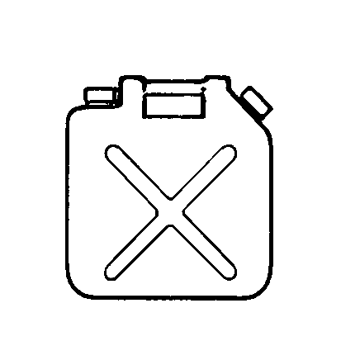
2. Employees who handle hazardous materials when an unexpected thing happened,
3. Manager of an employee.

You must train them the following time.
1. Training period of newly hired people.
2. When you in charge of new job and handle hazardous
materials at each section.
3. When you worked under another manager or transferred to
new branch office.
4 When new chemical harm was announced.

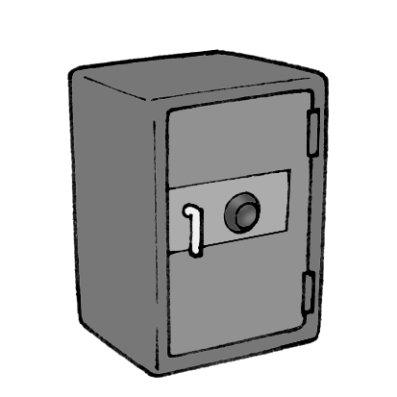
The following information must inform to employee and educate.
1, All the information included a crisis control program of
a company.
2. A storage place of hazardous materials.
Note: Store into fireproof cabinet materials which an ignition point
equal to or less than 100℃. In addition, if a refrigerator is necessary for keeping at cool and dark place, prepare an exclusive one and do not use together with food and etc,.
3. Existence of harmful chemical substance in working place or method to detect discharging.
4. A symbol and a technical term that are used on a label. (how to read label of a product)
5. A method to distinguish brand name, a general product name, an appearance, a toxic substance which includes a smell.
- The harmful chemical products using at working place.
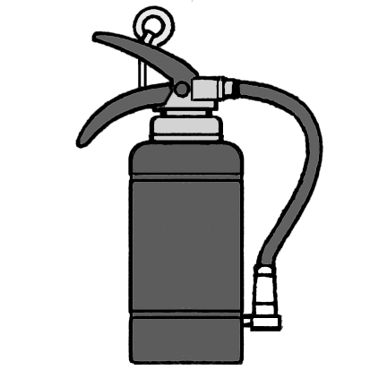
- Items which you should done if you are not able to protect and avoid dangerous situation from hazardous materials. (appropriate duties, a procedure
of emergency, a chain of command).
- Contents and a storage place of a dangerous transmission
program document of a company.
- The handling and an appropriate method of storage.
- Appropriate use of personal protection tool.
- A fire of emergency and digestion, a purification procedure and a chain of command.
- A method to obtain information on a toxic substance.

Material safety data sheet

An auto glass worker uses hazardous substance such as a medicine, undercoating agent (a primer), a solvent, a resin for repair, adhesive routinely.
Worker has to know the safe direction for uses and storage method according to instructions of a maker about these things.
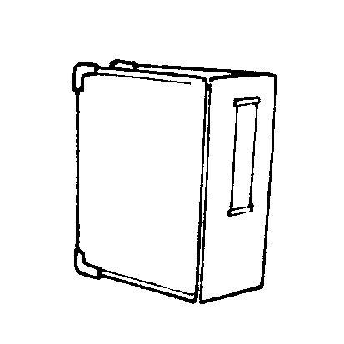
As for the material safety data sheet filed in a place of work, each maker must supply information of hazardous materials to a product user.
The following items are written down on a sheet.
* Product information.
* Information about dangerous raw materials.
* Physics, chemical data. Note、A person in charge must do new filing
* Data about fire and danger of an explosion. without forgetting.
* Data about the human body and harmful material for health.
* Data about reaction characteristics.
* Data about safety handling and direction for uses.
* Information of rules.
* A worker must be able to deal calmly with this information without upset, in case of emergency.
Dangerous wastage

Here, let's study an appropriate disposal method of hazardous substance.
There is clear guideline by law about classification of garbage, and disposal of industrial waste in Japan. Understand law and follow according to the policy of government office.
A method of disposal is prescribed by law about specific chemical.

A company must arrangement to have a waste transportation processing company to get rid of a toxic substance. On that occasion you must write in it at a data sheet of processing called a manifesto. (You must confirm till the last disposal site when contract company recycle and processing). In addition, it is decided by a law that label, specified contents and date, must put on a container of hazardous substance. (Law of "The dangerous materials handling method")

Following shows chemical products and materials which specified by law but used when auto glass working.
* All solvents.
* The urethane that it is not hardening treatment. (Except for hardening treatment)
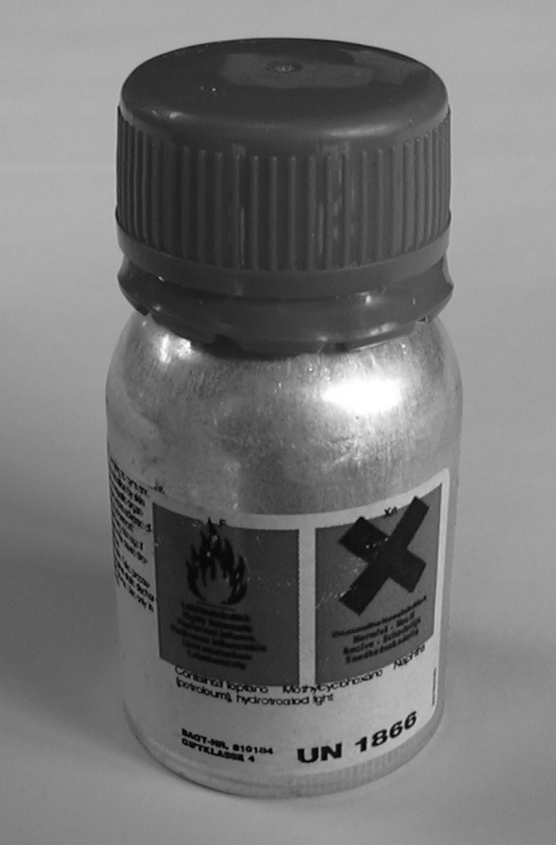
* The urethane that it was worked to stiffen
* Urethane undercoating agent. (a primer)
* Epoxy resin.
* Two pack adhesive. (Two pack epoxy resin)
* Silicon spray.
* The resin which is used for repair work.
Let's do the right disposal with the above-mentioned
guideline

An accident record

An accident may happen unluckily. Record all accidents to prevent a recurrence of a similar accident and update it whenever every accident outbreak. Classify each accident and diseases by a department and have to write entry of a total working days. Calculate these statistics every end of month. In addition, If accident authorization is necessary, take a procedure and reserve copy in office. Notify individual home of a victim.
Will learn about an automobile accident in another clause later.

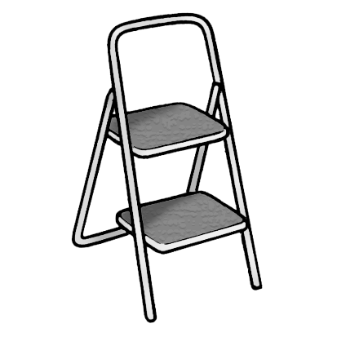
Safety inspection item

Worker must recognize the following items.
* Check and control of tool, an electric tool, a compressor
* Management of safety devices of a machine.
* Management of a ladder, stairs, a step, a stepladder.
* Easy handling and storage of a fire extinguisher.
* Check easy handling and storage of fire extinguisher. especially decide the management representative for checking expiration date on every beginning of the year. (A timeworn fire extinguisher may explode
due to fall out of low part.)
* With regard to use of personal protection tools.
* The appropriate handling of a flammable material.
* Transportation technique of heavy goods and glass.
* Hygiene aspect.
* Complement and easiness of care, use of a first-aid kit and training of an employee.
* Systematization of knowledge, conduct and transmission of worker who correspond to emergency evacuation.
Decide a timing and must be able to confirm and inspect the above items.
Label for safety

Glass worker often handles "regulated products" in which six classifications included such as compressed glass, flammable/combustible material, oxide, toxic/infection material, corrosives material and material which causes a highly dangerous chemical reaction.
An appropriate label must be put on these products. A label must print and attach to a product or the container with a symbol, a signature, a sticker, a seal, a label, a tag or packing, and it is printed.

Will describe knowledge of label which required to employer.

* Confirm whether an appropriate label sticks to the product which received from a supplier.
* Put a company label on a product which was produced.
* Confirm whether put all necessary information required by law on a label..
* Confirm whether supplier and company label should not be removed, erased and changed.
* Replace company label which is hard to read or peeled off.
* Teach to all employees who handle regulated products about importance, purpose and contents of labels including dangerous symbol.

Let's learn what we can evade much danger from information of one piece of label.
Employee's education which is required to employer. (Correspondence to a person who handles a regulated product)

Employee who includes outside worker such as contract employee or janitor but handling regulated products or working around regulated products area, must take training through worker educational program.
In addition, an employer must show a material safety data sheet to an employee.
The employer must guarantee and be done the following items to employee.

* The confirmation whether a data sheet of a regulated product is the newest issue.
* Obtain a data sheet of the regulated product which is in a work place and make data of a company.
* Educate an employee about a purpose and importance of data.
* Confirm data of a work place every year and update within 90 days if you obtained the latest information.
* Transmit all the dangerous information about a regulated product.
* Notify all the information of regulated products in work place about storage, handling and use.
* Do similar information disclosure about a product produced in a work place.
* Should be able to apply the information which you got about personal safety and health.

1 ― 7 Basic first-aid, emergency treatment (first-aid kit)
Even if we work with scrupulous attention and follow the manual, may get injured including fellow worker or people who work at same site. We must learn a method of a basic medical treatment for that occasion. The highest possibility of injury that automotive glass worker suffers are cuts and burns Let's learn actions to be taken of a cut in particularly.
In addition, we can deal with the neighboring people who got an injury and wound if we learn right knowledge.

At first will describe the dangerous symptom that a repairman could be involved.
* Dizziness
* Dizziness on standing up
* Nausea (vomiting)
* A headache
* Difficulty in breathing
If there is such a person, he must leave from work shop immediately or we must carry out him on a stretcher. If there are serious cases, you must not forget calling an ambulance either.
It is no need to say, we must take a medical advice in both cases.

Measures of a cut

A cut is common for an auto glass worker. Wear the gloves which were suitable for according to the appropriate glass handling and repair procedure to prevent the cut.
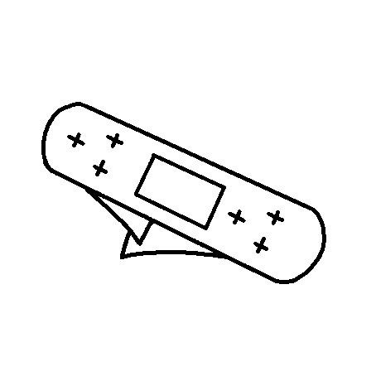
Will study measures of cut even though we paid full care to it.

- In the case of a small wound

* Wash away a wound with soap and water immediately.
And treat a wound with antiseptic solution.
* Completely cover an affected part by a first aid adhesive
plaster or a bandage after having used a styptic.
* Watch progress and take a medical advice afterwards if it is necessary.
(2) In the case of a symptom with bleeding
* Fold clean cloth and make a thick pad and fix it on a wound tightly and directly.
* Make a bleeding part upper than a heart and use a pressure bandage for an artery and wind it up tightly.
* If bleeding is settled, furthermore, put on cloth and a bandage and wind it up tightly.
* If blood soaks into the first pad, put on cloth from the top.
The first pad should not be removed because a wound opens.
* Use a pressure bandage rather than a tourniquet.
* Keep a patient warm and carry in a hospital. When it is difficult to carry with us, arrange an ambulance immediately.
Note: But when you suffer from an infectious disease, tell a caretaker and ask his appropriate measures. In addition, always use the vinyl gloves when you touch Blood of Others because patient could be suffered from infectious disease.
When you touched blood by any chance, wash it away with a large quantity of water immediately, and you must take a medical advice.

The most effective primary care for cut is to wash it away with a large quantity of water (cold water). Paralyze a pain and can wash down various germs. Let's do the appropriate measures that accepted a symptom afterwards.

Measures of a burn

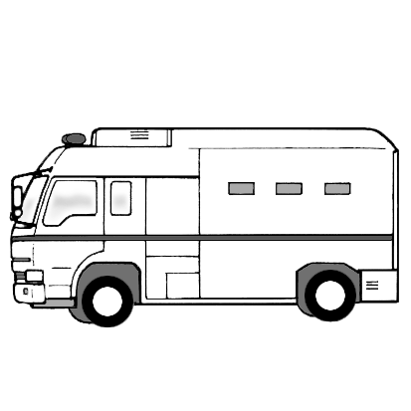
Cold water is the best medical treatment a burn basically without being concerned with desperation how far. There are three levels for a burn.
* Level 1, Skin turns red.
* Level 2, Foam appears.
* Level 3, There was foam, and skin becomes burn black.

Measures of level 1 and 2 , range of burn is narrow.
1, Dip it into cold water.
2, When a range of a burn is wide, use a pad of clean cloth. Soak cloth into cold water and hit the part which suffered a burn softly. Do not use antiseptic solution, ointment, spray. Do not break a vesicle and tear off skin.
3, Watch the progress and ask a medical advice if improvement of a symptom is not observed.
Measures of level 2 or 3 , range of burn is wide.
1. Call ambulance immediately.
2, Let an injured person relieve as much as possible while putting the clean cloth which soaked into cold water softly. But you must not take him to a hospital by yourself. Because there is much chance a patient getting better by urgent medical care.

A burn by chemical substance
Chemical substance is generated by an acid material or cautery material hung on to eyes or skin. There can be a charged with a burn by stimulated eyes with strong steam or smoke from chemical substance. Symptom shows in below.
* Eyes are wet and bloodshot, and there can become sensitive to light.
When a burn is a serious level, eyes grow like white.
* Skin turns red by strength of chemical substance, and has a foam and becomes black.
The above mentioned items could be happened.

An emergency measure of a burn by chemical substance.
1, Remove a dirty clothes.
2, Dip it into water for 15～20 minutes or until a pain is relieved.
Note; Collect water in a washstand or a slightly bigger container when you suffered a burn in eyes. Dip a face into water and repeat a blink and put water in the whole of eyes.
3, Cover it by clean cloth and bandage after having put water.
Take a medical advice, measures promptly in the following case.
* When strong chemical substance such as acid was put in eyes.
* When strong acid or cautery material hung in most part of skin. (more than 1/4 of a body or a face) of skin.
It's most important to wash with a large quantity of water promptly or cool because most of the material which we use does not react of hydrolysis reaction.
Measures of damaged eye
Measures of the damage of e
Eyes are delicate organs. When eye was hurt, can avoid the heavy damage by appropriate measures and can recover in a former state. According to the example, even some minor injury case did not fully recovered. Always think about to avoid the damage of eyes, and please take an enough protection step. When a foreign materials entered in eyes, can easily remove dust, sand, and an eyelash in many cases. It will be all right if you wash it away with a large quantity of water. But take a medical advice when an eyeball is red afterwards, and there is swelling, sense of incongruity. Take a treatment of a doctor immediately without an amateur being going to take it when a foreign material is seen in iris of eye or glass stuck into an eyeball.
Measures of early stage.
(1) Advise the person who bore an injury not to rub against eyes.
(2) Let eyes open and ask to watch top, bottom, right and left to an injured person and examines details.
(3) If a foreign material can confirm, wash it away with water.
(4) When you can't wash away with water or can't use water, if a foreign material does not stick in an eyeball, pick it up in a corner of a wet clean towel.
(5) Take a treatment of a doctor if you can't remove a foreign material after lightly fix bandage to eyes.

Measures when chemical substance was in eyes
(1) Hit cold water to a face of a wounded side as soon as possible and wash it.
Continue this for 10 minutes.
(2) When you cannot wash it, lays an injured person and open and washes away softly the eyes which was wounded while protecting not injured eye.
(3) Put an eye bandage or the clean cloth softly.
(4) Call an ambulance promptly and transport to a hospital.
Measures when eyes were strongly hitted.
(1) When a serious wound, eyesight deteriorates, take a medical advice.
(2) Call an ambulance and while waiting, cover eyes with clean cloth and handkerchief and lay an injured person for rest.
Because there can be cerebral hemorrhage in the eyes special thing, in the case of illness of eyes, you must learn transportation in downward-facing.

A blood pathogen (infectious diseases)

When touch blood and body fluid of the others, may infect with a blood pathogen.
When an automotive glass worker do emergency measures or cleaning after automobile accident, there is some possibility to get infect with a blood pathogen.

A main disease to be infected with by a blood pathogen is:
* Hepatitis B (HBV)
* Hepatitis C
* Acquired immunodeficiency syndrome (HIV)
* MRSA (there is much in low age child, but is easy to take a person at old age, too.)

The following is to be considered as a cause (origin).
* When a polluted sharp thing stuck in your skin.
* When blood touched to the part which suffered a wound. An example: A rash or a cut.
* When have entered into eyes, a nose, a mouth.
Note: Put on goggles, a mask, plastic gloves when you take care it.
For the prevention, use personal tool when possibility to touch blood or body fluid of others, and care while intercepting infection route such as eyes, a mouth, a nose and a wounded hands.
Will describe a general preventive guideline, next.
* After care, must wash a hand.
* If it is possible, use antiseptic solution and detergent.
* When you clean at the place where blood stuck to, use the personal protection tools which was suitable for it.
* Use a specified cleaning tool.
* Never touch directly to the glass or other things which possible to pollute.
* When you suffered a small wound, treat you by yourself.
Lastly but ten thousand think about, take a medical advice if there is a little chance of infection.

References : Main instructions for window repair work

With regard to the repair liquid (a resin), many of them containing acrylic acid and acetic acid which was designated as deleterious substance. Here, will describe acrylic acid.

Danger causes by acrylic acid.
When you inhaled it inflammation is caused on a throat, a nose, a mucous membrane of the bronchus, and there can be causing lassitude, a headache, dizziness, vomiting.
When serious case, it causes edema of the lungs, and difficult breathing.
First aid
Wrap a patient in a blanket immediately and rest quietly in bed and move to a place with fresh air. When difficult to breath or breathing stops, immediately apply artificial respiration. When a heart stops, apply chest compression.
When touched to skin
Stimulate skin intensely, and inflammation is caused.
First aid

Unclothe polluted clothes, shoes immediately
and wash it away with water.
When it is in eyes.
Stimulate a mucous membrane, and causes
inflammation goes blind when serious case.
First aid
Wash it away with water immediately. Continue it more than 10 minutes.
A polymerization inhibitor is added in a resin, but polymerization begins by heating, direct sunlight, peroxide, iron rust, and there can be an exploding.
When a fire broke out by any chance, move a container to a safe place immediately and water for cooling down of the container and neighboring place if a container is impossible to move.

When catch the fire, extinguish a fire with a digestive or a large quantity of water. Use powder or a bubble digestive as digestive.

Be careful about theft, loss and if something wrong happened, report to police, a public health center, and a fire department immediately.

A first-aid kit

An auto glass worker can work on a business trip.
Therefore, for emergency procedure in business trip, always prepare first-aid which is not affected by temperature changes in the automobile such as adhesive plaster, gauze, a bandage.
If a client of the business trip is a car repair company, you should confirm his storage of an emergency procedure tools for each other's safe management. In addition, prepare a first-aid kit in a company. The following items are better to keep in a first-aid kit. (A first-aid kit must keep in a cool and dark place.) A medicine must replace with new one every expiration date under supervision of manager.)

* Gauze (several pieces) * A cold medicine
* A bandage * Anti-diarrhea medication
* A pressure bandage * Headache pill
* Antiseptic solution * A stoma chic
* Adhesive plaster * Sinus medicine
* A first aid adhesive plaster * Anti-inflammatory analgesic plaster
* Ointment * Cough mixture
* Antioch medicine for insect sting * Throat candy Soap
* Soap
* Cooling sheet * Towel
* A Scissors * A bath towel
* Tweezers
* A thermometer
(Refer to color page: Simplified first-aid kit)

Objectives of health management on working site

Objectives of health management on working site are that the employers improve working circumstances, contents of work, employees’ health and prevent diseases to keep employees healthy.
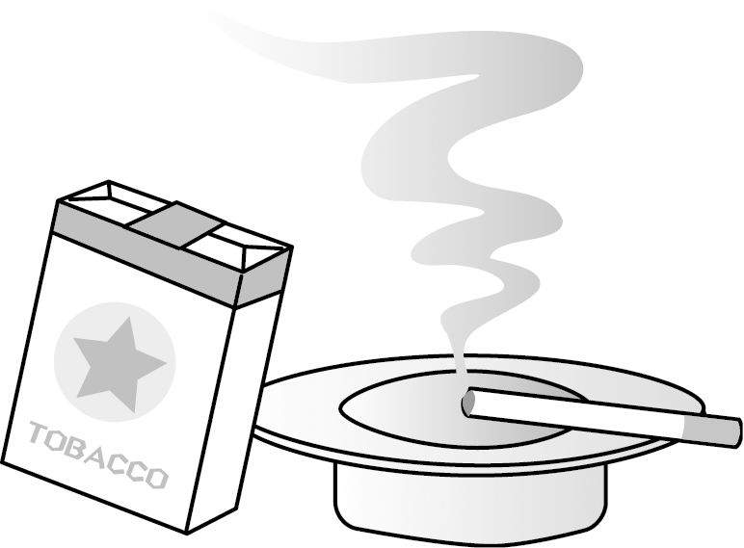
Targets of health management at working site are as follows.
- Prevention of life-style related diseases.
- Reduction of absences caused by diseases.
- Maintenance and improvement of health. (actions for forming mental and physical health)
You should always consider above on your business activities.
A reference item: According to the article 25 of the Health improving law legislated on 2004, you have to wipe off damage from passive smoking. You should make efforts on separating areas where workers can and can not smoke.

Promotion of medical checkup

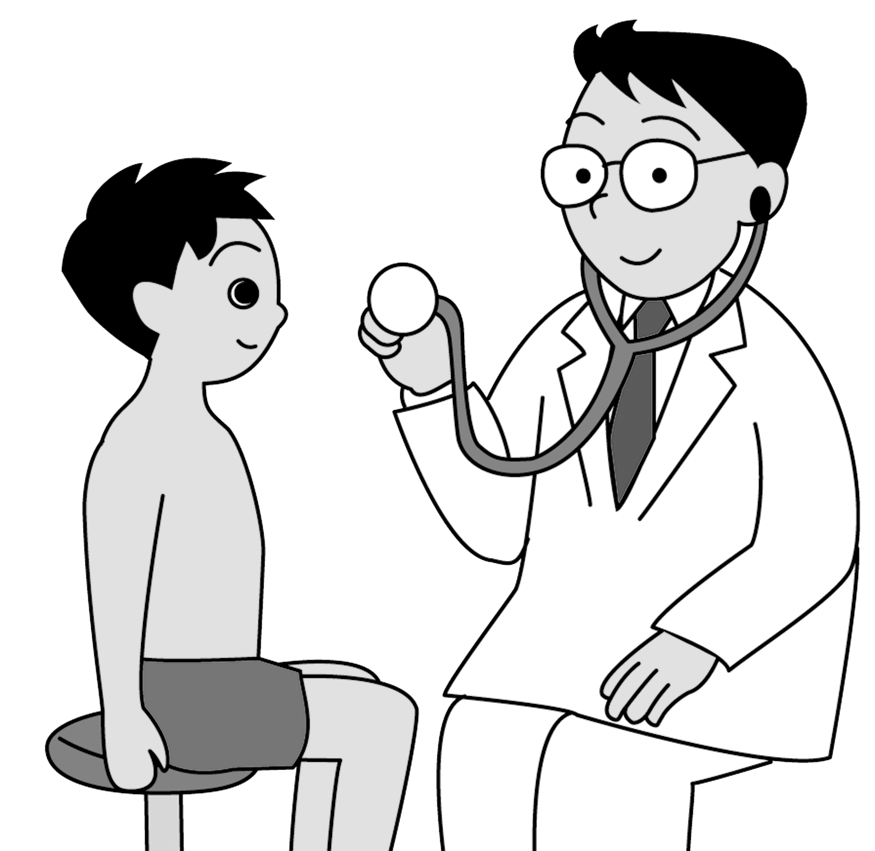
Health management by oneself is one of the most important items for human beings. Employers have responsibilities on keeping their employees healthy. Therefore employers have to make all of their employees take medical checkups once a year. Also, employees have responsibilities on taking checkups actively.
One of the law regulated medical checkups, commonly taken place on work places, is the general medical checkup. The main part of the general medical checkup is the periodic checkup. All employees have to take this once a year for the purpose of getting year-to-year changes on their whole medical data to take adequate follow-ups.

Health is one of the most precious things for human beings. Both of enterprises and individuals have responsibilities on maintaining their physical condition better. On this manual, all workers are recommended to take complete medical checkups once three to five years beside of regular ones.

1-8 Vehicle operation management

Auto glass workers do their jobs out of their working sites in many cases. They have responsibilities to treat company cars (=work vehicles), assigned to them, in safe and legal manners. They should treasure such work vehicles with safe driving in same way as their own cars. In this clause you are to be expected to learn safe operation and management of work vehicles.

On this manual safe treatment of work vehicles and guideline for workers are recommended as follows.
- Carry effective driving licenses and obey law/regulation.
- Companies have right to reject employees drive company cars because of their illegal and/or dangerous driving manners.
- In case that driving cars are closely related employees jobs, being rejected or refrained driving/using company vehicles means that they could lose their jobs.
- Forecasting and foreseeing driving is recommended. You can be involved into accidents even if you drive safely enough yourselves. To prevent such cases, drive without “maybe”, ex. “other cars will make their cars slow down”, paying continual attention.
- Both of driver and passengers have to wear their seatbelts. Put stickers encouraging wearing seatbelts on the dashboards. [Although this is clearly regulated, for vehicles with rear seats, a confirmation took place here.]
- Provide first aid kits, safety devices and fire extinguishers on the work vehicle.
- Confirm equipment, set inside/outside of the vehicle, is firmly fitted.

- On reverse moving, be guided by others or confirm outside of the vehicle by yourself.
- Never drive taking/after taking alcoholic beverages or drugs.
- When violating the road traffic law, report to traffic manager immediately.
- Keep documents like JCI, Japanese Compulsory Inspection, certificate or insurance policies inside of the vehicle.
- Make before-work inspections everyday. Not forget to record in the daily reports.
- If the number of the company vehicles is five or above, assign a safe operation manager according to the law.
- On use of cellular phone in the vehicle, only devices approved by regulations are available. One-peace handy radio devices will be treated same as cellular phones. Communication with only hand-microphones, like passenger transporters, is not punished by the road traffic law when controlled by assigned managers. [Current road traffic law, Nov.1/2004, rejects use of cellular phones during driving without adequate safety devices. However, employers should confirm safe way of use of cellular phones, not only thinking the use of them is legal or illegal.]

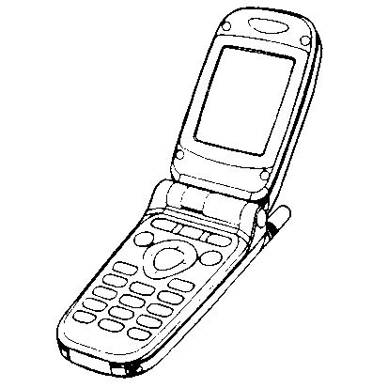
A sample of simple daily report

Jan.1/2005 Name: Taro JAGU Before work check: OK Before work mileage: 12345Km
Time | 9 10 11 12 1 2 3 4 5 6 7 8 |  |  | Note
Driving hours
Working hours
Where
What

Coping with traffic accidents, caused or got involved

- Take care of injured people first. Treatment should be limited up to the first aid.
- Call ambulances.
- Call police officers.
- When curious crowd is growing, seek some reliable persons and ask traffic guard at the scene.
Items shall be recorded

  - Record the name of witnesses, drivers, passengers, doctors/nurses in charge, etc.
  - Record the information, of all vehicles involved the accident, of their makes, model years, types and registration numbers, etc. picking up from JCI certificates.
  - Make layout-sketches of the scene and record geographical condition, location of signal lamps, sign boards, obstacles (if any) in it.
  - Also record the weather and road condition at the time when the traffic accident was happened.
  - After the reporting to police station was completed, come back to the office to make an accident report.
Items written above are not only for the cases you are involved yourselves. With the common sense of members of the society, you should help to take care of the accidents you encountered, saving lives, first aid and collection of the information of related vehicles, practically using what you have learned.

1-9 Safe work spaces
Auto glass workers do not always work at workspace of their companies. In many times they work at car dealers, auto repair shops and auto body shops, etc. One of the most important things is confirmation of safety at workspace in such cases. Here you will learn the guideline of safety management of workspaces.
Work space in the Repair shop --- Many repair shops have put various ideas on their workspaces realization. Here introduced some notices in such a process.
*Reject no related persons trespass without permission.
*Post clearly the name of manager in charge.
*Establish and post various kind of danger and emergency.
*Keep hot work equipment away.
*Keep dangerous objects away.
*Rule no smoking.
*Set fire extinguishers. [Assign managers and make them keep expiration date.]
*Provide enough ventilation.[On Fire Defense Law, ventilation fans are compulsory for work shops which stock and use organic solvent of over given quantity.]
*Provide enough amount of light for detail inspection of vehicles, repair objections.
*Provide enough space capable for full opening of both right/left side of doors and workers’ passing by.
*Provide a horizontal floor.
*Provide well-arranged first aid kits.
*Sort garbage.
Considering items above, creating of better work site is recommended.



Workspace in auto maintenance shop --- Auto maintenance shops and auto body shops are clearly well managed for safer operation under the laws and regulations than our business field, glass repair operation. However, for better work and higher level of safety management, we would like to give same items should be confirmed each other below.
*Ask the name of managers in charge.
*Ask the location of the fire extinguisher.
*Confirm the location of the water closet and other water supplies.
*Confirm the location of emergency exits and routes.
*Confirm the location of emergency evacuation places on the earthquake, etc.
*Ask the location of the first aid kits.
*Ask to learn various kinds of danger treatment manuals.
*Ask the location of the hot work related equipment.
*Ask the location of the dangerous objects in the shop.
Considering items above, implement safety management on the work.

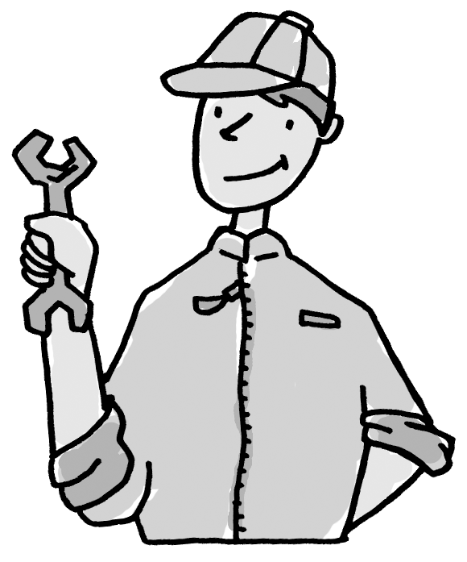
Then, we will comment on the work at non-preferable spaces out of own shops.
*Non-evenness space.
*On the vehicle inspection line. [On the inspection pit.]
*On the vehicle inspection lifts.
*On the vehicle washer line.
*On the vehicle frame-adjuster line.
*In the painting booth.
Unexpected accidents and dangerous conditions will be considered on the work at the spaces above. An overconfidence of “It has to be OK!” can be connected with accidents involving others. You should ask the clients to move the vehicles to the safer places, as possible as you can, for the safer and better works.

At the home of individual customer
Your customers may order work at their home. This case brings you an advantage that you do not need to carry and deliver the vehicles after work completion. Working in a parking lot of customers’ work sites also brings you another advantage that you do not need to carry and park the vehicles.
However in many cases, these places are not always safe enough. Having no water supply or no first aid devices might inhibit quick responses when unforeseen accidents happen and make damages from the accidents larger. Get information on the places you are going to do work and prepare least emergency devices and water bottle/PET bottle, for both drinking and washing, to be able to work safely.
You learned that many types of working situation could be expected on auto glass work. Sometime, the work would have to be implemented out door. Therefore, avoid direct sunlight and keep water supply in the mid-summer, and also keep yourselves warm in the mid-winter for maintaining workability. In any cases never forget two important items: One is that you have to keep your safety by yourselves. The other is that you have to improve safety on your working circumstances by yourselves.



Chapter 2 Basic knowledge on the automobile

The automobiles, definitely necessary for us living in the 21st century, were first brightly launched owing to the invention of the internal combustion engine on the late 19th century. However, as compared to its breakthrough engine, the body was poorly made of wood, in the same manner of coach building. And with the growth of the civilization, automobile world was changed and the automobiles were changed from a mere transporter to vehicle of various style and construction according to the purposes of use. Also its construction was changed to stiffer and safer. On this chapter, you will learn the basic knowledge of automobile that is necessary for auto glass work.

2-1 Auto body structure
Frame structure type is a combination of the frame, a counter part of skeleton of human body, and the body, a counter part of skin. Nowadays few models of passenger cars adopt this system.
Monocoque structure type is a kind of box shape structure assembled of stamp formed, spot-welded on its flanges, steel parts of 1-2mm thickness. Today, many passenger cars adopt this system because of its light weight and safety. Monocoque structure can be said “structure wrapped by crab shell to maintain its rigidity”. Glass is considered to be parts of the structure. Therefore, glass-fitting method has changed from gasket type to adhesive type for the purpose of maintaining rigidity and reducing the possibility of fall-off when the vehicle crashed. (Ref. 4-4 P.72 Adhesive)

2-2 Variation of vehicles and name of glass
Monocoque structure type is constructed by underbody part, called “platform”, and spaces[boxes] that are planned for purpose of use, fitted on it. The number of spaces can categorize vehicle body type.
3 Boxes --- Separated to three spaces: the engine compartment, the cabin and the luggage compartment. Passenger cars of sedan type, fixed hard top sedan/coupe type are categorized into 3 boxes.
2 Boxes --- Connection of the engine compartment and the cabin. Luggage space is included in the cabin. Van type and station wagon type are typically in this category. Recently, passenger cars of hatchback type, sports utility vehicle type and Japanese most mini-sized cars have getting into this category.
1 Box --- One cabin[box] ,fixed on the platform, accommodates whole of engine, passengers and luggage. Cab over engine type van and wagon can be in this category.

Categorization by body shape
Vehicles can be categorized into passenger cars, Japanese mini-sized cars, trucks and buses, etc. Their body shapes as following charts can sort each category.
When it comes to treating auto glass, in addition to the information related to the body shapes and glass, other information such as the number of doors for passenger cars, category of maximum payload for trucks and the maximum number of passengers for buses becomes necessary. [Chart2-2-1, 2-2-2] [Ref. 7-4 Distinguish of glass P.90 ]

Chart 2-2-1
 | Type | Shape | Number of doors
 | Type | Shape | 2 Doors | 3 Doors | 4 Doors | 5 Doors
 | Passenger car | Sedan |  |  | ○
 | Passenger car | Hard top sedan |  |  | ○
 | Passenger car | Coupe | ○
 | Passenger car | Hatchback |  | ○ |  | ○
 | Passenger car | 2 Boxes Wagon, Van |  | ○ | ○ | ○
 | Passenger car | 1 Box Wagon, Van |  |  | ○ | ○
 | Mini car | 2 Boxes |  | ○
 | Mini car | 1 Box |  |  | ○ | ○
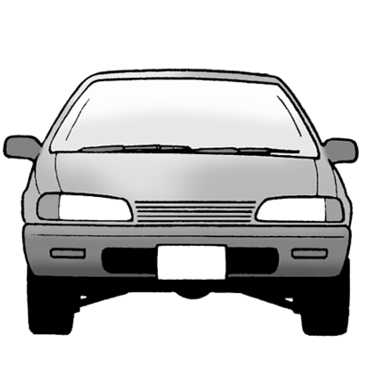
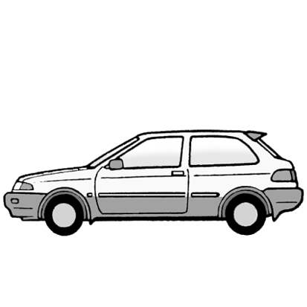
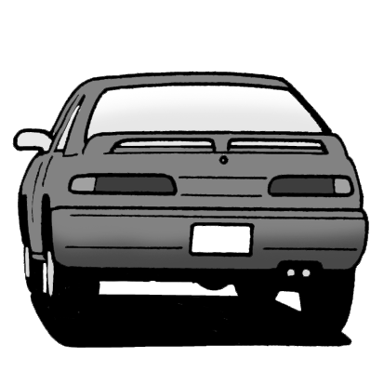

Chart 2-2-2
 | Truck | Heavy Duty | Maximum Payload:8t or over
 | Truck | Medium Duty | MP: 3t to below 8t
 | Truck | Light Duty | MP: below 3t
 | Truck | Mini truck | MP: 0.35t or below
 | Bus | Large Size | Riding Capacity:30 or more
 | Bus | Medium Size | Riding Capacity:29 or less
 | Bus | Small Size | Riding Capacity: 29 or less
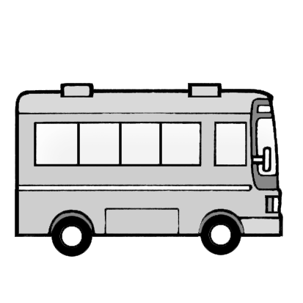
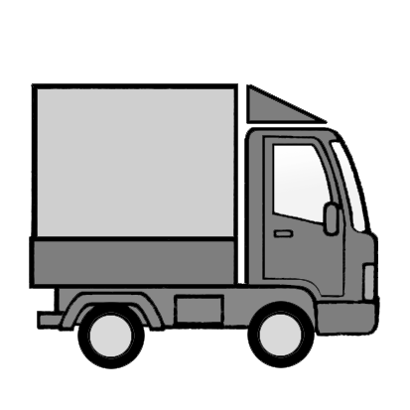

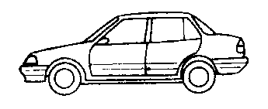
Sedan (3 Boxes)

Recreational vehicle (2 Boxes)
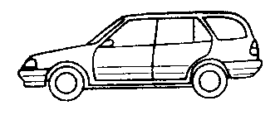

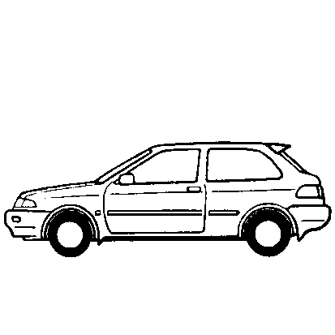
Coupe (2 Boxes)

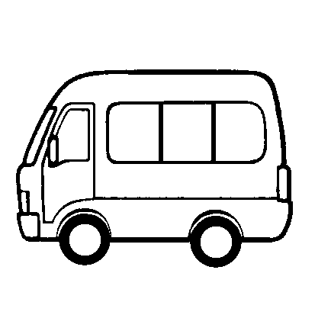
Cab over engine (1 Box)

In this manual, we would like to use specific words of auto glass business world. This is for dealing with glass manufacturers’ glass types and marks and also for clearing glass location on the vehicles.
Names of glass are as follows.
Front windshield --- Front glass [Front window]
Side glass --- Front vent. glass, Front door glass, Rear door glass,
Rear quarter glass, Side glass [Side window], Slide door glass
Back glass --- Rear glass [Rear window]
Roof glass --- Sunroof glass [Sun roof lid]
Note: Rear view mirror --- Room mirror, Inner mirror
Side view mirror --- Side mirror
AWASE glass --- Laminated glass
Names of glass will be expressed like above.

Chapter 3 Basic knowledge of auto glass
3-1 What is the glass?
The glass is said to have its origin at Egypt and Mesopotamia where one of the big fore ancient civilizations rose. And glass factories already existed at around BC 1500 and were manufacturing glass products. In the days of the Romans, revolutionary “Glass blowing method” was invented, instead of old “Glass stamping method”, and spread world-widely accompanying the expansion of the Roman Empire. In medieval Europe, famous Venetian glass was in its full flourish and color fixing technology, using metallic compounds, made progress to be used for stained glass in churches/cathedrals. It was around this time when the glass was also used for the various medieval architecture and large size flat glass or mirrors became available.
In the 20th century, the glass manufacturing method made rapid progress to complete “Rubbers method” by machine. Then forming method, in which the glass was formed flat from beginning, was developed by Fourcaolt in Belgium and automated mass-production method was developed 1910 through 1920. In 1950s, “Float method”, can be called a revolution on the flat glass forming, was completed in Great Britain.
At that time, Japan was in a high growth period of postwar and in the age of “Float method”, instead of the conventional “P board [Pittsburgh manufacturing process]”, mass production of the flat glass with thickness of 2mm to 25mm was realized.

Main component of the glass
Main component of the glass is silica[SiO2]. Natural crystal or quartz glass are made of only silica. The glass only made of silica has small expansion rate and molecular structure with a little flaw, both physically and chemically. However it need high temperature to be melted [1,713 ºC].
Therefore, to realize lower melting temperature and make the manufacturing process simple, soda[Na2O] and lime[Cao] were mixed and commonly used to get the soda-lime glass. The soda-lime glass is generally used for architecture and auto glass of modern age.

Main component of the soda-lime glass
 | Component | Content modulus | Note
 | Silica SiO2 | ７０～７２% | Main component
 | AL2O3  Aluminum Oxide | ０～２% | Increase modulus of elasticity & hardness
 | Lime CaO | ６～１２% | Decrease water solubility
 | MgO  Magnesium Oxide | ０～４% | Decrease water solubility
 | Soda Na2O | １２～１６% | Decrease melting temperature

Manufacturing process of the flat glass [Float method]
This is a manufacturing method of glass that was successfully developed by Pilkington brothers Co. in Great Britain on 1959. The method provides a good parallelism of glass board, no optical warps on glass surfaces and the glass surface that shines more brightly than polished glass, with no additional treatment. It also provides higher productivity than traditional “Pull-up method” with its higher manufacturing speed. As its manufacturing processes, from melting of material to stacking of products, are linked each other, whole of processes can be shorter and easily automated.
- Raw glass material, after melted in the melting pot, is carried through chilled rolls into the float-bath..
- The bath is filled with melted metal [Tin], whose specific gravity is higher than glass. While the glass material goes through higher temperature zone of the bath [the area around inlet: approx. 1,000ºC], uneven surfaces of the glass are melted and leveled even.
- Then the glass is gradually cooled during going through cooling zone [the area around outlet: controlled to approx. 600ºC].
- The glass is gradually hardened and further cooled in the gradual cooling furnace to be cut at the next process.
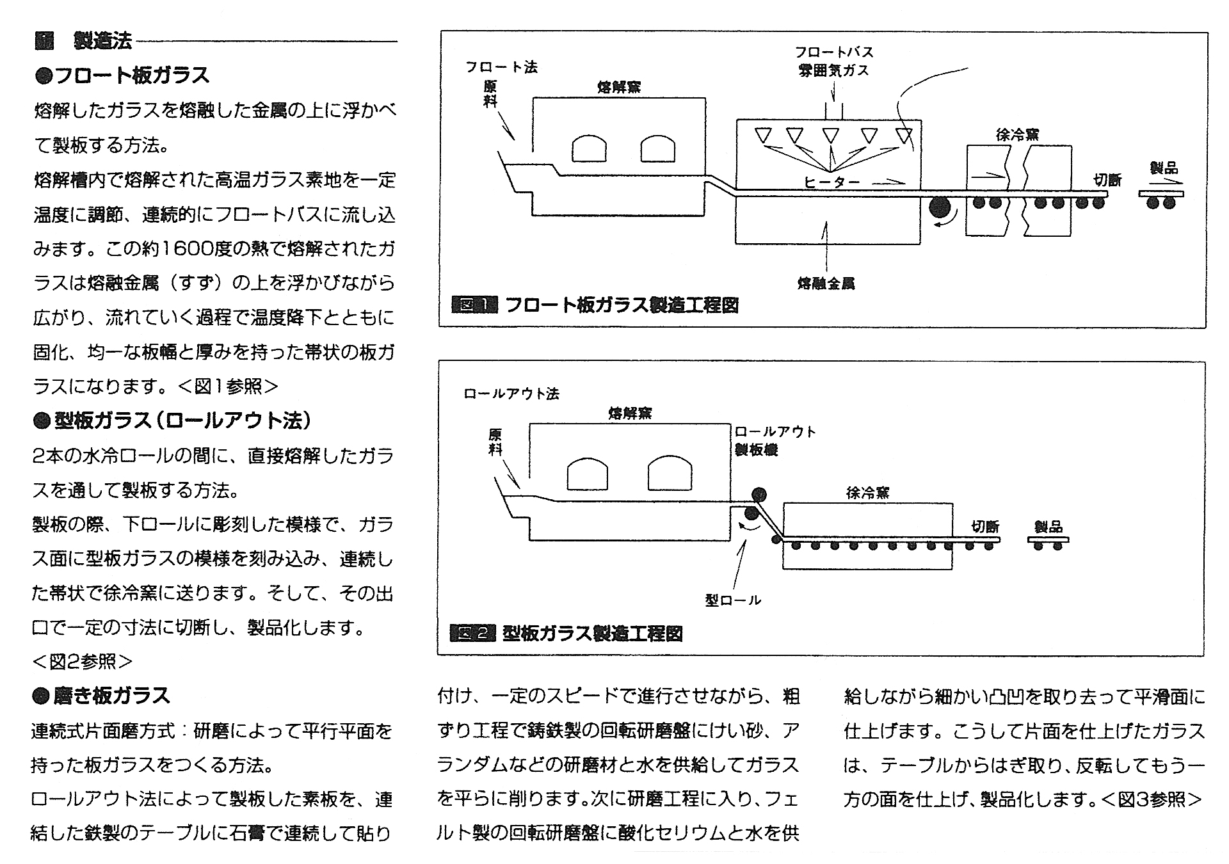
Figure 3-1-1 Process chart of Float manufacturing method
Figure 1. Flat glass manufacturing process
Figure ２. Molded glass manufacturing process
Cutting
Float method
Melting pot
Annealing furnace
Molding roller
Roll-out method
Roll-out molder
Melting pot
Float bath
Surround gas
Annealing furnace
Melted metal
Heater
Cutting
Product
Product
Raw
material
Raw
material

 Manufacturing method
 Float flat glass
The method to float melted raw glass material on melted metal to get flat glass.
The raw glass material, melted and controlled to the set temperature, is continuously run into the float bath.. The glass material of approx. 1,600ºC floats and spreads on the melted metal [Tin] in the bath and gets cooled, hardens to become belt shaped glass with even width and thickness. <Ref. Figure 1>
 Molded flat glass [Roll out method]
The method to run raw glass material directly between two water-cooled rollers to get belt shaped flat glass. The lower roller has a pattern carved on its surface to mould glass and run glass continuously into the gradual cooling furnace. Then at the end of the process, the glass is cut to be products. <Ref. Figure 2>
 Polished flat glass
Continuous one side polish method: The method to polish one side of the glass to get parallel flat glass.
The rough plates [glass], obtained by the Roll out method, are set on the steel tables ,linked each other, with plaster. While being conveyed with set speed, the glass plates are rough-polished by rotating polisher and polishing material of quartz sand, alundum and water. In the next process, the glass plates are fine-polished by rotating polisher and polishing material of cerium oxide and water to get completely polished surface.
Then the glass plate are taken off of the table, set the other surface and polished again. <Ref. Figure 3>

Figure 3-1-2 Polished flat glass manufacturing process
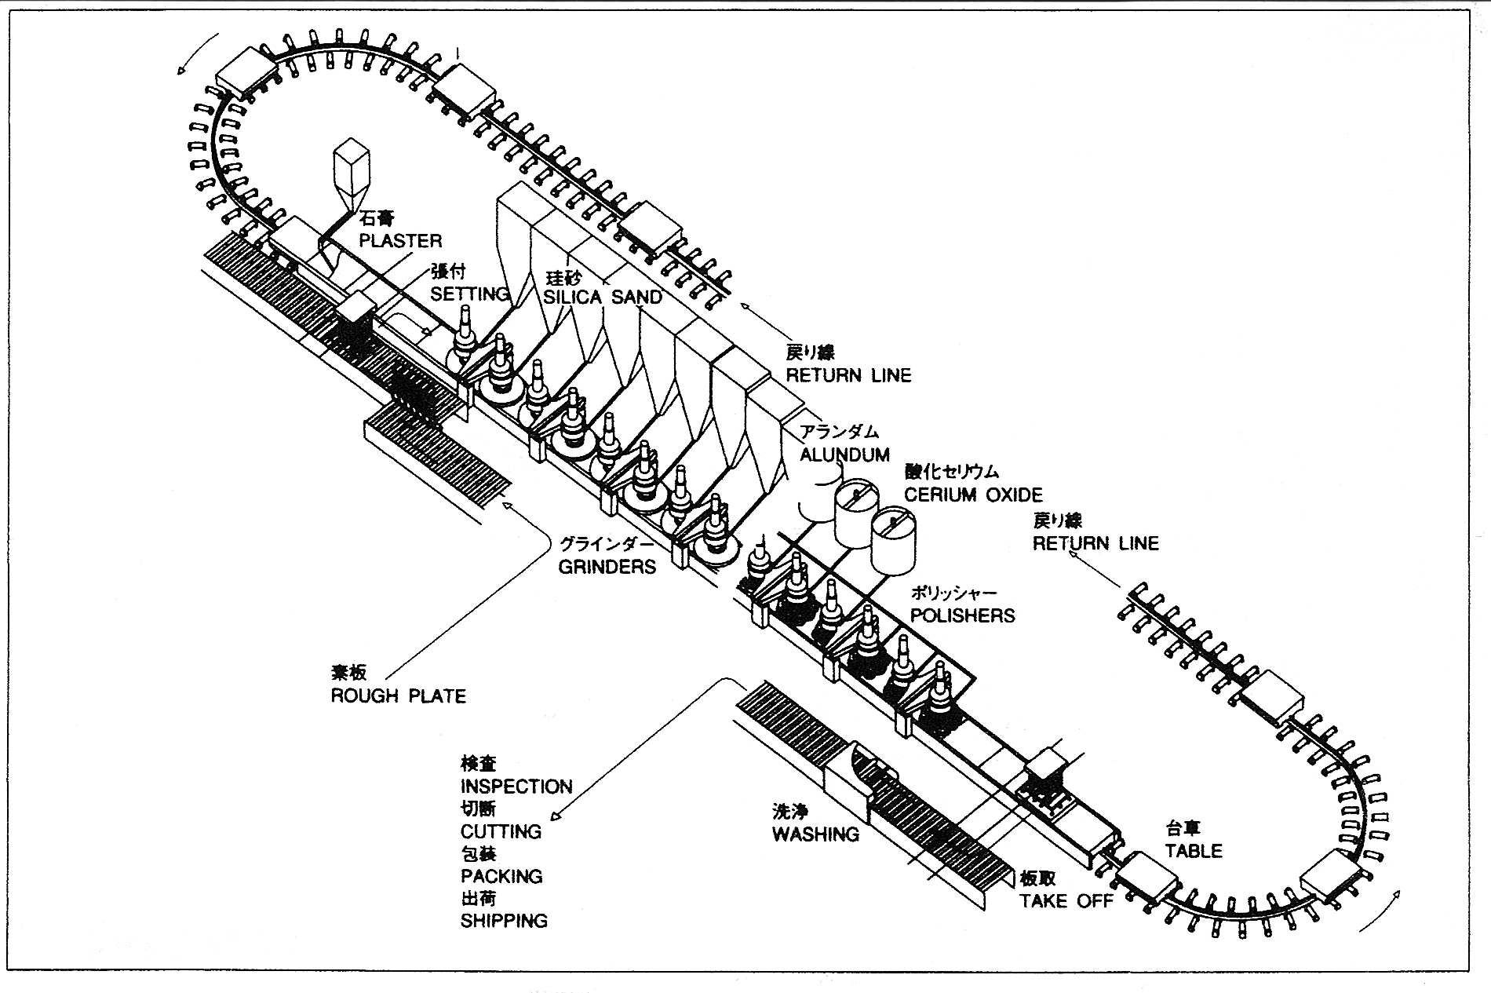
F s
Figure 3-1-3 Laminated glass manufacturing process
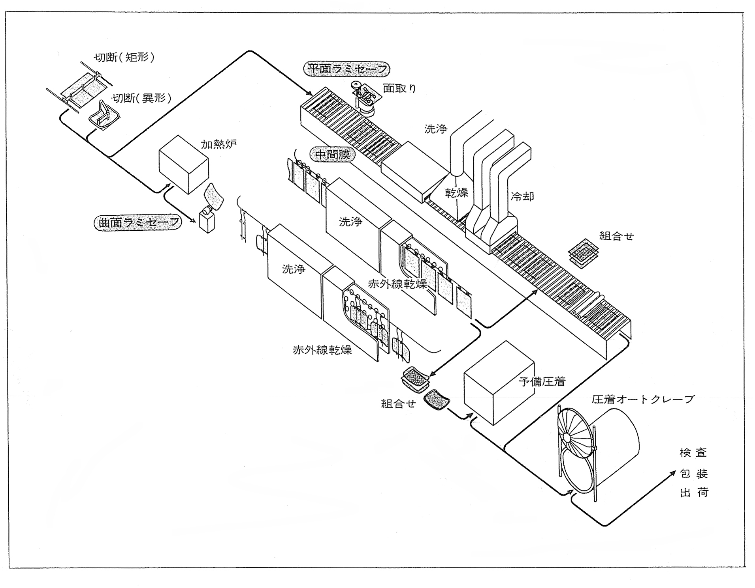
Drying
Pre-pressing
Washing
Washing
Washing
Cooling
Chamfering
IR drying
IR drying
Setting
Setting
Inspection
Packing
Shipping
Pressing autoclave
Intermediate film
Heating furnace
Cutting (irregular shape)
Cutting (rectangle)
Flat Lami-safe
Curved Lami-safe

3-2 Auto safety glass

3-2 Safety auto glass

The 29th article of Road Vehicles Act regulates “Vehicles’ front windshield glass shall be the safety glass”. [The exceptions are Heavy duty special vehicles and Small agriculture vehicles with maximum speed of less than 35Km/h and all vehicles with maximum speed of less than 20Km/h.]
Also, it regulates “Front windshield glass shall be able to maintain drivers’ view when damaged”. Beside of them, “Front windshield glass and other glass have to be transparent and not to prevent drivers’ view and have visible light transmissivity of 70% or over on the area necessary to confirm transportation condition” is regulated as a necessary condition..

What is the safety auto glass?
A special type of glass that is provided higher strength and is made to have the least hazardousness in case of an accident, by processing normal plate glass. Roughly classified, there are two types of safety glass, “Laminated glass” used for the front glass and “Tempered glass” used for other than the front glass. Various glass products have been developed for each condition or purpose of use under the Japanese Industrial Standard that stiffly regulates to maintain safety of auto glass.
The first performance standard for auto safety glass was JIS R 3205 “Laminated glass” determining necessary light resistance, heat resistance and impact resistance. However, with increasing of the number of exported vehicles, JIS R 3211 “Auto safety glass” and JIS R 3212 “Testing method for auto safety glass” were established, considering and accepting other countries’ regulations.
Test items newly added in JIS R 3212
- Visible light transmissivity
- Double images
- Abrasion resistance
- Head form [model of human head] impact test
- Penetration resistance
Note: JIS R 3205 was revised for applying for windows of architecture, railway vehicles and ships/boats.
[Ref.]
JIS R 3211 Refer to attached document
JIS R 3212 Refer to attached document
Road Vehicles Act Refer to attached document

JIS R 3211’s Major requirements for auto safety glass
 | Light resistance | No discoloration or cloud shall not be found on the intermediate film with exposition to sunlight for a longtime: [Test] Reduction rate of visible light transmissivity shall be 5% or less after exposed to quartz lamp of 750W for 100 hours.
 | Heat resistance | Resisting performance to high temperature for a longtime: [Test] No bubbles or other flaws shall not be found within 15 mm from edges or, in case of cracks occurred, within 10mm from the cracks after boiled in the water for 2 hours.
 | Impact resistance | To have the least necessary adhesive and strength to the impact by flying objects: [Test] No penetration of steel ball of 227g dropped from the height of 9m shall be found and the total weight of flakes came off by the impact shall not exceed 20 Kg.
 | Head form impact test | To check if penetration of 10 Kg head form model of human head, made of wood with felt cover, dropped from the height of 4m to the laminated front glass is found.
 | Penetration resistance | The laminated front glass shall have the least necessary penetration resistance: [Test] No penetration of steel ball of 2260g dropped from the height of 4m shall be found.
 | Visible light transmissivity | Visible light transmissivity shall be 70% or more on both front glass and side glasses, except rearward of driver/assistant seats,
 | Double images | Double images is a phenomenon that the primary image of the oncoming car’s headlight can be seen separated from its secondary image on the night driving. To check if double images occurs to give drivers illusions.
 | Perspective strain | To check if warps occurs on front glass or side glasses to obstruct driving, except rearward of driver/assistant seats.
 | Color discrimination | The color of objects have to be same when seen through front glass or side glasses, except rearward of driver/assistant seats: [Test] To check if colors of white, yellow, red, blue, green, umber, used for traffic signal and road sign, can be identified as same colors when seen through the glasses.
 | Alteration on measurement | To check if big alteration on measurement occurs under high temperature and high humidity. Warp shall not increase 1.3mm or more.
 | Low/high temperature resistance | The test of appearance alteration under low/high temperature. No crack, cloud, separation or other significant alteration shall be found.

3-3 Laminated glass
The laminated glass is made of two glass plates inserted a plastic sheet, Poly Vinyl Butyral, among them and pressed to be one piece.
Though the manufacturing method of the laminated glass was developed at early 20th century in Europe, it was widely spread in USA where large sized cars and safety-consciousness were common. The celluloid intermediate film was replaced by PVB that was developed around 1937 and has been used until now because of its stable performance.
In our country, though the production of the laminated glasses for passenger cars was started after WWll, many models adopted the tempered glasses like in Europe of those days. However as the number of exported vehicles increased, JIS was revised to require the laminated glasses for front windshield of the passenger cars produced in/after March of 1987 and for the trucks/buses produced in/after September of 1987.
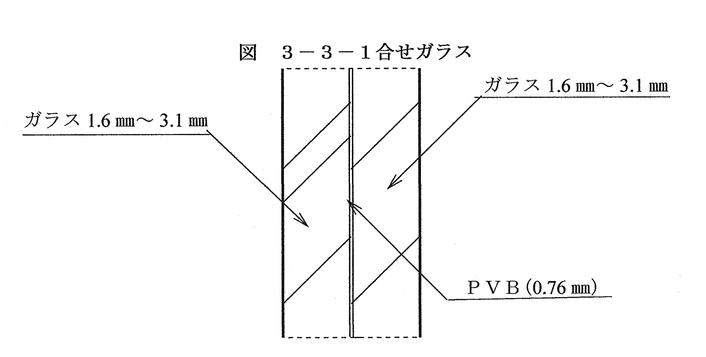
Figure 3-3-1 Laminated glass
Glass
Glass

Manufacturing process of the laminated glass
- Cut two pieces of rough plate into the same size/shape.
- Stamp marks onto one plate [for outer piece] and apply ceramic-print onto the other plate [for inner piece].
- After chamfering, heat and vent both of them adapting to the vending mold in the forming furnace.
- After cleaning, insert PVB sheet of 30mil thick [approx. 0.76mm] and apply pre-press.
- Apply load of approx. 15Kg/m² in the autoclave with 120 – 130ºC.
- Inspection, packing and shipping.

Figure 3-3-2 The manufacturing process of auto laminated glass
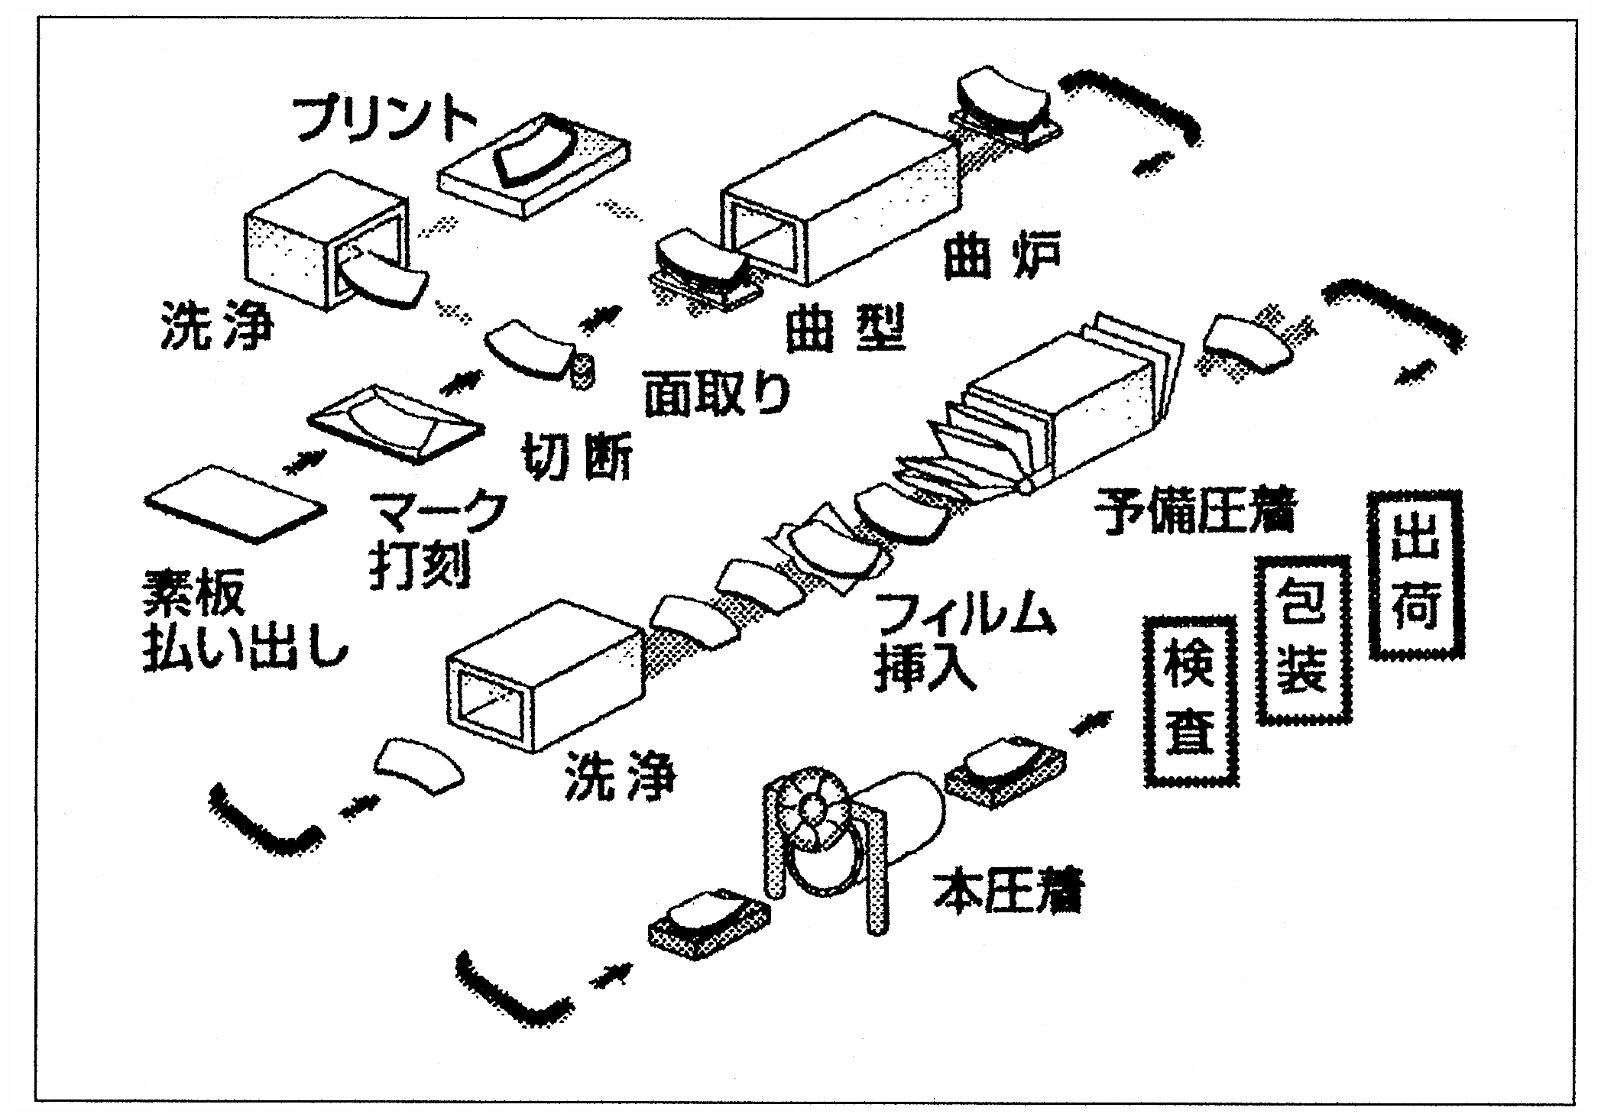
Pressing
Printing
Washing
Washing
Rough plate supplying
Marking
Cutting
Chamfering
Forming die
Forming furnace
Pre-pressing
Film inserting
Packing
Inspection
Shipping

Nature
- Excellent transparency
Because of using excellent plate (float) grasses and intermediate film (PVB) of high quality, it has transparency of the same level as normal plate glasses.
- No fragments scattered
In the event of being damaged, no fragments are scattered or fell down because of being supported by the stiff intermediate film.
- Uneasy penetration of impacting objects
Even if the outer glass was broken by some impacting objects, the inner glass would not be easily broken owing to the excellent penetration resistance of the intermediate film.
- Anti theft
Attempts of trespassing on the vehicles are uneasy because of the intermediate film..

Characteristics
-As use of thinner glass is becoming common recently, to reduce weight, careful and cautious operation, carrying and storage are required.
Ex. Actually a glass of only 4.3mm (1.6mm+ 1.6mm+0.76mmPVB) thick can exist.
-Tough gravel or something give impacts and make cracks on the glass, the visibility for safety driving can be maintained. However, variation of glass surface temperature by use of defroster or deicer will give the glass repeating expansion and shrink finally resulting in making the cracks extended.
-As a characteristic, small crack can be repaired.

3-4 Tempered glass
The plate glass whose strength is increased by process of rapid cooling after heated.
The tempered glass has higher strength than the normal plate glass to be able to bear a large variation of temperature.
In the event of being damaged, fragments will granulate (into the shape of dice) to relieve the danger of injury.
This glass was developed by Securit (a French firm) and has been used since around 1930.
In our country, the zone-tempered glass, which is partly broken into large fragments to maintain drivers’ sight, started to be used for the front glass along with the laminated glass on 1970. However as the whole of front glasses are regulated to be laminated on 1987, production of the zone-tempered glass ceased. For glasses, other than front glass, the tempered glass has been still used with some exception.
Manufacturing process of the tempered glass
1.Cut rough plates adapting to the vending mold.
2.After stamping marks, chamfer and ceramic-print..
3.Process (make holes and ceramic-print).
4.After heating the rough plates up to softening temperature (approx. 650ºC) by gas-flow method in the heating Lehr, adopt them to the vending mold by their own weight or press method. In the neighborhood of the outlet, cool rapidly by strong air-blow, etc.
*On rapid cooling process of the glass surface, thermal stresses are made by temperature gradient between the surface and inside of the glass. When the glass temperature came down to the ordinary level, the tensile stress will occur inside of the glass and the compression stress on the surface. Thus, the glass becomes tempered glass.
5. Inspection, packing and shipping
 Other than heating method, to get thinner tempered glasses for weight saving, the chemical method using chemical reaction between sodium and cerium can be capable.

Figure 3-4-1 The manufacturing process of auto tempered glass
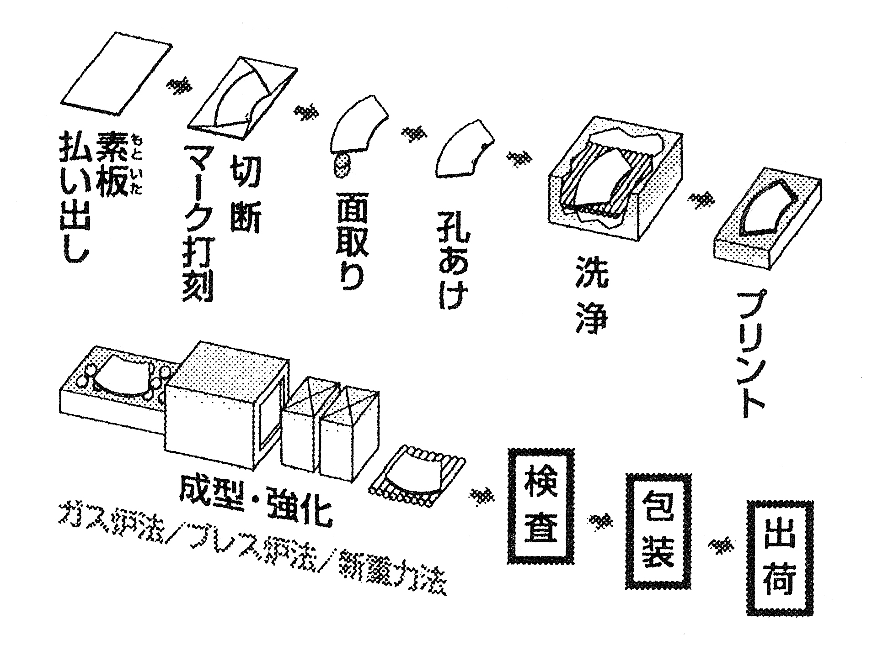
Shipping
Washing
Packing
Inspection
Forming ,Tempering
Rough plate supplying
Marking & cutting
Chamfering
Punching
Printing
Gas furnace/Press furnace/New own weight Method

Characteristics
1. As compared to the ordinary plate glass, the tempered glass has three to five times of impact resistance because of its strong surface tensile strength.
- In the event of being damaged, fragments will granulate (into the shape of dice) to relieve the danger of injury.
JIS R 3206 regulates the number of fragments: 40 or over within 50 X 50 mm tempered glass piece.
- The tempered glass has strong resistance to rapid temperature change.
Ex. In case of glasses of 5mm thick, the ordinary plate can be used only 60ºC at highest, while the tempered can be used up to 170 ºC.
- The tempered glass can not be cut because its inner stresses are balanced within whole of one piece glass. Therefore, it have to be cut with shrink margin considering heating and cooling process.
- The thickness of compression strain layer, from surface, is “15% of plate thickness”. If a crack exceeded this figure and reached extensile strain layer the glass would be instantaneously broken.
3-5 Front glass
Front glass of automobile is a very important part to maintain driver’s sight. It has been developed gradually and steadily according to the age’s requirement for safer, more comfortable reflecting automobile sales strategies. Front glass was regulated to be the zone-tempered glass or the laminated glass on 1970. The zone-tempered glass is made to be partly broken into large fragments to maintain drivers’ sight on the accident.
First, the laminated glass of (3mm+ 3mm+0.38mmPVB) thick was used. [Since 1987, use of the zone-tempered glass was ceased according to a JIS standard revised at 1979.]
However after the “Oil shock”, automobile manufacturers, who wanted to develop automobiles of better fuel consumption, planned weight reduction using thinner glasses besides of putting ideas on the automobile body, the metal parts. Automobile design was changed to be better on aerodynamics having less air resistance and the importance of glass was also increased. Especially the front glass is gradually considered as an important part structuring the whole of automobile body instead of a mere wind shield. And the adhesion type became the main fitting method of the front glass replacing the traditional gasket type.
Now front glasses of the most passenger cars, including the mini cars, are of adhesion [urethane] types and auto glass work firms and technicians are required to have much knowledge and information on safety work. [Ref. 4-1 Auto glass work method]

Genuine glass, Domestic non-genuine glass, Imported glass and Recycled glass
Now there are mainly fore types of glass merchandizes distributed for repair works.
Genuine glass
The glass which is used at automobile production lines made by the auto glass manufacturer according to the automobile manufacturer’s drawing. As it is originated with the master model of the automobile body, its fitting accuracy is already achieved. Quality Assurance [QA] is provided by the auto glass manufacturer and each automobile manufacturer’s logotype is stamped as the glass monogram. [Ref. 7-4 Identification of glasses P.90] Recently however, in case of the same type of automobile is sold by two or more automobile manufacturer’s sales channels or on in case of the OEM production automobiles, no automobile manufacturer’s name is described. Sometimes, glasses made at overseas plants, or at their subsidiaries’ plants, of the genuine auto glass manufacturer can be used on overseas production lines or partly on domestic production lines. In the case, the glass monogram is printed black instead of stamped.

Domestic non-genuine glass
Domestic production glasses, copied from genuine parts, with a little dispersion on the accuracy between manufacturers. As they meet the JIS standard, the glasses are widely acknowledged as substitutes for the genuine glasses. In addition, as their production cost, and so the retail price too, is low, many products are widely distributed. Even auto glass repair businesses use them.

Imported glass
Recently, auto glasses made in South-east Asian countries, China on their center, are becoming recognized in our country. There is some dispersion on the accuracy between factories and the difference between JIS and the countries’ own standards are not clear. And so, auto glass work businesses, must be responsible for the work, had hesitated to use them. However they started to use some imported glasses whose quality was confirmed. As their prices are low, the other businesses started to use them. Other big problem on the imported glasses is that timely responses to the automobile manufacturers’ engineering changes can not be easy with them.

Recycled glass [Used glass]
Recycle glass markets are completed in accordance with enforcement of the Automobile recycle law. Because of defects by flying gravel and windshield wiper, etc. on use or cracks on detaching work, generally speaking there is big difficulties on QA activities for their reinstallation work. Considering the PL law that is recently enforced and the responsibilities for the customer satisfaction, they can be said uneasy parts to accept for auto glass businesses.

Front glasses of special specifications

Glass with defogging and snow melting functions
HEATLITE W, THERLITE L
The laminated glasses with curled electric heating wires set on their intermediate films. The heating wires are too thin, called “Hair-line”, not to be recognized from distance of 30cm or more.
*They are also used for the snow removing vehicles/trucks.
Front glasses with deicers
Front glasses with deicing function set for automobiles of cold district version. There are heating wires printed on the lower part of the front glasses, snow bank near the windshield wipers. They have two types of fitting: 1.Inserting heating wires with the intermediate films. 2.Printing on the ceramic part of the inner glass.
*The way to distinguish glass marks [Ref. 7-4 Identification of glasses P.90]

Front glass with special functions
Front glass with the ”Head-up display”
Glasses which is metal-coated on the lower part, a little lower than the driver’s eye line, and have the function in which instruments and gages, such as speedometer and warning lamps, are displayed on the part.
*The way to distinguish glass marks [Ref. 7-4 Identification of glasses P.90]
Front glass with the mirror base/rain sensor
The type of automobile with its rear view mirror base attached on the inner surface of the front glass, instead of the inside trim of the ceiling, is increasing. Among such type of glasses, this is the type that the rain sensor base is set beside of the mirror base. The sensor detects rain falling automatically to make the wiper switch on.
*The way to distinguish glass marks [Ref. 7-4 Identification of glasses P.90]

UV protection and heat insulation glasses [high heat absorbing glass]
For front glasses, material with UV protection function or heat insulation effect are used.
*The way to distinguish glass marks, M number [Ref. 7-4 Identification of glasses P.90]

IR protection glasses [Infra Red ray protection glasses]
The laminated glass with Infra Red ray protection material kneaded into the intermediate film [PVB] to shut the ray out by 30%.

The glass with high heat insulation effect [Privacy glass/deep colored glass]
The glass with a little metal powder mixed in the raw material to absorb heat by ionic color development. It has larger effect than ordinary heat absorbing glasses, having visible light transmissivity of 70% or less.

Heat reflection glass
The glass reflects sun light to be able to prevent temperature inside of the automobile increase.

Low reflection glass
The glass processed of which the reflected figure of the dashboard does not easily reflect to inner surface of the front glass in the day with strong sun light.

Water repellent glass
The glass keeping better sight with water repellent effect with water repellent [silicon/fluorosis ] coated.
*M number has additional “.” with ordinary M numbers.

3-6 Door glass
Front door glass
They are side glasses for driver’s seat and assistant’s seat. JIS standard requires visible light transmissivity of 70% or more in the same manner for the front windshield glass. Normally the green glass of 4mm thick is used. As the glass’s visible light transmissivity is 79.9%, additional colored film coating is impossible under the regulation.

Rear door glass
They are glasses for doors back of the driver’s seat. As they have no requirements of JIS standard, on some models the deep colored glasses are set. Film coating is also available. When divided into two parts, the glass with up and down movement is called Rear door glass [RD] and fixed triangle shaped glass is called Rear quarter glass [RQ]
[Ref. 2-2 Basic knowledge on automobile P.34]

Slide glass
They are used much for one box commercial type van/wagon having two double sliding glasses [front & rear] or one of them slides in the metal frame. The frame, with glasses set in it, is bonded or installed with gasket to the automobile body. [Adhesive is usually butyl tape or urethane adhesive. ]

3-7 Side glass /Rear glass
Side glass fitting methods are the bonding [urethane adhesive], the screw fitting and the gasket fitting. For the bonding and the screw fitting, ceramic is printed generally and in many cases they are set in module or assembled. In many cases of the gasket fitting, glasses with no ceramic printed are fitted with weatherstrip.
Rear glass fitting methods are the bonding [urethane adhesive], gasket fitting and the screw fitting in which only glass is available to open/close [generally called: Glass hatch].

What is the module glass?
It is the glass/molding set which is formed in one-pierce on the production process. As it is formed in one-pierce, whole of parts have to be replaced when the molding part is damaged during detaching work. Therefore, basically no detaching work should be recommended.

What is the assembled [Assy] glass?
It is the glass with [clips for glass installation, moldings for setting clips and stoppers directly bonded to the glass] set in advance. In case of the bonding, if no moldings, clips and stoppers are prepared, the work has to be done very carefully.
* The way to distinguish glass marks of the module, the assembly glass [Ref. 7-4 Identification of glasses P.90]

Front venti [ventilation] glass
It is the glass of the front part of the front door glasses, becoming to be used much for wagon type and SUV type automobiles. Many of them are bonding [urethane adhesive] of module glasses.

Side glass [Quarter window glass, Side window glass]
They are basically the rear most side glasses for 2 box types or 1 box types of automobiles. Fitting methods are the bonding [urethane adhesive], the screw fitting and the gasket fitting..
For the bonding and the screw fitting, there are without-molding type [Assy glass] and with-molding type [Module glass or Assy glass]. The color of glasses are vary, such as privacy glasses [deep colored glass, heat reflecting glass], green glasses and UV protect glasses. For wagon type automobile, there is the glass with the radio antenna wire printed on the surface.

Rear glass [glasses with heating wires printed]
It is the tempered safety glass with conductive ink [as the heat source] baked on its surface and then copper/nickel plated on it. With switch-on, the glass is warmed to keep rear view sight, effective for the mist and the snow and the ice. No danger of electric shock or burn when touched by hands. In some cases, the diversity antenna or the TV antenna are printed on the glass. There are a few glasses with no printed nor ceramic printed. Also in small case, the laminated glass is used.

The glass used for the side/rear glass
UV protect glass
It is the glass with special material coated to protect UV. It is used for glasses except front glasses on all automobile models.
* The way to distinguish glass marks and M numbers [Ref. 7-4 Identification of glasses P.90]

Privacy glass
It is colored [deep colored] or metal coated [heat reflecting = half mirror] glass keeping the privacy inside of the automobile, shading the sun light and controlling inside temperature to maintain a comfortable ride.
Ex. deep gray glass, deep bronze glass, heat reflecting glass.
* The way to distinguish glass marks and M numbers [Ref. 7-4 Identification of glasses P.90]

Water repellent glass
It is the glass with the water repellent material [silicon/fluorine type] coated to keep better sight by the water repellent effect.
* M numbers are not differ from ordinary M numbers.

Chart 3-7-1 Optical nature and performance of various glasses
 | Kind of glass |  | Thickness  (㎜) | Visible-Light transmissivity  (%) | Infra-Red transmissivity  (%) | Ultra-Violet  transmissivity (%)
 |  |  | 2.8 | 77.6 | 53.8 | 15.2
 | Tempered glass | UV cool green | 3.1 | 75.4 | 49.0 | 10.0
 | Tempered glass | UV cool green | 3.5 | 74.4 | 47.1 | 9.7
 | Tempered glass | UV cool green | 4.0 | 72.8 | 44.5 | 8.2
 | Tempered glass | Green | 2.8 | 83.1 | 66.7 | 41.2
 | Tempered glass | Green | 3.1 | 82.2 | 64.4 | 37.8
 | Tempered glass | Green | 3.5 | 81.0 | 61.5 | 33.7
 | Tempered glass | Green | 4.0 | 79.9 | 56.5 | 29.2
 | Tempered glass | UV bronze | 3.5 | 73.7 | 71.2 | 10.0
 | Tempered glass | UV bronze | 4.0 | 72.9 | 70.9 | 8.7
 | Tempered glass | Bronze | 3.5 | 80.1 | 73.5 | 41.2
 | Privacy glass | Deep bronze | 4.0 | 62.1 | 62.0 | 23.0
 | Privacy glass | Deep gray | 3.1 | 24.6 | 21.3 | 5.1
 | Privacy glass | Deep gray | 3.5 | 20.8 | 17.8 | 3.2
 | Privacy glass | Deep gray | 4.0 | 16.8 | 14.2 | 2.8
 | Privacy glass | Deep green | 3.5 | 39.6 | 29.8 | 5.1
 | Privacy glass | Deep green | 4.0 | 37.7 | 27.7 | 4.4
 | Privacy glass | Heat reflecting deep bronze | 4.0 | 26.7 | 35.5 | 7.0
 | Privacy glass | Heat reflecting deep gray | 4.0 | 19.3 | 26.9 | 7.7
 | Privacy glass | Heat reflecting deep green | 3.5 | 33.1 | 30.5 | 9.7
 | Laminated glass | Green + green  UV green + green  High heat absorbing green + clear | 4.7 | 78.3 | 53.9 | 0
 | Laminated glass |  | 4.7 | 74.6 | 47.2 | 0
 | Laminated glass |  | 4.7 | 79.0 | 55.0 | 0
* Data was offered by Asahi glass Co., Ltd.

Chapter 4 Auto glass work
Auto glass technicians have to steadily learn various methods and technique on the work. Also pre-work study on the automobile is necessary: glasses and parts used for the automobile and fitting way to the body. You will learn working technique and adhesive.

4-1 Auto glass work method
There are mainly three methods of glass fitting to the body, gasket [weatherstrip] fitting, direct glazing and screw [bolt] fitting.

4-1-1 Gasket [weatherstrip] fitting
The weatherstrip fitting method, generally using rubber products, provides airtightness and a little increase of body strength when applied for fixed type glasses. Up to 1970, the weatherstrip fitting method was used for almost 100% of domestic automobiles. Nowadays, it is used for the freight automobiles, such as trucks.

Glass
Gasket
Body

Body

Direct glazing method
On the direct glazing method, the glass is directly fixed with adhesive after removing the old adhesive from the body. The method started to be used for new models on 1970, replacing the old type of glass fitting method. It provides many advantages such as weight saving for better fuel consumption, cost saving, realization of simple production process, use of robots and expansion of flexibility on body design work.
Glass
Body
Adhesive
Glass
Body

Adhesive
Molding

From weatherstrip to direct glazing
A rapid shifting of the fitting method, from weatherstrip to direct glazing, started at 1970. Nowadays, many automobiles use the direct glazing method. However, contrary to the expected advantages at the early stage, there appeared some problems. For example, the adhesive of early stage was three-part type that was expensive and uneasy to save time and material. On rust prevention problem, some new automobiles showed rust on the flanges, on which the glasses are fitted, within 1 year of use. These were fatal problems for automobile manufacturers. As the result, many studies on the improvement of adhesive, the rust prevention method at the fitting flanges, material, shape and fitting way of moldings and pins for them have been implemented.

4-1-2 Vicissitude of auto glass direct glazing adhesive
Since automobile manufacturers started direct glazing method, changes on direct glazing adhesive was only “Thiokol to urethane material”. Even Thiokol was used shortly in the early period and urethane material has been mainly used on manufacturers’ production lines. On the other hand at the repair work business, there was a big vicissitude of adhesive, from butyl material to silicon/metamorphism-silicon material to urethane material. This is because urethane material became easy to be purchased and used by auto glass repair businesses besides its performance was improved.
When the direct glazing method was first introduced, many repair firms did not use Thiokol because of problems uneasy to be solved, such as uneasy handling [as it was still three part type], higher cost, uneasy to purchase and difficulty on inventory management.
The direct glazing method was used in the USA in advance of Japan using the butyl tape as its adhesive. As the butyl tape was further better than Thiokol on its handling, cost and management, it became the main adhesive material used in Japanese repair business at first period. Problems of Thiokol, such as poor handling, also made the automobile manufacturers shift to newly developed urethane material as they always have to seek cost saving and better handling of the material. On the shifting to the new material, at that time, one of their most important requirements was to have “strong adhesiveness”. At that time, automobile manufacturers in the USA did not consider the weight saving seriously because they have not be very nervous of fuel consumption problem yet as compared to Japanese makers. Therefore, as their automobile bodies had enough rigidity than Japanese bodies, they did not need to make stiff requirements to adhesive material of its resiliency and adhesiveness. On the other hand, Japanese automobile manufacturers have to consider the weight saving, for solicitude about fuel consumption, which finally resulted in bodies a little weaker than that of the USA. Therefore, Japanese automobile manufacturers expected the method in which glasses bonded on the bodies share the part of sustaining rigidity. For that purpose, strong resiliency and adhesiveness are the necessary condition of the direct glazing adhesive. This was a basic idea at the beginning of the direct glazing method and, needless to say, Thiokol, the first adhesive used, has enough power fulfilling the condition. On the other hand, the butyl tape, widely used in the USA, has little resiliency besides less adhesiveness and weather resistance than the level of Japanese automobile manufacturers expected. There appeared the adhesive of silicon material.
The adhesive of silicon material had better weather resistance, resiliency and adhesiveness than the butyl tape. Especially, silicon material’s weather resistance was above all material and UV resistance was better than urethane. As it also can be used to every material as objectives of adhesion, the glass repair businesses began to use for its better handling.. Later metamorphism silicon, in which adhesiveness and resiliency are improved, is started to be used. However, silicon adhesive material had a fatal disadvantage. It had entirely no ability of successive joint. Once repaired with the silicon adhesive, it had to be completely removed when another repair work was needed. So it took much time for repair work and as another demerit, the silicon chemistry flew out by rain, stuck to the glass surface and prevented driver’s sight.
On the automobile production line, urethane adhesive material was improved to gradually fulfill automobile manufacturers’ requirements. And finally one part type of urethane adhesive material was invented and started to be used on the production line. One year later, supply of the material, to the repair businesses, started to resolve primitive problems of performance, cost and control. Thus, urethane adhesive material, with enough adhesiveness and resiliency fulfilling automobile manufacturers’ requirements, has established in the repair business world.

History of direct glazing adhesive on the automobile production line
- Thiokol 3 part type [Poly-sulfide material]
First domestic product used in Japan

1974 Urethane 2 part type adhesive
Expecting cost saving as compared to Thiokol
- Urethane 1 part type adhesive
No stirring loss and quality improvement as compared to 2 part type
1980 Urethane 1 part plus rapid hardening type adhesive
Improvement of the initial lasting power [adhesiveness]
Domestic automobile manufacturers have used Urethane 1 part type adhesive.

History of direct glazing adhesive on the auto glass repair work
1970 Butyl tape [Ribbon sealer]
Thiokol 2 part type
Does not harden [Butyl tape] Adhesive defect caused by poor stirring occurred.
1973 Silicon sealant
Contribution to the body strength and simplification of manufacturing process by hardening type adhesion – cost saving was planned.
1980 Urethane adhesive 1 part type
Aiming the improvement on adhesiveness [sharing strength] and successive joint
[Re-adhesiveness]. -- Contribution to the body strength
Metamorphism silicon adhesive
Aiming the improvement on corrosion resistance. Countermeasure for UV on exposed adhesive parts of special purpose vehicles.
1982 Improved urethane adhesive 1 part type
Aiming the improvement on adhesiveness and workability

We, glass repair firms, have to recover the lost performance of the customers’ automobiles up to the original level or above, as our duty. We have to well understand why the automobile manufacturers use the urethane adhesive to make an adequate repair work not to lose its performance as possible as we can. For that purpose, we should study and understand the “Directions for use” of each adhesive released by various manufacturers. And we should keep “to bring out the performance of adhesive enough” in our mind on the repair work. Also as JASO [Japanese Automobile Standards Organization] publishes adhesion performance data, we should recognize it as an important part relating to the automobile safety.

4-2 Preparation for auto glass work
To obtain the end-users’ trust, you have to consider your position and duty on the whole of works before beginning. Your each basic motion has to reflect your customers’ expectation and reliance. Therefore, the care/follow activities, “Before care” and “After follow”, are essential. Among them, “Before care” is more important than “After follow” because the complete “Before care” makes the “After follow” easier. While no “Before care” takes much time on “After follow”. It can be said that the “Before care” rules the result of work.
Then what should we do? [Ref. Chapter 7 Customer service P.86]
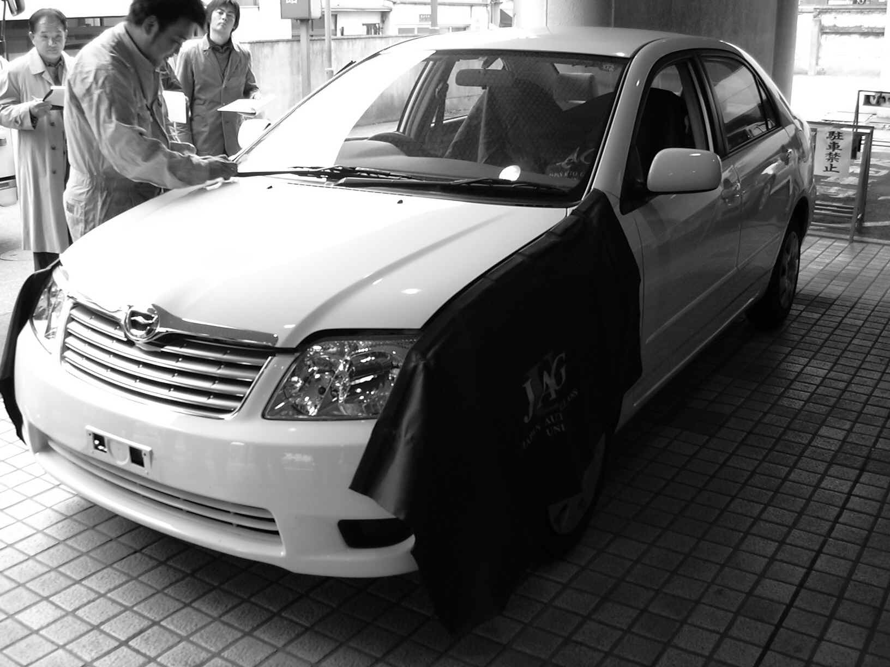
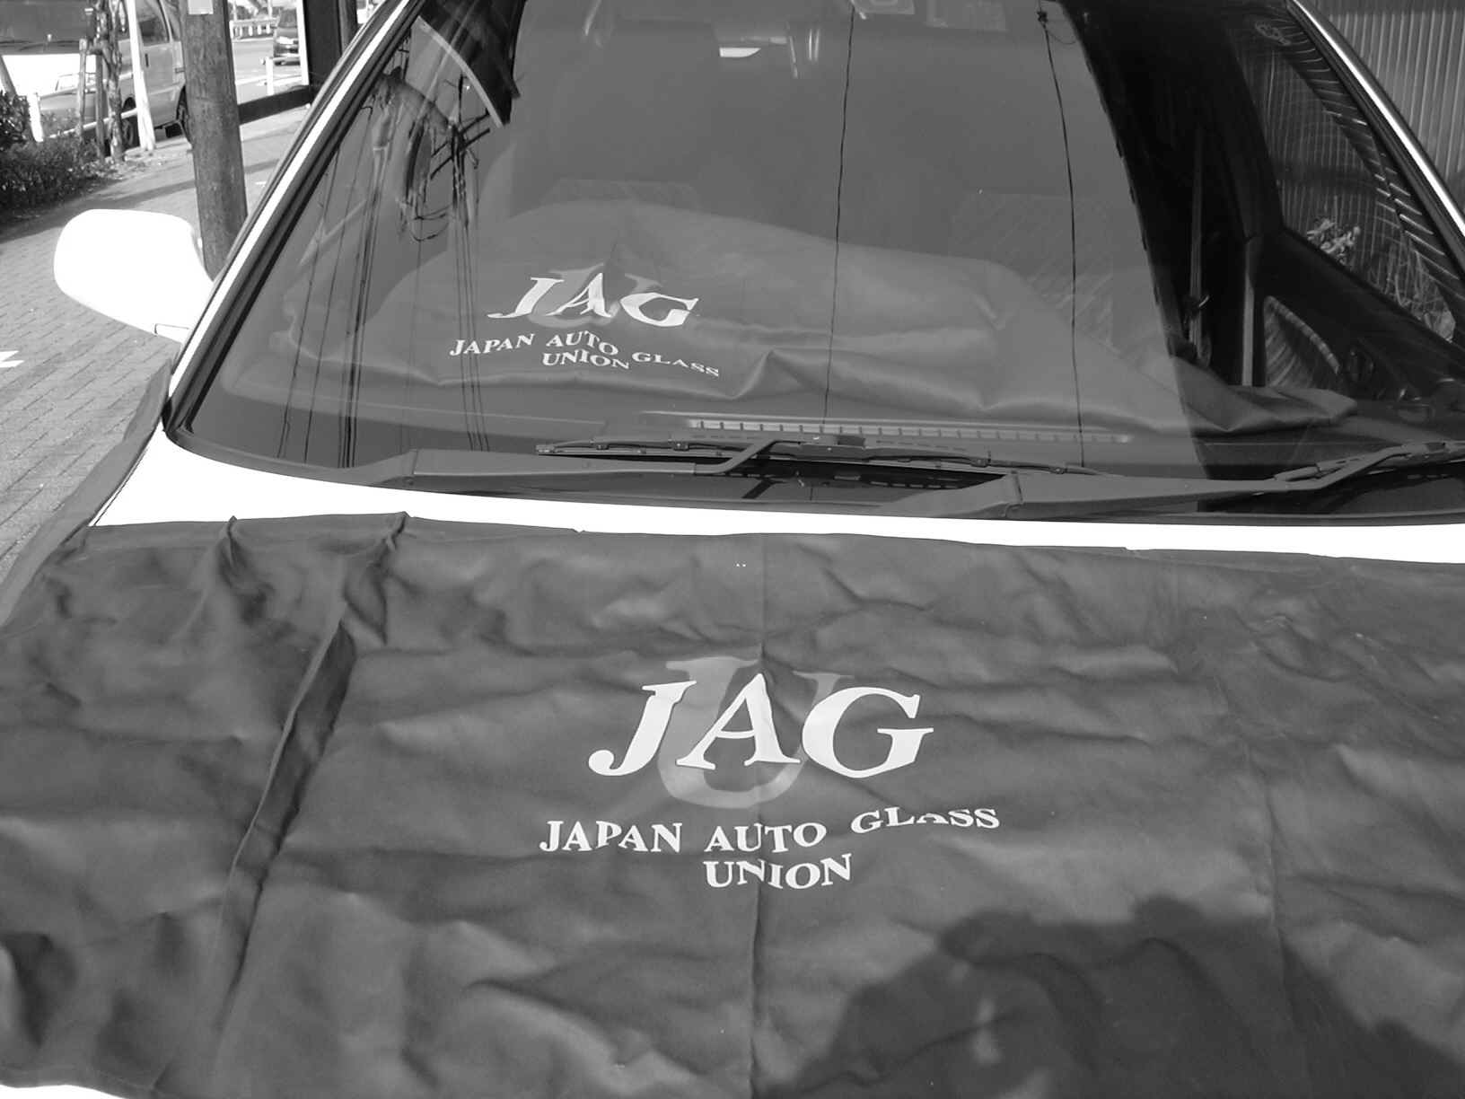
(1) Record the contents of before-work arrangement with the client, make work direction sheet and confirm connection on the emergency. [Cell phone number etc.]
(2) Identify the parts, such as glasses and moldings, necessary for work. [Confirm genuine parts number, product number]
[Search parts number from Vehicle registration number, Chassis number, Model year, Official model number, Official category number, DOT number, M number]
(3) Keep the spaces for the safety work.
[Confirm with RH/LH doors fully open. Check and remove dangerous items.]
- In winter season: If stoves or jet heaters are not set near by.
- The spaces, on which the automobiles are set, have to be even.
- [In case of the automobile is set near the lifts or frame adjusters, ask to replace it. ]
(4) Confirm brake and/or P [Parking] shift for the safety work.
(5) Check the automobile body [Check damages]
- Set damage protection for interior of the automobile [Seat cover, Foot mat, Dashboard cover]
* Steps should be covered with protection tape.
- Set damage protection for surrounding area of work.
[Protection tape on the peripheral area of glasses and body]
- Cover the defogger hole with tape to avoid invasion of glass fragment and adhesive.
[Add to dashboard covering]
- Prepare equipment and tools
[Glass table, detached parts box, rejected parts box, safe storage, etc.]
* Camera is necessary with the work on the insurance.
- In case of cooperation work, confirm each members’ sharing work.
- Confirm the moldings on detach/re-install work.
[Especially, with moldings supplied by clients, be very careful]

4 – 2 – 1 Work on Front Glass (Windshield)

Work on Weatherstrip

* Keep all parts removed in accordance with the following procedure in a safe place.

- Remove the wiper arm covers using a plastic blade with care not to scratch the covers.
- Remove the nuts fixing the wiper arms with a box wrench, and remove the wiper arms with a special tool to remove wiper arms.
- Remove the pins holding the cowl top cover with a plastic blade taking care not to damage the cover.
④ Take off the horizontal inner linings (right and left side) using a plastic blade and wearing work gloves not to make the linings dirty.
⑤ Remove the rear view mirror, often called as a room mirror or inner mirror.
⑥ Go out of the room and cut the adhesive inserting the plastic blade into the contacting line of the weather strip and body.
⑦ In the room, inserting the plastic blade into the contacting line of the weatherstrip and body to dislocate the weatherstrip and push the glass plate outside. Repeat this work until upper and vertical edges of the glass come out.
- Stop the pushing work when the upper and vertical edges are dislocated, and go out of the room and then slowly take off the glass together with the weather strip sticking around the glass.
- Remove the adhesive sticking to the body with the plastic blade. Remove the residual adhesive using white gasoline, then clean the surface of the dashboard.
* If rust and/or deformation is found on the body, inform the client of the fact and wait the client’s instruction.
(Refer to Chapter 5 Page 79 and Chapter 7 Page 102)
- Putting the glass on the work table and remove the weatherstrip.
* If the glass has broken, remove the broken chips of the glass and residual adhesive with appropriate tools such as the plastic blade and air tools to clean the groove of the weatherstrip.
⑫ Clean the glass with the glass cleaner or white gasoline, etc., and then fitting the corners of the glass to the corners of the weatherstrip to make the line of the rubber to fit to the original position, assemble the weatherstrip to the glass.
⑬ Attach the fixing string to the weatherstrip with the plastic blade.
⑭ Apply the adhesive, if necessary, along the contacting line between the weatherstrip and the glass and between the weatherstrip and the body.
⑮ Using vacuum cups on the glass sheet at right and left sides, adjust the glass onto the body to fix it.
⑯ In the inside of the room, adjust the width of the weather strip evenly toward the upper, lower, right and left sides, and then pulling the fixing string to remove, press the weatherstrip with fingers to fix it to the body.
⑰ Remove the adhesive running off from the line of glass or body with white gasoline, etc., and clean with the glass cleaner, etc.
- Assemble those disassembled parts in items ① through ⑤.

H Type Rubber Method

* Disassemble part in accordance with the following procedure, and keep all of them in a safe place.
① Remove the wiper caps using a plastic blade with care not to scratch the covers. Remove the nuts with a box wrench, and remove the wiper arms with a special tool to remove wiper arms.
② Remove the trim boards (inner linings) around the repairing area.
③ Take off the rubber core in the center of the H type rubber material using the special driver shown below or the plastic blade.
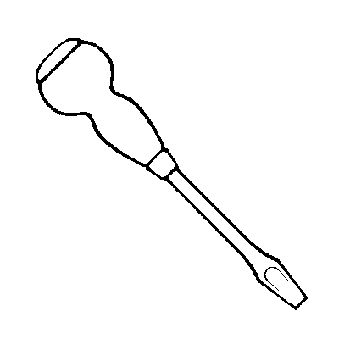
～ Special driver (shown below) ～
④ Cut off the adhesive between the glass and H type rubber material with the special driver or plastic blade, etc.
⑤ Peeling the upper edge of the H type rubber material off using the special driver or plastic blade, etc., push the glass out from the inside of the room.
⑥ Take off the glass from the outside of the room.
* If the glass has broken, clean the inside of the room and if a dashboard is installed, clean its upper surface.
⑦ Remove the H type rubber material from the body, and wipe to clean the body side of the H type rubber material with white gasoline or the like.
* If the glass has broken, clean the groove of the H type rubber material with the plastic blade or air tools, etc. to remove broken glass pieces and adhesive.
⑧ Check rust, deformation and etc. of the body.
* If rust, deformation, or the like is found, inform the client of the fact and wait the client’s instruction.
⑨ Install the corner of the H type rubber material to the corner of the body in parallel.
⑩ Apply lubricant to the H type rubber material for easy insertion of the glass.
⑪ Set the glass in the H type rubber material at the lower corners eliminating clearance using the plastic blade or the like by peeling the portion, push the H type rubber material to the vertical portion of the glass evenly widening the groove of the H type rubber material with the plastic blade etc., and then finally widen the upper edge of the H type rubber material to push the edge of the glass evenly.
- Wipe the lubricant between the H type rubber material and glass and between body and glass applying white gasoline, etc. to clean, and then inject the adhesive therein.
⑬ Apply lubricant to the groove for the rubber core of the H type rubber so that the rubber core can be easily installed in the groove using the special tool without pulling the core.
⑭ Clean the adhesive running off around the glass with white gasoline or the like.
⑮ Clean the glass using the glass cleaner or the like.
⑯ Install the parts mentioned in ① and ②.

4 – 2 – 2 Direct Glazing (Adhering)

Depending on the handling method of the adhesive, the weather condition may affect the work performance.
On working, refer to the adhesive manufacturer’s and automotive manufacturer’s instruction with regard to the temperature and humidity under which the products are used.
(The procedure to fill the adhesive to glass side is listed below.)

* Disassemble the parts in accordance with the following procedure, and keep all the parts in a safe place.

① Check if the new glass is equal to that installed on the repairing automobile. When disassembling and disassembling, check existence of flaws and dents caused by flying pebbles.
② Remove the inner liners and Rr. View mirror. (Take care not to scratch or damage.)
③ Remove the wiper arms and cowl top. (Take care not to scratch or damage.)
- Remove the mouldings.
* If the mouldings are made of non-reusable vinyl, cut them with a knife.
* Remove mouldings to be reused with a molding-remover not to scratch them.
- Remove the Fr. Glass.
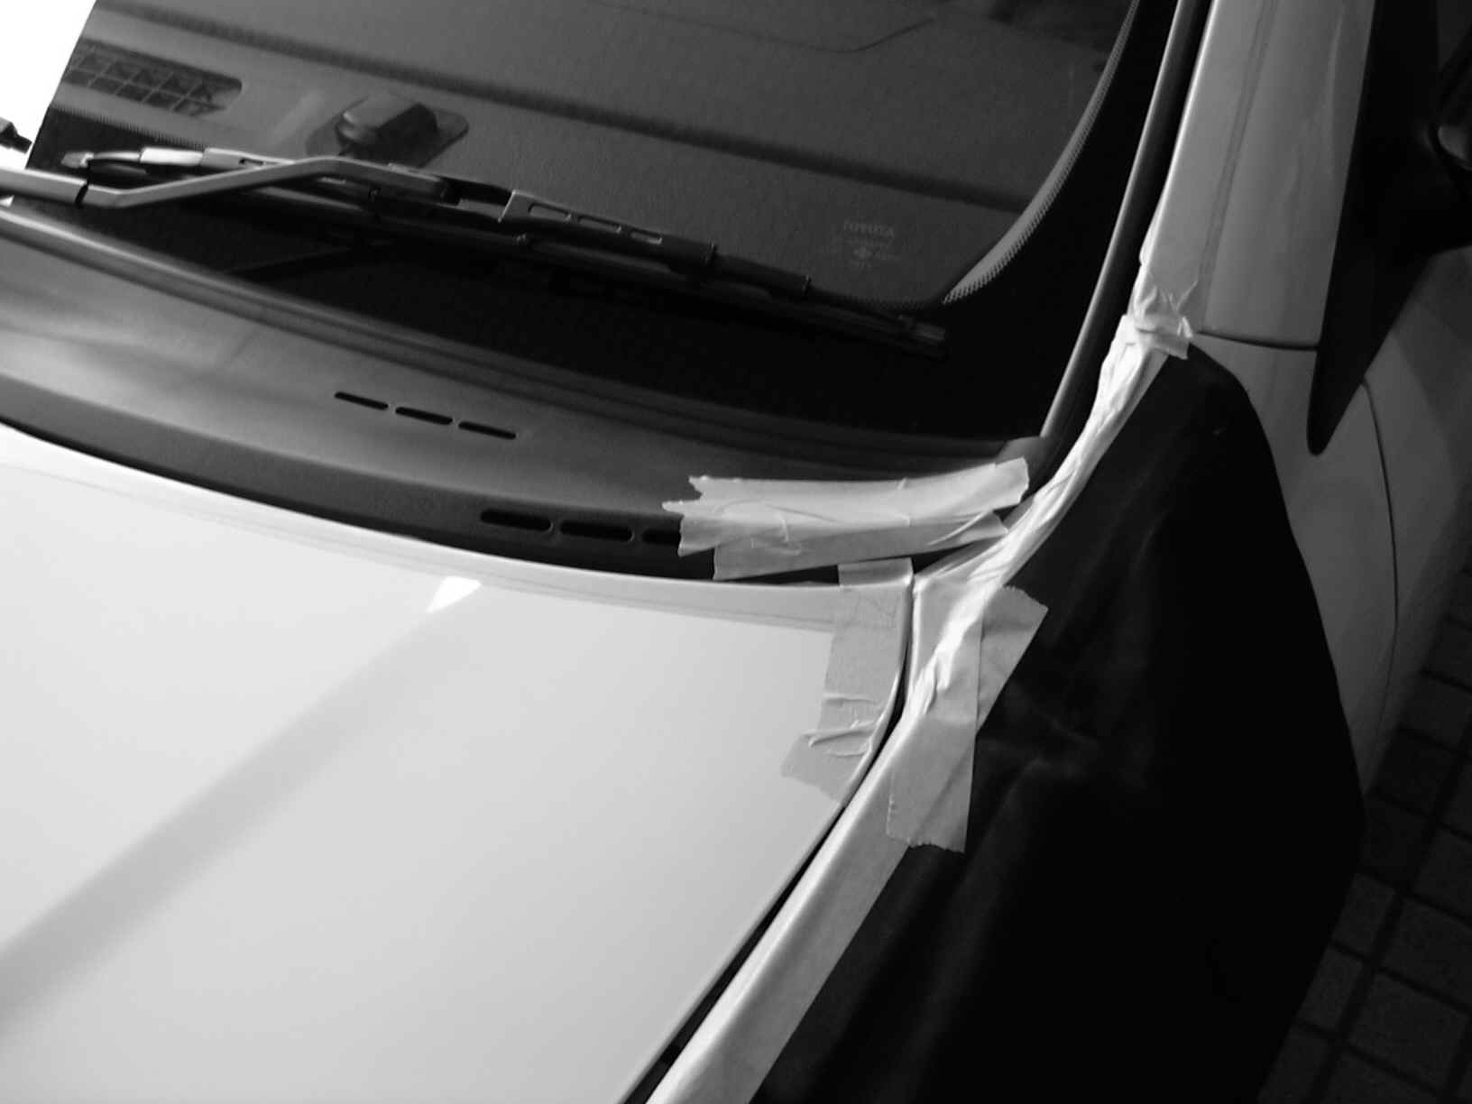
* Before removing, attach protective tapes or the like on the glass and body to prevent scratching.
* Insert a knife in the adhesive fixing glass, move the knife vertically against side surface of the glass to cut the adhesive. Pierce a piano wire through the adhesive with the piano-wire piercing tool (wire-pierce); fix both ends of the piano wire with wire grips; and remove the mouldings from the body by way of pulling the attaching line to glass and adhesive.
* Attach vacuum cups on the glass and remove the glass from the body.

⑥ Remove the adhesive on the body leaving its thin layer 1 to 2 mm not to scratch the body and not to scrape the paint layer with the scraper or knife. (If scraped the paint, apply rust-preventive agent.)
⑦ Take off glass pieces, adhesive residues and dirt, and remove dust and smear with a brush or air tools.
⑧ Clean the body with white gasoline or the like.
* If rust, deformation or the like is found on the body, inform the client and wait the client’s instruction.
⑨ Clean the adhering surface and circumference of the new glass.
* Take off the residual adhesive on the glass to be reused with a knife.
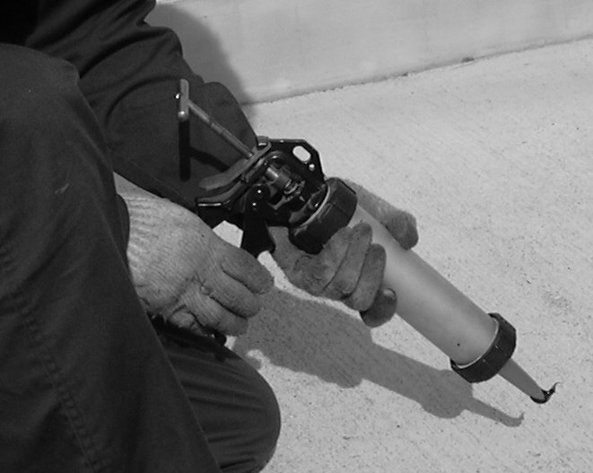
⑩ Apply the primer on the glass and body.
* Do not apply too thick, and do not apply on the adhesive.
* Comply with the adhesive manufacturer’s specifications.
* Attach the dam rubber and attachments on the glass. (In the case where the adhesive is filled to the glass side.)

⑪ Attach the vacuum cups on the glass.
⑫ Fix the glass onto the body temporarily.
⑬ Set the glass on the body at even locations of upper, right and left side, and put marking at two upper positions.
⑭ Remove the glass from the body.
* Attach those parts, labels or stickers which have been removed beforehand on the glass.
⑮ Apply the adhesive to the glass in accordance with the specification of the automobile model.
* In accordance with the adhesive manufacturer’s specification.
⑰ Install the glass on the body.
* Push the entire glass lightly, and adhere it tightly to the adhesive.
Note: Never move the glass fore and aft after installing the glass. Otherwise, the new adhesive may relocate and cause water leak or other defectives.
* To work on the windshield glass may requires two technicians.
* Retouch the areas with insufficient adhesive using the plastic blade or the like.
⑱ Install the mouldings
* Be careful about the mouldings, because some mouldings should be installed on the glass before fixing the glass.
* After fixing the glass tightly to the body, install the mouldings quickly.
* Press the mouldings and glass with protective tape or the like until the adhesive becomes hardened.
* Open the door glass until the adhesive become hardened.
⑲ After removing the adhesive running off from the mouldings and glass with white gasoline or the like, install the cowl top and wiper arms. (Be careful not to scratch them.)
* Before attaching the wiper arms, drive the wiper shafts for movement check. (If it is assumed that the setting position is dislocated, adjust the location to the original set position checking the wiper shafts only.)
⑳ Conduct visual check on water leakage, and clean all over.
(21) Inform the driver of the automotive of the required waiting time in writing until safe driving becomes possible.
(List necessary items such as the name of used adhesive, required hardening time, etc.)

4 – 2 – 3 Work on Door Glass

The work on the auto glass is not only on the windshield glass.
- The procedures for removing and exchanging the auto glass which is mechanically fixed.
- The way how to remove and exchange movable glass is explained.

* Keep the parts removed in accordance with the following procedures in a safe place.

Remove the adjacent parts which otherwise disturb the work such as the adjusting panel, arm rests, handles, glass run channels, etc.
- Attach preventive tape on the sides, and remove the inside handle bezels and assist grip covers of the door inside handles with the plastic blade.
- Remove the trim boards, door service hole covers. (Be careful neither to scratch nor to damage them.)
- Remove screws with the cross driver.
- Remove the glass stoppers (used for adjusting glass), door window frame mouldings.
- Remove the door outside mouldings (mouldings with water-preventive rubber for door glass). (Be careful not to break the pins.)
* In some cases such as the work shown in the photo, it may be easier to work with bare hands to handle small and fine parts such as removing small screws, but be sure to wear gloves whenever the job includes dangerous work.
- Remove the door window regulator and glass fixing nuts (and bolts).
- Remove glass.
* Remove the door window division bar if installed.
* If not damaged, remove the glass from the door and keep it in a safe place.
* If damaged, remove the regulator, glass run channels and trim cover (plastic sheet) inside of the automobile, and clean with a cleaning machine.
* Check if the glass run channel is reusable.
⑧ Install glass.
* Install the glass carefully not to scratch the body hitting with the glass.
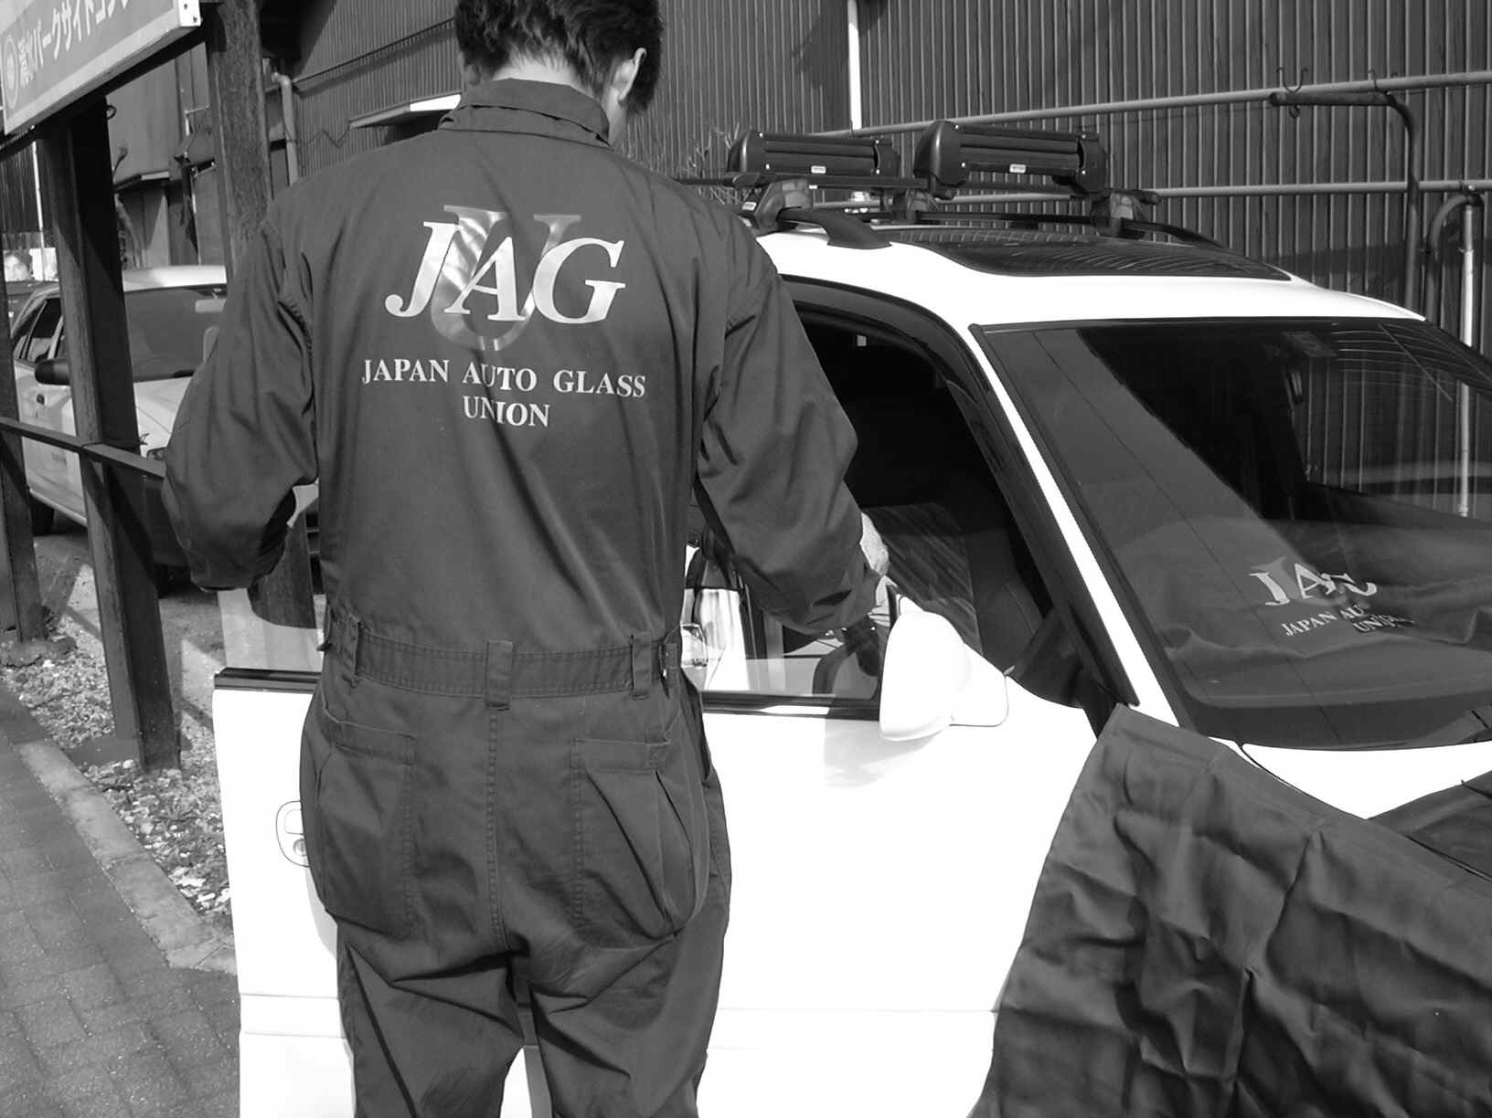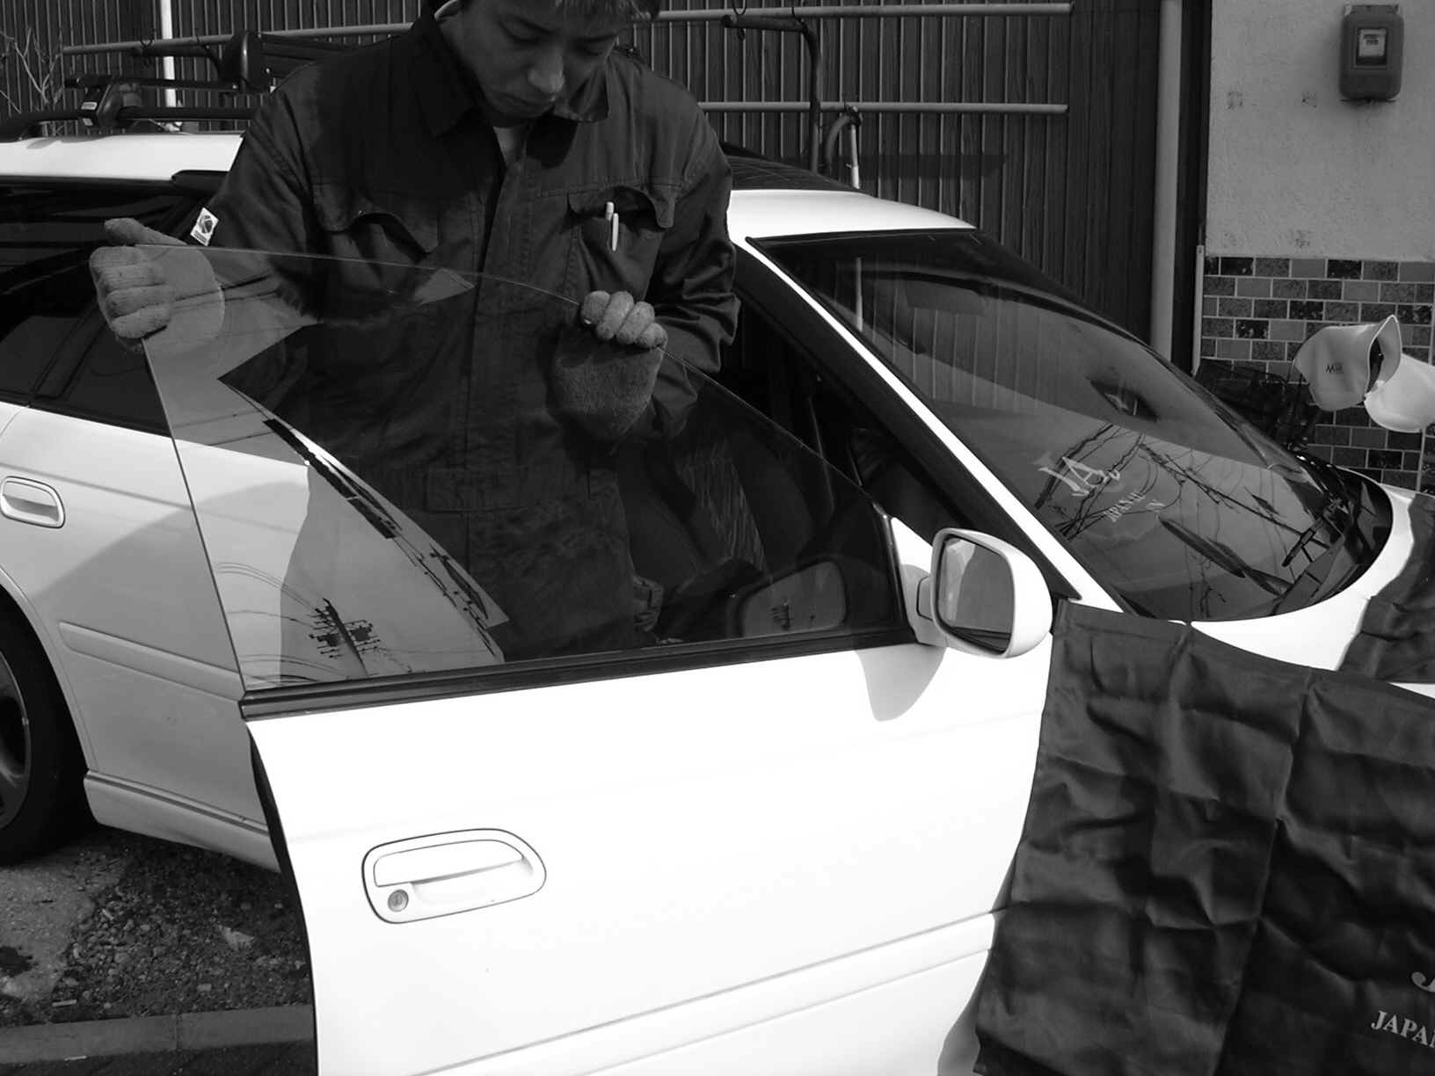

⑨ After checking the nuts are not defective, tighten them.
⑩ Conduct fitting adjustment of the glass.
1. Adjustment of glass posture (front downward, rear downward)
2. Adjustment of glass tilting
3. Adjustment of glass up and down
4. Adjustment of glass back and forward
* Be careful to adjust correctly depending on each brand. (Each brand has its own adjusting method.)
⑪ Check water leak.
⑪ Install the inner linings.
Note: Be careful if the automobile is installed with a safety gear to prevent being nipped. If such gear is installed, it is necessary to reset the regulator, to recheck with the testers or to be reset by an automobile sales dealer. Therefore, adjust it in accordance with the specification and instruction.

4 – 2 – 4 Work on Side Glass / Side Window, and Rr. Glass

Work on Side Glass (Weatherstrip)

* Remove the parts in accordance with the following procedure, and keep all of them in a safe place.
① Remove the screws fixing the seat belt at the side glass with a proper tool such as ratchet wrench or box wrench.
② Remove the rear seat cushion cover pads, rear seat back rest and rear seat hinge.
③ Remove the side trim cover (inner side lining) using the plastic blade taking care not to damage it.
* If a heating wire and/or antenna terminal is built-in, be careful not to apply strong force to disassemble. (Take care not to disengage the terminals.)
④ Go out of the room and cut the adhesive inserting the plastic blade into the contacting line of the weatherstrip and body.
⑤ In the room, inserting the plastic blade into the contacting line of the weatherstrip and body to dislocate the weatherstrip and push the glass outward. Repeat this work until upper and vertical edges of the glass come out.
- When the upper both sides of the weatherstrip have been opened, do not push the glass.
* Check deterioration of the weatherstrip.
* If the glass has broken, remove the weatherstrip slowly with care, and remove the glass pieces and adhesive remaining in the weatherstrip using the plastic blade or air tools.
⑦ Remove the weatherstrip as being attached to the glass.
⑧ Remove the legal seal (a certification of parking space) and the like from the surface of the glass removed as above.
* If the seals are not reusable because of damage due to broken glass, submit reissue request to the proper police.
⑨ Wipe out the adhesive from the body using white gasoline etc., and check existence of rust and flaws on the body.
* If finding abnormal conditions on the car, immediately inform the client of the fact and wait the client’s instruction.
* If the body condition is repairable by the glass repair shop, work on the body repair.
⑩ Clean the inside of the car with air tools or sweeping machine.
⑪ Remove the oil film or the like on the glass to be installed wiping away with the degreasing agent, etc., and check existence of flaws.
⑫ Attach the weatherstrip evenly around the glass to be installed.
* Fit the upper and lower corners of the weatherstrip to that of glass.
⑬ Attach the vacuum cups on the glass, and temporarily fit the glass to the body to check its fitness.
⑭ Place the working string to the weatherstrip using the plastic blade or the like.
⑮ Using the vacuum cups, mount the glass onto the body, and fix the weatherstrip to the body by pulling off the working string into the inside of the room.
* When applying the adhesive on the weatherstrip, fill the adhesive into the groove of the weatherstrip opening the groove with the plastic blade taking care not to put the adhesive on the glass. (In the case of filling the adhesive after fitting)
⑱ Wipe and clean the adhesive running off from the glass, weatherstrip and body with white gasoline or the like.
⑲ Install the side trim covers. Install the rear seat cushion cover pads, rear seat back rest and rear seat hinges.
⑳ Peel off the applied tape on the repairing car body. Clean the residual adhesive and dirt on the body. Clean the glass. Go inside of the room, and fix the heat wire and antenna terminal.

Fixing with Screw

* Remove the parts in accordance with the following procedure, and keep all the parts in a safe place.

① Remove the seat belt. Remove the rear seat cushion cover pads and rear seat back rest, and the roof-side inner garnish.
* If a heating wire and/or antenna terminal is built-in, be careful not to apply strong force to disassemble. (Take care not to disengage the terminals.) If difficult to work on that, contact the client.
② One of the technicians: Remove the screws, nuts and bolts using cross drivers or the like to disassemble the glass in the room; another technician: cooperate the technician for removing the glass carefully using the vacuum cups outside of the room to prevent the glass from falling down.
* To avoid any dangerous situation, sometimes two technicians conduct the outside work together.
④ Check the existence of damage on the parts and weatherstrip to be assembled.
⑤ Check the existence of rust, deformation and scratch on the body.
* When finding rust, etc., inform the client of the fact and wait the client’s instruction.
⑥ Clean the glass to be installed, remove oil and greasy materials with white gasoline or the like, and check the existence of flaws.
⑦ Install the glass.
* One of the technicians outside of the room: adjust the screw holes pushing the glass with the vacuum cups on the glass; another technician inside of the room: Fix the screws using the cross drivers, etc. (To avoid danger such as the glass falling down when worked by one technician, two technicians are to be arranged for this job.)
⑧ Install the roof inner garnish, rear seats and related parts and seat belts.
⑨ Check the glass windows for smooth movement.
⑩ Clean the glass with the glass cleaner. Peel off the protective tape around the glass.
⑪ Clean the working area. Check existence of flaws, deformation or dirt on the glass. Check the easiness of opening and closing of the glass windows. Check the installed condition of inner linings and existence of scratches and dirt on the linings. Check existence of scratches and dirt on the seats. Check the installed condition of the seat belts.

Direct Glazing (adhering)

There are much more types (specifications) of side glass for current automobiles than other parts, such as:
    - Mouldings are reusable and glass can be re-installed.
  - Moulings are not reusable but glass can be re-installed.
  - Easy to remove the module glass, or difficult
  - Butyl sponge tape used for fixing
  - Components of mouldings not identifiable

Therefore, discuss with the client how to repair the glass and which type of tools should be used considering various kinds of work and the ways to disassemble/assemble the glass.

Following work procedure is explained based on the commonly used method where the mouldings are reusable and the glass can be re-installed.

* Keep all parts removed in accordance with the following procedure in a safe place.

- Remove the screws fixing the seat belt assembly at the side glass.
- Remove the rear seat cushion cover pads, the rear seat back rest and rear seat hinge.
③ Remove the side trim cover with the plastic blade taking care not to damage it.
  - Remove the heating wire and antenna terminals, etc. (Take care not to disengage the terminals.) If difficult to work on that, contact the client.
⑤ Remove the mouldings with a moulding remover knife or the like.
⑥ Remove the glass.
* Attach the vacuum cups on the glass before starting work.
* Insert a knife in the connecting line of adhesive and glass, move the knife vertically against side surface of the glass to cut the adhesive. Pierce a piano wire through the adhesive with the piano-wire piercing tool (wire-pierce); fix both ends of the piano wire with wire grips; and remove the mouldings from the body by way of pulling the attaching line to glass and adhesive alternatively.
(By climping rigid plastic or rubber material into the borderline of the body and glass, the piano wire can be smoothly slid without damaging the mouldings, etc.)
⑦ Remove the adhesive on the body leaving such thickness as is enough to avoid being scratched by a scraper and knife.
⑧ Take off glass pieces, adhesive residues and dirt.
* Remove dust and dirt using a cleaner, brush or air hose.
⑨ Clean the adhering surface and circumference of the new glass.
* Take off the residual adhesive on the glass to be reused with a knife.
* Assemble the attachments (mouldings or the like) if it is so designed.
⑩ Attach the vacuum cups on the glass again.
⑪ Fit the glass on the body temporarily.
⑫ Set the glass on the body with even width of upper, right and left side, and put marking of the glass at two upper positions and one side position.
⑬ Remove the glass from the body, and attach those parts, labels or stickers, which have been removed beforehand, on the glass.
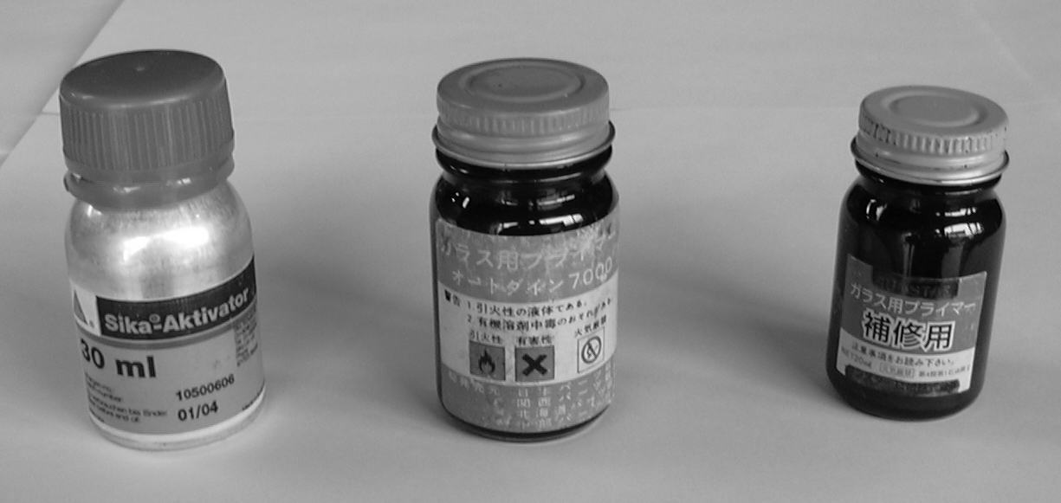
⑭ Clean the body with white gasoline, etc., and apply the primer. (Do not paint too thick, and do not paint on adhesive.)
* In accordance with the adhesive manufacturer’s specification.
⑮ Apply the adhesive to the glass in accordance with the specification of the automobile model.
* In accordance with the adhesive manufacturer’s specification.
⑯ Install the glass on the body.
* Push the entire glass lightly, and adhere it tightly to the body.
Note: Never move the glass fore and aft after installing the glass. Otherwise, the new adhesive may relocate and cause water leak or other defectives.
⑰ Install the mouldings. Keep the glass with protective tape until the surface of the adhesive becomes hard.
(When reusing the glass in the case of glass assembled with mouldings and if the fixing pins are broken or any other failure like that:)
Install the heating wire, antenna terminals, etc. Assemble the rear seat cushion cover pads, rear seat back rest and rear seat hinges.
⑱ Fix the screws for the seat belt assembly at the side glass. Remove the protective tape on the worked automobile. Clean the adhesive and dirt on the body. Clean the glass.

4 – 2 – 5 Working on Rr. Glass

Work on Weatherstrip
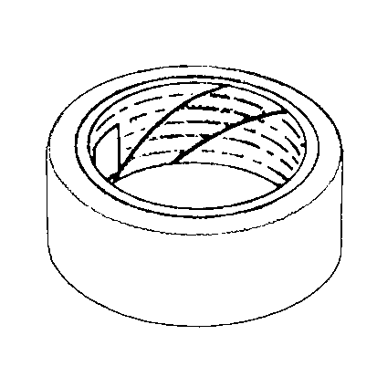

* Remove the parts in accordance with the following procedure, and keep all the parts in a safe place.

- Remove the wiper arms and wiper shaft nuts, if wipers are installed.
- Remove the rear seat cushion cover and rear seat back rest.
- Remove the back door trim board (inner lining).
* Remove the high-mount stop lamps (warning lamps to prevent rear-end collision), if installed.
- Adhere the protective tape on the body around the inside weatherstrip to prevent scratching. Be careful to prevent peeling off if the inner lining is hair-implant type.
- Insert the plastic blade between the weather strip and body at the outside body and cut the adhesive.
⑥ Insert the plastic blade between the weather strip edge and body at the inside body to peel off the edge and push the glass toward outside. Repeat this work.
- When the upper, left and right sides are peeled off, do not push the glass off.
- Go outside and remove the glass completely with the weatherstrip on it.
- Remove the adhesive inside of the body with the plastic blade, and take off residual adhesive if any with white gasoline or the like to check existence of rust or the like.
* If finding abnormal condition on the body, inform the client of the fact and wait the client’s instruction.
- Remove the weartherstrip from the glass.
* If the glass has broken, clean the broken pieces of the glass in the groove of the weatherstrip with the plastic blade or air tools.
- Place the glass on the working table for glass and attach the weatherstrip in parallel to the angle of the glass evenly.
- Place the working string to the weatherstrip with the plastic blade.
- Fill the adhesive between the weatherstrip and glass if necessary.
- Apply the adhesive at the portion where the weatherstrip contacts the body, if necessary.
- Attach the vacuum-cup type handles on the glass and fix the glass to the body.
- Adjust the weatherstrip width evenly at upper, lower, right an left sides in the room, and pulling the working string off, push the weathersrip to fix to the body.
- Remove the adhesive running off the glass and body, and clean the glass.

Fixing with Screw

* Remove the parts in accordance with the following procedure, and keep all the parts in a safe place.

- Remove the wiper arms and wiper shaft nuts, if wipers are installed.
- Remove the rear seat cushion cover and rear seat back rest, taking care not to make them dirty.
- Remove the back door trim board.
- Remove the high-mount stop lamps.
- Place the protective tape around the glass outside of the body.
- Remove the heating wire and antenna terminals. (Take care not to disengage the terminals.)
* If difficult to work on that, contact the client.
⑦ One technician: Hold the glass using the vacuum cups outside of the room to prevent the glass falling down. Another technician: Remove the screws, nuts and bolts using the cross driver in the room.
⑧ Remove the glass carefully not to hit the body using the vacuum cups.
⑨ Check existence of damages on the screws and nuts.
⑩ Check existence of scratches on rubber, etc.
⑪ Check existence of rust, deformation, scratches, etc. on the body.
* If finding rust, etc., inform the client and wait the client’s instruction.
⑫ Clean the glass to be fitted, remove oil films etc. with white gasoline etc., and check existence of flaws.
⑬ Install the glass.
* One of the technicians outside of the room: adjust the screw holes pushing the glass with the vacuum cups; another technician inside of the room: Fix the screws, nuts and bolts using the cross drivers, etc. (To avoid danger such as the glass falling down when worked by one technician, two technicians are to be arranged for this job.)
Note: This is basically a cautious comment for safe work and not obligating two-person work.
⑭ Clean the glass. Take off the adhered protective tape.
⑮ Check existence of flaws, deformation or dirt on the glass. Check the easiness of opening and closing of the glass windows. Check the installed condition of the back door trim covers, and existence of scratches and dirt. Check existence of dirt on the seats and floor. Check the installed condition of the seat belt assembly.

H Type Rubber Method

* Remove the parts in accordance with the following procedure, and keep all the parts in a safe place.

① Remove the wiper caps, nuts and wiper arms using adequate tools.
②Remove the back door trim cover.
- Attach the protective tape on the body around the H type rubber part.
④ Pick up the end of the rubber core in the center of the H type rubber part with the straight slot screw driver or plastic blade, etc. and pull and remove the core.
⑤ Cut off the adhesive between the glass and H type rubber part with the straight slot screw driver or plastic blade.
⑥ Peeling off the upper corner of the H type rubber part with the straight slot screw driver or plastic blade, push the glass outward from the inside.
⑦ Remove the glass to the outside of the room.
⑧ Remove the H type rubber part, clean the body with white gasoline, etc., and clean the body side of the H type rubber part with white gasoline, etc.
⑨ Check existence of rust, deformation, scratches or the like on the body.
⑩ If finding rust, etc., inform the client and wait the client’s instruction.
⑪ Attach the H type rubber part on the body.
⑫ Apply lubricant to the H type rubber part for easy assembling. Install the glass into the H type rubber part.
⑬ Wipe off the lubricant at the boundaries between the edge of H type rubber and glass and the body and glass with white gasoline, etc.
⑭ Clean the lubricant running off around the glass with white gasoline, etc.
⑮ Clean the glass with the glass cleaner, etc.
⑯ Assemble the back door trim covers, wiper arm(s), nuts, wiper cap(s).

Direct Glazing (Adhering)

* Remove the parts in accordance with the following procedure, and keep all the parts in a safe place.

- Remove the back door trim cover and wiper arm(s). (Take care neither to scratch nor to break.)
③ Remove the mouldings.
* Cut off the unreusable mouldings such as vynil mouldings.
* Remove the reusable mouldings with care not to scratch using the moulding removal pin or the like.
④ Remove the glass.
* Insert a knife into the border between the glass and fixing adhesive to cut the adhesive moving the knife vertically against the side surface of the glass. Pierce a piano wire through the border between the adhesive (dam rubber) and the glass with the piano-wire piercing tool (wire-pierce); fix both ends of the piano wire with wire grips; and remove the moulding from the body by way of shearing the attaching line to glass and adhesive alternatively.
(By inserting some material of solid plastic or rubber in between the body and glass, it is possible to slide the piano wire smoothly without scratching the moulding, etc.)
⑤ Taking care not to scratch the body, scrape off the adhesive on the body using a scraper, knife or the like.
⑥ Remove dirt of the glass, adhesive, etc. with the brush or air tool, and check existence of rust or deformation.
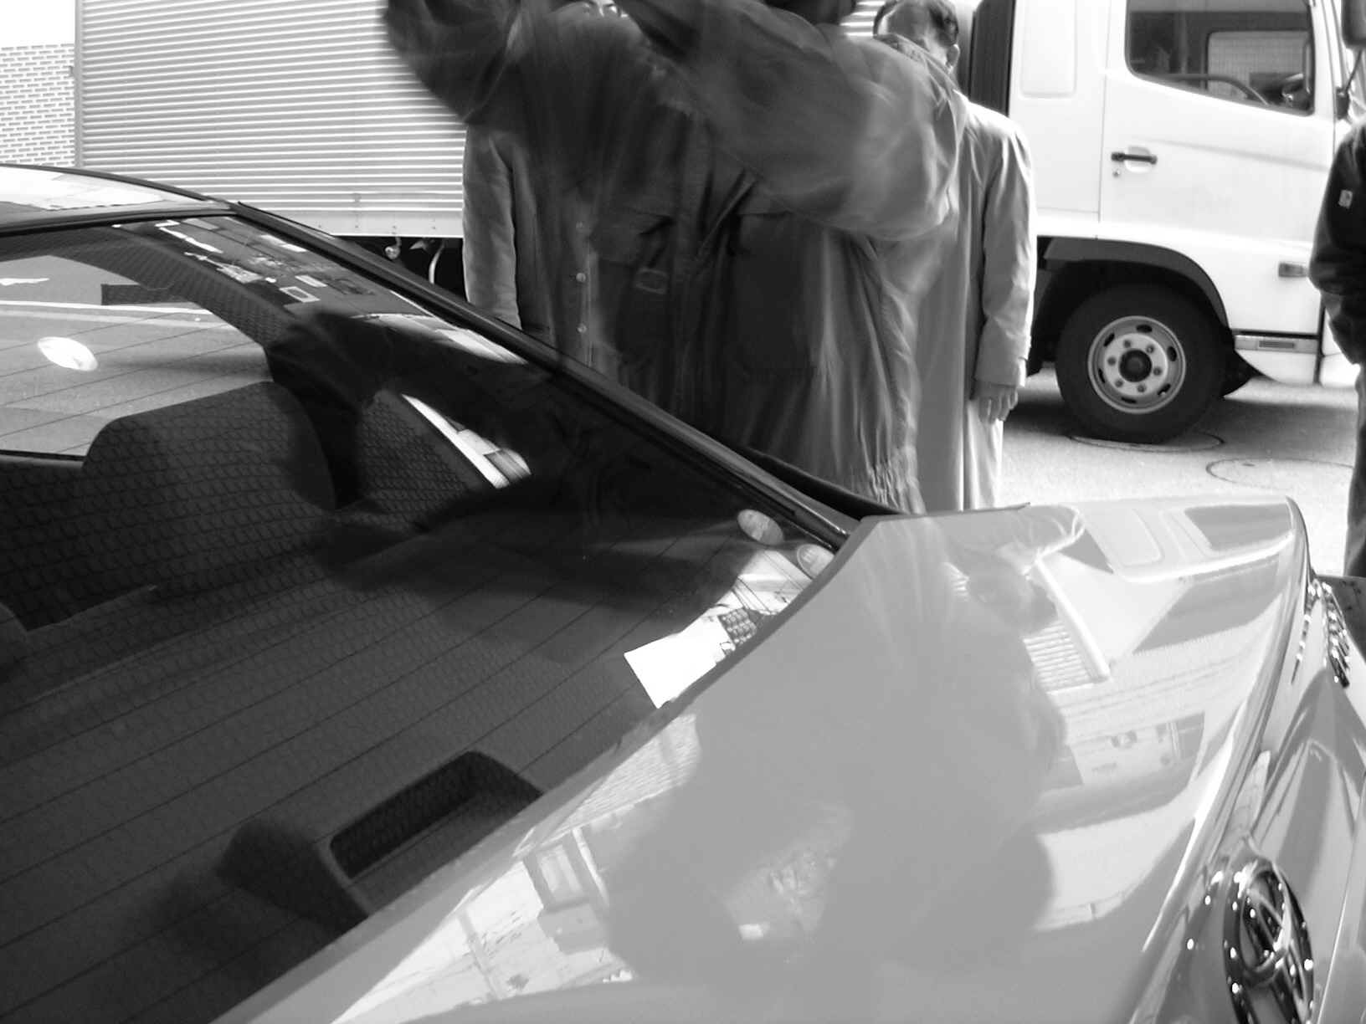
* If finding abnormal, inform the client and wait the client’s instruction.
⑦ After cleaning the adhered surface of the glass with degreasing agent, apply glass primer.
* Take off the residual adhesive on the glass to be reused with a knife.
* Use the primer specified by the paint maker.
⑧ Attach the attachments such as the dam rubber and stoppers to the glass.
⑨ Attach the vacuum cups on the glass.
⑩ Fix the glass onto the body temporarily.
⑪ Set the glass on the body at even locations of upper, right and left side, and put marking at two upper positions and one side position.
⑫ Remove the glass from the body again.
* Attach on the glass those parts, labels or stickers which have been removed beforehand.
⑬ After cleaning the body with white gasoline or the like, apply the primer for an automobile body.
* In accordance with the adhesive manufacturer’s specification.
* If a moulding assembly is used, fix the attachments such as mouldings to the glass.
⑭ After drying the primer for an automobile body, apply the adhesive to the glass.
* In accordance with the adhesive manufacturer’s specification.
⑮ Install the glass on the body.
* Push the glass evenly and lightly to adhere the glass tightly to the body.
Note: Never move the glass fore and aft after installing the glass. Otherwise, the new adhesive may relocate and cause water leak or other defectives.
* To work on the rear may require two technicians.
* Retouch the running off or shortage of adhesive using the plastic blade or the like.
⑯Install the mouldings.
* Attach the mouldings before the adhesive becomes solid. (Try to make smarter than before.)
* Keep the mouldings and glass tightly with protective tape until the adhesive becomes solid.
* Keep the doors open until the adhesive becomes solid.
⑰ Install the back door trim cover. (Take care not to scratch anything.)
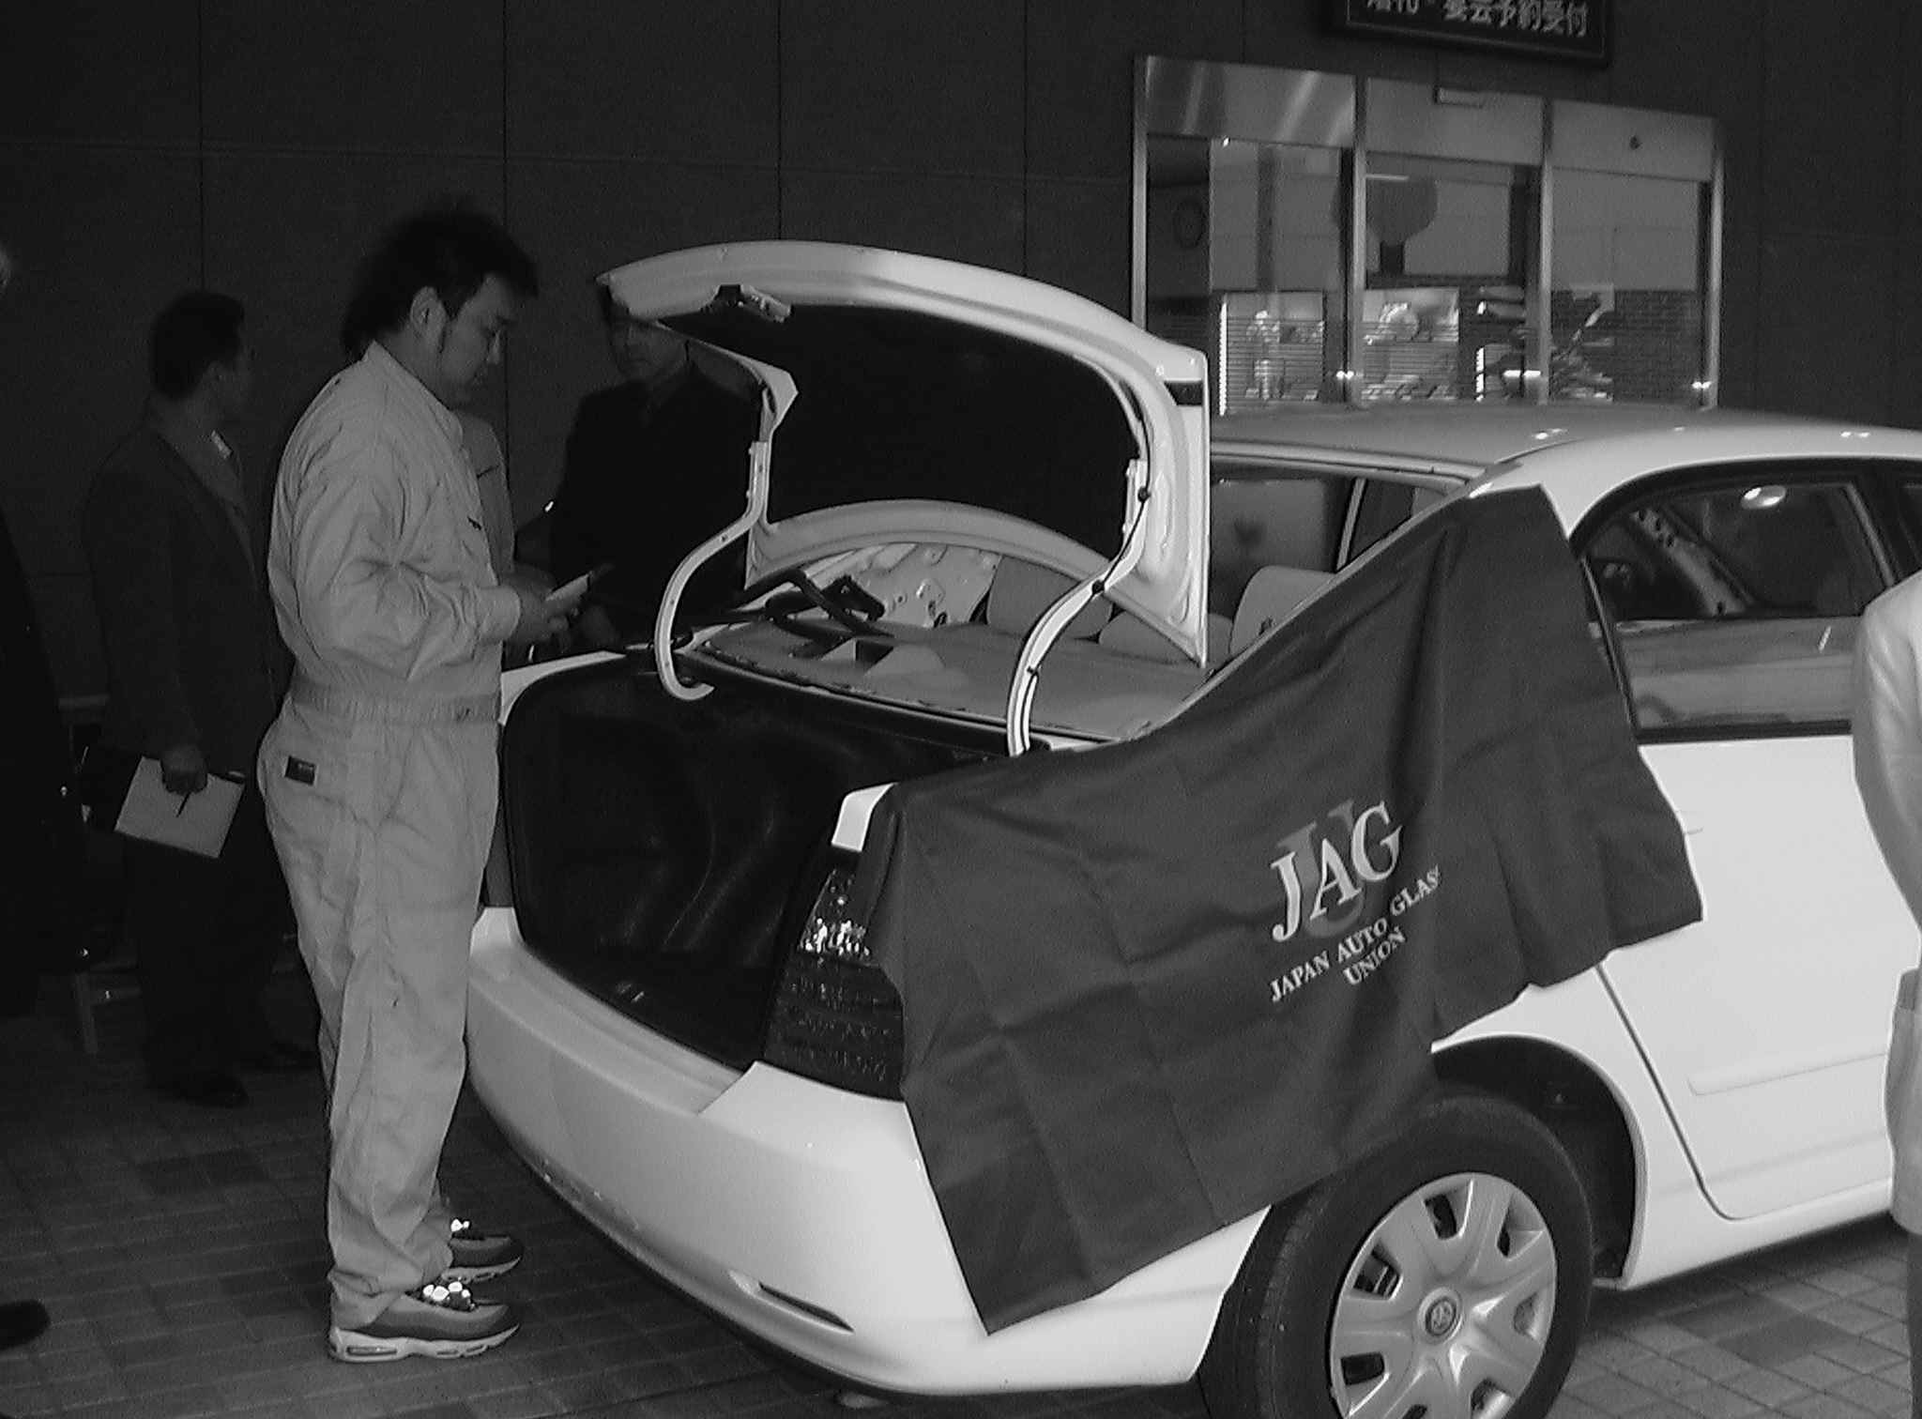
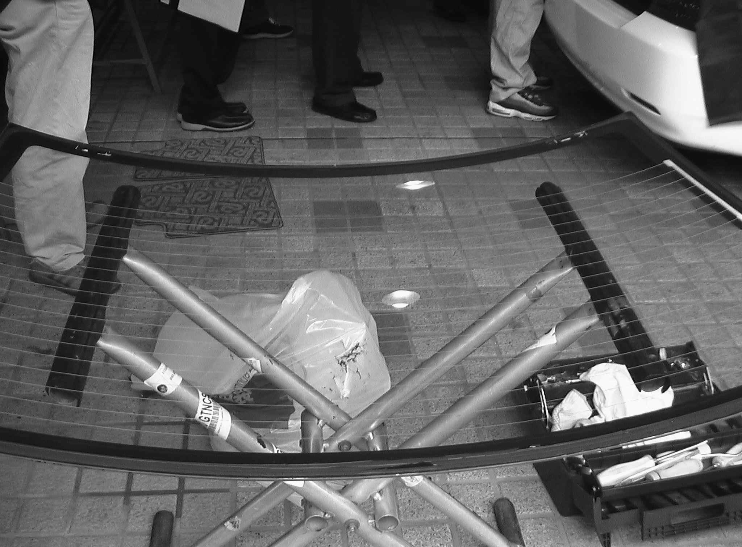
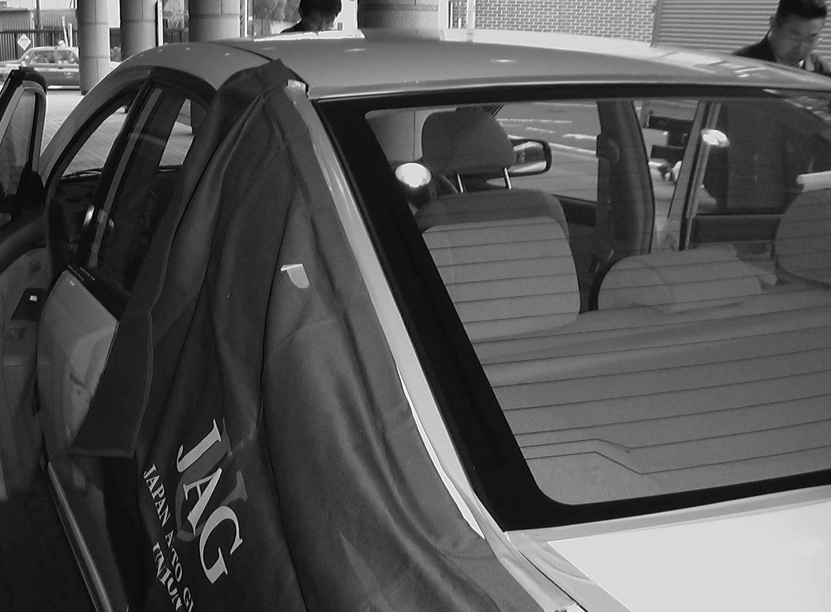
⑱ Install wipers. (Inspect wipers before installing.)

4 – 2 – 6 Sun Roof and Others

Sun Roof

Fixing with Screw

① Remove the trim cover, with the plastic blade taking care not to damage.
② Remove the nuts with the box wrench.
③ Attach the vacuum cups on the glass and remove the glass taking care not to hit the body.
④ Clean the glass.
* If the glass is broken, clean the ceiling and the room using a vacuum cleaner or air tool. It is to be noted that if an air conditioner for the rear seat is installed, the removal of the cooling gas in the air conditioner should be worked by its manufacturer, otherwise the room cleaning cannot be conducted completely.
⑤ Clean the glass using glass cleaning agent.
⑥ Attach the vacuum cups on the glass again and install the glass taking care not to hit the body.
- Adjust the thickness of the shim and fasten the nuts with the box wrench. (Tight the nuts in the order of opposing corners.)
* Adjust clearances at front, rear, left and right sides when the nuts are loose.
* Adjust the height with the number of shims when the nuts are loose.
* For adjustment with the motor, confirm manufacturer’s recommendation.
⑧ Make adjustment moving the glass.
⑨ Install the trim covers taking care neither to scratch nor to damage.
⑩ Clean the glass and remove the protective tape.

Direct Glazing (Adhering)

- Remove the trim face cover (inner lining) with the plastic blade. (Apply dirt prevention.)
- Remove the glass.
* If installed with the moulding, insert a knife in the clearance between the moulding and glass, and cut off the moulding entirely.
* Insert a knife into the border between the glass and fixing adhesive to cut the adhesive moving the knife vertically against the side surface of the glass. Pierce a piano wire through the border between the adhesive (dam rubber) and the glass with the piano-wire piercing tool (wire-pierce); fix both ends of the piano wire with wire grips; and remove the moulding from the body by way of shearing the attaching line to the glass and adhesive alternatively.
* Attach the vacuum cups on the glass and remove the glass taking care not to scratch the body.
③ Taking care not to scratch the body, scrape off the adhesive on the body using a scraper, knife or the like.
④ Remove dirt of the glass and adhesive.
⑤ Clean the body with white gasoline or the like, and apply the primer. (Do not apply too thick. Do not apply on the adhesive.)
* In accordance with the adhesive manufacturer’s specification.
⑥ Clean the adhering face and its surrounding of the new glass with white gasoline or the like.
* Remove the residual adhesive on the glass to be reused, if appropriate.
⑦ If the glass is fitted with dam rubber:
* Attach the dam rubber stopper on the glass.
⑧ Attach the vacuum cups on the glass.
⑨ Install the glass on the body temporarily.
⑩ Set the glass on the body at even locations of upper, right and left side, and put marking at two upper positions and two side positions.
⑪ Remove the glass from the body again.
⑫ Apply adhesive on the glass.
⑬ Install the glass on the body.
* Push the glass lightly to adhere tightly.
Note: Never move the glass fore and aft after installing the glass. Otherwise, the new adhesive may relocate and cause water leak or other defectives.
⑭ Install the trim face cover taking care not to scratch or damage.
⑮ Clean the glass and peel off the protective tape.

4 – 2 – 7 Final Inspection on the Auto Glass Work

The work consists of four processes, namely removal of parts, removal of glass, installation of glass and installation of parts. The key point which decides the finished level is the final process of installation of parts. In addition, the follow-up service to the client after repair will prevent troubles with the client.

- Check existence of dirt on the attached parts and mouldings and unused parts, and cleanliness of the room. Conduct final cleaning.

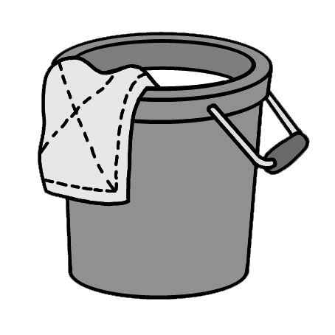
- Inspect the driving parts and check existence of water leak.
- Check matters instructed by the client.
- Check and inspect existence of flaws around the installed glass.
- Check the time of finishing work and describe it on the log book.

- Fill the work instruction sheet. (Such matters as instruction by the client, used equipment and parts, remarks, etc.)
- Clear off used tools and fixtures used on work.
- Clean the working area.
⑨ Communicate with the client verbally using the written work results of items ④ and ⑤.

The work processes entirely finish after completion of each of above items.
(Refer to Page 86 “Chapter 7 Customer Service”.)

4 – 3 Tools for Glass Work

Nowadays, automobile manufacturers are producing sophisticated automobiles which are very complicated for repair work. However, the tools to cope with this complexity are not always expensive ones.
Here we will discuss about general tools, special tools and electric tools to be used for replacing auto glass.

Tools
Tools generally used
* Knife (large, small)
～Longnose plier～
* Scraper
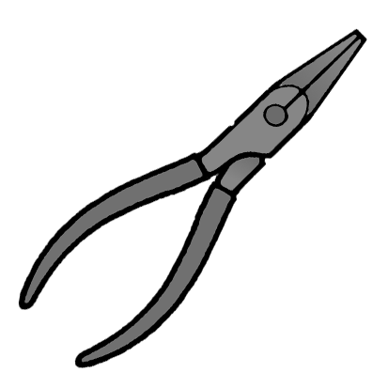
* Longnose plier
Calking gun
* Wrench (wrench, box wrench)
* Moulding remover
* Straight slot screw driver
* Cross slot screw driver
* Rivet gun
* Vacuum cup
～ Straight slot screw driver ～
* Adhesive tape, protective tape
* String
* Dash board cover
*Protective sheet (Seat cover)
* Fender cover
* Glass cleaner
* Wire pierce
～ Cross slot screw driver
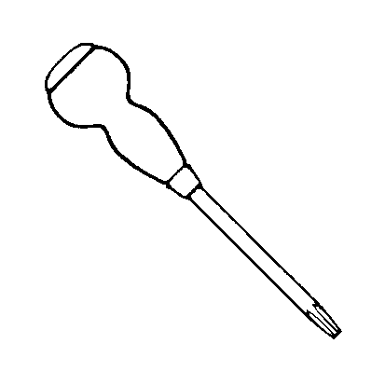
* Wire grip
* Stainless steel dish cover (Stainless steel plate)
* Air driven cutter, electric driven cutter
* Working stand
* Brush
* White gasoline
* Waste cloth
* Hammer (plastic rubber, steel)
* Magnet driver
* Box driver (7 mm – 17 mm)
* Pin punch (for opening through stopper)
* Awl
* Socket set (inch size)
* Wire brush
* Spanner (Wrench)
* Cut-out knife (Cold knife) (L-shaped cutter)
* Glass cutter
* Glass cutter plier
～ Nipper ～
* Insert/String
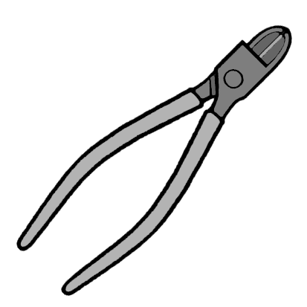
* Plastic blade
* Cutting blade holder
* Rivet
* Cleaning machine
* Electric drill
* Electric screw driver (Straight slot screw driver & cross slot screw driver)
* Nipper

Note: The cross slot screw driver is generally called as “Plus Driver”, and the straight slot screw driver is as “Minus Driver”.

4 – 4 Adhesive
The most important item in the auto glass work is the adhesive used for joining the glass to the automobile body. It is very important from the view points of construction and safety of automobiles.
Lack of application of the adequate working method and proper parts for repair may cause the glass to drop off and result in a serious accident. In addition, the auto glass contributes to the stiffness of the automobile body, and therefore it is necessary to assure the original strength even after the repair.
It is the auto glass technician’s responsibility to handle these products in accordance with the manufacturers’ instruction and to secure the work safety and quality. The adhesive is a substance which joins surfaces of two or more elements tightly. The auto glass adhesive joins various parts such as windshields to the frame. There are many types of adhesive such as organic, non-organic, natural, synthetic types, etc. In the auto glass industry, the strong plastic polyurethane material, generally known as Urethane, is used if otherwise specified.
Kinds of Adhesive
4 – 4 – 1 Urethane Adhesive
Mechanism of Adhesive Hardening

The sealant (Urethane polymer) becomes gradually hard from the surface to inside reacting with moisture in the air to create urea bonding and varies to gumlike elastic matter (polyamine). It creates the carbon dioxide gas (CO₂) as a by-product reacting with H₂O. The adhesive is so designed that the created CO₂ gas as a by-product is not to reside in the hardened material, but, if there exist some air bubbles in the sealant when joined, the CO₂ gas may dispersed into the air bubbles. In this case, if the air bubbles are broken, this condition may damage the originally designed adhesive force or recovery force, and also it may cause rain water leak, which should be paid attention to.

Ｈ Ｏ Ｎ
｜ ｜ ｜
ＯＣＮ－Ｒ－ＮＣＯ －Ｒ－Ｎ－Ｃ－Ｎ
｜
＋ Ｈ２０ Ｒ ＋ＣＯ２
｜
ＯＣＮ－Ｒ－ＮＣＯ －Ｒ－Ｎ－Ｃ－Ｎ
｜ ｜ ｜
Ｈ－Ｏ－Ｎ

(Sealant) (Moisture in air) (Gumlike hardened material) (CO₂)

Mechanism of Adhesive Joining

The urethane polymer acts as adhesive on urea bonding. Basically its reaction is final and no more. The main content of the glass is silicate which cannot be adhered directly to the urethane polymer. The same applies to steel plates and paint. Here the primer works. The primer works well in between the urethane polymer and materials to be adhered. The primer for glass reacts to the silicate, and also to the urea in the urethane polymer. In the same manner, the primer for painting reacts to both of paint and sealant. As a result of the oil shortage in 1973, the automobile manufacturers reacted to decrease the weight of automobiles to give them better fuel performance. But it was never easy way because they had also to cope with safety issues. One of the measures for lighter weight was to decrease the gages made of steel to eliminate heavy frames.
The automobile makers employed the monocoque structure in which the glass was joined as a strength member of the entire body. The glass shares the strength of the automobile frame, and for this purpose, it needs stronger adhesive than the butyl-type, thus the “Urethane-type” was created. The urethane-type adhesive has stronger than the former adhesive agents for auto glass such as Thiokol by 3 to 50 times, and has a very good performance in strength and flexibility. The urethane adhesive should have enough strength against impact pressure and to support the automobile structure, when applied to an automobile. The urethane adhesive should keep the glass in the most adequate location when joining the glass to the body, which again needs flexibility. If the urethane adhesive becomes too hard, it may break the glass, and it should join the smooth surface of the glass and rough surface of the body. The required time for hardening the urethane adhesive depends on temperature, humidity, and chemical components of the adhesive, and furthermore hardening may need a few days to a few weeks maximum depending on the weather or other conditions. Therefore, in accordance with the manufacturer’s recommendation, the client should be requested to acknowledge after how many hours or days the client can drive the vehicle. The hardening of the current urethane is strongly affected by the humidity in the air, and in the low humidity, the performance of hardening decreases. To avoid such deficiency, the adhesive is sometimes added with humidity (water moisture) after applied. The hardening process of the adhesive is a very important point in the glass work. Too early delivery of the repaired automobile to the client may cause troubles and even worse bring the client into a serious danger.

Single-liquid Type Adhesive
This is adhesive of which main component is single-liquid type urethane polymer hardening with humidity. The polymer hardening with humidity means that the adhesive hardens reacting with water moisture (H₂O) in the air. In 1980, the single-liquid type urethane adhesive was introduced in the repairing market, but it was, in those days, inferior to the dual-liquid type in the joining strength and hardening speed. However, nowadays, the single-liquid type sold in the market is achieving the strength performance stipulated in JASO (issued by the Society of Automotive Engineers of Japan) and its hardening speed is shortened significantly.
The single-liquid type urethane adhesive requires certain temperature and humidity to harden, and the ideal time is required for 24 hours, but there are many brands of single-liquid urethane adhesive offering shorter drying time. The single-liquid type urethane adhesive is available in a cartridge or packed in a foil container (sausage type) ready for use. Glass technicians may charge them in a caulking gun to apply. On each container, a film is attached to keep the condition of the adhesive in good quality. In the case of the “Sausage”, packed in foil, it can be heated before use.
The storage life of the urethane adhesive is generally short and it deteriorates after 6 to 9 months. The deteriorated urethane may affect the joint or hardening adversely. Therefore, it is necessary to avoid the use of such adhesive as is beyond the effective period.

Quick-drying Urethane Adhesive

The urethane adhesive requires 5 days to 1 week to achieve its maximum strength unde the “Necessary Condition”.
The Necessary Condition means that the environmental temperature is minimum 24 deg. C and relative humidity (RH) 50% or more. This slow drying performance has been argued between the auto glass repair shops and adhesive manufacturers. The auto glass repair shops requested the manufacturers to develop adhesive which supports sufficient working time for repair shops but earlier delivery of repaired automobiles to clients.
The product which meets the requirement is the Quick-drying Urethane Adhesive.

Dual-liquid Urethane Adhesive

The dual-liquid urethane adhesive functions in such way as the main agent (urethane polymer) hardens when the component of the hardening agent reacts on the main agent. Adhesive manufacturers developed this dual-liquid urethane adhesive to respond clients’ requirement. On the dual-liquid urethane adhesive, the catalytic agent is arranged in a separate manner from the base of adhesive and the hardening starts when the catalytic agent is mixed with the base. The containers of the dual-liquid urethane adhesive are two adjacent tubes, one of which contains adhesive and the other of which contains hardening agent. When these are mixed, they hardens faster than normal urethane through chemical reaction. Some of the dual-liquid urethane adhesive are contained in two plastic containers which have a special design in that the two kinds of liquid mix just before coming out onto the joining surface. The tip-end of the containers is called as the static mixer which has a plastic tube of about 20 cm long inserted. In the plastic tube, the adhesive and the hardening agent are mixed sufficiently on applying. This unique structure requires a special piston-type injector to use the dual-liquid urethane adhesive. The injector is some kind of a caulking gun which is a double-configuration type with a ratio-proportionate mechanism.
This injector pushes out the dual-liquid urethane adhesive through the small tip-end correctly. Many makers are developing new types of dual-liquid urethane adhesive and its sausage packs to mix before installing to a power gun, electric gun and caulking gun.

Features
The urethane for automotive use needs some special features other than adhesive for other use.
To comply with the requirement for the safety of passengers in an automobile and for the construction of the automobile, the urethane adhesive should have sufficient strength and also flexibility to fit to the curves designed on the automobile body.

4 – 4 – 2 Primer
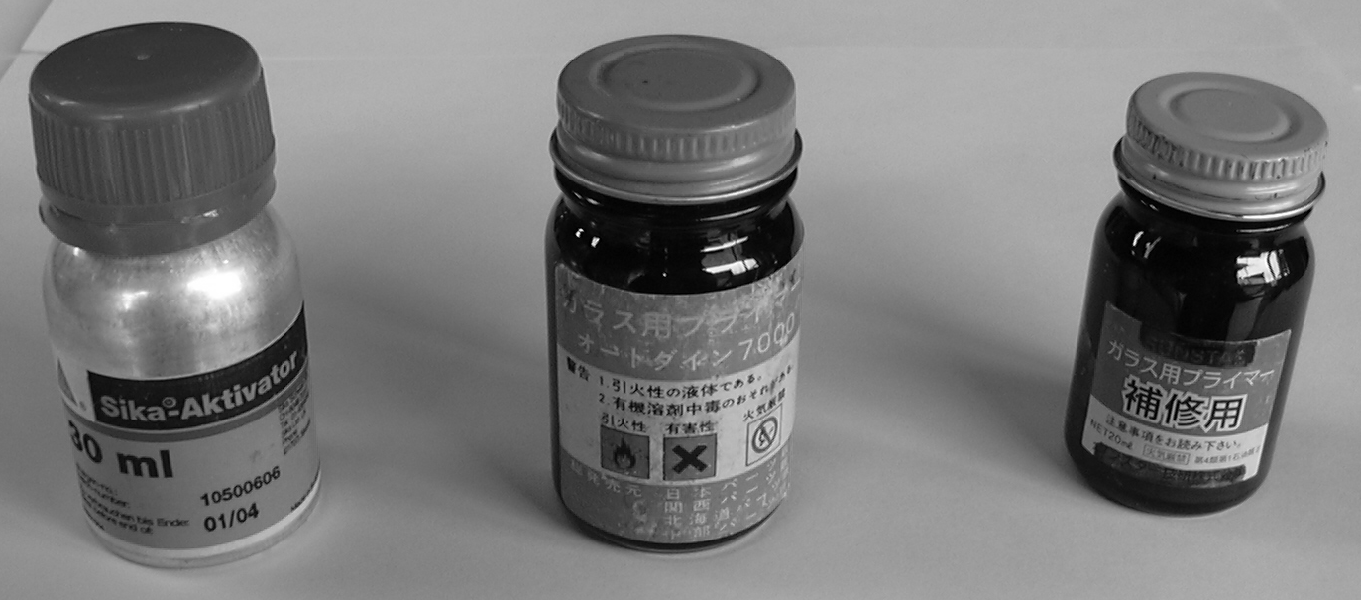
Primer is a prior-processing agent applied on various metallic parts and auto glass to have stronger joining force. Primer should be chosen depending on the kind of adhesive to be used.
There are many applications of primer such as strengthening bonding force, guarding the adhesive against hazardous ultra violet rays. In addition, various kinds of primer are available for each kind of adhesive such as corrosive prevention. It is important to find the purpose of each kind of primer to be used.

Glass Primer

The purpose of the glass primer is to block ultraviolet rays from the Sun and enhance adherence of the glass. Apply the glass primer (black) on the surface of the glass along the inside of the edge with thin film. (in accordance with the manufuacturer’s specification.)

Body Primer

Almost all of the primer for vehicle body are black and applied on the portion with scaled-off paint or scratches caused when dismantling, but it is sometimes misused.
It means that many technicians think it is necessary to apply the primer all over the body. The body primer should be applied only on the paint-scaled-off portion or on the scratches, which gives adhesive force to the painting surface and prevents corrosion. (in accordance with the manufacturer’s specification)

4 – 4 – 3 Butyl Tape
In 1950s, manufacturers developed a product called as “Butyl” for sealing agent.
This soft and adhesive material was rolled (because of this nature, it was called as ribbon as well) and applied between the glass and frame of automobiles. The glass and metallic part were sealed with rubber-based material with rather low strength. It was easy to handle on working and therefore used on the sliding doors and many other parts including windshields of domestically-built automobiles.

Performance Comparison Table of Adhesive for Auto Glass Repair

Kind | Advantage | Disadvantage | Adhesion force
Butyl tape | Immediately possible to drive | Easy to get soft at high temperature and heated. Not contributable to body strength. | Significantly changeable depending on temperature. Not hardening.
Thiokol | Fast in hardening | Not easy to work due to mixing two liquids. Apt to improper adhesion due to insufficient agitation | １０－５０ｋｇ ／ｃｍ２
Urethane series | Good elasticity, good fatigue durability, high tear resistance, good cold and weather durability, good adhesion to paint, good joint performance | High variety of viscosity due to temperature change, not-easy to wipe out, easily affected by ultraviolet ray, special primer application required for some adhesive materials | １３－５０ｋｇ ／ｃｍ２
Silicon series | Regardless of kinds of adhesive material, good workability, easy to wipe out, good heat, cold and weather durability, strong against ultraviolet ray | Very poor against tear force, low adhering strength, turbidity of glass surface due to decomposition after work, unpaintable, never jointable | ８－１０ｋｇ ／ｃｍ２
modified silicone | Regardless of kinds of adhesive material, good workability, easy to wipe out, strong against ultraviolet ray, higher adhesion than silicon series, paintable | Less adhesive than urethane series, lower water tightness, less jointing performance | １２－２０ｋｇ ／ｃｍ２
Note: The value in the column of adhering force means the average of the tensile strength.

4 – 5 Sealing Material
Sealing material was, in former days, very often used to seal the glass and rubber gaskets or glass and automobile body. The sealing material was generally based on butyl of which strength was rather weak. Therefore, in Japan, in these years, the urethane adhesive is used to avoid the glass dropping off when receiving impact force.

4 – 6 Supporting Products
4 – 6 – 1 Glass Cleaner
Various cleaners are used before or after the auto glass work or repair work.
Common use is to clean the glass before work, and after work or repair of the glass. Nowadays, there are a lot of kinds of glass cleaners in the market. However, the auto glass requires non-filming type cleaner. Almost all of the glass cleaners sold by the adhesive manufacturers are of this type. This type of cleaner normally limits the content of alcohol and ammonia and do not contain petroleum or silicon additives.

Followings are common hazardous additives.
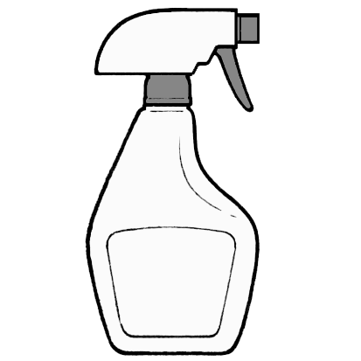
- Alcohol
- Ammonia
- Petroleum products
- Silicon
4 – 6 – 2 Lubricant

Lubricant in the greased condition (paste type) of fats from animals and plants had been used since 2400 B.C. The lubricant plays also following important roles other than to decrease energy consumption for better efficiency in machines by decreasing the friction at the contacting surface of machine parts. Other roles include followings:
* Sealing * Cooling * Preventing rust * Decreasing wear
We, as technicians, should have this kind of knowledge for better work achievement.

4 – 6 – 3 Dam Rubber
The dam rubber stops the running out of the adhesive to enhance hardening of the adhesive when working on the glass for the windshield and rear glass. In addition, it adjusts the clearance between the flange of the body and glass.

4 – 7 Automobile Protectors and Protecting Procedure

Glass technicians, who put the first class priority on one’s credit, should always take every meticulous care not to scratch the client’s automobile during keeping it. As preparation for glass work, it is necessary to protect the automobile body and interior furnishings (seats, foot mats).
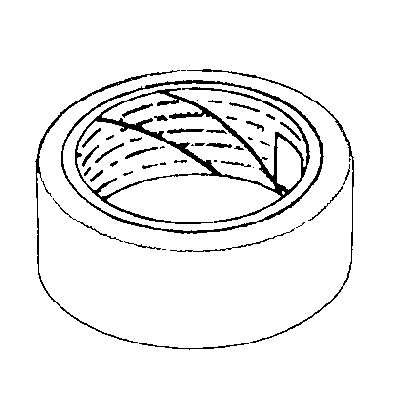
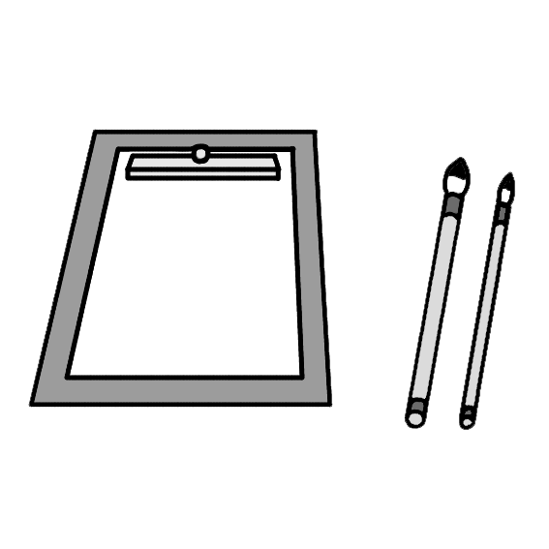
* Dash board cover
* Fender cover
* Floor mat cover
* Food cover (bonnet cover)
* Protective tape
* Seat cover
Followings are some adequate ways to protect automobiles.
① Take off hard articles such as a watch, accessories, a buckle on a belt, etc. which may scratch the automobiles. (It is desirable to wear an overall working cloth, but depending on the policy of the shops, separate type working wears are accepted, where those who wear belts should be careful about it.)
- Put protective covers over the hood, roof, seats in the room, floor, dashboard, etc. where the work will be extended. These covers protect the paint against damages caused by tools and parts.
The covers applied in the room reduce the damage risks on the automobile by lessening the cleaning work and the injury risks of the glass technicians as well.
(a) Always apply the protective covers over the surface of inner and outer furnishings, especially over the hole for the defogger.
(b) Protect the area where the tools may touch.
(c) Keep the room mirror in a safe place to avoid damage.
* In the case that the mirror is installed on the windshield, etc.
(d) Keep the wiper arms and the cowl top panels in a safe protected place.
(e) Check if any parts are left around the engine. (Never put any part there.)
(f) Move the automobile on a flat level and check if the gear shift lever is in a parking or neutral position and the side brake is applied.
(g) Check if any tools are not in any pockets of the working wear.
Clean gaskets and other parts as appropriate.
Hand the work sheet filled as appropriate.
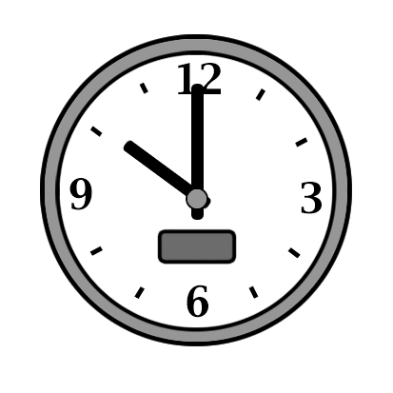
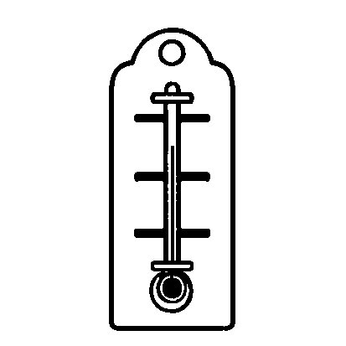
→
(Such items as temperature, time, check items, etc. See 7-5 on page 100)

Chapter 5 Corrosion
― For Better Glass Working ―

When an auto glass shop contracts replacing of the glass, it may often undertake repairing the corroded portion of the automobile.
In this chapter, the cause and repair of corrosion is discussed.
* Identifying the corrosion and its cause
* Resolving troubles encountered when working on corrosion

To find corrosion

It is helpful to collect information regarding the corroded portion on the automobile at the initial communication with the client.
It is a good question to ask the client if the client has experienced water leak into the room. In addition, ask the client if the client has heard wind noises. Almost all of the cases, the client has found some sort of corrosion traces on the vehicle. If nothing serious, continue the work routinely.

If there are any sign of corrosion, check some critical points. Followings are those to be visually checked from outside of the automobile.
* Existence of swell of the paint on the body
* Existence of corrosion color and spot
* Existence of breakage of the glass caused by an unidentifiable reason, without any hit mark
* Existence of rust at the edge of the glass

Followings are those to be visually checked from inside of the automobile.
* Existence of corroded color or any colored spot on the dashboard
* Existence of water spots inside (seat, floor mat, head liner, garnish, etc.)
* Existence of traces of water flow inside surface of the glass
* Tightness of the fixed glass (Check existence of clearance around the edge of the glass.)
* Existence of abnormal condition of adhered surface seen from inside of the vehicle

What should be done by technicians when finding corrosion

When a technician has found corrosion, communicate the client in accordance with the shop’s manual.
First of all, clarify the problematic matters before removing the glass. If the problem cannot be clarified at that time, it may be worked out in detail after removing the glass. If the corrosion starts at the welded part, it is necessary to check the existence of deformation of the body. If the deformation has been found, repairing of the deformation must be requested before any other thing.

1. If the corrosion is slight, take off the rust with a rust removing agent, and if the next process can be applied, continue the work.
2. If the corrosion is serious and the body is weakened or has corroded openings, ask a welding shop for repair and the glass repair work should be conducted after body repair.
3. If the corroded part does not affect the glass repair work, continue the glass repair.

If any corrosion exists, it is necessary to postpone the glass work until the body is completely repaired. The glass technicians must have enough experience of checking rust to judge the corroded conditions correctly. The repair shop (company) must prepare the work manual so that the technicians may judge and take measures correctly without any difficulty. (See 7-6 & 7 in Page 102)

Chapter 6 Other Techniques for Auto Glass Technicians
In these days, the auto glass technicians are required to have various techniques (jobs) other than replacing the glass and disassembling and assembling the glass. It is very important for the auto glass technicians themselves to acquire various techniques other than glass work.

In this Chapter, those techniques related to glass other than installation of glass are discussed.
6 – 1 Repairing Glass
In 1985, the windshield glass installed on the domestically-manufactured automobiles was changed to laminated glass. At that time or so, a new technique to repair broken windshield glass called as “Repair” was introduced from the overseas market in that a special liquid called resin was injected into the cracked portion of the windshield glass to prevent extension of the crack.
In the early stage, the quality of the resin was not so good and the repair needed a long time. But, in these days, the quality of the resin has become good and the required time is short enough. In addition, the reflactive index of the resin is very similar to that of the glass.
As the laminated glass becomes standard as the windshield glass instead of the strengthened glass, the cost of the glass has risen. Under these conditions, the glass repairing has rapidly become popular due to its lower cost and faster delivery to the client after repair.
The maximum size of the flaw which can be repaired is up to about 3cm, due to the better cost effectiveness and less quantity of waste than replacing the entire glass, it is expected that the demand for repairing up to this size may increase.

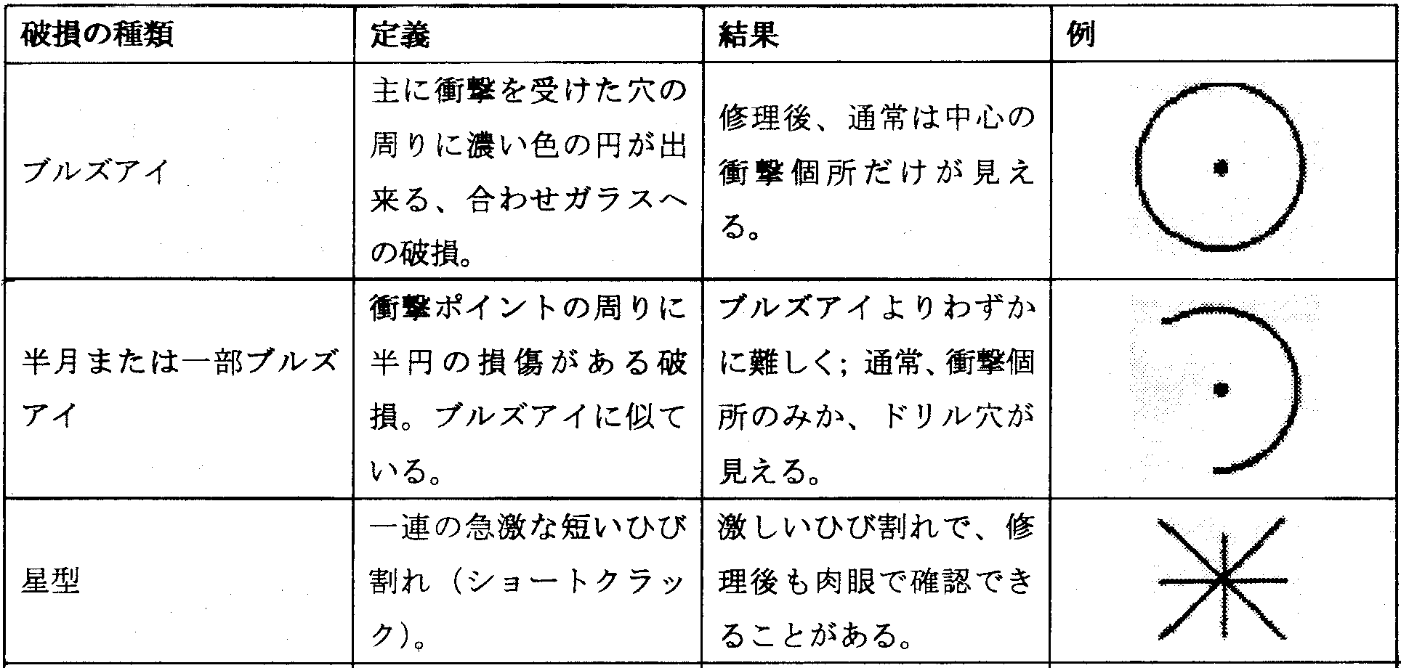
Repirable flaw

Kind of flaw | Definition | Result | Example
Bull’s eye | Dense color rings appears around a hole by strong hit, on laminated glass | After repair, the central hit dent may be visible.
Half moon or partial bull’s eye | Half circle flow around the impacted point, looks the like bull’s eye | A little bit more difficult to repair than the bull’s eye. Normally the impacted point or drilled hole may be visible.
Star | A series of short cracks | Serious cracks of which traces may be visible after repair

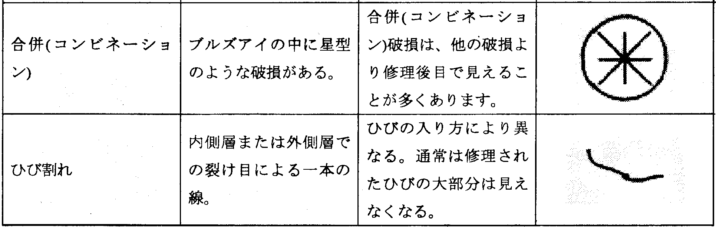
Combination | A flaw like a star in a bull’s eye | The repaired combination flaw may be more often visible than others.
Cracks | Single line of crack in the inner or outer layer of glass | Depends on nature of the crack. Normally the repaired crack may not be visible.

The standard of NGA is listed here for the reference.

Acute area (Center area) – A zone

According to the National Windshield Repair Association (NWRA) in the U.S.A., it is said that the size of the flaws and cracks is an important factor to judge they are repairable or not.
The acute area, which is an important area and known as the main eyesight area, is the range of lines from the driver’s eyes. According to the recommendation of NWRA, the acute area is defined as “the area just in front of the driver, of which size is 21.59 cm high and 27.94 cm wide (8.5 “ x 11”) starting from the just upper edge of the steering wheel”.

The NWRA recommends to repair flaws in the acute area on the glass “if the flaw can be hidden with a quarter coin (0.95” dia. [24.13 mm]) and the residual dent after repair is expected not more than 3/16” dia. (4.76 mm), and further if the residual flaw after repair is minimal”.

Finally listed here are those cracks on which neither NGA nor NWRA recommends to repair.
* Flaw or crack through both layers of laminated glass
* Three or more long cracks extending in the flaw
* Breakage or cracks polluted and caused by chemical substance which interrupts repair
* Breakage or crack on inner layer of the glass
* Breakage or cracks on the safety heat glass
* The size of flaw pit is 3/8” (9.525 mm) or larger.
* The impact pit depth reaches to the PVB layer.
* The crack reaches into the acute area of the glass.
* The edge crack crosses with the edge of the glass at one point or more.
* Armor glass
* Glass for airplane for business (glass for airplane of which cabin pressure is controlled at normal air pressure.)

6 – 2 Removal of Water Spot

In these days, water grime is easily caught on the glass due to the affection of acid rain, etc. And if failed to wipe out the residual water after washing automobile with well water, the impure substances such as calcium, silicon, other mineral substances included in the water may stick to the glass. In such cases, the glass shops may be requested to remove them.
To take off the water spot, various abrasive compounds are used. In addition to the traditional method, a new method to melt the water spot has been developed recently.
* The most popular method is to remove the water spot using a rotating buff with serium oxide powder.
Water spot ?
Water spot is different from oil film or dirt of water grime.
Rain water does not create water spot, but silicon compound, calcium, mineral substances do.

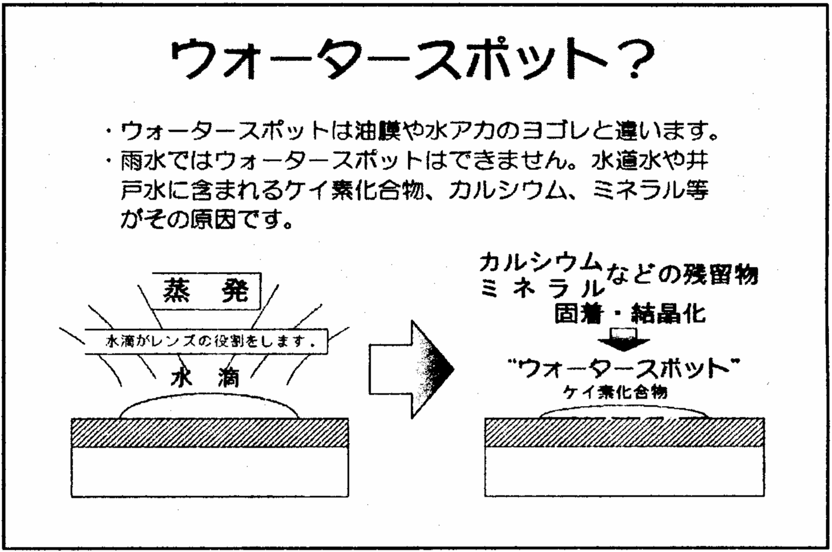

Residual calcium, mineral substances, etc. stick and crystallize.

Evaporation

A waterdrop works as a lenz.
Waterdrop
Silicon compound
Water spot

6 – 3 Glass Work on Construction Machinery
The flat glass has been mainly used on the construction machinery. Recently, three-dimensional glass shapes are gradually becoming popular, but majority is still flat glass. For this shape of glass, replacement can be conducted using the laminated flat glass cutting into the adequate shape. To install the glass, it is normal to fit the gasket called “H-rubber” and “S-rubber”. As the chances of this kind repair become less, the number of capable technicians becomes less. However, the same application is well utilized on the distribution panels for elevator hall, and then the application may not diminish immediately. This is one of the techniques to be memorized by good auto glass technicians.

Estimation method
- Calculate the cutting dimension of the glass.
- Multiply the unit price by the area.
The value to be multiplied by the area is called as the “Tsubo unit price” or “Inch unit price” of each glass shop.
（３） Add any bore portions.

Ａ

Ｃ

Ｂ

(4) Calculation of area
(A + B) x C = D D/2 = Area

How to cut laminated glass
Cut one side, and turn over to cut the same line. Dissolve intermediate film
(Poly Vinyl Butryral) by dissolved gasoline and alcohols solvent. By doing so,
cut off four directions.
Cut 8 times in all.
Next, cut the corner off roundly.
Cut it first where the space called “gouging” for wipers is located.
Finally, grind down the glass edge to make it smooth by a grinder. This is all
to complete the process.

Refer to Chapter 4 regarding the work processes.
For your reference, see the following general
calculation schedule.

Flat laminated glass； Calculation schedule (for inches)

Brand | Dimension （ｍｍ） | Dimension (inch) | Number of tsubos
ＰＬ６ | ６１０ × ９１４ | ２４×３６ | ６
ＰＬ６ | ６１０ × １２１９ | ２４×４８ | ８
ＰＬ６ | ６６０ × １０６７ | ２６×４２ | ７．５
ＰＬ６ | ６６０ × １３２１ | ２６×５２ | ９．３
ＰＬ６ | ７１１ × １２１９ | ２８×４８ | ９．２
ＰＬ６ | ７１１ × １３２１ | ２８×５２ | １０
ＰＬ６ | ７１１ × １５２４ | ２８×６０ | １１．６
ＰＬ６ | ８１３ × ９１４ | ３２×３６ | ８
ＰＬ６ | ８１３ × １０６７ | ３２×４２ | ９．３
ＰＬ６ | ８１３ × １２１９ | ３２×４８ | １０．６
ＰＬ６ | ８１３ × １３２１ | ３２×５２ | １１．５
ＰＬ６ | ９１４ × ９１４ | ３６×３６ | ９
ＰＬ６ | ９１４ × １２１９ | ３６×４８ | １２
ＰＬ６ | ９１４ × １５２４ | ３６×６０ | １５
ＰＬ６ | １０６７ × １２１９ | ４２×４８ | １４
ＰＬ６ | １０６７ × １３２１ | ４２×５２ | １５
＊Based on the glass dimension sold in public by glass manufacturers as of Oct 2004.
＊Formula to calculate tsubos：Example ６１４×９１４（As the number of tsubos are
based on Japanese measuring system, nearest figures are used.）
０．６１４×０．９１４×１０．７＝６．００４

Formula： Width（ｍ）×Height（ｍ）×Equalizing Value（set at １０．７）＝
Number of Tsubos

Chapter 7 Customer Service

In a long history of the Automotive Mechanics and Repair industry that has been
pursuing the safety, automotive glass has experienced various changes from
“tempered glass to laminated glass” and “gasket type to direct-grazing type”.
In that, automotive glass technicians were required to have high technologies for
the era, so they have met the requirement all the time. However, due to specific
structural issues on accepting an order, there is no exaggeration to say that it
was good if employees have merely attained “the skill as craftsmen, and it would
secure credit, and support the corporations as well as automotive glass industry.
But, in these days, each of you, the corporation, and the industry in its
entirety have to think again that we “have neglected” the services for our
customers in order for automotive glass industry, which has supported up until
now, to be recognized by the public that automotive glass is not merely a part of
repair parts, but a special part which requires reliable work as safety and security
critical component (bears a part of automobile rigidity), to avoid wash-down from
the wave of “restructuring” that is intended by automobile manufacturers.
We study in this Chapter using “service manual” provided.

７－１ Service is

In short, “We kindly provide services in response to customers’ needs”.
To do that, each individual thinks first to be customer friendly, and is required
to provide services. To respond to customers’ needs,

１．Entrusted service that provides some sense of security
・ Attainment of certain special knowledge backed up by theory
→ Can get the credit.
・ Providing information based on definite data
→ Will lead to bringing profits for customers.
・ Manner to wait on customers as service job
→ Departure from “professional sense”.
２．Definite undertaking technique
・ Making a profound study of high technique
→ Will lead to safety of customers.
- Services which relate to other than automotive glass undertaking
→ “General services” for automotive glass.
Provide “services” considering the above two themes.

Do not provide services only for self-complacency.
The most important matter is that we should focus on services and dealing
with customers to let them satisfied with the work provided by the
professional after the services have completed.



７－２ Flow of Work (Service)

① | Origin of work | When defects come up on the customer’s automotive glass,
some kind of access is made to us.
・ As the customer by himself thinks that automotive glass is
“an expensive item“, he can’t make up his mind to whom
he should contact and get an assistance with some relief.
Automotive glass repair firm places an “advertisement” and
“publicity” to gain recognition. This is the start of the work
and services.

② | Reception | Telephone, coming to the shop, access to homepages, etc.

The response at this time is very
important.
・ Manner to wait on customers.
(Refer to 7-3 P89)
・ Response to gain customer’s
relief.
・ Find out if the customer uses the insurance.
(If necessary, carry out the procedures for the customer)
 | Identifying glass | Promptly identify the required glass and parts, etc. for
the customer. (Refer to 7-4 P90)
・ Automobile inspection certificate (automobile name,
automobile type, year, classification segment number,
type designation number)
・ Glass monogram (color, sheet thickness, other information
on glass manufacturers)
・ Automotive glass search system, SS news

 | Estimate/Proposal | Calculate the cost for the work and submit proposals
to meet the conditions (cost, etc) of customers.
・ Recommend safety goods, especially adhesive that
meets the time for delivery requested by the customer.
Note：The estimating procedure is not cited here as
there is difference by corporations and regions.

③ | Work instruction | Preparation of work instruction (Refer to 7-5 P100)
・ Confirm with the customer the content of work, caution
item (especially re-painting part, handling of special
equipment), and prepare work instruction.
・ Based on the delivery of the automobile, instruct the work
completion time and adhesive to be used.

※ JAGU will continue to recommend adhesive which
indicate operational hours by temperature and humidity.
・Record glass part numbers and replacement parts.

④ | Work
Prior-inspection Confirm the automobile condition according to work instruction.
Record the condition without fail to resolve trouble after the
delivery of the automobile.
・Especially pay attention to cracks on the body, rust, and
defect of wipers, etc.
・Check spots, cracks, and the extent of blot on seat and
dashboard.
・If necessary, take a picture or others.
・If possible, ask the customer to confirm cracks, etc.

Work Chapter 4 Work on automotive glass Refer to P52

Completion Check: In accordance with work instruction, check to see the
condition of the automobile at the time of completion and
record the necessary information.
・ With or without cracks on interior and exterior after work .
completion and wipe-remaining of adhesive.
・ Location of glass and the condition of placement of mould,
etc.
・ Record the temperature, humidity, type of adhesive used at
the work.
・ Cleaning of interior and exterior.
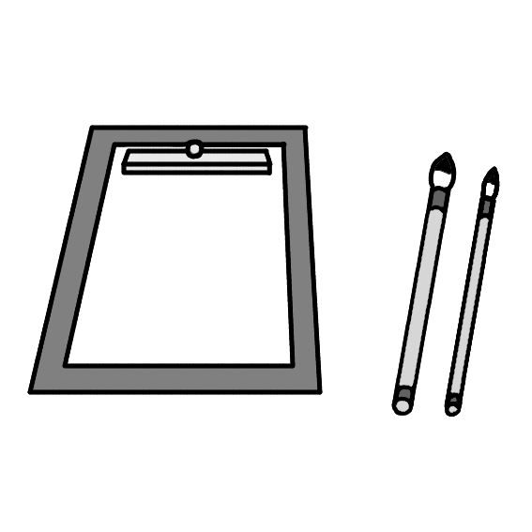

⑤ | Delivery | Work finishes after the customer’s check upon completion of
the work.
・ Explain the customer about parts’ replacement and additional work.
・ Advise the customer about
anything that has been noted.

⑥ | Direct mailing | Send a direct mail to the customer for campaign and
confirmation of the work that has been done. We are conscious
of introduction of future work and advertisement. (It is an idea
of the follow-up after the work, so it is alright to contact
the customer who directly comes to the shop. It will also lead
to the development of a new product).

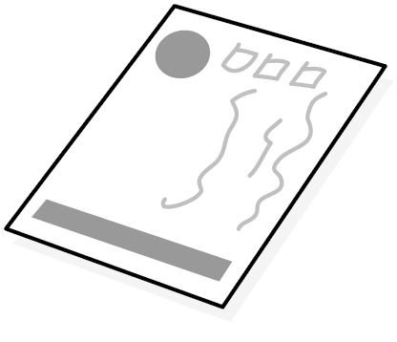


Above is considered as “ONE-COOL (flow of work)” when the job is done for a
normal customer.

For the qualification test, JAGU establishes “standardization of the work” in the
future.

2nd class ・・・Skill test in accordance with ④．
1st class ・・・Skill test in accordance with ②.

  - Service

The defect like breakage or water leak from automotive glass does not occur so
often. The customer is then concerned if the repair can be done and if so, how it
will cost. It is important to provide the job called “service”. It provides the
opportunity for learning of “waiting on customers” and leads to customers relying
on our services without any concerns. It is very important to receive the
compliment from customers who say “Better leave it to a specialist” = “Highest
degree of technology”.

Waiting on customers

As a daily motto, we should keep in mind of gratitude, delicate attention, cordiality, good faith, and honest heart. We should think about how we can be relieved from
the service if it is provided to us as customers. (Provide customer-friendly service.)

How to wait on customers
・ Greeting to customers with smile
・ Unclouded handling
・ With faithful attitude
・ With a polite remark
・ Not to forget etiquette and manner
・ With a quick motion
・ Greeting should be made with feeling and say “Thank you very much”.

Customers should have good impression as far as you pay attention to the above.
Especially, the initial impression is a major part of the customers’ evaluation at the first meet, and it is also a very important factor to have feeling of security. It leadsto the business, so we should keep it in mind to wait on customers in a cordial
manner.

The following items must be covered.
- Promise with regard to the work
- Delivery and pick-up time (Need to consider the convenience of
the customer as much as possible)
- In the lawful viewpoint, not to make senseless and impossible promise.
- Look your appearance (Unfortunately, we sometimes hear that the
appearance makes the impression, so you must at least wear clean
clothes and check your hair, etc.) .
- When you talk, look at the customer’s eyes (“Eyes are as eloquent as
the tongue.” When you wait on the customer with confidence, he will be
relieved.)
- Must repeat the promise with the customer, address, telephone number,
etc.
- When responding through the phone, answer clearly and crisply because
the customer can not see you..

7-4 Identification of glass

When the customer asks for replacement of glass or estimation, you must respond it
promptly to meet the customer’s needs. However, the customer does not normally
have knowledge about automotive glass. So, what you do the first is to collect
“definite information” for identification of glass from the customer. By using it,
you can propose “conditions which satisfy the customer”.

Processes to identify glass
1. Obtain the automobile information from Automobile Inspection Certificate.
2. Obtain glass information from the customer using automotive glass monogram.
3. If above information is not sufficient for the work, ask the customer for details.

1. Automobile Inspection Certificate
You can get the following information from the Inspection Certificate.
Type designated number, Classification distribution number ・・・Make sure
the shape of automobile (Figure 7-4-1, 4th line from upper right)
Example: Sedan, Hardtop, Hatchback, Wagon, Van, Number of doors, with hi-roof,
with standard roof, etc.
- Year, Frame number ・・・Minor changes made to automobile or changes in
product-number/glass type based on alteration of setup for glass.

Figure 7-4-1 (See translation below)
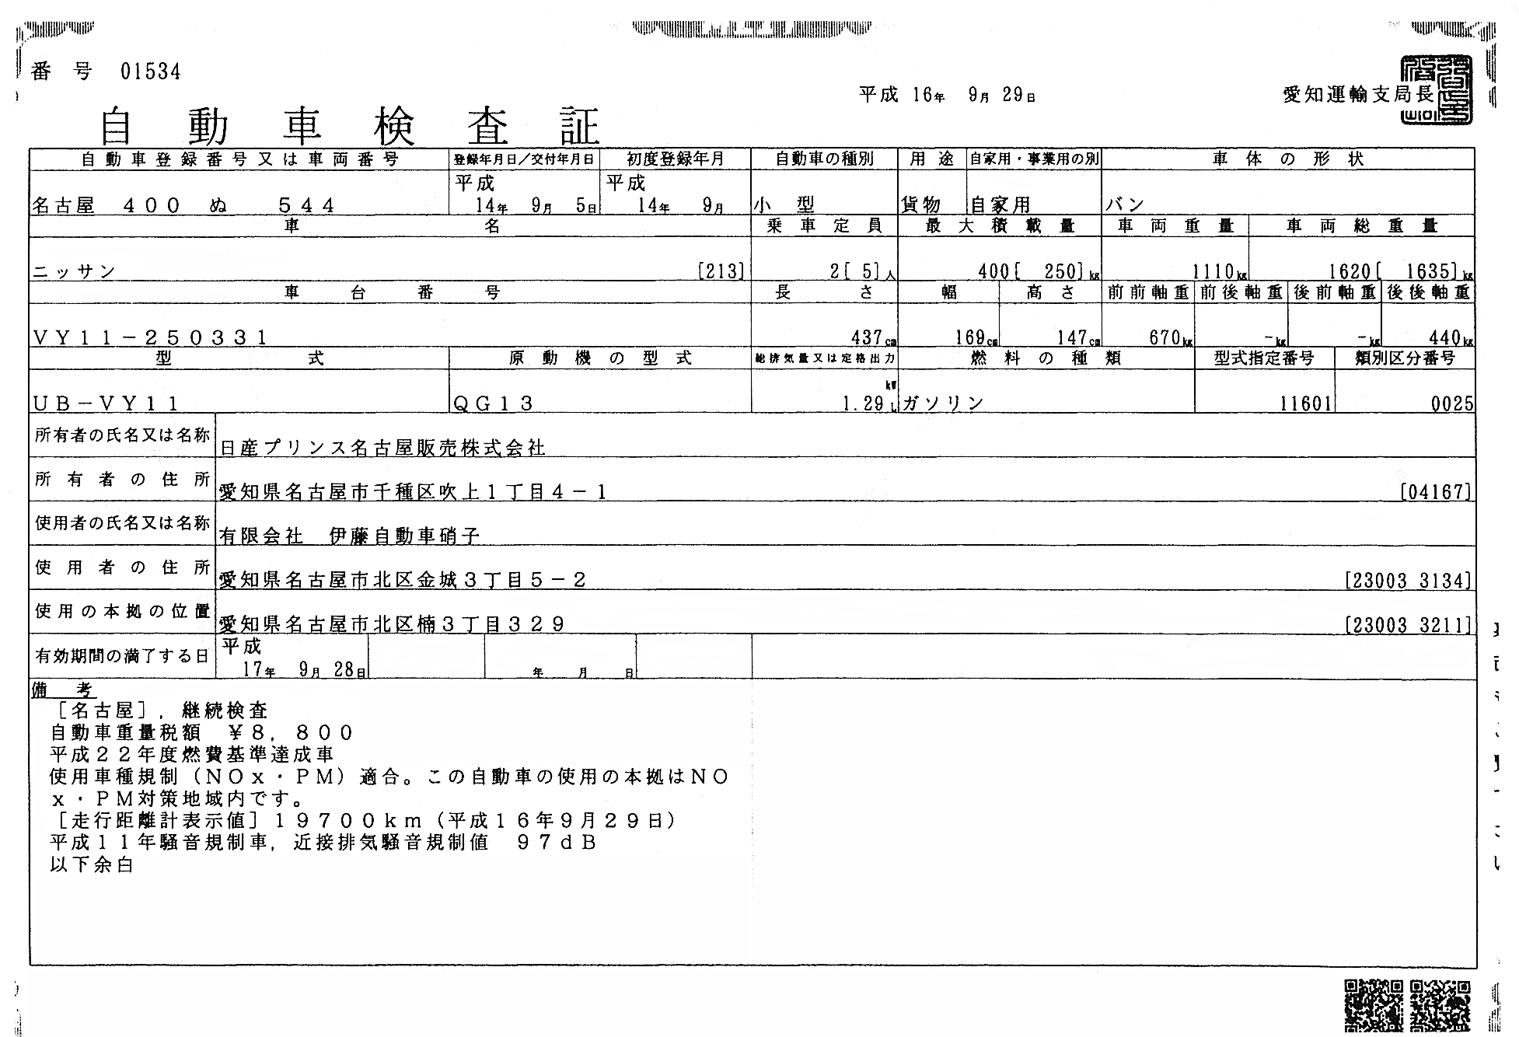

Figure 7-4-1
Number 01534
Automobile Inspection Certificate Sep 29, 2006 Seal: Chief, Aichi Transport Bureau
Automobile Registration No. Registration Date First Registration Class Purpose Private/Business Shape
Nagoya 400 Nu 544 Sep 5, 2004 Sep, 2004 Small sized Cargo Private Van
Automobile name No. of passengers Max. load Automobile net weight Automobile gross weight
Nissan 2 (5) 400(250) kg 1,110kg 1,620 (1,635) kg
Automobile No. Length Width Height FF Axle load FR Axle load RFAxle load RR Axle load
VY11-250331 437cm 169cm 147cm 670kg - - 440kg
Type Type of motor Max eng. Displacement Kind of fuel Type Des. No. Cls. Dist. No.
UB-VY11 QG13 1.29kw Gasoline 11601 0025
Owner’s name: Nissan Prince Nagoya Sales Co., Ltd.
Owner’s address: 1-4-1 Fukiage, Chigusa-ku, Nagaya, Aichi Pref.
Driver’s name: Itoh Automobile Glass Co., Ltd.
Driver’s address: 3-5-2 Kinjyo, Kita-ku, Nagoya, Aichi Pref.
Hdqtr address: 3-329 Kusunoki, Kita-ku, Nagoya, Aichi Pref.
Expiration Date: Sep 28, 2007/01/16
Remarks: (Nagoya) Renewal inspection, Tax \8,800, Passed 2012 fuel consumption standard, Vehicle class control (NOx・PM) adaptation. The Hdqtr is located in the NOx・PM countermeasure district. Mileage 19700 km
(Sep 29, 2006), Passed 2001 noise control, Adjacent exhaust noise control: 97dB End of the document

2. Automotive Glass Monogram: Monogrammed character: Figure 7-4-2
All automotive glasses have identification code and logo based on Monogram.
Figure 7-4-2

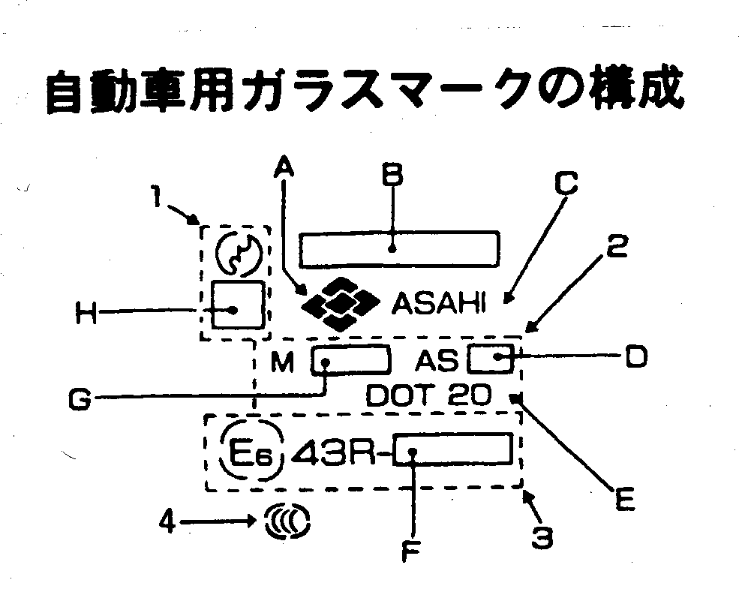
Configuration of automotive glass logo
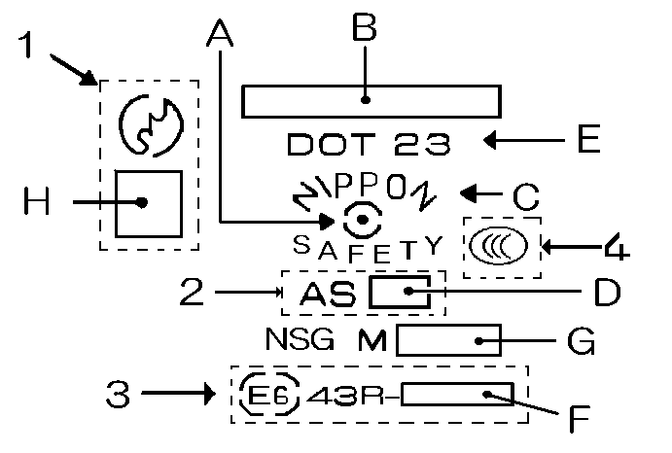

1. JI1. JIS Logo ・・・Japanese Industrial Standards Passed JIS R 3211
2. American certification・・・ANSI Mark Passed ANSIZ 26.1a(1969) test. (ANSI stands for American National Standards
Institute)
3. European certification・・・E1～Obtained from countries and regions:
E6: Obtained from Belgium
4. Chinese certification

A. Brand

B. Product’s name

 |  | Asahi Glass | Nippon Sheet Glass | Central Glass
 | Laminaed Glass | LAMISAFE | LAMIPANE | LAMILEX
 | Partially tempered glass | ZONELITE | VISILITE | ZONELEX
 | Tempered glass | TEMPERLITE |  | TEMPALEX

C. Manufacturer’s informal code

D. AS 1 ・・・Can be used for windshield glass (laminated glass)
AS 2 ・・・Can be used for other than windshield glass
AS 3 ・・・Privacy glass: Can be used for the driver’s seat or back.:
A S ・・・Gradation glass

- Registration Number for U. S. Department of Transportation
Asahi Glass DOT 20
Nippon Sheet Glass DOT 23
Central Glass DOT 44
Yokohama Kougaku DOT 137
Fujiwara Kogyo DOT 69
Japan Tempered & Laminated Glass DOT 166
Fuji Anzen DOT 265

F. Classification by category

G. M-Number (Designated identification number)
3rd and ４th figures behind M indicate “commodity item (kind)”, “variety
(mainly color), thickness, special processes, etc. It is very important
information to identify glass.

H. Variety of glass
Z- TP-Partially LP-Laminated glass
Variety of glass is stamped as shown above.

（Example） Ｍ ３ １ ４ □ □
① ② ③ ④ ⑤

 |  | ①-class | ②-class | ③-class | ④-class | ⑤-class
 | Asahi Glass | Commodity  item:  Laminated glass  Tempered glass | Variety:  Color | Thickness of  glass | Specialty  Item  Different  thickness  lamination | Special  treated
 | Nippon Sheet  Glas | Thickness of  glass | Variety:  Color: | Commodity  item:  Laminated glass | Special  treated | Special  treated  color  display
 | Central Glass | Commodity  item:  Laminated glass  Tempered glass | Variety:  Color | Thickness of  glass | Special  treated

※Pay attention to 2nd-class when the order is placed as 3 manufacturers
show color in 2nd-class.
Asahi Glass M-Number Schedule for Automobile
 | Item | Content | 1cls | 2cls | 3cls | 4/5cls
 | Commodity  item | Laminated glass(15mil film) | １
 | Commodity  item |  | ２
 | Commodity  item | Laminated glass (30mil film: Clear or dye in different color) | ３
 | Commodity  item | Partially | ４
 | Commodity  item | Laminated glass(30mil film: Full coloring) | ６
 | Variety | Sun-green, Sun-green + Sun-green |  | １
 | Variety | Clear + Sun-green |  | ２
 | Variety | Sun-green S + Sun-green, UV-cool-green + Sun-green) |  | ３
 | Variety | Clear, Clear + Clear |  | ４
 | Variety | Clear + Sun-blue |  | ５
 | Variety | Clear + Grey |  | ６
 | Variety | Sun-blue, Sun-blue + Sun-blue |  | ７
 | Variety | Sun-brown, Sun-brown + Sun-brown |  | ８
 | Variety | Clear + Sun-brown |  | ９
 | Variety | Grey, Grey + Grey |  | ０
 | Variety | Dark-brown, Dark-brown + Dark-brown |  | Ａ
 | Variety | Clear + Dark-brown |  | Ｂ
 | Variety | UV-clear |  | Ｃ
 | Variety | Clear + Sun-grey |  | Ｄ
 | Variety | PPG-grey + PPG-grey |  | Ｅ
 | Variety | Sun-greenS, Sun-greenS + Sun-greenS |  | Ｈ
 | Variety | UV-coolgreen, UV-cool-green + UV-cool-green |  | Ｈ
 | Variety | Clear + Sun-greenS, Clear + UV-coolgreen |  | Ｋ
 | Variety | PPG-new-dark-grey, Sun-bale-rey20 ・ 35 |  | Ｌ
 | Variety | Sunbale-grey + Sunbale-grey |  | Ｌ
 | Variety | UV-bronze, UV-bronze + UV-bronze |  | Ｔ
 | Variety | Sunbale-green50 + Clear ・Sun-green |  | Ｆ
 | Variety | UV-bronze + Clear |  | Ｎ
 | Thickness | 2.5mm(only ) |  |  | Ｔ
 | Thickness | 2.8mm(only ) |  |  | ２
 | Thickness | 3.1mm, 3,5mm, laminated(1.8 + 1.8, 2.0 + 1.6) |  |  | ３
 | Thickness | 4mm |  |  | ４
 | Thickness | 5mm |  |  | ５
 | Thickness | 6mm, laminated glass (3.1 + 3.1) |  |  | ６

 | Speciality  goods | Laminated goods with different thickness |  |  |  | Ｉ
 | Speciality  goods | Laminated goods with different thickness |  |  |  | Ｕ
 | Speciality  goods | Coating(Visible ray transmittancy-less than 70% |  |  |  | ５
 | Speciality  goods | Coating(Visible ray transmittancy-more than 70% |  |  |  | ７
 | Speciality  goods | Mesh print |  |  |  | 11
 | Speciality  goods | Metal coating + Meshprint |  |  |  | ９
 | Speciality  goods | Plastic coating ALW2 |  |  |  | Ａ
 | Speciality  goods | Plastic coating ALW3 |  |  |  | Ｅ
 | Speciality  goods | UV-cut-coating |  |  |  | UV
 | Speciality  goods | Heat-light-wire laminated glass |  |  |  | Ｈ

Nippon Sheet Glass M-Number Schedule for Automobile
 | Item | Content | 1cls | 2cls | 3cls | 4cls | 5cls
 | Thickness | 2.5mm() | 25
 | Thickness | 2.8mm() | 28
 | Thickness | 3.1mm() | 31
 | Thickness | Laminated 4.3mm・4.5mm・4.6mm, reinforced 3.5mm | ３
 | Thickness | Laminated 4.7mm・4.8mm・4.9mm・5.0mm・5.3mm, reinforced 4.0mm | ４
 | Thickness | Laminated 5.7mm・6.2mm, reinforced 5.0mm | ５
 | Thickness | Laminated 6.7mm・7.2mm, reinforced 6.0mm | ６
 | Variety | Green・UV-green + Clear/Green・UV-green |  | ０
 | Variety | Green・UV-green + Green |  | １
 | Variety | Grey + Grey/Dart-grey |  | ２
 | Variety | Grey + Clear/Grey |  | ３
 | Variety | Dark-bronze + Clear/Dard-bronze |  | ４
 | Variety | Clear + Clear/Clear |  | ５
 | Variety | Bronze + Clear/Bronze |  | ６
 | Variety | Blue + Blue |  | ７
 | Variety | Bronze + Bronze |  | ８
 | Variety | Blue + Clear./Blue |  | ９
 | Variety | UV-bronze + UV-bronze/UV-bronze |  | Ｂ
 | Variety | UV-bronze + Clear |  | Ｃ
 | Variety | Legato20・Galaxy(Privacy glass) |  | Ｑ
 | Variety | Legato50(Privacy glass) |  | Ｓ
 | Variety | Legato35(Privacy glass) |  | Ｙ
 | Commodity  item | Laminated glass（15mil film） |  |  | ０
 | Commodity  item | Laminated glass(30mil film)dye in different color, hot-wire  print, including glass with antenna |  |  | １
 | Commodity  item | Laminated glass(heating wire) |  |  | ２
 | Commodity  item | (with water repellent film) |  |  | ５
 | Commodity  item | (UV-cut-coating) |  |  | ６
 | Commodity  item | Partially |  |  | ７
 | Commodity  item | (Heating wire antenna・Shade-band・including  masking band) |  |  | ８
 | Specialty  goods | Entire coloring film(Laminated glass) |  |  |  | ３
 | Specialty  goods | Entire print() |  |  |  | ４
 | Specialty  goods | Colored glass: Color tone is specified at 5th-class. |  |  |  | ６
 | Specialty  goods | Metal coating |  |  |  | ９
 | Specialty  goods | Entire coloring film with blue series |  |  |  |  | ３
 | Specialty  goods | Entire coloring film with brown seris/Entire coloring film with  brown series |  |  |  |  | ４
 | Specialty  goods | Entire coloring film with grey series |  |  |  |  | ６
 | Specialty  goods | Colored glass with pink series |  |  |  |  | Ａ
 | Specialty  goods | Colored glass with light grey series |  |  |  |  | Ｂ
 | Specialty  goods | Colored glass with medium grey series |  |  |  |  | Ｃ
 | Specialty  goods | Blue/colored glass with green series |  |  |  |  | Ｄ
 | Specialty  goods | Green-grey/Colored glass with dark grey seris |  |  |  |  | Ｅ

Central Glass M-number schedule for Automobile
 | Item | Content | 1cls | 2cls |  | 3cls | 4cls
 |  |  | ２
 |  | Laminated glass | １
 |  | Partially | ０
 | Variety | Clear |  | １
 | Variety | Blue |  | ２
 | Variety | Bronze |  | ４
 | Variety | Grey |  | ３
 | Variety | Green |  | Ａ
 |  | Dark bronze |  | ５
 |  | Dark grey |  | ６
 |  | UV-green |  | Ｅ
 |  | Uv-bronze |  | Ｈ
 |  | Clear + Clear laminated glass |  |  | ７
 |  | Clear + Blue |  |  | ９
 |  | Clear + Grey |  |  | ２
 |  | Clear + Bronze |  |  | ５
 |  | Clear + Green |  |  | Ｂ
 |  | Blue + Blue |  |  | ８
 |  | Bronze +Bronze |  |  | ４
 |  | Grey + Grey |  |  | １
 |  | Green + Green |  |  | A
 |  | Clear + UV-green |  |  | F
 |  | Green + UV-green |  |  | G
 |  | Dark-green |  |  | ８
 | Thickness | 2.8mm(only )
 | Thickness | 3.1mm |  |  |  | ２
 | Thickness | 3.5mm |  |  |  | ３
 | Thickness | 4mm |  |  |  | ４
 | Thickness | 5mm |  |  |  | ５
 | Thickness | 6mm |  |  |  | ６
 | Thickness | 2.3mm + 1.6mm |  |  |  | Ｂ
 | Thickness | 2.3mm + 1.8mm |  |  |  | Ａ
 | Thickness | 2.3mm + 2.3mm |  |  |  | ７
 | Thickness | 2.3mm + 2.0mm |  |  |  | ８
 | Thickness | 3.5mm + 2.5mm |  |  |  | ０
 | Thickness | 4.0mm + 3.0mm |  |  |  | ９
 | Specialty  goods | Heat insulating film Laminated glass |  |  |  |  | ３
 | Specialty  goods | Entire coloring film with bronze |  |  |  |  | １
 | Specialty  goods | Metal coating |  |  |  |  | ６

About Other Monogram Display

1. Asahi Glass

［Toyota］
※１ ※２ ※３ ※４

・ ・ ・ ・ ←Mark２㎜φ
ＴＯＹＯＴＡ
Disply content: ※1 With gradation （dye in different color）
※2 Deicer for cold district goods
→K type (with sensor)
※3 With deicer
※4 With antenna
[IR cut glass]
Display content: Stamp 「・」under M-number
Ｍ３１４
・
［Water repellent glass］
Display content: Stamp 「・」in front of DOT display
・DOTー20
- Matters that require attention: High heat insulating glass (Privacy glass ・
Dark colored glass)
Glass absorbing heat by an iron coloring as a result of mixing glass
material with small amount of metal. It has more advantage than ordinary
heat absorbing glass, and it is heating-wire absorbing glass with visible ray
transmittancy of less than 70%.

2. Nippon Sheet Glass

［UV cut glass］
Display content: Stamp 「・」behind M-number or place underline on M-number.
Ｍ３０８． M３０８

Special display for［Tempered glass］
In case of ①-class is 2 digits (25, 28, 31), stamp 「．」lower right. of
①-class. However, there is no need to stamp if ②-class is alphabet.
（Example）Ｍ３１．０８ Ｍ３１Ｙ８

3. Central Glass

［IR cut glass］

Display content: Stamp 「・」in front of the commodity.
・LAMILEX
［Water repellent glass］
Display content: Stamp 「・」behind M-number.
M2E5・

Description of type/symbol by glass manufacturers

When glass is ordered or receipt of goods is checked, type/symbol by glass
manufacturers can be used in addition to parts number.

Asahi Glass
1. Classification of automobile type
(1) Automobile Manufacturers’ Code
11 Toyota 14 Hino 21 Suzuki
12 Nissan 17 Mitsubishi 24 Nissan Diesel
13 Isuzu 18 Daihatsu 26 Honda

(2) Color
Ｄ Blue ＮＭ Sun-greenS ＰＧ ＰＰＧ grey-heat-objection
Ｓ Clear ＭＶ ＵＶ-green ＭＯ Green-heat-objection
Ｂ Bronze ＢＶ ＵＶ-bronze ＧＭ Dark-green
Ｇ Grey ＧＶ Graver bell-bronze ＰＮ ＰＰＧ-new-dark-grey
Ｍ Green ＧＧ Greenish-grey

(3）Other
・Module/Assembly glass
「9」in front of car’s name (Example)9YH41D AOWRX
- Overseas product
「X」in front of car’s name (Example)XSM4M 4FHGX
- Heat-objection
- 「C」behind color code (Example)RH130BC 5FHX
- Mirror base
「M」behind color code (Example)YB41BM AFHX

・Diversity antenna
「V」behind color code (Example)RX0BVV ARBNX
・TV antenna
「Ｔ」behind color code (Example)RX0BVVT ARBNX
・Glass with deicer
「P」behind color code (Example)RT190DP ４FHQX

2． Place classification
(1) Front
FHGX Mercedes green dye in different color
FHCX Purple blue dye in different color
FHUX Grey dye in different color
FHKX Bronze dye in different color
FHQX Light blue dye in different color
FKNX With antenna

(2) Rear glass
Ｍ Heating wire print, without gilding ARM
Ｐ Heating wire print, with gilding RHP
Ｎ With antenna ARPNX
Ｗ Wire hole ARMWX
Ｘ With ceramic ARMX
Ｊ Heating wire print(with gilding)+antenna ARJWX
Ｕ Heating wire print(without gilding)+antenna ARUWX
Ｚ Heating wire print(with gilding)+antenna+key less ARZWX
Ｂ Heating wire print(with gilding)+key less ARBNX
Ｙ Heating wire print(without gilding)+wiper hole ARYXA
Ｅ Heating wire print(without gilding)+key less ARESX
Ｄ With telephone antenna 5RPDX

(3)Other code
・Setup change
FDRA1 FHX2
・Pattern change
RMXA RQXA
・Head-up display「H」
(Example) JS12BM 4FKXH
・ASSY classification
Mirror base「M※」
(Example) JS10B 4FKXM1

JA10D 4FQXM2

Nippon Sheet Glass
1. How to read glass type number
④
ＲＸ１００ＨＥ ＴＦ７Ｃ
Glass type ↑ ↑ ③Parts code
①Color code ②Thickness code

①Color code (Attach it to the last of glass type)
Clear S
Blue D
Green E
Bronze L
Grey G
Dark green C
Dark bronze N
Dark grey J

②Suffix code due to changes in the design
3.5mm T
Laminated glass(2.1+2.1mm or below) T
3.1mm N

③Parts code
Front glass Partial reinforcement F
Laminated Clear F1
Laminated Blue gradation F3
Laminated Grey gradation F5, F15
Laminated Green gradation F7
Laminated Bronze gradation F8, F18
Laminated Light blue gradation F13

④Masking process(Ceramic process) F | CＣ

7-5 Work Instruction (Preparation of Prior and Post
Work Inspection Sheet)

Work instruction is (undertaking instruction)
It is very important to check the condition of the automobile in accordance with
the work instruction, prior to undertaking the work. It helps an early solution
with the customer if the trouble occurs.

Prior Inspection procedures
1. Conduct prior inspection of the cause of damages (dent, crack)
2. Check to see no dent, paint peel-off, re-painting on the part (automobile body)
of the work.
- Check to see if the glass has been installed after the accident, although
the restoration of the automobile body was incomplete
(There are distortion and deflection.).
4. Condition of interior
・ Is the sheet ripped or foul?
- Are there any cracks on the dashboard?
- Aren’t there any damages or foul on the lining of ceiling and pillar?
- Aren’t there any damages to connectors for heating wire and
antennas on the rear glass?
5. Exterior
・Are wipers working? Aren’t arms bent? Aren’t rubbers ripped off?
・Any damages to cowl top, mould, etc?

Post Inspection procedures
1. In addition to applicable prior-inspection items, inspect to see if damages
have been increased on the interior and exterior.
2. Inspect the location of glass, cracks on mould, lifting, etc.
3. Clean interior and exterior including left over of adhesive wipe-up.
4. Conduct water leakage test.

Keep photographs if there are any applicable items shown above. If possible,
ask the customer prior to the work, and inspect again applicable items after
the work, and it is important to get the customer’s signature on the work
instruction. Meanwhile, write down used adhesives, temperature and humidity at
the time of work that can be used when any claims may arise.

And use the work instruction as a file to maintain customers’ list.
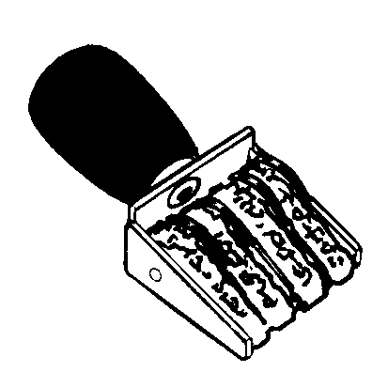

Work instruction (See translation below)

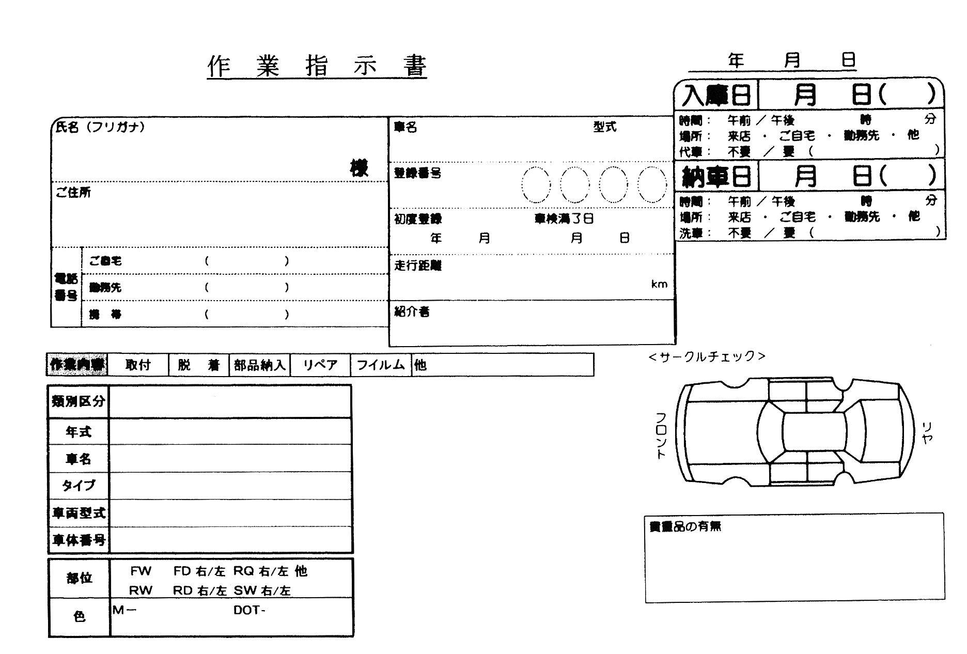

Work Instruction
Year Month Day
Inbound Date: Month Day
Time: Morning・Afternoon
Place: Coming to shop, Home, Work, Other
Loaner automobile: No/Yes
Delivery Date: Month Day
Time: Morning・Afternoon
Place: Coming to shop, Home, Work, Other
Automobile wash: No/Yes

Name Automobile name Type
Registration Number
Address Initial registration Month Day
Expiration Date Month Day
Mileage km
Introduced by
Tel: Home
Work
Cellular phone
Description of work: Fixing, Removal/Replacement, Parts delivery, Repair, Film, Other
Classification:
Year:
Automobile name:
Type:
Automobile type:
Automobile identification number:
Part: FW FD Right/Left RQ Right Left Other
RW RD Right /left SW Right /Left
Color:

〈Circle Check〉

Front Rear

Valuables: Yes/No

7-6 Claims handling

Even you carefully work on a routine basis, there are cases in which you have
caused the damages to interior and body of the customer’s automobile, or received
claims later because the automobile was leaking on rainy days.
In that instance, first
1. Remember that there is no excuse until after the cause has been identified.
Consider it seriously and apologize to the customer anyway.
2. When you feel comfortable, negotiate the best course of action.
These are important matters. Try to make good-faith efforts if you were wrong.

To solve the problem, if you are insured, contact the insurance company and ask
for its instruction.
If not,
- When interior parts are broken, immediately order necessary parts and
ask the technical firm or like for replacement.
2. For scratches on the body, polish with polishing powder or apply touch-up
paints. (after you have obtained the acceptance of the customer.)
- When scratches are deep, repaint at the firm which is specialized with
painting..
- When rainwater damage repair is done, do the necessary rework at your shop.
(Refer to the next paragraph)
These are processes to be taken. Choose the way the customer accepts anyway.

7-7 Rainwater damage repair

Not only the claim arisen from the work done, but the customer often asks for
rainwater damage repair. There are various reasons, and some examples are
- deterioration of weatherstrips, ② holes caused by rust at connected portions,
③ cracks on adhesives on impact.

Rainwater damage repair

- Confirm the portion of rainwater damage (Rainwater damage can’t be fixed
unless the portion of water leaking-in is repaired.)

① Confirm the customer
- When was water leak noticed?
- How did it happen?
Example: During the automobile-wash, or driving on a rainy day, etc.
・ Where is water pooled? Or, where is it coming from?
② Automobile check-up
・ When the portion of water leak is known, splash water on it.
In case of glass, it is good to blow the air powerfully from the inside.
・ If the portion of rainwater leak is not known, splash water from lower part of the automobile.
- Inside wheel house.
- Fender
- Engine room
- Cowl top or the portion where the wiper motor is installed after
removing cowl top
- Portion of roof nail. Seal by tape to avoid water flowing into glass
moulding when splash water on the roof.
f. Splash water on glass moulding from lower part, too.
③ Cause and countermeasure
・ When water is leaking at the stages of a～e,
Cause: Loosening of screw, deterioration, hardening, and mounting defect of
gasket seal, cracks on sealer of roof nail (adhesive for sheet metal
to fill in plate joints) (※1)
Countermeasure: Respond to the matters that can be done. (Retightening,
parts replacement)
Regarding (※1), ask sheet metal repair firm as a lot of sheet metal
work is involved. In this instance, as water is often coming out from
the joint of pillar and roof that is glued to windshield glass, it is
mistakable that water leaks from the glass.
- When water leak is confirmed at f,
Cause: Lost or peeling off of adhesive.
→Insufficient volume of adhesive (check the joint of sealer)
→Defective painting of primer (Did not follow the instruction of
paint manufacturers and applied sealer prior to hardening)
→Incomplete cleaning before adhesion(degreasing)
→Wrong selection of primer (There is a specialized primer for
moulding-material on side glass.)
→Moved the automobile before hardening of adhesive (Inform the
customer
of the time for being able to drive)
→ Glass moved up as a door was closed while all door glasses were
being shut.
→Rust broke out (Apply primer to the portion where the paint peels
off due to a full-cut method.) ※2
→Error of sheet metal repair work, distortion (※3)
Countermeasure: Remove glass to do the work again.
In case of ※2 and ※3, sheet metal repair may be done.

Mentioned above, you study “Customer Service” in this Chapter. Technique is that most in need for automotive glass workers. However, you can provide
customers with multi-relief if you wait on them with smile and identify necessary
glass without delay. The way to “The first-class automotive glass technicians
authorized by JAGU” will be opened if you are not only satisfied with advancement of technique, but strive to attain the improvement of customer service and
knowledge.

Chapter 8 Considering environment

People set and seek for their “healing environment”. However, we have to say that there are so many cases of not realizing of its destruction. In that condition, we are not allowed to be unconcerned with environmental destruction. Because, even it is absolutely imperative for modern society, we are engaged in the work on the “automobile” that is said to be dispersing CO and CO2 in the air. Although indoor air may be cleaned by using minus ion, we don’t consider that we protect ourselves from air pollution at global basis. Or, we can’t consider it in the real world. Each person should start practicing to prevent from environmental destruction even it is insignificant matter. You can practice now to stop idling and not to use the automobile if it is a short distance, etc.

Work by our automotive glass workers can’t be avoided from various problems such as, exhaust gas to industrial waste. And, it also requires the heart of more gentle service to the earth. “Automotive glass” that is handled by us can never be considered as non-recycle item. Of course, there are parts or portions which can’t be recycled under the present technology. However, industrial waste generated from all parts or portions may be reduced to “nothing” in the near future. Until then, we will strive to reduce the volume of industrial waste as much as possible and ask for the instruction of manufacturers except for non-processed portions which are consigned to industrial waste transport-process firms.
We study the environmental issues in this Chapter.

8-1 About disposal of waste glass

Handling for recycled-based society- In the “Automobile Recycle Law” enforced in 2006, the regulation is not clear to dispose of waste glass being processed by automotive glass work industry, but it can never be the issue avoided in the future.

Some of automotive glass sales and repair firms in the industry have already started detaching glass from intermediate film “Poly Vinyl Butryral”of laminated glass by using a glass grinding machine and ask industrial waste transport-process firms for disposal. We rely on industrial waste transport-process firms about recycling procedures, but it is important for us to be aware of involving in recycle-based society at all times and take it in advance.

* Introduce laminated glass grinding machine and processed form in the color page.
(by the courtesy of an automotive glass sales and repair firm)

8-2 About disposal of glass related products

Glass related products include aforementioned laminated glass, tempered glass, piano wire, moulding, fastener moulding, and adhesive, etc. It is required to process each product properly in accordance with the instruction from manufacturers.

* Laminated glass: At present, we think that most of automotive glass sales and repair firms ask industrial waste transport-process firms for disposal. At that time, each firm is obligated to fill in the form called “manifest” using its own name, and is responsible for the procedures how consigned industrial waste is disposed of and submit it. They bring in collected glasses to the vast extent of land to grind by the construction equipment, etc., and use a labor intensive method to pick up glasses in pieces with remained intermediate film. Then items which can be recycled will be recycled. (according to a disposal firm in Aichi prefecture)

* Tempered glass: For simplicial tempered glass waste, it can be recycled for glass product such as, a beverage bottle with color, etc. which does not require accuracy (degree of cleanliness), so it is very desired form to collect an item being sorted from the point of view of recycling. By the way, a glass with its popular-name called “privacy glass” is colored darken, and some manufacturers have developed techniques to considerably remove color, and its technique can be applied to technical change-over for broken tempered glass.

* Piano wire: It can be collected as ironwork and recycled, so individually categorized as resource.

* Molding: For an industrial waste, we have to take the procedure such as, consigning to disposal firms or returning to manufacturers, so it is desired for early recycling.

* Adhesive: At present, the procedure is the same as that of moulding. Especially, if the
automobile has been repaired a number of times, there is no record of who, when, how adhesive was used, so there are problems for not knowing what kind of waste disposal and recycling method should be taken. We have to specifically follow the instruction from adhesive manufacturers.

As stated above, there are many uncertain areas about industrial waste disposal around us under the present circumstances. We, automotive glass technicians have to strive for studying and knowing of better methods, and selection of environment friendly disposal methods. On top of this, we should not forget to strive for 100% recycling of automobiles with manufacturers.

Chapter 9 Handling of insurance – About Liability Insurance

Automotive glass industry & liability insurance

Automotive glass industry has a close relation with liability insurance including automobile insurance, etc. in the area of automotive glass repair caused by automobile accident.
In this Chapter, we study about liability insurance.

9-1 What is liability insurance?

In our daily life and business activities, we often suffer from the economic loss caused by unexpected accidents such as, casualty, mishap, etc. Liability insurance will protect our life from these risks, support business activities, and provide guarantee function in case of emergency.

Advertisement of liability insurance is normally processed through the liability insurance agent who receives a commission from liability insurance company. When an agent advertises liability insurance, he is required to have registration from the Director, Financial Services Agency, so he can’t do advertisement without registration. It is limited to persons who can do advertisement of liability insurance, and anyone can’t do advertising activities unless he has met the conditions for educations, etc. as prescribed and his employer has notified him as a practician for advertisement.

As the insurance business is also a business with high sociality and publicity, it is especially important to protect policyholders and others. The laws which the agent has to follow are various laws such as, Insurance Business Law, Consumer Contracts Law, Financial Instruments Sales Law, Identification Law, etc. and agent business is controlled by these laws, so the compliance is especially important order of business.

Liability insurance items include commonly well known insurances such as, automobile insurance which accounts for approx. 40% of total insurance premium weights and fire insurance. There are various liability insurances such as, accident insurance and general liability insurance provided against indemnification for damages, etc. and items in the third class including medical insurance which is positioned on the border with life insurance.targeted for household economy and business areas.

Contracts for these liability insurances are normally comprised of policy conditions and insurance premiums. Insurance contracts are structured by premiums based on the risk of damages, and indemnification description and premiums for insurance have been varied by insurance company and insurance items as a result of the recent deregulation of liability insurance business and progress in liberalization

9-2 Structure of automobile insurance

It is estimated that the amount of economic loss caused by traffic accidents in Japan is more than three trillion yen per annum (Fiscal year 2000) and it is also a huge economic loss for the nation. Of these traffic accidents, accidents generating injured persons are especially in a large number, so automobile insurance is used to pay for insurance money on bodily injuries and property damages that can secure the financial position of an individual at fault, contribute to the relief of the victim from the accident, and furthermore assist in solving disputes between an individual at fault and a victim by using out-of-court settlement services, etc. provided by liability insurance companies to socially achieve an important role.

Automobile insurance is divided roughly into the Compulsory Automobile Liability Insurance and the Voluntary Insurance for Automobile, which is required to take out by the Automobile Liability Security Law. As every automobile has to be insured with the Compulsory Automobile Liability Insurance that is required by the law as a rule, it is structured that insurance is generally taken out at the time of automobile inspection. It is aimed to minimally protect a victim whose life or body has been harmful from automobile operation, so it is structured to indemnify within certain limitation (Maximum 30 million yen for the death or permanent disability, maximum 1.2 million yen for bodily injury) to only indemnify the claims for bodily injury. For this reason, casualty for a high amount of personal indemnification and property damage accidents, etc. is covered by the voluntary insurance for automobile.

Voluntary insurance for automobile is generally insured by structuring of combination of coverage for bodily injury liability, property damages, passengers’ personal accident, self-incurred personal accident, uninsured automobile insurance, personal injury insurance, automobile’s physical damage, etc.
The liability description and premium are characterized to determine in many ways, based on various conditions on the type of automobile, grade, and age, etc. which are the purpose of insurance, and the grade discount system is set up for “without an accident” discount.
Of these, the coverage for bodily injury liability is the indemnification in addition to the compulsory automobile liability insurance, and it is aimed to pay the portion which exceeds the amount of payment from the compulsory automobile liability insurance.

  - Automotive glass damages
and
Structure for handling of accident using automobile insurance

As to the payment of automobile insurance to cover automotive glass damages, it is a case that a person who suffered property damages receives the indemnification from the person at fault using the coverage of property damages. Cases are mainly to indemnify glass damages caused by flying objects such as stones, or when his automobile’s glass was damaged by passengers’ personal accident, etc.

In each case, as to the start of repair and claims against an insurance company for repair charge, it is important to have a contact and communication with an insurance company
as well as parties concerned, and is also important to utilize insurance as it is sure to progress the facilitation of business by application of liability of automobile insurance.
Based on the types and liability description of automobile insurance owned by parties concerned, there is a set-up deductible (out-of-pocket expense), and there are many cases which involve the detail of an accident is not subject to the insurance payment or a part of repair cost results in the self-pay by parties concerned, and the use of payment is suspended by the parties concerned due to a minor repair cost. Furthermore, we must
pay attention to the case which insurance money is cut and balanced out due to comparative faults when there is a rating blame by the situation of an accident.
We see a lot of cases which require an advance arrangement with an insurance company about details of repair, parts expense, and labor, etc., so we must pay attention to its handling. We must especially pay attention when responding to the customer’s inquiries for the use of insurance coverage against an additional repair which do not have direct relation with the accident, or having a part in an unfair billing of insurance will result in detriment to the business that has been worked up for many years, so we are required to handle it fairly.

9-4 Liability insurance required by automotive glass industry

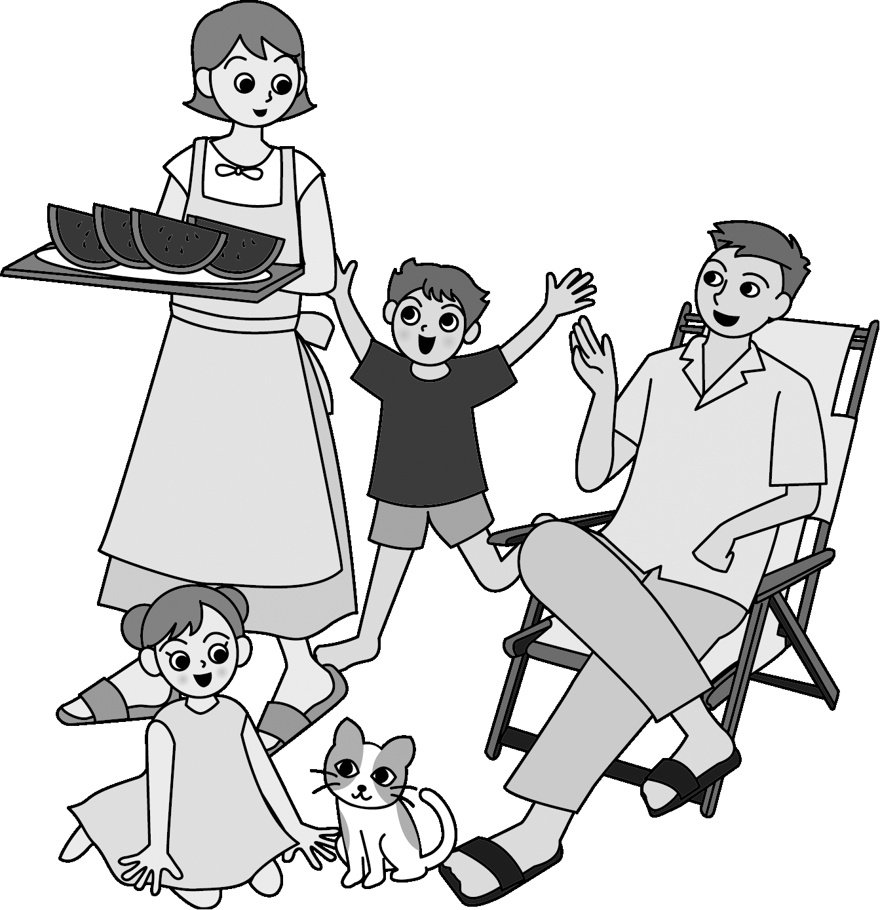
There are various liability insurances being used by automotive glass industry such as, Product Liability Insurance (Liability Insurance for Products), Liability Insurance for damages of the automobile while it is being kept in the shop, and Automobile Liability Insurance to cover damages of the automobile while it is under operation. It is desirable for automotive glass repair firms to insure for the improvement of customer services and stabilization of business.

JAGU’s 10 Articles
-From the person who has taken over the technology
to the person who will inherit it-

- Relief comes into existence after the work has been performed with the
highest technology.

2. Technology goes up by the daily hard work and efforts of engineers.

3. Engineers must acquire the knowledge to protect the safety for customers.

- Engineers provide customers with information concerning to the detail
of the work and safety upon work.

5. We will use the product which customers are satisfied with and material in accordance with the safety standard set by the JAGU to follow the procedures for their use.

6. Employers train engineers and assure their ability.

- Employers provide engineers with safe work environment.

- It leads to prosperity of the firms that engineers and employers work together to improve them, and also connects to the development of industry as a result of cooperation and having the same goal by firms throughout Japan.

9. JAGU will follow the technology which was built by those who have gone before us, and establish the system to connect to the next generation.

10. JAGU will continuously support all engineers and firms.

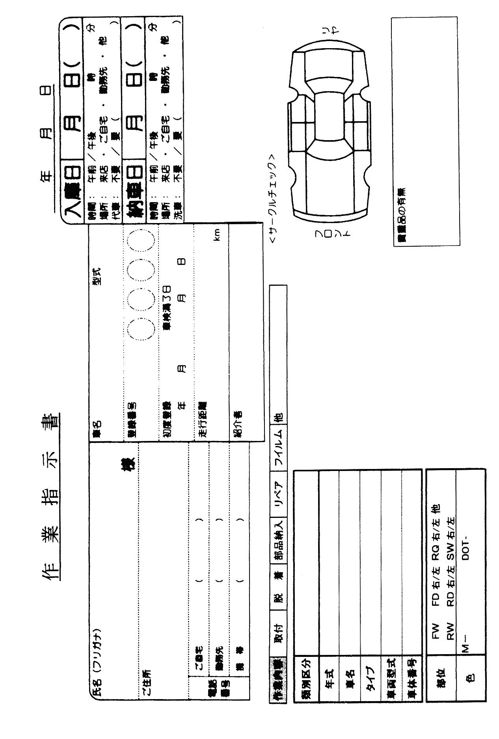

Work Instruction
Inbound Date： Month Day
Time: Morning・Afternoon
Place: Coming to shop, Home, Work, other
Loaner automobile: No/Yes
Delivery Date： Month Day
Time: Morning・Afternoon
Place: Coming to shop, Home, Work, other
Automobile wash: No/Yes
Name Automobile name Type
Registration Number
Address Initial Registration Month Day
Expiration Date Month Day
Mileage km
Introduced by
Tel: Home
Work
Cellular phone
Description of work: Fixing, Removal/Replacement, Parts delivery, Repair,
Film, other
Classification:
Year:
Automobile name:
Type:
Automobile type:
Automobile identification number
Part: FW FD Right/Left RQ Right/Left Other
RW RD Right/Left SW Right/Left
Color:
Valuables: Yes/No

JAGU Automotive Glass Engineer’s Manual
Published on March 1st, 2005

Publisher Japan Automotive Glass Association

（JAGU UNION）
〒101-0051
3-4, Kanda Jinbo-cho, Chiyoda Ward, Tokyo
Sogo Sheet Glass Kaikan 6th floor
TEL 03-3263-5810
FAX 03-3263-5820
http://www.jagu.jp

Compilation Mizukami Co., Ltd.
〒102-0073
1-12-30, Kudankita, Chiyoda Ward, Tokyo
Yano Bldg. 5th floor
TEL 03-5212-2631
FAX 03-5212-2632

Printing Wako Printing
〒805-0031
1-1-5, Kitsuta, Yahata-Higashi Ward,
Kita-Kyushu City, Fukuoka Prefecture
TEL 093-651-0949
FAX 093-652-7954

No printing/All rights reserved

