How to get the application from Apple Store?

Summary
To create an iTunes App Store account without a credit card please follow the steps below. In order to create an account without a credit card, you must make sure you are in the App Store, not the iTunes Store.

I. Creating an account on a computer
1. If you already have an account, choose Store > Sign Out.
2. Pick your country by clicking on the country flag located in the bottom right corner of the main iTunes Store page.
3. If your country also has an iTunes Store, you'll need to navigate to the App Store by clicking on App Store from the top navigation bar. If not, proceed to step 4.
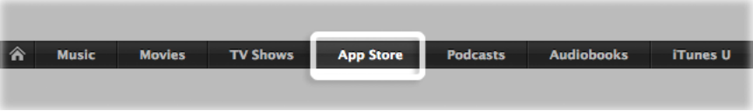
4. Important: Before proceeding to the next step, you must purchase a free application by clicking Free App.



5. Click create new account.

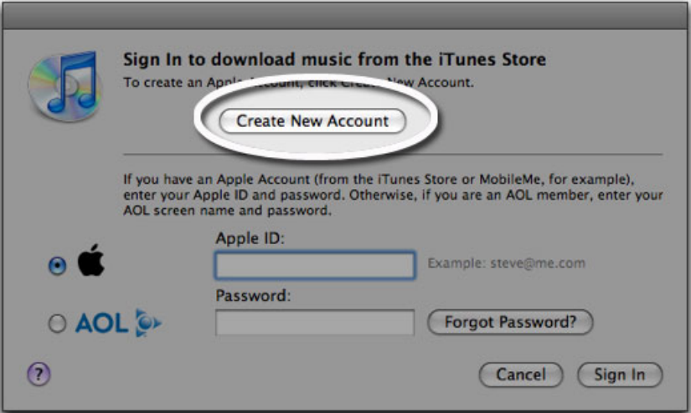

6. Click Continue.

7. You'll need to read and agree to the iTunes Store Terms & Conditions. Make sure you check the box next to where it says "I have read and agree to the iTunes Terms and Conditions."

8. Click Continue.

9. Enter your email address, create your password, continue to create and answer your security question, then enter your birthday. Click Continue.

10. Select None as the payment option.

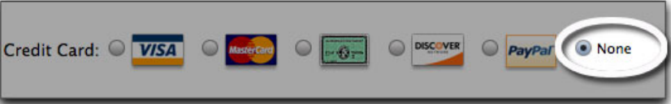

11. Continue to fill out the required name and address fields.

12. You'll then see a screen that says 'Verify your Account'. Click Done and then check your email for a verification email from iTunes Store.

13. Open the email and click the link enclosed in the email to activate your account.

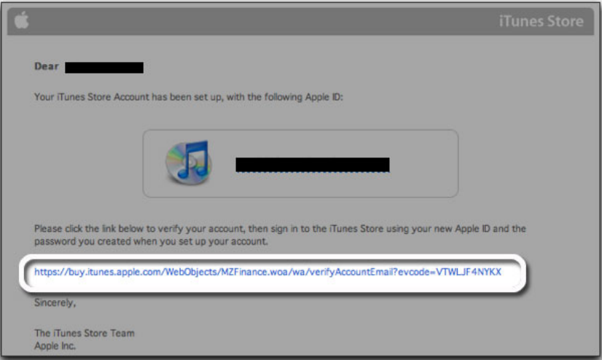

14. Once you click on the link, iTunes should then prompt you to sign in with your account name and password.

15. You'll then see the below "Congratulations" screen. Click Done to be taken to the App Store home page.

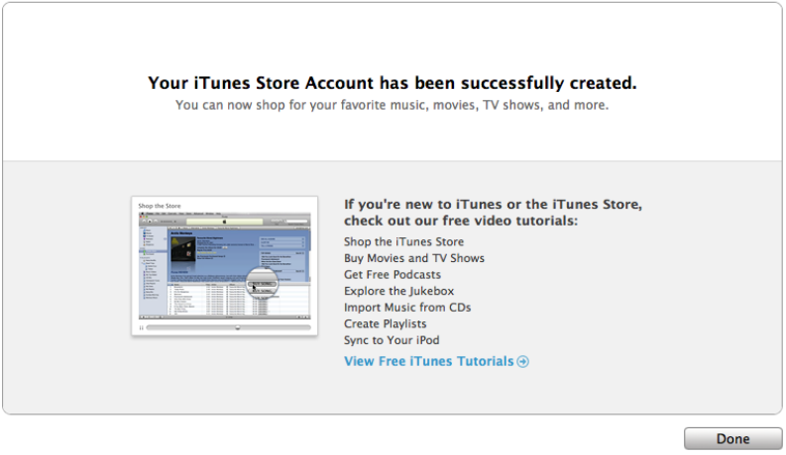

II. Creating an account on iPhone, iPad, and iPod touch

1. Open the App Store on your device.

2. Find a free application on the App Store.
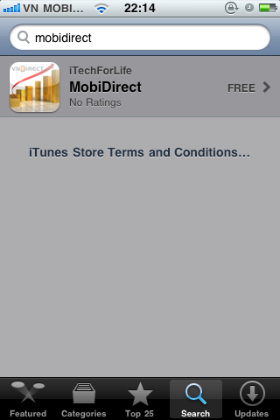

3. Important: Before proceeding to the next step, you must purchase the free application by tapping Free.

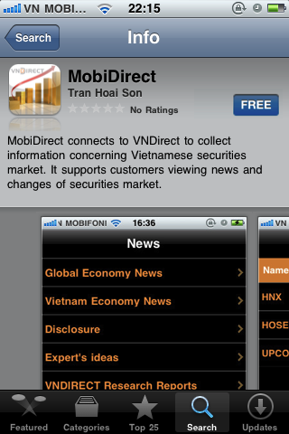

4. Tap Create New Account.

5. You'll need to read and agree to the iTunes Store Terms & Conditions. Tap Agree located at the bottom of the page to continue.

6. Choose your country, then tap Done.

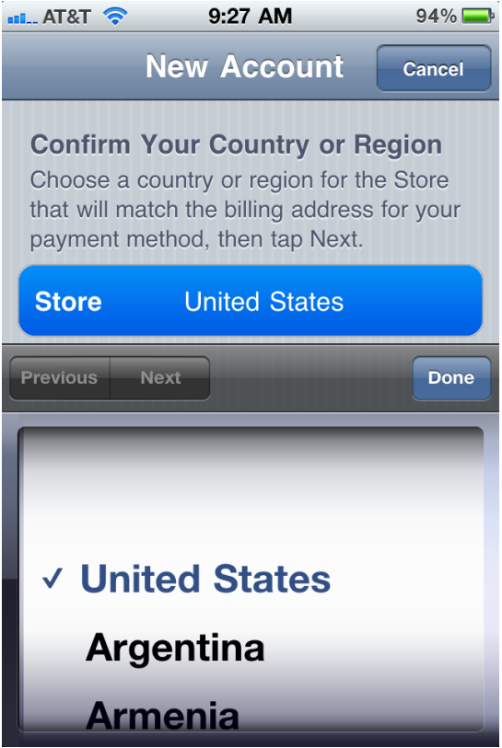

7. Enter your email address, security question, birthday, and create your password. Tap Next.

8. Select None as your payment option.

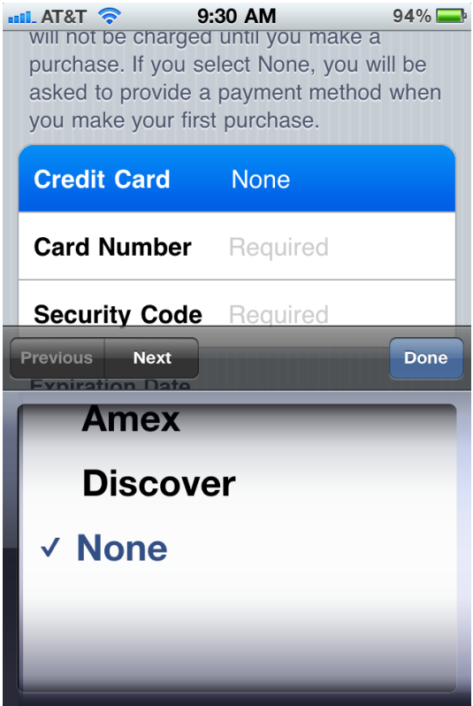

9. Continue to fill out the required email, address, and phone number fields. Tap Next.

10. You'll then see a screen that says "Verify your Account." Tap Done and check your email for a verification email from iTunes Store.

11. Open the email and click the link enclosed in the email to activate your account.

12. Once you tap the link, the App Store should automatically open and then prompt you to sign in with your account name and password.

13. Tap Sign In then when prompted and then tap Use Existing Account.

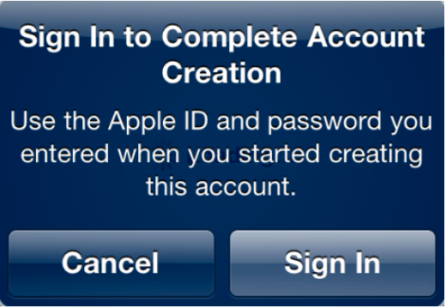

14. You'll then see a Congratulations screen. Tap Done to be taken to the App Store home page.

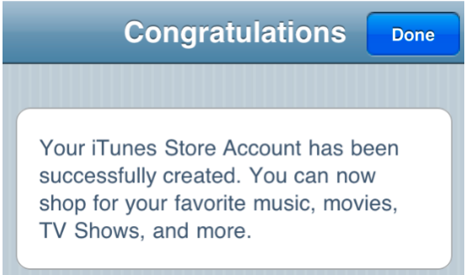

Download MobiDirect from App Store to your iPhone.

1. Turn on Wifi on iPhone (Setting->Wifi) and then touch on “App Store” icon

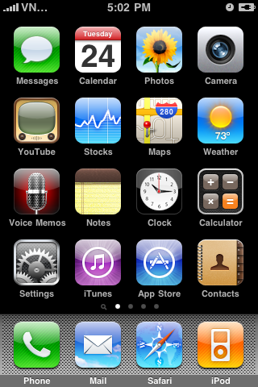

2. Touch on Search tab and input the name of application (MobiDirect or VNDirect) into the searching box.

3. Click on the “Free” button and keep it in order to change to “Install” Button

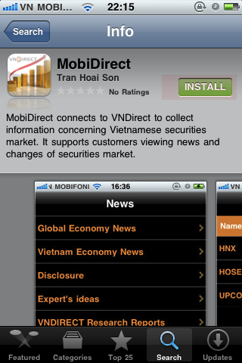

4. Input the password for your account to get the application.

