ISO/IEC JTC 1/SC 29/WG 1 N 4000

Date: August 11, 2006

ISO/IEC JTC 1/SC 29/WG 1
(ITU-T SG16)

Coding of Still Pictures

JBIG JPEG
Joint Bi-level Image Joint Photographic
Experts Group Experts Group

TITLE: 40th WG 1 Jeju Meeting, November 6-10, 2006:
Calling Notice and Registration Forms

SOURCE: WG 1

PROJECT: JPEG

STATUS: Calling notice, hotel reservation, meeting registration

REQUESTED
ACTION: For distribution

DISTRIBUTION: WG 1

Contact:

ISO/IEC JTC 1/SC 29/WG 1 Convener - Dr. Daniel T. Lee
Yahoo! Holdings Limited, 10 Hysan Avenue, Sunning Plaza, Ste. 2802, Causeway Bay, Hong Kong
Yahoo! Inc, 701 First Avenue, Sunnyvale, California 94089, USA
Tel: +1 408 349 7051/+852 2882 3898 , Fax: +1 253 830 0372, E-mail: dlee@yahoo-inc.com

1. Meeting Host
The ISO/IEC JTC 1/SC 29/WG 1 meeting will be hosted by the Korean Agency for Technology and Standards(KATS), which is the Korean National Body of ISO and IEC.

2. Meeting Date
The meeting will be held from Monday 6th to Friday 10th of November 2006.

3. Venue
The venue for the meetings is:

Jeju Shineville Luxury Resort
(http://www.shineville.com)
16, Tosan-ri, Pyosun-myun, Namjeju-gun, Jeju-Do, Korea
Tel: +82-2-3446-2308 Fax: +82-2-3443-7533

4. Host Contact
The host contacts for the meeting arrangement are:

Mr. Hack-Youp Noh and Ms. Moonkyung SHIN
KATS (Korean Agency for Technology and Standards)
2 Jungang-dong, Gwacheon, Gyonggi-do 427-716
Republic of Korea
Tel : +82-2-509-7262
Fax : +82-2-507-1924
Email : jungbo@ats.go.kr

5. Registration & Fees
Delegates are kindly requested to complete a Registration & Payment Form (Annex I), and return it to the host no later than 13th October 2006. You will receive an e-mail confirmation by meeting host.

The facilities fee for the meeting is $350.00 (US Dollar) if registered by 13 October 2006. Attendees who register after this date will be charged a total cost of $400.00. The facilities fee includes:

- Coffee at coffee breaks,
- Lunches from Monday to Friday,
- Social Event,
- all the meeting facilities, including a full day Wireless Access, A/V equipment for presentations, photocopier and other business services,
- and dedicated assistant inside the hotel during the days of the meeting.

Facilities fee will be payable at Jeju Registration Desk with by credit card (Visa, Mastercard, AMEX, Diners) or by cash (US dollar or Korean currency).

All cancellation must be made in writing, via e-mail: please send the cancellation notice to jungbo@ats.go.kr. You will receive an e-mail confirmation of your cancellation.

7. Accommodation (Meeting Venue)
Special arrangements have been made with the Jeju Shineville Luxury Resort (Class: Super Deluxe) to accommodate delegates and their accompanying persons to ISO/IEC JTC 1/SC 29/WG 1 meeting. Please directly send the reservation form (Annex II) to Jeju Shineville Luxury Resort Reservation via the following fax or e-mail no later than 13th October 2006. After that date the National Member Body does not guarantee the hotel booking.

>> Contact Point for Jeju Shineville Luxury Resort Reservation

Ms. Seungwon Rhee
Reservation Manager
Tel : +82-2-3446-2308
Fax : +82-2-3443-7533
E-mail: seungwonrhee@hanmail.net

- ROOM RATE(10% Tax and Breakfast all Included)
ROOM TYPE | US Dollar RATE
Single or Double | KRW 130,000 (1 person)
Twin | KRW 140,000 (2 persons)
(Room Rate KRW 130,000 is about USD 134 when the exchange rate is approximately One U.S Dollar(USD) equivalent to about 970 Korean Won (KRW) as of August 2006.)

Please keep in mind that the Korea National Member Body will not bear any financial responsibility in connection with your stay and accommodation.

9. How to get to Jeju Shineville Luxury Resort
The Jeju Shineville Luxury Resort is located in the most sought-after shoreline of Pyosun. The hotel is within 45km distance from the Jeju International Airport.

- Incheon International Airport (or Gimpo Domestic Airport) to Jeju (CheJu) International Airport
- Flight: Korean Air() or Asiana Airline()
- Flight time: About an hour

Note1: Flights to Jeju are mainly available from Gimpo Domestic Airport located about 40km from Incheon International Airport. Airport limousine buses are available from Incheon Airport to Gimpo Airport.

Note2: Incheon International Airport serves few domestic flights to Jeju as follows. For more details about the airport, please visit the website at http://www.airport.or.kr/
.
Airline |  | Flight No. |  | Departure Time |  | Destination |  | Flight days |  |  |  |  |  |  |  |  |  |  |  |  |  | Flight Operation Periods
 |  |  |  |  |  |  |  | MON |  | TUE |  | WEN |  | THU |  | FRI |  | SAT |  | SUN |  | Flight Operation Periods
 |  | OZ8551 |  | 07:45 |  | CJU |  |  |  |  |  |  |  |  |  |  |  |  |  |  |  | 2006.03.26~10.28
 |  | OZ8553 |  | 09:00 |  | CJU |  |  |  |  |  |  |  |  |  |  |  |  |  |  |  | 2006.05.24~10.28
 |  | OZ8551 |  | 17:20 |  | CJU |  |  |  |  |  |  |  |  |  |  |  |  |  |  |  | 2006.03.26~10.28
 |  | KE1423 |  | 17:30 |  | CJU |  |  |  |  |  |  |  |  |  |  |  |  |  |  |  | 2006.03.26~10.28

Note 3: There are direct flights to Jeju International Airport from Tokyo, Osaka, Nagoya, Fukuoka, Shanghai, Beijing, Shenyang and Taipei.

- Jeju International Airport to Jeju Shineville Luxury Resort
- Shineville shuttle buses run everyday for free as below.

<Shuttle BUS Time Table>
Departure Time | [ To direct Bus Stop ]  “No. 7 Parking Lot” in front of Gate 1 of Airport  If you get out of Gate 1, you will see No.7 Parking Lot  ※ Additional buses could be arranged according to participants’ arrival schedule.
10:30
13:30
15:30
17:00
20:00

- By taxi, it takes just 40 minutes, and fare is about 35,000 KRW(approximately USD 36).

- Map
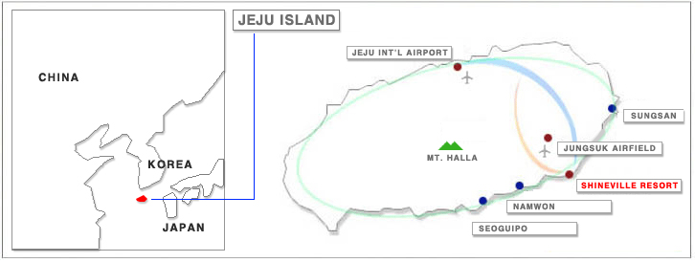

10. General Information

1) VISA
Delegates are advised to check with the local travel agent about regulations regarding VISA. In case of doubt, the information can be obtained from the nearest Korean Embassy or Consulate as well as the following website:
http://www.mofat.go.kr/me/me_a006/me_b025/me06_01.jsp

If you need an invitation letter for visa, please send the following information to Korea Host by e-mail (jungbo@ats.go.kr) with registration form.

- Name
- Sex: Male or Female
- Date of birth (dd-mm-yyyy)
- Passport No. & Date of Expiry (dd-mm-yyyy)
- Company / Organization
- Your Designation / Title
- Address
- Tel/Fax
- E-mail

2) Currency and Credit Cards
The unit of Korean currency is Won. Coin denominations are 10 won, 50 won, 100 won and 500 won. Bank notes are 1,000 won, 5,000 won, and 10,000 won. Bank checks are circulated in denominations of 100,000 won and over.
Foreign currency and traveler’s check can be converted into Korean won at foreign exchange banks and other authorized money exchangers. The exchange rate is subject to market fluctuations. One U.S dollar was equivalent to about 970 won as of August 2006.
Credit cards, including VISA, American Express, Diner’s Club, Master Card and JCB, are accepted at major hotels, department stores, and restaurants.

3) Using Electric Appliances in Korea
The standard voltage in Korea is 220 volts AC, 60 Hz with a round two-pin plug (same as in Germany or France). Always check the power supply before using your equipment.
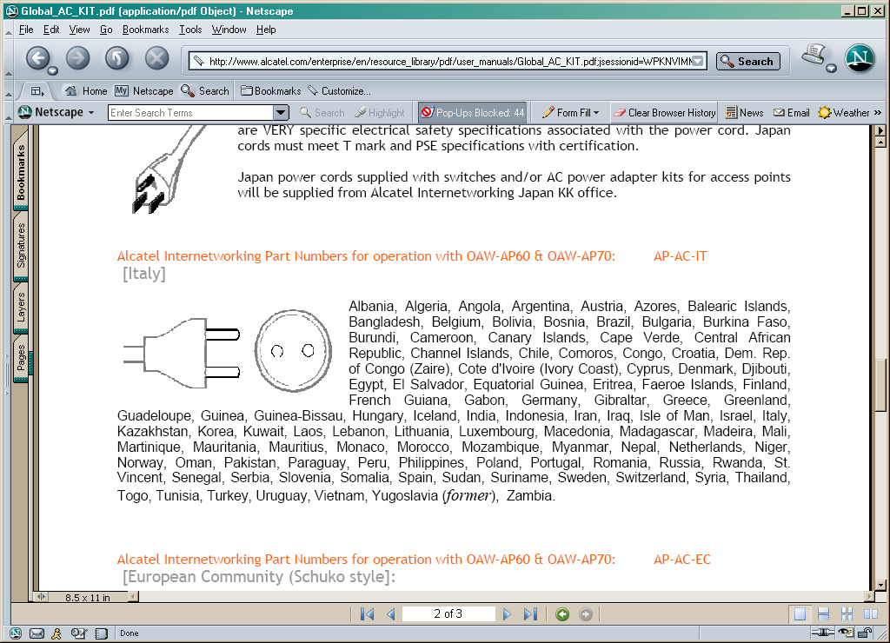

4) Sightseeing
Jeju Island(Jeju-do) is the premier tourist destination in Korea because of its stunning natural scenery and superior tourist amenities. Scenic beaches, waterfalls, cliffs and caves lie in harmony, and mild weather makes Jeju-do an even more ideal tourist destination

For any information on sightseeing of Korea, please visit the following homepage.
http://english.tour2korea.com/
http://www.hijeju.or.kr/eng/default.htm

5) LINKS
- Shineville Luxury Resort : http://www.shineville.com
- Inchon International Airport : http://www.airport.or.kr/Eng/home.jsp
- Gimpo Domestic Airport : http://gimpo.airport.co.kr/eng/index.jsp
- KOREAN Air : http://www.koreanair.com/
- ASIANA Airline : http://us.flyasiana.com

6) Jeju Island Geographic Area

FOR ANY OTHER INFORMATION, PLEASE FEEL FREE TO CONTACT TO THE HOST CONTACT.
ANNEX I

REGISTRATION & PAYMENT FORM

ISO/IEC JTC 1/SC 29/WG 1 Meeting

6-10 November 2006

Jeju Island, Republic of Korea

Delegates attending the meeting are requested to complete this form and send it to the Host Contact at the following address by fax or e-mail no later than 13th October 2006.

Mr. Hack-Youp Noh and Ms. Moonkyung SHIN
KATS, Republic of Korea
Tel : +82-2-509-7262
Fax : +82-2-507-1924
Email : jungbo@ats.go.kr

Delegate Information
Title(Prof., Dr., Mr., Mrs., Ms.)
Name(First name / Last name)
Company/Institution
Mailing Address:
City:
Country:
Tel:
Fax:
Email:
Representing (national body or liaison organization)
Head of National Delegation | □ Yes □ No
- Do you plan to stay Jeju Shineville Luxury Resort? □ Yes □ No
Payment
Please charge the amount indicated below:
Before 13 October 2006: $350.00 ◻ After 13 October 2006: $400.00 ◻

Facilities fee will be payable at Jeju Registration Desk with by credit card (Visa, Mastercard, AMEX, Diners) or by cash (US dollar or Korean currency).
ANNEX II

RESERVATION FORM

Jeju Shineville Luxury Resort
16, Tosan-ri, Pyosun-myun, Namjeju-gun,
Jeju-Do, Republic of Korea

Please send it to Jeju Shineville Luxury Resort Reservation via the following fax or e-mail.

If further information is required, please contact –
Ms. Seungwon Rhee
Reservation Manager
Jeju Shineville Luxury Resort
Tel: +82-2-3446-2308
Fax: +82-2-3443-7533
E-mail : seungwonrhee@hanmail.net or swrhee@shineville.com

Name (First / Last) | /

Country
Arrival Date / Time
Departure Date
Room Type (Single / Double use)
Room Rate  ( Including Breakfast) | Single or Double (1 Person): KRW 130,000  TWIN (2 persons): KRW 140,000
Payment Method / Credit Card No.
Contact Telephone Number
Contact FAX Number
※Cut Off Date | 13th October 2006
※Cancellation Policy | -In a week advance: No cancellation Fee  -In 6 to 2-day advance: 1 night rate  -In one day advance or no-show: 2-night rate
. * Room rates include 10% TAX and Breakfast.

(Provide following information if confirmation of registration is required)
Return confirmation of booking to:

Name: ……………………………………………………..

Fax: ………………………………………………………..

E-mail: …………………………………………………….

Tour Information

ShineVille offers all the attendees for JBIG/JPEG Jeju tour program option!

ShineVille is going to offer the attendees some tour programs as an optional activity during the event period. After you sign up for a program you want to join at the information desk on the spot, you can enjoy going sightseeing with your companies. The entry fee must be paid by the individual before going out. A tour guide who speaks English will be going together with you.
Jeju, the largest island, has a mild oceanic climate throughout the year with the smallest annual temperature range in South Korea. The temperature for the hottest summer months averages no more than 34.3℃ and no less than -3.2℃ in winter. The early November is the late autumn weather, unless there is an unusual change.

◈ Tentative Tour Schedules
1st Full Day Itinerary  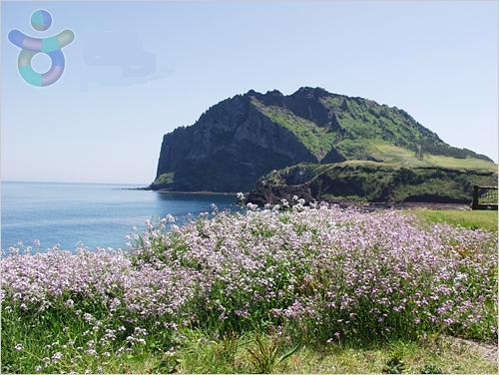 | 10:00 Departure  10:10~11:20 Jeju Folk Village  11:50~12:50 Sungsan Sunrising Peak  13:00~14:00 Lunch  14:30~16:30 Jeju Stone Park  17:00 Hotel  ※ 55,000 KRW - This price is based on 10 people.  If there are less than 9 people, it can be cancelled.
2nd Full Day Itinerary  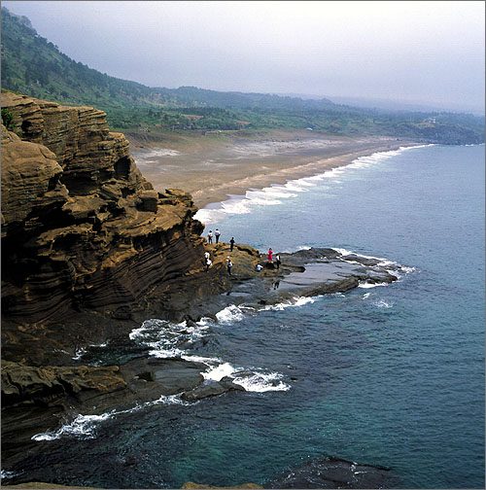 | 10:00 Departure  10:40~11:20 Chunjiyon Waterfall  11:40~12:30 Oedolgae Coast  12:50~13:50 Lunch  14:20~15:20 Yongmuri Coast  15:40~16:40 Bonsai Tree Garden  17:30 Hotel  ※ 57,000 KRW - This price is based on 10 people.  If there are less than 9 people, it can be cancelled.
1st Half Day Tour  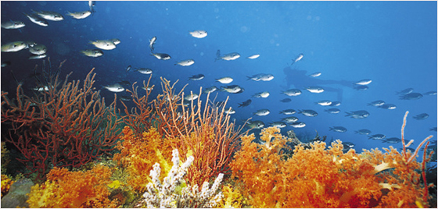 | 09:00 Departure  09:40~11:00 Submarine Tour  11:10~12:00 Jungbang Waterfall  12:30 Hotel  ※ 85,000 KRW - This price is based on 10 people.  If there are less than 9 people, it can be cancelled.
NOTICE:
- The detail schedule and price can be changed without prior notice.
- There will be a certain capacity for each itinerary. In case the number limit is not reached, it can be cancelled.

Yongmuri Coast
A scenic promontory, with small caves and huge rock walls sculpted by strong waves at the foot of Mt. Sanbang. You will marvel at the rocky hill that is shaped like the head of a dragon entering into the water.

Jeju Folk Village
At Jeju Folk Village the unique lifestyle and traditional culture of Jeju Island are presented as they appeared during the 19th century.
A mountain village, fishing village, botanical garden, market place, an old government building and authentic shamanistic rites one recreated.
Sungsan Sunrising Peak
The Peak is a volcanic crater perched out on the eastern tip of Jeju Island and is one of the ten most spectacular scenes of Jeju. The views of sunrising in the early morning are breathtaking at the summit. The peak is 182m above sea level. The rim of the crater is adorned with 99 craggy rock pinnacles reminiscent of a king's crown.

Chunjiyon Waterfall
The waterfall falls from a precipice with thundering sounds, creating white water pillars. It has the name Cheonjiyon, meaning ‘the heaven and the earth meet and create a pond’. At 22 m in height and 12 min width, the waterfall tumbles down to the pond to produce awe-inspiring scenery.

Jungbang Waterfall
This water is the only one falling directly to the sea in Korea. The 23 m-high waterfall has two streams of water. It produces the brisk sounds of water falling along the black wall, creating a splendid scene along with the ocean. Moreover, the neighboring precipitous cliffs and the stately old trees add to the unique scenic view of the waterfall.
This water is the only one falling directly to the sea in Korea.

Oedolgae
Oedolgae was created by volcanic eruption 1.5 million years ago. It is called "sea stack" in academic terms because it was formed by continual wave erosion. Natural Protection Area of Museom Island and Beomseom Island was designated as National Monument No. 421 in July 2000.

Submarine Tour
The submarine goes under water up to 45 m deep in the Seogwipo City Marine Park, which includes Munseom Island. As you go down, you can see various marine life such as tropical fish, coral and so on.

