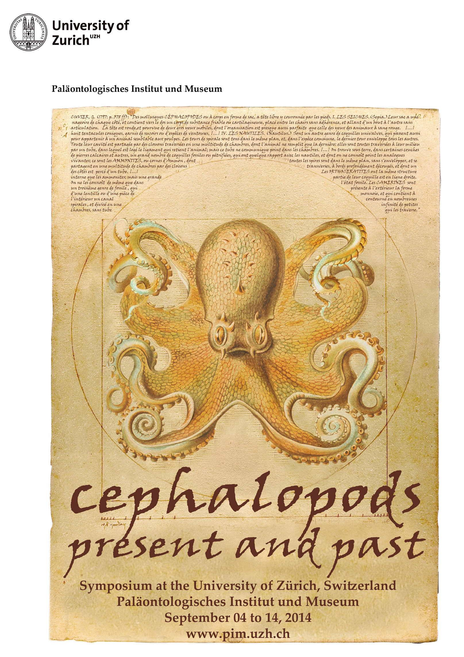
9th International Symposium
“Cephalopods ‒ Present and Past”
ISCPP 9

in combination with the

“International Coleoid Symposium”

Universität Zürich, September 04-14, 2014

Second circular

We cordially invite you to participate in the 9th International Symposium Cephalopods ‒ Present and Past and the International Coleoid Symposium, which will be held from September 04-14, 2014 in Zürich (Switzerland).
This tri- to quadrennial cephalopod symposium has its origin in the O. H. Schindewolf Symposium in 1985 at Tübingen University (Germany). The proceedings volume of this symposium was published in 1988 with the title “cephalopods – present and past”, hence the name of our meetings. This series of meetings is intended to be interdisciplinary in the sense that neontologists and palaeontologists from the entire planet meet and present their cephalopod-related research on biological and palaeontological topics. The cephalopod symposium is probably the best opportunity to learn more about recent advances in both fields of work. It also serves networking purposes and especially the field trips have proved valuable in this respect. Its moderate size and its interdisciplinary nature provide a well-balanced mixture of highly interesting talks and discussions, and it gives the meeting its particular charm.
We naturally hope to attract the interest of cephalopod workers from all over the globe and covering all disciplines involved with cephalopod research. You are therefore cordially invited to present your scientific results, discuss your contributions, exchange your ideas, and plan your future cooperation. We welcome not only experienced scientists and museum employees but especially young colleagues, who just started with their cephalopod research, be it as undergraduates, graduates, in a Master’s program, or in the course of their PhD-thesis. Additionally, non-professionals such as voluntary museum workers, species conservationists, fossil collectors or other persons interested in the subject are very welcome!
It is our aim to cover a broad range of cephalopod-related topics, to create a friendly and constructive atmosphere for scientific exchange, and to have a joyful time here in the largest town of Switzerland.

General information
1. Schedule
Thursday to Saturday, 04.-06.September 2014 – Pre-conference fieldtrip (Fossillagerstätten of the southern German Jurassic)

Sunday 07.09.2014 Registration, oral and poster presentations,
Icebreaker Party in the Zoological Museum
Monday 08.09.2014 Oral and poster presentations
Tuesday 09.09.2014 Oral and poster presentations
Conference dinner
Wednesday 10.09.2014 Oral and poster presentations

Wednesday evening to Sunday, 10.-14.09.2014 – Post-conference field trip (Mesozoic ammonoid localities of Switzerland)

ORAL CONTRIBUTORS
All speakers (apart from the symposium speakers) have been allocated 15 min. You should therefore prepare a 12 min talk to allow time for questions and switching between presenters. We are using a limited number of parallel sessions in adjacent theatres so this is especially important. A single A/V projector linked to two screens (i.e. displaying the same image) is available; the system is both Mac- and PC-based and PowerPoint is installed. We will try to accommodate anyone who requires other platforms/ hardware, provided they bring these with them. Your presentation should be submitted and checked the day before it is scheduled. If this is not possible, then please contact me.
POSTER CONTRIBUTORS
Poster boards are circa 2 m tall and 1m wide; they will not be supplied with power sockets. Each will accommodate an A0-sized poster presented in PORTRAIT format. The board will NOT do so in printed at this size in landscape format.
A more detailed preliminary program will be presented in autumn 2013 or spring 2014.

2. Venue
The conference will take place at the Universitaet Zentrum (see Map_below), University of Zurich, which is a 10 minute walk uphill from the main station (HB = Hauptbahnhof). Accommodation we have reserved is nearby, so no further public transport will be needed to get to the lecture halls from your hotel (only if you stay in places further away, obviously). We will walk also to the venue of the Conference dinner at the restaurant “Weisser Wind”.

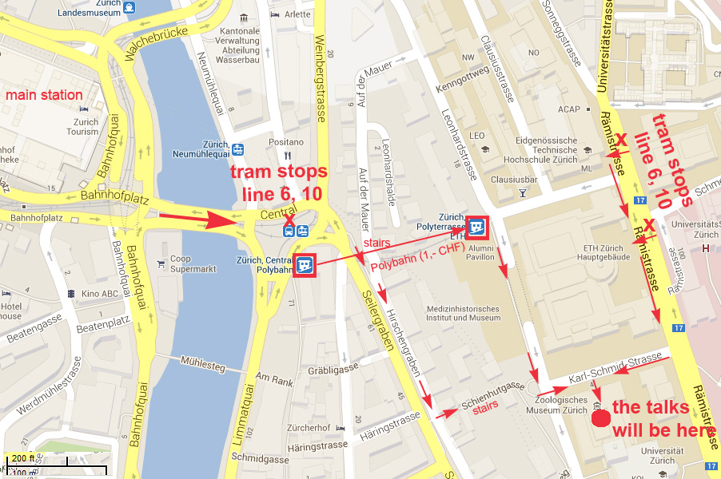

Zurich University
Paläontologisches Institut und Museum
Karl Schmid-Strasse 4
CH-8006 Zürich
Switzerland
Lectures will be held in KO2-F-180 Lichthof Nord

3. Maps

Four maps have been prepared to assist delegates in navigation in Zürich. They can be downloaded as jpg files using the links below:

http://www.pim.uzh.ch/symposia/ISCPP9/venue.php

4. Registration, Deadlines and prices
To register, please follow this link:

http://www.pim.uzh.ch/symposia/ISCPP9/index.php

Early registration
31. December 2013
Normal price: 200.00 Euro
Student price: 150.00 Euro

Abstract submission AND
Normal registration
30. April 2014
Normal price: 230.00 Euro
Student price: 180.00 Euro

Attention: abstracts submitted after midnight 30. April 2014 will not be considered.

Late registration
31. July 2014
Normal price: 260.00 Euro
Student price: 210.00 Euro

Registration starts in September 2013.

The registration fee for all participants includes:
- the participation in the conference with talks and posters,
- all coffee breaks,
- the icebreaker reception on Sunday, September 7th in the Zoological Museum,
- the conference dinner on Tuesday, September 9th 2014 in the “Weisser Wind”
- an original Mammut backpack with the stitched meeting logo, and
- the abstract book.

Accompanying guest registration is for persons accompanying symposiums participants, who will not be presenting. This will include icebreaker party, conference dinner and coffee breaks.
Early registration: 100.00 Euro
Regular registration: 130.00 Euro
Late registration: 160.00 Euro

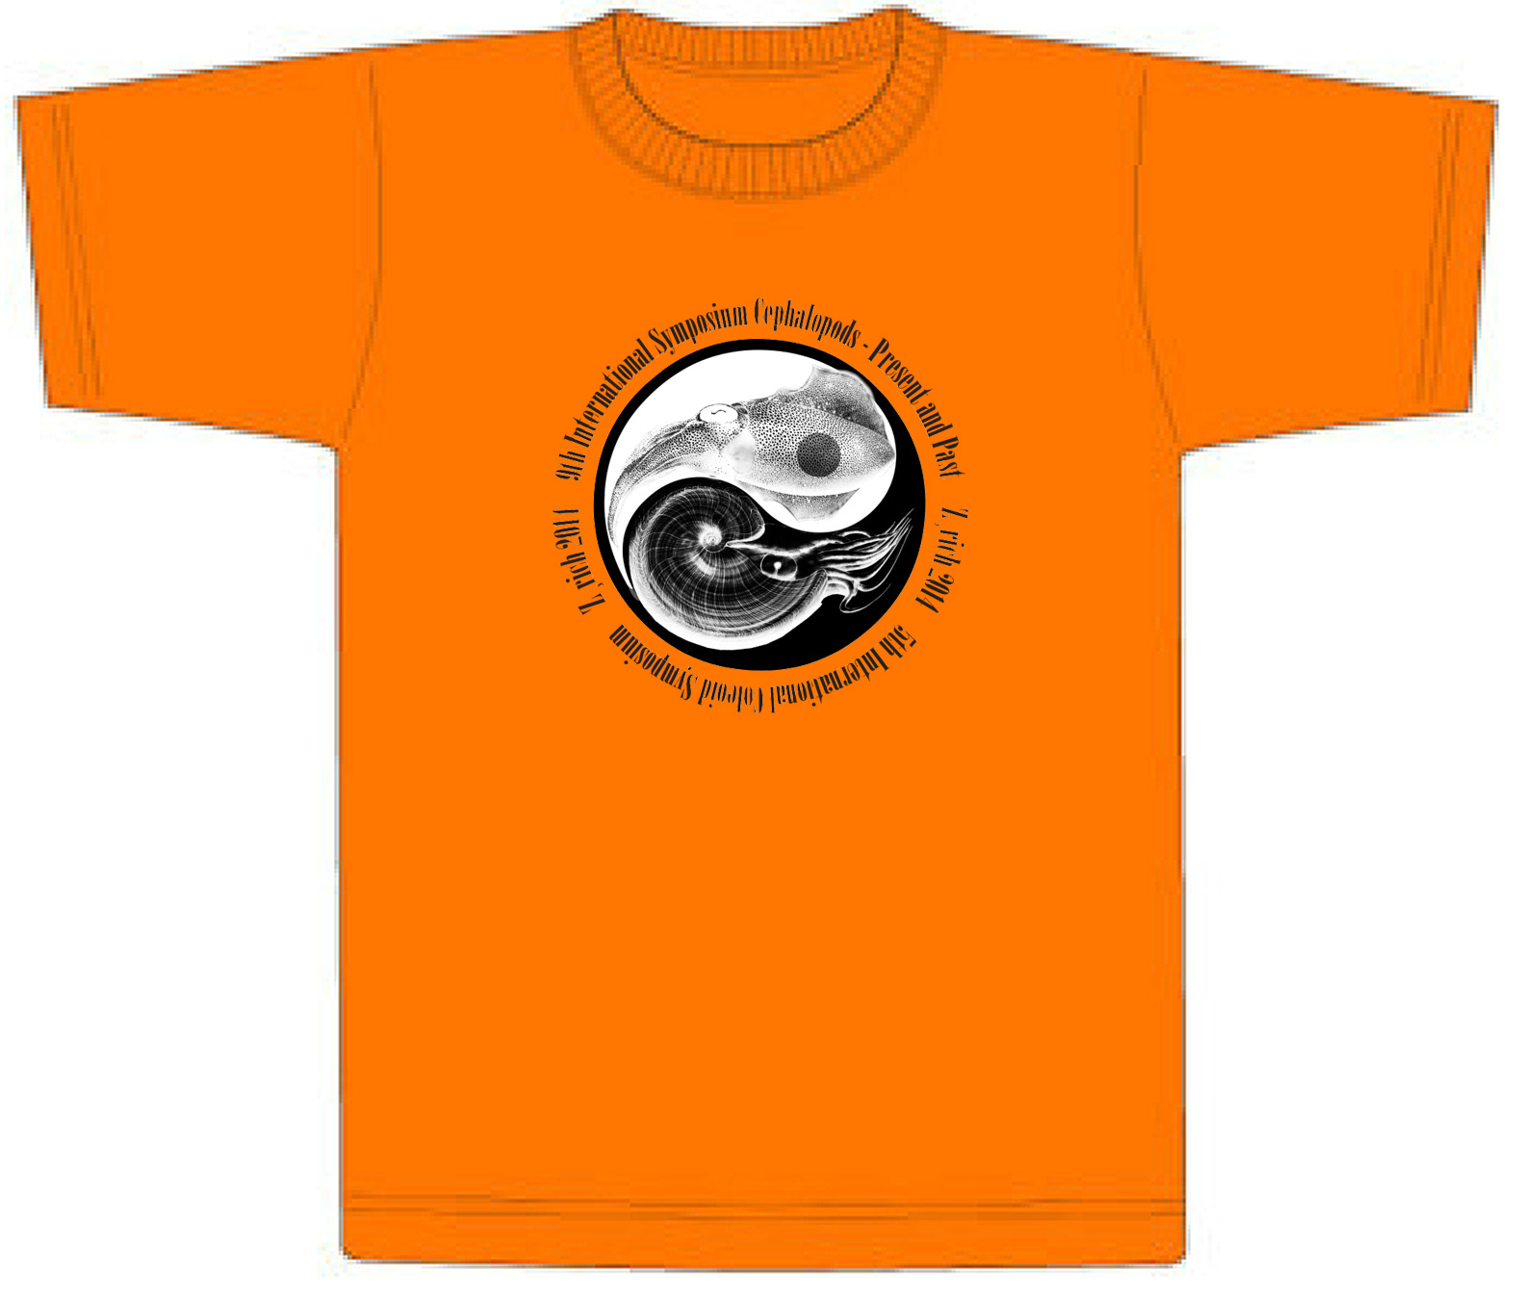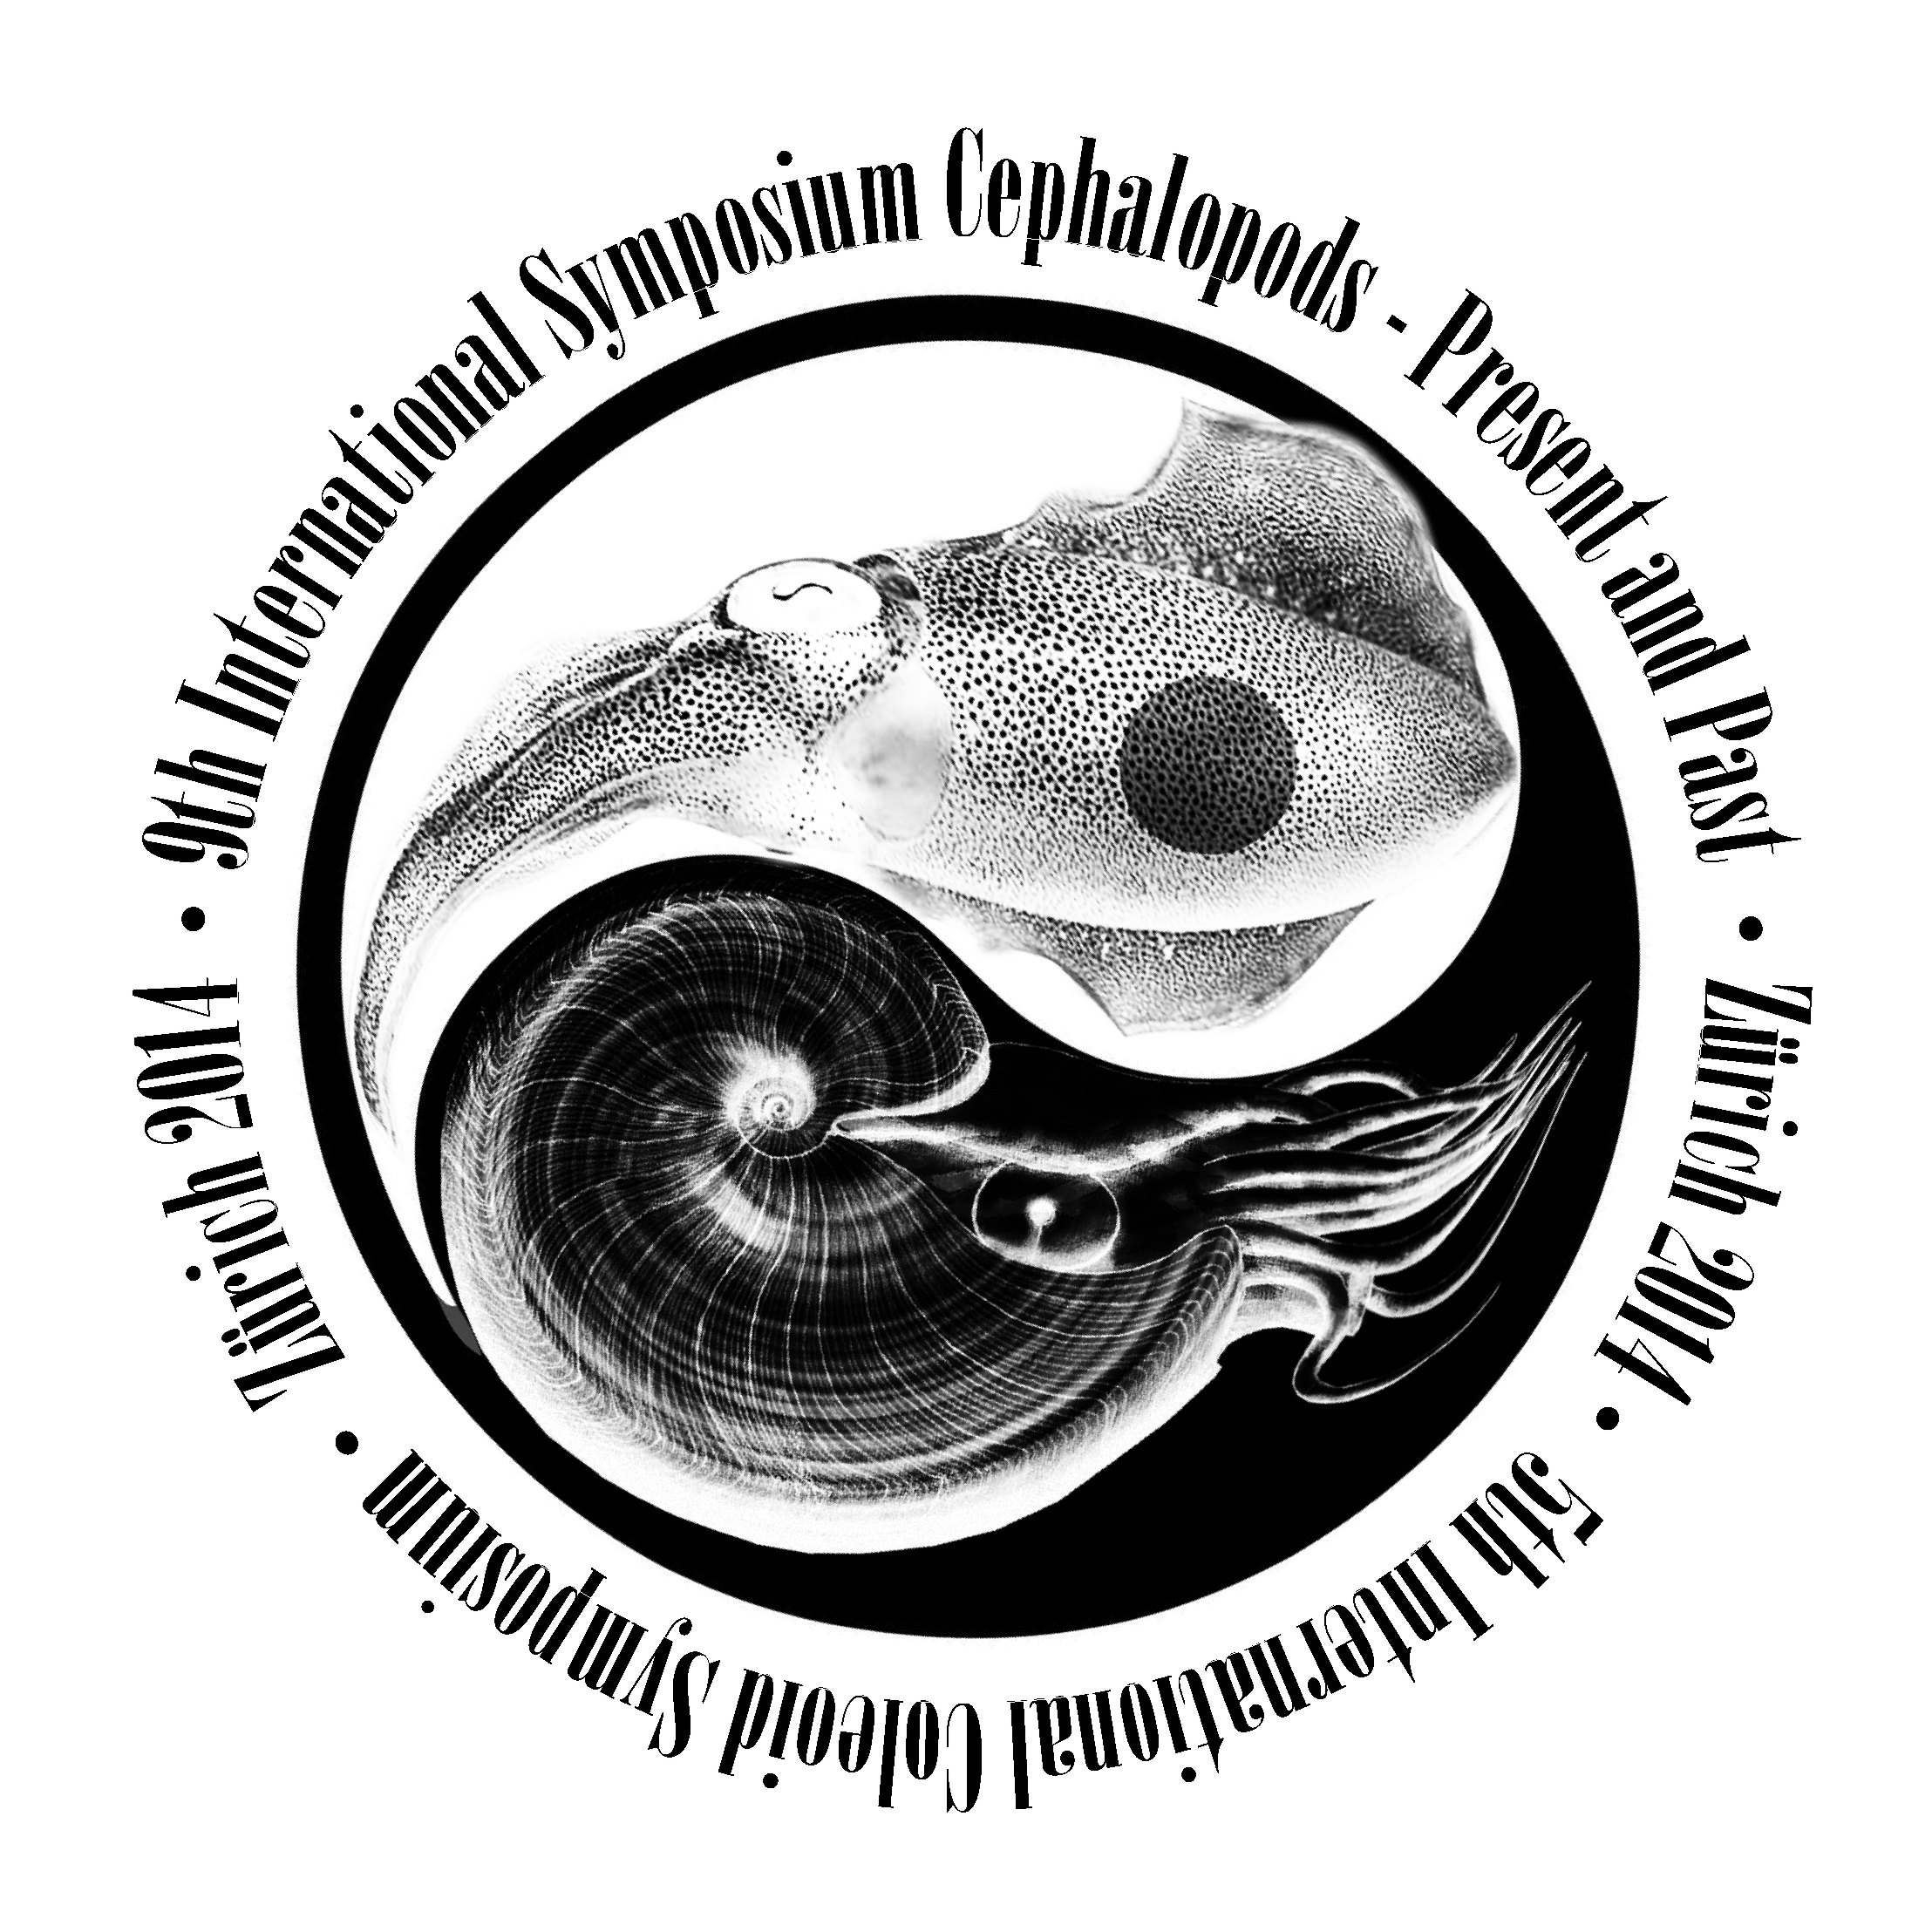
T-Shirt of the joint meeting:
20.00 Euro

Registrations and bookings will be taken on a strictly first-come-first-served basis.
No refunds will be available after the final deadline.

5. Payment information
Payment shall be made to
Please F-74600-01
Kurztitel: Cephalopods pre-past

6. Abstract submission information
Accepted abstracts will be collected in an abstract volume. These should be submitted electronically in MS-Word format (“doc” or “rtf” files only). The text of the abstract should not exceed 2500 letters including name(s) of the author(s), affiliations, mailing and e-mail address.

7. Publication of submitted papers
It is planned to publish a Proceedings volume in one of the Swiss palaeontological or geological journals.

8. Field trips
Pre-conference fieldtrip
Fossillagerstätten of the southern German Jurassic (Preliminary schedule)
Guides: Günter Schweigert, Martin Röper, Annette Schmid-Röhl & Christian Klug
Thursday, 04.09.2014 – departure from Zürich, Holzmaden; museum and quarry visits
Hotel Trompete Eichstätt
Friday, 05.09.2014 –Solnhofen, museum and quarry visits
Hotel Trompete Eichstätt
Saturday, 06.09.2014 – Dotternhausen, Nusplingen, museum and quarry visits, return to Zürich

Included: Hotels, breakfast, entrance fees, transport

Prices:
Euro 220.00 (single room)
Euro 160.00 (double room)

Attention:
- Booking is complete only after the payment has been completed.
- Limited number of participants: 24
- Not included: lunch
- Registrations and bookings will be taken on a strictly first-come-first-served basis.
- No refunds will be available after the final deadline.

Post-conference field trip 1
Jurassic ammonoid localities of Switzerland
Guide: Heinz Furrer
Thursday, 11.09.2014 – Bathonian and Oxfordian of Holderbank, Early Jurassic of Frick
Lunch: Restaurant Platane (Frick)
Included: entrance fee, transport

Price: Euro 50.00

Attention:
- It is not possible to book both post-conference fieldtrips because they are in the same time!
- Booking is complete only after the payment has been completed.
- Not included: meals
- Registrations and bookings will be taken on a strictly first-come-first-served basis.
- No refunds will be available after the final deadline.

Post-conference field trip 2
Mesozoic ammonoid localities of Switzerland and eastern France
Guides: Walter Etter, Peter Kürsteiner, Karl Tschanz, Antoine Pictet, Christian Klug
Wednesday, 10.09.2014 – departure from Zürich
Hotel a la Demi Lune, Issenheim
Thursday, 11.09.2014 – Triassic of eastern France
Hotel a la Demi Lune, Issenheim
Friday, 12.09.2014 – Cretaceous of western Switzerland
Hotel Zunfthaus zu Wirthen, Solothurn
Saturday, 13.09.2014 –Middle and Late Jurassic of northern Switzerland
Hotel Berggasthaus Alter Säntis, Alpstein
Sunday, 14.09.2014 – Cretaceous of eastern Switzerland, return to Zürich

Included: Hotels, half pension, entrance fees, transport

Prices:
Euro 600.00 (single room)
Euro 500.00 (double room)

Attention:
- It is not possible to book both post-conference fieldtrips because they are in the same time!
- Booking is complete only after the payment has been completed.
- Limited number of participants: 21
- Not included: lunch
- Registrations and bookings will be taken on a strictly first-come-first-served basis.
- No refunds will be available after the final deadline.

9. Accommodation
Each participant has to book him-/ herself an accommodation.
Rooms in a variety of hotels, hostels and guest-houses at a range of prices are available in Zurich city centre and can be reserved through the usual channels. In addition, we have organised discount rates at some hotels close to University.

Accommodation must be booked separately; bookings can be made individually (for students: why not try couch-surfing?) or via the following link (some hotels, where we made reservations and where we obtain a cheaper rate; BOOK EARLY, because these rates are available ONLY UNTIL END OF JULY 2014!
http://hotels.zuerich.com/zt/deutsch/ProjectProvStat.htm?IDProject=311&IDProjectOffer=42 Login: ISCPP92014
Passwort: 03092014
Zürich Tourismus, Hotelreservation
Im Hauptbahnhof
Postfach
CH-8021 Zürich
Tel.: +41 44 215 40 40
Fax: +41 44 215 40 44
E-Mail: hotel@zuerich.com

A credit card number is required at the time of booking as a guarantee for room.

Here are the included hotels (see Map below):

- Hotel St. Georges, Weberstrasse 11, 8004 Zürich,
single room 132.50 CHF double room 170 CHF
- Hotel Limmathof, Limmatquai 142,8001 Zürich,
single room 145 CHF double room 185 CHF
- Hotel Astor, Weinbergstrasse 44, 8006 Zürich,
single room 155 CHF double room 185 CHF
- Walhalla Hotel, Zürich,
single room 185 CHF double room 230 CHF
- Leonardo Boutique Hotel Rigihof, Universitätstrasse 101, 8006 Zürich,
double room 252/ 247 CHF
- Hotel Bristol, Zürich,
single room 190 CHF double room 290 CHF
- Hotel Sunnehus, Zürich,
single room 190 CHF double room 290 CHF
- Comfort Hotel Royal, Leonhardstrasse 6, 8001 Zürich,
single room 195 CHF
- City Hotel, Löwenstrasse 34, 8021 Zürich,
single room 215 CHF double room 270 CHF
- Hotel Franziskaner, Zürich,
single room 240 CHF double room 300 CHF
- Hotel du Théâtre, Zürich,
single room 267 CHF double room 314 CHF
- Hotel Adler, Rosengasse 10, 8001 Zürich,
single room 290 CHF double room 310 CHF
Think about sharing a room to save costs!

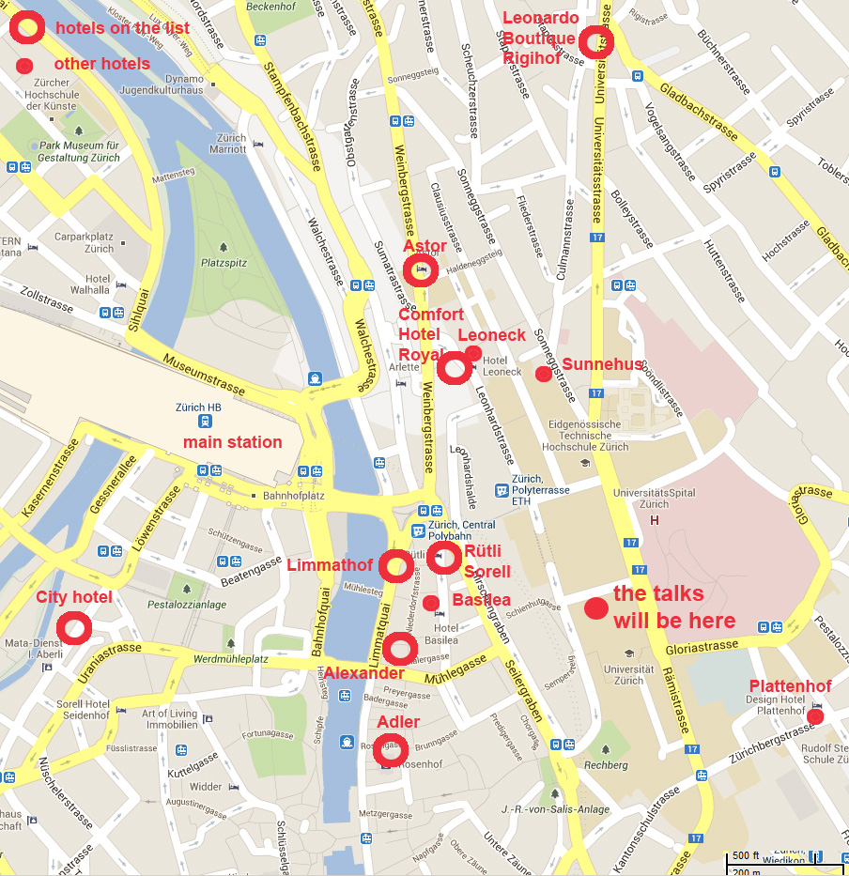

PhD and master students might prefer staying at the youth hostel:

Jugendherberge Zürich, Mutschellenstrasse 114, 8038 Zürich

Tel: +41 43 399 78 00, zuerich@youthhostel.ch, http://www.youthhostel.ch/zuerich

There are several other hotels (some indicated in the Map above), which are in a reasonable distance and NOT in this list (Design Hotel Plattenhof, Hotel Foyer Hottingen).

10. Travel information
For those who wish to avoid flying, Zurich can be reached by combining rail (e.g. via Paris, TGV usually takes about 4-5 hours to Zurich) or bus links, which might be more or less cheap but obviously time consuming. For the majority, flying will be the best option.

Plane
Zurich is served by Zurich Airport Kloten (ZRH), which is located north of Zurich City Centre. There are currently direct air links (including EasyJet from London) into Zurich from a large number of airports globally, and, in particular, from continental Europe and North America. If you want to get a good bargain, early booking is recommended. It is usually worthwhile consulting search engines such as, e.g., http://www.jetcost.co.uk/ or www.ebookers.com, which would search several other providers and airlines.
Another option is flying to Basel/ Mulhouse airport. From there, a bus takes you to the main station in Basel city. There are fast trains to Zurich which take about one hour. So in total, the journey Basel airport – Zurich would take about 1h 30min.

Transfer from the airport
There are frequent “S-Bahn” (city trains) and regular trains from the airport to the city centre (main station = Hauptbahnhof). You can use all of those, where Zurich HB is indicated (some are faster, some slower) with the same ticket from the vending machine in the airport (around 2 to 3 Euros; you can pay in Euros, Swiss Francs, Maestro, Postbank card, etc.). The transfer takes 10 to 15 minutes.

Getting to the Universitaet Zentrum-building (University of Zurich)
Once you’ve reached the main station (Zurich HB), leave the building towards the river Limmat. Be careful, because there is also the river Sihl, which is also close to the train station (see the first map above). You can always ask because most of the locals speak English well and are very helpful. Cross the Limmat until you reach the large roundabout with a bus stop and a tram stop (‘Central’). From there, you can:
- walk up the stairs: http://www.plaene.uzh.ch/KO2#ankermap
- take tram 6 or 10 to the stop ETH/ Universitaetsspital and then follow the first map;
you find a map of all connections within the city with this link:
http://www.zvv.ch/opencms/export/sites/default/common-images/content-image-gallery/linien-zonen-pdfs/Liniennetzplan_Stadt_Zuerich_2012.pdf
- take the cable car (Polybahn; see the first map). The entry is next door from Starbucks at Central (across the river from the main station). It costs 1 CHF (it is included when you have a valid ticket for Zone 110), a vending machine is at the entry of the Polybahn. It is a short romantic ride, which takes you to the Polyterrasse, which is a large terrace providing a nice view over town. Cross the terrace, turn left into the Karl Schmid-Strasse. The entry is between the two fish ponds.
We will put up signs to guide you, once you are close to the venue.

Train
Zurich is served by one main railway station: Zurich HB (main station = Hauptbahnhof). There are TGVs from Brussels and Paris, ICEs from Frankfurt, Stuttgart and Berlin and the Cisalpino from Milano. They are all rather comfortable and fast. Make sure whether you need reservations or not.

Local public transport: Tram and bus
Public transport is excellently organised in Switzerland and the costs are reasonable. In Zurich, there is roughly each 300 m a tram stop or a bus stop. You can get short distant tickets (‘Kurzstrecke’; only to the destinations listed on the vending machine), 1 hour tickets (in Zurich for Zone 110, which is the majority of the city) and 24 hour tickets for Zone 110. Zurich is not a very big town, so many places can easily be reached walking. Bear in mind, however, that there are many hills and walking through Zurich might involve climbing many stairs.

Taxi
There are usually abundant taxis in operation in the city centre at any given time. Zurich taxis belong to the most expensive taxis worldwide, so I recommend using them only if you are rich or lack another choice. It is possible to hail a taxi from the street, but convenient taxi ranks in the city centre are located on the Hauptbahnhof and around other bigger train or tram stations. You may also call one under +41 (0) 44 4444444 or +41 (0) 43 4555885 or +41 (0) 44 4504242.

11. Money
Be aware that Switzerland does NOT have the Euro as currency. You will need some Swiss Francs to survive here. You can change most currencies at the airport (on the level above the railway), at the main station (in the main hall, close to the large suspended statue by Niki de Saint-Phalle), and in any bank.

12. Maps
Zurich University, Zentrum:
http://www.plaene.uzh.ch/lageplaene/zentrum.html#ankermap

Icebreaker will be held in the Zoologisches Museum:
http://www.pim.uzh.ch/en/Institut/kontakt.php

The conference dinner will be held in the restaurant “Weisser Wind”:
http://www.weisserwind.ch/engl/e_standort.html

Lectures will be held in KO2-F-180 Lichthof Nord:
http://www.plaene.uzh.ch/floormaps/KOL_D.png

Posters will probably be presented in the Lichthof:
http://www.plaene.uzh.ch/lageplaene/KOLF.html

13. Contact
Comments and questions can be addressed to Christian Klug (chklug@pim.uzh.ch; 0041 44 6342337).

14. Scientific Committee
Prof. Dr. Hugo Bucher (Zürich, Switzerland)
Dr. Larisa Doguzhaeva (Moscow, Russia)
Dr. Dirk Fuchs (Freie Universität Berlin, Germany)
Dr. Christian Klug (Zürich, Switzerland)
Dr. Dieter Korn (Berlin, Germany)
Dr. Neil Landman (New York, USA)
Prof. Pascal Neige (Dijon, France)
Dr. Günter Schweigert (Stuttgart, Germany)
Dr. Jan Strugnell (Bandoora, Australia)
Prof. Kazushige Tanabe (Tokyo, Japan)
Dr. Margret Yacobucci (Bowling Green, USA)
Prof. Dr. Peter Ward (University of Washington, USA)

15. Organising Committee
Priv.Doz. Dr. Christian Klug (University of Zurich)
Dr. Dirk Fuchs (Freie Univerität Berlin)
Heike Götzmann (University of Zurich)
Dr. Walter Etter (Naturhistorisches Museum Basel)
Dr. Günter Schweigert (Staatliches Museum für Naturkunde, Stuttgart)
Dr. Heinz Furrer (University of Zurich)
MSc. Antoine Pictet (University of Lausanne)
MSc. Carole Naglik (University of Zurich)

16. Why not make a stay of it?
Switzerland at any time of the year is an excellent destination for a short break; why not come a few days early and see what the country has to offer? Alternatively, if anyone travelling with you is not enthralled by the idea of three days at a PalAss conference there is plenty to do.
http://www.myswitzerland.com/en/home.html
http://www.zuerich.com/en/Visitor.html

I look forward to welcoming you in Zurich 2014!

Best regards,

Christian Klug.

Zurich, October 16, 2013

