

Prescribed
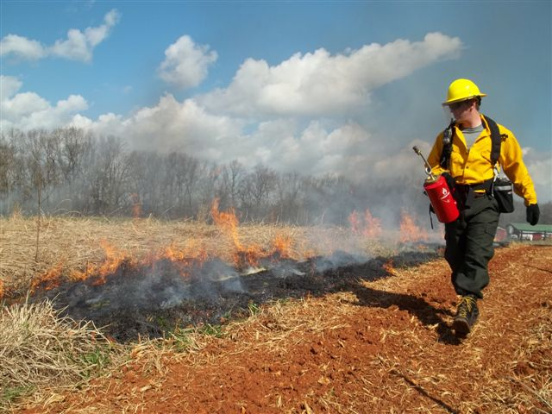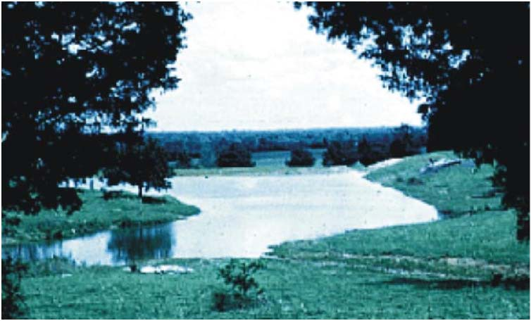

Burning
Controlled fire applied to a
predetermined area.

Lifespan of Practice: 1 year

Tennessee Implementation
Requirements No. TN-338

PLANS AND SPECIFICATIONS

Prescribed burning is a cost effective tool for managing native grasslands and understory vegetation in forestland. It provides multiple benefits for trees, forages and wildlife. Prescribed burning is often performed along with other forestry, native grassland and wildlife management practices as part of a resource management system for a conservation treatment unit.

This prescribed burning implementation requirement heet provides information to prepare a prescribed burning plan. This is not a standalone document; it works concomitantly with TN NRCS conservation practice standard Prescribed Burning (code 338), NRCS national policy, Section 190, Part 413, Prescribed Burning, of the General Manual, and the TN NRCS Prescribed Burning state supplement to the general manual. Certified or approved individuals must prepare a burn plan for prescribed burns, using the Tennessee Wildlife Resources Agency prescribed burn plan template. The actual burn plan contains the site specific specifications for applying a prescribed burn on the target fields in this job sheet. The purpose and intended burn results outlined below must be addressed in the burn plan.

When prescribed burning, one must:

1. Have a written prescribed fire plan for each forest, wildlife, and agricultural area to be burned.

2. Have onsite the prescribed fire plan during the burn and adhere to the plan, excepting unforeseen conditions that necessitate actions to keep the fire contained.
3. Comply with the TN Prescribed Fire laws.

4. Receive a burn permit from the Tennessee Division of Forestry.

5. Notify adjoining landowners, local fire departments, and public safety officials prior to burning.

6. Plan safety precautions before the burn and monitor during the burn.

OPERATION AND MAINTENANCE RESPONSIBILITIES

Under no circumstances shall an NRCS conservation planner or others working on behalf of the agency act as the “fire boss,” “burn boss,” or decision-maker during the application of a prescribed burn unless participating in an NRCS-approved training burn. NRCS conservation planners or others working on behalf of the agency shall not ignite a prescribed burn unless an emergency situation arises and the conservation planner is instructed to do so by the “fire boss,” “burn boss,” or decision-maker present.
If NRCS personnel and/or partners are present on the burn to provide prescribed fire application assistance prior to ignition and unfavorable conditions exist, NRCS employees and/or partners are required to immediately inform the fire boss or client of the concerns and request that they take corrective action, which may include postponing the burn. Should the designated fire boss or client not take corrective action and continue to implement the burn under conditions outside the parameters of the prescribed burn plan, NRCS employees and/or partners are required to inform the fire boss and client that NRCS participation is prohibited, withdraw assistance, and return to the field office and document appropriately.
Those employees and/or partners who have successfully attained or exceeded the TN NRCS Prescribed Burning Level 1 job approval authority acting in accordance with all Federal, Tribal, State, and local laws and within the scope of their work accept no greater or lesser liability than that associated with the performance of any other assigned duty.

The following worksheet will determine required job approval authority for constructing the prescribed burn plan.

Classification of Prescribed Burn | Signature Requirement
Class A | Level II Planner
Class B | Level II Planner and Area Biologist
Class C | Level II Planner, Area Biologist, and Area Conservationist

Tennessee NRCS Classification of Prescribed Burns
Insert the answer that best matches the burn application and include in the conservation plan.
Size ** |  |  |  |  |  | Score
1-25 acres |  |  |  | 1
26-50 acres |  |  |  | 2
51-100 acres |  |  |  | 3
101-300 acres |  |  |  | 4
Terrain
0-5% slopes |  |  |  | 1
6-12% slopes |  |  |  | 2
13-20% slopes |  |  |  | 3
21%+ slopes |  |  |  | 4
Vegetation
Low Volatile Less than 4 feet height (example: Cool season grasses, or similar) |  |  |  | 2
Highly Volatile 0-5 feet height (example: NWSG short grass species variety's, ) |  |  |  | 3
Woody or Highly Volatile 0-8 feet height (example: NWSG Tall grass species varieties) |  |  |  | 4
Woody vegetation Highly Volatile 8-12 feet (example: Trees, shrubs, cedar glades, woodlands) |  |  |  | 5
 |  | Total Score: |  |  |  | 0 | Review Signature Required*
Class A Burn Total Points 4-6 |  |  |  |  | Level II Planner
Class B Burn Total Points 7- 8 |  |  |  |  | Level II Planner and Area Biologist
Class C Burn total points 9+ (Class C Burns require on-site planning visit by the Area Biologist.) |  |  |  |  | Level II Planner, Area Biologist and Area Conservationist
Signatures  Landowner |  |  |  |  | Date
District Conservationist |  |  |  |  | Date
Area Biologist |  |  |  |  | Date
Area Conservationist |  |  |  |  | Date
* Plan must be approved by someone other than the developer.
** Size of burn: Acres to be burned on a single management unit during the same growing season are considered one prescribed burn regardless of the number of individual segments the fire is divided into. Total acres for any prescribed burn cannot exceed the size limits for the appropriate job classification.

The following specifics must be completed prior to the burn and then certified afterward as meeting or not meeting NRCS standards and specifications.

Purpose (check all that apply)
□ Control undesirable vegetation. □ Remove slash and debris.
□ Prepare sites for harvesting, planting or seeding. □ Enhance seed and seedling production.
□ Control plant disease. □ Facilitate distribution of grazing and browsing animals.
□ Reduce wildfire hazards. □ Improve wildlife habitat.

Prescribed Burn Area
Field or Stand # | Acres | Managed Cover Type | Burn Expectation and Results
Additional Notes or Requirements: ( timing, weather conditions, other considerations, etc)

Inspect for next prescribed burn: 20_ _

Prescribed Burning– Additional Information & Instructions
NRCS or approved burn plan attached. TN prescribed burning laws provided to client.

Burn Boss (burn plan)
A professional individual must prepare a burn plan for prescribed burns; NRCS employees must be Level 2 certified. The burn plan should identify the landowner’s purposes/objectives as well as required conditions for the burn. Burn plans must be submitted to NRCS upon request prior
to conducting the burn for review of purposes/objectives. All pertinent conditions required to meet the purpose(s) on the prescribed burn MUST be covered in the burn plan. These include, but are not limited to:
• Equipment, crew, and protective gear required
• Fuel and fuel moisture
• Prescribed weather conditions and parameters
• Season of burn
• Smoke management
• Required firebreaks
• Protection of sensitive areas (plants, animals, utilities, cultural resources)
• Mop-up requirements
• Emergency plan, including emergency contact phone numbers, safety zones, etc.

Certified Burner (burn boss)
A certified prescribed burner that is in charge of executing the prescribed burn on the ground. The burn boss may be the same certified burner that prepares the burn plan. A responsible landowner can conduct limited prescribed burns on their own property; however, a written burn plan prepared by a certified prescribed burner is still required when NRCS provides technical and/or financial assistance.

Compliance with Federal, State and Local Laws

Installation and application of this practice MUST comply with all applicable federal, state and local laws/ordinances. By signing this implementation requirements sheet below, the landowner certifies that he/she is familiar with TN prescribed fire laws and assumes liability associated with the prescribed burn according to Tennessee State Law, including provisions of becoming a Certified Prescribed Burn Manager through the Tennessee Division of Forestry (TDF) Program. If interested in becoming a Certified Prescribed Burn Manager, the landowner should contact TDF.
Additional Instructions:

Operation and Maintenance
Fire boss or designee will monitor numerous site factors (e.g., fuel condition and moisture content, weather conditions, human and vehicular traffic impeded by heat or smoke, liability, and safety and health precautions) during the operation of this practice. Sufficient fire suppression equipment and personnel will be available commensurate with the expected fire behavior to prevent a wildfire or other safety, health or liability incident.

NRCS field office personnel will do his or her best duty to ensure appropriate firebreaks are installed prior to the day of the burn and must provide the fire boss copies of the burn unit maps prior to ignition.

Burn crew personnel must be dressed appropriately (clothing, shoes, gloves and hats) for burning. On larger burns, crew members must be able to communicate via 2-way personal radios.

Monitor the burn site and adjacent areas until such time as ash, debris and other consumed material is at pre-burn temperatures.

Additional Requirements:

Maps and Field(s) Location
See conservation plan map for location of Prescribed Burning fields/stands.
Certifications
Job Sheet | Job Approval by: Date:
Job Sheet | Title:
Landowner Signature | Print Name:
Installation | Prescribed Burn Plan Prepared by (attach to jobsheet):  Prescribed Burn Completed by:
Installation | Review of post burn evaluation and fire effects:
Installation | Meets NRCS standards and specifications? □ YES □ NO
Installation | Certification by: | Date:

The United States Department of Agriculture (USDA) prohibits discrimination in all its programs and activities on the basis of race, color, national origin, gender, religion, age, disability, political beliefs, sexual orientation, and marital or family status. (Not all prohibited bases apply to all programs.) Persons with disabilities who require alternative means for communication of program information (Braille, large print, audiotape, etc.) should contact the USDA’s TARGET Center at (202) 720-2600 (voice and TDD).

To file a complaint of discrimination, write the USDA, Director, Office of Civil Rights, Room 326W, Whitten Building, 14th and Independence Avenue, SW, Washington, D.C. 20250-9410 or call (202) 720-5964 (voice or TDD). USDA is an equal opportunity provider and employer.

9/13

