INTEGRATED SYSTEM FOR FOREST FIRE EARLY DETECTION AND MANAGEMENT

DARKO KOLARIĆ
KAROLJ SKALA
AMIR DUBRAVIĆ

Ruđer Bošković Institute
Center for Informatics and Computing,
10000 Zagreb,
P.O.Box 180, Croatia
E-mail: dkolaric@irb.hr

Correspodence:
Darko Kolarić, PhD.
Institute Ruđer Bošković
Center for Informatics and Computing,
10000 Zagreb,
P.O.Box 180, Croatia
E-mail: dkolaric@irb.hr

Keywords:
Remote detection, Forest fire, IR camera, Thermographia,
IFFED system.

Abstract

Background and Purpose: Forest fires are a universal problem that both confronts and confounds many countries. Such fires not only destroy large amount of natural resources, but also destroys wildlife and their natural habitat, wreaks general havoc on ecosystems and creates environmental pollution.
For all that, fire fighting is one of today’s most important matters for natural and environmental resource protection and preservation.
Material and Methods: The growing concern regarding environmental devastation of this kind is the underlying reason for the development of modern fire-detection system. Forest-fire automatic detection is a complex problem that involves substantial amount of various sensorial information and data. Furthermore, the reliability of automatic detection systems is still a significant issue in the domain. This paper presents a scheme of an integrated system for early detection of forest fires. The system uses a telecommunication network to link several components for cooperative detection. The perception system is based on a network of sensorial stations and central stations. The sensorial stations collect data including infrared and visual images and meteorological information. The central stations exchange data to perform distributed analysis. An implementation of the system has been carried out at the Ruđer Bošković Institute, Centre for Infornmatics and Computing. The paper includes some experiments carried out in the Natural Park of island Mljet and Molat (Croatia) (1).
Results: This paper proposes a new distributed intelligent system for reliable forest-fire detection based on the integration of information from several distributed sensors and sources of information.

INTRODUCTION

Forest fires, also known as wild fires, are uncontrolled fires occurring in wild areas and cause significant damage to natural and human resources. Forest fires eradicate forests, burn the infrastructure, and may result in high human death toll near urban areas. Common causes of forest fires include lightning, human carelessness, and exposure of fuel to extreme heat and aridity. It is known that in some cases fires are part of the forest ecosystem and they are important to the life cycle of indigenous habitats. However, in most cases, the damage caused by fires to public safety and natural resources is intolerable and early detection and suppression of fires deem crucial.
The coastal zone of Croatia stretches in a long zone between the Adriatic Sea and the inland region with mountain chains Velebit and Biokovo. The area is characterized by a Mediterranean type climate and coincides with the Adriatic region with National Parks, Strict Reserves and Nature Parks. Due to climatic conditions favourable for fire occurrence and spreading (dry and hot summer periods, high temperatures, a relatively low air humidity, frequent winds, etc.), the vegetation composition (predominance of coniferous trees and macchia that produce a lot of burnable and easily inflammable substances), frequent visitors (tourism), as well as many other factors, a large number of fires in this region cause enormous ecological damage. The mass tourism development with related secondary house booming in our country has provoked an increasingly seasonal presence of urban population in the forest land. Visitors sometimes provoke accidentally small fires (from smoking, cooking etc.) that can easily become a danger event due to people's lack of capability to properly react. Moreover, the widespread road construction has facilitated the free access to remote natural areas, which makes it incredibly difficult for the forest managers to monitor and be aware of the location of people in the forest land.
The position and configuration of coastal zone is suitable for using sophisticated fire detection systems. Forest fires represent the greatest danger for the forests mostly in the coastal part of the Republic of Croatia. The development of tourism, as a significant segment of the Croatian economy, is tied closely with the existence of the coastal forests. The probability of their occurrence in this region is permanent and damages caused by them are considerable and difficult to remedy. Fires destroy momentarily large tracts of forests, thus changing the landscape of the whole region. By their action forest stands are denuded, the process of forest soils deterioration starts and the ecological balance is altered, all of which has a negative effect not only on the forests but on the economy as well. The recovery of fire-destroyed areas requires large human efforts, very important financial resources and a long period of time for re-establishing the pre-fire condition. In many countries, especially those in transition like Croatia, there is an absence of information on the environment, absence of information that already exists, absence of good statistical data, and especially there is insufficient quality and quantity of information on the correlation of research applications and environment, like indicators that are the basis in decision processes. That is the reason why the one of the most important instruments in creating an environment protection policy is starting an intelligent information system.

FOREST FIRE DETECTION METHODS

The two most important constraints in forest-fire detection are real-time computation and resolution in the localization of the alarm. In fact, early-fire detection is a task that should be carried out in few seconds. Moreover, the location of fire with enough resolution is also very significant (1,2).

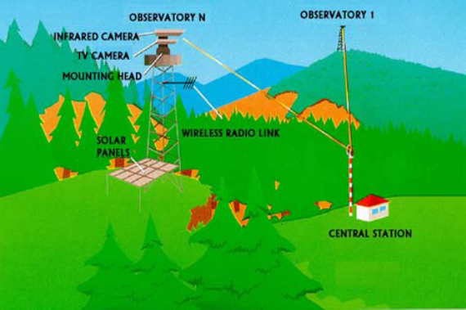

Figure 1. Bosque system (BAZAN-FABA, Spain).

The methods used for forest fire detection can be split in three different groups. The ground based, aerial and space borne detection platform based techniques. All groups can be subdivided based on temporal resolution, spatial resolution, spectral resolution and the cost of the system. There is also a difference in the wavelength band(s) in which the fire is detected. Infrared (IR) and ultra violet (UV) are used to detected the energy produced by the fire and the visible light is used to detect the smoke or/and fire plume. All camera systems can be either staring or scanning.

Figure 2. The forest fire detection with aerial observation.

The ground system for forest fire detection comprises a number of Peripheral Observation Station (POS) units installed at sites carefully selected by territory analysis and linked via radio or wire cables to a Command and Control Center (CCC). Each POS has horizontal 360° scanning platform with IR detector or high-resolution thermal-camera and TV camera, command and control unit, meteorological-data acquisition unit, transmission unit and power supply installed on a proper and well stabilized structure (tower, pole, post, lighthouse, etc..).
The ground based systems in commercial use are BOSQUE from BAZAN-FABA (Spain) (Figure 1.) (1), SRI-10 from ALENIA (Italy) (2), BSDS from FISIA, etc.

The use of airborne sensors and/or observers (Figure 2.) which is anyhow used to cover very wide areas, does not provide the optimal requisites of signalling rapidity or operational reliability especially in the presence of strong winds and/or low clouds. Typical representative is BOMEN (Canada) and GerINTRADAN (Denmark) (1,2).

Figure 3. Scheme of the space borne detection platform based techniques.

The use of satellites (Figure 3.) on close orbits, keep, more exalted the advantages and disadvantages of airborne designation; while the geostationary satellites require, for an effective detection, the large fire surface, the detection time delay and are in any case very sensitive to the presence of clouds. (The Landsat TM, NOAA AVHRR satellite, group of FUEGO satellites, etc.) (1-3).
The combination of minimum delay and resolution makes some detection techniques such as satellite-based techniques not yet reliable (4). However, satellite technologies seem to be very useful to activate early detection systems. Moreover, the incorporation of a new generation of high-resolution satellites seems promising.
The variability of the detection conditions in natural environments represents a significant issue. The direct application of some detection technologies based on the analysis of visual images does not provide good results in all cases. Visual sensors only can be used with appropriated lighting conditions and the reliability of the detection process presents poor results. However, some existing systems seem to be very promising (1,2,5).
The development and improvement of the utilisation of operational airborne sensors for early warning, detection, monitoring and impact assessment of wilderness fires resulted in enhanced capabilities to obtain detailed and comprehensive information on the extent of the occurrence and consequences of wilderness fires.
Infrared detection is the basis of some existing detection systems such as the Bosque system from FABA-BAZAN and BSDS system from FISIA-TELETRON (6). The performance of these systems varies. All the systems are able to detect early fires of small dimensions from distance of several kilometers. The Bosque system is capable of detecting a one square meter at ten kilometers or a ten square meter fire at twenty kilometers (6-8).

INTEGRATED SYSTEM FOR FOREST FIRE EARLY DETECTION (IFFED System)

Information and computer technology has certainly changed the face of early remote detection and management of fire, presenting exciting new challenges and rewards for fire fighters and fire action managers. High-tech equipment and software provides tools for fire detection with information processing, fire behaviour modelling, geographic information systems for better mapping, remote imagery and automatic weather stations for up to the minute forecasts, advances in resource monitoring and cost tracking (9).
Conventional techniques for smoke and fire detectors which are widely used today detect the presence of particles generated by smoke and fire by ionization or photometry. They produce an alarm only when particles reach the sensors to activate them. In the last couple of years image processing (video) based fire detection systems found a lot of applications in fire detection in closed spaces, but also in open spaces. Today several video based fire and smoke detection algorithms exist in literature and practice. These methods make use of various visual signatures (fingerprints) in time and space domain using Fast Fourier Transforms (FFT), characteristics of temporal object boundary pixels or Wavelet based fire detection methods (10,11). Growing concern about the trend of increasing vegetation destruction by fire has led to a number of international co-operative initiatives in wild land fire science, detection, management and policy development. During the last decades, the EC supported several R&D activities dealing with the physics, chemistry and ecology of forest fires. Several IT applications, such as Decision Support Systems and Fire Simulators, have been developed in the context of common European projects. Furthermore, starting in the 90s, a number of international and interdisciplinary fire research programmes contributed to a better understanding of the impacts of fire on ecosystems, bio-geo-chemical cycles, atmosphere and climate.

System Architecture of the IFFED System

In this paragraph the prototype of an automatic forest fire detection and management system (IFFED), designed by the Ruđer Bošković Institute -CIR, is illustrated and described, along with its application and installation (10).
The IFFED system is full modular, autonomous and works 24 hours a day. Its basic module consists of a Command and Control Centre (CCC) and of one or more Peripheral Observation Points (POP) (Figure 4). These modules can be distributed over the territory so as to cover the entire area of interest and can be connected to a hierarchically higher control which acts as National/Regional supervisor.

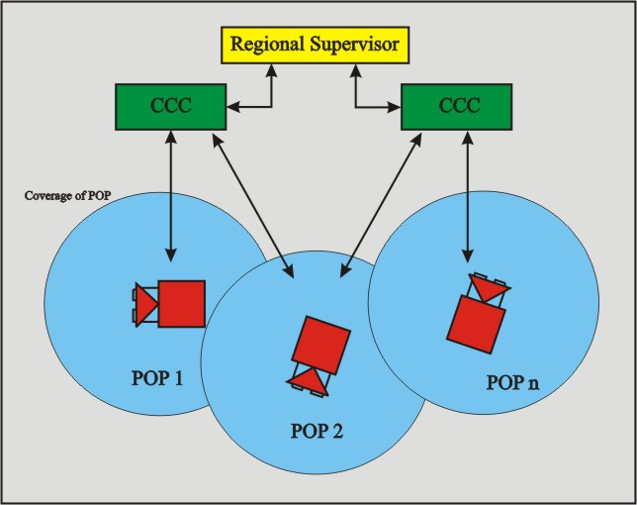

Figure 4. The block scheme of the IFFED system.

The IFFED system is an integrated forest fire detection and management system based on the use of observation points essentially consisting of towers supporting a special infrared and visual sensor, a weather station and a data transmission system, which are linked to the control centre for the acquisition and verification of the alarms.
The observatory points contain towers, which are located at high coverage points, have positioning systems with infrared and visual cameras, which move automatically sweeping the surveillance area. The power is provided by solar panels. Wind generators also provide an alternative power supply.
The towers use an infrared camera appropriate for high distances, with high resolution. There is also a color TV camera with power-driven zoom for use by an operator. The positioning system rotates the cameras in a circle, and also produces a vertical displacement. All these motions are programmed to cover the area under surveillance automatically, by means of repetitive sweeps.

A dense network of meteorological sensors is used to model the meteorological conditions (CAREGA factor) (10). The modeling of meteorological conditions allows the computation of local meteorological data. Thus, meteorological data such as wind speed and direction can be estimated in the area of the alarm. This local information has high relevance for detecting forest-fire, for reducing false alarm and predicting fire behavior (1,2,9).

The communication unit transmits the infrared and video information to the control centre. The control centre, which is linked to one or more observatory points, includes a supervisory system with monitors for thermal and video images from the observation points. The basic detection process is performed on these points. The observation points compress the video signals and send the images from both cameras to the control centre. The operator selects one of the images to be visualized in the main monitor of the station. The operator of the system is able to control the positioning system by using a radio link with the observation stations. He usually switches between thermal and video images when a fire alarm is generated by the thermal detection system. The operator can also tune threshold parameters, which are critical in the detection process. All the processing required for fire detection using thermal images is performed in the control centre. Thus, the centre has appropriate hardware and software for the digitization of the image, and the processing to detect and analyze the alarms from the images. A human operator should validate the forest-fire alarms. The centre also includes a display with a map to locate the fire. Some triangulation (when the fire is seen by two or more observatories) and intersection of line-of-sight techniques have been implemented to locate the fire.
The alarmed operator observes the monitor images and can zoom onto the alarmed point via remote command in order to make a visual inspection. The alarmed status then becomes a matter of the operator’s personal judgment. If the operator interprets the event as a real fire, the system will supply graphic informations concerning the characteristics of the area, such as meteorological data (wind direction and intensity), kinds of the trees in burning zone, better roads to reach the area, and so on (thematic maps).
The control centre can be provided with forecasting models such as risk level (risk-map) and fire-behavior (fire propagation and intervention management model). Based on a territorial and climate database (GIS layers), in addition to actual meteorological data, the system will predict the extent of the conflagration after processing and will display the burned area. The operator can then make an informed decision on the strategic deployment of fire-fighters and technical equipment to combat the fire most effectively.
The sensitivity of the IFFED detector unit is one of the essential parameters in the detection of fire starting points and the IR sensor integrated in the system is capable of detecting a fire area of approx. 6 square-meters from a distance of 10 km. The wide overage is approx. 30,000 hectares per observation point.

Should one wish to increase the system’s sensitivity, it is possible to reduce the sensor’s threshold level through a software command, for example during particular weather conditions, accepting the consequential increase in false alarms rate (11,12).

The Peripheral Observation Point

The main functions of the peripheral observation point are the following:
- Management of the azimuth and elevation scans.
- Acquisition of IR, meteo and data/images and visual images.
- Extraction of alarms from IR and visual sensor data/images (“spatial “ processing).
- Transmission of the coordinates of the extracted alarms to the control centre.
- Transmission of weather data to the control centre.

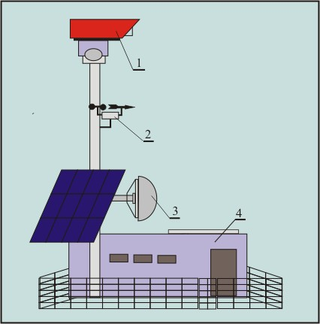

Figure 5. Peripheral observation point.

The components of a peripheral observation point (Figure 5.) are the following:
- The detector device (1) (13).
- Supporting structure equipped with lightning rod, anti-tempering system and fencing.
- Meteo sensors system: temperature, wind direction and speed sensors (2).
- Duplex communication channel for the transmission of IR/visual images and weather data and transmission-reception of control signals from/to the control centre (3).

Airtight container containing the control electronics for the drive unit and a local processor equipped with dedicated software, which constitutes the IR/visual data processing unit for alarm data extraction (4).

- No-break power unit.

The detector device (Figure 6.) consists of the following components:
- The IR channel:
  - The Cassegrian optics with bandpass filter for spectral band (2-5,6 μm).
  - Sensor HgCdTe with 195x260 pixels and thermoelectric cooling (Peltier cooler).
  - Adaptive DC/AC amplifier and microcontroller.
- The video channel:
- CCD color TV camera with power drive zoom (10-100mm/F1.6) and 500x582 pixels.
- The scanner unit for horizontal (360°) and
- vertical scanning (10°).

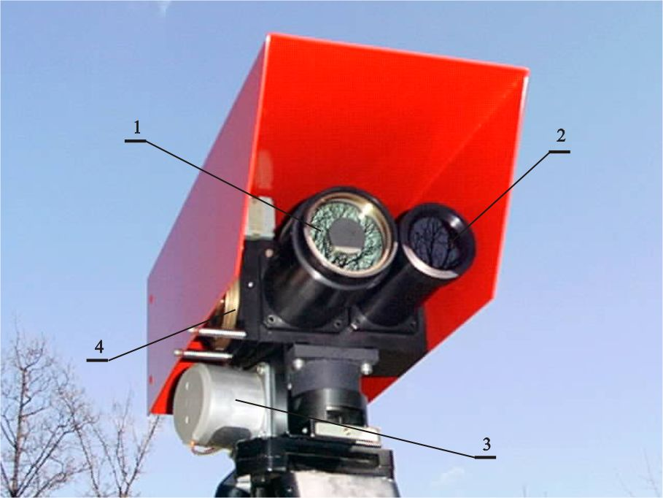

Figure 6. The detector device of the IFFED system.

The Command and Control Centre

The control centre merges all information from observation point to achieve reliable and efficient fire detection. Here is to show the working procedure of the detection system. The block scheme of the detection system is presents in Figure 7. Three main blocks can be identified: The sensor interface unit, the image processing unit and the decision function unit.
The sensor interface unit is responsible for the communication with the observation point. This block makes transparent the particularities of each sensor station and each sensor such as the capture delay and transmission means. The main meteorological sensors measure magnitudes such as temperature, precipitation, relative humidity, wind speed and orientation. Although the sensors provide local measurements, this information can be used to interpolate within the surveillance area using meteorological models. The real-time access database contains information regarding topography, terrain use maps and alarms detected in the last surveillance cycles of the positioning system in order to avoid detecting of previously analyzed alarms.
The image-processing unit has a significant relevance in the architecture of the system because the basic detection process is carried out with the infrared image. The block includes an IR processing tool, which performs several functions: IR detection, alarm filtering and oscillation analysis.

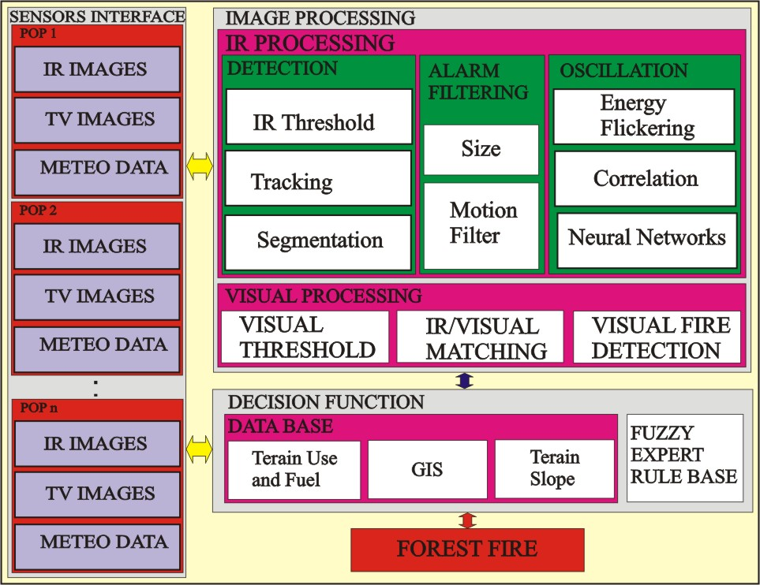

Figure 7. The block scheme of the detection system.

The IR detection function consists in segmenting the IR images using a threshold value that is computed dynamically from statistical parameters of the IR images. The segmentation consists in the application of a region-growing algorithm (8). A tracking algorithm is applied to avoid the detection of moving objects (14). The alarm filtering function consists in a set of rules to avoid alarms originated by spurious effects of the infrared camera or interference.
The oscillation analysis studies the temporal and frequency responses of the alarms in a sequence of infrared images. This technique extracts the small oscillations originated by the sudden movements of the flames of forest-fires. False alarms generated by solar reflections, heated objects or artificial lights do not suffer oscillations. Algorithms based on energy and correlation quantify the magnitude of the oscillations. Artificial Neural Networks (ANN) classify the alarm providing a forest-fire possibility (10,15). The design and computation of weights of the ANN were determined by an off-line supervised learning process.

The visual/image-processing tool is designed to integrate infrared and visual images. This tool applies optical and geometrical models of the particular arrangement of the visual and infrared cameras (with parallel axis) to determine the location in the visual image of the region detected in the infrared image. Therefore, the visual images can be integrated to validate alarms. This technique has two main functionalities. It can be used to reduce the false alarms rate. On the other hand, it is also useful for operator’s aid because it avoids seeking the alarm in the visual alarms, which is not an easy task particularly with cloudy weather.
From the segmentation of the alarm in the infrared and visual images, it is possible to obtain measures of the size of the region being analyzed (10,16). The ratio between the visual and infrared areas is a relevant parameter to discriminate between fires and false alarms and can be applied to confirm the fire.
A high number of false alarms, particularly those originated by solar reflections, have visual/infrared area relations similar to one. In this case, the solar reflection variable takes a high possibility value. If the visual/infrared area relation is higher than one, it means that the smoke plume has been segmented in the visual image. Thus, the smoke variable takes a high possibility value (17).
If the area relation is lower than one, the hot spot should not correspond to a solar reflection. However, it could be originated by a heated object, which is a false alarm, or a forest fire, which smoke plume has not been segmented. In that case, the hot spot cannot be classified as a forest fire or a false alarm (8,9).
The decision function unit combines the information from images, maps, meteorological data and the database with heuristic knowledge based on rules to produce a forest-fire possibility value. The output of the decision function block is a value in the range [0, 100] that represents the forest-fire possibility and the potential danger of the alarm (8). If the forest-fire possibility value is above an operator-selected alarm threshold, which is normally 0.5, the alarm will be considered as a forest fire. Otherwise, the alarm will be rejected.
The rules of the decision function are expressed in terms of fuzzy logic, which is an appropriate method to express imprecise knowledge. The membership functions and weights of the rules are fixed through a supervised learning process.
The real-time nature of the detection process imposes some limitations on the implementation. A real-time database system incorporating static and dynamic information is required. This database should be designed in a way that the access time is minimized. Thus, it is possible to transform between the map coordinates and the orientation angles of the cameras so that the database is accessed using the orientation angles. Therefore, it is necessary to design a database for each sensorial station.
The testing of the laboratory prototype of this type of detector dates back to 1999 and successively, in years 2001 to 2005. The obtained results of the test were satisfying. The measuring was performed with fire (open flame) in the area of ~1m², at the distance of 100 m, (1000 m). In total, 100 measurements were made under relatively the same conditions. The measurements were made in different parts of day, but the night measurements are not included into the total result, because of satisfactory work conditions (low background noise, etc.). The results in the process of measuring were over 98% for individual fire points.
The picture on Figure 8. presents the landscape from a color TV camera with the possibility of hot point-flame (inside the cursor) (13).

Figure 8. Visual image with position of a forest fire (island Molat).

Expected results

- Long-term surveillance of the environment state with distributed gathering of information.
- Efficient use and ownership of the data and making knowledge out of it.
- On the base of that data to analyse and predict potentially dangerous situations (conflagration, flood, pollution, changes in environment, natural plant and animal habitant) and to study those functions through certain time period.
- Active prevention of possible unwanted states.
- Methodology analyses of natural processes in environment and possible unwanted influence of man on such processes.
- With the usage of new scientific cognitions, mainly of non-linear dynamics (behaviour of complex systems), new cognitions in behaviour of natural environment can be discovered. The profit from this kind of approach is huge.
- The system itself is of prototype character. With future expand of this kind of system on the rest of territory units which have similar of different state of environment, it will be possible to get an insight into complex processes of nature and also will be possible to react duly in order to prevent or to mollify unwanted apparitions.
- Reduction of conflagrations, prevention of damage of flora and fauna, reduction of all the rest harmful effects which are primary the product of human act, these are main results of this system.

CONCLUSIONS

The presented analysis of forest fire detection systems, considering the specific conditions present in the protected areas of the Republic of Croatia, has given an absolute advantage to the ground based fire detection systems. The main advantage is perceived in the possibility of rapid detection concerning the time of occurrence and the size of the fire in the open area. They are adjustable to the ground configuration; they work in all meteorological conditions and are more cost-efficient in respect to the other detection systems. Using the IR sensitive elements-bolometers, the price of a detection unit decreases drastically which results in its widespread application in the securing of monitored area.
Ground based fire detection systems, besides its efficient fire detection, provide the security for the visitors of monitored area from incidents which can happen to them or which they can cause to the existing flora and fauna. The system of TV cameras, which is an integral part of each detection unit in the fire detection system, makes it possible to detect specific actions over great distances for which the existing ranger service is not capable of.
Inexpensive technologies of producing multi-spectral sensorial elements and the related optics, the more sophisticated methods of the evolution of the increased number of input parameters in the detection process, the increase in computing resources (Cluster Computers, CRO GRID Infrastructure) provide a widened and more efficient application of the stated concept concerning the remote forest fire detection in the future.

Acknowledgement: This work has been financed within the Sciantific Project, under the name Methods of Sciantific Visualisation (098-0982562-2567) at the Programme Distributed System and Visualisation, from MZOŠ R. Hrvatske.

REFERENCES

- Skala K., Kolarić D., Dubravić A., Pavelin A., Mladineo M., "Informacijska obrada šumskih požara" Tematska studija IRB Zagreb, FEB Split, Građevinski fakultet Split, Zagreb 2001.
- Kolarić, D. ; Dubravić, A. ; Skala, K. ; Remote Forest Fire Detection System, Proceedings of Electronics in marine ELMAR '98, Zadar, 1998. 80-85.
- Rauste, Y. (1996). Forest Fire Detection with satellites for for fire control. Int Archives of Photogrammetry and Remote Sensing, Vol.XXXI, Part B7 (Proc. of the XVIII Congress of ISPRS, Vienna, Austria, 9-19 July 1996).
- Den Breejen E., M. Breuers, F. Cremer, R. Kemp, M. Roos, K. Schutte and J.S. De Vries (1998), “Autonomous Forest Fire Detection”. Proceedings 3rd ICFFR Luso, Portugal. November 1998. pp. 2003-2012.
- De Vries, Jan S., and Den Breejen E. (1993), "Characterization of the visibility of wildfire smoke clouds". In Proc. SPIE Conf. Orlando, april 1993.Conf. 1968-76.
- Gandia A., Criado A., and Rallo M. (1994)., “El Sistema BOSQUE, Alta Tecnología en Defensa del Medio Ambiente”, DYNA, pp.34-38, n. 6.
- Kolarić, D.; Skala, K.; Multispectral Fire Detection, Proceedings of Electronics in marine ELMAR 1999 , Zadar, 1999. 120-125.
- Martinez-de Dios J.R., Arrue, C.; Distributed Intelligent Automatic Forest Fire Detection system, Proceedings of INNOCAP 99.
- Skala, K.; Legović, T.; Risović, D.; Kolarić, D.; Dubravić, A.; Forest Fire Detection and Evaluation System, Proceedings of Electronics in marine ELMAR '98, Zadar, 1998. 16-21.
- Kolarić, D.; Analiza multidiskretne daljinske detekcije slučajnog optičkog izvora, Dok. Disertacija, 2002.

- Kolarić, D.; Dubravić, A.; Skala, K.; Extraction of Information about Spatial Characterstics of Fire Plume from Video Signal, Proceedings of Electronics in marine ELMAR 2003, Zadar, 2003. 345-349.
- Laurenti A., and Neri A. (1996), “Remote Sensing, Communications and Information Technologies for Vegetation Fire Emergencies”,Proc. of TIEMEC’96, Montreal.
- Kolarić, D.; Skala, K.; Dubravić, A.;The Detector Device for Remote Forest Fire Detection, Proceedings of Electronics in marine ELMAR 2001, Zadar, 2001. 120-124.
- Kolarić, D.; Dubravić, A.; Skala, K.; Fire Flickering Detection Method for Discrimination of an Optical Source, Proceedings of Electronics in marine ELMAR 2000, Zadar, 2000. 46-49.
- Kolarić, D. ; Skala, K. ; Šćepanović, T. ; Low Spectral Density Analysis by Video Extraction, Proceedings of Electronics in marine ELMAR 2002, Zadar, 2002. 146-150.
- Kolarić, D.; Dubravić, A.; Skala, K.; Extraction of Information about Spatial Characteristics of Fire Plume from a Video Signal, Proceedings of Electronics in marine ELMAR 2003, Zadar, 2003. 345-349.
- Ollero, A., Arrue, B.C., Martinez, J.R.; Techniques for Reducing False Alarm in Infrared Forest-fire Automatic Detection Systems, Control Engineering Practice 7, 1999, 123-131.



