Middle Ages or Meso America
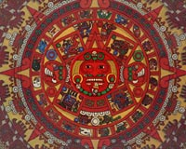  1. aztec overlay-meso | 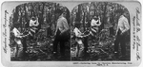  2. cacao-meso | 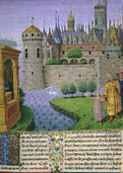  3. castle-middle | 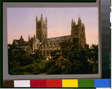  4. cathedral-middle | 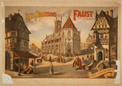  5. cathedral in town-middle
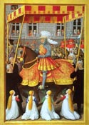  6. chilvary-middle | 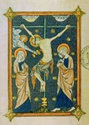  7. christ-middle | 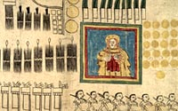  8. codex-meso | 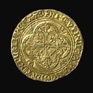  9. coin-middle | 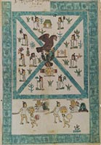  10. founding of tenoch- meso
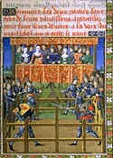  11.joust-middle | 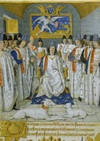  12. king with knights-middle | 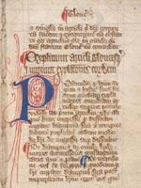  13. magna carta-middle | 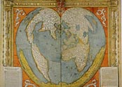  14. map-middle | 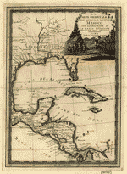  15.map_image-meso
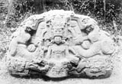  16. mayan stella-meso | 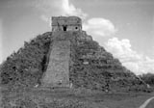  17. mayan temple3-meso | 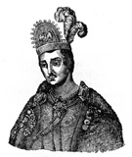  18. moctezuma-meso | 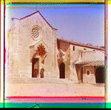  19. monastery-middle | 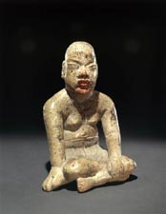  20. olmec statue-meso
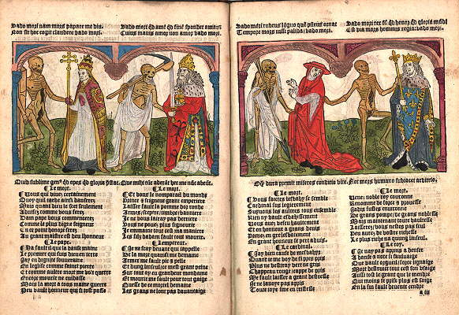  21. plague-middle | 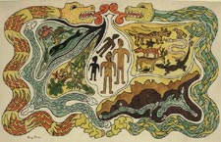  22. polpoh vu-meso | 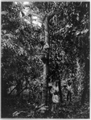  23. rubber tree-meso | 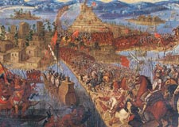  24. tenochtitlan-meso

#1

http://www.loc.gov/exhibits/world/heavens.html

Home - Object Checklist - Exhibition Overview - Treasure Talks - Read More About It - Credits
Exhibition Areas: Introduction - Creation - Explaining and Ordering - Recording the Experience

Aztec Calendar Stone
 | 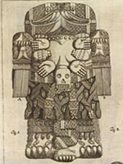  Antonio de León y Gama.  Descripción histórica y cronológica  de las dos piedras . . . .  Mexico City: F. Zuniga y Ontiveros, 1792.  Rare Books and Special Collections Division (95) | Eduardo Matos Moctezuma.  La Piedra del Sol. Calendario Azteca  (Sunstone. The Aztec Calendar).  México: 1992  General Collections (95.1)
In 1790 workers repaving near the Cathedral in Mexico City discovered a stone eleven and one-half feet in diameter inscribed with the Aztec calendar. When in use, the stone would have had bright polychrome colors and would have held sacrificed human hearts that the Aztecs believed were needed to feed the sun and keep civilization alive. This first study (pictured to the left) of the stone explained its 260-day divinatory cycle. The stone's colossal size, elaborate patterning, and symbolic imagery have made it an unofficial emblem of Mexico.
This book (on the right), by Eduardo Matos Moctezuma, director of the excavations of the central Aztec temple (Templo Mayor), uses color overlays to show how the stone, known as the "Piedra del sol" (sunstone), would have looked on the Aztec great temple. The volume also includes a facsimile of the first study of the stone published in 1792 by Antonio de León y Gama. Its colossal size, elaborate patterning, and symbolic imagery have made the sunstone an unofficial emblem of Mexico.

#2

 | NEW SEARCH | HELP | ABOUT COLLECTION
TITLE: Gathering cacao for chocolate manufacturing, Nicaragua, C. A.
CALL NUMBER: STEREO FOREIGN GEOG FILE - Nicaragua <item> [P&P]
REPRODUCTION NUMBER: LC-USZ62-98413 (b&w film copy neg.)
No known restrictions on publication.
MEDIUM: 1 photoprint on stereo card : stereograph.
CREATED/PUBLISHED: Meadville, Pa. : Keystone View Company, c1902.
CREATOR:
Keystone View Company.
NOTES:
H21099 U.S. Copyright Office.
No. 12837.
Copyright by B.L. Singley.
SUBJECTS:
Harvesting--Nicaragua--1900-1910.
Cacao--Nicaragua--1900-1910.
FORMAT:
Stereographs 1900-1910.
DIGITAL ID: (b&w film copy neg.) cph 3b44496 http://hdl.loc.gov/loc.pnp/cph.3b44496
VIDEO FRAME ID: LCPP003B-44496
CARD #: 89715954


#3
HOME - Introduction - Monarchs & Monasteries - Path to Royal Absolutism
Rise and Fall of the Absolute Monarchy - From Empire to Democracy
Conclusion - Acknowledgments

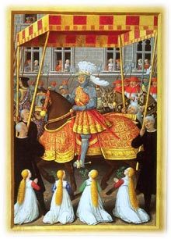
The Path to Royal Absolutism:

The Renaissance and Early 17th Century
(end of the 15th -- first half of the 17th centuries)

42. Pierre Bersuire (b. 1290-d. around 1362), Translation of Livy's (first century, B.C.) Decades (volume 2), Paris, after 1480, Manuscripts Department, Western Section, Fr. 274, Parchment
Commissioned by King John the Good (1350-1364), this first major literal translation of Livy into French was a key medieval reference work on antiquity. It inaugurated the translations commissioned under Charles V (1364-1380) and Charles VI (1380-1422), which provided aristocratic circles with a cultural model established by the royal entourage. The opening illustration shows Livy in his study. Carthage is depicted as the Ile de la Cité in Paris while Hannibal asks his father to take him to Spain.

http://www.loc.gov/exhibits/bnf/bnf0004.html

 | NEW SEARCH | HELP

#4
TITLE: Canterbury Cathedral, N.W.
CALL NUMBER: FOREIGN GEOG FILE - England--Canterbury <item> [P&P]
REPRODUCTION NUMBER: LC-USZC4-4769 (color film copy transparency)
MEDIUM: 1 photomechanical print : photochrom, color.
CREATED/PUBLISHED: [between 1890 and 1900]
NOTES:
No. 11143.
SUBJECTS:
Canterbury Cathedral--1890-1900.
Cathedrals--England--Canterbury--1890-1900.
FORMAT:
Photochrom prints Color 1890-1900.
REPOSITORY: Library of Congress Prints and Photographs Division Washington, D.C. 20540 USA
DIGITAL ID: (color film copy transparency) cph 3g04769 http://hdl.loc.gov/loc.pnp/cph.3g04769
CARD #: 96513053

 | NEW SEARCH | HELP | ABOUT COLLECTION

#5
TITLE: Lewis Morrison's magnificent new Faust
CALL NUMBER: POS - TH - 1889 .F3, no. 3 (C size) <P&P>[P&P]
REPRODUCTION NUMBER: LC-USZ6-451 (b&w film copy neg.)
No known restrictions on publication.
MEDIUM: 1 print (poster) : lithograph, color ; 73 x 105 cm.
CREATED/PUBLISHED: Cin'ti, O. : MacBrair Lith. Co., c1889.
CREATOR: MacBrair Lith. Co.
RELATED NAMES:Morrison, Lewis, 1845-1906.
Abraham, Edw. J. (Edward J.)
NOTES: U27951 U.S. Copyright Office Created by "The MacBrair Lith. Co., Cin'ti, O." "Copyrighted 1889 by Edw. J. Abraham." "Under the management of Edw. J. Abraham." Caption: The public square Nuremberg, Act I, scene 2. Lower corners missing.
SUBJECTS:Mephistopheles (Fictitious character)
Cathedrals--Germany--Nuremberg.
Plazas--Germany--Nuremberg.
City & town life--Germany--Nuremberg.
Theatrical productions.
Nuremberg (Germany)
FORMAT:Theatrical posters American.
Lithographs Color.
OTHER TITLE:Faust.
PART OF: Theatrical Poster Collection (Library of Congress)
REPOSITORY: Library of Congress Prints and Photographs Division Washington, D.C. 20540 USA
DIGITAL ID: (intermediary roll film) var 0689 http://hdl.loc.gov/loc.pnp/var.0689
CARD #: var1994000742/PP

#6
HOME - Introduction - Monarchs & Monasteries - Path to Royal Absolutism
Rise and Fall of the Absolute Monarchy - From Empire to Democracy
Conclusion - Acknowledgments

The Path to Royal Absolutism:

The Renaissance and Early 17th Century
(end of the 15th -- first half of the 17th centuries)

59. Jean Marot, Le Voyage de Gênes (Voyage to Genoa) (Jean Bourdichon, painter), Tours, around 1508, Manuscripts Department, Western Section, Fr. 5091, Parchment
Louis XII's rapid conquest of the city of Genoa in April 1507 struck public opinion as a remarkable feat of arms, sparking rapturous accounts by court chroniclers and poets who extolled the king's greatness and fame. Jean Marot, the king's official poet, composed a verse account of the victorious expedition, copied in a fine manuscript intended for Louis's wife, Anne of Brittany (b. 1477-d. 1514). In this illustration Louis XII makes a triumphal entry into Genoa.

http://www.loc.gov/exhibits/bnf/bnf0004.html
#7
HOME - Introduction - Monarchs & Monasteries - Path to Royal Absolutism
Rise and Fall of the Absolute Monarchy - From Empire to Democracy
Conclusion - Acknowledgments

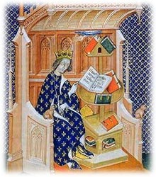
Monarchs and Monasteries:

Knowledge and Power in Medieval France
(late 8th -- late 15th centuries)

21. Frère Laurent, La Somme le roi (usually referred to as, The Book of Vices and Virtues), northern France, early 14th century Library of the Arsenal, MS 6329. Parchment
In 1279-80, at the request of King Philip the Bold (1270-1285), Friar Laurent, the king's confessor, composed a manual of moral instruction known as La Somme le roi. The author was inspired by earlier texts, in particular a treatise on vices and virtues entitled the Miroir du Monde (Mirror of the World). La Somme le roi was translated into numerous languages and dialects and achieved a wide circulation.

http://www.loc.gov/exhibits/bnf/bnf0003.html


Home - Overview - Treasure Talks - Object Checklist (Current) - Credits #8
Exhibition Sections: Top Treasures - Memory - Reason - Imagination
Huexotzinco Codex, 1531  Huexotzinco Codex, 1531  Plaintiff testimony and pictographs  of the products and services provided  as tribute  Page 2, 3, 4, 5, 6, 7, 8  Amate paper  Manuscript Division (2.7, 3.7)  Gift of Edward Stephen Harkness, 1928  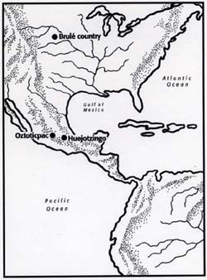 | The Huexotzinco Codex is an eight-sheet document on amatl, a pre- European paper made in Mesoamerica. It is part of the testimony in a legal case against representatives of the colonial government in Mexico, ten years after the Spanish conquest in 1521. Huexotzinco (Way-hoat-ZINC-o) is a town southeast of Mexico City, in the state of Puebla. In 1521, the Nahua Indian people of the town were the allies of the Spanish conqueror Hernando Cortés, and together they confronted their enemies to overcome Moctezuma, leader of the Aztec Empire.  After the conquest, the Huexotzinco peoples became part of Cortés'estates. During 1529-1530 when Cortés was out of the country, Spanish colonial administrators intervened in the daily activities of the community and forced the Nahuas to pay excessive taxes in the form of goods and services. When Cortés returned, the Nahuas joined him in a legal case against the abuses of the Spanish administrators.  The plaintiffs were successful in their suit in Mexico, and later when it was retried in Spain. The record shows [in a document uncovered in the collections of the Library of Congress] that in 1538, King Charles of Spain agreed with the judgement against the Spanish administrators and ruled that two-thirds of all tributes taken from the people of Huexotzinco be returned.  Additional Views:  Nahua Numbering System

#9
HOME - Introduction - Monarchs & Monasteries - Path to Royal Absolutism
Rise and Fall of the Absolute Monarchy - From Empire to Democracy
Conclusion - Acknowledgments

The Path to Royal Absolutism:

The Renaissance and Early 17th Century
(end of the 15th -- first half of the 17th centuries)

54. Coins of the eighth through the sixteenth centuries
This selection of coins depicts French coinage between the late eighth century and early sixteenth century. Charlemagne's reform of 794 created a new denarius whose appearance would change little until the tenth century. The denarius of Charles the Bald (840-877), a half-century later, still closely resembles that of Charlemagne (768-814). Exceptions to the almost exclusive use of silver that lasted until about 1270 included the gold solidi of Louis the Pious (814-840), intended for commerce with the peoples of the north. The absence of a purely royal coinage under Hugh Capet (987-996) suggests the weakness of the new Capetian dynasty: only some denarii and oboles issued by the bishop of Beauvais and a unique denarius of Laon survive. Philip II (1180- 1223) instituted the double system of the denier parisis north of the Loire and the denier tournois to the south. Under Louis IX (1226-1270) appeared the first multiple of the denier, the gros denier worth twelve denarii. The period from Philip IV (1285- 1314) to Philip VI (1328-1350) saw a multitude of gold coins of varied and artistic types, including the gold florin "à la Reine". The royal d'or, ordered October 9, 1429 represents Charles VII (1422-1461) shortly after his coronation. Although already part of the kingdom of France, Brittany retained some issues of a special type until the mid-sixteenth century. The king's portrait appeared for the first time under Louis XII (1498-1515) on heavy silver coins, called "testons", opening a new chapter in the history of French coins.
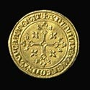  Louis the Pious,  solidus, Duurstede (?), 814-840.  Department of Coins, Medals and  Antiquities, 1072 | 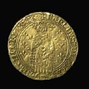  Charles VIII, ‚cu d'or de Bretagne, Rennes,  1491-1498.  Department of Coins, Medals and  Antiquities, 1862 | Charles VII,  royal d'or, Lyons,  1429-1431.  Department of Coins, Medals and  Antiquities, 1378 | 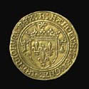  Philip IV, Gold Florin called "à la Reine,"  1305.  Department of Coins, Medals and  Antiquities, 233

http://www.loc.gov/exhibits/bnf/bnf0004.html

Home - Object Checklist - Exhibition Overview - Treasure Talks - Read More About It - Credits
Exhibition Areas: Introduction - Creation - Explaining and Ordering - Recording the Experience
Throughout the inhabited world, in all times and under every circumstance, the myths of man have flourished, and have been the living inspiration of whatever else appeared out of the human body and mind. It would not be too much to say that myth is the secret opening through which the inexhaustible energies of the cosmos pour into human cultural manifestation. Religions, philosophies, arts, the social form of primitive and historic man, prime discoveries of science and technology, the very dreams that blister sleep, boil up from the basic, magic ring of myth.
Joseph Campbell

Societal Beginnings

Frances F. Berdan and  Patricia Rieff Anawalt, ed.  Facsimile of the Codex Mendoza.  Berkeley: University of  California Press,1992.  Page 2  General Collections (50) | The Founding of Tenochtitlan  According to legend, the tribal god Huitzilopochtli led the Aztecs/Mexica to a spot where an eagle sat atop a prickly pear cactus (tenochtli) growing out of a rock and told them to build their capital there. This symbol now graces the Mexican flag. This image first appeared in the Codex Mendoza, a pictorial history of the Aztecs/Mexica, presumably prepared for the first viceroy of New Spain, Antonio Mendoza, ca. 1541. The original reposes in the Bodleian Library, Oxford University.  #10

http://www.loc.gov/exhibits/world/societal.html

#11
HOME - Introduction - Monarchs & Monasteries - Path to Royal Absolutism
Rise and Fall of the Absolute Monarchy - From Empire to Democracy
Conclusion - Acknowledgments

The Path to Royal Absolutism:

The Renaissance and Early 17th Century
(end of the 15th -- first half of the 17th centuries)

43. Cérémonies et ordonnances à gage de bataille (Ceremonies and Edicts for Trial by Combat), Paris, around 1460-1465, Manuscripts Department, Western Section, Fr. 2258, Parchment
This book outlines the procedures for settling a quarrel through trial by combat. This opening depicts the confrontation which takes place in an enclosed space, before juges d'armes who monitor the legality of the blows exchanged, and an elegant audience of lords and ladies. This copy was made for François II, Duke of Brittany (1458-1488). Its diminutive format, presentation of miniatures, and lavish decoration link the manuscript to books of hours rather than to treatises.

#12
HOME - Introduction - Monarchs & Monasteries - Path to Royal Absolutism
Rise and Fall of the Absolute Monarchy - From Empire to Democracy
Conclusion - Acknowledgments

The Path to Royal Absolutism:

The Renaissance and Early 17th Century
(end of the 15th -- first half of the 17th centuries)

44. Statuts de l'ordre de Saint-Michel (Statutes of the Order of Saint Michael), Tours, 1470, Manuscripts Department, Western Section, Fr. 19819, Parchment
In an effort to guarantee the allegiance of ranking nobles, Louis XI (1461-1483) founded the Order of Saint Michael in 1469. The book of Statutes exhibited here--the king's own copy and the finest of all extant copies--was illuminated by Jean Fouquet (b. around 1420-d. around 1480), the king's official painter. The manuscript's only large miniature depicts the king surrounded by the order's fifteen knights with the four officers of the Order in the background.

http://www.loc.gov/exhibits/bnf/bnf0004.html

Home - Object Checklist - Exhibition Overview - Treasure Talks - Read More About It - Credits
Exhibition Areas: Introduction - Creation - Explaining and Ordering - Recording the Experience
The Law is what it is--a majestic edifice, sheltering all of us, each stone of which rests on another.
John Galsworthy, 1910

Rule of Law

#13
Magna charta cum statutis angliae,  (Great Charter with English Statutes).  Page 2 - Page 3 - Page 4  Manuscript, fourteenth century.  Rare Book Collection,  Law Library (68) | Principles of Individual Liberty  Among the Law Library's rarest books, this miniature manuscript is still in its original pigskin wrapper. Intricate colored pen work graces this small version of the Magna Carta, the basic source of English common law. The Magna Carta established the principle that no one, not even the king, is above the law. The principles of individual liberty it confirmed influenced later political thinkers, including Thomas Jefferson.

http://www.loc.gov/exhibits/world/rule.html

#14
HOME - Introduction - Monarchs & Monasteries - Path to Royal Absolutism
Rise and Fall of the Absolute Monarchy - From Empire to Democracy
Conclusion - Acknowledgments

The Path to Royal Absolutism:

The Renaissance and Early 17th Century
(end of the 15th -- first half of the 17th centuries)

74. Oronce Fine (b. 1494-d. 1555), Map of the World, 1534-36, Department of Maps and Plans, Rés. Ge DD 2987 (63), Paper
Oronce Fine was one of the rare French geographers in the Renaissance to prepare maps of the world. This map is bordered with a handsome Renaissance decoration: two columns support a pediment bearing a Latin inscription signifying "A new and complete description of the world," interrupted in the middle by a coat of arms of France. Also to be noted is a vast southern land mass (Terra Australis), recently discovered but not yet explored.

http://www.loc.gov/exhibits/bnf/bnf0004.html

#15
 | PREVIOUS | NEXT | NEW SEARCH
Map Collections: 1500-2004
La parte orientale dell'antico e nuovo Messico con la Florida e la Bassa Luigiana dellineata sulle ultime osservazioni / Gio. Ma. Cassini som. inc.
Casini, Giovanni Maria, 1652-1719.
CREATED/PUBLISHED Roma : Presso la Calcografia Camerale, 1798.
NOTES Shows eastern Mexico, southeastern United States, Cuba, Jamaica, Central America, and northwestern Colombia. Relief shown pictorially. From author's Nuovo atlante geografico universale delineate suelle ultime osservazioni. -- Roma : Presso la Calcografia Camerale, 1792-1801. Scale [ca. 1:8,300,000] (E 280⁰--E 310⁰/N 40⁰--N 7⁰).
SUBJECTS
Latin America--Maps--Early works to 1800.
Latin America.
RELATED NAMES
Calcografia camerale (Rome, Italy)
MEDIUM1 map : hand col. ; 46 x 32 cm.
CALL NUMBERG3292.L3 1798 .C32
REPOSITORYLibrary of Congress Geography and Map Division Washington, D.C. 20540-4650 USA
DIGITAL IDg3292l ma001005 http://hdl.loc.gov/loc.gmd/g3292l.ma001005

#16
 | PREVIOUS | NEXT | NEW SEARCH
History of the American West, 1860-1920: Photographs from the Collection of the Denver Public Library
Mayan stela
Nusbaum, Jesse L. (Jesse Logan).
CREATED/PUBLISHED [between 1910 and 1913?]
SUMMARYA Mayan stela, a carved stone slab used for commemorative purposes, stands in front of several plants and trees, at Quirigua site, Guatamala. The stela (zoomorph P) is elaborately carved with the figure of a person on the front side.
NOTESTitle from inventory prepared by Western History Department, Denver Public Library.
SUBJECTS
Stele (Archaeology)--Guatamala--1910-1920.
Archaeological sites--Guatamala--1910-1920.
Maya art--Guatamala--1910-1920.
Indians of Central America--Antiquities & archaological sites--Guatamala--1910-1920.
Mayas--Antiquities & archaeological sites--Guatamala--1910-1920.
Quiriguá Site (Guatemala)--1910-1920.
Glass negatives.
Photographic prints.
MEDIUM1 copy photonegative : glass ; 13 x 18 cm. (5 x 7 in.)
1 photoprint ; 12 x 17 cm. (4 3/4 x 6 1/2 in.)
REPRODUCTION NUMBERN-307
REPOSITORYWestern History/Genealogy Department, Denver Public Library, 10 W. 14th Avenue Parkway, Denver, Colorado 80204.
DIGITAL IDcodhawp 00110307 http://photoswest.org/cgi-bin/imager?00110307+N-307

#17
 | PREVIOUS | NEXT | NEW SEARCH
History of the American West, 1860-1920: Photographs from the Collection of the Denver Public Library
Archaeology. Mexico
Nusbaum, Jesse L. (Jesse Logan).
CREATED/PUBLISHED [between 1910 and 1913?]
SUMMARY
Two men stand at the base of a pyramid-like structure with a flat-roofed building at its peak at Chichen Itza, a Mayan Empire ruin on the Yucatan Peninsula in Mexico. One of the men stands on the large stone steps leading up to the building. The other stands on the ground holding a tripod and camera.
NOTESTitle from inventory prepared by Western History Department, Denver Public Library. Number "20." written in lower corner of glass plate.
SUBJECTS
Archaeological sites--Mexico--Yucatan Peninsula--1910-1920.
Mayas.
Indians of Central America--Antiquities & archaeological sites--1910-1920.
Chichén Itzá Site (Mexico)--1910-1920.
Glass negatives.
Photographic prints.
MEDIUM
1 photonegative : glass ; 13 x 18 cm. (5 x 7 in.)
1 photoprint ; 12 x 17 cm. (4 3/4 x 6 1/2 in.)
REPRODUCTION NUMBERN-342
REPOSITORYWestern History/Genealogy Department, Denver Public Library, 10 W. 14th Avenue Parkway, Denver, Colorado 80204.
DIGITAL IDcodhawp 00110342 http://photoswest.org/cgi-bin/imager?00110342+N-342
#18
 | PREVIOUS | NEXT | NEW SEARCH
History of the American West, 1860-1920: Photographs from the Collection of the Denver Public Library
Montezuma
CREATED/PUBLISHED [between 1940 and 1960].
SUMMARYMontezuma II, an Aztec emperor, wearing a crown and cloak.
NOTESTitle from label in print. Typed on front of print: "Indians. Aztec. Biography. Montezuma". Photoprint of an illustration. Stamped on back of print: "KRMA-TV 1261 Glenarm PL. Denver Colo." Source: Dennison. "Illustrated History of the New World", 1873, p 51.
SUBJECTS
Montezuma--II,--Emperor of Mexico,--ca. 1480-1520.
Indians of Mexico--1510-1520.
Aztecs--Mexico--1510-1520.
Emperors--Mexico--1510-1520.
Photographic prints.
Film negatives.
MEDIUM
1 photoprint ; 19 x 24 cm. (7 1/2 x 9 1/2 in.)
1 copy negative ; 10 x 13 cm. (4 x 5 in.)
REPRODUCTION NUMBER
X-33671
REPOSITORY
Western History/Genealogy Department, Denver Public Library, 10 W. 14th Avenue Parkway, Denver, Colorado 80204.
DIGITAL ID
codhawp 10033671 http://photoswest.org/cgi-bin/imager?10033671+X-33671

 | NEW SEARCH | HELP | ABOUT COLLECTION
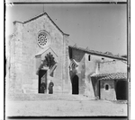 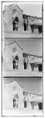 #19
TITLE: Katolicheskīi monastyr' [Italia]
TITLE TRANSLATION: Catholic monastery, [Italy]
CALL NUMBER: LC-P87- 1114[P&P]
REPRODUCTION NUMBER: LC-DIG-prokc-20213 (digital color composite from digital file from glass neg.)LC-DIG-prok-10213 (detail of digital file showing single frame from glass neg.)LC-DIG-prok-00213 (digital file from glass neg.)
MEDIUM: 1 negative (3 frames) : glass, b&w, three-color separation ; 24 x 9 cm.
CREATED/PUBLISHED: [between 1905 and 1915]
CREATOR: Prokudin-Gorskii, Sergei Mikhailovich, 1863-1944, photographer.
NOTES: Corresponding photographic print is in album: Various views and studies, Russian Empire and Europe, LOT 10333, no. 114. Digital color composite made for the Library by Blaise Agüera y Arcas, 2004. Forms part of: Sergei Mikhailovich Prokudin-Gorskii Collection (Library of Congress). LOT 10333, no. 114
SUBJECTS:Monasteries. Monks. Italy.
FORMAT:Glass negatives. Color separation negatives. Group portraits.
REPOSITORY: Library of Congress Prints and Photographs Division Washington, D.C. 20540 USA
DIGITAL ID: (digital color composite from digital file from glass neg.) prokc 20213 http://hdl.loc.gov/loc.pnp/prokc.20213
(detail of digital file showing single frame from glass neg.) prok 10213 http://hdl.loc.gov/loc.pnp/prok.10213
(digital file from glass neg.) prok 00213 http://hdl.loc.gov/loc.pnp/prok.00213
RELATED DIGITAL ITEMS
(album page with related prints)
CARD #: prk2000000385
#20

Olmec Sculpture  The Olmec are considered one of the earliest civilizations in Mesoamerica and the mother culture of later societies, including the Maya. Their artifacts exhibit a high degree of craftsmanship as demon-strated in this hand-modeled figure. The flesh areas are burnished, but not the hair zone or the split kilt. Red paint touches the tip of the nose, mouth, and chin, as well as the waistline and toes. Body features are picked out with incising, and tiny drill holes mark the ears, nostrils, and mouth corners on this extremely naturalistic figure. | Seated male figure  Las Bocas, Mexico. Olmec, 1100-500 B.C.  Cream-slipped ceramic sculpture  Jay I. Kislak Collection  Rare Book and Special Collections Division (21.2)  © Justin Kerr

#21

Treasures of Saxon State Library

Incunabula: Examples of Early Printing

The original Library founded by Prince Elector August in 1556 contained only twelve incunabula, or books printed before 1501. With the purchase in 1589 of Dietrich von Werthern's library, that number increased to nearly 500 titles. Additional incunabula were acquired during the eighteenth, nineteenth, and twentieth centuries by transfer from other libraries or by purchase.
Currently, the permanent collection of the Saxon State Library contains 2,384 incunabula (1,539 of which are still in the Russian State Library). In comparison to other libraries, this is not a large collection, but it encompasses the entire spectrum of fifteenth-century intellectual life: ancient authors, Bibles, theological and historical works, juristic literature, medieval books, travel accounts, and belles lettres. Exceptionally well-represented is the seldom displayed category of printings on vellum.
The exhibited pieces -- an ancient classic, a medieval chronicle, a German missal, a work on music theory, and a Dance of Death poem -- demonstrate the variety of the Library's early printed books.
A sixteenth century French edition, from Troyes, of the "Dance of Death"
Based on a fourteenth-century morality poem, the "Dance of Death" evolved into a set of illustrated verses depicting a dialogue between Death and people of all rank. The theme was very popular in fifteenth- and sixteenth-century Christian Europe, reminding the living that rank and station in life were meaningless in the face of death. The hand-colored woodcuts of the Troyes edition characteristically show alternating representations of ecclesiastical and secular society being carried off by Death. The pages on display show the Pope, the Emperor, a cardinal, and a king.
Author unknown Danse macabre (Dance of Death) Troyes, after 1500, leaves a ii/b, a iii/a Paper (14)


#22

Diego Rivera (1886-1957)  The Creation [Illustration for Popol Vuh], ca. 1931  Watercolor and gouache on paper  Jay I. Kislak Collection  Rare Book and Special Collections Division (11.1)  © Banco de Mexico Diego Rivera & Frida Kahlo Museums Trust | Diego Rivera and the Popol Vuh  The Popol Vuh recounts the religious beliefs and legends of the ancient Quiché Maya, who inhabited the highlands of Guatemala. Probably originally recited, the text is thought to have been set down first in hieroglyphic by indigenous writers in the 1550s, at the request of a Jesuit priest. In the 1930s, Mexican artist, Diego Rivera, long a champion of indigenous people, was commissioned to create these illustrations for an English translation that was never published of the Popol Vuh story.  The Popol Vuh begins with an account of the creation of the world. In the center of this image are fully formed figures of a male and a female, as well as two stiff awkward human-like forms suggesting the three successive attempts to fashion a human being, first out of clay, then wood, and finally out of maize. Rivera may have begun the project with this illustration, as it alone bears a full signature and a color bar across the bottom, possibly to facilitate color reproduction.

 | NEW SEARCH | HELP | ABOUT COLLECTION
#23
TITLE: [Tapping a rubber tree, Motagua Valley, Guatemala]
CALL NUMBER: LOT 11356-28 <item> [P&P]
Check for an online group record (may link to related items)
REPRODUCTION NUMBER: LC-USZ62-97813 (b&w film copy neg.)
No known restrictions on publication.
MEDIUM: 1 photographic print.
CREATED/PUBLISHED: [between 1890 and 1925]
NOTES:
Frank and Frances Carpenter Collection.
SUBJECTS:
Rubber plants--Guatemala--1890-1930.
Tapping--Guatemala--1890-1930.
FORMAT:
Photographic prints 1890-1930.
DIGITAL ID: (b&w film copy neg.) cph 3b43905 http://hdl.loc.gov/loc.pnp/cph.3b43905
VIDEO FRAME ID: LCPP003B-43905
CARD #: 89714012

#24

Unknown artists.  "The Conquest of Tenochtitlán," from the Conquest of México series  Mexico, second half of seventeenth century  Oil on canvas  Jay I. Kislak Collection  Rare Book and Special Collections Division (26.2) | The Conquest of Tenochtitlán  The painting displayed, the seventh in the series, depicts the conquest of Tenochtitlán (now the site of Mexico City). The battle between the Spanish under Cortés and the Mexica under the last Aztec leader Cuauhtémoc is more properly called a siege. It began in May of 1521 and lasted into August. With newly built ships, the Spanish controlled the lake surrounding the island and blockaded the city. Ultimately Cortés ordered the complete destruction of Tenochtitlán, including its palaces, temples, and squares. This painting attempts to distill the excitement, bloodshed, and drama of the siege into a single moment. Cortés leads his Spanish armies across one of the causeways and into the city. The captains of the other parts of his army also lead their troops towards the center of the city and the main temple compound. The Mexica put up a spirited and skilled resistance, but by August the death of much of the population, as well as months of scarce food and water, meant that they could no longer defend the city. The surrender of the survivors, the destruction of the main temple, and the capture of Cuauhtémoc marked both the end of the battle for Tenochtitlán and the end of Aztec empire.

http://www.loc.gov/exhibits/kislak/kislak-exhibit.html

