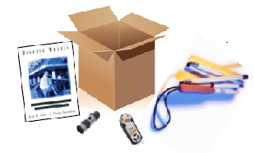
SWOMA 2011-12
Out of the Box and On a Shoe String

GPS: An Overview of Devices
and a Hands-on Experience
Thursday, November 10, 2011
GPS for Adults and Children
Friday, November 11, 2011
1:00 PM-2:30 PM

Presented by
Craig Phillips, COMS,Shawnee Mission School District, Shawnee Mission, KS
craigphillips@smisd.org
Cori Scruggs, Blind Rehabilitation Specialist
Cori.rasmussen2@va.gov
Ronita Jones, Blind Rehabilitation Specialist
Ronita.jones@va.gov
Rebecca Munjak, Blind Rehabilitation Specialist
Rebecca.Munjak@va.gov
Veterans Administration, Blind Rehabilitation, Waco TX

Don't Lose Your Way: Selecting the

Most Appropriate GPS Device for your Client

Presented by:
Ronita Jones, COMS, TVI
Rebecca Munjak, COMS, CVRT
Cori Scruggs, TVI, MA
Craig Phillips, COMS, TVI

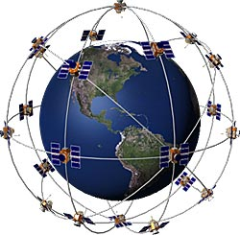
Figure 1 Clip art showing the Earth surrounded by a network of satellites.

Gps 101
- 1st satellite was launched in 1978
- 24 satellites constantly moving
- Satellites orbit 12,000 miles above the Earth
- Travelling at speeds of 7,000 mph. (Roughly)
- Signals travel by line of sight
  - Can go through clouds, glass, and plastic
  - Cannot go through most solid objects, such as buildings and mountains
- Triangulation
  - three satellites to calculate a 2D position (latitude and longitude) and track movement
  - four or more satellites to determine the user's 3D position (latitude, longitude and altitude) and track movement

POI = Point of Interest
- Point of Interest = Waypoints
  - Use POI rich environments to begin instruction
- Preset
  - Downloadable maps
  - TeleAtlas
  - NAVTEQ

POI= Point of Interest
Where is the “spot?”
Figure 2 A large rectagle with 9 red stars marking upper left, middle, right, middle left, middle, middle right, lower left, lower middle, lower right. In the box are the words, "Where is the "spot"?

Landmarks
- Manual set
- Noun first, then Adjective
  - “North High School, East Door…”
  - “Home, Front Door…”
- Pair with physical reference points

Some of the different gps devices out there
- Trekker Breeze
- Garmin Oregon
- TomTom
- BrailleNote
- Peepo
- Mobile Geo
- Sendero
- Google Maps
- Braille Sense
- VoiceNote
- StreetTalk
- Android
- Loadstone
- Navigon
- iPhone
- Kapten

GPS devices we are talking about today

Devices
- Trekker Breeze
- Garmin Oregon
- Kapsys Kaptan
- iPhone / iPad
- Braille Note
- Sendero Look Around

Instructor / Presentor
--- Craig Phillips
--- Cori Scruggs
--- Ronita /Rebecca
--- Rebecca Munjak
--- Ronita Jones
--- Rebecca Munjak

Trekker Breeze:
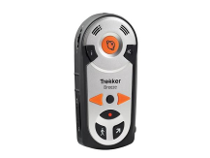
Figure 3 Trekker Breeze.
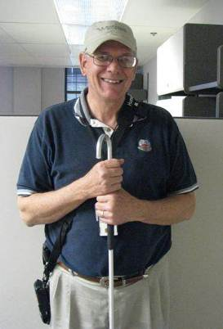
Figure 4 Picture of an instructor wearing a Trekker Breeze.

Benefits
- Easy to use.
- Set destinations or simply landmarks.
- Walking or vehicle directions.
- Explore mode.
- Points of interest
- Long battery life.
- Works in an open area.
- Routes.
- Enter Addresses without being there.
- Multiple function levels.
- One handed operation.
- Route preview.
- External speaker
- Male or Female voice?

Drawbacks:
- No visual display.
- No geocaching.
- Open area travel.
- Often lose signal strength.
- No motorized guidance to pre-recorded routes.
- $929

- 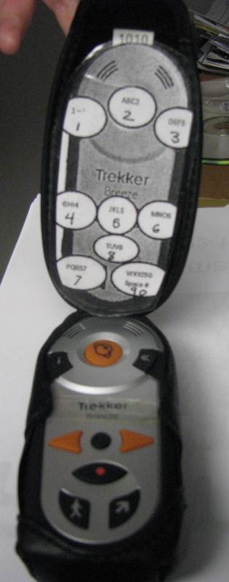
Figure 5 An open Trekker Breeze showing controls.

Garmin Oregon
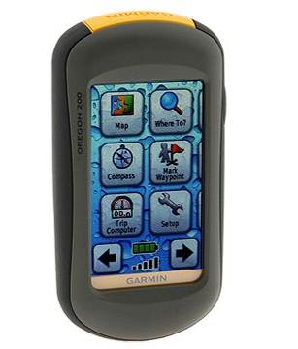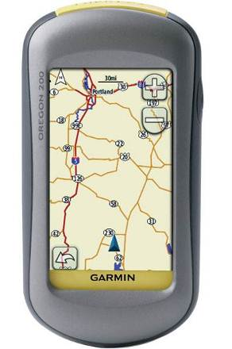
Figure 6 A front and back view of the Gamin Oregon.

Features
- Backpacking/Hiker GPS – added Street Maps for pedestrian use
- 3" sunlight-readable color LCD touchscreen.
- Slim and lightweight for maximum portability.
- Durable, waterproof design resists bumps, dust and dirt
- Record 1,000 waypoints or 50 routes.
- Supports Geocaching.com GPX files for downloading geocaches and detail directly to the unit.
- Picture viewer lets you display photos.
- High-sensitivity GPS receiver satellite prediction works in canyons, heavily-wooded areas and more.
- Add custom points-of-interests.
- Up to 16 hours of battery life powered by 2 AA batteries (not included).

Geocaching
- Treasure hunting using GPS Coordinates.
  - Someone hides treasure and logs the Coordinates onto the internet.
  - GPS user downloads sites straight to their GPS
  - GPS user follows instruction of GPS to find treasures.

Geocaching
- Treasure hunting using GPS Coordinates.
  - Someone hides treasure and logs the Coordinates onto the internet.
  - GPS user downloads sites straight to their GPS
  - www.garmin.com/geocache
  - GPS user follows instruction of GPS to find treasures.
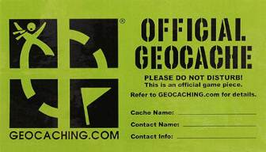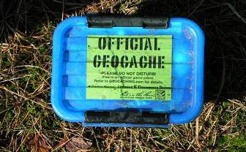
Figure 7 Two pictures showing a label on an official Geocache container and the container itself.

Wherigo (where I go)

What is it?
- You can build location based GPS experiences on your computer and play them in the real world
- Adventure games, puzzles, guided tours
- Add virtual characters, puzzles, and other interactions to geocaching.
- http://www.wherigo.com/builder/

Meet me at the rocket ship with your space suit on.
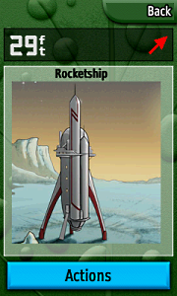
Figure 8 The image of a rocket ship appears on a screen.

Specifications: Low Vision GPS Only
- Display resolution: 240 x 400 pixels.
- Waypoints/favorites/locations: 1,000.
- Track log: 10,000 points, 20 saved tracks.
- Memory: 24 MB.
- Power source: 2 x AA batteries.
- Battery life: Up to 16 hours.
- Interfaces/Ports:
  - 1 x USB.
  - 1 x microSD memory card slot.
- Dimensions: 2.3" W x 4.5" H x 1.4" D.
- Weight: 6.8 oz.
- $399 plus $50 street maps

Pros
- Can be CUSTOMIZED
- Multiple Navigation modes
- Small/portable
- No Canyon effect
- 2 AA batteries
- Can load files from Geocaching.com
- Has GPS games
- Good Tech support

Cons
- No Voice output
- Small Screen that seems to have a lot of glare issues.
- Touch Screen – no buttons

Kapsys Kapten Plus
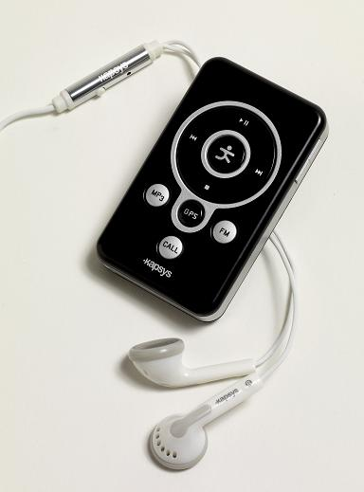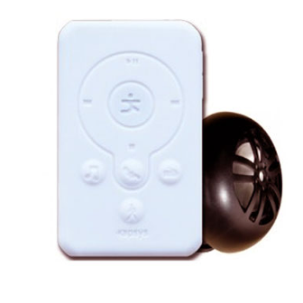
Figure 9 Two pictures showing the front and back of the Kapsys Kapten Plus.

Kapten Plus: Voice- controlled GPS unit.
- First introduced in French and European cities. Introduced later in USA.
- First designed for the sighted population. Over time the Visually impaired population took control and asked company to make corrections.
- It is intended for multi-transport navigation (by foot, public transport, bicycle, motorbike/moped, car).
- Size: 74mm x 44mm x 13mm
- Weight: 60 grams (without speaker)
- Memory: 3 GB max. (according to country)
- Battery: 7 hours
- MP3 audio player
- Speech recognition and text-to-speech : Nuance
- Connectivity : PC (Windows XP and higher) and Mac (Mac OS 10.5 and higher)
- Charging via USB
- Designed and manufactured in France.
- $475

Voice Interaction

Question:
- Battery?
- What Time is it?
- Where am I?
- Speed?
- Compass?
- Available Maps?
- Next instructions?
- What am I listening to?

Action by Kapten:
- Battery Level:
- It’s ‘current time’
- You are in (city, street)
- “MPH”
- “compass direction”
- “Current maps”
- “next navigation instruction”
- You are listening to “track”

Pros:
- Multiple Navigation modes
- Voice activated
- Small/portable
- Sleep mode after 5 minutes
- MP3
- FM Radio
- K-Tags, POI

Cons:
- Noise interference
- Hard to troubleshoot
- No Tech Support in the US.
- Canyon effect
- USB charger (if no computer?)
- 1 in 50 have data trouble

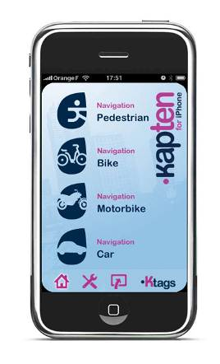


Figure 10 Picture of kapten for iPhone application.
$50

Bluetooth Keyboard
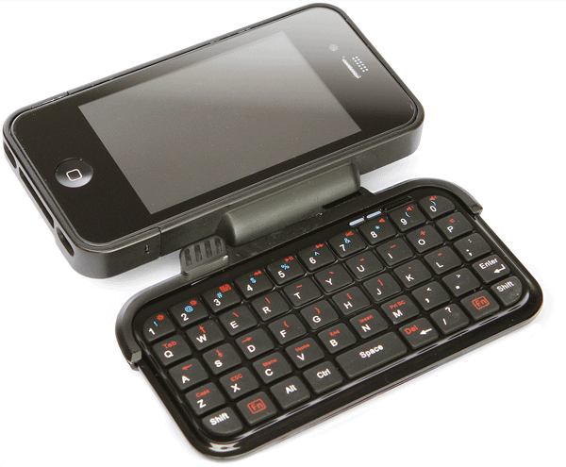
Figure 11 Picture of a Bluetooth Keyboard.
- $50
- Thinkgeek.com
- Really worth it?

Features
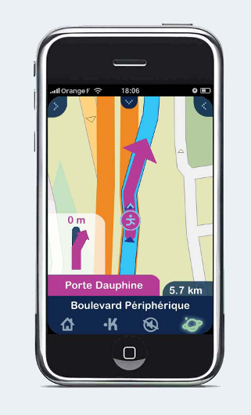
Figure 12 Picture of phone with application showing directions in French.
- Nice app for iPhone or other smart phones
- Internal compass to help orient map
- Nice literary feature. For public transit, lists change of station
- Ability share Ktags with friends on Facebook or e-mail
- Navigate to Contacts
- Clear voice/audible instructions.
- Nice Contrast of maps/color display Multi view of maps
- Large POI database

Pros
- GPS built into the phone
- Easy to use
- Clarity
- Navigate to contacts
- Multiple Navigation modes
- Share by e-mail Ktags
- Not designed just for Visually Imp.

Cons
$7.99 monthly fee
Visual Acuity to see maps
Poor GPS reception
If Driving, a not fast response time for turns

Google Maps
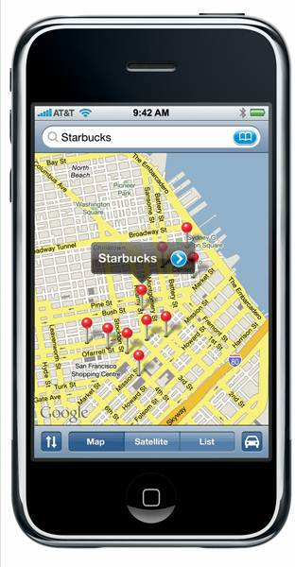
Figure 13 Cell phone showing Google Maps image of a Starbucks location.
- Built in.
- Search for businesses and addresses.
- Directions by car or by walking.
- Find current location.
- Cumbersome but workable.

iPhone App

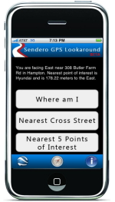

Figure 14 Sendero Group logo and picture of cell phone using Sendero GPS application.

LookAround App Features
- Works with iPhone
- Only $4.99
- Available on the iPhone App store.
- It announces the nearest points of interest and your current location.
- With a simple shake of the phone, find out where you are.
- LookAround does not provide routing although it can be used while a GPS routing program, such as Navigon, runs in the background.

VoiceNote , BrailleNote, Braille Sense with Sendero GPS
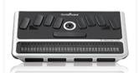
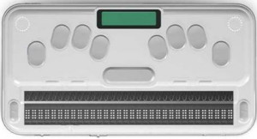
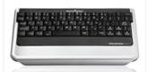

Figure 15 Pictured from top to bottom, VoiceNote Apex QT, BrailleNote Apex BT 32 Braille Notetaker, and Braille Sense.

VoiceNote Apex QT
- $4,000 - 2lbs

BrailleNote Apex BT 32 Braille Notetaker
- $ 8,000 - 1.8 lbs

Braille Sense
- $7,500 - 2lbs
- 8 GB Internal Flash Memory

Differences:
- QWERTY Keyboard vs. Braille Keyboard
- Keystrokes
- Wide LCD and VGA interface on Braille Sense.

Similarities:
- Word Processing
- Bluetooth and WiFi
- Book Reader
- Email
- Web Browsing
- Enhanced Media Player
- Voice Memo
- Daily Planner
- Scientific Calculator
- Stopwatch
- Address List
- Visual Display
- Online Help
- Active Sync

Maps Available from Sendero
- European map bundle includes Austria, Croatia, Denmark, Finland, France/Monaco, Germany, Greece, Italy, Luxembourg, Netherlands, Norway, Poland, Portugal, Republic of Ireland, Spain, Sweden, Switzerland, United Kingdom and more.
- North American Map Bundle includes maps from United States, Canada, the Virgin Islands, Puerto Rico and Guam
- Asian Map Bundle includes maps from Hong Kong, Singapore, and Malaysia
- South African Map Bundle includes maps from South Africa, Lesotho and Swaziland
- Mexico
- Australia
- New Zealand
- United Arab Emirates

“Look Around” mode

Figure 16 Clipart image showing a tangle of roads and buildings.

Simple Find Command locates POI’s farther away.
- Simple Find (SPACE F)
- Select “Restaurant” for category
- Select “All” for the sub category
- Type in your favorite Pizza Parlor and press enter.
- Select “V” for a vehicular route.

Sight Seeing:
- Switch to Sendero’s GPS Virtual mode to set your current position as a starting point.
- Select “Nearby Points of Interest” command (F) to find POI’s near your location
- Everything from museums to horseback riding could appear.
- Once you choose a destination, toggle back to GPS mode with V and a pedestrian route guides you to your destination.

Sightseeing by bus:
Using the “Look Around” mode, you will hear nearby POI’s announced as well as upcoming intersecting streets. If you put in your destination address ahead of time, you will have time to get your things collected before you reach your street.

Avid Sailor
You are an avid sailor and want to put in key turning points. You can enter the latitude/longitude for each turning point in your route. You can also change the repeat interval time from 12 seconds to 300 seconds so you can adjust your course every 5 minutes. Then switch your Heading Orientation Mode to Sailing for a more accurate course.

Meeting a Business Associate
You are traveling to another city and want to set up a meeting with a business associate. By using Space S command and choosing explore position you can set your hotel address as your virtual position. While in Virtual Explore mode you can travel around the streets looking for the perfect place to hold your meeting before you even leave on the trip. Then using the Simple Find (Space F) mode you can look around for a good restaurant to go to after the meeting.

Jimmy the College Student
Jimmy is a college student. He has a ride home from school, but he will have to walk to school each day alone. He sets the destination address for school. He has his friend drive him there once and as he rides in the car, he listens to the directions by using M for Multiple Repeat and D for Destination. Now he can walk the route by simply asking the BrailleNote for an automatic route. This will take him from point to point.

Who will use these products?
- Blind and Visually Impaired:
- High School and College Students
- Business men and women
- Occasional Travelers
- Avid world travelers
- Active passenger
- Grade school students

Common Sense
!!! The GPS is NOT a replacement for good Orientation and Mobility skills. Everyone should continue to use their cane, dog guide, or human guide when traveling with any GPS system. !!!

Sources of GPS Error
- Signal slows as it passes through the atmosphere
- Signal multipath occurs when the GPS signal is reflected off objects such as tall buildings or large rock surfaces before it reaches the receiver.
- Number of satellites visible-buildings, terrain, electronic interference, or sometimes even dense foliage can block signal reception
- Receiver clock errors- receiver's built-in clock is not as accurate as the atomic clocks onboard the GPS satellites.

Resources:
http://afb.org/aw/main.asp
http://www.apple.com/accessibility/
http://www.freedomscientific.com/
http://www.garmin.com/garmin/cms/site/us
http://www.google.com/accessibility/
http://www.humanware.com/en-international/home (Dan Brown - Texas Humanware Representative)
http://www.kapsys.com/modules/movie/scenes/home/
http://maps.google.com/
http://www.senderogroup.com/
http://www.wherigo.com/builder/
http://www.garmin.com/geocache

Using GPS with Children to Establish a Position in Space and Create Routes

Craig L. Phillips, MS Ed., COMS

Kansas Factoids
- World’s Best Ice Cream
- Dwight David Eisenhower
- Brown v. Board of Education
- Wichita
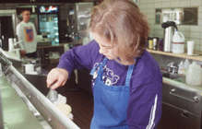
Figure 17 A girl scoops ice cream onto a cone at an ice cream shop.
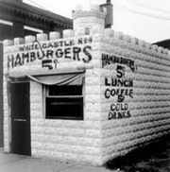
Figure 18 A picture of an old White Castle Hamburger restaurant.

The Law
- Educating Blind and Visually Impaired Students Federal Register: June 8, 2000.
- Assistance to States for the Education of Children With Disabilities; Preschool Grants for Children With Disabilities; and Service Obligations Under Special Education--Personnel Development To Improve Services and Results for Children With Disabilities; Final Notice Federal Register: August 21, 2006.

Berthold Lowenfeld
- Blindness imposes the following limitations:
- In the range and variety of experiences
- In the ability to get about
- In the control of the environment and the self in relation to it. (1948)

Preparation for O & M and GPS
- Positional concepts
- Compass orientation
- Landmarks
- Visual Maps
- Tactile maps
  - Wheatley
  - Tactile Town
  - Swell paper
  - Collage/Braillon

GPS Considerations
- Student interest
- Perceived utility
- Maturity > Age
- Cognitive ability
- Dexterity
- Route creation ability and stamina
- Techiness useful but…

Ehresman’s Theory of Relativity
“You are only as independent as your relatives allow you to be.”
Paul Ehresman

F Y I…
- “Outer space.” LE age 5
- “Mommy, we need to turn here” GT age 7
- “I didn’t know there were that many streets.” KM age 39
- “The two greatest fears of individuals who are blind and visually impaired are getting lost and looking stupid.” DK

Point of Interest = POI
- Point of Interest
  - Use POI rich environments to begin instruction
- Preset
  - Downloadable maps
    - TeleAtlas
    - NAVTEQ

Point of Interest = POI
Where is the “spot?”

Landmarks/Waypoints

Manual set
- Know where you are
- Noun first, then Adjective
  - North High School , East Door
  - Home, Front Door
- Pair with physical reference points
- Practice remaining landmarks

Sources of GPS Error
- Signal slows as it passes through the atmosphere
- Signal multipath occurs when the GPS signal is reflected off objects such as tall buildings or large rock surfaces before it reaches the receiver.
- Number of satellites visible-buildings, terrain, electronic interference, or sometimes even dense foliage can block signal reception
- Receiver clock errors- receiver's built-in clock is not as accurate as the atomic clocks onboard the GPS satellites.

Problem Solving
- Start with the key describer
- Take the back off for the battery
- Reset…
- Routing Hiccups
  - Turn back
  - Off route
  - Silence

Considerations for GPS Usage
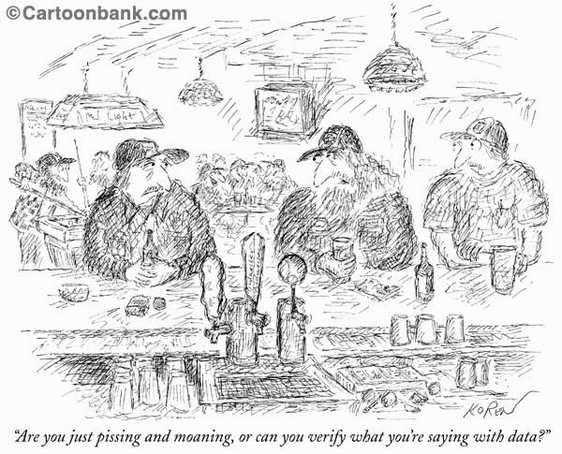
Figure 19 Carton showing men drinking beer at a bar. One man says to the other, "Are you just pissing and moaning, or can you verify what you're saying with data?"

Teaching Considerations
- Warm up the device.
- GPS usage demands solid fundamental O & M skills for the final +/-50 feet.
  - Context clues must be practiced.
  - Everything is relative.
- Street and Open Area Mapping
- The device is a where and when tool.

Teaching Considerations
- Take a cheat sheet on lessons and use it.
- Reset GPS position when setting landmarks.
- Multiple landmarks can be set at the same time/same spot.
- Address entry requires the organization parameters of the environment.
- Movement versus static position…

Teaching Considerations
- Preview routes for “blackholes.”
- Earplugs and headphones are not recommended when traveling outside.
- Use multiple SD cards.
- The difficulty or simplicity of learning how to use a system must work for the student first and the teacher second.

Four Stages of Learning
- Unconsciously Incompetent
- Consciously Incompetent
- Consciously Competent
- Unconsciously Competent

Curricular Integration
- Conceptual Development
- Literacy
- PE
- Geography
- Mathematics
- Social Competency

F Y I…
“I feel like I'm "cheating" somehow, when I don't have to keep track of what street is what, where it's located, what direction I'm heading, etc... it frees my mind up to concentrate on other aspects of orientation...and then, listening to the GPS as I'm riding in a car, realizing the breadth of this world that is outside my car window I have heretofore never gotten to interact with...amazing, simply amazing...”

Sources
Phillips, CL. (2011). Getting From Here to There and Knowing Where: Teaching GPS to Children who are Visually Impaired. Journal of Visual Impairment and Blind 105 (10), 675-680.
www.garmin.com
www.humanware.com
www.sendero.com
Leader Dogs for the Blind Trekker GPS Training

Craig L. Phillips, MS Ed. COMS
Arrowhead Administrative Center
6601 Santa Fe Drive
Shawnee Mission, KS 66202
Office: 913.993.9358
Cell: 913.645.8262
craigphillips@smsd.org
cleep1700@att.net

This conference is planned and sponsored by the Southwest Orientation and Mobility Association (SWOMA). This event is funded by conference registration fees, with additional support provided by Texas School for the Blind & Visually Impaired Outreach Programs. We appreciate the contribution of our speakers who generously donated their time to present at this event.

Texas School for the Blind & Visually Impaired Outreach Programs serves as the fiscal agent for this event.


Figure 1 TSBVI Outreach Programs logo.

