Search reference number
(official use)

NORTH KESTEVEN DISTRICT COUNCIL  SEARCH REQUEST FORM  Telephone 01529 414155 e-mail: land_charges@n-kesteven.gov.uk |  | 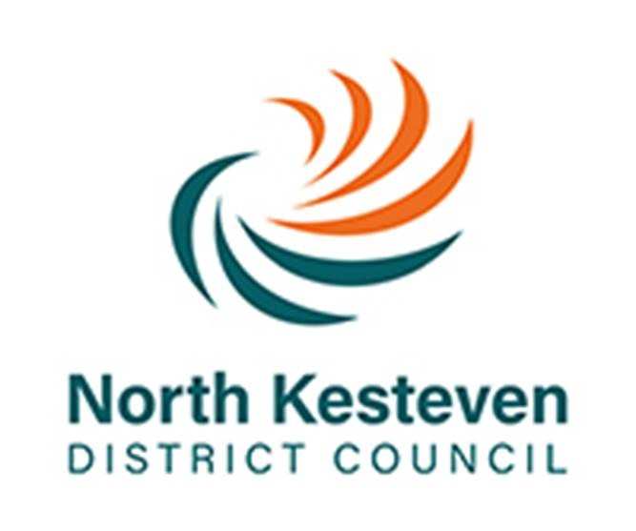
Description of the land/property - House Number/Name/Plot number, Address, Town/Village, Post Code (A location plan is required for all searches)
Description:

Place X in the relevant box to identify the search type you require note appropriate fee payment
RESIDENTIAL & COMMERCIAL – Payment by BACS/credit/debit card or cheque – fee breakdown on reverse of sheet | RESIDENTIAL & COMMERCIAL – Payment by account – fee breakdown on reverse of sheet

Search Type | Gross | Search Type | Gross
Full Search (LLC1/CON29) | £109.20 | Full Search (LLC1/CON29) | £99.50
LLC1 only | £21.00 | LLC1 only | £21.00
CON29 only | £88.20 | CON29 only | £78.50
Separate ratings/ parcels of land each | £17.60 | Separate ratings/ parcels of land each | £17.60
Solicitors own questions each | £17.84 | Solicitors own questions each | £17.84
Urgent search | £32.45 | Urgent search | £32.45
CON29 Optional Enquiries (please tick those required) – fee breakdown on reverse of sheet |  | Box C (name any additional roads that you require in response to CON29 enquiry 2)
CON29 Question Headings only used with permission of the Law Society | Gross | 1.
Road proposals by Private Bodies | £10.50 | 2.
Advertisements | £9.30 | 3.
Completion Notices | £8.30 | Solicitors own questions
Parks and Countryside | £8.30
Pipelines | £10.50
Houses in Multiple Occupation | £8.30
Noise Abatement | £8.30
Urban Development Areas | £8.30
Enterprise Zones & local Development Orders | £8.50 | Payment and reference details
Inner Urban Improvement Areas | £7.80
Simplified Planning Zones | £8.30 | Total Fee of £ (please use gross fee)
Land Maintenance Notices | £8.30 | Payment will be made by:
Mineral Consultation and Safeguarding Areas | £9.30 | Account Cheque to follow
Hazardous Substance Consents | £9.30 | BACS Credit Card
Environmental & Pollution Notices | £9.30 | Date
Food Safety Notices | £9.30 | Name of contact
Hedgerow Notices | £11.50 | Reference
Flood Defence & Land Drainage Consents | £4.80 | Telephone number
Common Land and Town or Village Green | £8.50 | Email address
Company Name and Address details
Name
Address
OUR AVERAGE TURNAROUND IS 2 WORKING DAYS

Search fees breakdown – 1 April 2019

RESIDENTIAL & COMMERCIAL – Payment by BACS/credit/debit card or cheque

Search Type | Net | VAT | Gross
Full Search (LLC1/CON29) | £94.50 | £14.70 | £109.20
LLC1 only | £21.00 | £0.00 | £21.00
CON29 only | £73.50 | £14.70 | £88.20

RESIDENTIAL & COMMERCIAL – Payment by account

Search Type | Net | VAT | Gross
Full Search (LLC1/CON29) | £86.42 | £13.08 | £99.50
LLC1 only | £21.00 | £0.00 | £21.00
CON29 only | £65.42 | £13.08 | £78.50

ADDITIONAL FEES DETAILS – Rates are the same for all payment methods

 | Net | VAT | Gross
Separate ratings/parcels CON29 | £13.83 | £2.77 | £16.60
Separate ratings/parcels LLC1 | £1.00 | £0.00 | £1.00
Total Separate ratings/parcels of land each | £14.83 | £2.77 | £17.60
Solicitors own questions each | £14.87 | £2.97 | £17.84
Urgent search | £27.04 | £5.41 | £32.45

CON29 Optional Enquiries – Rates are the same for all payment methods – No change to CON29 Optional question fees for 2019-2020

CON29 Question Headings only used with permission of the Law Society | Net | VAT | Gross
Road proposals by Private Bodies Q4 | £8.75 | £1.75 | £10.50
Advertisements Q5 | £7.75 | £1.55 | £9.30
Completion Notices Q6 | £6.92 | £1.38 | £8.30
Parks and Countryside Q7 | £6.92 | £1.38 | £8.30
Pipelines Q8 | £8.75 | £1.75 | £10.50
Houses in Multiple Occupation Q9 | £6.92 | £1.38 | £8.30
Noise Abatement Q10 | £6.92 | £1.38 | £8.30
Urban Development Areas Q11 | £6.92 | £1.38 | £8.30
Enterprise Zones & local Development Orders Q12 | £7.08 | £1.42 | £8.50
Inner Urban Improvement Areas Q13 | £6.50 | £1.30 | £7.80
Simplified Planning Zones Q14 | £6.92 | £1.38 | £8.30
Land Maintenance Notices Q15 | £6.92 | £1.38 | £8.30
Mineral Consultation and Safeguarding Areas Q16 | £7.75 | £1.55 | £9.30
Hazardous Substance Consents Q17 | £7.75 | £1.55 | £9.30
Environmental & Pollution Notices Q18 | £7.75 | £1.55 | £9.30
Food Safety Notices Q19 | £7.75 | £1.55 | £9.30
Hedgerow Notices Q20 | £9.58 | £1.92 | £11.50
Flood Defence & Land Drainage Consents Q21 | £4.00 | £0.80 | £4.80
Common Land and Town or Village Green Q22 | £7.08 | £1.42 | £8.50

