Listing Presentations & Marketing Programs
TABLE OF CONTENTS
OBJECTIVES 1
1. UNDERSTAN"DIN'G YOUR CUSTOMER 2
A IDENTIFY YOUR CUSTOMER 2
- WHO ARE THE DECISION MAKERS? 3
- WHEN Wil"L THE DECISION BE MADE? 3
- HOW WlLL THE DECISION BE MADE? .4
- KEY INGREDIENTS TO THE DECISION 5
- WHAT OTHER PROPERTIES MIGHT IMPACT A DECISION? 5
- HOW DOES TIllS PROPERTY "FIT" IN'THEIRPORTFOLIO? 6
H. ESTABLISH YOUR CUSTOMERS MOTIV ATIONS 6
I. HAS THE PROPERTY RECENTLY BEEN ON THE MARKET? 6
1. WHAT ARE THE PROBLEMS WITH THE PROPERTY? 7
K. QUALIFYIN'G THE PROSPECT BY THE NUMERAL 8
II. UNDERST AN"DIN'G THE PROPERTY , , , 9
A GATHERIN'G INFORMATION ON THE PROPERTY 9
- THE PRELIMINARY IN'TER VIEW 9
- THE COMPETITIVE PROPERTY ANALySIS 10
- SITE, BUILDING PLANS AND SPECIFICATIONS 11
- UNDERSTANDING BUILDING DESIGN AND EFFICIENCy 11
- THE ECONOMICS OF THE DEAL 12
m. FILLIN'G YOUR CUSTOMER'S NEEDS 12
A ASSESSIN'G YOUR OWN STRENGTHS AND WEAKNESSES 12
- WHAT HELP DO YOU NEED TO SERVICE THE LISTIN'G? 13
- CHOOSIN'G THE MEMBERS OF YOUR MARKETIN'G TEAM 13
- PERSONAL RESUMES AND REFERENCE LETTERS 14
- INVOLVING YOUR COMPANY MANAGEMENT 14
- REMEMBER, YOUR GOAL IS TO GET YOURSELF HIRED 15
ColdweU Banker Commercial Affiliates
Listing Presentations & Marketing P,ograms
IV. PREPARING YOUR LISTING PRESENTATION AND PROPOSAL IS
A INTRODUCTION , .. , " , , .. , .. , " 15
B, THE MARKETING PROPOSAL , ",., .. , .. ,.,16
C, THE SCOPE OF THE ASSIGNMENT 16
- PUTTING TOGETHER THE MARKETING TEAM 17
- USING OUTSIDE CONSULT ANTS 17
- THE MARKETING PLAN REPORTING SYSTEM 17
- THE LISTING PRESENTATION FOLDER 18
H. ASKING FOR THE ORDER, " ", , , 18
- CONSIDER YOUR PROPOSAL FROM THE RECIPIENT
PERSPECTIVE ,., "" "", .. , ,." 19
- DEVELOP THE CONCEPT OF RESOURCES TO ENHANCE THE
PROPERTY' S VALUE """, " , .. "" , 19
- LISTING/COMMISSION AGREEMENT 20
V, PREPARING YOUR MARKETING MATERIALS , , , 21
A BE CUSTOMER DRIVEN, BUT BUDGET CONSCIOUS 21
'. B. WHAT TO INCLUDE IN YOUR PACKAGE , 21
- TARGETING YOUR MARKET 22
- REGISTRATION PROCEDURES , , 23
VI. REPARING YOUR MARKETING CAMPAIGN 23
A COORDINATING MARKETING MATERIALS 23
- SELL YOUR ASSOCIATES ON YOUR LISTING 24
- THE REPORTING SCHEDULES 24
- MIDSTREAM MARKETING PLAN ADJUSTMENTS 25
- LISTINGS, RENEWALS, TERMINATIONS AND REGISTRATION 25
VII. ADDENDUM, .. , , ,. , .. , 26
PRELIMINARY INTERVIEW QUESTIONS 26
MARKET COMPARISON REPORT " 33
LEASE SlJMMAR Y , , , , , , 34
LEASE ABSTRACT FORMAT" " , , " ". 3 5
ColdweU Banker ColtUtU,cUd Affiliates
Listing Presentations & Marketing Programs
BlJILDIN'G REVIEW I'fEMS 36
QUESTIONS & ANSWERS EXA?vlPLE 37
MARKETIN'G EFFORTS S~ Y 39
MARKETIN'G ACTMTY DETAIL 40
OFFER & COUNIER OFFER SUMMATION 41
CASH SALE WORK SIIEET 42
BEST CASE, WORST CASE, PROBABLE CASE 43
LISTING PROPOSAL MEETING AGENDA 45
ARRIVING AT EFFECTIVE MARKET RENTS 46
ANALYSIS OF COMPETITIVE PROPERTIES 47
COMPETITIVE PROPERTY LOCATION MAP 48
INVESTMENT ANALySIS 49
SAMPLE REGISlRATION LET'fER 50
SAMPLE PROPERTY REGISTRATION LOG 51
SALESMANS TRANSACTION SUMMARy 52
RESlJJv1E 53
EXECUTIVE SUM1\1AR Y; INDUSTRIAL EXAMPLE 54
EXECUTIVE SUM1\1ARY; APARTMENT EXAMPLE 56
PACKAGE GUIDELINES 58
MARKETING ACTMTIES PLANNER 63
MARKETING PLANNING GUIDE AND SCHEDULE 64
SIERRA CROSSING APARTMENTS SALES PACKAGE 65
TAB DIVIDERS FOR MARKETING PACKAGES--MAY PRINTING 82
Coldwell Banker Commercial A/fiUates
Listing Presentations & Marketing ProgrtUttS
OBJECTIVES
Commercial real estate is a demanding business. To be successful, you must develop a broad market knowledge base, communicate your knowledge to property owners and then convince them that you are the best person to sell or lease their property. Basically, you are unemployed unless you have a good "saleable" listing and a workable marketing plan. Your goal is to become employed. A listing presentation should be considered your job interview and you should prepare accordingly.
Commercial real estate is not a multiple listing driven business. It is a market knowledge driven business. The successful commercial agent must learn to produce professional marketing materials with detailed maps and thorough area and market analysis and building infonnation. This infonnation must then be disseminated directly to prospective users and investors identified as you created your database. Others to be included are local business, community and development leaders and other commercial real estate agents in the market.
This material is designed to give you a system to follow when making listing presentations and executing marketing programs. Every owner or tenant will have different needs. The material in this workbook will give you some examples to consider when preparing a proposal and marketing flyer or sales package. Every associate should collect marketing materials in their own market and create a "library" of materials that can be used later as examples or as comps as properties are sold or leased in your local area.
This material will help you better understand why you must:
1. Be able to quickly identifY the decision makers within an organization and gain their confidence.
2. Understand the goals of your customer and set in motion a plan to accomplish them.
- Develop a complete understanding of the listing process as an extension of the Business Development System.
4. Learn to prepare marketing materials in keeping with the assignment and your market.
5. Learn to prepare materials that can be used in all of your listing presentations.
- Be able to put together a marketing proposal and collateral materials for every type of property that you choose to market.
7. Learn how to execute a focused, aggressive and results driven market plan.
ColJweU Banker Commercial Affiliates
Listing Presentations & Marketing Programs
THE SET UP:
Okay - you've been cold calling for weeks with little to show for it Finally, you contact a potential customer who says that he has a requirement to sell or lease his commercial building, and he wants you to prepare a listing presentation and present it to him and his associates in two weeks. This is what you've been working for all this time. It's time to swing into action, but you will only have one chance to do it right Now, what do you do first?
L UNDERSTANDING YOUR CUSTOMER
A. IDENTIFY YOUR CUSTOMER
» Determine your customer's type of business: developer, investor, owner/user,
tenant, family trust, syndicator, etc.
What type of business entity is your customer: a corporation, partnership, proprietorship or individual?
Each customer has a different agenda. Your job is to determine what they are trying to accomplish with a sale or lease and how much motivation exists with respect to pricing, timing, fmancing and other issues.
Plan a preliminary interview with your customer before your listing presentation to better understand the issues that you must address in your proposal.
Try to include several people in the preliminary interview so you are able to get different opinions of the assignment and relative importance of the issues you will uncover.
If the property is owned by a multi-property owner, the opportunity to do more business with the same ownership entity should be considered when preparing your presentation.
Demonstrate a sense of loyalty to the customer.
You must be sensitive to current market conditions and the customer's relationship with their fmancial partner or lender.
Try to determine before your fIrst meeting the financial commitment or investment they have made in the property.
Do they even have the resources to sell or lease the building? What is your customer's previous brokerage experience?
Will the presentation be formal or informal? Their place or yours? Get the proper and complete names, spelling and titles of everyone who will attend the presentation.
Why does the customer want to sel1Jlease the property? What factors or circumstances led up to this decision?
ColilweU Banker CollUtl£rcial Affiliates 2
Listing Presentations & Marketing Programs
B. WHO ARE THE DECISION MAKERS?
)0> You must know where your contact fits into the overall picture and what
influence your contact has with the customer. Who has the authority?
You need to understand the respective chain of authority. You do not want to be working with someone who has no influence or voice in the fmal decision with respect to selecting a broker.
If your contact does not have any apparent authority, ask your contact to invite someone with authority (a partner, senior officer, owner or their attorney) to your preliminary meetings.
If your customer will be using an attorney, the sooner you befriend him/her by demonstrating that you are competent, the better chance you have of completing a transaction.
If the opportunity is a "For Sale" listing, get an ownership and encumbrance report on the property from a title company to be sure you identify the persons with authority.
Find out how many other proposals they are requesting on the property and from which brokers. Know your competition.
Contact business leaders you have worked with in your community including bankers, attorneys, accountants and others who have a relationship with the customer, and ask each for a letter of reconunendation to include with your proposal.
C. WHEN WILL THE DECISION BE MADE?
)0> If you know the customer's timing you can create schedules and deadlines in
your proposal to coincide with theirs. Create a sense of urgency using their schedules.
If you propose to advertise the property in a commercial marketing publication with an upcoming deadline, you will create a sense of motivation for your customer to act within a given deadline.
If your community or office organizes commercial property tours through the MLS or the Economic Development Council, use those dates and schedules to encourage the customer to connnit to a listing in a timely fashion so their property can be included in any such activities.
If you already know of a buyer or tenant who is coming to town to look at the market, let your customer know so you can be prepared with enough information on the property prior to their arrival.

Coldwell Banker Commucuu Affiliates
3

Listing Presentations & Marketing Programs
Does the customer's decision to act hinge on another event that must take place fIrst? Do you understand those details?
Is a sale driven by a due date on the underlying note or are the sale proceeds required to move forward on another transaction?
If the proposal is to sublease space for a tenant, have they already committed to another location?
Is the customer willing to take a loss on a sublease to get the problem behind them?
Does the customer have the ability to sublease, with or without the landlord's approval? Who profIts if there is a profit?
If tenant improvements are required, is there enough money available to get the job done?
Are there other locations outside of your market where you could offer brokerage services?
D. HOW WILL THE DECISION BE MADE?
» You must determine the significant deal points and be sure to address them
on a point-by-point basis in your proposal. What are their needs?
Most often fInancial considerations and/or commission rates are not the determining factors in selecting a broker.
The decision makers must believe that you will be able to perform the task for which they are requesting a proposal.
Show the customer that you are willing to commit the necessary time. Make sure that the customer places a high value on your time by tying everything back to the customer's time value of money (their cost of carry and/or opportunity cost).
If a decision will take place on some prearranged date (partners meeting or Board of Directors session), know what that date is and arrange to speak with the prospect just before the event and as soon afterwards as possible.
After you present your proposal, follow up with a phone call and a letter the next day to determine if any unanswered questions arose after you left the meeting or if any issues need to be resolved before the decision date. A follow up letter is a perfect opportunity to summarize the customer's reasons for hiring you and minimizing any issues that were raised during your presentation.

Coldwell Banker Commercial Affiliates
4

Listing Presentations & Marketing Programs
E. KEY INGREDIENTS TO TIlE DECISION
);> In your preliminary interview you should have identified at least five issues
that are paramount to the success of your proposal, based on the customer's expectations.
In your proposal, you may want to set up a question and answer format to address what you already know are the key issues of the assignment Now answer those questions yourself (see pgs.37-38).
If you were diligent in your preliminary interview, you already have the answers to those questions and the customer's concerns. There should be no surprises.
You should prepare your presentation in a format allowing you to go from the least complex issue to the most difficult with concise and to the point answers.
When you have concluded your presentation, ask if you have missed anything or if you should be aware of any new issues that have come up since you met with them last Then, address any new issues.
F. WHAT OTHER PROPERTIES MIGHT IMP ACT A DECISION?
);> You must be aware of every property the owner has recently or is currently
marketing and review copies of their offering materials.
By securing copies of their current marketing materials, you will have an idea as to the level of quality and professionalism they are accustomed to using in their marketing efforts.
If they are or have recently offered property for sale, a previous sales package will give you some insight as to how realistic they might be in pricing issues.
Have they used exclusive brokers in the past or do they generally prefer to work on an open basis with all brokers?
Do they offer the brokerage community a full commission in the event of a sale or lease involving a broker?
Have there been any disputes you are aware of with respect to paying a brokerage commission in the past?
If they have other property listed and sell it, will they be less inclined to aggressively negotiate on your listing?

ColdweU Bunker Commercial AffiUates
5

Listing Presentations & Marketing Programs
G. HOW DOES THIS PROPERTY m IN THEIR PORTFOLIO?
);- Does a sale signify a change from one type of property to another?
Is this the last of this type of property they own?
Will the sale of this property generate proceeds to acquire a different property that would involve a broker?
Does the sale trigger a capital gain problem for the customer? Should a 1031 exchange be considered?
If the opportunity is to lease space, will this lease bring the building to full occupancy to allow a sale to an investor?
Should you combine a lease and sale listing agreement to be sure to cover either eventuality?
Will the sale of this property by a certain date allow the seller to wind down a partnership?
H. ESTABLISH YOUR CUSTOMER'S MOTIVATIONS
);> Try to identify early in your discussions the customer's motivations that are
driving the transaction.
Has the seller already committed the sale proceeds in anticipation of a "quick It sale?
Does the leasing of space finish off the project thus allowing funding of loan proceeds or other financial incentives?
Prepare a ttcash sale work sheee' showing the seller what they realistically should expect from a sale after all transaction costs including your suggested commission rate (see pg. 42).
Present these numbers on a ttbest case, probable case and worst case" scenario to have a range of figures to discuss with the customer (see pgs. 43-44).
Establish early in your analysis that there is enough room in the transaction for your commission and know where the money is going to come from.
Can the seller sell the property without other approvals?
1. HAS THE PROPERTY RECENTLY BEEN ON THE MARKET?
). If the property has been recently marketed, try to be sure there will be no
exclusions to the listing agreement.

ColdweH Bankn Commercial Affiliates
6

Listing Presentations & Marketing Programs
Determine quickly why the property did not sell or was not leased during the previous listing period.
Try to determine what offers were received and why they were rejected or how they were countered.
Secure a list of the prospects identified during the previous marketing efforts. In your estimation, were they serious prospects for the property?
Was the property professionally marketed?
If a broker was employed in the marketing effort, is the broker involved on a full-time basis in commercial activities?
If the property was professionally marketed and didn't sell or lease, be sure you really want to take on the responsibility.
If exclusions are going to be a part of the listing, limit any exclusions to a date certain in your listing agreement
If exclusions are involved, try to negotiate a reduced commission rate if one of the excluded parties performs.
If you are really uncomfortable with the exclusion issue, tell the customer you will wait until he has concluded his negotiations with his prospects. Then if a deal cannot be struck, you will take the listing without any exclusions.
1. WHAT ARE THE PROBLEMS WITH THE PROPERTY?
)- If the property suffers from a poor reputation, how will you overcome this
issue?
Has an environmental audit been completed on the property? Should one be preformed before attempting to market the property?
If the problems with the property are environmental, be sure that you even want to present a listing proposal.
Be sensitive to the potential problems the customer may have with their lender or rmancial partner with respect to what you have to report when discussing the property.
If a property has a ttnegative" reputation, the property must be priced accordingly or a budget must be prepared to reposition the property if a successful marketing effort is expected.
Properties of lesser quality can still be sold or leased, but the marketing strategy should be discussed up front with the owner. Cosmetic issues can be cured, but obsolescence and functional problems may be insurmountable to correct in the short term.

ColdweU Banker Commercial AfftlJates
7

Listing Presentations & MtlI'keting Programs
K. QUALIFYING TIlE PROSPECf BY TIlE NUMERAL
» Qualifying the prospect and the transaction is an ongoing process and part of
the job of every good broker. The process of qualifying the prospect and the transaction needs to be pursued on a continuing basis.
Remember the concept of "NUMERAL"I:
Needs Urgency Motivations Expectations Resources Authority Loyalty
Needs of the prospect: to buy, sell, more space, lower rent:, better tenants or better location. Be sure you understand the needs of your customer, otherwise how can you be sure you can help?
Urgency of the decision will influence how quickly the transaction will come together and how realistic the customer will be. Be aware of previous activity on the assignment to better understand the current urgency of the deal.
Motivations of all parties need to be understood: will a later "move in date" be a problem, is the timing of the sale or lease conditioned on another event or time table?
Expectations of the buyer, seller, tenant and landlord are always going to be different and probably diametrically opposed. Be prepared to handle the unexpected.
Resources not only involve fmandal considerations of the tenant but today the landlord or seller's resources may not be adequate to get the deal done. Even a fmandal institutions in possession of a property may not be willing to pour more money into a project they no longer believe in.
Authority to do the deal not only lies with the prindpals but often with the lender or other fmandal partner who may not want to go forward with the transaction. Be aware of who speaks for whom. Loyalty is a two way street. Will the customer protect you?
1
@CommerciallnvestmentReal Estate lnstitule, 1992. Reprinted with permission from C1402 Introduction to Commercial Brokem{!e.
January 1992, W. 6..10lhroogh 6..12.

ColdweU Banker CottUlU!rciilJ Affiliates
8

Listing Presentations & Marketing Progt'QJnS
n. UNDERSTANDING 1HE PROPERTY
A. GA1HERING INFORMATION ON THE PROPERTY
}o> Much of the infonnation you need you should already have as a result of
the Business Development System approach to your market
Secure property brochures, maps, photos, aerials and any other material that include the subject property and its neighborhood.
If the property is not new, try to get infonnation from old flyers, advertisements, assessor files or marketing presentations that have been used in the past
Call the title company that you work with and ask them for a complete property profile that will include the names of all owners, a property description and a list of all recorded documents encumbering the property. Ask for copies of all recorded documents.
If the property is a new development and the owner has selected an advertising or public relations firm to prepare collateral marketing materials for the property, meet with them and secure copies of the materials they have prepared.
Check your firm's data files for old marketing materials and brochures on the property.
Try to secure a copy of the building plans and specifications.
Ask the customer for a copy of any appraisals that might have been done on the subject property.
B. THE PRELIMINARY INTERVIEW
}o> Before you meet with the customer, be sure you understand what it is you
want and prepare accordingly.
Have an agenda to follow during your meeting.
Prepare a list of questions about the property before you go into a meeting with the customer (see pgs. 26~32).
Know in advance what you want to come away with in the way of infonnation and hard data: rent rolls, income and expense information, leasing brochures and mortgage information.
Be sure you visit the property just before you meet with the owners and walk the property inside and out Take plenty of pictures and good notes on your visit

ColdweU Banker Commercial Affiliates
9

Listing Presentations & Marketing Progroms
Bring a listing presentation book with materials from prior assignments, company infonnation, sample brochures that you have used before. news articles and letters of recommendation.
Are you going to be able to present from your laptop?
C. THE COMPETITIVE PROPERTY ANALYSIS
:> To properly assess how the customer's property will compete in the market,
you must prepare a competitive market analysis looking at every aspect of the property and the market
If you have been following the Business Development System, you already have sale and rent com parables.
If your AOR in not yet fully developed, call an appraiser and ask for a list of comparable sale or lease infonnation for similar properties in the subject property's location. Appraisers make great "partners" in securing listings. If they help you, offer to recommend them when your customers need an appraisal. Meet for lunch.
Prepare a market survey to compare building sizes, acreage, rental rates, vacancy, expenses, tenant improvement allowances, etc. Compare each component of your survey with the subject property and rate the property or space accordingly.
Use the results of this comparative analysis when suggesting a pricing strategy in your listing proposal.
Analyze the location of the property using maps and aerials.
What advantages does the property have with respect to transportation issues? Examine proximity to employee centers.
How large is the prospective tenant or buyer market for this type of property? Is it local, regional or national? Why?
Your future reputation depends on your successfully completing the assignment if you are selected. Be sure you can perform.
After you complete your competitive analysis, ask yourself if the property can really be marketed to your customer's expectations. If not, learn to say no.
For an investment property, prepare a ten-year cash flow analysis to see what kind of results the property will generate for the buyer (see pg. 49) and how the buyer will get out of the property.

Col4weU Banker Commercial AjjUiales
10

Listing Presentations & Marketing Programs
D. STIE, BUILDING PLANS AND SPECIFICATIONS
> Be sure you get actual and legible "as built" plans and specification
documents on the subject property so you are talking about the same building the owners are going to sell or lease.
"As built" plans can differ dramatically from the original set of architectural drawings. Be sure of what you have.
Building specifications documents will answer many of the questions that may arise with regards to the mechanical equipment and other specifications of the property.
When you visit the property, determine the physical problems with the property before you meet with the customer.
Be sure your listing materials accurately reflect the opportunity you are trying to promote.
E. UNDERSTANDING BUILDING DESIGN AND EFFICIENCY
» Understand the building from a prospective owner's and tenant's points of view.
Assume a position that a tenant or new owner would take when negotiating with a landlord and understand where they are coming from and how you are going to get around potential problems. Put yourself in the place of the buyer or the tenant
Visit the property during business hours when the tenants or visitors are at the property to observe the flow of traffic and people. Visit the property at night also, observe what is going on at the property and in the neighborhood.
Are there any major building problems that can't be fixed? Is the building's real value tied to some alternative use?
What is the load factor, useable and rentable square foot calculations? Have they been considered in your analysis? Use proper industry references to help you: BOMA, IREM, ICSC, etc.
Each property type has specific characteristics that you must understand and be able to discuss intelligently with a knowledgeable buyer or tenant
Get to know several architects and space planners in town and ask one of them to walk the property with you so you can better understand the property. Their expertise could be a big help in positioning the property for a new owner or tenant Include them as part of your

ColdweU Banker CtHtUIJercw Affiliates
11

Listing Presentations & M01'keting Programs
listing team if appropriate. Then recommend to the new owner or tenant if an architect is required.
F. 1lIE ECONOMICS OF THE DEAL
)- Before you proceed with any listing, be sure the space can be leased or the
property sold under current market conditions.
You must understand and break down the numbers to Iteffective" market rents (see pg. 46).
Understand the consequences of free rent periods, moving cost, rebates, or other concessions on the owner and the tenant
Can the landlord perfonn for the tenant and/or the buyer?
Where is the upside in the transaction?
How does the deal stack up in the market? If it's retail, do expenses seem in line with the guidelines in your market?
Show the seller your projections so he can see how the buyer will view the transactions and assumptions you used as to how the buyer gets into and out of the property. It is as important to show a buyer how he will get out of a deal as it is to show him how to acquire the property in the fIrst place. Is the seller really offering the buyer a good deal? Would the seller buy the property based on the way he has offered it to the market? If the property is not sold, by keeping the property, the owner will continue to live with the fInancial consequence of ownership he is offering the prospective buyer.
m. FILLING YOUR CUSTOMER'S NEEDS
A. ASSESSING YOUR OWN STRENGTHS AND WEAKNESSES
)- Do you have the experience to really take on this listing without the
assistance of another experienced associate?
Don't let your ego set you up for failure.
Review with your manager your prior involvement in similar listings and the results you achieved.
Don't hesitate to include an associate if you feel uncomfortable "going it alone". Leverage your experience and time by working with partners.

ColdweU BtIIIUr ctJmmeTcialAffl/iates
12

Listing Presentations & Marketing Programs
The last thing you want to do is try to "slide" into a significant listing. It will hurt you and your company in the long run.
We are now at the heart of the reason that the Business Development System works so well. There should be an expert by property type and/or geographical area in your office who knows this market segment "cold". With his or her help, you can blow the competition away. Winning is fun and profitable. Get that person involved on your team now, not six months down the road when you decide you can't handle the deal alone.
Be sure to conclude your presentation with a positive statement as to why the customer should go with your proposal. Close and shut up. Remember, this is your job interview.
B. WHAT HELP DO YOU NEED TO SERVICE TIlE LISTING?
» Know in advance where you will need help to support your marketing plan and include these team members from the onset
If you elect to include others in your listing, be sure to approach only those associates who will bring something additional to the table. Understand up front how any commission would be split if a "team member" introduces his buyer or tenant to the deal.
Determine who will be responsible for each phase of the marketing agenda. Develop written schedules and time tables.
Introduce each team member at your meeting to establish their credibility with your prospect
Identify their strengths as they relate to the assignment Do this verbally and include their resumes in your presentation.
C. CHOOSING THE MEMBERS OF YOUR MARKETING TEAM
» Get your office management involved in the deal if you can. Most customers
like to deal with the senior officers of a company.
Are there other consultants outside your fmn that should be included in the listing presentation or marketing phases?
Can you arrange "pro-bono" assistance from others in the commercial arena, such as a space planner, property manager, appraiser, or other professional, who would want to work with you if you get the assignment?
This is a good way to begin to establish referral business.
ColdweU Banker Commercial Affiliates 13
Listing Presentations & Marketing Progrtuns
D. PERSONAL RESUMES AND REFERENCE LEITERS
);> If you have not already done so, prepare a personal resume and include a
copy with all introductory correspondence and listing presentations.
Keep your personal resume up-to-date with the most recent transaction you have completed (see pgs. 52-53).
Be sure your resume sells your business skills and is not just a listing of family or social accomplishment or affiliations.
As soon as you have completed a transaction, secure a letter of recommendation from your customer while the iron is still hot
Have resumes of each of your commercial associates drafted in the same general format for ease of reading by your customer.
Include letters of recommendation in your listing presentation book and leave it behind for the customer to browse at his convenience after you have left his office.
By leaving the book behind you have just created an opportunity to return to the customer's office to pick up your listing presentation book at a later date.
Have several copies of this book available so you can continue to make presentations while the other is in use.
E. INVOLVINGYOURCOMPANYMANAGEMENT
);> If the involvement of your owner /broker or commercial manager would help,
ask them to attend your meetings.
Often the principals of your firm may have connections to your prospect unknown to you through charitable work, service clubs or other business activities.
This is a networking business and you should learn to tie as many tlcenters of influence" into your deal as possible.
Involving company management allows them to also give you some feedback on your presentation skills.
Be willing to admit that you do not know something and offer to get back to your customer with a solid, reliable answer after discussing the issue with your broker/manager or other informed sources.

ColdweU Banko Commercial Affiliates
14

Listing Presentations '* Marketing Programs
F. REMEMBER, YOUR GOAL IS TO GET YOURSELF HIRED
). Be sure that you have answered the most important questions.
Why me?
Why my company? Why now?
Your customer understands the concept of PM radio station "WDFM". ("What's In It For Me"). Can you answer this question? Have you answered all of the customer's questions adequately?
lV. PREPARING YOUR LISTING PRESENTATION AND PROPOSAL
A. INTRODUCTION
). Your listing presentation is your employment interview and you should set the
agenda As such, you want it to be a complete representation of your capability to handle the job at hand. However your presentation should not be so all inclusive that the seller or landlord feels you already have so much time invested in the transaction that you will take the listing on any terms they offer.
Prepare a thorough analysis of the property but not an elaborate "package" if you can avoid it at this time.
Use other packages from prior marketing assignments that you have done as an example of your intended packaging.
The materials you leave with the seller, should primarily involve infonnation on your marketing plan and your company, not something that can be copied and put on the street as part of a marketing package.
If you must leave a package behind, be clear that the package is for "DISCUSSION ONLY" and not a fmal product It is not your fmished product and you do not want anyone to think it is. Use a "DRAFT" stamp and stamp every page.
Use a laptop and presentation software or overheads, flip charts, photos or slides during your presentation and incorporate them in your handout
Practice your presentation two to three times with your team prior to the presentation date to be sure everyone is comfortable with their roles and has all of their material together.

ColdweU Banker Commercia/. Affiliates
15

Listing Presentations & MtU'keting Programs
B. THE MARKETING PROPOSAL
)- The marketing proposal should discU$ everything that you intend to do
and describe all collateral material you will need.
The proposal should outline in detail the marketing plan and explain the purpose and intended result of each segment of your plan with examples of prior successes.
A flow chart or time lines can be used to show the events and dates of each segment of the marketing plan over a period of time (see pg. 64). The proposal should include activities, broker lunches, tours, and reporting and follow up systems.
A thorough understanding must be reached with respect to collateral materials and who is fmancially responsible for their preparation and distribution.
As part of the discussion you should present a marketing budget to the seller if there will be a need for significant outside assistance.
A target market must be identified for the specific property and details of how you intend to reach the market discussed.
During your presentation, demonstrate the use of your database target marketing system and software and how this will help you when marketing the property.
Include your completed exclusive listing agreement with your proposal.
C. THE SCOPE OF THE ASSIGNMENT
)- Defme the objective, scope and duration of the assignment as you
understand them.
Be sure that everyone is in sync with respect to what is to be done by whom and when.
If you are including other associates in the assignment, clearly define each participantts role.
Set specific goals and attach a deadline to each.
Establish periods during which certain goals will be pursued and set a review time monthly to gauge results. Make modifications as required to the overall marketing plan.

ColJweU &mker CommercialAffdUltes
16

Listing Presentations & Marketing Programs
D. PU1TING TOGETHER 1HE MARKETING TEAM
» Include only those associates who really bring something to the table.
Just adding "bodies" to the marketing effort does not necessarily ensure greater success. It does, however, dilute the commission and incentives of the listing.
Bring in team members who work on complementary product lines and/or geographic areas where you expect to fmd prospective buyers or tenants.
Be sure everyone understands up front their respective participation in any fees generated on the "listing" and "selling" side of the transaction.
Draft a written agreement outlining the splits and each team member's responsibilities and have it initialed by every team member.
Have a control point registration form for all team members, especially when it comes to prospect registrations and commission understandings (see pgs. 50-51).
E. USING OUTSIDE CONSULTANTS
» Limit the number of outside consultants involved.
If outside consultants are to be employed, establish what services they are to provide, get their input, then have them step out of the transaction until you bring them back in.
The fewer people involved once the actual marketing period begins the fewer mixed signals will be broadcast
Try to find consultants who are already famiUar with your customer. Make sure the customer's last experience with any consultants you suggest was positive.
F. 1HE MARKETING PLAN REPORTING SYSTEM
};;> As part of your listing presentation, include a sample reporting format that
you intend to use on this assignment.
Cover the basics. See Coldwell Banker Canup Realtor@ sample fonnat (see pgs. 39-41).

ColdweU Banker CommercUd Afftl.Udes
17

Listing Presentations & Marketing Programs
Keep an accurate and dated list of everyone to whom you send infonnation. This may save you representation disputes later.
Allow yourself enough time to market the property before alerting outside brokers.
Thirty days should allow you enough time to prepare your package and organize your mailing and calling programs.
G. TIffi LISTING PRESENTATION FOLDER
» Have enough clean copies for each individual involved in the decision.
Use the pre-printed professional presentation covers and tabs, then bind your presentation. Kinko's can help.
Include your company logo and use originals as often as possible in your presentation.
Consider using desk top publishing software to really set off your proposal from others they might receive (see pgs 65-81).
A scanner can be used with your computer to "scan" in the customer's logo for inclusion in the presentation material. Otherwise
"photocopy" a logo on the cover sheet. ,
Include in addition to property specific materials, original materials on your company prof11e and personal biographies.
Include pictures, aerials and maps of the property that will show the customer your level of understanding of his or her property.
Use graphics whenever possible to tell your story.
H. ASKING FOR TIffi ORDER
» Be prepared to get the listing signed at the presentation even if that is not the
original understanding.
Arrive early on presentation day to properly set everything up. Be enthusiastic.
After you finish and answer all questions, ASK FOR THE LISTING.
Use all the presentation skills you have learned over your career: visuals, eye contact, voice inflection, trial closes and testimonials. Suggest that signing the listing at this time will get the marketing effort underway immediately.
If the prospect will not sign at that time, ask if there are any more questions that you have not answered, and then be quiet
Coldwell Banker Commercial Affiliates 1. 8
Listing Presentations & Marketing Programs
If they will not sign at this time, ask when you should get back to them. Politely thank them for the opportunity and leave.
If you have trouble standing up and presenting to an audience, enroll in a presentation class or join the Toastmasters.
What changes would you make in your proposal? Critique and review your proposal soon after presenting it to your customer.
I. CONSIDER YOUR PROPOSAL FROM THE RECIPIENT PERSPECTIVE
);> Assume the role of the customer.
What else would they like to know?
Have they been persuaded to hire you as their broker?
What "bottom line" questions do they have for the broker before making their decision?
Do they know you have the resources to enhance value?
Do they really understand today's environment requires aggressive marketing to complete an assignment and maximize price?
Do they appreciate your single point of contact commitment?
- DEVELOP THE CONCEPT OF RESOURCES TO ENHANCE 1HE PROPERTY'S VALUE
);> Carefully spell out this approach to marketing their property.
You are affiliated with a national company with more than 55,000 agents nationwide. You are on the Internet
Develop skills that allow you to offer many resources to the customer: valuation, consulting, leasing, sale, fmancing, property management, marketing and investment analysis.
Your team offers technical skills, spreadsheet summaries, marketing brochures, computer graphics, creative problem solving and solid local market knowledge.
Maximizing price will be achieved by using a team approach and "networking" •
You have the ability to cross company lines and access top producers. You have access to local, regional and national tenants and buyers. You keep informed with regular status meetings, follow up reports, on-site visits, local showings and contract negotiations.
As a single point of contact you will serve as marketing leader.

Coldwell BIlIfker Commercial Affiliates
19

Listing Presentations & MfII'keting Programs
Your responsibilities will focus your attention to the assignment and create a service driven perspective to achieve results.
As a single point of contact you will be able to provide maximum response time to questions or issues that arise.
As contact. you are personally responsible and sensitive to every issue affecting the assignment
You want their business and the responsibility that comes along with it.
You will be responsible as the team leader for the outcome of the activities provided by your team regardless of the source or the solution to the problem.
K.. LISTING/COMMISSION AGREEMENT
)- Include as many items that you feel comfortable with in your frrst draft of the
commission agreement.
Use standard company tlprinted" listing agreements with appropriate addendum for different property types and situations. (See your manager, local Board of Realtors® and/or attorney for approved forms in your area.)
It is easier to get something from the outset than to go back later and insert another request in your agreement.
Know who is authorized to sign any listing agreement and have the proper names already inserted in the signature block.
Attach your company standard pre-printed commission addendum to the agreement as it discloses the commission and manner in which you expect to be paid.
Your listing should cover any eventuality, lease, sale, option, salel1easeback, ground lease or build to suit. etc.
Prepare the agreement so that the effective date is the date the document is signed, not the date it was prepared or a future date.
You may want to consider pre-agreed to dates in the original listing document for price reductions or other modifications.

ColdweU Banker CommerciolAffdiates
20

Listing Presentations & Marketing Programs
V. PREPARING YOUR MARKETING MATERIALS
A. BE CUSTOMER DRIVEN, BUT BUDGET CONSCIOUS
» Immediately after the listing is signed, send a summary letter andlor preliminary flyer to the obvious prospects as you know they will hear about the availability of the property quickly (i.e.: they are the "obvious" prospects).
Primary contents of the package should include a cover letter, executive summary and key attachments including market conditions, inspection report and com parables vs. the subject property based on price and terms.
Design your materials considering your customer's interest in achieving the best price and terms.
Get an early understanding of outside costs associated with the preparation of the collateral marketing materials.
Agree in writing up front with your customer how much you will be paying for and how much they will cover.
If you plan to use aerials, photos or printed matter (they can be expensive), get quotes up front and approvals from your client before moving forward.
Be sure if an outside PR fIrm or advertising fInn is going to be used, that the agreement is directly between your client and the agency. Design your materials to fit your audience. Know what level of marketing will do the job and design your materials accordingly.
Give yourself enough lead time to allow for printing, label production and mailing.
Will mailing the material bulk rate really hurt the project or must everything go first class?
Can you prepare and include an insert in a local business newspaper or other local trade publications?
Design materials that will fit in standard-sized envelopes.
B. WHAT TO INCLUDE IN YOUR PACKAGE
» Requirements differ depending on the type of real estate and the assignment
Prepare a good executive summary (see pgs. 54-57).
If you are selling commercial properties a listing of Packaging Guidelines you should consider is included (see pgs. 58~62).

ColdweU Banke, Commercial Affiliates
21

Listing PresentaJions & Marketing Programs
Be sure to clear with your customer what infonnation they want to release in the sales package. Get the seller to sign off on any marketing materials you plan to distribute.
Land listings require a thorough knowledge of zoning, density, access, utilities, building codes and requirements and covenants, conditions and restrictions (CC&R's) if they have been fIled on the property.
If the assigrunent is to lease space, be sure to understand what type of tenants are allowed in the property - especially if the space is retail with a major drug or grocery already in the center.
Gather information on the existing tenants in a retail center, including sales information on a per-square-foot basis, CAM charges, merchants associations, business hours etc.
Have a leasing plan prepared for vacant space detailing column locations, TI's, typical lease, rest room facilities, ADA requirements, entrances and exits, ceiling heights, signage, HV AC information and how the space will be delivered.
C. TARGETING YOUR MARKET
)0> If you really know your market, you should already have a solid idea of where
you are going to take the deal.
By following the Business Development System you should already know every building owner and tenant in the market.
The most logical buyer is someone who already owns property in the market. You don't have to sell them on the area.
If you have properly cataloged all of the tenants in the market and know their lease expiration dates, you should have a database full of infonnation for a rifle shot approach to marketing vacant space.
Do not mass mail marketing materials. Rather send out a workable number of flyers and follow up each mailing with a phone call before continuing with another mailing. These phone calls will allow you to get some feed back on your listing.
Demonstrate your computer contact management software during the listing presentation to drive horne the point of your professionalism and marketing ability.

ColdweU Banker Commercial Affiliates
22

Listing Presentations & Marketing Programs
D. REGISlRATION PROCEDURES
)0> Set up a registration form to be used with each listing where all names and
contacts must be recorded.
Establish procedures where everyone is required to register any prospect or contact for the property (see pg. 51).
Before accepting registrations, be sure you have contacted all logical buyers or tenants for the listing yourself. Try to get this done during the fIrst two weeks of the listing period.
If you want to keep a really tight leash on your marketing package, demand the co-operating broker come to your office with a letter from his client on the clientts letterhead identifying the broker as the client's agent before you will release a complete marketing package. This is a good procedure to use with investment property sales with rent rolls and other sensitive information on the property. Establish dates during which the registration will be valid.
VI PREPARING YOUR MARKETING CAMPAIGN
A. COORDINATING MARKETING MATERIALS
)0> Assemble all items you described in your presentation that you intend to use
in your marketing efforts.
Establish priorities and deadlines, but allow enough time for your early marketing efforts to have time to work.
Set up personal sales calling schedules. Start with owners and tenants nearest to the property, then progress away from the property on the concentric circles approach. Continue to the local, regional or national markets if the property warrants that kind of effort
Prepare marketing tools needed for your effort: direct mail pieces, standard lease documents, demographic studies, signs, brochures, flyers, tours and other communication, advertising and public relations schedules. Refer to Marketing Activities Planner list in the addendum (see pg. 63).
Use originals whenever possible, if you must photocopy a piece, be sure it is a clean copy. Do not cross something out and write over it with the new information.
Use a "border" on photocopied materials and maps for a more professional look. Use mapping software.
Coldwell Banker Commercial Affdia/es 2 3
Listing Presentations & Marketing Programs
For larger or institutionally owned property, consider printing customized maps for the property.
A personal hand~written note on the bottom of a flyer directed to the recipient is effective. The recipient will read the note first and is more likely to retain the information.
B. SELL YOUR ASSOCIATES ON YOUR LISTING
» Take regular tours of all of the listings in your office, especially the new
listings as they are put into your office listing system.
Arrange a walk through of the property with your associates as soon as you have taken the listing.
Invite all other commercial brokers in your community to see the property once you have gone to all logical buyers or tenants for the deal.
Fstablish an outside commission split policy so everyone is clear on the commission structure.
Coach your telephone receptionist on how to handle incoming calls for the property. Be sure everyone at the front desk is aware of the listing. You never know when the owner may call to see how a "prospect" is treated.
See that each one of your associates has a flyer on the property.
If the sale is an investment opportunity, double check your math and the assumptions you used in arriving at your results. Be sure everyone is on the same sheet of music. Add a disclaimer.
Have your associates critique the deal with you after they go over the information. Report their comments back to your customer.
C. TIIE REPORTING SCHEDULE
» Design a reporting format and arrange a regular day each month when you
plan to meet with your customer to go over recent results.
Include your suggested reporting format in your original presentation package.
Set this schedule up on a word processing system or contact management program that will allow you to update previously entered information and any new contacts or activities since your last meeting. Regardless of how much is or isn't happening with your listing, always call your customer every Thursday or Friday to update
ColdweU Banke,. Commercial Affiliates 24
Listing Presentations & Marketing Programs
them on your progress. They want to know that you are thinking of them. (What if your toughest competitor happen to run into them over the weekend?)
Your best customer is your competitor's best prospect. Reporting schedules can include advertising and media' activities. showings. cold calling results, phone activity. and a separate report detailing any offers and counter offers.
If you use a computer client contact management system to contact other owners or tenants in your database their f1les can be updated as you go through your marketing efforts on this property.
D. :MIDSTREAM MARKETING PLAN ADJUSTMENTS
). Prepare your customer from he outset that adjustments may be necessary
once the marketing effort gets underway.
During your listing presentation, if you used the "best case, worst case and probable case" scenarios, your customer should not be too surprised if after a given period of time a price adjustment may be required.
Price is not the only way to get activity: terms, free rent, moving allowances. fInancing and concessions should all be considered.
FAX new information to your customer as it materializes: a newspaper article, a recent sale or lease in the neighborhood.
As the listing agent, you want your customer comfortable that you are always looking out for his or her best interest in the market. You should be their eyes and ears, especially if the customer does not live in the area.
E. LISTINGS, RENEW ALS, TERMINATIONS AND REGISTRATION
). Set these procedures up in advance when you are not in the heat of battle.
Your original listing should provide for a renewal sequence if this is something you can do in your market. If on the original expiration date the listing rolls to a rolling thirty-day notice exclusive, you are still able to control the property.
A termination clause should go both ways because once you get into an agreement you may want a way out, and possibly the customer may change their position as well. Be sure to give yourself enough

ColdweU Ban/u!r Commercial Affiliates
25

Listing Presentations & Marketing Progt'tl1tI3
time to get started. Draft the listing agreement providing for a written termination clause with advance notice.
Remember to set up a strict registration policy with outside brokers and deliver materials to them with a cover letter whereby they acknowledge your commission splits and policy as a condition of acceptance of your marketing materials.
VII. ADDENDUM
PRELIMINARY INTERVIEW QUESTIONS
Before meeting with your customer. organize a number of questions regarding the proposed transaction to be sure you come away from the meeting with enough information to prepare a proposal. A brief narrative describing your company and personal background should also be available to leave behind for those people who work for the customer but do not know you personally.
Some of the areas you should investigate will include the following questions. However, as every piece of property is unique, so is every listing Gob) interview. You should already know the answers to many of these questions as a result of following the Business Development System, but get the customer's answers and reactions to better understand what they understand about the market. Make a copy of the following pages and use them during the interview to be sure you cover these questions. Add other questions and items that are appropriate in your market and for the type of properties you work on.

ColdweU Banker Commercial Affiliates
26

Listing Presentations & MtIl'keting Programs
PRELIMINARY INTERVIEW QUESTIONS
DATE:
CUSTOMER'S NAME:
PROPERTY ADDRESS:
TYPE OF PROPERTY:
NATURE OF PROPOSAL:
1. How long have you owned the property? _
2. Why do you want to sell or lease at this time? _
3. When do you need to have the assignment completed? _
4. Who will my contact be within the organization? _
5. How long has the property been for sale or lease? _
6. When do you plan on selecting a broker? _
7. What experience level do you expect from your broker? _
8. Did you develop the property or purchase it? _
- What other services do you require: financing, property management, leasing, consulting, sales, vacancy report, absorption study or opinion of value?
10. Who is the ultimate decision maker with respect to the listing? _
11. How will the decision to list be made? _

ColdweU Btmker CommercUtl Affili4Jes
27

Listing Presentations & Marketing Programs
12. What marketing materials already exist for the property? _
- Will you provide copies of the year-to-date income and expense summary and most
recent fIscal year end results? _
14. Are copies of the leases available as well as a blank standard lease form? _
15. Do you have a copy of an appraisal done on the property? _
16. Do you have a copy of a current rent roll or lease analysis? _
17. What do you expect from my company in the way of collateral materials? _
18. Will you allow a sign to be placed on the property? _
19. Do you intend to enter into an exclusive listing agreement? _
20. Are there any parties you plan on excluding from the listing? _
21. Will you pay a commission if any excluded party performs? _
22. Has the property recently been available for sale or lease through a broker? _
23. Why are you changing your broker? _
24. How often do you want to meet with your broker once the marketing effort is
underway? _
25. Do you have a current rental survey on the property? _

Col4weU Banker CommercialAffUiates
28

Listing Presentations & Marketing Progroms
26. Who is authorized to sign on behalf of the ownership? _
- Does a sale or lease require a corporate resolution? _
- Who do you perceive to be the best prospect for the property? _
29. Why do you think the building has not leased or sold in the past? _
30. Have you had offers to buy or lease the building recently that have not gone forward?
31. How did you counter the offers? Why did they fail to come together? _
- Do you have copies of as-built plans and building specifications available? _
- When do you want me to return with my listing proposal? _
- How many individuals will be in attendance so I can prepare enough copies? _
- Are there any existing "first rights of refusal" affecting the property? _
- Do any options exist to purchase the property? _
- What are the five best features of the property? _

Co/dweU Banker Commercial Affiliates
29

Lisling PresentaJions & Marketing Programs
38. List the five major problems with the property. _
- Are significant lease expirations coming up soon? _
- What do you feel about the general condition of the property? _
- Are any major mechanical problems on the horizon? _
- Who is the current property manager? _
43. Does the property management firm know a sale or lease listing is contemplated? _
44. Can you provide me with a current rent roll with expiration dates? _
- Can you provide me with copies of the note and deed of trust? _
- Will a sale or lease need to be approved by the lender? _
47. What is being sold: land, improvements. personal property, 100% fee? _
48. Have you been given notice that any violations exist? _
49. Describe the amenities of the property. _

Coldwell Banker Commercial AffUi4Jes
30

Listing Presentations & Marketing Programs
SO. If you continue to own the property, what would you do to improve it? _
51. Where did your most recent tenant to vacate your property relocate? _
52. Will the ownership consider providing financing in a sale? _
53. What effective rental rate did you achieve on your most recent lease? _
54. Are any major tenants expected to vacate within the next twelve months? _
55. What properties are the major competitors to the subject property? _
56. Are any due dates or other financial obligations coming up? _
57. Do you have a Request For Proposal that you want me to follow? _
58. Are you familiar with the national network of Coldwell Banker brokers? _

ColdweU Btmker CommercialAffilkdes
31

Listing Presentations & Marketing Programs
- How familiar are you with other properties that my company has worked on in the
community? _
60. How has the property performed for you? _
61. When should I plan on coming back with my listing proposal? _
- Are you familiar with the concept of the Coldwell Banker Commercial Affiliates Business Development System and the specialist approach to commercial real estate?
COMMENTS: _

Coldwell Banker CollUtU!rcial Affiliates
32

SUBJECT PROPERTY:
GENERAL
LOCATION
AGE
APPEAL
TENANT MIX
FUNCTIONALITY OF SPACE
MARKET PERCEPTION
Name:
Address:
NAME'
SUBJECT PROPERTY
MARKET COMPARISON REPORT
COMPARISON COMPARISON COMPARISON COMPARISON COMPARISON COMPARISON COMPARISON
'I n ~ '4 IS 116 '7

w w
ECONOMIC
RENTAL RATE
FREE RENT
TENANT IMPROVEMENT
ALLOWANCE
ESCALATION TYPE

Listing Presentations & Marketing Programs
LEASE SUMMARY



DATI:
SUBMITTED BY PROPERIT
OWNER NAME
TERMISQE:
LEASE COMMENCEMENT I I _
LEASE USEABLE
TI:NANT
TI:NANT ADDRESS
PHONE NO. EMERGENCY
LEAse EXP. MOVE IN DATI:
RENTABLE SO.
1 __ -


OPTIONS:
EXPANSION CANCEllATION RELOCATION
RIGHT OF REFUSAL
NOTICE DATI: 1 1 _
NOTlCE DATI:
NOTICE DATI: ,
TIME TO RESPOND

SECURITY DEPOSIT TYPEIOESCRIPTIQN
1ST MONTH RENT PREPAID RENTISQ. FT.
RENT COMMENCEMENT DA TI: ' ' LATE FEE
1/ PARKING SPACES TOTAL MONTHLY CHARGE
FINISH OUT ALLOWANCE AMORTIZED FINISH OUT



RENTAL AOJUSTMENTS:
MONTHLY RENTAL 111 $ MONTHLY RENTAL 112 MONTHLY RENTAl 113 MONTHLY RENTAL 114 $ MONTHLY RENTAl #S $
DATES OATI:S OATES OATI:S
TO
TO TO TO

ESCALATIONS:
EXPENSE STOP BASE YEAR
CPI BASE
,.-" RENT BREAKPOINT
COMMON AREA MAINTI:NANCE CHARGE
TAX CHARGE INSURANCE CHARGE
UTILITY CHARGES BILLED MONTHLY
GUARANTOR:
ADDRESS
Co/dweU Banker Commercial Affiliates
SALES REPORTS (YIN)
(INOIAET All) (INOIAETAILl
ANNUALLY
34

TENANT:
Listing Presentations & Marketing Programs
LEASE ABSTRACT FORMAT
AJAX PLUMBING SUPPLIES

DEMISED PREMISES:
TERM:
LEASE COMMENCEMENT:
RENT COMMENCEMENT:
LEASE EXPIRATION:
INITIAL RENTAL RATE:
ANNUAL ESCALATION:
RENTAL CONCESSIONS:
Total Space:
Original Space:
Expansion Space:
Original Space:
Expansion Space:
Original Space:
Expansion Space:
Original Space:
Expansion Space:
December 31, 2002:
Original Space:
Expansion Space:
Original Space:
Expansion Space:
Original Space:
Expansion Space:
12,350 SF
8,000 SF, Space #12 4,350 SF, Space #13
10 years 57 months
January 1, 1992 April 1, 1995
July 1, 1982 May 1, 1995
Spaces 12 and 13
$4.25/SFINNN $5.00/SFINNN
3.5% per annum years 1-5; then CPI for years 6-10 capped at an 8% maximum.
3% per annum beginning with the 18 months rent check
Six months free plus $10,000 cash One month

RENEWAL OPTION:
OTHER:
Co14weH Banker Commercial AffJUates
Three (3) five (5) year options at 95% of the current market with six months advanced notice required.
The tenant has a first light of refusal to match any offer on any vacant space or if any offer to purchase the property is received, and must respond within 15 days of written notice. Purchase offer must not contain any contingency other than fmancing. Tenant's net worth is $115,000,000, and the company is listed on the American Stock Exchange.
35

Listing Presentations &.Marketing Programs
BUILDING REVIEW ITEMS

• | Bay Depth
• | Columns Per Floor
• | Column Spacing
• | Column Width
• | Ceiling Height
• | Electrical Service
 | Adequacy
 | After-Hours Charges
• | HVAC
 | Weekday Hours
 | Saturday Hours
 | After Hour Charges
 | Energy Efficiency
• | Elevator Adequacy
• | Plumbing Adequacy
• | ADA Compliance
• | Security System
 | Guard, TV
 | Card Access
• | Fire Safety System
• | Cleaning Services
• | Parking/Charges
 | Covered
 | Ratios
 | Lighted Area
• | Cleanliness
• | RestroomlNumber
• | Amenities
• | Overall Image

Co14weU Banker Commercial Affiliates
36

Listing Presentations & Marketing Programs
Questions & Answers
You may want to establish a dialogue between yourself and the customer at the time you are presenting your listing proposal based on infonnation that you gathered during your preliminary meeting. If you identified five or six major issues that you feel are important to the listing and success of the assignment. address those points in your proposal.
EXAMPLE: (Included in the narrative of your proposal).
CONCERNS IDENTIFIED DURING PRELIl\1INARY INTERVIEW

Question:
Answer:
Question:
Answer:
You asked how Coldwell Banker Commercial Smith & Associates will assure you that we will stay on top of the listing if we are selected to be your broker.
As you will notice in my proposal today, I included a time line of activities that I will follow as I move forward with my marketing efforts. An important item of the schedule is a monthly meeting I will have with you to update you on my progress to date and to give you feedback with respect to the property and the marketing program I will also review the property competitiveness in the market every 60 days to be sure
we are on track with our marketing activities. I will provide you with a written summary report showing all activities, serious contacts, recent market transactions, showings or written proposals received regarding the property, as well as your response to these inquiries and the current status of each.
Who will pay for the collateral materials and advertising?
As we will discuss today, Coldwell Banker Commercial Smith & Associates will advertise the property in the local commercial real estate periodicals if requested and will be responsible for routine mailings and preparation of sales packages and flyers.
If you elect to use a consultant. I will work with your advertising or public relations flnn to guide them in preparing a brochure especially for your property if this is something you desire. I will advise you on the cost that you could incur with this type of expense and what you might expect if you elect to put on a broker party or other on site event to be sure they are in line with these kinds of activities. Coldwell Banker Commercial Smith & Associates will install a sign on-site and will be responsible for this expense. Any other special marketing "activities we can discuss together and detennine the most effective way to proceed.

ColdweU Banker Commerci4l Affdiates
37

Question:
Answer:
Question:
Answer:
Listillg Presentations & Marketing Programs
You expressed concern as to how Coldwell Banker Commercial Smith & Associates will cover the entire market if we are selected to market your property.
As we have discussed in prior meetings, Coldwell Banker Commercial Smith & Associates requires its agents to focus not only in a commercial specialty, but also insists on complete market coverage. The brokers who work in my office are in contact with owners, tenants, business leaders and government authorities with personal visits, phone contact and distribution of newsletters. There are no active players in our market who are not known to us and are not contacted by someone in my office. As I demonstrated to you during my fIrst visit, I can recall prospects who might have an interest in your property through my computer software program and immediately contact them with a letter or phone call as we move forward with the marketing program or with any marketing adjustments if they are required down the road. If you select me to represent you on this listing, I will mail a preliminary letter to potential prospects in the next several days to alert them to this opportunity even before all of the marketing materials are finished. By using our computer software I can f1lter through our records to identify the most logical candidates.
When we met you were concerned about the age and condition of your property and what you could do to make it more attractive in the market
As you may be aware, I have visited your property several times during the last few weeks as part of my preparation for this meeting. I went by the property last night and noticed the parking lot lights were not all functioning and should be repaired. This is especially important as security is high on the list for today's tenants. Also, the lobby of the building should be painted and the addition of some foliage could be added fairly inexpensively. If your budget permitted, the parking lot should be treated with an emulsion and restripped which would really set it off and create a good fIrst impression. These items are not too costly, but would really help show off the building and demonstrate the concern that the building owner's have for their tenants.

By allowing yourself the luxury of asking and answering the questions. you can control the "written conversation" and lead the conversation to the point of asking for the listing. By following this format of controlled narrative you can put issues on the table without probing at the time of your listing presentation as you have already cleared the air in your proposal.

Co/dweU Banker Commercial AffJliates
38

Listing Presentations & Marketing Programs
MARKETING EFFORTS SUMMARY

FOR ntE MONTH OF: ----- PAGE NO. _1,,--_OF
REPORT DATE: BROKERAGE FIRM:
PROPERTY NAME: Sierra CrosSil\g Apartments LISTING AGENT:
ADDRESS: Lubbock. Texas
SELLER: Me Delbert McDougal
COMPANY: McDougal Properties
'i";;'::"""" "',"" '." • ""c ..
2
Coldwell Banker Rick. Canup, Realtors Rick Canup



# OF INQUIRIES __ 3 _
MONTHLY TOT Ai.
# OF PACKAGESJFL YERS
3



Usl9d below are aU additional OVGfall marl<.aoog effOl'tS to( ttlis properly such as: ads. lIyer maa-outs, etc.

DATE
ACTlVl1Y
START DATE FINISH DATE DETAILS/COMMENTS

'-1-92 | Ad put in "Texas Real | 1+92 | 2-1-92 | 24,000 copies mailed to investors. brol«lrs. banks.
 | Estale Investor". |  |  | professionals, & all CCIM's (CommGrcial specialists)
 |  |  |  | all over the United States.
'-28-92 | Ad put ill "Real Estate | '-28-92 | 3-24-92 | 45.000 copies printed-of which 29,000 are to be distributoo
 | Buyer's Guide" |  |  | via stands in approximately 100 loc:alions ill west Lubbock.
2-'-92 | Ad put in "Texas Real | 2+92 | 3-1-92 | 24,000 copies mailoo to investors, brokGrs, banks,
 | Estate Investor". |  |  | professionals, & all CC1M's (Commercial specialists)
 |  |  |  | all over the United Slates.
2-3-92 | 'Real Estate Buyer's Guide" | 2-3-92 |  | Copies of the "Real Estate Buyer's Guide" with an ad on lt1is
 | mailed, |  |  | property were mailed to 16,000 homes In the oost areas of
 |  |  |  | LubOOck.
3·2-92 | Ad pot in "Coldwell Banker | 3-2-92 | 4-30-92 | 4,700 copies of this now Coldwell Banker commercial
 | Commercial Property Guide |  |  | property magazine sent to 47 Coldwell Banker commercial
 |  |  |  | brokers lhroughoot the United States.
3-31·92 | Ad put in 'Real Estate | 3-31-92 | 5-26·92 | 45,000 copies printed-of which 29,000 are to be distributed
 | Buyer's Guide" |  |  | via stands in approximately 100 locations in west lubl:xx:k.
H-92 | Ad put ill "Texas Real | 4-1-92 | 5+92 | 24,000 copies mailed to investors, brol«lrs, banks.
 | Estate Investor". |  |  | professionals, & all CCIM's (Commercial specialists)
 |  |  |  | aU OV6r the United States.

CoUiweU Banker Commerci4l Affiliates
39

Listing Presentations & Muketing Programs
MARKEnNG ACTIVITY DETAIL

FOR THE MONTH OF: ..::J;;;.;uly:L,i.:...;1:..;:9;;;.;92:::.- PAGE NO. 1 OF
REPORT DATE:
PROPERlY NAME:
LOCATION:
SElLER:
COMPANY:
Allgust 7,1992 BROKERAGE FIRM:
Sierra Crossing Apartments LISTING AGENT:
Lubbock, Texas Mr.Delbert McDougal McDougal Properties
4
Coldwell Banker Rick Canup. Realtors Rick Canup

Shown below are the details 01 all inquiries received on lhll property listed above.
INVESTOR NAME
COMPANY (AREA CODE) PRINCIPAU PACKAGE SENT
DATE ADDRESS PHONE BROKER YESINO REASON FOR NOT PURSUING
2·17-92 | FraJi< Lanier | (310) | Prindpal | Y <lS, FIy<lr | Weldon Mansfield of Amarillo asked us III
 | Empire Fftl.al1Ci3l Mortgage | 419-5860 FAX |  | Faxed | Fax Ayers 10 him.
2-17092 | Weldon MansflElld | (800) | Principal | Yes, Flyer
 | 5120 McCarty | 359-8494 |  | Faxed
 | Amarilo, TX 79110 | 372-6638 FAX
2·20092 | auld<. Sinolo | (915) | Broker | Yas, Flyer
 | WestTexas~ | 520-8942
 | 2811 WestLoop25ON,Ill02 | 694·9933 FAX
 | MidaM, Tx 79705
2·20·92 | Sam Lopez | (GI9) | Principal | Yas, Flyer &
 | 318 Q1i)yenne lane | 480-8231 |  | Pad<.age
 | Escondido, CA 92028 | 969-3130 Page
2-20092 | Weldon Mansfield | (800) | Principal | Y <lS, Flyer
 | 5120 McCarty | 359-8494
 | Amarilo, TX 79110 | 372-6638 FAX
2·20092 | Paul Guzik | (619) | Broker | Yes, Flyer
 | 1400 5ltl Ave, Suite 201 | 544-1936
 | San Diego, CA 92101
2·20092 | Sieve Sim | (713) | Broker | Yes, Flyer
 | PM Realty Gl"oop | ~7
 | 1177W.1.oop Sooth, Suite 1200 | 966-3782 FAX
 | Houston. TX 1102.7
2·20092 |  | (004) | Broker | Yes, Flyer
 | Dunlop, BIadshaw Realty, Inc. | 584·1966
 | 1308-9395 120lll $lreet | 584-1679 FAX
 | Della, B.C •• Canada V4C 651
2-20-92 |  | (914) | Broker | Yes, flyer
 | 303 Soulh BroadNay | 332...c900
 | TanylOWn. NY 10591 | 332-4911 FAX
2·20-92 | Rog<lr FISher | (512) | t:lroj(jj( | Yes, flyer
 | The Ilmac:t.IIay Group | 828...c161
 | 12.50 NE Loop 410, f905
 | San Antonio, TX 78209
;,:.<:u~;,: | Uf. | 1305) | PIlOClpdJ | Yes, t'ly&r | I HaS a i:lroke( representlng hllO.
 | 9581 NW 481t1 Manot' | 345-0089
 | Coral SjXVlgs, fL 33076 |  |  |  |  | l
2·20-92 |  | (BOG) | Pnoapal | Yes, t'lyer |  | !
 | Box 92B | 273-9955
 | l3lxg6r, TX 79007
 |  |  |  |  | ,

Coldwell Banker CommercUd Affiliates
40

am PURCHASER
LISTED EBlC.a
PRICE DOWN
OFFEREQ PAYMENT TERMS & COMMENTS
3·11·92 All-on Grassano
116 Fairfield Road Fairfield, NJ 07006 (201) 575-4655
4·29·92 Allen Grasano (Prlncipal)
116 Fairfield Road Fairfield, NJ 07006 (201) 575·4755
4·29·92 Allen Grasano (Principal)
116 Fairfield Road Fairfield, NJ 07006 (201) 575·4755
$3,000.000 $2.000.000 25'Y. Actually $2,600,000 with $600,000 a! rehab allowance. Ownar carIY 75% loan @
prime plus 2%: 30 year amort.; 6 year call. Buyer ask for refinance provision at the end of 6 years,
$2.500,000 $2,000,000 $500,000 Own9r finances $1,$OO,OOO@lloaling rate of prime plus 2% or fixed rala of no
mor& than 9,25%; 30 yr. amort.; 6 yr. call; 60 day Inspection; 60 day closl).
$2.500,000 $1,800,000
Cash to $ell&r contingent upon securing 31d party financing: 60 day inspection: 60 day close.
5·7·92 Ray Pringle (Broker)
l.P.M.I. Luboock, IX
Cash. contingent on 3rd party loan.
$1,700.000
6·18·92 S. K Rogers
McDougal Realtors. Broker
Cash; 45 day feasibility period; 90 day close after formal contract execution.
$2,500.000 $1,900.000
7·10·92
Steve Davis Regency R&a~ors
Copy 01 Commission Agreement received. and also ar'l unsigned leller of Inter'lt (dated June 26, 1992) For $2.200,000 cash at closing.
Cash to Seller contingent upon sllCurlng 3rd party llnancing; 30 day Inspection; 30 day close,
8·18·92
AUen Grasano (Principal) 116 FaIrfield Road FaIrfield, NJ 07006
(201) 575·4755
SoutheastemProp. Dvpmenl Corp. $2.500,000 $1.330.000 The Herltage Group. Broker (Harry CI...)
8009 B6~lIn6 Road. Su~e 100
Dallas. TX 75240
(214) 490-1n6

$2,500,000 $2.200,000
Cash 10 Seller contingent upon securIng 3rd party financing: 45 day Inspection; 30 day close.
....•. "
.. ,
RICK CANUP. Rl1AI.TORS • (il(lIl) n3«77
I.
:t ••••
'"
---
Listing Presentations & M(U'kding Programs
CASH SALE WORKSHEET

Year:
Year:
Year:
Year:
Year:

MORTGAGE BALANCES & PRINCIPAL REDUCTION
PrinCIpal Balance-1s1 MIg. PrinCIpal Balance-2nd MIg. Principal Balance-3rd MIg. TOTAL UNPAID PRINCIPAL
PrincIpal Reduction-1st MIg.
Principal Reduction-2nd MIg:.
PrinCIpal Reductlon-3rd MIg.
TOTAL YEARLY PRINCIPAL PAID CUMULATIVE PRINCIPAL REDUCTION
CALCULATION OF SALE PROCEEDS
CALCULATION OF ADJUSTED BASIS:
Basts at ACQUtsihon 2 • CapItal Addlllons
3 less: Cost Recovery Taken
Adjusted BasIs al Sale
CALCULATION OF EXCESS CoR.
S. Total COSI Recovery Taken
6 StraIght Line <As.! Recovery
7 • Excess CoSt Recovery
6 Excess Cost Recovery C.O
9, Total Excess Cost Recovery

CALCULATION OF GAIN ON SALE
1O | $ale Pnce
~ 1 | Costs 01 Sale
, 2 | Adjusted BaSIS 01 Sale |  | $
13 | Pa,ltClpllllOn Payments | n
>4 | rOTAl GAIN
':' | Excess Cost Recovery | 0 | ( | )
1'; | Suspended Losses
: 1 | CAPITAL GAIN or (lOSSl | 1
CALCULATION OF TAX LIABILITY |  | 2
'8, | Excess Cost Recovery
,~ | Capital Gam | 3
2~1 | Taxable Income Irom Sale
21 | Tax Bracket | 4
n | Tax Liability on Sale
CAI.CULATlON OF SALE PROCEEDS |  | 5
23 | Total Sale Price
24 | Costs of Sale
25 | Paft'c,paliOn Payments | IRR
26 | Mortgage Balance{sj
Z7 | Sal€) Proceeds before Taxes
28 | Tax LIability on Sale
29 | Recapture of rec.
30 | SALE PROCEEDS AFTER

Cooy-.rogtll COMfJEACtAL-fN'V'€STMENT AEAl esrAt£ COU~n, ~ 1M REACroAS NATIONAL MA~K€nNG rNSltrVrEt 1-987 AU: t~t l~1"w'I.!d jj;-62.J':£'U
ColdweU Banker COmnu!rcw Affdiates
tnot- st.t!e-~-l-s 41nd ftqt.lt'.t'$ Pi.Slt1'HtlO ~"·(Un.
.••• !'l,1f! 000l 9lJ.aI"(W~. ~f.f) -..o(v'"'' 'f(lol"r\o 1-Out(t't w('"M~;J>Ah(A:,t.'i¥f:
P'epared by _
42

Listing Presentations & Marketing Programs
BEST CASE, WORST CASE, PROBABLE CASE
When pricing real estate for sale or lease, always allow room for negotiation and movement in market values from the very beginning. You should suggest during the preliminary interview and at the time you present your listing proposal that you will attempt to obtain the highest values in the market However, as you are aware, sometimes it is expedient to adjust the price or terms and you will have already prepared your customer for this possibility. Your customer will always remember the highest price you ever mentioned in any conversation you had with respect to the property. so be sure of your pricing scenarios.
BEST8CASE SCENARIO:
If a buyer could be identified coming out of a trade property or other involuntary conversion of real estate, that party may be more willing to accept a lower return than an investor with cash in the bank. The tax consequences of "exchanging" into a property at an aggressive price and the ability to identify and close within strict time parameters may generate the best offer. An all cash buyer who will purchase on a cap rate less than current market loan constants will also generate the best price, but fmding that buyer today may be very difficult
By providing seller fmancing or locating an aggressive lender, a higher price may be achieved.

Example:
$100,000 ofNGI and a Debt Coverage Ratio (OCR) of 1.30% using a 9.00% constant will produce a loan of $854,701. A lender willing to lend money on a 1.15% OCR with the same loan constant would be willing to loan $966,184. The higher loan amount of $111,483 is a result of fmding a more aggressive lender; however, loan-to-value ratios (LTV) must also be considered as often they will cap out at 60-75%. The price could possibly be further enhanced with seller take back financing at a constant lower than 9.00%.
An all-cash purchaser acquiring at less than a 9.00% cap rate would also generate a higher price; however. finding that buyer may present a serious market challenge.
DON'T PRICE mE PROPERTY ON AN All-CASH BASIS AT CAP RATES BELOW THE CURRENT MARKET OR BELOW LOAN CONSTANTS OR YOU WIll IMPLANT IN THE SELLER'S MIND A PRICE WHICH MA.Y BE TOTAllY UNREAUSTIC.

CoMweU Banker CommeTcialAlfiliates
43

Listil,g Presentations & Marketing Programs
WORST-CASE SCENARIO:
If the property is only desirable to a entrepreneurial type of buyer using the highest cap rates in your market, the lowest price will result In using the example of $100,000 of NOr at a cap rate of 12%, a price of only $833,333 is achieved.
Many buyers are able to purchase properties from distress sellers using current vacancy and solid expense numbers with aggressive cap rates in the 10%·12% range. If your customer's property must compete for this type of buyer then realistic discussions with respect to the property's value must include a discussion of this scenario.
If you customer insists that you list the property at what you believe is a totally unrealistic pricing scenario, you may not only be wasting your time and that of your customer, but also tarnishing your reputation as a professional in your community. Be prepared to discuss the worst·case pricing scenario with your customer, but also be sure of your facts and have recent comps to back up your fmdings. Then show them a way to sell the property at a realistic price.
PROBABLE-CASE SCENARIO:
The most logical case for a sale of a property is locating a lender will make a loan somewhere in the area of 60%·70% (L TV) of the purchase price. Know your lenders and their underwriting criteria as before a loan quote is given actual occupancy and real expense numbers will be evaluated and then the quote will be generated on a OCR and constant basis. If the resultant loan is greater than the suggested LTV, the lender will probably back off to the LTV ratio for a more conservative position. By suggesting to the customer that they consider some type of seller carry back fmancing, you may be able to get the deal done even in a conservative fmancing environment Be aware of current changes that are underway in the lending community.
If the seller is willing to take a deal with 20% down, and make up the difference between the best bank loan and the 20% down offer, the chance of a deal will be greatly increased. Using our NOr of $100,000 and a loan constant of 9.00% with the buyer requiring a 10.00% return on equity, the seller could take back a loan not to exceed 20% of the price at 9.00% interest only to make the deal, and achieve a price of $1,086,957 thus equating to a 9.20% overall cap rate.

ColdweU Btutker Commercial Affili4tes
44

DA TE:
TIME:
WHERE:
Listing PresentaJions & Marketing PrOgTtuns
liSTING PROPOSAL MEETING AGENDA OPEX SHOPPING CENTER
Wednesday, February 24, 19_
10:00 am.
Coldwell Banker Commercial Smith & Associates 11233 Main Street
Y ourtown, NY 10011 (516) 456-9000

PARTICIPANTS:
Coldwell Banker Commercial Smith & Associates:
Sam Listor
John Eagleton, CCIM Mary Johnson, SIOR Bill Smith, CPM
Commercial Developers:
Barry Lammersen, CCIM Steve Pearson, CCIM Gilbert Fell, CPM

TOPICS:
Why me? Personal resumes of marketing team with references Review of current commercial listings and market activity Prior experience of marketing team in Y ourtown, NY.
Review of preliminary meeting and findings
Market review and discussion of competitive properties Detailed property review and discussion
How will we do it? When? Proposed marketing plan and suggested materials Listing Agreement with attachments and schedules
Revisions to marketing plan and listing agreement
Why my company? History of Coldwell Banker Commercial Smith & Associates Why Commercial Developers should choose Coldwell Banker Commercial Smith & Associates

ColdweU Banker Commercial Affiliates
45

Listing Presentations & Marketing Programs
ARRIVlNG AT EFFECIIVE MARKET RENTS
When discussing rental rates in your market, be sure to reflect what the effective rents are in the market as opposed to "face rates". Tenants, investors and lenders work off the effective rent numbers when comparing one location to another and investors and lenders will arrive at an adjusted NOI by considering all concessions and incentives when computing rent There are many ways to look at concessions and real effective rents, and depending on the size and length of the lease, a detailed analysis should be conducted. Items that impact the overall cost to a tenant include but are not limited to free-rent periods, cash contributions, free parking, rental increases, timing of rental increases, expense pass through items, tenant buildout allowances and when each of these or other items are granted. A detailed cash flow of the lease discounted back to a net present value (NPV) is often used to compare one alternative to another. A simple example is presented below. However, you should learn to consider all alternatives and prepare a NPV analysis of any significant lease with varied concessions.

Building #1 |  | Building #2
Face Rate: | $11.75 per square foot, NNN | $10.50 per square foot, NNN
Term: | 60 months | 60 months
Square feet: | 2,000 square feet | 2,000 square feet
Total Rent: | $117,500 | $105,000
Free rent 6 months: | $(11,750) | $ | 0
Moving Allowance: | $( 2,500) | $( 1,000)
Tenant Allowance: | $( 3,000) | $( 1,500)
Net Cost: | $100,250 | $102,500
Effective Rent: | $ 10.02 | $ 10.25
If building #1 used a full CPI annual rental adjustment while building #2 only used .33% of the CPI, or the six months free rent were applied three months at the beginning of the second lease year and three months at the beginning of the fifth lease year, then considering the time value of money and CPI adjustments, the effective rent to the tenant might change substantially from the results achieved above. If you set up a net present value cash flow summarizing all of the alternatives, the results might be very different and could have a bearing on which building the tenant would occupy.

CoUlweU Banke, Conutl£rcial Affdiates
46

~
I
b:l |  |  |  |  | ANALYSIS OF COMPETITIVE PROPERTIES
t
~ |  |  |  | COWWElL BANKER COMMERCIAL SMITH & SMITH
! |  |  |  | OPEX SHOPPING CENTER ~ COMMERCIAL DEVELOPERS
l"\
i:
~
~ |  | BUILDING |  | NET RENTABLE | OCCUPANCY | ASKING RENTAL EXPENSE |  | TENANT | FREE RENT | EFFECTIVE
 | lD# | ADDRESS | AGE | AREA (s.f.) | (As or 0219-> | RATES (s.f.) | STOP | ALLOWANCE | 5 yr term | RATE $
~ |  |  |  |  |  |  | NNN | $5.00 s.c. |  | $7.88 - $8.55
 |  | OPEX Shopping Center | 1991 | 84,569 | 68% | $8.75· $9.51) |  |  | 6 months
 |  | 12111 Maple Avenue
 |  | Vienna, Vlrginla
 | 1. | Smlth Grocery Center | 1963 | 23,451} | 93% | $7.50 | NNN | 52.00 s.!. | None | $7.50
 |  | 2333 FlllrlU DrIve
 | 2. | Safeway Center | 1978 | 45,678 | 100% | $9.00 | NNN | NIA | None | $9.00
 |  | 11234 Route 68
 | 3. | Wlnn-Dixle | 1982 | 78,900 | 90% | $9.00 - $ln.oo | NNN | $2.50 | 3 months | $8.55
 |  | 3434 Seldom Run
 |  |  |  |  |  |  |  |  |  |  | t-o
 | 4. | Wal-Mllrt | 1991 | 10ti.000 | 89% | $10.00 | NNN | $2.00 | None | $10.00 | t:;.
 |  | 10200 Walton Way |  |  |  |  |  |  |  |  | S'
 |  |  |  |  |  |  |  |  |  |  | O'll
 | S. | Four Corners Mart | 1965 | 23,500 | 68% | $6.50· $7.00 | NN | $0 | Negotiable | $7.00 | ~
 |  | Routes 4,7,9,10 |  |  |  |  |  |  |  |  | l
 |  |  |  |  |  |  |  |  |  |  | ~
 |  |  |  |  |  |  |  |  |  |  | Ill'
 | 6. | Plggly Wigley | 1956 | 45,000 | 89% | $4.50 - $6.00 | NNN | Make offer | Negotiable | $?71 | a
 |  | 900 Snow flake Court |  |  |  |  |  |  |  |  | AI>
 | 7. | U- Totum Groceries | 1978 | 15,000 | 98% | $7.80 |  | $1.50 | 3 months | $7.1)2 | i
 |  | 2321 Concrete Plant Rd. |  |  |  |  |  |  |  |  | !
*'" |  |  |  |  |  |  |  |  |  |  | ~
-..J |  |  |  |  |  |  |  |  |  |  | 1

Listing Presentations & Mllf'kmng Pr(}grmns

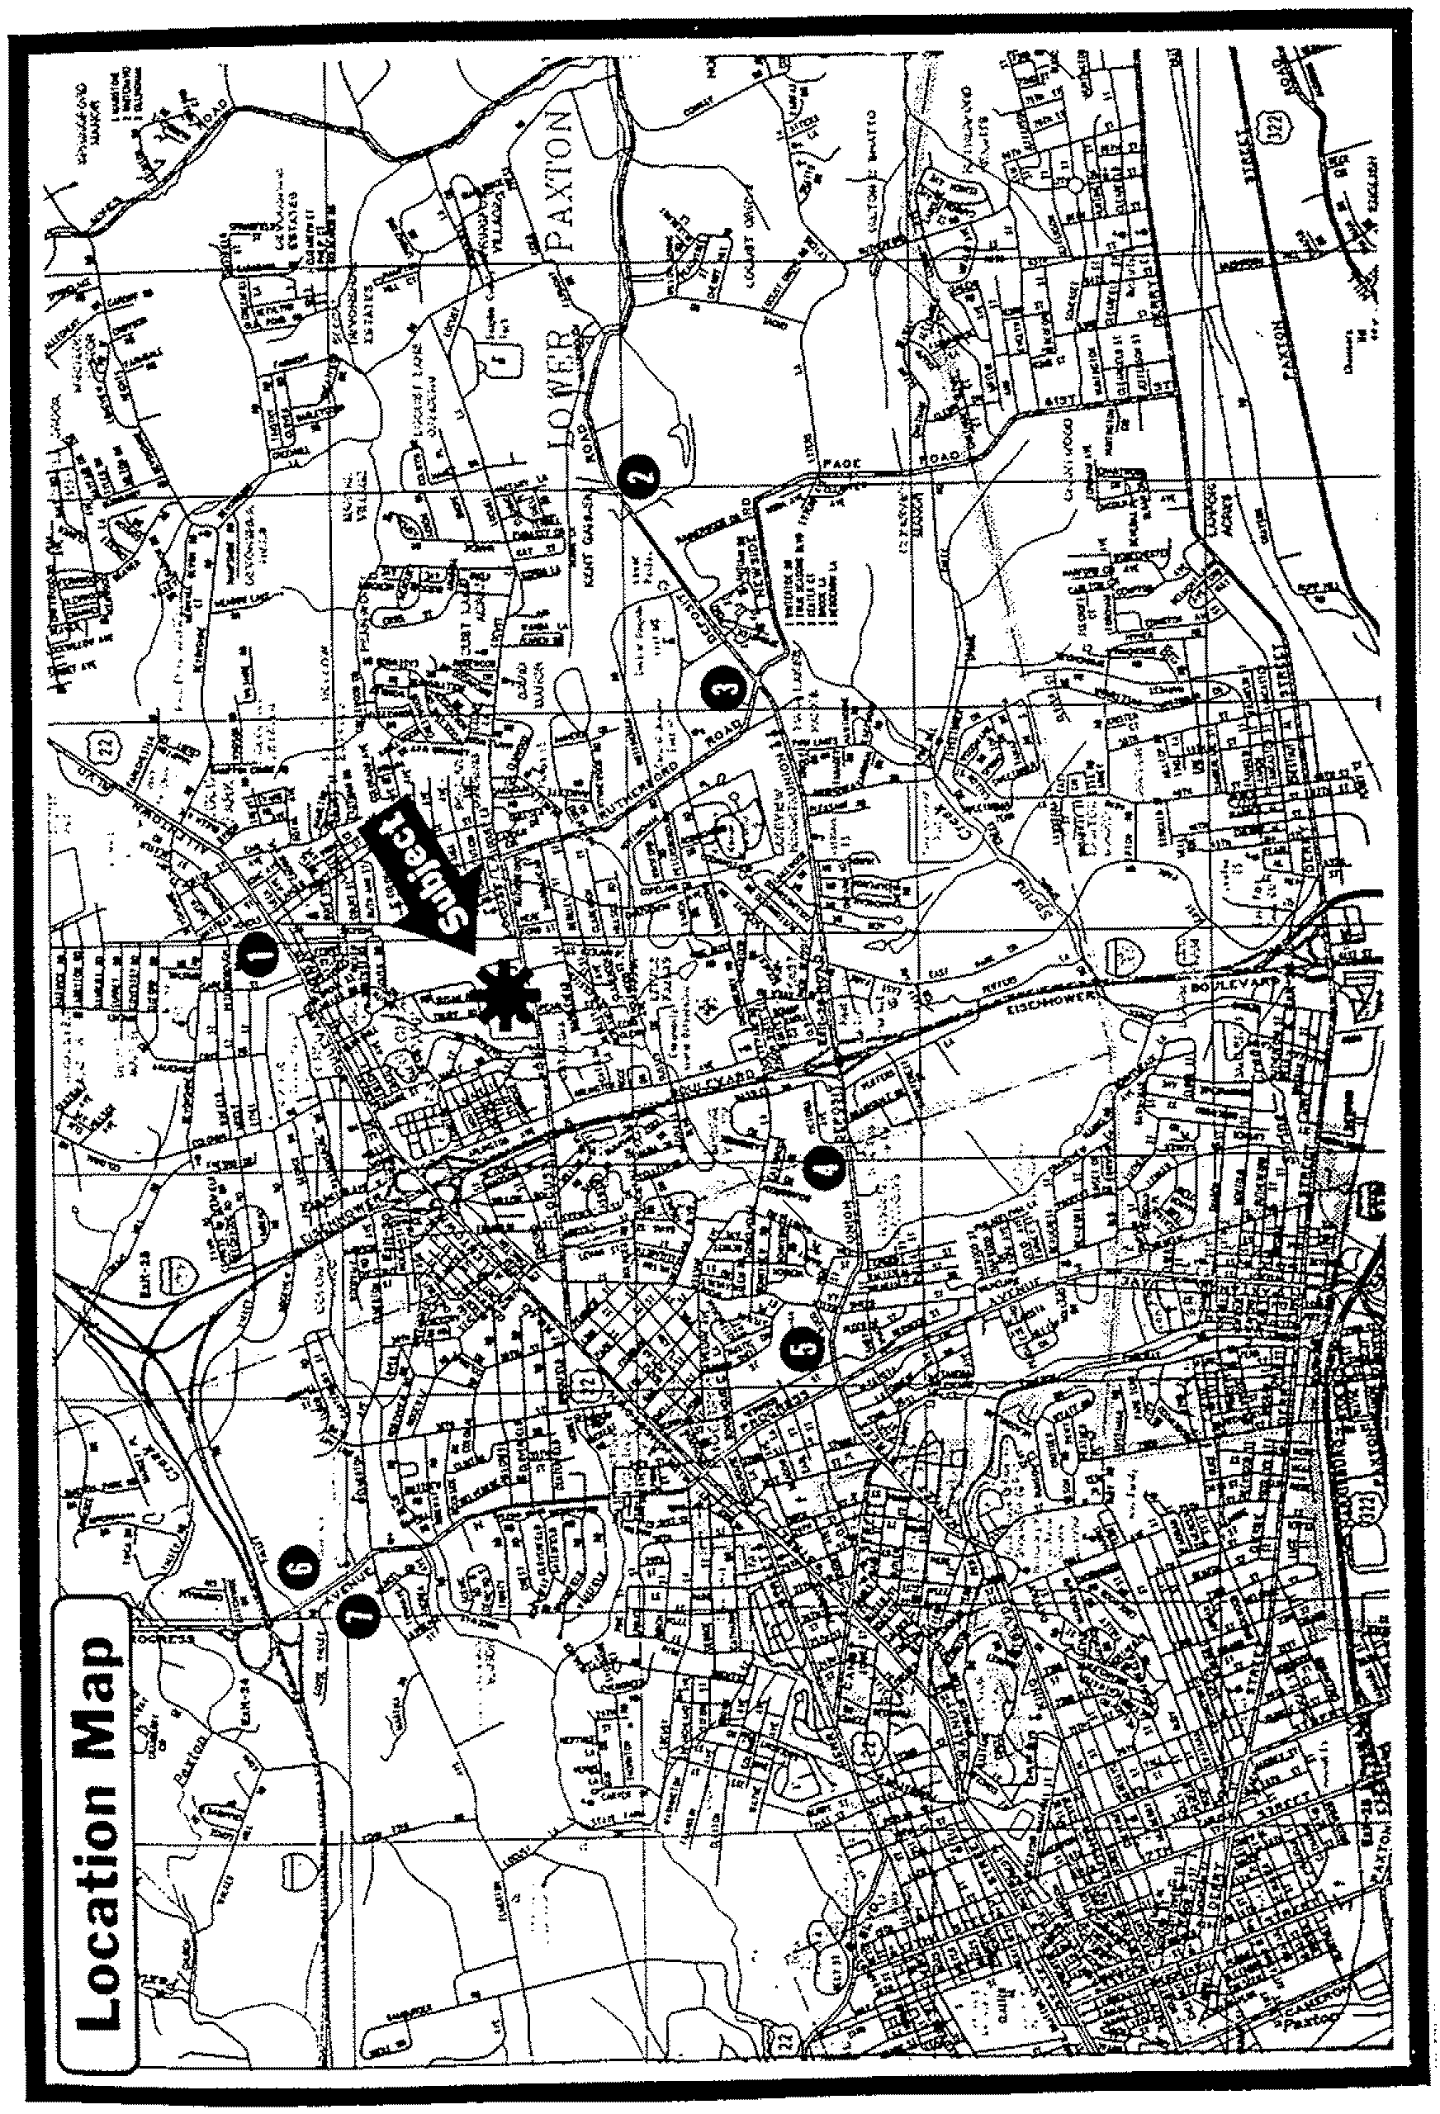
ColdweU BtutkeT Commerciol Affdiates

 |  | ~
 | ~ | {f
 |  | C
 | ~ | r;j
~ | t.-j | ;;.:
E::: | 0(1 | ~
~ | ~ | ~
~ | ~
2: | ~ | CII:l
§ |  | ~
 | U
 | ~ | ~
~ | ~ | 8
~ | 8 | =
u | ~ | Eo-(
~ |  | ~
 | ~ | u
~ |  | ~
~
~ | ~ | ~
 |  | ~
 | § | ~
 | u | ~
 |  | ~
48

PRO FORMl\. ASSUMPTIONS - FOR DISCUSSION PURPOSeS ONLY
SIJGQIlSt'EO SALes PRICE, $6,250,000
UPD"'t'EO, S"'TlJRD"'Y, FEllRUAA1I 27, 19_
". SAARY I,./\MMli:RSSN, COWWIll>l. SASK:IlR COMMllRCIAL SMITH & SMITH (703) 749-1155
l>ISTING PRESENTATIONS l\N!) MARKETING PROORllMS
OpllX SHOPPNG CENTER N'I!T RI!N'I'lIBl>1l J\.REl\,
RI!N'I'1I.l. INCOME, [3} OTHER INCOME:
TOTAL , VAClINCY , 5 \
EPPECTIVE GROSS:
llXPl!llSES: NNN LEASES 131
mlT OPERATING INCOMS:
DEBT SERVICE, (PROPOSED) (1)
PRE TAX CASH FI.OI<I:
CASIl ON CASH RSTUllll, PREE l\N!) CLI!J\R,
LEVERAGIlD BASIS, (II
A:OPEX
5
10
ll4,569
$Sll9',700 $713, B40 $73B,924
52,500 52,588 5<;,618
$7H,683 52,712
$791,447 5819,147 $847, Sl7 $877,491 $909.203 $939,990
$2,869 52,969 53,073 53,lst $3,292 $3,407
$912,890 $3,526
$692,200 | $71S,427 | $741,502 | $767, H5 | $794,315 | $822,116 | $850,8n | $880,612 | $911.495 | $943, H8 | 5976,416
534.010 | 535.821 | $37,075 | $39.373 | $39, no | $41,106 | $42,545 | 544,034 | HS,575 | $47,110 | $48,821
•••• _ •••••• ___ ••.• _ •• - - ____ .•••••.•••.•.•••••.••. '" .•..••• _ ••••••.••. '" •••• _ ••• ,.. ••••••.•• "' •••••••••• ""_ •• _ •• __ •• __ •••••• ______ •••••• ___ •••••• __ ••••••••••.•• ___ ••••••••.•••••••.••••••••••.••••• "' ••.••• Or •••••••• Or •••••••• _ ••••••••••••••••••.•••• _
5657,590 | $680.60S | 5704.421 | $729.0B2 | $154.600 | 5181,011 | $B09.34S | $B36,63B | $965,920 | 5996,22ll | $921,596
$15,000 | $15,600 | $16.224 | $16,813 | $17,54B | $18,250 | $19,9BO | $19,739 | $20,529 | $21.350 | 522,204
$642,590 | $66$,006 | $6llll,203 | $712,209 | $737,052 | $162,761 | $189,366 | 5ll16,899 | $B4S,392 | $814.81$ | S9()5,392
{$57~, 013} | ($579,0131 | ($579,0131 | ($$79,0131 | ($579, all) | ($5n,013) | ($579,013) | ($579,013 ) | ($519,Olll | ($S79,0131 | ($519,01) I
$63,571 | $85,993 | $109,190 | $133,196 | $158,039 | $183.148 | $210.353 | 5237.886 | $266,379 | $295,865 | $326,319
YEAR :
 | $ll.16 | $8 ••• |  | Sll.14 | 59.04
 | 10.28\ | 10.64\ |  | 11.01\ | 11.40\
 | 5,09\ | 6.88% |  | 8.14\ | 10.61>\
 | FREB •. Cl>1!J\R |  |  |  | LSVERAGED | (11
 | ON NOI |  |  |  | BASIS
0 | ($6,250,0001 |  | 1I1!J\R : | 0 | ($1,250,0001
1 | $642,5~0 |  |  | 1 | $63,571
2 | $665,006 |  |  | 2 | $85,993
3 | $68S,203 |  |  | 3 | $109,190
4 | $712,209 |  |  | 4 | $133.1%
5 | $737, 052 |  |  | 5 | $158,039
6 | $762,761 |  |  | 6 | $183,148
7 | $789,366 |  |  | 1 | $210,353
8 | $816,899 |  |  | S | $231,ll86
9 | $845,392 |  |  | 9 | $266,379
10 | $9,657,180 | (21 |  | 10 | $6.005,964 |  | (21
11 | 5905,392 |  |  | II | n26,379
 | ••• ilIollllllllll ••••••••••• |  |  |  | .................
 | 13 .1st |  | IRR: |  | n.n\
 | $6,S3S,765 |  | NPV, | 13\ | $2,491,ll6'
 | •• ""' •••• oo"""' •••••• |  |  |  | •• * .•••• 11II .•••••••••••••••
$10.03
Sll.50
$10.38
$9.36
$9.69
$10 .14
$11.12
12.20\ 14.10\
11.79\ 12 .64\
12.63\ 16.83\
13.01\ 19.03\
13.53\ 21. 31\
14.49\ 26,11\
IRR:
(I} FROPOSED DSBT OF $5,000,000; 10\120 YEARS WITH A Bl\LJ\NCE AFTER 120 PAYMENTS OF $3,651,216, DUE IN 10 YSAAS (2) SELL 11TH YEAR NOI AT 10\ CAP RATS, LESS 3\ COST OF sALE, PLtJS 10TH YEAR NOI; LESS LOAN Bl\LJ\NCE
(31 RIlNTAl. l\N!) OTHER INCOME INCRIlJ\SB AT 3.50\ PER YBAA, EXPENSE [lUlSERVESl INCRIlJ\SEO AT 4.00\ PBR i'BAA
11
Listing Presentations & Marketing Programs
SAMPLE REGISTRATION LETTER
(TO BE DRAFTED AND REVIEWED BY LOCAL COUNSEL)
February 23. 19_
Mr. Building Owner Light Manufacturing 12345 Railroad Avenue Standard. li, 65565
Re: 1234 Johntown Blvd.
Peoria, li, 65544
Dear Mr. Owner:
Since my last letter to you dated January 29. 19_. I have shown the above referenced property to the following individuals or fmns and therefore would like to register them with you pursuant to our listing agreement. The results of these showings will be discussed at our next regularly scheduled marketing meeting on Thusday. March 3, 19_.

1.
2.
Mr. Kirk Henderson 2322 Adams Street Niles,IL
Ms. Sally Jones
34980 Monroe Avenue Nottingham, IN
Represented by:
Represented by:
Jim Smith Century 21 Pros
Allan Listor CBCS

I look fOlWard to discussing these prospects and their reaction to the property.
Sincerely.
Allan Listor
ColdweU Banker ConutU!rcUd Affiliates
50

Listing Presentations & Marketing ProgTtuns
SAMPLE PROPERTY REGISTRATION LOG

PROPERTY:
ADDRESS:
OWNER:
AGENT:
DATE NAME
COMPANY
PHONE
CLIENT'S NAME

ColdweU Banker Commercuu Affdiates
51

Listing Presentations & Marketing Programs
SALESMAN'S TRANSACTION SUlWMARY
Salesman's name:
Salesman's title:
Professional designation:
Professional education:
Years of commercial real estate experience:
Awards and recognition received:
TRANSACTION EXPERIENCE:

1.
2.
3.
4.
Property name:
Address:
Building size:
Transaction value:
Property name:
Address:
Building size:
Transaction value:
Property name:
Address:
Building size:
Transaction value:
Property name:
Address:
Building size:
Transaction value:
Property type:
Parcel size:
Date:
Property type:
Parcel size:
Date:
Property type:
Parcel size:
Date:
Property type:
Parcel size:
Date:

PROFESSIONAL REFERENCES:
1. 2. 3.
ColJweU Banker Commercial Affiliates
4. 5. 6.
52

Resume:
John M. Eagleton, CCIM
Education: Florida State University
BA, 1968
Accomplislllnents: Joined Coldwell Banker Commercial Smith & Associates as a commercial associate
in 1988 after a twenty year career with ffiM.
While John was with ffiM, he was responsible
for the IDM western regional real
estate office, covering 78 individual real estate locations occupied by ffiM including owned and leased properties. Since joining Coldwell Banker, John has been involved in more than 67 transaCtions including sales, development deals, leasing and consulting assignments. John is an active member of the "1031 Club" and past president of
the state exchanger's organization.
Major clients John has represented over his career included Xerox, Citicorp, 1MB, Caterpillar, Dow Chemicals and others.
ColdweU &snker Commerci41 Affiliates
Listing Presentations & M{U'keting Programs
Expertise & Strength
Past President of the "1031 Club"
Property Analysis and Investment Skills
Retail Leasing Specialist
Tenant Retention Programs Corporate Real Estate Experience
Affiliations and A wards
Salesman of the Month (six times) Exchanger of the Year 1987 Association of Realtors
CCIM Member
Rotarian of the Year 1982
Board Member, James Madison High School Booster Club
53

Listing Presentations & MtlI'ketin.g Programs
EXECUTIVE SUMMARY

Property:
Address:
Age:
Size:
Description:
Location:
Site:
Price:
Price per Foot:
Average Rents:
NOI:
Cap Rate:
Cash on Cash:
Pretax IRR:
Marlex Industrial Building
11232 Railway Road Manufacturing, NY 10022
January, 1972; new roof installed June 19_
86,900 +/~ square feet; 3.6% office buildout
Property consist of one single story building of 86,900 square feet with
, 3,150 square feet of office buildout. The building is 24' clear and built of concrete block with a built up twenty year bonded roof which was replaced in 1995. Column spacing is 40' x 40', individual space heaters, 8" concrete floors, and rest rooms in each of the three tenant spaces. Density is .40 FAR which is the maximum allowed under the 1-6 industrial zoning. Parking for 73 cars, with room for 18 wheel trucks to turn around in the rear of the building. Twenty two dock high loading doors, two wells and one 14' clear drive in door in the north end of the building. Building is fully sprinklered with a wet system.
The property is located in the Railway Industrial Park off Interstate 35 at Exit 34. The site is less than one mile east of the interstate at the entrance to the park. A major truck stop and motels are also located at the park entrance. Thirteen Fortune 500 companies have major distribution facilities in the park.
Rectangularly shaped parcel of 4.98 acres; 218,456 square feet
$ 2,125,000 $ 24.45
$2.69 current NOI per square foot; $3.56 per square foot full service
$233,761 (pro Forma; see assumptions in complete marketing package)
11.00% (See assumptions)
9.85% on leveraged basis assuming existing debt; 11.00% free and clear (See assumptions)
18.81 % on leveraged basis; 13.69% unleveraged (See assumptions)

ColdweU Banker Commercial AffditJtes
54

Financing:
Occupancy:
Expenses:
Utilities:
Electrical:
Tenants:
Seller:
Listing Presenlations & Marketing Programs
Financed by a local bank with a current balance of $1,437,567; payable $164,653 per annum, and a current constant of 1 ].45%. Loan can be paid off with a 2% pre-payment fee or assumed for one point.
100.0% overall area occupancy is 96%
$.87 per foot. Taxes for 199_ were $37,650, or $.433 per square foot.
Public Service gas and electric on individual meters. Trash collection paid by tenant and owner is responsible for sewer and water.
3 phase; 3 wire; 200 amps and 230 volts
Three tenants occupy the building; 26,900 square feet, 20,000 square feet and 40,000 square feet. First lease expiration is 40,000 square feet in April, ] 999. Rents increase on lease anniversary date at .50% of CPI plus 100% of insurance and tax increases are passed through.
Local investor who bought the building empty in the fall of 1995.
PHOTO OF PROPERTY HERE
For Complete Package and Additional Information, Contact Ms. Joan Anderson
Coldwell Banker Commercial Anderson & Associates 1232 Main Street, Suite 212
Y ourtown, NY 10042
(212) 565-4440

The above information has been taken from sources we believe to be reliable. but it has not been verified for accuracy. You should cOl/ducI an independent investigation to determine the suitability of this property for your intended use. This properly is subject 10 change in price and lerms and withdrawal from the market without notice.
GoldweU Banker Commercial Affiliates
55

Listing Presentations & Marketing Programs
EXECUTIVE SUMMARY
Property: Glenn Gables Apartments
Address: 554 Glenn Gables Drive
Y ourtown, NY 10022
Age: March, 1987
Number of Units: 46
Description: Property consist of two, two and three story buildings of 23 llllits each,
with brick and vinyl siding, pitched roofs, heavy landscaping, carports, fireplaces, washer dryers in each llllit and condo map has been filed and approved. All units are two bedroom and average 985 square feet. T atal rentable square footage is 45,310 square feet. Density is eight llllits per acre. Rents range from $575 to $750 per month depending on location and view. On site surface parking for 110 cars, including forty six covered spaces. Amenities include pool and tennis court.
Location: Property is located in the Fernwood school district in the Glennmore
development adjacent to the Glenn Gables COlllltry club. Shopping is nearby at the Sycamore Safeway center.
Site: Irregularly shaped site of 5.78 acres
Price: $ 2,125,000
Price per Unit: $46,195
Price per foot: $44.50 per gross square foot; $46.90 per rentable square foot
Average Rents: $620 per month
$.63 per square foot
NOI: $203,188 (Pro forma; see assumptions in complete marketing package)
Cap Rate: 9.56% (See assumptions)
Cash on Cash: 7.36% on leveraged basis; 9.56% free and clear (See assumptions)
Pretax IRR: 16.81 % on leveraged basis; 12.24% llllieveraged (See assumptions)
Gross Multiplier: 6.2 times gross

ColdweU Banker Commercial Affiliates
56

Financing:
Occupancy:
Expenses:
Utilities:
Seller:
Developer:
Listing Presentations & Marketing Programs
Financed by a non-assumable mini-penn that is due in June 199_. Seller may consider some financing depending on other tenns.
93.48% overall area occupancy is 89%
$2,750 per unit per year; $2.97 per square foot; 38.9% of effective gross rents. Taxes for 199_ were $19,550 or $425 per unit per year.
Gas and electric paid by tenant on individual meters, owner is responsible for sewer, water and trash collection.
Out of area investment group.
Travis Development Group have build more than 800 apartment units and 378 single family homes in the area since 1985.
PHOTO OF PROPERTY HERE
For Complete Package and Additional Information, Contact Mr. John Anderson
Coldwell Banker Anderson & Smith
123 Maple Avenue, Suite 1212
Y ourtown, V A 20042
(703) 565-4440

The above information has been taken from sources we believe to be reliable, but it has not been verified for accuracy. You should conduct an independent investigation to determine the suitability of this properly for your intended use. This property is subject to change in price and terms and withdrawal from the market without notice.
CoMweU Banker Commercial Affiwues
57

Listing Presentations & Marketing Programs
PACKAGE GUIDELINES
TIlE FOLLOWING GUIDELINES SHOULD BE REVIEWED WHEN PREPARING AN EXECUTIVE SUMMARY AND INVESTMENT SALES PACKAGE.
1. THE COVER PAGE SHOULD INCLUDE THE FOLLOWING:
»- The cover page should contain enough infonnation to encourage the reader to read the
balance of the flyer or summary.
Identification of the property including the name of the building and address of the property.
Identity of the listing agent and Coldwell Banker Commercial office with complete name, address and phone and fax numbers of the listing agent and affiliate.
A disclaimer statement approved by the local affiliate broker/owner or commercial manager.
2. EXECUTIVE SUMMARY INCLUDING:
»- The Executive Summary should not be longer than two pages, but should provide
enough detail that a knowledgeable buyer can detennine if there is sufficient interest to request a complete marketing package.
Type of property: mini-warehouse, office, retail, industrial, aparunents. Property name, location and property address.
Age of the property, including year of construction or date of rehab. Size (square footage), number of units or stories.
Site or parcel size and dimensions.
Parking ratios, number of spaces, covered, structure, surface. Pricing infOlmation, unit cost breakdown; per foot, unit, acre. Rental infonnation: averages, market, effective rents, concessions.
Net Operating Income (NOI) and the rental, vacancy and expense assumptions you used in arriving at the NO!.
Cap Rate or other measures of valuation.
Financial returns: cash on cash, IRR, fmancing, amount of leverage and assumptions used in arriving at results.
Loan infonnation if the loan is assumable, and other sources of fmancing available including proposed seller fmancing.
ColdweU Banker Commercuu Affiliates 58
Listing Preselltaiions & Marketing Programs
Current occupancy and expected tenancy over next twelve months; lease roll over discussion with roll over schedule by month and space.
Expenses used in fmancial projections. Expenses experienced with similar properties in the market. Discuss any variances.
Utilities available andlor used at the property, financial responsible for each utility and description of the utility provider.
Type of seller: developer, individual, corporation, syndicator, investor and brief discussion of seller's motivation to sell the property.
Photographs of the subject property, interior and exterior shots.
3. MARKETING PACKAGES SHOULD INCLUDE: (In addition to the above items)
). Color photographs of the property should be included in all marketing packages.
Interior and exterior 4" X 6" color photographs of the property should be provided.
Take pictures of unusual features of the property. Pictures should show landscaping, entrances, amenities.
If the listing warrants the expense, aerial photographs should also be included in the complete marketing package.
4. PROPERTY DESCRIPTION:
). Describe the property assuming the reader will never visit the property in person.
A narrative of the subject property describing the features of the property, amenities, neighborhood, site, floor plans, roof and contiguous properties. Describe the interest offered for sale: fee simple, leasehold, partial.
Describe the HV AC system and any special features or life safety systems, discuss the landscaping and irrigation system.
If the property is multi*story, describe the elevator systems: how many cabs and the cab interiors.
Building construction materials, exterior material, architectural style, zoning, density, excess land and accessibility from major highways.
Site plan identifying building locations, ingress, egress and site amenities such as pool, car wash, freight docks, clubhouse, storage, parking and truck turnarounds.

ColilweU Banker Commercial Affiliaies
59

Listillg PreselltatiotlS & Marketing ProgrQJtlS
Real estate and personal property tax infonnation and assessed value broken down by land and improvements.
Discussion of what will happen to the assessed value after a sale takes place. Discuss the floor plan of the building and footprint on the site.
Describe any environmental issues that may exist or prior usage of the property if appropriate.
5. MARKET INFORMATION:
» A general discussion of the immediate area and regional market for the specific
property type you are marketing.
Include and identify locations of rental and sales com parables in this section on area maps.
Provide clean area and regional maps clearly identifying the location of the property and major activity centers or transportation routes.
Infonnation on the area's economy and economic trends.
Discuss area demographics, competition, vacancy, absorption, new construction, major tenants, and general trends in the immediate market and surrounding areas.
Include employment and other labor statistics.
6. FINANCIAL SUMMARIES:
» Provide infonnation and investment analysis on the subject property identifying all
sources or references and assumptions used at arriving at your results.
Provide current rent roll with detailed lease analysis for each tenant in the property, when the lease commenced and when it will expire.
Provide details on rent escalations in existing leases and dates they go into effect Fully discuss any options in existing leases.
Provide complete rent roll analysis including current market rents, concessions and effective rents in the market.
Sale/leaseback transactions should provide complete details of the lease tenns, purchase options and financial strength of the tenant and credit behind the lease guarantees.

ColdweU BfUIker CtmunercUd AfflUates
60

Listing Presentations & MiUketing Programs
Salelleaseback opportunities should disclose if an existing lease or new lease will be assumed or drafted at the time of the sale.
Provide detailed infonnation on any lease options including purchase option, term, rate and notice requirements.
Provide current expense information on a year to date basis and most recent full fiscal year.
Provide current mortgage information including current balance, lender's name, original balance, date of first payment, interest rate, amortization period, balloon due date, escrow requirements, principal and interest payment amount, and any other terms of the existing financing.
Discuss any due on sale or other financial consequence of a sale with the existing lender including yield maintenance fonnulas.
Provide infonnation on financing the buyer can expect from the seller, if any, current market interest rates, terms, Loan to Value (L TV) ratios and Debt Coverage Ratio the local lenders are using when underwriting a loan in your area.
7. LAND PACKAGES SHOULD INCLUDE THE FOLLOWING:
» Depending on the type of land offered, you should provide at a minimum the
following infonnation:
Regional and city maps showing the location of the site followed by a more detailed street map locating the site and major commercial activity centers at or near the property.
Aerial of the site and surrounding areas identifying major commercial centers and people generators.
Site plan or parcel map showing ingress and egress to public roadways. Information about zoning, allowable uses, utilities (Include location or distance from the property), size or capacity of all utilities, availability and the approximate cost to get utilities to the site.
Any issues affecting the roadways at or near the site.
Other issues affecting the development of the property for its most logical use including environmental, wetland or topography issues.
Demographic information near the site and the entire trade area.
Competition map identifying all competitive or proposed uses that may compete with the location at a future date.
Traffic counts in and around the property.
Any government proffers that will impact the development cost of the site. Identify any easements that cross or affect the development of the property.

Co/4weU Banker Commercial Affiliates
61

Listing Presentations & Marketing Programs
8. APPENDIX:
)- Include materials to support the marketing package from as many third-party sources
as available.
Include information from the Chamber of Commerce, local bank economic department, building department or Economic Development Corporation statistics to support your claims.
Provide sources of information to support current sales and leasing comparables, appraisals, sales surveys, vacancy reports, leasing summaries. Provide fmandaI information on the major tenants: annual reports, square footage sales information, marketing brochures.
Understand the terms of the lease forms used at the property and include a sample lease form with the package if available.
Provide a legal description, disclose covenants, easements or other issues of record affecting the property. Review the seller's title insurance policy as the seller can only sell what he or she has purchased.
If the property is subject to a ground lease. provide complete details of the terms and all fmandal provisions with respect to rental rate, options, lease terms and extensions or information regarding purchasing the property.
THESE GUlDELINES PROVIDE A FORMA T FOR DEMONSTRATING YOUR FAMILIARITY TIVlTH A PROPERTY PROPOSED FOR INCLUSION IN THE FRANCHISED BUSINESS. THESE GUlDELINES ARE GENERAL IN NATURE AND MAY NOT BE APPLICABLE TO EVERY PROPERTY. IN ADDITION, THE CIRCUMSTANCE OF A PARTICULAR SELLER, BUYER OR LOCAL JURISDICTION MAY REQUIRE ADDmONAL OR DIFFERENT INFORMATION FROM THAT DESCRIBED IN THESE GUIDELINES.

Col4well Honker CommeTcuu Affiliates
62

Listing Presentations & Marketing Programs

 | MARKETING ACTIVITIES PLANNER
• | Direct mail and phone follow up. | • | Cold calling on similar SIC code companies
• | Signage at the property. | • | Present to local board, list in MLS.
• | Prepare property prof11e. | • | Make marketing adjustments as you proceed.
• | Personal contacts. | • | Contact all prior clients about property.
• | Prepare flyer, brochure. | • | Canvass local neighborhood with flyer.
• | Press release, articles, TV. | • | Public agencies, EDC and Chambers.
• | Run classified ad in paper. | • | Use Wall StreetJoumal if warranted.
• | Establish broker bonus program. | • | Arrange for broker party and tour.
• | Send flyer to CCIM's, CPM's. | • | Set up display in lobby of property.
• | Mail all CPA's and lawyers. | • | Send flyers to all appraisers.
• | Contact all commercial brokers. | • | Contact space planners, architects.
• | Arrange for your office to tour. | • | Contact office equipment supply salesmen.
• | Put ad in specialty magazines. | • | Contact adjacent property owners.
• | Ad in state business magazines. | • | Use of CD-ROM based databases.
• | Similar property owners. | • | Consult yellow pages for prospects.
• | Contact local banks or CfP's. | • | Contact building maintenance companies.
• | Existing tenants for expansion. | • | Mail major employers in community.
• | Put together a presentation book. | • | Contact major franchise operators.
• | Advertise effective rents and | • | Prepare list of amenities at the property
 | concessions. |  | and in the area of the building.

ColdweU Banker CommercUd Affiliates
63

~
i
~ | MARKETING PLANNING GUIDE AND SCHEDULE |  |  |  |  |  | OPEX SHOPPING CENTER - COMMERCIAL DEVELOPERS
..•
~ | ITEM | Feb | Mu | Apr | May | June | July | Aug | Sept | Oct | Nov | De< | Jm '9_
I | Preliminary meeting
... | regarding Ii.ting | xu
i | RevlC:W materil\is and
~ | building information | xxx
i!
a | Listing Presentation | x"X | xX
Q
 | Complete or review building
 | competitive market position | xxxx" |  |  | x~x~,., |  |  | .xxxx |  |  | xxxxx |  | X;{XXX.
 | Complete brochure and
 | marketing pachges | xx | x"x
 | Develop propo •• 1 and other
 | materials for le.se opportunities | "" | .xx
 | Oroer building sign.ge and
 | collateral materials. in house tours |  | xx | .x"
 | Mail prope!1y flyers and other
 | materials (ongoing) |  |  | xxxxx | xx.xx" | x.xxx | "xxxx | x"xxx | x",",xx | xxx'" | xxxxx | xxxxx
 | Mail investment flyer:s to investors
 | and others (ongoing) |  | xx | xxx | X:lt:x,xx | xxxxx | xxx xx. | xxxxx | .• >xxxx | xxxxx | xuxx | xxxxx
 | Cold caU usmlbuyers (ongoing) |  |  | xxxxx | xxxx" | unx | xxux | xxxxx | xxx xx | xxxxx | uxxx | .U::Xx.x |  | l:'-<
 | Meet for marketing update monthly |  |  |  |  |  |  |  |  |  |  |  |  | 1;;'
 |  |  |  | .xxxx | x.:u:."" | xxxx.x | X};,;,X;( | J:X':O;X | xxx'" | x:t.uJ:, | x:o:;t,x | xxxxx | XXX;(;( | 5'
 |  |  |  |  |  |  |  |  |  |  |  |  |  | Ol:l
 | List and meet with Economic |  |  |  |  |  |  |  |  |  |  |  |  | l
 | Development Authorities. orhe" |  |  | ~.xxxx |  | xxxxx |  | xxxxx |  | ~:o::xx |  | x~:r..xx
 | Advertise in 100000and other |  |  |  |  |  |  |  |  |  |  |  |  | !
 | Coldwell Bwer media |  |  | l<AAU |  | xxxxx |  | ;(;1;';':';-:;( |  | X;l;.X;(X |  | x.'tu:,X |  | ~
 |  |  |  |  |  |  |  |  |  |  |  |  |  | Ii::l'
 | Lette" to o"!Sid" brokers |  |  | x:<. | xxxxx | xxxxx. | J::xx:t.x | ;u;;u:.x; | .xxxx | XX.:C(X | XXXJtX | x:u.xx |  | a
 | Al'flInge broker p.l'lY at .lte |  |  |  |  |  |  |  |  |  |  |  |  | fl.,
 |  |  |  |  | X:lI.XXX. |  |  |  |  |  |  | .:tx.:u:,x |  | f
 | C10>" sale andlor i"ue negotiation. |  |  |  |  | xxxxx. | ,""xxx | XXXXJI'. | xxxxx | x;t:xxx | xxXx:<. | xxxxx | ;w;xxxx.
 |  |  |  |  |  |  |  |  |  |  |  |  |  | i
 |  |  |  |  |  |  |  |  |  |  |  |  |  | il"l'l
'" |  |  |  |  |  |  |  |  |  |  |  |  |  | ~
.p. |  |  |  |  |  |  |  |  |  |  |  |  |  | ~
 |  |  |  |  |  |  |  |  |  |  |  |  |  | ~

Listing Presentations & Marketing Programs
SIERRA CROSSING APARTMENTS
232 Unit Complex Lubbock, Texas
Marketed Exclusively By RICK CANUP, CCIM, CRB, CRS 4924 S. Loop 289 Lubbock, Texas 79414
(806) 793--06n


RICK CANUP REAL TORS<t


• , : • : I •• I.
1M. __ •••• f9\It •• nol~_.....,.,trom----
Quyono "'" "IVOdtQ podQmt._dl~_"''*''''Y •••• -- "'101. --
a __ "'_1MP">C*'Y_to_~_I"laIn(I __ ~.

ColdweU Banker Commercial Affdiates
65

Listing Presentations & MtU'kding Programs


Sierra Crossing Apartments

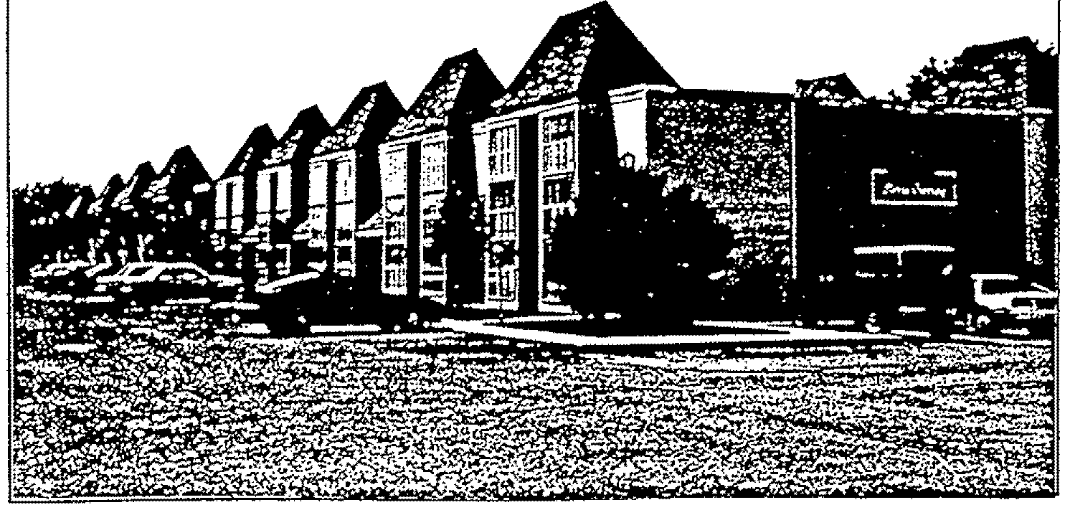
232 UNIT COMPLEX
2317 3rd Street Lubbock, Texas
Sales Price $6,650,000



• I
..

Tho. __ """I\g<K ••••••• ""'~M4, ••.• _from_---
6..,.... •..• ~ •• l*1<lrm._~_ •• kloo<llIfyand_at<'f_rlr."'. 9 __ '."- •••• _ ••.• "'_~...." •••• hll<q--~
ColdweU Banker Commercial Affiliates
66

Listing PreselUations & Marketing Programs

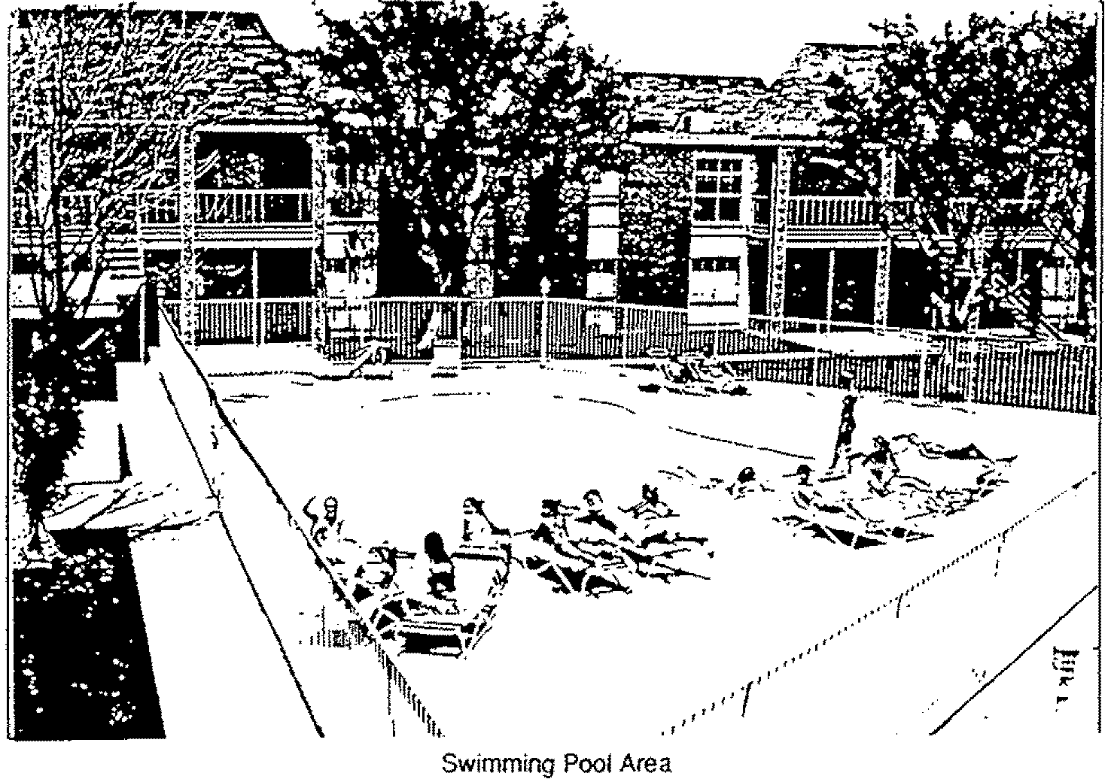
- ••.•• ";'f~~ ~." ."-f~· •..••• ~ •.•••.
":'"
; - .
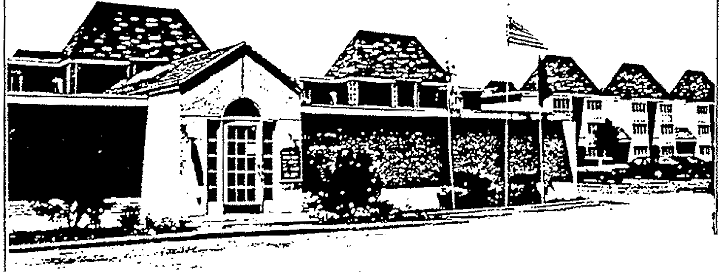
-

. .. -,...
,~ · .. ,~~c.tl' .. ~""""",~ f' -"- -~ ...•••. :.
_ •.••.• ,.'""\o..:';~J.~' ' ••
Office Area
••
: .
. -

~ .W~'I.ar4 figur_ ~4Il'l1.::l ~(l. wtll"no(gtW'Mt~~. MO.Uedlfoml.Ol.ltOlM ••.• ~ MIt~.2~" 9~ Vlf~1o(*'fOfm "~(1r~ ~kt~vd~ •. .any~alt"kt, a~. WM'lng:10 t.I"toow1'h4', ~ N.~fT\2M-"'~' MhtM kUOQ ~t*~~
C:'oldweU Ranker Commercial Afftliates
67
Listing Presentations & Marketing Programs



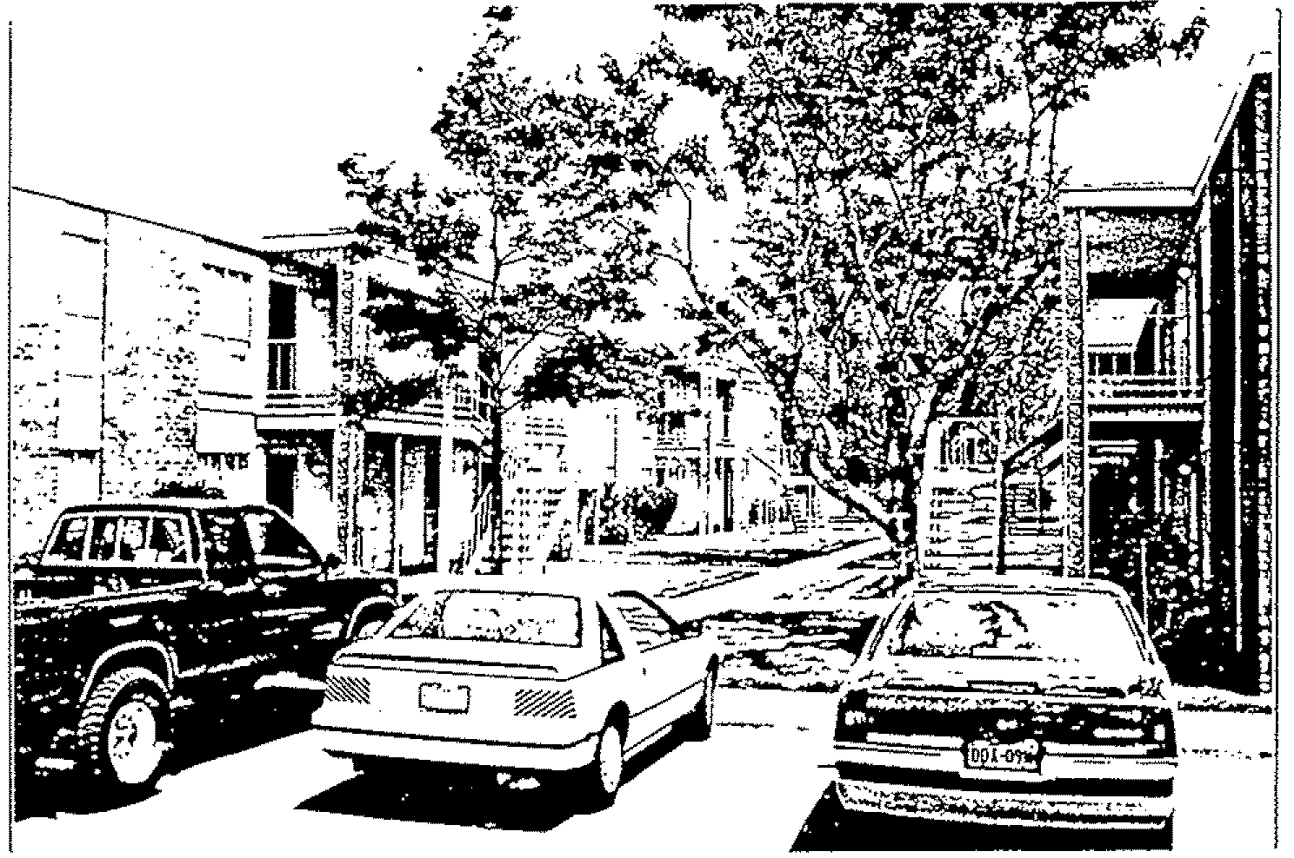
Another Exterior View

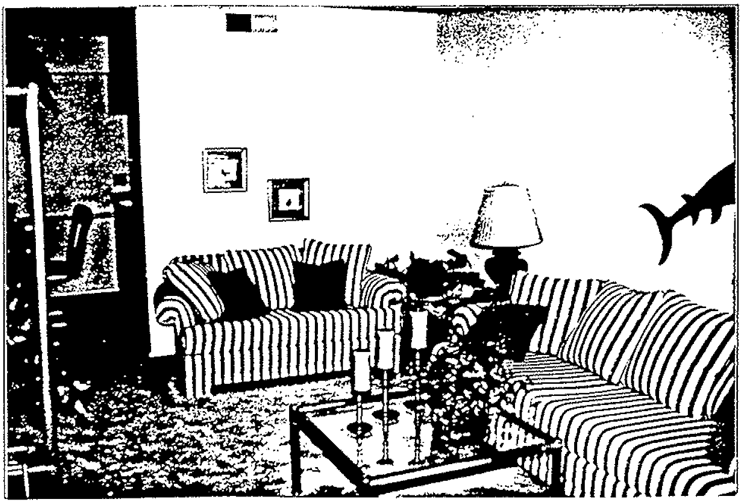

••
; ,
A Typical Living Room
..



n... tWe<T*'IU, ~ lig'\Jt~ QNCeni:e<I ~n. ~ nQ! OVU,;,nt*. ~O $OOJtlll4 It om ,0000.ro!!iC .• bolttervtt author. a',.....
Bvyt!ttl ve lJf90d to ptt1«m a due (.h~~ .uurt'lmtWrt 1() ~ltty 3hd eva.il..I.u. W( em':r~lal r"kl. a~. WV1J1n9 10 f,how I~~ at$ 10 t'Nke ,v!ar.gemor'\ts- ~h the jl~i09 ~ t>l;(~ ~If'v;l:
ColdweU Banker Commercial Affiliates
68

Listing Presentations & Marketing Programs

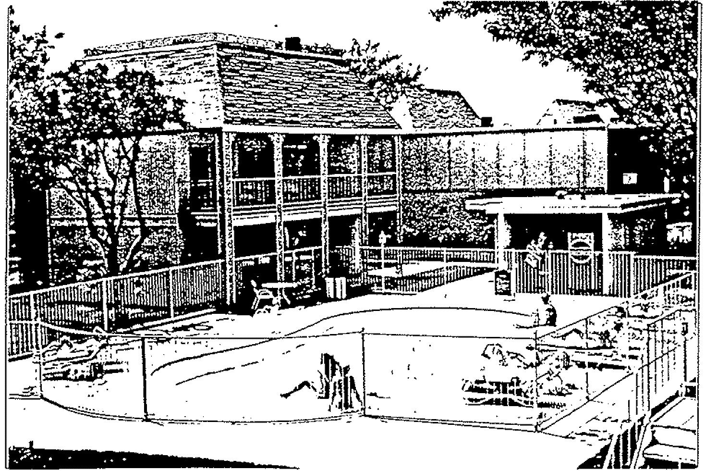
Clubhouse Building (Beyond the Pool)
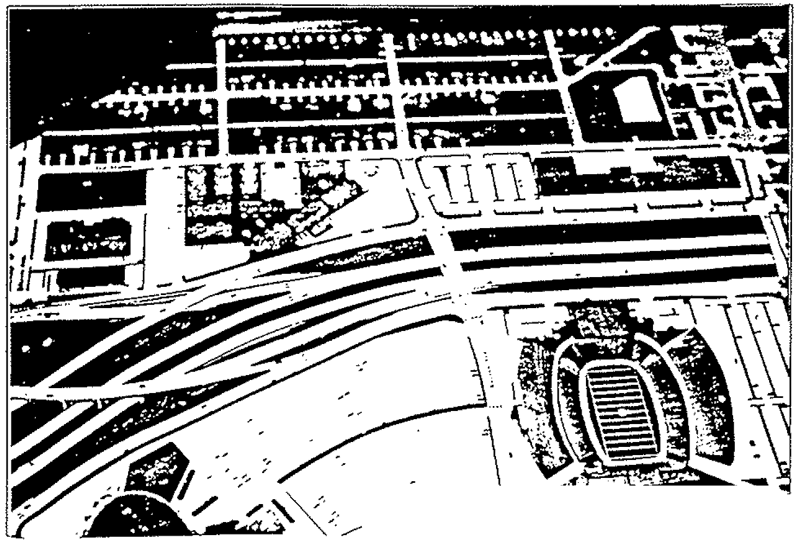
0._ :-"'Il
~ - - - ... ,::-- .. -- ..:.-- ~
~ tIC "" .. __ ~ ,
Highway Dept Model of Proposed Freeway

. ,
~ .W~'I .;wd flgtttet pt •• .enle<l' ~h" ~l_ no( 9~.a.nt..:J, V. i-o<:lJf'Ed ffOOl ~OOf'tlllll ••••• l>flilf{N. <wU''()(:.l:tMI!. 8\1'fOl'l1 at-. ~ lO ~()'m i\"'lJtt-dl~;u.t.-tIl$~ to~rty,JJ'l(l WalV/!Q'e My om'¥¢n~ l'eM. g~ warrtr..;) to &l'lQW thl) ~y .U$ ro-l'r\.U-f'Io ;VUJ'>Q'&r"!"W'\l. w'f:Tll/'\.., lo11t,f'l9!)t'OMt' b&l'0t~ ~1r"loQ
ColdweU Banker Commercial Affiliates
69

LOCA TION
UNIT MIX
INTERIORS
SECURITY
KITCHEN APPLIANCES
SWIMMING POOLS
CLUBHOUSE
SPRINKLERS
LANDSCAPtNG
LAUNDRY
PARKING
PROPOSED FREEWAY
BUILDINGS
Listing Presentations & Marketing Programs


2317 3rd Street--one block north 01 Texas Tech Universily in Lubbock, Texas
96 one bedroom flats
40 one bedroom studios .Jill two bedroom, 2 bath flats 232 Total Units
Plush carpeting in contemporary colors: textured & painted walls with wallpaper accents: mini·blinds.
Monitored security system With call buttons in each unit
A typical kitchen has a refngerator. electric range, dish· washer & disposal.
Two
A separate building with an actiVity room downstairs and a physical fitness area upslalrs. near one of the pools.
Full sprinkler system
Very attractive.
TwO laundry rooms
Ample paved parking, convenienHy tocated.
As plans now stand. the Texas Highway Dep!. expects to begin purchasing right-of -way for the proposed E-W Freeway in Ihe faU of 1993, with construction beginning a year or SO later. Part of the subject property, including two buildings, is expected to be acquired. (See Site Plan & photo 01 the mode!.) With the freeway to be built below grade. noise levels are not expected be a problem, and a planned Boston Avenue overpass will continue to provide direct access to the campus 01 Texas Tech University.
12 two-story apartment buildings 1 office building (new)
1 storage building (the former office building)
1 two-story clubhouse With upstairs weight room . ..2. small mail room bUIldings
17 Total Buildings

••
. -


I •

'h-. ,,\,;U~11- ~ 'IQvr_ fYI)lUlnIH ~olMn. ~ l'\IOl' 9lJ..V'afH-..d . .u. lieo;t$J horn sw",," WIt ~ .authOfU11W. a~ Ma u191>0 '-0 !*lqrm '" d"\.le 1;MQonott !il.Ueutnil'l'lIIO dilW'lUfy iIJlC "",.u;;U. iIo/\'( .,.nVI"(lt\fflItOt.:il tnka ~j:"",*,*'$ w.u'lIIt">Q·O.,~ t •••• '" ~~'t .Vltt» ...-..aktt .IHilJ'Iq~;' 'W!llr'o m.,,'\~'~ !'''''"JVV "";l')l"ITl-V~J('oq
ColdweU Banker Commercial Affdiotes
70

CONSTRUCTION Exterior Roofs Pali<ing Foundation
PROPERTY CONDITION
HEATING & COOLING
WATER HEATERS
UTILITIES
Listing Presentations & Marketing Programs


Brick veneer and masonite
Some Hat built-up & some pitched WIth comp shingles Asphalt
Concrete slab
Excellent. The entire property has been almost completely remodelled overt he past three years with new carpet. paint. stairs. and much more. Many of the appliances and about half of the air conditioners were also replaced. New builtup roofs were installed in 1989 and new composition roofs in 1991. A new rental office building was also built.
Individual HVAC units. aU electric
Six gas-fired boilers
Electricity is master metered and all u!ilities are paid by owner.

• J
. -
: I •
1.

T'ho .tzJ~ a.tlI':l1;gUfM pt-.t...u:ec.s: ~. ~it 00( Q~H<l -:utHa.lceO !rom &.OOrow ..••• btt~ .J..\JtN:lt'ltatrv.. _
B~ Me Uf9od" 1Q ~m .•. dU4t <11~ •••• ~ to ro.ntlty Ud ~. &f'r1 $OVI((ll"lJ'1."A.al ,.ka. B~. WV!1l\"l9 to.noow rl"4-~ .1t*tQ-ma.'IrA .r~ WIth n~ Iottl!'loQ ~t*~~ln9
ColdweU Banker Commercial AffiliaJes
71


Listing PresentaJions & Marketing Progrt1lnS

SIERRA CROSSING APARTMENTS
INCOME & UNIT MIX

TYPE.
NUMBER OF UNITS
SCHEDULED TOTAL PROJECTED sa. FT.
RENT PER UNIT RENT PER MONTtt PER UNIT
MONTHLY
RENT PER TOTAL
~~

1 Bedroom!1 Bath Flat 96
1 Bedroom!l Bath Studio 40
2 Bedroom!2 Bath Flat 96
232 Units

$385 | $36,960 | 615 | .6260 | 59,040
$44S | $17,800 | 744 | .5981 | 29,760
$610 | $S8,560 | 962 | .6341 | 92,352
 | $113,320 |  | .6256 | 181,152
 | Total Projocted |  | or .63¢ | Not Leasablo
 | Ront Per Month |  | per Sq. R. Square Feat
 | @ 1000/. |  | Average

••
: '
. -
:, t
I.

~ .w&meontt ,;V'l(! !~l,l.r •• ~~~ h4tt'~r'l. wtu\f l'l()t Q~UtiHd. a,r. ulCorflA1 h(l(fl.QVn::eI YiM beI-" • .;lvlhQtta:ltw ~u~.u. vl'Q«l'top.r1«m a<.h"'<l;~ ~~1¢ ~1I'y.1.tk1~ • .any ~QOl"No"'ta1(.1aI:
B~~ w.vn~ 10 v.ow a'~ property .v. 10 ma,Ir..$ <lii"~t1 'Ill1I!\ lhe 'W$tlnq ~ l)&!Q(tJ ~hQ
ColdweU Banker Commercial AffiliaJes
72

Listing Presentations & Mat'keting Programs


BROKER'S EXPENSE PROFORMA ON
SIERRA CROSSING APARTMENTS
232 Units 181,152 Square Feet
The following flguresarethls Broker's best estimate considering owner supplied figures as well as "normal"proje<:1ed costs. They are accurate for similar age & size properties, but they are subject to being adjusted whenever we have accurate expense history for at least 2 years.

 |  | ANNUAL EXPENSES | PER sa. FT. | BASED ON
Management Fees |  | $65,263 | $.3603 | 5% of 94% Occupancy'
Salaries for On-Site Mgt. |  | $38,000 | $.2098 | Mgr. plus Asst. Mgr. (Proforma)
Management Apartment |  | $0 | $.ססoo | Incl. in 7% projected vacancy
Maintenance & Repair |  | $169,194 | $.9344 | ProfOrma--lncludes Maintenance
 |  |  |  | Man, Ass!. Maintenance Man,
 |  |  |  | Maid + all repairs, maintenance
 |  |  |  | & capital replacements.
Miscellaneous |  | $44,270 | $.2444 | Actual lor 1991
Advenlsing |  | $11,217 | $.0619 | Actual for 1991
TraSh COllection |  | $0 | $.ססoo | Included in Utilities
Real Estate Taxes |  | $72,576 | $.4006 | Actual for 1991 (Inet. P"'*""&lpn,portyj"
Insurance |  | $12,008 | $.06S3 | Actual for 1991
Utilities | (All are paid by Owner) | $196,960 | $1.0873 | Actual for 1991 pncr_ '-"1
Expenses |  | $609,488 | $3.36 | 181,152 Nel Leasable Sq. Ft.
 |  | 1~027p.n •. ,ltl | Per Sq. Fl.
 |  |  | l~l
'ThiS figure is based on current scheduled rent plus miscellanous income.
"Upon sale. Real Estate Taxes are sublect 10 adjustment.

. ,
. '
; ..
I •

~ '$.w~t'l <I:IX1 ''1U'. pl'0Iil4Ir"I160 ~llIoln, W'h,s. nO( e;lv.atMlll!lOd. "'.'4QJrtld ftom aoul'ClM we bf,{.- .il:UU'~.anw"
8l,1f1!'" ~ I1ro«' 10 !*1ottn.t du. (nlkJ~ <l.Meutnor"!t 10 I$ontrty vxs ~lt MY ~It~ r.q "
a~ """"*1'rtnq~o ~l,""" ~'I' M.l¢~ .wr.v'iQ~. WllIh 1/\1t ;,t11"", t;lrok6t tlo4d()ol"e~"'iI
ColdweU Banker Commercial Affiliates
73

Listing Presentations & Mtuketing Programs


BROKER'S
INCOME & EXPENSE PROFORMA

Scheduled Gross Income
Less: Vacancy & Credit (6"1" estimated)
Effective Gross Income (94"/" estimated)
PiuS: Vending & Misc. Income
TOTAL INCOME:
Less: Projected Operating Expenses (b ••• 'O on 'a'. 152 ""l. ". @$3.36 potr ".1
Net Operating Income
Cap Rate
$1,359,840
$81,590 (6"4)
$1,278,250 (94%)
$27,000
$1,305,250
$609,488
$695,762 @ 94% o«upancy
10.5%

••
: '
. -
;1 •
I.

The .W~I ¥4 I\}Vt •• pt'1JIMI"I't4I)rJ "*-''1'\. '1IlI'h1!re: fIQl: OWlll.anieotd • .lie '~red 1lOtn-lOVl"OM: .•••• ~ alJ'!hoI"lf:;l:l""", 'Bvpn; :u-.v~ 16p.ttQrm <l-d~di~ ~l.t'NM'tt 10 ~IKy.and~. aJ'r'f~,,(lnrl"lll)nt.JJt!lll$.b Bt()tIMt 'WeJ'rt~ t(l.now'tt'oe ~ Atll!l to rt'l.lJf.e .I'~~I Wlh-iM ~~tR9 brO"-"" t')oe(Qrtt~.ng-
ColdweU Banker Com.nrercial Affiliates
74

SALES PRICE
TERMS
CURRENT OCCUPANCY
SCHEDULED GROSS INCOME
EFFECTIVE GROSS INCOME
VENDING & MISC. INCOME
GROSS OPERATING INCOME
EXPENSES
NET OPERATING INCOME
CAPITALIZATION RATE
SQUARE FOOT AGE
PRICE PER SQ. FT.
NUMBER OF UNITS
PRICE PER UNIT
AVERAGE UNIT SiZE
A VERAGE RENT
YEAR BUILT
LEGAL DESCRIPTION
Listing Presentations & Marketing Programs


$6,650.000
Cash
100% as of February 6. 1992. Almost all are students at Texas Tech University. & there is usually a waiting list.
$1 .359.840 @ current rates
$1,278,250 @ 94%, occupancy
$27.000 (Includes deposit forfeitures, late fees. etc.)
$1,305,250 @ 94% occupancy
$609,488 ($3.36 per sq. ft. x 181.152 NlSF)
$695.762 @ 94% occupancy
10.5%
181,152 Net Leasable
$36.71 (NlSF)
232
$28.664
781 Square Feel
$0.63 per sq. ft. per month (with utilities paid by owner)
1975. but almost completely remodelled within Ihe past Ihree years.
Blankenship NO.2. Tract B & East 130.33 ft. of Tract A

• •
o •
. .
; I.
I.

':'ht) ;;W~I Px:I 1'90101 j')(MMlt4!)rd ~-/"I. Ml~" OO'! 9v.at~e«f. are c.\KUfeo::l !forTi ~0lJ~ •••••• bfIc ••••• .alJttV)t.~~_. 8V'f"C'1."- .v. v~ iO t*1Orl'1'l,a, OlJoll dl~ .au_~ 10 ....s.nctty atl(1 0'\I'W.aI* Vf1 ~"Qntt"lot<M:al (.lla.
~~" _-ItI"r'Ilt"'IoQ lQ wowthl:t~.tM 1.o!'I'\:\M .!IIIf~ts wth1r'lo1t 11'$11"9 ~ {*~ptt,)OINdh9
ColdweU Banker Commercial Affdiates
75

Listing Presentations & Marketing Programs

BOSTON A VENUE
I
,
\ \
I
\ \
\
L \
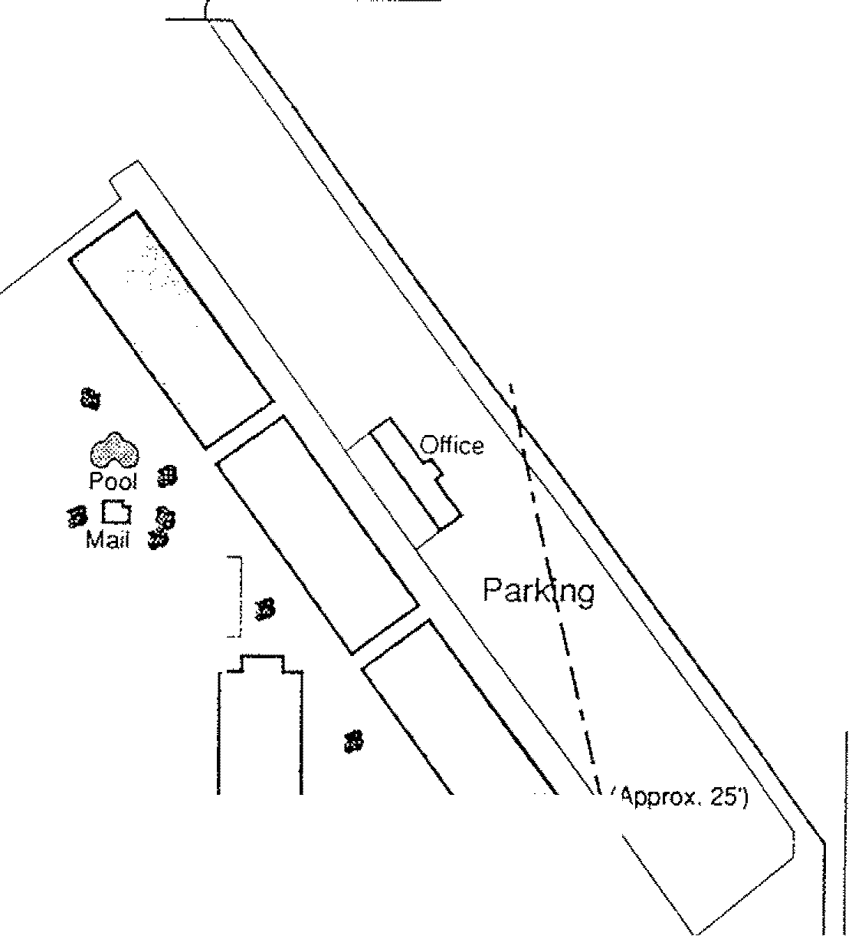
:.~_." Parking
-,'*
tl1 ---.--.---- [ _
~ 0 i Parking ~1
~ Storage I
- __ .• ._ .. __ --.J
I I

Approx. Right-ot-Way
of Service Road for the Proposed E-W Freeway
fl. (Approx. 25')
POOII· .... /."\\
.~TD \. \,
Mail Clubhouse, \ ,
, . "
#I ' \ \. ".,
" . \. "$
\. \ ) it I \ \// •
I '\
I r .... ---r----I
, I \ I
j I \ I
I •.... ----\-----'
I
~
•• lIS
I

Parking
•••
: .

~ s~~ ~ figv'" ~-toa '*'OIM-. Wf\.lit t)()It 9~Md . .v. !ecuf~ fromf~ lfii'ltbei~ au'lh:)lU1M'l fh,1'1'I'" are u~ 10 P!)I'IOfO'l a.du.e Q11i9000il0 ,;l&t.Of~ to'd1l!ltli1fy al'ld~.My('lll'\'\lTgl(r.rtaJ(n:1c:J a~ W4m'!r'O'1Q-th(]w l"-~~. t(l ~ .r.tf\9~. Wlfl'll"'" ksl:tl"l9 ~ bofJIfOfO«OCtlOdnc:
•• ••• t ••• : ,,, •• '"
IW W a:
ןm
:I:
I~
ColdweU Banker Commercitd Affiliates
76
Listing Presentations & Marketing Programs
n


1 BEDROOM, 1 BATH 615 sa. FT.

PANI t.:
KITCHEN



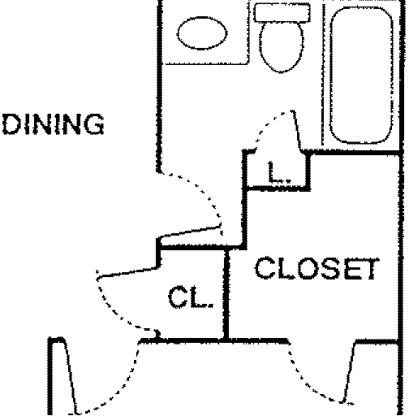

LIVING
BEDROOM

• •
10 -
: I •
I.

anI' ~t:rl~t" affj lIQ-utM ~4it'tlt!ld h.,illojn. wfllS!; t'IQ( 9U:U;JJ'lI~. N. 600Jrer:J 110m 'SO<.,l(O!M ..,.,.,. O!lIl~o .JothO/lf;JjlV'tll, •• au.,..,.... va Vl'Ifod-ll)ptorIOI'm.d=u. "I~ U4$i1itt"llWr'l1-QJd.4,nl!ty VKl ••••• .»J.u. VtY~"onn"IIItI:·Ult.kII
n~. \Ilf~·"U·"'q tQ-~l"(nrtI~~ Jj/llt10 ~.J1(.a,trQ,&t·N'~'II' wfh I,... l>&hl\<1 ~ ~Qm~1I"l9
Coldwell Banker Commercial Affiliates
77

Listing Presentations & MfUketing Programs


BEDROOM, 1 BATH STUDIO 744 SQ. FT.

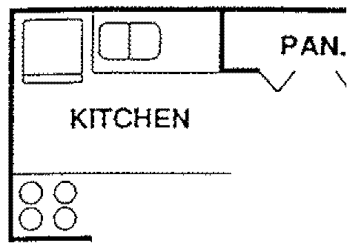
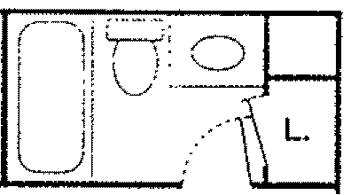
L.. -'
UVING
DINING
CLOSET
BEDROOM


OPEN



••
: .
. -
t •

rh,e .W~t- ¥Id l'ijU'Of. !')reit."t., h~.,l'\. wn''o !"oQt QV.l12J\HNd. at. &:flO.n4;d ftQtYl- ~¢oUtOM \W ~"4'; .:t.u1OO1(aif'Ye i\upn .lM VJ98d to ~l)fm •• OlJ<$ Olll9t\I('iC. ~ •• 1'\"IIIk'l110 fdM1tfy 2t'II(J l)YU)alt!l Mly ~"'I;¢n~l.-s teM ~~ .• wUrt"'9tO~Ir-.~ VfJ1o~ar.(~I' Yf1ihlhOlI'",t!~ tVO~()oofQc't't~lnQ
ColdweU Battlrer Commercial Affiliates
78

Listing Presentations & Marketing Programs

2 BEDROOM, 2 BATH 962 SQ. FT.
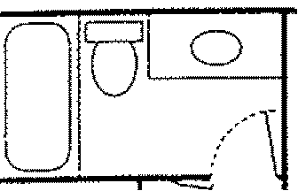
DINING
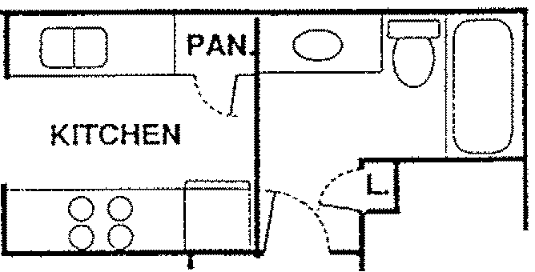
CLOSET
CLOSET
'.
CL
CL

UV1NG


BEDROOM
BEDROOM
• •
: '
..
:i ... i.
T'M: cwementt 2fl<l: Ui,ut. ~led hoe«M:t\ whiw oot 9uvaJ'rt-M<t. are IUlOJred Iron'! zouI"cliM YfoI' bflII~ .aotJlO<ltatlw. 8~ .v. •.• ~ to PtrlOt'm .a dv. dj~ .as&eI'lUT*,U to d«Itfty and O'\f~. &fly iI'!"l'VlNj(lI'f"lol!J.nia{ ttJM ;j~W,&(\'lnq IOtl"fOollrt 'he-~ N-.to ~ iJir~~t1....",p 1M Wing ~ t*~ ~lI"9
ColdweU Banker Commercial Affiliates
79
Listing Presentations & Marketing Programs


CITY OF LUBBOCK

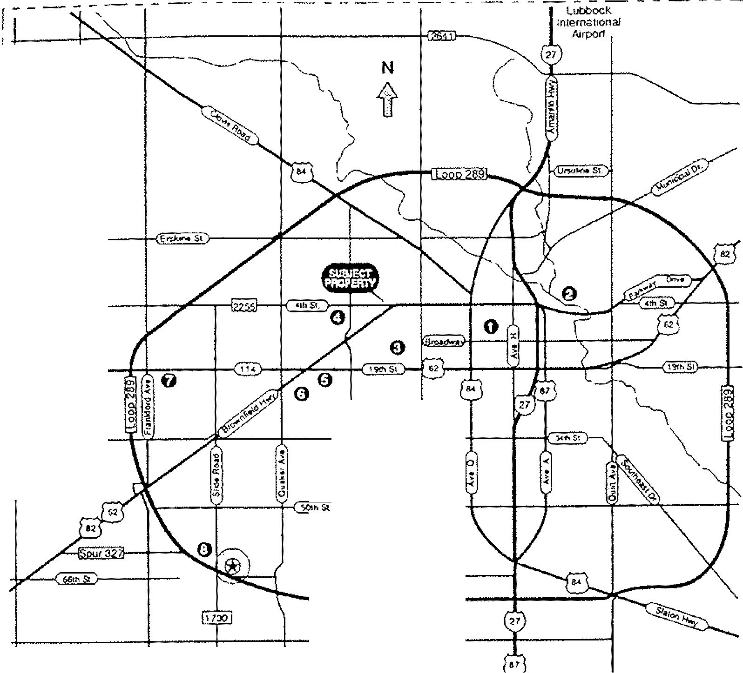
I!
I !j
('"
I
I L.
t .(
< •
~
00 28

o CWIC CeOfef &. Central 8usloess Dlstn-ct €} MacKenzie State Pari<
o Texas Tech Umverslty
() Lubbock General Hosp,tal & Texas Tem UniverSity Heallh SCIences Cenle<

«;) Methodist Hospital
() St Mary 01 The PlainS Hospital o Lubb<>ck ChnSllan University
~ Sooth Plains Mall
(~Coldwell Banket Rick Canup Reallors

ColdweU Banker Commercial Alflliiltes
80


Listing Presentations & Marketing Programs

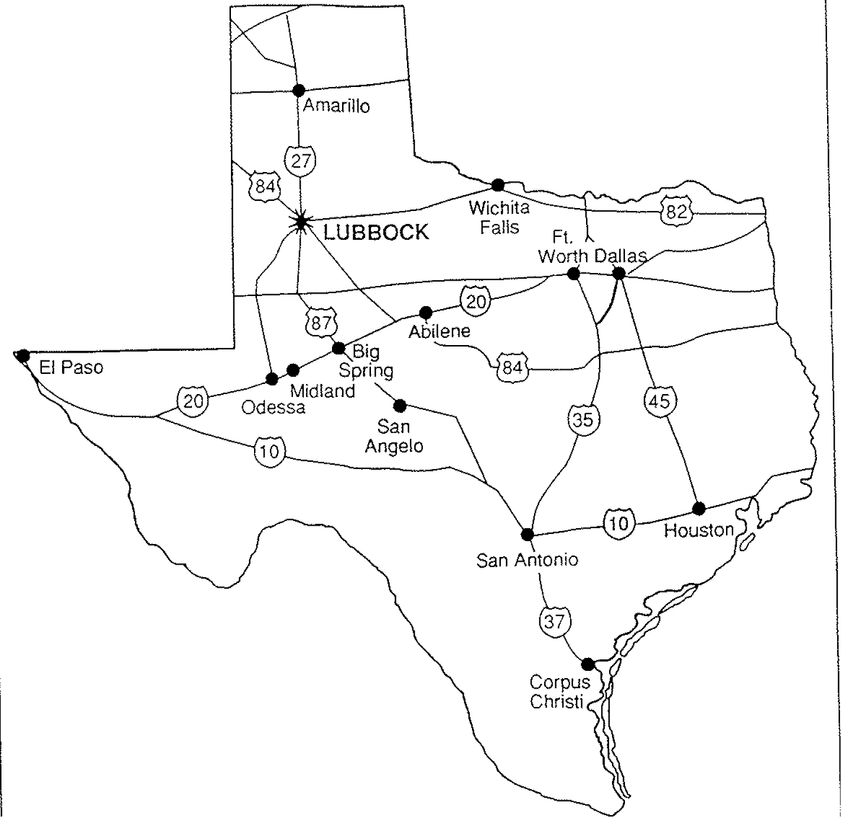

Coldwell Banker Commercial Affiliales
81

I r Executive ~
ct Summary
.,
~
~
~
~ .~
III
~ .ff .'5
"-l
V Property V Competitive V Compa'rawev-FT~ancial
Description Market Analysis Properties Aspects
Tenant Summary
Other Information
N co

