2008 NATIONAL COLLEGIATE
BOWLING
CHAMPIONSHIP

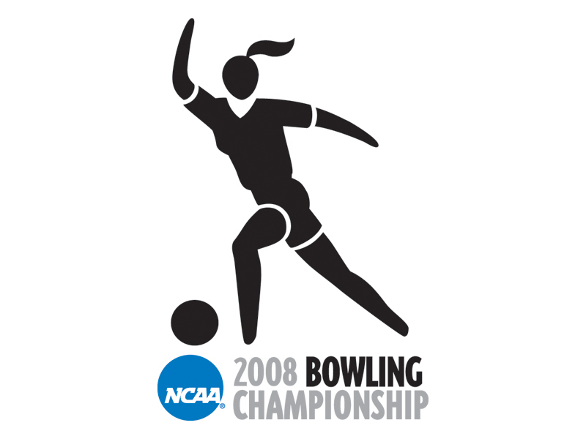

PARTICIPANT MANUAL

April 10- 12, 2008

(Sat.) 7:00 PM-Finals
Thunder Alley
Omaha, NE

UNIVERSITY OF NEBRASKA
ATHLETIC AND BOWLING STAFF

Area Code - 402

Dr. Tom Osborne One Memorial Stadium (W) 472-3011
Athletic Director

Pat Logsdon One Memorial Stadium (W) 472-3011
Assoc. AD / SWA

Bob Burton………………………………One Memorial Stadium………………..(W) 472-5663
Assoc, AD

Butch Hug Event Management (W) 472-1950
Tournament Director One Memorial Stadium (C) 540-1180 …………………………………………..Fax: 472-4662

Derek Bombeck Event Management (W) 472-9445
Assistant Tournament Director One Memorial Stadium (C) 540-2267
Fax: 472-4662

Bill Straub East College Union (W) 472-0404
Head Bowling Coach (C) 525-0404
Fax: 472-5032
Paul Klempa East College Union (W) 472-2399
Assistant Bowling Coach (C) 450-6015

Tom Dufresne Athletic Medicine (W) 472-1499
Trainer Stadium Training Room (C) 540-1394

Jess Schwager SID Office (W) 472-2263
Media Relations One Memorial Stadium Fax: 472-2005

Holly Adam Ticket Office (W) 472-3111 OR
Ticket Manager 625 Stadium Drive 1-800-824-4733
Fax: 472-0064

Camden Finney Marketing Coordinator (W) 472-4886
Marketing Coordinator One Memorial Stadium Fax: 472-9168

Dr. Lonnie Albers Athletic Medicine (W) 472-2276
Physician Stadium Training Room Fax: 472-2006

Ted Baer Thunder Alley (W) 905-2695
Owner

Brenda Stevens Thunder Alley (W) 905-2695
Operations Manager

TABLE OF CONTENTS

Championship Schedule of Events 4
Team, and NCAA Headquarters 5
Additional Hotels 6
Quick Guide to Omaha 7-9
Getting Around in Omaha 7
Omaha Airline Services 7
Bus Vendors & Rental Cars/Vans 7
Laundry & Churches 8
Local Restaurants/Cinema 9
General Tournament Information 10-14
1. Coaches/Administrators Meeting 10
- Sports Information/Media Credentials 10
- Athletic Training Services 10
- Expenses 11
- Admission – Competitors and Coaches 11
- Tickets 11
- Officials 11
- Uniforms/Benches 11
- Student-Athlete Patches…………………………………………………....11
- Souvenirs 12
- Parking 12
- Drug Testing 12
- Crowd Management 12
- Hospitality Room/Player Hospitality 12
- Press Room & Post-match Interviews 13
- Conduct of Competitors 13
- Insurance 13
- Seating 13
- Finals Coaches Meeting 13
- Thunder Alley 14
21. Map of Thunder Alley 15
22. Driving Directions from Airport to Hotels 16-17
23. County Map of Nebraska & Iowa 18
Coaches/Administrators Meeting Agenda 19
NCAA National Collegiate Bowling Checklist………………………………………..20
Travel Itinerary 21
Team Travel Party……………………………………………………………………...22
Official Team Roster Form 23
Banquet Reservation Form……………………………………………………………..24
CHAMPIONSHIP SCHEDULE OF EVENTS

MASTER SCHEDULE
(Wed.) April 9, 2008-
Committee Arrives………………………7:30a.m…………………………………Thunder Alley
Teams arrive/open practice/equipment checks 9:00-5:00p.m……………………...Thunder Alley
Coaches/Administrators Meeting……4:00p.m…………………………………Thunder Alley
Banquet…………………………………6:30p.m………………………………….Thunder Alley

(Thurs.) April 10, 2008-
Committee Arrives/Lane Conditioning 6:30a.m……………………………………Thunder Alley
Doors Open to Public 7:30 a.m. Thunder Alley
Open Practice 8:00-8:20 a.m. Thunder Alley
Announcements/Anthem 8:20-8:30 a.m. Thunder Alley
Qualifying Round: Block 1 8:30a.m-12:30 p.m. Thunder Alley
Break-lane conditioning 12:30-2:00 p.m. Thunder Alley
Doors Open to Public 1:30p.m. Thunder Alley
Open Practice 2:00-2:20p.m. Thunder Alley
Announcements 2:20-2:30p.m. Thunder Alley
Qualifying Round: Block 2 2:30-6:30p.m. . Thunder Alley

(Fri.) April 11, 2008
Committee Arrives/Lane Conditioning 7:30a.m……………………………………Thunder Alley
Doors Open to Public 8:30 a.m. Thunder Alley
Open Practice 9:00-9:20 a.m. Thunder Alley
Announcements/Anthem 9:20-9:30 a.m. Thunder Alley
Round 1 (MATCHES 1-4) 9:30-11:10 a.m. Thunder Alley
Open Practice 11:10-11:20 a.m. Thunder Alley
Round 2 (MATCHES 5-8) 11:20a.m.-1:00 p.m. Thunder Alley
Break-lane conditioning 1:00-3:00 p.m. Thunder Alley
Doors Open to Public 2:30p.m.. Thunder Alley
Open Practice 3:00-3:20 p.m. Thunder Alley
Announcements 3:20-3:30 p.m. Thunder Alley
Round 3 (MATCHES 9 & 10) 3:30-5:10 p.m. Thunder Alley
Open Practice 5:10-5:20p.m. Thunder Alley
Round 4 (MATCHES 11 & 12) 5:20-7:00 p.m. Thunder Alley
Awards Ceremony Immediately following Rd 4. Thunder Alley

(Sat.) April 12, 2008
Lane Conditioning ………………… Before 1:00p.m……………………………...Thunder Alley
Open Practice 4:00-4:20p.m. Thunder Alley
Announcements/Anthem 4:20-4:30p.m Thunder Alley
Round 5 (MATCHES 13&14) If Necessary 4:30-6:10pm Thunder Alley
Break 6:10-6:20p.m. Thunder Alley
Lane Conditioning/Announcements 6:20-6:30 p.m. Thunder Alley
Round 6 (Championship Final) 7:00p.m. Thunder Alley
Awards Ceremony Immediately following. Thunder Alley

*If there is no Round 5, doors will open and teams will be allowed to start practice at 6:00p.m.*

TEAM HEADQUARTERS

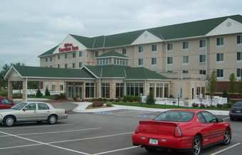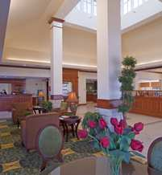
Hilton Garden Inn
17879 Chicago St
Omaha, NE 68118
$89 - 4 nights

Contact: Tami Miller
(402) 289-9696
Fax:(402) 289-2758
tami.miller@hilton.com
www.omahawest.stayhgi.com

Note: The Hilton Garden Inn has self laundry services.

NOTE: Sleeping rooms have been reserved with a check-in date of April 9th and a check-out date of April 12 or 13. Please confirm reservations with the hotel (including specific names on your rooming list) and request any additional rooms needed by teams and/or boosters. If an institution does not wish to stay at the headquarters hotel, it must obtain a written release from the hotel management.

NCAA HEADQUARTERS

Hampton Inn
17606 Arbor Plaza
Omaha, NE 68130
$89 per night
Contact: Lana Gifford
(402) 330-9500
Fax: (402) 330-9511
lana.gifford@hilton.com
www.omahawestlakeside.hamptoninn.com

Please see Page 6 for additional Hotel and Motel information for family and fans.

ADDITIONAL HOTELS

NORTHWEST OMAHA

Best Western Settle Inn 650 N 109th Ct Phone: (402) 475-9541
Omaha, NE 68154 Email: omahasettleinn.com

Comfort Suites 10503 Bedford Ave Phone: (402) 445-0400
Omaha, NE 68134 Email: choicehotels.com

Country Inn & Suites 11818 Miami St. Phone: (402) 445-4445
Omaha, NE 68521 Email: countryinns.com/omaha

ClubHouse Inn & Suites 11515 Miracle Hills Dr. Phone: (402) 496-7500
Omaha, NE 68154 Email: clubhouseinn.com

Crown Plaza Omaha Old Mill 655 N 108th Ave. Phone: (402) 496-0850
Omaha, NE 68514 Email: crowneplaza.com

Hampton Inn Westroads 9720 W Dodge Rd Phone: (402) 391-5300
Omaha, NE 68114 Email: hamptoninn.com

La Quinta Inn Omaha 3330 N 104th Ave. Phone: (402) 493-1900
Omaha, NE 68134 Email: www.lq.com

DOWNTOWN OMAHA

Courtyard by Marriott 101 S 10th Street Phone: (402) 346-2200
Omaha, NE 68102 Email: courtyardomaha.com

Embassy Suites 555 S. 10th Street Phone: (402) 346-9000
Omaha, NE 68102 Email: embassysuitesomaha.com

Hilton Garden Inn 1005 Dodge St Phone: (402) 341-4400
Omaha, NE 68102 Email: hiltongardeninnomaha.com

Hilton 1001 Cass St Phone: (402) 998-3400
Omaha, NE 68102 Email: omaha.hilton.com

CENTRAL OMAHA
Doubletree Guest Suites 7270 Cedar St Phone: (402) 397-5141
Omaha, NE 68124 Email: omahasuites.doubletree.com

Holliday Inn Central 3321 S. 72nd St Phone: (402) 393-3950
Omaha, NE 68124 Email: holiday-inn.com/omaha

QUICK GUIDE TO OMAHA

Getting Around in Omaha

If you're driving in Omaha, numbered streets run north-south, with the street numbers increasing as you travel westward. Lettered and name streets run east-west.

OMAHA AIRLINE SERVICES

Omaha is easily accessible by air, car, or bus. Nine (9) airlines serve the city. By car, Omaha is located on Interstate 80, 480, and 680. Omaha's Eppley Airport is located in the northeast part of the city.
Eppley Airport- 4501 Abbott Dr, Omaha 68110
(402) 422-6817 www.eppleyairfield.com

America West: (800) 235-9292 Frontier: (800) 432-1359
American: (800) 433-7300 Midwest Airlines: (800) 452-2022
Continental: (800) 523-3273 Northwest Airlines: (800) 225-2525
Delta: (800) 221-1212 Southwest: (800) 435-9792
United: (800) 241-6522

BUS VENDORS

Arrow Stage Lines 800-356-0727 A&B Shuttle………….. ..402 331-7558
Kincaid Coach Lines…800-407-3403 Ollie the Trolley………...402 597-3596

RENTAL CARS / VANS

NOTE: Each visiting team will be responsible for making their ground transportation arrangements. Please feel free to use the information we have provided to assist you in obtaining your ground transportation.

Avis (800) 831-2847
Budget (800) 527-0700
Dollar (800) 654-3131
Hertz (800) 654-3131
National…………………….. (800) 227-7368
Thrifty (800) 367-2277

Enterprise…………………... (800) 736-8222

MISCELLANEOUS SERVICES

Restaurants, movie theaters, shopping centers, and other items of local interest are included on the following pages and/or brochures provided in team packets afforded to Coaches, SIDs, Administrators, and Athletic Medicine Staff.

LAUNDRY

Camelot Cleaners Max I Walker
655 N. 132nd St (402) 492-8076 15627 W. Dodge Rd (402) 697-0368

Note: Laundry services are available at the team hotel.

CHURCHES

New Hope Apostolic Temple Free Methodist Church
6124 N. 99th Street (402) 733-0594 9525 Maple St. (402) 397-8014

New Creation Church Church of Nazarene Central
4801 N 144th St (402) 496-4240 8206 Blondo St (402) 393-8040

Highlands Missionary Baptist Church Grace Community Church
6202 Blondo St. (402) 551-1412 4801 N 144th St (402) 492-9111

St. Vincent Orthodox Church
St. Elizabeth Ann Seaton Catholic Church 2502 N 51st St (402) 551-9721
5419 N 114th St. (402) 493-2186

First Christian Church Peace Presbyterian Church
6630 Dodge St (402) 558-1939 333 S 204th St. (402) 289-1104

First Church of God 7th Day Adventist Church
1705 N 96th St (402) 391-1849 840 N 72nd St (402) 397-4813

Evangelical Bible Church Fellowship
7820 Fort St. (402) 571-3161 15555 W Dodge Rd (402) 333-9645

Bethany Lutheran Church
4200 N 204th St (402) 289-4440

RESTAURANTS-Village Pointe Area

Cheeseburger in Paradise 17304 Davenport St (402) 289-4210
Cold Stone Creamery 17304 Davenport St (402) 505-4192
Firebirds 17415 Chicago Cir (402) 359-1340
Johnny’s Italian Steakhouse 305 N 170th St (402) 289-9210
Kona Grill 295 N 170th St (402) 779-2900
The Melting Pot 17151 Davenport St (402) 391-6358
Mimi’s Cafe 301 N 175th St (402) 289-9610
Panchero’s Mexican Grill 17305 Davenport St (402) 934-5677
Paradise Bakery & Cafe Village Pointe (402) 934-5757
Letter Club 17404 Burke St (402) 763-8400
Scooter’s Coffeehouse Village Pointe (402) 934-9774
Tin Star 13164 B Plz (402) 333-7827
Subway 1119 N 204th near Thunder Alley
Scooters Coffeehouse 1119 N 204th near Thunder Alley
Arby’s 204th & Cumberland near Thunder Alley
Burger King 204th & Cumberland near Thunder Alley
Twisterz Sports Lounge and Restaurant 20902 Cumberland Dr. Thunder Alley
Food Court 20902 Cumberland Dr…… Thunder Alley
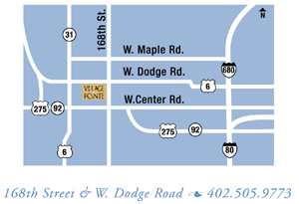

Village Point Cinema
(402) 289-4777
304 N 174th St, Omaha, NE 68118
GUIDE TO CHAMPIONSHIP INFORMATION

- COACHES/ADMINISTRATORS MEETING

The NCAA Division I Women’s Bowling Committee will conduct a meeting of competing teams at 4:00 p.m. on Wednesday, April 9th at Thunder Alley to review tournament procedures. It is mandatory that each institution’s head coach, assistant coach, and administrators present at the championship attend this meeting.

2. SPORTS INFORMATION / MEDIA CREDENTIALS

Each SID should request media credentials from Jess Schwager, Bowling Media Relations Director, (402) 472-2263. Radio stations wishing to broadcast should also contact Jess Schwager, Nebraska Media Relations. Please refer to the NCAA Broadcast manual policies and guidelines at www.ncaa.com regarding radio broadcasts.

3. ATHLETIC TRAINING SERVICES

The training room is located at Thunder Alley. The training room will be available prior to competition and one hour prior to practices. If you should need access earlier, please inform us prior to your arrival.

Physician Contacts:

Trainer: Tom Dufresne Work: (402) 472-1499
Cell: (402) 540-1394

Doctor: Dr. Lonnie Albers Work: (402) 472-2276

MEDICAL EMERGENCY INFORMATION

Alegent Health Lakeside Hospital 16901 Lakeside Hills Court (402) 717-8000
Omaha Fire & Rescue 911

ADDITIONAL MEDICAL
Alegent Health 1130 North 204th Ave (402) 289-3377
Elkhorn Family Medicine

Emergency equipment (spine board, splints, etc.) will be available for your use. Ambulance Service will be on call. A doctor will be on call during practices and in attendance at all matches.

Training Room – will be located near the Go Kartz at Thunder Alley. Trainers will be available prior to warm-ups and following matches for treatments.

4. EXPENSES

Teams will be responsible for paying all of their own expenses up front (food, lodging, medical, etc.). Expense reimbursement for participation in the 2007-08 championships will be filed through an online system. All competing institutions must request reimbursement through the new system in order to receive the appropriate reimbursement. The new Travel Expense System (TES), as well as per diem allowance policies, are available on the NCAA Web site at Travel Policies

5. ADMISSION – COMPETITORS AND COACHES

Competitors, coaches, officials, media, and event staff will be admitted by appropriately marked credentials. Credentials (13- 10 plus 3 coaches) for the official travel party will be provided in arrival packets to be distributed to coaches. All others must purchase an All-Session Ticket for $20.

6. TICKETS

Tickets are on sale at the Nebraska Athletic Ticket Office Monday through Friday, 8:30 a.m. to 4:00 p.m. (625 Stadium Drive). You may purchase tickets at Thunder Alley on Thursday, April 10, when the doors open.

TICKET COST

$5.00 per person / Single Session
$20.00 per person / All-Session

CONTACT: Holly Adam
(W) (402) 472-3111 FAX: (402) 472-0064
TICKET INFO: 1-800-8-BIG-RED

7. OFFICIALS

Officials are selected by the NCAA Division I Women’s Bowling committee.

8. UNIFORMS / BENCHES

All uniforms or apparel worn in competition or practice must comply with 2008 NCAA Women’s Bowling Rules and the NCAA Championship Handbook. During the Championship’s televised finals participating coaches must be dressed in business casual clothing at a minimum.

Warm-Up Suits. Permitted between games and for practice only. They will not be permitted during competition or on the awards stand and must be in compliance with all logo requirements. Full uniform must be worn during the competition and awards.

9. STUDENT-ATHLETE PATCHES

NCAA patches are being sent to you for placement on your student-athletes’ uniforms as a special way to distinguish your student-athletes as participants at the women’s bowling championship. Each team that has advanced to the championship is being provided with NCAA jersey patches. The preferred location for the patch is on the upper left corner of the jersey; however, the left sleeve is an acceptable alternative. If you have any questions regarding student-athlete patches, please contact Katie Holmes at the NCAA national office (317-917-6206).

10. SOUVENIRS

The official NCAA concessionaire is Event 1, a subsidiary of Gear for Sports, Inc. NCAA souvenir merchandise will be available on site. Event merchandise pre-order forms are available at http://www.ncaateamwear.com

11. PARKING

There will be ample parking for team, spectator cars, vans and buses at the team headquarters hotel, as well as at Thunder Alley.

12 DRUG TESTING

NCAA championship committees, following a recommendation from the NCAA drug-testing subcommittee, have discontinued the practice of announcing whether drug testing will be conducted at NCAA championships events.

Although knowing prior to competition whether NCAA drug testing was to occur had value for reasons of convenience, it left open the possibility that student-athletes might be tempted to use banned substances if they knew that NCAA testing was not being conducted at the site of competition.

All coaches and student athletes should presume that post-event NCAA drug testing would occur at this championship event. Please note that no student-athlete will be notified of or escorted to NCAA drug testing without the knowledge of an official, credentialed representative from that student-athlete’s institution.

If drug testing is to occur, student-athletes need to report to the designated area at Thunder Alley within 1 hour of completion of competition. A member of the institutions administrative staff will be notified before the student-athlete is taken to drug testing.

13. CROWD MANAGEMENT

The responsibility for crowd management rests with the Tournament Director & NCAA Bowling
Committee. The directors of athletics of the competing institutions are expected to communicate
with their student-athletes and fans to encourage enthusiastic support within the confines of good
sportsmanship

14. HOSPITALITY ROOM/PLAYER HOSPITALITY

The NCAA Hospitality/Meeting area will be located in rooms #4 & 5, located between the 24 Classic Bowling Lanes and the 16 Signature Lanes. Participant Hospitality will be located in rooms 1 & 2 and a portion of the Twisterz Sports Lounge and Restaurant.
(see map between pages 14/15)

15. PRESS ROOM & POST-MATCH INTERVIEWS

Press room and post-match interviews will be held in room #3, located just off of the Twisterz Sports Lounge and Restaurant.
(see map between pages 14/15)

16. CONDUCT OF COMPETITORS

The governing sports committee, or the games committee authorized to act for it, may impose any one or a combination of the following penalties on an institution or any student-athlete or representative of an institution guilty of misconduct that occurs incident to, en-route to or from, or at the locale of the competition or practice: (1) reprimand publicly or privately; (2) disqualify from future participation in championship; (3) ban the individual from participation in subsequent championship competition; (4) cancellation of all or a portion of payment to the institution of transportation and/or per diem allowance for the individuals involved; (5) withholding of all or a portion of the institution's share of revenue; (6) banishment of the institution from participation in one or more subsequent championships; (7) disqualification of an institution for a period of time from serving as host institution; (8) cancellation of all or a portion of the honorarium for hosting a championship; (9) financial or other penalties different from Nos. 1 through 8, but only if they have prior approval of the NCAA Executive Committee.

17. INSURANCE

The University of Nebraska provides comprehensive liability insurance coverage which extends to special events such as the NCAA Championships, except individual competitors shall be required to provide their own insurance with respect to participation in the Bowling matches. The University of Nebraska shall, however, provide comprehensive insurance for any injuries to student-athletes which are the direct result of negligence by the Championship host.

18. SEATING

Bleacher seating will be available during the competition. Seating will be available on a first come
first serve basis for all Thursday and Friday matches. Seating will be reserved for fans of the
qualifying teams for the Championship Match ONLY.

19. FINALS COACHES MEETING

All coaches of teams that will be participating in the Championship Finals and/or if necessary matches will have a mandatory meeting immediately following competition on Friday, April 11, 2008. The meeting will be held at Thunder Alley.

20. THUNDER ALLEY

The center has 40 synthetic bowling lanes with Brunswick pinsetters and Brunswick ball returns.

Information about Thunder Alley can be located at http://www.thunderalleyomaha.com

Each student-athlete is only permitted to use five balls during the championship. Only the official
manufacturer’s mark may be on each ball. Balls with extra commercial marks will be excluded
from championship competition.

Settee Area – Each team is permitted a maximum of 13 persons in the settee area, including the ten-
competing student-athletes. No ball bags will be allowed in the settee area. Only accessory bags
will be allowed.

Lane conditioning. Bowling lanes will be reconditioned during the break periods prior to each
round or upon the discretion of the women’s bowling committee.

The committee reserves the right to change the lane conditions at any time during the championship.

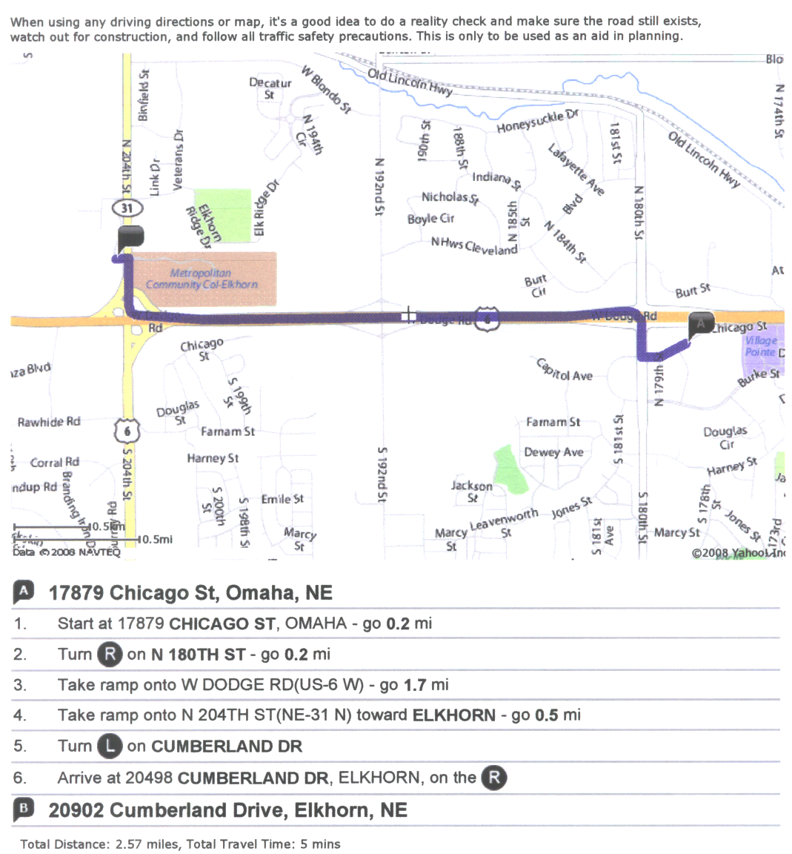
Here are the driving directions from the team hotel to Thunder Alley. If you are planning on mapping out your own driving route I found that it is best to get directions through yahoo.com as opposed to mapquest.com.
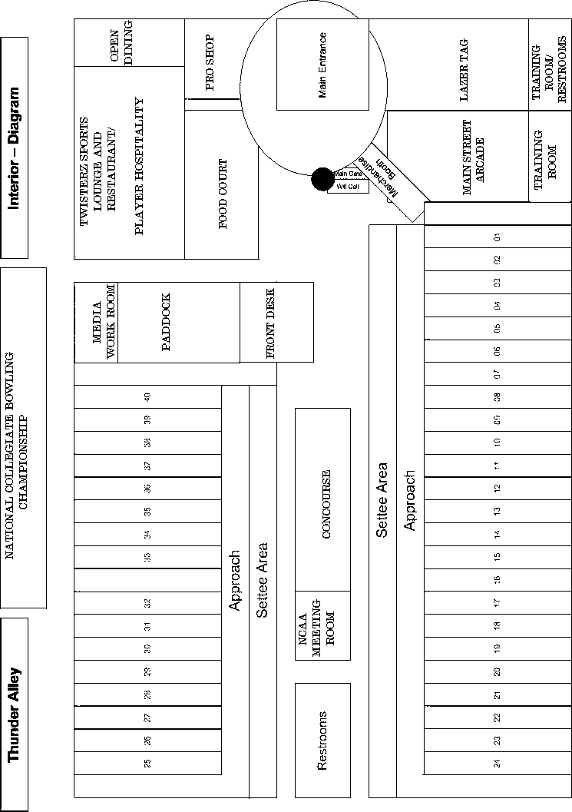
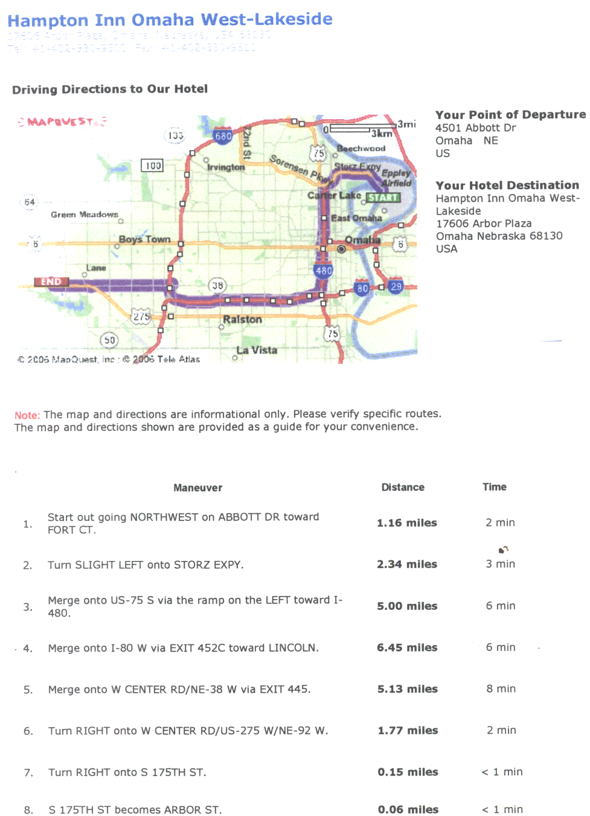
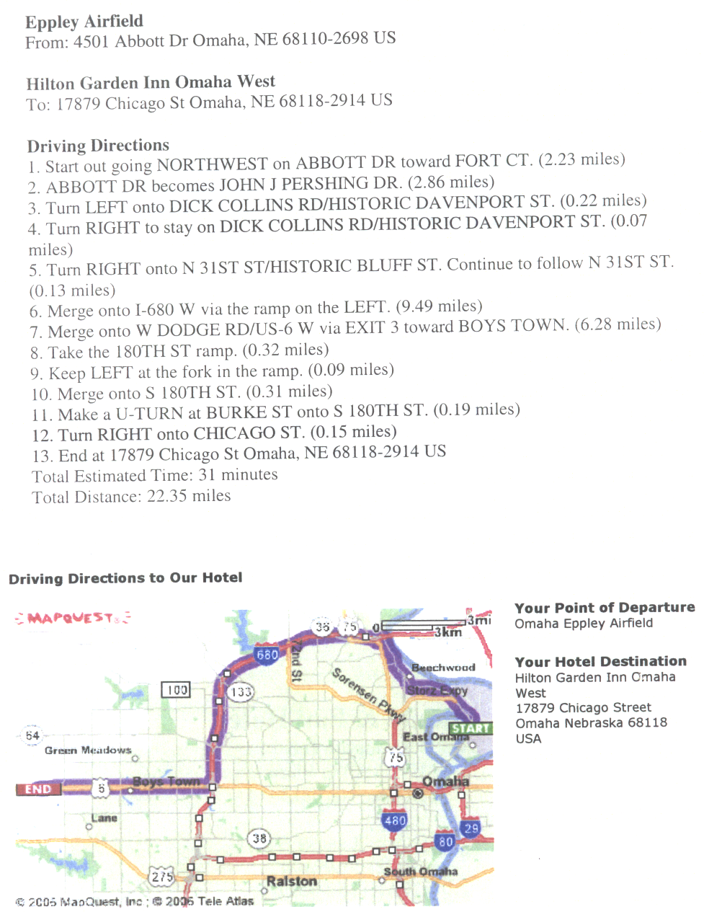
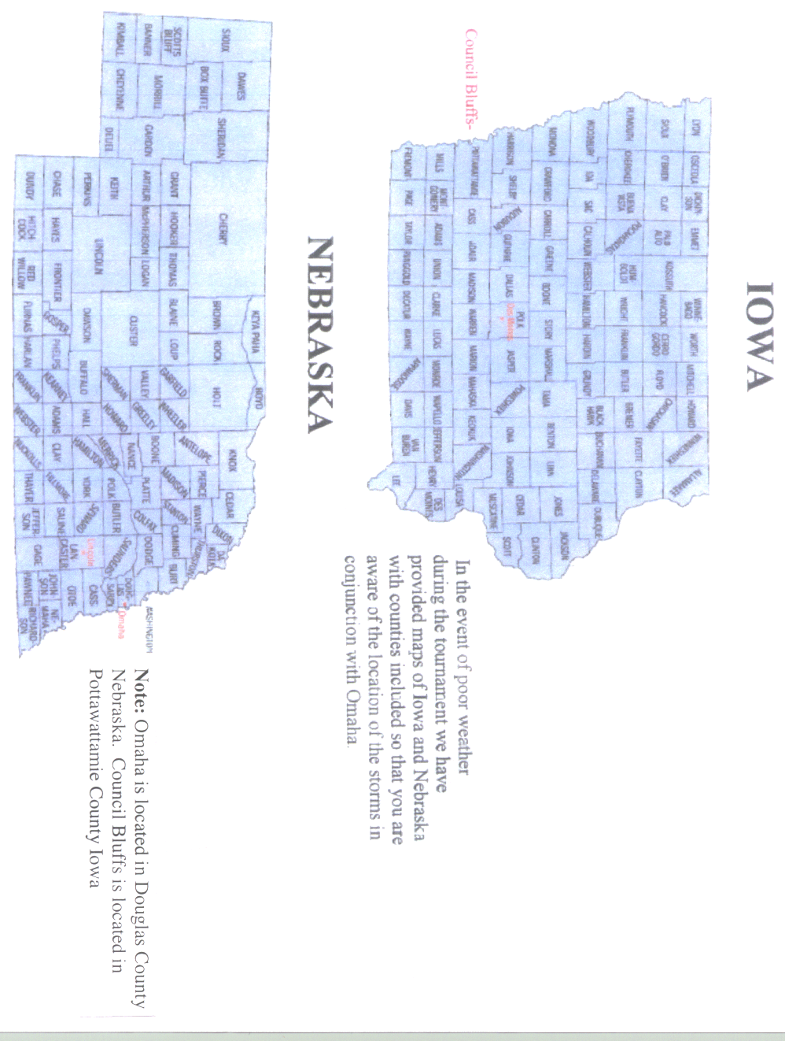
COACHES / ADMINISTRATORS MEETING AGENDA

Thunder Alley Conference Room April 9, 2008 4:00 p.m.

1. Match times
2. Lane assignments
3. Lane Patterns
4. Uniform assignments
5. Squad size/team benches
6. Practice procedures and policies
7. Schedule of events
8. Locker room assignments/location
9. Game protocol/opening ceremonies sequence
10. Warm-up procedures and policies
11. National Anthem
12. Tickets
13. Filming/videotaping
14. Match officials
15. Seating location
16. Awards
17. Post-competition interviews
18. Crowd control
19. Misconduct
20. Review medical plan
21. Drug testing, if applicable
22. Distribute championship materials
23. Other
NATIONAL COLLEGIATE BOWLING CHECKLIST

(Refer to the appropriate page in the Participant Manual for more information, where applicable.)

Make official traveling party arrangements through the NCAA Travel Service (Short’s Travel: 1-866-655-9215).

Distribute copies of this manual to all staff members who may be assigned specific tournament responsibilities (e.g., coaches, trainer, manager, designated administrator, sports information director, ticket manager).

Discuss ticket procedures and policies with your ticket manager and prepare to advise Holly Adam, our ticket manager, of your requirements. Tickets may also be purchased in advance by calling 800-8-BIG-RED. (Page 11)

Review schedule of events with the head coach and staff: news conferences, practice schedule, administrative meeting. (Page 4 & 10)

Make local ground transportation arrangements for the team, staff and fans (e.g., reserve buses, vans or cars). (Page 5-7)

By Monday, March 31st: Fax to the Hilton Garden Inn the rooming list for team block of rooms. (Page 5)

By Noon (CST), Monday, March 31st: Fax the Team Travel Itinerary Form, and the Official Traveling Party List, to the tournament director. (See attachments)

______ Team packets will be available to pick up at Thunder Alley upon arrival Wednesday April 9

______ Merchandise will available at Thunder Alley. Early order forms are available at http://www.ncaateamwear.com. The deadline for submitting early orders is 10pm Central time, Monday, March 31.

______ Banquet will take place on Wednesday, April 9th at 6:30pm at Twisterz located inside Thunder Alley. Immediately following the banquet the participants in the bowling championship will be given a card which will provide them with one ride on the Go Kartz and access to playing some of the arcade games. A limited number of banquet tickets will be available for guests at $40 per person. Names and credit card for payment must be included with banquet reservation form.

TRAVEL ITINERARY

Institution:

Arrival Date: Arrival Time:

Airline: Flying into Lincoln or Omaha ___________

Flight Number:

Departure Date: Departure Time:

Local Transportation: Cars Vans Bus

Total Vehicles

Staff Information

Person responsible for travel arrangements:

Work Phone: Fax Number: Cell Phone:

Sports Information Director:

Work Phone: Fax Number: Cell Phone:

Ticket Manager:

Work Phone: Fax Number: Cell Phone:

Trainer:

Work Phone: Fax Number: Cell Phone:

Return via Fax to: Butch Hug
By Noon, CST, Monday, March 31
FAX (402) 472-4662 Phone (402) 472-1950

2008 National Collegiate Bowling Championship

TEAM TRAVEL PARTY

PLEASE TYPE THE FOLLOWING:

Team:

Administrators:

Players:

Head Coach: 1.

Assistants: 2.

3.

4.

Managers: 5.

6.

Trainer: 7.

SID: 8.

Others: 9.

10.

Will you require any vegetarian meals at the banquet? Yes No #___________

Return via Fax to: Butch Hug
By Noon, CST, Monday, March 31

FAX (402) 472-4662 Phone (402) 472-1950
2008 NATIONAL COLLEGIATE BOWLING CHAMPIONSHIP

OFFICIAL TEAM ROSTER FORM

DATE:____________________ TEAM:_____________________________

CHAMPIONSHIP ROUND: __________________

NAME NUMBER

1. _____________________________________________ ____________

2 _____________________________________________ ____________

3. _____________________________________________ ____________

4. _____________________________________________ ____________

5. _____________________________________________ ____________

6. _____________________________________________ ____________

7. _____________________________________________ ____________

8. _____________________________________________ ____________

9. _____________________________________________ ____________

10. _____________________________________________ ____________

COACH: _________________________________________________________
2008 National Collegiate Bowling Championship
Banquet Reservation Form

Thunder Alley - Twisterz Lounge
Wednesday, April 9, 630pm

The official travel party of 13 will be complimentary. A limited number of guests will be allowed at $40 per person. Payment for guests is due at time of the reservation. You will be charged for all reservations made on this form.

Institution________________________________________________

Total number of travel party + guests_________________________

Total payment due number of guests x $40.00_______________

Credit card number ___________________ Expiration date_________

Names of guests not included on official travel party

1.___________________________________________________________

2.___________________________________________________________

3.___________________________________________________________

4.___________________________________________________________

5.___________________________________________________________

6.___________________________________________________________

7.___________________________________________________________

8.___________________________________________________________

9.___________________________________________________________

10.__________________________________________________________

Please FAX to Butch Hug by 5pm (CST) Monday, March 31st at 402-472-4662 ??’s to 402-472-1950

