Call Me SPEARHEAD
The Official Publication of the
Association of 3d Armored Division Veterans

July 1, 2004 Volume 18

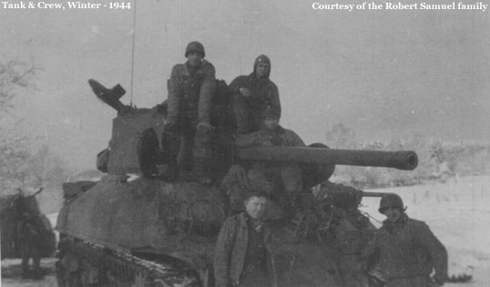

The 3AD in the Battle of the Bulge
As told in
“WWII as a combat engineer with the Third Armored Division”
By Robert T. Gravilin

On December 16, 1944 German General Field Marshall Von Runstedt attacked through the Ardennes Forest in Luxembourg and Belgium in an attempt to reach the North Sea and cut our forces in half. He attacked through the sector where the 106th Infantry Division had just been put in the line, fresh from the states. They had not seen any combat as yet. I remember they were training at Fort Leonard Wood when I was there. When the German “SS” troops with heavy armor hit the 106, there was mass hysteria. They broke and ran, not even firing their heavy artillery. When the word hit us in Germany, we were given orders to pull back through Liege Belgium and attack the Germans in the “Battle of the Bulge.” We were the Spearhead of the 1st Army and we were to join up with the 3d Army to our South in a giant pincers movement. Back through Belgium we went, driving day and night. The snow and bitter cold had not hit as yet. It was just misting and extremely foggy. We could hardly see the tank in front of us.

As we pulled south of Liege in the vicinity of Hotton, Belgium, we were trying to establish contact with the Germans. It was so foggy that we couldn’t see anything, but as we would pull down a narrow country lane, mortars and artillery would hit us so we would pull back and try another way. We couldn’t see them and we didn’t know where they were. We couldn’t have any aircraft spotters or call in air power because everything was socked in solid with fog. Finally we established defensive positions on a road between Hotton and Manhayt in the vicinity of Erezee. There were large ash trees of between 3 and 4 feet in diameter lining the two lane roadway. We put notches in the trees and wrapped explosive primer cord around the periphery of the trunks. When we exploded the primer cord, the trees fell on the roadway, blocking the road. We then laid mines in the fields on both sides of the road. We laid 1500 mines in those mine fields. We then set up anti-tank guns, bazookas, ext. (I was the bazooka man in our squad.) As the German columns advanced, they hit our road blocks. Some of the tanks tried to go around the road blocks and hit our mines in the fields. There was a terrific battle, tank against tank and a lot of artillery. The Germans fell back and we finally established a line. The weather remained cold, cloudy and rainy for days on end so we slugged it out on the ground with them, no air power. We moved in around Manhay and the Germans moved in behind us and cut us off. We were surrounded and getting pounded from all sides. A young Belgian family – mother, father, and the cutest little girl and boy were real nice to us – we took shelter in their cellar during the shelling. I gave the kids a chocolate bar I had and they sang a Belgium song to me. Later on when we came through this town after the battle of the Bulge was over, I saw their house completely burned down and destroyed. I often wondered if they were still alive. The Germans had a scorched earth policy to burn and destroy everything – so we couldn’t get any shelter or provisions.

During this time when we were surrounded, we couldn’t get any supplies or ammunition so we used them sparingly. I, fortunately, had put some “D” ration bars in my field jacket pocket so I had a little something to tide me over. “D” ration bars were kind of a semi- sweet chocolate bar about ½” thick by 3” x 5” wrapped in brown khaki colored thick waxy paper. Many times I went for days with only a couple bars. Finally we were able to radio back our position and our 105MM and 155MM artillery pounded the German lines and we were able to break through.

About this time six of us were on patrol, we went into an isolated Belgian house to check it out. As we were leaving, we saw a large German force coming up the road. They had cut us off from our lines. They were coming into the house so we went down into the cellar. We hid behind a stack of logs. The Germans came down the cellar but didn’t find us. They went upstairs and occupied the house as their C.P. (Command Post.) Our canteens were empty but there was a cistern on an outside wall that we dipped our canteens in. The water was greenish so we put the purification tablets in the canteens with the water – the water tasted horrible. Later on we round out that sheep were walking around above the cistern. We were down in the cellar for about 18 hours until our forces broke through the German lines. We thought sure we would be captured. The weather turned real bad then, blinding snow began to fall it it got down to zero and below. Our mail came up to us and Mother sent me a warm woolen khaki sweater and Dad had put a pint of Southern Comfort Whiskey in the center of the package. I was really thankful to get that. We had not received equipment for the bitter cold weather.

One of my buddies gave me a wool khaki colored hood to wear over my face with just holes for your eyes and mouth. His grandmother had knitted two of them and he got them in the mail. We were fortunate to get them because the next day the Germans overran our APO (Army Post Office) and captured everything. We captured some Germans and s supply truck the next day. We cut the German blankets in strips (They were a dark gray color) and wrapped them around our legs and bodies and put our uniforms over them. We also used paper layered under our clothes which helped. We wrapped blankets around our shoes because we didn’t have winter shoe packs. At night, you couldn’t dig in because the ground was frozen. The forests were all pines trees so all you could do was scrape the snow aside and lay pine branches down and get in our think nylon bed rolls or fart sacks as we called them, with all our clothes and shoes on and move from one side to another as you got cold. I remember my eye balls would pain from the cold. An occasional mortar or artillery shell would hit and the shrapnel would skip off the frozen ground and a lot of guys got hit at night. It got as cold as 18 to 20 degrees below zero at night. The water in our canteens were frozen, so we would put snow in our mess cup and heat it over a blow torch to make a cup of coffee with a packet of Nescafe from a “K” ration package. You couldn’t build a fire because the German’s would see the smoke and start shelling. As the Germans retreated from a town, they would burn it down so we had no shelter.

The sky had not been clear for weeks on end, just snow and cold, so we couldn’t get any air power to help us and it was difficult to get supplies to us. We would occasionally get replacements up to us for the dead and wounded. I remember when Frank Muscarello from Hammond, LA came to us. He had no combat experience. That morning we had just pushed off to capture some hills not far from Lierneuz. It was snowing so hard you could only see a few feet in front of you. As we were walking single file along the side of a narrow road, a German machine gunner opened up on us. We all hit the ditch along the side of the road. Frank just stood there frozen. I grabbed his leg and pulled him down and explained to him that they were shooting at him. The next time, I didn’t have to remind him. In fact, he beat me down. One fellow came to us as a replacement. I can’t remember his name, but I called him ‘Honest Abe’ because he reminded me of Abe Lincoln. He had been with the 1st Armored Division in the Africa and Sicily campaigns. He was shell shocked and should never have been sent up again. Whenever shelling began, he would hide under the halftrack, a tank or something and you couldn’t get him to come out. After this battle, he was sent back. Some fo the replacements would get hit, wounded, or killed before you could even find out their name.

We lost so many of our buddies in the Bulge; they were being killed or wounded at an alarming rate. Others were getting frozen-feet, hands, ect. As a result, the Army was sending a lot of inexperienced and under-trained replacements up to us. As we used to say “If they were warm and could move, they would send them into battle.” As I looked at these kids, my thoughts went back to when I first went into battle, just a scared young kid six months ago. I guess now I was considered a seasoned Veteran. As the shells would fall, guys would be hit and pieces of bodies would fly through the air. I remember one day a young replacement was brought up to us and as I shook hands with him, I heard a German shell coming in, I yelled “hit the ground”. When I picked my self up, I saw the kid with the top part of his body gone.

One of the Belgian towns we had just gone through was recaptured by a German group breaking in behind us. We attacked and retook the town where we found Belgian civilians, men, women, and children laying dead in the snow. German prisoners told us their SS officer had them killed because the children were crying. That was just some more of the many atrocities the SS troops committed. Many American Soldiers who tried to surrender were deliberately murdered by these same troops.

As the soldiers fell, they would freeze solid from the bitter cold and get covered up with snow. In addition to the hardships we encountered, our equipment many times would fail. Due to the weather, tanks wouldn’t start, vehicles froze and our guns misfired. These were undoubtedly the worse possible conditions in which to wage battle. As you moved through he snowy forests and fields, many times you would stumble over the frozen bodies, both German and American. Horses and cows were wandering around in the forests and fields in the blinding snow. Their barns were destroyed and burned down. They would get hit by shell fire or freeze or starve in the snow.

The Ardennes Forest seemed to favor the German Army as they fired barrage after barrage of artillery and mortar shells, the trees were being hit and shrapnel was flying everywhere. We had no air cover and were unable to dig foxholes because of the frozen ground. Nighttime presented even more terror. It was difficult to distinguish our troops from theirs in the blinding snow and darkness. Star shells would light up the snowy sky during their brief burning period before plunging back into the blackness of the forest. It was impossible to sleep nor was it advisable under these conditions. You would brush the snow aside under a fir tree and lay some evergreen branches down for a bed. You would dare not fall asleep and you and your buddies would keep each other awake.

Some American soldiers were found frozen with their hands tied behind their backs and naked they had been shot in the head. Belgium civilians were also found, men and women and children murdered by the Germans. The main German force we were facing was the 1st SS Leibstandarte Adolf Hitler Panzer Division, Germany’s elite division. After seeing the German atrocities, we were told to be very careful about taking prisoners.

One night about 2:30 AM, our lead tank hit a mine covered with snow in the road near Pont De Lorrain. Our platoon was called up to clear the road of mines into the town. We were told that our infantry units were in the town and had it secured. We pulled up quite a few “S” mines and as we got into the town, it was dark and snowing. There was a little light from a tank burning off in the distance. I saw a figure by the side of a building and I called out to him. “Hey Mac, what time is it?” He just ran away. A little farther down the main street of this small town, I saw another figure by a doorway. I called out to him, “What outfit is in this town?” He yelled “Americaners – Americaners” and he ran down the street. We got out of the town and radioed back for artillery. Our 105MM showered the town with white phosphorus shells and set most of the buildings on fire. We then attacked with the help of our tanks which had pulled up behind us. After we took the town, The German artillery battered us very heavily.

Sometimes the Germans would pull out of a town and leave it deserted. As we would search the houses for snipers, the Germans would have a booby trap attached to a door or something. When we opened the door, it would set off a charge in the attic that would start a fire. This would be a signal for the German artillery to open up on us. We lost quite a few guys from those shellings.

One night we pulled into a town – we surprised the Germans and they didn’t have time to burn it down. The retreated but did shell the town. I climbed in a hay loft still intact – pulled straw all around me to keep warm and fell asleep. At sometime during the night, I woke up to the noise of Germany flashlights. The flashlights didn’t have batteries in them but they had a little lever on them that would spin a small generator when they would continually push the geared lever. There must have been a dozen of them sleeping in the straw all around me, in the dark hayloft. I didn’t make a sound and finally they all crawled down from the hayloft and left.

The next day we had a tremendous tank battle as our tanks approached an open field – the German tanks were in the woods at the edge of the field which was about ¾ of a mile wide. We pulled our halftrack behind a hill and lay behind a creek bank. From early morning until late at night the shells, armor piercing and high explosive spun over our heads. Tanks and vehicles were burning everywhere with their shells exploding inside. Some tankers would come crawling over beside us – if they were lucky enough to get out alive. My canteen was empty so I dipped some water that was trickling down the creek from melting snow. I put in two halogen tablets that we had with us to kill the bacteria and drank the water. When it got dark we crawled back up the creek bed to get back behind our lines. I noticed the water was running over some dead horses and dead Germans and I had drank the water. I guess the halogen tablets killed the germs.

The next day we attacked towards a small town in the driving snow. When we reached the town, the Germans had already burned it down and there were still a few horses and cows stumbling around in the snow. “Doc” Hamann and I found part of a barn still standing and some hay left in a corner. We led the animals in the shelter and threw them some hay. That night I laid down next to a cow and laid against her belly a got a little warmth off of the cow. I remember thinking if that cow rolled over during the night it would smash me. You would never see any Belgians in those small towns. I don’t know if the Germans had killed them or they had fled before the Germans got there.

On Christmas Day, we pulled through Lierneux. There was a large church there and mass was going on so I went into the church and attended mass. We cut the Marche–Bastogne Road and set up road blocks around Soy. We had two Sherman tanks on the side of buildings where the road dead ended into another road, a “T” intersection. We set up our 57MM cannon facing down the road and I dug in with my bazooka about 50 yards further down the road. The Germans were still attempting to infiltrate our lines dressed like American soldiers and driving 106 division vehicles. We had just dug in when and American Jeep with four men with American uniforms came up the road. I got up and yelled “Halt” The kept going but a mach gun on the other side of the road started firing. The Jeep stopped and we went up to the Jeep with our guns on them. The driver and the two in back showed us their dog tags, but they didn’t speak. Next to the driver was a first lieutenant. He showed us identification but he spoke in kings English. I asked him if he thought Detroit would win the World Series. He said not, but the put up a bloody good fight. We pulled them out of the Jeep because the World Series had been between the Cardinals and Browns. It was discovered they were Germans in U.S. uniforms. We sent them back to our G-2 Intelligence group.

A little later on we heard the steel treads of a German tank coming down the road. As it got closer we could see it was one of Germany’s largest tanks – a Tiger Royal. As it got close to the roadblock, our 57MM opened up on it. I was like shooting peas at it – those shells just bounced right off it. It continued to rumble towards us. When it got alongside where I was dug in, I fired my bazooka at it. I hit the tank on its turret and that shell didn’t penetrate either – I think it just made them mad. The tank stopped began to rotate its 88MM gun toward me. Fortunately, I had cut the wire of a barb wire fence behind me, so I left the area. The tank fired a couple shells in my direction and then moved forward. As it approached the “T” intersection, our Sherman tanks with their 75MM guns opened up on the Tiger – their shells didn’t fare much better than my bazooka or 57MM shells. The 75’s bounced off the tank. The Tiger opened up on our Sherman’s and knocked them both out. In fact, one of the 88’s went in one side of s Sherman and out the other side. When the Tiger got up to the “T” intersection, it was too large to fit around the corner and it was trying to maneuver around, we called in our artillery from our 105MM self propelled guns and their shelling with white phosphorus set the German tank on fire. As the German tankers bailed out, we captured them.

The bitter cold weather stayed with us – cold and snow, so no air cover. As we moved down the roads or fields attacking the Germans, we would stay by the rear of a tank and get a little heat from the exhaust pipe. The only bad feature of that, however, was the Germans would zero in on the tanks with anti-tank artillery and machine funs. Our light tanks were equipped with a short barrel 75MM and machine guns, so they were no match for armor. They were used against infantry and ground troops. The Sherman’s were a match for the German Mark Series tanks but not the Tigers. In one sector we surrounded a large number of German troops. They were mainly Wehrmacht (draftees) but they had “SS” officers commanding them, so they didn’t give up until they were almost demolished. We lined up the prisoners and G-2’d them (G-2 means search them.) We took everything out of their pickets and threw it on a pile. An SS officer with them told me I could not search him because I was not an officer. I took his officers cap off and threw it on the ground. Then I proceeded to search him. He needed a haircut – I saw scissors on the pile so I hacked him all up. A regular Wehrmacht soldier standing next to him began to laugh. With that, the SS officer looked at him and he wiped the smile off his face and came to attention. If that officer could have had a chance to kill me, I would have been laying on the ground. Many times in battle, the SS officers would shoot their soldiers if they tried to retreat.

That evening my buck sergeant, John Schnor and I visited his brother in one of our 105MM self propelled artillery companies. They had moved in behind us. In the edge of a little town nearby, we saw a butcher shop. We went in and asked him if he any steak (in our broken French) He said, “oui, si fait”; (yes, yes indeed) He went out of the back of the sop and soon appeared with some large red steaks. We gave him some Belgian Francs for them and took them back to our squad. Using the blow torch and a large frying pan, we had liberated in Germany, we fried the steaks – they really tasted good. It had been a long time since we had fresh meat. Later on when we moved out of the little town into battle again, we saw where he had gotten the steaks. There was a knocked out German field artillery piece with two dead horses pretty well carved up laying in back of the butcher shop.

Another big tank battle the next day, toward dark I climbed up on one of our Sherman tanks with the hatch open on top of the turret. I was checking to see if anyone was alive inside. Just as I got on top and looked in the open hatch, an 88MM from a German Tiger tank fired point blank at my head – the tank was just about 10 yards from me behind a bush. The concussion from the 88 blast knocked me off the tank, even though the shell narrowly missed me. I moved pretty fast getting out of there. After those huge tank battles the fighting settled down to slugging it out in the forest hills and valleys. It was still bitterly cold and more snow fell. Our bombers and fighters still could not get airborne to help us.

The Germans were counter attacking and we were dug in around a valley which they were attempting to come through. We had dug holes by using dynamite and TNT to break the frozen crust. We had to stay awake because some of the infantry troops assigned to assist us had fallen asleep in their fox holes and the Germans snuck in and slit their throats at night. That is one of the most miserable feelings when you are so tired but you dare not fall asleep. We hadn’t slept for at least three days and night. We could hear German tanks starting their motors in the distance so we laid mines and concertina (concertina was barb wire rolled in coils) in the valley where they would attack. Later that night they did attck. Their tanks hit the mines and their infantry got tangled up in the barb wire and were cut down by our machine guns zeroed in on the valley. As they came to our positions our artillery fired star shells in the air, lighting up the whole area. Finally the sky cleared up and our bombers came over dropping us provisions and catching the German columns lines up bumper to bumper, or tank to tank on the roads. From dawn until dark our heavy bombers from the 8th Air Force and our fighter bombers assigned to us, bombed and strafed the German vehicles and troops. Cheer went up from all of us at the sight of our planes. Fires and dense smoke went up from the tanks, halftracks, gas trucks, ext. The Germans could not maneuver their tanks on the narrow roads with forests lining the road so the had nowhere to go.

The next day clouds moved in so no Air Force, but they had knocked out the heart of the German drive. We then pursued the retreating Germans with occasional rear guard action from them. We joined up with the 3rd Army toward the end of January and pulled back for a rest and re-equipment in the town of Durbuy, a kind of resort town in peace time. Here we stayed in a big hotel with no heat or plumbing. We dug latrines behind the hotel and used a blow torch turned on a radiator for heat. But it was a welcome relief to get out of the bitter cold and a foof over our heads. Those of us who were Catholic went to mass in a little stone church. The mass was said by a Belgian priest who spoke a little English. The Battle of the Bulge was undoubtedly on of the worst battle of the war.

This article is part of a biography written by Robert T. Gravlin. Bob joined the 23rd Engineer Battalion at St Lo and fought with them to the end of the war as a combat engineer. I met Bob at several WWII reunions I attended. Bob gave me his biography with permission to use it for the Association. I hope more veterans of WWII, the Cold War, and Desert Storm will consider writing their memoirs as well. Without people doing this, our memory will fade into forgotten history. We need more stories like this for both the newsletter, and the website. Please help us record the history of the 3d Armored Division so the efforts of all of us will never be forgotten. Send your articles to clmech@ptd.net or fax to 717-336-0693. I will also be coming to the reunion with video and audio recording equipment. I would like to record the stories of anyone who would be wiling to provide them.

Steve Depuy – Newsletter Editor

President’s Letter

Dear Spearheaders:

I hope all is well with each of our members and your families. I would encourage each of you to stay on top of your health and visit the doctor for a check up. I just had a scare with melanoma skin cancer but I caught the problem early and my prognosis is very good. We will get the oil changed in our cars every 3000 miles & even take our pets to the vet every year but we often neglect looking out for ourselves. Think about it!!

We are having our annual election for three positions on our Board of Directors. Please take the time to review the election section of the Forum Boards. This section of the Forum Boards allows each of our members to question the candidates running for election. We have four members running for election to the Board of Directors. They are Dan O’Leary, Steven Depuy, Jon Tellier and Hal Dudley.

Along with this election we will be saying good by to two directors who have served the A3ADV with distinction. Carl Erickson and Daryl Gordon serve as webmasters and have been driving forces behind the growth of the A3ADV. They both have spent countless hours organizing reunions, attending meetings, working on the website, answering phone calls and responding to mail to help the A3ADV grow. Your hard work has not gone unnoticed and your efforts are in keeping with the finest in Spearhead Traditions. Thank you Carl and Daryl! Job Well Done!

We are in the final stages of planning for the 2004 Reunion Columbus. Please help by registering early. Don’t wait until the last second to register for the reunion because we need to make sure the hotel staff can accommodate us at each meal and at each meeting. Do you want to attend a tour during the reunion? Let us know by registering because we will have limited space on the tour busses.

As I close out this section of the newsletter I hope that each of you knows that we have our brothers and sisters in harms way. The current members of the Bandits, Iron Dukes, Gunners, Spartans and the 54th FSB are all fighting in Iraq. Please remember them in your thoughts & prayers!

I look forward to seeing our members in Columbus

Kevin Colson
President
Iron Dukes 85-89

Commanders of the 3AD

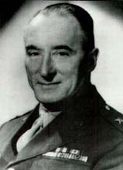

Lieutenant General Alvan Cullom Gillem Jr., was the first commander of the 3d Armored Division. General Gillem was a veteran of WWI. In 1940, he was the commander of the 66th Infantry (Light Tanks). At that time, it was the Army’s only Tank Regiment and he became one of the leaders in the establishment and development of our Armored Force. General Gillem commanded the 2nd Armored Brigade, and then General Gillem commanded the 3d Armored Division from April 1941, to January 1942. General Gillem helped instill “by word and deed”, the fiercely proud esprit de corps which lingered in the Spearhead division long after he had been promoted to higher command. General Gillem went on to command the II Armored Corps, and the Armored Command at Fort Knox Kentucky. He then took the XIII Corps to Europe in WWII. The XIII Corps pierced the Siegfried line and fought its way within 50 miles of Berlin. This was the closest American troops would come to the capital prior to VE Day. General Gillem was selected to command the Armored Task Force that was scheduled to invade Japan. But VJ day made this not necessary. In 1947, General Gillem was appointed Commanding General, Third Army with its headquarters at Fort McPherson, Georgia. He remained in this command until 1950 when he retired as a Lieutenant General with over 40 years of service. General Gillem ended his career at the same place it began, Fort McPherson.

It is our intention to continue this series and do an article on each commander of the 3AD in the newsletters in the order that they commanded the division. Any information you would have available to help give proper homage to the commanders would be appreciated.

On the Web

Have you seen the new forum section on the website at www.3ad.org ? All members in good standing are eligible to join up. Come join us as we solve all the world’s problems through great discussion of current events, and also remember the days gone by. Many of us have also gotten Yahoo instant messenger ID’s as well. We have been leaving our Yahoo ID’s in one of the forum sections on the website. Come join the fun, get into the forum section. And get a Yahoo ID and join us each day for discussion. We also need help with the website. We need people to take responsibility for units in the unit website section and in the forum section. Don’t just be a spectator, get into the game. Contact Kevin Colson at president@3ad.org and help out today.

Spearhead in the News

The swift dramatic charge of tanks through a confused and disorganized enemy makes headline news, but the success of these spearheading elements is often made possible only by the ground work of infantry soldiers who are part and parcel of every armored division. The blitz boys don’t ever go along just for the ride. Take, for example the night of battle experienced by a platoon of “Charlie” Company, 36th Armored Infantry Regiment, a unit of the 3d Armored “Spearhead” Division, in the taking of Fliesleden, Germany. The men of “Charlie” jumped off one black morning in March. The 3d Platoon commanded by Lt. Carl W. Schrieber, Harrison, Ohio led the first wave. The route of approach covered 4,000 yards of bare terrain which offered no protection from enemy fire. As the platoon approached Fliesleden, S/Sgt James G. Johnson, of Sugar Row, Va. who with his squad had been dispatched as right flank guard noticed a battery of five 88MM anti-tank guns firing across the company into another task force some thousand yards away. Lt. Schrieber and Sgt Johnson and his men ran for the nearest gun, and were almost upon it when the German artillerists noticed the attack. They began to fire small arms at the Americans. At the same time, the Jerries hurriedly attempted to hitch their high velocity weapon to its prime mover, a half-track so that they might retreat. Leading a wild charge, Lt. Schrieber, Sgt Johnson, and Edward “Paratrooper” Hughes of Sydney, Ohio ran into the midst of the enemy and initiated hand-to-hand fighting. The enemy force quickly surrendered and the platoon continued on its way. Sergeant Johnson and his squad immediately circled to the rear of the other four 88’s and found a position where they could pin down the crews with automatic fire from small arms. Two American tanks were then called up to finish the job. Advancing finally into the town, the platoon was suddenly surprised by an enemy half-track which advanced at high speed, machine guns blasting. Lt. Schrieber called for one of his grenadiers, and Pfc. Louis DiGiambattisti of Cliffwood N.J. dropped a white phosphorous rifle grenade into the German vehicle, smashing it completely. The fire from the burning half-track soon lit up the entire area so brightly that it made the platoon position dangerous. Lt. Schrieber then decided that the safest course was a further advance. Street by street, house by house, the platoon fought into Fliesleden. After penetrating the town for a considerable distance, the armored infantrymen halted for a breather. Lt. Schrieber heard a sound nearby and climbing a wall looked over into an adjacent courtyard to find that he had almost blundered into one of the enemy’s most potent tanks, a King Tiger! In the darkness, the huge vehicle looked bigger than a battleship but its turret was open and there lay the key to conquest. Lt. Schrieber lobbed a grenade inside and killed or wounded the entire crew. At dawn, the 3d Armored Division tanks roared on through Fliesleden for a spectacular advance. It had been a satisfactory nights work, but not unusual.

This article is from an article clipped out and sent to me by Ray Reeder, a WWII veteran of the 3d Armored Division. I do not know what paper it was originally printed in since that part of the paper is not present. We hope to make Spearhead in the News a regular feature of the Newsletter, please forward any articles you might have that speak of the history of the 3d Armored Division to clmech@ptd.net or fax to 717-336-0693

Association Store

Have you checked out the Association Store recently? There are many new items available. We have a “WWII” coin that has been struck to honor our WWII veterans. You may order the new WWII commemorative print to hang in your home or office. Check out the store on line, or come to the reunion and see the great new merchandise available to show the world that you are a Spearhead Vet. Check out the store at www.3ad.org/store today or write them at A3ADV Store, C/O Dave Feller, PO Box 556, Waukesha, WI 53187-0556.

Editorial

On May 29th, 2004 our government dedicated the WWII memorial in Washington D.C. The veterans of WWII have been rightfully called the greatest generation. The bravery and sacrifice made by the men who fought in WWII stands second to none. When you read Robert Gravlin’s account of the Battle of the Bulge, and realize the conditions the men of the “Spearhead” Division fought under during that winter, it makes you realize a lot more happened than we have seen in the movies. Just as the 3d Armored Division did not receive much credit for what they accomplished in Desert Storm publicly, the sacrifice of the division during the “Battle of the Bulge” has also been mostly un-noticed. We have all heard of the bravery of the men of the 101st Airborne holding Bastone. And we had understood that General Patton’s 3d Army broke through the German lines to relieve them. But few people have ever heard of the small brave engineer company that kept blowing up the bridges slowing up the German armored advance you can read about in an excellent book called “The Devils Advocate”, or the brave men of the 3d Armored Division who froze to death breaking through the toughest armored unit in the Nazi army. According to the accounts in Robert Gravlin’s story, you see a tremendous difference in how people reacted to the enemy. The inexperienced men of the 106th Infantry abandoned their equipment and fled when attacked. The men of the “Spearhead” division used what they had to slow down, and defeat the enemy, even when they did not have what would have been considered the proper equipment to do the job. When Robert Gravlin’s unit heard the German armored vehicles start their engines to prepare to attack. They slipped out and mined the area, set up barbed wire, and used what they had to stop the enemy. Firing a bazooka, and a 57MM cannon against a Tiger Tank would seem like a hopeless cause. But because of their bravery, they stopped the attack and held on until the weather broke and our Air Force broke the back of the enemy. A lot of brave men gave their lives to accomplish this. If they had broke and run as the 106th was said to have done, the entire war could have turned out much differently. Germany was on the verge of producing a new generation of weapons that could have turned the tide of the war. If Von Runstedt had broken through our lines, it would have been a disaster. But due to the bravery of the men of the WWII generation, the evil of the Nazi empire was defeated. Robert Gravlin gave me his memoirs over 3 years ago. I only began to read it the past few months. I am so grateful to him for recording this history for us. We constantly have messages left on the guestbook by relatives of deceased members of the 3AD who want to know what their relative did when he served with the “Spearhead” Division. Very few of us have taken the time to record our experience, whether in WWII, the Cold War, or Desert Storm. I appeal to all of you to please help us preserve that history so it will not be forgotten. I am going to be at the reunion with video and audio recording equipment. If you are there, please give me a little of your time so that I can record your story. None of us think what we did was all that important, but others find it very interesting.

Steven Depuy
Editor
A3ADV Newsletter

The views expressed in the editorial section are those of the writer and are not necessarily the views of the A3ADV. If you would like to submit an editorial for the newsletter, you may e-mail it to clmech@ptd.net, Fax it to 717-336-0693, or mail it to A3ADV Newsletter, PO Box 269, Reinholds, PA 17569

Mail Bag

The following letter was submitted by Hap Paulson, a veteran of the 703’d Tank Destroyer Battalion in WWII.
“Since you have been printing nostalgic stories from the “old” Spearheaders, I thought you might be interested in how the poorer member (703 TD) might have lived. “
Stolberg
The tank destroyers they will say, were lightly armored built for speed.
You never could “button the tank up”, because it had no roof indeed.
In the prolonged battle for Stolberg, no tanker allowed his head to be seen.
They dropped the “escape hatch” to the ground, ration boxes became their latrine.
As our task force rolled across the plain, I was ordered to “stay out of town”.
With your open turrets I was told, “one grenade could take your tank down.”
Wow, on this open plain, where could I go? With that problem, I was grappling.
How do you hide an M-10 tank, behind a five foot sapling?
In the surrounding hills was the Wehrmacht. Wolfgang, Gerhardt, get Max and Willi
The observer cried, ‘We have sitting ducks, and we can knock them silly”
Their first round was “short”, they adjusted. Their next barely “over”, it could have singed my neck.
I roared, “turn them over, move them out”, before they fire for effect.
We roared into Stolberg, on a different route, no one from our task force was near.
We left two men in each tank, the rest deployed, all of the nearby houses to clear.
Our prisoner total, netted just one. But to whom could he be sent?
No contact with any of our task force, it truly was puzzlement.
While the prisoner slept a restful sleep, we had to maintain a guard.
We had to have our vehicles manned, and place outposts it was quite hard.
Two days later, we contacted our task force, gave them our prisoner to keep.
When one of my weary tankers said, “maybe now I can get some sleep”
“Looking forward to the Columbus reunion, Vaya Con Dios,” Hop Paulson, 703 TD

Membership Report

Total Memberships 781

Lifetime Memberships 274

Annual Memberships 477

Associate Memberships 16

Memberships inactive <177>

Members who have passed away <14>

Active Members 584

Candidates for 2004 BOD Election

The candidates for BOD election appear in alphabetical order by last name.

Hal Dudley

Hal was a member of the 3d Armored Division from June 1981 to June 1991. Hal was with 3-12 Cav. from June 1981 to June 1984, and then moved to the division HHC, G-3 Training Section, where he was the NCOIC as well as the Night NCOIC and NCOIC of the Division TAC. Hal spent three months in 1987 in G-3 Plans and then in September 1987 moved to be the First Sergeant of HHC 3d AD. In December 1990, Hal helped prep the HHC for deployment to Desert Storm and once in Saudi Arabia, Hal took over as the Sergeant Major of the TAC.

Hal has worked with the Association of 3d Armored Division Veterans for several years as a member of the Board of Directors, Vice President and web page master for the Division HHC and Division Cavalry pages. Hal also was part of a group that attended the convention of the 3d AD WWII Association, made presentations about a coming together of the two associations and helped represent the A3ADV. Hal even went so far as to become a life member of the WWII Association. Hal is the only incumbent running for re-election this year.

Hal wrote to the newsletter, “I would like to continue to be a member of the Board of Directors to assist with the coming together of the two associations. I surely want to keep the memory and legacy of the 3d Armored Division alive. Please, consider me for election to the Board of Directors. Thanks, Hal”

Steven Depuy

Steve served with the 3d Armored Division from 1976, until 1979. Steve was trained as a scout, but upon his arrival at Ayers Kaserne, it was noted that he could type and he was offered the job of Brigade Re-enlistment office clerk. Steve served in the role until mid 1978. At that time, he desired to work in the job the Army had trained him for. He transferred to CSC 2/32 Armor and spent the remainder of his tour as an M-113 driver and a Dragon missile gunner. Steve was honorably discharged from active duty in 1979. In 1981, Steve enlisted in the PA National Guard and served as the company clerk of HQ & Co B, 103rd Medical Battalion, 28th Infantry Division. In 1984, Steve was honorably discharged from the guard.

Steve became a member of the Association in July of 1999. Steve served on the board of directors from 2000 until 2002. Steve was the Vice President of the Association from 2000 until 2001. Steve also served as the Secretary/Treasurer from 2000 until 2001, and the Treasurer from 2001 until 2002.

Steve wrote to the newsletter, “If elected, I intend to submit my name for the Association Secretary position for the next year to replace Daryl Gordon who is stepping down after serving in that role for the past 3 years. I feel that since I have previously held this position, I can make the turnover experience less painful to the Association after losing someone as vital as Daryl has been the past 3 years.”

Dan O’Leary

Dan arrived at Ayers Kaserne in April 1962. He was assigned to 2 MTB 1st Cav. He was a wheeled vehicle mechanic. After three months, he became the 1st Sergeants jeep driver. The last 12 months, he was the parts clerk. He left Ayers in October of 1964, as a member of the 3/33 Armor. Dan received an Honorable Discharge 30 Sept.1967.

Dan joined the Association in May of 2000, and he became life member this year. Dan has been working behind the scenes, through the guestbook looking for new members. Dan has been replying to each entry in the guestbook, with information on joining the Association and the reunion. Dan has compiled a list of all entries for the 33rd Armor and 2/1st Cav. from the start of the Association. Dan is also listing all other entries which he uses to connect old buddies.

Dan wrote to the newsletter, “If elected I would like to work on membership, and more outreach to people who sign our guestbook. Membership is the key to success and growth.”

Jon Tellier

Jon served with the 3d Armored Division from 1989 to 1990. Jon served as a platoon leader in D Company, 4-18 Infantry. Jon served in Desert Shield/Storm as a member of the “Diggin Higgins” Brigade. Jon was awarded the Combat Infantryman’s Badge, and Bronze Star during the conflict. Jon also served as a paratrooper in 3-325 ABCT in Vicenza, Italy from 1990-1994. He was an ROTC Instructor at the University of Mississippi from 1994-1996. He was the Commander of A Company, 3-325 PIR at Fort Bragg, NC from 1996-1998. And he was the Commander of HHC 1-1 Infantry, USMA from 1998-2000. Jon is currently assigned to DAD, USMA serving as Military Academy Liaison Officer.

Jon joined the Association in 2000 and has been a member in good standing since that time. He has responded to the call for volunteers to run for the BOD put out by the current leadership.

Jon wrote to the newsletter, “I would like the opportunity to work with the board, members (current and future) and other organizations to build on our existing foundation to create an association that remembers and commemorates the honors and traditions of the 3AD as well as promotes their accomplishments and achievements. I feel I am uniquely qualified to serve in this capacity since I served with the division in both peace and conflict and have the time to devote to achieving our goals and objectives. Members who join should have the resources to search and find those they served with as well as add information to the bulletin decision making, and remembrance of our long distinguishing history. As an association, we should seek ways to employ our resources, ideas, and extensive networking capability to maximize our membership opportunities and make us competitive with other organizations. Finally, we should strive to make A3ADV a center of excellence sustainable not only today, but for years to come.”

Association of 3d Armored Division Veterans
2004 Annual Reunion
Ramada Plaza Hotel & Convention Center
Columbus, OH

Event Schedule

Date | Activity | Time | Place
Wednesday  July 14 | Registration  Spearhead Bar  Welcome Party  (Complimentary hors d’oeurves, cash bar) | 3pm – 9pm  9am – TBD  7:30pm – 9pm | Toledo Room  Toledo Room  Convention Center
Thursday  July 15 | Continental Breakfast a la carte  Spearhead Bar  USAF Museum, Wright-Patterson AFB Tour  Longaberger Homestead Tour  Veterans Administration  Registration  Oktoberfest (Cash Bar) | 6am – 8am  9am – TBD  8am – 4:30pm  8am – 4:30 pm  9am – 3pm  5pm – 9pm  6pm – 8pm | Spearhead Bar  Toledo Room  Front of Hotel  Front of Hotel  6th Floor  Toledo Room  Convention Center
Friday  July 16 | Continental Breakfast  Spearhead Bar  A3ADV Business Meeting  Ladies’ Luncheon  Men’s Luncheon  Registration  Italian Buffet (Cash Bar)  Dance | 7am – 9am  9am – TBD  9am – 10:30am  11:30 – 2pm  12pm – 2pm  5pm – 9pm  6pm – 8pm  8pm – 11pm | Spearhead Bar  Toledo Room  Convention Center  Convention Center  Convention Center  Toledo Room  Convention Center  Convention Center
Saturday  July 17 | Continental Breakfast  Memorial Service  Mini Deli Buffet or Lunch on your own  City Tour and Motts Military Museum  Catholic Service  Protestant Service  Banquet (Cash Bar) | 7am – 9am  9am – 10:30am  10:30 – 12:30pm  12:30pm-4:30pm  3pm  3pm  6:30pm | Spearhead Bar  Convention Center  Convention Center  Front of Hotel  Convention Center  Convention Center  Convention Center

Association of 3d Armored Division Veterans
PO Box 681486, Indianapolis, IN 46268-1486
2004 Annual Reunion Registration Form

Name _____________________________________________________ E-Mail __________________________________

Address ______________________________________ City ____________________________ Zip Code _____________

Member #________ Unit & Years __________________________________________ Telephone ____________________

Guest(s) Name(s) and relationship (ex: Marcia, Wife, Robert, Son, Ect.)

____________________________________________________________________________________________________

Number Amount Subtotal
Reunion Registration _______@ $40.00 ___________
(Includes Saturday Banquet Dinner)

Thursday, July 15
Day Tour to USAF Museum at Wright-Patterson AFB _______@ $24.00 ___________
(Lunch and Imax Theater are on your own)

Day Tour to Longaberger Homestead _______@ $24.00 ___________
(Lunch is on your own)

Oktoberfest Buffet Dinner _______@ $20.00 ___________

Friday, July 16
Men’s Luncheon _______@ $20.00 ___________

Ladies Luncheon _______@ $20.00 ___________

Italian Buffet Dinner & Dance _______@ $24.00 __________

Saturday, July 17
Mini Deli Buffet Luncheon _______@ $15.00 __________

Motts Military Museum & City of Columbus Tour _______@ $24.00 ___________
(Includes cost of admission to Mott’s Miltary Museum

Total Registration Fees ___________

Enclosed is: (circle one) Check Money Order

Please charge my credit card for the total shown

Credit Card Number ______________ ______________ _____________ ______________ Exp;_____________

Signature:____________________________________________________________________________________________

WWII Commemorative Print & Coin

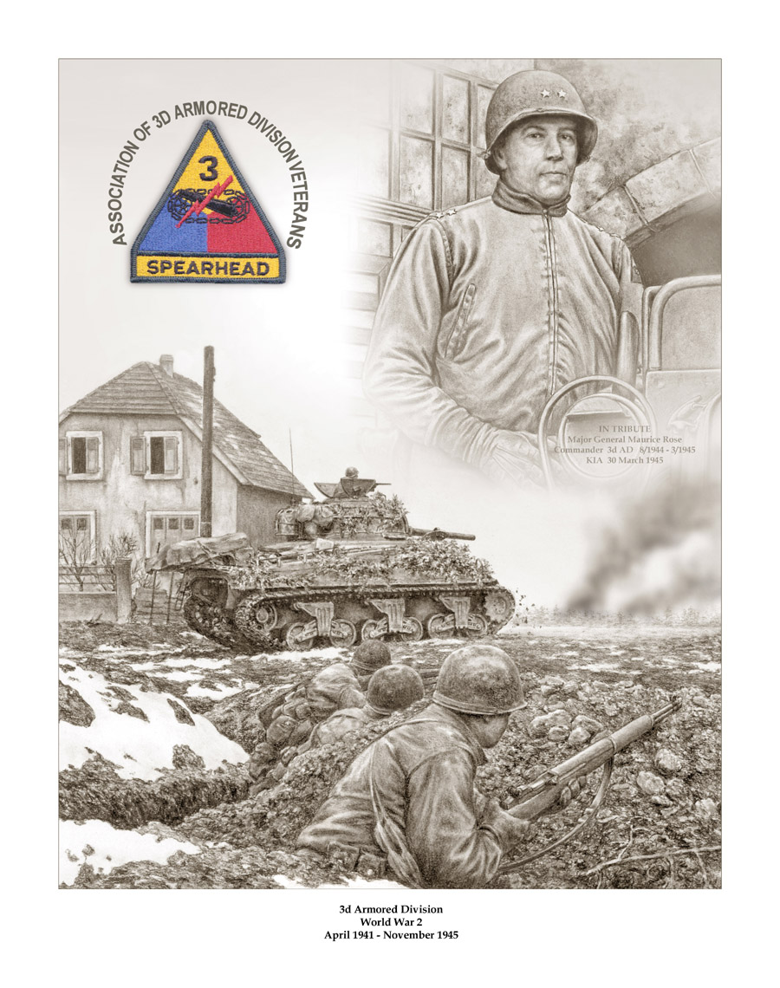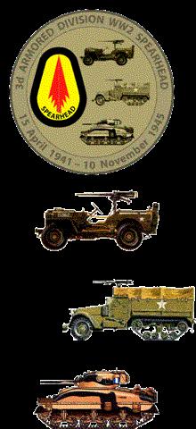

The Association is currently accepting orders for a print we have had commissioned to honor the WWII veterans of the Division, and General Maurice Rose, the division commander who was killed at Paderborn. You can order a print for $50 which includes shipping. We have also had a WWII commemorative coin struck to honor our WWII veterans. We will have both items available at the reunion. You may also purchase a copy by contacting the website store at www.3ad.org, or write A3ADV Store, C/O Dave Feller, PO Box 556, Waukesha, WI 53187-0556.

2004 BOD Election Ballot

Mail your ballot to;

Association of 3d Armored Division Veterans
PO Box 681486
Indianapolis, IN 46268-1486

Ballot must be mailed by July 7, 2004 in order to arrive in time for the election. If you are attending the reunion, you do not need to mail your ballot as all members present at the reunion will be able to vote there. Ballots not received at our PO Box by July 13 will not be counted.

Mark space to left of name. Please only vote for 3 candidates
Hal Dudley
Steven Depuy
Dan O’Leary
Jon Teller
Member Name
Member Number
Date
Signature

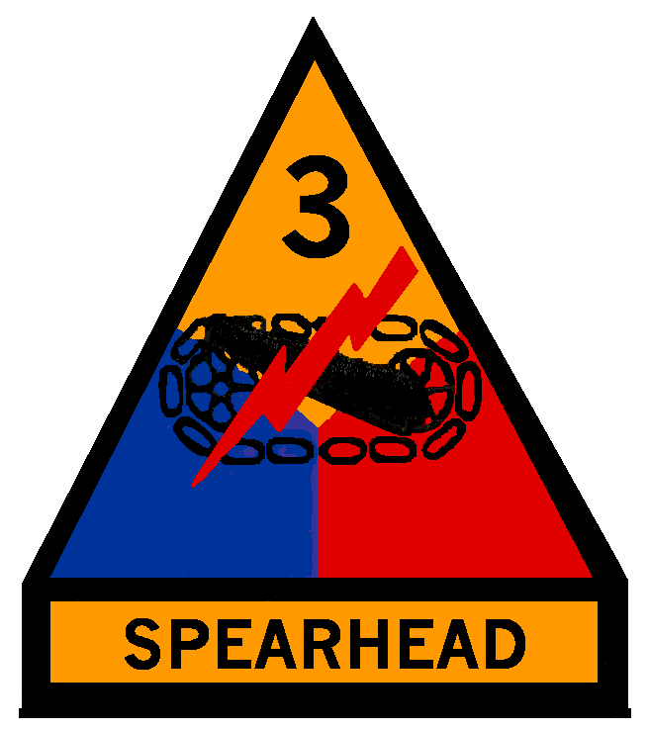
Steven Depuy
PO Box 269
Reinholds, PA 17569-0269

