LUNENBURG COUNTY BOARD OF SUPERVISORS
GENERAL DISTRICT COURTROOM
LUNENBURG COURTS BUILDING
LUNENBURG, VIRGINIA

Minutes of April 12, 2012 Meeting

The regularly scheduled meeting of the Lunenburg County Board of Supervisors was held on Thursday, April 12, 2012 at 6:00 pm in the General District Courtroom, Lunenburg Courts Building, Lunenburg, Virginia. The following members were present: Supervisors T. Wayne Hoover, Alvester Edmonds, Charles R. Slayton, Robert Zava, David Wingold, Edward Pennington, County Administrator Tracy M. Gee, Assistant to the Administrator Nicole Clark and County Attorney Frank Rennie. Supervisor Frank Bacon was absent.

Chairman Hoover called the meeting to order.

Supervisor Slayton led the Pledge of Allegiance and gave the invocation.

Chairman Hoover requested additions to the agenda from the Board and the public.

Chairman Hoover added a Landfill Committee update as 11A on request by Supervisor Zava. Credit card for the County Administration Office was added as 11B and credit card for the Social Services Director was added as 11C, both on request by Administrator Gee. Lunenburg Dixie Youth Baseball was added as 8C on request by Chairman Hoover.

Supervisor Pennington made motion, seconded by Supervisor Edmonds and unanimously approved, to accept the Consent Agenda to include the minutes from the March 8, 2012 and March 22, 2012 meetings, the Treasurer’s Reports Year-to-Date through February 2012 and the following Warrants for Approval:

March 2012: Payroll: #17035-17062 $ 33,685.12
Direct Deposit $ 77,828.05
Payroll Taxes Federal: $ 35,444.84
Payroll Taxes State: $ 6,320.17
Accounts Payable: #45200-45363 $ 524,630.88

Grand Total: $ 677,909.06

Treasurer Amona Currin approached the Board regarding her office. She reported that the office has completed the transfer to the new software. She noted that her figures balance with those in the County Administration Office. Mr. Paul Lee, of Robinson, Farmer, Cox & Associates, praised the Treasurer’s Office for accomplishing so much in just a short amount of time. Treasurer Currin stated that she and her staff are still learning the new system. She advised the Board that 95% of real estate taxes and 93% of personal property taxes have been collected.

Chairman Hoover thanked Treasurer Currin and Commissioner of Revenue Patricia Adams for meeting with Mrs. Connie Reese regarding her tax bills. The issue has been resolved.

Commonwealth Attorney, Robert Clement, recommended that Mr. Nicholas Daniel of the Circuit Court Clerk’s Office fill the vacancy on the Board for Piedmont Alcohol Safety Action Program.

Supervisor Zava made motion, seconded by Supervisor Edmonds and unanimously approved, to appoint Nicholas Daniel to the Piedmont Alcohol Safety Action Program Board.

Supervisor Zava made motion, seconded by Supervisor Slayton and unanimously approved, to include the Abstract of Votes from the March 6, 2012 Republican Presidential Primary Election.

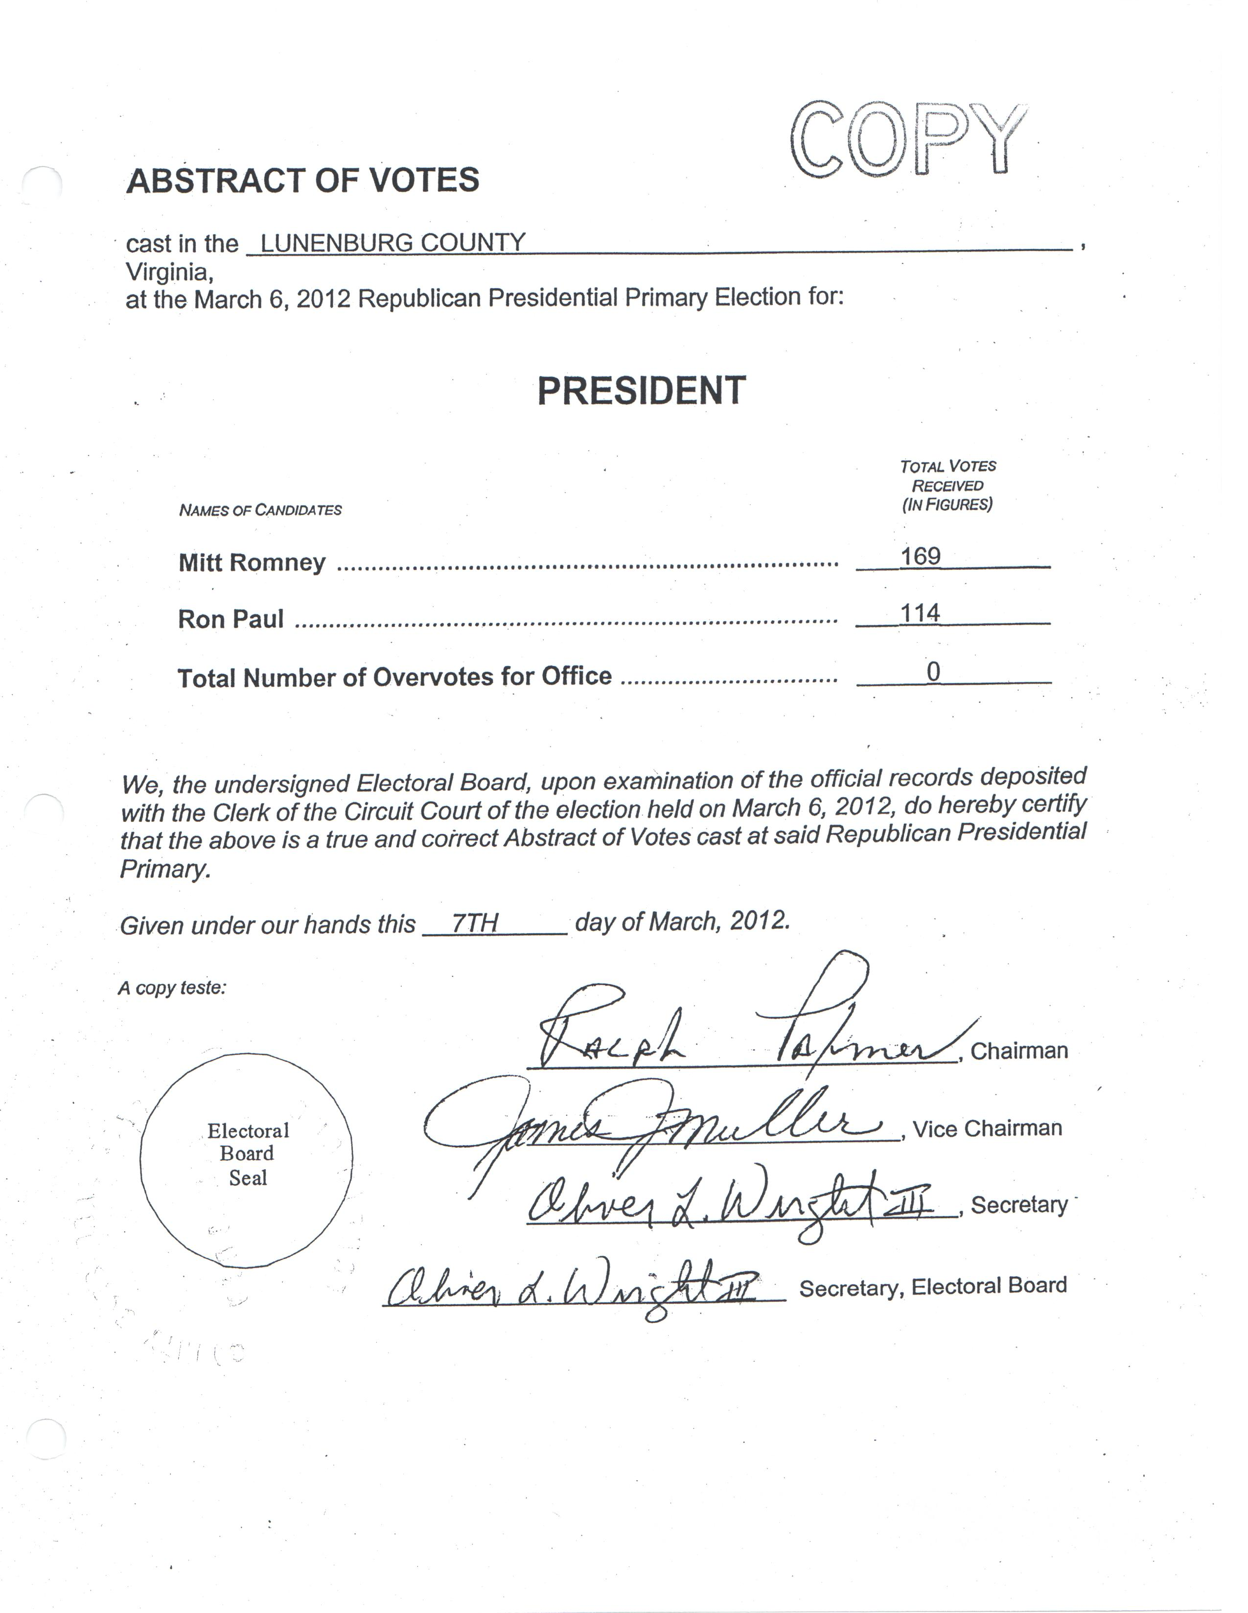
Supervisor Zava asked Electoral Board Member Mr. Oliver Wright what the cost is for such an election. Mr. Wright commented that each election cost about $7,000, however most expenses are reimbursed to the county.

School Superintendent Ms. Dora Wynn, requested that the Board accept a resolution regarding new grant awards and carry-over grant funds unspent last year totaling $629,567.
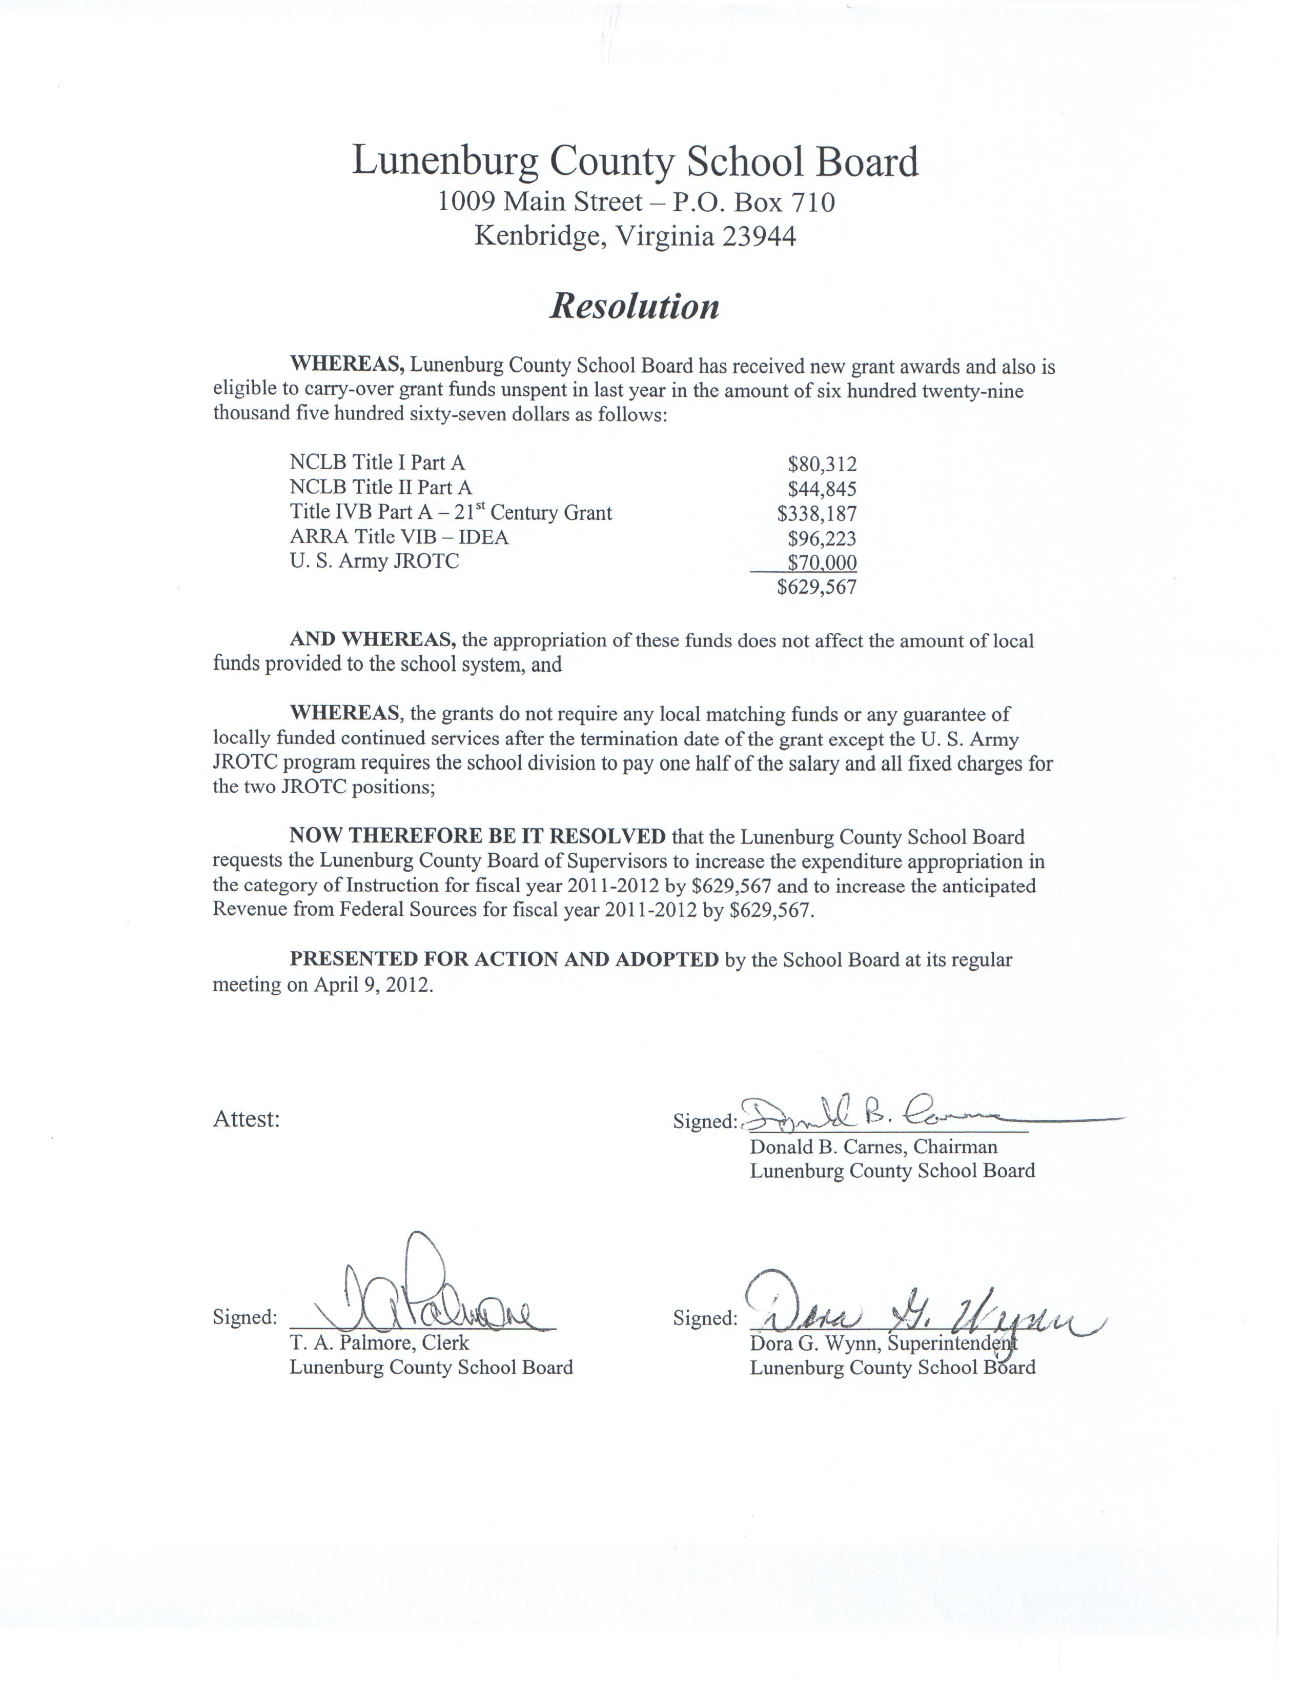

Supervisor Zava made motion, seconded by Supervisor Pennington and unanimously approved, to accept the School Board’s resolution.

Mr. Billy Smith of VDOT approached the Board to give the monthly report. Mr. Smith asked the Board how often they would like him to attend meetings now that he is the representative. The Board decided Mr. Smith would provide the written report monthly and he would be present for at least one meeting per quarter unless needed more often.

Mr. Smith stated that the railroad bridge project in Victoria has been postponed as there are currently no funds available. He should know more the first of July. For now, they are trying to keep the bridge passable by patching it.

Supervisor Pennington asked how they were patching the bridge. Mr. Smith replied that the concrete is removed and cleaned down to the rebar and new concrete is poured.

Mr. Smith commented that when funds become available, the bridge on Route 137 will be replaced before the bridge in Victoria, as this project is cheaper.

Mr. Smith informed the Board that VDOT will be updating the roads in Victoria by making them more level with tar and gravel patches. Chairman Hoover asked why secondary roads are paved for a few yards, skip a few yards and paved a few more. Mr. Smith informed him that VDOT has a 500 foot rule, meaning they cannot pave more than 500 foot in one section.

Mr. Smith addressed the 2013-2018 Secondary Roads Six-Year Plan. He stated that there was one addition to the plan, Route 712 Wallace’s Bridge. A little more funding was available to put towards this project.

Supervisor Wingold made motion, seconded by Supervisor Pennington and unanimously approved, to enter Public Hearing the 2013-2018 Secondary Roads Six-Year Plan.

There was no public comment.

Supervisor Edmonds made motion, seconded by Supervisor Pennington and unanimously approved, to close Public Hearing.

Supervisor Zava made motion, seconded by Supervisor Pennington and unanimously approved, to adopt the 2013-2018 Secondary Roads Six-Year Plan.

Administrator Gee explained the need for the county to increase the Real Estate Tax Rate by 2 cents from $0.36 to $0.38. Following the recent Reassessment, assessed values for Real Property decreased by 5% which constitutes the necessity of a 5% increase to offset the potential loss of budgeted revenue to equalize the tax rate.

Supervisor Zava made motion, seconded by Supervisor Edmonds and unanimously approved, to enter Public Hearing.

Paula Watlington of Sunset Lane in Victoria, spoke explaining that this is a slow economy and she can’t afford an increase in taxes. She commented that when her costs change, she must change her budget and the county should do the same.

There was no further public comment.

Supervisor Wingold made motion, seconded by Supervisor Zava and unanimously approved, to close Public Hearing.

Supervisor Wingold questioned whether the increase in rate would affect the amount of tax each property owner pays. Administrator Gee stated that the majority of property values decreased hence the need to increase the rate.

Supervisor Zava commented that this is still technically a rate increase. He then informed the Board that a neighboring county increased the real estate tax by 10% this year. He emphasized that if the rate is not increased now, cuts would need to be made quickly to balance the current budget. Approximately $170,000 will be cut if the rate is not raised, meaning layoffs or reduction of services would occur immediately.

Supervisor Wingold made motion, seconded by Supervisor Edmonds and unanimously approved, to increase the Real Estate Tax Rate by 2 cents from $0.36 to $0.38.

Chairman Hoover informed the Board that this year is the 50th year of Lunenburg Dixie Youth Baseball. Opening ceremonies will be held Saturday, April 14, 2012. He suggested that the Board present a resolution at the ceremony in honor of the league’s fifty years.

Chairman Hoover made motion, seconded by Supervisor Pennington and unanimously approved, to allow the Chairman to present a resolution to the Lunenburg Dixie Youth Baseball league.

Commissioner of Revenue, Patricia Adams, approached the Board regarding her budget. Commissioner Adams requested flat funding for her department. She explained that she was able to rearrange some of her line items, but was unable to reduce her overall budget.

Commonwealth Attorney Robert Clement addressed the Board stating that 4.2 percent of his budget comes from the county; the rest is funded by the state. He mentioned that last year he was asked to reduce his budget by 3%. The previous County Administrator reduced his entire budget, not just the County’s portion. Therefore he is operating on a greatly reduced budget already. Attorney Clement requested flat funding for FY 2012-13.

Treasurer Amona Currin, discussed her budget with the Board. Treasurer Currin expressed that her office took a big cut last year in the reduction of one employee. She explained that this is the first year for twice a year billing which will greatly increase their work load and costs. The Treasurer’s Office will see an increase in office supplies, advertising, and postage due to the twice a year billing. She also requested funding for training for her staff and one additional full-time position. Ms. Currin informed the Board that postage is one of her biggest expenses and the rate continues to increase.

Supervisor Zava stated that surrounding counties have explored other options to reduce costs. He stated that it’s time we starting thinking “outside the box” for ways to save. One suggestion he offered was to allow the public to visit the office and pay taxes only during certain times of day or days of the week. He reminded Treasurer Currin that flat funding should be the best anyone in the county can expect.

Sheriff Arthur Townsend gave his presentation to the Board. Sheriff Townsend requested flat funding to cover a number of challenges that exist within his departmental budget. His previously reduced postage budget has been depleted due to increased rates. His travel account has been exhausted since December due to an increase in the number of transports to and from other facilities. Sheriff Townsend stated that his motor vehicles account was cut by $15,000 for the current year and an additional $25,000 from past budget cuts. The department lost a vehicle due to an accident this year and the remaining funds will not allow them to replace the loss of a vehicle. He requested that the Board consider adding enough funds from the selective enforcement fund to purchase a car prior to the end of this year. Sheriff Townsend also explained that an increase in dues to the Central Virginia Criminal Justice Academy overextended this budgeted line item. He informed the Board that his office had a one-time windfall of funds from the compensation board vacancy savings account due to the retirement of two officers. These funds allowed his department to purchase office equipment, buy additional stamps and cover travel expenses through the remaining fiscal year with State funds. Sheriff Townsend reminded the Board that he will not have this extra cushion in following years. Sheriff Townsend stated that he is unable to produce any proposed cuts to the Sheriff’s Office FY2013 budget.

Administrator Gee spoke on behalf of Victim/Witness Director, Dawn Childers. Coordinator Childers’ letter to the Board stated that the county receives 100% funding from the Department of Criminal Justice Services. She is requesting flat funding with the addition of $1,000 for the purchase of a new computer. At this time, Coordinator Childers is unsure of exactly how much money DCJS is going to approve for her program.

Secretary of the Electoral Board, Ollie Wright, informed the Board that his department cannot make many cuts as they must open the polls on the required dates. Secretary Wright stated that they try to get as much reimbursement from the state as they possibly can. The Electoral Board does wish to modify some of its line items for additional accuracy of coding. Secretary Wright noted that the “Dues and Memberships” account may be reduced to zero as the Electoral Board will cover those expenses themselves.

Administrator Gee reminded the Board that several funds require balance transfers from the General Fund to balance each Fund. The negative fund balances for Fire/EMS Capital, Solid Waste Management and Debt Service were due to the absence of balance transfers at the end of FY2010 and FY2011. Administrator Gee reiterated that none of these transfers affect the Cash Balance. These expenditures have already taken place and are accounted for in the correct funds, they only lack the budgeted transfers. The County Administrator and Treasurer’s Office are working together to formulate a procedure for future transfers to avoid this issue in the future.

Supervisor Zava made motion, seconded by Supervisor Pennington and unanimously approved, to adjust the fund balances via adjusting entries per the auditor’s recommendation.

Community Development Director Beverley Hawthorne gave her monthly report. She reported that ABC Recycling is purchasing new equipment through USDA grants for recycling. Director Hawthorne reported that the reimbursement for Safety Technologies Incorporated, formerly known as the Shell Building, will be filed before April 15th. Plans are to have all work completed by May 15, 2012.

Supervisor Zava gave the Board an update regarding the Landfill Committee. He stated that property was purchased many years ago for a new convenience site. He recently visited the property and believes it to be a good site. He suggested that the committee discuss the site with VDOT and have VDOT draw up plans for an entrance and exit to and from the property. There was discussion of combining four sites into one. The four sites include Black’s Store, Red Rooster, Hank’s Store and Tanner’s Store. Supervisor Zava commented that there needs to be a solid program put in place within the next year. Supervisor Edmonds agreed stating the strong need to move forward due to the upcoming Transfer Station and the need for reduction of sites.

Supervisor Pennington made motion, seconded by Supervisor Wingold and unanimously approved, to move forward with the project within budget constraints.

County Attorney, Frank Rennie, stated that construction plans were available April 1st for the Transfer Station. A meeting was held today. Six qualified bidders attended and three additional bidders requested plans but did not attend the meeting. Bids are due April 26th and the county hopes to have a contract to be reviewed at the May meeting.

Administrator Gee stated that the Administrator’s Office is currently using a credit card secured by Community Development Director, Beverly Hawthorne. Ms. Gee requested that the County obtain its own credit card for the Administrator’s Office and the Social Services Department. She stated that the cards would be issued through Benchmark Community Bank and secured by Lunenburg County.

Supervisor Zava inquired as to whether there had been any problem or misuse in the past regarding credit cards. Administrator Gee replied there have been not problems in the past and the card would be kept in the petty cash box. Persons requesting use of the card would be required to sign for it and report the purpose of its use. Mrs. Gee suggested that the Board could review the monthly use of the card if they so wish. She stated that the cards would be useful for Social Services to purchases supplies for children when they are picked up and for the Administration office in registering for conferences and purchasing small equipment. Both cards would be paid in full each month.

Supervisor Zava made motion, seconded by Supervisor Pennington and unanimously approved, to obtain a credit card for the Administration Office and reports of expenses will be presented to the Board monthly.

Supervisor Wingold made motion, seconded by Supervisor Pennington and unanimously approved, to obtain a credit card for the Social Services Department and reports of expenses will be presented to the Board monthly.

Administrator Gee reported that a new Agriculture Agent, Lindy Tucker, has been hired for the Extension Office. She thanked Supervisor Wingold for assisting with the interviews.

Administrator Gee stated that direct deposit for payroll has been implemented. Chairman Hoover requested that all new employees be required to enroll in direct deposit. He also suggested a goal to have all employees enrolled by the end of 2012.

Administrator Gee informed the Board that she is working on a budget meeting schedule. She will update the Board when she has all the dates scheduled. Administrator Gee requested a continuation of this meeting on April 19th to hear budget requests from Social Services and all other public requests. She mentioned that the School Board Budget is needed by May 1st.

Supervisor Wingold made motion, seconded by Supervisor Pennington and unanimously approved, to enter Closed Session citing Virginia Code Section §2.2-3711A1 Personnel.

CERTIFICATION OF CLOSED SESSION MEETING

WHEREAS, the Board of Supervisors of Lunenburg County, Virginia (“Board”) convened a Closed Session Meeting on this date pursuant to an affirmative recorded vote in accordance with the provisions of the Freedom of Information Act; and

WHEREAS, Section 2.2-3712 of the Code of Virginia, 1950, as amended, requires a certification by the Board that such Closed Meeting was conducted in conformity with Virginia law.

NOW, THEREFORE, BE IT RESOLVED that the Board hereby certifies that, to the best of each member’s knowledge, (i) only public business matters lawfully exempted from Open Meeting requirements by Virginia law were discussed in the Closed Meeting to which this certification resolution applies, and (ii) only such public business matters as were identified in the motion convening the Closed Meeting were heard, discussed or considered by the Board.

VOTING YES VOTING NO ABSENT
Supervisor Edmonds Supervisor Bacon
Supervisor Hoover
Supervisor Pennington
Supervisor Slayton
Supervisor Wingold
Supervisor Zava

Supervisor Slayton made motion, seconded by Supervisor Pennington and unanimously approved, to return to Open Session.

Supervisor Wingold made motion, seconded by Supervisor Pennington and unanimously approved, to continue the meeting on April 19, 2012 at 6:00 p.m.

________________________________ ___________________________________
Tracy M. Gee, Clerk T. Wayne Hoover, Chairman
County Administrator Board of Supervisors

