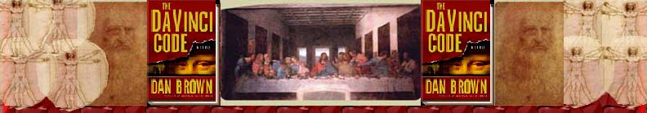Chapter 44
Rachel Sleeman

Double-entendre
ATM terminal
Cruciform logo
“Fonction terminer”
“Standard ATM machines allowed users three attempts”
PIN-Personal Identification Number
“cash machine”
“Fire away”
“air freight pet transport crate”
Five-petal rose
Rosewood
The Cup of Christ

Double-entendre rare obs. F. = the usual double entente, double understanding, ambiguity; (an example, of 1688, is given by Littré in Suppl.) Cf. also double entendement in DOUBLE a. 2 quot. 1548.] A double meaning; a word or phrase having a double sense, esp. as used to convey an indelicate meaning. Oxford English Dictionary Online © Oxford University Press 2004. The French word entendre [ahπ-tahπDR] is a transitive verb that means to hear, to understand, to expect, to intend. 21st Century French-English, English-French Dictionary ©The Philip Lief Group, Inc. 1996. A double entendre is a figure of speech similar to a pun. This figure of speech can be taken in either a literal or a figurative meaning. The literal meaning is an innocent one, while there is a second (usually sexual) meaning underlying the first. Although a French term, the French generally use the phrase double entente or double sens. One famous example of a Double Entendre appeared in the Miami Herald. General Motors made a bid to a company that manufactured screws and other metal pieces. The headline read:
Textron Inc. Makes Offer To Screw Co. Stockholders. To read more about double entendres, visit Headlines, Making an impact—accurately at: http://www.ku.edu/~edit/heads.html, 2 Oct. 2004.

ATM Short for ‘automatic teller machine’, an ATM has numerous names: a cash dispenser, a cash machine, a cashpoint, a Geldatomat (Germany), Postomat (in Switzerland), etc. An ATM allows a bank customer to conduct banking transactions world-wide. Any ATM machine in the world will work. The invention of the ATM machine was a collective effort. Don Wetzel was the chief inventor. He got the idea while waiting in a long line at a Dallas bank in 1968. The other two inventors were Tom Barnes, a mechanical engineer, and George Chastain, an electrical engineer. A working prototype appeared a year later and was patented in 1973. The first working ATM was installed in a New York Chemical Bank, and was used as an offline machine, meaning that money was not withdrawn from the account directly. Therefore, banks allowed only credit card holders with good banking records to use the new technology. Wetzel, Barnes and Chastain developed the first ATM cards with a magnetic strip and a personal ID number to get cash. Today, ATMs are used to both deposit and withdraw funds into a selected bank account. The use of computers allows any account holder to access funds from any ATM machine.
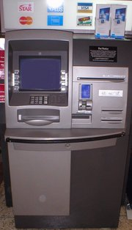

http://en.wikipedia.org/wiki/Automatic_teller_machine, 2 Oct. 2004.

To learn more about the history of the ATM, visit A History of the ATM+ info at:
http://www.totse.com/en/bad_ideas/scams_and_rip_offs/atminfo.html, 11 Nov. 2004
or
Automatic Teller Machine at: http://inventors.about.com/library/inventors/blatm.htm, 2 Oct. 2004.To see how an ATM works, visit How ATMs Work at: http://www.howstuffworks.com/atm.htm, 2 Oct. 2004.
Cruciform logo ad. mod.L. cruciform-is, f. cruc-em cross: see -FORM.] Definition of Cruciform- Of the form of a (right-angled) cross; cross-shaped: spec. in Bot. of the flowers of cruciferous plants; in Arch. of a church built in the form of a cross; in Anat. = CRUCIAL 1661 LOVELL Hist. Anim. & Min. 215 The cruciforme bone of the head [of a pike]. 1794 MARTYN Rousseau's Bot. ii. 29 These corollas are called cruciform or cross shaped. 1807 J. E. SMITH Phys. Bot. 268 The natural order of Cruciform plants, composing the Linnæan class Tetradynamia. 1827 Gentl. Mag. XCVII. II. 499 At Horton Kirby..the Antiquary will find a cruciform church.
Definition of Logo (short for Logogram)- Logogram- [f. Gr. - word + -GRAM]c. gen. A symbol, as found in road-signs, advertising, &c., designed to represent in simple graphic form an object, concept, or attitude.
1966 Sunday Times 27 Feb. 11/2 Labour's original badge..has progressively turned into what the trade calls a logogram. Oxford English Dictionary Online © Oxford University Press 2004
In context, the ‘cruciform logo’ is referring to the cross-shaped symbol located in the middle of a Swiss flag that is displayed outside of a Swiss bank.
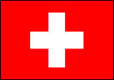
http://uk.geocities.com/bacon_trek/, 2 Oct. 2004

“Fonction terminer” “Transaction cancelled” (Rachel Sleeman. Translation obtained from The Bank of Bennington ATM in Bennington Vermont, when completing a transaction).

“Standard ATM machines allowed users three attempts” A customer is allowed three attempts to login to the ATM by entering a valid password. If no correct password is entered after three attempts, then the ATM system rejects the login attempt and asks for a new customer identifier. Once the system rejects the login attempt, the card no longer works at an ATM machine. Money is not directly accessible at a machine. In order to access funds via an ATM once again, it is necessary to reset the password or pin number through the local bank.
(Rachel Sleeman. Information also obtained through a phone call to the help desk at Middlebury National Bank)
PIN-Personal Identification Number- A PIN is a series of numbers that is used in certain systems to gain access, and verify identification. Most commonly, PINs are used for transactions at ATMs. PINs are a numeric passwords, ideally known only by the person whose PIN it is. Failure to expand the acronym often leads to the erroneous usage PIN number, in which there is a repetition of the final word. Throughout Europe and the United States, the in-store credit card signing process is being replaced with a ‘chip and pin’ system, where the customer is asked to enter the PIN instead of signing (Personal Identification Number, Wikipedia 1). Most commonly PINs are 4-digit numbers in the range 0000-9999 resulting in 10,000 possible numbers. A thief would have to guess an average of 5000 times to find the correct PIN.
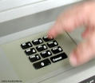
How Money Works at http://money.howstuffworks.com/atm5.htm, 2 Oct. 2004
To learn more about PINs, visit Personal Identification Number at http://en.wikipedia.org/wiki/Personal_identification_number, 2 Oct. 2004.
To learn a security flaw in the PIN generation system of the IBM 3624, which was duplicated in later software, visit Tech Reports at: http://www.cl.cam.ac.uk/TechReports/UCAM-CL-TR-560.pdf, 2 Oct. 2004.

cash machine See the entry for ATM (automatic teller machine).

“Fire away” The phrase “fire away” is an phrase commonly used in America. John Russell Bartlett’s Dictionary of Americanisms defines “fire away”: “to begin; to go on. An expression borrowed from the language of soldiers and sailors. A well-known auctioneer in Pearl street, when putting up an article, says: "Come gentlemen, give us a bid, “fire away” that is, go on.” The Chairman rose and said: "We are not ready yet, we must go on in order." Calls for Mr. H---. Mr. H--- from the midst of the audience said, 'Gentlemen, I beg to be excused, I came here to listen, not to speak." (Loud cries of 'Go ahead," Out with it," “Fire away”) Whereupon he commenced.--N. Y. Herald, Sketch of a Political Meeting.” John Russell Bartlett’s Dictionary of Americanisms © Bartlett and Welford, 1848.Visit the online version of the Dictionary of Americanisms by following this link: http://www.merrycoz.org/voices/bartlett/AMER06.HTM, 2 Oct 2004.
air freight pet transport crate Also called a cargo crate, the pet transport crate is carrier built for pets, so that they may be placed in an airplane as cargo (in a pressurized compartment). Pets traveling in the cargo hold must have a U.S. Department of Agriculture approved carrier. The crate usually contains a water dish attacked by brackets, positioned to be filled by an attendant without opening the crate. The crate is always clearly marked with “Live Animal” alongside two arrows indicating the correct upright position. www.petsonthego.com/transairlineregs.html, 2 Oct. 2004.
Five-petal rose
The five-petal wild rose is the ancestor to all modern roses. The flowers of wild roses usually have five petals, while the flowers of cultivated roses are often double. In French, the five-petal rose is called a ‘cinquefoil’. It is often found attached to the tops of Gothic arches, and pisces-shaped doorways and windows. The five-petal rose was thought to represent the womb of Mary, the root of Jesus’ birth. Therefore, the five-petal rose became a prominent symbol in Christian symbolism. To learn more about the symbolism of the ties between the Virgin Mary and the rose, visit: The Christian Symbolism of the Rose: Our Lady and the Rose at: http://www.udayton.edu/mary/rosarymarkings36.html
The five-petal rose also came to represent hidden worship of the Goddess Venus. In Roman times, the five-petal rose is called the ‘Rose of Venus.” The planet Venus, in its eight year cycle is woven in sidereal space, with Earth as its axis, comprising five synodic periods, that resemble the rose.
To read more about the symbolism of the medieval five petal rose, visit Symbolism of the Rosy Cross at: http://www.geocities.com/Athens/Acropolis/1896/RC.html

http://altreligion.about.com/library/glossary/symbols/bldefscinquefoil.htm


http://www.pelicannetwork.net/fg/rosa/rose_bloom.jpg , 2 Oct. 2004.

Rosewood 1. One of several kinds of valuable, fragrant, close-grained cabinet-wood, chiefly that yielded by tropical leguminous trees of the genera Dalbergia (esp. D. nigra) and Machærium; also, a tree yielding this wood.
The true rosewood of commerce is that imported from S. America, esp. from Brazil, where the name Jacaranda is applied to Dalbergia and to several species of Machærium.
1745 P. THOMAS Jrnl. Anson's Voy. 252 There is also another particular Wood, which they call Rose-wood... Its colour is black, inclining to red. Oxford English Dictionary Online © Oxford University Press 2004/
Rosewood is a type of hard ornamental wood with a dark reddish brown color, streaked and grained with a black intermediate layer. Rosewood is native to Brazil, Honduras, Jamaica, Africa, and India. It is fragrant and close grained. It is hard to work with because of its resinous nature and requires a fine polish (Encyclopedia Britannica 1). Since the tree’s wood begins to decay when it reaches maturity, large pieces of this wood aren’t used. Instead, rosewood is used typically for smaller projects, such musical instruments, piano cases, tool handles, art projects, and small pieces of furniture, cut from the wood before decay. Today, rosewood is rarely used, as the supply continues to diminish. “rosewood.” Encyclopædia Britannica. 2004. Encyclopædia Britannica Online. 30 Sept. 2004 <http://search.eb.com/eb/article?tocId=9064123>.

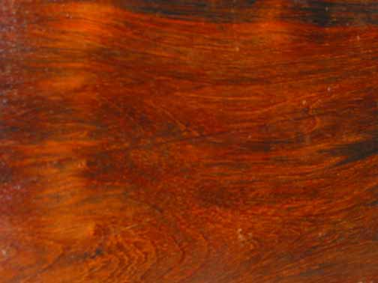

http://www.encyclopedia.com/html/r1/rosewood.asp, 2 Oct 2004.

The Cup of Christ Also known as the Chalice, the Cup of Christ is, according to Holy Grail legends, a physical cup. The Cup was the cup used at the Last Supper from which wine was drunk, symbolizing Jesus’ blood. It is written in the Gospel of Matthew, Matthew 26:26-28- “And as they were eating, Jesus took bread, and blessed it, and broke it, and gave it to the disciples, and said, Take, eat; this is my body. And he took the cup, and gave thanks, and gave it to them, saying, Drink ye all of it; For this is my blood of the new testament, which is shed for many for the remission of sins.” This phrase is repeated in Catholic mass today before communion: the breaking of the bread and the drinking of the wine that represent the body and blood of Christ. Jesus’ blood was a sacrifice, meant to relieve the sins of the world. In accepting Eucharist and the blood of Christ at communion, Christians “accept the Cup of Christ, the cup of salvation. (Ps. 116:13)” In Holy Grail legend, the Cup of Christ is also the cup which Joseph of Arimathea used to collect the actual blood of Jesus after his crucifixion while preparing the body for burial. The lost chalice has many powers that make it an object of numerous quests to find the Holy Grail. These powers include healing and restorative ability, communication with God, and immortality.

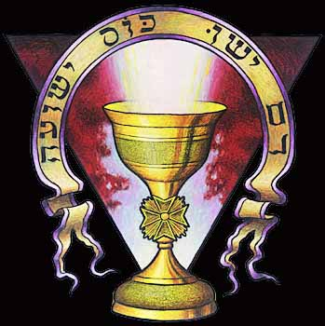
http://www.crystalinks.com/holygrail.html, 2 Oct. 2004.

To learn about the Cup of Christ and what it represents in Catholicism, visit The Cup of Christ at: http://www.bivocational.com/CupofChrist.htm, 2 Oct. 2004.
To learn about the view of Early Christians on the Holy Eucharist, visit: http://www.columbia.edu/cu/augustine/a/eucharist-q.html, 2 Oct. 2004.
To learn about basic information on the Holy Grail legend, visit The Holy Grail at www.lib.rochester.edu/camelot/grlmenu.htm, 2 Oct, 2004.

