Head Up Display

User Manual

Thanks for purchasing the A8 HUD. This HUD is designed to reflect your vehicles computer information onto your windshield offering a safer driving experience day to day as well as more importantly at high speeds and during night driving. As it removes the need for the driver to dip their head to view the instrument cluster. Installing this unit correctly will enable you to more effectively monitor your speed, this is helpful for novice drivers as well as experienced drivers in potentially avoiding speeding infringements.

The A8 HUD uses the most up to date technology throughout both its hardware and software as well as aesthetical design boasting a unique and elegant shape in its aesthetic final assembly.

To ensure your unit is set up and functioning properly it is crucial you read and
follow this user manual’s set up procedures.

If you encounter any issues please don’t hesitate to contact your nearest reseller.

HUD main features

- Plug and Play connectivity with any OBDII or EUOBD capable vehicle;
- 5.5”, 5 colour display;
- Multi colour design makes the screen easier to read highlight important details for quick viewing;
- The use of nanotechnology to eliminate unwanted reflections making the information easier to read;
- Driving mileage and consumption
- Ability to display a huge range of car statistics including: speed, engine rotational speed, water temperature, battery voltage, instantaneous fuel consumption, average fuel consumption, mileage measurement, shift reminder, fatigued driver reminder, low voltage alarm, high temperature alarm, speed alarm, engine fault alarm, fault code elimination, ability to change units e.g. Kilometre/mile
- Auto power on and off with the vehicle
- Automatic and manual brightness adjustment mode
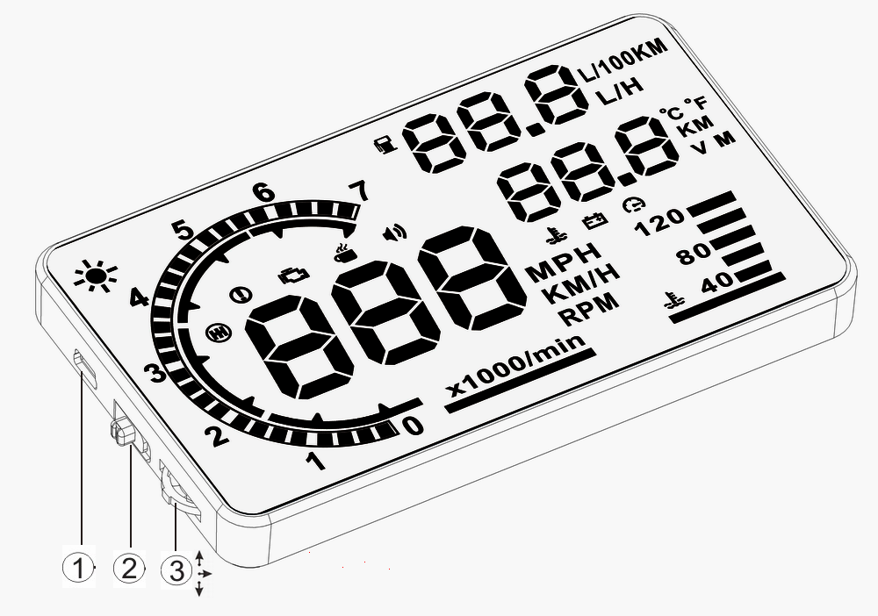
Unit functions

- OBDII cable input
- Power button
- Three way wave button:
  - Up button = up motion
  - Ok button = inward button press
  - Down button = down motion

Unit display information
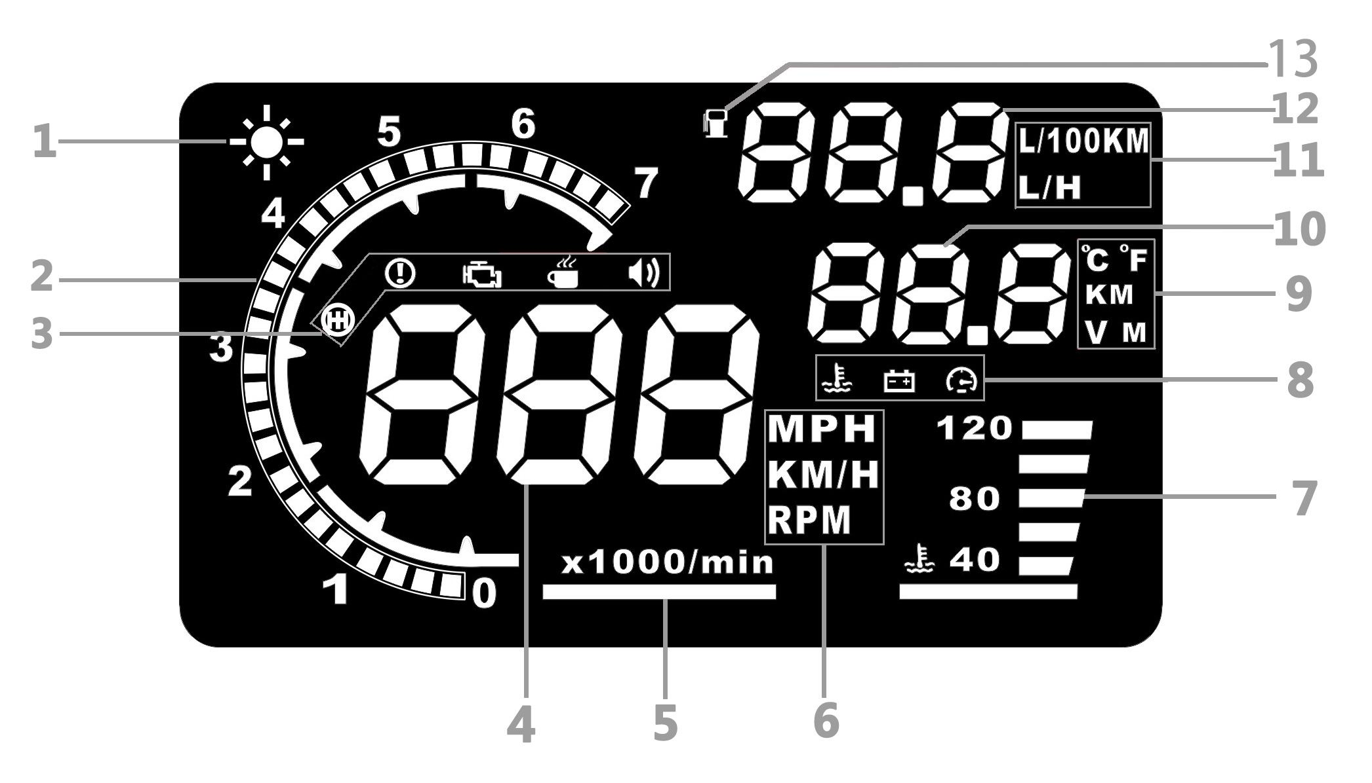

- Light sensor: Changes the unit’s display brightness to suit the constantly changing environment whilst driving.
- Rotational speed: Indicates the rotational speed of the engine.
- Alarm icon panel: From left to right, Shift reminder, over speed alarm, engine fault, fatigued driver reminder, buzzer.
- Speed: Live speed
- Rotational speed units: indicating the units of rotational speed
- Unit mark:
- KM/H = Kilometres/hour
- MPH = Miles/hour
- RPM = rotations per minute
- Engine temperature: Live engine temperature
- Secondary Alarm icon panel: From left to right, Engine temperature alarm, battery voltage alarm, overspeed alarm
- Unit mark: Left to right top to bottom
- Degrees (Celsius or Fahrenheit),
- KM = Kilometres
- V = Voltage
- M = Miles
- Multifunction display window: Voltage, Mileage, Water temperature.
- Fuel consumption unit mark:
- L/100km = Litres/100 kilometres,
- L/H = Litre/hour
- Fuel consumption display: Fuel consumption with adjustable units of measurement as above.
- Fuel consumption logo

HUD installation procedure

- Ensure your vehicle is OBDII compatible or EUOBD.
  - Check around the area under the steering wheel for an OBD plug
  - Contact your vehicle manufacturer or search online
  - Open the bonnet and look for a OBDII compatible sticker (this is NOT on all OBDII compatible cars, therefore isn’t a deciding factor)

- Locate the 16 pin diagnostic link (see picture 2). This is usually located in the area under the steering wheel.

- Start vehicle’s engine and ensure power switch is in the on position.

- HUD will power on with engine

  - If the HUD displays vehicle voltage, fuel consumption, speed and rotational speed the unit has installed correctly.
  - Failing the above: Wait up to one minute for software to sync and confirm OBD cable is plugged in properly.

Reflective film installation
Using the unit without the reflective film may result in a double image observed by the user depending on the windshield. If you see a double layer it is due to the windshields dual layer construction and you should install the film by following the instructions below.

- Place the supplied non-slip mat in the desired position on the dashboard with the HUD on top.
- Observing where the HUD reflects place the reflective film in position.
  - Ensure the surface is clean and dry before installing the film;
  - Remove the back protective side marked (1) and attach the film to the clean windscreen;
  - Once you’re satisfied with the location use a credit card or similar to remove any bubbles or air pockets that remain;
  - Remove the front side marked (2), if you need to adjust the HUD’s reflection, reposition using the nonslip mat.

Setting menu
A vehicles instrument cluster has an offset value meaning the value displayed on the factory instrument cluster is slightly higher than that computed by the vehicle. This offset value is different for different vehicle manufacturers. As a result we have built in our own offset from a large range of test data. If you find the value on your dashboard is different to the value displayed by the HUD you can change it through the following procedure.

- Enter the setting mode by holding the wave button down for 5 seconds.
- Wave button functions
  - Press inwards = OK button
  - Scroll down = down button
  - Scroll up = down button

- Once in the setting mode press the OK button to advance through the screens (see below), and the scroll buttons to adjust the parameters. The screen number you’re in is displayed in the top right hand corner.
- Once finished exit out of the setting menu by holding down the wave button again for 5 seconds.
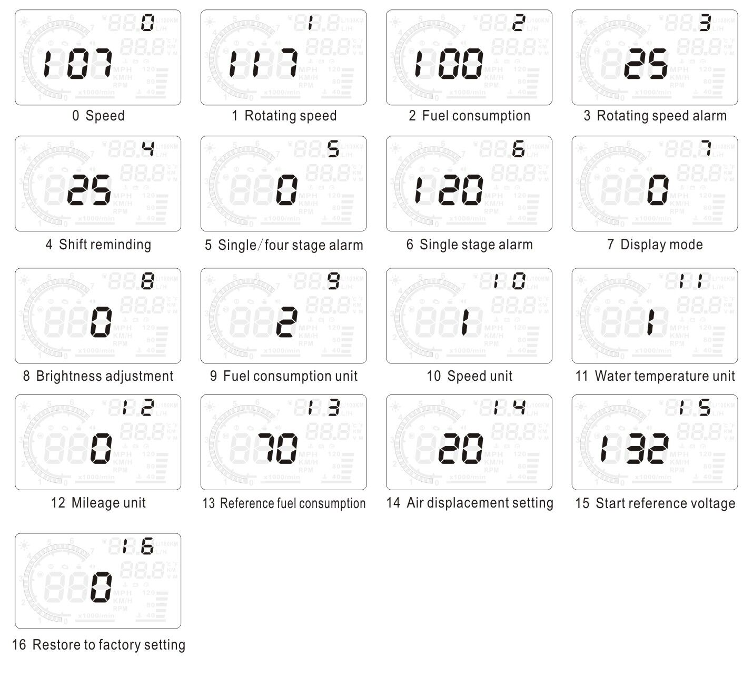

Menu | Parameters | Adjustment Range | Explanation | Defualt
0 | Speed | 50-150 | Adjustment Range 50%-%150. | 107
1 | Rotational Speed | 50-150 | Adjustment Range 50%-%150. | 117
2 | Fuel Consumption | 50-150 | Adjustment Range 50%-%150. | 100
3 | Rotational Speed Alarm | 10-75 | Adjustment Range 1000-7500 r. | 25
4 | Shift Reminder | 0-75 | Adjustment Range 1000-7500 r. | 25
5 | Single/Four Stage Alarm | 0-1 | 0 is a manual mode and 1 is the four-stage alarm value (60, 80, 100, 120km/h). | 0
6 | Single Stage Alarm | 30-250 | Setting range is 30km/h-250km/h. | 120
7 | Display Mode | 0-2 | 0 is an automatic mode: show all with speed under 80km/h; show high-speed mode with above 80km/h. | 0
8 | Brightness Adjustment | 0-2 | 0 is the automatic adjustment; 1 is the darkest and 2 is the brightest. | 0
9 | Fuel Consumption Unit | 0-2 | 0 is not a display, 1 is L/H, 2 is L/100km. | 2
10 | Speed Unit | 0-2 | 0 is RPM, 1 is KM, 2 is MPH. | 1
11 | Water Temperature Unit | 0-2 | 0 is to display water temperature, 1 is °C, 2 is °F. | 1
12 | Mileage Unit | 0-1 | 0 is KMH, 1 is MPH. | 0
13 | Reference Fuel Consumption | 10-500 | Vehicle fuel consumption. | 70
14 | Air Displacement Setting | 0-100 | 0 meand the vehicle has the airflow meter; 1 means the reference fuel consumption. 2, 3,…,100 means vehicle emission is 0.2L, 0.3L,…,10L respectively. | 20
15 | Start Reference Voltage | 110-150 | This is the auto power on and off voltage for the HUD. There is no need to set this component. | 132
16 | Restore to Factory Settings | 0-1 | Set to 1. Vertically press the ‘OK’ button for 5 seconds, then return to the display interface. | 0

2. Vertically press the ‘OK’ button
You can switch the display information between; water temperature, battery voltage, mileage, default power. After a successful scan, you can display mileage.
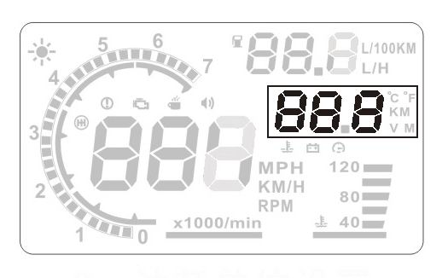
3. Dowturn the wave button for 5 seconds and the alarm buzzer icon will turn off. Upturn the wave button for 5 seconds and the alarm buzzer icon will turn on.
4. Clear the fault code
When the HUD is connected to the car, please do not start the engine. Turn your car on but do not start the engine. Have the HUD turned off. Press the downside key for 5 seconds and you will hear a ‘tick’ sound, which means that the HUD is back to factory settings.

Technical Parameters
Environment temperature - 40 ⁰C— +80 ⁰C
Barometric press:86-106KPa
Relative humidity:10%-95%
Environment voice:<=60dB
Alarm of sound level:>=30dB(A)
Work voltage:9V~16Vdc(12Vdc/400mA)
Size of product:12.5*7.5*1.5(cm)
Weight of product:110g

Some common problems are displayed below. If you incur any of these problems, please see the table for a solution.

Problem | Possible reason | The way to solve
No speed display | The setting value is too high or the function is closed | Cancel stages of alarm and open the switch of alarm
No rotating speed display | The setting value is too high or the function is closed | Reset the unit and open the switch of alarm
No display after starting | The switch is not opened | Open the switch and check the plug
Inaccurate display of fuel consumption | No air flow sensor | Reset the emissions and then calibrate
No speed or engine speed display | Not compatible with OBDII or EU-OBD port | Contact your vehicle manufacturer
No mileage display | No Settings for fuel and fuel consumption calibration | Switch to manual to input fuel and adjust fuel consumption
Speed is inaccurate | The unit of speed is MPH | Switch the unit of speed to KM/H
Display only shows speed and fuel | Speed exceeds 80KM/H | Enter into settings and switch display mode to 1

