COURSE INFORMATION

International Humanitarian Law (IHL) places a duty on States to ensure knowledge of and respect for the Law of Armed Conflict (LOAC). This duty obliges States to ensure that all members of their armed forces are properly trained in the LOAC according to the requirements of the various levels of responsibility. The LOAC is a vast subject, requiring different approaches according to the specific circumstances.

The aim of the course is to enable those officers at the Defence staff, service headquarters and/or from other military organisations who are in charge of planning the LOAC education, to analyse the needs, define the objectives, develop the teaching programmes and to integrate them in the programmes of the continuous education of the different categories of personnel within the armed forces.

The course is designed for military Officers, military lawyers and others responsible planning LOAC education or who are involved in writing doctrine, determining training requirements, curriculum development, the design of course modules and materials for LOAC education within their armed forces (Directors) and military officers and military lawyers responsible for teaching LOAC (Instructors).

Participants should:

- Ideally have a reasonable knowledge of the LOAC conventions and treaties,
- Have a global view concerning the education organisation within their armed forces,
- Know the specific education needs of the different categories of personnel within their armed forces.

The course is delivered in Arabic.

COURSE ADMINISTRATION

The registration fee is €1000 Euro. This should be remitted before the start of the course, or on arrival in cash, credit card or Euro currency cheque.

The registration fee covers:

- Transfers to/from Nice airport
- Course materials
- Lunches, coffee and tea breaks
- Reception drinks and course dinner
- Photograph, diploma.

The registration fee does not cover all other expenses incurred by the participant such as hotel accommodation, laundry or telephone calls. Participants must ensure that they bring with them sufficient funds to pay for such expenses.

Queries on the course including registration and administrative questions should be directed to:
Miss Sara Rossi at: sara.rossi@iihl.org

For any further information please consult our website www.iihl.org

International Institute of Humanitarian Law
Villa Ormond - Corso Cavallotti 113
18038 Sanremo, IM – Italy
Tel.: + 39 0184541848 – Fax: + 39 0184 541600
E-mail: sanremo@iihl.org – Web: www.iihl.org

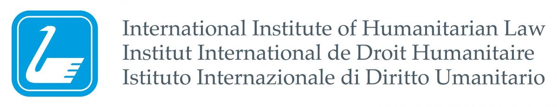

47th COURSE FOR DIRECTORS OF COURSES AND TRAINERS IN INTERNATIONAL HUMANITARIAN LAW
(ARABIC)

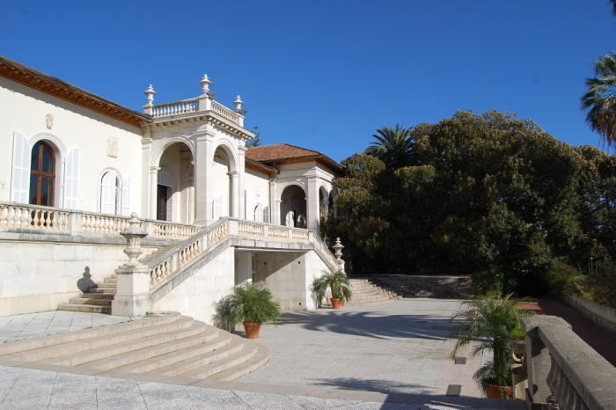

22nd -26th October 2018

PROGRAMME

Teaching Staff

Course Director
Senior Colonel Faouzi ALOUI
Tunisia

Monday, 22nd October 2018

08:30 - 09:00 Registration
09:00 - 09:20 Opening ceremony;
Military Department, IIHL

09:20 - 10:00 Introduction to the Course (Aim, Objectives and Organisation)

10:00 - 10:20 Coffee

10:20 – 12:30 General and legal obligations (lecture)

12:30 - 13:30 Lunch

13:30 - 15:00 National implementation (class work)

15:00 - 15:20 Afternoon Tea

15:20 - 16:30 National implementation of IHL in the armed forces of the respective countries (presentation by participants)

16:45 Welcome reception

Tuesday, 23rd October 2018

09:00 - 10:00 Development of a general directive for LOAC (class work)

10:00 - 10:20 Coffee

10:20 - 11:20 Guiding principles for a general directive for LOAC (class work)

11:30 – 12:30 Allocation of responsibilities (class work)
12:30 – 13:30 Lunch
13:30 – 15:00 Introduction to Integrated Teaching Method – ITM (lecture)

15:00 – 15:20 Afternoon Tea

15:20 – 16:30 Application of ITM
Needs Analysis (class work)

Wednesday, 24th October 2018

09:00 – 10:00 Application of ITM
Point of departure (class work)

10:00 – 10:20 Coffee
10:20 – 11:10 Application of ITM
Aim of a course (class work)

11:20 – 12:30 Application of ITM
Modules of the course (class work)
12:30 – 13:30 Lunch
13:30 – 15:00 Application of ITM
Sub-modules of a course (class work)
15:00 – 15:20 Afternoon Tea
15:20 – 16:30 Application of ITM
Sub-modules of a course (class work)

Thursday, 25th October 2018

09:00 – 10:00 Application of ITM
Objectives of the modules (class work)

10:00 - 10:20 Coffee

10:20 - 12:30 Application of ITM
Objectives of the modules (class work)

12:30 - 13:30 Lunch
13:30 - 15:00 Application of ITM
Structure of the course (class work)

15:00 - 15:20 Afternoon Tea
15:20 - 16:30 Assessment and Evaluation (class work)

20:00 Course dinner

Friday, 26th October 2018

09:00 - 10:30 Necessary Resources for the Implementation of LOAC
Presentation of didactic aids

10:30 - 10:50 Coffee
10:50 – 11:30 Course Evaluation

11:30 - 11:45 Closing Ceremony
Military Department, IIHL

12:00 Lunch and Depart

