SK STUDY GUIDE
PRESENTED BY:

The ATGPC SK Team

TEL: 619-556-5777/ 5778

Updated 31 Jul 2006

CHAPTER 1

ORGANIZATION AND ADMINISTRATION

NAVSUP P 484 - Supply Afloat Packaging Procedures

NAVSUP P 485 - Afloat Supply Procedures

NAVSUP P 486 - Food Service Management Procedures

NAVSUP P 487 - Ships Store Procedures

CHAPTERS OF THE NAVSUP P 485:
- Organization and Administration
- Material Identification
- Material Procurement
- Material Receipt Custody and Stowage
- Material Expenditure and Shipment
- Inventory Management
- Transportation
- Special Material
- Financial Management

NAVSUPSYSCOM – Has cognizance of the procurement of materials and services throughout the Department of the Navy.

INVENTORY MANAGERS – Primary responsibility of management for every assigned group of items, they assure the proper balance between requirements and assets.

SUPPLY DEPT. ORGANIZATIONAL CHART:
Small Fleet Unit

S1 – General Stores/Material/HAZMINCEN
S2 – Food Service
S3 – Ship’s Store & Retail Clothing
S4 – Disbursing/Postal

Larger Fleet Unit (i.e. Aircraft Carrier)

S1 – Stock Control
S2 – Food Service
S3 – Ship’s Store & Retail Clothing
S4 – Disbursing
S5 – Wardroom Mess
S6 – Aviation Stores
S8 – General Stores/Material
S9 – Customer Service
S10 – Quality Assurance
S11 – CPO Mess
S12 – Postal
S13 – Hazardous Material
Afloat Supply functions are categorized into material support and service functions.

The following materials are not included under the afloat supply dept.
Functions are as follows:
- Ammunition, Ammunition Containers – Ships Weapons or Combat Officers.
- War Reserve Stockpile Nuclear Weapons and Major Assembly – Weapons Officer.
- Navigational, Intelligence Charts and Maps – Ships Navigator.

Deployed Fleet Support

Ships are loaded with sufficient supplies to assure prescribed period of self sufficiency.

Organic level of supply consist of the allowance materials the ship is authorized to carry.

The first echelon of re-supply is that the material is positioned in ships of the Combat Logistics Forces (CLF)

There is no first echelon of re-supply for aviation peculiar materials.

The second echelon of re-supply are those materials positioned at ashore activities.

COMBAT LOGISTICS FORCES – Release deployed fleet units from direct dependency on shore bases for supply.

CLF INCLUDES THE FOLLOWING:

a. T-AFS - Combat Stores Ships
b. T-AF - Stores Ships
c. AO/T-A - Oiler
d. AOR - Replenishment oiler
e. AOE - Fast combat support ship
f. AE - Ammunition Ship

Supply support – Depending on ship type and operational requirements, CLF ships may carry one or more of the following categories of material:
a. FILL - Fleet Issue Load List
b. HULL - High Usage Load List
c. TARSLL - Tender and Repair Ship Load List
d. Ammunition
- Deck load
- Provisions
- Ships Store Merchandise (1Q cog)
- Bulk Petroleum Products

CONSOLIDATED AFLOAT REQUISITIONING GUIDE OVERSEAS (CARGO)(NAVSUP P 4998) – Lists the categories of material carried by each ship type.

SUBMARINE TENDERS (AS) – Are not part of the CLF, they replenish ships within own squadron.

ADVANCED BASE – Activated as necessary in times of war for the purpose of supplementing support provided by Combat Logistics Forces (CLF) in order to cope with increased tempo of operations.

OVERSEAS BASE – Permanent facility located outside the U.S. designed to support the fleet and overseas shore establishments.

The difference between an advance base and an overseas base is that, an advance base is temporary in nature and an overseas is permanent.

Fleet Support in United States Waters.

The primary contact points of operating forces are the FISC’S.

DEFENSE LOGISTICS AGENCY (DLA) – Manage about 60% of the Navy’s materials. They manage all 9 Cogs except 9Q (which are managed by GSA) Located and Headquartered at Ft. Belvoir, VA.

DLA CENTERS – Total of Five:
Defense Supply Center Philadelphia, PA (DSCP) – Food items, medical supplies, and clothing. **note formerly known as (DPSC).

Defense Energy Support Center (DESC) Washington, DC – Bulk petroleum and bulk petroleum based chemicals. **note formerly known as (DFSC).

Defense Supply Center Philadelphia, (DSCP) Philadelphia, PA – Industrial type items (e.g. bearings, wire rope, and sheet metal). **note formerly known as (DISC)

Defense Supply Center Richmond, (DSCR) Richmond, VA – Furniture, food preparation equipment, recreation equipment, packaged petroleum products, office supplies, and cleaning supplies. **note formerly known as (DGSC)

Defense Supply Center Columbus (DSCC) Columbus, OH – Electronic and electrical equipment and repair parts, structural material and equipment, components, and repair parts. **note DESC and DCDC merged together to form DSCC.

Defense Depot – Storage points for DLA materials. Does not accept requisitions, issues are made only when directed by DSC’s.

Ships w/out Supply Corps Officers - CO will designate in writing a line officer to be the Supply Officer. The will perform all functions of the Supply Officer EXCEPT DISBURSING.

Disbursing Officer – Assigned to the Ship by the Bureau of Naval Personnel.

Personnel from other departments may be designated as Supply Duty Officers (SDO’S) upon the approval of the CO.

COMNAVSURFORINST 5040.1 – SMI Instructions and Guidelines.

OPNAVINST 5510.1 – Department of the Navy Information Security Program Regulations.

OPNAVINST 3120.32 – Standard Organization and Regulation of the U.S. Navy.

SECURITY OF SUPPLY DEPARTMENT SPACES:
- Material in store always be kept under lock and key except when the bulk of such material makes stowage under lock and key impractical.
- Supply spaces will always be locked when not attended by authorized personnel.
- Responsibility for the security of spaces will rest with the person in charge of each space.
- Permission for entry of persons ordinarily not authorized to have access to supply spaces will be obtained from the Supply Officer or his delegated assistant.
- No supply space will be secured in such a manner that access by use of ordinary damage control equipment is impeded in an emergency.
- Keys to supply space padlocks will not be taken from the ship when the custodian goes ashore.
- A key log will be maintained to identify the holders of keys removed from the key locker.
- Combinations to combination locks will not be recorded in writing except as prescribed in Ships Store Afloat (see NAVSUP P 487, par 1030).
- All keys padlocks will be 1 ½ inch, pin tumbler type, with dead bolt either brass or bronze. The locks will be keyed individually and furnished with two master keys for each group and two grand master keys for each set.
j. All key less padlocks will be the three combination
manipulation resistance type 8077A, NSN 9Z5340-00-285-6523.
k. Combinations on keyless padlocks will be changed at least
every six months.

SPACE GROUPING AND ADMINISTRATION:
- GROUP 1 - General Stores Spaces – (Master Key)
- GROUP 2 - Food Service Spaces – (Master Key)
- GROUP 3 - Ships Store and Clothing Spaces – (No Master Key)
- GROUP 4 - Service Activities- (Master Key)
- 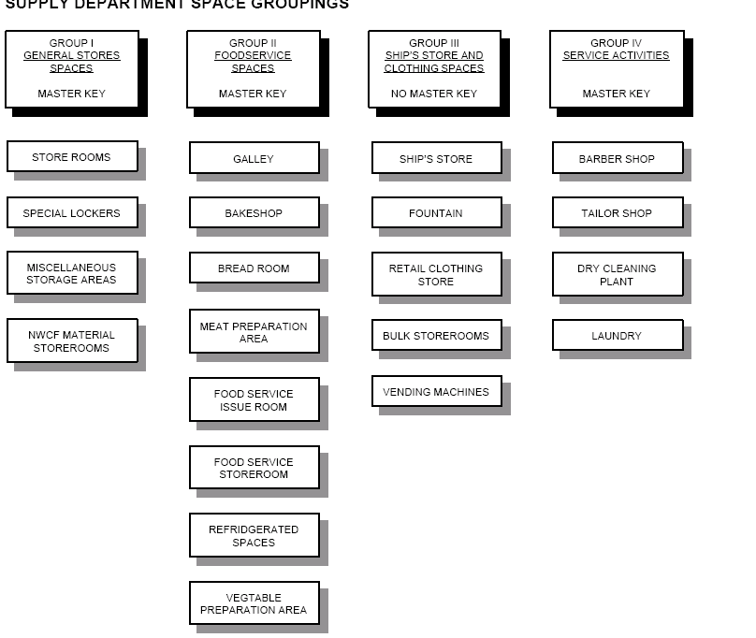

Grand Master Key will be kept by the Supply Officer, and will open all locks in groups 1, 2, and 4.

Other Department Heads will not be given keys to Supply Department Spaces.

The key or combination to the alcohol locker will be kept by the Supply Officer or the officer designated by the Commanding Officer.

Any Disbursing Official having public money not for current expenditures shall deposit the money without delay, but not later than 30 days after receipt.

NAVCOMPT MANUAL VOL. 4 – Contains authority, responsibilities and duties of persons relating to public funds.

Relief of a Supply Officer
The Supply Officer and his relief will conduct a joint inspection of all Supply Dept. spaces, personnel, files, records procedures and organizations.

Inventory of general stores is not required upon relief of the Supply Officer.
- Inventory 10 TO 15 percent of the total SIM/DBI/POS items carried.
- Inventory ¼ OF 1 percent of the total of non-SIM/non-DBI/non-POS items carried insuring that at least 50 percent of the items selected have recorded usage.
- Location audit ¼ of 1 percent of the total line items carried.
- Inventory 10 percent of total repairable assets carried.
- An inventory accuracy rate of 90 percent and the locator accuracy rate of 95 percent are considered to be acceptable.

20 Days – The relieving Supply Officer will prepare the report 20 days after reporting onboard.

The report will include:
  - A request for approval of relieving date.
  - A statement of any defects or deficiencies noted during the inspection.
  - A statement of the status of transfer of controlled equipage in use in the Supply Department.
  - A statement regarding stock record accuracy, that they have reviewed the latest change notice processing and that the latest allowance file updates have been conducted.
  - A statement indicating the number and replenishment cost of repair parts which are not in stock or on order and for automated ships, that a trial/dummy reorder review has been run to determine the dollar value and number of line items of storeroom stock deficiencies.
  - A statement indicating they have reviewed the automated supply system user access listing.
  - A statement indicating they have reviewed all automated supply system management reports and files and attesting to the accuracy and completeness of these reports and files.
  - The general condition of the Supply Department.
  - A statement of facts in dispute, if there is any disagreement between the officers as to the conditions discovered.

Retention of Records
Source documents such as receipt, issues, transfers, registers and physical inventory documentation will be retained for at least one year.

Report of Survey (DD 200) – Will be kept for at least two years.

Personal Effects- Consist of articles owned by an individual, as well as any articles of government property in his/her temporary custody.

Classifications of Personal Effects:
- CLASS 1 – Navy owned, Organizational Clothing
- CLASS 2 – Uniform items prescribed by the U.S. Navy
- CLASS 3 - Money
- CLASS 4 – Negotionable/non-negotionable (checks, bank books)
- CLASS 5 – Miscellaneous articles of intrinsic or sentimental
value

Categories of Personnel Effects:
- Lost, Abandoned, unclaimed personal effects (deserter or absentee)
- Personal effects of deceased or missing personnel
- Personal effects of persons determined to be mentally or physically incapacitated
- Lucky bag items (gear adrift/owner can not be determined)
- Personal effects unavoidable separated from owner

Commanding Officer – Are responsible for the collection, inventory, security of personnel effects.

Supply Officer – Upon receipt of personal effects from the inventory board, the Supply Officer is responsible for the custody storage, security, shipment and disposition of personal effects, and for the maintenance of adequate records.

The Commanding Officer will appoint in writing an inventory board;
- Enlisted personnel – Division Officer and a Petty Officer.
- Officer – Two Officers

NAVSUP Form 29 – Inventory of personal effects, a minimum of an original and 5 copies will be prepared.

Supply Officers of ships will retain effects abandoned by absentees and deserters for a period of 181 days, unless the effects are returned to the owner prior to the expiration of the 181 days. If personal effects are to be forwarded, forward them to Personal Effects Distribution Center (FISC Cheatham Annex, Williamsburg, VA) or to any other activity ashore, forward the original and two copies with a letter of transmittal to that activity.

CHAPTER 2

MATERIAL IDENTIFICATION

There are over four million items in the Department of Defense Supply System.

Cog Symbol – A cognizance symbol is a two position numeric-alpha code that identifies a stock numbered item with the Navy Item Manager of the specific category of material in which the item is included, also indicates whether the material is managed in an NSA stores account, and APA stores account or a non-stores account.

Federal Catalog System – Encompasses the naming, description, classification and numbering of all items carried under centralized inventory control by the Department of Defense and the civil agencies of the Federal Government as well as the publication of related identification data.

The Federal Supply Classification System – Is designed to permit the classification of all items of supply used by the Federal Government. Each item of supply will be included in one and only one, FSC. The FSC is made up of 2 two digit numeric codes: the federal supply group and the federal supply class. The federal supply group identifies by title, the commodity area covered by classes within the group.

There are a total of 76 groups
MOST COMMON:
- 31 – Bearings - 39 – Material handling equip.
- 40 – Rope, cable chain - 42 – Fire fighting, rescue
- 47 – Pipes, hose, fittings - 48 – Valves
- 51 – Hand tools - 52 – Measuring tools
- 53 – Hardware & abrasives - 55 – Lumber
- 59 – Electrical/electronics - 62 – Lighting fixtures
- 65 – Medical/dental - 67 – Photographic material
- 71 – Furniture - 72 – Household appliances
- 75 – Office supplies - 78 – Recreation, athletics
- 79 – Cleaning supplies - 80 – Brushes, paints, adhesives - 84 – Clothing - 88 – Live animals
- 91 – Fuel, lubricants - 95 – Metal bars, sheets

National Stock Number (NSN)- Is a 13 digit stock number assigned by the Defense Logistics Information Service (SLIS) Battle Creek, MI, to identify an item of material in the supply distribution system of the United States. It consists of a four digit federal supply classification (FSC) and a nine digit national item identification number (NIIN). The NIIN consists of a two digit national codification bureau (NCB) code and seven digits which in conjunction with the NCB code, uniquely identify each NSN in the federal supply distribution system.

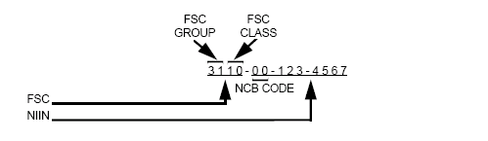

Special Material Identification Code (SMIC)- A two position alpha or alphanumeric code assigned by the Commander, Naval Supply Systems Command to certain NSN items which require source of quality control, technical design or configuration control and/or special controls for procurement, receipt, inspection, test storage, and/or issue. When a SMIC is assigned to an NSN item, the SMIC will be suffixed to the NSN in all supply documents and records.

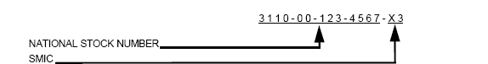

Navy Item Control Numbers (NICN) – Are items of material that re not included in the Federal Catalog System, but which are stocked or monitored in the Navy Supply System, and are identified by Navy item control numbers (NICNS). NICNS are 13 character item identification numbers, which are assigned by ICP’S or other Navy item managers for permanent or temporary control of selected non-NSN items under their cognizance.

Permanent “LL” Coded NICN’S – NICN’S with “LL” in the fifth and sixth positions and a “C” in the seventh position are assigned by ICP’S or other Navy item managers. Anything other than a “C” in the seventh position is a temporary NICN.

Local Item Control Number (LICN)- Is any item identification number assigned by an activity for its own use, is a NICN. However, to distinguish between NICN’s that are authorized in supply transaction documents, and those that are not, the term “local item control number” (LICN) will be used in lieu of a NICN to indicate the type of identification number that is not authorized in supply transaction documents. They may be assigned to shipboard stocked consumables which are not identified by an NSN, a NATO stock number, or another type of NICN.

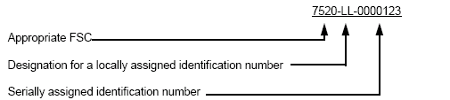

National Codification Bureau (NCB) CODE – The NCB codes are currently assigned are as follows.

- 00 – United States - 01 – United States
- 11 – NATO - 12 – Germany
- 13 – Belgium - 14 – France
- 15 – Italy - 17 – Netherlands
- 21 – Canada - 22 – Denmark
- 23 – Greece - 24 – Iceland
- 25 – Norway - 26 - Portugal
- 27 – Turkey - 28 – Luxembourg
- 29 – Argentina - 30 – Japan
- 31 – Israel - 66 – Australia
- 98 – New Zealand - 99 – United Kingdom

Fedlog- Is an interactive query system using the following types of search criteria; Part number; Commercial and Government Entity (CAGE); National Item Identification Number (NIIN); National/NATO Stock Number (NSN); item name; and NICN. Contains the basic management data necessary for preparing requisitions. It also includes an integrated historical record of deleted and superseded NIIN’s, with appropriate codes to indicate disposition action.

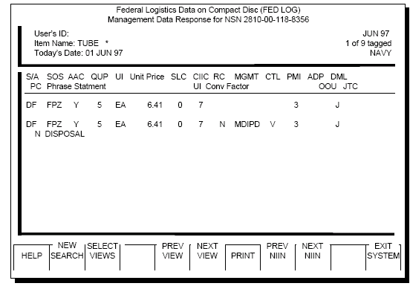

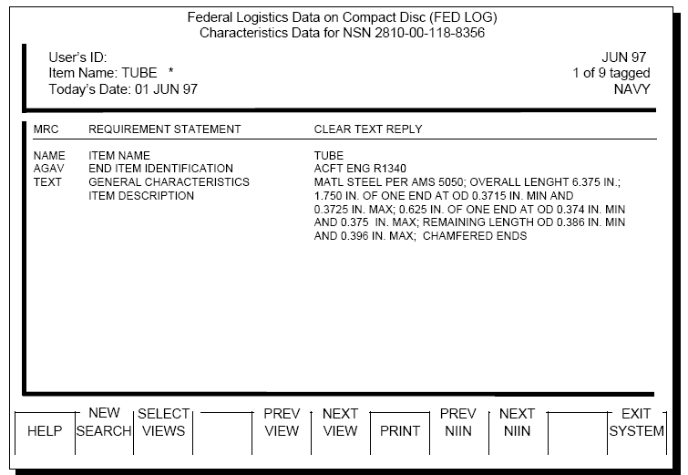

Coordinated Shipboard Allowance List (COSAL) – Provides both technical and supply information, which makes it an Integrated Logistics Support (ILS) document. It is a technical document to the extent that equipment/component/part nomenclatures, operating characteristics, technical manuals, etc are described in Allowance Parts Lists (APL’S) or Allowance Equipage Lists (AEL’S). The COSAL is an authoritative document, which lists:
- The equipment/components verified by Ship Configuration and Logistic Support Information System (SCLSIS) to be installed on a ship to perform its operational mission.
- The repair parts, and special tools required for the operation, overhaul, and repair of equipment/components.
- The Operating Space Items (OSI) and consumables necessary for the safety, care and upkeep of the ship.

SPCCINST 4441.170A – COSAL USE AND MAINTENANCE MANUAL

HMEO&E COSAL Part I – Contains the Summary of Allowance Parts/Equipage/Components (SOAPL) and the indexes.

Part I – Consists of five sections
SOAPL
Section A – Nomenclature (noun name) sequence to APL
Section B – Service Application to APL
Section C - APL/AEL Sequence to EIC to ALISIN
Section D – EIC to APL/AEL
Section E - ALISIN to APL

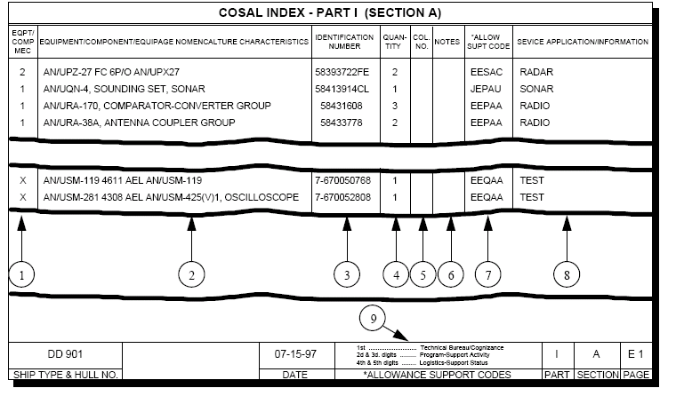

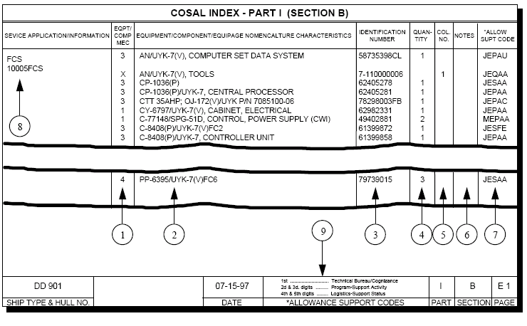

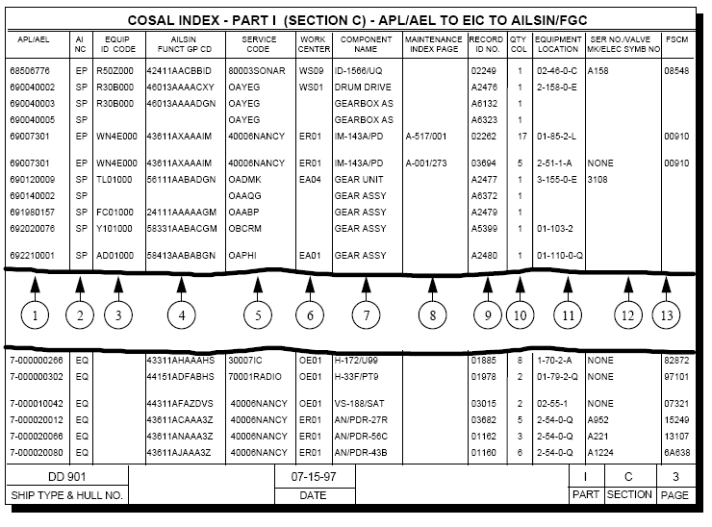

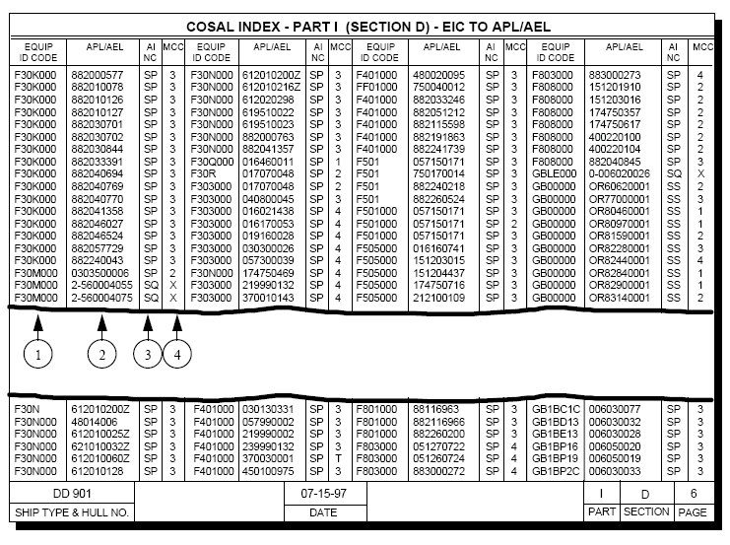

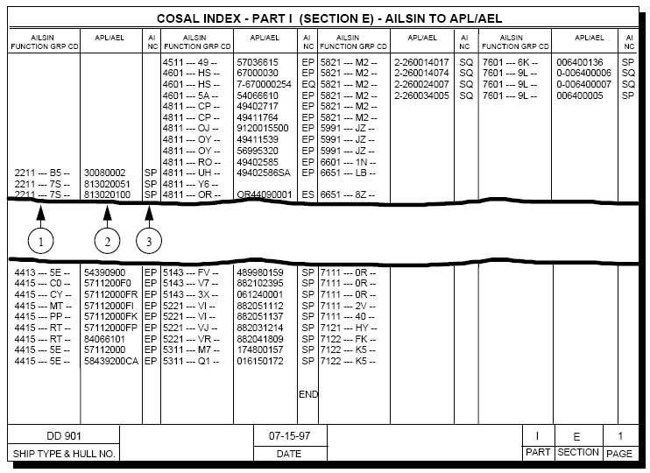

HMEO&E COSAL Part II

Part II – Consists of three sections
Section A – Allowance parts lists
Section B – Circuit symbol number to stock number (electronic APL)
Section C – Allowance Equipage List
Bald APL’S
Allowance components list
Misc. repair APL’S (89000 SERIES)
Configuration RIC’S

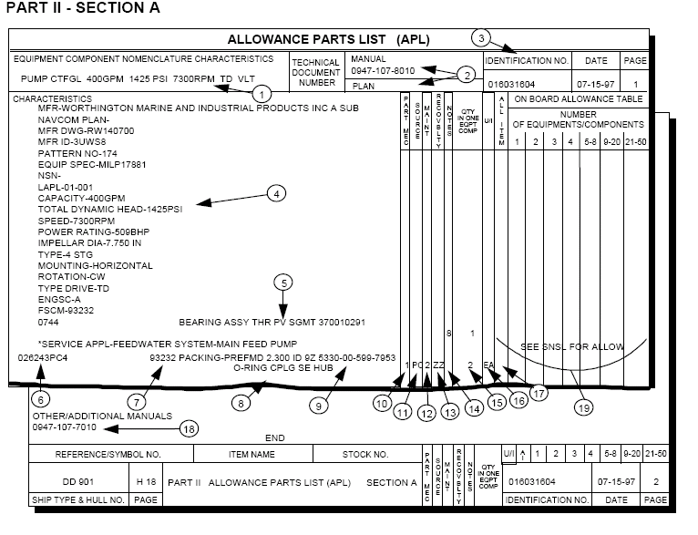

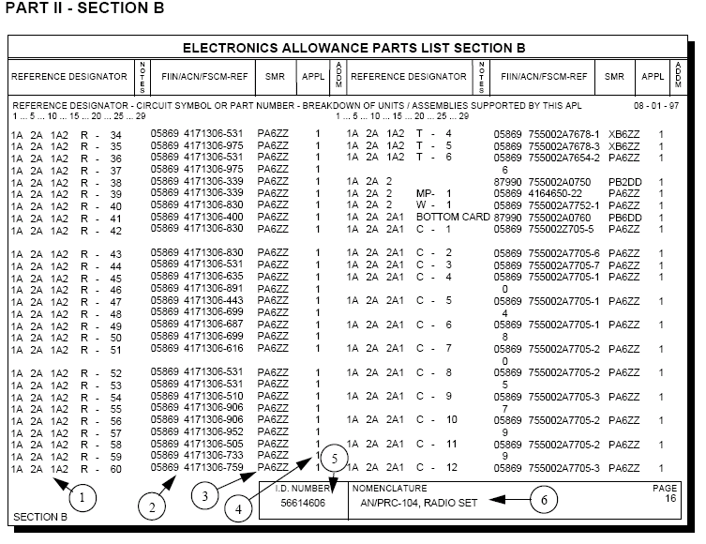

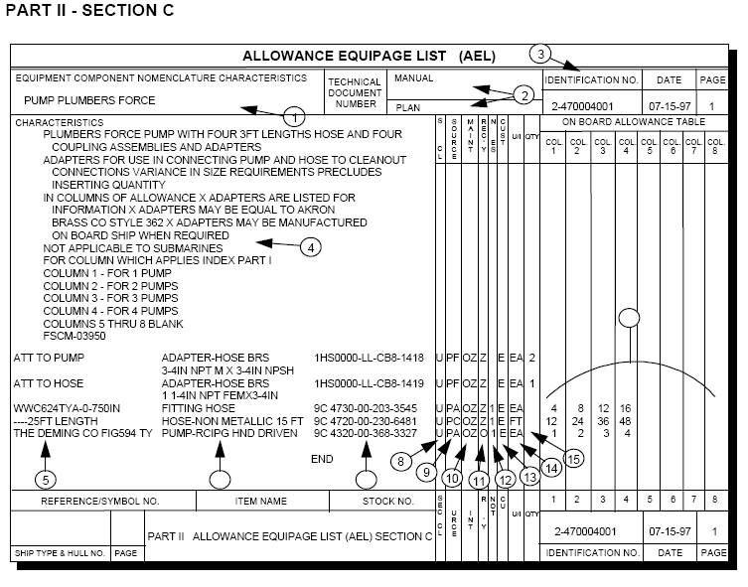

HMEO&E COSAL Part III

Part III – Consists of Six Sections
Section A – SNSL Storeroom items
Integrated Stock List (ISL)
Section B – Operating Space Items (OSI)
Section CF – Maintenance Assist Modules (MAMS)
Old to new stock number cross-reference list
Ships Value List
Section D – Alternate number cross-reference to NIIN/NICN
Section E – General use consumable list (GUCL)
Section F – Forms and publications

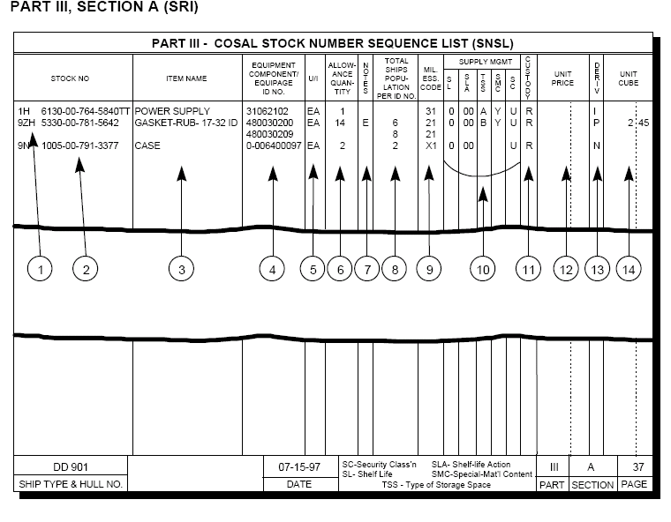

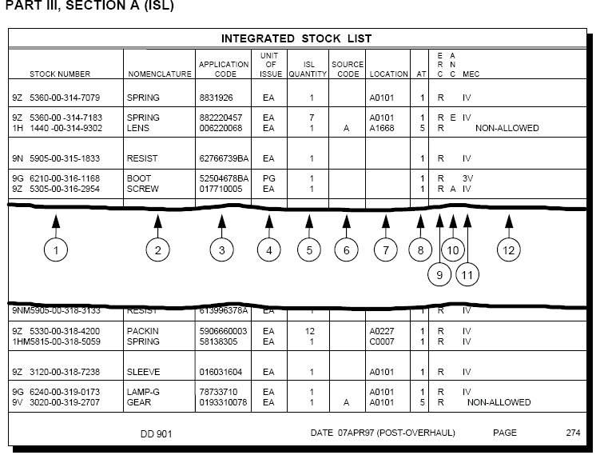

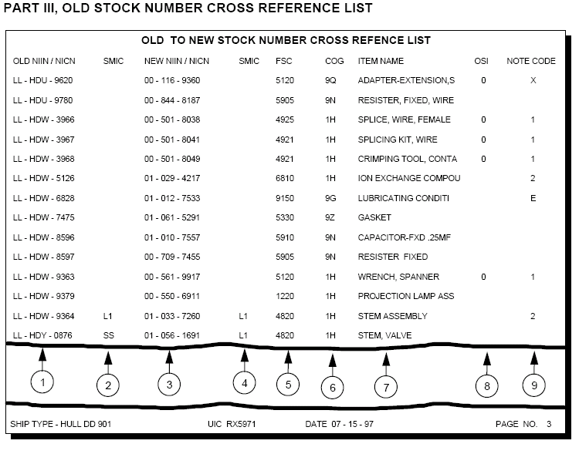

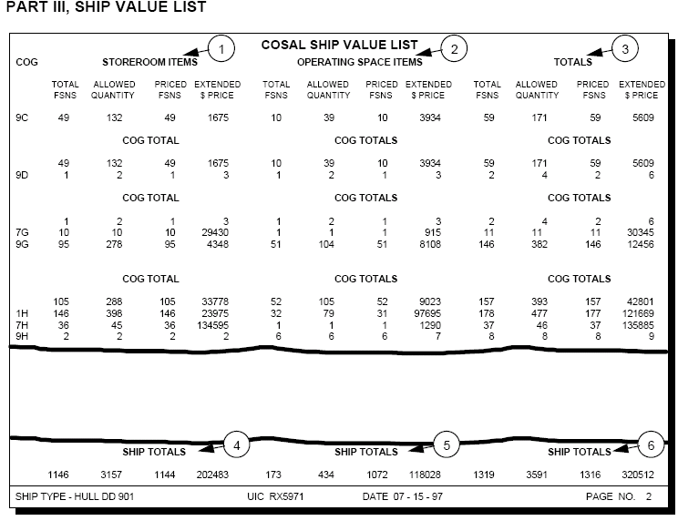

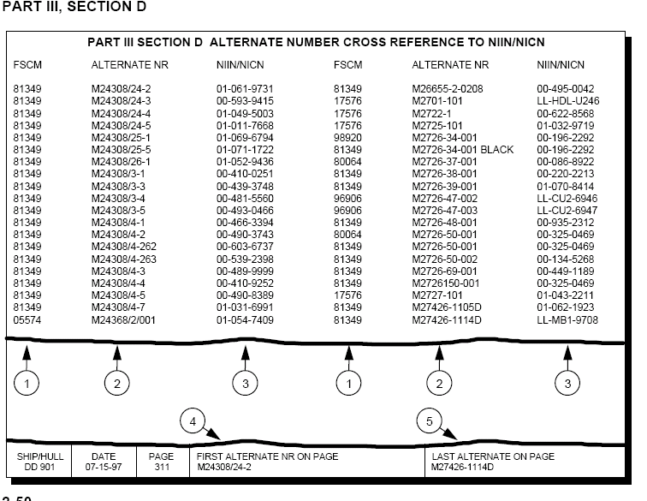

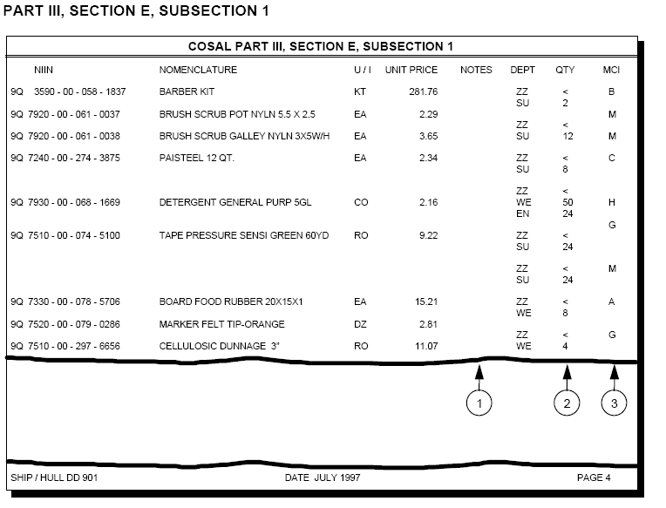

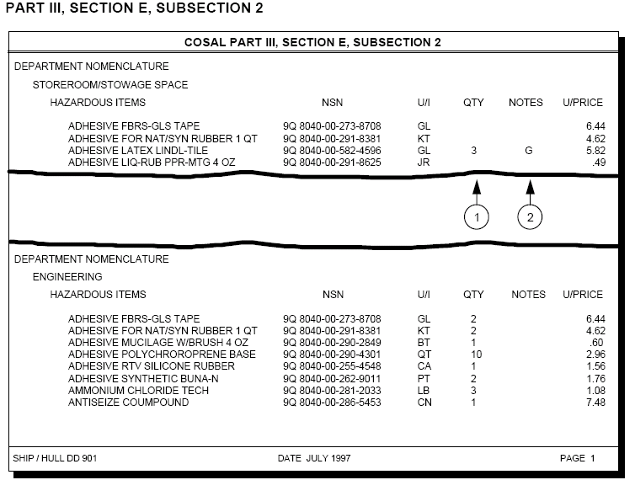

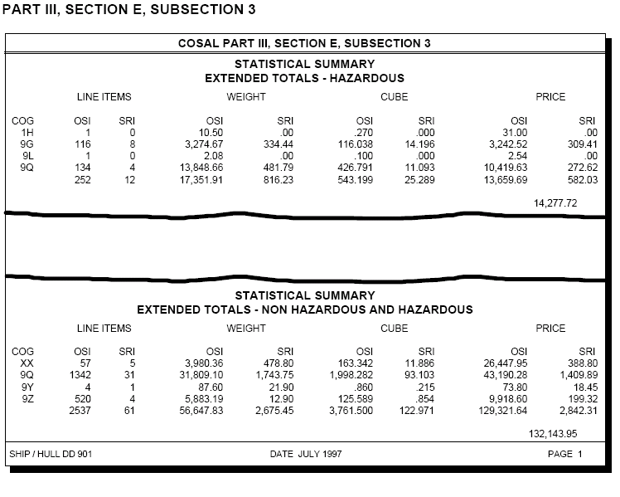

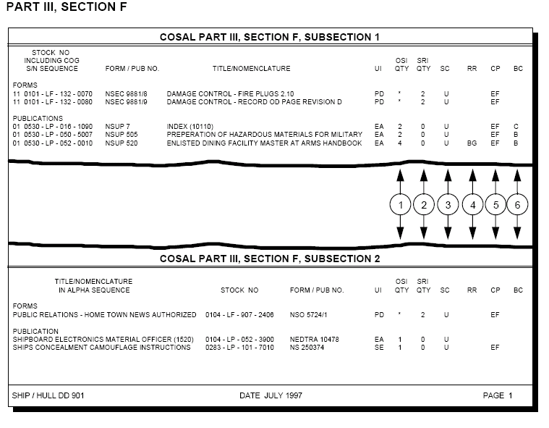

HMEO&E APLS – Consists of nine digits

Electronic APLS – Consists of eight digits

Aviation Consolidated List (AVCAL) – Is published by NAVICP Philadelphia, PA. The AVCAL lists the items and quantities of aeronautical material authorized to be stocked by CV/CVN/LPH/LHA/LHD ship types to support the maintenance and operations of embarked aircraft. It is tailored to each ship and the items listed are selected from all Allowance Requirement Registers (ARR’S)/Allowance Lists (AL) that apply to the embarked aircraft.

NAVSUP 1220-2 – Allowance change request, it is the prescribed document for requesting all additions/deletions or quantity increases/decreases in all published allowance lists.

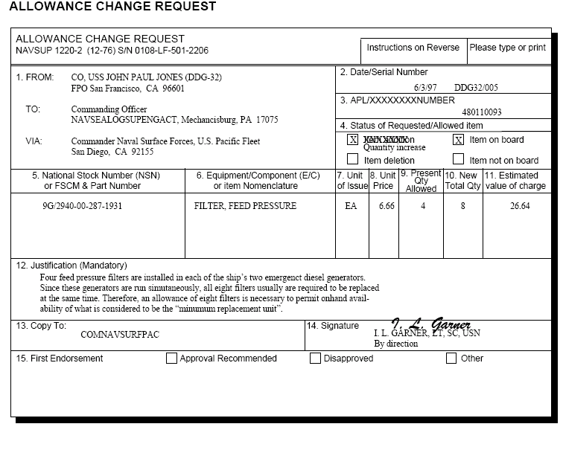
OPNAV 4790/CK – CONFIGERATION CHANGE REQUEST

Color codes for gas cylinders:

- Yellow – Flammable materials
- Brown – Toxic/poisonous materials
- Blue – Anesthetics
- Green – Oxidizing materials
- Gray- Asphyxiating
- Red – Fire protection
- Black – Oxygen and other gases
- Buff (tan) – Industrial
- Orange – Refrigerants



CHAPTER 3

MATERIAL PROCUREMENT

There are two basic methods by which a ship may obtain the materials and services it requires.
- Submit requisition to supply activity or to another naval vessel.
- Direct purchase from a commercial source.

MILSTRIP will be used for ordering all material from the Navy Supply System, other military instillations, the Defense Logistics Agency, and the General Stores Administration.

MILSTRIP Requisitioning forms:
- DD 1348 – DOD Single Line Item Requisition Document (Manual)
- NAVSUP 1250-1 – Single Line Item Consumption Document (Manual)
- NAVSUP 1250-2 – NON-NSN Requisition
- DD1348-6 – DOD Single Line Item Requisition System Document(Manual long form)

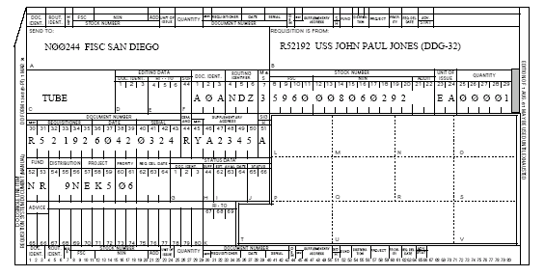

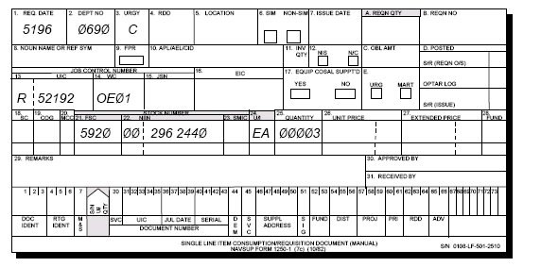

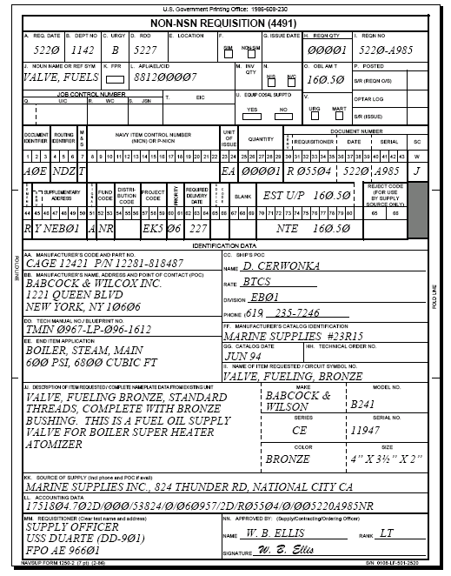

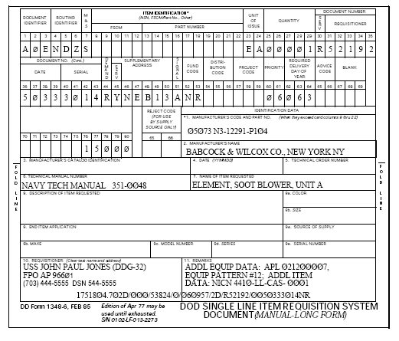

MILSTRIP Requisition Format- relies upon coded data for processing requisitions by means of automatic data processing equipment.

C9999- Will be entered in the quantity block for all continuing services.

Service designator codes:
- R- Pacific fleet
- V- Atlantic fleet
- N- Ashore activity

Serial numbers “9700-9999” – Are for ships store use only.

Zero COG Material – Interim support items, free issue to requsitioner to capture demands.

Zero COG material’s migration:
- 0J – 1H - 0Q – 1R
- 0M – 7E - 0U – 7G
- 0O – 7H - 0R – 7R

Distribution of a DD form 1348-6:
- Original – To ashore shore activity
- Green copy – To OPTAR record keeper for filing in holding file #1.
- Pink copy – To material outstanding file.
- Yellow copy – To ashore supply activity with the original.
- White copy (1ST) – Return to the requesting department.
- WHITE COPY (2ND) – Historical demand file.

DD 1149 – REQUISITION, INVOICE AND SHIPPING DOCUMENT. The following types of materials are excluded from MILSTRIP and will be requisitioned by DD 1149 unless otherwise indicated:
- Ships propulsion and aviation fuel, bulk lubricants.
- COG I materials not assigned a NICN
- COG OK, library materials - by letter to CNET.
- Industrial plant equipment.
- Communication security equipment – same as crypto
- Nuclear ordnance
- Presentation Silver – on a loan basis from NAVSUP OR SECNAV.

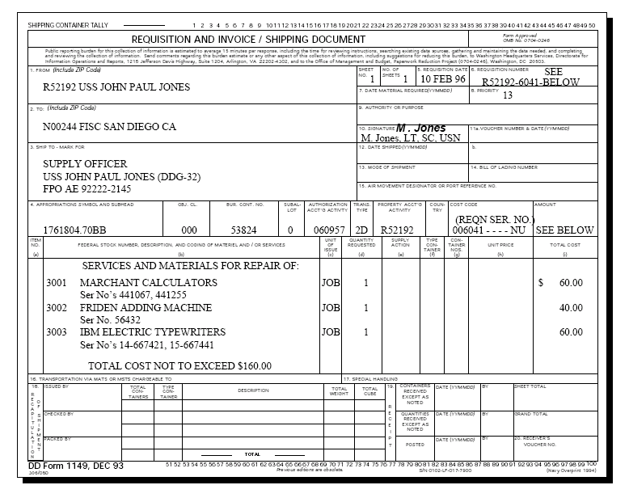

During minimize, communication only Priorities 01-08 will be transmitted via naval message.

CASREP (NORS) Requisitions will be submitted via DAAS on a separate message with a “W” in the 1st position of the serial number.

Validation of transmitted data. To preclude re-transmittal of erroneous data, DAAS validates the following significant data fields in requisitions:
- Document identifier
- Routing identifier
- NSN
- Quantity
- Requisitioner
- Signal code
- Media and Status code
- Supplementary addressee.

DAAS maintains a copy of incoming messages for 60 days.

Uniform Material Movement and Issue Priority System (UMMIPS) – Is the requirement to assign priorities in accordance with standards set forth in the UMMIPS. The basis for expressing the military urgency of a requirement is the priority designator, which ranges from 01 (highest) to 15 (lowest). The priority designator assigned to a requisition determines the time frame within which the requirement normally will be processed by the supply system.

Table relating F/AD and UND’S to priority designators.

UND F/AD’S
I II III IV V

A 01 02 03 07 08

B 04 05 06 09 10

C 11 12 13 14 15

F/AD – Force Activity Designator- Identifies the category on the basis of its military importance.
- I – Combat forces, US forces designated by the President
- II – Combat ready and combat support forces, 24 –HRS Combat Deployment forces.
- III – US Forces outside the CONUS not in I OR II.
- IV – Forces in combat ready D plus 30 to 90.
- V – All other forces not in 1 thru IV.

Limitations on high priority requisitions 01-08.
- Submarines and FBM tenders – 80%
- Destroyer tenders, Non-FBM Tenders, CV’S, LPH’S, Fleet maintenance – 70%
- Navy/Marine Aircraft Squadrons and Marine Aircraft
Groups – 70%
- Navy/Marine Corps Air Stations (non-industrial), WESTPAC Industrial Facilities, Naval Communications Activities - 60%
- Navy/Marine Corps Airs Stations (industrial) – 55%
- NARF’S and Shipyards – 50%
- Underway Replenishment Ships, Research, Development and Laboratory Activities, Training Activities – 40%
- FISC’S (former Naval Supply Depots) – 25%
- FISC’S (former Naval Supply Centers) –15%
10. Surface Ships not included in category a, b, or g – 55%
11. Others – 55%

PRI 01 – 03 AND PRI 01 – 08 NORS/NMCS requisitions will be processed by the supply system on a 24 HR 7 day work week.

PRI 04 – 08 – NON-NORS/NMCS AND 09- 15 Requisitions will be processed by the supply system on an 8- HR 5 day workweek.

In foreign ports the contracting officer should ensure that all materials will be received and paid for while in port.

Supplies not to be purchased without Bureau/Office approval:
- Centrally procured NSN items other than to satisfy emergency
requirements.
- Material in excess of allowance, except when emergency
approval of an in excess requisition has been obtained from
the senior officer present afloat.
- Boats
- Library materials
- Forms, printing, binding, blank book work and contract (commercial) printing
- Technical ordnance articles
- Printing equipment and machinery
- Automotive equipment
- Transportation facilities, equipment, material, parts, and
supplies required for domestic transportation.
10. Industrial plant material
11. Photographic equipment
12. Office equipment (i.e. word processing equipment or fast
copying machines)
13. Other material or services restricted from purchase by
Government regulation or instruction.

Divers and Swimmers Clothing-Eligibility Navy and Marine Corps personnel assigned to Navy and Marine Corps Units (e.g. explosive ordinance disposal units, deep sea divers groups, search and rescue (SAR) units) designated as qualified divers or underwater swimmers, are eligible to receive any or all specified articles of personal diving outfits and accessory equipment upon successful completion of a CNO approved search and rescue swimmer school or divers underwater swimmers school. Issues of personal diving clothing to all officer and enlisted personnel will be recorded on a NAVPERS 1070/613.

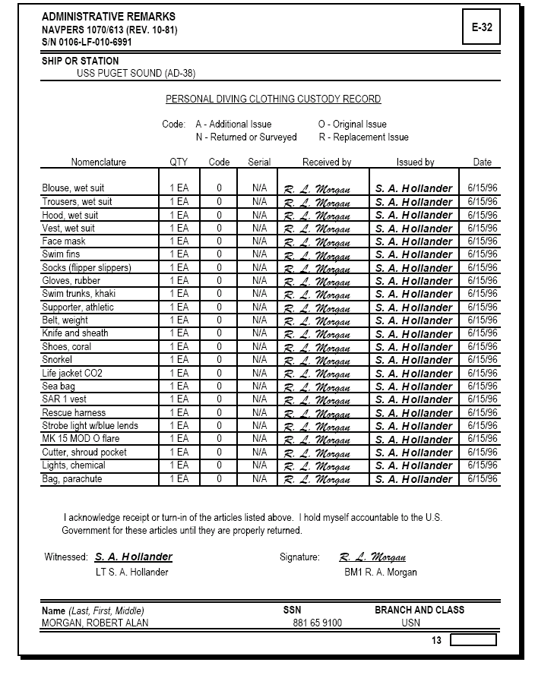

Leather Flight Jackets- Are authorized for wear by naval aviators (pilots and naval flight officers), naval flight surgeons, and enlisted crewman in flight status who are qualified to wear air crew wings. Flight jackets are to be ordered from the only authorized single navy stock point, which is the Supply Officer, FISC Jacksonville, by letter personally signed by the Squadron/Station Commanding Officer. The letter must contain, name, rank (rate/rating) and social security number of a bonafide recipient and must be accompanied by a completed requisition (DD 1348-6 or NAVSUP 1250-1) for each flight jacket requested.

All MTR’S Will be requisitioned by PRI “06 or higher” when authorized.

All DLR’S will be limited to a quantity of one per requisition, except:
- Aircraft tires (FSC 2629)
- Transducers/Hydrophones (FSC 5845)
- Radiac equipment (FSC 6665)

Commonly used advice codes:
2B - Do not sub 5G – One for one exchange
2C – Do not back order 5K – Fill or kill
2F - Obsolete 5S – Remain in place
2L - QTY exceeds normal 5V – Combo of 5G/2B
2P – Continuous length 53 – Combo of 5A/2B
5A - Survey 5N – Reduced price
5D – Initial requirement

2S COG/X1 SMIC Materials – Will only be requisitioned by naval message or letter directly from NAVSEA 08 with valid justifications.

Field level repairable (FLRS) (1H/1R/3H) – Repaired/condemned at organizational or IM’s level.

Quartz Crystals – Allowance is set by SPAWAR.

Supply Officer is responsible for the procurement of ships propulsion fuel.

Engineering Officer is responsible for determining the ships fuel requirements.

Ships are not authorized to purchase any non-habitability materials without the approval of TYCOM.

Official representation funds (ORF) are the only authorized funds for the procurement of gifts.

Types of requisition status:
- Exception status
  - Material obligation
  - Procurement for direct delivery
  - Partial issue and partial other action
  - Substitution
  - Change of NSN, U/I, COG
  - Requisition returned for specific cause
  - Referral order
  - Cancellation acknowledgement
  - Any circumstance, which indicates that issue may not, made within time frame established for the priority indicated on the requisition.
- 100% supply status – Provides information on every action taken by the supply source on the requisition.
- Shipment status – Consists of advice of shipment including date of shipment, mode of shipment, registration number on registered parcel post shipments, transportation control number or bill of lading number, and date available for shipment.

Time frames for furnishing status:
- Supply status
  - PRI 01-08 – Within 48 HRS upon receipt of requisition/follow-up.
  - PRI 09-15 – 5 workdays upon receipt of requisition/follow-up.
- Shipment status
  - PRI 01-03 – 24 HRS after released to the carrier or after receipt of follow-up.
  - PRI 04-08 – 48 HRS after released to the carrier or after receipt of follow-up.
  - PRI 09-15 – 3 working days after released to the carrier or after receipt of follow-up.

Review of outstanding requisitions:
  - PRI 01-03 – Daily
  - PRI 04-08 – Weekly
  - PRI 09-15 – Monthly

When requested status on a requisition is not received, a follow-up should be sent after 3 days for PRI 01 – 08, 7 days for PRI 09 – 15, 10 days after submittal of requisition.

“3” types of follow up documents
1. AF_ Document – Request current status of requisition.
2. AT_ Document – Process as an original document if no record.
3. AFC Document – Request for improved ESD.

Follow up restrictions:
- No status received – Submit follow-up after RDD/SDD.
  - PRI 01 – 08 - Submit follow up requisition after 3 days from requisition submittal.
  - PRI 09 – 15 – Submit follow up requisition after 10 days from requisition submittal.

AFT – Tracing registered parcel post. Should be sent no earlier than 10 days or no later than 60 days (90 days for medical/dental) after shipment date.

Requisition modifier may be initiated by requisitioner, supplementary addressee, monitoring activity or ICP to modify previously submitted requisitions when:
- F/AD is upgraded/downgraded
- Urgency of need has changed

The following fields can be modified when requisitions are held by ICP or DLA integrated managers:
  - CC 7 - M&S Code
  - CC 45 - 50 - Supp Address
  - CC 51 - Signal code
  - CC 52 – 53 - Fund code
  - CC 54 – 56 - Distribution code
  - CC 57 – 59 - Project code
  - CC 60 – 61 - Priority
  - CC 62 – 64 - RDD
  - CC 65 – 66 - Advice code

Cancellations cannot be requested when shipment status has been received.

Cancellations on non-NSN materials will not be requested when procurement status is received, unless material cannot be utilized at all.

MOV’S for PRI 01-08 Requisitions are considered over-aged for validation when requisitions have been outstanding for more than 30 days and 75 days for PRI 09-15 past requisition date.

MOV will be conducted quarterly by Navy stock points.

MOV QUARTERLY SCHEDULE:
CYCLE CUTOFF DATE RESPONSE DATE

1 20 JAN 05 MAR
2 20 APR 05 JUN
3 20 JUL 05 SEP
4 20 OCT 05 DEC

CHAPTER 4

MATERIAL RECEIPT, CUSTODY AND STOWAGE

Supply Officer is responsible for the receipt, identification and inspection of all incoming stores except:

- Medicinal Supply - Medical Officer
- Marine Corps - Marine Corps
- Bulk Petroleum - Engineering Officer
- Ammunition - Weapons Officer

Physical receipt of all incoming stores is delegated to the leading storeroom storekeeper.

Leading storeroom SK’S – Will ensure that all incoming materials are received, identified, inspected, sorted and distributed to the proper storeroom or departments.

Duty storekeeper – Will ensure that material delivered after working hours will be properly received or turned over to the appropriate department, and all documents will be annotated, and given to the leading storekeeper the following day.

Receipt of materials at sea:
- Prior to replenishment, assign specific tasks to personnel. Whenever possible, have personnel from other departments work with you.
- Develop a traffic flow.
- Station responsible petty officers at various locations of the flow.
- Do not count items at drop off point.

Types of receipt documents:
- DD FORM 250 – Material under Government contracts (materials procured by a DD form 1155)
- DD FOR 1348-1 – Receipt from ashore activity
- DD FORM 1149 – Materials excluded from MILSTRIP
- DD FORM 1155 – Order for supplies and services

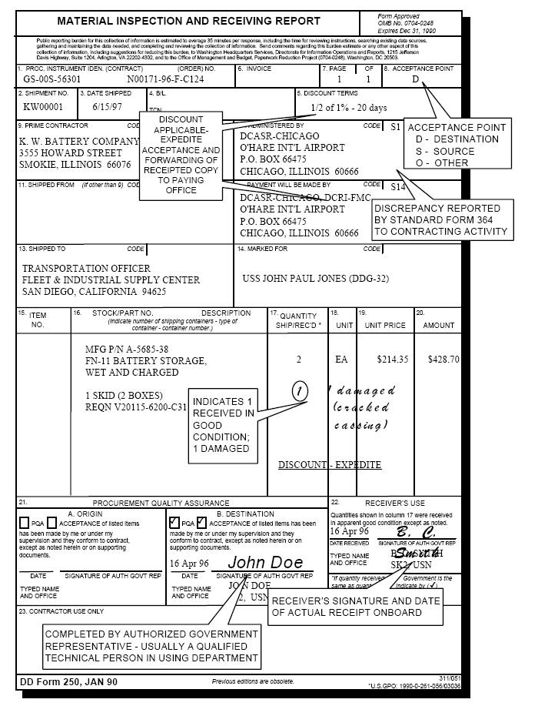

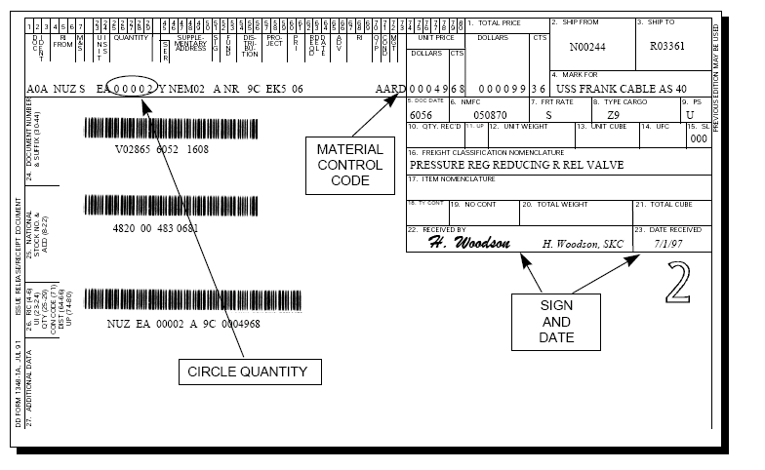

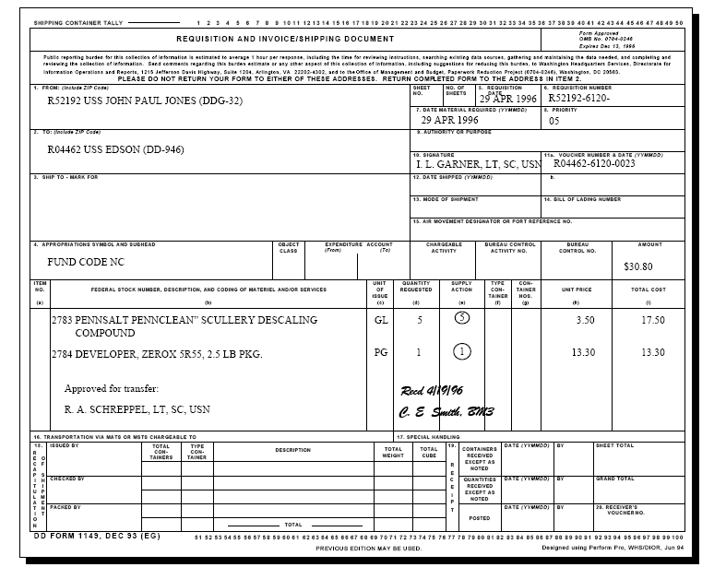

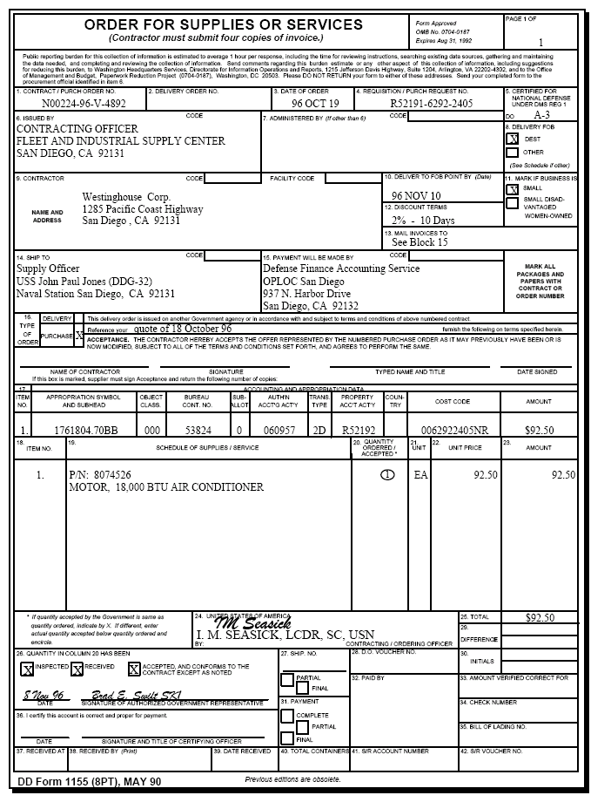

Government Bill of Lading (GBL) STD FORM 1103 AND 1103B)- Serve as transportation contracts between commercial carriers and the U.S. Government.

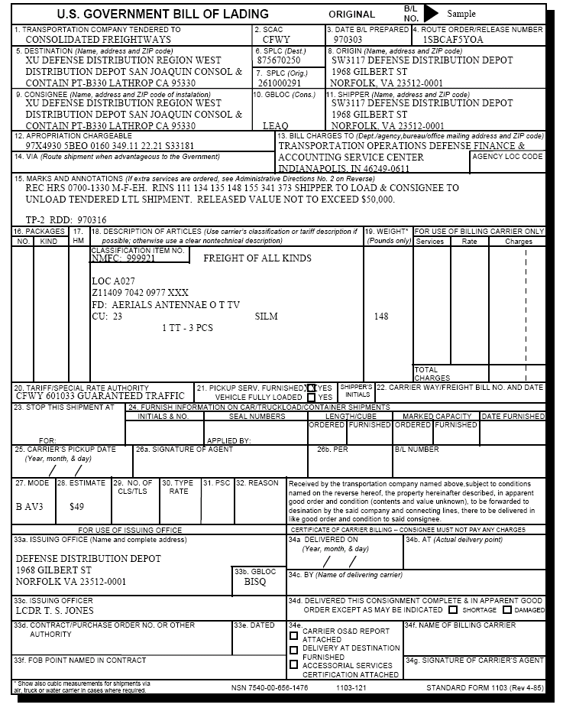

Receipt of materials from Naval activities require a quantity count only.

Receipt of stores from other Government activities, other than Naval activities, will be inspected for quantity and quality. Assistance will be requested from the using department to assist in the quality inspection.

Supplementary address on the DD form 1348-1 will normally contain the storeroom location, work center code. However it will contain the UIC of the stock point that initially received the requisition when:
- The item is managed under a 9 COG.
- The item was NIS at the stock point.
- The requisition was referred to GSA/DLA activity.

SECNAVINST 4355.13 – Report of discrepancy procedure

STD FORM 361 – Transportation discrepancy report

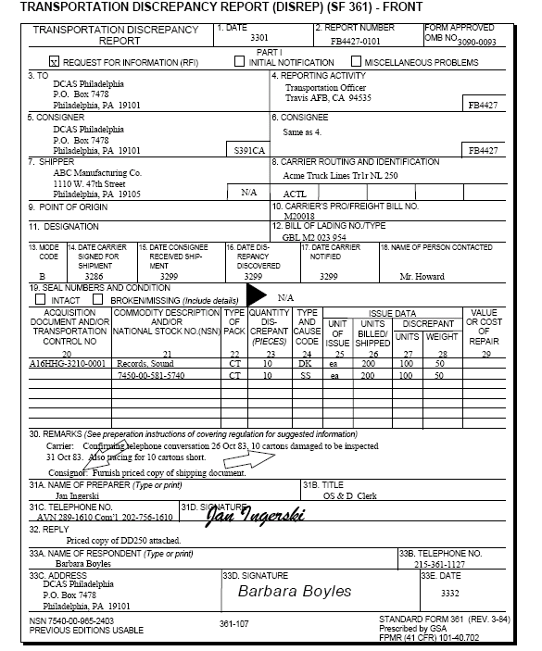

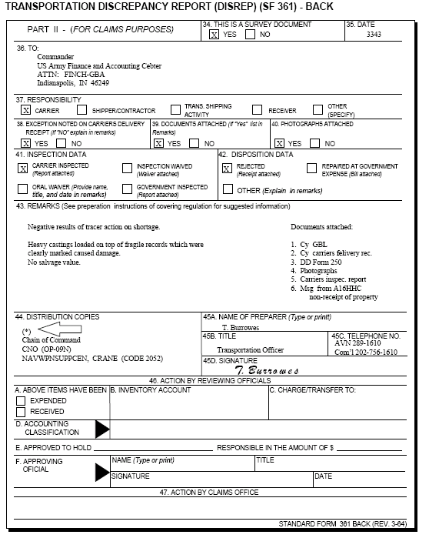

STD FORM 364 -Supply Discrepancy Report (SDR)

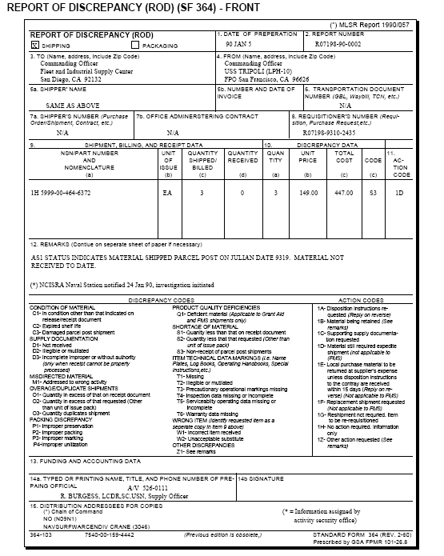

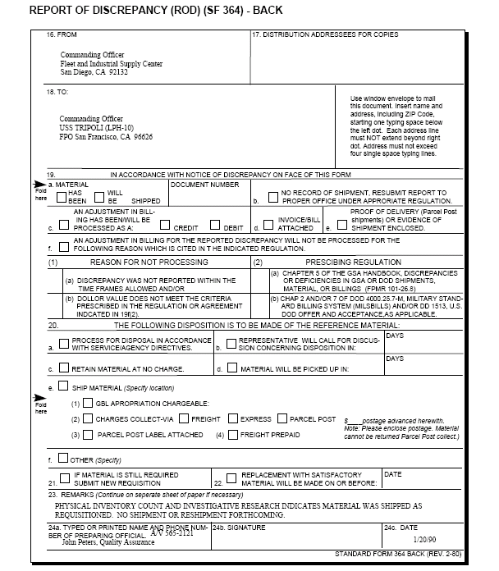

Navy action activity is required to respond to a SDR with in 45 days of receipt of the SDR.

The first follow up for the SDR should be sent after 60 days. Subsequent follow ups will be sent at 30 day intervals.

The submitting activity of the SDR is authorized to clear inventory records for all SDR’S with no reply after 6 months from the submission of the SDR or appearance of the over-aged material in lost in transit.

The following shipping type discrepancies are reportable by SDR’S:
- The shortage/over-aged value is in excess of $100.00 per line item.
- Wrong materials, unacceptable subs, duplicate shipments regardless of dollar amount.
- Classified or protected items regardless of dollar amount.
- Shipped to the wrong activity regardless of dollar amount.
- Supply documentation is missing/improperly prepared.
- Items valued in excess of $100.00 when shipped through parcel post not received in a damaged condition.
- Material received for repair, that have been cannibalized with out the item managers approval, when the dollar value is in excess of $100.00.
- Repetitive discrepancy, regardless of dollar value.
- Discrepancy shipment from a contractor/vendor, regardless of dollar value.
10.Improper packaging when the cost of correction exceeds $50.00.

The responsibility for raising questions during UNREP for receipt of discrepancy, lies on the receiving ship.

Discrepancies less than $100.00 per UNREP will be charged to the receiving ship.

STD FORM 368 – Quality deficiency report (QDR)

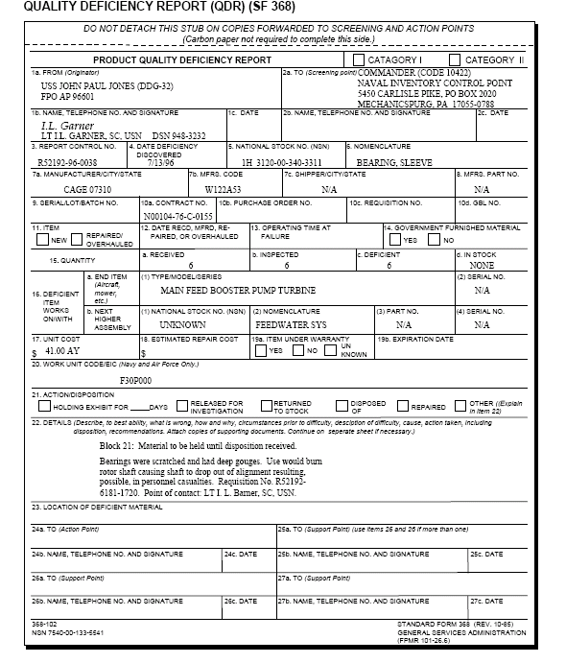

Defective material identified by a QDR, will be isolated, suspended and held for a minimum of 90 days unless otherwise directed.

Category I – May cause death, injury or severe occupational illness, would cause loss or major damage to weapons, restrict combat readiness. Forwarded within one day by message.

Category II – Does not meet the criteria for category I. Forwarded within five working days.

Retain all QDR records for 2 years.

Determination when a shipment is complete.
- Supply ashore – Turned over to the representative of the ship.
- Deliveries alongside a barge/ship – Inspected, accepted, and delivered alongside such barge/ship.
- From CLF- When materials have been loaded alongside ship/barge and a signature has been obtained.
- UNREP – When the material have cleared the side of the issuing ship.

NAVCOMPT form 442- Discount label.

Medical Officer or his representative will sign all DD 1155’S for drinking water as to the quality and the requesting department will check for quantity.

Receipt of small arms- Will be left unopened and placed under lock and key until the ordering department is available for receipt inspection. A joint inspection will be conducted to verify the quantity and serial number of each item received. If a discrepancy exists, the receiving and ordering department representatives will document the discrepancy. Both the material and the receipt documents will be returned to the security locker. The Supply Officer and the ordering department head will be notified immediately of discrepancies.

Maintenance Assist Modules (MAMS) – Assigned an allowance note code of “N” and are listed in the COSAL Part III Section CF.

All radioactive materials will not be transferred outside of the Navy without proper authorization.

Ships will not offload allowance list items of equipage/equipment for temporary storage ashore in excess of one year without prior approval from the appropriate TYCOM.

Consumables, tools and repair parts used in support of the ships allowed equipage/equipment will not be offloaded except during a shipyard overhaul/ILO.

All materials temporally stored ashore will be documented on a DD form 1149 annotated “MEMORANDUM INVOICE ONLY” in data block 4.

Material protection levels:
Level A – Protection against the most severe condition known or
anticipated.
Level B – Less severe that A, for multiple handling and ocean
transport.
Level C – Favorable conditions during shipment/handling.

Materials in shipboard storerooms and other stowage area, will be arranged to:
- Ensure maximum utilization of the space.
- Provide orderly stowage and accessibility.
- Prevent damage to the ship and injury to personnel.
- Reduce the possibility of material loss/damaged.
- Facilitate the issue of old stock first (FIFO).
- Facilitate inventories.

Each storeroom location will be designated with a 5 digit alpha-numeric characters.

Space layout factors.
To maximize the extent available, stowage of general stores will adhere to the following:
- Locate heavy/bulky materials in an area most convenient to hatches and material handling equipment.
- Locate light and bulky material in spaces with overhead clearance to maximize space.
- Segregate materials which are dissimilar in type or classification, (i.e. hazardous/non-hazardous, classified/non-classified)
- Locate frequently requested materials as close as possible to the point of issue.
- Locate shelf life material in readily accessible areas to facilitate frequent screening.
- Provide isles at least 30 inches wide between bins/aisles and cabinets.
- Avoid multiple locations for like items.
- Stow/mark materials with labels facing outward.

Types of storerooms:
- Main issue – Centralized distribution point for SIM and shelf life items, the most accessible.
- Bulk issue – Bulky items
- Repair parts – For repair parts except bulkhead mounted spares.
- Hazardous materials- For hazardous materials listed in the CHIL.
- Flammable liquids – For flammables.
- Acid locker – Lead proof, lead lined box/chest with 3/8 inch inscription reading “ACID BOTTLE STORAGE” kept inside the flammable liquid storeroom.
- Alcohol locker – For grain alcohol, kept inside the flammable liquid storeroom.

The flammable liquid storeroom is located at either side of the ship, below the full load water line, not adjacent to a magazine. Equipped with an automatic fire alarm and carbon dioxide system.

Flammable items with the FF SMCC code must be stored in the flammable liquids storeroom:
- Liquids – SMCC’S “D”, “F”, “G”, “P” and “S” for wood alcohol.
- Paste, grease, semi-solids with the SMCC code of “G”.
- Solids – SMCC of “Z”.

Compressed gasses must be stowed on the weather decks or below decks specifically assigned for that purpose.

Flammable liquids have a flash point of 100 degrees F and below.

Combustible liquids, grease and paste have a flash point of 200 degrees F or below.

CHAPTER 5

MATERIAL EXPENDITURE AND SHIPMENT

There are 4 ways to expend material from records:
1.Issue 2.Transfer 3.Survey 4.Cash Sales

Expenditure numbers for DLR’S will duplicate the document number assigned for replacement requisitions. Expenditure for repairables (DLR’S) will be filed separately.

Material transfers are one of the duties of the Supply Officer, unless otherwise directed by the CO, with the exception of medical and dental supplies. Other department heads are not authorized to approve material transfers.

Maintenance Assist Modules (MAMS) may only be transferred upon the approval of the TYCOM.

“B” Summary – Is a list of materials transferred within the same TYCOM, these are non-chargeable transactions.

NSA type material between ships of the same TYCOM is non-chargeable, however the value of the transactions will be reported on the “B” summary.

“A” Summary – Is a list of materials transferred between different TYCOM’S. These are chargeable transactions.

Inter-ship transfers of APA materials are non-chargeable, however it should be documented.

Transfer of fuel to other ships will be documented in an unpriced memorandum DD form 1149.

Quantity of fuel transferred will be determined by the gauges of the receiving official.

Over-aged CBR, over 10 years, old clothing will be considered for use in training operations or turned into the nearest supply activity ashore.

Safes and lockers with combination locks will be turned in or transferred with the combination reset to 50-25-50.

Presentation Silver will not be transferred between ships or surveyed without prior approval from NAVSUP. All copies of surveys and invoices will be forwarded to NAVSUP within 30 days.

All unserviceable MTR’S will be turned into the nearest ATAC/HUB/NODE.

Credit for MTIS will not be given to the following:
- APA – Free issue
- Extended money value of $100.00 or less
- Non-NSN Materials

Credits for turn-ins, will be given to the TYCOM allotment as indicated by the cite fund code.

Material transfers have not impact on the transferring ships OPTAR. OPTAR. Although it can be used as a basis for requesting an augmentation from TYCOM.

MTIS transactions do not include transfer of materials to disposal for DRMO and transfer of DLR’S in NRFI conditions.

A “C” will be entered in CC 73 for MTIS if a credit is requested.

HUB – Is a Navy operated facility which provides verification of the drawing/part numbers to NSN’S for all DLR’S. They correct erroneous documents.

FLR – Field level repairable, identified by MCC Code “D”.

NODE – A DLR Collection, consolidation and trans-shipment point. Validation of NSN’S and part numbers are not accomplished.

ATAC will not be used to transport DLR’S for repair/maintenance within the fleet.

TAC Code N935 is reserved for the ATAC program.

Credit exchange DLR’S excluded from ATAC:
- Aircraft engines
- Marine gas turbines
- FBM components
- Classified items
- All materials coded for disposal
- Materials under QDR investigation
- Redistribution
- Nuclear reactor plant materials
- Radiacs, FSC 6665
10. Hazardous, flammable materials
11. Small arms
12. 1H/1R/3H COG FLR’S with MCC Code “D”

Atlantic and Mediterranean fleet units will send DLR’S to the nearest HUB/NODE, disregard Part II of the MRIL.

Pacific and WESTPAC fleet units must continue to review Part II of MRIL.

Fleet units in the Indian Ocean, will consign all freight to:
ATAC NAVY DLR AGENT (N63005)
BANZ WAREHOUSE, JUFFAIR, BAHRAIN
PSC 456, BOX 103
FPO AE 09834-2800

NAVSUP P 4107 – MRIL

NAVSUP P 484 – Supply Afloat Packaging Procedures

Supply Department will document and package all NRFI MTR’S within 48 HRS. and ship them within 24 HRS. (TOTAL OF 72 HRS).

DLR follow-ups (CARCASS TRACKING) – when activities requested DLR’S using one of the following advice codes, they are required to return a NRFI carcass to the supply system. ICP’S will keep the transaction open for possible additional charges until a turn-in is received, the following guidelines apply for follow-ups:
ADVICE CODE NO. OF DAYS FROM REQN DATE FOLLOW UP SENT

5G “N” SERVICE CODE REQNS TO ASO - 45 DAYS
5V “R” /”V” SERVICE CODES REQNS TO ASO - 60 DAYS
  - ALL REQNS TO NAVICP - 90 DAYS
NO. OF DAYS FROM JULIAN DATE STRM ISSUE
5R “N” SERVICE CODE REQNS TO ASO – 45 DAYS
5Y “R”/”V” SERVICE CODE RQNS TO ASO - 60 DAYS
5S/52 ALL REQUISITIONS TO SPCC -90 DAYS

BK1 – Follow-up on NRFI Carcass

BK2 – Response to BK1, must be received by ASO in 21 days or NAVICP in 60 days.

BKR - BK2 response contains invalid data, response is shown in CC 65.

BK3 – Notification of additional billing, sent if response is not received as specified or BK2 indicating that turn will not be made.

BK4 - Notification of billing reversal, difference between the net and standard price.

DRMO will reject your material turn-in for failure to enter the proper disposal code on the DD form 1348-1.

Materials turned into DRMO, fall under three categories:
- Items that need IM’S disposal authority.
- Items that do not need IM’S disposal authority.
- Scrap or waste.

Report of Survey (DD FORM 200) will be generated for all unresolved discrepancies:
- Supply System Stocks
  - Sensitive items (Narcotics, drug abuse substance, precious metals) regardless of dollar value.
  - Classified items regardless of dollar value.
  - Arms, ammunition, explosives, regardless of dollar value.
  - Pilferable items, items easily converted for personal use when the extended value is $750.00 or more.
  - Repetitive loss when there is an indication or suspicion of fraud, theft or negligence.
  - Non-controlled items when the dollar amount is $6,000.00 or more.

For property book material, the Commanding Officer will determine if a DD 200 is required to assign responsibility and to provide relief of accountability.

Commanding Officers have full accountability for all report of surveys generated within their command.

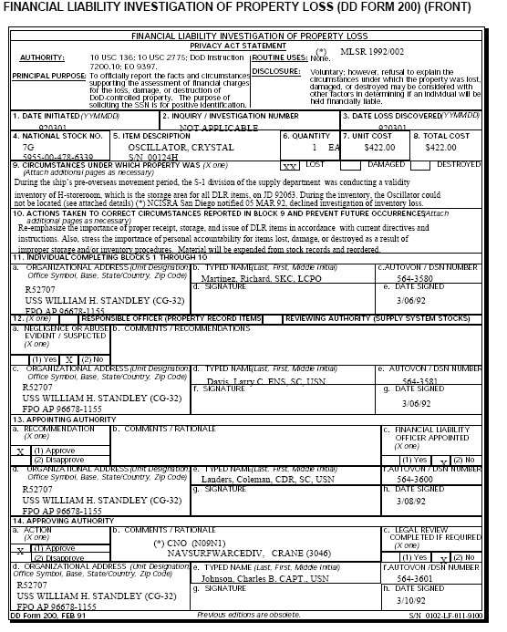

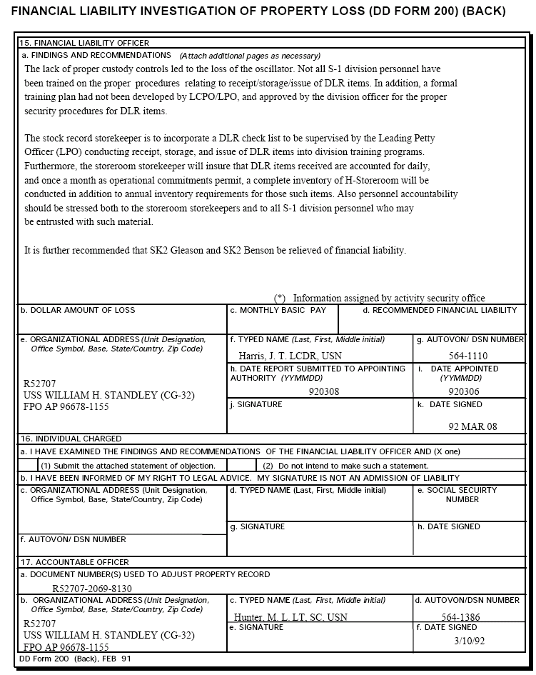

CHAPTER 6

INVENTORY MANAGEMENT

Inventory Management Segment – Shipboard material inventories are divided into 4 segments:
- Operating Space Items (OSI) – Items in the custody and management of other department heads. Listed in Part III Section B of the COSAL.
- Repair Parts – Under the custody and management of the Supply Officer. Listed in the Allowance Parts List (APL), Part II Section A of the COSAL.
- Consumables – Under the custody of the Supply Officer if stowage permits. All stocked consumables are under the management of the Supply Officer irrespective of their stowage location.
- Maintenance Assist Modules (MAMS) – Under the custody of the cognizant department head and will be located in the appropriate maintenance space. Listed in Part III, Section CF of the COSAL, listed with an allowance note code of “N”.

OPNAVINST 4441.12 – Navy policy governing the range and depth of material which each ship is required to carry for self support.

The range and depth, of non-demand based items will be limited to the COSAL items and quantities while demand based items will be determined by the usage and prescribed endurance levels.

SHIP TYPE REPAIR PARTS/ NON-EQUIPMENT
EQUIPMENT RELATED RELATED
CONSUMABLES CONSUMABLES
(DAYS ENDURANCE) (DAYS ENDURANCE)
AIRCRAFT CARRIERS 75 DAYS 60 DAYS
CRUISERS 75 DAYS 45 DAYS
DD/DDG/FF/FFG/SMALL COMB 75 DAYS 30 DAYS
AD/AR/AS 75 DAYS 75 DAYS
AMPHIBIOUS SHIPS
NO EMBARKED TROOPS 75 DAYS 60 DAYS
EMBARKED TROOPS 75 DAYS 45 DAYS
CLF SHIPS 75 DAYS 60 DAYS

Average endurance level – Quantity of material required to be on hand to sustain operation, for a stated period without augmentation. Median between safety level and high limit. The safety level is plus ½ of the operating level.

High limit – Requisitioning Objective (RO), a maximum quantity of material on hand to sustain operation.

Maintenance Source Codes – Identifies the source of parts other than the supply use during maintenance. Block 18 of the NAVSUP 1250-1.
  - - Cannibalized from other equipment.
  - - Drawn from salvage.
  - - Manufactured by other activity.
  - - Unassigned.
  - - Furnished by a ship or other activity.

Order and shipping – Is the time elapsed between the submittal of the requisition and the receipt of the material.

SIM/DBI Item – Two or more demands within a six month period.

Supply, Edit, Audit, and SIM (SEAS) – Computer information system for certain TYCOM’S that generate consumption, financial management and other supply management reports.

Supply Source Codes – Identifies the source of material at the time of the requisition:
  - Allowance list material issued from storeroom stock.
  - Load list material issued from storeroom stock.
  - Non-allowance material issued from storeroom stock.
  - Allowance material NIS.
  - Load list material NIS.
  - Stock non-allowance material NIS.
  - Not carried material. Not listed on APL/OSI.
  - Repair parts procured as DTO during and ILO.
J- Not carried material listed in APL, but not on SNSL/ISL.
K- DTO medical/dental material.
L- NC/non-COSAL procured from alteration.
X- Price difference on Budget OPTAR Report.
9- RFI material returned to stock for disposition.

Purpose of physical inventory:
- Determine stock defiencies that require replenishments.
- Determine/reconcile all deficiencies between stock record balance and physical count.
- Determine/implement controls needed to correct discrepancies.
- Ensure that material is properly identified, packaged and stowed.
- Update location and management data in the stock locator record.
- Consolidate national stock numbers to one location or storeroom, where possible.
- Provide a basis for adjusting financial balances in inventory control.

Types of physical inventory:
- Bulkhead to bulkhead – A physical count of all materials within a storeroom or ship. Usually done during ILO’S or when the storeroom fails the 90% accuracy rate as prescribed during the random sampling.
- Specific commodity – A physical count of all items comprising of a generic segment of materials (same COG’S, FSC/Same application).
- Special Material – A physical count of all items because of their physical characteristics, cost, mission essentiality or other reasons that require separate identification and inventory (i.e. classified/hazardous/controlled equipage).
- Spot/specific item – An unscheduled physical count of certain items to verify its existence, usually taken as a result of a NIS indication during a requisition.
- Velocity – A physical count of frequently demanded items. Periodic inventories of SIM items and post issue inventories on non-SIM items are examples of velocity.
- Random sampling – Used in automated ships for selective stock items. 5% of total items carried minus the items frequently inventoried (fast movers and special items)
90% - Minimum acceptable accuracy rate.
95% - For Strategic Systems Programs(SSPO) materials, FBM Tenders.

Scheduled inventory requirements:
1. SIM/DBI/POS Materials
  - All ships except aircraft carriers and class 207 ships.
Semi-Annually- Inventory to be completed within two weeks.
  - Aircraft carriers – Annually.
All aeronautical material – Inventoried completely upon return to CONUS from an extended deployment except Alaska and Hawaii.
  - Special Accounting Class 207 Ship – Annually
  - Special Accounting Class 224 Ship (load materials) – Upon return to CONUS except Alaska and Hawaii.

- NON-SIM/NON-DBI/NON-POS materials
  - Non-Automated – Inventory remaining balance after every issue.
  - Automated – Annually, constant with the inventory schedule.

- SIM DTO Materials – Inventoried by respective department head prior to an extended deployment.

- Classified/Hazardous Materials – Annually or upon change of custodial responsibility.

- Controlled drugs, precious metals – Quarterly or upon change of custodial responsibility.

- Materials in other departments custody – Quarterly

A major difference is when the difference of the physical count and the stock record is 10% or more.

For the Special Accounting Class 224 and 207 ship, an investigation is not required if the discrepancy is below $1,000.00 per line item.

Controlled equipage – Are item which require special management because the material is essential for the protection of life, valuable and can easily be converted for personal use.

Minor Property – Which are highly sensitive or has a unit cost of $300.00 ($100.00 for pilferable items) will be included in the controlled equipage inventory.

Equipage custody codes:
S – Controlled equipage, custody signature is required.
O – Operation/Navigation departments, controlled equipage, custody
signature not required.
U – Supply, controlled equipage, custody signature not required.
M – Medical/Dental, controlled equipage, custody signature not
required.
W – Weapons, controlled equipage, custody signature not required.
L – Multiple departments, controlled equipage, custody signature
not required.
E – Non –controlled equipage.

Controlled equipage expended to end-user – respective department will maintain custody of the item, and the inventory will not be delegated except when authorized.

The original copy of the Controlled Equipage Custody Card (NAVSUP 306) will be kept by the Supply Officer and the duplicate copy will be kept by the cognizant department.

Controlled Equipage designated by the CO/TYCOM will be identified as such with “CO Designated” or “TYCOM Designated” annotated on the top or bottom of the card.

All controlled equipage will be inventoried bi-annually (every 2 years) in each odd numbered year, during the period of 15 Feb –15 Mar.

Inventories of controlled equipage must be completed within 30 days after the commencement date.
a. Upon commissioning, activation, reactivation of the ship.
b. Upon relief of the department head
c. Upon change of command.

Each command having custody of presentation silver, will submit an itemized inventory report to:
NAVSUPSYSCOM, DEPUTY COMMANDER
FLEET SUPPORT,
CORPORATE PLAN AND LOGISITICS
WASHINGTON, DC
No later than 20 March of every odd numbered year beginning in 1987.

Upon change of command, or activation of the ship, and itemized inventory of all gifts other than presentation silver will be submitted to:
CURATOR OF THE NAVY
NAVAL HISTORICAL CENTER
WASHINGTON, DC.

Material Control Codes (MCC) for MTR’S:
- DLR’S under IRIM program
G- FBM weapons systems DLR’S requiring intensive management.
H- DLR’S other than E, G, Q, OR X.
Q- FBM weapons systems DLR’S requiring special testing.
X- Special program DLR’S.

Response time for processing issue request:
1. MATERIAL ONBOARD:
UND PROCESS/ISSUE TIME
A 1 HR
B 2 HR
C 24 HR

2. Material not onboard:
PRIORITY REQUISTION PREPARATION TIME
01-08 2 HR
09-15 24 HR

SIM items require quarterly stock status review and inventoried semi-annually.

Demand for stock items are registered when the requested item issued and the transaction has been posted to the stock record card.

Demand for N/C items are registered when the requested item is requisitioned. If the requisition is cancelled because it is no longer required, the demand is nullified.

SIM items will be stocked consistent with the high and low limits. Repair parts designated as “SIM” will be stocked to the allowance quantity will be replenished on a one for one basis.

Blue stock record cards (NAVSUP 1114) will be maintained for reactor plant items (“Q” COSAL ITEMS).

Red bordered stock record card will be maintained for other special category items (DLR, hazardous, critical, etc.)

Buff stock record cards will be maintained for other types of material.

AT Codes (Allowance Type Codes)

1 - COSAL item
2 - Load List item
3 - Combo of 1 & 2
4 - SIM item
5 - TYCOM authorized
6 - Excess material
7 - Economic retention
8 - Demand Recording
9 - Substitute item

Prescribed order and shipping time (O&ST):
0 DAY – If the item is readily available from Servmart/Tending ship.
30 DAYS – Non-deployed ship in CONUS excluding Alaska and Hawaii.
- Deployed ships if items can be obtained from stock points in
Alaska, Hawaii, or CLF ships.
75 DAYS – Deployed ships in areas other than Western Pacific, if the
item can only be obtained in the U.S.
90 DAYS – Deployed ships in the Western Pacific if the item can only
be obtained in the U.S.

Economic Reorder – Is the replenishment quantity of low cost, small cube SIM items, which may be increase by an additional 90 days supply, but additional quantity will not exceed $40.00 per line item.

Stock Control:
- SIM items – Will be replenished up to the high limits.
- Non-SIM items – Will be replenished on a one for one basis, but not to exceed the allowance.

CHAPTER 7

TRANSPORTATION
Not ready for issue items- CCA’s and EM’s found to be not ready for issue (NRFI) should be repackaged using, the same parameters to ensure against further degradation during transit to an IMA or a repair depot.
Classified Matter- Classified CCA’s and EM’s must be packed in containers which completely conceal the contents. Containers will be sealed to prevent tampering or premature opening and in a manner that contents can not be inspected without displaying visual evidence of forcible opening.
All CCA’s and EM’s shall be considered ESD sensitive and therefore must be handled, prepared and packaged at certified 2M stations or other sites authorized as ESD safe.
How to package electrostatic sensitive electronic devices- Practically all circuit boards and electronic modules contain electrostatic components. The equipment technician should wrap these items in the conductive wraps they came in. If “pink poly bubble wrap” is not available, plain aluminum foil may be used.
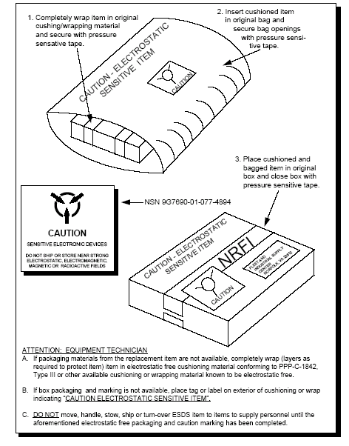
The preferred method of shipment for DLR’s is certified mail.
Shipment preparation- Material must be prepared ad packaged to minimize damage during shipment. The NAVSUP P-484 illustrates basic packing and labeling methods and explains how to prepare reusable containers for shipment.
- Remove or obliterate all old transportation and/or shipping markings on reusable containers. Item nomenclature markings should not be removed from reusable containers.
- Overpack materials only when necessary to prevent damage in transit. Over packing is not necessary when in a reusable container or when an item is turned into ashore activity for shipment.
- Deliver shipments to the fleet unit designated to handle transshipment material or the nearest ashore supply/shipping activity.
- When shipping via multipack, ensure that all items in the multipack are destined for a single consignee under the same priority. Particular attention must be given to the method of packing to ensure heavy items are in the bottom.
Mail is a primary and preferred means of moving material from and to ships. Mailable material includes any papers or materials which meet U.S. Postal Service standards relative to weight, size and physical properties.
Use first class mail when shipping all mailable material 0-11 ounces.
Use priority mail when shipping NMCS, PMCS, CASREP, SEEREP, MICAP, 999, 777, and material critical to flying or marine safety.
Parcels containing unloaded small arms for official use are mailable under conditions specified by postal regulations. Packages containing small arms, whether mailed or shipped will bear no external markings indicating the nature of their contents. Small arms forwarded by the U.S. Postal Service will be sent as registered mail (returned receipt requested) and their registry slip furnished the sender will be attached to the ship’s retained original of the DD Form 1348-1A. Personally owned weapons will not be mailed.
The U.S. Postal Service will accept and forward parcels mailed containing narcotics and drug abuse control items, however, each parcel must be cosigned as registered mail to the medical officer.
Military Official Mail (MOM) is a special procedure approved by the U.S. Postal Service for providing air transportation of official stamped mail (B) at a rate which is considerably cheaper than that for priority mail. However MOM only provides air transportation between overseas Military Post Offices (MPO’S) and a CONUS gateway terminal.
The Defense Transportation System (DTS) is that portion of the worldwide infrastructure that supports DOD transportation needs in peace and war. The Transportation Control Movement Document (TCMD) is normally used to ship material within the DTS.
When a TCMD is not available, a DD Form 1348-1A may be used if the essential transportation data is included.
CONUS shipments generally move by commercial carrier on GBL/CBL and do not move through the DTS.
Hazardous material refers to any material (specified by the Department of Transportation, Federal Aviation Agency, Coast Guard, federal or military agency) which under conditions incident to transportation is liable to cause fires, create serious damage by chemical action, or create a serious transportation hazard? DOT/Coast Guard/FAA regulations require that hazard shipments be certified for shipment by the shipper. All hazardous materials shall be accompanied with a DD Form 1348-1A, which indicates that this is dangerous and may require further packaging consideration.
Upon receipt of personal effects from inventory boards, the Supply Officer will be responsible for the custody, storage, security, shipment and disposition of personal effects. Unaccompanied shipments of personal effects originating from deployed ships and overseas locations must have Copies of the individual's orders and a proper customs certification.
The Airlift Clearance Authority (ACA) controls the movement of air eligible materials. All shipments originating overseas, moving by commercial air and weighing over 100 pounds must be cleared/routed by the overseas ACA. Shipments originating in CONUS with overseas destination moving by Air Mobility Command (AMC) or commercial air, regardless of the weight, must be cleared/routed by NAVTRANS Norfolk, Va.
The ACA will challenge the requirement to airlift cargo based on what criteria, when the weight exceeds 100 lbs / shipment volume exceeds 15 cubic feet / requisition date is more than 90 days old / transportation charges are more than $4,000. Exceptions, are when RDD is 999 / "W" or "G" series requisitions that are less than $4,000 in transportation costs.
Greensheet is a procedure where specifically identified Navy cargo in the AMC system gains movement precedence over other priority Navy cargo, including 999 shipments.

CHAPTER 8

SPECIAL MATERIAL

Presentation Silver
Presentation silver is considered to be “priceless” and many of the skills used in creating it are a “lost art” and irreplaceable artistic expression. Presentation silver may consist of a single line item ( a bowl, tray, candelabra) or a group of items (punch bowl set, tea set, dinner service). Other valuable articles may consist of paintings, portraits, original historical documents, engraved clocks or chronometers, and other such items with to warrant continuing accountability. Presentation silver is the property of the U.S. Navy and cannot be authorized by ship/activity Commanding Officer to be loaned or returned to anyone without prior NAVSUP and/or UNSECNAV approval.
Acceptance of Gifts:
- Only the Secretary of the Navy can accept gifts of a value in excess of $50,000.
- Gifts of a value from $10,000 to less than $50,000: Vice-Chief of Naval Operations.
- Gifts of a value at less than $10,000: the Commander Naval Supply Systems Command.
A letter to the appropriate level of authority must be submitted requesting approval to accept the gift. Presentation silver received by a ship as a gift is classified as namesake silver. Namesake silver is assigned to the ship for as long as that ship remains in commission.
Promptly after receipt of silver, an appraisal must be obtained to determine the value of the silver. If appraisal services are performed aboard a ship, the contractor must be accompanied by a crew member at all times. The contractor must provide an appraisal of the reproduction cost of the silver as opposed to the fair market value. Reproduction cost is defined as “The total cost to reproduce an exact replica of the property, at current costs, using a similar or the same artist or craftsman, materials and design as the original property.”
Within 60 days of receipt of presentation silver a complete inventory, of the donated items will be sent to Commander, Naval Supply Systems Command. For gifts other than presentation silver, the report will be sent to: Naval Historical Center, Curator Branch.
Proper management of Presentation Silver dictates that a system must be in effect which enables the holder of the presentation silver to adequately identify to the appropriate investigative body a complete description of the item(s) should it/they become lost or destroyed. An 8x10 black and white photograph of each item shall be taken using a ruler in the photograph to indicate actual size. A copy of the entire set will be sent to NAVSUP and 2 copies of the photographs will remain onboard for inventory purposes.
Presentation silver items and other valuable gifts which have been lost, stolen or destroyed must be expended by means of survey. The survey action will be initiated as soon as the loss or irreparable damage is discovered. A detailed description of the circumstances relative to the loss or damage will be included in the DD Form 200. Missing or destroyed silver must be reported to NAVSUP within 48 hours after discovery via naval message.
HAZMAT
The Supply Officer is responsible for the following:
- On ships the size of frigates or larger, he/she will establish and operate the HM Division.
- Identify the locations and quantities of all HM stored aboard ship and proved a list to the Gas Free Engineer/Damage Control Assistant, Safety Officer, and Medical Department representive.
- Coordinate a ship wide physical inventory of all HM on an annual basis.
- Centrally manage and forward all SHML Feedback reports for any HM not listed in the SHML to NAVICP.
- Maintain the Hazardous Inventory Control System (HICS) PC based program and provide a hard copy of Material Safety Data Sheets (MSDS) upon request.
- Ensure that supervisors are trained annually in proper marking, handling, stowage (as appropriate), usage, reutilization, spill response, and disposal procedures relative to HM and in the use of MSDS’s.
- Retain the Hazardous Material Information Systems (HMIS) which contains MSDS information. Retain hard copy MSDS’s for locally purchased material and for materials not covered in HMIS. Ensure that hard copy MSDS’s are available to personnel or their supervisors upon request.
- Ensure that all HM containers are properly labeled before acceptance.
All Hazardous Material Division personnel must be trained in all aspects of HAZMAT handling. Extensive routine shipboard HAZMAT training must be conducted in order to maintain and improve command awareness and compliance. Department Heads and all supervisors should be thoroughly briefed on the program and its implications annually.
Hazardous material is identified by a Special Material Content Code (SMCC) B,C,D,F,J,P,R,S,T,U,V, and W.
- Hazardous material is any material that is regulated as hazardous, requires a MSDS, and during end use treatment handling, packaging, storage, transportation or disposal meets or has components which meet or have potential to meet the definition of Hazardous Waste (HW).
- Hazardous Material has a flash point below 200 F or subject to spontaneous heating or polymerization with release of large amounts of energy when handled, stored, and shipped without adequate control.
All requests for Hazardous Materials (HM) must be processed through the Hazardous Inventory Control System (HICS) Coordinator or HAZMIN Supervisor. All HM issues will be processed as a customer walk-thrus.
Container tracking enables “Cradle to Grave” control of HAZMAT. This function ensures that every container of HAZMAT is handled properly. Container control numbers are automatically generated in the HICS program. All HAZMAT containers checked out from the "HAZMIN center", whether partially full or completely used, must be returned within 48 hours. Rags are approximately what 35 % of the ship's HM volume.
Storerooms and lockers:
Flammable liquid storeroom will normally be located at either end of the ship, below the full load waterline, not adjacent to a magazine, and will be equipped with an automatic fire alarm and CO2 system. This storeroom also should have incandescent and explosion proof overhead lights (protected by lamp guards), with the switch outside the compartment; and non-sparking vent fans with the controllers outside the compartment. Flammable items required to be stowed in the flammable liquids storeroom are assigned special material content codes (SMCC) in the HMIS as follows:
- Liquids: SMCCs “D”,”F”,”G”,”P” (when applicable to wood alcohol), and “S”
- Pastes, greases, and other semi-solids: SMCC “G”
- Solids: SMCC “Z”
Acid Locker: Acid Locker is a leak proof lead-lined box, chest, or locker especially designed for stowing bottles or carboys of acid.
- A label bearing the inscription “ACID BOTTLE STOWAGE” in 3/8 inch letters that must be securely attached to the lid of each acid locker.
- Acid lockers will be kept in the flammable liquid storeroom. However, acid lockers that contain only medical acids may be kept in a medical storeroom.
- Items required to be kept in the acid locker are assigned a SMCC “V”.
- Nitric acid (an oxidizer) are required to be kept in the acid locker is assigned SMCC “J”.
- Liquid acid, unless classified as safe material, will be stowed in the acid locker.
- Corrosive acids (or vapors) must not be allowed to come in contact with the skin or eyes. A storekeeper who stows or issues these acids, will wear rubber gloves, rubber aprons, and goggles (as necessary) to protect himself and his clothing from acid burns.
- Corrosive acids are acute fire hazards, therefore, should be stowed separately from oxidizing or flammable materials.

Alcohol Locker is a chest or locker used for security stowage of grain alcohol’s which are highly susceptible to pilferage (ethanol or ethyl alcohol).
- Alcohol lockers will be located in the flammable liquids storeroom; however, lockers that contain only medicinal alcohol (100 proof or less) may be located in any secure space designated by the Commanding Officer.
Oxidizing Material listed in the HMIS is identified by SMCC “J”. Many shipboard fires with resultant fatalities have been attributed to improper stowage or handling of oxidizing materials, particularly calcium hypochlorite.
Calcium Hypochlorite is a bleaching agent and disinfectant. Onboard ship it is authorized for the purification of potable water, sewage treatment and biological and chemical (B/C) agent decontamination.
- Is noncombustible, however, it is a strong oxidizing agent which will generate heat, liberate chlorine, and cause fire when stowed in contact with paints, oils, greases, detergents, acids, alkalis, antifreeze, fabrics and other organic and combustible materials.
- Stocks of calcium hypochlorite shall not be maintained specifically for B/C decontamination. Stocks for other applications are adequate for emergency decontamination.
- Only six ounce bottles shall be procured and used for potable water purification.
- Three and three quarter (3 ¾) pound bottles shall be used for sewage waste treatment.
- Calcium hypochlorite will be stored in lockers or bins labeled “HAZARDOUS MATERIAL-CALCIUM HYPOCHLORITE” in red letters on a white background.
- Bins or lockers should be located above the waterline and at least five feet away from any point heat source or surface which may exceed 100F.
- They must not be subject to condensation or water accumulation.
- The area shall not be adjacent to a magazine and shall not be used for stowage of paints, oils, greases, or combustible organic materials.
- No more than 48 six ounce bottles or 36 ¾ pound bottles shall be located in any individual locker or bin.
Compressed Gases must be stowed on the weather deck, unless the ship has below deck stowage spaces specifically designed for such material. Compressed gases are categorized as flammable (acetylene), non-flammable (helium, nitrogen, carbon dioxide, argon) and oxidizing (oxygen, chlorine). Flammable and oxidizing gases will not be stowed in the same compressed gas storeroom. Non-flammable gases may be stored with either flammable or oxidizing gases. Additional storage and handling requirements:
- Will be stowed vertically and securely (with valve protection caps in place).
- Away from other flammable materials (especially grease and oil).
- When stowed on the weather deck, they will be located as far as possible from navigation, fire control, or gun stations; and will be protected from direct rays of the sun, accumulation of snow and ice.
- When stowed below deck, any leaking fumes must be prevented from entering ventilation air intakes leading to working or living spaces.
- Empty cylinders will be stowed and handled with the same precautions as full cylinders.
- Flammable and oxidizing gases will not be stowed in the same compressed gas storeroom.
- Non-compressed gases may be stowed with either flammable or oxidizing gases.
- Do not drag or slide cylinders required to be moved. Secure them in hand trucks. If hand trucks are not available, then roll them on the bottom edge.
- Acetylene is inherently unstable, and may explode when subjected to heat or shock, or upon contact with chlorine or certain metals such as copper, silver, and mercury. Therefore acetylene must be stowed separately from oxygen or any other materials with which it forms an explosive compound. Testing for suspected leaks must be done with soapy water. You must you wait at least two hours to use an acetylene cylinder when it is known or suspected that it has been stowed on its sides.
Aerosol products are liquids, solutions, or powders suspended in a gas propellant and contained in dispensers equipped with release valves. Aerosol containers will burst if exposed to heat sources in excess of 120F, and are prone to leakage of subjected to impact. Aerosol products are extremely flammable and in sufficient concentration, can be anesthetic or asphyxiating. Should be stowed in the flammable liquid storeroom, or in cabinets away from oxidizing materials; and mechanical ventilation will be used, when necessary, to remove accumulated vapors.
Flammable liquids have a flash point of 100F or below; combustible liquids, greases and pastes have a flash point of 200F or below. Except for drummed petroleum products, which may be stowed in racks on the weather decks, flammable liquids and other flammable or combustible material will be stowed in the flammable liquids storeroom. Items which are flammable and/or combustible include:
- Gasoline, oils, kerosene, and other petroleum products
- Chemicals
- Stencil paints, marking inks, and printer ink
- Solvents, thinners, primers, compounds, varnishes, and lacquers
- Alcohol, acetone, ether, an naphtha
- Greases and pastes
Radioactive Material: Radioactive items listed in FEDLOG are identified by SMCC “R” or “X”. Any area used for storage of radioactive material (or each bin if there is no designated area) will:
- Be conspicuously posted with the standard radiation symbol and the words “CAUTION RADIOACTIVE MATERIAL”.
- Will be monitored when initial or replenishment stocks of radioactive items are stowed.
- Rubber gloves, safety goggles, and a rubber apron will be worn and extreme caution will be used in handling damaged/broken radioactive instruments, electron tubes, etc.
Toxic substances may cause discomfort, asphyxiation, and/or death if ingested or inhaled, or if absorbed through the skin.
- Assigned a SMCC “T”
- Will be stowed in a cool, well ventilated area, separate from acid, and will be protected from fire hazards or impacts which may break seals or damage containers.
- Each case, carton, and individual container of toxic material must be labeled with a warning such as the following: “POISON! IF TAKEN INTERNALLY, WILL CAUSE SERIOUS ILLNESS, AND POSSIBLE DEATH!”
Halons and Chlorofluorocarbons (CFC) refrigerants are ozone depleting substances (ODS). Defense Logistic Agency (DLA) provides central management for ODS products.
Depot Level Repairables (DLR)
Depot Level Repairables are those Navy managed items which, based on unit cost, annual demand, difficulty of repair, or other economic considerations, have been selected by cognizant inventory managers for special inventory control. DLR’s must be returned to the Designated Support Point (DSP)/Designated Overhaul Point (DOP) when they are Beyond Capable Maintenance (BCM) at the authorized maintenance activity. DLR items are listed and identified by:
- NSN
- Cognizance symbol
- Material Control Code (MCC) H, E, X, G, Q
- Using the Master Repairable Listing (MRIL)
- An appropriate Source, Maintenance, and Recoverability (SM&R) Code is assigned to each DLR indicating the level and degree of maintenance authorized.
Aviation Activities will use the Aviation Intermediate Maintenance Department (AIMD) or the Intermediate Maintenance Activity (IMA) to provide local repair of not ready for issue (NRFI) DLR’s.
Progressive Depot Level Repairables (PDLR’s) must be repaired and condemned at the depot maintenance level according to the recoverability code listed in FEDLOG, but which can be repaired or tested and checked at a lower maintenance level.
Requisitions for exchange advice coded DLR’s will be limited to a quantity of one per requisition with the following exceptions:
- Aircraft tires
- Transducers/hydrophones
- Radiac equipment
- When the requirement is the result of allowance or load list range and depth increases (non-exchange)
Requisitions for DLR items will be submitted only to fill fixed allowance shortages or to satisfy an immediate maintenance requirement when the required DLR is not carried or not in stock. And will cite the correct advice code in cc 65-66 on the MILSTRIP. When an unserviceable DLR item is turned in to the supply department, simultaneously with the submittal of an issue request for a replacement item which currently is NIS or NC, the issue request will be processed, and then the requested item will be requisitioned.
DLR’s will be issued on a one for one exchange. Each issue request for a SLR must be identified as such by the entry of the applicable MCC and by the notation “DLR Item” in the remarks block of the issue document.
Stock levels for DLR’s will be based on fixed allowances established by the appropriate inventory manager (ICP) and included in applicable allowance and load lists (COSAL, AVCAL, TARSALL, FILL). The fixed allowance will identify both the range and depth of items to be carried. Depth increases to fixed allowance quantities and all range additions will be requested by submission of a NAVSUP 1220-2 Allowance Change Request (ACR).
Afloat activities will conduct annual inventories of all Depot Level Repairables. Upon completion, all DLR’s identified as excess will be turned in to the nearest ashore supporting activity.
DLR items are procured and managed by the inventory manager on the premise that unserviceable DLR items, when not locally repairable, will be expeditiously shipped to the nearest Advanced Traceability and Control (ATAC) HUB or NODE. The ATAC program simplifies the retrograde process. It provides traceability/accountability, establishes HUBS for centralized Retrograde Processing and NODES for unconsolidated and Transshipment, ensures TIR reporting to the ICP for all retrograde material, reduces carcass tracking follow-ups and reduces delays in movement and processing of retrogrades.
Preparing DLR’s for turn in:
- Pack or crate in accordance with the NAVSUP P484.
- Attach a DD Form 1348-1A (citing “BC1” in the Doc Id)
- Enclose a SRC card/Logbook, if required, in the container with the retrograde.
- Enclose VIDS/MAF form if required, in the container with the retrograde.
- Enclose pre-printed ATAC mailing or shipping label. If a label is not available, ensure that the DLR is addressed to the nearest HUB/NODE.
- The supply department will document and package unserviceable DLR items within 48 hours of receipt, and when possible, will ship such items within 24 hours after shipments have been prepared.
Carcass Tracking
The DLR Carcass tracking system is the Navy’s program that provides inventory managers with the means to monitor the flow of NRFI repairables from end-users through Retrograde Pipeline and repair cycle and subsequent return to supply system stock. When activities have requisitioned DLR items using advice codes 5G, 5R, 5S, 5V, 5Y, 52 or 56 they are required to turn a NRFI carcass in to the supply system.
Follow up on NRFI carcasses (BK1)
Document identifier BK1 DLR shipment follow up document is submitted by the NAVICP via DAAS to the activity responsible for the NRFI turn in. The BK1 follow up will be received by message.
Response to a Follow up (BK2)
Upon receipt of a “BK1” document the unit must research the status of the turn in in the retained records. A follow up response (BK2) must then be submitted in reply to each follow up (BK1) received. The response will be transmitted to NAVICP. The BK2 response will be transmitted to the ICP via DAAS and must be received by either NAVICP Phil or NAVICP Mech within 21 days to NAVICP Phil or with in 50 days to NAVICP Mech.
Rejected follow up response (BKR)
When the BK2 response contains invalid data, the NAVICP will send a reject status, document identifier BKR with the reject reason cone in position 65.
Notice of additional billing (BK3)
When NAVICP has not received a BK2 response from an activity within the allowable timeframe or receives a BK2 indicating no turn in will be made, the NAVICP will process a BK3 document notifying the activity that the difference between the net and standard price will be billed.
Billing reversal (BK4)
The NAVICP will process a document identifier BK4 notifying an activity that their account will be credited by the difference between the net and standard price. The BK4 will reverse a billing which resulted from a lack of, or invalid response to a carcass follow up. This reversal will only occur when the customer responds or turns in a carcass after the date that a BK2 response was due and only when the late response/turn in is accepted.

CHAPTER 9

FINANCIALS

Congress provides Operations and Maintenance, Navy (O&M,N) obligation authority for a twelve month fiscal year. The Navy Comptroller provides these O&M,N funds to Fleet Commanders in Chief (CINCs). The CINC’s then provide them to the Type Commanders (TYCOM) who allocates the OPTAR grants quarterly to fleet units. TYCOM’s grant each ship or activity funding in the form of Operating Targets (OPTAR) to obtain the material and services necessary for day-to-day operations.

OPTAR funds are derived from the activity’s projected expenditures based on the amount used during the previous 12 months and their operating schedule for the next twelve months.

Operating Targets are issued to activities for a particular fiscal year. Obligations can only be incurred during the first twelve months of the accounting cycle. Expenditures (payments for obligations) can be made throughout the entire 72 month period.

Types of Operating Targets:
- OFC-20 Supplies and Equipage(S&E). The S&E category provides funds for obtaining materials or services used in the daily operations of the activity. This could include consumable supplies, repair parts, services and maintenance contracts.
- OFC-20 Repair of Other Vessels (ROV). The ROV category provides funds used for repair work conducted on other afloat units and service craft by activities with Intermediated Maintenance Activity (IMA) capabilities.
- OFC-50 Aviation Operations Maintenance (AOM). This OPTAR is provided to fund the procurement of material and services necessary to support the Aircraft Maintenance Department at aviation activities. AOM funds are properly chargeable for repairs to aircraft and supporting-maintenance equipment.
- OFC-01 Flight Operations (FLTOPS). Provided to aviation squadrons, this OPTAR is used to procure fuel consumed in flight, flight crew clothing, and administrative material for support of the squadron.
- OFC-09 OPTAR used for Fleet Initial Outfitting for Individual Material Readiness List (IMRL) and Marine Table of Basic Allowance (TBA).
- OFC-10 OPTAR used for aircraft support, other (includes support for automated data processing equipment, and drones and targets)
- OFC-15 OPTAR used for initial outfitting and replacement of aircraft photographic equipment.
- OFC-21 OPTAR used for travel of personnel in connection with aviation related travel.
- OFC-23 OPTAR used for transportation of material.

Navy Working Capital Fund

The Defense Working Capital Fund, formerly known as the Defense Business Operating Fund (DBOF), is a revolving industrial fund for a large number of defense support functions. It utilizes business like cost accounting to determine total cost of the business activity. The Defense Working Capital Fund is made up of the Army Working Capital Fund, the Air Force Working Capital Fund and the Defense Wide Working Capital Fund.

Navy Capital Working Fund (NWCF) finances the procurement of material carried at designated naval activities ashore and afloat. As a revolving fund, the NWCF is reimbursed when material is issued and working capital is made available to replenish the activity’s stock.

Each category of NWCF is assigned a Budget Project(BP) and the funds are sub allocated to the Commanding Officers responsible for the assigned BP’s. The following budget project numbers are used for NWCF:
- BP 14- Shipboard Consumables, Field level repairables (1H, 3H cogs).
- BP 15- Forms and Printed Matter (1I cog)
- BP 21- Ships Store Stock (1Q cog)
- BP 23- Ships Overhaul Material (various cogs)
- BP 25- Special NSA Transactions (various cogs)
- BP 28- Retail Repair Parts and Supplies (all 3, 5 & 9 cogs except 3H, 5R, & 9X)
- BP 34- Aviation Consumables (1R, 5R cogs)
- BP 38- Retail Fuel and Related Materials (9X)
- BP 81- Shipboard Depot Level Repairables (7E, 7G, 7H, 7N, &7Z cogs)
- BP 85- Aviation Depot Level Repairables (7R cog)

Accounting Systems

An accounting and financial management system is required to control and report how the various types of funds are used. The accounting system must provide, accounts, records, and procedures for recording transactions and then summarize accounting data into a prescribed reporting format.

Appropriation Accounting System

Congress passes legislation known as appropriation acts to provide funds for various military programs. The Department of Defense has set up the Future Years Defense Plan (FYDP) to establish planned force structure and financial levels for military departments that cover a six year period.
Funds are appropriated through annual, continuing and multiple-year appropriations as follows:
- Annual Appropriations are made for current operations and maintenance expenses of the Department of the Navy. This appropriation is available for obligation during the fiscal year of the appropriation and for payment of these obligations for six years thereafter. The annual appropriation expires at the end of the sixth subsequent fiscal year and unobligated portion is transferred back to the treasury.
- Continuing Appropriations are made for specific programs. This type of appropriation become available at the beginning of the fiscal year following the appropriation act. It remains available until exhausted or until the purpose specified in the appropriation has been accomplished.
- Multiple-Year appropriations are available for incurring obligations for a definite period in excess of one fiscal year. This type of appropriation will not normally be handled at the shipboard level with the exception of Other Procurement, Navy (OPN) funds.
- Appropriation Limitations is the amount fixed by Congress which an activity may not exceed when obligating or expending funds for certain objects or purposes.

Fund Codes

End-use fund codes are used in OPTAR accounting. End-use fund codes serve the same purpose as shore station job orders. The budget submission by the Type Commander depends of collecting cost data by the budget categories of activity group, sub-activity group, expense element, etc. The two digit afloat end-use fund codes must be crossed by the DFAS accounting dictionary back to the related activity group, sub-activity group, expense element etc. for budget preparation. The accounting spread will be shown on all obligation and expenditure documents.

NWCF fund codes. Stock requisitions for all NWCF activities will use Other Supply Officer (OSO) transfers and will cite NWCF fund codes.

Accounting Data

The purpose of accounting data is to completely identify the proper account against which a financial document should be charged or credited. The accounting spread or fund code will be shown on all obligation and expenditure documents. Each element of the accounting data requires a specific number of characters to complete its data field. Country codes are not considered as one of the nine digit fields of a complete line of accounting.

ACCOUNTING DATA CONSITS OF:
11 DIGITS – APPROPRIATION AND SUBHEAD
3 DIGITS – OBJECT CLASS
5 DIGITS – OPERATING BUDGET
1 DIGIT - SUB ALLOTMENT
6 DIGITS – AUTH. ACCOUNTING ACTIVITY
2 DIGITS – TRANSACTION TYPE
6 DIGITS – PROPERTY ACCOUNTING ACTIVITY
12 DIGITS – COST CODE
Line of Accounting 1751804
17 – Identifies the DEPARTMENT OF THE NAVY
5 – Specifies the FISCAL YEAR
1804 - For OPERATION, MAINTANENCE, AND NAVY (OM&N)

17X4911 – NAVY STOCK FUND
17X4912 – NAVY INDUSTRIAL FUND
17X4888 – NAVAL WORKING FUND
17X6875 – NAVY MANGEMENT FUND
17X8723 – SHIPS STORE PROFITS

Financial Reports

OPTAR Reports are submitted by activities to report the status of each OPTAR and related information to DFAS and the TYCOM. They are also used to submit unfilled orders, cancellation documents, and processed listings to DFAS.
Aviation activities use OPTAR reports for the submission of the Fuel Consumption Report to the TYCOM.
OPTAR reports consist of the OPTAR Transmittal (TL) Report (NAVCOMPT 2156) and the Budget OPTAR Report(BOR)(NAVCOMPT 2157).

OPTAR Document Transmittal Reports (TLs)
The OPTAR Document Transmittal Report (NAVCOMPT 2157) is used to submit unfilled orders (obligations) and cancellations to DFAS. Frequency of TL submission will be in accordance with TYCOM directives. TL’s will be submitted for each OPTAR held by the activity for which a transaction was processed during the reporting period. Negative reports will not be submitted.

Budget OPTAR Report
The Budget OPTAR report (BOR) is submitted monthly for the current fiscal year and for the first six months following the close of the fiscal year. Thereafter, BORs are to be submitted for the remaining 18 months of the shipboard accounting cycle only when there has been a change to the obligation value (column 22). The BOR will be submitted by naval message to TYCOM and DFAS no later than the first working day of the month following the month being reported.

Listings

The Summary Filled Order/Expenditure Difference Listing (SFOEDL) is produced as a result of the reconciliation process conducted by DFAS. It consists of OPTAR related expenditures for which no matching obligation has been reported to DFAS. Expenditures with a money value different than the reported obligation, corrections to previously rejected transactions, and carcass charges.
SFOEDLS are produced monthly from the first through the twenty-fourth month and then quarterly thereafter to the end of the thirty-six month accounting cycle.
The processing, review, and validation will be completed within 10 days following receipt.

The Unfilled Order Listing (UOL) is sent by DFAS to OPTAR holders for whom they perform OPTAR accounting. The UOL lists unfilled orders (obligations) held in the DFAS files which have not matched with related expenditure documents and have not been cancelled. It is produced and distributed monthly. The UOL must be reviewed and processed within 20 days following receipt. Each transaction on the UOL must be reviewed to determine whether the material or service has been received.

STANDARD SUBJECT IDENTIFICATION CODES

1000 – Military Personnel
2000 – Communications
3000 – Operations and Readiness
4000 - Logistics
4400 – Supply Control
4440 – Inventory Control
4441 - Allowances
5000 – General Admin and Management
6000 – Medical and Dental
7000 – Financial Management
8000 – Ordnance Material
9000 – Ships Design and Ships Material
10000 – General Material
11000 – Facilities and Activities Ashore
12000 – Civilian Personnel
13000 – Aeronautical Material
16000 – Coast Guard

SUPPLY APPENDICES

1 – Advice codes
2 – Status codes
3 – Distribution codes
4 – Document Identifiers
5 – Mode of Shipment codes
6 – Project codes
7 – Routing Identifiers
8 – MILSTRIP
9 – Logistics Management Codes (SMIC CODES, Controlled Equipage Item
Inventory, MCC Codes)
10 – MILSTRAP
11 – Country/International Organization Codes
12 – Planned Requirement
13 – Change Notice
14 – Special Material Identification codes (SMIC)
15 - SUADPS-RT Reports and Listings
16 – Media and Status codes
17 – Management codes
18 – COGS
19 – Unit of Issue
20 – Supply Directives
21 – Personal Property Transportation codes
22 – Navy Airlift Clearance Authorities Worldwide
23 – Acquisition Advice codes
24 – Weapons System Designator codes
25 – SFM Reports and listings
26 – Stock Action/Technical Information Codes
27 – Types of Storage Codes

