Project Number GXP-0508

Design of an Extrusion System to Optimize the Production of Self-Assembled Collagen Microthreads

A Major Qualifying Project Report

Submitted to the Faculty

of the

Worcester Polytechnic Institute

in partial fulfillment of the requirements for the

Degree of Bachelor of Science

by

________________________
William Bishop

_______________________
Diana Camire

________________________
Ngoc Chau Duong

________________________
Jason Robinson

Approved by:

______________________________
Professor George Pins, Advisor
Table of Contents
Authorship Page 4
Acknowledgements 5
Abstract 6
Executive Summary 7
Table of Figures 9
Table of Tables 11
1. Introduction 12
2. Literature Review 15
2.1 Clinical Motivation 15
2.1.1 Injuries 15
2.1.2 Treatments 16
2.1.3 Motivation for Tissue Engineered Ligaments 20
2.2 The Anterior Cruciate Ligament 21
2.2.1 Mechanical Properties 22
2.2.2 Structural Properties 24
2.2.3 Molecular Properties 25
2.3 Work with Collagen Threads 28
2.4 Extrusion of Collagen Threads 31
2.4.1 Manual Extrusion Method 31
2.4.2 Limitations 33
2.5 Automated Systems 35
2.5.1 Salo 35
2.5.2 Organogenesis 37
2.5.3 Limitations 40
3. Project Approach 40
3.1 Project Hypothesis 41
3.2 Project Assumption 41
3.3 Project Aims and Specification 42
4. Design 42
4.1 Clarification of Design Goals 44
4.1.1 Objectives 46
4.1.2 Development of Revised Client Statement 50
4.2 Conceptual Designs 52
4.2.1 Design Group’s Initial Ideas 52
4.2.2 Clients’ and Designers’ Conceptual Designs 55
4.2.3 Morphological Chart 67
4.3 Preliminary Design 68
4.3.1 Metrics 68
4.3.2 Selection Matrices 69
4.4 Final Design Modification 78
4.5 Detailed Design 81
4.5.1 The Bath System 81
4.5.2 Extrusion Vehicle Model 86
4.5.3 Anchoring Method 88
5. Methodology 90
5.1 Materials of construction 90
5.2 Device Construction 93
5.2.1 Water Bath Construction 93
5.2.2 Extrusion Vehicle Construction 93
5.2.3 Anchoring Method Construction 94
5.2.4 Automated System Controller 96
5.3 Device Validation 97
5.3.1 Collagen Extraction Protocol 98
5.3.2 Collagen Extrusion Protocol 98
5.3.3 Tensile Testing 99
5.3.4 Diameter Testing 100
6. Results 101
6.1 Fiber Production 101
6.2 Fiber Diameter 102
6.3 Fiber Tensile Strength 105
7. Conclusion 108
8. Recommendations 110
Bibliography 111
Appendix 1: Chemcial Bath Used for Organogenesis Automated System 116
Appendix 2: Metrics 117
Appendix 3: Metric Justifications 120
Appendix 4: Motor Controller/Driver Options 121

Authorship Page

Section Written By Edited By

1. Introduction DC, CD All
2. Literature Review
2.1 Clinical Motivation JR All
2.2 Properties of Tendons/Ligaments All All
2.3 Work with Collagen Threads CD All
2.4 Extrusion of Collagen Threads JR All
2.5 Automated Systems WB All
3. Project Approach
3.1 Project Hypothesis All All
3.2 Project Assumptions All All
3.3 Project Aims and Specifications All All
4. Design
4.1 Clarification of Design Goals CD All
4.2 Conceptual Design DC ,JR All
4.3 Preliminary Design DC All
4.4 Final Design Modification DC All
4.5 Detailed Design All All
5. Methodology
5.1 Materials of Construction All All
5.2 Device Construction All All
5.3 Device Validation All All
6. Results JR All
7. Conclusion WB All
8. Recommendations DC All
Acknowledgements

We would like to thank the following people for their help and assistance throughout this project.

Professor George Pins, our project advisor who gave us guidance and advice throughout the project.

Professor Ross Shonat,for providing us with rat tails to conduct our validation experiments.

Kevin Cornwell for his advice, guidance and assistance with laboratory methods.

Lisa Wall for helping us with the acquisition of key parts of our device.

Ken Stafford for his assistance and advice for the different component of the device.

We also would like to thank the following graduate students who have assisted us: Katie Bush, Angela Throm, Brett Downing.

Abstract

The goal of this project was to design and construct an automated system for the extrusion of fibrillar type I collagen to produce collagen microthreads of uniform structural and mechanical properties. This was done through the design, construction, and validation of an automated collagen extrusion system which extruded type I collagen through small diameter tubing into a fiber formation buffer to produce collagen threads. The threads created were validated by comparing their structural and mechanical properties to manually extruded threads. The result of this study and following studies using this device will aid in the design of collagen-based scaffolds such as for ACL replacements.

Executive Summary
Ligament tissue engineering aims to produce a living scaffold that mimics native ligaments in the body by combining cells and a scaffold material. There are over 250,000 anterior cruciate ligament injuries annually in the United States. Over 150,000 of these patients receive an ACL replacement. Currently the gold standard treatment is an autograft where a portion of the patient’s patellar tendon is removed for the replacement of the ACL. Though this is the most commonly used reconstruction, it has many limitations associated with it, including the weakening of the patellar tendon, slow transition from patellar tendon formation to ACL formation, and a limited supply of autograft tissue. There has been great interest in the creation of new tissue engineered scaffolds for the reconstruction of damaged ACL. One widely used scaffold material for this research has been type I fibrillar collagen extruded to create threads. Fibers are extruded manually via a time consuming process that produces threads with varied dimensions and mechanical properties. These variations in thread properties have slowed the progress of further research. The goal of this project was to design and construct an automated device to produce collagen threads of uniform structural and mechanical properties. The requirements for the device were: it must extrude collagen through small diameter tubing into a bath of fiber formation buffer (FFB); fibers must be created on a frame enabling fixation and stretching after formation, and the device must produce as many fibers as possible in a single bath.
The design criteria led to a design process involving both the clients and the designers. Through processes such as pairwise comparison charts and a weighted objectives tree, the design group was able to rate the objectives according to their importance to the project. These objectives lead to a brainstorming session where many ideas pertaining to the different components of the automated system were formulated to meet the most important objectives.
The final automated system consists of three unique parts: (1) a temperature-controlled water bath, (2) a motor driven extrusion vehicle on a simple belt and pulley system and (3) a thread anchoring mechanism. The final cost of the project was $1,000. Diameter and tensile tests were performed to analyze and compare the fibers produced automatically to the manually extruded fibers. The results showed that the fibers produce automatically exhibits more uniform structural and mechanical properties than those produced manually. The average value for the unhydrated fiber diameter was 70 µm with a standard deviation of 0.5 µm. Fibers produced using the manual extrusion method were 53 ± 7.6 um. Fibers extruded automatically demonstrate a significantly smaller variation compared to those fibers extruded via the currently system. The Ultimate Tensile Strength for the automated and manually extruded fibers were 0.7 ± 0.05 and 1.5 ±0.2 MPa respectively. Hydrated Fiber Diameters were 350 ± 6.8 and 140 ±19 microns and Strain at Failure of 0.80 ± 8 and 0.42 ± .12 for automated extrusion and manually extruded threads respectively.
Future recommendations for this device include the development of an automated bath system, the production of an integrated stretching mechanism, integration of an automated syringe pump and upscaling the device to produce a larger quantity of fibers. Furthermore, this device can be used to extrude fibers of other materials, allowing for future work with various ACL scaffold materials.

Table of Figures
Figure 1: Knee Anatomy (Marieb, 2002). 16
Figure 2: Overview of ACL Reconstruction 17
Figure 3: The Anatomy of the Human Knee (Marieb, 2002) 22
Figure 4: Hierarchical Structure of Ligaments 24
Figure 5: Collagen primary structure α chain. (Wolfgang, 1998). 25
Figure 6: Model for type I collagen self-assembly (Silver et. al. 2003) 27
Figure 7: Pins Collagen Fiber Extrusion System (Pins et al., 1997) 32
Figure 8: Current Manual Extrusion System 34
Figure 9: Threads Manually Extruded 34
Figure 10: Schematic of Collagen Fiber Extrusion Device by Salo et al. 1952 36
Figure 11: Image of Automated Extrusion Device Developed by Organogenesis (US. Patent 5,378,469) 38
Figure 12: Design Process (Dym and Little 2003) 44
Figure 13: Weighted Objective Tree 51
Figure 14: Track System (Cross-sectional View) 53
Figure 15: Track System (Arial View) 54
Figure 16: Design 2 (Sketch) 55
Figure 17: Pasta Machine Gun (left) 56
Figure 18: Waterfall Extrusion (right) 56
Figure 19: Belt/Tube Extrusion (left) 57
Figure 20: Draw Tower Extrusion (right) 57
Figure 21: Microfluidic Extrusion System 58
Figure 22: Annular Extrusion (left) 59
Figure 23: Manifold Extrusion (right) 59
Figure 24: SFF Extrusion 60
Figure 25: Heating Plate (left) 61
Figure 26: Closed Loop Heating System (right) 61
Figure 27: Hot Water Bath Heating System 62
Figure 28: Oven Heating system 63
Figure 29: Raised Knobs (left) 64
Figure 30: Porous Material (right) 64
Figure 31: Clamps (left) 65
Figure 32: Porous Material with Screen (right) 65
Figure 33: Snap in Rack (left) 66
Figure 34: End Rack (right) 66
Figure 35: End Rack Track 67
Figure 36: Extrusion Vehicle Design 1. 79
Figure 37: Extrusion Vehicle Design 2. 80
Figure 38: CAD Drawing of Extrusion Vehicle Final Design 81
Figure 39: Double-wall Water Bath Prototype. 82
Figure 40: Water Flow within the Bath 82
Figure 41: Mass Spec for Silicone 86
Figure 42: Mass Spec for Lexan® 86
Figure 43: Extrusion Vehicle Model. 88
Figure 44: Preliminary Testing of Porous Material for Anchoring Device. 89
Figure 45: Image of Completed Vehicle System 94
Figure 46: Removable Anchoring System – Design 1 95
Figure 47: Anchoring Device in Bath 95
Figure 48: Anchoring Device - Design 2 96
Figure 49: Automated Extrusion Device 96
Figure 50: Device - User Interface for Automated System 97
Figure 51: Mechanical Test Strip 99
Figure 52: Device for Tensile Testing 100
Figure 53: Automated Extruded Collagen Threads (left) versus Manually Extruded Threads (right) 102
Figure 54: Automated Extruded Threads (left) and Human Hair (right) 105

Table of Tables
Table 1: Pros and Cons of Graft Types 20
Table 2: Mechanical properties of continuous collagen threads after soaking in PBS (US. Patent 5,378,469) 39
Table 3: List of Attributes 45
Table 4: Indented Project Objectives 46
Table 5: First Level Objectives Pairwise Comparison Chart 48
Table 6: Minimize Variation: Second Level Objectives Pairwise Comparison Charts 49
Table 7: Time Efficient: Second Level Objective Comparison Chart 49
Table 8: Cost Effective: Second Level Objective Comparison Chart 50
Table 9: User Friendly: Second Level Objectives Pairwise Comparison Chart 50
Table 10: Ease of Use: Third Level Objectives Pairwise Comparison Chart 50
Table 11: Morphological Chart 68
Table 12: Extrusion Heads Selection Matrix 70
Table 13: Extrusion Heads Selection Matrix Cont. 71
Table 14: Bath/Heating System Selection Matrix 73
Table 15: Anchoring System Selection Matrix 75
Table 16: Rack System Selection Matrix 76
Table 17: Double-wall Water Bath Preliminary Testing Result. 83
Table 18: Preliminary Test Result for Collagen Adhesion Testing 89
Table 19: Automated Extruded Collagen Fiber - Unhydrated Diameter 103
Table 20: Manually Extruded Collagen Fibers – Unhydrated Diameter 103
Table 21: Tensile Testing Results for Automatedly Extruded Collagen Threads 106
Table 22: Tensile Testing Result for Manually Extruded Collagen Threads 106
Table 23: Result Summary Table 109

1. Introduction

Every year, 312,500 people tear one of the numerous ligaments in their body (Woo et al, 2005). Left untreated, these injuries can result in chronic pain and restricted mobility. Annually, over 250,000 cases of torn anterior cruciate ligament alone are diagnosed. The ligament cannot heal itself naturally in the body when severely torn. For this reason, there are over 150,000 surgeries performed and over two billion dollars worth of medical treatments for ACL injuries each year (Cooper et al., 2005).
Numerous strategies have been developed to repair a torn ACL, including replacement with autografts, allografts, and synthetic grafts. All treatments attempted thus far have many advantages and limitations. Use of a patellar tendon autograft is the standard for ACL replacement, efficiently assuming the function of the ACL and providing a rapid recovery time. However, this method requires the physician to compromise one part of the patient’s body to help another, and a second surgical site must be made. An alternative for ACL replacement is the use of an allograft, where cadaver or donor tissues are used for repair. A small supply of implants, greater chance of rejection and disease all limit the use of allografts. When any form of human tissue is not a viable option, synthetic materials are another possible substitute. Synthetic materials can be easily produced and have lower immunogenic responses than autografts or allografts. However, fatigue failure is a major limiting factor for synthetic ACL replacements.
Due to the limitations of current treatment methods, the need to develop a more suitable material for ACL replacement remains. In the 1980’s, Kato and Silver synthesized collagen fibers using insoluble type I collagen from bovine cornium (Kato et al., 1989). When bundles of threads were implanted in an animal model, they promoted aligned fibrous ingrowth during ligament healing (Goldstein, 1989). However, the result showed poor neoligament regeneration in vivo.
Kato and Silver’s process was modified by Pins and colleagues in 1997 (Pins et al. 1997). By utilizing a self-assembling process, the collagen molecules form fibers with properties similar to those of native tissue (Pins et al., 1997). In addition, these threads also exhibit D-period characteristics (Pins et al. 1997), and possess similar fibroblast migration rates to those of native tissue (Cornwell et al. 2004).
Researchers have shown that self-assembled collagen threads represent a strong candidate for ligament replacement; however, the current manual extrusion method expolored by Pins et al has a low production rate and results in fibers with non-uniform structural and mechanical properties. Thus, there is a need for an automated extrusion system that will increase the production rate and produce fibers with consistent structural and mechanical properties. Of the several systems in existence, Organogenesis patented the most recent automated collagen extrusion system. This automated device extrudes collagen into a continuous thread, moving it from one chemical bath to the next, and finally wrapping it around a spindle (US Patent # 5,378,469). Unfortunately, the one dimensionality of this system introduces other limitations. Production of a single fiber is plagued with a high incidence of thread breakage. It is also impossible to make two and three dimensional lattices without further processing. Lastly, collagen threads are transported from one chemical bath to another, resulting in a large device that is not suitable for small institution laboratories.
In response to the limitations of current collagen thread production technologies, the goal of this project will be to design a novel automated collagen extrusion system. Innovative features of this device will include: adjustable features to synthesize long fibers, produce multi-dimensional lattices, and be compact enough to fit on a small lab bench. Such a device will increase the production of collagen fibers, allowing for more rapid advances in tissue engineering research. To validate the claim that the incorporation of an automated extrusion system, in conjunction with Pins’ fiber formation methodology, results in superior fibers, various tests will be conducted. A light microscope will be used to assess the diameter and overall shape over a short section of the extruded fiber and tensile testing will be performed.
After constructing the device, threads were extruded using the automated extrusion device. These treads were analyzed and found to possess more uniform physical and mechanical properties when compared to threads created using the current manual extrusion system. Additionally, this system significantly increases the number of threads produced in each batch, while reducing the overall time of production. The use of this device will provide a means to rapidly develop collagen based scaffolds and meshes for use in tissue engineering applications.

2. Literature Review
To truly understand the project, background research and literature reviews must be completed. It is important to note information on a variety of topics pertaining to the ACL, injuries associated with the ligament and its main constituent, collagen. Furthermore, the designers must gain knowledge on the advantages and limitations associated with the current collagen extrusion methods.

2.1 Clinical Motivation
The goal of this project is to design an automated collagen extrusion device. The first step in understanding the problem at hand is to determine the need for such a device. Focus on the anterior cruciate ligament is the clinical motivation for an extrusion system. This is detailed in the following sections.

2.1.1 Injuries
During exercise and movement, the knee is subjected to a great amount of stress. When the knee is subjected to a force that it cannot withstand, most often a tendon or ligament is torn which is most commonly known as a sprain. One of the most severe tears that can occur in the knee is when the knee is subjected to rotational and flexural forces which it cannot withstand resulting in damage to the ACL (Figure 1). Severe damage to the ACL results in more than 150,000 annual reconstructions in the United States. (Frank et al., 1997).

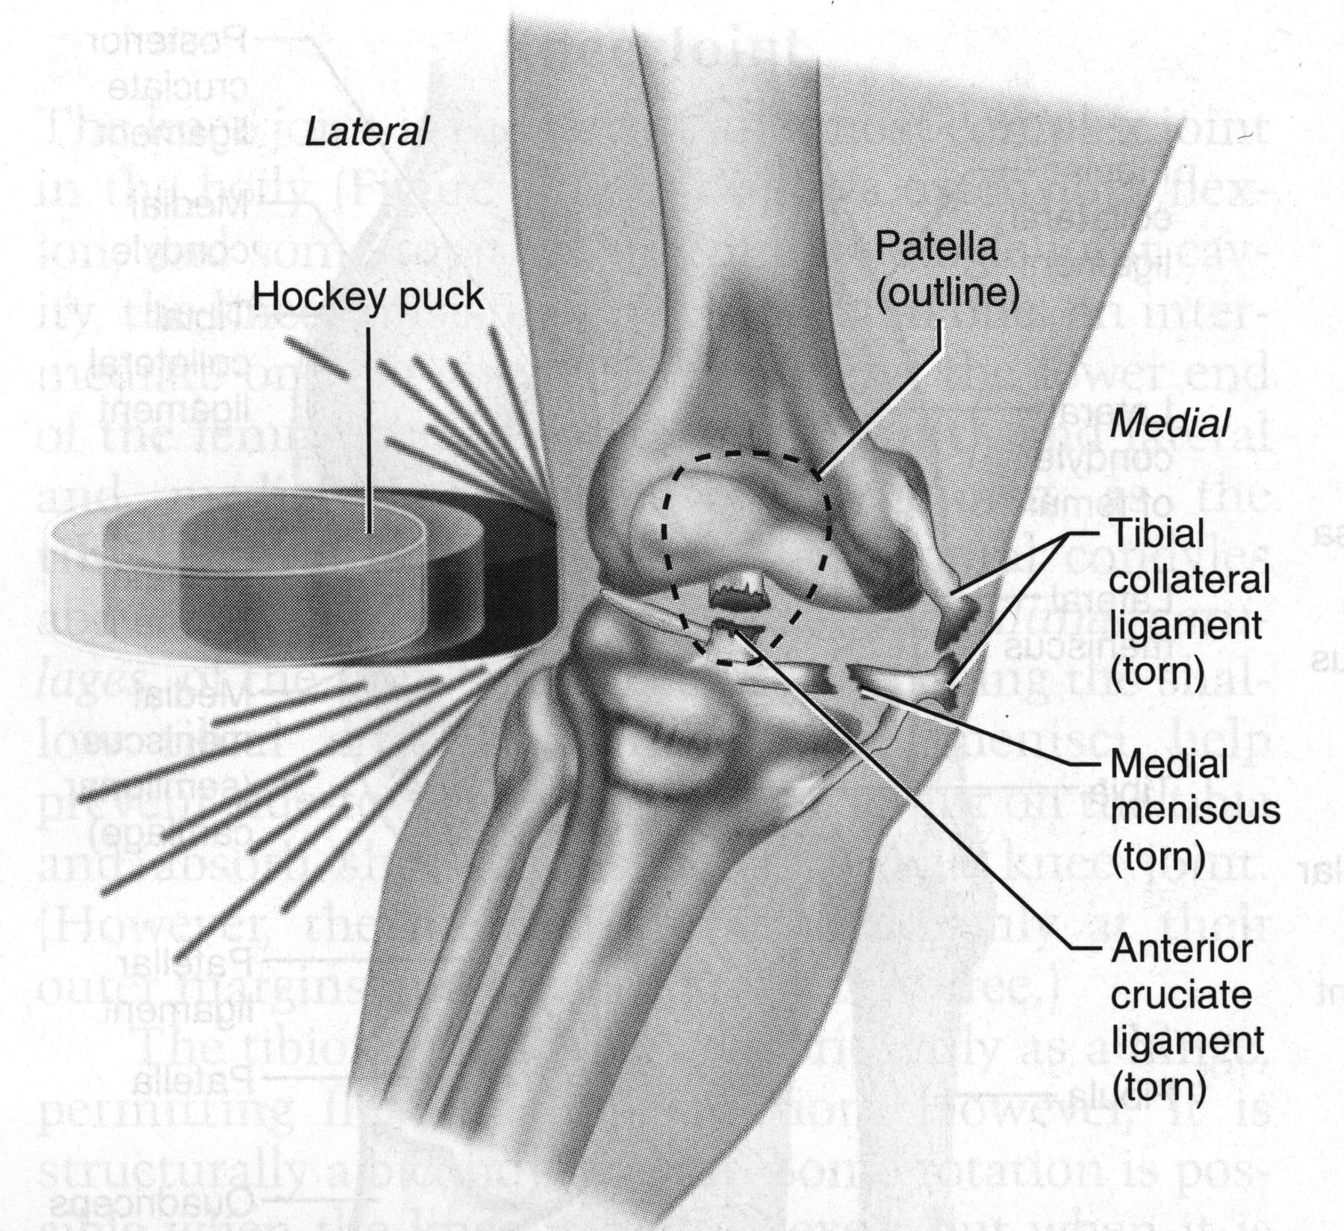
Figure 1: Knee Anatomy (Marieb, 2002).

When the ACL is torn to a great enough extent, the only available treatment is surgery. Completely ruptured ligaments require prompt surgery to prevent complications due to inflammation. If the joint is not repaired promptly, the inflammation can break down neighboring tissues and further complicate the injury. The fibrous structure of the ACL also prevents the ligament from being sewn back together. If the damage is great enough to require surgery, the surgeon must remove the damaged ACL and replace it with a graft (Frank et al., 1997).

2.1.2 Treatments
Currently, there are three main types of implants that can be used; autografts, allografts, and synthetic grafts. There are advantages and limitations associated with each of these grafts. In complete ACL surgery, the entire damaged ACL is removed and a graft is inserted and fixed to the tibia and femur using bone screws often made of titanium alloy (Ti-6Al-4V) or pure titanium (CP titanium). The general overview of a reconstructed ACL using any of the three grafts can be seen in Figure 2 below.
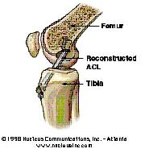
Figure 2: Overview of ACL Reconstruction

2.1.2.1 Autografts
An autograft is characterized by the surgical removal of one area of a patient’s body in order to repair a damaged area. A well known example of an autograft procedure is a skin graft for burn victims. In this instance, skin from either the thigh or the buttocks is removed and grafted onto the burn area. In the case of ACL replacement, the patient’s patella tendon or hamstring tendon is used for reconstruction. In the patella tendon surgery, the inner 1/3 of the patella tendon is extracted. A small hole is drilled in both the femur and the tibia and the extracted patella tendon is threaded into place where the ACL used to be. The graft is then attached using bone screws and the wound site is surgically closed. Another area used for ACL autografts is the hamstring tendon which connects the hamstring to the patella. A section of the tendon is removed and used to replace the ACL. The insertion of this graft is identical to that of the patella tendon autograft. Autografts are currently the most widely used method of reconstruction for ACL tears (Frank et al., 1997).
The leading problem with autografts is the weakening of one area of the body to strengthen another. With ACL surgery, the implanted grafts are often not as strong as the initial ACL and cannot withstand the loads applied to them. This inability to withstand loads leads to failure of the implant and the need for a second surgery. Furthermore, if an autograft is used it can only be performed once per knee due to the weakening of the donor site. If the implant does fail, the donor site remains weakened, and a different method of reconstruction must be used.
2.1.2.2 Allografts
For ACL allograft replacement, the ACL of a cadaver is used to replace the damaged ACL of the patient. The allograft procedure is often used if the patient was given a different type of graft that failed. An allograft implant must be extensively cleaned before implantation to prevent disease transmission and immunogenic response.
Allografts are a valid alternative to autogenous grafts for the replacement of the anterior cruciate ligament, provided that there is careful screening for viral disease, appropriate pretreatment (freezing or freeze-drying) of the graft, and use of sterilization techniques that do not weaken the graft (Frank et al., 1997). The leading problem with allografts is rejection by the patient’s body. The chance of rejection is great for any implant, and much greater for an implant from another human. The body has an autoimmune response that attacks any material that is not native to a specific human. After implantation of a cadaver ACL, an autoimmune response is triggered which generally results in destruction of the ligament. This is the reason the ligament is cleaned and de-celled before being implanted. By removing all immunogenic properties, the patient’s body will be less likely to recognize the replacement as foreign and will not launch an immune response.
2.1.2.3 Synthetic grafts
Synthetic grafts have been used for some time for this procedure but have proven to not be as effective as either allografts or autografts. For this reason, they are not often used for ACL replacement in humans. Some of the most common materials used for synthetic grafts are: carbon fibers, Dacron, Gore-Tex, and more recently, silk. Some of the first synthetic grafts consisted of a large number of synthetic fibers bundled together to make a tendon like structure. Once this structure was produced, the surgeon would implant it in the same fashion as the allografts or autografts. More recently, researchers have investigated the use of a synthetic material in conjunction with either an autograft or allograft. This synthetic graft is placed alongside the artificial ACL and is intended to support some of the load exerted on it. The purpose of this is to limit the amount of failures due to overstress in the beginning of the implant process (Frank et al., 1997).
Though synthetic grafts possess a great potential for ACL replacement, the current synthetic grafts have shown to have numerous limitations. Current data compiled from eight studies suggests that between 40 and 78 percent of 855 synthetic ligaments that were implanted and studied over a fifteen-year period failed over time (Frank et al., 1997). Also, Guidon and colleagues (Guidon et al., 2000) examined 117 surgically excised ACL replacements that included more than fourteen types of commercially available ACL prostheses and concluded that there was no correlation between the duration of implantation and the degree of collagen infiltration. This lack of collagen infiltration may account for a lot of the high failure percentages for synthetic grafts.
Table 1 below details the advantages and limitations of the current ACL replacements. Since there are still numerous limitations with each type of available graft, there is a need for research pertaining to new replacement materials.
Table 1: Pros and Cons of Graft Types
Graft Type | Pros | Cons
Autograft | - Low rejection rate  - Adapts well to new role | - Weakening of patellar tendon  - Strength weaker compared to native ACL
Allograft | - No weakening of other areas of body  - Actual ACL used | - Rejection  - Disease  - Low supply
Synthetic graft | - Produced easily  - Can be produced in mass  - Various materials can be used | - Rejection  - Mechanical Fatigue  - Toxic material  - Low collagen in-growth

2.1.3 Motivation for Tissue Engineered Ligaments
As described in the previous chapter, the ACL is an important part of the knee which maintains the knee’s stability and function. Though various materials have been used as ACL replacements, only a few companies have developed useful prosthetic devices for implant reinforcement. The introduction of these ligamentous prostheses generated much interest because they offered the benefit of quick recovery and rapid rehabilitation of the knee without sacrificing the autogenous tissue. While the initial studies were promising, long term results were disappointing with relatively low success rates. It is quite clear that the use of ligamentous prostheses did not appear to solve the problem of ACL rupture (Canty et al., 2002). Thus in the new age of technology, researchers begin a new phase of ACL replacement through the development of a bio-mimetic tissue engineered scaffold.
There is a growing interest in tissue engineered solutions to musculoskeletal injuries. Tissue engineering is the application of biological, chemical, and engineering principles toward the repair, restoration, or regeneration associated with partial- or whole-organ transplantation (Altman et al., 2002). It is acknowledged that the ideal ACL scaffold should be biodegradable, porous, and biocompatible, exhibit sufficient mechanical strength, and be able to promote the formation of ligamentous tissue.

2.2 The Anterior Cruciate Ligament
The human knee is the largest and most complex joint in the body. It allows extension, flexion, and a small amount of rotation (Marieb, 2002). The stability of the knee is provided by a group of four ligaments which connect the bones of the knee together. The medial collateral ligament (MCL) provides the stability for the medial aspect of the knee while the lateral collateral ligament (LCL) provides the stability for the lateral aspect of the knee. The two major ligaments in the knee are the anterior cruciate ligament (ACL) and the posterior cruciate ligament (PCL). The ACL is located in the center of the knee and limits the degree of rotation and forward movement of the tibia during extension. The PCL is also located in the center of the knee and is responsible for the limitation of backward movement in the knee. An overview of the knee is seen in Figure 3 below.

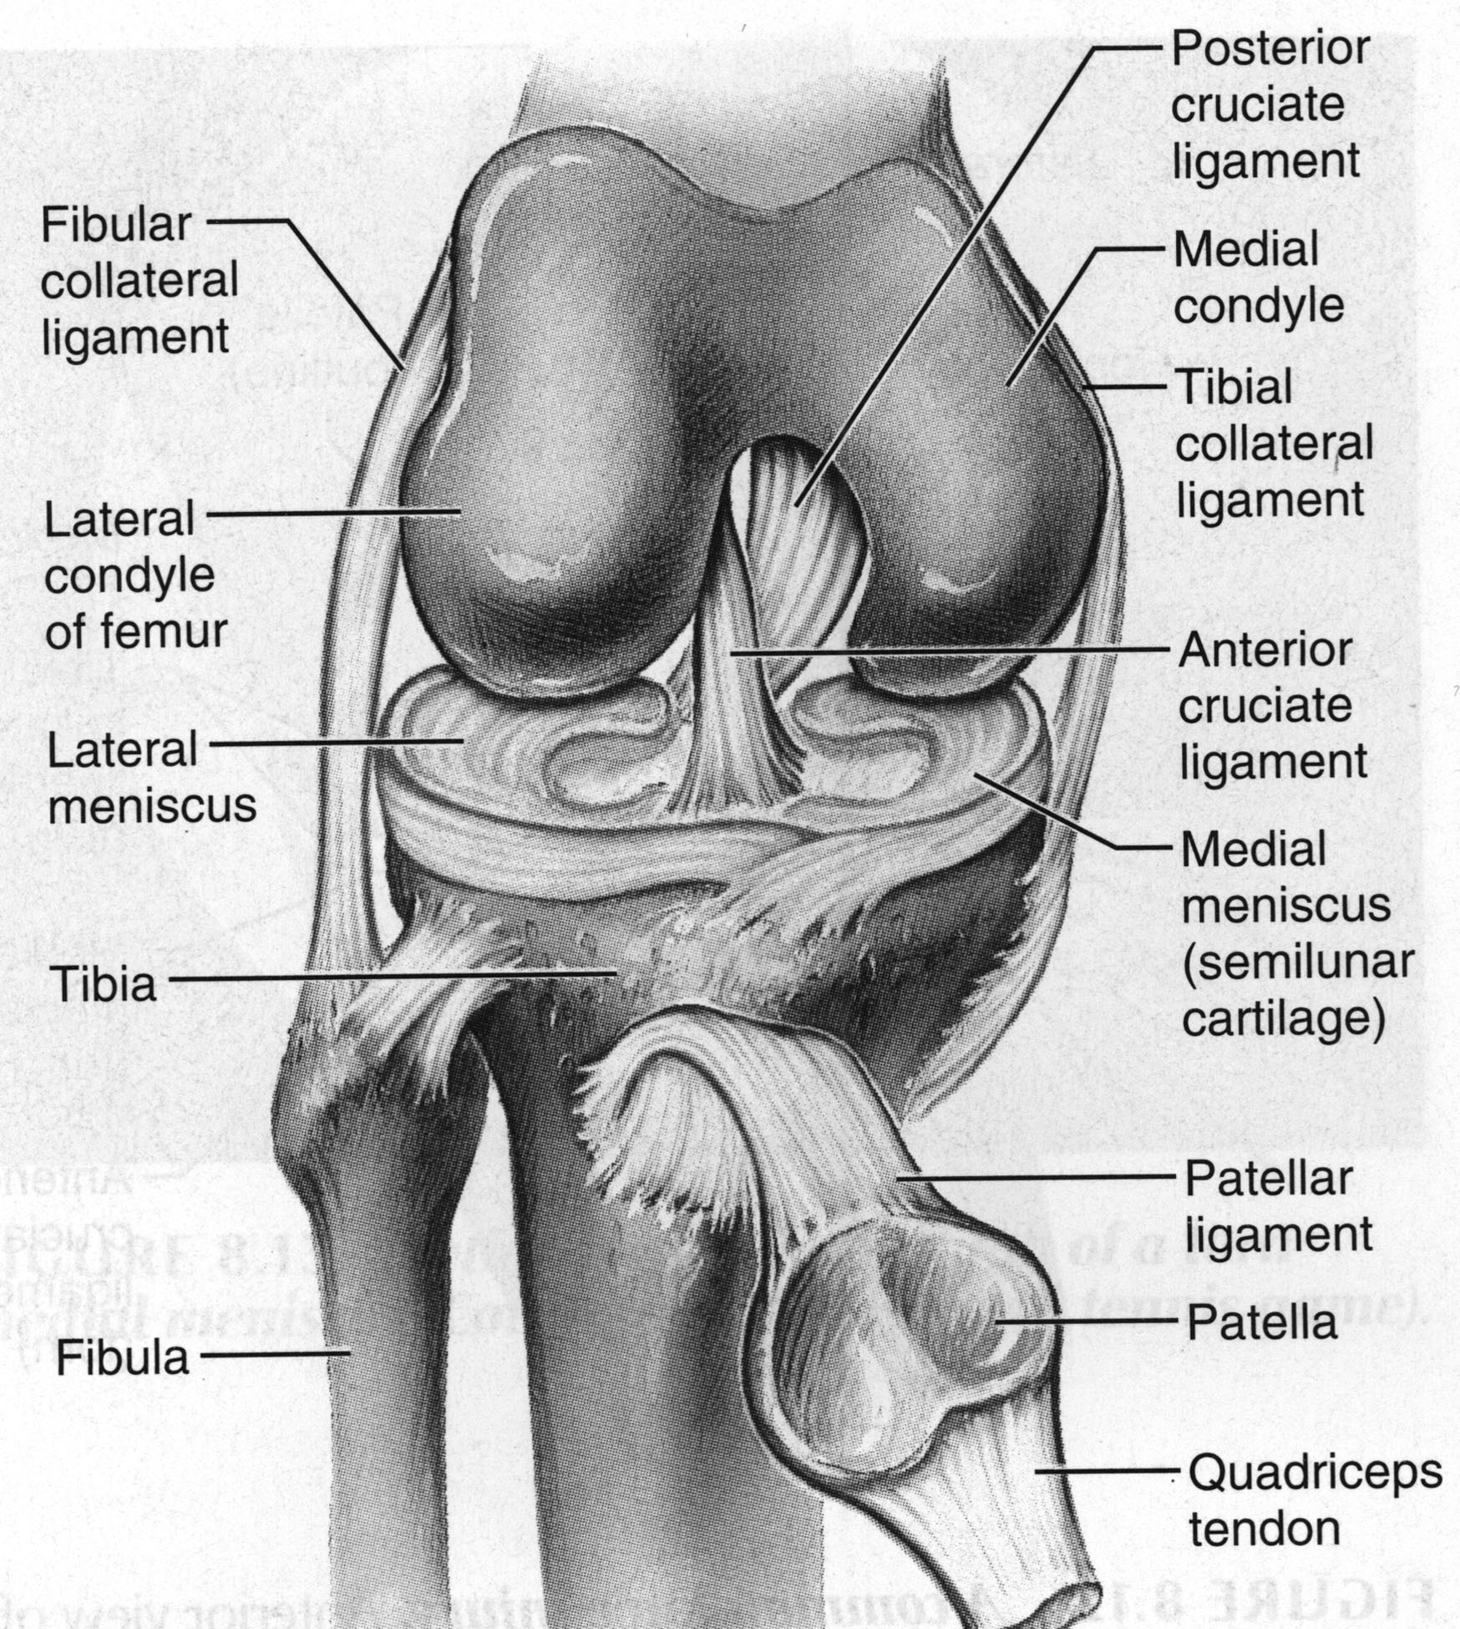
Figure 3: The Anatomy of the Human Knee (Marieb, 2002)

In order to produce a bio-mimetic tissue engineered scaffold for ACL replacement, it is necessary to understand the mechanical, structural, and molecular properties of native ACL.

2.2.1 Mechanical Properties
The ACL functions as one component within a dynamic system, sharing tensile loading with other tendons and ligaments in the knee. These ligaments provide the function of fixation preventing flexion, extension and rotation. Injuries to these ligaments typically occur during contact sports activities. When the ACL is injured, the hamstring muscles adapt to take on the role of the ACL in resisting tibial motion. The ability for the hamstring to taken on the function of the ACL account for why some patients are able to have nearly normal function of the knee in the presence of a torn ACL.
A normal ACL has been shown to carry loads throughout the entire range of flexion and extension of the knee. This is accomplished by the recruitment of various fibers within the structure of the ACL as the knee joint moves. Fibers in the ACL, like other connective fibers, are recruited on the basis of subtle three-dimensional changes in the position of the joint and mechanical loads placed on them. Since fiber bundles are recruited in various patterns, it is clear that the ACL can fail differently depending on the load. Due to this phenomenon, the maximum strength of the ACL is not a fixed value, but a range of values. Another factor that contributes to fiber recruitment is the placement of the ACL on the femur and the tibia. A fourth factor that influences how fibers of the ALC are recruited is related to the internal structure of the ligament. Individual fibers within the ACL do not appear to change length during movement of the joint. However, at a histological level, fibers do change length as they are recruited into tension, and must do so as the joint moves. Fibers do this by straightening their crimp (Frank et al., 1997).
The ACL, like other ligaments, carries only small loads during normal use. Loads on the anterior cruciate ligament are, at most, only about 20 percent of its failure capacity of 2500 Newtons (Frank et al., 1997). The maximum loads placed on the ACL are caused by the quadriceps-powered extension of the knee, moving it from approximately 40 degrees of flexion to full extension. The ACL, although a bundle of fibers, biomechanically does not behave as a simple collection of fibers. Rather, it behaves as a viscoelastic structure, dissipating energy and adjusting to lengths and loadings as a function of the number of loading and unloading cycles. This also allows the ACL to have microscopic adjustments to internal stresses over time, thus influencing stresses and forming a natural resistance to failure (Frank et al., 1997).

2.2.2 Structural Properties
Tendons and ligaments control the mechanical properties of many joints in the body. In particular, the three dimensional stresses placed on the knee require that the ligaments found there, primarily the ACL, are strong enough to handle the cyclic loading of the body. This is accomplished primarily by the most important stress-carrying protein structure, type I collagen (Fratzl, 1997). Type I collagen molecules self-assemble (outside of the cell membrane) into collagen fibrils. These collagen fibrils then order into a hierarchical structure (see Figure 4) eventually forming ligaments.

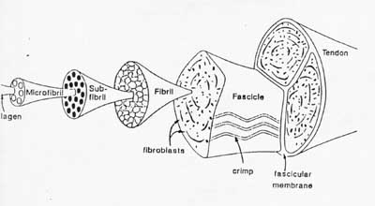
Figure 4: Hierarchical Structure of Ligaments
(Kastelic et al. 1978)
The largest structure is the tendon or ligament itself. The ligament is formed of fascicles containing fibrils and fibroblasts responsible for the production, and remodeling of collagen. The crimp is an angular bend in the fibril, allowing elongation to a greater extent than if its constituents were strictly linear. It can be pictured as a “slinky” stretching up and down as its coils respond to oscillating loading. From the level of the fascicle, the fibrils, sub-fibrils, and micro-fibrils make up smaller and smaller elements eventually concluding at the level of collagen molecules. (Viidik, 1973).

2.2.3 Molecular Properties
Collagen is the most abundant acellular component of ligaments that provides load transfer and mechanical stability. The primary structure of type I collagen is a pro α chain consisting of an amino acid triplet Gly-X-Y (Ottani et al., 2002). The Gly-X-Y structure is highly conserved and the hallmark trait of the collagen family (Figure 5). The D spacing of the fibrils is also specific to collagen. The X and Y amino acids are usually characterized by proline in the X, and hydroxyproline in the Y position (Miller, 1985).
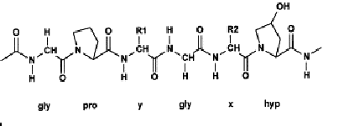
Figure 5: Collagen primary structure α chain. (Wolfgang, 1998).
The pro α chain has three major domains: an NH₂-terminal peptide, an α1(I) chain, and a carboxyl acid group, termed the pC end (Miller, 1985). The central domain of the primary structure coils into a tight left-handed α-helix due to steric repulsion between the proline and hydroxyproline residues in the α1(I) chain. The steric repulsion forms the secondary structure of collagen (Ottani et al., 2002). Due to the residue spacing (.286 nm) and the angle of separation (108°), the glycine residues make a row across the surface of the α-helix, which allows for the formation of the tertiary structure (Ottani, 2002).
The tertiary structure of collagen refers to the fundamental unit known as procollagen: three polypeptide chains intertwined to form a right-handed triple-helix with a pitch of approximately 8.6 nm. This triple helix produces a rod-like structure, characterized by its high tensile strength and low flexibility (Silver et al., 2003). The rod-like structure is approximately 300nm long and flanked on both ends by a globular domain (Ottani et al., 2002).
The procollagen molecule then undergoes a series of enzymatic modifications within the endoplasmic reticulum. Cleavage of signal sequences triggers the translocation of the peptide chain across the membrane. This relocation initiates the intracellular processing of collagen fibril formation. Folding of the procollagen C-propetides allows inter-chain disulfide bonds to form. This then signals the propagation of the collagen triple helix forming the C to the N-terminus of the molecule. The C-propeptides have an essential function in the assembly of the three α-chains into a trimetric collagen monomer. The C-propeptides direct the association of the three chains of procollagen serving as an initiation point of triple helix formation (Hulmes, 2002).
After processing and procollagen assembly, the triple-helical molecules are packaged within the Golgi compartment. Secretory vesicles are released into the extracellular space. Following the secretion of procollagen, propeptides are removed by procollagen N- and C-proteinases. This triggers the spontaneous self-assembly of collagen molecules into fibrils. The C-propeptides are essential for both the initiation of procollagen assembly from the constituent chains and lateral assembly of procollagen molecules (Silver et al., 2003). It has been suggested that as long as the C-propeptide remains attached to the rest of molecule, solubility remains high. Studies have shown that the C-propeptide of fibril-forming collagen is removed from small diameter fibrils during growth possibly during fibril fusion (Ruggerio et al., 1988). The presence of the N-propeptide does not prevent fibril formation though it does influence fibril shape and diameter. While the C-propeptide domains of the fibrillar procollagens are highly conserved, much greater variability is seen in the N-propeptide. The collagen molecules produced by cleavage of the propeptides have a high tendency for self-assembly and spontaneous formation of fibrils. The collagen molecules aggregate through fibriollgenesis into microfibrils consisting of four to eight collagen molecules and further into fibrils. These fibrils reach from 10 to 500 nm in diameter depending on tissue type and stage of development. The triple-helices are staggered by 67 nm with an additional gap of 40 nm between succeeding molecules show in Figure 6. These collagen fibrils organize into fibers, which can form larger tissue complex (Silver et al., 2003).
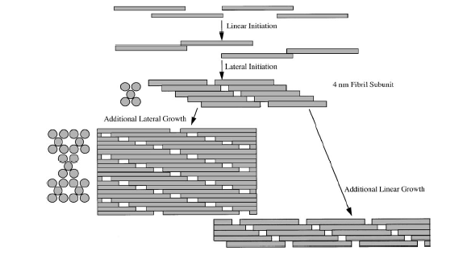
Figure 6: Model for type I collagen self-assembly (Silver et. al. 2003)

2.3 Work with Collagen Threads
Researchers have investigated the use of various synthetic material for the construction of ACL replacement, including Darcon®, carbon fibers and nylon. Although these materials exhibit high mechanical load, the materials have a high probability for failure due to mechanical fatigue. In addition to synthetic materials, researchers also studied the potential of biologically base material. Altman and colleagues (Altman et al. 2003) have investigated the use of silk-base materials as a potential source for ACL replacement. Silk’s unique mechanical properties, coupled with the ability to weave the fibers into wire-rope geometry, provide control over the matrix’s final mechanical properties to mimic the mechanical properties of native ACL. However, one of the major limitations associated with silk-base biomaterials is the lack of data for the biological response to silk fibers. In addition to silk-base materials, since collagen is the major acellular component of tendon and ligaments that provides load transfer and mechanical stability, many investigators have attempted to explore the use of reconstituted collagen fibers for construction of orthopedic implants.
Kato and colleagues (1989) have shown the potential of reconstituted type I collagen fibers for tendon and ligament replacement. These collagen fibers appear to be very biocompatible even in the presence of low concentrations of glutaraldehyde. They promote fibrous aligned ingrowth in a setting of ligament healing. Thus, they represent a strong candidate as a ligament scaffold or tendon prosthesis if their crosslink density can be increased (Law et al., 1989). The method and extent of crosslinking profoundly influences the strength, resorption rate, and biocompatibility of collagenous biomaterials. Comparing the effects of two physical crosslinking methods, ultraviolet irradiation (UV) (254nm) and dehydrothermal treatment (DHT), on the mechanical properties and molecular integrity of collagen fibers extruded, Dunn and associates (1995) demonstrated that UV irradiation is a rapid and easy means of increasing the mechanical strength of collagen fibers. Furthermore, Dunn (Dunn et al., 1995) studied the effects of fiber diameter (20, 50, or 90 microns), crosslinking agents (uncrosslinking, dehydrothermal-cyanamide or glutaraldehyde) and hydration on the initial mechanical properties, as well as the biocompatibility and subcutaneous degradation rates of the extruded fibers. Dunn found that by minimizing the diameter, fiber strength can be increased without prolonging the fiber degradation rate. Low-diameter, dehydrothermal-cyanamide crosslinked fibers have greater tensile strength and a more rapid degradation rate than medium-diameter, glutaraldehyde crosslinked fibers, and are therefore more suitable for use in a degradable ligament reconstruction device. However, Kemp and colleagues (Kemp et al. 1995) studied the effect of crosslinking in correlation with the rate of body remodeling. The studied indicated lightly crosslinked collagen fabric implants were remodeled within 90 days post-implantation, while the heavily crosslinked fabric resulted in little new tissue ingrowth and a marked foreign body reaction. The study also reported that in a dog model, the ACL implants were adequately replaced by functional neoligamentous structure within 12 weeks.
Based on these findings, collagen fibers and fiber scaffolds have been used in the development of a tissue engineered ACL replacement. Bellincampi et al (1998) and Dunn and associates (1997) have conducted experiments on a tissue-engineered approach to ligament reconstruction using fibroblast-seeded collagen scaffolds. Dunn evaluated a prototype composite collagenous anterior cruciate ligament replacement device designed to possess the advantages of biological grafts and synthetic materials. Collagenous anterior cruciate ligament prostheses were made by embedding 225 reconstituted type I collagen fibers in a type I collagen matrix, and placing polymethylmethacrylate bone fixation plugs on the ends. In animal models, the acellular scaffold showed promotion of neotissue ingrowth. The ultimate tensile strength and ultimate load increased substantially due to deposition and remodeling of neoligament tissue. The neoligament ultimate load was 2 to 4 times the initial load value of the prosthesis. Implantation of a resorbable composite collagenous anterior cruciate ligament prosthesis encourages the development of functional neoligament tissue. However, the majority of these collagen scaffold implants did not induce functional neotissue ingrowth. Additionally the tissue ingrowth was inconsistent and hard to control (Dunn et al., 1995). In both Dunn’s and Bellincampi’s experiments, there was also evidences of implant failure to regain strengths comparable to the native tissue. Thus these findings demonstrate the need for a collagen scaffold with structural hierarchy and biochemical cues that closely mimic that seen in tissues in vivo.
In 1997, Pins et al. developed a process for the extrusion of high strength collagen fibers by using solutions under optimum conditions that caused soluble collagen molecules to self-assemble into fibers. It has been shown that threads assembled from solutions of soluble collagen molecules possess improved mechanical properties with a higher density of align fibrils than threads extruded previously using insoluble collagen (Pins et al., 1995). These reconstituted fibers also exhibit the D period characteristic of collagen and can be cross-linked using either chemical or physical techniques. In 2004, Cornwell et al. suggested that threads with an increased alignment of collagen were found to have fibroblast migration rates similar to native tendon, 0.75 to 1.25 mm/day (Cornwell et al., 2004).
With the various uses for collagen threads in the biomedical field, there is a need for a way to extrude collagen fibers. The following sections will identify the current methods of fiber extrusion as well as their limitations.

2.4 Extrusion of Collagen Threads
Currently, collagen threads are extruded by hand in a chemical bath of fiber formation buffer. The method used by Pins et al. 1997 produces collagen fibers that closely mimic the properties of native collagen. The following section will outline this method, the process used to extrude the collagen into threads, and the disadvantages of manual extrusion.

2.4.1 Manual Extrusion Method
There are several different chemical processes for producing collagen fibers in a laboratory environment. One method that has proved very effective in producing collagen threads is the method described by Pins et al. 1997.
Fiber formation was accomplished by extruding this 10 mg/ml collagen solution through small diameter FEP tubing into a fiber formation buffer by hand (Figure 7). This buffer consists of 135mM NaCl, 30 mM TrizmaBase, and 5mM sodium phosphate dibasic. The solution was then adjusted to a pH of 7.4 using 1N HCL and 1N NaOH. The extruded collagen was soaked in the fiber incubation buffer for a period of 24 hours. After this time, extraction of the buffer occurs and replacement with fiber incubation buffer consisting of 135mM NaCl, 10 mM TrismaBase, and 50 mM sodium phosphate dibasic is performed. After soaking in this solution for 24 hours, rinsed in distilled water for 60 minutes, the fibers are allowed to dry under their own weight.
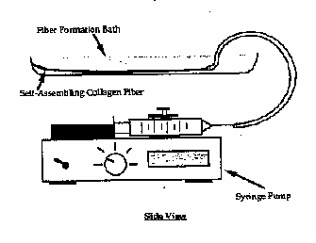
Figure 7: Pins Collagen Fiber Extrusion System (Pins et al., 1997)

The ultimate goal of this extrusion process is to create threads with similar mechanical properties to native rat tail tendon threads. Native rat tail tendon threads have an average tensile strength of 40 MPa (Kato et al, 1989). The extrusion method used by Pins produced collagen threads with mechanical properties less than that of native tendon threads (UTS around 24 MPa). In order to compensate for this lack in strength, the fibers were cross-linked and/or stretched. These threads are cross-linked using DHT. These threads were then mechanically tested by mounting dry fibers on a paper frame with an epoxy adhesive (Pins et al, 1995). It was found that DHT cross-linking could produce a maximum ultimate tensile strength of 91.8 MPa for hydrated fibers. Use of different cross-linking methods or stretching can produce desired mechanical characteristics.

2.4.2 Limitations
There are many disadvantages of fibers created by this manual extrusion system. The greatest problem associated with this method is the uniform properties of extruded threads. The threads extruded manually did not possess the same structural and mechanical properties due to the user’s non-repetitive hand movement. This difference in hand motion changes the overall size of the fiber. By moving ones hand faster, the fibers are stretched during production, and will be thinner; while moving the hand slower makes the collagen bunch up creating a larger diameter fiber. Another limitation of this hand extrusion process is the speed at which it is done. The process takes a considerable amount of time (up to 1 hour) creating a small number of threads. If a researcher must make collagen fibers by hand to use them for tests, they are using valuable time that could be used doing further research on previously made threads. In addition, the current method has no mean for fiber attachment; the extruded fibers are allowed to adhere to the side of the bath. In many instances the fibers will detach and adhere to each other, thus further decreasing the fiber production (as shown in Figure 8 and 9 below). The system consists of a syringe pump that pumps the collagen solution through small diameter tubing into a fiber formation baths. The baths are submerged in a water bath with a water heater to maintain the temperature of the FFB at roughly 37 degrees Celsius.
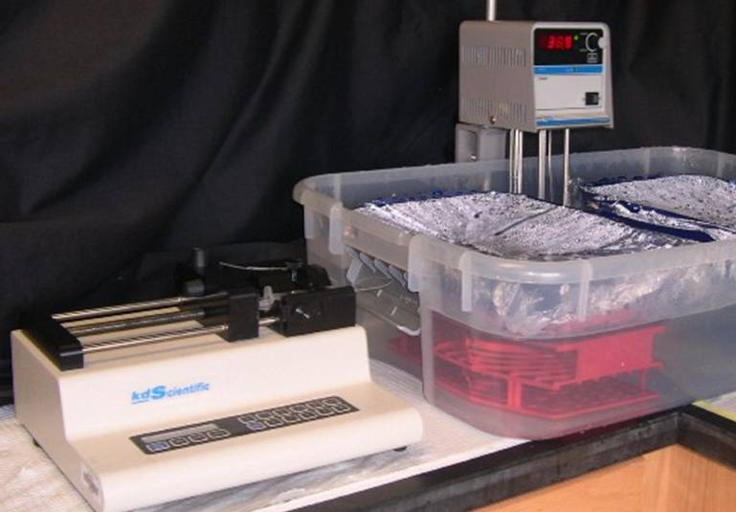
Figure 8: Current Manual Extrusion System

The design of an automated collagen extrusion process could eliminate many of the problems associated with the manually extruded fibers. The automated system produce fiber with more uniform structural and mechanical properties, in addition to increase the fiber production rate.
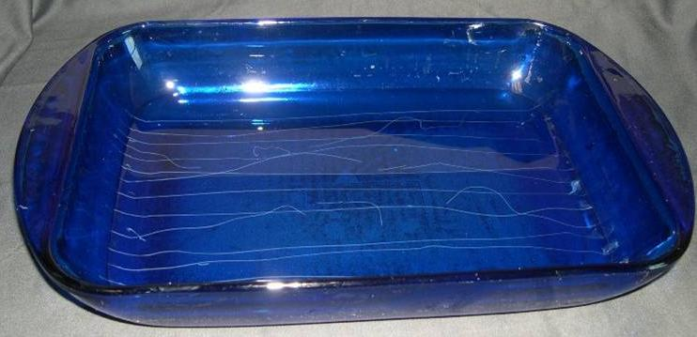
Figure 9: Threads Manually Extruded

2.5 Automated Systems
Due to the disadvantages associate with the manual extrusion method, researchers investigated various methods to overcome these limitations. Since 1950, there have been few automated collagen extrusion devices patented in the U.S. This section will look at two of these extrusion systems, as well as detail their advantages and disadvantages.

2.5.1 Salo
Currently few methods exist to produce collagen fibers via an automated extrusion system. Salo et al (US Patent #2598608) patented a device for the development of extruded collagen fibers in 1946. These fibers were claimed to be high strength and resistant to enzymatic digestion due to their orientation and the longitudinal alignment of the individual fibrils. They also account for between 1.5 and 2.0% of the weight of the collagen gel used in the extrusion process. In the processing of the collagen into fibers, it is important to control the elongation at various stages of the extrusion process. This elongation provides additional alignment of the molecules in turn increasing strength. These parameters are controlled using the device seen in Figure 10.

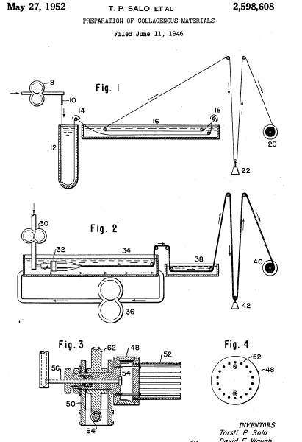
Figure 10: Schematic of Collagen Fiber Extrusion Device by Salo et al. 1952

In their process involving the figure above, where a single collagen thread is extruded, the collagen gel is supplied to a metering pump (# 8 in the Figure) and forced downward to a nozzle (10) with a length larger than the diameter located above the dehydrating bath. This distance above the bath serves to stretch the fibers. The dehydrating bath contains acetone which causes the gel to become weaker, however, the fiber increases in diameter as it moves through the bath. The fiber is then wrapped around a pulley (14) which provides an additional stretch of 15%. The fibers are under constant tension maintained by their own weight. The remaining acetone and acid, which is holding the fibrils together, is removed by washing the fibers in a bath of distilled water and then the fibers are dried under tension with a weight of 1.2 to 1.5 grams. The fibers are then wound onto a spool. To produce fibers of greater cross sectional area, a multi-filament extrusion process is used as seen in Part II of the Figure above. This method utilizes a rotating head with multiple nozzles to extrude several streams of collagen gel. To carry out this process, collagen gel is supplied to the pump (30), to the rotating nozzle assembly (32) and then discharge into a bath of flowing acetone to impart stretch and orientation of the molecules. The acetone is flowing from one end of the bath to the other by means of a circulating pump (36). Dehydrating and washing are performed using the same procedure as the monofilament fiber, however, a second bath (38) is used to rinse the fibers before being wound onto a spool (40). A series of pulleys provide tension for the fibers to be stretched as they are drying. (Salo et al 1952)

2.5.2 Organogenesis

In 1989 Kato and Silver (Kato et al. 1989) described the design for an automated system to extrude long continuous collagen threads. The automated fiber formation process involved the use of a belt-driven mechanism that carried the extruded fibers from a syringe to various chemical baths. Using this device, Kato was able to produce up to 23 meters of continuous collagen fibers, with the reported UTS of 0.8 ± 0.17 MPa, 38.2 ± 4.93% strain. This system was later purchased and modified by Organogenesis. The new Organogenesis’ system produces collagen threads having improved properties over known collagen threads (US. Patent 5,378,469). The best fibers produced with this system have an ultimate tensile strength of greater than 1MPa for non-crosslinked threads and greater than 45MPa for crosslinked threads. These collagen threads are also suitable for knitting, weaving, and producing tissue constructs. Additionally, the present invention also provides banded collagen threads similar to native-banded collagen fibrils.
Figure 11 below shows a schematic diagram of the apparatus with each component labeled. The current device provides means for extruding the collagen solution (1), a dehydrating bath (10), a rinsing bath and mean for drying the threads (30), and an uptake spool (40). These functions are accomplished by many small elements which are placed in series to produce the system. The subunits used for collagen extrusion (1) include a syringe pump (2), a syringe (3), leader tubing (4), and a blunt needle (51). The dehydrating bath (10) includes a dehydrating trough constructed of materials compatible with collagen such as PVC and polycarbonate (11), dehydrating agent (12), and a recirculation pump (13). The rinsing bath (20) includes a rinsing trough (21) and rinse liquid (22). The mean for drying the collagen threads (30) includes a drying cabinet (31), pulleys (43-47), and a heater/blower (32) (US. Patent 5,378,469).
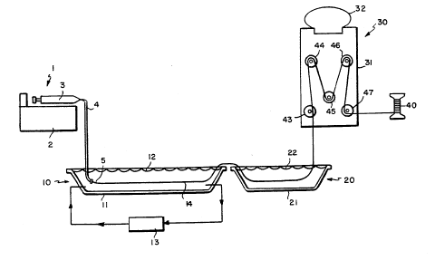
Figure 11: Image of Automated Extrusion Device Developed by Organogenesis (US. Patent 5,378,469)

After testing various conditions, a solution of 5 mg/ml in 0.005% acetic acid is degassed, loaded into the syringe and connected to the leader tubing and needle. The syringe is placed in the pump and the leader tubing is placed in the dehydrating bath under the surface of the agent. The syringe pump is set to extrude solution at a rate of 2.0 to 3.5 ml/min. The dehydrating bath is comprised of a dehydrating agent having a higher osmotic pressure than that of the collagen solution (>500 mOsm) and a preferred pH of 7 to 9. Preferred drying agents include water soluble, biocompatible polymers such as Dextran.RTM and polyethylene glycol dissolved in a buffer such as sodium phosphate or sodium borate comprising 20-30% by weight. When the dehydrating bath has a sodium phosphate concentration of 0.1 to 0.5M, native banded fibrils are formed. The thickness of the extruded collagen threads is determined by the rate of infusion and the circulation of the dehydrating solution in the bath. When enough slack is generated, the thread is pulled through the pulleys and placed onto the uptake spool after passing through the rinsing bath of phosphate buffered saline and the drying cabinet at 43 degrees centigrade. Crosslinking of the fibers can be performed by passing the thread through a solution of 2% glutaraldehyde. Collagen threads prepared by the current invention have a collagen concentration of 300 to 600 mg/ml, a diameter of 50 to 250 microns, and the following properties seen in Table 2 (US. Patent 5,378,469).
Table 2: Mechanical properties of continuous collagen threads after soaking in PBS (US. Patent 5,378,469)
Thread A Thread B
Non XL Glut XL Non XL Glut XL
________________________________________________________________________

Ultimate tensile strength (MPa) 0.8 .+-. 0.2 37 .+-. 7.9 1.7 .+-. 0.6 70 .+-. 7.0

Ultimate strain (%) 38 .+-. 4.9 17 .+-. 3.0 30 .+-. 10 45 .+-. 10

Modulus (MPa) 3.6 .+-. 0.8 270 .+-. 69 5.7 .+-. 2.0 134 .+-. 13

Load at Break (gm) 1.2 .+-. 0.3 14 .+-. 2.5 11 .+-. 3.9 167 .+-. 9.6

Swelling (%) 165 .+-. 16 24 .+-. 9.9 390 .+-. 35 63 .+-. 9.1
________________________________________________________________________

2.5.3 Limitations

The major drawback to the current devices is that they work on the principle of a single thread being produced and drawn through various baths. If this single thread breaks in the process, it is very difficult to restart the process and if unnoticed, the automated device will continue to produce unusable fibers causing a loss of time and money. Additionally the use of multiple baths causes the fiber to be exposed to the surrounding environment and also causes a great deal of stress to be placed on the fibers as it is transfer along the production process. Lastly, a woven or 3D structure is impossible without weaving after the fiber is produced which involves further processing.
Due to the various disadvantages of manual extrusion and the existing automated systems, there is room for much improvement. Through this project, we will design and build an automated device that will address the aforementioned disadvantages.

3. Project Approach
Once the background information is thoroughly researched and understood, the design team can begin to focus on the specified project. The first steps to engage in are defining the project hypotheses, assumptions and aims. This will help to define the project and the expected outcome of a successful design.

3.1 Project Hypothesis
The objective of this project is to develop an improved automated collagen extrusion system which will produce and stretch fibers based on the fundamentals used in the current method. Currently, most methods for collagen extrusion are completed by hand resulting in a large amount of time needed and in fibers of varying dimensions and quality.
As of 2004, only two automated collagen extrusion system had been patented to reach this goal. However, these systems have some disadvantages as described above in section 2.5.3.
It is hypothesized that the design of a new automated collagen extrusion device will result in an increase in the number of fibers produced per production cycle over the current methods; additionally the device will produce threads with uniform structural and mechanical properties, closely mimicking those of natural tissue.

3.2 Project Assumption
The hypothesis indicates that the design of a new automated collagen extrusion device will result in fibers that exhibit uniform structural and mechanical properties and increase in fiber production. Therefore, some assumptions must be made:
- Standardized fiber dimensions will result in fibers that have consistent structural and mechanical properties.
- Variations in fiber dimensions are due to the manual production.
- The extrusion process does not impact the stability and quality of collagen molecules.
- The current self-assembly procedure, used by Pins et al.1996 provides optimal self-assembled threads.
- The concentration of type I collagen is continuous throughout the fiber.

3.3 Project Aims and Specification
The goal of this project is to design the described automated device to produce uniform type I collagen fibers that exhibits structural and mechanical properties similar to natural ligament collagen fibers.
The specific aims of this project are:
- To produce a collagen threads that is comparable to the threads produce with the manual extruding methods.
- To produce collagen with qualities similar to that of natural fibers
- To develop a repeatable and automated method, resulting in uniform fibers.
- To optimize the rate of type I collagen fiber extrusion/production.
- To be able to stretch and dry fibers under controlled conditions.
- Conduct and develop analysis procedures to assess hypothesis.

4. Design
This section will focus on the process of developing the design of the automated collagen extrusion system. Before we proceed with the designing process, it is essential to clarify the outcome of the project for the stakeholders. There are three major groups of stakeholders involved in the design process: the clients, the designers and the users. A client is a person, or group of people, who wants a specific project designed. The client provides an initial statement outlining the ultimate goal of the project which motivates a team of designers to complete the project at hand. It is the job of the designers to develop a final design and specifications so the project can be easily made and used in its perspective field. The last stakeholder is the user, the person who will use the device. For the automated collagen extrusion system, Professor George Pins and PhD Candidate, Kevin Cornwell are the clients, William Bishop, Diana Camire, Ngoc Chau Duong and Jason Robinson are the designers and the users consist of Kevin Conrnwell and anyone interested in using the automated system to extrude collagen fibers.
The design process is a step-by-step procedure that is outlined in Figure 12 below. The process starts with the initial client statement as the project motivation. At this initial stage, the designers must clarify all the objectives, constraints and functions in order to revise the client statement into a more concise and accurate description of the problem statement. After revising the client statement, the design phases begin. The first of these phases is conceptual design, where general concepts are formed in order to establish design specifications and generate design alternatives. Once this is completed, the design team can then move onto the next phase, preliminary design. In this phase, the conceptual design ideas are analyzed and evaluated in order to select the most appropriate working design for the problem at hand. In the final phase, detailed design, the selected design is refined and optimized in order to produce the final product.
Project Motivation

Clarification of Design Goals:
Clarify objectives
Establish user requirements
Identify constraints
Establish function
Conceptual Design
Preliminary Design
Detailed Design
Establish design specification
Generate alternatives
Refine and optimize design

Model or analyze design
Test and evaluate design

Final Design

Figure 12: Design Process (Dym and Little 2003)

4.1 Clarification of Design Goals
An understanding of the clients’ and the users’ needs and requirements is needed to design an optimal system. The end product should meet the needs of the clients, while considering the constraints and wants of the designers and the users. Thus, applying the design process stated above, we attempted to find a solution that would meet the objectives, functions and constraints defined by all the stakeholders. The initial problem statement provided to us stated:
“Design and develop an automated extrusion system to synthesize and stretch collagen fibers.”

The first important task was to qualitatively identify the requirements of the project. After thorough discussion with the clients (Dr. George Pins and PhD Candidate Kevin Cornwell), the team was able to formulate a list of attributes for the design, broken down into three groups: objectives, function and constraints. The objectives are the goals of the device set by all the stakeholders, functions are the requirements of which the device must be able to perform and the constraints are the limitations applied to the design of the device. Table 3 is a list of attributes.
Table 3: List of Attributes
Objectives | Functions
Minimize fiber variations | Able to stretch fiber
Maintain fiber structure | Able to produce fiber
Maintain fiber property | Able to control production
Automated sytem | Able to control extrusion orientation
Ability to produce continuous fibers | Allow to user to set and control parameters  (rate of extrusion)
Increase fiber production rate | Monitor and control production state
Self Contain | Able to hold fiber
Accurate | Control and maintain water bath temperature
Means for fiber fixation | Constraints
Ease of Use | Device must fit on lab bench
Upgradeable | Time
Time efficient | Cost
 | Durability
Construction of materials does not interact
with collagen
 | Fixed Anchors

4.1.1 Objectives
To better understand the significance of the design project, we re-organized the objectives list and further broke it down into sub-categories. The top level consists of the main goals, while the lower levels are the sub-goals which would aid us in the process of achieving the main goal. We also eliminated objectives that were not in the scope of our project due to time and financial constraints as well as other factors beyond our control. Thus an indented objective list was formulated as shown in the Table 4.
Table 4: Indented Project Objectives
- The device should minimize variation of fibers
  - Constant fiber dimension (i.e. fiber diameter)
  - Constant fiber orientation (i.e. spacing between fibers)
  - Constant mechanical properties
  - Maintain structural and mechanical properties of the extruded threads.

- The device should be time efficient
  - Reduce length of time require to extrude collagen fiber
  - Increase fiber quantity per batch

- The device should be user friendly
  - Ease of use
    - Fixed anchoring system
    - Easy to set up
    - Easy to clean
  - Upgradeable/Expandable
  - Self-contained
  - Easy Storage

- The device should be cost effective
  - Cost of fabricating device
  - Cost of running device

- The device should be able to produce long and continuous fibers

- Accuracy

According to our indented objectives, we identified six major objectives: minimize variation between fibers, time efficient, user friendly, cost effective, the ability to produce long continuous fibers, and accuracy. In order to minimize the variation between extruded collagen fibers, the different parameters, such as fiber dimension and orientation must be constant while ensuring the stability and mechanical properties of the fibers. The new automated system must also expedite the production process by increasing the quantity of fibers and reducing the length of time require to produce one batch of collagen fibers. Since the client expressed interest in performing different mechanical tests, the produced collagen fibers should be fixed onto an anchoring system that is stable and easy to handle. This specification falls under the third major objective, user friendly. Overall the device must accurately control various parameters, i.e. fiber diameter, flow rate, and spacing between fibers.
Some of the objectives, however, are clearly more important than the others. To determine which objectives are more essential to the design of the device, a weighted objective tree must be constructed. Using the indented objectives, we generated three sets of Pairwise Comparison Charts, which were completed by each of the stakeholders. The Pairwise Comparison Charts compare each of the objectives to the others of the same level. The more important objective receives a score of 1 while less important objectives receive a 0. If both objectives were comparably relevant to the design, a score of ½ would be assigned to both. Once all the objectives receive a score, the sum of each objective determines its rank. In this case, the objective that receives a 5 would be the most important criteria for the design process, while the objective with a score of 0 is regarded as the least important attribute. All the objectives, however, are essential to the design process; we must normalize the score to eliminate the score of zero by adding one to each score and divided by the highest score. Thus the objectives would receive scores of 6/21, 5/21…1/21 respectively. The results of the Pairwise Comparison Charts completed by the stakeholders are presented below in Table 5, using the following key:
Key:
1 Clients and User
1 Designer

Table 5: First Level Objectives Pairwise Comparison Chart

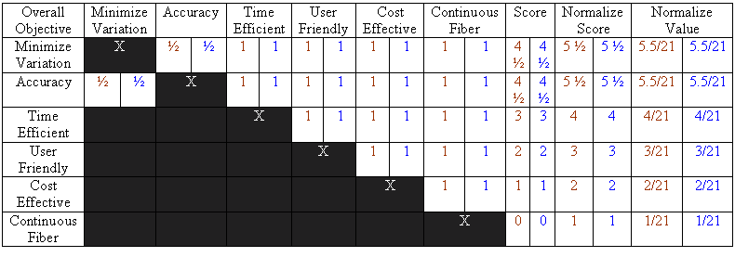

Minimizing the variation between fibers and accuracy were identified as the most important objectives by all the stakeholders, followed by time efficient, user friendly, cost effective and continuous fibers respectively. Tables 6, 7, 8, 9, and 10 below further analyzed the sub categories of the main objectives.
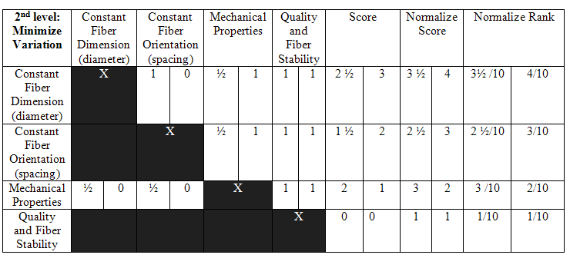
Table 6: Minimize Variation: Second Level Objectives Pairwise Comparison Charts

The most important sub-objective for minimizing the variation between fibers is that the device must able to maintain constant fiber dimensions. As stated in Section 3.2, we assumed that by standardizing the fiber dimensions, we would be able to minimize the variation of the fibers’ mechanical property, and the extruded fiber would closely mimic those of natural type I collagen fibers.
Table 7: Time Efficient: Second Level Objective Comparison Chart
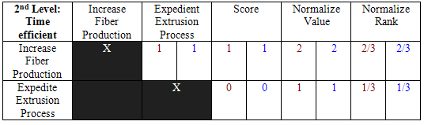

In the second sub-objective category, the ability to increase the production of fiber per batch significantly out weighs the ability to expedite the extrusion process. With cost, however, both sub-objectives were equally important.
Table 8: Cost Effective: Second Level Objective Comparison Chart
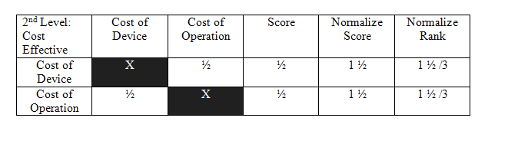
Finally the objective of “user friendly” was broken down into four components, as shown in the table below. These objectives were ranked accordingly, with “ease of use” obtaining the highest score. This objective was then broken down into more sub components. It was determined that obtaining a fixed anchor system for easy handling during mechanical testing of the process was more relevant than the amount of time it required to set up and clean up the system.
Table 9: User Friendly: Second Level Objectives Pairwise Comparison Chart
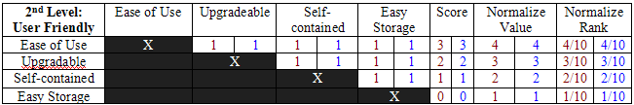
Table 10: Ease of Use: Third Level Objectives Pairwise Comparison Chart
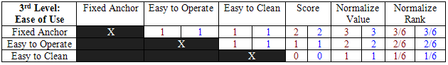

4.1.2 Development of Revised Client Statement

The Pairwise Comparison Charts were valuable in gaining quantitative confirmation of the clients’ needs and interests. Consequently, we created a weighted objectives tree showed in Figure 13. Each of the objectives were assigned two weight values. The first value, on the left, is the weight in comparison to the objectives on the same level. The second value is the weight in relation to all the objectives taken into consideration for the device. The most important objective when designing the automated collagen extrusion system is to minimize the variation between the fibers by keeping all the fiber parameters constant while ensuring the mechanical properties of the collagen.
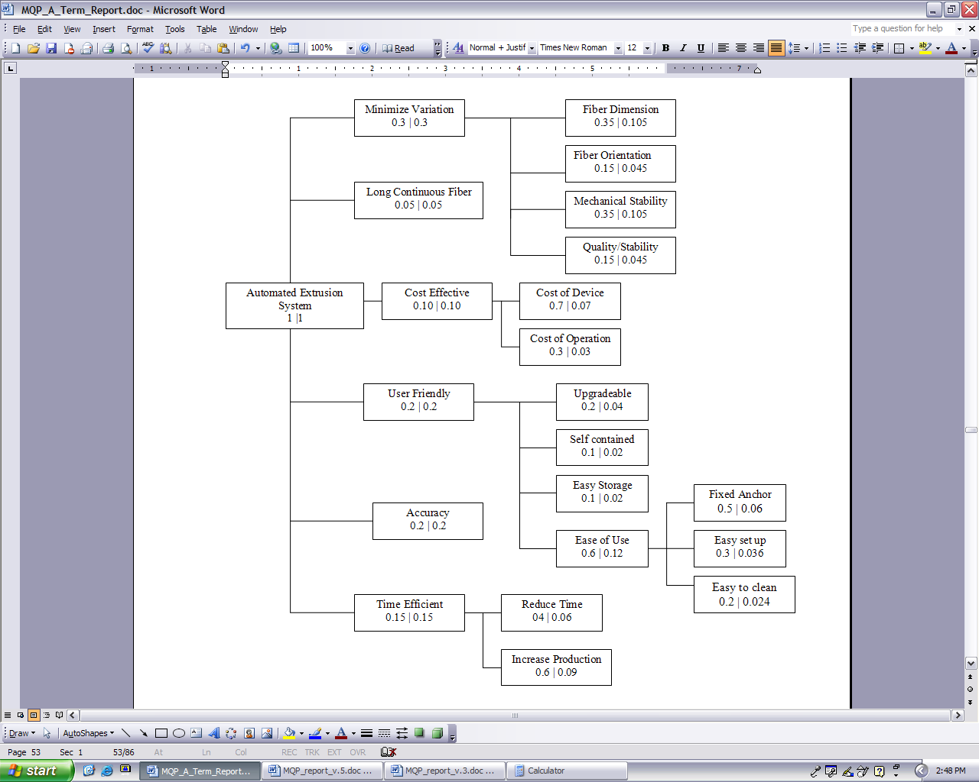
Figure 13: Weighted Objective Tree

With the aforementioned weighted objectives in mind, a revised client statement was created to further clarify the goal of the project. The revised client statement states:
“Design and develop an automated extrusion system that accurately, efficiently and repeatedly produces and stretches a large quantity of mechanically stable collagen fibers of standardized size in a user friendly manner.”

4.2 Conceptual Designs
Based on the limitation associate with the current manual extrusion system and the existing current system, the new device will consist of four major components: (1) an extrusion device, (2) aqueous bath, (3) anchoring device and (4) automated control system. With the established objectives, constraints and functions, conceptual designs must be created. These designs help to stimulate creativity and other ideas, as well as to give a base for further exploration of the means that are possible for the needed functions.

4.2.1 Design Group’s Initial Ideas

Before approaching the clients for a brainstorming session, the design group began brainstorming different ideas of how to construct the automated extrusion system. Based on the current methods and the automated system developed by previous researchers, the new automated system will be composed of three main components: a water bath that allows thermal regulation of the fiber formation buffer, the extrusion vehicle that allows movement in both x and y directions and the anchoring system for threads fixation.
The following were the initial design ideas.
The two Figures below (Figure 14 and 15) depict the preliminary design for the extrusion vehicle. A small diameter PEF tubing is attached to the end of a syringe filled with 10 mg/ml collagen solution and the syringe will be placed in a syringe pump. The end of the tubing will be placed through a motorized extrusion vehicle and will be lowered until the end of the tubing is submersed in a fiber formation buffer located in a container below. The extrusion vehicle will be controlled by a computer using lab view software which will command the vehicle to move in one of two dimensions.
Once the syringe pump is set to the desired rate of extrusion, the rate is entered into the computer and the speed of the extrusion vehicle is calculated to create the desired rate of extrusion. Once this has been completed, the syringe pump will be turned on and the extrusion process, controlled by the computer, will be started. The computer will instruct the vehicle to go A units in the X direction, increment up a determined number of units in the Y direction, then proceed to go A units in the -X direction. This process will be continued until the entire fiber formation buffer container has been filled with extruded fibers. Once this is completed, the system will be shut down. The buffer solution will be changed as desired.

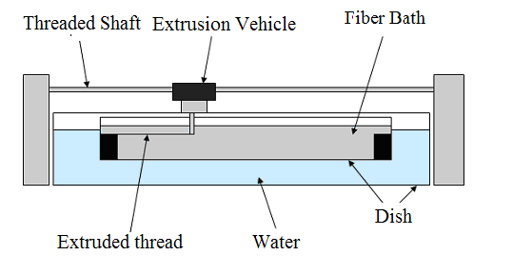
Figure 14: Track System (Cross-sectional View)

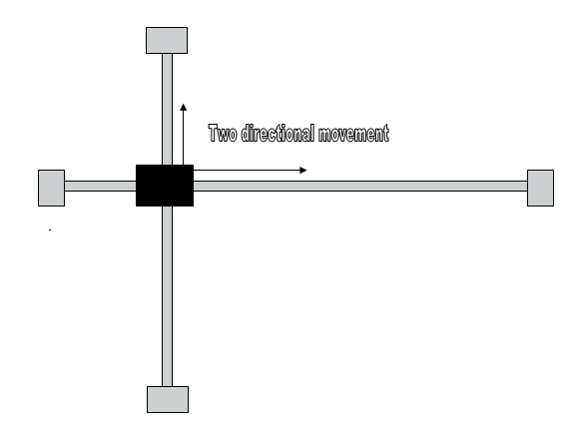

Figure 15: Track System (Arial View)

The second preliminary design also works on the basis of using a track for movement across the bath (Figure 16). However, there is a circular pipe used for the arm, which is connected to only one track. The track runs from left to right across the bath, as well as up and down. For up and down movement across the bath, rollers are connected to the pipe, which will roll up and down the pipe via a small battery operated motor that spins a cam, allowing for threads of collagen to be produced in the same manner as the previous design. In this design, multiple syringes and tubing can be used to extrude more collagen threads at one time. The advantages of this system are that this design meets the following objectives: Reproducibility, stability, quantity, fast, automated, fixed anchors, one frame, upgradeable, expandable, easy to use, and self contained. However, there are also some disadvantages to using this design. Since there are two different tracks, there is less of a chance of the device being accurate. The use of rollers can also take away from accuracy of the system. Lastly, there may be a larger cost for the two different tracks as opposed to a single track system.

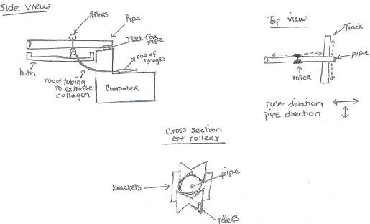
Figure 16: Design 2 (Sketch)

4.2.2 Clients’ and Designers’ Conceptual Designs
To develop more design ideas, a brainstorming session was held between the clients and the design team. The following section is a description of the various means to complete the different functions of the automated collagen extrusion system as well as a list of the advantages and limitation for the specific designs.

4.2.2.1 Extrusion Heads
The extrusion heads will be used to extrude the collagen solution into the fiber formation buffer. The heads should allow single or multiple threads extrusion.

Spaghetti Pasta Extrusion: This is a design for a single extrusion head. This head consists of a single large diameter tube encasing numerous smaller diameter tubes. This design could produce numerous threads at one time allowing for a large number of threads to be created in a short period of time.

Pros: Cons:
- Large number of fibers created at one time - Fibers sticking together after extrusion
- Single extrusion head - Low bending capability of extrusion head
- Standardized size

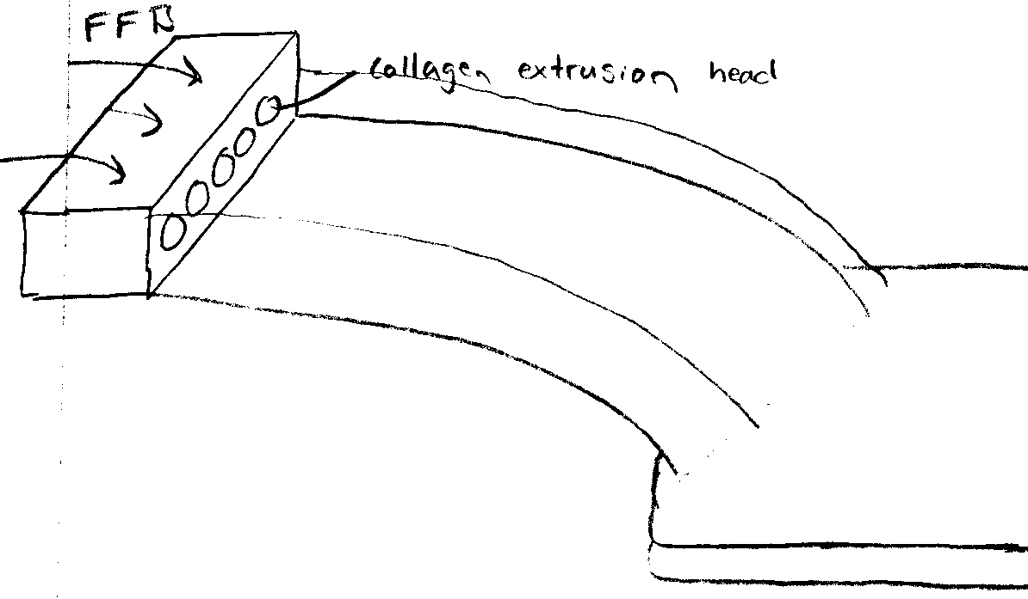
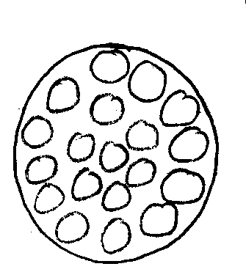
Figure 17: Pasta Machine Gun (left)
Figure 18: Waterfall Extrusion (right)

Waterfall Extrusion: This is a design for an extrusion head as well as thread movement and a formation bath. This design consists of a multiple output extrusion head with fiber formation buffer flowing over it onto a gradual decline ramp. The collagen will be extruded through the extrusion head and will be pulled down the ramp slowly by the flowing fiber formation buffer. The fibers will begin to form on the ramp and will continue to form when they leave the ramp and enter the bath of fiber formation buffer.

Pros:
- FFB reused
- Continuous fibers
- Numerous fibers created at one time

Cons:
- Large size
- No anchoring/stretching system
- High rate of evaporation
- No fiber alignments
- Fiber bunching at bottom of waterfall
- Problems with fiber breakage

Belt/Tube Extrusion: This design co-extrudes collagen and fiber formation through a small diameter tube onto a belt which is submerged in fiber formation buffer. The belt moves the collagen fiber through the bath and into a fiber incubation bath, and finally, the end of the fiber is placed on a spool by hand. The spool then winds up the thread as it is created producing one long continuous fiber.

Pros:
- Continuous fiber

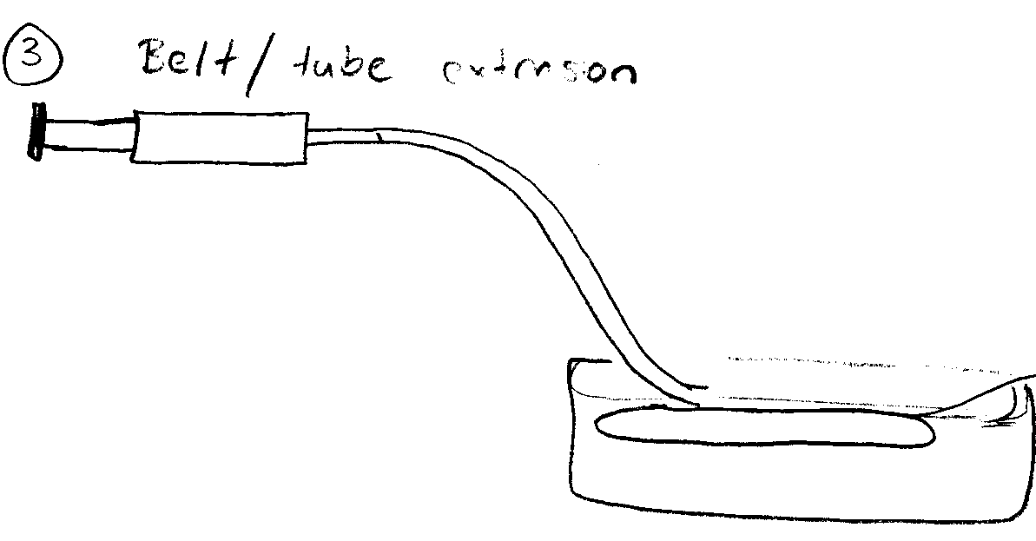
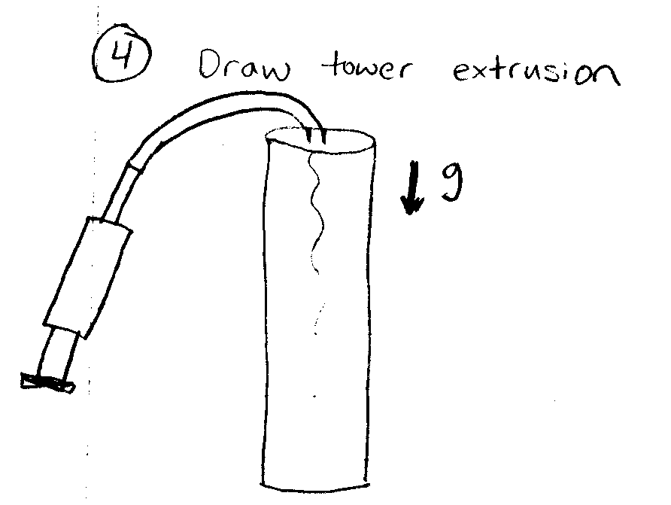
Cons:
- Fiber breaking
- No anchoring/stretching system
- Large system
- Problems with cleaning belts

Figure 19: Belt/Tube Extrusion (left)
Figure 20: Draw Tower Extrusion (right)

Draw Tower Extrusion: This design consists of a tall tube filled with fiber formation buffer. Collagen is then extruded slowly through a small diameter tube into the tower. The collagen is extruded at the rate at which it sinks due to gravity. When the fiber reaches the bottom of the tank, the extrusion is stopped and the top of the fiber is attached at the top to prevent sinking. This method can produce many fibers in the same tower which can be as long as the tower is tall.

Pros:
- Small amount of buffer used
- Easily made/run
- Cost effective
- Long fibers

Cons:
- Fiber sticking to sides
- Fiber breakage
- Slow
- No anchoring/stretching system
-problems with fiber removal

Microfluidic Extrusion System: This design consists of a thin wafer which is design via CAD then laser machined onto a thin wafer with an inlet and outlet port. A mirror image of the same design is then fabricated and the two sections are pressed together to form a channel. A solution of fiber formation buffer and collagen are then injected in parallel. The fibers are then allowed to form and then are removed from the system for further manipulation.

Pros:
- Compact
- Highly controlled geometry
- Lots of fibers
- Extrusion + stretching in one system

Cons:
- Wafer production
- Must to be careful with wafers since reusable
- Must find wafer material able to be stretched elastically

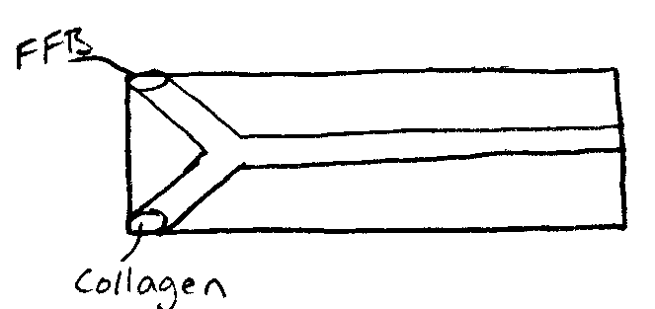
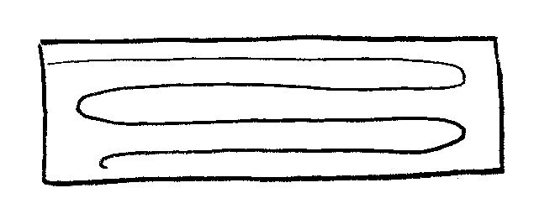
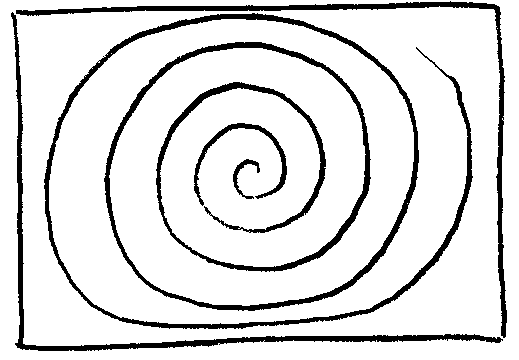

Figure 21: Microfluidic Extrusion System

Annular Extrusion: This is the design for a single extrusion head which consists of a small diameter tube encased in a large diameter tube. This allows for one material to be pumped through one tube while another material is being extruded around it. In our design, collagen will be extruded through the small diameter tube and fiber formation buffer will be extruded around it through the larger diameter tube.

Pros: Cons:

- Minimal turbulence problems - Single fiber produced at one time
- Minimal sticking - Low bending ability
- Can be used in multiple systems - Must have duel pumping
- Can extrude two materials in one head systems/rates for the two tube system

Manifold Extrusion (single or multiple output): In this design, a syringe is attached to a single tube which branches out into numerous smaller tubes. This extrusion will allow for multiple fibers to be created at one time and on a single plane. This is similar to the pasta machinegun design, however, the tubing is in parallel and not bunched up in a tube.

Pros:
- Multiple fibers produced at one time
- Can be used in multiple systems
- Single extrusion pump
Cons:
- Chance of blockage
- Turbulence

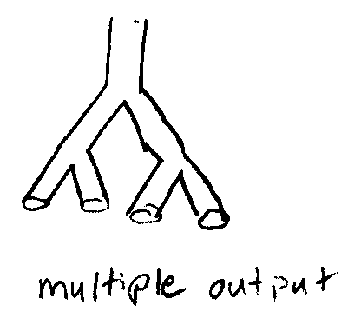
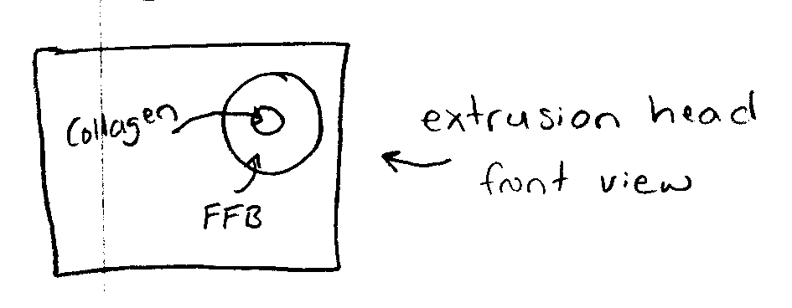
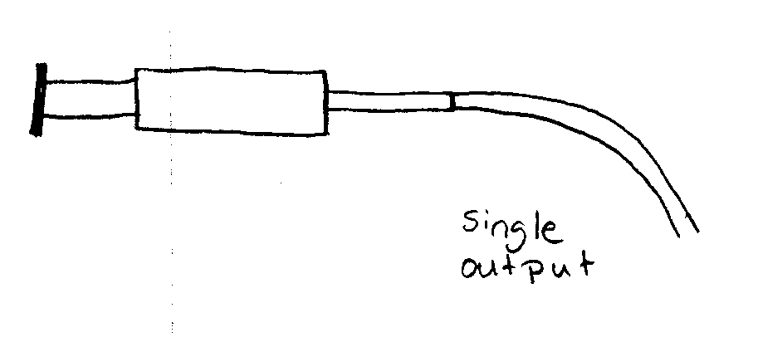

Figure 22: Annular Extrusion (left)
Figure 23: Manifold Extrusion (right)

SFF: This design incorporates one of the extrusion head designs into a bath/extrusion system. In this design, a 2D plotter working much like a printer will extrude fibers into a bath of fiber formation buffer. There are two methods to achieve this extrusion; a stationary extrusion head and a moving bath, or a stationary bath and a moving extrusion head. In either of these methods, collagen will be extruded through an extrusion head and into a bath of fiber formation buffer. The collagen will be laid down in parallel or in a cross-mesh. Further movement in the vertical direction could allow for a 3D collagen matrix to be produced using SFF.

Pros:
- Semi-simple system
- Integration with various extrusion heads
- Very precise
- 3D scaffold construction possible with vertical movement integration

Cons:
- Complicated electronics
- Electronics in liquid problems
- Costly

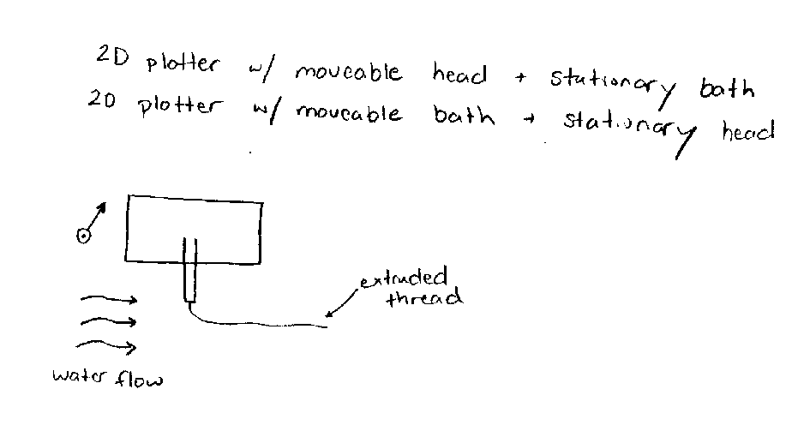

Figure 24: SFF Extrusion

4.2.2.2 Bath/Heating Systems
To decrease the size of the new device, the bath component must be compact, consist a single chamber. The bath/heating system should able to maintain the temperature of the aqueous solution at 37 degrees Celsius.
Heating Plate/Electric: A glass dish filled with fiber formation buffer will be placed on a metal heating plate set to 37 degrees Celsius. The glass plate will be insulated on all sides not touching the plate and will be heated directly from the heating plate. Any of the multiple system extrusion heads can be used with this heating bath method. The extrusion head movement mechanisms that can be used with this heating method are the SFF and manifold extrusions.

Pros:
- Removable heat source
- Small space required
- Cost

Cons:
- Overheating
- Evaporation
- User safety
- Precision

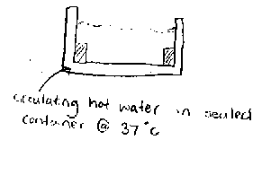
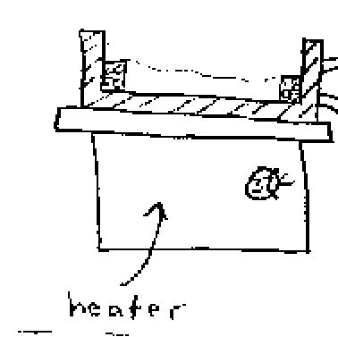

Figure 25: Heating Plate (left)
Figure 26: Closed Loop Heating System (right)

Closed Loop Hot Water Heating System: This is a design for a double walled bath made of Lexan® with a ½ - 1” gap between the two walls. Hot water will be circulated between these two walls by means of a water pump and heating reservoir. A volume of water will be heated to 37 Celsius and used as the water to be pumped through the system. A water heater and controller will be used to maintain the temperature of the water. The inner bath will then be filled with fiber formation buffer and will be heated by the conductive heat flow from the circulating hot water. This bath can be used with either the SFF or manifold extrusion systems.

Pros:
- No turbulence
- Cost
- Safe
Cons:
- Additional space needed for heater
- Precision
- Heat loss

Hot Water Bath Heating System: A glass or Lexan® bath will be partially submerged in a larger bath of water heated to 37 degrees Celsius. The inner bath will be filled with fiber formation buffer and will be raised off the bottom of the inner bath using a wire rack. Fiber formation buffer will then be added to this inner bath for fiber extrusion. In this system, multiple baths can be used at one time depending on the size of the heated water bath. This heating system can be used with either the SFF or manifold extrusion systems.

Pros:
- Simple design
- Cost

Cons:
- Large size
- Evaporation
- Unstable
- Variation in temperature

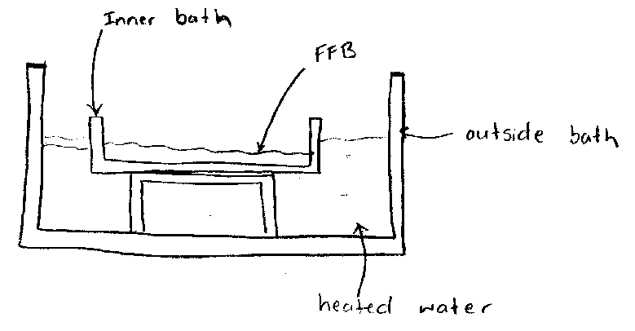

Figure 27: Hot Water Bath Heating System

Oven Heating System: A heating chamber much like an oven will heat a glass bath filled with fiber formation buffer to 37 degrees Celsius. The oven will be set to 37 and a glass bath will be placed in the oven on a rack. Once the bath is up to temperature, collagen will be extruded into the bath using either the SFF or manifold extrusion system.

Pros:
- Temperature control
- Low turbulence
- No heat loss from bath

Cons:
- Entire system in heating chamber
- Cost
- Safety
- Size
- Complex heating

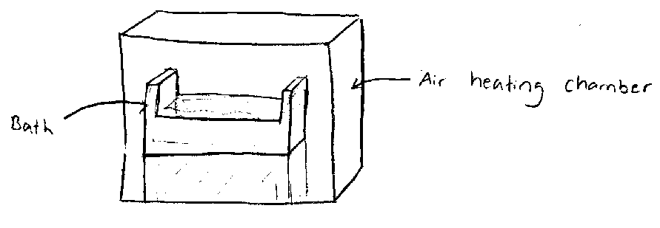

Figure 28: Oven Heating system

4.2.2.3 Anchoring Systems
The current manual extrusion system has no mean for fiber fixation, thus many times fiber will detach from the side of the bath. Thus overcome this limitation, the new device must incorporate an anchoring device for proper fiber fixation.
Raised Knobs: A series of raised knobs will be placed on two identical blocks which are as wide as the bath is and only a few inches in length. These blocks will then be placed on opposite ends of the bath and will be used to hold the extruded fibers. This attachment method will allow for a continuous fiber to be created in a small system. This attachment system can be used with either the SFF or manifold extrusion system.

Pros:
- Able to hold continuous fiber

Cons:
- Complicated calculation for corners
- Extra stress on fiber at knobs

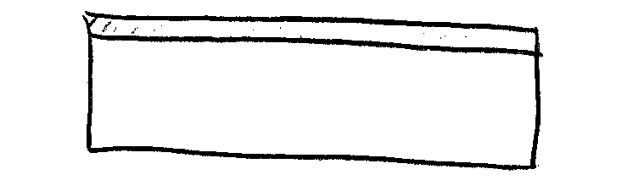

Figure 29: Raised Knobs (left)
Figure 30: Porous Material (right)

Porous Blocks: Two identical blocks which are either porous or have a porous top will be placed on opposite sides of a bath filled with fiber formation buffer. The bath will be filled with buffer until the fluid level is higher than the blocks. Collagen will then be extruded into the bath and onto the blocks on each end. It is hoped that this will create fiber attachment at the ends preventing fibers from moving around the bath after extrusion.

Pros:
- Simple design
- Good adhesion

Cons:
- No continuous fibers
- Fiber un-removable from rack
- Cleaning issues

Clamps: Two identical blocks will be placed on opposite ends of a bath filled with fiber formation buffer. The bath will be filled with buffer until the fluid level is higher than the blocks. Collagen will then be extruded into the bath and onto the blocks on either end. After all the desired fibers are extruded a clamp will be placed on the top of the block holding the fibers in place. This system can be used to both hold the fibers in place during assembly and also for stretching after the fibers have been extruded.

Pros:
- Can hold continuous fiber
- Cleaning
- Removable fiber from surface
Cons:
- Stress on fibers at clamp
- Fiber breakage

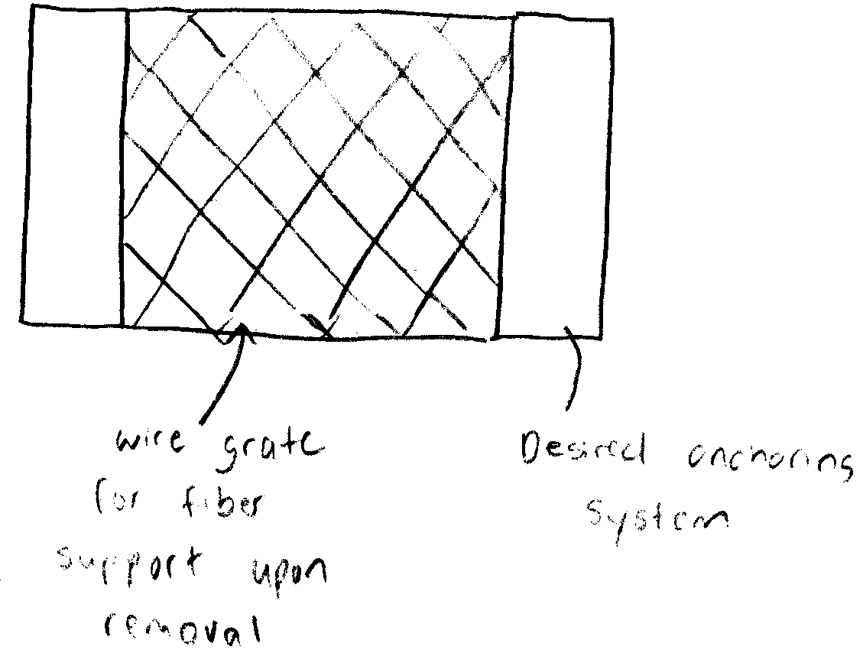
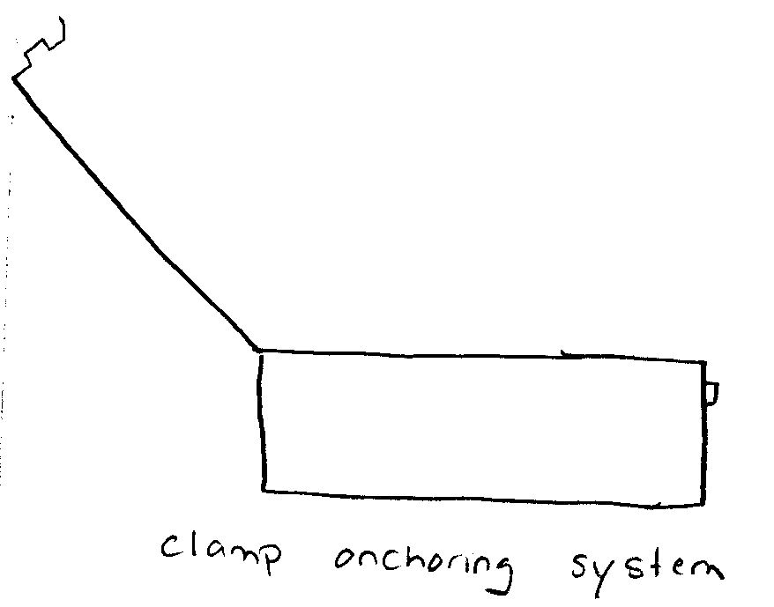

Figure 31: Clamps (left)
Figure 32: Porous Material with Screen (right)

Porous Material with Screen: This system takes the advantages of the porous blocks and combines them with a support system for the fibers. Due to the fact that these fibers need to be moved after they are processed, a mesh platform would provide support to prevent breakage and to remove the need to move fibers individually.

Pros:
- Wire supports fibers
- Can be used with any anchoring system
Cons:
- Fiber sticking to grate
- Fiber formation around grate

Clamps with Knobs: This system would combine the advantages of the clamping system with that of the knob system. When combined the two systems would remove the chances of having the fibers come off the knobs during transport and would also allow for a continuous fiber to be extruded.

4.2.2.4 Rack System

Snap in Rack: The idea of extruding fibers onto a material for transport and stretching necessitates a device to secure the rack so a standard extrusion path can be maintained. The snap in system would work similar to that of a Lego where the anchor would “snap into” a crenellation at the bottom of the bath. This would in turn provide the standardization needed.

Pros:
- Removable
- Quick
- Firm fixation

Cons:
- Possibility of fiber breakage upon removal
- Fibers cannot be stretched while anchor is attached.
- Same fixation position every time

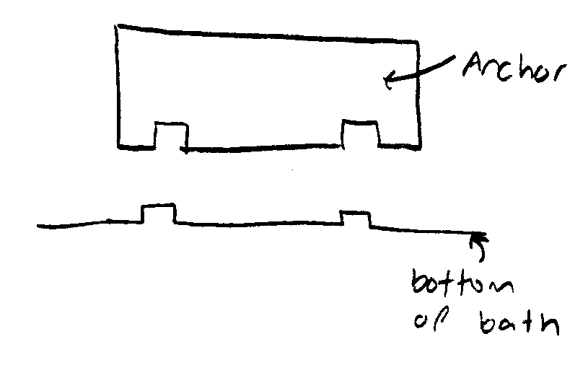
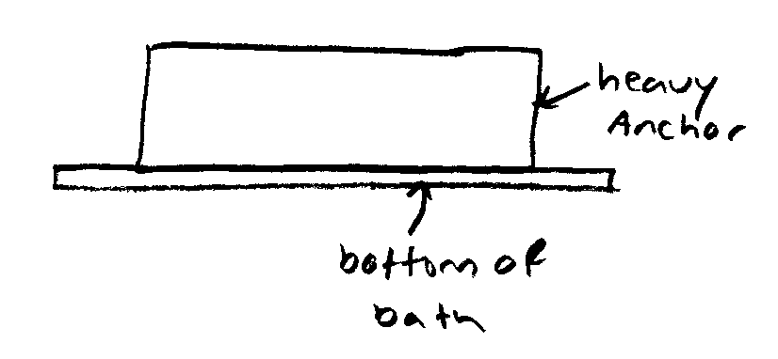

Figure 33: Snap in Rack (left)
Figure 34: End Rack (right)

End Rack: The end rack system works by having a heavy anchor sitting on the bottom of the bath. This system allows for the rack to be moved easily and is cheap to produce. However, it does not provide a standardized system to extrude fibers onto.

Pros:
- Moveable
- Cost
- Ease of use
- Fibers can be stretched while anchor is in place
Cons:
- No firm fixation
- Anchoring area slightly different every time

End Rack Track: The end rack track system combines a porous material onto a moving “stretcher”. This device would allow for both standardization of fiber extrusion and provides a means of stretching the extruded fibers without removing the fibers from their extrusion tub. Fibers would be extruded onto the porous material, then, after processing the screw drive would turn stretching the fibers.

Pros:
- Firm fixation
- Stretching while hydrate and un-hydrated
Cons:
- Standardized anchoring distance
- Cost
- Complex design

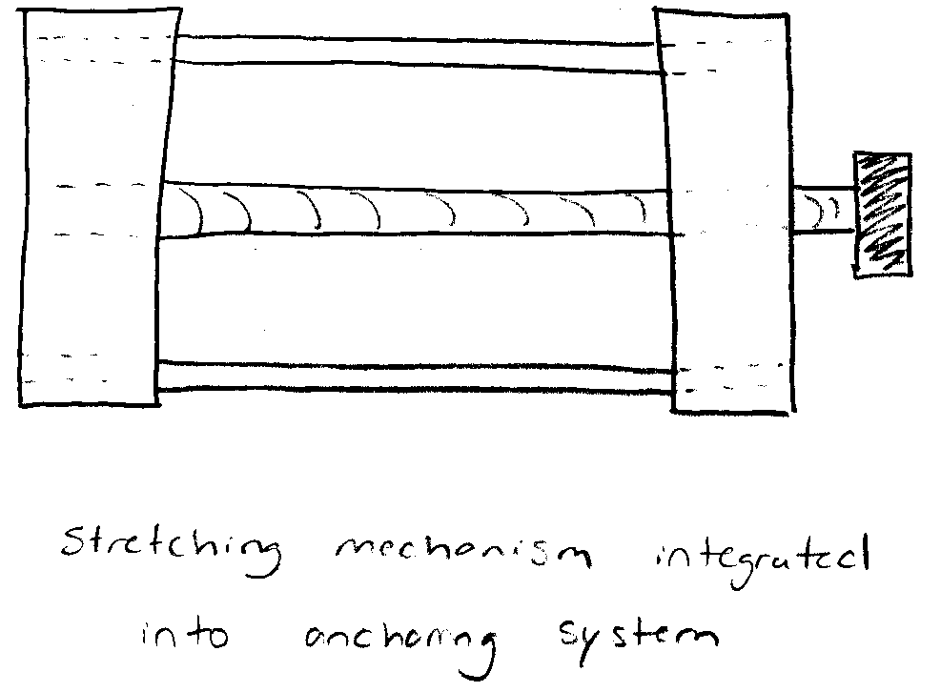

Figure 35: End Rack Track

4.2.3 Morphological Chart

A morphological chart provides a way in which to view the means for the project’s functions in a logical manner. The following morphological chart (Table 11) shows the various means that were created in the brainstorming session for an automated collagen extrusion device.
Table 11: Morphological Chart
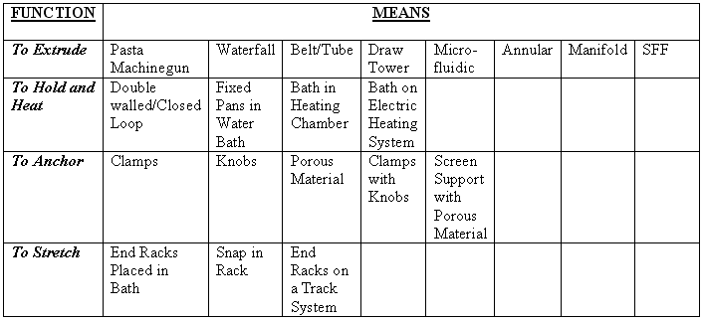

4.3 Preliminary Design
After determining the various methods of completing the design for an automated extrusion device, metrics were created in order to rate the alternative designs and rank them in opposition to each other. The metrics shown in appendix 2 were used to determine a score for each individual method and selection matrices were constructed to confirm which particular design best met the weighted objectives for each part of the device.

4.3.1 Metrics
Each metric used a score of 1 to 3, 3 being the highest possible score, so that the best design alternative for a particular part would receive the highest score. For example, an extrusion head that performs better than the currently used extrusion system in all objectives, including laying 8 fibers every minute resulting in over 41 fibers per batch and costing less than $125 would receive the highest possible score among the extrusion heads.
Based on the metrics, some justifications were needed in order to correctly score each design possibility. One example of such a justification would be as follows. An extrusion system with multiple heads of the same diameter would result in a higher probability of more standardized diameter and length of fibers in the overall batch, leading to a score of 3. The justifications used for the metrics can be found in appendix 3.

4.3.2 Selection Matrices
Selection Matrices are used to create a numerical value for each option in the morphological chart, specifying the option that meets all of the design constraints and best fits the needs of the clients, users and designers based on the objectives of the design. First, the options were judged on constraints. An option which met a constraint would receive a “Y” and then be scored on the objectives; while the options that did not meet that constraint would receive an “N” and be eliminated from scoring. The score given to each option for a particular objective is multiplied by the weight of that objective to receive a weighted score for every objective. Finally, the sum of the weighted scores results in a total score for each option. The option with the highest score in each category is then selected for the final design. If a particular objective did not correspond with a particular category, an “X” was placed in the score position, signifying that the options were not scored on that particular objective.
Three objectives were not included in the selection matrices. Both “fiber quality” and “fiber stability” were impossible to rank due to the fact that there would be no way to truly be sure of a score without first making a prototype and carrying out experiments to see how specific designs affect the stability and quality of the fibers. Also, the “cost of operation” was negligible due to the fact that none of the ideas posed any type of problem with the cost of operation. Therefore, there was no need to rank each device on this objective. With the deletion of these objectives, the maximum possible score would be 82 (sum of the percent of weighted objectives multiplied by 100) multiplied by the highest possible metric score of 3 which equals a top score of 246. The tables below show the selection matrices and the choices that were selected, indicated by the circled total score.
In the first category, extrusion heads, the option Belt/Tube Extrusion was eliminated due to the fact that this system would not fit on a typical lab bench. The microfluidic extrusion system was also eliminated immediately due to its high cost. The other options were then scored. The option that best fit the design objectives (largely due to its decreased time and increased quantity) was the manifold extrusion system with multiple extrusion heads.
Table 12: Extrusion Heads Selection Matrix

EXTRUSION HEADS
Design Constraints | Pasta Machinegun |  | Waterfall Extrusion |  | Belt/Tube Extrusion |  | Draw Tower Extrusion |  | Microfluidic Extrusion
C: Fit on Lab bench | Y |  | Y |  | N |  | Y |  | Y
C: Time | Y |  | Y |  | Y |  | Y |  | Y
C: Cost | Y |  | Y |  | Y |  | Y |  | N
C: Durable | Y |  | Y |  | Y |  | Y |  | Y
C: Doesn’t interact with collagen | Y |  | Y |  | Y |  | Y |  | Y
C: Fixed Anchors | Y |  | Y |  | Y |  | Y |  | Y
Design Objectives (weight %) | Score | Weighted Score | Score | Weighted Score | Score | Weighted Score | Score | Weighted Score | Score | Weighted Score
O: Minimize fiber dimension Variation (10.5) | 2 | 21 | 1 | 10.5 |  |  | 2 | 21
O: Minimize spacing variation (4.5) | 1 | 4.5 | 1 | 4.5 |  |  | 1 | 4.5
O: Decrease time (6) | 3 | 18 | 3 | 18 |  |  | 1 | 6
O: Increase quantity (9) | 3 | 27 | 1 | 9 |  |  | 1 | 9
O: Upgradeable (4) | X |  | X |  |  |  | X
O: Self contained (2) | X |  | X |  |  |  | X
O: Ease of storage (2) | 3 | 6 | 1 | 2 |  |  | 2 | 4
O: Fixed anchor (6) | X |  | X |  |  |  | X
O: Easy to set up (3.6) | 3 | 10.8 | 1 | 3.6 |  |  | 2 | 7.2
O: Easy to clean (2.4) | 2 | 4.8 | 2 | 4.8 |  |  | 2 | 4.8
O: Low cost (7) | 2 | 14 | 2 | 14 |  |  | 2 | 14
O: Continuous fibers (5) | 2 | 10 | 3 | 15 |  |  | 3 | 15
O: Accuracy (20) | 1 | 20 | 1 | 20 |  |  | 1 | 20
Total (82 *3=246) |  | 136.1 |  | 101.4 |  |  |  | 105.5

Table 13: Extrusion Heads Selection Matrix Cont.

EXTRUSION HEADS CONT.
Design Constraints | Annular Extrusion |  | Manifold Extrusion (Multi) |  | SFF
C: Fit on Lab bench | Y |  | Y |  | Y
C: Time | Y |  | Y |  | Y
C: Cost | Y |  | Y |  | Y
C: Durable | Y |  | Y |  | Y
C: Doesn’t interact with collagen | Y |  | Y |  | Y
C: Fixed Anchors | Y |  | Y |  | Y
Design Objectives (weight %) | Score | Weighted Score | Score | Weighted Score | Score | Weighted Score | Score | Weighted Score | Score | Weighted Score
O: Minimize fiber dimension Variation (10.5) | 2 | 21 | 3 | 31.5 | 2 | 21
O: Minimize spacing variation (4.5) | N/A |  | 3 | 13.5 | 3 | 13.5
O: Decrease time (6) | 1 | 6 | 3 | 18 | 2 | 12
O: Increase quantity (9) | 1 | 9 | 3 | 27 | 2 | 18
O: Upgradeable (4) | X |  | X |  | X
O: Self contained (2) | X |  | X |  | X
O: Ease of storage (2) | 2 | 4 | 2 | 4 | 2 | 4
O: Fixed anchor (6) | X |  | X |  | X
O: Easy to set up(3.6) | 2 | 7.2 | 2 | 7.2 | 1 | 3.6
O: Easy to clean (2.4) | 2 | 4.8 | 2 | 4.8 | 1 | 2.4
O: Low cost (7) | 2 | 14 | 2 | 14 | 1 | 7
O: Continuous fibers (5) | 3 | 15 | 2 | 10 | 3 | 15
O: Accuracy | 3 | 60 | 3 | 60 | 3 | 60
Total (82*3=246) |  | 141 |  | 190 |  | 156.5

For the Bath/Heating System selection matrix, the bath in a heating chamber was eliminated due to the fact that the design group was unable to find a heating chamber which would operate less than 40 degrees Celsius which would result in an interaction with the collagen ultimately denaturing it. With a score of 75.6, the Double walled/Closed loop water circulation system was the best choice for the Bath/Heating System since it is very user friendly.
Table 14: Bath/Heating System Selection Matrix

BATH/HEATING SYSTEM
Design Constraints | Double walled/Closed loop water circulation |  | Fixed pans in warm water bath |  | Bath in heating chamber |  | Bath on electric heating system
C: Fit on Lab bench | Y |  | Y |  | Y |  | Y
C: Time | Y |  | Y |  | Y |  | Y
C: Cost | Y |  | Y |  | Y |  | Y
C: Durable | Y |  | Y |  | Y |  | Y
C: Doesn’t interact with collagen | Y |  | Y |  | N |  | Y
C: Fixed Anchors | Y |  | Y |  | Y |  | Y
Design Objectives (weight %) | Score | Weighted Score | Score | Weighted Score | Score | Weighted Score | Score | Weighted Score | Score | Weighted Score
O: Minimize fiber dimension Variation (10.5) | X |  | X |  |  |  | X
O: Minimize spacing variation (4.5) | X |  | X |  |  |  | X
O: Decrease time (6) | X |  | X |  |  |  | X
O: Increase quantity (9) | X |  | X |  |  |  | X
O: Upgradeable (4) | X |  | X |  |  |  | X
O: Self contained (2) | 1 | 2 | 2 | 4 |  |  | 1 | 2
O: Ease of storage (2) | 2 | 4 | 2 | 4 |  |  | 2 | 4
O: Fixed anchor (6) | X |  | X |  |  |  | X
O: Easy to set up(3.6) | 3 | 10.8 | 2 | 7.2 |  |  | 3 | 7.2
O: Easy to clean (2.4) | 2 | 4.8 | 2 | 4.8 |  |  | 2 | 4.8
O: Low cost (7) | 2 | 14 | 2 | 14 |  |  | 2 | 14
O: Continuous fibers (5) | X |  | X |  |  |  | X
O: Accuracy | 2 | 40 | 2 | 40 |  |  | 1 | 20
Total (82*3=246) |  | 75.6 |  | 74 |  |  |  | 52

The main concern with the anchoring system was to find a design which would secure the threads as to be able to stretch them and keep them in a fixed position. The option of using knobs as an anchoring system was thus eliminated for the reason that the knobs would only hold a single continuous thread in place throughout the entire length of the bath without actually keeping each pass along the bath in a fixed position. Therefore, a tear in one part of the fiber would result in the entire fiber breaking and not being secured any longer. The scores for the rest of the options resulted in a tie between the porous material, and the use of a screen with the porous material. The clamps did not score well due to the fact that they could potentially damage the fibers. For this project, the designers opted to use the screen along with the porous material. Since the bath is designed to be drainable, the screen would help to support the fibers against the fluid flow of the draining bath.
Table 15: Anchoring System Selection Matrix
ANCHORING SYSTEM
Design Constraints | Clamps |  | Knobs |  | Porous material |  | Clamps with Knobs |  | Screen with Porous material
C: Fit on Lab bench | Y |  | Y |  | Y |  | Y |  | Y
C: Time | Y |  | Y |  | Y |  | Y |  | Y
C: Cost | Y |  | Y |  | Y |  | Y |  | Y
C: Durable | Y |  | Y |  | Y |  | Y |  | Y
C: Doesn’t interact with collagen | Y |  | Y |  | Y |  | Y |  | Y
C: Fixed Anchors | Y |  | N |  | Y |  | N |  | Y
Design Objectives (weight %) | Score | Weighted Score | Score | Weighted Score | Score | Weighted Score | Score | Weighted Score | Score | Weighted Score
O: Minimize fiber dimension Variation (10.5) | X |  |  |  | X |  |  |  | X
O: Minimize spacing variation (4.5) | X |  |  |  | X |  |  |  | X
O: Decrease time (6) | X |  |  |  | X |  |  |  | X
O: Increase quantity (9) | X |  |  |  | X |  |  |  | X
O: Upgradeable (4) | X |  |  |  | X |  |  |  | X
O: Self contained (2) | X |  |  |  | X |  |  |  | X
O: Ease of storage (2) | 3 | 6 |  |  | 3 | 6 |  |  | 3 | 6
O: Fixed anchor (6) | 2 | 12 |  |  | 3 | 18 |  |  | 3 | 18
O: Easy to set up(3.6) | 3 | 10.8 |  |  | 3 | 10.8 |  |  | 3 | 10.8
O: Easy to clean (2.4) | 3 | 7.2 |  |  | 2 | 4.8 |  |  | 2 | 4.8
O: Low cost (7) | 3 | 21 |  |  | 3 | 21 |  |  | 3 | 21
O: Continuous fibers (5) | 1 | 5 |  |  | 1 | 5 |  |  | 1 | 5
O: Accuracy | X |  |  |  | X |  |  |  | X
Total (82*3=246) |  | 62 |  |  |  | 65.6 |  |  |  | 65.6

The final category for design is the Racking System to allow for the fibers to be held in place, as well as be stretched upon drying or shortly there after. The End Racks on a Track System received the highest score due to the fact that it is highly upgradeable and will allow the user to adjust the amount of stress/strain placed on the fibers and the degree of stretching on the fibers.
Table 16: Rack System Selection Matrix

RACK SYSTEM
Design Constraints | End Racks  Placed in Bath |  | Snap in Rack |  | End Racks on a Track System
C: Fit on Lab bench | Y |  | Y |  | Y
C: Time | Y |  | Y |  | Y
C: Cost | Y |  | Y |  | Y
C: Durable | Y |  | Y |  | Y
C: Doesn’t interact with collagen | Y |  | Y |  | Y
C: Fixed Anchors | Y |  | Y |  | Y
Design Objectives (weight %) | Score | Weighted Score | Score | Weighted Score | Score | Weighted Score | Score | Weighted Score | Score | Weighted Score
O: Minimize fiber dimension Variation (10.5) | X |  | X |  | X
O: Minimize spacing variation (4.5) | X |  | X |  | X
O: Decrease time (6) | X |  | X |  | X
O: Increase quantity (9) | X |  | X |  | X
O: Upgradeable (4) | 1 | 4 | 1 | 4 | 3 | 12
O: Self contained (2) | 3 | 6 | 3 | 6 | 3 | 6
O: Ease of storage (2) | 3 | 6 | 3 | 6 | 3 | 6
O: Fixed anchor (6) | 2 | 12 | 3 | 18 | 3 | 18
O: Easy to set up(3.6) | 3 | 10.8 | 3 | 10.8 | 3 | 10.8
O: Easy to clean (2.4) | 3 | 7.2 | 2 | 4.8 | 2 | 4.8
O: Low cost (7) | 3 | 21 | 3 | 21 | 3 | 21
O: Continuous fibers (5) | X |  | X |  | X
O: Accuracy | 2 | 40 | 3 | 60 | 3 | 60
Total (82*3=246) |  | 107 |  | 130.6 |  | 138.6

With the use of the selection matrices, the final design was chosen. The compilation of the selection option from each category will result in a design that best meets the needs of the users, clients and designers. The final design consists of a manifold multi output extrusion head, a double walled, closed loop circulating bath and heating system, a porous anchoring system complete with screen and an adjustable track stretching device. The manifold extrusion head would allow for more fibers to be produced at one time, decreasing the variability of fiber dimension and extrusion time while increasing the quantity produced per batch. The double walled, closed loop bath and heating system circulated water in such as way as to keep the collagen at the desired temperature of 37 degrees Celsius, while never coming in contact with the fibers. Also, the bath includes a drain to prevent fiber handling between bath chemical changes, contributing to fiber stability. The porous anchoring system was chosen due to the fact that the porous material provides a strong anchor without damaging the collagen fibers. The screen portion of the anchoring system was added so as to provide stability to the fibers during the draining of the bath. Therefore, the fibers would not deform due to the fluid flow during the changes in bath chemicals. Finally, the adjustable track stretching device provides a way in which to stretch the fibers without damage and time inefficiency caused by handling.

4.4 Final Design Modification
Throughout the year, our design changed numerous times, until a final design was selected. At the beginning of the project, each team member thought of various means of producing our device. Each of these ideas was then brought to a brainstorming session where the advantages and limitations of each idea were found. During this brainstorming session, new ideas were also discovered. After discussing each of the designs in detail, an initial design was selected. The chosen design consisted of a large vehicle on extended rollers passing over a bath while extruding collagen through small diameter tubing. The large vehicle as well as the smaller one suspended off it, would be driven using stepper motors and screw drives. Each axis would have one stepper motor and screw drive associated with it. Though this initial design excelled in many areas, more problems arose than were anticipated. Upon exploration of every aspect of the design, we found that parts of this design would not function properly without being redesigned. Ultimately, the major problem with the design was the length of the supports holding the device off the ground. These supports would have to roll the entire length of the bath on a simple set or rollers. The height of the supports would put a lot of torque on the supports causing them to catch as the device moved. A hand drawn sketch of this initial device design can be seen in the Figure 36
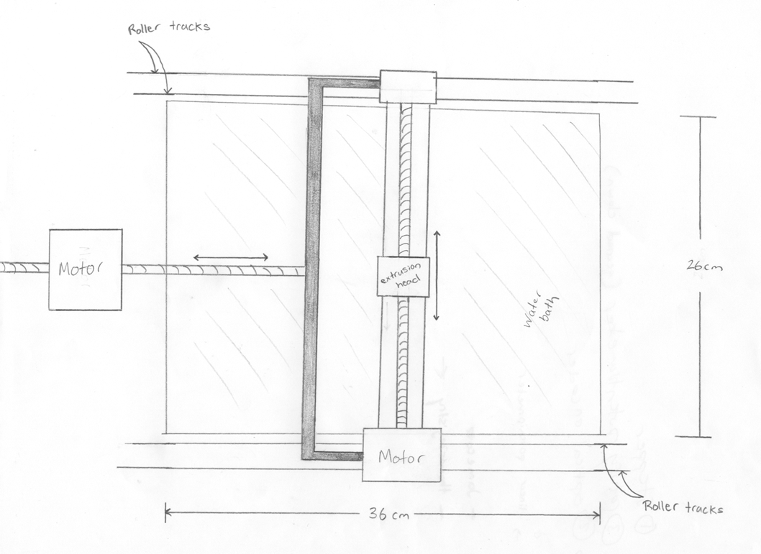
Figure 36: Extrusion Vehicle Design 1.

After a great deal of thought, it was decided that the device should not be suspended in the air by way of supports on rollers. It was decided that the device should be constructed in such a way that all the moving parts are attached to an inverted base. This base would then be suspended off the ground by stationary supports. The use of stationary supports would prevent problems associated with the torque applied to the supports. This device consisted of all the same motors and screw drives; however they were in a different orientation problems due to torque. A hand drawn sketch of the new device design is showed in Figure 37 below.
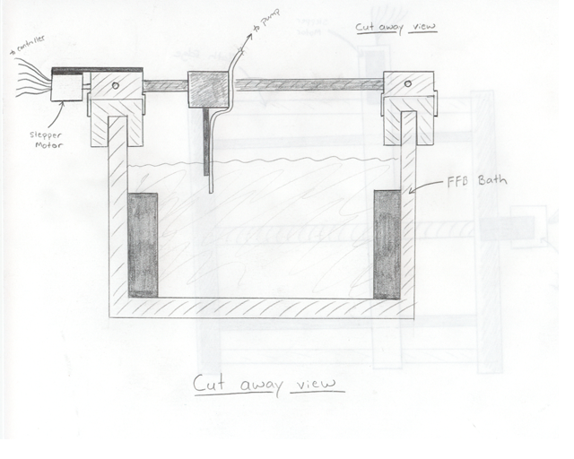
Figure 37: Extrusion Vehicle Design 2.

Though this device was thought to be much better than the previous design, there were still other problems associated with it. The most important of these problems involved the movement aspect of the device. The movement would be produced using screw drives attached to stepper motors. These screw drives have a great potential for damage and must be treated carefully. If a screw drive becomes damaged, the threads could become slightly bent, preventing movement along that portion of the device. Furthermore, the use of metal screw drives suspended over a physiologic solution (basically salt water) would inevitably, over time, present corrosion problems. This corrosion would greatly effect the movement of the vehicle as well as possibly contaminating the solution the collagen is being extruded into. In order to eliminate the potential for damage and corrosion problems, a new way of moving the device was designed. This new method could be used on the existing device and would provide a more durable movement system. It was decided that a simple belt and pulley system would be used for movement. This simple belt and pulley system has been used extensively and repeatedly in printers with few problems. It is anticipated that it will function in the same manner in our final design which can be seen in the computer aided design drawing (CAD) shown below (Figure 38).
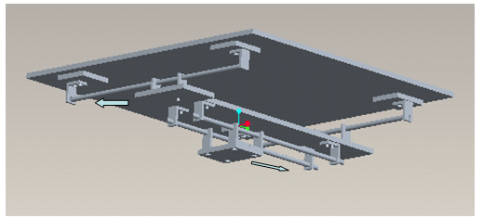
Figure 38: CAD Drawing of Extrusion Vehicle Final Design

4.5 Detailed Design
After the final designed was selected, the next step was to validate the design. Through preliminary testing and modeling described in the section below, we were able verify our design concept and optimize the design of our device.

4.5.1 The Bath System
Due to its simplicity, we first constructed a working prototype of the bath component. Lexan® was used as the primary material for the bath construction due to its desirable physical properties as well as the fact that it is easy to machine. In addition, the material is widely available at a low cost. The outer layer of the bath was constructed using clear Lexan® to allow the user to view the circulating water inside. The inner bath was constructed using black Lexan® to provide a contrasting background to the opaque collagen threads, allowing the user to monitor the fibers and their attachment. The pieces of Lexan® were attached with Acrylic Cement and the bath was sealed with 100% silicone.
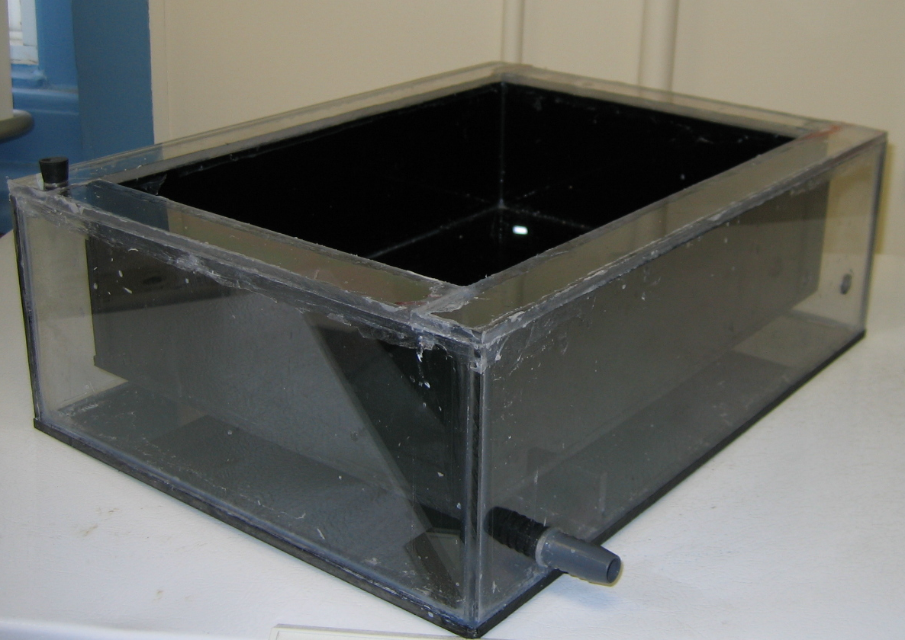
Figure 39: Double-wall Water Bath Prototype.

Within the walls and floor of the bath, we needed water to circulate throughout the entire surface of the inner bath. Therefore, we constructed channels in order to control the flow of water. Three pieces of Lexan® were attached with Acrylic Cement to the bottom of the bath before it was sealed.

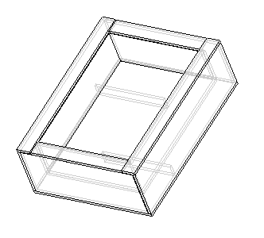
Figure 40: Water Flow within the Bath

Since it is essential for the bath to maintain a physiologic temperature of 37 degrees Celsius, we designed an experiment to test the time it took for the bath to heat up to temperature as well as the ability of the bath to maintain the desired temperature. The prototype was hooked up to a VWR circulation pump (VWR Scientific Products, model #1160A), and the set point temperature adjusted to 37 degrees Celsius. The inner bath was filled with room temperature fiber formation buffer. The temperature of the inner bath was recorded every ten minutes, using an analog thermometer, to determine the heat loss to the environment and the amount of time required for the buffer to reach the desired temperature. After a period of 40 minutes, the buffer didn’t rise above 35.6 degrees Celsius. Therefore, we adjusted the temperature on the circulation pump to 38 degrees Celsius. At a temperature of 38 degrees Celsius, the buffer did not rise above 36.0 degrees Celsius so the water circulation was increased to 39 degrees Celsius. At that temperature, the fiber formation buffer maintained a temperature of 36.7 degrees, plus or minus .4 degrees Celsius.
In order to confirm the proper set point on the circulator pump of 39 degrees Celsius, we performed a second experiment. By starting the circulator at 39 degrees Celsius and maintaining that temperature throughout the experiment, the buffer reached the proper temperature in less than 30 minutes. The buffer then remained at 36.5 degrees Celsius for the remainder of the experiment.
Table 17 below shows the data for the two experiments. It was concluded that setting the circulating water at 39 degrees Celsius maintains a buffer temperature of 36.5 +/- .5 degrees Celsius.
Table 17: Double-wall Water Bath Preliminary Testing Result.
Time | Temperature
Time | Experiment 1 | Experiment 2
0 | 32 | 32
10 | 34.5 | 34.6
20 | 35.2 | 36.2
30 | 35.2 | 36.5
40 | 35.2 | 36.6
50 | 35.9 | 36.4
60 | 36.0 | 36.5
70 | 36.0 | 36.8
80 | 36.2 | 37.0
90 | 36.4 | 36.9
100 | 36.5 | 37.1
110 | 36.5 | 36.9
120 | 36.5 | 36.9

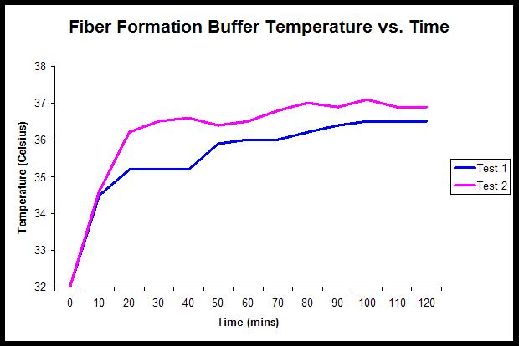

Graph 1: FFB Temperature versus Time.

Though the temperature control worked well, leakage along the edges of the inner bath was observed during the test. This problem could be overcome by adding more silicone to better seal the bath. It also came to our attention that there exists a potential interaction between the silicone and the collagen fibers. Thus Mass Spectrometry (Mass Spec) was performed for verification. It was found that the silicone did not yield a positive mass spec, thereby making it a suitable sealant for the bath. Additionally, Mass Spectrometry was conducted to ensure that Lexan® did not produce any byproducts (see Figures 41 and 42 below respectively).
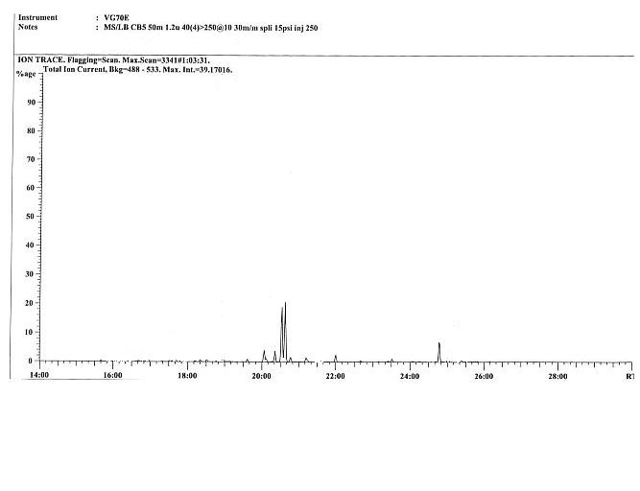
Figure 41: Mass Spec for Silicone

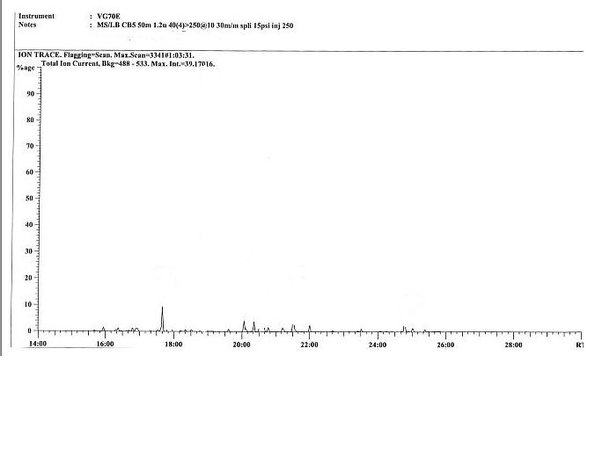
Figure 42: Mass Spec for Lexan®

4.5.2 Extrusion Vehicle Model
After constructing the bath, the second step in building our device consisted of making a three dimensional model. This model was constructed to eliminate potential problems not seen during the design phase due to the small amount of time available to construct the device. Additionally, in order to correctly space the frame and the various moving parts, the model would allow us to make adjustments without wasting valuable materials. Foam-core board was used to make the base, front to back panel and side to side vehicle, as well as to imitate the L brackets which would be used to attach the pieces together. Wooden dowels were used as the sliding rods, allowing the vehicle and front to back panel to move in the correct motions.
Constructing the model allowed us to correctly adjust the spacing in order to utilize the entire space of the bath as well as to ensure complete functionality of all moving parts. After making the model, the group realized that the front to back panel would need to be expanded on one end in order to house the motor in charge of its motion. We also realized that we may need to add weights to the opposing ends of the motors on the base and front to back panel in order to equalize the weight so that the moving parts would create less friction and move uniformly when sliding over the bars. Lastly, we discovered that the L brackets that supported the sliding bars on the base had to be lifted by at least 3/8 of an inch so that the motor wouldn’t impede the motion of the front to back panel.
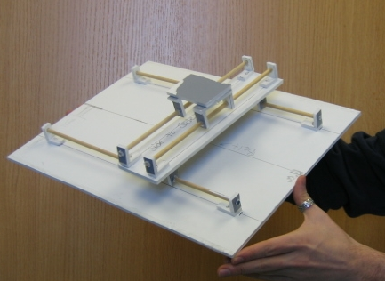
Figure 43: Extrusion Vehicle Model.

4.5.3 Anchoring Method
In addition to testing the silicone, more tests were performed in order to find a proper porous material that would not interact with the collagen for the anchoring system. To start the experiment, various materials were placed in beakers of distilled water for 48 hours to test for visible leachables. The following materials were tested: Pumice, artificial sponge, coral, Lexan® and glass. Pumice and coral both had visible leachables in the water and were excluded from further testing. However, the Lexan® , glass, and artificial sponge did not show any signs of particles and were subjected to mass spectrophotometry testing. Since none of these materials leached organic solvents, more tests needed to be conducted in order to find the best possible porous material.
In addition to being inert, the proposed system would have to utilize a porous material onto which fibers would attach immediately following extrusion and would remain attached during the formation process. After negative results from the leaching tests were found for the Lexan®, sponge and glass, we etched the glass, by hand and by power sander, and etched the Lexan® by hand to allow for adhesion. Next, the four samples were placed in a bath of fiber formation buffer and 10 mg/ml acid soluble rat tail tendon (RTT) collagen was extruded using standard protocol onto each of the materials. After the fibers were allowed to form, an evaluation of their adhesion to each of the materials was performed.
To objectively evaluate adhesion to each of the porous materials we assigned values from 1 to 4 based on the criteria of: (1) – did not adhere (2)-fiber was removed from porous material by touching the fibers with tweezers (3)-fiber was removed from porous material when fiber was aligned (4)-fiber was able to withstand applied tension without release from material as seen below.
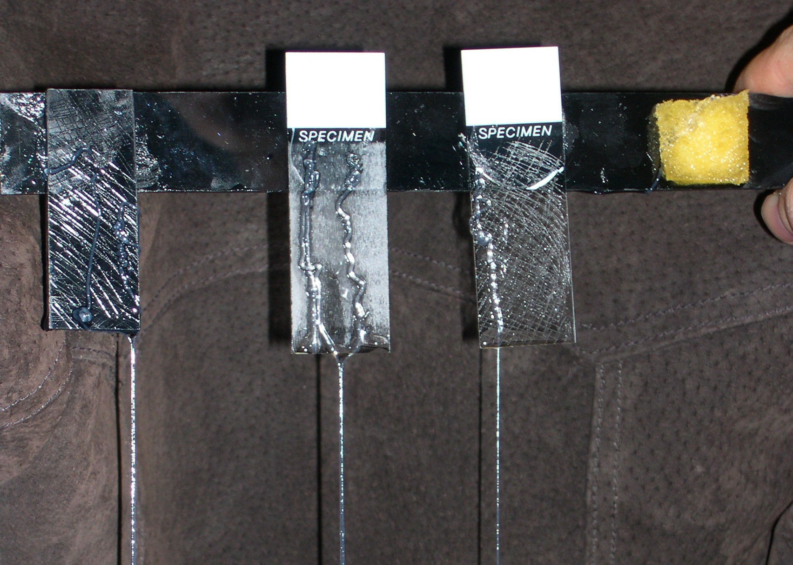
Figure 44: Preliminary Testing of Porous Material for Anchoring Device.

Table 18: Preliminary Test Result for Collagen Adhesion Testing
Experiment | Material | Attachment
Experiment | Material | After 5 minutes | After 30 minutes | After 60 minutes | After 90 minutes
A | Synthetic Sponge | 1 | 1 | 1 | 1
B | Hand etched glass | 4 | 4 | 4 | 4
C | Machine etched glass | 4 | 3 | 2 | 2
D | Hand etched Lexan® | 4 | 4 | 4 | 4

The only naturally porous material showed poor adherence and received scores of 1 or 2 during the experiment. The etched materials faired better and received scores of 3 and 4 due to their fair amount of adhesion. Two materials performed equally well, the hand etched Lexan® and glass, and the best option had to be decided. Since the etched glass was sharper, which could cut the fibers, and was more brittle, we decided that the etched Lexan® would perform the best under tensile loading.

5. Methodology
In the methodology section, we will discuss the materials of construction, how each component was constructed, and how we assessed the functionality of each component.

5.1 Materials of construction
The materials used to construct this device were selected based on: cost, availability, machining properties, and resistance to corrosion by saline solutions. It was found that Lexan® when purchased from a scrap pile at a local plastic store, Plastics Unlimited Inc, Worcester, MA, would be the most cost effective material for use as the base portions of the device. Lexan® is very resistant to corrosion as well as being extremely easy to work with.
After discussing the selected materials with the client and user for this design, it was determined that Lexan® should be the primary material for construction of the entire device. Large pieces of ¼” Lexan® were purchased at $1.75 per pound from Plastics Unlimited. After purchasing the Lexan®, it was used to construct both the double walled closed loop bath, and the base portions of the two dimensional extrusion system. The physical properties of Lexan® allow it to be both glued and screwed together. The entire bath system was glued together using acrylic cement (also purchased from Plastics Unlimited), which chemically melts two adjoining pieces of Lexan® together making for a solid watertight seal. All of the seams were then sealed again using generic household silicone cement to ensure that the bath was watertight.
The extrusion system was created using Lexan® (Plastics Unlimited), stainless steel rods (MSC), Teflon® bushings (MSC), plastic pulleys, rubber belts, aluminum brackets, and stainless steel screws. The brackets were constructed of aluminum angle bar which was acquired free of charge and purchased at Home Depot, Inc. This angle bar was custom cut to the dimensions of the brackets needed. Rods were then selected according to cost and corrosion resistance. It was found that 316 stainless steel could be purchased in ¼” diameter rods. The 316 stainless steel would exhibit very good corrosion resistance as well as being easy to work with (cut). Two 72” long ¼” diameter stainless steel rods were purchased from MSC for $6/each. The rods were then cut to size using a hack-saw with a metal cutting blade attached.
The pulleys and belts were selected, not by cost, but by availability. It was suggested that we obtain belts and pulleys for our device from old inkjet printers. After removing the plastic covers from two inkjet printers, the idler and drive pulleys were removed. In addition, the belts were also removed due to the fact that their pitch would match the pitch of the pulleys obtained from the same printer.
The bushings used in this device were used to prevent metal on metal sliding of the brackets on rods. These bushings were ordered one size larger than the diameter of the rods to prevent sticking and provide constant smooth motion. The bushings ordered are constructed of Teflon® which is a lubricious material used as bushings in numerous metal on metal applications.
The motors, controllers, and drivers are the most important component of our automated device. The selection of these motors was based on; cost, size, weight, upgradeability, and ease of programming. The specification for our small motor requires a torque of 32 oz*in and need to move at a speed of 100 RPM. The large motor requires 90 oz*in at a speed of 100 RPM. These numbers were obtained based on the weight of the device and the desired extrusion rate required to meet our clients needs. The first motors and controllers selected were NEMA size 17 stepper motors attached to a 1240I controller/driver from Applied Motion Inc. The motors were large enough to provide enough power to create the desired movement of our device, yet small enough to fit on the device. These motors would then hook up to the controller/driver, which allow for programming and controlling of the device. However, it was found that the controller could only support one axis of motion. This lack of two-axis movement would not work for our design and various solutions were explored to solve this inadequacy (Appendix 4). These options were then presented to the client. Based on cost and performance, it was decided that two new motors with integrated controllers/drivers would prove to be the best option for our device.

5.2 Device Construction
The following sections will describe the methods used to construct each component of the device including: the water bath, extrusion vehicle, and anchoring system in detail.

5.2.1 Water Bath Construction
Since the prototype of the bath, described in section 4.5.1, worked sufficiently well, we decided to use the prototype as the final device. Therefore, there was no further construction for the bath system.

5.2.2 Extrusion Vehicle Construction

After constructing a model of the extrusion vehicles attached to the base, construction commenced on the prototype which would be used for testing. The prototype dimensions are the exact dimensions of the model with the exception that a few of the L-brackets used to attach the track were put on risers to solve clearance issues. Additionally, the large extrusion vehicle needed an additional piece of Lexan® added to allow for the proper mounting of the motor. All materials discussed in the pervious sections were used in the construction process. The stainless steel rods were press-fit into each of the L-brackets and all other brackets were attached using stainless steel screws after tapping into the Lexan®. The Teflon® bushings were also press-fit into each of the L-brackets. No adhesives were used in the process of constructing any part of the extrusion vehicle with the exception of acrylic cement used to glue the Lexan® risers to the base. An image of the completed vehicle system can be seen below. (N.B. updated pictures will be added as soon as they are taken) In future versions of this paper, information on the programming and electrical systems used will be added, however, this has been completed to date.
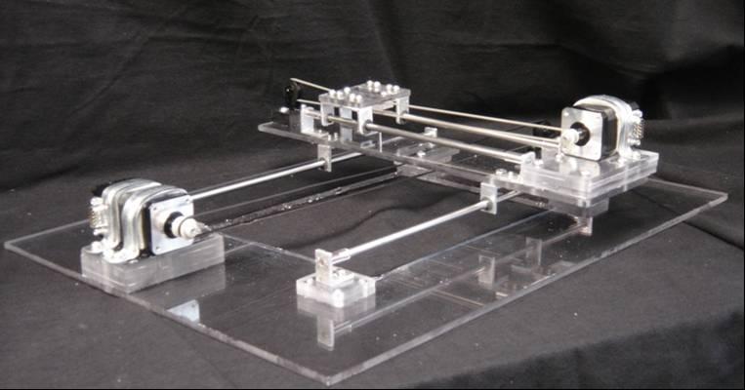
Figure 45: Image of Completed Vehicle System

5.2.3 Anchoring Method Construction
After testing various porous materials discussed in previous sections, a removable attachment system was constructed. This system was constructed out of Lexan® strips stacked vertically and adhered using acrylic cement with an etched removable strip. This removable strip will allow for threads to be produced, and then, easily removed from the bath. Additionally, alternate strips can be placed back into the bath so multiple series of threads can be produced. An image of this system can be seen in Figure 46 below.
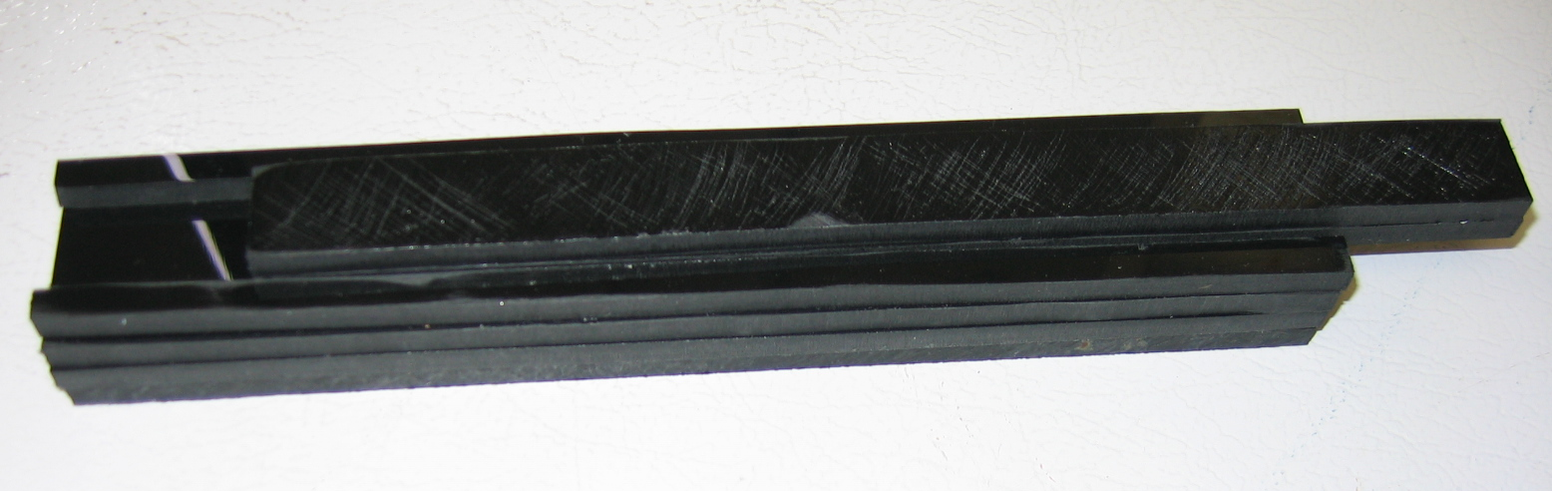
Removable Anchoring Strip
Hand Etched Lexan

Figure 46: Removable Anchoring System – Design 1

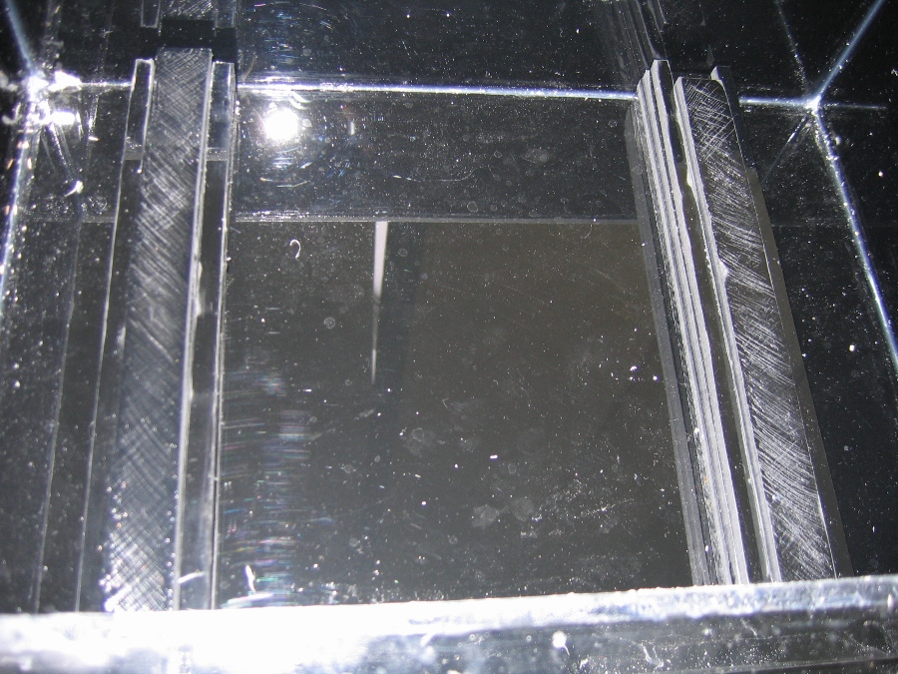

Figure 47: Anchoring Device in Bath
However, during preliminary testing it was found that the sharp edges of this anchor device do not provide a smooth transition between the anchoring devices and the open aqueous bath. Consequently, a breakage would occur at the point. We decided that to provide a better transition for the extrusion tube, the edges of the anchoring device will be round off with a curvature of a hemisphere as demonstrate in Figure 48. This new design proved to be more effective for fiber anchoring and resolve the breakage problem observed previously.

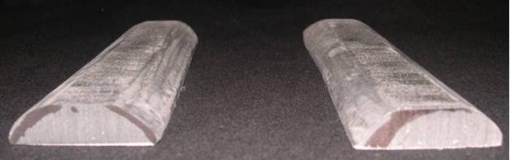
Figure 48: Anchoring Device - Design 2

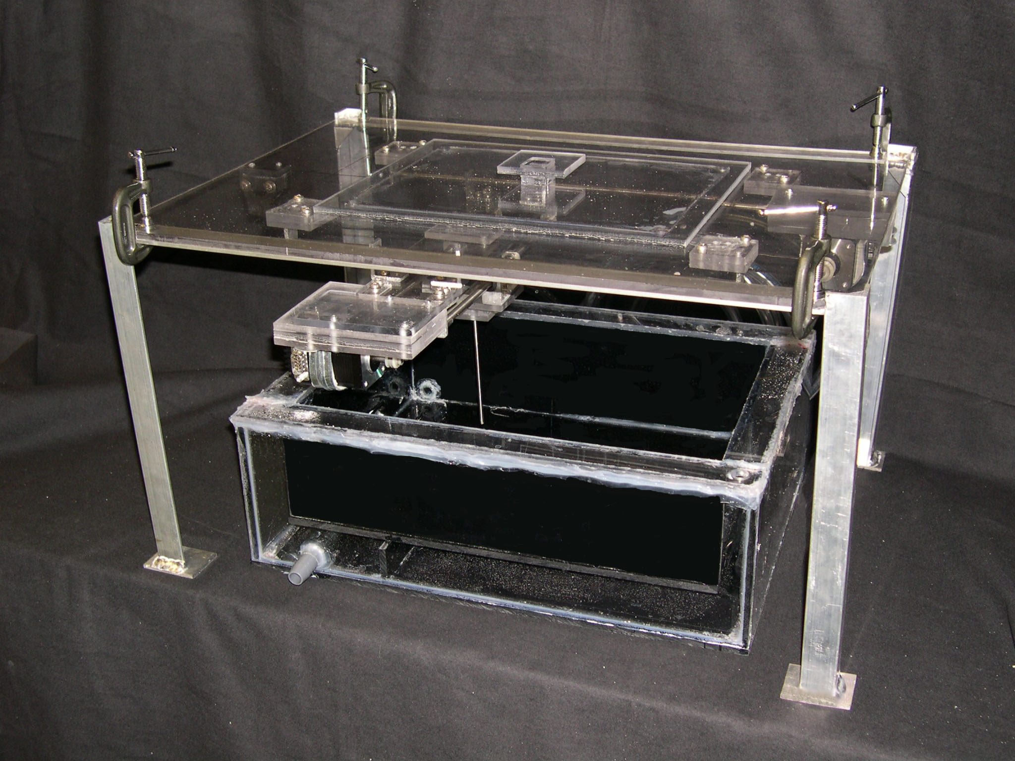
Figure 49: Automated Extrusion Device

5.2.4 Automated System Controller

The device was programmed using a simple LabView program providing the desired motion. The program was able to allow the user to choose fiber distance, as well as the spacing between the fibers. Once this was done, the program was run and the device completed the program and stopped. After this initial program was used to test the device, a new LabView program was created having a better user interface for use by people not accustomed to the device. The screen shot in Figure 50 shows the user interface of the LabView program which is currently being worked on. Though this program does not currently function at 100%, the user interface in this shot is what we are striving for. After future programming it will hopefully be fully functional and provide an excellent program for controlling our device.
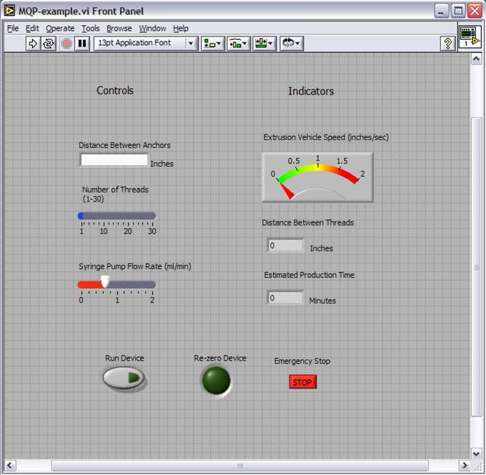
Figure 50: Device - User Interface for Automated System

5.3 Device Validation
Upon the completion of the device construction, it is important for the design team to validate and test the efficacy of the automated system. This section will focus on the protocol used to extrude collagen fibers and the testing/analysis methods.

Collagen Extraction Protocol
The collagen was extracted from rat’s tails tendon using the protocol described previously by Kato and associate in 1989 (Kato et al., 1989). The 13 tails of Sprague-Dawley rats were obtained from physiology laboratory on campus and place in distill water. The tendons were removed by clamping a haemostat on the thin free end applying a tensile force long the tendon axis breaking the tail and gently pulling the tendon out. The tendon fibers was rinsed in distilled water and stirred in 1600 mL of 3% (vol/vol) acetic acid overnight at 4 degrees Celsius. The supernatant was separated from the stock solution by centrifugation at 12,800g at 4°C for 2 hours. The supernatant was precipitated with 320 mL of 30% NaCl (wt/vol) solution, and the pellet was collected by centrifugation at 4420g at 4°C for one hour. The pellet was dissolved in 400 mL of 0.6% (vol/vol) acetic acid and dialyzed five times against 1.0 L of 1 mM HCl. The resulting collagen solution was lyophilized and stored at 4°C. The purity of the starting material was verified by SDS-PAGE. For collagen thread extrusion, a small quantity of type I collagen was dissolved in 5 mM HCl solution at a final concentration of 10 mg/ml and stored in syringes at 4°C.

Collagen Extrusion Protocol
Collagen threads were extruded from solutions of either soluble or insoluble type I collagen following a procedure similar to that described previously by Pins and colleagues in 1997. Briefly, collagen solutions were extruded through 0.38 mm inner diameter polyethylene tubing (Becton Dickinson, Inc., Franklin, NJ) using a syringe pump (KD Scientific, New Hope, PA) set at a flow rate of 0.7 mL/min. Threads were extruded into a bath of fiber formation buffer (pH 7.42, 135 mM NaCl, 30 mM TrizmaBase (Tris), and 5 mM NaPO₄ dibasic; Sigma, St. Louis, MO) maintained at 37°C overnight. The buffer was then replaced with a fiber incubation buffer (pH 7.42, 135 mM NaCl, 10 mM Tris, and 30 mM sodium phosphate dibasic, Sigma) that was maintained at 37°C for 24 h. The incubation buffer was then replaced with distilled water, and the threads were incubated at 37°C overnight. Finally, the threads were removed from the water bath, air dried, and stored at room temperature in a desiccator. This method was used for both the manual extrusion and automated extrusion method.

Tensile Testing

In order to determine the tensile strength of the fibers created with our device, a hand made mechanical testing machine was used. This device consisted of a load cell (hooked up to a computer for data acquisition) placed on a syringe pump. Tests strips were then created for each fiber being tested. These strips consisted of a fiber glued onto a stretching strip using surgical grade silicone glue as can be seen in Figure 51.
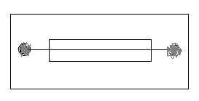
Collagen Thread
Test Strip Paper (vellum)
Surgical glue

Figure 51: Mechanical Test Strip
Once the fibers were attached to the test strips, their diameters were measured for use in further calculations. The diameter measurements were done using a 1 cm eye piece ruler with a 20x lens on a standard cell culture microscope (Nikon T5100). After the measurements were taken, the test strips were submersed in a 10% phosphate buffered saline solution for at least 1 hour. Once the fibers were properly hydrated their hydrated diameters were measured in the same manner as the un-hydrated fibers. After all of the diameter measurements were taken, the fibers were then attached to the hand made tensile testing machine. One end of the fiber strip was attached to the load cell which the other was attached to the moving section of the syringe pump. After attachment, the machine was run using LabVIEW to stretch the fiber until breakage. Each fiber was testing in this manner and the data collected on the computer was labeled and saved for later use.
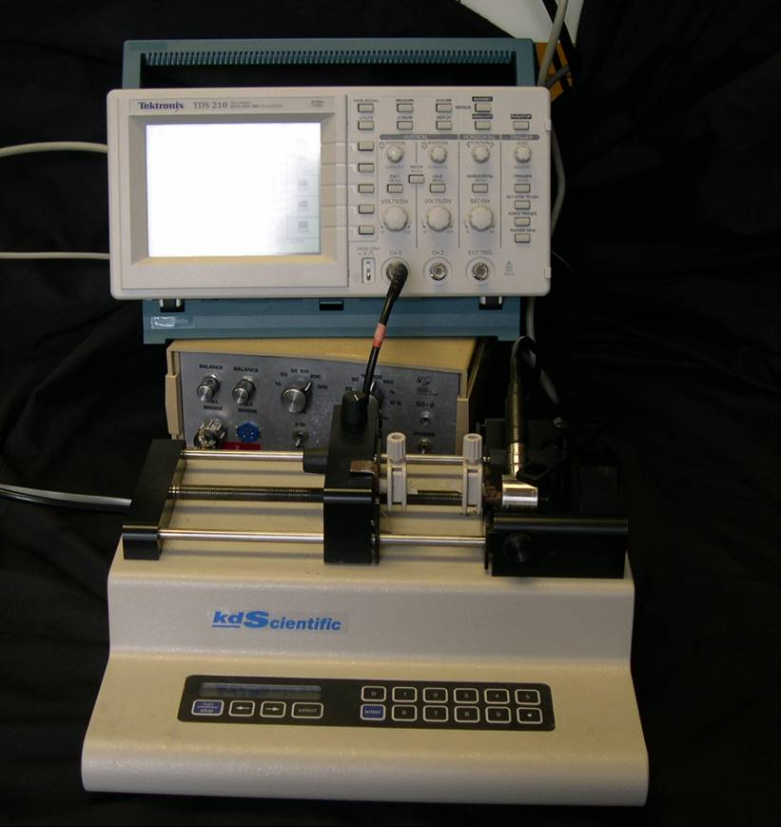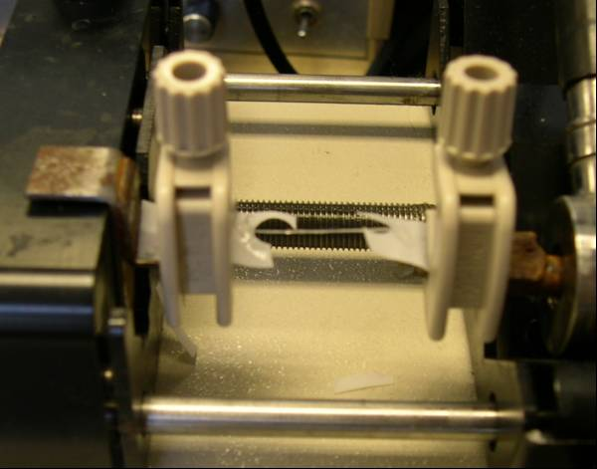
Figure 52: Device for Tensile Testing

5.3.4 Diameter Testing
Though there were some diameter measurements done during the tensile testing of the fibers, a more extensive diameter testing was done to determine diameter variation over the length of the fibers produced with our device. In order to accomplish this, dried, full length fibers, were placed under a fluorescent microscope at 20x magnification (Nikon T5100). The 1 cm eye piece ruler used in the tensile testing measurements was used to test the diameters for this experiment as well. In order to determine the diameter variation over the length of the fibers, measurements were taken starting at one end and working toward the other. There was no precise distance between the test points; however, they were as close together as possible while still allowing the measurements to be taken in a reasonable amount of time. There was an average of 20 measurements taken per fiber. The data collected from this experiment was placed in and Microsoft Excel spread sheet and a line graph showing the diameter variation of the fibers was created. In order to compare our fibers with those produced by the current hand extrusion method, fibers created from the current method were also tested in this manner.

6. Results

Adhering to the methods and procedures described in the section above, we were able to validate our automated device. This section will compare the fiber’s properties (diameter, tensile strength) between manually extrude fibers and our fibers.

6.1 Fiber Production

One of the major limitations associated with the currently manual extrusion method is their low production rate. As stated previously, with the manual extrusion methods, it took roughly 30 minutes to produce a batch of fibers. In addition the high probability of breakage associate with either poor extrusion speed, or poor fiber fixation further decreased the production yields. However, the new automated system was able to produce a batch of fiber in less than 5 minutes. During the production process, we observed minimal or no fiber breakage. Figure 53 below clearly demonstrated the differences between the fibers extruded manually and those extruded using our automated device. The automated extruded fibers, attached firmly to the anchoring devices. The production yield was almost one hundred percent.

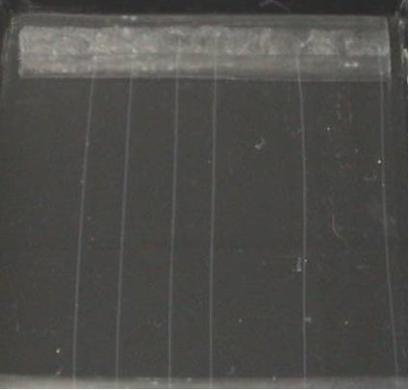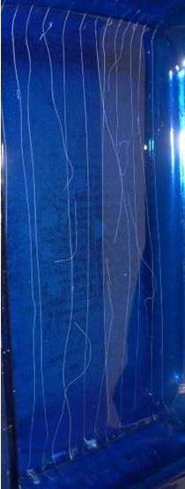
Figure 53: Automated Extruded Collagen Threads (left) versus Manually Extruded Threads (right)

6.2 Fiber Diameter
Using the protocol describe in section 5 above, we measured and compared the unhydrated diameter of the fibers produced using the automate system versus those manually extruded (provided to us by Kevin Cornwell), as showed in Tables 19 and 20 below.

Table 19: Automated Extruded Collagen Fiber - Unhydrated Diameter
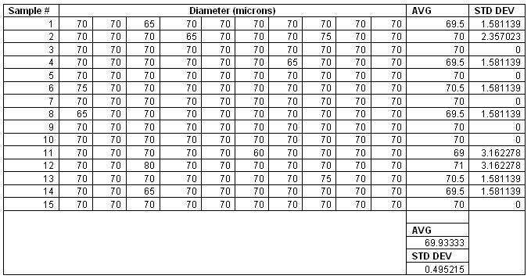

Table 20: Manually Extruded Collagen Fibers – Unhydrated Diameter
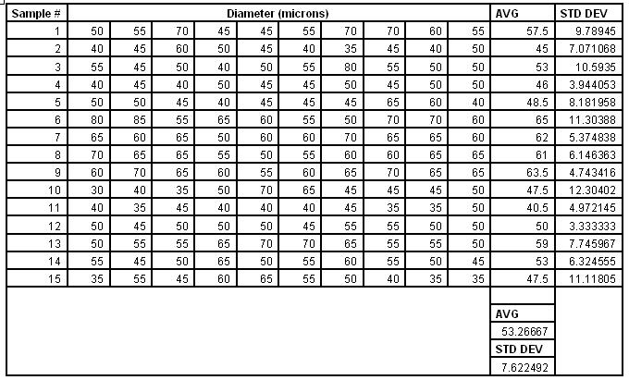

The data indicated that, the fibers produced using our automated extrusion device have much smaller variation between fiber diameters than the threads produced manually. The average thread diameter of the automated extrusion threads was found to be 70 ± 0.5 microns, whereas the diameter of the threads produced using the manual extrusion method were found to have an average diameter of 53 ± 7.6 microns. The threads produced using our automated device had a variation of much less than 3% (comparing to the 14% variation for manually extruded fibers). Thus we have showed that our device was able to produce fiber with more uniform structural properties, exhibiting less than 5% variation between fibers.

Graph 2: Unhydrated Diameter Measurement: Automated Extrusion Threads vs. Manually Extruded Threads.
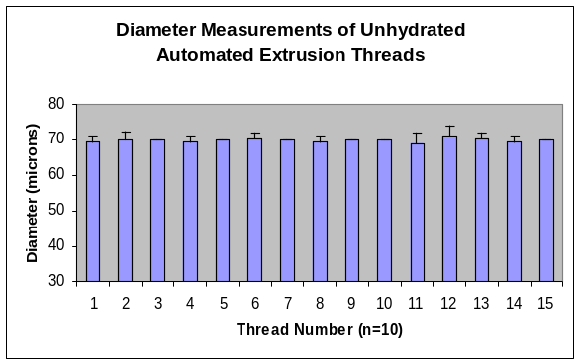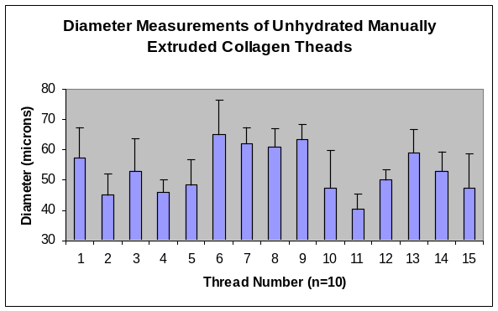

Though the precision of our device is much better than that of the current manual extrusion method, our device does not accurately match the diameter measurements for the fibers extruded using the manual extrusion method. One of the other goals of the project was to accurately match the parameters of the threads created using the current manual extrusion method. One of the reasons for this difference in thread diameter could be accounted for by the difference in extrusion speed during the production process. The threads produced using the automated method had a syringe pump flow rate of 1.5 ml/min whereas the threads produced using the manual extrusion method had a syringe pump flow rate of 0.7 ml/min. This difference in flow rate could drastically affect the diameters of the threads produced. In order to attempt to fix this difference, the flow rate used for the automated method could be changed to 0.7 ml/min and the speed of the extrusion vehicle could be slowed down accordingly to match the extrusion speed of the collagen.

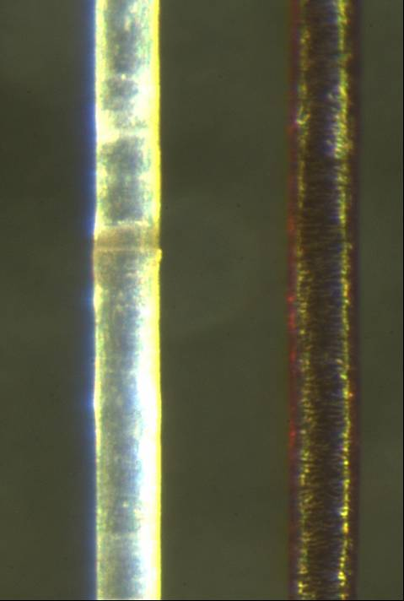
70 microns
Figure 54: Automated Extruded Threads (left) and Human Hair (right)

6.3 Fiber Tensile Strength

After performing the previously described mechanical testing of our fibers, we were able to compare this data with that of the manual extruded threads. The comparison of this data was done in the same manner as the diameter testing described above. The data was placed into charts as well as graphs to better show the data collected and the differences between the data. The tables and graphs can be seen in Tables 21 and 22 and Graphs 3 and 4.

Table 21: Tensile Testing Results for Automatedly Extruded Collagen Threads
Sample # | Wet Diameter (microns) | Maximum Stress (Mpa) | Maximum Load (mN) | Strain at Failure
1 | 360.5 | 0.74 | 0.75 | 0.70
2 | 359.5 | 0.75 | 0.76 | 0.78
3 | 362 | 0.7 | 0.72 | 0.68
4 | 351 | 0.63 | 0.6 | 0.75
5 | 352.5 | 0.64 | 0.6 | 0.75
6 | 354 | 0.75 | 0.73 | 0.85
7 | 341 | 0.63 | 0.6 | 0.81
8 | 355 | 0.76 | 0.72 | 0.94
10 | 347 | 0.73 | 0.7 | 0.66
11 | 350.5 | 0.72 | 0.61 | 0.63
AVG. | 353.3 | 0.71 | 0.68 | 0.75
STD. DEV. | 6.75 | 0.056 | 0.067 | 0.090

Table 22: Tensile Testing Result for Manually Extruded Collagen Threads
UTS (MPa) |  | SD | Strain at Failure |  | SD | Modulus (MPa) |  | SD
1.5 | ± | 0.2 | 0.421 | ± | 0.12 | 4.0 | ± | 1.2

Graph 3: Stress Strain Curve for Automated Extrusion Threads
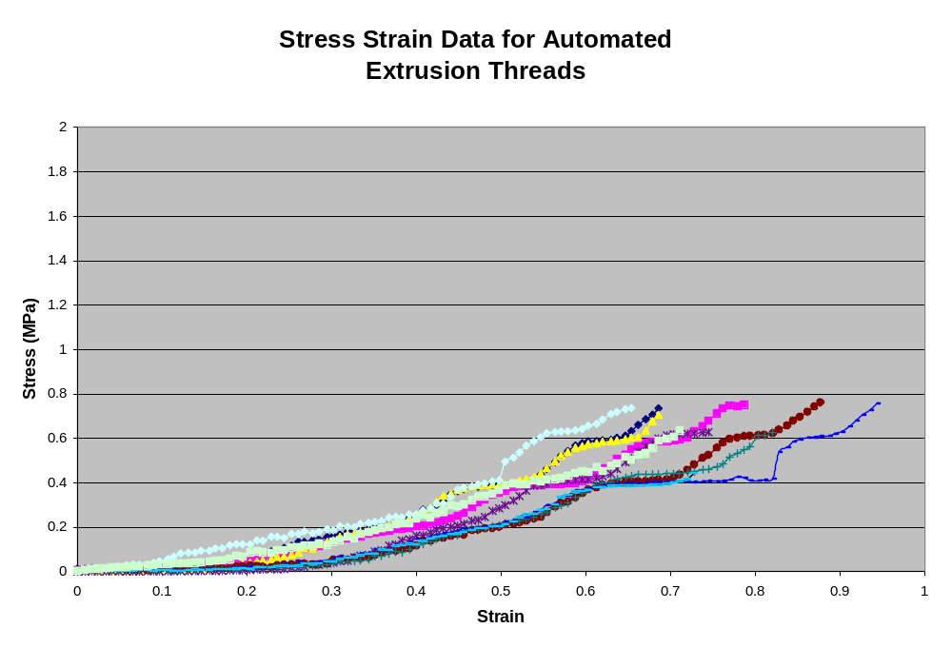
Graph 4: Stress Strain Curve for Manually Extruded Threads
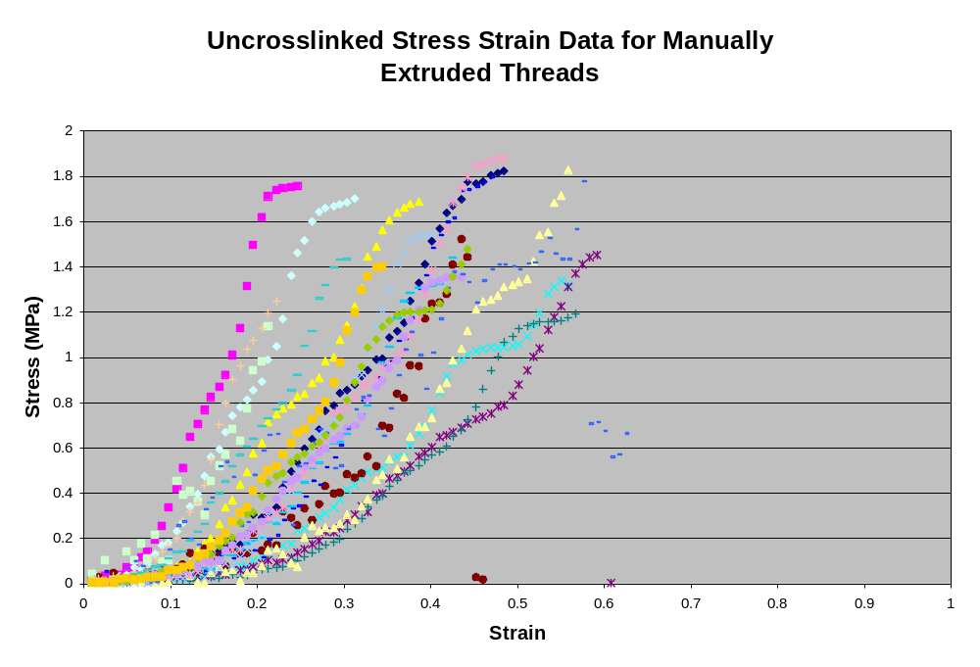
As can be seen from these graphs, the threads produced using our automated method have much less variation between the fibers than the threads created using the current manual extrusion method. The average ultimate tensile strength and ultimate strain of our automated threads are 0.7 ± 0.05 MPa and 80 ± 8 % respectively. The threads produced using the current manual extrusion method have an average ultimate tensile strength and an ultimate strain of 0.908 ± 0.208 MPa and 67.97 ± 6.874 % respectively. Once again, it can be seen that the variation in the fibers being produced using our device is much less than that of the fibers produced using the current manual extrusion method. The mechanical properties of the threads created using our automated device were shown to be less than those from the manual extrusion system. The reason for the difference in UTS may be from the difference in diameters of the fibers. Since stress is function of force per area, the fibers may have withstood the same amount of force, but because of the difference in diameters, the manual extruded threads had a larger UTS value. The change in syringe pump flow rate may also fix this problem if it produces threads with similar diameters to those created using the manual extrusion system.

7. Conclusion

The production of collagen threads will allow for the future development of multidimensional, multilayered, and multimaterial meshes and scaffolds. Through the development of an automated extrusion system, research in each of theses areas will be accelerated. This device will allow researchers to produce large quantities of collagen threads with increased uniformity and mechanical properties. Additionally, these threads can be bundled together in a cable-like structure for use as an ACL replacement scaffold helping to repair the over 150,000 ACL injuries annually.
After completing numerous tests produced using the automated system, we were able to determine that we met all of our project goals and objectives. The fibers produced by an automated system are superior to those produced by the current manual extrusion system (see Table 23 below). Fibers produced using an automated system were more uniform overall, and possessed a lower standard deviation that fibers produced manually. Additionally, the number of fibers produced was significantly increased over the manual extrusion system.

Table 23: Result Summary Table
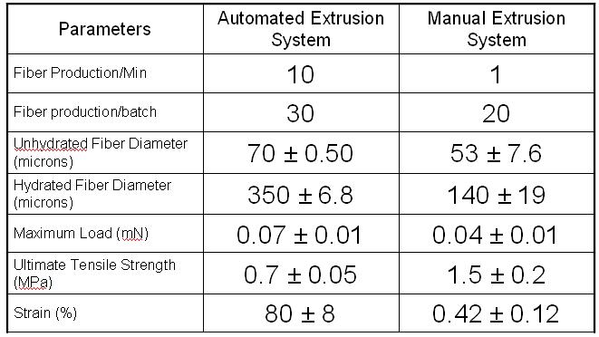
8. Recommendations

The results show that the designed automated device has a productivity that is more than ten times that of the manual extrusion method. However, there are still some functions that can be improved. Designing a fully automated bath which can automatically change buffers without human interaction can further increase the productivity of the automated device. Integration of the automated bath and a syringe pump into Lab View would also allow for less user involvement, decreasing the probability of human error. In addition to improvements of the existing method, there is also an opportunity for supplementary components such as a stretching system. Incorporating an automated stretching system would alleviate almost all human handling of fibers, again decreasing the probability of fiber failure due to human error.
Lastly, now that the basic working design is created, the device can be modified to allow for further research. Increasing the size of the entire system would allow for the production of an even larger quantity of fibers. Also, the device can be used to extrude just about any other thread-like material, such as silk, for use in future research.

Bibliography

Alastair, W. M. and M.F. Macnicol. “10–16 year results of Leeds-Keio anterior cruciate ligament.” The Knee 11 (2004): 9-14.

Altman GH, Diaz F, Jakuba C, Calabro T, Horan RL, Chen J, Richmond J, Kaplan D “Silk matrix for tissue engineered anterior cruciate ligaments.” Biomaterials 23 (2002): 4131-4141

Altman GH, F. Diaz, C. Jakuba , T. Calabro, R. L. Horan, J. Chen, J. Richmond, D. Kaplan. “Silk-based biomaterial.” Biomaterials 24 (2003): 401-416.

Bellincampi LD, Closkey RF, Prasad R, Zawadsky Jp, Dunn MG. “Viability of fbroblast-seeded ligament analogs after autogenous implantation.” Journal of Orthopedic Research 16 (1998): 414-420.

Birk DE, Silver FH, Trelstad RL. Cell Biology of Extracelluar Matrix. Plunum Press, New York 1991.

Birk DE. Nurminskaya MV, Zycband EI. “Collagen fibrillogenesis in situ: fibril segments undergo post-depositional modifications resulting in linear and lateral growth during matrix development.” Developmental Dynamics: an official publication of the American Association of Anatomy 202 (1995): 229-243.

Bourke, SL, J. Kohn, M.G. Dunn. “Preliminary Development of a Novel Resorbable Synthetic Polymer Fiber Scaffod for Anterior Cruciate Ligament Reconstruction.” Tissue Engineering 10 (2004):43-52.

Brody GA, Eisinger M, Arnoczky SP, Warren FR. “In vitro fibroblast seeding of prosthetic anterior cruciate ligaments: a prelimnary study.” American Journal of Sports Medicine 16 (1988): 203-208
Canty EG, Kadler KE. “Collagen fibril biosynthesis in tendon: a review and recent insights.” Comparative Biochemistry and Physiology Part A 133 (2002): 979-985.

Christiansen DL, Huang EK, Silver FH. “Assembly of type I collagen: fusion of fibril subunits and the influence of fibril diameter on mechanical properties.” Matrix Biology 19 (2000): 409-420.

Cooper JA, Lu HH, Ko FK, Freeman JW, Laurencin CT. “Fiber-based tissue engineer scaffold for ligament replacement: design consideration and in vitro evaluation.” Biomaterials Article in Press (2004).

Cornwell, KG, BR Downing, GD Pins. “Characterizing fibroblast migration on discrete collagen threads for applications in tissue regeneration.” Journal of Biomedical Materials Research Part A 71A(2004): 55-62.

Delorenzi N, Sculsky G, Gatti CA. “Effect of monovalent anions on type I collagen fibrillogenesis in vitro.” International Journal of Biological Marcromolecules 19 (1996): 15-20.

Dunn MG, Tria AJ, Kato YP, Bechler JR, Ochner RS, Zawadsky JP, Siler FH. “Anterior cruciate ligament reconstruction using a composite collagenous porsthesis. A biomechanical and histologic study in rabbits. American Journals of Sports and Medicine 20 (1992):507-515.

Dunn MG, Liesch JB, Tiku ML, Zawadsky JP. “Developemnt of fibroblast seeded ligament analogs for ACL reconstruction.” Journal of Biomedical Material Research 29 (1995): 1363-1371.

Dunn MG, Avasarala PN, Zawadsky JP. “Optimization of extruded collagen fibers for ACL reconstruction.” Journal of Biomedical Material Research 27 (1997): 2545-2552.

Dym CL, Little P. “Engineering Desing: A Project-Based Introduction” Wiley 2003

Frank, C. B. MD, FRCS(C) and D.W. Jackson MD. “The Science of Reconstruction of the Anterior Cruciate Ligament.” The Journal of Bone and Joint Surgery, Incorporated 17-A(10) (1997): 1556-1576.

Fratzl P, Misof K, Zizak I, Gapp G, Amenitsch H, Bernstorff S. “Fibrillar structure and mechanical properties of collagen. Journal of Structural Biology 1998; 122 (1-2) :119-22. Review.

Gelse K, Poschl E, Aigner T. “Collagen – structure, function, and biosynthesis.” Advanced Drug Delivery Reviews 28 (2003): 1531-1546.

Gentleman E, Lay AN, Dickerson DA, Nauman EA, Livesay GA, Dee KC. “Mechanical characterization of collagen and scaffolds for tissue engineering.” Biomaterials 24 (2003): 3805-3813.

Goh MC, Paige MF, Gale MA, Yadegari I, Edirisinghe M, Strzelczyk J. “Fibril formation in collagen.” Physica A 239 (1997): 95-102.

Goldstein JD, Tria AJ, Zawadsky JP, Kato YP, Christiansen D, Silver FH. “Devleopemnt of a reconstituted collagen tendon prosthesis. A preliminary implantation study.” Journal of Bone and Joint Surgery, American Volume 71 (1989): 1183-1191.

Goulet F, Germain L, Rancourt D, Caron C, Normand A, Auger FA. “Tendons and ligaments.” Principles of Tissue Engineering, pp. 639-645.

Guidon, M., Y. Marois, J. Bejui, N. Poddevin, M. W. King, and R. Guidoin. “Analysis of retrieved polymer based replacements for the ACL.” Biomaterials 21 (2000): 2461-2474.

Holmes DF, Graham HK, Trotter JA, Kadler KE. “STEM/TEM studies of collagen fibril assembly.” Micron 32 (2001): 273-285.

Huang D, Chang TR, Aggarwal A, Lee RC, Ehrlich HP. “Mechanism and dynamics of mechanical strengthening in ligament-equivalent fibroblast-populate collagen matrices.” Annual Biomedical Engineering 21 (1993): 289-305.

Hulmes David. “Building collagen molecules, fibrils and suprafibrillar structure.” Journal of Structural Biology 137 (2002): 2-10.

Józsa L, Kannus P. Human tendons. Champaign, Illinois: Human Kinetics, 1997:576

Jiang, F., H. Horber, J. Howard, D. Muller. “Assembly of Collagen into Microribbons: affect of pH and electrolyites.” Journal of Structural Biology Article in Press (2004).

Kannus, T. “Structure of tendon connective tissue.” Scandinavian Journal of Medicine and Sports 10 (2003): 312.

Kato YP, Christian DL, Hahn R, Shieh SJ, Goldstein JD, Silver FH. “Mechanical properties of collagen fibers: a comparison of reconstituted and rat tail tendon fibers.” Biomaterials 10 (1989): 38-41.

Kato YP, Silver FH. “Formation of continuous collagen fibers: evaluation of biocompatibility and mechanical properties.” Biomaterials. 11 (1989):169-175.

Kemp PD, Cavallaro JF, Hasting DN. “Effects of carbodiimide crosslinking and load environment on the remodeling of collagen scaffolds.” Tissue Engineering 1 (1995):71-79.

Lamande SR, Bateman JF. “Procollagen folding and assembly: the role of endoplasmic reticulum enzymes and molecular chaperones.” Cell & Developmental Biology 10 (1999): 455-464.

Laurencin CT, Ambrosio AMA, Borden MD, Cooper JA. “Orthopedic applications.” Annuals Review for Biomedical Engineering (1999): 19-46.

Law JK, Parson JR, Silver FH, Weiss AB. “An evaluation of purified reconstituted type I collagen fibers.” Journal of Biomedical Materials Research 23 (1989): 961-977.

Lee CH, Singla A, Lee Y. “Biomedical applications of collagen.” International Journal of Pharmaceutics 221 (2001): 1-22.

Marieb, Elaine Nicpon. Anatomy and Physiology 1st Edition. Benjamin Cummings, San Francisco, CA ©2002.

Miller, Edward J., “The structure of fibril-forming collagens.” The Annals of The New
York Academy of Sciences. 460 (1985): 1-13.

Organogenesis, (US. Patent 5,378,469) 1995.

Ottani V, Martini D, Ranch M, Ruggeri A, Respanti M. “Hierarchical structures in fibrillar collagens.” Micron 33 (2002): 587-596.

Parkinson J, Kadler KE, Brass A. “Self-assembly of rodlike particles in two dimensions: Asimple model for collagen fibrillogenesis.” Physical Review E 50 (1994): 2963-2966.

Pins, G. D. and F. H. Silver. “A self-assembled collagen scaffold suitable for use in soft and hard tissue replacement.” Materials Science and Engineering C3 (1995): 101-107.

Pins GD, Christiansen DL, Patel R, Silver FH. “Self-assembly of collagen fibers. Influence of fibrillar alignment and deocrin on mechanical properties.” Biophysical Journal 73 (1997): 2164-2172.

Ruggerio F, Plaffle M, vonder Mark, K, Garrone R. “Rentention of carboxypropeptides in type II collagens fibrils in chick embryo chondrocyte cultures.” Cell Tissue Research 252 (1988): 619-624.

Salo et al, US Patent #2598608, 1946.

Silver FH, Freeman JW, Seehra GP. “Collagen self-assembly and the development of tendon mechanical properties.” Journal of Biomechanics 36 (2003): 1529-1553.

Viidik, A. “Functional properties of collagenous tissue.” International Review of
Connective Tissue Research. 6 (1973): 127-215.

Wang MC, Pins GD, Siler FH. “Collagen fibers with improved strength for the repair of soft tissue injuries.” Biomaterials 15 (1994): 507-512.

Weadock KS, Miller EJ, Bellincampi LD, Zawadsky JP, Dunn MG. “Physical crosslinking of collagen fibers: comparision of ultraviolet irradiation and dehydrothermal treatment.” Journal of Biomedical Material Research. 29 (1995): 1373-1379.

Weadock KS, Miller EJ, Keuffel EL, Dunn MG. “Effect of physical crosslinking methods on collagen fiber durability in proteolytic solutions.” Journal of Biomedical Material Research 32 (1996):221-226

Wess JT, Hammersley AP, Wess L, Miller A. “Molecular packing of type I collagen in tendon.” Journal of Molecular Biology 275 (1998): 255-267.

Wolfgang, Friess. “Collagen – biomaterial for drug delivery.” European Journal of
Pharamaceutics and Biopharmaceutics 45 (1998): 113-136.

Woo, Savio L. Y., Steven D. Abramowitch, Robert Kilger and Rui Liang. “Biomechanics of the Knee Ligaments: Injury, Healing and Repair.” Journal of Biomechanics. Journal still in Press. 2005.

Appendix 1: Chemcial Bath Used for Organogenesis Automated System

The baths described below were used in the following examples unless otherwise noted:
A. Dehydrating Bath
1200 g PEG (8000), 20 g of monobasic sodium phosphate (monohydrate) and 71.6 g of dibasic sodium phosphate (anhydrous) were dissolved approximately 4000 ml water in the 10 L vessel and mixed well until the solids were dissolved. The pH was then adjusted to 7.50.+-.0.05 with 1N NaOH and water added to a final volume of 6000 mi.

B. Rinse Bath
Phosphate Buffered Saline (PBS) was prepared by dissolving 0.35 g Potassium phosphate monobasic, 7.5 g Sodium phosphate dibasic heptahydrate, and 22.5 g Sodium Chloride in water and adjusting the find volume to 5000 ml.

EXAMPLE I--COLLAGEN THREAD PRODUCTION
A. Materials and Equipment
1. Collagen: Collagen was prepared as disclosed in U.S. Ser. No. 07/407,465, supra, and stored at 4.degree. C. until ready to use. Collagen in 0.05% acetic acid at 5.0 mg/ml was degassed by centrifugation prior to use.
2. Beckton Dickinson 60 cc syringe with widely spaced O-rings.
3. Popper & Sons, Inc. blunt stainless steel needle, 18 gauge, with silicone leader tubing and bridge.
4. Harvard Apparatus Syringe Pump (Pump 22).
5. An 18 foot long PVC dehydration trough 2 inches in diameter, with Masterflex Pump and norprene tubing.
6. Dehydrating Agent 20: PEG (8000 M. Wt.) from Spectrum, phosphate-buffered at approximately pH 7.50.
7. A rinsing trough, 6 feet in length.
8. Rinsing bath (1/2.times.PBS).
9. Drying cabinet with pulleys and heated blowers (2).
10. Level wind uptake spool and driver.

Appendix 2: Metrics

Minimizing Variation of Fibers:

Objective: Minimize fibers diameter variation
Units: Rating diameter variation on a scale of 1 (worst) to 3 (best)
Metric: Measure the diameter of all the fibers in one batch. On a scale of 1-3, assign the following ratings to the diameter variation: 1 is worse than, 2 is equal to, and 3 is better than the current extrusion system.

Objective: Minimize variation in fiber spacing
Units: Rating spacing variation on a scale of 1 (worst) to 3 (best)
Metric: Measure the spacing between each fiber in one batch. On a scale of 1 to 3, assign the following ratings to the measured spacing: 1 is worse than, 2 is equal to, and 3 is better than the current extrusion system.

Objective: Stability of collagen fibers
Units: Rating stability on a scale from 1 (worst) to 3 (best)
Metric: Measure the stability by handling the fibers as done by Pins et al. Assign the following rating to the stability of the fibers. Torn fibers receives a 1; fibers with weakened mechanical strength receives a 1; fibers that withstand normal handling receives a 2.

Time Efficient:

Objective: Reduced length of time required to extrude the collagen fibers
Units: Rating extrusion time on a scale of 1 (worst) to 3 (best)
Metric: Measure the time it takes to extrude one batch of threads on a scale from 1 to 3; extruding 1 fiber every 30 seconds receives a 1, extruding 2 fibers every 30 seconds receives a 2 and extruding 4 fibers every 30 seconds receives a 3.

Objective: Increased fiber quantity per batch
Units: Rating the quantity per batch on a scale of 1 (worst) to 3 (best)
Metric: Count the number of fibers extruded per batch. Assign the following rating to the relative number of fibers per batch: 0-20 fibers receives a 1, 21-40 receives a 2, and 41 or better receives a 3.

User Friendly:

Objective: Upgradeable/expandable
Units: Rating the ability to upgrade or expand the device on a scale of 1 (worst) to 3 (best)
Metric: Estimating the degree to which the device can be upgraded or expanded, assign the following rating. No option for upgrading or expanding receives a 1; the possibility of upgrading or expanding to allow for changes in inputs or chemical baths receives a 2; the possibility of the aforementioned changes as well as the possibility of producing two and three dimensional extrusions receives a 3.

Objective: Self-contained
Units: Rating the need for outside equipment using the scale of 1 (worst) to 3 (best)
Metric: Rating the amount of external equipment needed, assign the following rating. Devices that require external computers, syringes and manual labor receive a 1; devices that require external computers only receive a 2; devices that require no external equipment receive a 3.

Objective: Ease of storage
Units: Rating the ease to store the device on a scale of 1 (worst) to 3 (best)
Metric: Calculating the amount of time and space needed to store the device, assign the following rating: 1 takes more time and space than, 2 takes the same amount of time and storage, and 3 takes less time and space to store than the current extrusion device.

Ease of use

Objective: Fixed anchoring system
Units: Rating the fixation device on a scale of 1 (worst) to 3 (best)
Metric: Determine the degree of anchoring of the fiber to the system. Assign the following rating to the degree of anchoring. Systems that do not anchor fibers receive a 1; systems that only anchor fibers through precise handling receive a 2; systems that have a firm anchor regardless of handling receive a 3.

Objective: Easy to set up
Units: Rating ease to set up on a scale of 1 (worst) to 3 (best)
Metric: Determine the time and difficulty to set up, assigning the following rating: 1 is not as easy and more time consuming, 2 is the same as, and 3 is easier and less time consuming than the current extrusion system.

Objective: Easy to clean
Units: Rating ease of cleaning on a scale of 1 (worst) to 3 (best)
Metric: Determine the time and difficulty to clean the device. Assign the following rating: 1 is harder than, 2 is the same as, and 3 is easier than the current extrusion system.

Cost Effective

Objective: Minimize cost of fabrication
Units: Rating the cost on a scale of 1 (worst) to 3 (best)
Metric: Determine the bill of materials. Estimate labor, overhead and indirect costs. Calculate the total cost, assigning the following rating. Over $1250 receives a 1; $850 – 1149 receives a 2; less than $850 receives a 3. (Ranked based on the fact that the extrusion head with motors accounts for 15% of the cost, the arm and tracking system accounts for 70% of the cost, the bath accounts for 5% of the cost, the anchoring system accounts for 5% of the cost and the stretching device accounts for 5% of the cost.)

Produce Long Continuous Fibers

Objective: Long, continuous fibers
Units: Rating the length and continuity of a scale of 1 (worst) to 3 (best)
Metric: Measuring length, assign the following rating: 1 fibers are shorter than, 2 fibers are the same length as, and 3 fibers are longer than the current extrusion system.

Accuracy

Objective: minimize variation in overall procedure
Units: Rating the variation in control of parameters on a scale from 1 (worst) to 3 (best)
Metric: Measuring the variation, assign the following rating: 1 variation is worse then, 2 variation is the same as, and 3 variation is better than the current extrusion system.

Appendix 3: Metric Justifications

Minimize fiber dimension variation: Extrusion systems with numerous heads of the same diameter would result in a higher probability of more standardized diameter and length in the overall batch. Extrusion systems with a constant, controllable flow rate would result in a lesser degree of fiber dimension variation than those systems using gravity, water flow etc.

Minimize spacing variation: Extrusion systems with numerous, fixed, parallel heads would result in fibers with lower spacing variation than systems where the arm system would need to move more times to lay the same number of fibers (i.e. decreased arm movements = less spacing variation).

Fiber stability: (Though it can’t be tested until the final device is designed, the following are the rationalizations for fiber stability.) Less handling (i.e. clamping and stretching) needed to create the fibers would result in greater stability. Anchoring systems which create stress on fibers would result in lowered fiber stability.

Decrease time: Increased number of extrusion heads would result in less time needed to make a batch of fibers. Increased extrusion rate would decrease the amount of time needed to make a batch. An anchoring/racking system that alleviates the need to handle fibers frequently would decrease the time needed to make a batch of fibers.

Increase quantity: Increased number of extrusions with smaller spacing would result in more fibers per batch. Increased bath size would increase quantity. Anchoring systems that don’t require specific spacing (ex. knobs) would allow for more fibers per batch.

Upgradeable: Any extrusion head that allows for expansion into 3D extrusion is highly upgradeable. Racking systems that would allow for controlled stress/strain on the fibers in the future would be upgradeable.

Continuous fibers: Extrusion heads as well as baths that allow the user to set the fiber length will result in continuous fibers. Extrusion systems that provide one continuous fiber will result in continuous fibers. Anchoring systems that do not interfere with or break fibers would result in continuous fibers. Racking systems that reduce stress/strain on fibers would result in continuous fibers

Accuracy: Adequately meeting most to all of the objectives would result in a system with overall accuracy.

Appendix 4: Motor Controller/Driver Options

Option 1: 2 Single axis Driver/Controller Boards $690.00

Components

Product | Quantity | Cost/unit | Total Cost
1240i Controller/Driver | 2 | 250.00 | 500.00
Power Supply | 1 | 70.00 | 70.00
Stepper Motor | 2 | 60 | 120.00
Total Cost |  |  | 690.00

For this option we will need to purchase one more 1240i Controller/Driver only. We will hook both controllers/drivers into the PC and bypass the Hub.

Pro:
- Product currently in stock (takes up to 1 week for ground shipping)
- Independently control each axis
- No return cost
- Simplest option
- No alterations to the frame needed

Cons:
- Cannot integrate the syringe pump into the device
- More cost than anticipated

Options 2: Dual axis Driver/Controller Board from ACS motion $990 + return shipping
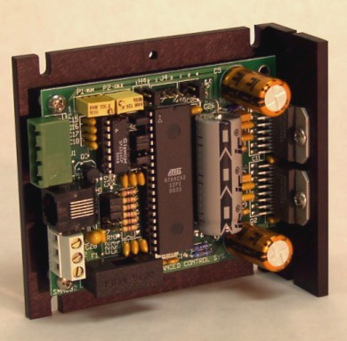
http://www.acsmotion.com/

Product | Quantity | Cost/unit | Total Cost
Stepper Motor | 2 | 60.00 | 120.00
Power Supply | 1 | 70.00 | 70.00
Dual axis Driver/Controller (SMC-32) | 1 | 800.00 | 800.00
Total Cost |  |  | $990.00
For this option will need to spend another $800.00 for the dual axis controller that is able to control 4 different motors. In addition, we will need to return the current single axis controller/driver.

Pros:
- Single integrated controller/driver
- Product currently in stock (2 days for ground shipping)
- Future upgrade to 3 axis
- Best/most professional performance for our range of motion
- No alterations to current frame
Cons:
- Expensive. Need to purchase the dual axis driver/controller for $800 + shipping. In additional, we will have to return the single driver/controller purchased from Applied Motion.
- Return shipping for the current controller
Options 3: Dual Integrated Motor Controller/Driver $730.00 + return shipping
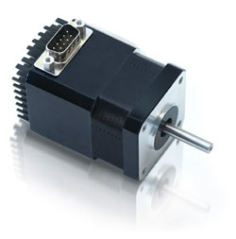
NEMA 17, 1.8º Bipolar Step Motor
Operates from +12 to 40 VDC
Phase current ranges from 0.1 to 1.5 Amps Peak
Step Resolutions of 1/2, 1/4, 1/8, 1/16, 1/32, 1/64
1.50 Amp Chopper (PWM) Driver
Two Digital I/O's and two dedicated Inputs
Execution Halt Pending a Switch
Pre-wired for Opto Switch Inputs
Homes to an Opto or Switch Closure
Fully programmable ramps and speeds
Software selectable Hold and Move currents
Stand Alone Operation with no connection to PC
Stores up to 16 different programs at once with 4 kBytes of memory
Up to 84.8 oz-in of Holding Torque

www.rmsmotion.com
Designer's Kit (KIT-01) Includes:
- RS485 to RS232 Converter Card (ACC-01)
- An Optical Sensor
- Red Switch Push Button
- Extra wiring for I/O
- CD-ROM with Software and Manuals
IMC17 has an integrated NEMA 17 Step Motor, and comes in three different sizes:
Product | Quantity | Cost/unit | Total Cost
Integrated Motor Controller/Driver | 2 | 280.00 | 560.00
Power Supply | 1 | 70.00 | 70.00
Designer Kit | 1 | 100.00 | 100.00
Total Cost |  |  | $730.00
For this option we will need to purchase 2 integrated stepper motor controller/drivers and the designer kit. This system is simple. However, due to the larger dimension of the motor, we will need to redesign the extrusion vehicle for balance.

Pros:
- Simple system
- Product in stock (7 days for ground shipping)
- Ease of programming/future use
Cons:
- Return shipping for the current controller and the stepper motors
- 2 serial ports needed
- Re-design of the extrusion vehicle to overcome the drag force introduce by the larger motor
- Slightly more expensive than option 1
Options 4: 1 single axis driver/controller for short axis, pulley for long axis

Components

Product | Quantity | Cost/unit | Total Cost
1240i Controller/Driver | 1 | 250.00 | 250.00
Power Supply | 1 | 70.00 | 70.00
Stepper Motor | 1 | 60 | 60.00
Pulley/constant speed motor/optical input | 1 | 50 (Est) | 50.00
Total Cost |  |  | $430.00

Pros:
- Least expensive
- Products in stock (4 days for ground shipping)
- Ease of programming/future use

Cons:
- Return shipping for one current stepper motor
- Low control and precision
- Low-tech POS

