ANNEX II + III: TECHNICAL SPECIFICATIONS + TECHNICAL OFFER

Contract title: Supply of Visibility items for EUAM activities

Lot 3 – VIP Visibility Items
Publication reference: EuropeAid/139860/ID/SUP/UA (EUAM-18-47)
Columns 1-2 should be completed by the Contracting Authority
Columns 3-4 should be completed by the tenderer
Column 5 is reserved for the evaluation committee
Annex III - the Contractor's technical offer
The tenderers are requested to complete the template on the next pages:
- Column 2 is completed by the Contracting Authority and shows the required specifications (not to be modified by the tenderer),
- Column 3 is to be filled in by the tenderer and must detail what is offered (for example the words “compliant” or “yes” are not sufficient)
- Column 4 allows the tenderer to make comments on its proposed supply and to make eventual references to the documentation
The eventual documentation supplied should clearly indicate (highlight, mark) the models offered and the options included, if any, so that the evaluators can see the exact configuration. Link to the web site where the description of the proposed model exists is not enough. It is obligatory to add the detailed description of specification offered.
It is also obligatory to provide samples of each of the following items listed below. Colours, dimensions of samples and the logo can be different from the colours, dimensions of items and the logo detailed below. Bidder’s samples shall effectively demonstrate the availability of the required materials and technologies to fully fulfil the requirements of the related VIP items, including custom design where needed.
Sample items submitted as part of Tenderer’s offer are to be submitted free of charge. Samples of the winning Tenderer will be retained for quality verification purposes for future deliveries; samples of unsuccessful Tenderer(s) will be returned if specifically requested by the Tenderer.
Offers that do not permit to identify precisely the models and the specifications and/or for which the samples as required above were not provided may be rejected by the Evaluation Committee.
The offer must be clear enough to allow the evaluators to make an easy comparison between the requested specifications and the offered specifications
1.  Item Number | 2.  Specifications Required | 3.  Specifications Offered | 4.  Notes, remarks,  ref to documentation | 5.  Evaluation Committee’s notes
VIP-1 | Travel case “Leather”  Size: 12 x 20 cm  Material: full grain leather  Leather laces (up to 1 cm wide) used as a fastening or 2 magnetic buttons  Various pockets: for credit cards, for a boarding pass and a passport  EUAM logo application: embossing, maximum 2 x 2 cm  Each item should be wrapped/packed individually.  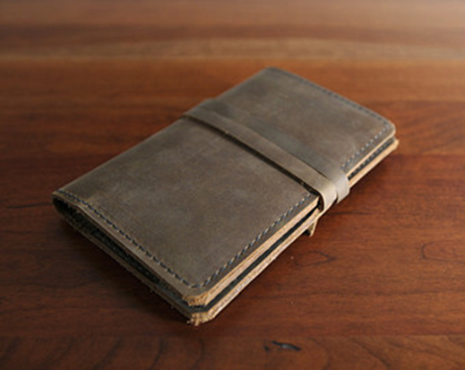
VIP - 2 | Business card case  Clam shell firm construction, covered with real leather  Suitable for standard size for business cards (8.9 x 5,1 cm)  Volume: minimum for 20 cards  Colour: cognac, black, grey, navy blue  EUAM logo application: embossing, , maximum 2 x 2 cm  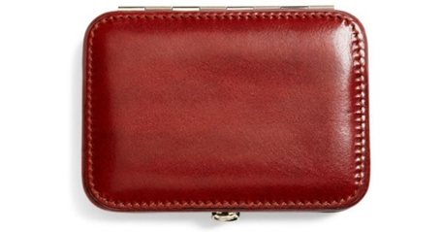
VIP-3 | Glass paperweight  Size: height – 15 cm from the base, thickness – 1 cm  Base – 11 x 4 x 2 cm  Shape: diamond  Inside: laser engraving  Individual gift box (with lodgement) for each item.  Box material: carton with a lodgment, cigarette paper and tissue paper Artelibris air bag blue navy/ Artelibris air bag blue/or equivalent.  Box printing: 2+0 silk screen printing, on the top of the box  The colour of the interior cloth is blue.  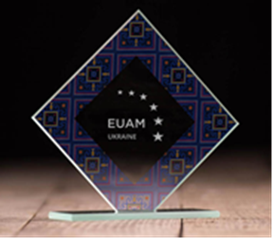
VIP-4 | Premium pen ”Parker IM” or equivalent  Fountain pen, housing made of brass and coated with matt black lacquer.  Body parts decoration and cap: chrome, stainless steel nib.  The main body and the cap engraved.  EUAM logo: engraved, located on inner part of the pen under the cap.  5 spare cartridges for each pen has to be included.  Packaging: standard gift-box that comes with a pen.  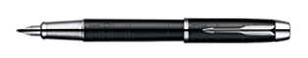
VIP-5 | Meteorological station  Size – 27.5 х11.5 х 3 cm.  Material – stainless steel, wood, glass and a brass plaque for EUAM logo  EUAM logo application: laser engraving on a plaque at one point, 8 cm x 2.5 cm +/-10%.  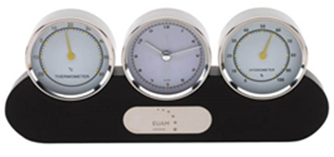
VIP-6 | Wooden plaque  Size: 210 х 150 х 20mm  Material: real wood, with a brass round plate 80 mm in diameter, width 1.5 mm.  Application: chemical etching on a medal and engraving on wood.  Each item should be packed in an individual gift box.  Box material: carton with a lodgment and tissue paper Artelibris air bag blue navy/ Artelibris air bag blue/or equivalent.  Box printing: 2+0 silk screen printing, on the top of the box, maximum 10 cm  The colour of the interior cloth is blue.  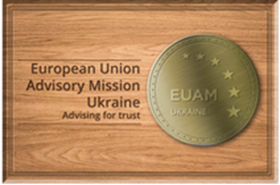
VIP-7 | Cufflinks  Size: 19 x 19 mm  Material: brass  Top: galvanic gold, cold enamel of blue colour,  Application in three layers: chemical etching,  UV printing (3+0), polymer lens  Fastening – cast fitting  Each item should be packed in an individual gift box.  Box material: carton with a lodgment and tissue paper Artelibris air bag blue navy/ Artelibris air bag blue/or equivalent.  Box printing: 3+0 silk screen printing, on the top and the sides of the box, width 3 cm  Lodgment and velvet inside of the box.  Box size: 6 x 6 x 3(H)cm  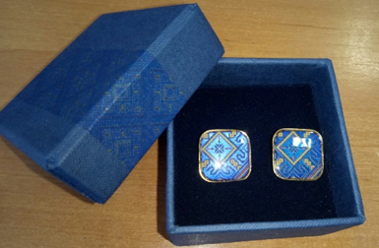
VIP-8 | Real leather business card case  Size: 94 х 62 х 15 mm  Material: real leather  Solid shell, full surface, Magnet fastening  Printing: 4+0 UV printing (ornamental, please see a pic for your reference), full surface  Each item should be delivered in an individual gift box.  Box material: carton with a lodgment and tissue paper Artelibris air bag blue navy/ Artelibris air bag blue/or equivalent.  Box printing: 4+0 silk screen printing, full surface  navy/ Artelibris air bag blue/or equivalent.  Lodgment and velvet inside of the box.  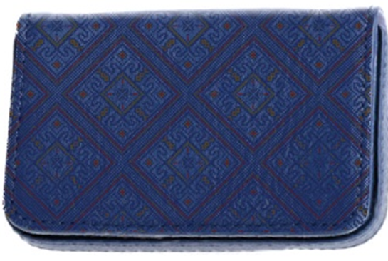
VIP-9 | Pocket mirror  Size: 84 х 95 х 10 mm  Cover material: real leather  Solid shell, Magnet fastening  Printing: 4+0 UV printing (ornamental, please see a pic for your reference), full surface  Each item should be delivered in an individual gift box.  Box material: carton with a lodgment and tissue paper Artelibris air bag blue navy/ Artelibris air bag blue/or equivalent.  Box printing: 4+0 silk screen printing, full surface  navy/ Artelibris air bag blue/or equivalent.  Lodgment and velvet inside of the box.  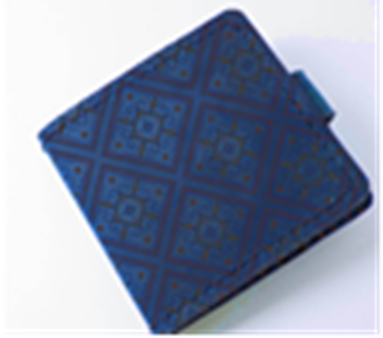
VIP-10 | Woven tie  Size: width 6cm, length 130 – 145 cm  Inner side: EUAM logo label, 1.5 (w) x 4 (l) cm  Each should be packed in an individual gift box.  Box material: carton with a lodgment and tissue paper Artelibris air bag blue navy/ Artelibris air bag blue/or equivalent.  Box printing: 3+0 silk screen printing (ornamental), on the top of the box at 1 point  Lodgment and velvet inside of the box.  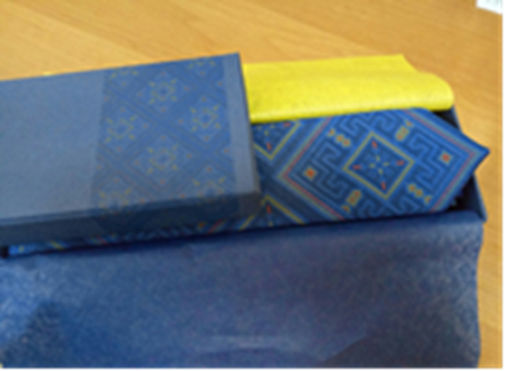
VIP-11 | Two-sided tippet, made from two clothes  Size: 40х120 cm  Satin: 85g/m2  Application: 4+0 heat transfer printing, full surface  EUAM logo label at the side stitch  Each should be packed in an individual gift box.  Box material: carton with a lodgment and tissue paper Artelibris air bag blue navy/ Artelibris air bag blue/or equivalent.  Box printing: 3+0 silk screen printing, on the top of the box at 1 point  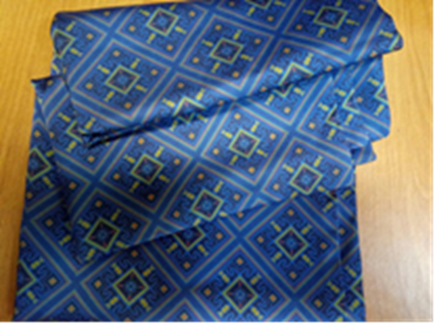
VIP-12 | EUAM medal  Size: Ø 5.5 cm, width 3mm  Material: brass  Avers: chemical etching (in accordance with a given layout)  Reverse: chemical etching (in accordance with a given layout)  Each should be packed in an individual gift box  Box material: natural wood of dark colour  Box size: 11.7 (w) x 9 (h) cm  Inner side of the box: velvet shield (2 cm2) with a brass EUAM logo (1,1 cm2) and a velvet lodgement for a medal  Application on the box: engraving 2.5 x 2.5 cm (EUAM logo)  Magnet fastening and a slider on the opposite side  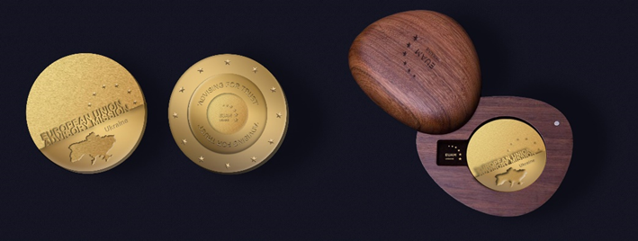

Please note that the image is an idea only and does not necessarily reflect the image of the product expected from you

