
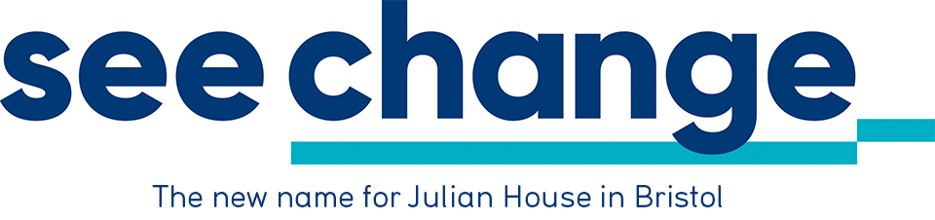

Kilimanjaro Challenge

7-15th February 2020

EVENT DETAILS

Julian House/See Change in conjunction with Natural High Safaris are organising a very special event, a trek to the 'roof of Africa' - Mt Kilimanjaro. During the five-day trek, participants will cross a variety of terrain and see some amazing flora and fauna. They'll almost certainly make some new friends and as for the views - words or pictures cannot do it justice.

Apart from being be the adventure of a lifetime, those taking part will be helping Julian House to provide support to some of the most marginalised members of society. Not just life changing support– sometimes life saving support.

Is there any climbing involved?

The Kilimanjaro Challenge offers the opportunity for any reasonably fit and healthy individual (who is prepared for some hard work) to scale a high-altitude mountain without any technical climbing. A support team of experienced guides, porters and cooks is provided, which leaves participants free to enjoy each trek, at their own pace. It is planned to hold a training/briefing weekend prior to departure.

Do I have to carry all my kit?

No. During each day of the trek, participants only carry a small day sack/rucksack. This will contain extra clothing, water bottle, sun cream etc. The remainder of their kit – sleeping bag, change of clothing etc will be taken by porters, who will also be carrying the food and other supplies.

Outline itinerary (further detail attached)

Trip duration 9 days, with 5 days spent on the mountain. During the ‘active’ phase of the trek, participants will stay two-person tents. The Marangu Hotel will be used for the remaining days.

Will I need to buy lots of special kit?

This should not be necessary. Anyone who enjoys the outdoors will have most of the important items for the event – broken in walking boots, waterproofs. A ‘three seasons’ (or better) sleeping bag will be required. A full kit list will be provided.

Will it be possible to stay on and see more of the country?

Yes. This can be arranged directly with Natural High Safaris but will incur an extra personal cost. Further details available at www.naturalhighsafaris.com

What about altitude sickness?

The reduction in oxygen higher up the mountain will affect most of the participants, to varying degrees. Shortness of breath during exertion, increased heart beat rates and headaches are mild forms of altitude sickness and are commonly encountered. However, the thrill of reaching the top and the spectacular views more than compensate for any discomfort.

What sort of people will be taking part?

Experience from previous events shows that the Kilimanjaro Challenge will appeal to all sorts of people, men and women of all ages. The average age is likely to be about 35. The team will be relatively small, between 10-15, which means that everyone will get to know each other and will probably make new friends.

How do I sign up for the Challenge?

If you have any further queries give us a call. Otherwise, all you need to do is complete the enclosed registration form and a cheque (or credit card details) to cover the required registration fee. By doing so, you are pledging to raise the minimum level of sponsorship for the event.

How easy is it to raise the sponsorship target?

Enclosed with this pack are some fundraising hints with advice and guidance on how to achieve their sponsorship target. Julian House will also be able to provide assistance and materials to help eg posters, collecting tins, sponsor forms, letters of authority, press releases etc. Events are good ways to generate support - something as straightforward as a quiz at the local pub or perhaps a car boot sale. Some people may choose to forego birthday presents and instead ask for sponsorship. Also, some companies have matching schemes, whereby they will match monies raised by employees.

Are there any other expenses?

All travel, accommodation and most meals are included within the Challenge costs. The only items not covered are a Tanzania visa (£40), travel insurance, tips for guides, drinks and other items of a personal nature.

Payment of sponsorship?

Given that all the travel costs must be paid up front by Julian House, it is an important condition of taking part that 75% of the sponsorship target is paid nine weeks before departure. The remainder of the sponsorship must be paid within five weeks of returning.

Where does the sponsorship money go?

Part of the sponsorship money raised will be used to cover the travel and other trip costs, as detailed below:

Registration Minimum Level Trip Costs
Fee of Sponsorship (Covered within
sponsorship)
£400 £3500 (£1665)

When the registration fee is paid, part of this fee will be used to cover Julian House's initial administration costs and the remainder paid to Natural High Safaris in respect of participants’ flight/travel arrangements. Julian House is acting as agents for Natural High Safaris and will issue an ATOL receipt for this payment, to confirm that this money is protected by the ATOL holder’s bond.

The outstanding tour costs will be deducted from the sponsorship money raised; the remaining sponsorship money will be treated as a donation to Julian House.

*The total trip costs are £2428 but the combination of participant’s registration fee and £363 sponsorship from a Julian House sponsor means that the net trip costs which have to be met from sponsorship raised is £1665. This in turn helps to reduce the sponsorship target for participants.

KEY CONDITIONS OF ENTRY IN ADDITION TO THOSE OF NATURAL HIGH SAFARIS

- A non refundable registration fee is required from each participant, payable to Julian House.
- In addition participants pledge to raise the minimum level of sponsorship (£3500). 75% of this must be paid nine weeks prior to departure; the remainder within five weeks of returning from the Challenge. All cheques etc should be made payable to Julian House.
- If for whatever reason these requirements are not met, places on the Challenge will be forfeited. (Any shortfall in sponsorship can be made up by a personal contribution)

Conditions of Entry - cont'd

- Where a place is forfeited all sponsorship forms and fundraising materials must be returned to Julian House. Sponsors should be advised and given the option of donating their pledges to Julian House or having them returned.
- All participants in the Kilimanjaro Challenge do so at their own risk. It is compulsory that all participants are individually insured either through the tour operator or independently. This travel insurance must cover personal accident, medical expenses and repatriation. The policy must include a minimum cover of £50,000 for medical and repatriation expenses. Please note the free insurance offered with some credit cards does not cover repatriation. If obtaining insurance independently, participants must ensure their insurer is aware of the type of travel undertaken. This cover is compulsory and is the participants’ responsibility. Policy numbers and insurers must be supplied to Julian House before departure. We also recommend that participants consult their GP.
- Participants must be aged 18 or over by the date of departure.
- All flights, timings and itinerary details may be subject to change. Transfers to and from the airport being used for the Challenge are at participants’ own expense.
- The Kilimanjaro Challenge is being organised by Natural High Safaris – ATOL 6768

