Weakening Online Security Measures with
ARP Cache Poisoning

Submitted by: Robert Bobek
Submitted to: Dr. A. K. Aggarwal
Submitted on: November 25th, 2007

TABLE OF CONTENTS

I. ABSTRACT …………………………………………………………….... 1

II. ROUTING IN ETHERNET …………...……………………………...… 1

III. EXPLOITING ETHERNET THROUGH ARP CACHE POISONING ..... 2

IV. WHAT IS DSNIFF? ……………………………………………………...… 2

V. WHAT IS THE SECURE SOCKET LAYER (SSL) PROTOCOL? ……..... 3

VI. SSL HANDSHAKE PROCESS …………………………………………… 4

VII. THE ATTACK EXPERIMENT ………………………………………....... 5

VIII. TEST ENVIRONMENT ………………...………………………………. 7

IX. NETWORK TOPOLOGY ………………………………………………… 9

X. MOUNTING THE ATTACK ………………………………………………… 9
XI. OBSERVATIONS AND CONCLUSIONS ………………………………….. 14

XII. REFERENCES …………………………………………………………….. 15

TABLE OF FIGURES

FIGURE I: SSL ATTACK …………………………………………….……… 6

FIGURE II: NETWORK TOPOLOGY ………………………………………. 9

FIGURE III: BEFORE ARP CACHE POISONING …………….…………… 10

FIGURE IV: AFTER ARP CACHE POISONING ……….………………….. 10

FIGURE V: GENERATING FAKE CERTIFICATE ..………………………… 11

FIGURE VI: CREATING HOSTS FILE FOR DNS SPOOFING ………..….. 11

FIGURE VII: CERTIFICATE PROBLEMS WARNING …………………….. 12

FIGURE VIII: CERTIFICATE PROBLEMS WARNING DETAILS ..……… 13

FIGURE IX: GREP OUTPUT FROM 'DECIPHERED' FILE ..…………….. 14

I. ABSTRACT

Ethernet is the most popular LAN technology utilized in today’s computing environments. However, it was originally designed with no security in mind and therefore it suffers from malicious attacks that can severely compromise user security. Since the advent of online banking, shopping and auctioning, putting you credit card number or other confidential information through the Internet has been a major concern.

Since 1994, cryptography technologies have emerged to mitigate the security problems that Ethernet or the Internet in general was exposed too. For example, SSL/TLS was introduced to provide secure end-to-end point web transactions. Although we have these security measures in place, unfortunately, because the way Ethernet was designed, it is still possible to break this security.

This paper will focus on ARP cache poisoning, a very old attack that is still effective today. ARP cache poisoning can provide an Attacker a foundation to mount further dangerous attacks. Ultimately, in combination with open-source tools and ARP cache poisoning, I will demonstrate how to break an SSL connection between a Client and a remote destination and as a result, be able to capture the user login credentials.

II. ROUTING IN ETHERNET

Data exchanged within an Ethernet network is accomplished through Link Layer Routing. An Ethernet switch will forward Ethernet frames to the corresponding Node on the network using the ARP table. The ARP table within an Ethernet switch contains a relational mapping of each nodes IP address and its corresponding MAC address as well as the port they are associated to on the switch. Therefore, when a Packet comes to an Ethernet network, the switch will examine the IP datagram to determine which node it is destined for. The switch accomplishes this by retrieving the MAC address in which the IP address is associated with, and then it determines the port that the MAC address belongs to. Finally, using all this information, the switch forwards the frame to the corresponding Node.

In the event that an IP Datagram comes to an Ethernet network and the ARP table does not contain a mapping for a specific IP address, the Address Resolution Protocol (ARP) is used to solve this problem. The switch will send out an ARP request through each port on the switch, tagged with the IP address that it is looking for. When each Node on the network receives the ARP request, only the Node configured with the IP address requested will reply; otherwise the ARP request is discarded by each node. The reply is an ARP reply type message containing the nodes IP and MAC address. The ARP reply will tell the Ethernet Switch there exists a node on the network configured with the requested IP Address. At this point, the Ethernet switch will make the corresponding updates in the ARP table and forward the last request to it. Note, each Node on the network also contains an ARP cache of IP-to-MAC relationships of every other node on the network. All Nodes will also send out ARP Request broadcasts if its ARP cache does not contain a mapping for a specific IP Address.

III. EXPLOITING ETHERNET THROUGH ARP CACHE POISONING

Ethernet by design does not use any form of ARP Request/Reply authentication which is primarily the reason why Ethernet has become vulnerable to attacks like Man-in-the-Middle. A Man-in-the-Middle attack is when an Attacker injects themselves logically between two communicating nodes, commonly a Gateway (the switch) and a PC. This can easily be accomplished by manipulating the Ethernet switch ARP table and a Victim’s ARP cache by sending these Nodes spoof ARP replies, otherwise the process known as ARP Cache Poisoning.

If the Attacker sends a spoof ARP reply to the Ethernet Switch indicating that its MAC address belongs to an IP address of another machine, the switch would accept the reply and update the corresponding ARP table entry. This means any traffic that was originally destined for a certain machine on the network will now be forwarded to the Attacker’s machine. The same can be accomplished with a Victim. An Attacker can send spoof ARP reply’s to a Victim that would indicate the Attacker’s MAC Address associated with the Gateways IP Address. Now, whenever the Victim sends data to the Gateway IP Address, the Attacker’s MAC Address is used and therefore the data will be forwarded to the Attacker’s machine.

Other then Authentication being the problem of Ethernet’s design, ARP reply’s do not have to be paired with ARP requests. The Attacker can continuously send spoof ARP reply’s to the two victim nodes to maintain its position in the middle without waiting for ARP requests.

IV. WHAT IS DSNIFF?

dsniff is a collection of security tools directed at layer 2 switching. Each tool can perform a unique attack at layer 2, some of which include ARP Cache Poisoning, DNS Spoofing and password sniffing.

We’ll look at several of the tools (but not all) included in dsniff and provide a brief overview of what each tool can accomplish.

Note: any command marked with * requires arpspoof to be mounted first.

arpspoof

arpspoof is a tool that easily aids the process of conducting a Man-in-the-Middle Attack. Its usage only requires two parameters. For example;

arpspoof –t 192.168.1.1 192.168.1.103

Using this command, arpspoof will tell 192.168.1.1 (the gateway) that our MAC address belongs to IP Address 192.168.1.103 (which in fact does not).

*dsniff

dsniff is an advanced password sniffing tool. What makes this tool interesting is that it will only filter out passwords to the screen as apposed to other sniffing tools that will also output other packet info. Note, this tool will only sniff out passwords from protocols that don’t encrypt the communication stream, such as POP, IMAP and FTP.

*webspy

webspy is capable of listening for HTTP connections and reconstructing all HTML data on the Attackers browser. This allows you to visually see where the victims are navigating to on the Internet.

*dnsspoof

dnsspoof forges DNS replies. An attacker can create a file that will list IP Address to DNS name relationships in which dnsspoof can then use to make corresponding forged DNS replies.

*filesnarf

filesnarf sniffs for Network File System (NFS) traffic and can re-construct any data passed through the Attackers machine. You can also use filters with filesnarf so that for example, only .mov and .wmp filetypes are captured.

*webmitm

webmitm is one of two tools included in this toolkit that can really create problems for victims. It is used to sniff out SSL traffic between two Nodes. When webmitm is executed, it runs an HTTP and HTTPS proxy. It also goes through the process of creating a fake SSL certificate. Using webmitm in conjunction with dnsspoof, we can re-direct our Victim to our HTTPS proxy and relay his/her traffic from our proxy to the intended destination.

V. WHAT IS THE SECURE SOCKET LAYER (SSL) PROTOCOL?

The Internet has become a popular source for banking, shopping, auctioning and other services like this. Therefore it has become necessary to have our banking or other confidential information protected during transit through the public network.

Secure Socket Layer has become a standard technology used in the industry to achieve confidentially, integrity and authentication while transmitting data from one computer to another through the Internet.

SSL can be paired with a variety of unsecured protocols like POP, SMTP, LDAP but commonly it used for HTTP. SSL in it simplest form works by using an encryption key to encrypt all communication data before it is sent off to the public network and then the corresponding recipient uses a decryption key to decrypt and process the data.

SSL uses both asymmetric encryption and symmetric encryption. The two types are defined below;

Asymmetric Encryption

There exist two keys, a public and private key. The public key is made public for the world and can only be used to encrypt messages. The private key is kept secret and is used to decrypt messages encrypted by the corresponding public key. Although these keys are mathematically related, there is no practical way of deriving the private key from the public key.

Symmetric Encryption

The same single key is used for both encryption and decryption.

SSL also uses digital certificates for server authentication, specifically X.509 certificates. Digital certificates will confirm the identity of the owner that you are trying to establish a connection with and also to attest that the public key you are to use in fact belongs to the owner as well. In summery, digital certificates prevent Servers from impersonating false entities. A valid certificate will give the customer reassurance that they are sending their personal information to the intended destination securely.

Digital certificate are issued from a certifying authority (CA) that are willing to vouch your identify as a legitimate business or company. For example, if abc.com wants to enable SSL on there website, they must apply for a certificate by filling out a certificate signing request (CSR), containing details about their domain and organization and also attaching to it, their public key (in which is automatically created, along with the private key during this process). The CA will validate their details by determining things like whether they have control over the domain they specified in the CRA or if there business is listed in the public governments records. If the validation passes, the CA will issue them a certificate containing abc.com’s details, as well as the issue and the expiry date.

VI. SSL HANDSHAKE PROCESS

The SSL handshake is a sequence of exchanged messages taking place in order to establish a SSL session. The following outlines this procedure;

1. When a client connect to a secured URL (indicated by “https://” rather than “http://), the webserver automatically presents the clients browser with the website certificate.

2. The client’s web browser will decide whether to accept the certificate or not. This step is usually transparent to the user if the certificate is legitimate but if the certificate has problems, it will warn the user and give the user the choice to whether or not accept to the certificate. A certificate will not have problems if the following requirements are met;

I. The certificate is currently valid and not expired
II. The certificate was signed by a trusted certificate authority
III. The common name on the certificate matches the DNS name of the server.

3. If the web browser accepts the certificate automatically or if the client accepts the certificate when presented the warning message (if it is a bad certificate), the client will then generate a random symmetric key, encrypt it using the website’s public key and transfer it to the web server.

4. When the server receives the clients encrypted message, it will decrypt it using its private key. At this point, both the client and the website know the symmetric keys and from this point forth, data encryption and decryption are achieved using these symmetric keys.

VII. THE ATTACK EXPERIMENT

The attack experiment will demonstrate how a man-in-the-middle attack in combination with dsniff tools can be mounted together to retrieve the credentials from a Secure Socket Layered Connection.

We will conduct this attack against our Victim and the University of Windsor Student Webmail Service, https://webmail1.uwindsor.ca .

The methodology behind this attack works as follows;

1) The Attacker becomes the man-in-middle between the Victim and the Gateway using arpspoof.

2) Using webmitm, the Attacker creates a fake SSL certificate. The certificate is attached to the HTTPS proxy that also starts when webmitm is executed.

4) dnsspoof will be running on the Attacker's machine to ensure that all DNS replies to webmail1.uwindsor.ca are to be re-directed to the Attacker's IP Address. As well, Wireshark will be used to capture all packets on the wireless interface to a local dump file.

5) Now, when the Victim navigates to https://webmail1.uwindsor.ca, the traffic is re-directed to the Attackers HTTPS proxy. At this point, the fake certificate will interject in the data stream. The Victim's browser will prompt him/her to either Accept or Reject the certificate. We must rely on the user to click on Accept, otherwise this method will not work.

6) If the Victim accepts the certificate, the Attacker's proxy will retrieve the SSL traffic and relay it to the intended destination. Essentially, two separate SSL tunnels are created; one that sits between the Victim and the Attacker's proxy and the other that sits between webmail1.uwindsor.ca and the Attacker's machine.

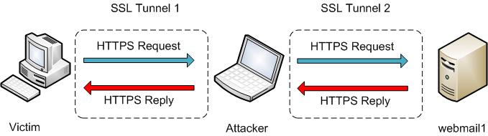

Figure I: SSL Attack

7) As the Victim authenticates against webmail1.uwindsor.ca, the Attacker is capturing this data in a dump a file. Since the packets are captured at the Data Link Layer, packets will be encrypted because of SSL.

8) Using SSLdump, the Attacker will be able to decrypt this dump file. This is possible since the Victim used our fake certificate and also that fact that we know the symmetric key. The Attacker will use SSLdump with the combination of our keyfile to get this job done.

9) Because the decrypted dump file will have a large amount of data, the Attacker will use a Unix utility by the name of ‘grep’ to parse through the data and look for specific strings like ‘pass’ or ‘password’ or ‘login’

VIII. TEST ENVIRONMENT

Hardware Details:

Home Router/Switch:
- Linksys WRT54GS-CA Wireless-G Broadband Router with SpeedBooster
- 4-port 10/100Mbps switch (ports running at 100Mbps)
- Set to Wireless G-Mode
- MAC: 00-1A-70-F9-3E-3D

Victim Computer:
- Athlon XP 2400+ (Desktop)
- 512MB RAM
- Integrated 10/100 Mbit Network Card (running at 100Mbps Full Duplex)
- Windows XP Professional 5.1.2600, Service Pack2 (not fully updated)
- MAC: 00-50-8D-FB-0E-A7

Attacker Computer:
- HP Pavillion DV 1170CA (Laptop)
- 512MB RAM
- Intel 2200 PRO/WirelessBG (running at 100Mbps Full Duplex)
- MAC: 00-0E-35-D7-AD-2C

Software Details

Attacker’s Computer:

Operating System: Ubuntu 7.04

Software: dsniff
Version: 2.4 Beta1 (released May 27, 2002)
Source: http://monkey.org/~dugsong/dsniff/

Description: (Described above)

Software: SSL Dump
Version: 0.9 Beta 3
Source: http://www.rtfm.com/ssldump/

Description: An SSLv3/TLS analyzer.

Software: Wireshark
Version: 0.99.6a
Source: http://www.wireshark.org/

Description: A free packet sniffer utility used for many purposes. Such include network troubleshooting, network auditing, protocol development/analyzing and education.

Software: grep
Version: 2.5.1
Source: Installed with Ubuntu

Description: A UNIX utility that performs a search on given text and will output the lines matching a specific search pattern or regular expression.

Victim’s Computer

Operating System: Windows XP Professional 5.1.2600, Service Pack2 (security
updates fully updated)

Software: Internet Explorer v6
Version: 6.0.2900
Source: Included with Windows XP

IX. NETWORK TOPOLOGY

The following diagram is a network topology of the test environment. The wireless access point will consist of two computers, one wired and the other wireless

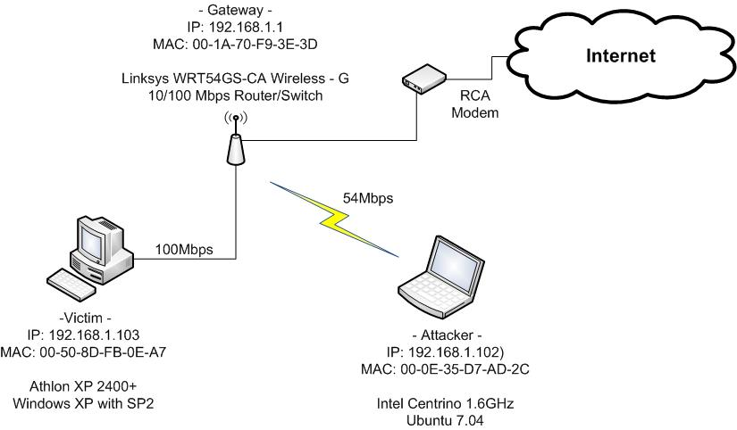

Figure II: Network Topology

X. MOUNTING THE ATTACK

Before we begin the, we must enable IP Forwarding on the Attacker's machine. This will ensure that while we become the man-in-the-middle, we forward all traffic between the Victim and the gateway so that the Attacker does not disrupt there communication.

Since we need to have root access to enable IP Forwarding, the Attacker will need to execute;
sudo –i

and then enter the root password. Now that Attacker has root privileges, we enable IP Forwarding by executing;

echo "1" > /proc/sys/net/ipv4/ip_forward

Also, when the dsniff package was installed, it created a folder with some of its config file in the /usr/share/dsniff, so we will begin from there.

Now we begin the attacking process.

1. The Attacker must first perform a man-in-the-middle attack using arpspoof to aid the ARP cache poisoning process. The following command are executed,

sudo arpspoof -i eth1 -t 192.168.1.1 192.168.1.103

sudo arpspoof -i eth1 -t 192.168.1.103 192.168.1.1

The first command says, use the wireless interface (eth1) and tell our target (-t), the gateways, that the Attackers MAC Address belongs to the 192.168.0.3 IP Address

The second command says, use the eth1 interface and tell our target (-t), the Victim, that the Attacker's MAC Address belongs to the 192.168.1.1 IP Address.

We have now logically injected ourselves in the middle of the Victim's and Gateway’s data stream. To prove this, here is a snapshot of the before and after ARP cache table on the Victims machine.

Before ARP Cache Poisoning:

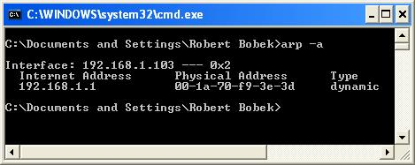
Figure III: Before Arp Cache Poisoning

After ARP Cache Poisoning:

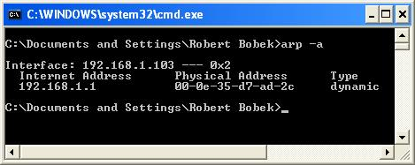
Figure IV: After Arp Cache Poisoning

2. We will now use the webmitm tool. This tool can be executed using the command;
webmitm –d
If this command was executed for the first time, it will go through the process of creating a fake SSL certificate using the OpenSSL binaries. The Attacker will answer the prompts as accurately as possible to make the certificate as convincing as possible.

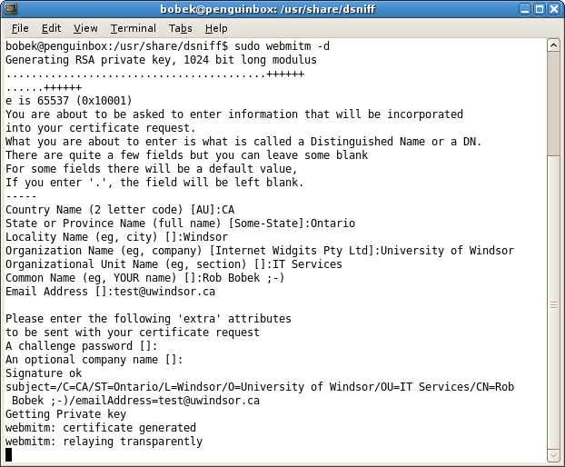
Figure V: Generating Fake Certificate

When the fake certificate is complete, webmitm will also start an HTTP and HTTPS proxy running on ports 80 and 443, respectively.

3. The next stage in the attack is to setup dnsspoofing so that when the Victim connects to https://webmail1.uwindsor.ca, the Victim is redirected to our HTTPS proxy. The Attacker will create a file called hosts (any name can be used) in the current directory in which will be used to associates DNS names to particular IP Addresses. The followings illustrates this,

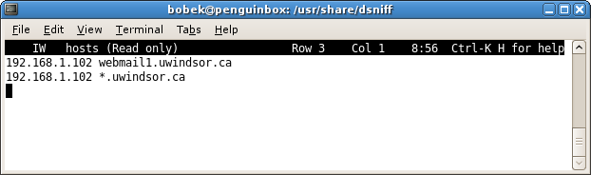
Figure VI: Creating Hosts File for DNS Spoofing

Since we are specifying *.uwindsor.ca, we are actually redirecting all *.uwindsor.ca traffic to the Attacker's machine. Normally this is not a good idea since we essentially only want traffic destined for webmail1.uwindsor.ca. The Attacker will then execute dnsspoof like so;

sudo dnsspoof -i eth1 -f hosts

This means, run dnsspoof on interface eth1 and use the file (-f) hosts for DNS-to-IP resolution.

4. At this point, the Attacker will execute Wireshark to capture all traffic between the Victim and *.uwindsor.ca. In the 'Capture Options', the Attacker will select to listen on the eth1 interface and under 'Capture File', the Attacker will specify 'ciphered.pcap' as the filename to capture all packets.

5. Everything is in place and now we will navigate to webmail1.uwindsor.ca on the Victim's machines. When this is done, the Victim's browser will prompt him or her with this message;

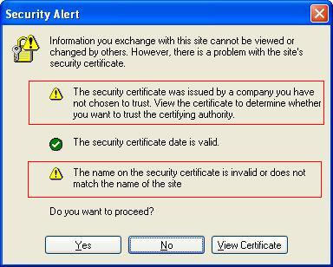
Figure VII: Certificate Problems Warning

The message clearly indicates that there is something wrong with the certificate that the Victim was presented with. In fact, the prompt indicates the exact reasons;

1) The security certificate was issued by a company you have not chosen to trust. View the certificate to determine whether you want to trust the certifying authority.

2) The name on the security certificate is invalid or does not match the name of the site.

Viewing the certificate details will show us this;

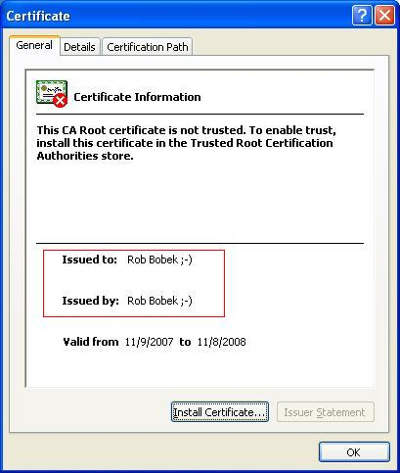
Figure VIII: Certificate Problems Warning Details

Clearly, by viewing the details of the certificate, it does not look legitimate. Although, the Attacker could have made this look more convincing, this information was inputted for fun for the purpose of our demonstration and to show that the certificate was in fact manufactured by the Attacker.

6. At this point, the Attacker shuts down Wireshark and begins to analyze the packets. However, because the packets are encrypted, SSLdump can be used in combination with the ciphered pcap file and keyfile to decrypt the data.

ssldump -r ciphered -k webmitm.crt -d > deciphered

This tells SSLdump to take the capture packets (-r) and use the webmitm.crt as the keyfile (-k) and decrypt (-d) the contents into 'deciphered' file.

7. 'deciphered' will contains a large amount of plaintext data. That Attacker will use the UNIX utility grep to conveniently search for typical words that would likely output something important. The Attacker will execute;

cat deciphered | grep -A 5 -B 5 Pass

Cat will output the contents of 'deciphered' into the terminal. However, using grep as the filter with parameters -A 5 -B5 Pass, if the word Pass is matched anywhere in the contents of the file, output the line that contains the word Pass and the five lines before and after it.

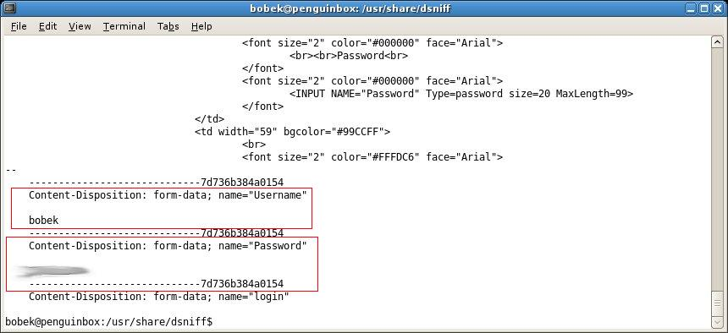
Figure IX: Grep output from 'deciphered' file

The word Pass was found along with the credentials to webmail1.uwindsor.ca.

XI. OBSERVATIONS AND CONCLUSIONS

Secure Socket Layer is a protocol that contains a suite of strong cryptographic ciphers to protect and secure data during transmission into the public network. Although, we were successful in retrieving the victim’s credentials to a secured website, we are not actually breaking the encryption itself. We are simply misleading the victim into believing that we were the trusted source by acting as a proxy to the real source and therefore tricking the victim’s browser into giving us the symmetric keys. This attack is also only possible if the attacker was on the same network as the Victim and was able to manipulate the ARP caches on the Switch and the Victim to create a man-in-the-middle environment.

Using tools like ArpWatch will monitor MAC/IP associations and can send alerts if it notices suspicious activity. Also, this attack really relies on the victim. Since the Attacker is using a bogus certificate, if the user doesn’t decide to accept the certificate at the warning message prompt, then the attack will not be successful. However, because the majority of web users are careless, they accept any prompts/warnings they encounter on the Internet without realizing what the possible implications are, making this attack very possible even today.

XII. REFERENCES

[1] Burkholder, Peter. “SSL Man-in-the-Middle Attacks”. Sans Institute 2002.
February 1, 2002 (v. 2.0)
URL: http://www.sans.org/reading_room/whitepapers/threats/480.php

[2] M.S. Bhiogade. “Secure Socket Layer”. June 2002.
URL: http://www.informingscience.org/proceedings/IS2002Proceedings/papers/Bhiog058Secur.pdf

[3] “Network Security – Authenticating through SSL”. IBM.
URL:
http://publib.boulder.ibm.com/infocenter/cicstg/v6r1m0/index.jsp?topic=/com.ibm.cics.tg.doc/cclai/cclaim0008.htm

[4] “What is SSL”
URL: http://info.ssl.com/article.aspx?id=10241

[5] “Introduction to Secure Sockets Layer”. Cisco.
URL:
http://www.cisco.com/en/US/netsol/ns340/ns394/ns50/ns140/networking_solutions_white_paper09186a0080136858.shtml

[6] “Arp Message Format”
URL:
http://www.h3c.com/portal/Products___Solutions/Technology/IPv4___IPv6_Services/ARP/200701/195560_57_0.htm

[7] ”Arp Cache Poisoning”
URL:
http://www.grc.com/nat/arp.htm

[8] “DSNIFF”
URL:
http://codeidol.com/security/anti-hacker-tool-kit/Sniffers/DSNIFF/

