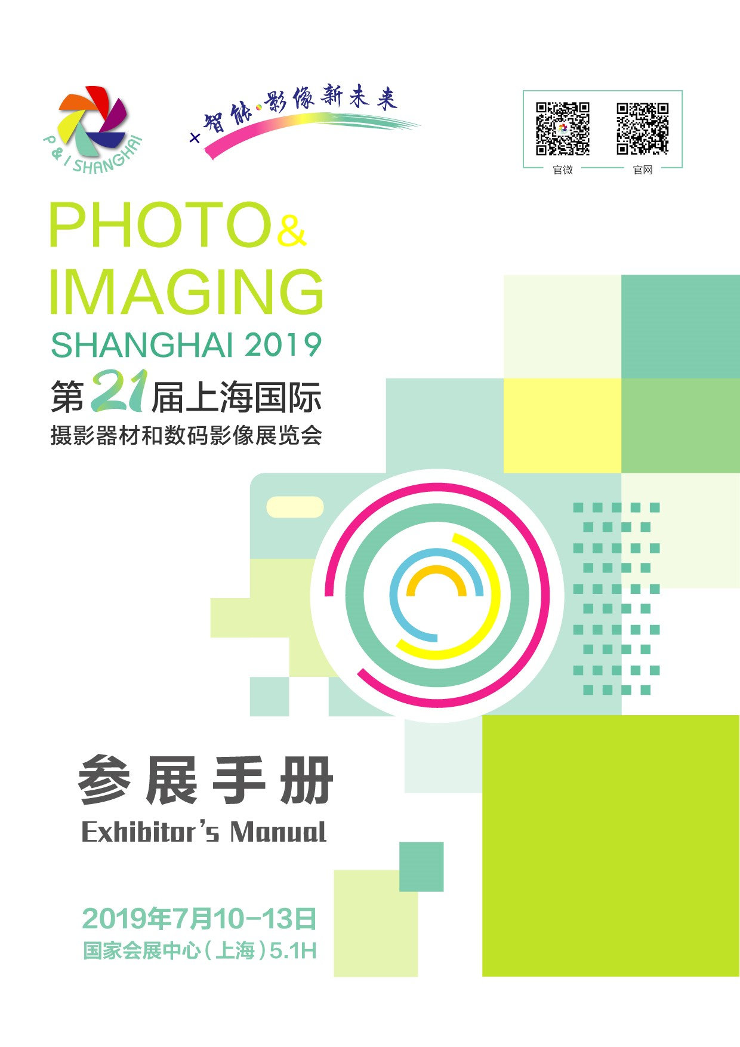
Directory
Content |  | Compulsory | Deadline | Page
Foreword |  |  |  | 3
Letter of Safety Responsibilities |  |  |  | 4
Schedule of Event |  |  |  | 5
List of Contacts |  |  |  | 6
About NECC |  |  |  | 7
Transportation |  |  |  | 8-9
Facilities Around NECC |  |  |  | 10-11
General Information |  |  |  | 12-13
Rules & Regulations |  |  |  | 14-20
Fire Control Safety Requirement |  |  |  | 21-25
Safety in Working Requirement |  |  |  | 26-28
Instructions for Stands with Special Decoration for Exhibitors and Constructors |  |  |  | 29-33
Instructions for Standard Stands for Exhibitors |  |  |  | 34-35
Technical Information |  |  |  | 36
Shipping Guidline |  |  |  | 37-39
Index of Forms
1 | Registration for Official Catalog | ☆ | 10 Jun. 2019 | 41
2 | Delegation List | ☆ | 10 Jun. 2019 | 42
3 | Building Approval for Special Stand Design | ☆ | 10 Jun. 2019 | 43
4 | Seminar Application |  | 10 Jun. 2019 | 44-45
5 | VIP Visitors Invitation |  | 10 Jun. 2019 | 46
6 | Catalog Advertisement |  | 10 Jun. 2019 | 47
7 | Onsite Advertisement |  | 10 Jun. 2019 | 48-50
8 | Hotel Reservation |  | 10 Jun. 2019 | 51
9 | Company Name For Stand Fascia | ☆ | 10 Jun. 2019 | 52
10 | Additional Furniture Rental |  | 10 Jun. 2019 | 53
11 | Additional Electrical Rental |  | 10 Jun. 2019 | 56
12 | Power Supply For Lighting Rental | ☆ | 10 Jun. 2019 | 57
13 | Equipment & Fittings Rental | ☆ | 10 Jun. 2019 | 58
14 | Service Location Plan | ☆ | 10 Jun. 2019 | 59
15 | Booth Construction Service | ☆ | 10 Jun. 2019 | 60
16 | Invitation Letter Application |  | 10 Jun. 2019 | 61
 | Notice for exhibitors registration |  |  | 62

Foreword

Dear Exhibitor:

Welcome to the Photo & Imaging Shanghai 2019!

This is your personal copy of the Exhibitors’ Manual, which has been carefully compiled to assist you in your preparation for the event. We recommend a careful study of its content to ensure that the Photo & Imaging Shanghai 2019 will be a successful experience for your company. The manual will provide you with information required for the preparation of your exhibition stand. General guidelines, marketing aides and useful addresses are also included in the manual.

The “Index of Forms” lists every individual form included in the manual and shows you which forms are compulsory to return. The other forms are for your attention and completion where necessary.

Please send us the order forms by the stipulated deadlines so that we can ensure that the services you require are arranged before the exhibition. Do remember to make a copy for your own reference.

We look forward to welcoming you at the Photo & Imaging Shanghai 2019!

Best Regards

Organizing Committee
May, 2019



SHANGHAI INTERNATIONAL EXHIBITION CO. Ltd
ADD.: No.10 Building, HONGQIAO ZHENRO Center, 666 Shenhong
Road, Shanghai, China(201106)
Tel: 021-62792828
Email: interphoto@siec-ccpit.com

Letter of Safety Responsibilities

The Photo & Imaging Shanghai 2019 is scheduled to be held during Jul. 10-13, 2019 at NECC. In order to guarantee the general safety of the exhibition, all exhibitors must undertake the following responsibilities during the move-in, move-out and the show periods.
- Strictly abide by all the relevant laws, rules and regulations concerning production safety, fire work and labor protection issued by Shanghai Municipality, and production safety, fire and labor protection organizations in charge and make sure to accept their supervision and administration.
- Strictly abide by all the safety and fire management regulations and requirements set up by the organizers, NECC, and carry out safety protection measures to guarantee safety.
- Instruct the employed freight forwarders, contractors and other agents to strictly abide by all the relevant laws, rules and regulations concerning production safety, fire work and labor protection issued by Shanghai Municipality and production safety, fire and labor protection organizations in charge, and also to strictly abide by all the safety and fire management regulations and requirements set up by the organizers, NECC and carry out safety protection measures.
- Responsible for the education of exhibitors’ own staff on production safety and to supervise and urge them to abide by relevant operation safety codes and regulations and take necessary safety precaution and fire prevention measures accordingly.
- Responsible for daily inspection and supervision of exhibitors’ own booths, and deploy fire-extinguishing equipment accordingly and appoint special personnel to carry out safety prevention.
- Strictly abide by rules and regulations concerning fire prevention and explosion prevention, and ensure that all construction materials don’t include flammables and explosives such as spandex prohibited by the fire bureau, flammable materials such as wood structure and etc. must be fireproofed. Make sure that all the staff doesn’t smoke in the exhibition halls. Make sure that flammables, explosives such as paint, lacquer thinner, xylem and etc. don’t enter into the exhibition halls. Make sure that open fire, heaters and welding are not made use of in the exhibition halls. Make sure that not used are those building materials and facilities eliminated according to the state orders.
- Make sure that no materials may be stored in the fire lanes to guarantee the fire lanes and safety exits and public passages remain clear and unobstructed.
- Make sure that booth construction and dismantling are not subcontracted to the unlicensed units with no legal person right.
- Make sure that exhibitors’ staff’s personal safety and property safety are taken good care of.
- In case the exhibitor or exhibitor’s staff don’t abide by or don’t strictly abide by the above regulations, the exhibitor would bear all the legal liabilities and compensate for economic losses.

Shanghai International Exhibition Co., Ltd
May, 2019
Schedule of Event

Build-up Period | Date | Time
Exhibitor Nominated Contractor Move-in | Jul. 08th, 2019  Jul. 09th, 2019 | 09:00 – 18:00  09:00 – 22:00
Official Stand Contractor Move-in | Jul. 08th, 2019  Jul. 09th, 2019 | 13:00 – 18:00  09:00 – 22:00
During the build-up period, exhibitors who require extra working hours must submit applications before 15:00 to the onsite operational department of NECC.
Exhibitor Registration (Raw Space) | Jul. 08th, 2019  Jul. 09th, 2019 | 09:00 – 18:00  09:00 – 20:00
Exhibitor Registration (Package Stand) | Jul. 08th, 2019  Jul. 09th, 2019 | 13:00 – 18:00  09:00 – 20:00
All exhibitors must produce a copy of the signed contract when registering for exhibitors’ badges at the registration counter.
Exhibition Period | Date | Time
Opening Hours of Exhibition for Exhibitors | Jul. 10th, 2019  Jul. 11th-12th, 2019  Jul. 13th, 2019 | 08:30 – 18:00  08:30 – 13:00  08:30 – 16:00
Opening Hours of Exhibition for Visitors | Jul. 10th, 2019  Jul. 11th-12th, 2019  Jul. 13th, 2019 | 09:00 – 17:00  09:00 – 17:00  09:30 – 15:00
Dismantling Period | Date | Time
Electricity Cutting-off | Jul. 13th, 2019 | 15:30
Exhibits Move-Out and Stand Dismantling | Jul. 13th, 2019 | 16:00 – 22:00
The Move-out Notice will be handed out to all exhibitors’ booths on Jul.12th, 2019. Exhibitors must produce the Move-out Notice and Exhibitors’ Badges to apply for Cargo Release at the onsite service counter after 15:00. During the Move-out Period, exhibits must be moved out before booth material.

Notes:
- All exhibitors must construct and decorate their stands before 20:00 on Jul. 09th 2019. Cleaning of the exhibition hall commences from 19:30, and no construction or decoration is permitted during hall cleaning.
- Exhibitors who require exceptions from this rule must obtain written permission from the Organizer.
- Stand dismantling starts at 16:00 and ends at 22:00 on Jul.13th, 2019. Additional fees are required if overtime.

List of Contacts

Organizer | Official Freight Forwarder
Shanghai Int’l Exhibition Co. Ltd  Add: No.10 Building, HONGQIAO ZHENRO Center, 666 Shenhong Road, Shanghai, China(201106)  Tel: +86 - 21 - 6279 2828  Fax: +86 (0)21 65455124  Website: www.interphoto.com.cn  E-mail: interphoto@siec-ccpit.com  Contact: Ms. Lina Zhang / Ms. Sandy Sun / Mr. Wang Yunmin | Shanghai Expotrans Ltd.  Unit 605-608, No.555 An Yuan Road, Shanghai,200040,China  Tel: +86 - 21 - 6013 1850  Fax: +86 - 21 - 6217 9788  E-mail: yangwenjun@xptrs.com.cn  Contact: Ms .Yang Wenjun Mr. Pan Feng
Official Stand Contractor | Stand Decoration Contractor
Shanghai Arts & Sales Exhibition Service Co.,Ltd.  Room1212, Shanghai Modern Traffic  & Commercial Plaza No 218, Heng Feng Rd,  200070, P.R.China  Tel.:+86 -21 - 5127 6786  Fax: +86 - 21 - 5127 6799  E-mail： artsales@163.com  Contact：Ms.Vicky Wang | Shanghai Yizhan Exhibition Service Co., Ltd  Add: Room 305 No.10 Building, Ruri Commercial Park, 3855 Shangnan Road, Pudong District,Shanghai, China  Tel: 18918965058/+86 (0)21 5058 0765  Email: 396817299@qq.com  Contact: Ms. Amiee Zou
Official Travel Agent
Shanghai Dahua Exhibition & Conference Corp. Ltd
Add: No.10 Building, HONGQIAO ZHENRO Center, 666 Shenhong Road, Shanghai, China(201106)
Tel:+86- 21- 6279 28288*231/282
Fax:+86- 21- 6547 2403
Email: dahua@siec-ccpit.com
Contact: Ms. Windy Yu

About NECC
NECC, National Exhibition and Convention Center (Shanghai), is a large exhibition center co-built by Ministry of Commerce of China and Shanghai Municipal Government, with a total construction area of 1.47 million square meters, among which 1.27 million square meters are above ground. It consists of exhibition halls, the NECC Plaza, office buildings and a high-end brand hotel, offering services concentrating exhibition, convention, events, commerce, office work and accommodation.
The facade of the NECC building draws inspiration from a mellow and auspicious “four-leaf clover” with the Commercial Plaza acting as the central core and the exhibition halls as the leaves. Blending with many Chinese elements and design concept of symmetry axis layout, it is one of the landmark buildings in Shanghai.
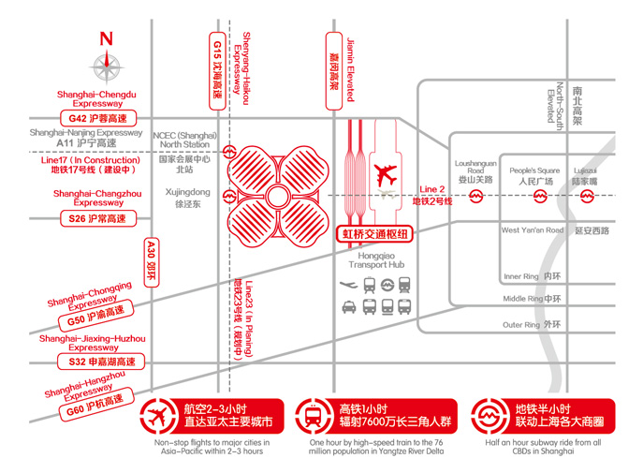

Address: No.333 Songze Avenue, Qingpu District, Shanghai (North Entrance)
No. 1888 Zhuguang Rd, Qingpu District, Shanghai (West Entrance)
Website: www.neccsh.com

Transportation

By Plane
NECC is only 1.5km away from the Hongqiao airport and 60 km away from the Pudong airport Both of them can be reached by the Metro Line 2.

By Train
NECC is only 1.5km away from the Hongqiao Railway Station and it can be reached by the Metro Line 2.
NECC is 25km away from Shanghai Railway Station and 23km from Shanghai South Railway Station. People can take Line 1 to the People `s square Subway Station and then transfer to Line 2 to get to NECC

By Bus
Bus NO.865:Go to 3 Subway Station of Shanghai Zoo, Caohejing Development Zone, and jinjiang amusement Park
Bus NO.706:Go to Jiuting Subway Station
Bus NO.776:Go to Ziteng Rd Subway Station, Zhongshan Park Subway Station

By car
1.From downtown Shanghai direction:
1.1Elevated Road Line
From Yan`an Elevated Rd and the South of Outer Ring: Jiamin Elevated Rd-Jianhong Elevated Rd-East Yinggang Rd-the designated areas of NECC
From Beidi Elevated Rd and the North Outer Ring:Jiamin Elevated Rd-Songze Elevated Rd-Panlong Rd Off-ramp -Longlian Rd-Zhuguang Rd-the designated areas of NECC
1.2Ground Line
From Beidi Rd/West Tianshan Rd/West Xianxia Rd: Shenchang Rd/Hua xiang Rd-Songze Avenue-Zhuguang Rd-the designated area of NECC
From Yan`an Rd: West Yan`an Rd-Huqingping Highway-Zhuguang Rd-the designated areas of NECC
2.From Yangtze River Delta direction
The passenger flow from Hangzhou, Ningbo, Suzhou can respectively come together from expressway G60, G2 and so on, to G15 shenhai expressway-Songze Ave.off-ramp-Songze Ave.-the designated areas of NECC, or Songze Ave.-Zhuguang Rd-East Yinggang Rd-the designated area of NECC.

Facilities Around NECC(Shanghai)

Supermarket near the NECC(Shanghai)：
◆ Hualian GMS Shopping Center（No. 960 Shenbin Road, 3 km from the NECC）
◆ Carrefour（Xujing） （No. 1829 Huqingping Highway, 4 km from the NECC）

Catering industry and commercials near the NECC(Shanghai):
◆ THE HUB (Shaoxing Road/Shenchang Road, 2.5 km from the NECC)
◆ Longfor Hongqiao Tianjie (No. 869 Shenchang Road, 2.5 km from the NECC)
◆ Carrefour Plaza (No. 1829 Huqingping Road, 4 km from the NECC)

Bank near the NECC(Shanghai):
◆ Bank of China (No. 1199 Ning Hong Road)
◆ Industrial and Commercial Bank of China (No. 71 Jinghua Road)
◆ China Construction Bank (No. 492 Jinfeng Road)
◆ Agricultural Bank of China (No. 5201 Beibei Road)
◆ China Merchants Bank (No. 29, Suhong Road)
◆ Bank of Shanghai (No. 1548 East Yinggang Road)

Supporting facilities in the NECC(Shanghai):
On-site cash machine
◆ Bank of China (located in the middle of the Exhibition Boulevard, No. C0-101Office Building Road)
◆ China Construction Bank (No. R-L118 in NECC PLaza, No. A0-101 Office Building Road)

On-site convenience store:
◆ C-store (No. R-L101 in NECC PLaza, No. A-L101 Office Building Road)
◆ 7-ELEVEn (No. R-L106 in NECC PLaza)
◆ FamilyMart (No. B-L101 in B0 Office Building Road)

Business center
◆ Near the West entrance (8 meters floor)
◆ Near the North entrance (0 m floor)

On-site flower shop:
◆ Near Gate 5.1H-22
◆ Near Gate 3H-21

Resident institutions:
◆ Public Security Police Station: 2nd Floor near the No. 15 Gate, Outside Hall 3

On-site dining:
There are various options of Chinese and Western cuisine in Central Round House, such as Lihua, Dicos, Kungfu, McDonald's, Master Kong, Pizza Hut, Starbucks, chinauff, BLN Restaurants & Caterings, Melrose Pizza, and so on.

General Information

1. Name of Event
PHOTO & IMAGING SHANGHAI 2019

2. Layout of the Venue
National Exhibition and Convention Center (Shanghai)
No.333 Songze Avenue, Qingpu District, Shanghai (North Entrance)

No. 1888 Zhuguang Rd, Qingpu District, Shanghai (West Entrance)

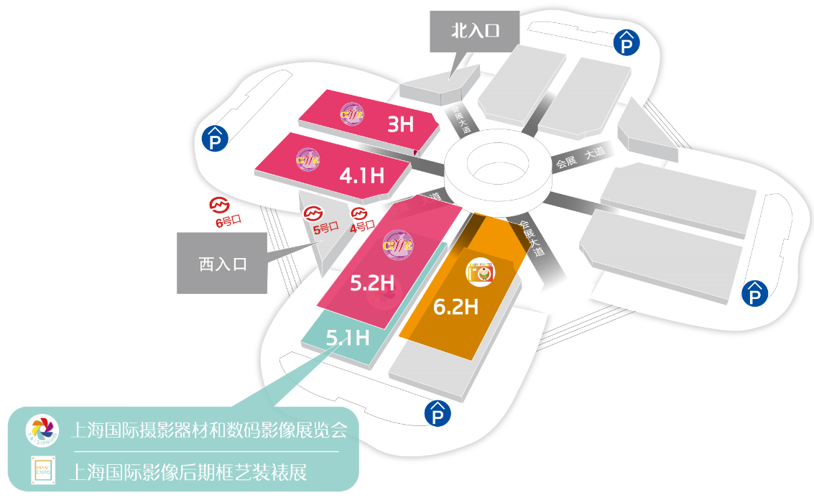

3. Dates & Times
Jul. 10 2019 Wednesday 09:00 – 17:00
Jul. 11 2019 Thursday 09:00 – 17:00
Jul. 12 2019 Friday 09:00 – 17:00
Jul. 13 2019 Saturday 09:00 – 16:00

4. Organizers
CCPIT, Shanghai Sub-council
Shanghai Photographers’ Association
Shanghai International Exhibition Co., Ltd

5. Visitor Admission
- Visitors must register at the registration counter at the entrance area of the hall.
- Admission is free for professionals, invited guests, trade and business visitors.
- The Organizer reserves the rights to refuse admission or to remove any person from the event without having to specify a reason.
- No photography or video equipment is allowed in the hall unless approval is obtained from the organizer.
- Business attire or smart casual are compulsory, shorts and sandals are not permitted.

Rules and Regulations

For the purpose of these "Rules and Regulations", the "Organizers" shall mean:

CCPIT, Shanghai Sub-Council
Shanghai Photographers’ Association
SIEC- Shanghai International Exhibition Co., Ltd.

1. Regulations Observance
Every Exhibitor, his agent or contractor, must observe the Rules and Regulations, including any amendments which may be applicable from the date of the Exhibition and introduced by the relevant Authorities or the Organizers.
Failure to observe these rules and regulations may result in the Authorities or the Organizers ordering the closure and removal from the Exhibition hall all or part of the stand or exhibits in the event that this occurs, the Authorities and the Organizers will not be held liable for any related charge, loss or damage thereby suffered by any Exhibitor.
The Exhibitors or the sub-contractors will read the Regulation hereto carefully before the set up and exhibition time. Should if there is any question, please inquire of the Organizers and the official service suppliers.
Please be kindly noticed that the rules and regulations regarding safety and fire fighting are totally updated in this manual, which must be strictly followed by exhibitors and contractors. If there were rules and regulations in the manuals of previous events that do not match up to the manual of Photo & Imaging Shanghai 2019, the rules and regulation of this Manuel should be followed.

2. Important Information
2.1
The Organizers recommend the Exhibitors and their service suppliers to use the service and consultancy of official freight forwarder and official stand constructor. Please refer to contact page for their detailed contact. The Organizers and the official agents are not liable for any mistake, transport delay, unsatisfying service and conflicts caused by non- official service supplier.

2.2
The Exhibitors with self-constructed stand shall submit the detail of design plans, drawings, construction material and etc to the Organizers in written form according to the manual before appointed due date. Material preparation and construction are only allowable in accordance with its design plan with the Organizers approval. All Exhibitors, their agents, contractors, forwarders and suppliers should strictly abide by the rules on Work Safety, Fire-fighting, IPR Protection, Liabilities and Insurance, etc.

2.3
Should if the Exhibitors intend to launch activities, including performance, press conference, and gift and material distribution, on-site, the specific plan shall be submitted to the Organizers in written form. The Exhibitors are allowed to hold the activities in appointed time-interval with the Organizers’ approval. The sound volume of such activities shall be under strict control of 70 db.

2.4
All exhibits, goods, products, posters, documents, video or services presented by the exhibitor shall be relevant to the Exhibition theme and be part of the exhibits proﬁle. Direct selling and subletting the space are forbidden. The Organizers reserve the right to remove any exhibit, articles or item complementary to an exhibit, which contravene this regulation. Any costs incurred will be borne by the Exhibitors.

2.5
According to the requirement of Construction of spiritual civilization in China, then exhibition and event should play a positive role in enhancing good social environment. As organizer, we boycott any kind of on-site event like obscene, degraded, and violence.

2.6
Admission into the Exhibition hall will be strictly controlled that one badge is for one person. And it cannot be borrowed and sold to others, otherwise it'll be conﬁscated.

2.7
The badges for the workers of contractors and freight forwarder have to be ﬁlled with real name and photo according to the regulations of NECC. For the detail, please call the NECC, tel: 021-67008487 or log in www.cc.neccsh.com.
2.8
The trafﬁc during setting up and dismantling time will be strictly controlled. The date and route of transport vehicles are arranged by the Organizers and official freight forwarder. The Exhibitors shall apply and contact the Organizers and ofﬁcial freight forwarder in advance.

2.9
All exhibitors and workers must wear safe-helmet and use safe-belt (if work over 2 meters) during the working time.

2.10
All booths must switch off the electricity every day after the exhibition center closes. And NECC will cut off the main electricity supply after that. Exhibitor must submit an application to NECC next day morning to get the electricity re-supplied. Exhibitors who need 24 hours power supply should submit the application to the organizer in advance.

2.11
All booths should have its own safe regulation and safe supervisor to ensure the safety during the exhibition.

2.12
Credit cards are not accepted on-site for paying service orders. All payments must be done through bank transfer or check on site due to tax regulations. Please pay in advance to avoid any possible inconvenience.

2.13
All exhibitors and show pavilion organizers should take responsibility and obligations according to the contact and follow the rules and regulation of the manual.

3. Admission and Identification
Admission into the Exhibition hall will be strictly controlled. Exhibitors, their representatives, delegates, and trade visitors are all required to put on their respective badges for admission into the Exhibition hall. Exhibitors will receive the badges when they register if there is no payment problem existing. The badge is at owner's disposal only and shall be used when entering and leaving.
Replacement for lost badges require additional fees. The Organizers reserve the right to decide the number of exhibitorsˇ badges.

3.1
Exhibitors
Exhibitors are permitted to enter the Exhibition area half an hour before opening time and remain not more than half an hour after the closing time during the Exhibition days (Jul.11-13, 2019). Exhibitors and their staffs are requested to be present at their stands at least 15 minutes before the opening hours of the Exhibition.

3.2
Temporary Staff
The number of the badges and how many times the badge could be used per day will be decided by the organizer.

3.3
Press
All the journalists and reporters that access the event will wear the "Journalist's Pass" produced and distributed by the Organizers to visit and report, should if the exhibitors intend to invite press by themselves, please submit the related materials to the Organizer to let the Organizers confirm the invitation.

3.4
Organizers
Staff of the Organizers will wear "Organizer's Pass" badge.

3.5
Distinguished guests will wear "VIP" badge to visit the show. The Exhibitors can apply for the VIP badges to the Organizers in advance. Because of the large number of coming guests of the exhibitors and the Organizers, the Organizers may not be able to arrange the VIP list requested by the exhibitors. Please take that into your understanding.

3.6
Manning of exhibition stands and conducts of stand personnel
All Exhibition stands must be fully staffed and operational throughout the opening hours of the Exhibition. Exhibitors must not participate in any activity that causes, or is likely to cause, annoyance to visitors or other Exhibitors.

4. Site plan
The Organizers reserve the right to alter the layout, plans and positioning of all stands, if in their opinion, such change(s) are desirable or necessary, for the beneﬁt of the Exhibition and the Exhibitors.

5. Sub-letting of stands
Exhibitors must not transfer, dispose of part with or otherwise sub-let, in whole or in part, their contracted space, office meeting area, store area, or other accommodation whatsoever, whether for ﬁnancial consideration or otherwise, or enter into any agreement to do so. An Exhibitor, being ofﬁcially appointed sole agent or sole licensee, must declare, at the time of application for space, the name(s) of the principals to be represented and conﬁne his / her display to their products. This regulation shall be deemed to include any subsidiary material and/or product not being a part of, but used as complementary to, an exhibit. An Exhibitor may not, except by written endorsement from the Organizers, display directly or indirectly, advertise or give credits to any products other than his own or his principal's. The Organizer reserve the right to have masked or removed from the Exhibition hall any products or signs violating this regulation.

6. Presentations, Demonstrations of Exhibits and exhibitors' on-site activities
An Exhibitor intending to present or demonstrate equipment, exhibit, product or all kinds of activities on site at his stand must:

6.1
Submit to the Organizers full details of any working exhibits, involving moving parts, inflammable materials, laser, dangers and all kinds of on-site activities, in writing and obtain approval prior to the Exhibition.

6.2
All exhibits, goods, products, posters, documents or services presented by the exhibitor shall be relevant to the Exhibition theme and be part of the exhibits proﬁle. Direct selling and subletting the space are forbidden. The Organizers reserve the right to remove any exhibit, articles or item complementary to an exhibit, which contravene this regulation. Any costs incurred will be borne by the Exhibitors.

6.3
Ensure that all moving machines be ﬁtted with safety devices when the machines are in operation. These safety devices may be removed only when the machines are disconnected from the source of power.

6.4
Ensure that any moving machines displayed shall only be demonstrated within the stand area, operated by qualified persons of the exhibitors and shall not be left running without the proper supervision of such persons.

6.5
Safety install and guard all working exhibits to prevent slippage and position the exhibit within the actual stand area and in a way that would not be hazardous or cause any injury to all persons, whether visitors, staff or contractors.

6.6
Isolate starting devices to prevent operations by any visitor or other unauthorized person.
Ensure that toxic fume, exhaust or other irritants caused by the exhibits / products are not released into the Exhibition hall.
Prior approval from the relevant controlling authority, in addition to that of the Organizers, must be obtained for such purpose.

6.7
Ensure that gas cylinders, naked ﬂames and welding demonstrations are not exposed in the Exhibition hall and stands. Prior Fire Safety Bureau (FSB) approval must be obtained and their conditions for such purpose fully met and satisﬁed before any demonstration is carried out.

6.8
No engine is allowed to be started or maintained indoor. The oil in the tank must be lower than 10%.

6.9
Ensure that adequate protection is catered to prevent damage to the Hall flooring, carpet and facilities. Any damages caused will be at the responsibility of the Exhibitor concerned.

6.10
Ensure that all the relevant local government authority license and or permits are obtained and its stipulated regulations and conditions observed and abided with for the demonstration and / or use of electronics, radio and / or satellite transmitting equipment.

6.11
Ensure that only products uninvolved in any intellectual property rights dispute for which they are agent, distributor or dealer, are displayed. Should if there is any intellectual property rights dispute between/ among Exhibitors in the event, the Organizers reserve the right to stop them from exhibiting and hand them over to intellectual property rights ofﬁce.

6.12
Ensure that noise level does not interference or annoyance to visitors or other Exhibitors (Max 70 db).
The Organizers limit the sound volume and reserve the right to suspend the on-site activities of the exhibitors who don't obey the Organizers' supervision. Demonstrations with a high level of noise or other objections factors may only take place at certain times stipulated by the Organizers, who reserve the right to reduce the sound level or switch of the audio / visual displays should they cause any problem.

6.13
Should if the Exhibitor intend to launch activities, including performance, press conference gift and material distribution, on site, the specific plan shall be submitted to the Organizer in written form in advance. It's principally forbidden for the exhibitors to run a on-site patrolling advertising team. The Exhibitors are allowed to hold the activities with the Organizers’ approval. The Exhibitors shall guarantee that such activities do not violate the political and spiritual civilization and ensure the safety of the event during the activities. The Organizers will guide or temporarily stop the activities under safety situation on site.
The Organizers demand that the neighbor stands within the same hall shall have staggered times of activities. Should if there is any problem caused by the activities, the Organizers reserve the right to turn down the sound volume, shut down the equipment or stop the activities. Only exhibits, posters, documents and materials relevant to the Exhibition proﬁle as determined by the Organizers and the Customs will be allowed. The Organizers reserve the right to remove from the Exhibition hall, any exhibit, poster, and articles, or any item complementary to an exhibit, which in their opinion, contravene this regulation.

6.14
No staff recruitment is allowed within the exhibition center.

7. IPR Protections
To protect the Intellectual Property Rights (IPR) of all exhibitors and to ensure the legal rights of the exhibitors and the exhibits during the Photo & Imaging Shanghai 2019, the Consulting Ofﬁce for IPR protection is to be set up by the Organizers. Exhibitors should abide by IPR laws, rules and regulations in China and any international treaties on the protection of IPR applied in China. Exhibitors should not show any product or issue any material which infringes the IPR of any other party. Exhibitors or agents should provide active cooperation for the investigation for obtaining the evidence, inspection and enquiry work conducted by Shanghai IPR Administration, the judicial department and the Organizers. Any exhibit or material suspected of infringement should be removed from the exhibition.

8. Security
During the exhibition Shanghai Police Security Bureau and security of Shanghai New International Expo Center ensure the security and safety of your exhibits in the exhibition halls. Nevertheless, responsibility is expressly denied for any loss or damage which may befall any person or property of the exhibition from any cause whatsoever. You must arrange your own insurance to cover all stages of the event for your exhibits.
The Exhibition hall provides 24 hours security service. The exhibitors shall apply and contact the Exhibition Hall in advance and bear the cost incurred.
Please keep your personal belongings and exhibits in a safety place. Do not leave valuable exhibits or properties in the exhibition hall after show time every day. Exhibitors are strongly advised to pack and remove from the Exhibition area all portable, attractive and valuable items at the end of each day when the Exhibition closes as this is the time that there is the greatest risk of loss and theft. Before you return the rental equipment and facility to the suppliers, please make sure that your booth is safely guarded.

9. Liabilities and insurance
All Exhibitors participating in this Exhibition must arrange at their own cost "all-risk" insurance coverage from Origin Country up to their Exhibition stand including duration of the Exhibition period and return to domicile. Exhibitors are strongly advised to pack and remove from the Exhibition area all portable, attractive and valuable items at the end of each day when the Exhibition closes as this is the time that there is the greatest risk of loss and theft. All these items MUST NOT be left unattended or out of sight at any time. The Organizers will not be responsible for the safety of articles of any kind brought into the Exhibition by the Exhibitors, their agents, contractors, visitors or any other persons whosoever.
Exhibitors shall ensure that they are fully covered by insurance and take up public liability and comprehensive protection. The period of liability of the Exhibitor shall be deemed to run rom the time the Exhibitor or any of his agents or contractors ﬁrst enter the Exhibition site, and to continue until all his exhibits and property have been removed.
The Exhibitor shall ensure, indemnify and hold the Organizers harmless in respect of all costs, claims, demand and expenses to which the Organizers may in any way be subjected as a result of any loss or injury arising to any person howsoever caused as a result of any act or default of the Exhibitor, his agents, contractors or invitees.
Exhibitors shall also be responsible for making good any loss or damage to any items which they have rented or hired from the ofﬁcial contractors. And Exhibitors shall take all necessary precautions to prevent any damage to their equipment, exhibits and displays before making any connection to the electrical supply of the ofﬁcial contractors. Exhibitors must ensure that their temporary staff and the staff of their servants or agents are insured against claims for workman's compensation.
Exhibitors are required to provide evidence and proof of the above insurance to the Organizers/ Show Manger if requested to do so.

10. Dilapidation of the exhibition hall and equipments
The ﬂoor weight of indoor exhibition hall is 3 ton/sqm, and if there were vertical vibration, the weight should be reduced to 50%.
It's forbidden to build booth or put weight over the 2 main cable pit within the exhibition hall. Please take it into consideration that there are 3 different areas on outdoor space: heavy load area, 15 tons/sqm; normal load area, 5 tons/sqm; light load area, 2 tons/sqm..
Exhibitors are responsible for the cost of making well or replacing any damage or dilapidation to the Exhibition premises, whether caused by themselves, their agents, contractors or by any person employed or engaged on their behalf by such agents or contractors.
Exhibitors occupying Shell Scheme stands are also responsible for the cost of making good, any damage to the contractor's stand structures, ﬂoor covering, light ﬁttings and any other hired items, whether caused by themselves, their agents, contractors or by any person employed or engaged on their behalf by their agents or contractors. The cost of repairing and replacing for any damages will be assessed by the Ofﬁcial Stand constructor and charged to the Exhibitor concerned.

11. Catering / Flowers / Furniture
Box lunch, non-appointed catering, plants and furniture, etc. are not allowed to bring into the exhibition hall without permission.
Please contact the ofﬁcial contractors for any additional orders. Exhibitors are responsible for all the disputes and loss caused by making orders to any non-ofﬁcial contractors.
There exist catering and ﬂower suppliers in NECC. Any other non-appointed suppliers are not allowed to run similar businesses in NECC.
If small-scale catering service is to be provided in the booth, Exhibitors should apply to the Organizers and submit all the documents including License for food hygiene, business license of the catering supplier, catering service plan, schedule and description 1 month before the opening of the show. And the catering supplier should apply to relevant authorities to get the License for Exhibition Admittance in advance. All the documents should be complete and get approval by the Organizers. Exhibitors are required to obtain the approval from the Organizer before they can bring their own flowers and furniture in NECC. Take-away lunches are in principle not permitted in NECC. There exist catering and ﬂower suppliers in NECC. Any other non-appointed suppliers are not allowed to run similar businesses in NECC. Should there be any need for take-away lunches, clients shall ﬁll out an application form in advance and submit it to the Organizer together with copies of food sanitation license and lunch operation permission. The lunch boxes are required to be delivered only to the designated place and collected by the buyers. The suppliers are not permitted to enter the halls. It's strongly suggested by the organizers that exhibitors and visitors should not buy or take any food or drink from illegal peddlers in NECC.

12. Stand cleaning
The Organizers will arrange for the general cleaning of the Exhibition halls prior to the opening of the exhibition and daily thereafter. It is the responsibility of the exhibitors to maintain their stands in a tidy condition at all times.

13. Lost and found
All inquiries regarding lost and found items should be made to the NECC security office. All lost and found articles are catalogued and stored for 30 days. At the expiry of this period, all articles will be disposed of at the discretion of the Organizer and no other person shall have any further claim to those articles. The Organizer shall not be responsible for any items not collected during the stipulated period.

14. Removal of waste
During the build-up and tear-down days of Exhibition, the aisles of the Hall must not be obstructed with packing and construction materials or debris. Contractors building "Raw Space Stands" or stand interiors are responsible for removing their own building waste and off-cuts from the site at the end of each day. Painting and sawing can only be carried out at certain designated areas outside the Exhibition hall.
At the end of the Exhibition, contractors must remove from the site all the materials especially the double- sided carpet tape used from their clients stands by the respective timings stated in the "Operations Schedule". The Organizers reserve the right to charge the Exhibitor concerned for the removal of excessive waste (stand construction debris, crates/pallets, cartons, packing materials or literature).

15. Storage
Cartons, crates, cases, packing materials and containers used for storage and consignment of exhibits should no be stored within the Exhibition hall. Prior arrangements for safekeeping such items must be made with the Ofﬁcial Freight Forwarder. The Organizers reserve the right to remove and dispose of any such items left in the Exhibition area. Any storage or disposal costs incurred will be borne by the Exhibitors.

16. Failure to exhibit
Any organization which, has signed and submitted a valid Contract for space reservation, and fails to exhibit or turn up for the Exhibition, and has not been released from the Contract by the Organizers, shall be held liable for the full cost stated in the Contract, plus any additional costs incurred by the Organizers as a result of the failure to exhibit or turn up for the Exhibition

17. Force majeure
The timing and duration of the Exhibition may be altered, due to any cause whatsoever, beyond the control of the Organizers.
The Organizers shall not be responsible for any loss sustained by the Exhibitor, which is directly or indirectly attributed to an Act of God such as ﬁre, ﬂood, earthquake, windstorm, epidemic disease or other natural disasters, act of any sovereign government, and any law and judgment relating to labor dispute. In the event of such circumstances, the money paid by the Exhibitor, or any part therefore, may not be refunded to the Exhibitor.

18. Authority of premises
In the event of any problems or disputes on-site, the decision of the Organizers, being lessee of the premises, will be ﬁnal and shall be respected and accepted by the exhibitors and their service suppliers. The Organizers also reserve the right to amend any earlier decision made in order to meet and satisfy any unforeseen or prevailing circumstance for the beneﬁt of the Exhibition and concerned parties.
Fire Control Safety Requirement
1. General
1.1 The exhibitors, their agents, constructors or facilitators should earnestly carry out the related guidelines and policies of ﬁre control safety work issued by the state and Shanghai municipal government during move-in, exhibition, and move-out-in the ﬁtment or constructing, tearing down for the stands in indoor or outdoor show areas and in the maintenance during the exhibition period, to strictly execute all rules, regulations and provision, including Fire Control Law of P.R.C., Shanghai Fire Control Rules, Shanghai Exhibition Industry Fire Control Safety Administrative Provisions, Shanghai Exhibition Hall Fire Control Safety Administrative Standards, to strictly follow and observe the related safety provisions and requirements by the organizers and for the exhibition halls, including this manual, show pre-notice, move-in instructions, safety instructions, site notiﬁcations, Show Hall Service Manual by Shanghai New International Expo Centre etc. to adopt and cooperate with the organizers, show halls and the related departments of the government for the work of surveillance, inspection, supervision and emergency evacuation etc.
1.2 Shanghai City Fire Station will have the new rules of Shanghai exhibition ﬁre control, the organizer, venue, and other related parts will pay attention on that. During the exhibition period, the fire safety work of this exhibition will proceed, strictly adhering to the new rule. If the ﬁre safety manual held by the organizing committee does not tally with the new rules and regulations, matters regarding the ﬁre safety of the exhibition will still be subjected to the new rule.
1.3 The exhibitors and their constructors shall set up safety inspection system, carry out instruction and training for ﬁre control safety, assign the special person to be in charge of ﬁre control safe operation, and he must wear the safety ofﬁcer identiﬁcation at site.
2. Stand construction
2.1 For all the stands with special decoration, the exhibitors and the trusted constructors must declare to the organizers for approval before the deadline date, for details, please refer to Appendix III <the Instructions for Stands with Special Decoration of for exhibitors and constructors in the Rules and Regulations>.
2.2 The constructing or finishing material used for stands or other construction must conform incombustible or nonflammable material approved by the ﬁre control department, thereof combustion performance grade shall be no less than Grade B1 (ﬂame resisting type), anti-ﬂaming ﬁre-proof treatment must be carried out for that which is ﬂammable material for timberwork or top ﬁshnet, it only can be used if it attains grade B1 and is approved by the ﬁre control department.
2.3 The inﬂammable material of elasticity cloth, black-out cloth, bamboo, straw, foam plastic etc. is strictly prohibited for use even if it is after anti-ﬂaming ﬁre-proof treatment.
2.4 The combustion performance grade for carpets for the construction of stands shall be no less than grade B1(ﬂame resisting type).
2.5 It is strictly prohibited for such actions to disturb the proper operation of the ﬁre control safety as well as monitoring facilities in the ﬁre alarm bell contacts, ﬁre hydrant, ﬁre extinguishers, emergency exits etc.
2.6 Stand construction or the structure is not allowed to disturb the normal operation of the ﬁre ﬁghting system, or hinder ﬁre passages, public passages or passageways of all the exhibition halls. Otherwise, the exhibitors and constructors must adjust the construction schemes to meet to the requirements, and adopt the handling and rectify on time, and bear the associated costs. For the speciﬁc issues, please contact the organizers in advance.
2.7 The should be at least 1.2 meter wide passages between the stand construction and ﬁre hydrants, equipment room gate and alarm bell point of contacts. There should be 1.0 meter inspection gallery between the stand construction and the wall face of the show hall and nothing is allowed there.
2.8 It is strictly prohibited to suspense or hang any articles on the spray system or illuminating apparatus of hall suspended ceilings. It is strictly prohibited for the alignment or approach of the spotlights or other heating equipment to the show hall ﬁre control spray system.
2.9 Fire resistive material should be used on the ceilings or tops of the exhibition booth. And these should not embarrass the normal operation of ﬁre controlling system, air vent, and supervisory control system. Every exhibition booth need prepare ﬁre extinguisher according to the ﬁre control rules. Bengaline and shade cloth are not allowed to be used on the booth.
2.10 It is strictly prohibited to carry out weld tasks in the Show hall. It is strictly prohibited to carry out ﬁre working in the Show hall.
2.11 The special working workers must hold related operating certificates or work licenses stipulate by the government, the operation must be strictly done according to the regulations to eradicate all operation against rules and direction.
3. Electrical installation
The laying of electric wiring and the installation of electric equipment must conform to the related ﬁre control safety technique provisions by the state and Shanghai municipal government and with the following requirements.
3.1 Electric cabinet application
When applying for power consumption for a stand, safe current carrying capacity shall be taken into consideration to ensure safe operation without overload or over current of electric wiring or electrical equipment. For speciﬁc power consumption quota, please refer to Clause 2.9 of the Rules and Regulations.
3.2 Connection of electric cabinets
3.2.1 The installation personnel for electric wiring and electrical equipment should hold effective electrician safe operation certiﬁcates.
3.2.2 During the constructio of stands (including ordinary stands and stands with special decoration), qualified equipment and material shall be used. Duplex sheath copper core wire and cable shall be used and the conductor cross section must be≠1.5mm. Electric material must be with enough safe current carrying capacity. It is strictly prohibited to use single wire, twisted pair wire or aluminum core wire without sheath. The wiring should be: line voltage shall take the form of three phase ﬁve wiring (L1, L2, L3, N, PE); phase voltage shall take the form of single-phase three wiring (L, N, PE).
3.2.3 All the metal trusses and metal enclosures must be grounded reliably. Wire laying must be ﬁxed, and is not allowed to be laid on roads, terraces or passages, it should be ﬁxed by poling or other safety ways, when electric wiring crosses walkways there must be gap bridge board for protection. The wire branch connection shall not be banded directly with insulating tapes, electric porcelain and mold joints shall be used for connection and then insulation protection will be carried out, for the rest, and the Low Voltage Distribution Design Speciﬁcations shall be strictly followed.
3.2.4 The distribution boxes for standard stands must be put into the cable trenches of the Show hall; and those for stand with special decoration must be put into the cable trenches of the Show hall or inside the stand. It is strictly prohibited for the distribution boxes to be put in the aisle, ﬁre passages or in the obvious parts of the stands.
3.2.5 Electric lighting equipment in the outdoor show places shall all be rain-proof, safety measures of moisture protection, rain-proof and windproof etc. shall be put into effect.
3.3 Before the power is supplied for the whole of the exhibition, stand working personnel should check accordingly and ensure that it conforms with the Low Voltage Apparatus Safety Operation Speciﬁcations.
3.4 The installation and use of heavy duty electric equipment shall be checked and ratified by the Show hall, ad can be used only the safety is ensured as the precondition. Iodine lamps and other high temperature light ﬁxtures and neon lamps cannot be installed and nobody shall take the liberty to make the installation, and they can only be used after being examined and approved by the department concerned and checked and veriﬁed by the Show hall. The mounting height of neon lamps shall be no less than 2.5 meter. Heavy duty tungsten halide lamps are not allowed to be used.
3.5 The distance between light ﬁxtures and construction material or exhibits shall be greater 50 centimeters.
3.6 Shut down after closing
3.6.1 Each stand shall ensure that the power supply for the facilities is off after the exhibition is closed each day. If the power is not off, the organizers and Show hall will turn off the main switch of the power supply, and the exhibitors shall bear all consequence concerned. The power supply of the stands which are shut down will be restored by the organizer after the application is made to the organizer in written form the next morning and the safety inspection is made by the organizer.
3.6.2 The power supply shut down by the exhibitors or constructors themselves will be restored by them before the exhibition begins.
3.6.3 The venue will cut off the power supply everyday after the venue close. It Exhibiters, who need 24-hours electric supply (sharing the same electric box with the illuminating system is forbidden), water and air supply, should submit the application to the organizer and ofﬁcial stand contractors by written.
4. Oil paint and dope
4.1 During the period of move-in and exhibition, it is not allowed to make great area oil painting for exhibit or showing material. It is only allowed to make small area touch-up painting during the period of move-in with all safety protection measures ready. It is strictly prohibited to use any oil paint or dope with penetrating odor, unmatched with environment protection or safety for decoration of stands. The safety protection measures include: To oil paint at ventilation places;
To use innocuity oil paint;
Dry paper or plastic ﬁlm shall cover the cement ﬂoor;
It is prohibited to make oil paint on the Show hall vertical construction (namely walls);
It is prohibited to wash oil paint material inside or near Show halls.
4.2 The exhibitors are responsible for any damage to the organizers and Show halls resulting from paintwork and bear costs for damage and rehabilitation expenses at polluted areas.
4.3 Flammable and explosive dangerous goods as oil paint shall be kept outside the Show hall where is safe.
5. Dangerous goods
5.1 If it is not approved by the organizers, Show hall and related government departments:
It is strictly prohibited to demonstrate or operate heating, barbecue stoves, or make heating or open ﬁre apparatus, candles, lanterns, torches, welding equipment or other smoke creating material.
It is strictly prohibited to demonstrate or operate any electric power, mechanism or chemistry apparatus which are cognizance dangerous. It is strictly prohibited to use poisonous or hazardous material, including ﬂammable liquid, ﬂammable gas, compressed gas or dangerous chemicals.
It is strictly prohibited to use open ﬁre, hydrogen balloons.
It is strictly prohibited to use exploders, petroleum, ﬂammable, explosive, poisonous corrosive materials.
It is strictly prohibited to carry in the Show hall any weapons, ﬁrearms, cutlery, ammunition, detonator, inﬂammable substance, radioactive substance or other hazardous substance as well as non-importation articles, piracy articles, articles which may be a hindrance to be a hindrance to Show or any articles unallowed by the department concerned of the government.

5.2 The amount of the storage of solid or liquid dangerous goods in the stand shall not be more than that for one day's usage. The remainder should be deposited in the area and at the time speciﬁed by the organizers.
5.3 Internal combustion engine vehicles such as Automobiles, motorcycles etc.and other oil-burning apparatus are not allowed for maintenance, or start, and storage oil in the tanks shall be less than 10%.
5.4 Poisonous waste must be sealed and put into proper containers, indicating corresponding marks, and managed and handled according to the related waste disposal methods by the government.
6. Pressure vessels
6.1 The exhibitors must make the written application to the organizers in advance if they are to use helium, argon, nitrogen inertia compressed gas, and with the approval they can bring it to the Show hall. The exhibitors shall be fully responsible for the use, supervision, shipping, storage, keeping and safety of the pressure vessels.
6.2 All the pressure vessel and equipment taken into the Show hall shall observe the related security standards and regulations.
6.3 If the pressure vessels are not put in good order, the organizers will notify the exhibitors to pullout the vessels safely from the hall or to the appointed location momentarily, and the exhibitors must cooperate and execute.
7. Smoking limit
It is strictly prohibited to smoke in the areas where there are no smoking signs.
8. Emergency assurance
8.1 The ﬁre apparatus and other ﬁre ﬁghting devices shall be equipped for the stands with special decoration with the satisfactory quality and quantity.
8.2 The stands with special decoration shall be equipped at all evident positions with emergency indicating lamps, identifying nighttime evacuating indication path.
8.3 The safety inspection system shall be set up by the exhibitors and constructors, a person shall be assigned for ﬁre control safe operation to ensure safety for the construction of the stand, exhibition and move-out. Should any accident happen, it must be reported to the organizers at the ﬁrst time.
8.4 The exhibitors and together with the constructors shall responsibly cooperate with the organizer and the concerned government departments and Show hall for all the activities of security tour inspection, rectification, emergency evacuation, and shall observe instruction and put into effect.
Safety in Working Requirement
1. General
1.1 The exhibitors, their agents, constructors or facilitators, during the period of exhibition preparation, exhibition period and move-out period, in the ﬁtting out or constructing tearing down and maintenance of the stands inside and outside the Show hall for the current exhibition, shall earnestly carry out the related safety in working guidelines and policies issued by the state and Shanghai municipality labor protection, safety in working competent departments, and strictly execute the related laws and regulations of labor protection, including the Law of Safety in Working, Production Safety Accident Report and Surveying Handling Rules of P.R.C., Shanghai Safety in Working Rules etc. To strictly follow and observe the related safety provisions and requirements by the organizers and for the exhibition halls, including this manual, show pre-notice, move-in instructions, safety instructions, site notifications, Show Hall Service Manual by Shanghai New International Expo Centre etc. Adopt and cooperate with the organizers, show halls and the related departments of the government for the work of surveillance, inspection, supervision and emergency evacuation etc.
1.2 The exhibitors and their constructors shall set up safety inspection system, carry out instruction and training for safety in working task, assign the special person to be in charge of fire control safe operation, and he must wear the safety officer identiﬁcation at site.
2. Safety supervision
2.1 The exhibitors and their constructors shall earnestly put into effect the safety responsibility system; strengthen site safety tour inspection and supervision.
2.2 The exhibitors and their constructors shall observe the related provisions and speciﬁcations of the state building operation industry, and ensure that the site operation personnel and special working personnel have all acquired the relevant operation certiﬁcates or work licenses.
2.3 It is strictly prohibited to make illegal subcontracting, subletting or subordinating for the construction, maintenance or demolition of the stands with special decoration.
2.4 The exhibitors shall oblige the hired construction companies, agency companies or facilitators to purchase insurance for related persons and property etc. Otherwise, the exhibitors shall undertake the relevant liabilities and losses. For details, please refer to Clause 10 of the Rules and Regulations.
2.5 The exhibitors and their construction companies shall make the civilization construction, and carry out well the safety protection measures. During the period of move-in or move-out, all the working personnel in the exhibition areas (indoor or outdoor of the pavilions) must put on safety caps.
2.6 For those who are to ascend (higher than 2 meters) for work shall put on safety caps, safety belts as well as other necessary safety protection measures. They must use qualified ascending instruments conformed to safety requirement, it is strictly prohibited to use unqualiﬁed ascending instruments. It is strictly prohibited for transferring tools or objects by throwing, yet transfer modes or bagging or rope suspending shall be used instead. Those who are not ﬁt for operating at high places are prohibited to work at high places. It is strictly prohibited to work after having wine.
2.7 The weather factors of strong wind, heavy rain, thunderstorm etc. must be taken into consideration for the construction structure of the outdoor stands.
2.8 The lifting machinery (platform type platform type)/ vehicles for the installation of the stands can enter the hall only after it is applied to and approved by the organizers and the Show hall.
3. Drawing inspection
For all the stands with special decoration, the exhibitors and the trusted constructors must submit the drawings and declare for inspection before the deadline date.
4. Stand height
Hall | 5.1H
Maximum Height | 4m

5. Facility management
5.1 The application for all lightening supply, electric power, water source, air supply etc. must be made to the ofﬁcial construction general agent appointed by the organizers.
5.2 When applying for power consumption for a stand, safe current carrying capacity shall be taken into consideration to ensure safe operation without overload or over current of electric wiring or electrical equipment. For speciﬁc power consumption quota, please refer to Clause 2.9 of the Rules and Regulations.
5.3 One socket can be only used for a piece of showing equipment or machine. The multinomial sockets are not allowed for use so as to avoid the short circuit due to the overload.
5.4 The power supply for each stand must be shut down when the exhibition is closed everyday. Failure to shut down the power supply, the Organizers shall turn off the main switch for the power supply, the exhibitors and the constructers shall be borne all the consequences. The power supply of the stands which are shut down will be restored by the organizer after the application is made to the organizer in written form the next morning and the safety inspection is made by the organizer.
5.5 The power supply shut down by the exhibitors or constructors themselves will be restored by them before the exhibition begins.
6. Emergency assurance
6.1 The safety inspection system shall be set up by the exhibitors and constructors, a person shall be assigned for safety in working to ensure all safety in working of their own stands during the construction of the stand, exhibition and move-out. Should any accident happen, the report shall be made to the organizers and the corresponding measures shall be taken.
6.2 The exhibitors and together with the constructors shall responsibly cooperate with the
organizer and the concerned government departments and Show hall for all the activities of
security tour inspection, rectification, emergency evacuation, and shall observe instruction
and put into effect.

Instructions for Stands with Special
Decoration for Exhibitors and Constructors
1. Safety requirement
The exhibitors for open space stands may select the construction general agent appointed by the organizers or select by themselves the constructors with the relevant qualiﬁcation to construct stands. And shall earnestly read and strictly observe the provisions of the Rules and Regulations and <Fire Control Safety Requirements>, <Safety in Working Requirements >, and all the requirements of the Instructions.
2. Construction drawing inspection
For all the stands with special decoration the exhibitors and the trusted constructors must ﬁll in Form 3 before Jun.10 2019 and submit them to the organizers. Otherwise, the organizer agree that the venue have the right to reject exhibitors' or there contractors' construction.
Exhibitors and there contractors will bear any consequences caused by that.

Special declaration
The organizers and related government competent departments reserve the right to re-inspect or entrust the third party to inspect and to amend the construction schemes submitted by the exhibitors and constructors. All the preparing and construction work can be carried out only after the exhibitors and the constructors have signed the Safety in Working and Fire Control Duty Letter of Commitment of the Show Manual before entering the Show for construction and with the approval by the organizers.
Otherwise, the exhibitors or constructors will assume responsibilities and consequences there from. The organizers will not grant the exhibitors or thereof constructors to handle all kinds of entering formalities or carrying out stand construction.
If the organizers, Show hall and the ﬁre control safety department of the government think that the construction or structure of the stands blocks out the neighborhood stands or obstructs the normal operation of the ﬁre ﬁghting system, air conditioning air outlet, ventilation opening, monitored control system or hinder the passageways of the ﬁre control, public passages and Show halls the exhibitors and constructors must adjust the construction schemes to meet with the requirements And accept the treatment and make the rectiﬁcation on time, The exhibitors and constructors shall assume the associated costs. For the speciﬁc issues, please contact the organizers in advance, The exhibitors and their constructors shall make the civilization construction and carry out well the safety protection measures.
During the period of move-in or move-out all the working personnel in the exhibition areas (indoor or outdoor of the pavilions) must put on safety caps. For those who are to ascend (higher than 2 meters) for work shall put on safety caps, safety belts as well as other necessary safety protection measures. The weather factors of strong wind, heavy rain, thunderstorm etc. must be taken into consideration for the construction structure of the outdoor stands.
3. Overhead cost /deposit construction certiﬁcate
3.1 The constructors for stands with special decoration shall render overhead cost for the construction of the stand with special decoration before stand construction the standard is RMB 25.00/ m².
3.2 The constructors for stands with special decoration shall disburse deposit for stand construction to the Show hall or construction general agent before stand construction. The deposit is RMB 100 / m² for open space construction, minimum RMB 5,000 for each stand. After the stands are dismantled, and there is no any damage to the hall ground, wall face or facility and equipment and they are kept clean, the deposit will be refunded to the constructors with the approval of the Show hall.
3.3 The latest provisions for the certiﬁcation of construction
According to the latest provisions and requirements of National Exhibition and Convention Center (Shanghai) (NECC) the absolutely new management method have been made for the certiﬁcations for construction agents and forwarding agents the real name system with photos shall be used all and singular all the certiﬁcates of construction during the periods of move-in and move-out shall be registered, examined and veriﬁed, photo taken, made and supervised by the pavilion organization.
For details, please contact the Certiﬁcate Centre of NECC, the consultation phones are 021-67008487, or log on its ofﬁcial site www.cc.neccsh.com .

4. Stand heights
Hall | 5.1H
Maximum Height | 4m

5. Stand boundary
5.1 All the stands and national pavilions must be divided clearly with the area stated in the contract, no stand structure or exhibit can go beyond the stand boundary.
5.2 Exhibitors are not permitted to display, hang, or distribute any exhibit, material, furniture or product, nor extend their stand structures and ﬁttings, beyond their contracted boundaries.
5.3 For the sake of the overall visual effect of the exhibition. The consideration of the wide sight shall be taken into for the stand arrangement in all entire car Show halls it shall not make any sight affection to any other stand in the same hall. If the organizers think that the backboard, side panel or other structure of a stand keep out the neighbor stand they have the right to require the exhibitors and constructors to adjust the construction scheme to meet to the requirement and accept the treatment and rectify on time the associated costs shall be assumed by the exhibitors and constructors.
5.4 Booth opening the booth side which faces the walking passages must remain open.
5.5 It is not allowed to build walls around an island stand except for building walls inside the stand. The exhibitors are not allowed to use the back of the wall of the neighbor stand as its own wallboard. And it is not allowed to show his own-name or sign on the wall of neighboring booth etc.
5.6 The name and stand number of the exhibitor shall be evidently marked for the stand. Otherwise, the organizers have the right to choose the proper position and ﬁx the stand number and collect the corresponding cost.
5.7 The wallboard facing other exhibitors' stand or public areas shall conform to the quality requirements ratiﬁed by the organizers, Show hall and related government departments.
6. Facility applications
6.1 The constructors for open space stands must ﬁll in the form and submit written application for lightening power, three phase power, water source, air supply to the appointed construction general agent before the deadline date. The application for all lightening supply, electric power, water source, air supply etc. must be made to the ofﬁcial construction general agent appointed by the organizers.
6.2 When applying for power consumption for a stand safe current carrying capacity shall be taken into consideration to ensure safe operation without overload or over current of electric wiring or electrical equipment. For speciﬁc power consumption quota, please refer to Clause 2.9 of the Rules and Regulations.
6.3 During the period of move-in and move-out, the stands with special decoration may be supplied with the temporary power supply yet the application must be made to the appointed construction general agent 24 hours ahead.
6.4 The organizers have the right to shut down the power supply to any power equipment which the organizers think dangerous or might bring potential safety hazards to other exhibitors or visitors
6.5 The exhibitors and constructors must make written application at least 45 days before the opening of the exhibition to the appointed construction general agent, if they are to carry special light ﬁxtures, bulbs or other lighting equipment for stands.
6.6 One socket can be only used for a piece of showing equipment or machine. The multinomial sockets are not allowed for use so as to avoid the short circuit due to the overload. Severe short circuit accidents will initiate ﬁre accidents and the restoration work shall take several hours it will bring about inconvenience and losses to other exhibitors.
6.7 To indicate all the mounting positions you have ordered for the additional power equipment so that the electric installation engineer or related personnel can make the necessary arrangement for you before you arrive at the Show.
6.8 The stand ground must be covered with carpets or other appropriate material for the details of the provisions of the ground protection of the Show hall, please refer to Clause 11 of the Rules and Regulations.
6.9 The installation, wiring and removal of all the power equipment must be completed by the construction general agent appointed by the exhibition.
6.10 Before the power is supplied, all the power equipment and devices must be tested and ratified by the engineers with professional certiﬁcates appointed by the Show hall.
7. Shut down after closing
7.1 The power supply for each stand must be shut down when the exhibition is closed everyday. Failure to shut down the power supply, the Organizers shall turn off the main switch for the power supply the exhibitors and the constructers shall be borne all the consequences. The power supply of the stands which are shut down will be restored by the organizer after the application is made to the organizer in written form the next morning and the safety inspection is made by the organizer.
7.2 The power supply shut down by the exhibitors or constructors themselves will be restored by them before the exhibition begins.
7.3 If a stand needs electric equipments (which are not allowed to share one panel with illumination) with uninterrupted power supply, and equipments with water and gas supply round the clock the application shall be made in written form to the organizer or the ofﬁcial constructors agent in advance.
8. Construction material
8.1 The constructing or finishing material used for stands or other construction must conform incombustible or nonflammable material approved by the ﬁre control department thereof combustion performance grade shall be no less than Grade B1 ﬂame resisting type anti-ﬂaming ﬁre-proof treatment must be carried out for that which is ﬂammable material for timberwork or top ﬁshnet it only can be used if it attains grade B1 and is approved by the ﬁre control department.
8.2 The inﬂammable material of elasticity cloth, black-out cloth, bamboo, straw, foam plastic etc. is strictly prohibited for use even if it is after anti-ﬂaming ﬁre-proof treatment
8.3 The combustion performance grade for carpets for the construction of stands shall be no less than grade B1 ﬂame resisting type.
8.4 If these materials, like glasses, organic glasses, toughened glasses, acrylic panel, polycarbonate panel and others, are used surrounding the stand or exhibiting cars, wooden or metallic fence must be used for reinforcing as well as warning marks. Additional staffs are needed to segregate the crowds from these materials if necessary.
9. Ceiling / top
9.1 If the stand has the ceiling or top, ﬁreproof material must be used, and it shall not obstruct the normal operation of the Show hall ﬁre ﬁghting system, ventilation opening or monitored control system.
9.2 Fire resistive material should be used on the ceilings or tops of the exhibition booth. And these should not embarrass the normal operation of ﬁre controlling system, air vent, and supervisory control system. Every exhibition booth need prepare ﬁre extinguisher according to the ﬁre control rules. Bengaline and shade cloth are not allowed to be used on the booth.
10. Emergency assurance
10.1 The ﬁre apparatus and other ﬁre ﬁghting devices shall be equipped for the stands with special decoration with the satisfactory quality and quantity.
10.2 The stands with special decoration shall be equipped at all evident positions with emergency indicating lamps, identifying nighttime evacuating indication path.
10.3 The safety inspection system shall be set up for special decoration stand a person shall be assigned for safe operation to ensure safety for the construction of the stand, exhibition and move-out.
10.4 The stands with special decoration shall responsibly cooperate with the organizer and the concerned government departments and implement all the activities of security tour inspection, rectiﬁcation, emergency evacuation and shall observe instruction and put into effect.
11. Stands cleaning
For details, please refer to Clause 12 & 14 of the Rules and Regulations.
12. Insurance requirement for Stands with Special Decoration
To insure the safety of workers during the build-up period, exhibitors and stand contractors are required to purchase liability insurance for stands, which will take both exhibitors and contractors as the insured. The insurance fee is 500 RMB.
For details, please contact:
China Pacific Property Insurance Co. LTD.
No. 400 Wusong Road, Shanghai, China
Tel: 13002176003
E-mail: 13002176003@163.com
Phone No.: 95500
Contact: Ms. Chen Yin
Instructions for Standard Stands for Exhibitors

1. The standard stands shall be constructed by the construction general agent appointed by the organizers, the basic structures of which are constituted with white standard frames and brattices. For the accouterment of the furniture and electrical apparatus for the stands, please refer to the contract. The cost is ﬁxed.
2. Exhibitors of standard stands should submit the Form 9 < Company Name for Stand Fascia >. The company name on the stand fascia should keep unanimous with the name on application form, and be supplied to the ofﬁcial stand contractor before the deadline. Exhibitors should pay any fees cost by changing the content of fascia on site.
3. If the exhibitors want to revise and enlarge some facility and need more water, power and gas supply, please refer to the Form 12 and Form 13 in the manual and make the application to the appointed construction general agent before the deadline date at their own cost. Please rent furniture, when necessary, from the ofﬁcial construction general agent, do not rent any furniture from any non notiﬁed constructors for furniture, failure to do so, the exhibitors shall be responsible for any dispute and loss.
4. The application for all lightening supply, electric power, water source, air supply etc. must be made to the ofﬁcial construction general agent appointed by the organizers. The installation, wiring and removal of all the power equipment must be completed by the construction general agent appointed by the exhibition. Before the power is supplied, all the power equipment and devices must be tested and ratiﬁed by the engineers with professional certiﬁcates appointed by the Show hall.
5. Without the consent from the organizers and appointed construction general agent, no change or append can be made to the structure of the standard stands, including the oil paint of the wallboards and stickup wallpaper, it is not allowed to hit nails or rill, if help is needed when hanging or displaying exhibits, please contact the appointed construction general agent. No poster is allowed to be hanged or stuck on the pillars or walls in the halls.
6. Exhibitors must keep their contraction, setup, furniture and exhibits within their stand area.
7. All the stands and national pavilions must be divided clearly with the area stated in the contract, no stand structure or exhibit can go beyond the stand boundary.
8. It is strictly prohibited for such actions to disturb the proper operation of the ﬁre control safety as well as monitoring facilities in the ﬁre alarm bell contacts, ﬁre hydrant, ﬁre extinguishers, emergency exits etc. Stand construction or the structure is not allowed to disturb the normal operation of the ﬁre ﬁghting system, or hinder ﬁre passages, public passages or passageways of all the exhibition halls. There should be at least 1.2 meter wide passages between the stand construction and ﬁre hydrants, equipment room gate and alarm bell point of contacts. There should be 1.0 meter inspection gallery between the stand construction and the wall face of the show hall and nothing is allowed there.
9 . It is strictly prohibited to put any things on the electric boxes and electric wires. Any things like exhibits and materials should be in duty and keep a safe distance to electric facilities.
10. It is strictly prohibited to connect electric wires by exhibiters themselves. For any results like power tripping, short circuit, wire burning and electric box broken, caused by that illegal behavior, exhibitors have the responsibility to pay for those costs.
11. The organizers have the right to shut down the power supply to any power equipment which the organizers think dangerous or might bring potential safety hazards to other exhibitors or visitors.
12. The socket supplied in the stand can only be used for normal facilities like TV, computer, and water dispenser. This kind of socket must not be used for displaying exhibits and lighting facilities. Exhibiters who bring lighting facilities by themselves must apply for special electric boxes of lighting. Exhibiters, who need electric supply for their exhibits, must apply for other special electric boxes. Noticed, lighting facilities must not share one electric box with exhibits. Exhibiters should apply both electric boxes separately. One special socket can only supply power for one facility or exhibit. The multinomial stocks are not allowed to be used.
13. For details of the protection provisions for Show hall ground, please refer to Clause 11 of the Rules and Regulations.
14. The power supply for each stand must be shut down when the exhibition is closed every day. Failure to shut down the power supply, the Organizers shall turn off the main switch for the power supply, the exhibitors and the constructers shall be borne all the consequences. The power supply of the stands which are shut down will be restored by the organizer after the application is made to the organizer in written form the next morning and the safety inspection is made by the organizer.
15. The venue will cut off the power supply every day after the venue close. If Exhibitors, who need 24-hours electric supply (sharing the same electric box with the illuminating system is forbidden), water and air supply, should submit the application to the organizer and ofﬁcial stand contractors by written.
Technical Information
1. Exhibition Hall Description
1.1 Exhibition Hall Technical Specification:
Hall No. | 1H | 2H | 3H | 4.1H/5.1H
Height（m） | 0
Cargo Entrance  （m：Width*Height） | 8*6.5
Hall Size（m） | 269*106
Hanging Point for Booth Construction | /
Column Grid（m*m） | / |  |  | 27*36
Net Height（m） | 32 |  |  | 12
Floor Loading（ton/m2） | 5 |  |  | 3.5
Lighting（LX） | 300
Loading Method | Through special loading pass to different halls

1.Compressed Air：
Hall No. | Amount（m3/min）
1H+2H | 15
3H+4.1H+4.2H | 20
5.1H+5.2H+6.1H+6.2H | 10

1.3 Water Supply:
Hall No. | Water Supply（m3/h）
1H | 24
2H | 24
3H+NH | 24
4.1H+4.2H+WH | 36
5.1H+5.2H | 36

SHIPPING GUIDELINE

Shanghai Expotrans Ltd. is the official freight forwarder of the exhibition. We provide exhibitors with logistics services including global transportation, customs clearance, on-site handling, forklift and crane rental, etc.

For further information please contact:

SHANGHAI EXPOTRANS LIMITED
ADD: Floor 10, NO.555 AN YUAN ROAD
SHANGHAI 200040, CHINA
TEL: +86-21-6013 1818, FAX: +86-21-6217 9788
ATTN: Mr. Jay Zhou, E-MAIL: zhouzhiying @xptrs.com.cn

Do not sent cargo to the above address directly. Should there be any local exhibits need to be sent to us, a detailed warehouse address will be provided upon request.

Please fill in the two forms that attached and hand in to us if necessary.
Pre-Advice And General Order Form
List of Exhibits

Important notice on hand-carried exhibits：

According to the latest customs regulation, carrying by hand is no longer acceptable for importing exhibits. Shanghai Expotrans is not responsible for any exhibits detention by China Customs caused by hand-carrying.

Pre-Advice And General Order Form
This form must be completed and returned before Jun 24, 2019 duly signed by shipper / consignor
Please return this form to:  SHANGHAI EXPOTRANS LTD.  ATTN: Mr. Jay Zhou  TEL: +86-21-6013 1818  FAX: +86-21-6217 9788  E-MAIL: zhouzhiying@xptrs.com.cn | Shipper / Consignor / Exhibitor:
 | CONTACT:
 | TEL: |  |  | FAX:
 | E-MAIL:

The following exhibits:
Total Pieces: |  |  |  | Kind of packing:
Weight (KG): |  |  |  | Dimensions (CBM):
by the transport mode of:
□ AIR under AWB number: |  |  |  |  |  |  |  | Flight:
□ SEA | with B/L number: |  |  |  |  |  | □ In Original |  | □ Surrendered
□ SEA | Vessel / Voyage: |  |  |  |  |  |  | □ LCL |  | □ FCL*
□ Other:
will be arriving Shanghai on the date of:

Please arrange delivery to the Exhibition:
Exhibitor: |  |  | Hall: |  | Booth:

Following documents will be attached / provided later:
□ Copy / Original of the Way Bill
□ L.O.E. - List of Exhibits (FORM 2)
□ Self Declearantion of Non-Wood / Processed Wood Packing (FORM 4)
□ Crane / Forklift Renting Order (FORM 5)
□ ATA Carnet with INTRUST LETTER (FORM 6)
□ Others:

Please arrange delivery to the Exhibition:
Exhibitor: |  |  | Hall: |  | Booth:

*FCL Container details:

We hereby authorized  Shanghai Expotrans Limited  to handle the a.m. Exhibition goods. All charges will be on our account. | Stamp and Signature:
 | Date:

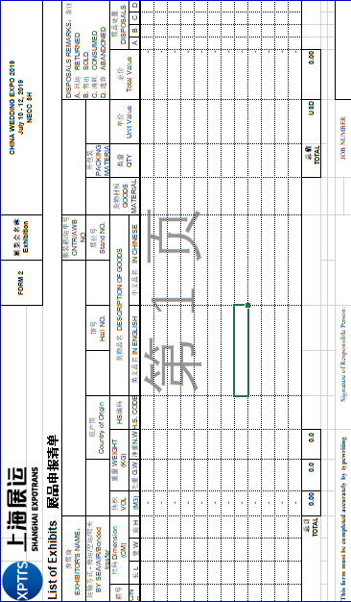

Index of Forms

This order forms checklist is for your information.
● Forms marked with ☆ are “compulsory” and must be returned to organizer or official stand contractor from all exhibitors.

1 | Registration for Official Catalog | ☆ | 10 Jun. 2019 | 41
2 | Delegation List | ☆ | 10 Jun. 2019 | 42
3 | Building Approval for Special Stand Design | ☆ | 10 Jun. 2019 | 43
4 | Seminar Application |  | 10 Jun. 2019 | 44-45
5 | VIP Visitors Invitation |  | 10 Jun. 2019 | 46
6 | Catalog Advertisement |  | 10 Jun. 2019 | 47
7 | Onsite Advertisement |  | 10 Jun. 2019 | 48-50
8 | Hotel Reservation |  | 10 Jun. 2019 | 51
9 | Company Name For Stand Fascia | ☆ | 10 Jun. 2019 | 52
10 | Additional Furniture Rental |  | 10 Jun. 2019 | 53
11 | Additional Electrical Rental |  | 10 Jun. 2019 | 56
12 | Power Supply For Lighting Rental | ☆ | 10 Jun. 2019 | 57
13 | Equipment & Fittings Rental | ☆ | 10 Jun. 2019 | 58
14 | Service Location Plan | ☆ | 10 Jun. 2019 | 59
15 | Booth Construction Service | ☆ | 10 Jun. 2019 | 60
16 | Invitation Letter Application |  | 10 Jun. 2019 | 61
 | Notice for exhibitors registration |  |  | 62

Form 1 Registration for Official Catalog ☆
Deadline：Jun. 10, 2019

Return to:  Shanghai Int’l Exhibition Co. Ltd  No.10 Building, HONGQIAO ZHENRO Center, 666 Shenhong Road, Shanghai, China (201106) Tel:(86-21) 6279 2828  Fax: (86-21) 65455124  : interphoto@siec-ccpit.com  QQ：800036328 | Company Name：
 | Add: | Zip:
 | Tel: | Mobile：
 | Fax: | Email:
 | Contact Person： | Booth No.:
 | Signature: | Date:

Company Name ( in English ):
Company Name ( in Chinese ):
Address:
Tel: |  | E-mail:
Fax: |  | Website:
Contact Person: |  | Booth No.:
Text in English:
(Limit:100 characters)

Text in Chinese:

Company LOGO
(TIF, JPG)

Note: Please make sure the form is sent via E-mail to interphoto@siec-ccpit.com before deadline.

Form 2 Delegation List ☆
Deadline：Jun. 10, 2019

Return to:  Shanghai Int’l Exhibition Co. Ltd  No.10 Building, HONGQIAO ZHENRO Center, 666 Shenhong Road, Shanghai, China (201106) Tel:(86-21) 6279 2828  Fax: (86-21) 65455124  : interphoto@siec-ccpit.com  QQ：800036328 | Company Name：
 | Add: | Zip:
 | Tel: | Mobile：
 | Fax: | Email:
 | Contact Person： | Booth No.:
 | Signature | Date:

Please list in full details of stand personnel requiring Exhibitor badges. Only registered exhibitors are eligible to apply for these badges. Each 9 sqm booth will be provided with 3 badges freely. You can pick up your badges onsite during Jul. 9-14, 2019. All the exhibitors should wear the badges during exhibition dates Jul. 10-13, 2019.

Name | Position | Nationality | Company Name
1.
2.
3.
4.
5.
6.
7.
8.
9.
- Use extra paper if necessary.
- This form is for your exhibitor’s badges.

Authorized by: Position:
(Please print.)

Exhibitor: Booth No.:

Signature: Date:

Form 3 Building Approval for Special Stand Design ☆
Deadline：Jun. 10, 2019

Return to:  Shanghai Arts & Sales Exhibition Service Co.,Ltd.  Room1212, Shanghai Modern Traffic  & Commercial Plaza No 218, Heng Feng Rd,  200070, P.R.China  Tel.:+86 -21 - 5127 6786  Fax: +86 - 21 - 5127 6799  E-mail：artsales@163.com  Contact：Ms.Vicky Wang | Company Name：
 | Add: | Zip:
 | Tel: | Mobile：
 | Fax: | Email:
 | Contact Person： | Booth No.:
 | Signature | Date:

1. All the indoor and outdoor special stands should ﬁll out the form and submit ﬁles to the organizer for approval. Please submit the following documents required to process your application(drawings by fax are not accepted):
① Floor plan ② Elevations (1front-side and 2 sides)
③ Section (Side elevation) ④ Booth perspective drawing (1front-side and 2 sides)
⑤ Structural drawing and Description ⑥ Detailed booth material checklist and description
⑦ Measures on ﬁre-ﬁghting & contact info of the person-in-charge

2. The following special stand should additionally submit ﬁles to HAH which is appointed by NECC for drawings structure review, which charges extra costs:
① Indoor double-storey stand and Outdoor double-storey stand
② Outdoor one-storey stand
③ Indoor one-storey stand with booth height 4.5m and above

Person in Charge of the Exhibitor (Signature & Stamp):______________________

Booth Contractor:______________________________

Person in Charge of the Booth Contractor (Signature & Stamp):__________________________

Notes:
1. All documentation must be submitted in English or Chinese. The drawings must be to scale and dimensioned in Arabic numbers and in meters.
2. Please strictly abide by the Rules and Regulations of the Exhibitor’s Manual.
3. Please submit all the documents in quadruplicate files or by email to the Organizers before 10 Janurary, 2016. Material preparation and construction are only allowable in accordance with its design plan with the approval by the Organizers and related departments. Contractor should carry out stand construction strictly according to the approved drawings. If any changes, please ask the Organizer for re-approval.
4. Incomplete documents, drawings by fax, or overdue submission will not be accepted.
5. Application for hanging point is not accepted.
6.Height Limited for booth in each hall:
Hall | 5.1H
Limit | 4m

Form 4 Seminar Application
Deadline：Jun. 10, 2019

Return to:  Shanghai Int’l Exhibition Co. Ltd  No.10 Building, HONGQIAO ZHENRO Center, 666 Shenhong Road, Shanghai, China (201106) Tel:(86-21) 6279 2828  Fax: (86-21) 65455124  : interphoto@siec-ccpit.com  QQ：800036328 | Company Name：
 | Add: | Zip:
 | Tel: | Mobile：
 | Fax: | Email:
 | Contact Person： | Booth No.:
 | Signature | Date:
● Photocopy this form if more than two seminars are to be proposed.
You are most welcome to propose technical seminar topics (commercial topics are not accepted). Please fill in this form and return it to the Organizer before Jul. 10, 2019 for topic selection and approval. You will be notified on or prior to Jul. 10, 2019of topic acceptance. If accepted, you are required to prepare 3 sets of complete paper outlines submitted to the Organizer by Jul. 10, 2019. You should pay for hall rental, interpretation and organization for each seminar. If you want to cancel the topic which has been approved, you should still pay RMB3000. The seminar fee must be paid before Jul. 10, 2019 to the Organizer's bank account.

1. Proposed Topic of Presentation: ______________________________________________________

2. Proposed Speaker (s) and Title(s):_____________________________________________________

3. Brief Synopsis (200 words at least):
__________________________________________________________________________________
__________________________________________________________________________________
4. I shall need an interpreter.
□ Yes Please specify language: □ No

Date | Time | Choose√
Jul. 10, 2019 | 09:00-12:00
Jul. 10, 2019 | 13:00-16:00
Jul. 11, 2019 | 09:00-12:00
Jul. 11, 2019 | 13:00-16:00
Jul. 12, 2019 | 09:00-12:00
Jul. 12, 2019 | 13:00-16:00
Jul. 13, 2019 | 09:00-12:00

• Late or on-site order: orders received on or after Jul. 10, 2019 will be subject to 50% surcharge;
• Only written application will be approved.

Conference Room Details

Meeting rooms located in the Exhibition Avenue
Room No. | Area  (m²) | Style | Capacity  （persons） | Equipments | Price(RMB) | “√”
M3-01 | 165 | Reception | 22 | No fixed meeting equipments | 5000
M3-02 | 184 | Theater | 112 | Wireless microphone*2, Gooseneck microphone*2，Projector*1, Projection Screen*1, audio equipment | 5500
M3-03 | 176 | Theater | 112 |  | 5500
M4-01 | 172 | Board | 48 | No fixed meeting equipments | 5000
M4-02 | 176 | Theater | 112 | Wireless microphone*2, Gooseneck microphone*2，Projector*1, Projection Screen*1, audio equipment | 5500
M4-03 | 176 | Classroom | 100 |  | 5500
M5-01 | 171 | Board | 48 | No fixed meeting equipments | 5000
M5-02 | 176 | Theater | 112 | Wireless microphone*2, Gooseneck microphone*2，Projector*1, Projection Screen*1, audio equipment | 5500
M5-03 | 176 | Theater | 112 |  | 5000
M6-01 | 165 | Reception | 22 | No fixed meeting equipments | 5000
M6-02 | 176 | Theater | 112 | Wireless microphone*2, Gooseneck microphone*2，Projector*1, Projection Screen*1, audio equipment | 5500
M6-03 | 176 | Classroom | 100 |  | 5500

Meeting rooms located in the office building
Room No. | Area  (m²) | Style | Capacity  （persons） | Equipments | Price(RMB) | “√”
B0-01 | 468 | Theater | 272 | Wireless microphone*2, Gooseneck microphone*7，Projector*1, Projection Screen*1, audio equipment | 14000
B0-02 | 468 | Classroom | 208 |  | 14000

Form 5 VIP Visitors Invitation
Deadline：Jun. 10, 2019

Return to:  Shanghai Int’l Exhibition Co. Ltd  No.10 Building, HONGQIAO ZHENRO Center, 666 Shenhong Road, Shanghai, China (201106) Tel:(86-21) 6279 2828  Fax: (86-21) 65455124  : interphoto@siec-ccpit.com  QQ：800036328 | Company Name：
 | Add: | Zip:
 | Tel: | Mobile：
 | Fax: | Email:
 | Contact Person： | Booth No.:
 | Signature | Date:

The organizer provides exhibitors opportunities to invite VIP visitors. If you would like to invite specific Chinese visitors of your own to visit the exhibition, please give the details of the invitees to us in Chinese. Upon receipt the below form, the organizer will do his utmost to ensure that they are invited to the exhibition.
Choose the VIPs in your data, fill in the below information in Chinese and e-mail to us at interphoto@siec-ccpit.com.

Invitee’s Name： | Position：
Company： | Mobile：
Tel： | Fax：
E-mail： | QQ：
Address & Zip：

Invitee’s Name： | Position：
Company： | Mobile：
Tel： | Fax：
E-mail： | QQ：
Address & Zip：

Invitee’s Name： | Position：
Company： | Mobile：
Tel： | Fax：
E-mail： | QQ：
Address & Zip：

Form 6 Catalogue Advertisement
Deadline：Jun. 10, 2019

Return to:  Shanghai Int’l Exhibition Co. Ltd  No.10 Building, HONGQIAO ZHENRO Center, 666 Shenhong Road, Shanghai, China (201106) Tel:(86-21) 6279 2828  Fax: (86-21) 65455124  : interphoto@siec-ccpit.com  QQ：800036328 | Company Name：
 | Add: | Zip:
 | Tel: | Mobile:
 | Fax: | Email:
 | Contact Person： | Booth No.:
 | Signature | Date:

A Ticket Advertising (Net Size: 50mm×40mm) (Deadline：Jul. 10, 2019)
- Ticket Back Cover | 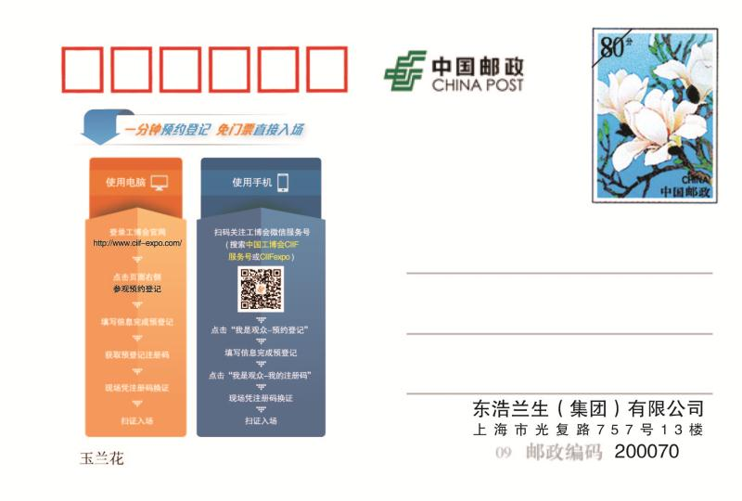  Colour +Word | RMB 15,000/10,000pcs.

B Visitors' Guide (Net Size: 140mm×210mm) (Deadline：Jul. 10, 2019)
- Inside Full Page | Colour +Word | RMB 20,000/50,000pcs.

C Name Badge (Net Size: 100mm×140mm) (Deadline：Jul. 10, 2019)
- Badge Back Cover | Colour +Word  Net Size: 100mm×140mm | 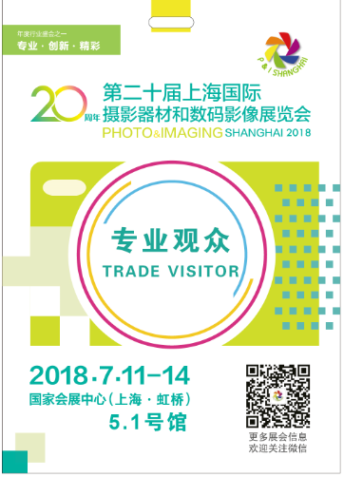 | RMB 15,000/10,000pcs.
- Badge Lanyard |  |  | RMB 10,000/10,000pcs.

D Multimedia Advertising (Deadline：Jul. 10, 2019)
- Official Website + Wechat + Digital Catalog | Colour +Word | RMB 5,000/exhibition period
- Promoting Advertisements in Wechat Moments | Colour +Word | RMB 30,000/time | The ad will appear as the fifth in the Moments of over 100,000 users.

Form 7 Onsite Advertisement
Deadline：Jun. 10, 2019

1.Outside Advert List
No. | Items | Size（H x W） | Price(RMB) | Introduction | Picture | √
2C | Billboard outside metro exits | 3M×2M | 1125 /m² | Billboard outside Exit 5 | 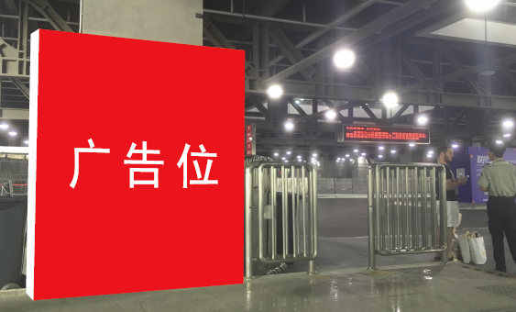
4 | Billboard between halls | 3.5M×5M | 900/m² | Single/double sided | 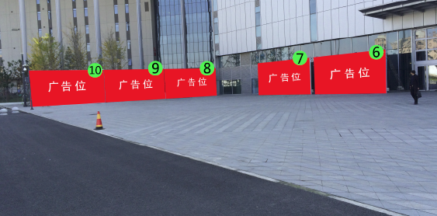
7 | Billboard beside the elevator in the West Square | 3.5M×5M | 900/m² | Elevator in the West Square | 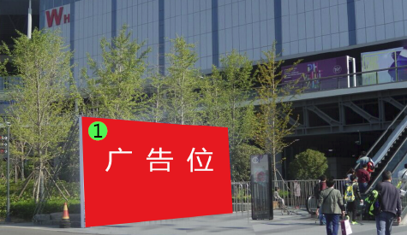

2. Inside Advert List
No. | Items | Size（H x W） | Price(RMB) | Introduction | Picture | √
21 | Ground Sticker ads | recommended size 0.8 M×1.2M | 680/m² | Inside exhibition halls | 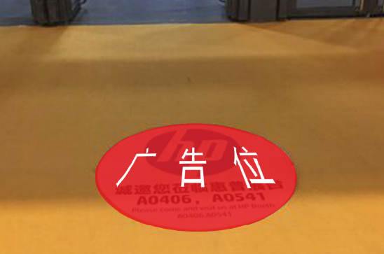
22 | Hanging ads inside NH | 8：7.5M×27M  others：10M×10M | 900/m² | Inside North Hall | 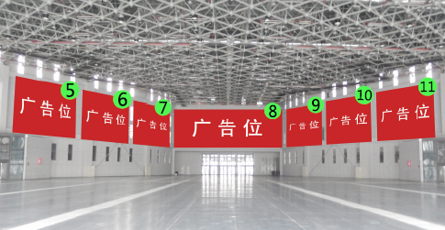
23A | Hanging ads inside exhibition hall | 12M×8M | 900/m² | Inside hall 1,2 3,charged for both sides | 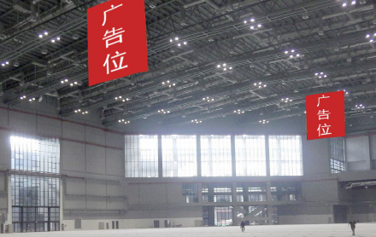
23B | Hanging ads inside exhibition hall | 4M×6M | 900/m² | Inside hall 4.1-8.1, charged for both sides | 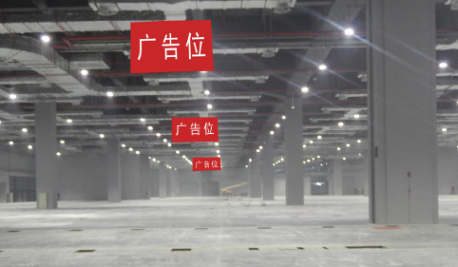
26A | Door sticker ads | big：refer to attachment 1  small：3.6 M×3.4M | 900/m² | Above the entrance to the hall | 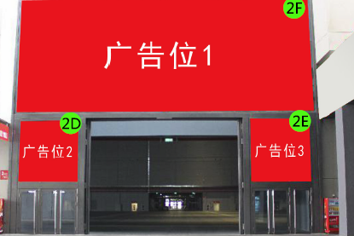
29 | Ads on the elevator | NH：1.5 M×13M，  WH-outside：1.5 M×15M，WH-inside：1.5 M×14M | 680/m² | Elevators | 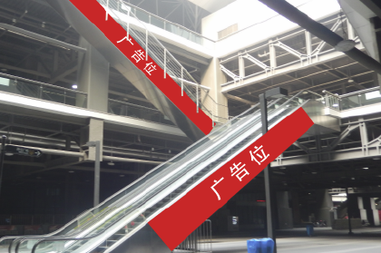
33A | Billboard outside WH | 4 M×8M | 900/m² | West Hall | 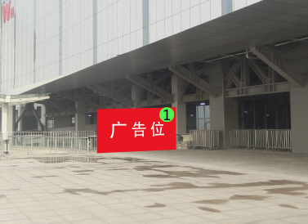
38C | Hanging ads around WH | 3.3M ×17M  2.8M ×17M  2.8M ×11M | 900/m² | West Hall | 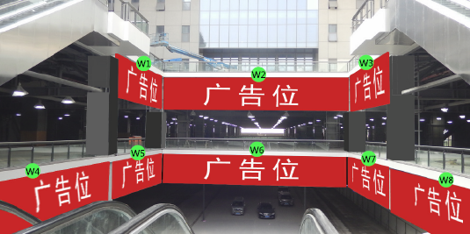
38D | Sticker ads above the North Hall | 9M ×18M  2.2M ×18M  2.2M ×12M | 900/m² | On the North Hall | 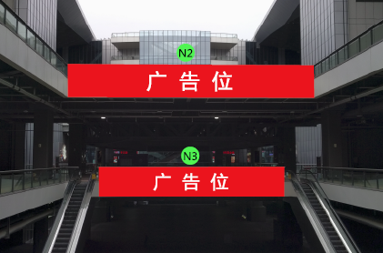
42 | Ads on the column of the West Hall | 3M×1.5M× 4 | 900/m² | West Hall | 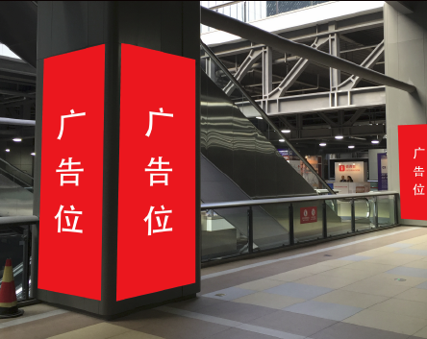

4、LED Screen ads
No. | Item | Size(H x W) | Price | Introduction | Picture
 | LED screens in the corridors | Red 1、2、3、4: 384 x1472；  Red 5:384 x1984；  Red 6:352 x 2496；  Red 7:480 x 2496；  Blue: 2、3、14、15:  288x1984 | 10000RMB/Panel/Period | Ads will be played for 15 seconds 180 times/day. | 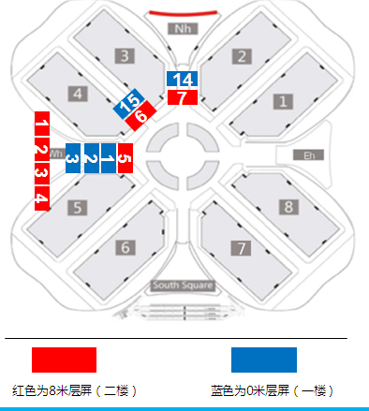  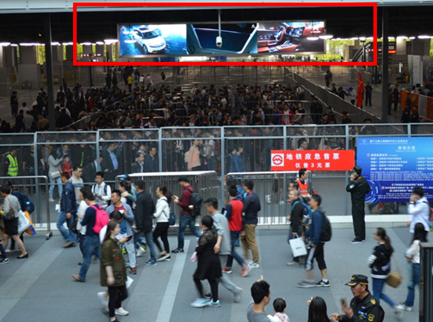

Notes:
- All the contents of advertisements can not violate the <Chinese Advertisement Law>.
- Inkjet printing ads requirements: below 20m², picture accuracy 50 dpi; above 20m², size ratio 1:1, picture accuracy 35 dpi;5cm bleeding each side,
File formats: TIF,PDF,AI,CDR；. If provide AI files, text of pictures must turn curve.
Video format: MP4; no more than 10M, no more than 25 frames/second, with 2000kbps
Picture format: JPG; no more than 2M, picture accuracy within 72 dpi.
- Detail position of adverts shall be confirmed by NECC venue finally.
Attachment 1
Hall | Entrance Number | Size(H x W)
5.1 | 1 | 3.4m（H)×8.4m（W)
5.1 | 4 | 3.2（H)×8.2m（W)
5.1 | 7 | 3.2（H)×8.2m（W)
5.1 | 17 | 3.74m（H)×8.4m（W)
5.1 | 20 | 3.74m（H)×8.4m（W)
5.1 | 21 | 2.1m（H)×4.6m（W)
5.1 | 22 | 3.4m（H)×8.4m（W)

Form 8 Hotel Reservation
Deadline: Jun. 10,2019

Welcome to  PHOTO & IMAGING SHANGHAI 2019 | Please return the form to:  Shanghai Dahua Exhibition & Conference Co., Ltd.
Welcome to  PHOTO & IMAGING SHANGHAI 2019 | Add: No.10 Building,Hongqiao Zhenro Center, 666  Shenhong Road,Shanghai,China (201106)  Contact Person: Ms. Windy Yu & Ms. Eloise Tao Tel: (86) 21-62792828 Fax: (86) 21-65455124 Email: dahua@siec-ccpit.com

Please tick in the appropriate◻

OPTION 1 Sofitel Shanghai Hongqiao
(★★★★★, 2.5km to the venue, 666 Taihong Road, Minhang District, Shanghai)
◻ Deluxe Room：RMB 850 per room per night (breakfast included)

OPTION2 Melia Shanghai Hongqiao
(★★★★★, 3.5km to the venue, 1118 Gaojing Road, Qingpu District, Shanghai)
◻ Superior Room：RMB 600 per room per night (one breakfast included)

OPTION 3 Hilton Garden Inn Shanghai Hongqiao
(★★★★, 4km to the venue, 1915 Huqingping Road, Qingpu District, Shanghai)
◻ Standard Room：RMB 500 per room per night (one breakfast included)

OPTION 4 Jinjiang Star Pingshang Shanghai Jiading Malu Baoan Highway Hotel
(Chain, 19km to the venue, East Gate No.1, Lane 3705, Baoan Road, Jiading District, Shanghai)
◻ Standard Room：RMB 289 per room per night (breakfasts included)

We will reserve ________________ room (s) for the following person (s):
Person Name | Qty. of Rooms | King  /Twin | Check in/  Check out | Booking Guarantee
 |  |  |  | Credit Card No. | Expiry Date

NOTES:
- All accommodation reservations are on a "First Come First Served" basis.
- If you wish to share a room, please indicate the name of your roommate.
- Please pay the room charge directly to the hotel when you check out.
- Room rates are subject to change and prior notification will be given.

Contact Person ： Email：

Company Name： Booth No. (exhibitors only) ：

Tel： Fax：

Form 9 Company Name For Stand Fascia ☆
Deadline: Jun.10,2019

Please return form to：  Shanghai Arts & Sales Exhibition Service Co.,Ltd.  Room1212, Shanghai Modern Traffic  & Commercial Plaza No 218, Heng Feng Rd,  200070, P.R.China  Tel.:+86 -21 - 5127 6786  Fax: +86 - 21 - 5127 6799  E-mail：artsales@163.com  Contact：Ms.Vicky Wang | Company Name：
 | Address：
 | Tel：
 | Fax：
 | E-mail：
 | Authorized by：
 | Date：
 | Signature：
 | Hall/Booth No.：

• This Form must be filled in completely by every exhibitor who booked the Standard
Booth. And then must be returned/faxed to Shanghai Arts&Sales before the deadline.

- ENGLISH NAME：PLEASE USE BLOCK LETTERS

- CHINESE NAME：PLEASE WRITE CLEARLY

• If we don’t receive your Fascia Board details by the above deadline, we will make your Fascia Board according to the Information by Organizer. If you want to change the content of the Fascia Board On-site, you should pay for the additional money.
• If you want to put your logo on the fascia board, please send a sample to us, and then we will give you the quotation. (The logo should not larger than 200mm ×200mm. )
□ Please send us the quotation based on the logo. ( If you require please √ in the □ )

Form 10 Additional Furniture Rental
Deadline: Jun.10,2019

Please return form to：  Shanghai Arts & Sales Expo Ltd.  Room1212, Shanghai Modern  Traffic & Commercial Plaza  No 218,Heng Feng Road,Shanghai  Tel.：+86 21 5127 6786  Fax：+86 21 5127 6799  E-mail：artsales@163.com  Contact Person：Ms.Vicky Wann | Exhibitor Information
 | Company Name：
 | Address：
 | Tel：
 | Fax：
 | E-mail：
 | Authorized by：
 | Date：
 | Signature： | Hall/Booth No.：

• This Form must be filled in completely by every exhibitor who require the service. And must be
returned/faxed to Shanghai Arts&Sales before the deadline.
• The rental time is one exhibition period. Please look at the Stylebook.

Item | Description(mm) |  | Unit (RMB) | Qty. | Total
CH-01 | Folding Chair |  | 20.00
CH-02 | Grey Fabric Chair |  | 80.00
CH-05 | Bar Chair(Black) |  | 60.00
CH-06 | Bar Chair |  | 100.00
CH-08 | Sofa |  | 250.00
FX-01 | Folding Door | 1000W×2000H | 180.00
FX-02 | Shelf (Flat / Slope) 1000W×300D |  | 60.00/70.00
FX-03 | Cost Stand |  | 100.00
FX-05 | Wheeled Hanging Rail |  | 120.00
FX-06 | Catalogue Holder |  | 100.00
FX-07 | Human models |  | 300.00
TA-01 | Round Table | DIA800×750H | 120.00
TA-02 | Glass Round Table | DIA800×750H | 150.00
TA-03 | Square Table | 700W×500D×750H | 100.00
TA-04 | Rectangular Table | 1200W×800D×750H | 120.00
TA-06 | Coffee Table | 500W×500D×450H | 150.00
TA-07 | Information Counter | 1000W×500D×750H | 100.00
TA-08 | Table Showcase with lock | 1000W×500D×900H | 250.00
TA-09 | Tall Showcase | 1000W×500D×2500H | 450.00
TA-10 | Lockable Cabinet ..锁锁锁 | 1000W×500D×750H | 120.00
TA-11 | Display Cube 500W×500D×1000H/500H |  | 200.00/120.00
TR-01 | Truss 300×300×1000L |  | 200.00
 | System Panel 1000W/500W×2500H |  | 150.00/100.00
 | Waste Paper Basket |  | 10.00
 | Carpet /㎡ |  | 35.00
 | Totalize:
• Late order :50% penalty fee will be charged for any late orders received after the deadline;
• Refer to back page for payment details;
• Please look at the remittance information in Form 11.

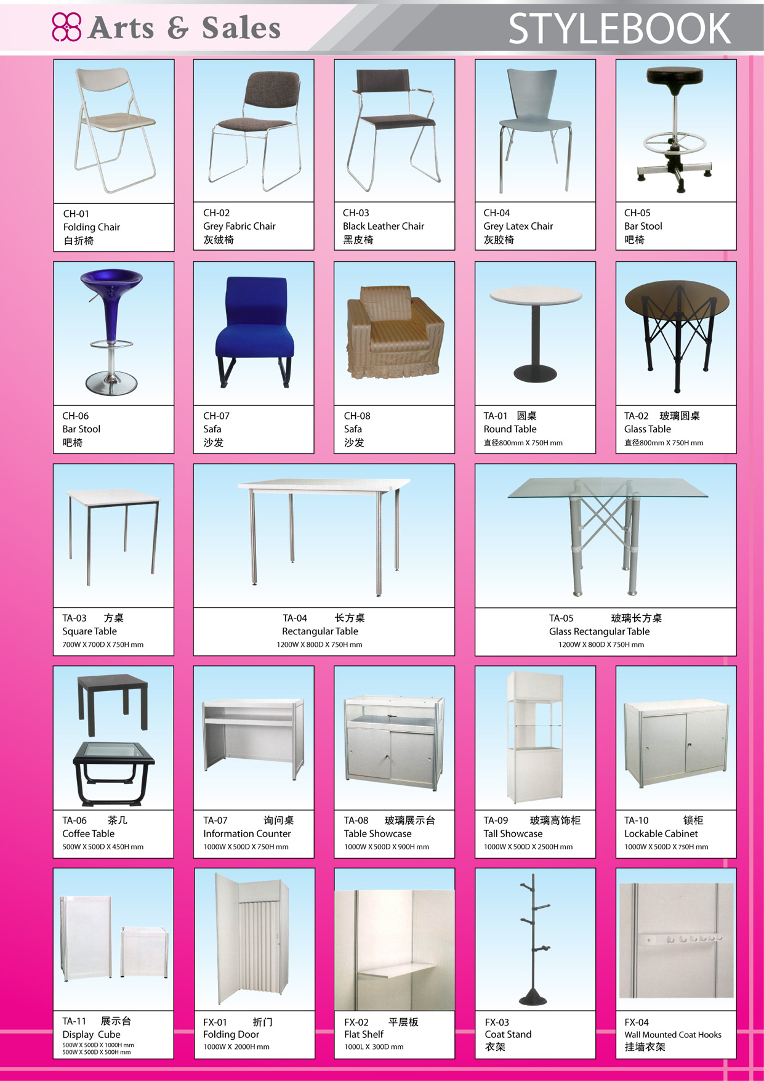

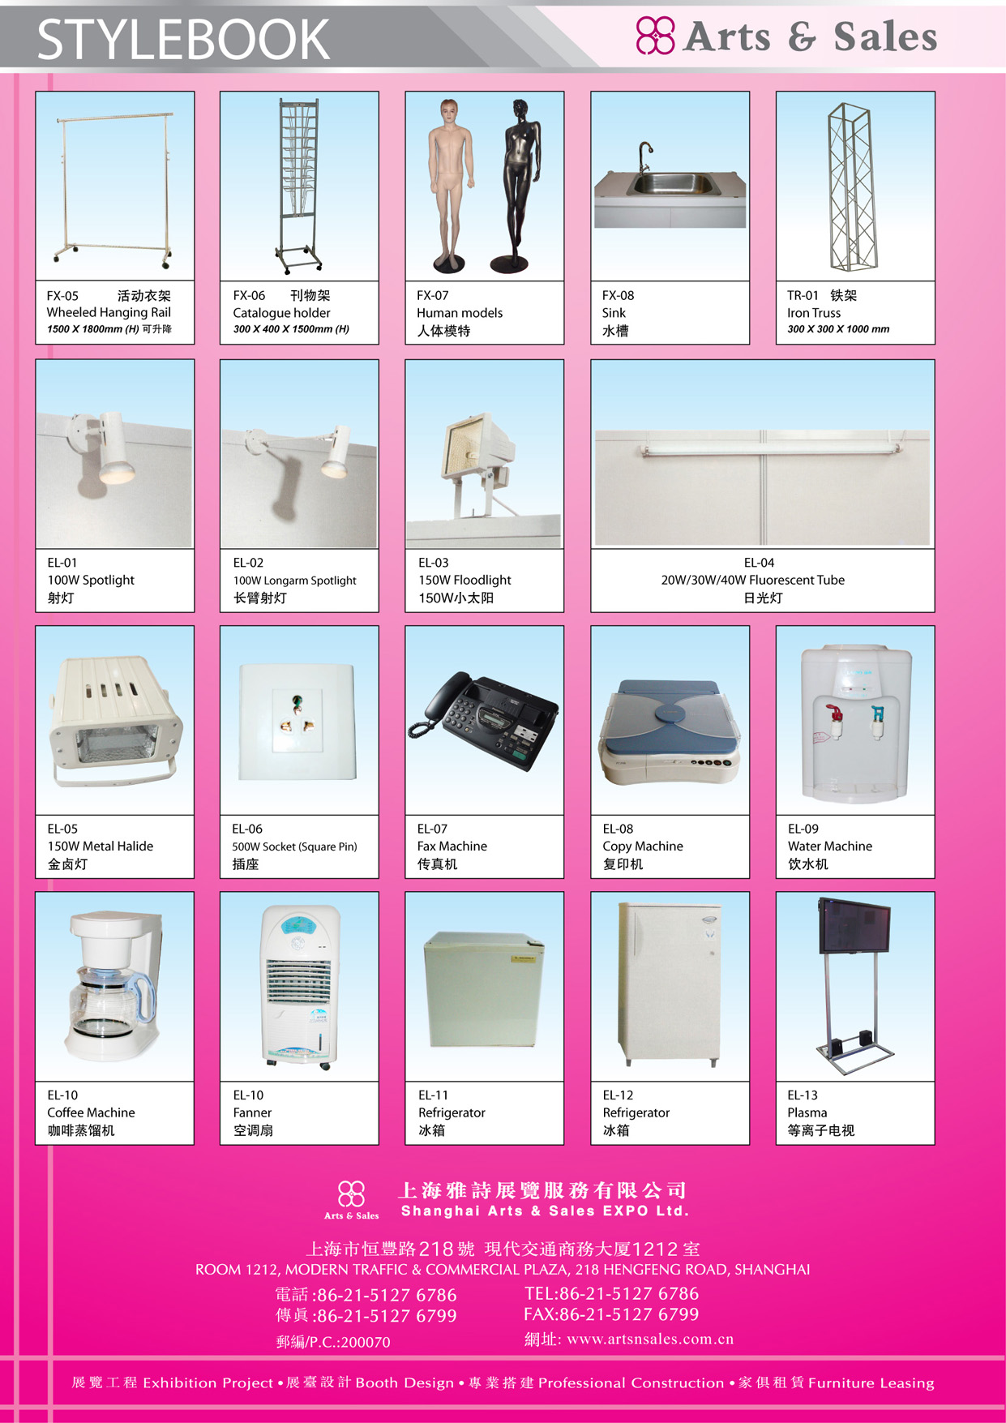

Form 11 Additional Electrical Rental
Deadline: Jun.10,2019
Please return form to：  Shanghai Arts & Sales Expo Ltd.  Room1212, Shanghai Modern  Traffic & Commercial Plaza  No 218,Heng Feng Road,Shanghai  Tel.：+86 21 5127 6786  Fax：+86 21 5127 6799  E-mail：artsales@163.com  Contact Person：Ms.Vicky Wann | Exhibitor Information
 | Company Name：
 | Address：
 | Tel：
 | Fax：
 | E-mail：
 | Authorized by：
 | Date：
 | Signature： | Hall/Booth No：

• This Form must be filled in completely by every exhibitor who require the service. And must be returned/faxed to Shanghai Arts&Sales before the deadline.
• The rental time is one exhibition period. Please look at the Stylebook.

Item | Description(mm) | Unit(RMB) | Qty. | Total
EL-02 | Longarm Spotlight . 100W | 90.00
EL-04 | Flourescent Tube . 40W | 90.00
EL-05 | Metal Halide 150W | 300.00
EL-06 | Socket 500W | 150.00
EL-07 | Fax machine | 1,200.00
EL-08 | Copy machine | 2,000.00
EL-09 | Water machine | 300.00
EL-12 | Refrigerator(Small) | 600.00
EL-14 | Plasma 42’’ | 4,000.00
 | Totalize:

Please kindly send cheque to:
Name of Beneficiary: SHANGHAI ARTS AND SALES EXPO LTD.

Account No: 310066441018170240686 SWIFT CODE: COMMCNSHSHI

Name of bank: BANK OF COMMUNICATIONS SHANGHAI MUNICIPAL BRANCH ZHABEI
SUB-BRANCH

• Late order : 50% penalty fee will be charged for any late orders received after the deadline;
• Refer to back page for payment details .

Form 12 Power Supply For Lighting Rental
Deadline：Jun.10,2019
Please return form to：  Shanghai Arts & Sales Expo Ltd.  Room1212, Shanghai Modern  Traffic & Commercial Plaza  No 218,Heng Feng Road,Shanghai  Tel.：+86 21 5127 6786  Fax：+86 21 5127 6799  E-mail：artsales@163.com  Contact Person：Ms.Vicky Wann | Exhibitor Information
 | Company Name：
 | Address：
 | Tel：
 | Fax：
 | E-mail：
 | Authorized by：
 | Date：
 | Signature： | Hall/Booth No：
• This Form must be filled in completely by every exhibitor who require the service. And must be returned/faxed to Shanghai Arts&Sales before the deadline.
• The rental time is one exhibition period.

Item | Description(mm) | Unit（RMB） | Qty | Overrun  Unit（RMB） | Qty | Total
Power Supply For Lighting | 15Amp/380V,Switch Box | 1,600.00 |  | 2,400.00
Power Supply For Lighting | 15Amp/220V,Fire Monitor Box | 300.00 |  | 450.00
Power Supply For Lighting | 30Amp/380V,Switch Box | 2,400.00 |  | 3,600.00
Power Supply For Lighting | 30Amp/220V,Fire Monitor Box | 350.00 |  | 525.00
Power Supply For Lighting | 60Amp/380V,Switch Box | 3,800.00 |  | 5,700.00
Power Supply For Lighting | 60Amp/220V,Fire Monitor Box | 400.00 |  | 600.00
Operation Fee | Booth Construction Operation | 25.00 | m²
 | Totalize:

• Main power for lighting/for machine should be ordered separately;
• Multi-plug is NOT allowed;
• Late order : 50% penalty fee will be charged for any late orders received after the deadline;
• Refer to back page for payment details;
• Please look at the remittance information in Form 10
Form 13 Equipments & Fittings Rental
Deadline：Jul.10, 2019

Please return form to：  Shanghai Arts & Sales Expo Ltd.  Room1212, Shanghai Modern  Traffic & Commercial Plaza  No 218,Heng Feng Road,Shanghai  Tel.：+86 21 5127 6786  Fax：+86 21 5127 6799  E-mail：artsales@163.com  Contact Person：Ms.Vicky Wann | Exhibitor Information
 | Company Name：
 | Address：
 | Tel：
 | Fax：
 | E-mail：
 | Authorized by：
 | Date：
 | Signature： | Hall/Booth No：
• This Form must be filled in completely by every exhibitor who require the service. And must be returned/faxed to Shanghai Arts&Sales before the deadline.
• The rental time is one exhibition period.

Item | Description(mm) | Unit（RMB） | Qty | Overrun  Unit（RMB） | Qty | Total
Power Supply For Machine | 15Amp/380V,Switch Box | 1,600.00 |  | 2,400.00
Power Supply For Machine | 15Amp/380V,Fire Monitor Box | 300.00 |  | 450.00
Power Supply For Machine | 30Amp/380V,Switch Box | 2,400.00 |  | 3,600.00
Power Supply For Machine | 30Amp/380V,Fire Monitor Box | 350.00 |  | 525.00
Power Supply For Machine | 60Amp/380V,Switch Box | 3,800.00 |  | 5,700.00
Power Supply For Machine | 60Amp/380V,Fire Monitor Box | 400.00 |  | 600.00
Telephone  &  Internet | LDD(deposit 3000) | 1,200.00 | /
Telephone  &  Internet | DDD(deposit 3000) | 1,600.00 | /
Telephone  &  Internet | IDD (deposit 3000) | 3,200.00 | /
Telephone  &  Internet | 10M broadband | 6,100.00 | /
Compressed  Air | 0.5HP-5HP(≤0.4M3/ Min & 8-10kgf /cm2) , Ø 10mm, | 3,500.00 | /
Compressed  Air | 6HP-10HP(≤0.9M3/ Min & 8-10kgf /cm2) , Ø 19mm, | 4,000.00 | /
Compressed  Air | 10 Bar, 1m3/Min, Ø 25mm | 4,500.00 | /
 | Totalize:

• Main power for lighting/for machine should be ordered separately;
• Multi-plug is NOT allowed;
• Late order : 50% penalty fee will be charged for any late orders received after the deadline;
• Refer to back page for payment details;
• Please look at the remittance information in Form 10
Form 14 Service Location Plan
Deadline：10 JUNE , 2019
Please return form to：  Shanghai Arts & Sales Expo Ltd.  Room1212, Shanghai Modern  Traffic & Commercial Plaza  No 218,Heng Feng Road,Shanghai  Tel.：+86 21 5127 6786  Fax：+86 21 5127 6799  E-mail：artsales@163.com  Contact Person：Ms.Vicky Wann | Exhibitor Information
 | Company Name：
 | Address：
 | Tel：
 | Fax：
 | E-mail：
 | Authorized by：
 | Date：
 | Signature： | Hall/Booth No.：
• If you have ordered any main power / air compressor / water / telephone line / network line, please fill in completely and send/fax to Shanghai Arts&Sales before the deadline.
(Scale: 1 □ = 1 sqm )
_________

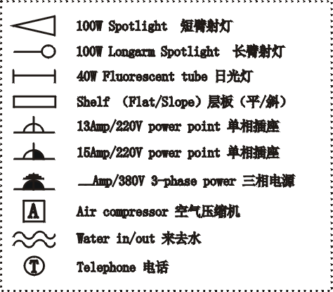

_________
• If you don’t return the plan to us before the deadline, we will set the equipments in proper position.
• Any relocation on site is subject to 50% surcharge.

Form 15 Booth Construction Service
Deadline: Jun.10, 2019

Please return form to：  Shanghai Arts & Sales Expo Ltd.  Room1212, Shanghai Modern  Traffic & Commercial Plaza  No 218,Heng Feng Road,Shanghai  Tel.：+86 21 5127 6786  Fax：+86 21 5127 6799  E-mail：artsales@163.com  Contact Person：Ms.Vicky Wann | Exhibitor Information
 | Company Name：
 | Address：
 | Tel：
 | Fax：
 | E-mail：
 | Authorized by：
 | Date：
 | Signature： | Hall/Booth No.：

• This Form must be filled in completely by every exhibitor who require the service. And must be returned/faxed to Shanghai Arts&Sales before the deadline.

- If the exhibitors who have booked the “RAW SPACE STANDS” want to use the Official Stand Contractor as your appointed contractor, please send this form to us ASAP. We will contact you and draw the stand design on the basis of your requirements with the quotation.
- If the exhibitors who have booked the “RAW SPACE STANDS” have chosen other contractors as the appointed contactors, please fill in the following form completely and send/fax us.

Stand Contractor:
Address:
Contact person:
Tel: | Fax: | Email:
Signature:
Date:
Exhibiting company:
Address:
Contact person:
Tel: | Fax: | Email:
Signature:
Date:

Form16 Invitation Letter Application

Deadline: Jun.10, 2019
Please return the form to:  Shanghai International Exhibition Co. Ltd | Company:
Add: No.10 Building, HONGQIAO ZHENRONG Center,666 Shenhong Road, Shanghai, China(201106) | Add:
Contact Person: Lynn Yang | Contact Person:
Tel: 86-21-62792828 | Tel: Fax:  E-mail:
Fax: 86-21- 65455124 | □ Exhibitor, Booth No.  □ Visitor
E-mail: yangqiaoling@siec-ccpit.com | Signature：

The invitation letter is issued by Shanghai International Exhibition Co. Ltd.
Please supply information as listed below for those who need an invitation letter to support their application for a visa. Accurate information is essential. Full details must be typed. One copy is for one applicant only.
Processing time: 5 to 7 working days.
Exhibition： | PHOTO & IMAGING SHANGHAI 2019
Surname:
Given Name:
Nationality:
Gender:
Date of Birth: | ____(DD)____(MM)____(YYYY)
Occupation / Position :
Passport No.:
Date & Place of Issuances:
Expiry Date:
Duration of Staying: | ___(DD)___(MM)____(YYYY)  ___(DD)___(MM)____(YYYY)
Please Specify: | - The original invitation letter sent by express delivery(EMS)  - The copy of the invitation letter sent by email or fax
Notes:
1.Applicant’s passport must be valid for at least SIX MONTHS beyond the intended date to enter PR China or any destination.
2.Upon receiving the invitation letter, please take it together with your passport to Chinese Embassy or Consulate to get visa.

Notice for exhibitors registration

Dear exhibitors,

Thank you for your great support and cooperation to Photo & Imaging Shanghai 2019. Please take this note or booth booking agreement onsite with your business card for exhibitor registration.

Registration Date and Time:
Raw space exhibitors:
Jul.08, 2019 09:00-18:00
Jul.09, 2019 09:00-20:00

Package stands exhibitors:
Jul.08, 2019 13:00-18:00
Jul.09, 2019 09:00-20:00

Registration Place:
National Exhibition and Convention Center (Shanghai)
No.333 Songze Avenue, Qingpu District, Shanghai (North Entrance)
No. 1888 Zhuguang Rd, Qingpu District, Shanghai (West Entrance)

Registration Details:

Booth No.:_____________ Company Name: __________________________

Contact Person: ___________ Mobile Number: __________________

Note:
1. Please fill in this form clearly and attach your business card for onsite registration.
2. You can pick up your exhibitors’ badges during Jul.10-12, 2019 while register onsite. You should return the completed Form 2 - Delegation List to the organizer before Jul.10,2019 for badges application.

