
Niaz Ahmed - Ghazi Khan
Residence: Baldia Town, Karachi - Pakistan
Email: ahmedghazi05@gmail.com
Contact No: 03132180644, 03160103995
___________________________________________________________________________
Objective:

To establish myself in a stable and well-reputed company, where I can utilize and contribute my expertise, experiences and harness my potential to be a part of the company’s growth with my loyalty, dedication and hard work in an environment that offers challenge, recognition and a bright career.

Summary:

Available to join the company with over UAE working experience and strong artistic skills, target oriented, graduate of Master of Science in Business Administration with Solid background in handling strategy and able to handle customer service, retail sales, very flexible and easy to adopt or handle different type of nationality of customers. Giving support and assistance to the customer. Outstanding background in information and communication technology. Fluent in speaking, writing English and Arabic language. A good team player can work efficiently under pressure.

PROFESSIONAL EXPERTISE:

SpeedEx Courier & Logistics (Posta Plus Group)
Modern Line Distribution L.L.C
Duration: October 2017 – Until Now
Location: Dubai- Umm Ramool, Street-4, Warehouse
Position: HR Coordinator
Salary- 4000 (AED)
Staff ID: 1641
Link: https://www.postaplus.com/r

Duties:

•Representing the SpeedEx Courier Services.
•Calling Outbound calls to customers.
•Greetings to the customers.
•Communicate with all type of customers.
•Answer questions about office working hours timings to customers.
•Assisting the customers to pick the shipment from Umm Ramool location.
•Handle complaints regarding shipment delivery & re-arrange the shipment for location.
•Maintain the Microsoft Excel records in system.
•Maintain current standards & compliance with postal regulations.
•Maintain the grooming standard & punctuality at work.
•Keep work areas orderly, clean & safe, ensures proper care in the use of computer.
•Perform miscellaneous job-related duties as assigned.
•Working on Courier Manifest Application, Microsoft office, Excel etc.


Emirates Post Group HQ (Government of Dubai)
Duration: December 2016 - April 2017 (5-months)

Location: Dubai, Umm Ramool, Street-9
Position: Postal Clerk/ Customer Care
Salary- 3000 (AED)
Staff ID: 45956
Link: https://www.epg.gov.ae/

Duties:

•Representing the Emirates Post Group Services.
•Calling Outbound calls to customers.
•Greetings to VIP gold customers.
•Communicate with VIP gold Arabic customers.
•Answer questions about office working hours timings to customers.
•Assisting the customers to pick the shipment from Umm Ramool location.
•Handle complaints regarding shipment delivery & re-arrange the shipment for location.
•Maintain the Microsoft Excel records in system.
•Maintain appropriate records for postage & inbox mails.
•Maintain current standards & compliance with postal regulations.
•Maintain the grooming standard & punctuality at work.
•Keep work areas orderly, clean & safe, ensures proper care in the use of computer.
•Perform miscellaneous job-related duties as assigned.
•Working on Courier Application, CRM, Microsoft office, Excel etc.


Emirates Airline Group HQ (Contract)
Avis Emirates Transport by Luxury Cars L.L.C.
Duration: March 2016 – June 2016 (4-months)
Location: Dubai Airports, Terminal-3, Arrivals, G floor, Exit-1
Position: Customer Services (First Class and Business Class)
Salary- 2000(AED)
Staff ID: Access Card (Temporary)
Link: www.avis.ae/

Duties:

•Representing the Emirates Airline services to customers.
•Greetings to VIP First and Business Class customers.
•Research required information using available resources.
•Manage and operate the VTS Samsung tablet in the vehicle.
•Communicate with VIP First and Business Class customers.
•Ensuring that the VIP customers are sent to proper drop-off location.
•Checking the dispatch receipt from the customers for drop-off location.
•Regularly check the customers for departure pick up location.
•Drop-off the VIP customers at Dubai Airports, Terminal-3.
•Ensuring the quality of the customers is delivered from us.
•Checking and analyzing the services of the customers.


Etisalat Telecommunication Company (Semi-Government)
Serco BPO Global Services FZE L.L.C (contract)
Duration: December 2015 – February 2016, (3-months)
Location: Dubai Academic City, Arab Bank Building, 3rd floor
Position: Collection Officer
Salary- 4000 (AED)

Staff ID: Access Card (Temporary)
Link: https://www.etisalat.ae/

Duties:

- Excellent communication skills with ability to negotiate with the customer under adverse conditions.
- Should be honed to recognize or differentiate between willful / intentional defaulters and others to restrict further exposure and initiate suitable collection actions.
- Ability to strike a delicate balance between service and collections roles.
- Flair for consistent achievement of productivity and performance targets with high motivational levels.
- Ability to handle stress that may evolve due to constant target pressures and collections follow-ups, which may become monotonous after a sustained period of time.


Sharaf HQ Investment Group L.L.C
Duration: August 2015-November 2015, (4-months)
Location: Dubai, DCC (Deira City Center), 2nd floor
Position: Sales Executive - Indoor
Assigned: Telecom (Smart Phones)
Salary- 2000 (AED)
Staff ID: Access Card (Temporary)
Link: https://uae.sharafdg.com/

Duties:

- Identifies business opportunities by identifying prospects and evaluating their position in the industry; researching and analyzing sales options.
- Sells products by establishing contact and developing relationships with prospects; recommending solutions.
- Maintains relationships with clients by providing support, information, and guidance; researching and recommending new opportunities; recommending profit and service improvements.
- Identifies product improvements or new products by remaining current on industry trends, market activities, and competitors.
- Prepares reports by collecting, analyzing, and summarizing information.
- Maintains quality service by establishing and enforcing organization standards.
- Maintains professional and technical knowledge by attending educational workshops; reviewing professional publications; establishing personal networks.

Dnata- Emirates Airline Group HQ (Semi-Government)
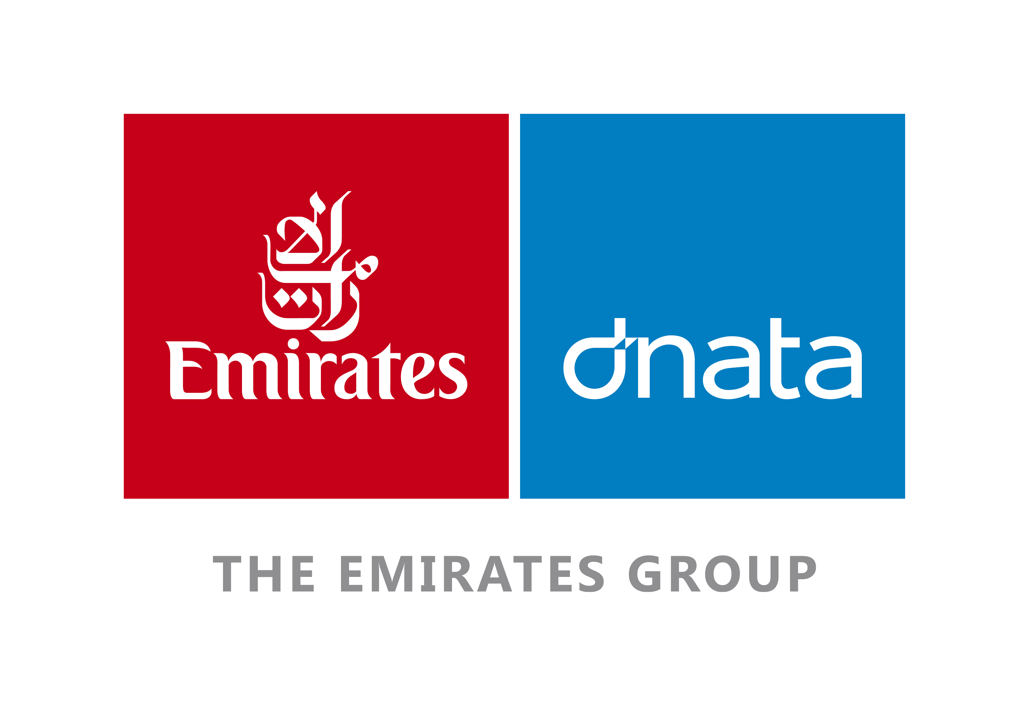
Duration: December 2012 - June 2015 (2 years + 6 months)
Location: Dubai Airports, Terminal -3, Level-B2, ULD office
Position: Office Clerk/ Coordinator
Salary- 3000 (AED)
Staff ID: 422241
Link: http://www.emiratesgroupcareers.com
Duties:

- Check incoming paperwork (correspondence, invoices etc.), also make copies before disturbing.
- Sort all papers alphabetically and according to content, dates, significance etc.
- Create or update records with new files and information.
- Store all paperwork in designated places securing the important documents.
- Enter paperwork into an electronic system either by date entry or by using optical scanners.
- Deal with all requests to access files and keeps logs of borrowed papers.
- Develop an efficient filing system to make updating and retrieving files easier.
- Follow policies and confidentiality dictations to safeguard data and information.
- Monitor inventory of files, report shortages, papers clips etc.



Jado Pado (Online Shopping)
Al Bogari Commodities Holdings L.L.C
Duration: August 2012 – October2012 (3-months)
Location: Dubai, Emaar Square, Bolevard Building-2, Level-1
Position: HR Coordinator
Salary- 3000 (AED)
Staff ID: Access Card (Temporary)
Link: https://jadopado.com/

Duties:
- Manages documentation, including contracts, maternity documentation, and sickness documentation.
- Communicates with staff for the purpose of ordering office supplies and planning of meeting rooms.
- Schedules interviews with hiring managers and coordinates the group interview process.
- Coordinates training requirements, including organizing rooms for employee training, printing training certificates and filing them accordingly, reviewing training policies, and updating training systems.
- Organizes relevant office events.
- Organizes staff meetings and executive schedules.
- Coordinates corporate events.
- Keeps office clean and organized to promote an efficient working environment.


Emirates Integrated Telecommunications Company (DU)
Styra Corp BPO Management Services (Project Base)
Duration: February 2012 - June 2012 (5- months)
Location: Dubai Media City, Grand Midwest Tower, 33rd floor
Position: Call Center Representative
Project: NXT Internet TV (Device)
Salary- 5000 (AED)
Staff ID: Access Card (Temporary)
Link: www.du.ae/

Duties:
- Receiving Inbound calls and Outbound calls from customers.
- Assisting and conducting live demonstration of the device to the entire walk in customers in the store.
- Respond to customer inquiries.
- Research required information using available resources.
- Handle and resolve customer complaints.
- Provide customers with product information.
- Enter customer information in system.
- Responsible of attending call such as inquiries, complains and online troubleshooting of the device for our consumers, and posting it in our system to be escalated in du IT department.
- Making outbound calls to all DU VIP Consumers.
- Answering inquiries of our customers through Email locally and overseas.
- Responsible of selling the NXT device to existing du consumers and new customers.
- Manages and supervise the system in the office.
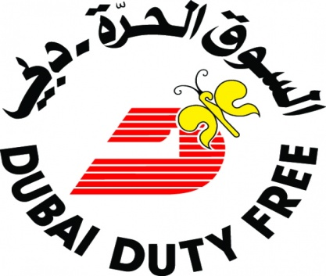
Dubai Duty Free Group (Semi- Government)
Duration: July 2005– January 2011, (5-years)
Location: Dubai Airports- Terminal 3, Departure, Shop floor
Position: Sales Assistant/ Brand Merchandiser
Salary-7000 (AED)
Staff ID: 2616
Link: https://www.dubaidutyfree.com/

Duties:
- Sells products by establishing contact and developing relationships with prospects; recommending solutions.
- Identifies business opportunities by identifying prospects and evaluating their position in the industry; researching and analyzing sales options.
- Maintains relationships with clients by providing support, information, and guidance; researching and recommending new opportunities; recommending profit and service improvements.
- Identifies product improvements or new products by remaining current on industry trends, market activities, and competitors.
- Prepares reports by collecting, analyzing, and summarizing information.
- Maintains quality service by establishing and enforcing organization standards.

DSF-Dubai Shopping Festival (Part Time, One Month)
Duration: January 15th 2004– February 15th 2004

Location: Dubai Global Village, Al Garhoud
Position: Promotion Boy / Cashier
Assigned: Evolution Rides
Salary- 4000 (AED)
Staff ID: Exhibitor Pass
Link: www.globalvillage.ae/dsf

Duties:

- Greetings to the customers.
- Communicate with all type of nationalities customers.
- Demonstrate e and provide information on promoted products and services.
- Create a positive image and lead consumers to use it.
- Use lectures, films, charts or slide shows.
- Distribute product samples, broachers, flyers etc. to source new sales opportunities.
- Identify interest to understand customer needs and requirements.
- Set up booths or promotional stands and stocks products.
- Report on demonstration related information (interest level, questions asked, number of samples/ flyers distributed etc).



Dubai Municipality – Public Health (Government of Dubai)

Duration: October 1999– June 2005, (5-years)
Location: Dubai, Al Quoz- Industrial- 3, Street- Umm Suqeim
Position: Customer Services Representative
Salary-1,400 (AED)
Staff ID: 991527
Link: https://www.dubaimunicipality.com/

Duties:
- Attracts potential customers by answering product and service questions; suggesting information about other products and services.
- Opens customer accounts by recording account information.
- Maintains customer records by updating account information.
- Resolves product or service problems by clarifying the customer's complaint; determining the cause of the problem; selecting and explaining the best solution to solve the problem; expediting correction or adjustment; following up to ensure resolution.
- Maintains financial accounts by processing customer adjustments. Recommends potential products or services to management by collecting customer information and analyzing customer needs. Prepares product or service reports by collecting and analyzing customer information. Contributes to team effort by accomplishing related results as needed.

ACADAMIC QUALIFICATION:

American Heritage University - Master of Business Administration (year 2012)
City of London College - Bachelor of Business Administration (year 2010)

COMPUTER PROFICIENCY:

MS WINDOWS (2000, ME, XP, VISTA, WINDOWS 8).
MS OFFICE (Word Excel, Power point, Outlook).
QuickBooks Pro, in powered, Solomon, POS, MRMS.
PC Assembling, Software and Hardware Troubleshooting and Networking.

COMPUTER INSTITUTIONS:

Cyber Cosmos Educational Institute, Dubai.
Galaxy Computers Institute, Dubai.
Institute of Professional Advancement (IPA).

ACHIEVEMENTS CERTIFICATES:

Speedex Courier & Logistics (Posta Plus Group)
Emirates Airline Aviation College (Semi- Government)
Dubai Duty Free Group (Semi- Government)
Dubai Municipality- Public Health (Government of Dubai)
Pakistan Association Dubai (Musical Concert)

DRIVING LICENSE:

License No 542824
Vehicle No 3, 5, 6
Issue Date 23/10/2000
Expiry Date 18/11/2021
License Available Light Vehicle, Heavy Bus &Minibus
License Type Manual
Place of Issue Dubai

PERSONAL DETAILS:

Date of Birth 5th January 1979
Nationality Pakistan
Marital Status Married
Passport No KK1150753
Date of Issue 10th/April/2017
Date of Expiry 9th/April/2022
Place of Issue Dubai
Visa Status Employment

EID-UAE (Emirates Identity Card of United Arab Emirates) DETAILS:

EID No 784-1979-5304714-5
Expiry Date 10th/January/2020
EID Type Computerized
Printed Type English/Arabic
Place of Issue Dubai

NICOP (National Identity Card Overseas Pakistanis) DETAILS:

NICOP No 420000-476075-7
Issue date 6th/October/2012
Expiry date 6th/October/2022
NICOP Type Computerized
Printed Type English
Place of Issue Dubai

HOBBIES:

Watching TV, News, Reading Books, Surfing Internet, Music, Playing Football and Cricket.

LANGUAGES KNOWN:

Arabic, English, Hindi, Urdu, Hindko & Punjabi.

REFERENCE:

- Mr. David Mckern, (IT Technical Support Line Manager), DU Telecommunication.
      - NXT Internet TV, Grand Midwest Tower, Dubai Media City
      - Email: david.mckern@du.ae, david.mckern@anayou.com

DECLARATION:

I hereby certify that the above and fore mention are true and correct to the best of my knowledge and that any false information will be grounds for my disqualification.
Niaz Ahmed - Ghazi Khan.

