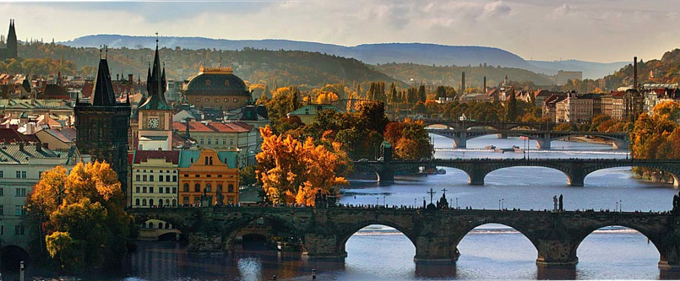

Annual meeting of ANSS
1. - 3. May 2015
Lindner Hotel Prague Castle
Prague, Czech Republic

Registration Form for delegates and spouses

Registration Form for delegates and spouses
To ensure your participation to the meeting, please kindly fill in your data in the following form. We would like to ask you to check off the meeting activities that you will be attending. Please email back to Martin Horna martin.horna@mhconsulting.cz with a copy to Prof. Liborio Parinno: liborio.parrino@unipr.it once you complete the registration. Thank you for your support!

Personal Data
Last Name |  |  |  | Title:
First Name: |  |  |  | Position:
Telephone: |  |  |  | Email:
Speciality:  Organization: | ______________________
Organization Address:
Zip code: |  |  |  |  | City:
Country:
Special dietary requirements:
(allergy, vegetarian, etc)
Special remarks:
Accompanying person: |  | ☐ YES ☐ NO

Specific problems, challenges, research ideas, potential awareness campaigns or other issues that you would like to present at the ANSS meeting. Please describe:

ANNS meeting 2015 Activities
Please tick the corresponding boxes if you want to or will attend the named activities.

Thursday, Apr 30, 2015 - ONLY FOR the 5 ANSS-EC MEMBERS!

☐Overnight stay at Lindner Hotel Prague Castle ☐ Accompanying person € 30,-
(Single room including breakfast)

The following is FOR ALL ATTENDANTS of this meeting (all ESRS board members, ANSS-EC-members and all presidents or their representatives including accompanying persons):

Friday, May 01, 2015

☐Welcome reception Friday evening (get-together) ☐ Accompanying person € 57,-
(Buffet dinner in hotel restaurant)

☐Overnight stay at Lindner Hotel Prague Castle ☐ Accompanying person € 30,-
(Single room including breakfast)

Saturday, May 02, 2015

☐Full day meeting Saturday at Lindner Hotel Prague Castle ☐ Accompanying person € 78,-
(Full day catering inc. 2 x Coffee Break and Lunch with 1 x soft drink)

☐Gala Dinner Saturday evening ☐ Accompanying person € 93,-
(Degustation menu including wines or unlimited beverage for 3 hours (without spirits) in Restaurant Mlynec)

☐Overnight stay at Lindner Hotel Prague Castle ☐ Accompanying person € 30,-
(Single room including breakfast)

Sunday, May 03, 2015

☐Half day meeting Sunday at Lindner Hotel Prague Castle ☐ Accompanying person € 70,-
(Half day catering inc. 1 x Coffee Break and Lunch with 1 x soft drink)

I will pay accompanying person costs by:
☐Bank Transfer - Complete your registration first to get your variable symbol and payment instruction. We will send you Participant´s variable symbol first which is generated by our registration system and must be presented in Details of Payment with the Participant´s name otherwise the payment cannot be identified. All payments made by bank transfer have to be net of all bank charges. To simplify the identification of your payment please enclose a copy of your bank transfer with the registration form and send it to the Congress Secretariat by email to: martin.horna@mhconsulting.cz

☐On-site by cash - In this case we require credit card guarantee. Please fill form below. Credit card will be charged only in no-show situation. In regular situation please have exact amount in EUR or equivalent in CZK. Please note that we don‘t accept credit cards on on-site registration just cash!

Registration Cancellation policy:
Mailed or e-mailed:
Cancellations received up and including 15th March 2015, full Refund
After15th March 2015 no refund will be made + charged 100% form your credit card if not paid in advance by Bank Transfer.

Payment for Accompanying Person – credit card guarantee:

Name:____________________________________________________________________________

Type of Credit Card:_________________________________________________________________

Credit Card number:_________________________________________________________________

Expire Date:__________________________________CVC-Code:_____________________________

Signature:_________________________________________________________________________

