

Wireless Siren System

Installation Guide


input.doc

Copyright©Crow Engineering Ltd. 2008
The copyright of this document is owned by Crow Engineering Ltd., its agents and/or professional advisors. No part of parts hereof may be reproduced, distributed, republished, displayed, broadcast, hyperlinked or transmitted in any manner or by any means or stored in an information retrieval system without the prior written permission of Crow Engineering Ltd. or the copyright owner provided that permission is granted to download and print the materials in this document for personal, non-commercial use only provided you do not modify the materials and that you retain all copyright and other proprietary notices contained in the materials. This permission terminates automatically if you breach any of these terms or conditions. Upon termination, you will immediately destroy any downloaded and printed materials.
Trademarks
The trade marks, service marks, and logos (the "Trade Marks") used and displayed in this document are registered and unregistered Trade Marks of Crow Engineering Ltd. and others. Nothing in this document should be construed as granting, by implication, estoppel, or otherwise, any license or right to use any Trade Mark displayed in this document, without the written permission of Crow Engineering Ltd. or other Trade Mark owners. The name of Crow Engineering Ltd. or the Crow Engineering Ltd. logo may not be used in any way, including in advertising or publicity pertaining to distribution of materials in this document, without prior written permission.
Disclaimer
The information in this manual was accurate and reliable at the time of its release. However, we reserve the right to change the specifications of the product described in this manual without notice at any time.
Device Compliance Standards
CE
EN 300 220 v2.1.1
EN 50131
2002/95/EC RoHS
Manufacturing Compliance Standards
ISO 9001:2000
2002/95/EC RoHS
Print Version 03
Nov 2008

Contents
Introduction 1
Primary Tasks of the Siren System 1
Transceiver Unit Description 1
Siren Unit Description 2
Communication Features 2
Operating Modes 3
Unit Command Diagram 3
Physical Locations 4
Transceiver Unit 4
Siren Unit 5
Quick Reference 6
Installing and Learning the Siren Units by the Transceiver (BUS Modes) 6
Installing and Learning the Sirens (BUS and Standalone) 7
Connecting the Transceiver for Standalone Mode 8
Installing the Siren System 10
Installing the Siren Units 10
Physically Installing the Siren Units 10
Setting the Siren Unit Address Jumpers 12
Mode Functions and Maintenance 13
Low Battery Indication 13
Changing the Siren Battery 13
Erasing the Siren Memory. 13

Introduction
The Wireless Siren System is composed of Transceiver Unit and Siren Alert devices. The Transceiver unit is connected to Alarm System Control Panel, and sends its commands to activate the Siren Unit(s) by Wireless communication Transceiver.

Primary Tasks of the Siren System
- Send controls from the control panel to the siren units in order to operate high power alert device using PIEZO siren and power LED
- Manage and report the status indications between the Siren Units and the Control Panel (Communication Status, tamper, arm, disarm and low battery)
- Constantly monitors and synchronize the wireless communication from the Transceiver to each device in the system.

Transceiver Unit Description
The Transceiver Unit has two modes of operation:
  - Connected to the Runner BUS and communicates to the Control Panel via this connection.
  - Connected to a control panel via discreet inputs and outputs. This connection allows interface to any type of Control Panel.

Units Features
- Jumper selection to switch between the two modes of operation - Dipswitch 1 sets the operating mode (Bus – ON and Standalone - OFF)
- Two types of controls can be sent to each siren. One to activate/deactivate the siren, second to provide short beeps when arming and disarming the Alarm System.
- The unit can control up to 8 siren units. In Bus mode the sirens can be divided to two separate groups. (Separate siren activation to each group)
- Can be connected to the Crow Runner BUS or to any Control Panel.
- Two physical connections (IN-1 & IN-2) are used for both modes – For BUS mode IN-1= CLK, and IN-2 =DAT
- The unit is protected by Tamper switch (optional for installation in separate housing).
- Tamper OUT is used in both modes to signal the Control Panel about this condition
- Radio frequency jamming detection logic
- The unit has its Tamper Switch. It can be used if installed in separate housing. The Tamper Switch can be disabled by Dip Switch 2 if the Transceiver is installed in protected area (like inside Control Panel).
- In standalone mode IN-1 activates the siren (Piezo +LED) and IN-2 sends the indication of the arms or disarms of the control panel.
- If the Siren is activated the Transceiver can send a reset control to shut it off.

Siren Unit Description
- The siren, when operated, emits a sound of over 100db
- The Siren unit is able to operate on non rechargeable batteries (3.6V/14Ah Lithium) and should last for a minimum of 4 years
- An external 12V DC (9-14V DC) power input can be connected using the internal battery (3.6V/14Ah Lithium) as backup
- 4 mode jumpers are used to set the siren unit's features. The Siren activates the sound and an LED for short period (beeps) when Arming and Disarming controls are received. These beeps and flashes can be shut off by the option jumpers.
- Battery test generate once a day.
- Multiple tamper switches protected (Cover and Back tamper).

Communication Features
- The Transceiver communicates with the siren units every 1 min.
- Every seven minutes the Transceiver communicates over the bus (in BUS Mode) with the alarm system to report the status of the siren's system communication.
- If one of the siren units does not synchronize with the Transceiver after more then seven minutes the Transceiver notifies the control panel via the connected bus, if in BUS mode, by not sending (stopping) the Supervision messages as in normal operation. If in Standalone mode the Transceiver activates it's "Tamper Out" Signal after about 20 Minutes.
- If one of the siren units in the system reports a low battery condition the Transceiver will send the "Low Bat” status over the bus when in BUS mode. In standalone and in BUS modes extra beeps are added to the normal number of beeps that are heard when Arming and Disarming the System .
- The Transceiver is able to detect any jamming attempts and notifies the alarm system via the Bus (in BUS mode) and via the Tamper out signal in Standalone Mode.
- If the siren is activated for any reason (Alarm/Siren Tamper) it can be reset using the Control Panel's Keypad.
- If any siren unit is activated and not stopped by the User, it will be stopped automatically by a timeout timer after two minutes.
Exception: Only In UK time out is 15 minutes (Jumper Selected)

Operating Modes
As mention above, there are two basic operating modes:
- Bus mode – is when the Transceiver is connected to the runner bus
- Standalone Mode –when the Transceiver is connected to Control Panel that is provided by Third Party Company, (without Runner BUS).

Unit Command Diagram

Physical Locations

Transceiver Unit
Figure 1: Transceiver Locations Diagram

Siren Unit
Figure 2: Siren Unit Locations Diagram

Quick Reference
.
Mnemonic | Description
<PROG> | PROGRAM key.
<ENTER> | Enter key.
 | Press key or enter parameter

Installing and Learning the Siren Units by the Transceiver
(BUS Modes)
Up to 8 siren units can be activated by single Transceiver. In BUS Mode, these sirens can be divided to two groups (A&B) for activating their sirens (by receiving two separate activation controls).
Notes:
It's important to locate the Siren at least 2 meter distance from the transceiver.
It's recommended to install the transceiver at least 2
meter from the FW-Receiver if there is any.
 | Command or Instruction | Description
1 | Set mode DIP 1  ON (BUS Mode)  OFF (Standalone) | Set the Mode using DIP 1.
3 | Enable/Disable tamper DIP 2  ON – Transceiver Tamper enabled  OFF – Transceiver Tamper disabled | If the Transceiver is installed in a controlled environment the Tamper can be disabled.  If installed with external housing option, Enable the Tamper, and make sure it is functioning
4 | Power OFF the Control Panel
5 | Install Transceiver card | The Transceiver can be installed inside a control panel or in separate housing(using supplied PCB standoffs) .
6 | Connection a Transceiver inputs  to a BUS | Pos = +12Volt  Neg = -12Volt  CLK = IN-1  DATA = IN-2
7 | Power up the panel
8 | Ensure system is disarmed
9 | <PROG> code <ENTER> | Factory default code 000000
10 | <PROG> 122 <ENTER> Zone (1 to 16) 1 5 <ENTER> | Select spare zone for the Siren Indications (prefer Zone 16). Option 1 for Zone 16 activation and option 5 for radio device selection.
11 | <PROG> 164 same zone as above <ENTER> | Select Radio Learn mode and wait for mode to change.
12 | <ENTER> | Start learning process.
13 | On Transceiver <Learn/Test> button | On the Transceiver, press the Learn/Test button. The Control Panel Starts short beeps. The beeping stops as soon as the device is registered (learned).

Installing and Learning the Sirens (BUS and Standalone)
 | Instruction | Description (See Fig. 2 on page 5)
1 | Install the sirens on a flat surface
2 | Connect Piezo siren cable
3 | Connect battery cable | Connect the battery cable and slide the battery into its restraint clip.
4 | Connect +12V external power | Connect external 12V power source (optional).
5 | Set Group A or Group B in the Siren Mode switches | Jumper "A". See also Table 7 on page 11
6 | Install Jumpers B and C to enable audible and flashes indications. | See Table 6 on page 11
7 | Transceiver <Learn/Test> | On the Transceiver press Learn/Test button.  Blue LED on Transceiver starts flashing.
8 | Siren <Learn> | On the siren press Learn button. Blue LED on the Transceiver turns to solid "ON" for three seconds and then turns OFF. The Siren is learned by the Transceiver.

Connecting the Transceiver for Standalone Mode
In standalone mode it is not needed to register (learn) the siren Transceiver with the Control Panel.

Notes:
It's important to locate the Siren at least 2 meter distance from the transceiver.
It's recommended to install the transceiver at least 2
meter from the FW-Receiver if there is any.

- To install the siren Transceiver in standalone mode:
1. Ensure that the Transceiver is located in an area that ensures a strong signal to the siren cluster.
2. Disconnect the mains power to the Control Panel.
3. If the Transceiver is inside its own enclosure, remove the cover.
OR
If the Transceiver is to be installed inside the control unit, remove the cover.
4. Disconnect the control system battery.
5. On the Transceiver card set the DIP switch 1 to OFF standalone mode.
See Figure 1 on page 4 for location of DIP switches.
6. If Transceiver is installed in a secure location set DIP switch 2 to OFF (down).
This disables the tamper circuit. When DIP switch 2 is ON the tamper is enabled
7. Use the standoffs spacers supplied with the unit to mount the Transceiver in an external housing.
8. Connect the Transceiver to Control Panel signals' per the table below..
Third Party Control Panel's Connector | Transceiver Connector
Siren Activation Control Output | IN-1
Arm/Disarm Status from Panel | IN-2
-12V | -12V
+12V | +12V
Tamper input to Control Panel | Tamper Out
9. Reconnect the battery and plug the control panel unit back into the mains.
10. Do not close the cover at this time.
11. Ensure that the panel is powered up.
12. Go to found. above.

Installing the Siren System

Installing the Siren Units

Physically Installing the Siren Units
A Transceiver can control up to 8 sirens. It is recommended that the units be installed on a flat surface in a prominent location.
- To install the siren in each location:
1. Choose a location for each one for the installation of each siren units. Make sure that there is Radio coverage to this location from the Transceiver.
Place the Siren Units high enough off the ground in order to make them inaccessible to passers-by and well within the wireless range of the cluster Transceiver
2. Remove the two pivot screws that secure the siren cover.
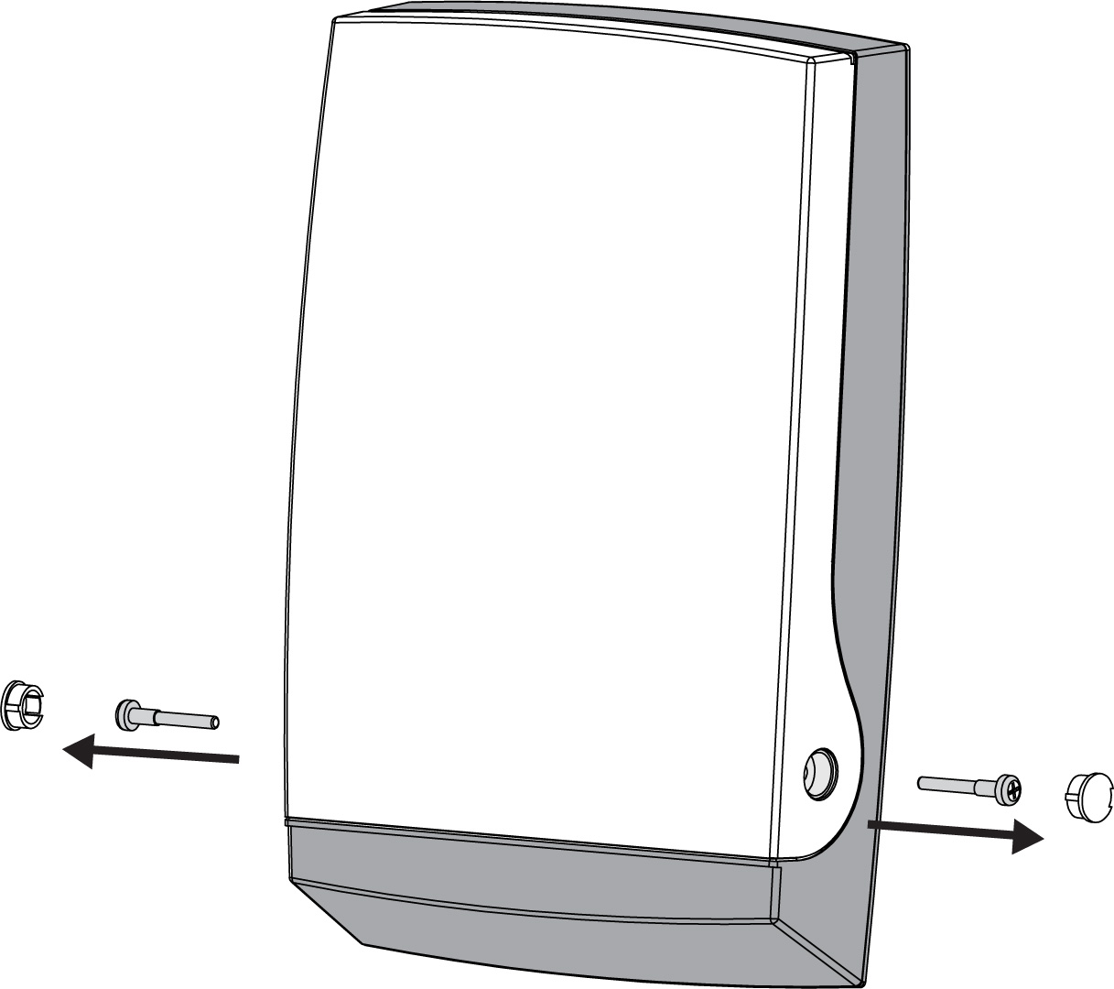
Figure 3: Siren Unit
3. Remove the siren cover.
4. Place the unit on the installation surface and mark out the four screw holes.
5. Use a 8 mm bit to drill the holes
Figure 4: Open Siren Unit
6. Fix the unit onto the installation surface.
7. Ensure that the Piezo siren is connected to the Piezo connector (as shown below).
Figure 5: Siren Connectors
8. Insert the battery into the battery clip and connect it to the BAT connector (shown above).
 Note: The battery shall be Installed/replaced by service man

Setting the Siren Unit Address Jumpers
Each unit in a system must be learned by the Transceiver as described above

Siren's Jumper's MODE SET-UP
Jumper No. | Function if = O (Open) | Function if =1 (Close)
A | Area A Group | Area B Group
B | NO Flashes with ARM/Disarm | Flashes appear with ARM/Disarm
C | NO Beeps with ARM/Disarm | Beeps sound with ARM/Disarm
D | 2 Min Time out | 15 Min Time out
Figure 6: Siren Jumpers set-up
To set the siren unit Mode jumpers:
1. As Mention above, the Sirens that are connected to one Transceiver can be divided to two groups from operation purposes. Jumper A (See above) is setting these two groups. Jumper C is enabling the short beeps when arming and disarming the Control Panel - 2 beep for Arm and 1 beeps for Disarm.
2. Jumper B is enabling the short Flashes from the Power LED when Arming and Disarming the Control Panel
3. Jumper D is setting the time-out of the siren; 2 minutes and 15 Minutes.

Mode Functions and Maintenance

Low Battery Indication
The battery is tested every 4 hours and after power-up.
When the siren battery is low more beeps are added to the ARM/Disarm beeps in order to indicate the LOW BAT condition of the siren unit. When Arming the siren there are 3 beeps, short pause and another 3 beeps instead of two beeps and when Disarming the siren there will be 3 beeps instead of one.
This Low Battery indication's beeps and flashes will be "on" no matter what the status of Mode Jumpers B and C.
In Bus Mode the Low Battery status will be reported to the Control Panel via the BUS and will be indicated as Device's Low Bat Alarm.

Changing the Siren Battery
To change the siren battery:
- 1. Remove the two pivot screws as shown in Figure 2on page 5.
- Disconnect the Power Supply and replace the battery by fresh one.
- Verify Low Bat restored and then connect the Power supply.
Note: The battery shall be Installed/replaced by service man

Erasing the Siren Memory.
If a siren has to be re-programmed from zero to new Transceiver. The reset activation is done by disconnecting the Power Supply and removing the battery and reconnects it while holding the Learn Switch for 5 seconds.

Specifications
Value | FW-Siren Specification (External Unit)
More then 100dB | Sound Pressure Level
2700 Hz | Fundamental Frequency
Yelp | Siren Tone
2700 ±500 Hz | Frequency Range
Power LED | Flash Light
9V÷15V DC or Battery 3.6V /19Ah Lithium. | Power Supply Voltage
Standby:110uA ±10uA@ Battery operation  20mA±2mA@12V DC operation..  Alarm:  Average: 950mA @ Battery operation.  Max: 1.8A @ Battery operation.  Average: 200mA @ 12V DC operation.  Max: 1.8A @ 12V DC operation. | Current consumption (Speaker and Strobe).
Up to 1.8A | Power Supply current limitation
3W | Maximum Power
120 seconds/15min | Siren Alarm Period
2.8V | Low Battery Level
LED Flash @ Arm/Disarm | Low Battery Indication
- LED Flash : Arm-1 Disarm-3  - LED Flash with Beeps : Arm-1 Disarm-3  Depends on Jumper D status. | Arm/Disarm Indication
Every 7 min. | Supervision
Normally Closed.  After power up the Tamper will activate only after the second opening and then Activate the Piezo for 120 sec or till reset by the C.P. | Tamper Switch
> 5 Years (Based on 2 min Piezo operation/month) | Battery Life
External Box: P.C. (3mm thick). | Material
L=310mm x W= 205mm x H= 75mm | Dimensions of unit
1.2 Kg | Weight (Without Battery)
-30oC to +70oC | Operating temperature range
IP 43  Plastic PC with UV protection  Conformal coated circuit board | Case Protection Level

Value | Transceiver Specification (Remote)
9V-14V DC | Power Supply
Receive:30mA±5mA  Transmit:40mA±5mA | Current Consumption
Up to 1.8A | Power Supply current limitation
-10oC to +50oC | Operating temperature range
-20oC to +70oC | Ambient temperature, storage
IN-1: Trigger Alarm.  IN-2: Trigger Key Arm/Disarm  BUS Connection via Fast Connection or Terminals | Inputs
Tamper Out Terminals ,  Dry contacts 12V DC/100mA | Outputs
Blue LED indicate Rx/TX | Indication
Connected by hardware to TAMP OUT output.  Can be ignored(see Dipswitch 2) | Tamper
Dip#1 : Define the Mode operation  #1 On: BUS Mode.  #1 OFF: Universal Mode  Dip#2 : Define Tamper  #1 On: With Tamper  #1 OFF: Without Tamper | Dipswitch 2

