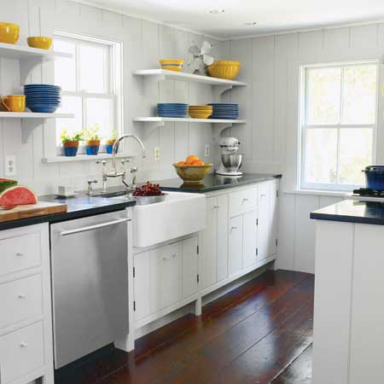
A New Kitchen

You are going to design and cost a new kitchen for your home.

First of all, you need to measure the length and width of your kitchen at home and make a scale drawing of your (empty) kitchen. You also need to measure and make a note of where the doors, windows, radiators, sockets, cooker point (gas or electricity) and water (i.e. the sink, dishwasher, washing machine) are located.

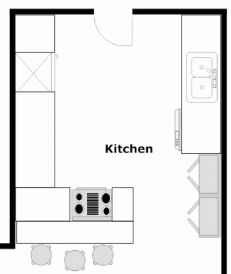
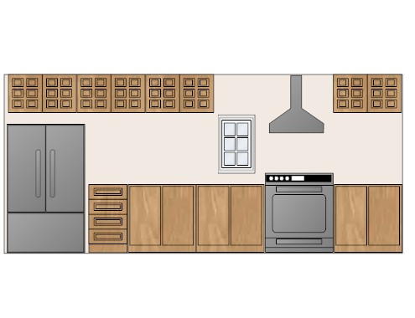
Your teacher will tell you how much money you have to spend on the units, worktop and appliances. Choose which style and size of units you want in your kitchen. Cut these out of paper to make templates. You can then keep arranging your units until you are happy with your design. Then stick the templates onto your scale drawing (the wall units will need to be stuck on top of the base units).

For each wall, draw elevations to show what it will look like.

Calculate the area of your kitchen floor. Decide on the floor
covering (tiles, laminate, solid wood, vinyl) and work out the cost of the flooring for your kitchen.

The walls will need to be tiled, at least behind the sink and above the cooker. You may wish to tile all the walls between the worktop and the wall units. Work out the area of wall to be tiled and, having chosen your tiles, calculate how much it will cost (remember to include tile cement/grout!).

The ceiling and any walls not tiled will need to be painted. Calculate areas and work out the cost of the paint.

You need to provide a detailed list of all the costs of your kitchen: the base and wall units, worktop, plinths, appliances, flooring, tiles and paint. Work out how much your kitchen costs in total.

Find out the typical interest rate on a bank loan for the amount you wish to borrow. Also find out a typical interest rate for a credit card and the interest rate for a savings account. Investigate four methods of paying for your kitchen: saving up first to enable you to pay for it when you buy it, obtaining a bank loan to enable you to buy the kitchen and then pay back the bank, using a credit card and paying back either the minimum payment and, lastly, using a credit card and paying back a fixed amount for a given number of months (more than the minimum payment).

Which payment option do you think you will choose? Why?
A New Kitchen – Teacher’s Notes

Pupils will all have different size kitchens and so will be working on different scale diagrams, unless you specify the scale.

Give pupils a budget of between £2000 to £5000, depending on how many features you wish pupils to include in their kitchen. Slow workers may only need a smaller budget for the minimum requirements whereas faster workers might need a larger budget to include fancy items in their kitchens!

There are a variety of resources that you could use:
B&Q have a kitchen book with dimensions of units etc
Focus provide templates for the units
Ikea also provide templates in store, but online give dimensions of units.

Pupils need to investigate the APR for their loan over, say 36 or 60 months. They also need to investigate interest rates on credit cards to work out how long it would take them to pay it off if they paid for their kitchen using a credit card.

There is a complicated formula which works out interest to pay given APR and the number of payments. However, there is an online calculator which does it for you! See:
http://www.moneymadeclear.fsa.gov.uk/tools.aspx?Tool=loan_calculator
or in Excel, you can use the formula =PMT(interest rate/12 for monthly payments, no of payments, capital borrowed)
Eg, For £2000 borrowed over 36 months at APR 7.9% the formula is =PMT(0.079/12,36,2000)

This will hopefully prompt lots of healthy discussions about saving up for items before purchasing them and the merits of different types of borrowing money.

