THE ANNUAL REPORT IS PREPARED FOR THE BENEFIT OF EVERY PERSON IN THE FIVE FORKS CONGREGATION. WE WANT YOU, THEREFORE, TO DO THE FOLLOWING PRIOR TO OUR ANNUAL BUSINESS MEETING.

- You should carefully study the various reports and other material contained herein, so that you are prepared to discuss and ask questions intelligently.

- Please come to the Business Meeting, promptly, prayerfully, and with a sense of your individual Christian responsibility to this important phase of the Lord’s work.

- Record the action taken for each item of business and make any other notes you may find helpful and then keep this report as your official minutes of this year’s Business Meeting.

NOTE: All Informational Reports will be approved in one group.

DATE: THURSDAY, JANUARY 25, 2018

COUNCIL SECRETARY: LIN YODER

RECORDING SECRETARY: ELLEN EGOLF

CLERICAL STAFF: _______________, _______________, __________________

_______________, _______________, __________________

_______________, _______________

ATTENDANCE: ____________________________

FIVE FORKS BRETHREN IN CHRIST CHURCH

SIXTY-SIXTH ANNUAL BUSINESS MEETING

CHURCH PHONE NUMBER: (717) 762-2991
CHURCH E-MAIL: office@fiveforkschurch.org
CHURCH WEB SITE: www.ffbic.org

TABLE OF CONTENTS
FOR THE

FIVE FORKS BRETHREN IN CHRIST CHURCH
SIXTY-SIXTH ANNUAL BUSINESS MEETING

January 25, 2018

7:00 p.m.

APPOINTMENT OF CLERICAL STAFF 1

TABLE OF CONTENTS 2

ITEM I APPROVE MINS. OF 2017 ANNUAL COUNCIL 3

ITEM II ELECTIONS & CONFIRMATIONS 3

ITEM III INFORMATIONAL & FINANCIAL REPORTS 4-40

ITEM IV PROPOSED 2018 SPENDING PLAN 41-45

ITEM V ADOPTION OF MINUTES 46

IN CASE OF INCLEMENT WEATHER CONDITIONS, YOU CAN CALL THE CHURCH
FOR A MESSAGE CONCERNING CANCELATION OF THIS MEETING,
CHECK OUR WEB SITE AT www.ffbic.org
OR CALL THE CHURCH OFFICE (717-762-2991)

ITEM I. MINUTES OF THE JANUARY 25, 2017 ANNUAL BUSINESS MEETING

ACTION: 1. Mike Garland 2. Marlin Witter

NOTES: Motion Passed

ITEM II. ELECTION & CONFIRMATION OF CHURCH OFFICIALS

A. ELECTION OF CHURCH BOARD MEMBERS: (vote for 4)

Church Board Slate: Peggy Dawson, Sandy Gray, Ed Herald, Steve Mitchell, Angie Petersheim, John Stoner, Lin Yoder

______________________________ January 2020*

______________________________ January 2021

______________________________ January 2021

______________________________ January 2021

*This will be a two-year term in order to maintain a balanced rotation. The individual who will serve this term will be determined at the February church board meeting.

B. CONFIRMATION OF CHURCH GROUNDS & MAINTENANCE MEMBERS:
(3-year term)

Mike Hawbecker January 2021
John Lehman January 2021
Bobby Bingaman January 2021
Bill Reynolds January 2021

C. CONFIRMATION OF DEACON COUPLES: (5-year term)

Ken & Melanie Arendt January 2023
Darwin & Bernice Chamberlin January 2023
Ed & Karen Herald January 2023

D. CONFIRMATION OF FINANCE COMMITTEE MEMBERS: (2-year term)

Dave Martin January 2020
Rhetta Martin January 2020

ITEM III. INFORMATIONAL AND FINANCIAL REPORTS

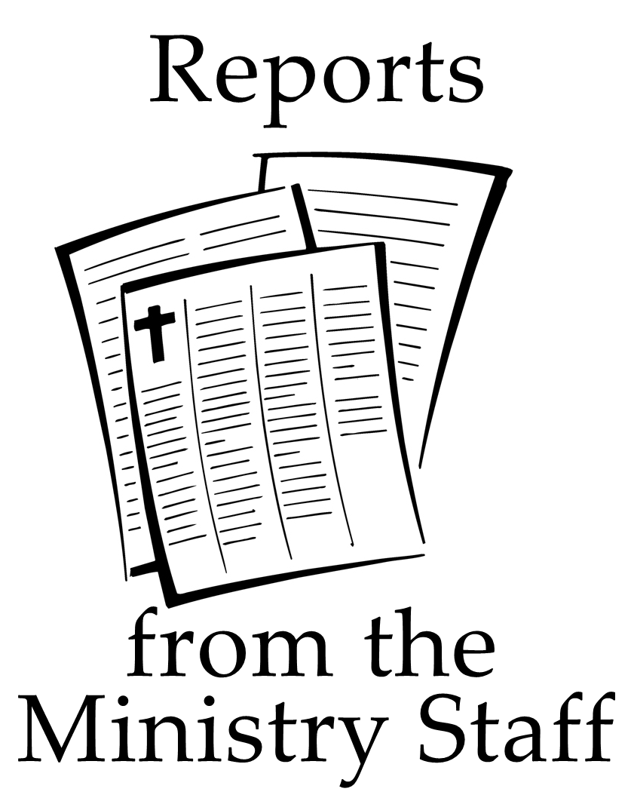

PASTOR RAY’S REPORT

Darlyss and I once again express our gratitude to you for allowing us to serve as pastor and wife. Throughout the year we have felt your love, support, and encouragement.
2017 was a year of several significant changes for our congregation in the area of staffing. At the beginning of the year, we welcomed Josh and Laura to Five Forks as Josh took up the responsibilities of directing our Worship Ministry. I thank the Lord for bringing Josh and Laura to us and for the way their specific gifts have helped us in this area of ministry.
At the end of the year, we saw the arrival of Kenton and Kelsey to our team as Kenton took up the responsibilities of our Youth Ministry. I am grateful for the opportunity to work with Kenton and learn from him.
After many years, Margaret retired from working in our office and Bryn is very ably picking up responsibilities to help carry on the work of the church that often goes on behind the scenes by our secretarial staff.
Bob Tengler concluded his years of ministry as assistant to the pastors at the end of the year.
There have been many other changes in volunteers in almost every area of ministry at Five Forks.
With changes in personnel, comes a number of other changes as well, as each individual, uniquely gifted and called by God begins to use their gifting to participate in what God is doing in His Church that meets at Five Forks. This is the nature of being a dynamic organism rather than a stagnant institution. At times it is uncomfortable but often necessary.
People respond to change differently. Changes bring a certain amount of uncertainty often accompanied by some angst until we settle in to a new normal. The angst may cause us to resist even good changes.
Our response to change is often affected by how we choose to view changes. Changes also bring some excitement and the opportunity for renewal and growth. I am excited to see what changes God will bring to us at Five Forks that will enable us to be even a brighter 'Light on the Hill' for Him, shining into the community and world with the hope of the Gospel.
When I find myself resisting changes, simply because they are changes, I try to remind myself, this is God's Church and he will teach me, and us, new things about himself, about myself, about ourselves, and about how He wants to continue to usher his kingdom into the world through his Church. He is a big God and I can trust Him to lead where he wants us to go.
I invite all of us to join and embrace the opportunity of a new year, with more changes, as an opportunity for God to grow us.

-Pastor Ray

PASTOR BILL’S REPORT

“Being confident of this, that he who began a good work in you will carry it on to completion until the day of Christ Jesus.” (Philippians 1:6)

These words - written by the apostle Paul to the church in Philippi – have been an encouragement to me since I first became a follower of Jesus 35 years ago. Like Paul, I am confident, and I trust you are as well, that the work God has begun in all of us will continue on until the day He returns or calls us home.
I’m grateful for this position and opportunity that I’ve been given to serve at Five Forks. On a personal level as I look back over 2017, the most exciting thing is what I am learning through the study of God’s Word. The responsibility of preparing and presenting sermons is both awesome and sobering. But it is in this preparation that God reveals Himself and challenges me personally. He has taught me much this past year and I pray He will do the same in the coming year.
There have been many exciting events on a church-wide level as well. Early in the year, the loan was paid off on the “Laying Bricks for Jesus” project. It’s great being debt-free, both financially and spiritually!
This past year we had the privilege of baptizing 24 individuals who made a profession of faith in Jesus.
I believe we are making progress in defining our purpose as a church. About a year ago we began using the word “muddled” to describe our purpose as a congregation. Over the course of the past year, I have come to see that our purpose at Five Forks encompasses three levels that are similar to the purpose of the 1st century church. Jesus told His disciples that “...you will be my witnesses in Jerusalem (locally), and in Judea and Samaria (regionally), and to the ends of the earth (globally).”
In the same way, we are looking to establish and build a sense of community within our congregation (locally). This takes place through our Life Groups, Bible Studies, Prayer Groups and other occasions when we gather together. We then look to go out and be active in serving the people of the surrounding communities (regionally). There have been many examples this past year of Five Forks being a friend and support to those living in southern Franklin County. Finally, we desire to reach out even further to have a positive impact on a national and worldwide level (globally). In 2017 Hailee Martin (Mozambique) and Caitlin Recard (Kenya) went out from our congregation to serve abroad. Five Forks has a long history of sending and/or supporting various missionaries or mission organizations. We will look to continue to build on these three areas as we desire to act on Jesus’ words: “...you will be my witnesses...”
Another exciting change has occurred on a staff level with the hiring of both Josh and Kenton. Josh’s heart is fully set on God and I have come to value the spiritual insight he has to offer as we work together in preparation for the worship services. In the short time I have had with Kenton, I also see his enthusiasm for God and the love that he has for our teens. I am so glad to have both of them on our staff and look forward to how God will use them here at Five Forks!
I believe many of us share the same area of concern and that is in regards to individuals or families who no longer attend services at Five Forks. Through the years I’ve come to see that there are many different reasons why people stop attending a specific church, including Five Forks. Because of this, there is no single answer that will address all of the reasons why some are no longer a part of our congregation. But it does call us back to the basics: invite people, make everyone feel welcome, look to get everyone connected to our church family. Most importantly, point them to Jesus by the words we speak and by the way we live out our faith. This falls on all of us and so let’s challenge each other to help make Five Forks a community that cares about growing closer to Jesus as we support and encourage each other.
Also, be encouraged by the fact that this past year numerous individuals and families have started attending Five Forks and are becoming involved in the life of the church. We are praying that this year the Lord will help us connect with and minister to many who do not yet have a personal relationship with Jesus.
Thank you again for the opportunity to serve as one of your pastors. Remain confident in Him who began a good work in you to carry it on to completion. As He works in us and through us, let us love Him and serve Him wholeheartedly throughout 2018!

-Pastor Bill

PASTOR BRIAN’S REPORT

John 15:12-14 – This is My commandment, that you love one another as I have loved you. Greater love has no one than this, than to lay down one’s life for his friends. You are My friends if you do whatever I command you.

In the past few years, I’ve written three reports for the year – a report on senior citizens ministry, a report on adult education, and a general pastor’s report. For this year, I’ve chosen to combine the three into one. It seems more efficient!

Seniors’ Ministry…
I chair a committee for our senior citizens’ fellowship. Serving with me are Sandy Gray, Doug and Sandy Russo, Nancy Showalter, Bob and Peg Stanhope, Bob and Barb Tengler, Sally Wagaman, and Jane Yoder. We plan fellowships, group meals, and special events for the senior citizens at Five Forks Church. Not a month goes by that we don’t have something happening.
Once again this year, we had a group attending the Spring and the Fall Seniors Days at Roxbury, held on the second Tuesdays of May and of October. Around 200 or so people attend these events, so there’s an opportunity to fellowship with others. There’s plenty of music, singing of hymns, and a special afternoon concert. We always have a challenge from the Word. And there’s a very good meal provided as well.
We had an indoor “picnic” in July, with a patriotic theme this year. We sang a medley of well-known songs together, and we took a quiz on American history. Keystone Family Restaurant catered a wonderful meal for us. We held the event here at the church in our multipurpose room.
Just this past December was our annual Christmas banquet at Savoy. Again, there was a good meal. We did a lot of singing there as well. I think we sang every Christmas song in our book! There were some devotional thoughts and stories shared. And we played some games as well!
We had about fifty people in attendance at each of these meals. We charge our seniors a discounted price so people on fixed incomes can afford to join in. We’re grateful that we have funds to supplement the full costs for the meals. Thank you for your giving which makes this possible! I’m sure that if we had to charge full price, many of our seniors wouldn’t be able to attend.
In June, we took a day trip to ride the Pride of the Susquehanna, a paddle-wheeler which heads out on the river, departing from City Island in Harrisburg. A narrated tour lasted about 45 minutes. After that, we headed to the Walnut Bottom Diner for a good meal there. Many thanks to Mike Knechtel, who drove the bus for us!
In the months where we don’t have events like the above planned, we have a fellowship in our chapel – usually the first Friday of the month. There are snacks. And a special speaker. And some snacks. Or maybe we’ll watch a DVD together. And, of course, we have snacks! A special thank-you to all the volunteers who brought things to share this past year!

Adult Education…
While we don’t have a committee for adult education, we have a good group of teachers and hosts in our adult Sunday school classes who serve us by preparing lessons and guiding discussions in our various classes. I’m afraid that if I tried to list everyone who helped this past year, I would overlook someone, and I don’t want to do that. Suffice it to say, we could not do this if it weren’t for our volunteer teaching staff, who channel their passion for the Bible’s truth by sharing it and exploring with other like-minded folks.

As 2017 came to a close, I was especially excited when, upon placing a request for teachers for the Berean class in the newsletter, three men volunteered to come teach! I praise the Lord for that, for I know He led these men to step up and help out! Like those of you who attend other adult classes here, our Bereans love to share in fellowship of prayer and in study of the Bible together. If we hadn’t gotten at least one more teacher to help out, it could possibly have meant the end of the class. And so God gave us three!
My pastoral prayer for you all in the year ahead is that Christ protect you through keeping the evil thing at bay, and that He empower you in keeping the good thing before you for His glory!
Thank you so much for allowing me to serve!

-Pastor Brian
PASTOR JIM’S REPORT

Children are truly a blessing from the Lord. With these blessings also come responsibilities. As stewards of God's children, parents are responsible for helping children grow physically, intellectually, emotionally and spiritually. I believe Five Forks has a certain responsibility toward children, too.
2017 has been another full year of teaming up together to minister to kids. I want to personally thank the Lord for hearing my prayers. It has been my continued prayer that the message of Jesus Christ would always be the top priority in the lives of children. I have shared this with you in the past and now we look to 2018.
God has been faithful and I continue to find this to be true. I have seen this valuable message being communicated to the children each week as they take an active part in their classes and programs. I have also seen families together strengthened through the ministries they have experienced at Five Forks. Praise God!
I’m committed to trust God to continue to provide me with vision and direction as I serve here at Five Forks and I am challenging each one of you to catch this vision. Much work remains to be done in 2017 and the years to come. The challenges will be great, but the opportunities abound. Let us participate together joyfully and witness a great time to be part of the church of Jesus Christ!
I am always thankful for all volunteers who are committed to working with the children here at the church and would ask those who are not to prayerfully consider helping in 2018.
Thanks for allowing me to serve!

Philippians 4:13 “I can do everything through him who gives me strength.”

-Pastor Jim

PASTOR SHAUN’S REPORT

Shaun’s report is included in the Youth Ministry Team report.

WORSHIP MINISTRIES REPORT

It has been 9 months since being called to Five Forks. That is hard to believe. Here are some positive things that I have overseen (with invaluable help from others) to improve the area of Worship Minstry: (1) improving the overall sound of the live stream/foyer mix (still some work to do in this area), (2) improving the equipment used for onstage in-ear monitoring (thanks, in large part, to a generous donation from a member of the congregation as well as Chance and Dustin helping to select the equipment), (3) getting involved in the stage design to create something a little bit more professional/visually appealing, (4) inviting and including more people in the worship team rotation (including from the youth… which is one of my primary goals, (5) eventually improving the 8:00am Traditional house mix/the way the singers are mic'd after some trial and error, (6) getting a Traditional Choir started back up as well as one for the Modern Services, (7) moving all scheduling for Worship Teams / Singers / Accompanists to Planning Center to make scheduing more efficient.
As with anything, everybody likes different things and has differing opinions. I pray that I am willing to accept others' opinions and constructive criticism even as I attempt to give feedback and vision in a humble manner. I hope to move forward in that mindset of humility and look forward to another year and more opportunities to serve the Lord with the Five Forks family.

-Josh Roach, Worship Director

ASSISTANT TO THE PASTORS & LAY PASTOR’S (BOB TENGLER) REPORT

2017 was very interesting and challenging. Many people in nursing homes or confined to their homes. The Lord called me into ministry and for the past 14+ years, I have dedicated myself to serving His people and making them a priority. But the time has come for me to say “goodbye”. Thanks to each and every one of you for this opportunity to serve.

-Pastor Bob

COUNSELING SERVICES REPORT

It has been an honor to serve as a pastoral counselor at Five Forks Church. This was my 10th year serving our church and others in the community. For many, this past year was hard; having experienced loss, difficult relationships, anxiety and depression. Others experienced the joy of newfound faith, strengthened relationships, spiritual growth, personal development and forgiveness. I praise God for His wisdom, compassion and insight in our counseling ministry. We covet your prayers for this ministry in 2018!

Psalms 29:11- The LORD will give strength to His people; the LORD will bless His people with peace.

-Rochelle Nolt



CHURCH BOARD REPORT

We spent much of our time in pro and con discussions of different issues, always keeping in mind our commitment to our God and to the congregation before decisions were made. We have seen prayer answered, a few new ministries started, discussed new ideas for congregational worship, loved the people unconditionally, and thru it all, have felt God’s presence with us. We are truly and firmly committed to serving the congregation…with God’s help. Many times there are differences of opinions in the discussions, but even then, the ‘Board’ remains UNITED. We can see the power of the Holy Spirit working in each meeting. Please continue to pray for us to be obedient leaders who bring glory to God through our service to Him.
The following are highlights of our monthly meetings:
January:
- Set Christmas Dinner dates…Tuesday, December 5, Thursday, December 7, Friday, December 8, Tuesday, December 12, and Thursday, December 14 with Friday, December 15 as a snow date.
- Set the times for the 5 - 2017 Christmas Eve services. Approved The Growing Tree Preschool request to explore the possibility of offering an afternoon program on Mondays, Wednesday, and Fridays.
- Search teams continue to pursue candidates for Worship Director and Youth Director.
- Approved the Finance Committee recommendation for the 2017 Spending Plan figure of $1,102,978. Was noted that if received contributions are in par with 2016, funds will be in place for the two ‘Director’ positions.
- Approved the slates for the Church Board, Deacon Board, G&M Board, and Finance Committee.
- Approved the motion to have voting for Church Board Members the same as for Pastors, i.e.; ballots in church mailboxes with a 10 day voting period. This would be on a 1 year trial basis.
- Discussed a document ‘A Starting Point’, (Putting together a 5 year plan).
February:
- A ‘Special’ Church Board meeting was held to discuss extending an invitation to Josh Roach as Director of Worship Ministries. Also discussed was the financial package for him.
- Appointed Pastor Bill as Church Board Chair for a 3 year term, and Pastor Shaun as Co-Chair for a 1 year term. Lin Yoder was appointed Church Board Secretary for a 1 year term, and Sandy Gray appointed as Church Board Recording Secretary for a 1 year term.
- Approved Bonnie Branthaver’s request to serve as photographer for the church at no charge.
- Approved Sheila Cooper and April Sprenkle as Money Counters and Harley Smith as another Assistant Treasurer.
March:
- 31 Conversions were reported and Attendance was very close to 2016.
- Approved Barb Harbaugh’s request for permission to hold Music Camp, June 12-16.
- Discussion on Defining ‘Who We Are’. A) Purpose/Vision/Mission/Values. B) Core values C) Meeting House document compiled by Carlisle BIC.
April:
- Pastor Bill reported that the BIC Regional Conference was held at the Chambersburg BIC Church with the main point of discussion: BIC Constitution and By-laws. Bill will bring more information in the coming months, as our Annual Council 2018 will look to approve a recommendation from the denomination.
- Approved Job Description for Director of Maintenance with the increase in hours from 4 to 6 weekly. Will ask Finance to approve the additional $3,200. It was noted that the candidate must go thru a background check.
May:
- Nominations/Appointments for the Social Media Advisory Committee to replace a member who stepped down. A nominee must have a presence on Social Media as well as gifts of discernment and wisdom.
- Discussion continued on Defining ‘Who We Are’ Purpose/Vision/Mission/
Values.
June:
- Peggy Dawson accepted the offer to serve on the Social Media Advisory Committee.
2. The Board began a discussion on Term Voting. The Board discussed how
Five Forks does this and how the denomination does this. Strengths and
Weaknesses were identified and discussion will continue.
3…The topic of ‘Women in Ministry’ was discussed as some in the congregation have expressed a concern over the makeup of the Church Board…12 voting members, 11 male, and 1 female. The concern came from both genders and various age groups. At the next Board meeting, there will be a discussion on different ways to potentially bring better balance on the Board in hopes of retaining broader representation.
July:
No Meeting
August:
- A Search Committee (Pastor Bill, Angie Petersheim, Todd Smith, Lin Yoder), seeking a part time replacement for Margaret who has accepted a position elsewhere, interviewed three candidates and would like to extend the offer to Bryn Yoder. This motion was approved.
- The Church Board developed a slate for members for the 2018 Discernment Committee.
- The CPA, Ray L. Miller sent Pastor Bill a recommendation for changes in our financial reporting. He suggested that the Special Activities Funds be used first and then the General Funds. The Finance Committee recommendation that ‘the Church Board give approval to the proposed changes by Mr. Miller was approved. Bill recommended that the Board look to the Finance Committee to work out the details.
- Approved Tony Martin’s request to show the movie ‘The Case for Christ’ at the church in the fall at a cost of $199.
6. In continuing the discussion on Defining “Who We Are’, Bill suggested that a small committee be formed bringing individuals from the congregation along-side a few Board members to get their point of view. Harvey Payne was asked to head this up
September:
- Motion passed to hire Brad Gift as Maintenance Supervisor for 8 hours per week.
- Discussion continued on topics such as “end of term” voting and the composition of the Church Board.
October:
- Motion approved to renew Licensed Lay Ministers.
- 2017 Community Christmas Dates were confirmed approved as follows: Dec 5, 7, 8, 12 and 14 with 15 as a snow date. Responsibilities were assigned to church board members.
- It was decided that the Board will bring a recommendation to Council re: retaining a Director (as opposed to a Pastor). Possibly having a 10-day voting period for the congregation to give their input/comments. The Board would then weigh this input before making a final decision.
November:
- Approved a request for the Ladies Bible Study to start a quilting class/session from 9-10.
- Shaun gave an update on the Youth Director interviews. A strong candidate, Kenton Hock, received a unanimous “yes” vote from youth and advisors. He is a 2016 grad from LBC with a degree in Youth Ministry and Bible.
- Pastors were excused as the Board discussed 2018 wages for Office Staff.
- The board entered into discussion with Board member Harvey Payne regarding the possibility of him serving as a consultant to the pastoral staff starting in 2018.
December:
No Meeting

One of our greatest desires as a Board is to have unity in our congregation, even as we differ on certain subjects.
As a Board, we do not take lightly the responsibility you have given us, and we desire to be worthy of your trust. If we are willing to work together for one great cause, serving the Lord, much can be accomplished. It just goes to show, that when we work together, not always expecting our way to win out, the LORD will provide more than we expect.
We praise HIM for making it all possible! We praise the LORD for His goodness and faithfulness as we continue to serve Him, here at Five Forks and in the community.
We sincerely covet your prayers for the Pastors, staff and volunteers who serve, on the Board and many other ministries here at Five Forks.
Although this has been said before, please know that the Board members are very sincere about the following comment!
Even though we are very busy, we are never too busy to listen to ideas or comments you may have. We are after all, the Lord’s servants, dedicated to serving the best interest of the church and you, the congregation. May He continue to bless the Five Forks Church in 2018.

-Sandy Gray, Recording Secretary

AVERAGE ATTENDANCE FIGURES FOR 2017
Worship Service - 734
Sunday School - 273
Wednesday Evening (Fall, Winter, Spring) = 295

OFFICIAL CHURCH MEMBERSHIP REPORT

Total Members as of January 1, 2017 673

DECREASES:
Transferred Out, Withdrew or Removed 8

Deceased 8

INCREASES:
Transferred In, Received by Confession of Faith 9

Total Members as of December 31, 2016 666

Transferred Out, Withdrew or Removed
Emma (Wetzel) Benedict*, Ellen Black*, Cheryl Cordell*, Tim Cordell*, Kathy Egolf*, Terry Egolf*, Tiffany Geesaman*, Lisa Ulrich*

Deceased (*denotes official members)
Betty Bingaman*, Shirley Bumbaugh, Mary Chamberlin*, Archie Flohr, Anna Horwath*, Bob Izer, Sam Masters, LaNono Mong*, Melvin Peck*, Dick Provard*, Beverly Reed*, Lois Shafer, Jack Short*, Jim Vinson

Transferred in, Received by Confession of Faith
Lauren Belella*, Stacey Belella*, Cherle Carl*, Frank Carl*, John Frain*, Shirley Frain*, Cindy Stains*, Greg Stains*, Lee Yoder*

BAPTISMS IN 2017 - Totaled 24

2/19: Tonya Bryant, Cherle Carl, Frank Carl, Bonnie Havens, Sara Miller, Ashley Powers, Jeremiah Rinehart, Blake Sedgwick, Brad Smith, Ali Sollenberger
4/19: Nathan Cordell, Rebekah Cordell, Anna Provard, Ethan Shank, Garrett Welty
6/11: Faith Anne Helman, Leah Helman
7/16: Shae Beckner, Charlotte Rhodes, Gavin Rhodes, Blake Stinson
10/12: Jackson Bowser, Derek Buhrman
12/10: Brendan Huse Clifton

DEACON BOARD REPORT

In 2017, your Five Forks Deacon Board consisted of 15 deacon couples, plus Pastor Ray Kipe. Dwayne and Melanie Buhrman served as chairpersons, with Brian and Melanie Bitner serving as assistants. Ken and Melanie Arendt served as Treasurer and Secretary.
While there are a number of things that the deacons are involved with throughout the year, the cooperation and teamwork the deacon couples exhibit make the tasks go quickly and without overwhelming any one couple. Each person on the Deacon Board possesses different gifts, but as a group we are an outstanding team and together successfully accomplish many great things throughout the year.
The deacons are involved with or oversee many events that take place within the church during the year. Some examples of areas of deacon oversight include:
- Assisting people with financial assistance – both church affiliated and community outreach. 2017 again saw an increased need for this type of assistance and provided a great opportunity for the church and deacon board to demonstrate God’s love.
- Preparing the communion articles and assisting with the serving during Communion services.
- Serving as greeters at each of the Sunday morning worship services.
- Planning the Annual Widows/Widowers Luncheon
- Planning the Annual Love Feast and Ingathering. The deacons also distribute the food collected from the Thanksgiving Service to the various families in need.
- Assisting with Baptism/Membership Services
- Overseeing the Food and Clothes Closet Ministries.
- Coordination of meals for those that have been sick or hospitalized.
- Coordination and maintenance of medical equipment that can be used by church or community individuals.
In 2017, the Care Ministry Team, continues to grow with deacon couples and nearly 22 other couples and/or individuals who have expressed an interest in participating in this outreach ministry.
There are few ministries within the church as diverse as the Deacon Board. This Board gives an opportunity for each to use the gifts and talents he/she has been given to provide spiritual support and blessings to many. Your continued prayers would be appreciated as we work to fulfill the responsibilities placed before us and we willingly accept.

-Melanie Arendt

CARE MINISTRY REPORT

The Care Ministry is a ministry in which we attempt to make contact with and offer support to those from the congregation who experience hospital stays, surgeries, deaths in the families etc. In this ministry, we in the church office rely heavily on the information and updates given to us about those who are in need of being contacted. Please help us by contacting the office about people we may be able to care for.
-Pastor Ray

DISCERNMENT COMMITTEE REPORT

The DC currently is made up of nine individuals who meet during the final quarter of each year in order to fill different ministry positions in the church through appointment, confirmation or election. One of the main areas of responsibility, is in presenting a slate of Church Board nominees, some that will be elected by the congregation. This committee also is responsible for submitting names for confirmation for our Deacon Board, Grounds and Maintenance Committee and Finance Committee. The DC is also responsible for a number of other appointments, such as Hospitality Committee, Library Staff, Ushers, etc.
The Discernment Committee consists of: Lee Grimm, Nancy McKee, Melissa Mitchell, Brad Sell, Adam Shank, Bill Shank, Rachel Showalter, Phyllis Witter, Chad Yoder

-Pastor Bill

FINANCE COMMITTEE REPORT

Our Lord has been faithful again as He has blessed Five Fork Church through the generous giving by you the congregation. As of the writing of this report, we find ourselves running behind the 2017 proposed spending plan, but our cash flow is very good and all our obligations are being met. In the past years, the Lord has blessed us with strong year end giving and if He blesses us again this way, the finance committee anticipates meeting our 2017 Budget.
Praise the Lord, we were able to pay off our Building Fund Loan in January of 2017 and have been contributing money each month from contributions and budgeted money for the next building phase that may arise. As of our Treasurer’s October Report, there is a Building Fund Balance of $95,003.02.
The Finance Committee met throughout the year to approve the following items:
Approval of a fundraiser for the “When the Storms Rage” conference
In February, the Finance Committee met to disburse the 2016 excess year end funds which were $30,000. Below is the list of how the funds were disbursed:
Deacon Special Activities Fund $7,000
Steve Newcomer – Revus Project $2,000
Orville & Cheryl Hade Mozambique $1,500 (payable to BIC Missions)
Allegheny Conf. Pension Fund $3,000
B.I.C. Cooperative Ministries $3,000
Project Big Love $200
Franklin County Young Life $3,000
Biblical Education Center $500
Hagerstown Rescue Mission $200
Waynesboro Ambulance $200
Waynesboro Fire Dept. $200
Franklin County Jail Ministry $150
Cumberland Valley Christian School $150
Mennonite Disaster Service $500
MCC Meat Canning $150
Habitat for Humanity $150
Child Evangelism $150
Cumberland Valley Relief Center $150
Waynesboro Human Services $150
New Hope Shelter $1,000
Uprise Festival $150
Shalom Christian Academy $150
Cedar Ridge Ministries $150
Wycliffe Bible Translators $150
BIC Missions Spice $250
Camp Joy-El $150
Gospel Tide $150
Spring of Hope Counseling $150
Word FM Radio $150
Women in Need $150
Kevin & Jeanne King-NYC $250
Navajo BIC Mission $300
My Brother’s Keeper-Romania $300
Christian Retreat Center-BIC $300
Lee Ann Sebald-Navigators $1000
Health Insurance – Spec/Act. Fund $2000
Gabrielle Sanfillppo $200 (Missionary to Orphan School in South Africa)
Brittany Smith-tentative $200 (Missionary to Mali, Africa)
Marklunds in China-tentative $500
Approval of subcommittee to meet with Ray Miller, CPA, to discuss spending some of the accumulated monies in the Spec/Act. Fund rather than the budget
Approval of Hailee Martin missions trip fundraiser
Approval for Caitlin Recard to send letters to raise support on her missions service to Kenya
Approval to take anywhere from $1,600 - $3,200 from the $10,000 that is now sitting in staff reserve to use for the purpose of increasing the maintenance position hours
Met to discuss the suggestions from Ray Miller
Approval of the request to take the need to the congregation for donations to help cover the cost of Chrome book covers
Approval to send some of our Disaster Relief Funds to MDS for Florida and Puerto Rico
Met to set the 2018 Spending Plan
As we enter 2018, may we continue to trust in our faithful God who holds all things in His hands. We the Finance Committee want to continue to be good stewards of the monies that God blesses the Five Forks Church with.

-Ron Strite

BENEVOLENT FUND REPORT

The Benevolent Fund was created in 2007 to help those who experience an extraordinary financial need. The Fund is a way for people to make special bequests in their Will, or for those who are blessed to make special donations above their normal tithe. The Fund will keep the principle largely intact and primarily disburse only the earnings. The primary recipient of the distributions will be coordinated with the Deacons; however, the Fund may provide disbursements elsewhere. The principle is preserved in order to provide funds for the future and on an ongoing basis.
Generally, only the earnings generated by the Fund will be disbursed for benevolent purposes. The overall goal for the Fund is at least one million dollars before using the principle. There are special circumstances for using money from the fund once it reaches $250,000 in value.
The current unrealized value as of December 29, 2017 was $286,656 compared to the previous year value of $246,525. The Fund received $1,550.00 in contributions during 2017.

The Benevolent Fund Committee has the following duties
  - Prepare statements for the church.
  - Invest the money with socially responsible funds. The fund is governed by an Investment Policy Statement.
  - Calculate and disperse the “earnings” generated each year for benevolent causes.
  - Decide when and if any principal will be used.
  - Promote the fund.
  - Meet to review and update program statements.
  - Decide if the asset allocation is appropriate.
  - Decide if the investments are performing within expectations.
  - Authorize the disbursement requests

The Committee consists of Brad Sell, David Neterer, Derek Hine and Lin Yoder.

-Lin Yoder
YOUTH MINISTRY TEAM REPORT

Five Forks youth group had an incredible 2017. In doing some reading recently and in interacting with many young people in our culture, I found that there is a sad misunderstanding about following Jesus. Many see following Jesus through the lens of “religion and rules. Following Jesus becomes something I must do to be a good person and make God happy.” But that is such a sad way to think about our Christian faith. So in youth group, we have spent the last few months rethinking the Christian faith and learning to understand our Christian faith as “going on a great adventure with the Creator of the Universe by our side.” Viewing our faith this way changes the purpose and place of following Jesus in our lives. We took 6 weeks to study the life of Jonah and his Great Adventure helping us to begin discovering our own.

We also took some time in Sunday school & at youth group relating our discussions to larger cultural issues. We did a series on popular music, pulling out Biblical themes along the way and followed that up with several discussions on issues of race and politics which are so prevalent in the world around us. Taking our lessons and thinking about how our faith informs our everyday life. One of the things we are talking about as a youth group and discovering more and more is the incredible way that the message of Jesus transcends cultures and age groups and brings so many different people together under a common purpose.
A second purpose of youth ministry is developing wholesome community and building sincere relationships with other followers of Jesus. So over the past several years, we have been focusing a good bit of energy in building up our small group program. Each Wednesday night, teens meet for about 20 minutes with other teens of their same age & gender to talk about the Bible lessons and also to simply connect and talk about life. We have also provided times for the small groups to do service projects together and just get together for fun and fellowship. In regards to some of the service projects, some of our groups have pulled weeds, baked cookies, visited nursing homes, worked at BEC etc. And for nights of fun, groups have gone bowling, made bonfires, painted nails, visited Chic-fil-A or simply hang out at their youth leaders home. We have seen our small group ministry grow and connect teens to our ministry as a whole and provide a great opportunity for Christian Community! In the year ahead, we will be looking to focus some time and energy on getting our teens more actively involved with and connected to the larger church body!
And of course, it wouldn’t be youth group if our year wasn’t filled with many good times together…2017 was filled with just plain out having fun! Some of our events included: flag football, our annual trips to Raystown Lake and Uprise Festival and we spent our summer Wednesday evenings at the Bumbaugh’s home, hanging out, with camp fires and late-night swimming. And there were many other good times, and the point of all of this to help our teens connect with one another and with the youth leaders. It’s our hope that friendships can be started and grow during these fun times together. Ultimately, that these friendships would then enhance our times of Bible study in allowing everyone to open up about life and questions and challenges that we face.
Finally, and this is true every year…as with all youth ministries, I owe a HUGE thank you to the true hero’s behind this ministry, our youth leaders. While many people are at home on Wednesday nights, our youth leaders are here sitting in discussion groups with teens. While many people are kicking up their feet on Friday nights and Sunday afternoons, our leaders are hanging out with teens, acting crazy and learning their life stories. They’re texting teens, receiving phone calls at odd hours of the night, watching sporting events and mentoring our young people. None of this ministry would be possible if it were not for the many youth leaders who give so generously of their time, resources, creative ideas and most importantly their passion to see our young people come to know Jesus.
I am truly humbled and honored to work with such an awesome group of people and thank them for the many ways they have mentored me through 8 years of youth ministry at Five Forks. And now we are excited for some of the changes taking place in our youth ministry. Just this past fall we successfully made the transition of including 6th grade students into our youth ministry. And as many of you are now aware, 2018 looks to be an incredible opportunity. After a nearly a yearlong search, we are excited that Kenton & Kelsey Hock have agreed to join the Five Forks family and Kenton will be taking over leadership of the youth ministry. It has been a pleasure beginning the process of getting to know this awesome young couple and their passion for teens and especially their desire to see teens following Jesus. I look forward to the new vision and leadership Kenton will provide for our students and I am eager to begin new adventures of ministry in other areas here at Five Forks.

-Pastor Shaun

CHILDREN’S SUNDAY MORNING MINISTRY REPORT

In 2017, there were thirteen different children classes staffed and ready for teaching children in the preschool and elementary grades during the second and third hour of services each Sunday morning. The average attendance was again less this year. There were approximately thirty-five teachers, helpers, and subs who faithfully volunteered each Sunday of the year with the children in their classrooms. I personally want to say thank you to all the teachers and helpers for your faithfulness and commitment. Your love for the children is of high value and you’re truly a blessing to the church and the families that attend each Sunday.

Another important part of the Children’s Department is the Sunday School Secretaries, Diane Cordell, and Glenda Knechtel. They faithfully go around the church each Sunday to collect the offerings and attendance papers from each class.

-Pastor Jim

AWANA CLUB REPORT

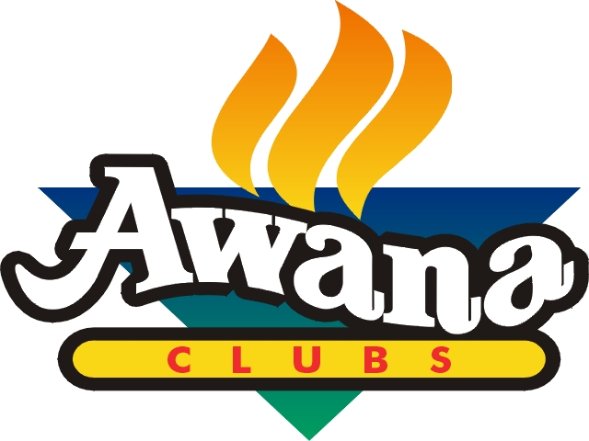
Awana Club has continued to help children move in a forward direction in their spiritual maturing process. We are responsible to team up with parents and help Five Forks grow through the Awana Club. We see the importance of helping to create strong foundations in clubbers lives through the Awana curriculum that is biblically based and reveals God’s truths….that clubbers will learn the whole Bible instead of just familiar stories over and over. Children desperately need to know about Jesus and be able to have the opportunity to receive him as their personal Savior. It’s necessary that on any given Wednesday night, when clubbers are gathered for learning and training, that they would be able to hear the good news of Jesus Christ. We are grateful for the many individuals who desire to reach and disciple the next generation through the timeless truth of God’s Word. Their investment of time, prayer and resources allows Awana to touch the lives of children and youth around the world.
2016 -17 marked the 9th year of club at Five Forks. The Awana program, to minister properly to each child, requires a lot of volunteers. There was an average of 150 adults and clubbers attending Awana this past year. It took many volunteers to staff and be a support to each club. Clubbers continue to invite their friends…those friends get excited and invite their friends. Kids are excited to come each Wednesday night. Awana is such a blast! We need your help to volunteer to be a handbook listener or class helper. There is a big difference between doing something for the family and doing something with the family.
Thanks for your great effort!

-Pastor Jim

VBS AND VBS JR. REPORT

Operation Arctic was an exciting VBS! There were an average of 136 kids and 100 adults in attendance each night. What a great adult per child ratio for the week! Many, many people gave their time, energy and focus to the VBS ministry this year. A great VBS is only possible with the help of many people coming together. Every position, large and small was needed to make this event a success. We would like to say “Thank You” to all the adults and teens who gave so unselfishly to this ministry. The Toddler VBS Jr. was going each night as well, thanks to efforts of the VBS Jr. team. Over 45 - 4&5 yr. olds gathered in the children’s ministry area. There were age appropriate puppet skits, crafts, games, and Bible lessons in both VBS and VBS Jr. by trained CEF summer staff. We raised $850 to support a project at Iris International that Hailee Martin was a part of this summer.


“Praise God from whom all blessings flow!” Give thanks to God for another successful Vacation Bible School.

-The VBS Directors

LEGO CAMP REPORT

Lego Camp was a great success and many thanks go out to Brett Kagarise, who organized and directed. There were several youth that assisted in each of the pairs of campers all week, which was a big help as well. The camp was computer based and used the Lego Education WeDo sets. There were over 25 campers for both AM and PM camps. The campers were able to build Lego models featuring working motors and sensors; program their models; and explore a series of cross-curricular, theme based activities. The campers developed their skills in science, technology, engineering, and mathematics as well as their social skill of working with a partner for the week. Brett led a daily Bible story and prayer time, which corresponded with what the campers would be building that day.

-Pastor Jim

NURSERY REPORT

The nursery continues to be a place where children 0-3 may play and be cared for while their families enjoy worship services and Sunday school on Sunday mornings. On Wednesday evenings, the nursery is open for the children whose parents help with our Awana program, attend Bible Study, or are involved with any other ministry in the church. Several new babies have been born this past year and we look forward to meeting them! Thank you to all the wonderful nursery workers who help so faithfully each week. I am always looking for more workers so please stop in the nursery and talk to me! The children especially like to be read to so I’ve added a nice new wooden bookcase. I am also anxious to see how the children like the new wooden parking garage and cars that is on its way. These items should be enjoyed for years to come. May the children see Jesus in each one of the workers who care for them.

-Kim Helman, Nursery Coordinator

CHILD ABUSE PREVENTION REPORT

“LET THE CHILDREN COME. . . AND BE WELCOME IN OUR CHURCH”

With all the laughter and life children and youth bring to Five Forks comes a tremendous responsibility of protecting those who are given to us to nurture and teach. One of the ways we protect our children and youth is through following the CAP policy set down by our church board.
The Five Forks Church CAP policy states that each person who wishes to volunteer in our children/youth departments must first have regularly attended Five Forks Church for 6 months, filled out in-house forms and be interviewed by myself or a pastoral staff member. Since PA has put a new law into effect, all volunteers need to have both PA state clearances processed prior to serving in any capacity with children and youth. Note: State clearances are good for 5 years for volunteers. After all paperwork is completed and reviewed, and references contacted, the pastoral staff will determine placement of service.
Our biggest change this year was the retirement of Margaret in August. She had served the church for 14 years. It is my honor to have been chosen as her replacement as CAP Coordinator, and I hope to be able to serve the congregation with the same dedication.
The following statistics reflect the CAP activity for 2017:
32 – New Adult volunteers interviewed by our pastoral staff
31 – Had background checks done during 2017
82 – Adults participated in the Annual CAP Training provided by Dianne Eberhardt and her team
26 – CAP files were purged - those who haven't attended or served in the past 5 years.
NOTE: The 2018 annual CAP training will be held in April and will be taught by some of our own members who work in the Waynesboro School District. The subject of this training will be a sequel to last year’s subject, "No More Meltdowns". This will provide volunteers who had previously attended the training to be able to ask constructive questions, speak with last year’s trainers, and be given a general follow-up.
All volunteers who are actively involved with Children/Youth here at Five Forks are required to fill out an Annual Update form each January. This keeps their CAP files current. We have active and inactive CAP files. If you temporarily do not plan to work in any of the areas of children/youth, you may request your CAP file be put into the inactive file until you wish to volunteer again.
Our goal is to protect both our volunteers and our children in the area of abuse.
Thanks to all who volunteer and follow this policy.
If you have any questions, feel free to email me at bryn@ffbic.org. It is my pleasure to serve in the capacity of CAP Coordinator.

-Bryn Yoder, CAP Coordinator

BELL CHOIR REPORT

Five Forks continues to have a full three-octave bell choir and also a bell quartet that play for the traditional services at Five Forks.

There are currently 16 ringers who participate in the ministry, the majority of who have participated since the beginning (we joke, but it’s true…once you’re hired….you will not be fired!). 2016-2017 marked the ninth “season of ringing” at our church for both groups. Each ringer commits time out of their busy schedules to rehearse every Monday evening from September through May (taking summers off to avoid the prime vacation season). Unlike a vocal choir, where the same musical line is shared by more than one singer, each bell ringer is responsible for a unique piece of the music. Several weeks of rehearsal are necessary to ensure each individual part is woven together to create the music shared with the congregation. Each group scheduled to provide Special Music approximately 5 times per year during the traditional services.

-Janice Besecker
CONCERT COMMITTEE REPORT:

Committee Members: Chris Bumbaugh, Barrie & Gloria Hawk, Melanie Buhrman, Vernon Fortney, Sandy Gray, and several helpers on the night of concerts. To our disappointment, Vernon resigned in the Spring. He was not replaced, although we would welcome interested members.
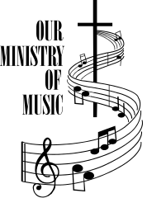
The 2016 report was submitted before December 10th, thus this notice of a previously announced concert. The Mark Schultz concert for December 10th was canceled due to lack of sales.
March 26th: Farm Hands – Attendance 380
September 10th: PromisedLand Quartet – Attendance 120
November 18th: Peter Furler/Ryan Stevenson – Attendance SOLD OUT

Possible Concerts for 2018:
March 25th: Ernie Haase & Signature Sound
April 15th: Farm Hands
May: City Rock Fest
June 3: Ivan Parker

A lot of preparation goes into planning and presenting concerts, so we’re very appreciative of those who support our efforts even though it may not be your music preference. We are looking for new committee members. If you are interested in supporting the different genres of music, please contact Chris Bumbaugh or Sandy Gray.

-Sandy Gray

GROUNDS & MAINTENANCE COMMITTEE REPORT

Members of the G&M Board for 2017 were Gene Benedict, Mark Bitner, Doug Drooger, Marlin Witter, Tim Cordell, John Cordell (insurance), Bill Reynolds, Brian Campbell, Mike Hawbecker (chairman), Matt Hade, Kevin Biesecker (treasurer), John Lehman (vice chairman), and Mike McEntire (secretary).
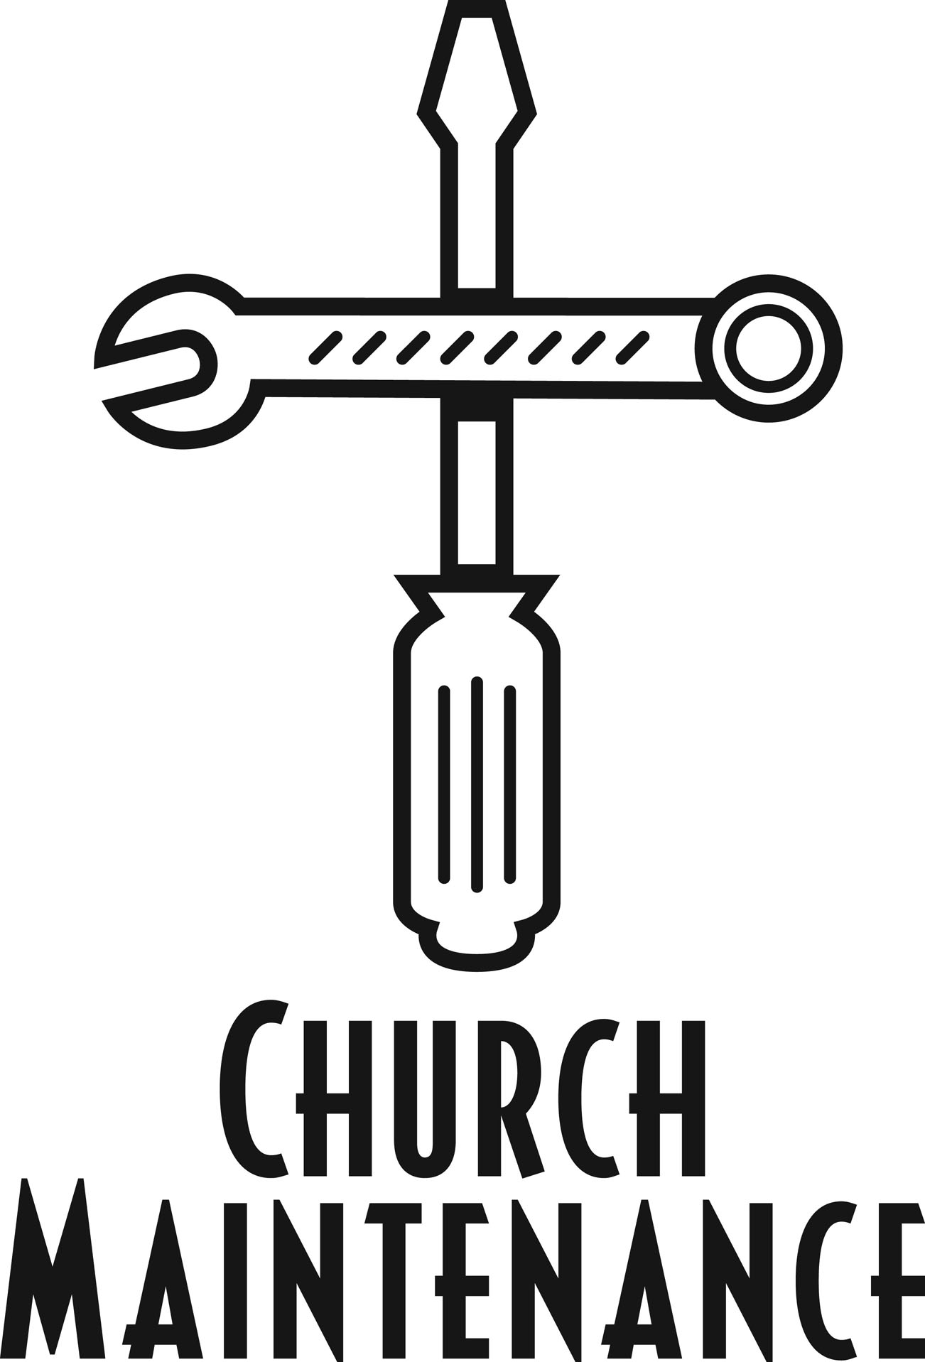
Monthly meetings were held, with the exception of July and December, beginning with devotions and prayer. Meetings consist of a review of items of maintenance, requests forwarded, budget review, and business communications of the properties.
Numerous work nights manned by G&M members were scheduled throughout the year. Board members gave their time to complete tasks as required. The board completes as many projects as possible with the members volunteering their time while soliciting outside help as needed. A representative from our board attends the Planning & Development and Church Board meetings.
Projects completed this past year:
- Monthly walk-through of all areas of the church checking emergency devices, lighting, and general observations.
- Manage annual testing and inspections of elevator, sprinkler systems, fire alarm, fire pump, and tank refill.
- General maintenance of systems, equipment, and vehicles.
- Installed new door and carpet in relocation of Pastor Bill’s office, repaired drywall as needed.
- Moved and replaced brackets on chairs in auditorium.
- Updated new chandeliers in foyer on lower level.
- Repaired drywall in children’s wing.
- Rented manlift and cleaned exterior windows of whole building.
- Made initial contact with contractor in regards to new roof at food pantry building.
- Installed entry sign and stop sign for upper parking lot.
- Widened entry way for upper parking lot.
- Created area in upper parking lot for woodcutting project use.
- Replaced carpet in new youth pastor office and room B30.
- Developed new budget for 2018.
- Added stones and line striping in parking lots.
- Installed new light fixtures and coverings of emergency lights and thermostats in MP Room.

-Mike Hawbecker

PLANNING & DEVELOPMENT REPORT

The Planning and Development Committee generally meets once each year and consists of the staff, Church Board, Finance Committee and Grounds and Maintenance Committee. The main purpose of this committee is to plan and prioritize capital improvement projects.
The P & D committee met in November and discussed a number of projects including upgrades in the following areas: signage, lighting (inside and out), offices, gym floor/walls. Some of these have already been completed while others are still in the planning stage.

-Pastor Bill

CELEBRATE RECOVERY REPORT

Celebrate Recovery is a Christ-centered 12-Step program of recovery from hurts, habits, and hang ups based on 8 principles taught in the Beatitudes. Our meetings are every Tuesday night at 7pm. We serve a meal and have a fellowship time at 6pm. The meeting begins with worship. Every other week, there is a lesson or a member of Celebrate Recovery gives a testimony. After the worship time on Tuesday nights, we break into gender specific open share groups. This year, we have established a Veterans open share group for men.

Celebrate Recovery is a place where anyone can come to a safe, confidential place to deal with issues. Our Celebrate Recovery group has assisted two other groups in Franklin County to become established in their local church. For the 4th year, we have sponsored Celebrate Recovery Inside at Franklin County Jail and have seen souls accept Christ as Savior. Some inmates are leading other inmates to the Lord and have prayer every night before lights out.
We have completed this year, in our Celebrate Recovery, an advanced step-study for those who have been in recovery for years for both men and women. We have reached out to those with mental health issues and veterans, this year. As we recruit certified helpers, we hope to start a pre-recovery program for the children and teens of parents in recovery. The children’s program is called Celebration Place and the teen program is called, The Landing. It teaches children and teens tools to keep them growing in Christ while their parents recover from hurts, habits, and hang-ups.
Our sixth year in Celebrate Recovery at Five Forks Church has been awesome. During 2016-2017, our attendance has been consistent. We have 15 to 30 people coming almost every Tuesday night. Members from the congregations from Hagerstown, Waynesboro, Greencastle, and Chambersburg have sent people to our group. We are grateful for all the prayers and support in and outside Five Forks Church. We have newcomers almost every week. As a result of this ministry in 2016-2017, over 15 souls have chosen to accept Christ’s salvation and one was baptized at our worship service. We conducted two communion services this year.
Celebrate Recovery at Five Forks Church is becoming a great outreach to the church family and community. We have achieved consistent growth this year in newcomers and in adults in Celebrate Recovery moving into leadership positions. We have a worship leader that leads worship from the piano that plays once a month and another worship leader and friends that lead worship twice a month. We plan twice a year, we invite a special music group that ministers to those in recovery, come in for one Tuesday night. This year, we were able to invite four groups to come in and worship with us. Our kitchen staff has done a wonderful job of hospitality and serving, this year.
An offering plate is set out every Tuesday night to offset the expenses of the program. Our budget goes for training, materials, and food. We have special dinners and fellowship events throughout the year. This year, Celebrate Recovery continues with the Adopt the Road Project on Five Forks Road, as a clean-up the community project.
Yvonne and I would like to thank all the adults that have stepped into leadership positions and for the helpers from the congregation in the Five Forks Church family and the community to keep Celebrate Recovery a growing ministry.
This Celebrate Recovery ministry is important to help our congregation and community to recover from hurts, habits and hang ups. If you are looking for a place to serve, come talk with us. The best place to be on a Tuesday night is Celebrate Recovery at 7pm in the Chapel. If you are hungry, come check us out!

-Ray & Yvonne Rottler

COMMON GROUNDS CAFÉ REPORT


The café continues to be an essential part of our Sunday morning connections with our friends and family. We will be going through some changes for 2018 as David Tiedemann has stepped down from leading this ministry.
It takes many volunteers each week to keep our café going. We have lead crews, setup crews, cleanup crews and Sunday morning volunteers, so if you would like to get involved, there are plenty of areas for you to help. If you would like to help, please contact Julie at the church office 717-762-2991 or julie@ffbic.org.

-David & Julie Tiedemann

HOSPITALITY COMMITTEE REPORT

Another busy year has come to a close for the hospitality committee. We are so very grateful for the many voluenteers that have helped make the events a success. We are very blessed to have a wonderfully equiped kitchen that makes the events much easier to complete.

As a committee, we are responsible for the preparation of meals for funerals, church events such as the five Community Christmas Dinners, LoveFeast and the All-Church Picnic, as well as the Auction and the Fall Fun Day. The events that happen behind the scenes are sometimes challenging but the event is rewarding as we use our gifts of servanthood to help others.
This past year, we served a number of funeral meals to church family or family members. Once again we want to thank all the volunteers who have been so generous of their time when asked to help. We have appreciated all of the support that we have been given.

-Dustin & Jen Bowman, Bob & Carol Eberly

FOOD PANTRY MINISTRY REPORT

The Food Pantry has experienced another busy year in 2017. We served an average of 226 households containing approximately 704 individuals each month. We distributed 3,498 bags during 2017. We continue to receive donations from our generous business donors like Shop ‘N Save in Waynesboro, Kline’s Grocery, Sunnyway Foods, Tracey’s Orchard, Benedict’s Produce and Hillside Poultry. Many within our congregation and community share extra from their own gardens and we regularly receive eggs from a generous donor. The Food Pantry has been blessed with donations from area food drives. We also appreciate the continued support of the “item of the month” from the congregation.
Looking ahead to 2018….. Costs for purchasing items has gone up and we no longer qualify for many of the free items we once had available to us. If you are involved with any school, civic, etc. organizations and are looking for a way to help the community, consider a food drive to benefit the Food Pantry. It would be greatly appreciated.
We are always thankful for the many volunteers who are dedicated to serving the clients of the Food Pantry. Our volunteers serve in many ways from picking up food from our business donors, bagging groceries once a month, serving the clients during service hours and helping to keep everything clean. We would love to have more volunteers, if you feel led to be involved in this important ministry, please speak to a member of the leadership team.
Once again, thank you for all your support of the Food Pantry Ministry.
Leadership Team: Lee & Carol Grimm, Dave Peiffer, Greg & Cindy Stains, Bonnie Yoder

OPERATION CHRISTMAS CHILD REPORT

We collected different items each month from the congregation which we used to hold a packing party on October 28, 2017. We packed 194 boxes to be shipped out to Samantha’s Purse.

-Penny Bakner

GROWING TREE PRESCHOOL REPORT

Growing Tree Preschool, assosciated with Shalom Christian Academy, continues to operate a preschool in our facility each school year. There is a TTh session for the first year children and a MWF session for second year children. Classes fill up fairly quickly, so if you have an interest in enrolling your child, please contact Lisa Eby at growingtree@shalomca.com .

-Pastor Ray

CHURCH AUCTION REPORT

The auction saw a few changes this year. It remained a fun and social night for the church. The amount brought into the church was $9,600.00. This could not have been accomplished without the help, time, and donations of many. As we look to next year, think about skills and talents you have that would contribute to the auction. We look forward to this year's upcoming auction.
If you have any questions or contributions please contact Melissa Mitchell at smitch466@gmail.com or 717-977-9078.

-Melissa Mitchell

EXTENSION DEPARTMENT REPORT

The “Light on the Hill” newsletter was mailed each week to those who no longer live in the area, or who are home-bound but would like to continue to receive our newsletter. We also email our newsletter to Bishop Patterson at the Allegheny Office.
Flowers were sent from the church office to overnight patients in the hospital, for the birth of babies and for immediate family members at the death of a loved one. In 2017, there were 156 flower arrangements sent to people in our church family, 8 of which were hand-delivered by our volunteers, Carroll & Esther Stottlemyer. We are thankful for their service as this helps us stay within our flower budget. The following is a breakdown of flowers sent in 2017: Get Well-90; Babies-6; Sympathy-60.

- Church Office

CHURCH LIBRARY REPORT

The functioning of the library continued much the same as it has in previous years. There was an increase in items checked out. The number
of items added were about the same. There were numerous donated items given to the library. The collection of BIC History Journals is now complete. I continued to train Courtney Hade in the administrative areas of running the library.
Best of all, the staff of the library continued to serve faithfully and excellently. They are Linda & Gary Besecker, Diane & John Cordell, Joyce and Garry Cordell, Glenda & Mike Knechtel, Margie & Ira Moore, Yvonne Larson and Dottie Helfrick.

-Joanne Wingert

PARISH NURSE MINISTRY REPORT

I have just completed my 14th year as your Parish Nurse here at Five Forks. I have thoroughly enjoyed serving you in this way, but I feel that it is time for me to step down from this position. Carolyn Smith will continue to be involved with some of these responsibilities, including monthly blood pressure checks. The 7:30 A.M. blood pressure time will be discontinued.

I have enjoyed talking with many of you over the years as you went through many different medical issues. Thank you for allowing me to serve you and may we all continue to serve Jesus. God bless you!

-Barb Tengler

WORK PROJECTS REPORT

The Work Projects ministry was active again in 2017. We assisted a number of people who had to move from one residence to another. We helped with several roofing projects. We continue to supply firewood to a number of people in the community. This year we also began doing some home repair projects, like repairing a porch that had begun to rot out.

If you are a handy person and enjoy doing this type of manual ministry work, please contact Pastor Ray (ray@ffbic.org or phone 717-762-2991 ext 204) so he can add your name to the list of volunteers to be contacted when ministry opportunities arise.

-Pastor Ray

LADIES WEDNESDAY MORNING BIBLE STUDY REPORT

The Wednesday morning ladies Bible study is studying "Transformation" this year. We are focusing on how we are to minister to "one another" from the New Testament passages that encourage us to be connected with one another spiritually, emotionally and in action. Some weeks we have teaching, other weeks different ladies share what God is doing in their lives and what ministry they are involed in, or interests they have. We have had a tea (Barb Tengler), shared books we are reading, took a field trip to the clothes closet/food pantry (Sheri Siner), were introduced to quilting and a new quilting ministry oportunity (Karen Butts) and learned about decorating cookies (Jenny Kipe). We are getting to know one another and growing in relationships with each other and our Heavenly Father.
We have a diverse group of about 30 women from young mothers to not so young! We are thankful for the support of the church in providing childcare.
Our leadership team includes Karen Butts, Trudy Stoner, Sherri Siner-Toth and Heidi Payne. We would love for more ladies to join us. If you have any questions concerning what we are doing please give one of us a call!

-Heidi Payne

“WHEN THE STORMS RAGE” LADIES SUPPORT GROUP REPORT

Our ladies ministry, When the Storms Rage, has grown a bit over the past year. We have raised money through different fundraisers such as an Essential Oils Seminar and different paint nights. Currently, we are trying to build up a committee of ladies who would be willing to help plan different events, fundraising, conferences, etc.
Our prayer is to be an outreach to ladies that battle depression and/or anxiety, to let them know they are not alone and to encourage them. We currently have a Facebook page that has over 100 members where we post encouragement, some people also post prayer requests and know that someone is praying for them. Over the past three years, we have had conferences and have seen the attendance grow gradually through those past three years. This year we had a conference and had two special speakers and saw the Lord move through the ladies who attended.
We are praying that our ministry will grow and we can become an outreach to help and encourage those who need it the most. Thank you for the continued support and prayers as we attempt to get this ministry going.

-Jodi Martin

FALL FUN DAY REPORT

This was our fifth Fall Fun Day. We had 30 craft vendors and 20 yard sale vendors. It was once again very successful. We had new friendships made and lots of fun.

A BIG thank you to all the people who helped make it run so smoothly. See you next year!

-Linda Gift

MISSIONS REPORT

This year we had the joy of seeing 2 young women from the congregation, Hailee Martin and Caitlin Recard answer the call to go into missions service in Mozambique and Kenya. We had the privilege of supporting them with our finances, prayers and interactions. We also supported, through our short term missions spending plan line item, several other young people who embarqued on shorter missions trips. I pray we will always have a heart for what God is doing in building his kingdom around the world. We also support several other individuals and couples, some serving right in our county and others continents away.
I encourage you to take a look at the spending plan for the names of those we support - under "Ministries away from Five Forks." May we always be generous in providing financial support and may we always have listening ears as they want to tell us about their experiences. We look forward to seeing more people going on missions trips in 2018.
On more than a few Sunday mornings, we have introduced the congregation to other people serving God in many different ministries by having them set up displays in the foyer near the café. I encourage you to visit these displays and interact with the people God has called into special ministry service.

-Pastor Ray

ELO (EXPERIENCE LIFE OUTDOORS) REPORT

The success and future of Experience Life Outdoors, just like many others, is only possible because of the numerous volunteers that devote countless hours for a common goal. The goal of showing others who Jesus Christ is by building relationships with people. Last year, we held a children’s fishing rodeo, hiking trip, turkey shoot, two 3D archery shoots, and a camping trip. Because of our volunteers, we were able to connect with over 400 people. Some of these people we may never see again and some have been coming back to various events making it easier to build relationships and gain people’s trust. By doing this and spending time with people, we are able to show them who Jesus Christ is without them feeling as though it is forced on them. Thank you to everyone who has donated their time and resources to this ministry.


-Brian Bitner

YOUTH BASKETBALL CLINIC REPORT

The youth basketball started the first Saturday of the New Year and continued every Saturday morning except one until the end of February. We had 12 first and second graders from 9-10, 17 third and fourth graders from 10:15-11:15, and 13 fifth and sixth graders from 11:30-12:30.
The month of January was primarily spent on learning the fundamentals of the game as well as sportsmanship and keeping a positive attitude through all aspects of the game. The month of February was spent on running up and down the basketball court putting the fundamentals to use or let’s say attempting to put them to use. It was truly a joy to see the children learning the game as well as making new friends and just having fun.
Thanks especially to Doug Miller, Dan Izer, Brett Kagarise, and Tad and Kim Dockman for their help and to the church family for their prayers and support of this ministry.

-Dwayne Buhrman



Serving You in 2018
(Staff, Boards, Committees, & Ministry Heads)

STAFF

Staff (Pastors and Directors):

Brian Black (term expires January 2018), Bill Shank (19), Shaun Kipe (19), Ray Kipe (20),Jim Recard (20), Josh Roach (20), Kenton Hock (21)

Office Staff:

Julie Tiedemann (Office Administrator), Ellen Egolf, Bryn Yoder, Dave Martin (Financial Assistant), Kim Helman (Infant Ministry Coordinator)

Custodians:

Lorie Fortney, Mary Fleagle, Brad Gift (Maintenance Director/Water/Lock-up), Gene Gorman (Lawn), Jay Frey (Snow), Charlie Birely (Lock-up)

BOARDS & COMMITTEES

Church Board (12):

Two Pastors: Bill Shank (chair), Shaun Kipe (assistant chair)

Eight Congregational Representatives: Matt Nolt (2019), Joel Wenger (2019), Harvey Payne (2020), Todd Smith (2020)….4 to be elected this year.

Treasurer: Gene Gorman (2019)

Deacon: Mike Garland (2019)

Deacon Board:

Jake & Amy Harshman (19), Mike & Linda Garland (19), Penny Bakner (19), Craig & Della Koons (20), Laverne & Laura Petersheim (20), Dwayne & Melanie Buhrman (21), Brian & Melanie Bitner (21),
Lee & Carol Grimm (21), Brian & Brenda Monn (21), Neal & Lorraine Mishler (22), Randy & Kim Eberly (22), Greg & Cindy Stains (22)

To be confirmed: Ken & Melanie Arendt (23), Darwin & Bernice Chamberlin (23), Ed & Karen Herald (23)

Grounds and Maintenance Board:

Mark Bitner (19), Kevin Biesecker (19), John Cordell (19), Doug Drooger (19), Mike McEntire (19), Marlin Witter (19), Matt Hade (20), Mike Leese (20), Scott Martin (20)

To be confirmed: Bobby Bingaman (21), Mike Hawbecker (21), John Lehman (21), Bill Reynolds (21)

Finance Committee:

Gene Gorman (19), Shelia Cooper (19), April Sprenkle (19), Joyce Benedict (19), Kevin Hord (19),
Ron Strite (20), Harley Smith (20)

To be confirmed: Dave Martin (20), Rhetta Martin (20)

Benevolent Fund Trustees: Brad Sell, Lin Yoder, Derek Hine, Dave Neterer

Discernment Committee: Brad Sell (19), Rachel Showalter (19), Lee Grimm (19), Phyllis Witter (20), Melissa Mitchell (21), Nancy McKee (21), Chad Yoder (21), Bill Shank (Pastoral Representative)

Hospitality Committee: Della Koons (Events), Carol & Bob Eberly (Funerals)

MINISTRY HEADS

Archery Ministry: Lynn Petersheim, Scott McAllister

Auction: Melissa Mitchell

Audio Visual: Chance Reecher

AWANA:
Cubbies: Heather Leese, Kari Rock
Sparks: Marsha Oyler, Jacki Hord
TNT: Cheryl Freeman, Tara Oravec, Ken Arendt

Bell Choir: Janice Besecker

Blood Pressure Screening: Carolyn Smith

Café: David and Julie Tiedemann, Kirk Besecker, Dan McCleaf, Mike & Bobbi Pryor, Stanley & Pat Pryor, Cristy Pugh, Sue Bingaman, Judy Reitz, Bob Shank, Terry Branthaver, Frank & Cherle Carl, Connie Houser, Austin Black, Gene Monn

Celebrate Recovery: Ray & Yvonne Rottler

Children’s Basketball Clinic: Dwayne Buhrman, Dan Izer, Doug Miller

Clothes Closet: Della Koons

Concert Committee: Melanie Buhrman, Chris & Jennifer Bumbaugh, Sandy Gray,
Barrie & Gloria Hawk Sr.

Craft Camp: Jacki Hord
Crossing Guard: Howie Schroyer

ELO (Experience Life Outdoors): Brian Bitner

Fall Fun Day: Linda Gift

Five Forks Fellowship: Sandy Gray, Doug & Sandy Russo, Nancy Showalter, Bob & Barb Tengler, Sally Wagaman, Jane Yoder, Brian Black (Pastoral Representative)

Food Pantry: Bonnie Yoder, Lee & Carol Grimm, Greg & Cindy Stains, Dave Peiffer, Ray Kipe (Pastoral Representative)

Ladies Wednesday Morning Bible Study: Heidi Payne

Lego Camp: Brett Kagarise

Library: Joanne Wingert, Courtney Hade, Diane Cordell

Navigating the Storm: Jodi Martin

Quilting Ministry: Karen Butts

Saturday Morning Men’s Group: Ron Strite

Ushers: Gene Gorman, Ken Rouzer, Bob Crowe, Tom Becraft, Ken Arendt, Charlie Birely, Daren Eshbaugh, Derek Hine, Eric Martin

Website: Alex Yoder, Chad Yoder

Youth Group Leaders: Chris Bumbaugh, Brad & Billie Cole, Craig & Mary Cordell, Tad & Kim Dockman, Mary Fleagle, Kevin & Deb Geis, Amy Hansen, Dave & Barbie Helman, Ed Kline, Mike Knechtel,
Renee Mays, Steve Mitchell, Tim Oyler, Deanna Reed, Mike & Diane Shank, Beth Swankler, Elaine Wishard, Todd & Amy Kennedy, Sean Bockstie, Randy & Kim Eberly, Melissa Grove, Mike Leese, Adam & Carol Shank

2017 Treasurer’s Report
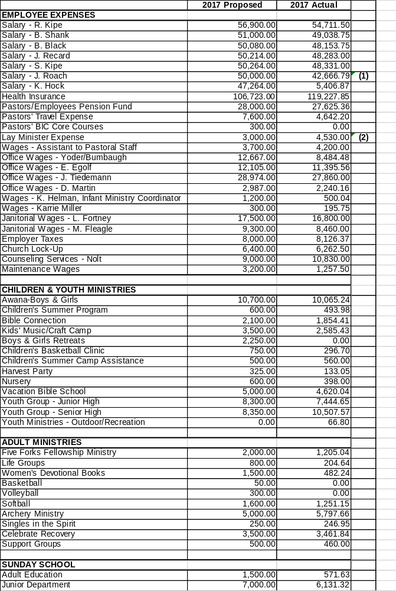

2017 Treasurer’s Report 2017 Proposed 2017 Actual

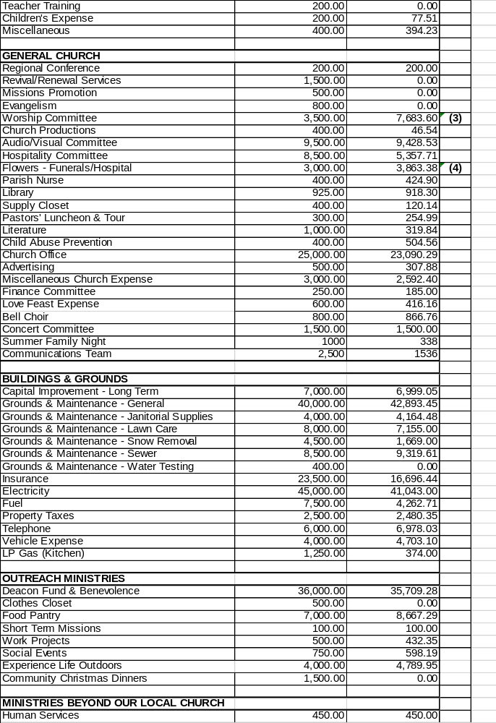

2017 Treasurer’s Report 2017 Proposed 2017 Actual

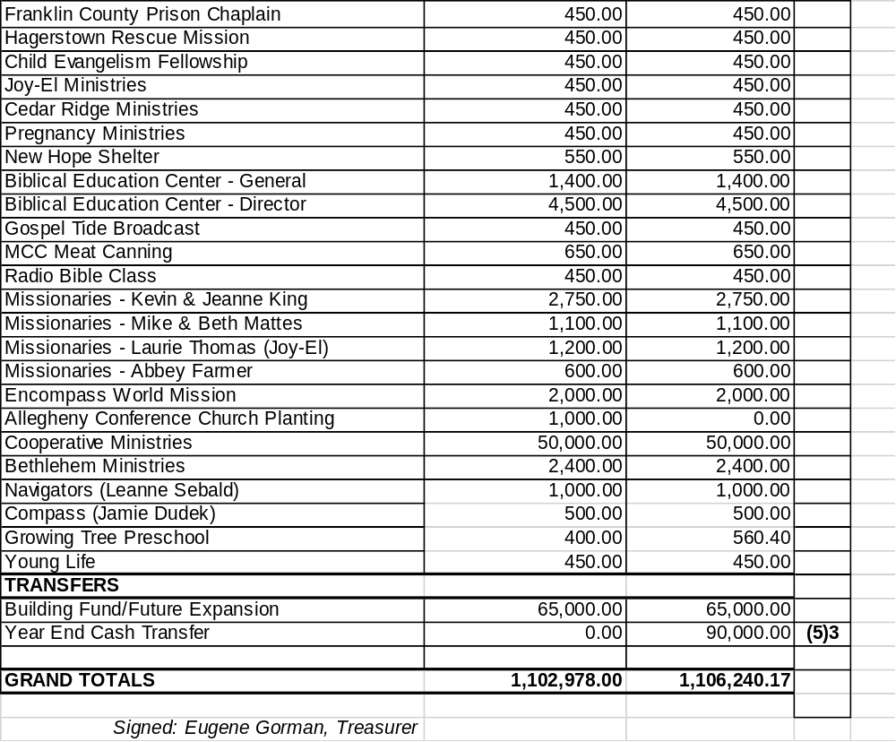

Treasurer’s Report Notes

- Salaries for both Josh and Kenton (on the following line) are below projected figures due to the fact that neither came on staff at the beginning of the year (March and December respective).

- Lay Minister Expense - Our Lay Ministers provide a valuable service for the church, delivering small gifts to first time visitors, making phone calls and visiting people who are part of our congregation (in nursing homes for example).

- Worship Committee – A large part of this total included the replacement of the outdated SamePage system, in addition to adding a new monitor system. Monies were also used to upgrade the stage design and upgrade the sound of our live stream audio.

- Flowers (Funerals/Hospitals) – Our church office oversees this ministry where flowers are sent to those who are in the hospital overnight or experience a death in the immediate family. This figure is challenging to project due to the uncertainty of need from year to year.

- Year End Cash Transfer ($90,000) – This is a portion of the money that was left over once all of the 2017 expenses were paid. We are grateful for the Lord showing us favor once again this past year. This money has been transferred to our Special Activities Account and will be disbursed when your Finance Committee meets in February.
NOTE: Actual expenses (not including transfers) were $951,240.17.

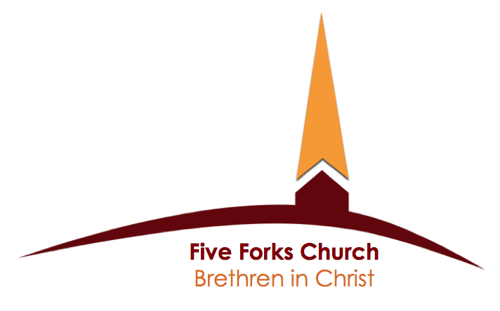
GENERAL ACCOUNT REPORT

Balance on hand, January 1, 2017 28,828.95

Total 2017 Income 1,121,900.44
Sub-Total 1,150,729.39

2017 Expenses (as shown with Treasurer’s Report) (951,240.17)

Transfer to Building Fund (65,000.00)

Transfer to Special Activities Fund (2017 Excess Funds) (90,000.00)*

Balance on hand, December 31, 2017 44,489.22

*The Finance Committee will meet in February to designate these funds for special purchases and ministry support.

Edward Jones Investment
Contingency Fund 158,673.00
2017 Gains 6,692.00
2017 Balance 165,365.00

This fund was established many years ago to help cover unanticipated major expenses (replacing heat pumps, boiler, etc.).

Ameritrade Investment
Special Benevolent Fund 246,525.00
2017 Gains 41,331.00
2017 Balance 287,856.00

BUILDING FUND REPORT

Cash balance on hand, January 1, 2017 9,257.29

2017 Receipts:
CONTRIBUTIONS
Contributions 45,800.25
General Fund Transfer 65,000.00
RENTAL INCOME
Church Facilities 6,155.00
MISSCELLANEOUS INCOME
Memorial Gifts 2,466.00
Church Auction:
Live Auction/Silent Auction 8,810.00
Kitchen Sales 782.20
Bonus Books 432.00
Subtotal Church Auction 10,024.20
Subtotal Miscellaneous Income 12.490.20

Total Income 129,445.45
Sub-Total 138,702.74

2017 Expenses
Building Loan Payments (Principal & Interest paid to BICF) (17,154.29) *

Cash balance on hand, December 31, 2017 $ 121,548.45

* Paid in full – January 2017

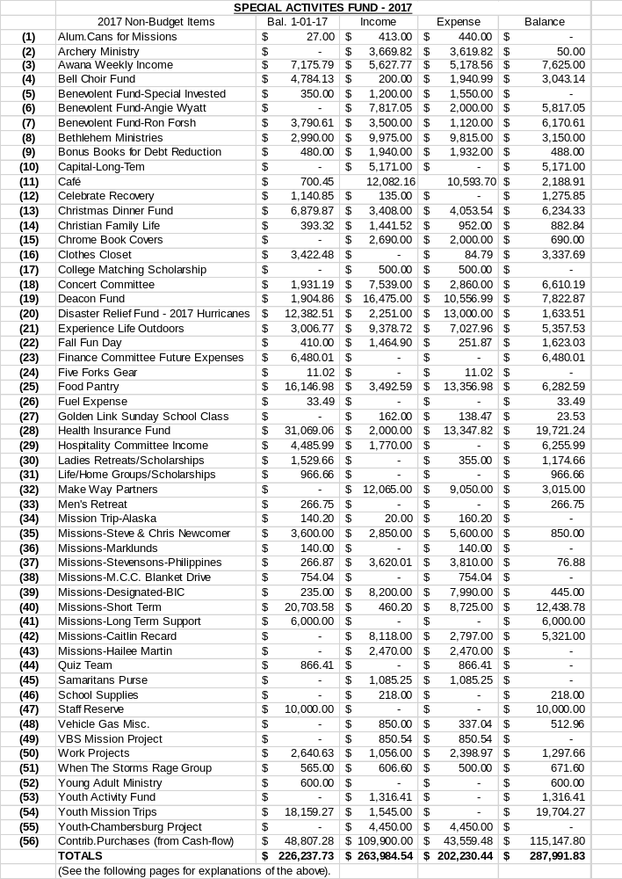

Special Activities Fund - Notes

- Alum Cans - There are stations around the church parking lots where empty aluminum cans are dropped off by anyone wishing to support missionaries Mike and Beth Mattes (Christian Coalition Outreach) and Sharon Smith (Biblical Education Center). Bob Tengler redeems the cans for cash and sends the money on to the designated missionaries or their agencies.

- Archery Ministry - This is money the Archery ministry raises and sets aside to purchase target racks and other items for their ministry.

- AWANA Weekly Income – These funds come from the offering that is received every Wednesday evening, and helps offset the cost of this ministry. (Note: Other churches using the AWANA program often charge dues, but we preferred to do this as a voluntary offering.)

- Bell Choir Fund – These are funds that are used to help with any expenses associated with our Bell Choir, including maintenance of the bells.

- Benevolent Fund - This fund was created to help those in need, whether man-made or by natural disaster. This fund will keep the principal largely intact and disperse only the earnings, with the primary recipient of the distributions being coordinated with the Deacons. As funds come in, they are held in this Special Activities Fund until they are invested with Ameritrade.

- Benevolent Fund (Wyatt) – This is a fund approved and established by our Deacon Board to help with Angie’s medical expenses.

- Benevolent Fund (Forsh) – This is a fund approved and established by our Deacon Board to help with Ron’s medical expenses.

- Bethlehem Ministries – These are contributions that are made and designated to the support of Ra’ed and Jen (Ensminger) Abu Rumann as they live and minister in Bethlehem.

- Bonus Books for Building Fund – These books are available for purchase throughout the year. Once we pay for any Bonus Books that we sell the profits are transferred to our building fund.

- Capital Long Term – This is money that was not used in 2017 and has been transferred from our General Fund to the SAF. As funds accumulate, they can be used for capital improvement projects.

- Café – This is the money that is placed in the donation boxes each week (as well as some designated giving) which is used for the food, drink, paper products and other expenses that allow the café to function.

- Celebrate Recovery – These are funds that are received via the offering at their weekly event, or by designated giving. These funds are used to further the work of this ministry.

- Christmas Dinner Fund - These are funds that were contributed during the nights of the 2017 Christmas Dinners. These funds will be used to help offset the cost of the 2018 Christmas Dinners.

- Christian Family Life – This is money collected by the Christian Family Life Sunday School class that is used to sponsor a child through Compassion International.

- Chrome Book Covers – This is money that was raised to help us partner with the Waynesboro School District to help with the expense of Chrome Book covers for low income families.

- Clothes Closet – This is money that came in designated for the support of the Five Forks Clothes Closet ministry.

- College Matching Scholarship – Some colleges will match contributions made through a students home church. These were funds that were contributed in 2017.

- Concert Committee – These are funds that were donated in order to promote and hold concerts here at Five Forks.

- Deacon Fund – These funds are given to the Deacons over and above what is set aside from our General Fund. Some of these funds come from individuals who a designated contribution; other funds may come from excess funds from the previous year.

- Disaster Relief Fund - These are funds that have come in to support work teams and relief efforts when natural disasters occur. Funds were sent out to help in Texas, Florida and Puerto Rico in 2017 due to hurricane damage.

- Experience Life Outdoors - These are funds that have been set aside or donated to help with this outreach ministry started by Brian Bitner in 2015.

- Fall Fun Day – These are funds that are contributed to help offset the costs of the Craft/Yard/Bake sale that is held in early November.

- Finance Committee Future Expenses – This are funds that have been set aside to help cover the costs of equipment that may be needed in the future.

- Five Forks Gear – These are funds that were left over from the sale of church apparel in 2016. These funds have been moved to the last line item in this SAF.

- Food Pantry – This is money received that has been designated to the Food Pantry Ministry.

- Fuel Expense – These are funds that have been donated to help offset the cost of gas when vehicles are used for work projects, helping someone move, etc.

- Golden Link SS Class – These are funds that have been contributed by members of this Adult Education Class for class activities.

- Health Insurance Fund – A majority of this money came to the church in the form of a health insurance rebates. Some excess funds from previous years were added as well. These funds are used as part of the Heath Reimbursement Account.

- Hospitality Committee Income – These are monies received from individuals designated to go to the Hospitality Committee from provided funeral meals, etc.

- Ladies Retreat/Scholarships/Ministry – These were funds collected to provide help for women who may need financial assistance in order to attend a Ladies Retreat. These funds have been unused for several years and will be used to offset expenses from our Wednesday morning Ladies Bible Study.

- Life/Home Groups/Scholarships – These are funds that are used to help provide financial assistance for the purchase of materials used for home Bible Studies.

- Make Way Partners - Is an organization working to overcome human trafficking in Sudan and South Sudan. These are funds received by individuals wishing to contribute to this mission organization.

- Men’s Retreat – These are funds that came in to help cover expenses for a Men’s Retreat sometime in the future.

- Mission Trip Alaska - These were funds that were raised for the 2013 Missions Trip to Alaska. We have moved these funds to the Short Term Missions line item.

- Missions/Steve and Chris Newcomer - This was money given by individuals designated to provide support for Steve and Chris who were serving in Mozambique. Steve returns to Mozambique periodically for ongoing projects and these funds help to support that work.

- Missions/Marklund - These funds were given by individuals inside and outside our church designated to help support the Marklunds who are from our church are serving abroad.

- Missions/Stevenson – These are donations received on behalf of Shane and Rachel Stevenson serving in the Philippines.

- Missions/MCC Blanket Drive. This money came in during our church wide fundraising event held in the Spring of 2016. These funds were sent on to MCC early in 2017.

- Missions/BIC – Money given by individuals designated to go to BIC missionaries around the world.

- Short Term Missions – These are funds given to help support those who serve on Short Term Missions Projects.

- Missions Long Term Support – These are funds set aside to help offset the cost of long term missions support for individuals from the church. The money has come from year-end excess funds.

- Missions/Recard – These are funds that have been contributed on behalf of Caitlin Recard who is living and serving in Kenya.

- Missions/Martin – These are funds that were contributed on behalf of Hailee Martin who served in Mozambique during the summer of 2017.

- Quiz Team – We do not currently have a Quiz Team in place, and so these funds have been transferred to youth ministry.

- Samaritans Purse – These were funds given by individuals designated to help with the “shoe box” project sponsored by Samaritan’s Purse.

- School Supplies – These are funds that came in from individual contributors to help offset the cost of school supplies in 2017.

- Staff Reserve – These funds were set aside from 2014 year-end excess funds to help offset the cost of hiring future staff.

- Vehicle Gas Miscellaneous. See #26 above. These will be combined early in 2018.

- VBS Missions Project – These are funds that were raised for the 2017 VBS project (Support for Hailee Martin ministry in Mozambique).

- Work Projects – These are funds that came in designated to help with the various community work projects that are performed by volunteers from the church.

- When the Storms Rage – These are funds received to help offset the costs of activities offered by this ministry led by Jodi Martin.

- Young Adult Ministry – These are funds that were received to help offset any cost incurred by a young adult ministry event.

- Youth Activity Fund - These are funds that were received over and above what was spent for one or more youth activities in 2017. These funds can be used for one or more events in 2018.

- Youth Missions Trip - These are funds remaining from the Belize Missions trip that took place in the summer of 2016. These excess funds may be used for any upcoming Youth Missions Trips.

- Youth/Chambersburg Project – These are funds given or raised by the youth to help cover the expenses of our youth participating in the Chambersburg Project. This is a week-long event where youth and adults do home repairs for needy families

- Contributions/Future Purchases – $90,000 of these dollars are excess funds from 2017. The balance comes from designated giving for special purchases such as projectors, computers, etc, when they are needed. The Finance Committee will be meeting in February to determine how to disburse/designate the $90,000 carry over.

2018 PROPOSED SPENDING PLAN

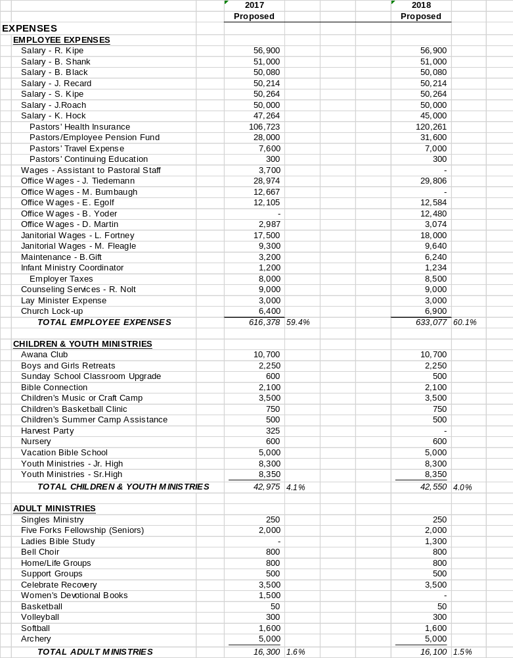

2018 PROPOSED SPENDING PLAN
2017 2018
Proposed Proposed
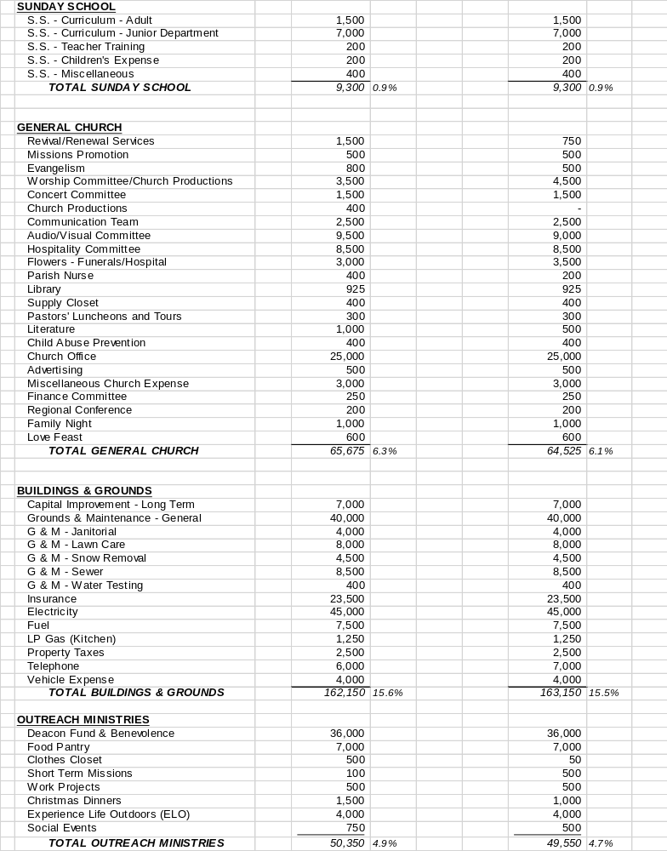

2018 PROPOSED SPENDING PLAN
2017 2018
Proposed Proposed
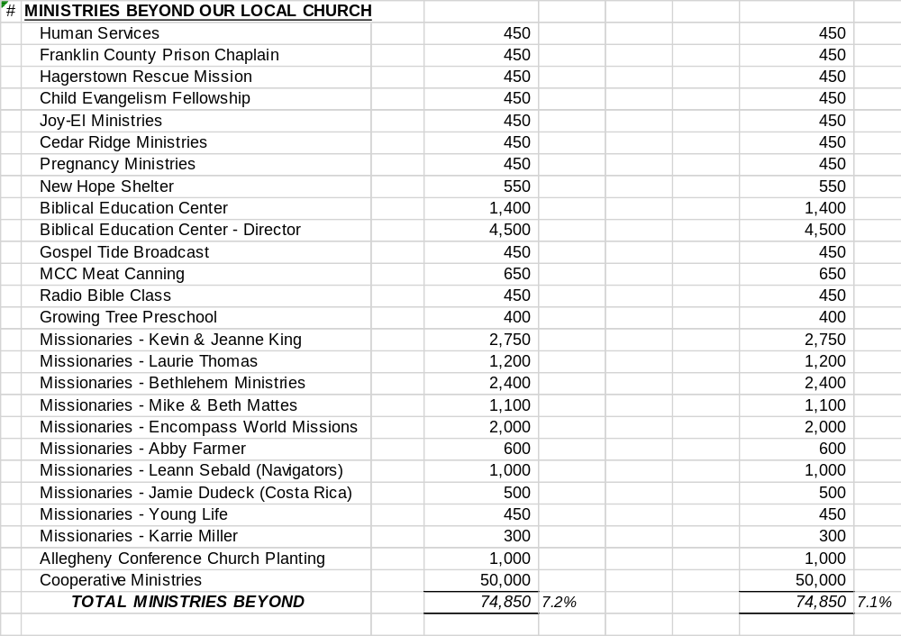

TOTAL EXPENSES 1,037,978 100% 1,053,102 100%

Building Fund 65,000 65,000

Grand Total EXPENSES AND TRANSFERS 1,102,978 1,118,102

ACTION: 1. _________________
2. ____________________

NOTES: ________________________________

2018 PROPOSED SPENDING PLAN
ITEMS OF NOTE

The Finance Committee is proposing a Spending Plan figure of $1,118,102 for 2018. This will be an increase of $15,124 over the 2017 figure. Note: Due to the fact that contributions in 2017 were $20,000 higher than projected, the 2018 Spending Plan figure is actually $5,000 less than what was contributed in 2017.

The Spending Plan figures from the past ten years:

2018 Proposed Spending Plan $1,118.102 increase of $15,124
2017 Proposed Spending Plan $1,102, 978 decrease of $43,116
2016 Proposed Spending Plan $1,146,094 increase of $42,076
2015 Proposed Spending Plan $1,104,018 increase of $14,808
2014 Proposed Spending Plan $1,089,332 increase of $25,667
2013 Proposed Spending Plan $1,063,665 increase of $29,484
2012 Proposed Spending Plan $1,034,180 increase of $29,171
2011 Proposed Spending Plan $1,005,009 increase of $22,127
2010 Proposed Spending Plan $ 982,882 decrease of $49,069
2009 Proposed Spending Plan $1,031,951 increase of $20,600

Office Staff

Julie Tiedemann serves the church as our full-time office administrator and works 40 per week. Ellen Egolf and Bryn Yoder are part-time office staff. Dave Martin serves as our financial administrator and works up to 4 hours each week. Kim Helman serves as our Nursery Coordinator and her responsibilities include recruiting and scheduling for infant childcare.

Note: Because Julie is full-time we contribute 8% of her annual income to the Brethren in Christ Pension Fund. Since Pastors/Directors are considered to be self-employed they are responsible to pay all of their Social Security taxes (15.3%). We pay 7.65% of the Social Security taxes for the other employees of the church.

HEALTH INSURANCE

The Church offers a group health plan. Since it is a group plan the staff does not pay taxes on the health insurance premiums. The insurance plan does have high deductibles which a Health Reimbursement Account helps to fund. The plan also includes dental and vision coverage. Staff that are covered by their spouse’s insurance are reimbursed by the church to an amount that would not exceed what it would cost to be covered by the church plan. This reimbursed amount is taxable to staff.

COOPERATIVE MINISTRIES

All Brethren in Christ churches are asked to provide support to “Cooperative Ministries”. These funds go to the denominational headquarters for various denominational expenses…church plantings, Brethren in Christ World Missions, discipleship opportunities, etc.

BUILDING FUND

$5,416 is transferred each month from the General Fund to the Building Fund. These funds will be used for Phase II of the Laying Bricks For Jesus Project.

If there are any questions you have, or things you do not understand about
our 2018 Proposed Spending Plan, please email Pastor Bill (bill@fiveforkschurch.org)
or the church office (office@fiveforkschurch.org) and we will try to find the answer for you.

We thank you for giving faithfully.

We thank the Finance Committee for their efforts to guide our use
of finances and we thank the Lord for His provision this past year.

ITEM V: ADOPTION OF MINUTES

ACTION: 1. ______________________________ 2. _______________________________

NOTES: _____________________________________________________________________

CLOSING PRAYER

