ANNUAL REPORT
2008

HELSINKI UNIVERSITY OF TECHNOLOGY
Low Temperature Laboratory
Brain Research Unit and
Physics Research Unit
http://ltl.tkk.fi
Table of Contents

PREFACE 4
SCIENTIFIC ADVISORY BOARD 6
PERSONNEL 6
ADMINISTRATION AND TECHNICAL PERSONNEL 6
SENIOR RESEARCHERS 7
GRADUATE STUDENTS - (SUPERVISORS) 8
UNDERGRADUATE STUDENTS 9
VISITORS 9
OLLI V. LOUNASMAA MEMORIAL PRIZE 2008 11
INTERNATIONAL COLLABORATIONS 12
ULTI – ULTRA LOW TEMPERATURE INSTALLATION 12
CONFERENCES AND WORKSHOPS 12
LOW TEMPERATURE PHYSICS RESEARCH 15
NANO group 15
PICO group 22
KVANTTI group 26
ROTA group 28
THEORY group 32
μKI group 40
BRAIN RESEARCH UNIT 42
TEACHING ACTIVITIES 51
COURSES 51
RESEARCH SEMINARS ON LOW TEMPERATURE PHYSICS AND NANOPHYSICS 52
RESEARCH SEMINARS OF THE BRU 53
SPECIAL ASSIGNMENTS 54
ACADEMIC DEGREES 54
PH.D. DISSERTATIONS 55
TECHNICAL SERVICES 55
ACTIVITIES OF THE PERSONNEL 57
PUBLICATIONS 80
APPENDIX 1 87
APPENDIX 2 93
APPENDIX 3 96

PREFACE
Academician Olli V. Lounasmaa, the founder and first director of Low Temperature Laboratory (LTL) passed away in 2002, leaving behind an unfinished autobiography of about 900 pages. Olli’s daughter Kiti Müller took the ambitious task to edit the memoirs. The memoirs, titled “Täällä ei näperrellä! – Kylmäfyysikon kuumat paikat”, were published in January 2008 and included a detailed history of LTL. Kiti Müller donated the proceeds of the memoirs for the Olli V. Lounasmaa Memorial Prize. On behalf of LTL I would like to thank Kiti Müller for her generosity and support to our laboratory.
The full research program of LTL has been evaluated 9 times since 1995. The latest evaluation took place on 1st of April, 2008, when the Scientific Advisory Boards of our two Centers of Excellence (CoE in Brain Systems Neuroscience and Neuroimaging and CoE in Low Temperature Quantum Phenomena and Devices) held their evaluation meetings. The evaluation report of CoE in Low Temperature Quantum Phenomena and Devices can be found in Appendix 1.
The success of LTL is based on its excellent research equipment which has been recognized even at European level. In 1995–2003 the Brain Research Unit operated (NEURO)BIRCH I, II, and III (Neuromamagnetic Brain Research) as a FP4- and FP5-funded major European Research Infrastructure, giving annual access to about 15 European scientists. Similarly, in 1995–2008 the Physics Research Unit operated ULTI I, II, III, and IV (Ultra Low Temperature Installation), as a FP4-, FP5-, and FP6-funded major European Research Infrastructure, giving annual access to about 20 European scientists.
In 2008 12 leading European low temperature laboratories formed a European Microkelvin Collaboration – MICROKELVIN, and received FP7-funding from the Capacities Specific Programme called Infrastructures. MICROKELVIN is coordinated by LTL and funded for the time period of 1.4 2009–31.3. 2013. Three of the partners, TKK, CNRS Grenoble, and University of Lancaster are serving as European access-giving sites in low temperature physics. The evaluation report of MICROKELVIN application can be found in Appendix 2.
In 2008 Finland, inspired by the European ESFRI-process, conducted a national survey of its research infrastructures. In the survey an international evaluation panel selected 24 infrastructures to the list of present (map) and 19 to the list of future (road map) important national infrastructures. CRYOHALL, the PRU-operated low temperature infrastructure, was elected to the map and roadmap. NEUROIMAGING, a BRU-coordinated consortium of 3 infrastructures, was elected to the map. CRYOHALL and NEUROIMAGING were the only TKK-coordinated infrastructures selected to the map or to the roadmap.
In 2003, LTL established a memorial prize carrying the name of late Academician Olli V. Lounasmaa. The first prize was awarded in 2004 to Professor John Clarke from University of California, Berkeley, for his pioneering research and development work on ultra-sensitive magnetometers called SQUIDs. In 2008 the Selection Panel of Vice Rector Outi Krause, and Professors Mikko Sams and Riitta Hari (chairman) awarded the second Olli V. Lounasmaa Memorial Prize to Dr. Seiji Ogawa from Tohoku-Fukushi University in Sendai, Japan, for his pioneering observations that have led to the emergence of functional magnetic resonance imaging of human brain function. The award ceremony took place on April 1, 2008 at TKK, in association with the Celebration and Alumni Day of the Low Temperature Laboratory. The Prize was financially supported by Helsinki University of Technology.
The European Research Council (ERC) was founded in 2007. It is the first European funding body set up to support investigator-driven frontier research. In 2008 ERC selected its first Advanced Grant winners. Altogether 275 scientists were funded from an initial pool of about 2000 applicants. Professor Riitta Hari from LTL, with her proposal “Brain2Brain – Towards two-person neuroscience”, was one of the 9 Finnish recipients of this prestigious 5-year grant.
Two scientists of LTL received special recognition in 2008. Docent Nina Forss was awarded the Nordic Prize for her pain research as an alternative for animal experiments. The Prize was given by three Nordic Foundations: Juliana von Wendt Fund from Finland, Stiftelsen Forskning utan djurförsök from Sweden, and Alternativfondet from Denmark. The undersigned received the Theodor Homén Prize in Physics from the Finnish Society of Sciences and Letters. The Theodor Homén Prize is awarded annually-triannually and alternates between a researcher in physics and one in Finnish history.

Mikko Paalanen
Director of the LTL

SCIENTIFIC ADVISORY BOARD
LTL has a Scientific Advisory Board (SAB), appointed by the Rector of TKK for the years 2006–2011. The members also serve in the SABs of the Centers of Excellence of the Academy of Finland, coordinated by the LTL. Our current SAB has the following 5 members:
For the Center of Excellence on Low Temperature Quantum Phenomena and Devices
Prof. Mats Jonson, Gothenburg University, Gothenburg, Sweden
Prof. John Saunders, Royal Holloway, University of London, UK
For the Center of Excellence on Systems Neuroscience and Neuroimaging
Prof. Chris Frith, Functional Imaging Laboratory, University College London, UK
Prof. Denis Le Bihan, CEA Saclay, France
Prof. Nikos K. Logothetis, MPI for Biological Cybernetics, Tübingen. Germany.
The SABs of both CoEs held their evaluation meeting on 31st of March, 2008. The evaluation report of CoE in Low Temperature Quantum Phenomena and Devices can be found in Appendix 1.

PERSONNEL
The number of persons working in the LTL fluctuates considerably since scientists are employed for relatively short periods only and students often work on part-time basis.

ADMINISTRATION AND TECHNICAL PERSONNEL
Mikko Paalanen, D.Sc. (Tech.), Professor, Director of the LTL
Peter Berglund, D.Sc. (Tech.), Docent, Technical Manager, until 31.8.2008
Alexander Savin, Ph.D., Technical Manager, from 1.9.2008
Rob Blaauwgeers, Ph.D., special equipment designer
Teija Halme, secretary
Antti Huvila, technician
Mia Illman, nurse, laboratory assistant
Arvi Isomäki, technician
Juhani Kaasinen, technician, until 31.12.2008
Antti-Iivari Kainulainen, technical assistant
Helge Kainulainen, technician
Jari Kainulainen, nurse, laboratory assistant, until 31.10.2008
Marita Kattelus, radiographer, laboratory assistant (AMI)
Tuire Koivisto, secretary
Markku Korhonen, technician
Leena Meilahti, secretary
Pirjo Muukkonen, financial secretary
Liisi Pasanen, secretary
Petteri Räisänen, system administrator
Veli-Matti Saarinen, project engineer
Ronny Schreiber, research engineer
Pieter Vorselman, project manager

SENIOR RESEARCHERS

Physics Research Unit
Harry Alles, D.Sc. (Tech.)
Romain Danneau, Ph.D., until 2.9.2008
Vladimir Eltsov, Ph.D.
Aurelien Fay, from 18.8.2008
Pertti Hakonen, D.Sc. (Tech.), Professor
Tero Heikkilä, D.Sc. (Tech.), Docent
Meri Helle, D.Sc. (Tech.)
Risto Hänninen, D.Sc. (Tech.)
Sergey Kafanov, Ph.D. (Tech.), from 1.6.2008
Nikolai Kopnin, Ph.D., Professor
Matti Krusius, D.Sc. (Tech.), Professor
Matthias Meschke, Ph.D.
Teemu Ojanen, D. Sc. (Tech.), until 29.2.2008
Gheorghe-Sorin Paraoanu, Ph.D.
Jukka Pekola, D.Sc. (Tech.), Professor
Alexander Sebedash, Ph.D.
Mika Sillanpää, D.Sc. (Tech.)
Igor Todoschenko, Ph.D.
Juha Tuoriniemi, D.Sc. (Tech.), Docent
Grigori Volovik, Ph.D., Professor
Fan Wu, Ph.D.

Brain Research Unit
Riitta Hari, M.D., Ph.D., Professor, Head of the Brain Research Unit
Toni Auranen, D.Sc. (Tech.), from 17.3.2008 (AMI)
Paolo Belardinelli, Ph.D.
Gina Caetano, D.Sc. (Tech.), until 31.8.2008
Synnöve Carlson, M.D., Ph.D., Professor
Nina Forss, M.D., Ph.D., Docent, part-time
Marja-Liisa Halko, Ph.D., part-time
Päivi Helenius, Ph.D. (Psych), Docent
Yevhen Hlushchuk, M.D., Ph.D., until 31.10.2008
Veikko Jousmäki, Ph.D., Docent
Jaakko Järvinen, Ph.D.
Erika Kirveskari, M.D., Ph.D., part-time
Miika Koskinen, Ph.D. (Tech.) (AMI)
Jan Kujala, D.Sc. (Tech.),
Catherine Nangini, Ph.D.
Tiina Parviainen, Ph.D. (Psych.)
Elina Pihko, Ph.D. (Psych.), Docent
Hanna Renvall, M.D., Ph.D., from 1.3.2008
Riitta Salmelin, D.Sc. (Tech.), Academy Professor
Mika Seppä, D.Sc. (Tech.)
Päivi Sivonen, D.Sc. (Psych.)
Pia Tikka, Ph.D. (Arts), from 20.8.2008
Simo Vanni, M.D., Ph.D., Docent
Minna Vihla, M.D., Ph.D., part-time, on leave from 9.6.2006

GRADUATE STUDENTS - (SUPERVISORS)

Physics Research Unit
Khattiya Chalapat, M.Sc., from 4.7.2008 - (Gheorghe-Sorin Paraoanu)
Robert de Graaf, M.Sc. - (Matti Krusius)
Tommy Holmqvist, M.Sc. (Tech.) - (Jukka Pekola)
Jaakko Hosio, M.Sc. (Tech), from 23.5.2008 - (Matti Krusius)
Heikki Junes, M.Sc. (Tech.) - (Harry Alles)
Antti Kemppinen, M.Sc. (Tech.) - (Jukka Pekola)
Matti Laakso, M.Sc. (Tech.), from 11.9.2008 - (Tero Heikkilä)
Lorenz Lechner, M.Sc. - (Pertti Hakonen)
Jian Li, M.Sc. - (Gheorghe-Sorin Paraoanu)
Sarah MacLeod, M.Sc., from 1.8.2008 - (Jukka Pekola)
Matti Manninen, M.Sc. (Tech.), from 26.2.2008 - (Juha Tuoriniemi)
Juha Muhonen, M.Sc. (Tech.), from 15.9.2008 - (Jukka Pekola)
Antti Paila, M.Sc. (Tech.) - (Pertti Hakonen)
Joonas Peltonen, M.Sc. (Tech.), from 29.1.2008 - (Jukka Pekola)
Elias Pentti, M.Sc. (Tech.) - (Juha Tuoriniemi)
Juho Rysti, M.Sc. (Tech.), from 28.11. 2008 - (Juha Tuoriniemi)
Anssi Salmela, M.Sc. (Tech.) - (Juha Tuoriniemi)
Jayanta Sarkar, M.Sc. - (Pertti Hakonen)
Roman Solntsev, M.Sc., on leave from 22.09.2008 - (Matti Krusius)
Andrey Timofeev, M.Sc. - (Jukka Pekola)
Pauli Virtanen, M.Sc. (Tech.) - (Tero Heikkilä)
Juha Voutilainen, M.Sc. (Tech) - (Tero Heikkilä)
Brain Research Unit
Linda Henriksson, M.Sc. (Tech.) - (Simo Vanni)
Jaana Hiltunen, Phil. Lic. - (Riitta Hari)
Lotta Hirvenkari, M.Sc. (Tech), from 1.5.2008 - (Riitta Hari)
Annika Hultén, M.Sc. (Psych.) - (Riitta Salmelin, Matti Laine)
Miiamaaria Kujala, M.Sc. (Phil.) - (Riitta Hari)
Hannu Laaksonen, M.Sc. (Tech.) - (Riitta Salmelin)
Satu Lamminmäki, M.D. - (Riitta Hari)
Mia Liljeström, M.Sc. (Tech.) - (Riitta Salmelin)
Sanna Malinen, M.Sc. (Tech.) - (Riitta Hari)
Lauri Nurminen, M.Sc. (Psych.), from 1.7.2008 - (Simo Vanni)
Lauri Parkkonen, M.Sc. (Tech.) - (Riitta Hari)
Ville Renvall, M.Sc. (Tech.) - (Riitta Hari)
Linda Stenbacka, M.D. - (Simo Vanni)
Miiamaaria Saarela, M.Sc. (Phil.) - (Riitta Hari)
Linda Stenbacka, M.D. - (Simo Vanni)
Topi Tanskanen, M.Sc. (Psych.) - (Riitta Hari)
Johanna Vartiainen, M.Sc. (Tech.) - (Riitta Salmelin)
Nuutti Vartiainen, M.D. - (Nina Forss, Riitta Hari)

UNDERGRADUATE STUDENTS

Physics Research Unit
Mikko Ervasti, 20.5.–20.8.2008
Jaakko Hosio, until 23.5.2008
Petri Heikkinen, 1.6.–21.8.2008
Pasi Häkkinen, 19.5.–31.12.2008
Juho Häppölä, 20.5.–31.8.2008
Jukka-Pekka Kaikkonen, from 21.5.2008
Laura Korhonen
Jonne Koski, 20.5.–31.8.2008
Matti Laakso, until 11.9.2008
Pasi Lähteenmäki, from 4.2.2008
Matti Manninen, until 26.2.2008
Juha Muhonen, until 14.9.2008
Joonas Peltonen, until 29.1.2008
Antti Puska
Juho Rysti, until 28.11.2008
Jaakko Sulkko, from 19.5.2008
Matti Tomi
Brain Research Unit
Hanne Antila, from 26.5. 2008
Maarit Aro, until 15.10.2008
Tuukka Hiltunen, 26.5.–31.8.2008
Antti Jalava
Marika Kaksonen
Leena Karvonen, until 30.6.2008
Lauri Nurminen, until 1.7.2008
Pavan Ramkumar
Tom Rosenström, until 31.8.2008
Timo Saarinen
Sini-Maaria Sipponen, until 31.5.2008

VISITORS

ULTI Visitors ( Low Temperature and Nano Physics)
Bunkov, Yury, Prof., 25.3.–4.4., Institute Néel, CNRS, Grenoble, France
Chagovets, Timofeev, M.Sc., 1.–31.1, Physics Academy, Czech Republic
Courtois, Hervé, PhD, 20.2.–31.7., CNRS, France
Galperin, Iouri, Prof., 13.–24.3., University of Oslo, Oslo, Norway
Garcia, Pascual Cesar, Dr., 16.3.–2.4., University of Pisa, Italy
Giazotto, Francesco, Prof., 2.–13.3., Scuola Normale Superiore, NEST-INFM, Pisa, Italy
Haley, Richard, PhD, 27.–31.3., Lancaster University, Lancaster, UK
L’vov, Viktor, Prof., 25.3.–2.4., Weizmann Instutute of Science, Rekhovot, Israel
Pickett, George, Prof, 20.–25.1., 19.–26.2., 28.3.–3.4., Lancaster University, Lancaster, UK
Sonin, Edouard, Prof., 1.2.–2.4., Hebrew University of Jerusalem, Jerusalem, Israel
Tsepelin, Viktor, PhD, 18.3.–2.4., Lancaster University, Lancaster, UK

Other visitors
Ankerhold, Joachim, Dr., 15.–19.12, University of Ulm, Germany
Dimitriev, Vladimir, Prof., 17.–23.7., Kapitza Institute, Moscow, Russia
Glaum, Konstantin, Dr., 9.–22.12., University of Ulm, Germany
Hekking, Frank, Prof., 28.3.–4.4., Joseph Fourier University, LPMMC-CNRS, Grenoble, France
Jannes, Gil, MSc, PhD, 13.4.–16.5., IEM, Madrid, Spain
Kuznetsov, Evgenii, Dr., 25.–30.11., P.N. Lebedev Physical Institute, Moscow, Russia
Manohar, Kumar, MSc, 24.–26.6., Leiden University, The Netherlands
Melnikov, Alexander, PhD, 1.–14.10., Russian Academy of Science, Nizhny Novgorod, Russia
Nakahara, Mikio, Prof., 14.–20.6., Kinki University, Osaka, Japan
Parshin, Alexander, Prof., 7.–9.4., 20.–31.10., Kapitza Institute, Moscow, Russia
Pascarella, Annalisa, 1.–16.11., University of Genova, Italy
Pashkin, Yuri, Prof., 24.4.–10.5., 13.–26.7., NEC Corporation, Tsukuba, Japan
Roukes, Michael, Prof., 21.–23.10., Kavli Nanoscience Institute, California, USA
Schuermann, Martin, Dr., 2.–11.9., University of Nottingham, UK
Silaev, Mikhail, PhD, 9.–13.6., Russian Academy of Sciences, Russia
Staeren, Noël, Dr., 1.–6.12., University of of Maastricht, The Netherlands
Strunk, Christoph, Dr., 25.–26.11., University of Regensburg, Germany
Wengler, Julien, ENS student, 2.5.–31.8., CNRS, France
Wiesner, Maciej, Dr., 1.1.–15.8., Adam Mickkiewitz University, Poland
Von Phöstl, Veronica, MSc., 25.3.–30.9., University of Bologna, Italy
Zmeev, Dmitri, Dr., 1.–27.1., Kapitza Intitute, Moscow, Russia

GROUP VISITs
Presentation for summer students, 1.2.
”Human brain structure and function” (course for physicists), 7.3
EU’s Future and Emerging Technologies Unit and Tekes (7 administrators), 14.3
ABI-info for upper secondary school classes (20 students), 26.3.
Stadia University of Applied Sciences (teacher and 15 students), 4.4.
Millennium Prize International Selection Committee to the Brain Research Unit, 11.4.
Nanohouse opening day visitors, 20.5.
Lahti’s Lyceum (teacher and 30 students), 27.5.
Participants of Progress in Paper Physics Conference (about 80 people), 3.6.
Students from Espoo secondary schools, 17.9
Lithuanian student group (about 20 students), 24.9.
Brain godparents (two groups, about 40 persons), 29.9
Tour and consultation for exhibition designers from Heureka, 1.10.
TKK Open Doors Day (about 200 visitors), 11.10.
Physics Student Club of University of Nijmegen, The Netherlands, (19 students), 17.10.
LUMA Science Days (about 20 natural science and mathematics teachers), 24.10.
ABI-info for a upper secondary school class (20 students), 31.10.
Psychology Students from University of Helsinki 14.11
Laboratory introduction for 40 students and their parents, 29.11.
Groups from various high schools in Finland, during all year

OLLI V. LOUNASMAA MEMORIAL PRIZE 2008

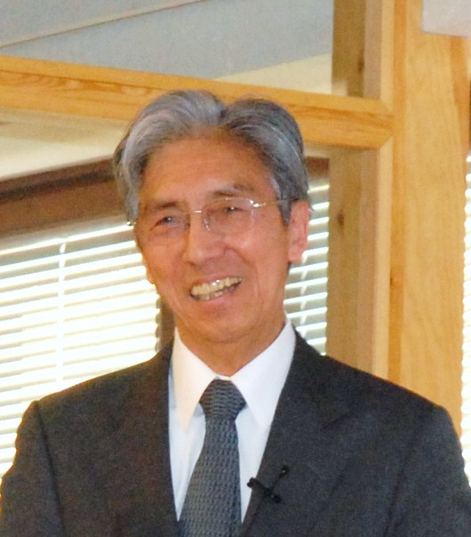

The second Olli V. Lounasmaa Memorial Prize was awarded to Dr. Seiji Ogawa from Tohoku-Fukushi University in Sendai, Japan, for his pioneering observations that have led to the emergence of functional magnetic resonance imaging of human brain function. The award ceremony took place on April 1, 2008 at TKK, in association with the Celebration and Alumni Day of the Low Temperature Laboratory.
Dr. Ogawa was elected for the Prize by a Selection Committee of Professors Outi Krause (vice rector of TKK), Mikko Sams (TKK), and Riitta Hari (chair, TKK). Helsinki University of Technology financially supported the Memorial Prize. The speech given by Riitta Hari during the award ceremony is given in Appendix 3.
After the award ceremony Dr. Ogawa gave a lecture “BOLD-based fMRI – its beginning and a new approach“.

INTERNATIONAL COLLABORATIONS

ULTI – ULTRA LOW TEMPERATURE INSTALLATION
Coordinator: Mikko Paalanen
Funding: EU's 6th framework program, Transnational Access to Major Research Infrastructures. (EU contract # RITA-CT-2003-505313)
Duration: 1.4. 2004–31.3. 2008
Participating groups of the LTL: INTERFACE, NANO, PICO, ROTA, THEORY and YKI
The ULTI Large-Scale Facility continues the services of ULTI III for European scientists. It will provide them 72 visitor months in the LTL and full access to its research facilities.
During 2008 altogether 11 European visitors from 6 different countries used the facility for 6.3 months.
ULTI web page: http://ltl.tkk.fi/eu.html

CONFERENCES AND WORKSHOPS
Low Temperatures 2008
Coordinator: Matti Krusius
Helsinki University of Technology, Espoo, Finland, March 28–April 1, 2008
Low Temperatures 2008 was a five-day event which included three parts: (i) Symposium on Quantum Phenomena and Devices at Low Temperatures on 28.–30.3.2008; (ii) Research evaluation of the two Centers of Excellence coordinated by Low Temperature Laboratory on 31.3.2008; and (iii) Celebration and Alumni Day of Low Temperature Laboratory on 1.4.2008.
Symposium on Quantum Phenomena and Devices at Low Temperatures
Hotel Matinlahti, Espoo, Finland, March 28–30, 2008 (ULTI User Meeting)
A symposium on Quantum Phenomena and Devices at Low Temperatures, an EU-sponsored ULTI User Meeting, gathered 135 researchers in nanoelectronics and low-temperature physics from 16 countries. The 3-day program included 36 talks and 53 poster presentation covering a wide range of topics:
- Quantum turbulence
- Magnetic resonance in superfluids
- Interface between condensed matter and quantum field theories
- Helium crystals
- Coherent condensates
- Quantum effects in resonance circuits
- Superconductivity and noise in mesoscopic systems
- Applications in nanophysics
- Single-electron metrology
- Electronic properties of carbon nanotubes
The Proceedings of the Workshop contained 18 articles and were published in JLTP 153, 5/6, December 2008.
Website: http://ltl.tkk.fi/wiki/ULTI2008
Celebration and Alumni Day of Low Temperature Laboratory
Saha, Helsinki University of Technology, Espoo Finland, April 1, 2008
The purpose of the alumni day was to celebrate the inauguration of the new laboratory building, the graduation of more than 100 PhDs from the laboratory and the awarding of 2nd Olli V. Lounasmaa Memorial Prize to Seiji Ogawa for his contributions in the development of fMRI technique. The programme was composed of physics and neuroscience colloquia, visits to different research groups in the new laboratory building, and of an alumni meeting with a buffet dinner. The alumni meeting was participated by Nobel Laureate Douglas Osheroff and about 50 former PhD students of the laboratory.
Conference on Micro- and Nanocryogenics
Chairman: Jukka Pekola
Helsinki University of Technology, Espoo, Finland, August 3–5, 2008
Conference on Micro- and Nanocryogenics was a satellite of the 25th International Conference on Low Temperature Physics (LT25). It was organized by Low Temperature Laboratory of Helsinki University of Technology. Altogether 59 participants from 10 countries attended the conference. The aim of the conference was to bring together scientists working in fields related to thermal phenomena in small systems. The topics of the conference included thermal effects and thermodynamics in micro- and nanostructures, electronic refrigeration and thermometry, ultrasensitive detection of radiation, and nanoelectromechanical systems.
The Proceedings of the Workshop contained 9 articles and were published in JLTP 154, 5/6, March 2009.
Website: http://ltl.tkk.fi/PICO/conference.html

Mind Forum III: Conscious, unconscious, habit
Chairman: Riitta Hari
Majvik Meeting and Convention Hotel, Kirkkonummi, Finland, March 6–8, 2008
This workshop was the third one in a series of five multidisciplinary workshops of the Mind Forum, which started in 2007. The aim of the workshop was to discuss phenomena and concepts related to consciousness, such as unconscious processing, habit, addiction and the sense of reality. The first two days of the workshop were held in Finnish and the third day was held in English. 36 invited guests attended the workshop: one from the United States, one from the Netherlands, and 34 from Finland. Five of the Finns attending the workshop were PhD students. The scientific program contained 10 oral presentations in Finnish, three oral presentations in English and three sessions dedicated to discussions only (two in Finnish, one in English). The talks were given by experts in psychology, sociology, psychiatry, philosophy, comparative religion studies, folkloristics, and cognitive science. In addition, experts in brain research, educational psychology, and computer science contributed to the discussions. There were no poster presentations. An abstract booklet in Finnish was delivered to the participants at the start of the workshop; an English version of the abstract booklet (translated by the coordinator, Dr Jaakko Järvinen) was provided to the overseas guests.
Website: http://www.mieliforum.fi/english.html

Mind Forum IV: Minds in interaction
Chairman: Riitta Hari
Majvik Meeting and Convention Hotel, Kirkkonummi, Finland, September 4–6, 2008
This workshop was the fourth one in a series of five Mind Forum workshops (see previous entry). The aim of the workshop was to discuss the role of interaction in the development of the mind. The first two days of the workshop were held in Finnish and the third day was held in English. 30 invited guests attended the workshop: one from Canada, one from Italy, and 28 from Finland. Six of the Finns attending the workshop were PhD students. The scientific program contained seven oral presentations in Finnish, three oral presentations in English and four sessions dedicated to discussions only (three in Finnish, one in English). The talks were given by experts in philosophy, brain research, sociology, psychiatry, educational psychology, and cognitive science. In addition, experts in computer science, comparative religion studies, and history contributed to the discussions. There were no poster presentations. An abstract booklet in Finnish was delivered to the participants at the start of the workshop; an English version of the abstract booklet (translated by the coordinator, Dr Jaakko Järvinen) was provided to the overseas guests.

Mind Forum V: The final seminar
Chairman: Riitta Hari
University of Helsinki, Main building, Helsinki, Finland, November 20, 2008
The final seminar of the Mind Forum summarized the main results of this two-year project. An audience of approximately 70 invited Finnish researchers, PhD students, journalists and decision-makers heard five brief presentations from the Board members and participated in a panel discussion. Unlike in previous Mind Forum seminars, the program was entirely in Finnish. There were no poster presentations. An abstract booklet in Finnish was provided for the representatives of the media. After the scientific program, the guests were invited to enjoy the hospitality of the University of Helsinki at a reception hosted by the Vice Rector, Professor Hannele Niemi.
11. valtakunnallinen lukitutkijatapaaminen
Helsinki University of Technology, Espoo, Finland, March 7, 2008
BRU scientists Päivi Helenius and Tiina Parviainen in collaboration with Erilaisten oppijoiden liitto organized at TKK the 11. Annual Meeting of Dyslexia and Reading Research March 7, 2008. The meeting had 87 pre-registered participants from all over Finland. The program was very intense with 13 presentations introducing recent progress on basic and applied research on developmental learning disorders. After the meeting the participants gathered in the Nanotalo lobby for buffet dinner and guided tours in the MEG measurement site.
Website: http://neuro.hut.fi/luki
Physiology and neurobiology of human brain imaging
University of Helsinki, Viikki Biocenter, January 15, March 3and Helsinki University of Technology, Espoo, Finland, May 20–21, 2008
Prof. Riitta Hari and Dr. Simo Vanni from BRU organized together with Prof. Kai Kaila (Helsinki University, Dept. Biological and Env. Sciences & Neuroscience Center) a workshop on physiology and neurobiology of human brain imaging: Neuronal activity, energy metabolism and neurovascular coupling. The workshop was held at the University of Helsinki, Viikki Biocenter January 15, 2008 and March 3, 2008 and at TKK May 20–21, 2008. Aim of the seminar was to introduce the current knowledge on the physiological and neurobiological bases of the BOLD signal monitored with MRI and to discuss how and why does an increase in neuronal activity lead to a local increase in blood flow and what kind of neuronal activity triggers a signal. The lectures at TKK were given by local (Kai Kaila, Riitta Hari, Simo Vanni, Tom Rosenström, Myoung Soo Kwon, Jaakko Virtanen, Dubravko Kikic) and visiting scientists (Matthew Colonnese, INMED, Marseille; Jozien Goense, Max Planck Institute for Biological Cybernetics, Tübingen; Martin Lauritzen, University of Copenhagen).
Website: http://www.helsinki.fi/fgsn/courses/fmri_workshop08.htm

LOW TEMPERATURE PHYSICS RESEARCH

NANO group
R. Danneau, P. Hakonen, P. Häkkinen, L. Korhonen, L. Lechner, P. Lähteenmäki, A. Paila, A. Puska, J. Sarkar, M. Sillanpää, J. Sulkko, M. Tomi, and F. Wu
Visitors: M. Gaass, Yu. Makhlin, E. Sonin, and M. Wiesner
Collaborators: J. Aarik, H. Alles, M. Craciun, D. Gunnarsson, J. Hassel, E. Kauppinen, J. Kolehmainen (Diarc Ltd.), J. Lian, A. Morpurgo, J. Oostinga, S. Paraoanu, P. Pasanen (Nokia NRC), J. Penttiä (Aivon Ltd.), P. Queipo, S. Russo, H. Seppä, R. Simmonds, E. Thuneberg, T. Tsuneta, J. Tuorila, CARDEQ, and MIKES partners
The research work of the NANO group is focused on three areas: 1) Mesoscopic quantum amplifiers and qubits, 2) Quantum transport in carbon nanotubes and graphene, and 3) Current fluctuations and fast dynamics in quantum circuits. In all of these categories, our measurements are centered at microwave frequencies, involving reflection measurements for qubits, transmission measurements for AC-conductance, and two channel noise recording for cross correlation studies.
European Union funded research projects have become an integral part of the work of NANO group. Two projects are ongoing: one of them, coordinated by P. Hakonen, is an IST-STREP dealing with carbon nanotubes and the second one is an INTAS-project, coordinated by G. Schön, which deals with quantum information. Most of our samples, especially the Josephson junction devices, are made in our own in-house semiclean room. As we are not producing any carbon nanotubes ourselves, all our nanotube samples have been obtained on collaborative basis of some sort, either in European projects or within other collaborations. Also, our graphene samples have either been manufactured in our own clean room or they have been obtained via collaboration.
In the field of mesoscopic quantum amplifiers and qubits, we have further developed the dispersive charge detection techniques deviced by our group recently for studies of the quantum measurement. In addition to charge-phase qubits, we have also worked on pure phase qubits that we have received from Ray Simmonds at NIST, Boulder. In carbon nanotubes and graphene, we have continued our collaboration with Nokia, gradually concentrating more and more on graphene. One of the major goals in the TKK-NRC collaboration is to find fabrication methods and graphene devices that could be patented. One patent application was filed on the work of NANO-group.

PHASE QUBITS AND LANDAU-ZENER INTERFEROMETRY
M. Sillanpää, J. Li, Yu. Makhlin, A. Paila, S. Paraoanu, and P. Hakonen
We continued the work on investigating what happens when a quantum two-level system is driven by a field having an amplitude comparable to the system level spacing. We recently modeled the scheme as a Mach-Zehnder type of interferometry. In atomic physics, one is faced with a problem of handling such high energy fields, and consequently, this type of "artificial atoms" forms a unique testing platform for studying quantum mechanics in this limit. In particular, in the original atomic systems, one has not studied the interaction between the two-level system and an external resonant cavity when the qubit is strongly driven. We fabricated a charge qubit coupled to an electrical resonator, and observed a splitting of the Mach-Zehnder interference peaks due to the interaction of the qubit and the resonator. Theoretical modeling is still ongoing, together with J. Tuorila and E. Thuneberg (University of Oulu).
A new collaboration was started with the National Institute of Standards and Technology (NIST, former postdoc employer of one of of the investigators, M. Sillanpää) in Colorado, USA, on Josephson phase qubits. The collaboration combines the strength of NIST having exclusive microfabrication capabilities, and our experience on high-frequency readout of quantum circuit in 1–4 GHz range.
As a first experiment in the collaboration, we have investigated the phase "qubit" as a multilevel quantum system. In the fields of atomic physics and quantum optics, various experiments have utilized the naturally multilevel bound state structure of atoms. A system, whose dynamics spans three levels, can already display a rich spectrum of phenomena. Interrelated observations known as the Autler-Townes splitting, coherent population trapping, and electromagnetically induced transparency, have been thoroughly investigated with atoms. We have discerned for the first time these phenomena in a superconducting artificial atom. The results constitute a basic test of quantum mechanics on the way towards more and more complicated systems, as well as they provide insight on possibilities of quantum information processing using higher-dimensional Hilbert spaces.

VIBRATIONAL SPECTROSCOPY OF AN ARTIFICIAL ATOM
D. Gunnarsson, Yu. Makhlin, A. Paila, J. Sarkar, E. Thuneberg, J. Tuorila, and P. Hakonen
We have performed microwave reflection experiments on a charge-phase qubit coupled to an LC oscillator. We find that the system behaves like an artificial molecule showing vibronic sideband transitions. These results can be explained in terms of the Franck-Condon principle and resolved-sideband cooling or heating of the oscillator.
Our artificial molecule is made of aluminum components that are in superconducting state. The electronic states of the molecule are represented by a Josephson-junction qubit, and the nuclear separation corresponds to the magnetic flux in a loop containing the qubit and an LC oscillator. After the fabrication, there are still two tunable parameters that control the level spacing of the qubit and allow a clear mapping of the transitions. We made spectroscopic studies by exciting the vibrations with a low-frequency drive. Simultaneously, we induced vibronic transitions with a high-frequency drive. We measured the reflected low-frequency signal and found that the spectral weights of the vibronic transitions obeyed the Franck-Condon principle, as in traditional molecules. We observed also an asymmetry between the red and blue-detuned transitions which can be interpreted as resolved-sideband cooling or heating of the vibrations. A comparison between the analogy and the measurements was made with numerical simulations using Bloch equations for the qubit coupled to classical equations of the circuit. The simulations reproduced well the observed vibronic spectrum.
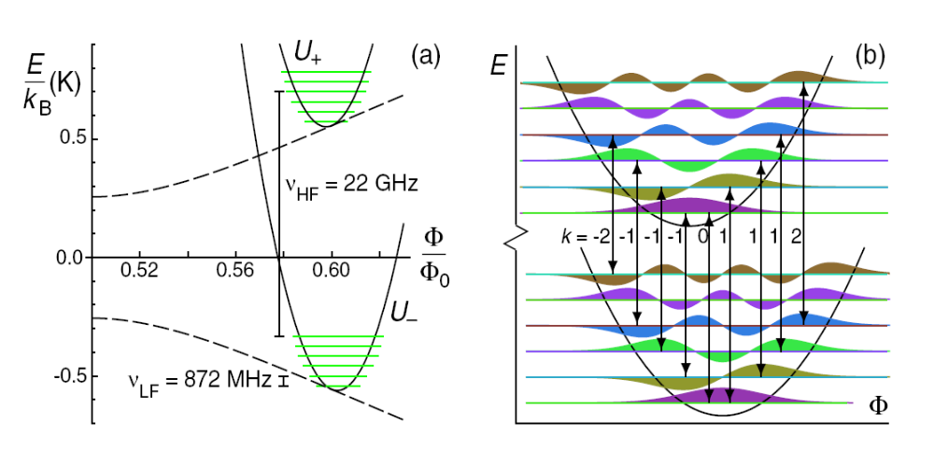
Fig. 1. The potential energy and eigenenergies in the artificial molecule. (a) The total potentials U_ and U₊ (solid curves) are formed as a sum of qubit energy (dashed line) and a harmonic vibrational potential. The six lowest energy eigenstates are shown for both electronic states. (b) A close-up at the lowest eigenstates together with wave functions (shaded areas). The strongest transitions according to the Franck-Condon principle are shown by arrows and are labeled by the change of vibrational quanta k.

BLOCH OSCILLATING TRANSISTORS (BOT)
J. Hassel, L. Korhonen, A. Puska, J. Sarkar, H. Seppä, and P. Hakonen
We have continued our development work of a fully superconducting Bloch oscillating transistor. In comparison to the previous results from 2007, the main difference is that the collector resistance of a thin film chromium resistor was nearly 10-fold (240 kΩ). Also the tunnelling resistances of the emitter and base junctions were larger, 30 kΩ instead of the earlier value of 10 kΩ. IV-measurements of the new sample featured properties similar to the superconducting BOT in 2007. A formation of a double-maximum inelastic Cooper-pair tunnelling peak was observed when emitter E_{J} was tuned, and a current gain of 22 was measured near the onset of hysteresis. Noise measurements with current bias to the base junction gave an input referred noise level of 0.9 fA/√Hz at 20 Hz. This corresponds to a 4 fA/√Hz noise level at 1 Hz which is still above the 1 fA/√Hz requirement set by the quantum triangle measurement application.
After the analysis of these new fully superconducting BOT samples it was concluded that BOTs for the quantum triangle experiment should be done with the old design having a NIS junction on the base. Adaptation of a germanium mask process into the fabrication of the BOTs was then started. The Ge mask enables good control of the line width with large undercut needed in the old BOT design with four angle evaporation.

SWNT TRANSISTORS WITH SUPERCONDUCTING CONTACTS
R. Danneau, E. Kauppinen, P. Häkkinen, P. Queipo, F. Wu, and P. Hakonen
We have continued our investigations on proximity induced superconductivity in carbon nanotubes using Al/Ti electrodes. In 2008 we have mostly concentrated on the Kondo regime, where we found two different types of Kondo resonance peaks. Shown in Fig. 2, Kondo characteristics are clearly visible in the differential conductance G_{d} surface plot with Coulomb blockade diamonds separated by zero bias conductance ridges for odd number of electrons. Notice that for one type of Kondo resonances (red arrows) there is just a simple G_{d} peak at low bias voltage, while for another type of resonances (blue arrows) there is a small conductance dip near zero bias. Because the external magnetic field is very weak (B = 70 mT) and is applied only for suppressing the superconductivity, the small dip in conductance signifies a zero-field splitting of the Kondo peak.
These two different types of resonances have a clear difference in measured critical current I_{CM} at the same Kondo temperature T_{K}. We conjecture that the observed zero-field splitting is related to SU(4) Kondo effect, which is peculiar to carbon nanotubes. The SU(4) Kondo effect has been shown to lead to a dip in the density of states at small energies, which could suppress the superconducting critical current. In addition, the SU(4) Kondo can explain the unusually large value of T_{K} by the enhanced degeneracy of a multiple-level quantum dot. Alternatively, the zero-field splitting may be related to the recent observation of spin-orbit coupling in SWNTs.
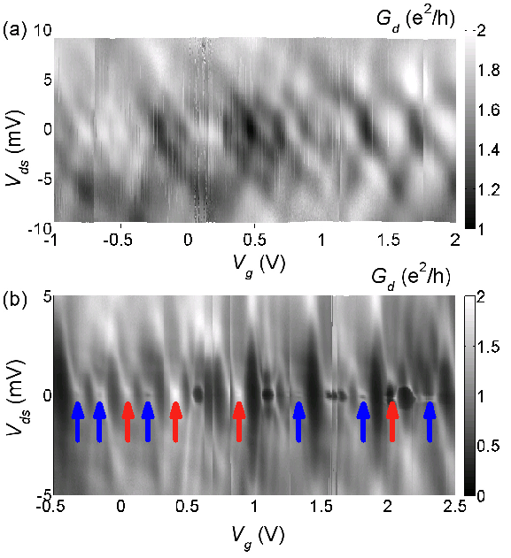 | 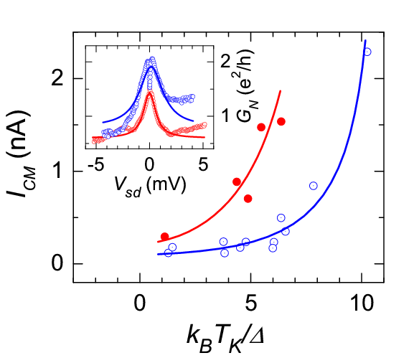

Fig. 2. (Left) Normal state differential conductance G_{d} on the plane spanned by bias voltage V_{ds} and gate voltage V_{g} in (a) Fabry-Perot regime, and (b) Kondo regime both at T = 30 mK. Normal state was achieved in both cases with a magnetic field of B = 70 mT. Red and blue arrows in (b) refer to two types of resonance peaks, which have one magnitude difference in I_{CM} with equal Kondo temperature T_{K}. (Right) Measured critical current I_{CM} versus scaled Kondo energy k_{B}T_{K}/∆ for Kondo resonances marked by red and blue arrows in the left frame. Peaks with zero-field splitting are denoted by blue circles, while red dots refer to non-split peaks in Fig. 2(b). The two solid curves are to guide the eyes. The inset shows two typical G_{N}−V_{ds} relations for the different kinds of conductance peaks and their Lorentzian fits. The curve for non-split peak has been shifted downwards by 0.3 units for clarity.

KINETIC INDUCTANCE OF MULTIWALLED CARBON NANOTUBES
M. Gaass, L. Lechner, A. Paila, and P. Hakonen
Electrometers based on Cooper-pair tunneling are, in principle, dissipationless, and thus advantageous due to their small back action noise. We have studied the so called L-SET circuit, in which the frequency of Josephson plasma oscillations in a superconducting junction device is tuned below one GHz by a parallel LC circuit. In the present case, we have used a Josephson junction made out of a multiwalled carbon nanotube with Pd/Nb contacts. We observed gate-tunable critical currents up to I_{c} ~ 10 nA, which are deduced from shifts in the LC-circuit resonance frequency caused by the Josephson inductance (∝ 1/I_{c} ) of the MWNT junction. This is the first time that the true critical current, not a switching current, has been measured in MWNT junctions.

NOISE IN GRAPHENE RIBBONS
M. Craciun, R. Danneau, A. Fay, A. Morpurgo, J. Oostinga, S. Russo, M. Tomi, F. Wu, and P. Hakonen
Owing to its unique structure, graphene conduction occurs via massless Dirac fermions. Graphene is a gapless semiconductor: the conduction and the valence band are touching at two inequivalent points (K and K', usually called Dirac points) where the density of state vanishes. Nevertheless, the conductivity at the Dirac point remains finite as charge is carried by evanescent waves, i.e. by tunneling between the leads. These unique properties are also reflected in shot noise of graphene. In short and wide graphene strips (W/L ≥ 3), that we measured in 2007, both minimum conductivity and Fano factor reached universal values of 4e²/πh and 1/3, respectively, at the Dirac point.
In the end of 2008, we continued our shot noise measurements in graphene nanoribbons. Our samples were manufactured in Delft using e-beam patterning and RIE etching. Differential conductance of a sample with the width of W = 110 nm and the length L = 600 nm is shown in Fig. 3. Around the Dirac point, a transport gap is formed, either by low-dimensional confinement or by Coulomb effects; the irregular, diamond-like structure points to the latter origin.
In the two measured GNR samples, very small Fano factor was found, with a typical value of F < 0.04. This suggests that strong inelastic scattering is present in our GNR samples leading to suppressed shot noise. One possible scenario for this is that the conduction in GNR is based on inelastic hopping through a number of irregular quantum dots.
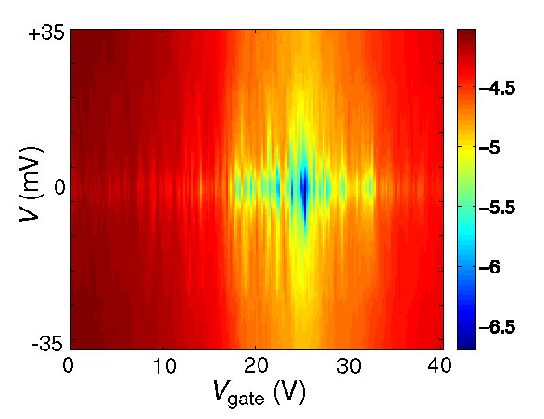

Fig. 3. Differential conductance log(G_{d}) of a W = 110 nm GNR sample versus bias voltage V and gate voltage V_{g} measured at 4.2 K.

PROXIMITY EFFECT IN GRAPHENE
R. Danneau, A. Fay, M. Tomi, M. Wiesner, F. Wu, and P. Hakonen
We have started detailed transport and noise measurements in a superconductor-graphene-superconductor (SGS) junction, at the temperature of 100 mK. The superconductor leads, which are used to connect the graphene sheet, correspond to a sandwich of 10 nm of titanium (contact layer), 50 nm of aluminium and 10 nm of titanium. Here, the aluminium is the superconductor with a gap energy Δ ~ 200 μeV. The SGS junction can be viewed as a superconductor-normal metal-superconductor (SNS) junction where the density of states in the normal metal can be tuned with an applied gate voltage. Especially, at the Dirac point, the density of states in the graphene vanishes and the transport in graphene takes place by evanescent modes.
The current-voltage characteristics of our SGS junctions show a supercurrent branch with a critical current which can be tuned from 50 nA to 250 nA with the gate voltage. In the subgab region, i.e. when the bias voltage V_{ds} < 2Δ/e, the charge transport is mediated by multiple Andreev reflections. The effective charge q* which goes through the junction, is related to the integer number m of Andreev reflections by q* = 2em. At specific gate voltage values V_{ds} = 2Δ/me, the processes with charge q* become allowed and the measured conductivity varies significantly. We have also been able to measure the noise in the subgap region: the noise displays staircase-like behavior, which is expected if the transport involves only a few channels. However, these steps should not be clearly visible for a diffusive SNS junction.

GRAPHENE DEVICES
H. Alles, A. Fay, L. Lechner, P. Pasanen, M. Tomi, M. Wiesner, F. Wu, and P. Hakonen
During the last year, we produced about 40 sheets of graphene on top of 250 μm thick SiO₂ layer using micromechanical cleavage. 30% of these samples were found to contain single layer sheets while the rest had bilayers. Before contacting, the graphene sheets were characterized by optical interferometry and by Raman spectroscopy. In optical interferometry the sample is imaged with a microscope-mounted camera that has a separate charge-coupled device (CCD) sensor for all primary colors. By calculating the red, green and blue contrasts between the graphene sheet and the substrate, and by comparing these values with theoretical predictions, we are able to determine the thickness of a graphene sheet with high precision up to 5 layers. Moreover, with the combined effort of optical and Raman studies, we are capable of distinguishing folded mono- and bilayers from true multilayers.
The contacted samples have been scanned up to 1 V bias voltage to characterize the basic electron-phonon processes and their influence on the electronic device properties. We have also grown HfO₂ coatings on these samples in collaboration with Jaan Aarik from Tartu University. The influence of 15 nm thick HfO₂ layers on the electron mobility in graphene was investigated, and a reduction of 50% was found far away from the Dirac point. Transport near the Dirac point, however, was not modified.

SQUID AMPLIFIERS
P. Lähteenmäki, M. Sillanpää, and P. Hakonen
A high frequency SQUID amplifier fabricated from photolitographically patterned thin films of niobium was set up to operate in a 50 Ω system and characterized by measuring its IV-curve, S-parameters and noise temperature. The device was measured in our dry dilution cryostat (NANO-X) cooled down to 100 mK. The noise temperature of the device was found to be a factor of 6 from the quantum limit with a gain of 14 dB at 700 MHz. Stability issues and certain other problems were identified in the amplifier and a new design was made in order to address them. As the previous devices, the new SQUID amplifier design will be manufactured in collaboration with VTT Quantronics group.
A new concept for a microwave amplifier based on RLC shunted Josephson junctions operated as a reflection amplifier was also studied both with the help of a simulation as well as with direct experimentation. Simulations suggest equal or better performance than conventional SQUID amplifier and a simpler design. Experiments show an expected shape for the IV-curve and plenty of gain in a 4K setup. Different prototype junction amplifiers will be fabricated along with the new SQUID amplifier designs.
CAPACITIVE SIDEBAND READOUT OF NANOMECHANICAL RESONATORS
M. Sillanpää, J. Muhonen, J. Sarkar, J. Sulkko, and P.J. Hakonen
Mechanical GHz resonators hold great promise for various sensors and detectors, as well as building blocks for quantum information. However, the detection of their vibrations is notoriously difficult, because of a twofold challenge: 1) tiny displacements (down to femtometers) 2) high intrinsic impedance levels considering GHz operation.
We have developed a novel read-out scheme which is based on sideband generation in an LC-circuit in which the mechanical vibration modulates the capacitance C. Easy fabrication, possible room temperature operation, wide bandwidth, and fully electronic readout makes this technique truly promising. We verified experimentally the sideband generation up to mechanical frequencies of 200 MHz, and achieved an excellent agreement with our theoretical models and previous experiments. In our measurements on a 2-micron-long, doubly-clamped aluminum beam hysteric behavior, annealing effects, as well as pressure and temperature dependence were observed.

PICO group
Meri Helle, Tommy Holmqvist, Sergey Kafanov, Antti Kemppinen, Sarah MacLeod, Matthias Meschke, Juha Muhonen, Jukka Pekola, Joonas Peltonen, and Andrey Timofeev
Collaborator: M. Möttönen (Dept. of Applied Physics, TKK)
The main research topics in 2008 in PICO group were the investigation of quantized current in a hybrid turnstile, cooling at the quantum limit, and a new primary thermometer. Furthermore we managed to prove the origin of hysteresis in a SNS Josephson junction and developed a technique to fabricate suspended metallic nanostructures.

ELECTRONIC REFRIGERATION AND THERMOMETRY
Meri Helle, Tommy Holmqvist, Sergey Kafanov, Sarah MacLeod, Matthias Meschke, Juha Muhonen, Mikko Möttönen, Jukka Pekola, Joonas Peltonen, and Andrey Timofeev
Collaborators: Herve Courtois (CNRS), Sami Franssila (TKK), Francesco Giazotto (SNS), Tero Heikkilä (LTL), Frank Hekking (CNRS), Nikolai Kopnin (LTL), Antti O. Niskanen (VTT), Cesar Pascual Garcia (SNS), Yuri Pashkin (NEC), Lauri Sainiemi (TKK), Alexander Savin (LTL), Stefano Tirelli (SNS), and Jaw-Shen Tsai (NEC)
Single-junction thermometry
We developed the concept and theory and demonstrated experimentally primary thermometry based on a four-probe measurement of a single tunnel junction embedded within four arrays of junctions (SJT). We showed that random sample specific and environment-related errors can be avoided in this configuration. This method relates temperature directly to Boltzmann constant, which will form the basis of the definition of temperature and realization of official temperature scales in the future.

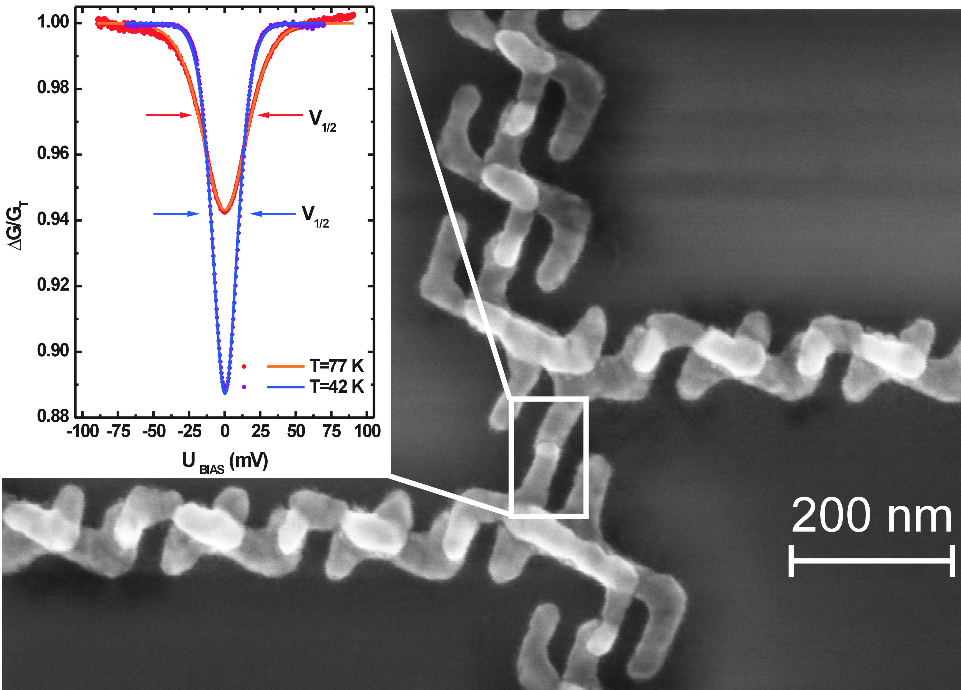

Fig. 1. A single-junction thermometer. The junction (framed) is embedded within arrays to protect it from environment noise. The graphs show temperature measurements at 42 K and 77 K.
Quantum-limited refrigeration
We have demonstrated quantum limited electronic refrigeration of a metallic island in a low temperature micro-circuit. We showed that matching the impedance of the circuit enables refrigeration at a distance, of about 50 µm in our case, through superconducting leads with a cooling power determined by the quantum of thermal conductance. Our results are consistent with the concept of electromagnetic heat transport. We observed and analyzed the crossover between electromagnetic and quasiparticle heat flux in a superconductor.

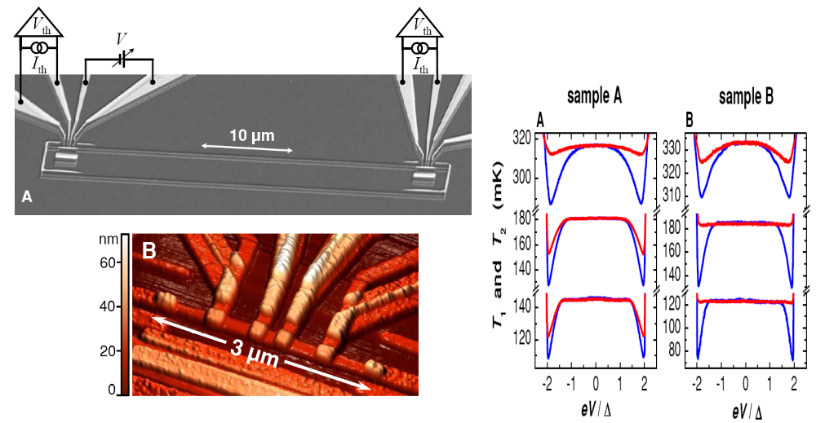
Fig. 2. The measurement of cooling at the quantum limit. Top left: the sample with two resistors separated by a distance of 50 μm enclosed in a superconducting loop. Bottom left: a close-up of one of the normal metal resistors with attached electrodes. Right: experimental data of NIS electronic cooling of the island directly connected to the refrigerator (blue line) and of the remote island (red line). Remote cooling persists down to the lowest temperatures indicating electromagnetic energy exchange between the resistors.
Out-of-equilibrium Josephson nano-junctions
Hysteresis in the transport through superconductor–normal-metal–superconductor (SNS) Josephson junctions has attracted some attention recently. We investigated it by measuring directly the electron temperature in the normal metal. Our results demonstrate unambiguously that such hysteresis results from an increase of the normal-metal electron temperature once the junction switches to the resistive state. In our geometry, the electron temperature increase is governed by the thermal resistance of the superconducting electrodes of the junction.
In another experiment we demonstrated experimentally the manipulation of supercurrent in Al-AlOx-Ti Josephson tunnel junctions by injecting quasiparticles in a Ti island from two additional tunnel-coupled Al superconducting reservoirs. Both supercurrent enhancement and quenching with respect to equilibrium were achieved. We demonstrated cooling of the Ti line by quasiparticle injection from the normal state deep into the superconducting phase.
Energy relaxation in a BCS superconductor
We have studied quasiparticle energy relaxation at subkelvin temperatures by injecting hot electrons into a superconducting aluminium island and measuring the energy flux from quasiparticles into phonons both in the superconducting and in the normal state. The data show strong reduction of the flux at low temperatures in the superconducting state, in qualitative agreement with the theory for clean superconductors. However, quantitatively the energy flux exceeds that obtained from the theoretical predictions, suggesting an enhanced or additional relaxation process.
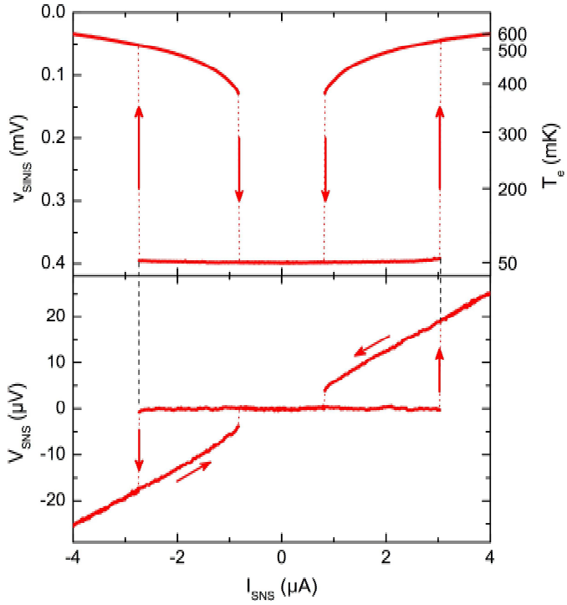
Fig. 3. Hysteresis of a proximity SNS Josephson junction. Bottom panel shows the current-voltage characteristics, and the top one the associated temperature of the N part. Hysteresis is of thermal origin.
Suspended metallic beams
We have developed a simple fabrication method for reliably releasing narrow submicron-sized metal beams from the silicon substrate. The process is based on reactive ion etching and uses a conducting substrate to avoid charge-up damage and is compatible with, e.g., conventional e-beam lithography, shadow-angle metal deposition, and oxide tunnel junctions. The devices, including tunnel junctions onto the beam, function well. They can be cooled by NIS tunneling. Experiments to reveal the energy relaxation in this low dimensional system are in progress.

ELECTRON PUMPING
Sergey Kafanov, Antti Kemppinen, Mikko Möttönen, and Jukka Pekola
Collaborators: Dmitri Averin (Stony Brook), Sergey Lotkhov (PTB), Antti Manninen (Mikes), Yuri Pashkin (NEC), and Jaw-Shen Tsai (NEC)
The synchronous manipulation of individual electrons in solid-state devices became available when single electronics started about two decades ago. Ultrasmall structures in a low-temperature environment form an ideal domain for addressing electrons one by one. In the so-called metrological triangle, voltage from the Josephson effect and resistance from the quantum Hall effect would be tested against current via Ohm's law for a consistency check of the fundamental constants of nature, h and e. Several attempts to create a metrological current source that would comply with the demanding criteria of extreme accuracy, high yield and implementation with not too many control parameters have been reported. We have proposed and proven the concept of a hybrid normal-metal–superconductor turnstile in the form of a one-island single-electron transistor with one gate, which demonstrates robust current plateaux at multiple levels of ef at frequency f. Theoretically the quantization accuracy is limited by the trade-off between the processes of missed electron tunneling, backward tunneling, Andreev reflection and Cooper-pair–electron cotunneling. It should be possible to achieve the metrological accuracy of 10⁻⁸, while maintaining the quantized current of few tens of pA, just by one turnstile with realistic parameters using aluminum as a superconductor. In 2008 work focused on identifying the various error sources in this pumping scheme.

KVANTTI group
Khattiya Chalapat, Jian Li, Mikko Ervasti, and Sorin Paraoanu
During 2008, a lot of effort has been devoted to setting up a proper laboratory space in the new building of the Low Temperature Laboratory. The group is grateful to Dr. A. Savin for invaluable help and ideas. A shielding pit of base area 1 m² and height 2 m has been designed and fabricated in the workshop: it has completed the electromagnetically shielded room operated by the group. Frames for the BlueFors gas handling system have been designed, fabricated in the workshop, and installed outside the room. Another shielded room brought from the University of Jyväskylä is now used as a shielding room for the SQUID magnetometer. This work will continue during 2009.
FRAGMENTATION IN BOSE-EINSTEIN CONDENSATES
Sorin Paraoanu
A long-standing conceptual problem in theoretical condensed-matter physics is how the phases between two separate superfluids get established. We have developed a theory of measurement-induced interference for weakly interacting Bose-Einstein condensed (BEC) gases. The many-body state resulting from evolution from an initial fragmented (Fock) state can be approximated as a superposition of Gross-Pitaevskii (GP) states; the measurement breaks the initial phase symmetry, producing a distribution pattern corresponding to only one of the GP solutions. We discuss analytically solvable models, such as two-mode on-chip adiabatic recombination and soliton generation in quasi one-dimensional condensates. This theory is also built up for the noninteracting case, where an alternative simpler proof can be provided.
References: Paraoanu G S, Phys. Rev. A 2008, 77: 041605R; Paraoanu G S, J. Low Temp. Phys. 2008, 153: 285.
SUPERCONDUCTING QUBITS: TWO-QUBIT QUANTUM GATES
Jian Li, K. Chalapat, and Sorin Paraoanu
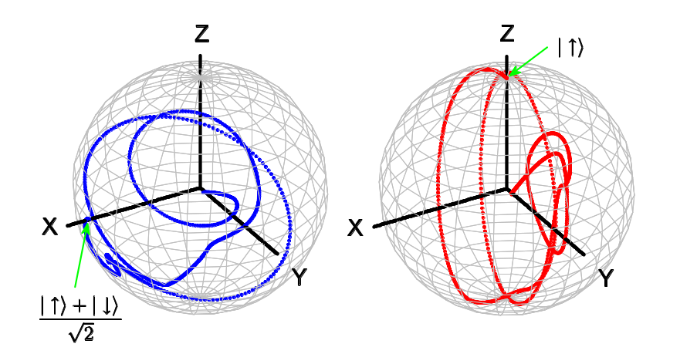
We have studied analytically and numerically the problem of two qubits with fixed coupling irradiated with quantum or classical fields. In the classical case, we derive an effective Hamiltonian and describe its entangling properties. We identify a coupling/decoupling switching protocol and we construct composite pulse sequences leading to a CNOT gate. In the quantum case, we show that qubit-qubit-photon multiparticle entanglement and maximally entangled two-qubit states can be obtained by driving the system at very low powers (one quanta of excitation). We propose a quantum non-demolition (conditional) method to read out the qubits: we show that an entangled state is established between the qubits when no photon leaks out of the resonator, while for a generic microwave drive we characterize the photon-qubit-qubit entanglement. Our results can be applied to a variety of systems of two superconducting qubits coupled to resonators.
Figure: The Bloch sphere representation of the qubits under a sequence of pulses implementing a CNOT gate.
References: Li Jian, Chalapat K, and Paraoanu G S, Phys. Rev. B 2008, 78: 064503.
SUDDEN DEATH OF ENTANGLEMENT
Jian Li, K. Chalapat, and Sorin Paraoanu
We have studied the effect of driving for a recently discovered quantum-information phenomenon known as “sudden death of entanglement”. We find that local driving of the qubits increases this effect.
References: Li Jian, Chalapat K, and Paraoanu G S, J. Low Temp. Phys. 2008, 153: 294.
MICROWAVE PROPERTIES OF NANOCOMPOSITES
Khattiya Chalapat, Jian Li, and Sorin Paraoanu
Collaborators: Molecular Materials group (TKK); University of Notthingham; Nokia Research Centre
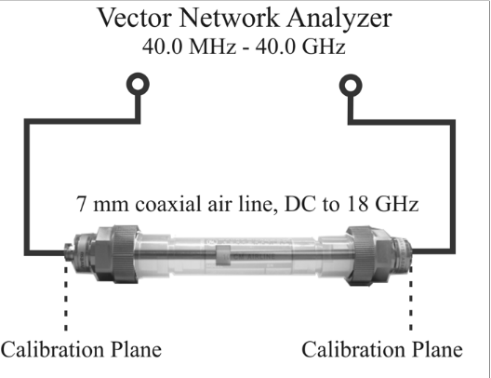
We have tested a microwave measurement system with 18 GHz bandwidth, consisting of a precision mismatched airline and a vector network analyzer (see the schematic). We have measured a number of test samples, and also nano-composite samples fabricated in he Molecular Materials group at HUT. We have also installed a system consisting of an electromagnetic cavity resonator and measured the resonant frequencies corresponding to the electromagnetic TE_{10n} modes.
PHOTODEVICES
Sorin Paraoanu
Collaborators: J. Kallioinen, J. Korppi-Tommola (University of Jyväskylä)
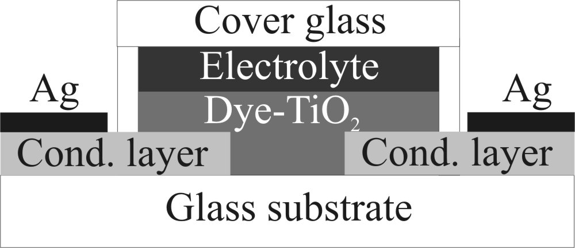
We have fabricated a device consisting of two silver films separated by a gap filled with dye-sensitized TiO₂ permeated with electrolyte (see schematic). The device combines the structure of a solar cell with that of a photodiode. The optical absorption spectrum was measured under irradiation with standard sources and natural light. We have also measured the IV characteristic and dI/dV at various bias voltages and characterize the device under different illuminations and we point out that it behaves as a phototransistor.
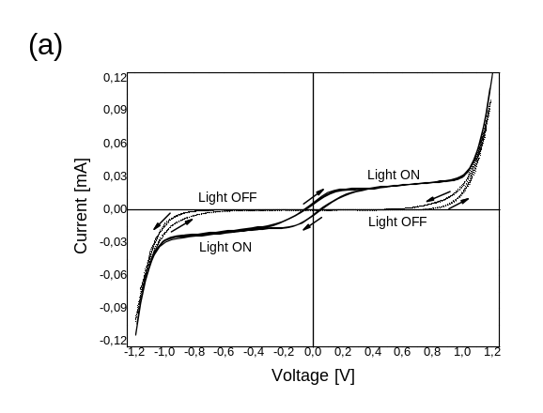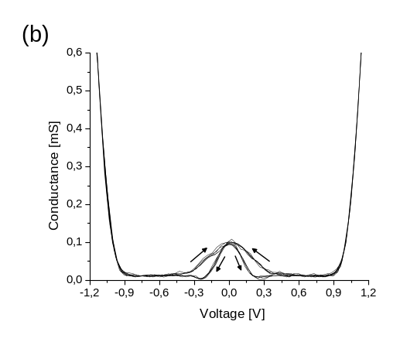
Figure: (a) Current-voltage sweep in the dark (dotted line) and under low intensity illumination (solid line). Five cycles were measured between voltages of -1.2 V and +1.2V (speed of 200 mV/s). (b) Dynamic conductance dI/dV (overlap of several cycles) under illumination. The arrows show the direction of the scan.
References: Kallioinen J, Hassan M R, Paraoanu G S, and Korppi-Tommola Jouko, J. Photochem. Photobiol. A 2008, 195: 352.

ROTA group
V.B. Eltsov, R. de Graaf, P. Heikkinen, J. Hosio, R. Hänninen, M. Krusius, and R.E. Solntsev
Visitors: Yu.M. Bunkov, E. Kuznetsov, V. Lebedev, V. L’vov, Y. Nago, M. Silaev, E. Sonin, M. Tsubota, D.E. Zmeev, and H. Yano
DYNAMICS, TURBULENCE, AND DISSIPATION IN COHERENT QUANTUM SYSTEMS
The equilibrium state of a superfluid in homogeneous rotation around a fixed axis is an array of rectilinear line vortices. These are topologically stable line defects in the phase coherent superfluid quantum field, with a quantized circulation of persistent unattenuated particle current around a line-like core. In rotation, in stationary state, the vortices are arranged parallel to the axis of rotation and are spaced equidistant from each other, such that their density is directly proportional to the angular velocity of rotation, Ω. The equilibrium vortex array in the rotating superfluid is the equivalent of an array of quantized flux lines in a type II superconductor in homogeneous magnetic field. In the superfluid the vortex array locks the superfluid fraction to corotation with the normal component, which in turn is forced to rotate with the walls of the sample container. Thus both components rotate like a solid body with the container. What happens if rotation is suddenly stopped?
This question was answered long ago at higher temperatures. Vortices are part of the superfluid condensate and tend to move with the superfluid fraction. After a sudden deceleration to rest the superfluid fraction with its vortices starts to move with respect to the normal component. Normal excitations are then scattered by the vortices, which gives rise to friction, the so-called mutual friction. At higher temperatures mutual friction is large and the relative motion of vortices with respect to the normal component is rapidly damped. As a result, the density of vortices decays towards zero while they drift outward to the container wall, where they annihilate. If mutual friction is large, the outward motion is laminar, like in superconductors, while at low mutual friction it may become turbulent, as observed sometimes in helium superfluids. However, in the zero temperature limit, T−> 0, the normal component vanishes and mutual friction approaches zero. Does it mean that the superfluid with its vortices loses contact with the external world and rotates forever, after the container has been brought to rest? This situation has been shown to apply for circulating superflow in the absence of vortices. Or does a new mechanism of vortex dissipation become observable at the lowest temperatures, by providing the friction needed to remove the vortices from the sample at rest?
Our measurements suggest that both answers are possible in the Fermi superfluid 3He-B, while in the more conventional Bose superfluid 4He the latter case with finite dissipation might be more appropriate in most practical experiments. The sudden stop of rotation is a traditional measurement in superfluid dynamics, often referred to as “spin down” of the superfluid component. Two variants of the spin-down response in 3He-B are shown in Fig. 1, where the vortex density is plotted as a function of time. The two measurements differ in the measuring environment in which the superfluid sample is contained. A slow laminar response with mutual-friction damped outward radial motion is measured for a near perfect circular cylinder, while an order of magnitude faster turbulent response is measured when cylindrical symmetry is destroyed.
In the laminar case the vortices remain polarized (to better than 90 %) along the cylindrical symmetry axis during their outward motion. This leaves little opportunity for interaction, which would lead to tangle formation and reconnections. Thus the vortex density decays slowly and monotonicly to zero. In the turbulent case the perturbed flow, which interacts with solid walls [3], causes tangling and reconnecting so that during the deceleration the first response is a five-fold overshoot in the vortex density, which then rapidly starts to decay, when the cryostat comes to rest. This is typical of the nonlinear turbulent decay, where the hydrodynamic energy is initially dumped into the flow on the length scale of the flow disturbance and then flows along the nonlinear Richardson cascade into smaller and smaller eddies (which consist of bundles of roughly parallel vortices). This part of the energy cascade obeys the Kolmogorov spectrum and gives rise to a turbulent decay with the time dependence found in Fig. 1 [4].
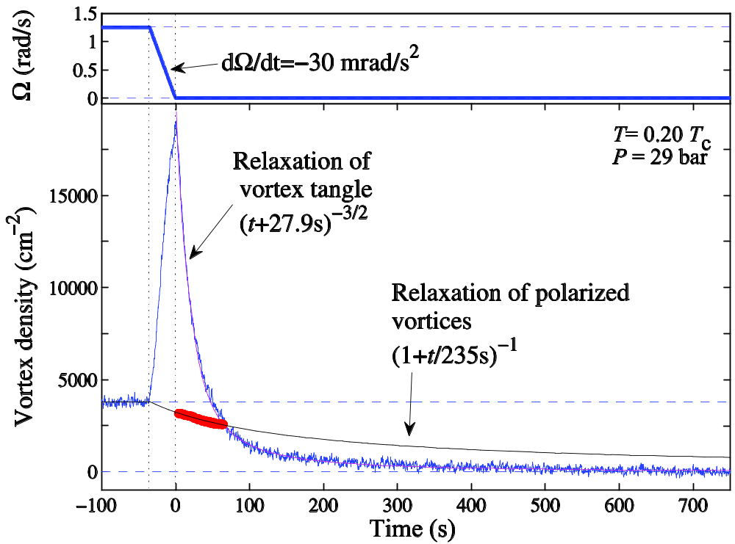
Fig. 1. Superfluid response to a rapid stop of rotation in a “spin down” experiment. The response is measured in two different geometries: (1) NMR measurement [1] of superfluid counterflow velocity in a smooth-walled right circular cylinder (red data points). The result is compared to a fit of smooth radially outward vortex motion [black trace with n(t) ∝ (1+t/τF)-1, where τF = 1/(2αΩinitial)], damped by mutual friction α(T), which in this temperature regime tends exponentially to zero as a function of temperature. (2) Measurements with a quartz tuning fork oscillator [2], where the fork itself destroys the cylindrical symmetry of the measuring environment (continuous blue trace). The response is determined from the increase in damping or the width of the resonance curve of the oscillator. It can be fitted with a decay n(t) ∝ (t+t0)-3/2, which is characteristic for the Kolmogorov energy cascade. The rate of decay in the two cases differs by an order of magnitude.
For quantized vortices the inter-vortex distance defines the length scale where a crossover from vortex bundles to individual vortices has to occur in the energy cascade. On the quantum length scales < the turbulent energy flows into helical Kelvin-waves which are excited and expand on individual vortex lines. The Kelvin-wave cascade is ultimately terminated on the length scale of the superfluid coherence length ξ by some as yet unexplained dissipation mechanism. In more or less homogeneous and isotropic turbulence (case (2) in Fig. 1) the crossover from the Kolmogorov to the Kelvin-wave cascade is less of a difficulty than for highly polarized vortices (case (1) in Fig. 1). Bridging the energy cascades across the crossover regime ~ has been coined the “bottleneck effect” [5]. Thus it might be possible at absolute zero temperature that in a perfect cylindrical environment quantized vortices could rotate undisturbed for ever, after stopping rotation of the container.
CRYOSTAT RECONSTRUCTION
In 2007 measurements on the rotating ROTA cryostat were finished on December 23. The machine was then warmed up to room temperature over Christmas, dismantled and transported piece-wise to the new laboratory building during the next two weeks. This ended the story of the world’s first rotating nuclear-demagnetization-cooled cryostat in its original laboratory building where its construction was started in 1978. In the second half of 1981 the first rotating measurements were started. For almost ten years the cryostat remained the only one in the world, making use of this privilege to discover the numerous topological defects in the order parameter field of the 3He Fermi superfluids.
Owing to limited man power resources all of 2008 was spent on reconstructing the rotating refrigeration installation in its new laboratory environment. It now looks rather different from before. The cryostat is not surrounded any more with an electrically shielded enclosure. Instead there is a robust steel platform above the cryostat which provides access to a second higher level and supports an instrument carousel. This carousel contains most of the rotating measuring electronics and is electronically locked to synchronized rotation with the cryostat. In this way vibrations from the electronic instrumentation with rotating fans are not transmitted to the cryostat and heat leaks from mechanical disturbance are reduced. The second improvement in mechanical stability is an active feed-back system with pneumatic air dampers on each of the four concrete support pillars on which the cryostat rests. This system with position sensitive sensors provides efficient damping of vertical vibrations and some damping in the lateral directions.
A brushless dc servo motor is used to pull the belt drive which controls the cryostat rotation. Careful analysis of the stability of the cryostat’s rotation showed that the lowest harmonics from the motor leak into the cryostat rotation, in spite of the large moment of inertia which the cryostat represents and which acts as a mechanical low pass filter. A correction of this problem is still in progress. This is required to bring the stability of rotation to the level where it is comparable to an uncertainty better than ± 1 vortex line in the number of vortices.
A further improvement is the upgrading of the vacuum and gas handling system, where computer-controlled pneumatic valves are now used to automate the daily operating routine before and after rotating measurements. This upgrade is a major time saver in our daily tasks and brings the vacuum system to the modern technological level, with automated valves and oil-free vacuum pumping.
With these improvements the operation of the cryostat has been appreciably enhanced for very low temperature operation below 0.2 Tc in the superfluid 3He temperature regime. Currently it is the only rotating refrigerator in the world which is capable of operating at such low temperatures with accurately stable rotation. These investments in hardware will hopefully allow us to perform the crucial measurements on vortex dynamics in the zero temperature limit in both the isotropic 3He-B and the axially anisotropic 3He-A Fermi systems.
References:
[1] Eltsov V B, de Graaf R, Hänninen R, Krusius M and Solntsev R E, Experiments on the twisted vortex state in superfluid 3He-B. J. Low Temp. Phys. 2008, 150: 373–383.
[2] Blazkova M, Clovecko M, Eltsov V B, Gazo E, de Graaf R, Hosio J J, Krusius M, Schmoranzer D, Schoepe W, Skrbek L, Skyba P, Solntsev R E and Vinen W F, Vibrating quartz fork – a tool for cryogenic helium research. J. Low Temp. Phys. 2008, 150: 525–535.
[3] de Graaf R, Hänninen R, Chagovets T V, Eltsov V B, Krusius M and Solntsev R E, The Dynamics of Vortex Generation in Superfluid 3He-B. J. Low Temp. Phys. 2008, 153: 197–227; arXiv:0708.3003v2 [cond-mat.stat-mech].
[4] Eltsov V B, de Graaf R, Hänninen R, Krusius M, Solntsev R E, L’vov V S, Golov A I, and Walmsley P M, Turbulent dynamics in rotating helium superfluids. Prog. Low Temp. Phys. Vol. XVI, ed. M. Tsubota, pages 46–146 (Elsevier Publ., Amsterdam, 2009) [preprint arXiv:0803.3225v2].
[5] Eltsov V B, Golov A I, de Graaf R, Hänninen R, Krusius M, L’vov V S, and Solntsev R E, Quantum turbulence in a propagating superfluid vortex front. Phys. Rev. Lett. 2007, 99: 265301; L’vov V S, Nazarenko S V, and Rudenko O, Gradual eddy-wave crossover in superfluid turbulence. J. Low Temp. Phys. 2008, 153: 140–161.

THEORY group
Tero Heikkilä, Risto Hänninen, Nikolai Kopnin, Matti Laakso, Pauli Virtanen, Grigori Volovik, and Juha Voutilainen
LTL theory group draws many of its projects from the in-house experimental groups and aims to support the on-going experiments. However, the theory group works mostly independently from the other LTL groups and a major part of the projects is targeting problems posed by experiments or theory elsewhere.
The theory work concentrates on three major topics: nanoelectronics, (Nikolai Kopnin and the team lead by Tero Heikkilä), ultra-low temperature physics (Grigori Volovik and Risto Hänninen) and cosmology (Grigori Volovik). The YKI group relies in its theory support mostly on the short term visits of Alexander Parshin from the Kapitza Institute
During 2008, Tero Heikkilä paid a four-month visit to the Kavli Institute of Nanotechnology in Delft University of Technology, establishing close ties to the theory groups of Profs. Yuli Nazarov and Gerrit Bauer.

THERMAL AND NONEQUILIBRIUM EFFECTS IN NORMAL-SUPERCONDUCTING HETEROSTRUCTURES
Tero Heikkilä, Pauli Virtanen, and Juha Voutilainen
In collaboration with the PICO group, Panu Helistö and Arttu Luukanen from VTT, Francesco Giazotto from Scuola Normale Superiore in Pisa, Italy, Gianpiero Pepe from Università di Napoli “Federico II”, Italy, and the group of Norman O. Birge in the Michigan State University, the USA.
In this project, we have studied the control of the superconducting properties in superconductor–normal-metal–superconductor (SNS) weak links via different types of external fields. We have also studied the inverse effect: how superconductivity affects the response to the fields.
We have continued our collaboration with the experimental group of Norman Birge from Michigan State University to describe the nonequilibrium properties of SNS junctions. In our recent study, we explored especially the response of the supercurrent to a large in-plane magnetic field.
We have also studied the use of SNS junctions as thermal radiation detectors in collaboration with Francesco Giazotto, Gianpiero Pepe, Panu Helistö and Arttu Luukanen. According to our analysis, an SNS-based detector, “Proximity Josephson Sensor” (PJS), compares favorably to the commonly used alternative, Transition Edge Sensor (TES). The advantages of PJS over TES are the easily reached small absorber volumes and the possibility to tailor the response such that it is optimal exactly at the desired operating temperatures. Reading the PJS via its kinetic inductance allows also suppressing the Johnson noise, a further alternative to commonly used dissipative TES readouts. Besides suggesting the basic operation, we have also studied how the response is modified due to proximity effect -induced variations in the electronic spectrum. We have a pending patent for this type of a detector.
The basic operation principle of the PJS relies on readout of the changes of the electronic temperature induced by the radiation coupled to the SNS junction. The change in the electronic temperature depends, besides the microwave power, also on the strength of the coupling of electrons to the external world. In most cases the most dominant coupling is due to the electron-phonon interaction. We have recently studied how this coupling is modified in the presence of the superconducting proximity effect. The proximity effect causes an energy minigap in the local density of states of the SNS junction. This minigap depends on the phase difference between the two superconductors and is mostly responsible for the proximity-effect induced changes in the electron-phonon coupling. In particular, we have shown in our work that the heat flow between the electrons and phonons can be tuned with a magnetic field through the phase dependence of the minigap. This magnetic field modified heat flow can be detected with the present state of the art experimental techniques.
One of the most interesting open problems in the theory of superconductivity related to the conventional superconductors is their response to strong microwave or millimeter wave fields. We have recently studied this topic together with our collaborators in Madrid, see below in “High-frequency effects in mesoscopic conductors”.
CHARGE TRANSPORT IN MULTIPROBE BALLISTIC GRAPHENE
Tero Heikkilä and Matti Laakso
In collaboration with the NANO group and the Nokia-TKK Nanosystems project.
In graphene tuned to the charge neutrality (Dirac) point, the density of charge carriers disappears as the density of states vanishes. As a result, one would expect an insulating state. However, as there is no real energy gap between the valence and conduction bands, graphene remains conducting. However, it turns out that combining a ballistic nature of ultraclean graphene with the lack of charge carriers leads to a diffusive behavior where the conductance of a given graphene sample is proportional to the ratio of the width and length of the sample. The reason for this diffusive behavior is the presence of far-reaching evanescent states which decay only slowly.
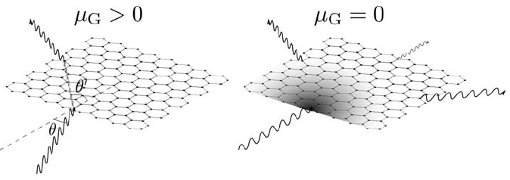
Figure 1: A schematic explanation for the difference between ray-optics and evanescent-optics pictures of electron propagation in graphene. Far from the Dirac point, the ray optics picture is valid whereas close to it one has to describe evanescent waves.
In this project we have studied the charge transport in multiprobe ballistic graphene samples at and near the charge neutrality point. A special focus of our investigations was on the cross correlations, in particular on the exchange Hanbury Brown-Twiss effect. This effect depends on coherent processes coupling all the leads and therefore in usual (integrable) ballistic systems the exchange contribution vanishes. This is because in ballistic systems electron dynamics is semiclassical and for each electron one can determine a well-defined direction. However, in graphene close to the Dirac point the current is carried via evanescent waves, which spread throughout the conductor. As a result, we find that the exchange contribution is finite and of the same order of magnitude as in diffusive structures.
HIGH-FREQUENCY EFFECTS IN MESOSCOPIC CONDUCTORS
Tero Heikkilä, Matti Laakso, and Pauli Virtanen
In collaboration with Juan Carlos Cuevas and Sebastien Bergeret from Universidad Autonoma de Madrid, Spain
The transport properties of a superconductor–normal-metal–superconductor (SNS) junction can change drastically when it is irradiated with radiation whose frequency is comparable to the inverse electron transport time through the junction. On this typically gigahertz frequency scale, the interplay of the electromagnetic field with the superconducting correlations generates a nonequilibrium distribution of quasiparticles in the junction, which modifies the supercurrent flowing through it; both the dependence on temperature and on the phase difference are affected. Understanding this process in detail, especially for strong fields, is an open problem in nonequilibrium superconductivity.
In this project we study the effect of GHz microwave radiation on the superconducting coherence, quasiparticle distribution, and time-dependent current in an SNS junction, based on the microscopic theory of nonequilibrium superconductivity. We are able to describe the nonequilibrium generation in a wide parameter range, and extend results to the nonlinear power regime via numerical simulations. With these predictions, we can study the temperature and power dependence of the critical current, and its evolution from the adiabatic low-frequency regime to high frequencies where nonequilibrium contributions become important and cannot be neglected. Our predictions concerning changes in the current-phase relation due to radiation are also relevant to recently published experiments.
Besides the properties of the SNS junction, where superconductivity is the major phenomenon affecting the microwave response, we have also studied how single-electron tunneling behaves at high frequencies. In this project we studied how a single-electron transistor responds to a small amplitude ac drive. We found that in addition to the familiar resistive response in the case of photon assisted tunneling the SET also exhibits a reactive response which is non-zero even under Coulomb blockade. This is due to processes where an electron can tunnel back and forth to a virtual state on the island. At low frequencies this response can be described by an effective capacitance. Moreover, this effective capacitance depends strongly on the gate charge of the SET. At microwave frequencies an rf-SET like measurement of the reflection coefficient can be used to detect the gate charge provided that the capacitance of the surrounding circuit does not mask the quantum capacitance of the SET.
STATISTICS OF TEMPERATURE FLUCTUATIONS
Tero Heikkilä and Matti Laakso
In collaboration with Yuli Nazarov from Delft University of Technology
We study the statistics of the fluctuating electron temperature in a metallic island coupled to reservoirs via resistive contacts and driven out of equilibrium by either a temperature or voltage difference between the reservoirs. The fluctuations of temperature are well-defined provided that the energy relaxation rate inside the island exceeds the rate of energy exchange with the reservoirs. We quantify these fluctuations in the regime beyond the Gaussian approximation and elucidate their dependence on the nature of the electronic contacts.

NOnequilibrium properties of mesoscopic superconductors
N.B. Kopnin
Collaborators: J. Pekola and PICO group (LTL), Yu.M. Galperin (University of Oslo, Norway), V.M. Vinokur (Argonne National Laboratory, US), and C.P. García and F. Giazotto (Scuola Normale Superiore, Pisa, Italy)
In collaboration with the PICO group, we have been studying the transport characteristics of hybrid normal-superconductor nanostructures. In particular, the electron-electron and electron-phonon interactions and the heat transfer between these subsystems at very low temperatures have been investigated both experimentally and theoretically. The quasiparticle energy relaxation at sub-kelvin temperatures has been investigated by injecting hot electrons into an aluminum island and measuring the energy flux from quasiparticles into phonons both in the superconducting and in the normal state. The data show strong reduction of the flux at low temperatures in the superconducting state, in qualitative agreement with the theory for clean superconductors. However, quantitatively the energy flux exceeds the theoretical predictions both in the superconducting and in the normal state, suggesting an enhanced or additional relaxation process.
Effects of the Coulomb interaction on transport in normal and superconducting quantum conductors have been studied for arbitrary transparency of the contacts. We considered resonant transmission through a gated finite-length quantum wire connected to leads via finite transparency junctions, such that the escape time is much smaller than the energy relaxation time in the wire. The coherent electron transport is strongly modified by the Coulomb interaction. The low-temperature current-voltage curves show step-like dependence on the bias voltage determined by the distance between the quantum levels inside the conductor, the pattern being dependent on the ratio between the charging energy and level spacing. If the system is tuned close to the resonance condition by the gate voltage, the low-voltage IV curve is Ohmic. At large Coulomb energy and low temperatures, the conductance is temperature-independent for any relationship between temperature, level spacing, and coupling between the wire and the leads.

Studies of superconductivity in graphene
N.B. Kopnin
Collaborators: E.B. Sonin (Hebrew University of Jerusalem, Israel), A.S. Mel'nikov, I.M. Khaymovich, I.A. Shereshevskii (Institute of Microstructures, Nizhny Novgorod, Russia).
Possible superconductivity of electrons with the Dirac spectrum is analyzed using the BCS model. Assuming existence of certain pairing interaction between electrons in graphene we calculate the critical temperature, the superconducting energy gap, and supercurrent as functions of the doping level and of the pairing interaction strength. Zero doping is characterized by existence of the quantum critical point such that the critical temperature vanishes below some finite value of the interaction strength. However, the critical temperature remains finite for any nonzero electron or hole doping level when the Fermi energy is shifted away from the Dirac point. As distinct from usual superconductors, the supercurrent density is not proportional to the number of electrons but is strongly decreased due to the presence of the Dirac point.
Under the assumption that graphene is in a superconducting state due to either intrinsic or extrinsic mechanisms, we investigate the electronic structure of a multi-quantum vortex in superconducting graphene. The Bogoliubov-de Gennes theory is applied to excitations near the Dirac point. We suggest a scenario describing the subgap spectrum transformation which occurs with a change in the doping level. For an arbitrary vorticity and doping level we investigate the problem of existence of zero energy modes. The crossover to a Caroli-deGennes-Matricon type of spectrum is studied. We also present a numerical solution describing the transformation of the quasiparticle subgap spectrum with a change in the doping level.

SPIN SUPERFLUIDITY, Magnon BEC and NOVEL SUPERFLUIDITY OF 3HE IN AEROGEL
G. Volovik
Collaborator: Yuriy Bunkov (Institut Nèel, France)
Spin superfluidity is the spontaneous phase coherent precession. The representative of spin superfluidity is the well known Homogeneously Precessing Domain arising in 3He-B. It can be interpreted as Bose condensation of spin waves – magnons, see reviews [1]. In this description the Goldstone collective mode of coherently precessing state in 3He-B corresponds to phonons in the supefluid magnon gas, and the applied RF magnetic field plays the role of the symmetry breaking field which induce the mass of phonons [2]. This mass has been measured in recent experiments.
Investigation of the superfluid 3He has led to connection with another area of physics – physics of disordered systems. This is the investigation of the behavior of superfluid 3He confined in aerogel. Randomly oriented silicon strands of aerogel produce the random local anisotropy for the order parameter. Superfluid 3He-A confined in aerogel provides the first example of anisotropic superfluids, which exhibits the Larkin-Imry-Ma effect: the quenched random anisotropy destroys the long-range orientational order. This is confirmed by new NMR experiments on 3He-A in aerogel.
It has been also found that a sufficiently large uniaxial deformation applied to aerogel restores the orientational order. This occurs because the deformed aerogel acquires a global anisotropy along the axis of squeezing; this regular anisotropy suppresses the Larkin-Imry-Ma effect and induces a homogeneous orientation of the order parameter in the whole sample. Thus the squeezing of the aerogel is a unique tool for obtaining a uniform orientation of the order parameter in the whole sample in both phases of He. The experiments have been also done with the stretched aerogel [3]. As distinct from the squeezed aerogel, the orbital momentum of 3He-A is kept in the plane, which is analogous to the XY magnets as distinct from the Heisenberg magnet in isotropic aerogel. As a result the Larkin-Imry-Ma effect for the Heisenberg magnet is transformed to the Larkin-Imry-Ma effect for the XY model. These two glass states have different NMR signatures and are identified in experiment. The stretched aerogel also leads to the new states of magnon BEC in 3He-B.

Connection to cosmology and particle physics
G. Volovik
Collaborator: Frans Klinkhamer (University of Karlsruhe, Germany)
Physics of superfluid 3He influences the development of many other areas of physics. There are several reasons for that. One of then is the complicated structure of the order parameter which simultaneously shares the properties of many other condensed matter systems such as magnetic materials, liquid crystals, superfluid 4He, Bose-Einstein condensates (BEC) in ultra-cold gases, high-temperature and chiral superconductors, systems exhibiting quantum Hall and spin quantum Hall effects, etc. The other reason is that superfluid 3He belongs to the same universality class and is described by the same topology in momentum space as the Standard Model of weak, strong and electromagnetic interactions. This class is characterized by the existence of topologically stable Fermi points in the excitation spectrum. Close to the Fermi point all the ingredients of the Standard Model and gravity emerge: left-handed and right-handed fermions, gauge bosons, metric field, relativistic invariance and other physical laws. This supports the new paradigm that the elementary particles (quarks and leptons), weak, strong and electromagnetic fields, as well as the gravitational field and space-time itself, are entities which naturally emerge in the low energy corner of the medium called quantum vacuum.
The condensed matter experience tells us that there are two complementary schemes for the classification of quantum vacua, both are based on quantum mechanics which is assumed to be a fundamental theory. The traditional classification – the Grand Unification (GUT) scheme – assumes that fermionic and bosonic fields and gravity are also the fundamental phenomena. They obey the fundamental symmetry which becomes spontaneously broken at low energy, and is restored when the Planck energy scale is approached from below. The Fermi point scenario which we are developing provides a complementary anti-GUT scheme in which the `fundamental' symmetry and `fundamental' fields of GUT gradually emerge together with `fundamental' physical laws when the Planck energy scale is approached from above. The emergence of the `fundamental' laws of physics is provided by the general property of topology – robustness to details of the microscopic trans-Planckian physics. In this scheme, fermions are primary objects. Approaching the Planck energy scale from above, they are transformed to the Standard Model chiral fermions and give rise to the secondary objects: gauge fields and gravity. Below the Planck scale, the GUT scenario intervenes giving rise to symmetry breaking at low energy. This is accompanied by formation of composite objects, Higgs bosons, and tiny Dirac masses of quark and leptons. In the GUT scheme, general relativity is assumed to be as fundamental as quantum mechanics, while in the second scheme general relativity is a secondary phenomenon. In the anti-GUT scheme, general relativity is the effective theory describing the dynamics of the effective metric experienced by the effective low-energy fields. It is a side product of quantum field theory or of the quantum mechanics in the vacuum with Fermi point.
Developing this scheme in collaboration with Professor Klinkhamer from Karlsruhe we introduced the notion of the Lorentz-invariant self-sustained quantum vacuum which is characterized by the conserved extensive thermodynamic variable q [4]. We found that in such vacuum the value of the cosmological constant in an emergent-gravity scenario is determined by the self-tuning of this variable. For the perfect quantum vacuum, the equilibrium value q₀ adjusts itself so that vacuum energy is nullified. In our considerations, a crucial role is played by the Lorentz invariance of the quantum vacuum, for which there is strong experimental support. A small nonzero value of the cosmological constant is proportional to the perturbation which violates the original Lorentz invariance of the perfect (unperturbed) quantum vacuum. Though the vacuum energy density is governed by processes in the deep ultraviolet vacuum, our approach demonstrates that the thermodynamics of the vacuum energy can be described by a relatively minor extension of the low-energy (infrared) effective theory. The introduction of an infrared thermodynamic variable, describing certain properties of the deep vacuum can be considered as the first step in a bottom-up approach (trying to go from the effective low-energy theory to the fundamental microscopic theory at Planck scale). This simple approach already allowed us to introduce the thermodynamic notion of the vacuum compressibility, which is a new fundamental constant, and to estimate the thermodynamic back reaction on the vacuum by low-energy phenomena. This also allows us to discuss the spectral function of vacuum energy, i.e. the contribution to the vacuum energy from different energy scales [5].
The next step is the dynamics of the vacuum variable in the expanding Universe. We derived the equations which combine the dynamic equation for the variable q, and Einstein equation for the gravitational field [6]. The solution of these equations gives the explicit mechanism of relaxation of the effective vacuum energy density (cosmological "constant" or dark energy). The theory gives a flat Friedmann-Robertson-Walker universe with rapid oscillations, whose amplitude drops to zero asymptotically. Starting from the universe with the cosmological "constant" of the order determined by the Planck energy scale, the vacuum energy decays to the almost zero value. Extrapolating to the present age of the Universe, the order of magnitude of the obtained vacuum energy density agrees with the observed near-critical vacuum energy density of the present universe. This demonstrates the possible solution of the main cosmological constant problem (why the present vacuum energy density is by 120 orders of magnitude smaller that the natural value E_{Planck}⁴ estimated from the natural Planck energy scale) and the other problems related to the dark energy and dark matter. In particular, the oscillating vacuum energy density may constitute a significant part of the cold dark matter in the standard Friedmann-Robertson-Walker framework.
We also demonstrated that in the low-energy limit the q-theory gives rise to a particular type of the so-called f(R) model, which is the phenomenological description of the modified gravity popular in the cosmological community [7]. The macroscopic quantum-vacuum theory allows us to distinguish between different phenomenological f(R) models on physical grounds.
The remained problem is why the present vacuum energy density is frozen, i.e. does not decay to zero in future expansion of the universe. We propose the scenario in which the role of the q-field is played by the gluon condensate of quantum chromodynamics (QCD). We relate the remnant vacuum energy density to the mechamism of quark confinement in QCD. The remnant cosmological constant of an expanding universe is estimated as K_{QCD}³ / E_{Planck}², where K_{QCD} is the tension of string connecting quarks. The only input for this estimate is general relativity, quantum chromodynamics, and the Hubble expansion of the present Universe [8].

hawking radiation
G. Volovik
There are many challenges to simulate the phenomena on black holes by using condensed matter systems. One of them is to study an analogy between gravity and superfluidity, in which a superfluid ground state (superfluid vacuum) serves as the analog of the vacuum of relativistic quantum fields, while the flow of the superfluid liquid imitates the metric field acting on ‘relativistic’ quasiparticles (phonons, ripplons, fermionic excitations, etc.). At the moment the Hawking radiation in the analog sstems has not been observed. However, the theoretical experience with the condensed matter analogs of event horizon is fruitful, since we know the structure of the analog of the quantum vacuum in condensed matter. It suggests in particular a new view on the Hawking radiation in different gravitational backgrounds. The condensed matter experience allowed us to formulate the Hawking radiation as the semiclassical tunnelling process. We apply this description to the de Sitter vacuum, which is the asymptotic state of our universe. We found that the de Sitter vacuum is stable against the Hawking radiation. Though the quantum tunnelling exponent does correspond to the thermal spectrum of radiation, the matrix element is strictly zero due to the special symmetry of the de Sitter vacuum, and the radiation does not occur. On the other hand the detector immersed into the de Sitter background violates the symmetry of the de Sitter vacuum. As a result the detector will detect the radiation which looks as thermal, but with the effective temperature twice larger than the Hawking temperature associated with the cosmological de Sitter horizon [9].
References:
[1] Volovik G E, Twenty years of magnon Bose condensation and spin current superfluidity in 3He-B. J. Low Temp. Phys. 2008, 153: 266–284.
[2] Volovik G E, Phonons in magnon superfluid and symmetry breaking field. JETP Letters 2008, 87: 639–640.
[3] Elbs J, Bunkov Yu M, Collin E, Godfrin H and Volovik G E, Strong orientational effect of stretched aerogel on the 3He order parameter. Phys. Rev. Lett. 2008, 100: 215304/1–4; arXiv:0707.3544.
[4] Klinkhamer F R and Volovik G E, Self-tuning vacuum variable and cosmological constant. Phys. Rev. D 2008, 77: 085015/1–14.
[5] Volovik G E, On spectrum of vacuum energy. arXiv: 0801.2714 v3.
[6] Klinkhamer F R and Volovik G E, Dynamic vacuum variable and equilibrium approach in cosmology. Phys. Rev. D 2008: 063528/1–12.
[7] Klinkhamer F R and Volovik G E, f(R) Cosmology from q-theory. JETP Letters 2008, 88: 289–294.
[8] Klinkhamer F R and Volovik G E, Gluonic vacuum and q-theory. Phys. Rev. D 2009, 79: 063527.
[9] Volovik G E, On de Sitter radiation via quantum tunneling. arXiv:0803.3367.

μKI group
Heikki Junes, Jukka-Pekka Kaikkonen, Matti Manninen, Elias Pentti, Juho Rysti, Anssi Salmela, Alexander Sebedash, Igor Todoshchenko, and Juha Tuoriniemi
EXPERIMENTS AT MICROKELVIN TEMPERATURES
The main themes in activity during year 2008 for our group were to set up the microkelvin cryostat to its new location at the renovated Nano-house, to confirm its performance, and to prepare and improve experiments to be run at the new place. The first successful cooldown of the refrigeration system was made in May 2008 and a temperature of 0.0002 kelvin was measured after a quick precool and demagnetization cycle. An important but largely unpredictable issue was to find the heat leak levels of the newly constructed setup at its new stand. We observed heat loads of comparative magnitude to the previous installation, which decisively demonstrates the success of the restoration and acceptability of the changed environmental conditions. In particular, the decision of parting with the electrically shielded room called for proof of practice.
Two different experiments were being prepared for the microkelvin instrument: experiments on helium mixtures and on surface properties of solid 3He. The first one to be cooled down is designed for investigations of helium mixtures at ever lower temperatures in the hunt for superfluidity of the dilute 3He system. This is to be done at the melting pressure of the saturated mixture, where phase changes in the dilute-rich/liquid-solid multicomponent substance are exploited to produce cooling in the sample itself. The final internal cooling will be performed only after the sample substance is already at a temperature well below the superfluid transition of pure 3He, i.e. 0.3–0.5 mK. This calls for sophisticated arrangement to control the status and phase equilibrium of the sample in an adiabatic fashion. The preparations for the equipment were being finalized during this year. Also, thermometry at this regime becomes very challenging, for which considerable effort has to be put into.
The second set of experiments is aimed to explore phenomena on the surface of solid 3He. The first arrangement under preparation is designed for the generation and detection of predicted crystallization waves on the interface between superfluid and solid 3He in a tubular compressional cell with internal copper nuclear demagnetization plates and heat exchangers. This design is referred to as a Leiden-Lancaster cell, as some features developed in these two famous laboratories has been combined here. The excitation and detection of deflection of the crystal surface will be made by fine interdigital capacitors, which have to endure fair DC voltage needed to adjust the contact angle of the solid surface on the cell wall and which also must deliver reasonable response to the alternating small deviations in permittivity when the helium surface is in motion. Crystallization waves on the surface of solid 3He have specific interest, as unlike anything else they are supposed to have a magnetic component due to the nuclear spin of 3He. In longer term, these experiments are planned to be continued in an even more sophisticated system, where optical investigations can be made in presence of a magnetic field strong enough to influence the state of the nuclear spin system in the antiferromagnetically ordered phases of solid 3He at very low temperatures well below one millikelvin.
An issue under constant development in an experimental setup reaching for the lowest temperatures ever accessed is thermometry for the experiment at hand. For this purpose we are preparing to invest on most sensitive detecting of thermal noise currents by the latest and most refined SQUIDs. In addition, we are developing small secondary probes giving very precise readings of temperature, once calibrated, based on resonances of second sound in helium mixtures coupled to quartz tuning forks.

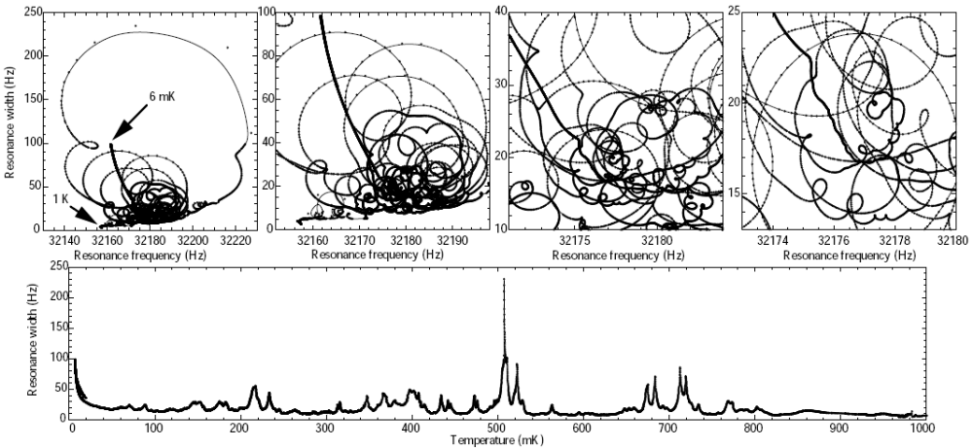

Fig. 1. Second sound resonances in dilute helium mixtures coupled to a quartz tuning fork produce beautiful patterns to its resonance frequency versus resonance width diagram. Here, a small quartz resonator was placed inside the mixing chamber of a dilution refrigerator cooled down from about 1 K to 6 mK in roughly 24 hours. The resonance pattern, though extremely complex, is reproducible as long as the conditions (geometry, concentration and pressure) are unchanged, and this can be used to give easily distinguishable markers at specific values of temperature – with resolution approaching one microkelvin at the scale of one kelvin.

BRAIN RESEARCH UNIT
The research programs of the Brain Research Unit aim to deepen the understanding of human brain function in health and disease by exploiting, developing, and integrating the most advanced spatiotemporal methods of non-invasive human neuroimaging. The research included design and construction of stimulation and monitoring devices to create versatile but controlled stimulus environments for systems neuroscience experiments.
We study human brain function by measuring weak magnetic fields outside the head. This method, magnetoencephalography (MEG), allows a totally non-invasive view into healthy and diseased human brains during different tasks and conditions. Our 306-channel neuromagnetometer (Vectorview, Elekta-Neuromag Ltd), functional since 1998 and upgraded in 2008, houses 204 gradiometers and 102 magnetometers with a whole-scalp coverage. To combine functional and structural information, we typically integrate MEG data with the subject's magnetic resonance images (MRIs).
We also use functional magnetic resonance imaging (fMRI) at the Advanced Magnetic Imaging (AMI) Centre of TKK; fMRI with its excellent spatial resolution complements the superb temporal resolution of MEG in tracking activation patterns and sequences in the human brain. The AMI Centre operates a 3-tesla MRI/fMRI superconducting magnet (General Electric 3T Signa) for whole-body imaging.
Since the beginning of 2006, we form the core of the Center of Excellence on Systems Neuroscience and Human Brain Imaging, appointed by the Academy of Finland for years 2006–2011. The other partners of the Center of Excellence work at the AMI Centre of TKK, at the Applied Electronics Laboratory of TKK, and at the Neuroscience Unit of the University of Helsinki.
During our first year in Nanotalo, our new MEG facility has worked very well. Our new three-layered magnetically shielded room provides several technical improvements compared with the old two-layered magnetically shielded room. With the upgraded MEG sensors and the data acquisition system, allowing sampling frequencies up to 5000 Hz, our MEG facility is one of the most advanced sites in the world, with gratifying low noise figures.
The new location of the BRU has turned out to improve group cohesion as people can meet each other severa times per day close to their office space.
We list below our achievements from 2008 in the form of published papers.
HUMAN SYSTEMS NEUROSCIENCE
Koskinen M and Vartiainen N. Removal of ballistocardiogram artifact from EEG data acquired in the MRI scanner: selection of ICA components. Conf Proc IEEE Eng Med Biol Soc 2008; 2008: 5220–5223.
The removal of ballistocardiogram (BCG) artifact from the EEG recorded in the MRI scanner is challenging. Few studies have utilized independent component analysis (ICA) in this task. A drawback of ICA has been the proper selection of the BCG related components. The key idea in this work is to use the difference between the power spectrum of the artifact-processed data and the spectrum of data recorded outside the scanner as a cost function in the selection of the BCG related independent components. Forward floating selection algorithm was implemented to find the components to minimize this criterion. Also, the typical component selection criteria based on the correlation with electrocardiogram (ECG) signal and on explained variance were compared in this respect. The correlation criterion was least successful leaving considerable residual artifact in the signal. With the first few removed components the variance criterion performed as well as the minimum spectral difference criterion. With the variance criterion alone, however, the number of the components to be removed cannot be determined. The suggested methods may provide objective means to validate residual artifact or the possible loss of physiological signal due to artifact removal and to help selecting the proper artifact-related components.
Nahum M, Renvall H and Ahissar M: Dynamics of cortical responses to tone pairs in relation to task difficulty: A MEG study. Hum Brain Mapp. 2008 Aug 18 [Epub ahead of print].
We investigated the effect of task difficulty on the dynamics of auditory cortical responses. Whole-scalp magnetoencephalographic (MEG) signals were recorded while subjects performed a same/different frequency discrimination task on equiprobable tone pairs applied in blocks of five, which were separated by a 10 s intertrial interval. Task difficulty was manipulated by the interpair frequency difference. The manipulation of task difficulty affected the amplitude of the N100m response to the first tone and the latency of the N100m response to the second tone in each pair. The N100m responses were smaller and peaked significantly later in the difficult than in the easy condition. The later processing field (PF) responses were longer in duration in the difficult condition. In both conditions, the duration of the PF response was negatively correlated with the subject's performance in the task, and was longer in the less successful subjects. The PF response may thus reflect the subjects' effort to resolve the task. The N100m and the PF responses did not differ between the tone pairs along the five-pair trial as a function of task difficulty, suggesting that changes in response along the five-pair trial are not easily affected by high-level manipulations.
Parkkonen L, Andersson J, Hämäläinen M and Hari R: Early visual brain areas reflect the percept of an ambiguous scene. Proc Natl Acad Sci USA 2008, 105: 20500–20504.
When a visual scene allows multiple interpretations, the percepts may spontaneously alternate despite the stable retinal image and the invariant sensory input transmitted to the brain. To study the brain basis of such multi-stable percepts, we superimposed rapidly changing dynamic noise as regional tags to the Rubin vase-face figure and followed the corresponding tag-related cortical signals with magnetoencephalography. The activity already in the earliest visual cortical areas, the primary visual cortex included, varied with the perceptual states reported by the observers. These percept-related modulations most likely reflect top-down influences that accentuate the neural representation of the perceived object in the early visual cortex and maintain the segregation of objects from the background.
Saarela MV and Hari R: Listening humans walking together activates the human social brain circuitry. Social Neurosci 2008, 3 (3–4), 401–409.
Human footsteps carry a vast amount of social information, which is often unconsciously noted. Using functional magnetic resonance imaging, we analyzed brain networks activated by footstep sounds of one or two persons walking. Listening to two persons walking together activated brain areas previously associated with affective states and social interaction, such as the subcallosal gyrus bilaterally, the right temporal pole, and the right amygdala. These areas seem to be involved in the analysis of persons' identity and complex social stimuli on the basis of auditory cues. Single footsteps activated only the biological motion area in the posterior STS region. Thus, hearing two persons walking together involved a more widespread brain network than did hearing footsteps from a single person.
Seppä M: Continuous sampling in mutual-information registration. IEEE Trans Image Proc 2008, 17: 823–826.
Mutual information is a popular and widely used metric in retrospective image registration. This metric excels especially with multimodal data due to the minimal assumptions about the correspondence between the image intensities. In certain situations, the mutual-information metric is known to produce artifacts that rule out subsample registration accuracy. Various methods have been developed to mitigate these artifacts, including higher order kernels for smoother sampling of the metric. This study introduces a novel concept of continuous sampling to provide new insight into the mutual-information methods currently in use. In particular, the connection between the partial volume interpolation and the recently introduced higher order partial-volume-type kernels is revealed.
Tanskanen T, Saarinen J, Parkkonen L, Hari R: From local to global: cortical dynamics of contour integration. J Vision, 8: Article 15, pp 1–12.
Processing of global contours requires integration of local visual information. To study the involvement of different cortical areas and the temporal characteristics of their activity in such integration, we recorded neuromagnetic responses to arrays of Gabor patches in which a proportion of the patches was oriented either tangentially or radially with respect to a global circular contour; arrays with random patch orientations served as control stimuli. The first responses at 60–80 ms around the calcarine sulcus were similar to all stimuli. Starting from 130 ms, responses to the tangential contours differed significantly from responses to control stimuli, and the difference reached its maximum at 275 ms. The most pronounced differences emerged around the parieto-occipital sulcus, precuneus, cuneus, and superior and middle occipital gyri. This pattern of cortical activity was similar irrespective of whether the local elements were radial or tangential to the circle; however, the differences were smaller for the radial contours and tended to start 20–30 ms later. Correspondingly, discrimination reaction times were shortest for the contours consisting of tangential elements. These results demonstrate two spatially and temporally distinct stages of visual cortical processing, the first one limited to local features and the second one integrating information at a more global level.
Taulu S and Hari R: Removal of magnetoencephalographic artifacts with temporal signal-space separation: Demonstration with single-trial auditory-evoked responses. Hum Brain Mapp 2008 Jul 25.
Magnetic interference signals often hamper analysis of magnetoencephalographic (MEG) measurements. Artifact sources in the proximity of the sensors cause strong and spatially complex signals that are particularly challenging for the existing interference-suppression methods. Here we demonstrate the performance of the temporally extended signal space separation method (tSSS) in removing strong interference caused by external and nearby sources on auditory-evoked magnetic fields-the sources of which are well established. The MEG signals were contaminated by normal environmental interference, by artificially produced additional external interference, and by nearby artifacts produced by a piece of magnetized wire in the subject's lip. After tSSS processing, even the single-trial auditory responses had a good-enough signal-to-noise ratio for detailed waveform and source analysis. Waveforms and source locations of the tSSS-reconstructed data were in good agreement with the responses from the control condition without extra interference. Our results demonstrate that tSSS is a robust and efficient method for removing a wide range of different types of interference signals in neuromagnetic multichannel measurements.
Vartiainen NV, Kirveskari E, Forss, N: Central processing of tactile and nociceptive stimuli in complex regional pain syndrome. Clin Neurophysiol 2008, 119: 2380–2388.
OBJECTIVE: Patients with complex regional pain syndrome (CRPS) suffer from continuous regional limb pain and from hyperesthesia to touch and pain. To better understand the pathophysiological mechanisms underlying the hyperesthesia of CRPS patients, we investigated their cortical processing of touch and acute pain. METHODS: Cortical responses to tactile stimuli applied to the thumbs, index and little fingers (D1, D2, and D5) and nociceptive stimuli delivered to dorsa of the hands were recorded with a whole-scalp neuromagnetometer from eight chronic CRPS patients and from nine healthy control subjects. RESULTS: In the patients, primary somatosensory (SI) cortex activation to tactile stimulation of D2 was significantly stronger, and the D1–D5 distance in SI was significantly smaller for the painful hand compared to the healthy hand. The PPC activation to tactile stimulation was significantly weaker in the patients than in the control subjects. To nociceptive stimulation with equal laser energy, the secondary somatosensory (SII) cortices and posterior parietal cortex (PPC) were similarly activated in both groups. The PPC source strength correlated with the pain rating in the control subjects, but not in the patients. CONCLUSIONS: The enhanced SI activation in hyperesthetic CRPS patients may reflect central sensitization to touch. The decreased D1–D5 distance implies permanent changes in SI hand representations in chronic CRPS. The defective PPC activation could be associated with the neglect-like symptoms of the patients. As the SII and PPC responses were not enhanced in the CRPS patients, other brain areas are likely to contribute to the observed hyperesthesia to pain. SIGNIFICANCE: Our results indicate changes of somatosensory processing at cortical level in CRPS.
LANGUAGE PERCEPTION AND PRODUCTION
Hultén A, Vihla M, Laine M and Salmelin R: Accessing newly learned names and meanings in the native language. Hum Brain Mapp 2008, Apr 15. [Epub ahead of print].
Ten healthy adults encountered pictures of unfamiliar archaic tools and successfully learned either their name, verbal definition of their usage, or both. Neural representation of the newly acquired information was probed with magnetoencephalography in an overt picture-naming task before and after learning, and in two categorization tasks after learning. Within 400 ms, activation proceeded from occipital through parietal to left temporal cortex, inferior frontal cortex (naming) and right temporal cortex (categorization). Comparison of naming of newly learned versus familiar pictures indicated that acquisition and maintenance of word forms are supported by the same neural network. Explicit access to newly learned phonology when such information was known strongly enhanced left temporal activation. By contrast, access to newly learned semantics had no comparable, direct neural effects. Both the behavioral learning pattern and neurophysiological results point to fundamentally different implementation of and access to phonological versus semantic features in processing pictured objects.
Kujala J, Gross J, and Salmelin R: Localization of correlated network activity at the cortical level with MEG. Neuroimage 2008, 39: 1706–1720.
In both hemodynamic and neurophysiological imaging methods, analysis of functionally interconnected networks has typically focused on brain areas that show strong activation in specific tasks. Alternatively, connectivity measures may be used directly to localize network nodes, independent of their level of activation. This approach requires initial cortical reference areas which may be identified based on their high level of activation, their coherence with an external reference signal, or their strong connectivity with other brain areas. Irrespective of how the nodes have been localized the mathematical complexity of the analysis methods precludes verification of the accuracy and completeness of the network structure by direct comparison with the measured data. Therefore, it is critical to understand how the choices of parameters and procedures used in the analysis affect the network identification. Here, using simulated and measured magnetoencephalography (MEG) data, and Dynamic Imaging of Coherent Sources (DICS) for connectivity analysis, we quantify the veracity of network detection at the individual and group level as a function of relevant parameter choices. Using simulations, we demonstrate that coupling measures enable accurate identification of the network structure even without external reference signals, and illustrate the applicability of this approach to real data. We show that a valid estimate of interindividual variability is critical for reliable group-level analysis. Although this study focuses on application of DICS to MEG data, many issues considered here, especially those regarding individual vs. group-level analysis, are likely to be relevant for other neuroimaging methods and analysis approaches as well.
Laaksonen H, Kujala J, and Salmelin R: A method for spatiotemporal mapping of event-related modulation of cortical rhythmic activity. Neuroimage 2008, 42: 207–217.
Cortical rhythmic activity can be systematically modulated by stimuli or tasks and may thus provide relevant information about brain function. Meaningful use of those phenomena requires characterization of both locations and time courses of event-related suppressions and increases of oscillatory activity. However, localization of the neural sources of cortical rhythms during intervals of very low levels of activity, and within short time intervals, is not a trivial matter. Hence, event-related modulation of rhythmic activity has typically been described at the level of magnetoencephalography (MEG) sensors or electroencephalography (EEG) electrodes, without reaching into the brain. Here, we introduce erDICS, an event-related version of Dynamic Imaging of Coherent Sources that allows spatial mapping of the level of oscillatory activity in the brain as a function of time, with respect to stimulus or task timing. By utilizing a time-resolved frequency-domain beamformer, erDICS yields the spatial distribution of both power suppressions and power increases. Permutation tests further reveal areas and time windows in which the modulations of oscillatory power are statistically significant, in individual subjects. We demonstrate the usability of erDICS on simulated and real MEG data. From the erDICS maps we identify areas showing salient event-related changes of rhythmic activity, represent them with equivalent current dipoles and calculate their contribution to the measured signal. Comparison of this multidipole model with the original signal yields a quantitative measure of goodness for the identified source areas and the analysis approach in general.
Liljeström M, Tarkiainen A, Parviainen T, Kujala J, Numminen J, Hiltunen J, Laine M, Salmelin R: Perceiving and naming actions and objects. Neuroimage 2008, 41:1132–41.
Neuropsychological studies have suggested differences in the cortical representations of verbs and nouns. Assessment of word-class specific deficits often relies on picture naming with different sets of images used for action and object naming. Such a setup may be problematic in neuroimaging studies, as the perception of the image and the actual differences in retrieving verbs or nouns become intertwined. To address this issue, we investigated how different sets of images affect the pattern of activation in action and object naming. In the present fMRI experiment, healthy volunteers silently performed both action and object naming from action images, and object naming from object-only images. A similar network of cortical areas was activated in all three conditions, including bilateral occipitotemporal and parietal regions, and left frontal cortex. With action images, noun retrieval enhanced activation in bilateral parietal and right frontal cortex, areas previously associated with visual search and attention. Increased activation in the left posterior parietal cortex during this condition also suggests that naming an object in the context of action emphasizes motor-based properties of objects. Action images, regardless of whether verbs or nouns were named, evoked stronger activation than object-only images in the posterior middle temporal cortex bilaterally, the left temporo-parietal junction, and the left frontal cortex, a network previously identified in processing of action knowledge. The strong influence of perceptual input on neural activation associated with noun vs. verb naming can in part explain discrepancies in previous lesion and functional neuroimaging studies on the processing of nouns and verbs.
Uusvuori J, Parviainen T, Inkinen M and Salmelin R: Spatiotemporal interaction between sound form and meaning during spoken word perception. Cereb Cortex 2008, 18: 456–466.
Cortical dynamics of spoken word perception is not well understood. The possible interplay between analysis of sound form and meaning, in particular, remains elusive. We used magnetoencephalography to study cortical manifestation of phonological and semantic priming. Ten subjects listened to lists of 4 words. The first 3 words set a semantic or phonological context, and the list-final word was congruent or incongruent with this context. Attenuation of activation by priming during the first 3 words and increase of activation to semantic or phonological mismatch in the list-final word provided converging evidence: The superior temporal cortex bilaterally was involved in both analysis of sound form and meaning but the role of each hemisphere varied over time. Sensitivity to sound form was observed at approximately 100 ms after word onset, followed by sensitivity to semantic aspects from approximately 250 ms onwards, in the left hemisphere. From approximately 450 ms onwards, the picture was changed, with semantic effects now present bilaterally, accompanied by a subtle late effect of sound form in the right hemisphere. Present MEG data provide a detailed spatiotemporal account of neural mechanisms during speech perception that may underlie characterizations obtained with other neuroimaging methods less sensitive in temporal or spatial domain.
VISION SYSTEMS PHYSIOLOGY
Henriksson L, Nurminen L, Hyvärinen A, Vanni S: Spatial frequency tuning in human retinotopic visual areas. J Vision, 2008, 8: 1–13.
Human medial occipital cortex comprises multiple visual areas, each with a distinct retinotopic representation of visual environment. We measured spatial frequency (SF) tuning curves with functional magnetic resonance imaging (fMRI) and found consistent differences between these areas. Areas V1, V2, VP, V3, V4v, and V3A were all band-pass tuned, with progressively lower SF optima in V1, V2, and V3A. In VP and V3, the SF optima were similar to optima in V2, whereas V4v showed more individual variation and scattered SF representations on the cortical surface. Area V5+ showed low-pass SF tuning. In each area, the SF optimum declined with increasing eccentricity. After accounting for the cortical magnification, the cortical extent of the optimal spatial wavelengths was approximately constant across eccentricity in V1, which suggests an anatomical constraint for the optimal SF, and this extent is actually comparable to the extent of horizontal connections within primate V1. The optimal spatial wavelengths in the visual field are also of similar extent to the spatial summation fields of macaque V1. The progressive decline in the SF tuning from V1 to V2 and V3A is compatible with the view that these areas represent visual information at different spatial scales.
Pihlaja M, Henriksson L, James AC and Vanni S: Quantitative multifocal fMRI shows active suppression in human V1. Hum Brain Mapp 2008, 29: 1001–1014.
Multifocal functional magnetic resonance imaging has recently been introduced as an alternative method for retinotopic mapping, and it enables effective functional localization of multiple regions-of-interest in the visual cortex. In this study we characterized interactions in V1 with spatially and temporally identical stimuli presented alone, or as a part of a nine-region multifocal stimulus. We compared stimuli at different contrasts, collinear and orthogonal orientations and spatial frequencies one octave apart. Results show clear attenuation of BOLD signal from the central region in the multifocal condition. The observed modulation in BOLD signal could be produced either by neural suppression resulting from stimulation of adjacent regions of visual field, or alternatively by hemodynamic saturation or stealing effects in V1. However, we find that attenuation of the central response persists through a range of contrasts, and that its strength varies with relative orientation and spatial frequency of the central and surrounding stimulus regions, indicating active suppression mechanisms of neural origin. Our results also demonstrate that the extent of the signal spreading is commensurate with the extent of the horizontal connections in primate V1.

OTHER USERS of BRU FACILITIES
Auranen T, Nummenmaa A, Vanni S, Vehtari A, Hämäläinen MS, Lampinen J and Jääskeläinen IP: Automatic fMRI-guided MEG multidipole localization for visual responses. Human Brain Mapping 2008 May 8 [Epub ahead of print].
Previously, we introduced the use of individual cortical location and orientation constraints in the spatiotemporal Bayesian dipole analysis setting proposed by Jun et al. ([2005]; Neuroimage 28:84–98). However, the model's performance was limited by slow convergence and multimodality of the numerically estimated posterior distribution. In this paper, we present an intuitive way to exploit functional magnetic resonance imaging (fMRI) data in the Markov chain Monte Carlo sampling -based inverse estimation of magnetoencephalographic (MEG) data. We used simulated MEG and fMRI data to show that the convergence and localization accuracy of the method is significantly improved with the help of fMRI-guided proposal distributions. We further demonstrate, using an identical visual stimulation paradigm in both fMRI and MEG, the usefulness of this type of automated approach when investigating activation patterns with several spatially close and temporally overlapping sources. Theoretically, the MEG inverse estimates are not biased and should yield the same results even without fMRI information, however, in practice the multimodality of the posterior distribution causes problems due to the limited mixing properties of the sampler. On this account, the algorithm acts perhaps more as a stochastic optimizer than enables a full Bayesian posterior analysis.
Braeutigam S, Swithenby SJ and Bailey AJ: Contextual integration the unusual way: a magnetoencephalographic study of responses to semantic violation in individuals with autism spectrum disorders. Eur J Neurosci 2008, 27: 1026–1036.
Autism is a neurodevelopmental disorder associated with deficits in language and social communication. Behavioural studies indicate abnormal semantic organization in individuals with autism, but little is known about the neural mechanism underlying the processing of language in context. Magnetoencephalography was used to record neural responses in 11 able adults with autism spectrum disorders reading meaningful sentences and sentences ending with a semantically incongruous word (e.g. 'He sent a photo to the trumpet'). Spatially extended evoked signals at 400 ms (N4) and 750 ms (LPC), as well as synchronized gamma-oscillations, provided clear evidence for specific neuronal processes sensitive to sentence context that differed in individuals with autism compared with typically developing individuals (11 healthy volunteers). Amongst other differences, N4 responses following incongruous words were weaker over left temporal cortices, whereas LPC responses to incongruous words and long-latency gamma-oscillations following congruous words were stronger over central and prefrontal regions in individuals with autism compared with the control group. Also, incongruous words elicited long-lasting gamma-oscillations above 40 Hz in the clinical group, but not in typically developing subjects. These findings may indicate unusual strategies for resolving semantic ambiguity in autism. Moreover, the observed gamma-band responses provide evidence for sustained cortical synchronization across segregated areas in individuals with autism, contrary to claims that a general deficit in either temporal binding or long-range connectivity may explain autism.
Ylipaavalniemi J and Vigário R: Analyzing consistency of independent components: An fMRI illustration. Neuroimage 2008, 39: 169–180.
Independent component analysis (ICA) is a powerful data-driven signal processing technique. It has proved to be helpful in, e.g., biomedicine, telecommunication, finance and machine vision. Yet, some problems persist in its wider use. One concern is the reliability of solutions found with ICA algorithms, resulting from the stochastic changes each time the analysis is performed. The consistency of the solutions can be analyzed by clustering solutions from multiple runs of bootstrapped ICA. Related methods have been recently published either for analyzing algorithmic stability or reducing the variability. The presented approach targets the extraction of additional information related to the independent components, by focusing on the nature of the variability. Practical implications are illustrated through a functional magnetic resonance imaging (fMRI) experiment.
OTHER PUBLICATIONS by BRU PERSONNEL
De Tiège X, Op de Beeck M, Funke M, Legros B, Parkkonen L, Goldman S, Van Bogaert P: Recording epileptic activity with MEG in a light-weight magnetic shield. Epilepsy Res 2008, 82: 227–231.
Ten patients with focal epilepsy were studied with magnetoencephalography (MEG) to determine if a new light-weight magnetically shielded room (lMSR) provides sufficient attenuation of magnetic interference to detect and localize the magnetic correlates of epileptic activity. Interictal MEG epileptic events co-localizing with the presumed location of the epileptogenic zone were found in all patients. MEG measurements performed in the lMSR provide an adequate signal-to-noise ratio for non-invasive localization of epileptic foci.
Kortelainen J, Koskinen M, Mustola S and Seppänen T. EEG Spectral Changes and Onset of Burst Suppression Pattern in Propofol/Remifentanil Anesthesia. Conf Proc IEEE Eng Med Biol Soc. 2008; 2008: 4980–4983.
This paper studies how remifentanil, a commonly used intraoperative opioid, affects the relation of the onset of burst suppression pattern (BSP) and the spectral changes of EEG during anesthesia. The onsets of BSP were detected using both manual and the automatic method proposed from the EEGs of twenty-seven patients who had received different amount of remifentanil with the anesthetic. The spectral changes were determined by calculating the frequency progression patterns of the EEGs. The results showed that remifentanil significantly affects the relation of EEG spectral changes and the onset of BSP. The finding is important since the current EEG-based assessment of the depth of anesthesia basically relies on the analysis of the spectral features and BSP.
Kortelainen J, Koskinen M, Mustola S and Seppänen T. Remifentanil modifies the relation of electroencephalographic spectral changes and clinical end points in propofol anesthesia. Anesthesiol 2008, 109: 198–205.
BACKGROUND: Depth-of-anesthesia monitoring with the electroencephalogram has become widely used in anesthesia practice. Generally, the methods presented are based on the spectral changes of the electroencephalogram. In this study, the authors evaluate the influence of remifentanil on the relation of timely occurrence of clinical endpoints and the spectral behavior of the electroencephalogram. METHODS: Twenty-seven patients scheduled to undergo a surgical procedure were randomly assigned to three groups. Patients blindly received equal volumes of saline or remifentanil (7.5 or 30 microg.kg.h) 1 min before induction of anesthesia with infusion of propofol (30 mg.kg.h). The occurrence of loss of counting, loss of obeying verbal command, and loss of reaction to tetanic stimulation was assessed. The electroencephalogram was recorded from electrode Fz referenced to the common average, and an iterative algorithm was applied to solve the underlying frequency progression pattern. The positions of the clinical endpoints on the pattern were analyzed. RESULTS: The administration of remifentanil during induction of anesthesia with propofol led to an earlier occurrence of the clinical endpoints on the frequency progression pattern. A significant difference (P < 0.05) was observed between the saline and high-dose patient groups in all three endpoints. The effect of remifentanil was proportional to the infusion rate. CONCLUSIONS: The infusion of remifentanil during propofol anesthesia significantly modifies the mutual relations of the electroencephalographic spectral characteristics and the endpoints in a predictable and quantifiable manner. This finding suggests that the electroencephalographic phenomena and the endpoints may not be identical but rather to some extent separate manifestations of hypnotic drug effect.
Kortelainen J, Koskinen M, Mustola S and Seppänen T. Time-frequency properties of electroencephalogram during induction of anesthesia. Neurosci Lett 2008, 446: 70–74.
A method for detailed description of the time-frequency characteristics of electroencephalogram during induction of anesthesia is proposed. The method, based on averaging of time-normalized smoothed pseudo-Wigner-Ville distributions, is applied to data recorded from nine patients undergoing propofol anesthesia. An extensive representation of the frequency progression pattern related to the induction of anesthesia is given and the time-frequency characteristics that are consistent/not consistent between patients are determined. It is also illustrated how four different clinical end-points, generally used in the assessment of the depth of anesthesia, can be related to different phases of the frequency progression pattern. The method presented has importance in providing information about the neurophysiological phenomenon during induction of anesthesia and can therefore be used in the development of new monitoring algorithms.

TEACHING ACTIVITIES

COURSES
Low Temperature Physics, Theory of Superconductivity (Tfy-3.4801)
Lectures: Prof. Nikolai Kopnin 22 hours
Teaching assistant: M.Sc. Matti Lakso

RESEARCH SEMINARS ON LOW TEMPERATURE PHYSICS AND NANOPHYSICS
Coordinators: Vladimir Eltsov, Tero Heikkilä, and Sorin Paraoanu
Jayanta Sarkar, LTL, Finland, Journal club on Circuit quantum electrodynamics, Jan 8
Dmitry Zmeev, Kapitza Institute, Moscow, Russia, NMR studies of superfluid 3He in anisotropic aerogel, Jan 10
Matti Laakso, LTL, Finland, Scattering approach to transport in graphene, Jan 15
Sergey Kafanov, Chalmers, Sweden, The radio frequency Single-Electron Transistor: Noise properties and its potential for detecting electrons on helium, Jan 18
Romain Danneau, LTL, Finland, Shot noise in graphene, Jan 22
Antti Paila, LTL, Finland, Journal club on Circuit quantum electrodynamics, Jan 29
Pertti Hakonen, LTL, Finland, Journal club on NEMS, Feb 5
Tero Heikkilä, LTL, Finland, What happens when superconductivity leaks?, Feb 12
Mika Sillanpää, LTL, Finland, Journal club on NEMS, Feb 19
Jukka Pekola, LTL, Finland, Hybrid turnstile for single electrons, Feb 26
Edouard Sonin, Hebrew University of Jerusalem, Israel, Coexistence of ferromagnetism and superconductivity in conventional and unconventional superconductors, Feb 27
Pertti Hakonen, LTL, Finland, Shot noise in carbon nanotubes and grapheme, Mar 4
Sorin Paraoanu, LTL, Finland, "Much ado about nothing" – on vacuum fluctuations, Casimir effect and superconducting resonators, Mar 11
Juha Muhonen, LTL, Finland, Journal club on NEMS, Mar 19
Pauli Virtanen, LTL, Finland, Peltier effect in superconducting heterostructures, Mar 25
Romain Danneau, LTL, Finland, Journal club on Transport in graphene and carbon nanotubes, Apr 8
Fan Wu, LTL, Finland, Apr 15
Andrey Timofeev, LTL, Finland, Quasiparticle energy relaxation in a superconductor, Apr 29
Jae I. Park, National Institute of Standards and Technology, Boulder Colorado, USA, Measuring the quantum states of a superconducting cavity, May 5
Yuri Pashkin, NEC, Tsukuba, Japan, Metal beams as high frequency nanomechanical resonators , May 6
Matti Laakso, LTL, Finland, Journal club on Transport in graphene and carbon nanotubes, May 13
Fan Wu, LTL, Finland, Journal club on Transport in graphene and carbon nanotubes, May 20
Lorenz Lechner, LTL, Finland, Dual beam devices – controlling the nanoscale, May 27
Matthias Meschke, LTL, Finland, Calorimetric SNS thermometry, Jun 3
Sergey Kafanov, LTL, Finland, Noise properties of the single-electron transistor, Jun 10
Mihail Silaev, Institute for Physics of Microstructures, Russian Academy of Science, Nizhny Novgorod, Russia, Electronic structure of vortices in clean type-II superconductors, Jun 11
Hiroyoshi Nobukane, Hokkaido University, Japan, Parity violation in single domain Sr₂RuO₄ single crystal, Aug 15
Yasuhiro Asano, Hokkaido University, Japan, Conductance spectroscopy of spin-triplet superconductors, Aug 18
Juha Voutilainen, LTL, Finland, Nano Journal Club, Sep 9
Matti Laakso, LTL, Finland, Electronic transport in multiprobe graphene structures, Sep 11
Tero Heikkilä, LTL, Finland, Temperature fluctuations statistics of electrons, Sep 23
Sorin Paraoanu, LTL, Finland, Nano Journal Club, Sep 25
Tommy Holmqvist, LTL, Finland, Tunnel junction thermometry in an electromagnetic environment, Sep 30
Grigori Volovik, LTL, Finland, Dynamics of the cosmological constant, Oct 7
Sarah MacLeod, LTL, Finland, Nano Journal Club, Oct 7
Alexander Mel'nikov, Institute for Physics of Microstructures, Russian Academy of Sciences, Nizhny Novgorod, Russia, Vortex molecules in thin films of layered superconductors, Oct 9
Jian Li, LTL, Finland, Entanglement of superconducting qubits via microwave fields: Classical regime, Oct 14
Antti Kemppinen, LTL and Mikes, Finland, Oct 21
Michael Roukes, Kavli Nanoscience Institute, California Institute of Technology, USA, Nanosystems and complexity: from "craft", to technology, to new scientific frontiers, Oct 22
Joonas Peltonen, LTL, Finland, Nano Journal Club, Oct 28
Aurélien Fay, LTL, Finland, Tunable coupling between a charge qubit and a phase qubit, Nov 4
Khattiya Chalapat, LTL, Finland, Nano Journal Club, Nov 18
Meri Helle, LTL, Finland, Adiabatic phase coherent pumping of charge – Berry phase made clear in the Cooper pair sluice, Nov 20
Christoph Strunk, University of Regensburg, Germany, Josephson coupling through carbon nanotube quantum dots with Nb- contacts, Nov 25
Antti Paila, LTL, Finland, Nano Journal Club, Dec 2
Jukka Pekola, LTL, Finland, Experiments on quantized heat conductance, Dec 9
Lorenz Lechner, LTL, Finland, Nano Journal Club, Dec 16

RESEARCH SEMINARS OF THE BRU
Synnöve Carlson, LTL, Facilitation of tactile working memory by tractography-guided TMS to the prefrontal cortex, Jan 28
Veikko Jousmäki, LTL, MEG system in Nanotalo: Updates and changes, Feb 5
Jaakko Kauramäki, BECS, TKK, Work in progress: Dynamic frequency selectivity, Feb 11
Miika Koskinen, Nuutti Vartiainen, TKK, EGG/fMRI acquisition and artefact removal in AMI centre, Feb 18
Ricardo Vigario, Jarkko Ylipaavalniemi, TKK, ICA of fMRI data, Feb 18
Päivi Helenius, LTL, Cortical activation evoked by spoken words in SLI and dyslexia, Feb 25
Lauri Nummenmaa, University of Turku, Department of Psychology, Finland, What eye movements reveal about processing of emotional scenes and faces?, Mar 3
Miika Pihlaja, BECS, TKK, Information processing in basal ganglia, Mar 10
Daniel Kysliuk, BECS, TKK, Work in progress, Mar 17
Jan Kujala, LTL, Study of cortical rhythmic activity and connectivity with magnetoencephalography, Apr 14
Aapo Hyvärinen, Helsinki Institute for Information Technology, University of Helsinki, Causal discovery, Bayesian networks, and structural equation models, Apr 21
Stina Ojala, University of Turku, Finland, Categorical perception in speech and sign, May 5
Sari Levänen, Harvard Medical School-Athinoula A. Martinos Center for Biomedical Imaging, Cortical representation of sign language studied with fMRI, May 12
Marja Balk, BECS, TKK, Temporal synchrony of audiovisual stimuli modulates activation of superior temporal sulcus, May 26
Jyrki Mäkelä, BioMag, HUS, Finland, Effects of CNS stimulation on MEG, Jun 2
Walter Freeman, University of California at Berkeley, USA, Explaining the neurodynamics by which brains construct knowledge from information and Considerations on maximizing information flow rates from scalp EEG for BCI, Sep 15
Pavan Ramkumar, LTL, Modeling the dynamics of human neuromagnetic brain rhythms, Sep 29
Kristian Donner, Department of Biological and Environmental Sciences, University of Helsinki, Finland, Evolution of communication, Oct 13
Minna Lehtonen, LTL and Helsinki Collegium for Advanced Studies, Finland, Neural correlates of morphological processing, Oct 27
Bradley J MacIntosh, Department Clinical Neurology, FMRIB Centre, John Radcliffe Hospital, University of Oxford, Developing arterial spin labeling cerebral blood flow imaging forclinical MRI, Nov 3
Risto Ilmoniemi, BECS/TKK Towards hybrid MEG-MRI technology, Nov 10
Henrik Ehrsson, Department of Neuroscience, Karolinska Institutet, Sweden, Multisensory mechanisms of body ownership, Nov 12
Teppo Särkämö, CBRU Dept of Psychology, University of Helsinki, Effects of music and speech on brain plasticity after stroke: neuropsychological and MEG follow-up study, Nov 24
Iiro Jääskeläinen, BECS/TKK, Spatiotemporal brain imaging of human auditory cognition, Dec 8

SPECIAL ASSIGNMENTS
Juho Rysti, Acoustic resonator for measuring the 3He concentration in gaseous Hehelium mixtures. Instructor: Doc. Juha Tuoriniemi.
Matti Tomi, Electron transport and shot noise in graphene. Instructor: Prof. Pertti Hakonen

ACADEMIC DEGREES

DIPLOMA THESES
Jaakko Hosio graduated as M.Sc. from the Department of Engineering Physics and Mathematics on May 23. His diploma thesis Generation and detection of quantum turbulence in superfluid ³He-B was done in the LTL. Supervisor: Prof. Matti Kaivola, Instructor: Dr. Vladimir Eltsov.
Matti Laakso graduated as M.Sc. from the Department of Engineering Physics and Mathematics on September 11. His diploma thesis Eletronic transport in multiprobe graphene structures was done in the LTL. Supervisor: Prof. Päivi Törmä, Instructor: Doc. Tero Heikkilä.
Matti Manninen graduated as M.Sc. from the Department of Engineering Physics and Mathematics on February 26. His diploma thesis Towards a new experimental setup for optical studies on ³He crystals was done in the LTL. Supervisor: Prof. Risto Nieminen, Instructor: Dr. Harry Alles.
Juha Muhonen graduated as M.Sc. from the Department of Engineering Physics and Mathematics on September 15. His diploma thesis Electronic cooling of suspended metallic nanowires was done in the LTL. Supervisor: Prof. Matti Kaivola, Instructors: Prof. Jukka Pekola, Dr. Antti Niskanen and Dr. Matthias Meschke.
Joonas Peltonen graduated as M.Sc. from the Department of Engineering Physics and Mathematics on January 29. His diploma thesis Josephson junctions as detectors of non-Gaussian noise was done in the LTL. Supervisor: Prof. Matti Kaivola, Instructor: Prof. Jukka Pekola.
Juho Rysti graduated as M.Sc. from the Department of Engineering Physics and Mathematics on November 28. His diploma thesis Interactions in dilute ³He-⁴He mixtures was done in the LTL. Supervisor: Prof. Risto Nieminen, Instructor: Dr. Juha Tuoriniemi.

PH.D. DISSERTATIONS
Jan Kujala defended his Ph.D. thesis Study of cortical rhythmic activity and connectivity with magnetoencephalography on April 24th, 2008. His opponent was Dr. Stefan Kiebel, Wellcome Trust Centre for Neuroimaging, Functional Imaging Laboratory, London, UK, and supervisor: Academy Professor Riitta Salmelin
Topi Tanskanen defended his Ph.D. thesis Dynamics of contour, object and face processing in the human visual cortex on May14th, 2008. His opponent was Professor Rafael Malach, Department of Neurobiology, Weizmann Institute of Science, Rehovot, Israel, and supervisor: Professor Riitta Hari.

TECHNICAL SERVICES

Machine shop
Kauko Herold, Seppo Hiltunen, Antti Huvila, Arvi Isomäki, Juhani Kaasinen, Hannu Kaukelin, and Markku Korhonen
The Machine Shop of Department of Electrical Engineering, with its two technicians Kauko Herold and Seppo Hiltunen was merged in December 2007 with the joint Mashine Shop of Low Temperature Laboratory (Huvila, Isomäki, Kaasinen and Korhonen) and Department of Engineering Physics (Hannu Kaukelin). Mr. Juhani Kaasinen retired on Desember 31, 2008.

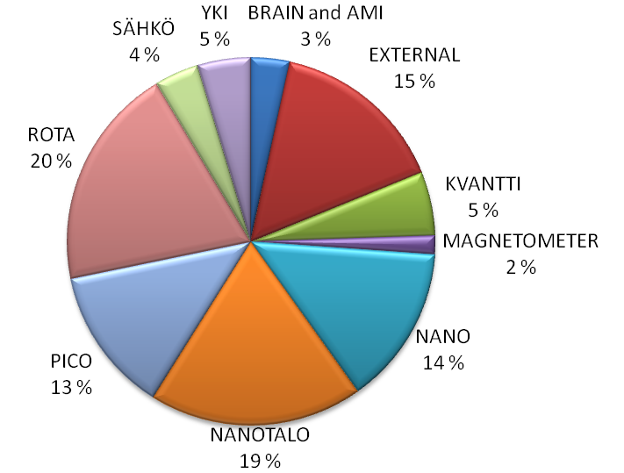

The distribution of workshop usage. Total hours were 3 196 h.

CRYOGENIC LIQUIDS
Arvi Isomäki and Antti Huvila

Liquid helium
The total amount of liquid helium purchased was 27 050 l and 14 700 l were delivered to the users. The losses of liquid He were 45.7%. The user distribution is depicted below. 15.6% of liquid He was sold to external users.

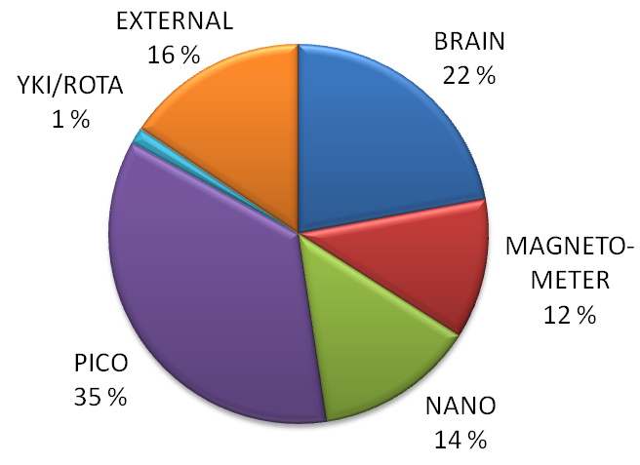

Liquid nitrogen
The production of liquid nitrogen was outsourced at the beginning of 2008. The old nitrogen liquefier was sold to University of Lappeenranta.

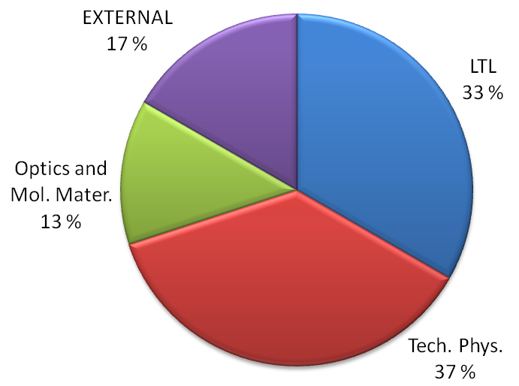

Total usage of liquid nitrogen was 15 000 l.

ACTIVITIES OF THE PERSONNEL

AWARDS AND HONORS
Blaauwgeers Rob and Peter Vorselman, 3rd Prize, Venture Cup, Finland, 1.5.
Forss Nina, Nordic Research Award Year 2008, Juliana von Wendt Foundation, Stiftelsen Forskning utan Djurförsök, and Alternativfondet, Eläinten hyvinvointifoorum, Helsinki, Finland, 12.11.
Junes Heikki, 2nd Prize for the best talk, Cryoconference 2008 – Young researchers, Oxford Instruments, Series of Conferences and Training Courses, Marie Curie Advanced Cryogenics Course, Miraflores de la Sierra, Spain, 12.9.
Lechner Lorenz, Best Poster Award EFUG 2008, EFUG, Maastricht, The Netherlands, 2.10.
Paalanen Mikko, Theodor Homén Prize, The Finnish Society of Sciences and Letters, Finland, 29.4.
Voutilainen Juha, McKinsey Award for the best MSc at TKK, McKinsey & Company and TKK, Espoo, Finland, 16.4.
Volovik Grigory, Membership in German National Academy of Sciences, 28.3.

PERSONNEL WORKING ABROAD
Alles Harry
- Institute of Physics, Tartu University Tartu, Estonia, 20.–28.3., 5.–8.5.

Heikkilä Tero
  - Kavli Institute of Nanotechnology, Delft University of Technology, University, Delft, Netherlands, 1.3.–1.7.
Isomäki Arvi
- Institute of Physics, Tartu University Tartu, Estonia, 17.9.–12.10.
Jousmäki Veikko
  - Cleveland Clinic Foundation, Cleveland, Ohio, Elekta Neuromag system start-up and teaching, 17.–27.1.
  - Oxford, Warneford Hospital, UK, Elekta Neuromag response pad installation, 6.–7.3.
  - CEA, Saclay, France, Paris, France, Elekta Neuromag system start-up and teaching, 8.–12.9. ,
  - Nebraska Medical Center, Omaha, Nebraska, USA, Elekta Neuromag system start–up and teaching, 13.–23.11.
Kopnin Nikolai
  - Hebrew University of Jerusalem, University, Jerusalem, Israel, 5.1.–14.2.
  - Argonne National Laboratory, University of Chicago, Argonne, Chicago, USA, 9.4.–8.5.
  - University of Oslo, Oslo, Norway, 18.–29.8.
Pekola Jukka,
  - State University of New York, Stony Brook, research collaboration, Stony Brook, NY, USA, 27.1.–12.2.
Peltonen Joonas
- Scuola Normale Superiore, NEST center: National Enterprise for nanoScience and nanoTechnology, Pisa, Italia, 2.4.–12.5.

CONFERENCE PARTICIPATION AND LABORATORY VISITS
Alles
Participation, Physics Days of Estonian Physical Society, Tartu, Estonia (18.–19.3.)
Participation, Symposium on Quantum Phenomena and Devices at Low Temperatures, Espoo, Finland (28.–30.3.)
Danneau
Oral presentation, Shot noise and evanescent wave transport in graphene, 25th International Conference on Low Temperature Physics (LT25), Amsterdam, The Netherlands (6.–13.8.)
Poster, Shot noise and evanescent wave transport in graphene, Graphene Week 2008, Trieste, Italy (24.–29.8.)

de Graaf
Oral presentation, Measurements of vortices with a quartz tuning fork in rotating superfluid 3He-B below 0.3Tc., Frontiers of Low Temperature Physics (ULT2008), London, UK (14.–17.8.)
Poster, Vortex motion in 3He-B below 0.4Tc: Response to a step change in rotation velocity in a cylindrical sample, 25th International Conference on Low Temperature Physics (LT25), Amsterdam, The Netherlands (6.–13.8.)
Eltsov
Invited talk, Experiments on decay of quantum turbulence at very low temperatures, Frontiers of Low Temperature Physics (ULT2008), London, UK (14.–17.8.)
Poster, Coherent spin precession below 0.3Tc in superfluid 3He-B: A tool to study vortices and vortex-free flow in rotation, 25th International Conference on Low Temperature Physics (LT25), Amsterdam, The Netherlands (6.–13.8.)
Poster, Vortex core contribution to textural energy in 3He-B, Frontiers of Low Temperature Physics (ULT2008), London, UK (14. – 17.8.)
Fay
Invited talk, Tunable coupling between a superconducting charge and phase qubit, GDR Physique Quantique Mesoscopique, Aussois, France (8.–11.12.)
Forss
Participation, Third International Conference on Transcranial Magnetic and Direct Current Stimulation, Göttingen, Germany (1.–4.10.)
Hakonen
Invited talk, Shot noise in ballistic single walled carbon nanotubes and in graphene, Quantum Transport and Nanophysics, La Thuille, Italy (8.–15.3.)
Invited talk, Shot noise in graphene, RTN Nano Meeting 2008 – Fundamentals of Nanoelectronics, Bremen, Germany (7.–11.4.)
Invited talk, Shot noise in nanocarbons, Spin and Qubit 2008, Copenhagen, (3.–4.7.)
Invited talk, Noise properties of nanocarbon devices at microwave frequencies, Nano-carbon Kick-off Meeting, Chalmers, Gothenburg, Sweden (13.10.)
Oral presentation, Shot noise in ballistic and disordered graphene, ICTP Conference Graphene Week 2008, Trieste, Italy (25.–29.8.)
Lecture, Shot noise in single walled carbon nanotubes and in graphene, Nanoscience Colloquium, Grenoble, France (8.–11.6.)
Poster, Characterization of graphene NEMS resonators up to 1 GHz, Mechanical Systems in the Quantum Regime, Ventura, CA, USA (17.–22.2.)
Poster, Shot noise in graphene, NT08, Ninth International Conference on the Science and Application of Nanotubes, Montpellier, France (29.6.–4.7.)
Poster, Superconducting weak links of single walled carbon nanotubes in the Kondo regime, NT08, Ninth International Conference on the Science and Application of Nanotubes, Montpellier, France (29.6.–4.7.)
Poster, Josephson inductance and induced supercurrents in multiwalled carbon nanotubes, 25th International Conference on Low Temperature Physics (LT25), Amsterdam, The Netherlands (6.–13.8.)
Poster, Landau-Zener interferometry in a charge-phase qubit, 25th International Conference on Low Temperature Physics (LT25), Amsterdam, The Netherlands (6.–13.8.)
Participation, Symposium on Quantum Phenomena and Devices at Low Temperatures, Espoo, Finland (28.–30.3.)
Participation, CARDEQ Review Meeting, Paris, France (24.–27.4.)
Halko
Participation, Annual Conference, Society for Neuroeconomics, Park City, USA (25.–28.9.)
Hari
Invited comment, Muistelmia Olli Lounasmaasta, Olli Lounasmaan muistelmien julkaisutilaisuus, Helsinki, Finland (29.1.)
Invited talk, Brain in time: Dynamics of human perception and brain processing, Viikki Biocenter Monday Lectures, Helsinki, Finland (11.2.)
Invited talk, Studies of eye gaze and fixation (Brains in social interaction), UI-ART Kick-off Workshop, Espoo, Finland (29.2.)
Invited talk, What the brain does when it is "idling", Towards a better brain usage; Biobio Society Annual Meeting, Helsinki, Biomedicum (27.3.)
Invited talk, Ihmisaivojen peilautumisjärjestelmistä, Suomen Psykoanalyyttisen Yhdistyksen kokous, Helsinki, Finland (8.5.)
Invited talk, Basic principles and applications of fMRI, Physiology and neurobiology of human brain imaging; Finnish Graduate School of Neuroscience, Espoo, Finland (22.5.)
Invited talk, Aivot ja mieli: Neurotiede ja psykiatria kohtaavat, Mielenterveyden monitieteiset ulottuvuudet, Kuopio, Finland (22.5.)
Invited talk, Brain basis of social interaction: Towards two-person neuroscience, Nobel Symposium Genes, Brain and Behaviour, Stockholm, Sweden (12.–14.6.)
Invited talk, Mirroring others, Future directions of speech production research, First Workshop of the Finnish Speech Research Collegium, Herrankukkaro, Rymättylä, Finland (17.6.)
Invited plenary talk, When time matters: Neuromagnetic approach to human brain function, FENS Forum of European Neuroscience, Geneva, Switzerland (12.–15.7.)
Invited plenary talk, Time matters from senses to cognition, BIOMAG 2008 International Conference on Biomagnetism 2008, Sapporo, Japan (25.–29.8.)
Invited talk, About MEG alpha, mu, tau, and sigma rhythms, BIOMAG 2008 International Conference on Biomagnetism 2008; in Workshop on, Sapporo, Japan (25.–29.8.)
Invited talk, Two-person neuroscience in studies of social interaction, Special lecture; University of Sapporo Medical School, Sapporo, Japan (29.8.)
Invited talk, Sosiaalisen vuorovaikutuksen aivoperusta, Mieli-forum IV, Majvik, Espoo, Finland (4.–6.9.)
Invited talk, Keynote lecture "How we mirror others: Insight from human brain imaging", 38th EACBT (European Association for Behavioural and Cognitive Therapy) Annual Congress, Helsinki, Finland (11.9.)
Invited talk, Need and challenges of two-person neuroscience, ESF Exploratory Workshop on Mirror Neurons and Social Cognition, Turin, Italy (23.–25.9.)
Invited talk, Do we need two-person neuroscience?, Louis-Jeantet Foundation 25 years Jubilee Symposium, Geneva, Switzerland (7.–9.10.)
Invited talk, Aivokuvantamisen näkymiä, Espoon sotaveteraanit ry:n valistusjaoston esitelmätilaisuus, Espoo, Finland (20.10.)
Invited talk, When time matters – Neuromagnetic approach to human brain function, Stockholm Brain Institute Lecture @ Nobel Forum, Stockholm, Sverige (4.11.)
Invited talk, Mieli, aivot, keho ja ympäristö – vuorovaikutuksen maailma, Mieli-forumin päätösseminaari; Mind Forum final seminar, Helsinki, Finland (20.11.)
Invited talk, Towards two-person neuroscience, Opening of Centre for Cognitive Neuroimaging, University of Glassgow, Glasgow, Scotland (28.11.)
Invited talk, MEG frequency tagging, MEG: New Images of Brain Dynamics, Paris, France (10.–12.12.)
Lecture, Brain in Time: MEG Studies of Human Cognition, Integrative Neuroscience, Graduate Course, University of Helsinki, Helsinki, Finland (15.10.)
Participation, Twentieth Anniversary Fondazione Rosselli. International Conference "Brain, Knowledge, and Social Behaviour", Turin, Italy (26.9.)
Heikkilä
Invited talk, What happens when superconductivity leaks?, University of Jyväskylä Physics Colloquium, Jyväskylä, Finland (15.2.)
Oral presentation, Proximity Josephson Sensor for Terahertz Radiation, Conference on Micro- and Nanocryogenics, Espoo, Finland, (3.–5.8.)
Lecture, Mesoscopic heatronics: thermal effects in nanostructures, Theory lecture, Leiden, Netherlands (3.6.)
Lecture, Mesoscopic heattronics: thermal effects in nanostructures, Theoretical physics seminar, Delft, the Netherlands (8.5.)
Lecture, Temperature fluctuation statistics on mesoscopic islands, Pisa, Italy (16.10.)
Poster, Proximity Josephson sensor for terahertz radiation, 25th International Conference on Low Temperature Physics, Amsterdam, Netherlands (7.–13.8.)
Participation, Symposium on Quantum Phenomena and Devices at Low Temperatures, Espoo, Finland (28.–30.3.)
Participation, International Symposium "Nanoelectronics and Quantum Transport", Universität Karlsruhe, Germany (18.–19.4.)
Participation, Nanoscopic Transport: Quantum Noise, Josephson Junctions, and Molecular Electronics, Freiburg, Germany (1.–3.11.)
Helenius
Invited talk, Auditory cortical activation evoked by words and speech sounds – Neuromagnetic studies on normal children and adults with language learning impairments, Universite Catholique de Louvain, Louvain-La-Neuve, Belgium (23.5.)
Invited talk, Speech evoked cortical activation in language learning impairments, BioMag-NSU seminar, Helsinki, Finland (11.9.)
Oral presentation, Puheen herättämät aivovasteet lukivaikeuksisilla ja SLI aikuisilla, 11. valtakunnallinen lukitutkijatapaaminen, Espoo, Finland (7.3.)
Oral presentation, Auditory cortical activation during word processing in SLI and dyslexia, The 46th Annual Meeting of the Academy of Aphasia, Turku, Finland (19.–21.10.)
Poster, Cortical activation evoked by spoken word forms and repetition in SLI and dyslexia, Cognitive Neuroscience Society Meeting, San Francisco, USA (12.–15.4.)

Helle
Poster, Cooling via superconducting line, Conference on Micro- and Nanocryogenics, Espoo, Helsinki University of Technology, Finland (3.–5.8.)
Poster, Experimental determination of the Berry phase in a superconducting charge pump, 25th International Conference on Low Temperature Physics (LT25), Amsterdam, The Netherlands (6.–13.8.)
Hosio
Oral presentation, Generation and detection of quantum turbulence with a quartz tuning fork, Cryoconference 2008, Miraflores de la Sierra (Madrid), Spain (7.–13.9.)
Poster, Quartz tuning fork as a probe of quantum turbulence in rotating 3He-B, Symposium on Quantum Phenomena and Devices at Low Temperatures, Espoo, Finland (28.–30.3.)
Hultén
Poster, Neural correlates of word learning and forgetting. An MEG study., The 46th Annual Meeting of the Academy of Aphasia, Turku, Finland (19.–21.10.)
Hänninen
Poster, Instability of a quantized vortex at a solid boundary in applied flow, Symposium on Quantum Phenomena and Devices at Low Temperatures, Espoo, Finland (28.–30.3.)
Poster, Superfluid vortex dynamics inside tilted rotating cylinder, Symposium on Quantum Phenomena and Devices at Low Temperatures, Espoo, Finland (28. –30.3.)
Poster, Superfluid vortex dynamics in tilted rotating cylinder, LT25, The 25th International Conference on Low Temperature Physics, Amsterdam, Netherlands (6.–13.8.)
Poster, Turbulence in steady-state vortex motion along a rotating column of superfluid 3He-B below 0.4Tc, Frontiers of Low Temperature Physics (ULT2008), London, UK (14.–17.8.)
Jousmäki
Lecture, MEG overview, System Start-up, Cleveland Clinic Foundation, Cleveland, Ohio, USA (21.–30.1.)
Lecture, MEG overview, System Start, NeuroSpin, CEA, Saclay, France (7. – 12.9.)
Poster, Skin-stretch stimulator, Biomag 2008, Sapporo, Japan (25.–29.8.)
Junes
Oral presentation, Step energies of facets on 4He crystals below 0.6 K, Frontiers of Low Temperature Physics (ULT2008), London, UK (14.–17.8.)
Oral presentation, Helium crystals investigated with a Fabry-Pérot interferometer and a high-accuracy pressure gauge, Cryoconference 2008, Miraflores de la Sierra, Madrid, Spain (8.–13.9.)
Poster, Anisotropy of growth kinetics of 4He crystals below 0.6 K, 25th International Conference on Low Temperature Physics (LT25), Amsterdam, The Netherlands (6.–13.8.)
Kirveskari
Invited talk, Facilitation of motor evoked potentials and pedicles srew stimulation in scoliosis surgery, International Meeting for Intraoperative Neuromonitoring in Neurosurgery and Orthopedic surgery', Freiburg, Germany (31.3.–1.4.)
Participation, Third International Conference on Transcranial Magnetic and Direct Current Stimulation, Göttingen, Germany (1.–4.10.)
Kopnin
Invited talk, BCS superconductivity of Dirac electrons in graphene, International Conference on Quantum Transport and Fluctuations at Nanoscale, Pržno, Montenegro (31.8.–5.9.)
Invited talk, Superconductivity of Dirac electrons in graphene, Fundamentals of Eletronic Nanosystems, St. Petersburg, Russia (29.6.–4.7.)
Participation, L.D. Landau Memorial Conference, Moscow, Chernogolovka, Russia (19.6.–26.7.)
Koskinen
Oral presentation, Removal of ballistocardiogram artifact from EEG data acquired in the MRI scanner: Selection of ICA components, IEEE EMBC'08, Vancouver, Canada (20.–24.8.)
Krusius
Invited talk, Topological defects and non-equilibrium phase transitions, Frontiers of Low Temperature Physics (ULT2008), London, UK (14.–17.8.)
Poster, Vortex front propagation in rotating superfluid 3He-B: A measurement of turbulent dissipation below 0.4 Tc, 25th International Conference on Low Temperature Physics (LT25), Amsterdam, The Netherlands (6.–13.8.)
Kujala
Invited talk, Brain rhythmic activity and imaging dynamic networks: From coactivation to causality, Human Brain Mapping 2008, Melbourne, Melbourne Convention Centre, Australia (15.–19.6.)
Invited talk, Magnetoenkefalografia sosiaalisen vuorovaikutuksen tutkimuksessa, Psykiatrisen kuvantamisen perusteet, Turku, Finland (12.11.)
Lecture, Sosiaalisen vuorovaikutuksen aivotutkimus, Aivokummit -yleisötapahtuma, Espoo, Finland (29.9.)
Poster, Brain basis of human social cognition, Finnish Graduate School of Neuroscience Student Symposium 2008, Helsinki, Finland (8.10.)
Participation, Brain Connectivity Workshop 2008, Sydney, University of New South Wales, Australia (12.–13.6.)
Participation, NEURO Mid-Term Seminar, Helsinki, Finland (25.–26.8.)
Participation, Mieli-foorumi, Kirkkonummi, Finland (4.–6.9.)
Laakso
Poster, Effective capacitance of a single-electron transistor, Symposium on Quantum Phenomena and Devices at Low Temperatures, Espoo, Finland (28.–30.3.)
Participation, Introduction to Quantum Systems and Devices, Nuuksio National Park, Finland (15.–18.6.)
Participation, 58th Meeting of Nobel Laureates, Lindau, Germany (29.6.–4.7.)
Lamminmäki
Participation, First Workshop of Finnish Speech Research Collogium, Rymättylä, Herrankukkaro, Suomi (17.6.)
Lechner
Poster, New FIB processing concept for nanocarbons, EFUG 2008, Maastricht, The Netherlands (1.10.)
Poster, Direct measurement of the critical current in a multiwalled carbon nanotube, Symposium on Quantum Phenomena and Devices at Low Temperatures, Espoo, Finland (28.–30.3.)
Poster, Direct observation of supercurrent in a multiwall carbon nanotube, NT08, Ninth International Conference on the Science and Application of Nanotubes, Montpellier, France (29.6.–4.7.)
Poster, Enhancement of CNT – Metal contact by ion beam irradiation, NT08, Ninth International Conference on the Science and Application of Nanotubes, Montpellier, France (29.6.–4.7.)
Participation, CARDEQ Review Meeting, Paris, France (24.–27.4.)
Participation, FEI User Club Meeting 2008, Eindhoven, The Netherlands (7.–9.4.)
Li
Participation, QUROPE Workshop, Otranto, Italy (13.–20.9.)
Liljeström
Oral presentation, Perceiving and naming actions and objects: an fMRI study, Academy of Aphasia Annual Meeting 2008, Turku, Finland (19.–21.10.)
Manninen
Oral presentation, Thermal linking with copper and silver at submillikelvin temperatures, Cryoconference 2008, Miraflores de la Sierra (Madrid), Spain (8.–13.9.)
Poster, Experimental setup for the observation of crystallization waves in 3He, 25th International Conference on Low Temperature Physics (LT25), Amsterdam, The Netherlands (6.–13.8.)
Poster, A cell for cooling 3He crystals down to 0.2 mK, Frontiers of Low Temperature Physics (ULT2008), London, UK (14.–17.8.)
Meschke
Oral presentation, Gate-controlled electronic refrigeration in a normal metal-superconductor hybride single-electron transistor, Finnish Physics Days 2008, Turku, Finland (27.–29.3.)
Oral presentation, NIS refrigeration in the presence of Coulomb effects: Heat transistor, Conference on Micro- and Nanocryogenics, Espoo, Finland (3.–5.8.)
Poster, The quantum of thermal conductance governing photonic heat conduction, 25th International Conference on Low Temperature Physics (LT25), Amsterdam, The Netherlands (6.–13.8.)
Poster, Gate-controlled electronic refrigeration in a normal metal-superconductor hybride single-electron transistor, 25th International Conference on Low Temperature Physics (LT25), Amsterdam, The Netherlands (6.–13.8.)
Muhonen
Poster, Suspended SINIS structure, Symposium on Quantum Phenomena and Devices at Low Temperatures, Espoo, Finland (28.–30.3.)
Poster, Electronic cooling of metallic nanowires, Conference on Micro- and Nanocryogenics, Otaniemi, Espoo, Finland (3.–5.8.)
Nangini
Poster, MEG predicts stimulus-rate dependence of BOLD, Human Brain Mapping Conference, Melbourne, Australia (16.–20.6.)
Poster, PENS Spring School, Models in neuroscience: Turning experiments into knowledge, St. Petersburg, Russia (27.4.–5.5.)
Paalanen
Invited talk, Future prospect in low temperature quantum electronics and nanorefrigeration, University of Basel, Basel, Switzerland (7.11.)
Invited talk, Future prospect in low temperature quantum electronics and nanorefrigeration, ULT2008, London, UK (14.–17.8.)
Invited comment, Pulse tube refrigeration and electronic nanocoolers, ULT2008, London, UK (14.–17.8.)
Invited comment, Tieteellinen tutkimus ja innovaatiot, Tieteellinen tutkimus ja innovaatiostrategia-seminaari, Helsinki, Finland (22.9.)
Invited talk, Future prospect in low temperature quantum electronics and nanorefrigeration, The Impact of 100 Years of Quantum Fluids: present and future directions, Lancaster, UK (3.7.)
Lecture, Future prospect in low temperature quantum electronics and nanorefrigeration, Institute of Physics, Chinese Academy of Sciences, Beijing, China (10.10.)
Participation, Planning meeting of Finland-Sweden Future Conference 23.9.2008, Helsinki, Finland (4.11.)
Paraoanu
Invited plenary talk, Superconducting quantum circuits, EURYIAS08, Bucharest, Romania (28.4.–4.5.)
Invited talk, Macroscopic quantum-coherent systems, Exotic phenomena in the mesoscopic world, Bucharest, Romania (2.7.)
Poster, Interaction-free measurements of superconducting circuits, Quantum optics: from photons and atoms to molecules and solid state systems, Obergurgl, Austria (24.2.–1.3.)
Poster, Nano-hybrid materials at microwave frequency, NMP : Nanotechnology, Materials and New Production, Helsinki, Finland (16.–17.4.)
Poster, Cooper pair resonances and subgap Coulomb blockade in a single electron transistor, 25th International Conference on Low temperature Physics (LT25), Amsterdam, Netherlands (6. - 13.8.)
Poster, Entanglement of superconducting qubits via microwave fields: classical and quantum regimes, 25th International Conference on Low temperature Physics (LT25), Amsterdam, Netherlands (6.–13.8.)
Poster, Phase coherence and fragmentation in weakly interacting bosonic gases, 25th International Conference on Low temperature Physics (LT25), Amsterdam, Netherlands (6.–13.8.)
Poster, Phase coherence and fragmentation in weakly interacting BECs, Symposium on Quantum Phenomena and Devices at Low Temperatures, Helsinki, Finland (28.–30.3.)
Poster, Entanglement of superconducting qubits via microwave fields: Classical and quantum regimes, Symposium on Quantum Phenomena and Devices at Low Temperatures, Helsinki, Finland (28.–30.3.)
Poster, Entanglement of superconducting qubits via microwave fields: Classical and quantum regimes, Quantum Decoherence and Quantum Information Science, Leiden, Netherlands (11.–15.8.)
Parkkonen
Invited talk, Precision of MEG – Theoretical boundaries, INCF: Imaging Brainstorm: The resting brain: What happens when nothing happens?, Tampere, Finland (13.–14.3.)
Invited talk, MEG/EEG Instrumentation and experimental design, Human Brain Mapping 2008, Melbourne, Australia (15.–19.6.)
Invited talk, On the nature of MEG signals, Magnetic tunnel junctions for highly sensitive sensors, Les Vaulx de Cernay, France (21.–23.10.)
Poster, MEG source modeling by Bayesian tracking: Validation of the particle filter approach, Human Brain Mapping 2008, Melbourne, Australia (15.–19.6.)
Poster, A descriptive model of the dynamics of rhythmic brain activity, Neuroinformatics 2008, Stockholm, Sweden (7.–9.9.)
Participation, Mieli-forum IV, Majvik, Kirkkonummi, Finland (4.–6.9.)
Participation, MEG: New Images of Brain Dynamics (NeuroSpin MEG inaugural symposium), Paris, France (10.–11.12.)
Pekola
Invited talk, Microrefrigeration and thermometry in nanoelectronics, Ultracold Nanomatter, Toronto, Canada (14.–16.2.)
Invited talk, Nanoelectronics: physics and devices, Introduction to Quantum Systems and Devices, Espoo, Finland (16.–18.6.)
Invited plenary talk, Pumping energy and charge by hybrid tunnel junctions, 25th International conference on low temperature physics (LT25), Amsterdam, The Netherlands (6.–13.8.)
Invited talk, Single-electron tunnelling, XV International Summer School Nicolás Cabrera, Madrid, Spain (14.–19.9.)
Invited talk, Hybrid single-electron transistor as a source of quantized electric current, Quantum Dynamics in Dots and Junctions: Coherent Solid State Systems, Riva del Garda, Italy (5.–10.10.)
Invited talk, Physics and technology of superconducting mesoscopic devices, Electrical and Optical Characterization of Nanodevices, Rome, Italy (11.6.)
Oral presentation, Single-electron turnstile, SCOPE Kick-off Meeting (EU STREP), Stockholm, Sweden (15.–17.10.)
Oral presentation, Basics of electronic cooling, E-Fridge Kick-off Meeting (EPSRC), London, UK (5.–6.11.)
Lecture, Pumping charge and energy, State University of New York, Stony Brook, USA (8.1.)
Lecture, Experiments on the quantized heat conductance, Néel Institute, CNRS, Grenoble, France (12.11.)
Peltonen
Poster, Detecting the third cumulant of shot noise with a hysteretic Josephson junction, European School on Nanosciences & Nanotechnologies 2008, Grenoble, France (24.8.–13.9.)

Pentti
Poster, Measurements of the solubility of 3He in 4He at mK temperatures by quartz tuning fork, Symposium on Quantum Phenomena and Devices at Low Temperatures, Espoo, Finland (28.–30.3.)
Pihko
Invited talk, Magnetoencephalography (MEG) reveals cortical maturation of tactile processing, Biomag 2008, Sapporo, Japan (25.–29.8.)
Poster, Neuromagnetic responses to native and non-native speech sounds in AWAKE infants, Biomag 2008, Sapporo, Japan (25.–29.8.)
Poster, Magnetoencephalography in investigating somatosensory processing in very low birth weight infants, Biomag 2008, Sapporo, Japan (25.–29.8.)
Poster, Somatosensory evoked magnetic fields in adolescents with congenital spastic hemiplegic cerebral palsy, Biomag 2008, Sapporo, Japan (25.–29.8.)
Poster, Auditory evoked fields in children with langeage impairment, Biomag 2008, Sapporo, Japan (25.–29.8.)
Ramkumar
Poster, A descriptive model of the dynamics of rhythmic brain activity, ICNF Congress on Neuroinformatics, Stockholm, Stockholm, Sweden (7.–9.9.)
Poster, Oscillatory response functions: Towards a parametric model of rhythmic activity, PENS School 2008: Models in Neuroscience, St. Petersburg, Russia (27.–5.5.)
Renvall
Poster, Phantom to study variability of fMRI activations within and across measurements, European Society for Magnetic Resonance in Medicine and Biology, 25th Annual Meeting, Valencia, Espanja (2.–4.10.)
Rysti
Participation, Finnish Physics Days 2008, Turku, Finland (27.3.)
Saarela
Invited talk, Pain and the empathic brain, 31th Annual Congress of the Scandinavian Association for the Study of Pain, Turku, Finland (8.–11.5.)
Invited talk, Sensomotoriikka ja sosiaalinen vuorovaikutus, Tutkittua tietoa motoriikasta ja sensoriikasta-koulutuspäivä, Mahdollisuus Lapselle ry., Helsinki, Finland (10.4.)
Salmela
Poster, Acoustic resonator providing fixed points of temperature between 0.1 and 2 K, 25th International Conference on Low Temperature Physics (LT25), Amsterdam, The Netherlands (6.–13.8.)
Poster, Quartz tuning fork measurements in helium mixtures at millikelvin temperatures up to melting pressure with varying concentration, Frontiers of Low Temperature Physics (ULT2008), London, UK (14.–17.8.)
Salmelin
Invited talk, MEG and cognitive neuroscience (Basic MEG/EEG Course), 14th Annual Meeting of the Organization for Human Brain Mapping (HBM2008), Melbourne, Australia (15.–19.6.)
Invited plenary talk, Language function and dysfunction: an MEG perspective, The 46th Annual Meeting of the Academy of Aphasia, Turku, Finland (19.–21.10.)
Invited talk, Electrophysiological findings in stuttering, The neural bases of stuttering, Paris, France (16.5.)
Sebedash
Poster, Improved capacitive melting curve measurements, 25th International Conference on Low Temperature Physics, Amsterdam, The Netherlands (6.–13.8.)
Poster, Adiabatic melting of 4He crystal in superfluid 3He, Frontiers of Low Temperature Physics (ULT2008), London, UK (13.–17.8.)
Sillanpää
Invited talk, Coherent manipulation of quantum information using two Josephson phase qubits coupled to a resonant cavity, APS March Meeting 2008, New Orleans, USA (10.–14.3.)
Stenbacka
Poster, Seeing globally – fMRI of peripheral visual field, Society for Neuroscience Annual Meeting 2008, San Diego, USA (3.–7.11.2008)
Tikka
Invited talk, Enactive cinem: Simulatorium eisensteinense, Knowledge through Practice Seminar, Brighton, Brighton University, UK (27.10.)
Invited plenary talk, Enactive cinema: Simulatorium eisensteinense, Between Life & Mind & Art, Hove, Sussex, University, UK (29.10.)
Invited talk, Enactive cinema: Simulatorium eisensteinense, Leicester, De Montfort University, IOCT, UK (24.10.)
Timofeev
Poster, Josephson junctions as detectors of high frequency shot noise in mesoscopic conductors, European School on Nanosciences & Nanotechnologies 2007, Grenoble, France (26.8.–15.9.)
Poster, Brownian electron refrigerator, Moriond 2008 Quantum Transport and Nanophysics, La Thuile, Italy (8.–15.3.)
Poster, Brownian electron refrigerator, Symposium on Quantum Phenomena and Devices at Low Temperatures, Espoo, Finland (28.3.–1.4.)
Poster, Brownian electron refrigerator, Conference on Micro- and Nanocryogenics, Espoo, Finland (3.–5.8.)
Poster, Recombination-limited energy relaxation in a superconductor, 25th International Conference on Low Temperature Physics, Amsterdam, The Netherlands (6.–13.8.)
Todoshchenko
Oral presentation, Devils staircase of facets on the surface of 4He crystals, 25th International Conference on Low Temperature Physics, Amsterdam, Netherlands (6.–13.8.)

Tuoriniemi
Invited talk, Quartz forks: Ultra high Q-values, Frontiers of Low Temperature Physics (ULT2008), London, UK (14.–17.8.)
Poster, Nuclear ordering and superconductivity in lithium, 25th International Conference on Low Temperature Physics, Amsterdam, The Netherlands (6.–13.8.)
Vanni
Invited talk, Estimating the spatial resolution and quantity of fMRI signal, Physiology and Neurobiology of Human Brain Imaging, Espoo, Finland (20.–21.5.)
Invited talk, A view to lesioned visual cortex, Visual Lesion Register 25-year Seminar, Helsinki, Finland (24.10.)
Oral presentation, Extrastriate visual processing: Integration of computational, psychophysical and imaging approaches, Academy of Finland: Neuro Mid-term Seminar, Helsinki, Finland (27.1.)
Lecture, Physiology of vision II, University of Helsinki, Department of Physiology, Helsinki, Finland (22.9.)
Lecture, Functional brain imaging, Lecture in masters' degree in neuroscience program at Neuroscience Centre, University of Helsinki, Helsinki, Finland (8.10.)
Lecture, Functional brain imaging: from phenomena to information, LUMA Seminar for Science and Mathematics Teachers, Espoo, Finland (24.10.)
Lecture, FMRI in brain research, Post Graduate Course in Psychology, Helsinki, Finland (31.10.)
Vartiainen
Invited talk, Imaging of pain, FGSN Symposium 2008: Brain & Pain, Helsinki, Finland (6.–7.10.)
Invited talk, Aivojen toiminnallinen kuvantaminen, Helsingin Sotaveteraanit ry Meeting, Helsinki, Finland (3.11.)
Oral presentation, Neural dynamics of reading morphologically complex words, Academy of Aphasia Annual Meeting 2008, Turku, Finland (19.–21.10.)
Lecture, Aivojen toiminnallinen kuvantaminen – ikkuna aivoihin, University of the Third Age at the University of Helsinki, Helsinki, Finland (30.9.)
Virtanen
Poster, Phase states of multiterminal mesoscopic normal-metal-superconductor structures, Moriond 2008 Quantum Transport and Nanophysics, la Thuile, Italy (8.–15.3.)
Poster, Microwave-enhanced supercurrent in SNS junctions, Conference on Micro- and Nanocryogenics, Helsinki, Finland (3.–5.8.)
Poster, Phase states of multiterminal mesoscopic normal-metal-superconductor structures, Symposium on Quantum Phenomena and Devices at Low Temperatures, Espoo, Finland (28.–30.3.)
Volovik
Invited talk, Fermi point scenario of emergent physics, The Royal Society Discussion Meeting, London, UK (28.–29.1.)
Invited talk, General principles of emergent physics with application to the cosmological constant problem, SFB/TRR 21-Colloquium, Ulm, Germany (8.2.)
Invited talk, Emergent physics: Fermi point scenario, Colloquium at Karlsruhe University, Karlsruhe, Germany (2.5.)
Invited talk, General principles of emergent physics and their application to the cosmological constant problem, Colloquium at Regensburg University, Regensburg, Germany (5.5.)
Invited talk, Bose-Einstein condensation of magnons in superfluid 3He, BEC-2008, 4-th International Workshop "Theory of Quantum Gases and Quantum Coherence", Grenoble, France (3.–7.6.)
Invited talk, From Landau Fermi liquid and Landau two-fluid hydrodynamic to physics of quantum vacuum and cosmology, Landau Congress, Moscow and Chernogolovka, Russia (19.–26.6.)
Invited talk, Topology in momentum space, fermionic spectrum and quantum phase transitions, Competing Orders, Pairing Fluctuations, and Spin Orbit Effects in Novel Unconventional Superconductors, Dresden, Germany (30.6.–11.7.)
Invited talk, Helium liquids and the Universe, International Summer School Nicolas Cabrera: 100 Years of Liquid Helium, New Physics at the Edge of Absolute Zero, Miraflores, Spain (14.–19.9.)
Invited talk, Principles of emergent physics and application to problems of dark energy, International Workshop DICE 2008: From Quantum Mechanics Through Complexity to Spacetime, Castiglioncello, Italy (22.–26.9.)
Invited talk, Principles of emergent physics with applications to relativistic quantum fields and gravity, Laboratoire de Physique Théorique et Modèles Statistiques, Orsay, France (18.11.)
Lecture, Helium liquids and the Universe, Néel Institute, Grenoble, France (20.11.)
Lecture, Principles of emergent symmetries from topology in momentum space, Landau Institute, Chernogolovka, Russia (22.2.)
Lecture, Thermodynamics and dynamics of vacuum energy and cosmological constant, Landau Institute, Chernogolovka, Russia (5.9.)
Lecture, Magnon BEC in superfluid 3He, Landau Institute, Chernogolovka, Russia (17.10.)
Participation, Editorial Board Meeting of the Journal JETP Letters, Moscow, Russia (21.2., 3.4., 15.5., 19.6., 4.9., 25.12)
Participation, Meeting of Scientific Council of Landau Institute, Chernogolovka, Russia (16.5.)
Participation, Meeting of Dissertation Council of Landau Institute, defence of 2 PhD and 2 second doctor degree dissertations, Chernogolovka, Russia (27.6.)
Participation, Meeting of Landau Institute: Election of Scientific Council of Landau Institute, Chernogolovka, Russia (28.6.)
Participation, Meeting of Dissertation Council of Landau Institute, defence of PhD by Menshutin, Chernogolovka, Russia (26.12.)
Voutilainen
Poster, Nonequilibrium charge transport in quantum SINIS structures, VIth Rencontres de Moriond in Mesoscopic Physics, La Thuile, Italy (8.–15.3.)
Poster, Cross coupling of energy levels in a noninteracting quantum dot, 25th International Conference on Low Temperature Physics, Amsterdam, The Netherlands (6.–13.8.)
Poster, Nonequilibrium charge transport in quantum SINIS structures, Frontiers of Low Temperature Physics (ULT2008), London, UK (13.–17.8.)

Wu
Oral presentation, Evolution of SWNT weak links from Fabry-Perot to Kondo regime, 25th International Conference on Low Temperature Physics, Amsterdam, The Netherlands (6.–13.8.)
Oral presentation, Shot noise in graphene, CARDEQ Meeting, Paris, France (24.–26.4.)

EXPERTISE AND REFEREE ASSIGNMENTS
Auranen
Referee:
  - Human Brain Mapping
  - NeuroImage
Berglund
Membership in distinguished societies:
  - Svenska Tekn. Vetenskapakademien i Finland
  - Finnish Academy of Technical Sciences
Carlson
Opponent: Alexander Degerman, University of Helsinki, Helsinki, Finland, 12.11.
Pre-examiner of a doctoral thesis: Antti Knaapila, University of Helsinki, Helsinki, Finland, 21.08.
Eltsov
Guest Editor: Journal of Low Temperature Physics
Referee:
- The Journal of Fluid Mechanics
- Journal of Low Temperature Physics
Chairman of the session: Magnetic resonance in superfluids, Symposium on Quantum Phenomena and Devices at Low Temperatures, ULTI, Espoo, Finland, 28.–30.3.
Organising a conference at TKK: Symposium on Quantum Phenomena and Devices at Low Temperatures, ULTI, Espoo, Finland, 28.–30.3.
de Graaf
Organising a conference at TKK: Symposium on Quantum Phenomena and Devices at Low Temperatures, ULTI, Espoo, Finland, 28.–30.3.
Hakonen
Position of trust in scientific organizations: Evaluator of ERC advanced grants applications, ERC, 1.1.–31.12.
Membership in distinguished societies:
  - Finnish Academy of Sciences and Letters
  - Fellow member, American Physical Society
  - Academia Europaea
Chairman of the session:
  - Superconductivity in carbon nanotubes, Symposium on Quantum Phenomena and Devices at Low Temperatures, ULTI, Espoo, Finland, 28.–30.3.
  - Carbon nanotubes, 25th International Conference on Low Temperature Physics, Amsterdam, The Netherlands, 6.–13.8
Opponent: Aurelien Fay, Joseph Fourier University, Grenoble, France, 9.6.
Pre-examiner of a doctoral thesis: Pierre Marie Billangeon, University of Paris Sud, Paris, Orsay, France, 1.2.
Hari
Leader position in a scientific organization:
  - Director of Advanced Magnetic Imaging Centre (AMI), TKK
  - Chief physician, Dept. Clin. Neurophysiology, HUSLAB, HUCH (part-time) ad 30.6.2008
  - Member of Medical Advisory Board, General Electric, General Electric Health Care (Europe; 3T MRI devices), Italy
  - Member of Advisory Board, INFC (International Neuroinformatics Coordinating Facility), The INCF National Node of Finland, Finland.
Member of a distinguished society:
- National Academy of Sciences of the USA
- Finnish Academy of Sciences and Letters
- Academia Europaea
Chairman of the conference or organising committee: Mieli-forum (Mind forum) III, IV and V (3 different conferences), Helsinki, Sipoo and Espoo, Finland, 1.1.–31.12.
Membership of the organising committee: Physiology and neurobiology of human brain imaging; Finnish Graduate School of Neuroscience, Espoo, Finland, 20.–21.5.
Chairman of the session: Imaging Brainstorm, Session: Methods for natural stimulation, Käsi- ja taideteollisuuskeskus Verkaranta, Tampere, Finland, 13.–14.3.
Interview:
- Interview for TV Teema (Tutkiva juttu) about human brain function and brain imaging, Yleisradio TV Teema, Helsinki, Finland, 30.11.
- Interview about human brain imaging for a brain-related book to be published by HS, Helsingin Sanomat, Helsinki, Finland, 31.12.
Referee:
- Human Brain Mapping
- Neuroscience
- Cerebral Cortex
- Proceedings of the National Academy of Sciences USA
Member of the editorial board:
- Cerebral Cortex, Oxford Journals
- Neuroscience Research, Elsevier
- Brain Topography, Springer
- NeuroImage, Elsevier
- Proceedings of the National Academy of Sciences USA (ad hoc editor)
Organizing a conference outside TKK:
    - Mieli-Forum III, Majvik, Espoo, Finland, 6.–9.3.
    - Mieli-Forum IV, Majvik, Espoo, Finland, 4.–6.9.
    - Mieli-Forumin päätösseminaari; Mind Forum final seminar, Helsinki, Finland, 20.–20.11
Statement for the appointment of a professor: Fellow of the Royal Society, London, United Kingdom, 17.2.
Opponent: Pär Nyström, Uppsala University, Faculty of Social Sciences, Department of Psychology, Uppsala, Sweden, 8.9.
Heikkilä
Guest Editor: Journal of Low Temperature Physics
Membership of the organising committee: Symposium on Quantum Phenomena and Devices at Low Temperatures, ULTI, Espoo, Finland, 28.–30.3.
Chairman of the session: Superconductivity and noise in mesoscopic systems, Symposium on Quantum Phenomena and Devices at Low Temperatures, ULTI, Espoo, Finland, 28.–30.3.
Interview: Radiaattori, YLE Radio 1, Radio, Finland, 23.4.
Referee:
  - Physical Review B
  - Physical Review Letters
  - Europhysics Letters
Helenius
Referee:
- Neuroimage
- Cognitive Neuropsychology
Chairman of the conference or organising committee: 11. valtakunnallinen lukitutkijatapaaminen, Chairman of organising committee, Espoo, Finland, 7.–7.3.
Helle
Guest Editor: Journal of Low Temperature Physics
Organising a conference at TKK: Conference on Micro- and Nanocryogenics, MNC, Espoo, Finland, 3.–5.8.
Hirvenkari
Interview: Ihmiskoe: aivojen magneettikenttiä mittaamassa, YLE Radio 1, Radio, Espoo, Finland, 17.4.
Hlushchuk
Referee: NeuroImage
Hänninen
Referee:
    - Physical Review Letters
    - Journal of Low Temperature Physics
    - Physical Review E
    - Physical Review B
    - Journal of Physics: Conference Series
Chairman of the session: Posters on coherent quantum systems I, Symposium on Quantum Phenomena and Devices at Low Temperatures, ULTI, Espoo, Finland, 28.–30.3.
Organising a conference at TKK: Symposium on Quantum Phenomena and Devices at Low Temperatures, ULTI, Espoo, Finland, 28.–30.3.
Junes
Membership of the organising committee: Symposium on Quantum Phenomena and Devices at Low Temperatures, ULTI, Espoo, Finland, 28.–30.3.
Järvinen
Secretary of the conference or organising committee:
    - Mieli-forum III: Tiedossa, tiedostamatta, tapana, Majvik, Kirkkonummi, Finland, 6.–8.3.
    - Mieli-forum IV: Mielet vuorovaikutuksessa, Majvik, Kirkkonummi, Finland, 4.–6.9.
Jousmäki
Referee:
- Brain Research
- Human Brain Mapping
Chairman of the session: Pain and Somatosensory Function, poster session, Biomag 2008, Sapporo, Japan, 25.–29.8.
Kirveskari
Organizing a conference outside TKK: National educational course for medical doctors specializing in clinical neurophysiology, 11.–11.6.
Kopnin
Member of the scientific board: Landau Institute for Theoretical Physics of the Russian Academy of Science, Russia.
Chairman of the session: Measuring techniques of quantum turbulence in zero temperature limit, Symposium on Quantum Phenomena and Devices at Low Temperatures, ULTI, Espoo, Finland, 28.–30.3.
Krusius
Member of the editorial board: Physica B: Condensed Matter
Leader position in a scientific organization:
    - Chairman, Finnish Academy of Sciences and Letters, Section of Physics and Astronomy, 1.1.2007–31.12.2008.
    - Member of Board, European Physical Society, Low Temperature Section, Condensed Matter Division, 1.1.2007–31.12.2008.
Membership in distinguished societies:
  - Finnish Academy of Sciences and Letters
  - Academia Europea
  - Fellow member, American Physical Society
  - Institute of Physics, UK
Member of scientific associations:
  - Finnish Physical Society
  - Individual ordinary member, European Physical Society
Chairman of the conference: Symposium on Quantum Phenomena and Devices at Low Temperatures, Espoo, Finland, 28.–30.3.
Membership of the organising committee: Symposium on Quantum Phenomena and Devices at Low Temperatures, 28.–30.3.
Chairman of the session:
- Symposium on Quantum Phenomena and Devices at Low Temperatures, ULTI, Espoo, Finland, 28.–30.3.
- 3He in aerogel, International Conference on Low Temperature Physics (LT25), Amsterdam, The Netherlands, 6.–13.8.
Meschke
Chairman of the session: Posters on nanophysics, Symposium on Quantum Phenomena and Devices at Low Temperatures, ULTI, Espoo, Finland, 28.–30.3.
Organising a conference at TKK: Conference on Micro- and Nanocryogenics, MNC, Espoo, Finland, 3.–5.8.
Meilahti
Secretary of the organising committee:
- Symposium on Quantum Phenomena and Devices at Low Temperatures, ULTI, Espoo, Finland, 28.–30.3.
- Conference on Micro- and Nanocryogenics, MNC, Espoo, Finland, 3.–5.8.
Muhonen
Organising a conference at TKK: Conference on Micro- and Nanocryogenics, MNC, Espoo, Finland, 3.–5.8.

Paalanen
Position of trust in scientific organizations:
  - Chairman of Commission C5, International Union of Pure and Applied Physics (IUPAP), College Park, Maryland, International, 1.11.2005–1.11.2008.
  - Chairman of evaluation panel PE3, starting grant applications, European Research Council, Brussels, Belgium, 1.1.2008–31.12.2010.
  - Chairman of Selection Panel, Young Investigator Prize in Low Temperature Physics, IUPAP C5, Maryland, USA, 1.1.2007–31.12.2008.
  - Coordinator of ULTI, European Commission/LTL, Transnational Access to Research Infrastructure, FP6 of European Commission, Espoo, Finland, 1.4.2004–31.3.2008.
  - Member of Steering Board, Helsinki University of Technology, Advanced Magnetic Imaging Center, Espoo, Finland, 1.1.2005–31.12.2011.
  - Member of Selection Committee, London Prize, Duke University, USA, 1.1.2005–31.12.2008.
  - Member of Selection Committee, Simon Prize, IOP, UK, 1.1.2005–31.12.2008.
  - Member, SSF, Stiftelsen för Strategisk Forskning, Evaluation committee of Swedish funding of microelectronics in 2003–2008, Stockholm, Sweden, 6.–11.4.
  - Member of Nanoscience Working Group, International Union of Pure and Applied Physics (IUPAP), 2006–2008.
  - Member of Steering Committee, European Science Foundation, ESF Programme on Arrays of Quantum Dots and Josephson Junctions, Strasbourg, France, 1.1.2004–31.12.2009.
  - Member of Board, Biomedicum, Helsinki, Finland.
  - Member of EURAMET, European Association of National Metrology Institutes, Scientific Advisory Board, Teddington, England, 1.1.2007–31.12.2010.
  - Member of Working Group, Aalto University Research Assessment Exercise, Espoo, Finland, 2008–2009.
  - Member of Board, Instrumentarium Foundation, Helsinki, Finland, 2008–.

Editor: Journal of Low Temperature Physics
Membership in distinguished societies:
  - Finnish Academy of Sciences and Letters
  - Finnish Academy of Technical Sciences
  - Fellow member, American Physical Society
  - Academia Europaea
  - The Royal Academy of Arts and Scences in Göteborg
Member of scientific associations: Finnish Physical Society
Membership of the organising committee: Ultracold NanoMatter 14–16.2.2008, Toronto, Canada, 1.1.2006–1.1.2008.
Chairman of the session:
- Helium crystals, Symposium on Quantum Phenomena and Devices at Low Temperatures, ULTI, Espoo, Finland, 28.–30.3.
- Conference on Micro- and Nanogryogenics, MNC, Espoo 3.–5.8.2008, Espoo, Finland, 3.–5.8.
- Closing Ceremonies, 25th International Conference on Low Temperature Physics, Amsterdam, The Netherlands, 6.–13.8.
Reviewer of a grant application: Norsk Forskningsråd
Statement for the appointment of a professor: Rutgers University, New Jersey, USA
Interviews:
- Innovaationyliopisto, YLE Radio 1 (Toimittaja Sisko Loikkanen), Helsinki, Finland, 29.5.
- Kylmälaboratorion tulevaisuus, YLE Radio 1 (Toimittaja Sisko Loikkanen), Helsinki, Finland, 29.5.
- Tutkijan isänmaallisuus, YLE Radio 1 (Toimittaja Sisko Loikkanen), Helsinki, Finland, 29.5.
Paraoanu
Referee:
  - Physical Review B
  - Journal of Low Temperature Physics
Chairman of the session: Posters on nanophysics, Symposium on Quantum Phenomena and Devices at Low Temperatures, Espoo, Finland, 28.–30.3.
Member of scientific associations: QUROPE – Coordinated Action FP6/membership and coordination for Finland, Espoo, Finland, 1.9.2006–30.12.2008
Interview: Punct ... si de la capat, TVM Plus, Piatra Neamt, Romania, 10.7.
Parkkonen
Referee: Human Brain Mapping
Pekola
Leader position in a scientific organization: Vice President, Finnish Physical Society, Finland, 1.4.2007–31.3.2009.
Membership in distinguished societies:
  - Finnish Academy of Sciences and Letters
  - Finnish Academy of Technical Sciences
Member of scientific associations: Finnish Physical Society
Member of the editorial board: Journal of Low Temperature Physics
Board member: Nanodev Consortium (SSF), Chalmers Tekniska Högskolan and Kungliga Tekniska Högskolan, Gothenburg, Sweden, 1.1.–31.12.
Chairman of the conference or organising committee: Conference on Micro- and Nanocryogenics, MNC, Espoo, Finland, 3.–5.8.
Membership of the organising committee: Conference on Micro- and Nanocryogenics, MNC, Espoo, Finland, 3.–5.8.
Chairman of the session:
  - Application in nanophysics, Symposium on Quantum Phenomena and Devices at Low Temperatures, ULTI, Espoo, Finland, 28.–30.3.
  - Electronic refrigeration, Conference on Micro- and Nanocryogenics, MNC, Espoo, Finland, 3.–5.8.
  - Single charge coherence 2, Quantum Dynamics in Dots and Junctions: Coherent Solid State Systems, Riva del Garda, Italy, 5.–10.10.
Interview: Raduaattori/YLE haastattelu, Elektrodien parissa Nature Nanotechnology, News and views, Radio, Finland, 14.5.
Opponent: Sukumar Rajauria, University of Joseph Fourier, Physics, Grenoble, France, 14.11.
Peltonen
Organising a conference at TKK: Conference on Micro- and Nanocryogenics, MNC, Espoo, Finland, 3.–5.8
Pentti
Organising a conference at TKK: Symposium on Quantum Phenomena and Devices at Low Temperatures, ULTI, Espoo, Finland, 28.–30.3.
Pihko
Referee:
  - Brain Research
  - Clinical Neurophysiology

Statement for the appointment of a docent, Department of Social Sciences, Psychology, University of Jyväskylä, Jyväskylä, Finland (5.8.)
Renvall
Referee: NeuroImage
Salmelin
Position of trust in scientific organizations:
  - Member of evaluation panel, The Wellcome Trust, Neuroscience and Mental Health Funding Committee, London, UK, 1.1.2007–31.12.2008.
  - Member of evaluation panel, European Research Council, ERC Advanced Investigator Grants, Brussels, Belgium, 1.1.–31.12.
Editor: Human Brain Mapping

Member of the editorial board:
  - NeuroImage, Elsevier
  - Brain Topography, Springer
Referee:
- NeuroImage
- Journal of Cognitive Neuroscience
- Cognition
Membership of the organising committee: 14th Annual Meeting of the Organization for Human Brain Mapping (HBM2008), Melbourne, Australia, 15.–19.6.
Chairman of the session:
- Basic MEG/EEG course, 14th Annual Meeting of the Organization for Human Brain Mapping (HBM2008), Melbourne, Australia, 15.–19.6.
- Magnetoencephalographic (MEG) investigations of language, The 46th Annual Meeting of the Academy of Aphasia, Turku, Finland, 19.–21.10.
Saarela
Interview: 45 minuuttia, MTV3, Helsinki, Finland, 27.2.
Saarinen
Interview: Ihmiskoe, Radio Suomi, Helsinki, Finland, 17.4.
Seppä
Member of scientific associations: Finnish Academy of Technical Sciences
Sillanpää
Chairman of the session: Quantum effects in resonance circuits, Symposium on Quantum Phenomena and Devices at Low Temperatures, Espoo, Finland, 28.–30.3.
Todoschenko
Chairman of the session: Posters on coherent quantum system II, Symposium on Quantum Phenomena and Devices at Low Temperatures, Espoo, Finland, 28.–30.3.
Tuoriniemi
Editor: Cryogenics, Advisory Editor
Referee: Journal of Physics: Conference Series
Chairman of the session: Posters on quantum turbulence, Symposium on Quantum Phenomena and Devices at Low Temperatures, Espoo, Finland, 28.–30.3.
Interviews:
- Radiaattori Kylmälaboratoriossa, Yle Radio 1 (toimittajana Sisko Loikkanen), Helsinki, Finland, 16.4.
- Radiaattori, Yleisradio, Helsinki, Finland, 21.5.

Vanni
Referee:
- Human Brain Mapping
- International Journal of Psychophysiology
Virtanen
Referee:
- Physical Review B
- Physical Review Letters
Volovik
Membership in distinguished societies:
  - Deutsche Academie der Naturforscher Leopoldina (the German Academy of Sciences Leopoldina)
  - Finnish Academy of Sciences and Letters
Editor:
  - JETP Letters
  - Physical Review Letters, Divisional Associate Editor
Member of the editorial board:
  - JETP Letters
  - Phys. Rev. Lett
Chairman of the session:
- Landau Congress, Moscow and Chernogolovka, Russia, 19.–26.6.
- International Workshop DICE 2008: From quantum mechanics through complexity to spacetime, Castiglioncello, Italy, 22.–26.9.
- Editorial Board Meeting of the Journal JETP Letters, Moscow, Russia, 16.–16.10.

PUBLICATIONS

BRAIN
- Auranen T, Nummenmaa A, Vanni S, Vehtari A, Mämäläinen M, Lampinen J and Jääskeläinen I P, Automatic fMRI-quided MEG multidipole localization for visual responses. Human Brain Mapping 2008, online 8 May 2008.
- Braeutigam S, Swithenby S J and Bailey A J, Contextual integration the unusual way: A magnetoencephalographic study of responses to semantic violation in individuals with autism spectrum disorders. Eur. J. Neurosci. 2008, 27: 1026–1036.
- Castrén E, Hari R, Järvinen J, Lehtonen J, Lonka K, Niemivirta M, Peräkylä A, Pyysiäinen I, Salenius S, Sams M and Ylikoski P, Lapsia ei saa unohtaa. Suomen Kuvalehti 2008, Kirje, 3/2008: 59.
- Davis C, Kislyuk D, Kim J and Sams M, The effect of viewing speech on auditory speech processing is different in the left and right hemispheres. Brain Res. 2008, 1242: 151–161.
- De Tiшge X, Op de Beeck M, Funke M, Legros B, Parkkonen L, Goldman S and Van Bogaert P, Recording epileptic activity with MEG in a light-weight magnetic shield. Epilepsy Research 2008, 82: 227–231.
- Hannula H, Neuvonen T, Savolainen P, Tukiainen T, Salonen O, Carlson S and Pertovaara A, Navigated transcranial magnetic stimulation of the primary somatosensory cortex impairs perseptual processing of tactile temporal discrimination. Neurosci. Lett. 2008, 437: 144–147.
- Hari R and Parkkonen L, MEG in the study of higher cortical functions. In Book: . Event-related Potentials in Patients with Epilepsy: from Current State to Future Prospects (progress in Epileptic Disorders 2008, 5: 103–112.
- Henriksson L, Nurminen L, Hyvärinen A and Vanni S, Spatial frequency tuning in human retinotopic visual areas. Journal of Vision 2008, 8: 1–13.
- Hultén A, Vihla M and Salmelin R, Accessing newly learned names and meanings in the native language. Human Brain Mapping 2008, online 15 Apr 2008: Epub.
- Jääskeläinen I, Kauramäki J, Tujunen J and Sams M, Formant transition-specific adaptation by lipreading of left auditory cortex N1m. NeuroReport 2008, 19: 93–97.
- Kaurijoki S, Kuikka J T, Niskanen E, Carlson S, Pietiläinen K H, Pesonen U, Kaprio J M, Rissanen A, Tiihonen J and Karhunen L, Association of serotonin transporter promoter regulatory region polymorphism and cerebral activity to visual presentation of food. Clinical Physiology and Functional Imaging 2008, 28: 270–276.
- Kortelainen J, Koskinen M, Mustola S and Seppänen T, Remifentanil modifies the relation of electroencephalographic spectral changes and clinical end points in propofol anesthesia. 2008, 109: 198–205.
- Kortelainen J, Koskinen M, Mustola S and Seppänen T, Time-frequency properties of electroencephalogram during induction of anesthesia. Neurosci. Lett. 2008, 446: 70–74.
- Kortelainen J, Koskinen M, Mustola S and Seppänen T, EEG Spectral Changes and Onset of Burst Suppression Pattern in Propofol/Remifentanil Anesthesia. IEEE Eng Med Biol Soc 2008: 4980–4983.
- Koskinen M and Vartiainen N, Removal of ballistocardiogram artifact from EEG data acquired in the MRI scanner: selection of ICA components. IEEE Eng Med Biol Soc 2008: 5220–5223.
- Kujala J, Study of cortical rhythmic activity and connectivity with magnetoencephalography. Thesis, Low Temperature Laboratory 2008: 186.
- Kujala J, Gross J and Salmelin R, Localization of correlated network activity at the cortical level with MEG. Neuroimage 2008, 39: 1706–1720.
- Kujala M V, Tunne kanssani. Yliopisto 2008: 12, 28–29.
- Laaksonen H, Kujala J and Salmelin R, A method for spatiotemporal mapping of event-related modulation of cortical rhythmic activity. Low Temperature Laboratory Publications 2008: 1–20.
- Laaksonen H, Kujala J and Salmelin R, A method for spatiotemporal mapping of event-related modulation of cortical rhythmic activity. Neuroimage 2008, 42: 207–217.
- Liljestrіm M, Tarkiainen A, Parviainen T, Kujala J, Numminen J, Hiltunen J, Laine M and Salmelin R, Perceiving and naming actions and objects. Neuroimage 2008, 41: 1132–41.
- Nahum M, Renvall H and Ahissar M, Dynamics of cortical responses to tone pairs in relation to task difficulty: A MEG study. Human Brain Mapping 2008: online 18 Aug 2008, .
- Parkkonen L, Andersson J, Hämäläinen M and Hari R, Early visual brain areas reflect the percept of an ambiquous scene. Proc. Natl. Acad. Sci. USA 2008, 105: 20500–20504.
- Pihlaja M, Henriksson L, James A C J and Vanni S, Quantitative multifocal fMRI shows active suppression in human VI. Human Brain Mapping 2008, 29: 1001–1014.
- Saarela M V and Hari R, Listening to humans walking together activates the social brain circuitry. Soc Neurosci 2008, 3: 401–409.
- Salmelin R, Aivot ja kielen ymmärtäminen. Tieteessä tapahtuu 2008: 1/2008, 6–9.
- Seppä M, Continuous sampling in mutual-information registration. IEEE Transactions on Image Processing 2008, 17: 823–826.
- Tanskanen T, Dynamics of contour, object and face processing in the human visual cortex. Thesis, Helsinki University and Low Temperature Laboratory 2008: 148.
- Tanskanen T, Saarinen J and Hari R, From local to global: Cortical dynamics of contour integration. Journal of Vision 2008, 8 (7): 1–12.
- Taulu S and Hari R, Removal of magnetoencephalographic artifacts with temporal signal-space separation: Demonstration with single-trial auditory-evoked responses. Human Brain Mapping 2008: .
- Tikhonravov D, Neuvonen T, Pertovaara A, Savioja K, Ruusuvirta T, Näätänen R and Carlson S, Effects of an NMDA-receptor antagonist MK-801 on an MMN-like response recorded in anesthetized rats. Brain Res. 2008, 1203: 97–102.
- Uusvuori J, Parviainen T, Inkinen M and Salmelin R, Spatiotemporal interaction between sound form and meaning during spoken word perception. Cerebral Cortex 2008, 18: 456–466.
- Vanni S, Näkіjärjestelmän toiminta. Tieteessä tapahtuu 2008: 1/2008, 10–14.
- Vanni S, Aivojen tietojenkäsittelyn kuvantaminenIn Book: . Brain Mapping 2008: xx.
- Vartiainen N, Kirveskari E and Forss N, Central processing of tactile and nociceptive stimuli in complex regional pain syndrome. Clinical Neurophysiology 2008, 119: 2380–2388.
- Zhang B, Tan H, Sun N L, Wang J H, Meng Z Q, Li C Y, Fraser W A, Hu X T, Carlson S and Ma Y Y, Maze model to study spatial learning and memory in freely moving monkeys. Journal of Neuroscience Methods 2008, 170: 111–116.
KVANTTI
- Kallioinen J, Hassan M R, Paraoanu G S and Korppi-Tommola J, Dye-Sensitized Nanostructured TiO2 Film Based Photoconductor. J. Photochem. Photobiol. A 2008, 195: 352–356.
- Li J, Chalapat K and Paraoanu G S, Entanglement of superconducting qubits via microwave fields: Classical and quantum regimes. Phys. Rev. B 2008, 78: 064503/1–17.
- Li J, Chapalat K and Paraoanu G S, Enhancement of sudden death of entangelemt for driven qubits. J. Low Temp. Phys. 2008, 153: 294–303.
- Paraoanu G S, Localization of the relative phase via measurements. J. Low Temp. Phys. 2008, 153: 285–293.
- Paraoanu G S, Phase coherence and fragmentation in weakly interacting bosonic gases. Phys. Rev. A 2008, 77: 041605/1–4.
NANO
- Andresen S E S, Wu F, Danneau R, Gunnarsson D and Hakonen P J, Highly sensitive and broadband carbon nanotube radio-frequency single-electron transistor. J. Appl. Phys. 2008, 104: 033715/1–4.
- Andresen S E S, Wu F, Danneau R, Gunnarsson D and Hakonen P J, Highly sensitive and broadband carbon nanotube radio-frequency single-electron transistor. J. Appl. Phys. 2008, 104: 033715/1–4.
- Chaste J, Lechner L, Morfin P, Fève G, Kontos T, Berroir J-M, Glatti D C, Happy H, Hakonen P and Placais B, Single carbon nanotube transistor at GHz frequency. Nano Letters 2008, 8: 525–528.
- Chaste J, Lechner L, Morfin P, Féve G, Kontos T, Berroir J-M, Glattli D C, Happy H, Hakonen P and Placais B, Single carbon nanotube transistor at GHz frequency. Nano Letters 2008, 8: 525–528.
- Danneau R, Evanescent wave transport and shot noise in Graphene: Ballistic. J. Low Temp. Phys. 2008, 153: 374–392.
- Danneau R, Klochan O, Clarke W R, Ho L H, Simmons M Y, Hamilton A R, Pepper M, Ritchie D A, 0.7 Structure and Zero Bias Anomaly in Ballistic Hole QuantumWires. Phys. Rev. Lett. 2008, 100: 016403/1–4.
- Danneau R, Klochan O, Clarke W R, Ho L H, Micolich A P, Simmons M Y, Hamilton A R, Pepper M, Ritchie D A, 0.7 Structure and zero bias anomaly in one-dimensional hole systems. Physica E 2008, 40: 1501–1503.
- Danneau R, Wu F, Craciun M F, Russo S, Tomi M Y, Salmilehto J, Morpurgo A F and Hakonen P J, Shot Noise in Ballistic Graphene. Phys. Rev. Lett. 2008, 100: 196802/1–4.
- Danneau R, Wu F, Craciun M F, Russo S, Tomi M Y, Salmilehto J, Morpurgo A F and Hakonen P J, Evanescent wave transport and shot noise in graphene: ballistic regime and effect of disorder. J. Low Temp. Phys. 2008, 153: 374–392.
- Gunnarsson D, Tuorila J, Paila A, Sarkar J, Thuneberg E, Makhlin Y and Hakonen P, Vibronic spectroscopy of an artificial molecule. Phys. Rev. Lett. 2008, 101: 256/8061–4.
- Hakonen P, The challenge of sensing mass on a nanoscale. eStrategies: Projects 2008, Science, Technology and Innovation: 100–101.
- Hamilton A R, Danneau R, Klochan O, Clarke W R, Micolich A P, Ho L H, Simmons M Y, Ritchie D A, Pepper M, Muraki K, Hirayama Y, The 0.7 anomaly in one-dimensional hole quantum wires. J. Phys.: Condens. Matter 2008, 20: 164205/1–8.

PICO
- Ahonen O, Möttönen M and O'brien J, Entanglement-enchanced quantum key distribution. Phys. Rev. A 2008, 78: 032314/1–6.
- Averin D V and Pekola J, Nonadiabatic charge pumping in a hybrid single-electron transistor. Phys. Rev. Lett. 2008, 101: 066801/1–4.
- Courtois H, Meschke M, Peltonen J T and Pekola J P, Origin of hysteresis in a proximity Josephson junctions. Phys. Rev. Lett. 2008, 101: 067002/1–4.
- Courtois H, Rajauria S, Gandit P, Hekking F W J, Pannetier B, Inherent Thermometry in a Hybrid Superconducting Tunnel Junction. J. Low Temp. Phys. 2008, 153: 325–338.
- Hekking F W J, Niskanen A O and Pekola J P, Electron-phonon coupling and longitudinal mechanical-mode cooling in a metallic nanowire. Phys. Rev. B 2008, 77: 033401.
- Holmqvist T, Meschke M and Pekola J P, Double oxidation scheme for tunnel junction fabrication. J. Vac. Sci. Technol. B 2008, 28: 28–31.
- Kafanov S, Brenning H, Duty T, Delsing P, Charge noise in single-electron transistors and charge qubits may be caused by metallic grains. Phys. Rev. B 2008, 78: 125411/1–7.
- Kemppinen A, Manninen A J, Möttönen M, vartiainen J J, Peltonen J T and Pekola J P, Suppression of the critical current of a balanced superconducting quantum interference device. Appl. Phys. Lett. 2008, 92: 052110/1–5.
- Kubala B, König J and Pekola J, Violation of the Wiedemann-Franz law in a single-electron transistor. Phys. Rev. Lett. 2008, 100: 066801//1–4.
- Kuopanportti P, Möttönen M, Bergholm V, Saira O-P, Zhang J and Whaley K B, Suppression of 1/f noise in one-qubit systems. Phys. Rev. A 2008, 77: 032334/1–8.
- Minina N Ya, Brandt N B, Savin A M and Bogdanov E V, Method for elastic uniaxial stress of single crystals: description and applications. Journal of Physics 2008, 121: 032002/1–6.
- Möttönen M, Vartiainen J J and Pekola J P, Experimenral determination of the Berry phase in a superconducting charge pump. Phys. Rev. Lett. 2008, 100: 177201.
- Möttönen M M, Kvantti-informaatio – tämän vuosisadan vallankumous!?. Arkhimedes 2008: 1, 24–29.
- Pekola J P, Holmqvist T and Meschke M, Primary tunnel junction thermometry. Phys. Rev. Lett. 2008, 101: 206801/1–4.
- Pekola J P, Vartiainen J J, Möttönen M, Saira O P, Meschke M and Averin D V, Hybrid single-electron transistor as a source of quantized electric current. Nature Physics 2008, 4: 120.
- Satrapinski A F, Savin A M, Novikov S and Hahtela O, Experimental study of Evanohm thin film resistors at sub Kelvin temperatures. Meas. Sci. and Technol. 2008, 19: 055102/1–5.
- Tirelli S, Savin A M, Garcia C P, Pekola J P, Beltram F and Giazotto F, Manipulation and generation of supercurrent in out-of-equilibrium Josephson tunnel nanojunctions. Phys. Rev. Lett. 2008, 101: 077004/1–4.
- Tuboltsev V, Savin A and Räisänen J, Electron-phonon coupling in ion implanted cobalt silicide below 1K. Applied Physics Letters 2008, 92: 112102/1–3.

ROTA
- Blazkova M, Clovecko M, Eltsov V B, Gazo E, de Graaf R, Hosio J J, Krusius M, Schmoranzer D, Schoepe W, Skrbek L, Skyba P, Solntsev R E and Vinen W F, Vibrating quartz fork – a tool for cryogenic helium research. J. Low Temp. Phys. 2008, 150: 525–535.
- Bueno J, Blaauwgeers B, Parshin A Ya and Jochemsen R, Effect of the magnetic order on 3He. J. Low Temp. Phys. 2008, 150: 306–310.
- de Graaf R, Hänninen R, Chagovets T V, Eltsov V B, Krusius M and Solntsev R E, The Dynamics of Vortex Generation in Superfluid 3He-B. J. Low Temp. Phys. 2008, 153: 197–227.
- Eltsov V B, de Graaf R, Hänninen R, Krusius M and Solntsev R E, Experiments on the twisted vortex state in superfluid 3He-B. J. Low Temp. Phys. 2008, 150: 373–383.

THEORY
- Bradley D I, Fischer S N, Guénault A M, Haley R P, Kopu J, Martin H, Picket G R, Roberts J E and Tsepelin V, Relic topological defects from brane annihilation simulated in superfluid 3He. Nature 2008, 4: 46–49.
- Bradley D I, Fisher, S N, Guenault A M, Haley R P, Kopu J, Martin H, Pickett G R, Roberts J E, Tsepelin V, The Annihilation of Two Phase Interfaces in Superfluid He-3: Simulated Brane Annihilation in the Laboratory. J. Phys. Soc. Japan 2008, 77: 111005/1–6.
- Bradley D I, Fisher, S N, Guenault A M, Haley R P, Kopu J, Martin H, Pickett G R, Roberts J E, Tsepelin V, Annihilation of an AB/BA interface pair in superfluid helium-3 as a simulation of cosmological brane interaction. Phil. Trans. R. Soc. A 2008, 366: 2803–2812.
- Bunkov Yu M and Volovik G, Bose-Einstein condensation of magnons in superfluid. J. Low Temp. Phys. 2008, 150: 135–144.
- Bunkov Yu M and Volovik G E, Spin Vortex in Magnon BEC of Superfluid 3He-B. Physica C 2008, 468: 609–612.
- Crosser M S, Huang J, Pierre F, Virtanen P, Heikkilä T T, Wilhelm F K and Birge N O, Nonequilibrium transport in mesoscopic multi-terminal SNS Josephson junctions. Phys. Rev. B 2008, 77: 014528/1–14.
- Elbs J, Bunkov Yu M, Collin E, Godfrin H and Volovik G E, Strong orientational effect of stretched aerogel on the 3He order parameter. Phys. Rev. Lett. 2008, 100: 215304/1–4.
- Giazotto F, Heikkilä T T, Pepe G P, Helistö P, Luukanen A and Pekola J, Ultrasensitive proximity Josephson sensor with kinetic inductance readout. Appl. Phys. Lett. 2008, 92: 162507/1–3.
- Hänninen R and Schoepe W, Universal Critical Velocity for the Onset of Turbulence of Oscillatory Superfluid Flow. J. Low Temp. Phys. 2008, 153: 189–196.
- Klinkhamer F R and Volovik G E, Self-tuning vacuum variable and cosmological constant. Phys. Rev. D 2008, 77: 085015/1–14.
- Klinkhamer F R and Volovik G E, f(R) Cosmology from q-theory. Pis'ma v Zhurnal Éksperimental'noi i Teoreticheskoi Fiziki (JETP Letters) 2008, 88: 339–344.
- Klinkhamer F R and Volovik G E, Dynamic vacuum variable and equilibrium approach in cosmology. Phys. Rev. D 2008: 063528/1–12.
- Kopnin N B and Sonin E B, BCS superconductivity of Dirac electrons in graphene layers. Phys. Rev. Lett. 2008, 100: 246808/1–4.
- Kopnin N B, Taddei F, Pekola J P and Giazotto F, Influence of photon-assisted tunneling on heat flow in a normal-metal-superconductor tunnel junction. Phys. Rev. B 2008, 77: 104517/1–9.
- Laakso M A and Heikkilä T T, Charge transport in ballistic multiprobe graphene structures. Phys. Rev. B 2008, 78: 205420/1–5.
- Laakso M A, Ojanen T and Heikkilä T T, Effective capacitance of a single-electron transistor. Phys. Rev. B 2008, 77: 233303/1–4.
- Ojanen T and Jauho A P, Mesoscopic photon heat transistor. Phys. Rev. Lett. 2008, 100: 155902/1–4.
- Sonin E B, Charge transport and shot noise in a ballistic graphene sheet. Phys. Rev. B 2008, 77: 233408/1–4.
- Takeuchi H, Tsubota M and Volovik G, Zel'dovich-Starobinsky effect in atomic Bose-Einstein condensates. J. Low Temp. Phys. 2008, 150: 624–629.
- Volovik G, On Larkin-Imry-Ma state of 3He-A in aerogel. J. Low Temp. Phys. 2008, 150: 453–463.
- Volovik G E, Phonons in magnon superfluid and symmetry breaking field. Pis'ma v Zhurnal Éksperimental'noi i Teoreticheskoi Fiziki (JETP Letters) 2008, 87: 736–737.
- Volovik G E, Emergent physics: Fermi-point scenario. The Royal Society (Phil. Trans. R. Soc. Lond.) 2008, A 366: 2935–2951.
- Volovik G E, Twenty years of magnon Bose condensation and spin current superfluidity in 3He-B. J. Low Temp. Phys. 2008, 153: 266–284.

μKI
- Alles H, Ülivoolav tahke heelium? Eesti Füüsika Seltsi Aastramat 2007 2008: 76–84.
- Junes H J, Alles H, Manninen M S, Parshin A Y and Todoshchenko I A, Stacking fault energy in 4He crystals. J. Low Temp. Phys. 2008, 153: 244–249.
- Pentti E M, Tuoriniemi J T, Salmela A J and Sebedash A P, Quartz tuning fork in Helium. J. Low Temp. Phys. 2008, 150: 555–560.
- Pentti E M, Tuoriniemi J T, Salmela A J and Sebedash A P, Solubility of 3He in 4He at millikelvin temperatures up to the melting pressure measured by a quartz tuning fork. Phys. Rev. B 2008, 78: 064509/1–13.
- Sebedash A P, Tuoriniemi J T, Pentti E M and Salmela A, Osmotic pressure of 3He-4He solutions at 25.3~bar and Low Temperatures. J. Low Temp. Phys. 2008, 150: 181–186.
- Todoshchenko I A, Alles H, Junes H J, Manninen M S, Parshin A Ya and Tsepelin V, Elementary Excitations in Solid and Liquid 4He at the Melting Pressure. J. Low Temp. Phys. 2008, 150: 258–266.
- Todoshchenko I A, Alles H, Junes H J, Manninen M S and Parshin A Ya, Devil's Staircase of Facets on the Surface of He-4 Crystals, Phys. Rev. Lett. 2008, 100: 255302/1–4.

APPENDIX 1

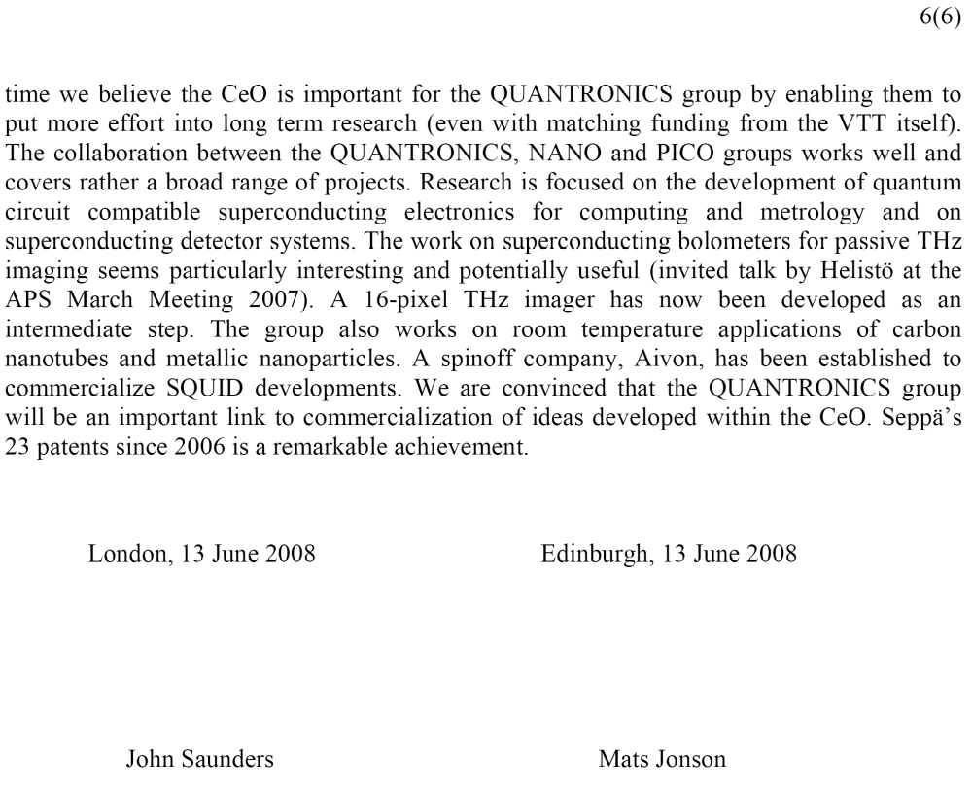

APPENDIX 2

APPENDIX 3
OVL Memorial Prize to Dr. Seiji Ogawa
Riitta Hari
1 April 2008
TKK
Ladies and Gentlemen,
It is my pleasure to introduce to you the recipient of the 2nd Olli V. Lounasmaa Memorial Prize, Dr. Seiji Ogawa, who will receive this award for his pioneering observations that have led to the emergence of functional magnetic resonance imaging of human brain function.
This Prize is to memorize and honor the late Academician Olli V. Lounasmaa who was the founder and a long-term director of our Low Temperature Laboratory and a higly respected scientist. In Finland Olli Lounasmaa is also remembered for his colourful opinions on science policy. Olli Lounasmaa passed away in December 2002 at the age of 72.
The memoirs of Olli Lounasmaa—edited by her daughter professor Kiti Müller—were published recently by The Finnish Society of Sciences and Lettres (Suomen Tiedeseura, Finska Vetenskaps-Societeten), which has kindly promised that the profit will support future Olli V. Lounasmaa Prizes; books are available also during this event.
Olli Lounasmaa, a low-temperature physicist, turned his interest into brain research after having reached his 50th birthday. Olli often said that two research problems go above all others: the generation of the universe in the big bang and the function of the human brain. Olli Lounasmaa very strongly supported and contributed to the development of all aspects of magnetoencephalography, MEG, from instrumentation to analysis and applications to neuroscience. The advantage of MEG is its high temporal resolution in following up how groups of brain cells speak to each other.
Today’s prize recipient has developed another noninvasive human brain imaging method, the functional magnetic resonance imaging, fMRI, that allows active brain sites to be pinpointed with millimeter precision.
Two thirds of the human body are water. With magnetic resonance imaging it is possible to follow the state and distribution of protons, the hydrogen nuclei in the tissue water. During a magnetic resonance imaging, the person under study is put into a strong magnetic field—several teslas in strength—and brief magnetic pulses are sent to her to excite the protons. On the basis of the returning radio-frequency signals an image is formed of the structure of the tissue, for example of the brain.
Dr. Ogawa went one important step further, advancing the method from structural to functional. He demonstrated that it is possible to use deoxy-hemoglobin as the body’s own contrast agent. Deoxy-hemoglobin—that is hemoglobin that has already given away the oxygen it was carrying—is paramagnetic, meaning that it forms a tiny magnetic distortion, susceptibility change, around the red cell in which it is located. This change will alter the behavior of closeby protons, and it is thereby possible to detect with MRI where in the brain the blood oxygenation level—called BOLD—has changed. Consequently, spatially accurate information is obtained about active brain sites.
The discovery of the BOLD signal by Seiji Ogawa in the early 1990’s has given rise to a massive expansion of noninvasive human brain imaging. One contributing factor for the very rapid spread of fMRI was that clinical magnets were available in several places, and it was possbile to adapt the fMRI protocol to them. Currently, fMRI-compatible magnets are available at about 10 000 sites all over the world, and fMRI is used for very different types of human brain imaging, from basic neuroscience to clinical applications, especially in neurology and psychiatry.
Seiji Ogawa studied applied physics at the University of Tokyo, Japan and then moved to USA where he made his PhD in chemistry at Stanford University in 1967.
After a postdoctoral year at Stanford, Dr. Ogawa joined in 1968 the Bell Laboratories in New Jersey, where he stayed over 30 years. In 2001 he moved back to Japan to lead Ogawa Laboratories for Brain Function Research in Tokyo. Dr. Ogawa is currently affiliated with Tohoku-Fukushi University in Sendai, Japan
Dr. Ogawa has received multiple international honors for opening the field of functional MRI. I here mention only the prestigious Japan International Prize 2003 from the Science and Technology Foundation of Japan.
Today Dr. Ogawa will give us a lecture about “BOLD-based fMRI: Its beginning and a new approach”
But before that I would like to ask the Rector of the Helsinki University of Technology, Matti Pursula to give the official certificate to Dr. Ogawa; I would also like to thank the University for support for this year’s Prize.
Ladies and Gentlemen, please welcome the recipient of the 2nd Olli V. Lounasmaa Memorial Prize.

