

Measuring Levels of Privacy Concern: Context and Trade-offs Between Competing Desires

An empirical research project presented to the

School of Information Management

Victoria University of Wellington

in partial fulfilment of the requirements for the degree of

Master of Information Management
(MIM)

By

Anne Yau
14th December 2006
PREFACE

I certify that the Report is my own work and all references are accurately reported.

This report is not confidential.

Anne Yau
December 2006

SYNOPSIS

Whether justified in philosophical, political or utilitarian terms, privacy is almost always seen as a claim or right of individuals that is under threat. The proliferation of computers, networks, electronic information services and digital data has increased concern about privacy to the extent that, according to The Economist, it is doomed. This view is mostly portrayed in overseas literature, particularly from the United States. But how concerned are New Zealanders about privacy? This is one of the main areas of investigation in this research project. This study also examines New Zealanders’ privacy attitudes and behaviour regarding the use of technologies, and the relative importance of privacy and the benefits of technologies.

Using Alan Westin’s privacy index to measure the level of concern about privacy, this study found that the level of concern amongst New Zealanders was low compared to that of the United States and UK. The large majority of respondents were neither concerned nor unconcerned about privacy but were pragmatic about the privacy issues associated with the use of technology. This study showed that while privacy is a consideration in the use of technologies, it was clear that many respondents valued the convenience and benefits of technology more than privacy when presented with these choices in specific contexts.

The prominence of the Internet and the increased potential for unauthorised access to information through its interconnectedness has led to greater concern about information security than information privacy. Most respondents took some steps to protect the security and privacy of their information. However, respondents took more measures to keep their information secure than to protect information privacy.

CONTENTS
PREFACE 1
SYNOPSIS 2
1. INTRODUCTION 6
2. LITERATURE REVIEW 8
2.1 The Concept of Privacy 8
2.2 The Privacy Balance Paradigm 11
2.3 The Privacy Issue – the Impact of Information Technologies 13
2.4 Privacy Concerns and Regulatory Approaches 16
2.5 Measuring Privacy Concerns: Westin’s ‘Privacy Index’ 20
2.6 Challenges of Researching Privacy 22
2.7 Privacy studies/surveys in New Zealand 26
3. RESEARCH METHODOLOGY 29
3.1 Sample 30
3.2 Questionnaire Design 30
4. RESULTS 35
4.1 Background Data 35
4.2 Important factors or concerns in the use of technologies 37
4.3 Attitudes regarding Collection and protection of personal information 40
4.4 The trade-off between the benefits of technology and privacy 45
4.5 Are New Zealanders really concerned about privacy? 47
4.6 Segmentation of the sample 48
4.7 Description of Segments 50
4.8 Correlation between Attitudes and Behaviour 53
5. DISCUSSION 57
5.1 The Concept of Privacy 57
5.2 Level of concern about privacy in New Zealand 58
5.3 Privacy attitudes and behaviour 60
5.4 The trade-off between privacy and the benefits of technology 64
6. LIMITATIONS AND FUTURE RESEARCH 66
7. CONCLUSION 68
BIBLIOGRAPHY 71
APPENDICES
Appendix 1: Questionnaire 76
Appendix 2: ANOVA – Importance of or concern for collection of personal information 81
Appendix 3: ANOVA – Attitude regarding the control or handling of the collection of personal information 82
Appendix 4: ANOVA – Practices to protect personal information 83
Appendix 5: ANOVA – Relative importance (trade-offs) of the benefits versus the privacy implications of technology use 85
Appendix 6: Example correlations – total sample 87
Appendix 7: Example correlations – collection, handling and use of personal information 88
Appendix 8: Example correlations – E-commerce and information security 91
Appendix 9: Sample correlations – concerns and behaviour 93
Appendix 10: Example correlations – Trade-off scenarios 94
FIGURES
Figure 1: Relationship between nationality, cultural values, levels of privacy concerns and regulatory approaches to privacy protection………………………. | 16
Figure 2: Level of Government Involvement in Privacy Management…………... | 18
Figure 3: Example question from ORC International Survey 2002……………… | 33

TABLES
Table 1: Gender…………………………………………………………………….. | 35
Table 2: Age………………………………………………………………………..... | 35
Table 3: Use of technologies………………………………………........................... | 36
Table 4: Unprompted important factors or concerns in the use of technologies.. | 37
Table 5: Importance of and concern about specified factors in the use of technologies……………………………………………………................................... | 38
Table 6: Collection and handling of information………….……………………… | 40
Table 7: Legal protection of privacy and responsibility for protection…………. | 41
Table 8: Attitudes regarding technology and personal information…………….. | 42
Table 9: Practices to protect personal information………………………………. | 43
Table 10: Trade-off between benefits and privacy………………………………... | 45
Table 11: Levels of concern about privacy: New Zealand, United States and UK | 47

INTRODUCTION
Privacy is doomed… get used to it. (The Economist, 1999)

Whether justified in philosophical, political or utilitarian terms, privacy is almost always seen as a claim or right of individuals. Privacy is also seen as a right that is constantly under threat. The proliferation of computers, networks, electronic information services and digital data has increased concern about privacy to the extent that, according to The Economist, it is doomed. This theme has been represented in and arguably reinforced by a large corpus of literature and even popular media with films like Gattacca and Minority Report. Smith (as cited in Bennett & Raab, 2003) maintained that a steady flow of stories about the intrusive nature of modern technology, about the abuse and misuse of personal data, and about the size and interconnectedness of contemporary information systems has had a steady impact on public and political consciousness.

This view that privacy is being eroded, dying, vanishing, is mostly portrayed in overseas literature, particularly from the United States. Privacy is a highly subjective and contextual subject, and should be considered (along with other factors) in the framework of cultural values and regulatory approach to privacy protection. Therefore, one of the main areas for investigation in this research project is: How concerned are New Zealanders about privacy? Is privacy as big an issue in the New Zealand context, as it appears to be overseas?

This research project also aims to examine New Zealanders’ privacy attitudes and behaviour regarding the use of technologies, and the relative importance of privacy and the benefits of technologies.

The central research questions of this study are therefore:
- How concerned are New Zealanders about privacy?
- What are the privacy attitudes and behaviours, values and benefits associated with the use of technologies?
- How important is privacy compared to these values and benefits, how do New Zealanders view the trade-off between these competing desires?

LITERATURE REVIEW

This section provides background to the research through a review of some of the literature on privacy. The literature review is focused on those areas central to the scope of this research.

The Concept of Privacy
What is privacy? It is an almost customary feature of any analysis of privacy to begin with a disclaimer about the inherent difficulty of defining exactly what ‘privacy’ is and disaggregating its various dimensions. It is something that is taken for granted and most people would have a sense of what privacy is but have difficulty putting it into words. The concept and meaning of privacy has long been debated by philosophers, social scientists, academic lawyers and other scholars. All definitions, to some extent, are based on assumptions about individualism and about the distinction between the realms of civil society and the state. However, many gloss over essential cultural, class-related and gender differences. Literature on privacy tends to give readers an overwhelming sense that privacy is a deeply contested concept, which often varies according to context and environment. (Bennett & Grant, 1999)

According to Bennett and Raab (2003), in Western culture, the modern claim to privacy and the contemporary justification for information privacy as a public policy goal was derived from a notion of a boundary between the individual and other individuals, and between the individual and the state. This concept of privacy rests on a construct of society as comprising relatively autonomous individuals and on notions of differences between the privacy claims and interests of different individuals. According to John Stuart Mill (as cited in Bennett & Raab, 2003), there should be certain ‘self-regarding’ activities of private concern, contrasted with ‘other-regarding’ activities to community interest and regulation. Shils (as cited in Bennett & Raab, 2003) argued that privacy is essential for the strength of American pluralistic democracy because it bolsters the boundaries between competing and countervailing centres of power. Dr Alan Westin, a leading academic (whose book Privacy and Freedom has shaped virtually all current thinking about privacy as a public issue), reinforced the importance of privacy for liberal democratic societies – in contrast to totalitarian regimes:
A balance that ensures strong citadels of individual and group privacy and limits both disclosure and surveillance is a prerequisite for liberal democratic societies. The democratic society relies on publicity as a control over government, and on privacy as a shield for group and individual life. (Westin, 1967, p24)

Westin also addresses the specific functions that privacy plays. It promotes freedom of association. It shields scholarship and science from unnecessary interference by government. It permits the use of a secret ballot and protects the voting process by forbidding government surveillance of a citizen’s past voting record. It restrains improper police conduct such as unreasonable search and seizure. It also serves to shield those institutions, such as the press, that operate to keep government accountable.

In a seminal law review article Samuel Warren and Louis Brandeis (1890) defined privacy simply as “the right to be let alone” – to go about life free from unreasonable interference by external forces.

Privacy has also been defined comprehensively:
Privacy is a concept related to solitude, secrecy, and autonomy, but it is not synonymous with these terms; for beyond the purely descriptive aspects of privacy as isolation from the company, the curiosity, and the influence of others, privacy implies a normative element: the right to exclusive control of access to private realms… the right to privacy asserts the sacredness of the person;… any invasion of privacy constitutes an offence against the rights of the personality – against individuality, dignity, and freedom. Arnold Simmel (as cited in Cavoukian & Tapscott, 1997)

Privacy can be divided into the following facets (Rosenberg, 2004; Banisar & Davies, 1999):
- Territorial privacy – concerning the setting of limits on intrusion into the domestic and other environments such as the workplace or public space.
- Privacy of the person – this is concerned with protecting a person against undue interferences such as physical searches and drug testing, and information that violates his or her moral sense;
- Privacy of communications, covering the security and privacy of mail, telephones, email and other forms of communication;
- Privacy in the information context – this deals with the gathering, compilation and selective dissemination of personal information such as credit data and medical records.

The discourse on privacy as a policy issue has largely focused on information privacy and it is this facet of privacy that this research project will focus on. In this sense, privacy can be defined as “the claim of individuals, groups or institutions to determine for themselves when, how and to what extent information about them is communicated to others.” (Westin, 1967, p7)

However, the rise to prominence of Internet communications and e-commerce has led to privacy of communications (and transmission) attracting more attention and concern. The increased concern with privacy of communications has caused some confusion between the meanings of information privacy and information security and the terms are often used interchangeably. As Clarke noted (as cited in Bennett & Raab, 2003), the term ‘privacy’ is used by some people to refer to the security of data or security of data during transmission as protection against various risks, such as data being accessed or modified by unauthorised persons. These aspects, however, are only a small fraction of the considerations within the field of ‘information privacy’. That is, data security is a necessary but not sufficient condition for information privacy. An organisation might keep the personal information it collects highly secure, but if it should not be collecting that information in the first place, the individual’s information privacy rights are clearly violated.

The Privacy Balance Paradigm
While privacy is a necessary element of quality of life in modern society, protecting privacy also imposes real costs on individuals and institutions. It can facilitate the dissemination of false information by making discovery of that falsity more difficult or impossible, for example, when a job applicant lies about his previous employment. Or it may protect the withholding of relevant information, as, for example, when an airline pilot fails to disclose a medical condition that might affect job performance. Privacy interferes with the collection, organisation and storage of information on which organisations can draw to make rapid, informed decisions, such as whether to grant credit or welfare assistance. As these examples suggest, the cost of privacy may be high. (Cate, 1997)

The price of privacy can also be measured in social as well as economic terms. Privacy may threaten safety. For example, in light of the evidence concerning recidivism among child molesters and other sexual offenders, protections against disclosure of past offences interfere with the public’s ability to learn the necessary information to protect itself.

Privacy may be seen as an anti-social construct. It recognises the right of individuals, as opposed to anyone else, to determine what they will reveal about themselves. As a result, privacy conflicts with other important values within society, such as society’s interest in facilitating free expression, preventing and punishing crime, protecting private property and conducting government operations efficiently. To the extent that legal protections and social mores concerning privacy interfere with the acquisition and use of information, privacy may even conflict with the interests of the persons whose privacy is being protected. If someone requires emergency medical attention, but privacy laws interfere with the hospital obtaining their medical records, they may face risks of incorrect diagnosis or treatment. Instant credit, better targeted mass mailings, lower insurance rates, special recognition for frequent travellers, and countless other benefits come only at the expense of some degree of privacy. (Cate, 1997)

Privacy values are therefore constantly in tension with other values. Privacy is not an absolute. It is contextual and subjective. It is neither inherently beneficial nor harmful, but involves a complex aggregation of positive and negative attributes. Moreover one’s individual privacy interests may conflict with another’s, with the interests of society, or even with others of his own interests. What is needed is a balance, of which privacy is a part. Determining what that part is in any specific context requires a careful evaluation of subjective, variable and competing interests such as cost, convenience, and quality and variety of services. (Cate, 1997)

Privacy protection in law and practice also involves a balance between competing values in order to achieve a result that safeguards individual privacy while accommodating other important social, political and economic ends (Raab, 1999). This doctrine of ‘balance’ constitutes the prevailing model for privacy protection and was largely shaped by Westin and his work Privacy and Freedom (1967).

However, Raab (1999) questions whether its premises and their practical implementation have really been scrutinised. For example, he points out that the ‘right balance’ as adjudged by policy makers or by privacy regulators, might result in less or more privacy. The point of balance struck between convenience and confidentiality, between privacy and public interest, is different for different individuals, and it changes. Yesterday’s balance might not be today’s; what is right or acceptable in one country might not do in another. Technological change often renders old balances obsolete. There may be many different points of view to be taken into balance on each issue, not just two. Moreover, the importance of the anti-privacy values or interests may be variable and disrupted, so that data users and data subjects might disagree strongly on whether a particular compromise constitutes a balance between their points of view.

Raab also argued that in implementing policy, there are several dangers in the balancing process. One is that interests and values might be irreconcilable, so that no bargains can be struck. Another, conversely, is that balances are all too easily struck at a certain level, so that privacy is traded off in concessions to surveillance, rather than restricting it. This could be because power positions are unequal, with privacy as typically “what’s left over when all other interests are satisfied” (Westwood, 1999, p 240). Therefore Raab suggests that steering towards privacy is perhaps a better paradigm for privacy protection. Steering towards privacy would imply that incursions need to be legitimated, rather than the other way around and that it would be based on the premise that data collection and processing should be minimised and justified.

In contrast to Raab, Etzioni (1999) argued that a responsive communitarian approach to privacy protection is required, where policy makers and regulators would seek to balance individual rights with social responsibilities, and individuality with community. The responsive communitarism approach evolved in response to the dramatic shift in American society between 1960 and 1990 toward individualism. In a communitarian paradigm, privacy is not treated as a good one seeks to maximise in and of itself. Privacy would not be extended to the point where it undermines the common good; conversely, duties set to maintain social order cannot be expanded to the point where they destroy privacy. Thus, policymakers and citizens who advocate the communitarian ideal of equilibrium between privacy and the common good may seek to limit privacy when doing so will yield major gains in public safety and health and no viable alternatives are available.

The Privacy Issue – the Impact of Information Technologies
The personal life of every individual is based on secrecy, and perhaps it is partly for that reason that civilized man is so nervously anxious that personal privacy should be respected. Anton Chekhov (1860-1904)

Privacy has always been under challenge throughout recorded Western history - by social and technological forces (Flaherty, 1999; Bennett & Raab, 2003). Flaherty (as cited in Rule, McAdam, Stearns & Uglow, 1980) in his work Privacy in Colonial New England described some aspects of early New England life as outrageously intrusive by today’s standards; for example, throughout Puritan settlements, the local law-enforcement officers were expected to concern themselves not only with crimes against persons and property, but also with lapses from strict Puritan morality. Thus they were charged to report “… stubborn and disorderly children and servants, nightwalkers…persons whatsoever tending to debauchery … or idle, profligate, uncivil and rude practices of any sort.” (Flaherty, as cited in Rule et al, 1999, p 13)

A more recent example of an attack on privacy from a social force is the United States government’s response to the 9/11 terrorist attacks. The USA Patriot Act 2001 was introduced to expand the government’s powers to fight terrorism through such means as electronic surveillance, physical searches and access to business records, and heightened homeland security through, for example, more rigorous scrutiny of travellers at borders.

Technological forces have long threatened privacy - since the invention of written communication. In recording people’s personal information, including their past misdeeds and shortcomings, a desirable element of “forgetfulness” in social relationships may be eroded (Rule et al, 1980). In more recent times there has been the telegraph, telephone, camera, which in their turn, were each viewed as highly invasive of personal privacy. For example, in the 19th century, the telegraph made the content of communications vulnerable to the actions of the curious and to “those who stand at the centre of society, in positions of authority in political, administrative, and cultural institutions” (Shils, as cited in Rule et al, 1980, p 17). Seipp (as cited in Rule et al, 1980) recounted the successful effort of the Lincoln administration to monitor telegraph communications during the early months of the American Civil War. Clearly the association between extreme demands on personal privacy and overriding “reasons of state” was as strong then as now.

The current concern about privacy emerged in the 1960s with the advent of the large mainframe computer and grew with the rapid spread of information and communication technologies into every facet of life. Exponential increases in computing power, and dramatic decreases in the physical size of computers and other communication devices, along with the development of the Internet has led to more and more data, at lower cost being collected, accessed, manipulated and stored, especially from disparate, geographically distant, locations.

However, technology by itself does not violate privacy: it is the people using this technology and the policies they carry out that create violations (Garfinkel, 2001). As Rule et al (1980) stated, the privacy issue is not entirely the result of new technologies, but the result of uses of technologies which have been with us for a long time. They contend that the social structures of advanced industrial society gave rise to distinctive demands (often but not always abetted by new technologies) for personal information. The characteristics of modern society that encouraged demand for personal information are: the ability to treat information as an independent resource; the specialisation of social functions; and the formal organisation. These conditions led to the emergence of the bureaucracy, or as Shils (as cited in Rule et al, 1980) identified as the centres of power - powerful but distant social entities, usually agencies specialising in information-handling. In order for bureaucracies to render to each individual customer their precise ‘due’ in light of their history and current situation, they must base any actions on detailed personal information. This apparently insatiable appetite for information was satisfied by the computer’s ability to electronically link diverse databases of information relating to the same individual. Thus, vast amounts of personal information could be compiled relatively easily. As organisations grew larger and information technologies became more pervasive and more powerful, the potential for surveillance through the use of data (or ‘dataveillance’) grew dramatically and heightened the capacity for the gradual but steady erosion of privacy (Cavoukian & Tapscott, 1997).

Whether privacy is being threatened by social or technological forces, there is a large body of literature that portrays privacy as something that ‘we’ once had; and now it is something that public and private organisations employing the latest information and communication technologies are eroding or denying us. Such literature is often written in polemical tones, and Orwellian metaphors and imagery abound. Such has been the extent of anxiety on the topic that the Economist magazine proclaimed in an editorial: “Privacy is doomed… get used to it.” (The Economist, 1999)

Privacy Concerns and Regulatory Approaches
To what extent is the public anxious about privacy? Bennett and Raab (1999) questioned the view that privacy was being eroded, vanishing or diminishing. They contend that “We simply do not know whether we would have enjoyed higher ‘levels’ of privacy in the past” (p27). They ask how does one calibrate a ‘level’ of privacy or privacy concern, and who are ‘we’. These measurements are highly subjective and dependent on a range of diverse contextual circumstances.

Milberg, Burke, Smith and Kallman (1995) in their study of the relationships between nationality, cultural values, level of privacy concerns and regulatory approaches found that differing privacy concerns and values have an impact on the regulatory approach to privacy protection embraced by a particular country. They also found that there may be a reciprocal relationship, in which a country’s regulatory approach affects its inhabitants’ levels of concern. Thus the relationship between levels of privacy concern and regulatory approach is two way. (See Figure 1)

Figure 1. Relationship between nationality, cultural values, levels of privacy concerns and regulatory approaches to privacy protection (Milberg et al, 1995)

Values
Nationality
Regulatory
Approaches
Privacy
Concerns

Milberg et al (1995) found that:
- Levels of personal information privacy concern differed across countries;
- Respondents in high “uncertainty avoidance”, high “power distance” or high “individualism” countries exhibited higher levels of concern regarding information privacy;
- Countries with higher levels of “uncertainty avoidance” or “power distance” exhibited higher levels of government involvement in regulating information privacy; while countries with higher levels of “individualism” exhibited less government involvement and more individualistic approaches to regulating information privacy.
- Lower levels of privacy concern was associated with both countries with no privacy regulation and countries with high levels of government involvement in privacy management; and higher levels of privacy concern will be associated with lower to moderate government involvement.

Thus, as pointed out by a number of other authors (Bennett, 1992; Flaherty, 1989; Smith, 1994; cited in Milberg et al, 1995) Milberg et al concluded that regulatory responses usually occur in reaction to a growing level of discontent within the populace, which is translated to legislation in some form. The Milberg et al study also concluded that there is a reciprocal relationship between regulatory structure and levels of privacy concern, that is, regulation will increase as concern increases to a point at which regulation is sufficient to dampen concerns; then concerns will relax as the regulation becomes embedded.

The Milberg et al study used the works of Bennett (as cited in Milberg et al, 1995) and Smith (1994) to classify privacy regulation approaches as being on a spectrum ranging from self-help at the lower regulation end to licensing at the other. Bennett’s models of privacy regulation are based on the nature and level of protection afforded by legislation and mechanism for compliance. While none of the models has been observed in its pure form, countries adopt one (or a combination) of the approaches to some extent.
Figure 2. Level of Government Involvement in Privacy Management (Smith, 1994)
Lower
Higher
Medium
Self-help
Voluntary
Control
Data
Commissioner
Registration
Licensing

The five models, from least government involvement to most (see Figure 2) are:
- The Self-help model – depends on data subjects challenging inappropriate record-keeping practices. Rights of access and correction are provided for data subjects, but they are responsible for identifying problems and bringing them to the courts for resolution.
- The Voluntary model – relies on self-regulation on the part of organisational players. The law defines specific rules and requires that a “responsible person” in each organisation ensures compliance.
- The Data Commissioner model – relies on the ombudsman concept through a commissioner’s office. The commissioner has no powers of regulation but advises and educates on data handling; monitors technology and make proposals; performs some inspections of data processing operations; and investigates complaints from, and to some extent acts as an advocate for, citizens.
- The Registration model – requires databases to be registered with a government enforcement agency, who would stipulate specific conditions for collection, storage and use of personal data. Organisations would not be prevented from creating databases but where complaints are received and an investigation reveals a failure to adhere to data protection principles, the system would be ‘deregistered’. Thus this model provides remedial rather than anticipatory enforcement of principles.
- The Licensing model – is much like the registration model and requires organisations with databases to be licensed. This model, however, anticipates potential problems and heads them off by requiring a prior approval for any use of data.

At the lower end of the privacy protection spectrum is the United States, whose system falls into the voluntary model, and affords little protection for the individual, especially in the private sector. Although the United States has The Federal Privacy Act 1974, it only regulates the collection, maintenance, use and disclosure of personal information by the department, agencies, offices and administrations of the federal government. Protection in the private sector relies on sectoral laws and self-regulation and according to Cate (1997. p98) “is disjointed, inconsistent and limited by conflicting interests”.

In an environment which is highly competitive and in which sectoral and self regulation is predominant, industries whose survival depends upon the capture, storage, transmission and processing of information about individuals will naturally want to limit privacy protection regulations. Policy development and the political system in the United States can be subject to strong and influential lobbying from commercial interests (Gandy, 2003). Critics of the United States approach to privacy protection have also argued that the approach’s lack of a single oversight agency is problematic and enforcement can be lax (Kim, 2006).

Toward the higher end of the privacy protection spectrum are the systems of some European countries and New Zealand, which provide comprehensive protection for the individual through legislation that covers the collection and use of personal information by both the public and private sector, complemented by sectoral laws and an oversight agency.

The New Zealand privacy regime would be classified as a data commissioner model. New Zealand’s Privacy Act 1993 covers both the public and private sector, and includes several industry codes of practice, for example, the Telecommunications Information Privacy Code. Compliance of the Privacy Act is administered by the Office of the Privacy Commissioner, an independent Crown entity. Some of the Privacy Commissioner’s functions include investigating complaints about breaches of privacy, promoting and educating privacy best practice, and examining proposed legislation and how it may affect individual privacy. As well as legislated industry codes of practice, privacy best practice is also often reflected in voluntary codes of practice such as the Marketing Association’s Code of Practice for Direct Marketing.

The UK regulatory model is also at the higher end of government involvement in privacy protection. It is classified as the Registration model which requires databases to be registered with a government enforcement agency, who would stipulate specific conditions for collection, storage and use of personal data.

Measuring Privacy Concerns: Westin’s ‘Privacy Index’
Since the late 1970s Dr. Alan Westin, has conducted over 30 privacy surveys in the United States. He has created a privacy index to summarise the survey results and show trends in privacy concern (Kumaraguru & Cranor, 2005).

In his surveys from 1995 to 2003 Westin based the privacy index on agreement or disagreement with the following statements:
- Consumers have lost all control over how personal information is collected and used by companies.
- Most businesses handle the personal information they collect about consumers in a proper and confidential way.
- Existing laws and organisational practices provide a reasonable level of protection for consumer privacy today.

Westin then classified the public into three categories:
- Privacy Fundamentalists - those respondents who agreed with the first statement and disagreed with the second and third statements.
- Privacy Unconcerned - those disagreed with the first statement and agreed with the second and third statements
- Privacy Pragmatists - all other respondents.

Westin’s privacy index has been used in other studies to both segment their results and as a benchmark with which they can compare their own survey results (Acquisti & Grossklags, 2004; Joinson, Paine and Reips, 2005).
However, Kumaraguru and Cranor (2005) warn that although Westin’s research is of use to privacy researchers, his surveys were usually conducted in the context of studies commissioned by corporations that intended to use the results as part of their efforts to influence the public policy process.

Westin’s segmentation has also been criticised for the labels and terms he has used to describe the segments. The Electronic Privacy Information Center (EPIC) contends that Westin’s segmentation is geared towards the message that those who care about privacy are unreasonable, and public policy should be designed for the middle group (EPIC).

EPIC argued that Westin has chosen pejorative terms to describe those who care a great deal about privacy – “fundamentalists”. Privacy fundamentalists are those who are "passionate about what they see as business threats to their consumer privacy and favour active government regulation of business information practices." They believe that "consumers have lost all control over how personal information is collected and used by companies." Westin has chosen to label another segment with a term that has positive value -"pragmatists." Westin further portrays "pragmatists" in a positive light by describing them as a "middle group with balanced privacy attitudes".

Challenges of Researching Privacy
The subject of privacy has many facets, is very complex, and is a highly subjective and contextual issue. As a result, privacy research faces many challenges in addition to those already encountered generally in surveys and research.

As discussed earlier, the concept of privacy is difficult to define. The vagueness and contestability of the definition of privacy makes it more difficult to measure than other objects of public concern, such as environmental pollution (Bennett & Raab, 2003). If privacy cannot be defined satisfactorily, then it is also difficult to select measurement criteria that could be used unambiguously and objectively. Moreover, measures of people’s feelings about the extent to which privacy is ensured or invaded cannot assume that the researchers and the respondents intra or inter surveys had the same concept of privacy in mind.

Beyond the definitional aspects, people's responses are subject to situational relativity. A person who has a current health condition that is embarrassing to them might well be more likely to place a high value on health care data relative to other data, or to other interests. A person's attitudes to the disclosure of details on a doctor's certificate supporting an employee's absence from work are likely to vary depending on whether they are interviewed in the context of their role as an affected employee or as a supervisor. (Clarke, 2002)

Agre & Rotenburg (1997) pointed out that the extreme lack of transparency in societal transfers of data gives the issue a nebulous character. Citizens may be aware that they suffer harm from the circulation of computerised information about them, but they usually cannot reconstruct the connections. This may account in part for some of the striking mismatch between public expression of concern in opinion polls and the lack of popular mobilisation in support of privacy rights.

Harper and Singleton (2001) also found in their study that consumer demand or concern for privacy is high, but was not backed up by evidence of consumer behaviour. They found that only a small percentage of consumers opt out of marketing lists, regularly change their passwords or use encryption.

This apparent dichotomy between privacy attitudes and actual behaviour was investigated by Acquisti and Grossklags (2005). Their survey found that not surprisingly, concerns for privacy were correlated to how important an individual regards privacy to be. However, by contrasting privacy importance and privacy concerns, Acquisti and Grossklags found that for those who most regard privacy as important, concerns were not always equally intense.

The survey also investigated privacy-related behaviour in the use of several privacy technologies or strategies and found a multifaceted picture. Usage of specific privacy technologies or strategies was consistently low – for example, only 33 percent of their sample encrypted their emails, 18 percent had put a credit alert on their credit report, and 17 percent had removed their phone numbers from public directories. However, aggregating usage, at least 75 percent did adopt at least one strategy or technology. Acquisti and Grossklags contend that these results indicate a multifaceted behaviour: because privacy is a personal concept, not all individuals protect it all the time. Nor do they have the same strategies or motivations. But most do act in some way.

Acquisti and Grossklags also pointed out that when comparing privacy attitudes with reported behaviour, individuals’ generic attitudes may appear to contradict their attitudes in specific situations, because as according to Fishbein and Ajzen (as cited in Acquisti & Grossklags, 2005) a person’s generic attitude might be affected by different factors than those influencing her conduct in a specific situation. An example of such attitude/behaviour dichotomy was found in a Mass Insight survey (2000). When asked about technology generally, 43 percent considered the benefits of technology more important than the privacy risks and 42 percent considered the privacy risks more serious than the technology benefits. However, when asked about the Internet the results were 56 percent and 27 percent respectively.

These dichotomies between attitudes and actual behaviour do not imply irrationality or reckless behaviour. The individual decision process with respect to privacy is affected and hampered by multiple factors, including (but not limited to) what they know, how much they care, and how costly and effective their actions they believe can be. Acquisti and Grossklags reported that although the respondents to their survey displayed sophisticated privacy attitudes and a certain level of privacy-consistent behaviour, their decision process seemed to be affected by incomplete information, bounded rationality and systematic psychological deviations from rationality.

Incomplete information resulted in an alternation of awareness and unawareness from one scenario to the other. For example, in Acquisti and Grossklags’ survey 84 percent of respondents believed that it is most or very likely that information revealed during an e-commerce transaction would be used for marketing purposes. Yet in their technologically savvy and educated sample, over 70 percent could not name or describe an activity or technology to that would allow them to browse the Internet anonymously and to prevent others from identifying their IP address.

Bounded rationality limits people’s ability to acquire, memorise and process all relevant information, and makes it necessary to rely on simplified mental models, approximate strategies and heuristics. An example of simplified mental models was evident when some respondents commented that if a transaction with the merchant was secure, nobody else would be able to see data about the transaction. However the security of a transaction does not imply its privacy. Yet, security and privacy seem to be synonyms in simplified mental models of certain individuals.

A vast body of economic and psychological literature has revealed several forms of psychological deviations from rationality that affect decision making, many of which would apply to privacy-sensitive scenarios. Examples are an idiosyncrasy between losses and gains (in general, losses are weighted heavier than gains of the same absolute value) and a tendency to trade off costs and benefits in ways that damage their future utility in favour of immediate gratification. Acquisti and Grossklags suggested that respondents’ behaviour regarding use of privacy-related technology was an example of discounting, where people have a systematic bias to overrate the present over the future. They reported that over 50 percent of respondents used answering machines or caller-ID to screen calls or have registered their numbers in a do-not-call list. However, 82 percent have never put a credit alert on their credit report. The negative consequences of not using this protection could be much more damaging than the nuisances associated with unwanted phone calls. The negative consequences are also postponed and uncertain, while the activation costs are immediate and certain.

Another common problem with privacy surveys is that many distinguish poorly among the variety of issues relating to modern uses of personal information. Thus, credit card fraud and identity fraud may be referred to as privacy problems, even though these things are crime problems unrelated to legitimate uses of information. Spam and junk mail may be referred to as privacy problems even though they are better characterised as matters of annoyance and inconvenience. “Privacy” may also be used interchangeably with “security”. They are related, but as explained under Section 2.1 security is a necessary but not sufficient condition for information privacy.

Many surveys on privacy issues only ask questions about “how concerned” individuals are about privacy. “Concerned” is a ‘loaded’ word and results can be misleading as to the strength of consumers’ interest in privacy. As one would expect survey results typically show respondents reporting they are concerned or very concerned about privacy, or with particular uses of information. But this does not reveal how consumers feel about privacy in comparison to other concerns.

Do consumers actually go through their days worrying about the privacy of medical information in health providers’ databases, or do they worry more about the security of their homes from break-ins? If given a choice of how to spend five minutes, would a consumer read a magazine, opt out of having personal data being used by their bank for product promotions, look up what a “cookie” is online, or watch the sun set? Privacy surveys do not tell policymakers such answers. But it is choices like these that are the best indicators of true levels of “concern” (Harper & Singleton, 2001). Moreover, these surveys often fail to explain the nature of the concerns or identify the associated causes.

Similarly, a full picture of the trade-offs between privacy and other consumer desires is rarely offered in surveys (Harper & Singleton, 2001). Polls and surveys cannot effectively replicate the choices that individuals make in the real world, where they must choose among competing desires. While privacy may be a concern for consumers, it is also clear that they value the previously unavailable conveniences that technology provides. Most people have found their lives improved in small ways by technological innovation – from automated teller machines to the convenience cards that earn savings at the supermarket without the bother of clipping coupons. Consumers are increasingly purchasing goods and services on-line and use the Internet for everything from paying bills to researching their next holiday. The question is, at what point do privacy concerns outweigh the convenience of technology? (Mass Insight Corporation, 2000)

Privacy studies/surveys in New Zealand
There has been little research into privacy concerns in New Zealand. From the limited number of studies into privacy in New Zealand it appears that the level of concern about privacy is not high (sixth out of nine major policy issues tested – see below). Many of the concerns that they did have were related to the Internet. In spite of these concerns many people continued to use the Internet because of its convenience.

The Office of the Privacy Commissioner (2006) survey provided a limited picture of the general public’s privacy concerns. The results of their 2006 telephone survey of a nationally representative sample of 750 New Zealanders included:
- Individual privacy rated 6th (7th in 2001) on the level of concern out of nine major policy issues tested. 56 percent (47 percent in 2001) of respondents declared they were concerned or very concerned. The highest concerns (with 73-75 percent concerned) were education, level of crime and violence and health services. Concerns about the power of government, unemployment and the possibility of a terrorist attack in New Zealand rated lower than the concern for privacy.
- 85 to 89 percent responded concerned or very concerned to various statements regarding handling of information by New Zealand businesses, for example, “a business that you don’t know gets hold of your personal information”.
- The highest level of concern amongst eleven privacy issues were recorded for the security of personal details on the Internet (84 percent) ahead of for example, confidentiality of medical records (78 percent), privacy of personal details held for credit reporting (67 percent), a compulsory ID for every New Zealander (50 percent) and data sharing between government departments (37 percent).

A comprehensive study into privacy in New Zealand was undertaken by Reilly and Cullen (2006) focusing on people’s experience with dealing with the government, the largest user of personal information. The purpose of this study was to investigate the relationship between privacy and trust, with an emphasis on how citizens’ concerns about, and experiences involving, information privacy are related to the level of trust they have in government organisations. The study involved a series of focus groups comprising a variety of community groups, a survey of individuals who had submitted privacy-related complaints to the Office of the Privacy Commissioner, and interviews with community representatives.

The main findings from the Reilly and Cullen (2006) study relevant to the questions areas for this research project are:
- Participants’ concerns about information privacy fell within two main categories: technology-related concerns (including the perception that there is greater potential for damaging privacy breaches, plus worries more closely associated with the Internet), and concerns specifically related to government organisations.
- The majority of participants were unaware of their rights in relation to information privacy, were unlikely to be aware of the Privacy Act of 1993, and were largely unfamiliar with the obligations placed on organisations that request and collect their information.
- The majority of participants felt confident that their personal information would be handled properly and be adequately protected by government and private business.
- Although nearly all participants reported having low levels of confidence in the privacy and security of the Internet, many continue to use online services (online banking, e-commerce and online auctions). Convenience was the most commonly cited benefit of using online services.

A Statistics New Zealand (2005) survey to provide information for its online census facility included the following results:
- 58 percent of respondents considered the Internet the least secure option for returning census forms. The main reasons were concerns about hackers and lack of trust in Internet security.
- Mixed level of agreement for the statement, “New technology is increasing the security of information that the Government collects about New Zealanders”. 30 percent of respondents agreed, 40 percent were neutral and 26 percent disagreed.

The results of the few studies into privacy in New Zealand suggests that privacy is not a major concern. This study set out to confirm this, using a measure which can be compared with other countries and thus placing the result into context especially with regard to the regulatory approach to privacy protection. The research also sought to examine New Zealanders’ privacy concerns, attitudes and behaviour in relation to the use of technology, in particular the relationship between concern/attitude and behaviour, and the trade-off between privacy and benefits.

RESEARCH METHODOLOGY

Research methodologies are generally categorised into two broad categories: quantitative research and qualitative research. The methodology used will depend on the objectives of the research questions. Where the objective of the research is to establish, confirm, or validate relationships and to develop generalizations that contribute to theory, a quantitative approach is more appropriate. If the intent of the research is to seek a better understanding of complex situations or to explore and interpret, and then use the observations to build a theory from the ground up, then a qualitative approach is best. (Leedy & Ormrod, 2001)

The main objective of this study was to examine and measure the extent of the public’s privacy concerns, attitudes and behaviour, including relationships between concerns/attitudes and behaviour. The research involved measuring the frequency and/or levels of characteristics or variables, and confirming or validating expected correlations between those characteristics. Therefore, the most appropriate methodology for measuring variables and establishing correlations was descriptive quantitative research. Descriptive quantitative research as opposed to experimental quantitative research (the other main type of quantitative research methodology) was appropriate because the study aimed to examine a situation as it is (Leedy & Ormrod, 2001). Experimental quantitative research involves changing or modifying the situation under investigation so that cause-and-effect relationships can be examined.

The data for the research was gathered through a questionnaire survey. Given the time and resource constraints, a questionnaire survey was conducted as opposed to a survey conducted face-to-face or by telephone. Obviously because a questionnaire does not require interviewing time, it allows a larger number of people and a wider cross-section of the population to be reached in a given amount of time.

Sample
The time and resource constraints of the research required the use of convenience groups. In order to get as wide a cross section of the public as possible, the sample was drawn from different sources. The questionnaire was distributed to 3 convenience groups known to the researcher and the research project supervisor (the groups will be described in more detail in Section 4.1):
- The author’s workplace – a government ministry. The large majority of these respondents have tertiary postgraduate qualifications and are in policy advisory positions.
- The quiz patrons of a suburban bar – this group could be expected to be knowledgeable and well read.
- Students of 2 School of Information Systems postgraduate classes – an Honours class and a post-experience Masters class.

To increase the response rate of the survey respondents were given a small incentive (chocolate bar) and were entered into a draw for CD vouchers.

Questionnaire Design
(See Appendix 1 for the questionnaire)

In designing the questionnaire there was three main considerations:
- Having some method of determining how concerned New Zealanders are about privacy but without asking respondents ’loaded’ questions including how concerned they are about particular issues;
- Being able to compare some of this research with a study from another country to place the results in context especially with regard to the culture and the characteristics of that country and their privacy regime. Comparisons of the results from this research, and approaches to privacy protection and other factors in New Zealand with that of another country may provide possible reasons for the results of this study;
- A means of finding out how respondents view the balance or trade-off between the benefits of a technology and any privacy issues associated with its use.

The questionnaire covered the following areas:
- Demographics and technology/service (Question 3) – to provide background on the respondents and to determine respondents’ frequency of use of technologies/services that have privacy-related issues associated with their use.
- Important factors or concerns when using technologies (Question 4) – this was an open-ended question and therefore did not prompt respondents about privacy issues. The objective of this question was to determine if privacy was a ‘top-of-mind’ concern for respondents.
- Importance of, or concern about, specific factors when using technologies (Question 5) – here respondents were asked to rate the importance/concern of factors such as convenience, cost, security of information. This was to determine how important privacy matters were compared with other factors.
- Practices to protect personal information (Question 6) – to find out what measures respondents took to protect their information, and to then compare action taken with their level of concern.
- A section with statements on familiarity with information protection required by law, attitudes towards how much information is collected, responsibility for protecting information and the impact of technology on privacy (Question 7).
- Weighing up the relative importance of benefits and privacy related to the use of technology in varying scenarios (Question 8) – this is discussed further below.

Measuring the privacy issue: segmentation
A major consideration in the questionnaire design was the ability to compare the research with that of another country. In order to do this the same questions must be asked. Despite criticism of Westin’s segmentation/index from EPIC (see Section 2.5), his method (with slight modifications) was included in this research to provide a useful starting point from which to determine how concerned New Zealanders are about privacy. Westin’s method was chosen for a number of reasons:
- It provided a measure of the general level of concern about privacy whereas other surveys found investigated specific privacy issues but did not measure general concern;
- It provided a means of segmenting the sample to enable investigation into the privacy characteristics of meaningful groups rather than of a large general public.
- A study in the UK also used Westin’s segmentation/index; therefore this research could be compared with both the United States and the UK studies.

The segmentation for this study is based on the following statements:
1. Consumers have little control over how personal information is collected and used by companies.
2. Consumers have little control over how personal information is collected and used by the government.
3. Most businesses handle the personal information they collect about consumers in a proper and confidential manner.
4. Existing laws and organisational practices provide a reasonable level of individual privacy today.

Westin’s segmentation included only 3 statements – he did not include statement 2 above. The author felt that a statement about government needed to be included as it is a significant collector and user of personal information and New Zealand’s privacy laws cover both the public and private sector.

Westin’s statement 1 was also slightly different (difference bolded) – “Consumers have lost all control over how personal information is collected and used by companies.” The author of this paper felt that this statement was too ’loaded’ in the New Zealand context. Therefore the “lost all” was tempered to “little”.
Using the same method of categorisation as Westin’s segmentation (see Section 2.5), the following categories were created:
- Privacy concerned – are the people who agree (strongly agree or agree) with statements 1 or 2, and disagree (strongly disagree or disagree) with statements 3 and 4;
- Privacy unconcerned – are the people who disagree with statements 1 or 2, and agree with statements 3 and 4; and
- Privacy pragmatists – the remainder.

The balance or trade-off between benefits and privacy
As noted in Section 2.6, Harper and Singleton (2001) pointed out that privacy research or surveys rarely offer insights into the trade-offs between privacy and other consumer desires. An ORC International (2002) telephone survey on biometric identification attempted to address this shortcoming by asking questions in the manner shown below.

Figure 3. Example question from ORC International Survey 2002

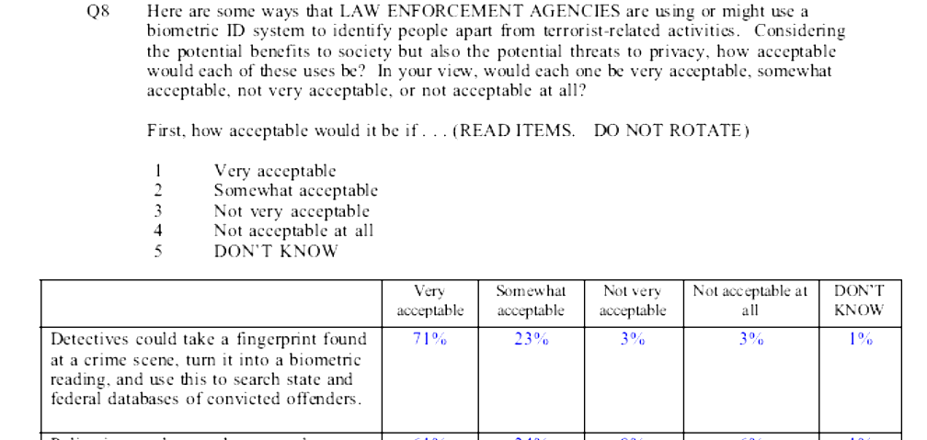
The ORC question provided the outcome of the weighing up of the competing desires but did not give an insight into the weighing up process in reaching such decisions, that is, what is the relative importance of the benefit and privacy. Therefore the above approach was modified so respondents were asked to consider scenarios of the use of technologies and indicate explicitly where they sat on the balancing scale between a specified benefit at one end and privacy at the other. The question (see Appendix 1, Question 8) was thus:
“Weighing up the benefits to you or society and the potential impact on privacy, dignity or security of personal information, where do you see yourself on the scale between the benefit at one end and your concern about privacy at the other, in deciding if that use is worthwhile or justified.”
Respondents were then asked to indicate their position on a Likert scale of 1 to 5 where 1 would mean that the benefit of the technology was so great that it outweighed any concerns about the privacy and 5 would mean vice versa. Analysis of the mean and frequencies of the scores would indicate the sample’s overall preference or concern for privacy in that context.

This approach attempts to provide a means of replicating some of the choices individuals make in the real world. In using a technology or service there are competing desires, for example, convenience or safety against privacy or cost. The approach enables the researcher to gain insights into the relative importance of those competing desires. This method of determining the trade-offs between privacy and benefits may as yet be untested – this is difficult to confirm as research articles and commercial or political polls do not always publish their questionnaires. This study will test the effectiveness of this technique. If successful the technique can be developed further to build a picture of the relative importance of many factors compared to privacy for a particular technology use, or of the relative importance of one factor compared to changing degrees of privacy invasion.

RESULTS

Questionnaires were distributed to 134 people and 117 responses were returned (all usable). Some statistics are based on less than 117 because of missing figures or ‘don’t know’ responses. Percentages are based on the valid sample for the question.

This section will report the results - discussion of the results will appear in the next section.

Background Data
Table 1. Gender
Gender | Percentage of total sample % | % of total 20-65 year olds in NZ*
Female | 43.6 | 52.2
Male | 56.4 | 47.8
*Statistics New Zealand Census 2001. Because of the Census age groupings and knowledge that very few if any cases are under 20 years or over 65 years, a narrower population provides a more meaningful comparison.

Table 2. Age
Age | Percentage of total sample % | % of total 20-65 year olds in NZ*
Under 30 | 16.4 | 22.4
30 – 49 | 58.6 | 51.2
50 plus | 25.0 | 26.4

The groups chosen to participate in the questionnaire survey were those easily accessed by the author; therefore the sample has inherent biases. The respondents are: all from Wellington; around 40 percent are in policy advisory positions - they and the university students are tertiary educated (compared with only about 10 percent in the total New Zealand population (Statistics New Zealand Census 2001)) with most having postgraduate qualifications; and the quiz patrons can be expected to be ‘well read’ and knowledgeable, and more likely to be in professional, technical or managerial occupations than the New Zealand general population (62 percent of the population in XXX suburb are in professional, technical or managerial occupations compared to 37 percent for the total New Zealand population Statistics New Zealand Census 2001)).

The selection of the population sample accounts for some of the skew towards males (56 percent), which in the same general population (20 – 65 years) is 48 percent, and towards the 30-49 age group (59 percent), which in the same general population is 51 percent (see Tables 1 and 2). The under 30 age group (16 percent) is under-represented in this sample – they are 23 percent of the 20-65 age general population.

Table 3. Use of technologies
 | Daily  % | Weekly  % | Monthly  % | Few times  a year % | Nil  %
Loyalty card | 6.8 | 47.0 | 17.9 | 13.7 | 14.5
Credit card | 21.4 | 47.0 | 17.9 | 6.8 | 6.8
Internet banking | 12.1 | 42.2 | 19.8 | 6.9 | 19.0
Internet purchasing | 0 | 2.6 | 34.8 | 50.4 | 12.2
Surf internet | 69.0 | 18.1 | 6 | 3.4 | 3.4
Mobile phone | 76.1 | 17.1 | 0.9 | 2.6 | 3.4
Email | 97.4 | 1.7 | 0 | 0 | 0.9

All respondents used at least one of the technologies or services listed in Table 3, and the ones with the highest use were email, mobile phone, Internet (for information) and credit card. Significantly, 23 percent of the respondents did not use the Internet for banking or for purchases or both. Respondents were not asked why they did not use particular technologies, but some of the characteristics of this group of ‘non e-commerce’ respondents are discussed later.

Important factors or concerns in the use of technologies
Respondents were asked what was important to them or what were their concerns in relation to the use of the technologies. The aim of this question was to determine whether, unprompted, privacy issues were important or of concern.

Table 4. Unprompted important factors or concerns in the use of technologies
Factor/Concern | Number of mentions | Percentage % of total mentions
Security | 65 | 23.8
Privacy | 22 | 8.1
Spam | 7 | 2.5
Fraud, theft | 6 | 2.2
Viruses | 4 | 1.5
Collection and use of info by company, marketers | 3 | 1.1
Anonymity | 2 | 0.7
Authentication | 1 | 0.4
Subtotal - privacy, security factors | 110 | 40.3
Speed | 41 | 15.2
Simplicity, ease of use | 36 | 13.2
Convenience | 27 | 10.0
Reliability, access | 25 | 9.2
Price, cost, value for money | 15 | 5.5
Reputable company or goods | 4 | 1.5
Rewards | 3 | 1.1
Subtotal - benefits, use requirements factors | 151 | 55.3
Other factors | 12
Total | 273

Table 4 shows that only 8 percent of respondents freely mentioned privacy as important or a concern in their use of technologies. However, security, a related concept was mentioned by 24 percent of respondents and is the factor with by the far the most mentions. The meaning of privacy was not explored in this questionnaire but this question has indicated that privacy, components of the concept of privacy and related concepts are important or of concern – they are 40 percent of factors mentioned. However, factors relating to the benefits and functionality of technology attracted more mentions as a group (55 percent) and generally individually, apart from security.

Respondents were then asked to rate (using Likert scale of 1 to 5) the importance of or concern about specified factors in their use of technologies.

Table 5. Importance of and concern about specified factors in the use of technologies
Factor | Total important or concerned  % | Neutral  % | Total not important or not concerned % | Mean
Convenience | 93.0 | 4.4 | 2.6 | 1.6
Easy to use | 86.1 | 10.4 | 3.5 | 1.6
Speed, saves time | 88.5 | 8.8 | 2.7 | 1.6
Company’s policy and systems to keep your information secure | 73.9 | 12.1 | 13.9 | 2.0
Cost/fees | 67.2 | 22.4 | 10.3 | 2.2
Ongoing information is collected about you through its use | 62.9 | 17.2 | 19.8 | 2.4
You had to disclose personal information at the start | 59.1 | 21.7 | 19.1 | 2.4
Safety (e.g. mobile phone) | 59.1 | 17.4 | 23.5 | 2.5
Facility for complaints and redress | 28.7 | 32.2 | 39.1 | 3.1
Rewards or discounts | 33.0 | 25.2 | 41.7 | 3.2
As shown in Table 5, respondents rated convenience as the most important factor in the use of technologies, followed closely by speed and ease of use. These results are similar to the previous open-ended question in which the factors relating to utility and functionality generally were more important. Information security came a more distant fourth; however, the wording of this statement may have affected its importance rating. The statement may have been interpreted more as comment on company practices rather than the importance of information security. The statement could have been more direct, for example “Your information is kept secure”.

The statements You had to disclose personal information at the start and Ongoing information is collected about you through its use which reflect the concept of privacy more closely, rated lower than the importance of cost or fees.

Attitudes regarding Collection and protection of personal information

Collection and handling of information

Table 6. Collection and handling of information
 | Total agree % | Neutral % | Total disagree % | Mean
1. Consumers have little control over how personal information is collected and used by companies | 50.5 | 23.4 | 26.1 | 2.6
2. Consumers have little control over how personal information is collected and used by the government | 47.7 | 23.9 | 28.4 | 2.7
3. I am concerned that organisations are collecting too much information about me | 49.1 | 28.6 | 22.3 | 2.7
4. Most businesses handle the personal information they collect about consumers in a proper and confidential manner | 37.5 | 36.5 | 26.0 | 2.9
5. Organisations need to collect a certain amount of information about individuals in order to identify them correctly, provide their goods and services to the right people and to provide better service | 58.4 | 29.2 | 12.4 | 2.4

Approximately half of respondents agreed with the first 3 statements in Table 6 – these are somewhat ‘emotive’ statements which evoke some sense of loss of control, and indicate some concern but not to an overwhelming extent.

Only 37.5 percent of respondents felt that businesses handled information collected in a proper and confidential manner; but there was also just as large a group who were neutral about the subject - these people perhaps have no particular issues relating to the privacy of their personal information and therefore have no particular opinion. However, individuals in this group may change their response as soon as an issue impacts them. In the Reilly and Cullen (2006) study, participants regarded businesses more favourably - 58 percent of participants (n = 58) agreed that I feel confident that my personal information will be handled properly and be adequately protected by the private businesses I deal with.

    - Legal protection of privacy and responsibility for protection
Table 7. Legal protection of privacy and responsibility for protection
 | Total agree % | Neutral % | Total disagree % | Mean
Existing laws and organisational practices provide a reasonable level of individual privacy today | 46.7 | 39.0 | 14.3 | 2.6
Existing laws and organisational practices provide a reasonable level of individual privacy on the Internet today | 35.4 | 37.4 | 27.3 | 3.0
The government provides the legal framework for protecting privacy but it should ultimately be the responsibility of the organisations that collects the information and the individuals whose information is being collected, to ensure the information is protected | 65.5 | 17.3 | 17.3 | 2.4
The individual should be responsible for taking reasonable steps to keep their personal information and computer secure | 87.8 | 7.0 | 5.2 | 1.7

Table 7 shows that 46.7 percent of respondents thought that existing laws and organisational practices provided reasonable level of individual privacy. However, it appears that respondents felt that their privacy was less adequately protected when using the Internet – only 35 percent agreed with a similar question regarding privacy on the Internet. In both statements there were sizable percentages who were neutral. This group are probably those who have not had any experiences to judge otherwise; however, might at any time form an opinion if affected by a breach of privacy or trust.

Respondents largely agreed with New Zealand’s approach to protecting individual privacy by providing a comprehensive baseline level of legal protection, within which both organisations and individuals must take responsibility for protecting personal information.

    - Attitudes regarding technology and personal information
Table 8. Attitudes regarding technology and personal information
 | Total agree % | Neutral | Total disagree % | Mean
ICTs have made it easier for organisations to collect, analyse and use personal information | 93.9 | 4.4 | 1.7 | 1.5
The increasing capabilities and use of ICTs has resulted in increased potential for individual’s privacy to be compromised | 87.6 | 8.9 | 3.5 | 1.6
Technology can also increase the security of information through e.g. encryption and authentication systems | 77.5 | 17.1 | 5.4 | 2.0
I am reluctant to purchase goods or services on the Internet because I am concerned that information about me may be passed on without my consent or stolen | 30.4 | 22.3 | 47.3 | 3.2
With the increasing use of surveillance cameras I feel I could be watched going about my normal business | 50.9 | 22.3 | 26.8 | 2.7

Most respondents (77 percent to 94 percent) agree that ICTs make it easier for personal information to be collected and kept secure, but also to be analysed and used and potentially be compromised (see Table 8).

While 51 percent of respondents felt the increasing use of surveillance cameras compromised their privacy, only 30 percent were concerned that their personal information may be misused or stolen while purchasing goods or services on the Internet. The large difference in concern may be due to respondents’ experience with the technologies and the relative benefits they provide. Respondents would have more experience with e-commerce than with surveillance cameras and e-commerce provides direct personal benefits e.g. convenience. Respondents’ knowledge and experience of surveillance cameras and privacy-related issues would be more limited and the benefit is to society and indirect.

    - Behaviour to protect personal information
Table 9. Practices to protect personal information
 | Always or usually % | Neutral % | Rarely or never % | Mean
I have software on my computer to secure my computer against spyware, viruses and spam | 93.7 | 1.8 | 4.5 | 1.4
I give only the minimum information to apply for or purchase goods and services | 86.6 | 9.8 | 3.6 | 1.6
When asked if I wish to receive newsletters or further information on products or services from an organisation I have purchased from I say no | 80.9 | 15.5 | 3.6 | 1.8
I follow the practices suggested by my bank, employer, best practice advice to keep my personal information and accounts secure | 79.3 | 14.4 | 6.3 | 1.8
I look for verification that my transactions are secure when purchasing goods on the Internet | 68.0 | 16.5 | 15.5 | 2.1
I disable my computer from receiving cookies | 38.1 | 15.2 | 46.7 | 3.2
I read privacy statements on websites and application forms | 24.8 | 22.1 | 53.1 | 3.4
I am familiar with my rights under the Privacy Act with regard to the information collected about me | 45.0 | 24.7 | 30.3 | 2.8
I am familiar with what organisations must do to protect any information collected about me | 45.0 | 22.5 | 32.4 | 2.9

Most respondents - around 80 - 90 percent - took some measures to minimize the collection of personal information and/or to keep their computer and their personal information secure (see Table 9). Fewer but still a high number (68 percent) of respondents looked for verification that their Internet transactions were secure. However, nearly 10 percent of respondents answered “don’t know” for this question.

Low numbers of respondents read or checked the privacy policy statements on websites or application forms (25 percent) or disable their computers from receiving cookies (38 percent). Again nearly 10 percent of respondents answered “don’t know” to the question about disabling cookies.

45 percent of respondents thought they were familiar with the Privacy Act. The same percentage reported they were familiar with organisations’ legal requirements under the Act. 30 and 32 percent were not familiar with the Privacy Act and organisations’ legal requirements respectively. In the Reilly and Cullen study the majority (exact percentage was not given) of participants were unaware of their rights and organisations’ obligations in relation to personal information privacy. However, it must be remembered that the sample for this study is relatively well educated and well informed.

The trade-off between the benefits of technology and privacy
Table 10. Trade-off between benefits and privacy
 | Preference for benefit (1 + 2) % | Neutral (3) % | Preference for privacy  (4 + 5) % | Mean
1. Mobile phones provide anywhere, anytime communication but users’ movements may be tracked or traced via data collected by the relay stations | 80.0 | 14.8 | 5.2 | 1.8
2. Text messaging is a convenient form of communication but messages may be retained by mobile service providers and used by police as evidence for crime detection | 77.4 | 16.5 | 6.0 | 1.9
3. Government departments share information so that they can detect benefit fraud and abuse | 68.1 | 17.2 | 14.6 | 2.2
4. A unique ID number, electronic storage and sharing of medical records amongst all health providers will assist in speedier and more effective treatment for patients | 61.2 | 24.1 | 14.7 | 2.4
5. Government agencies issuing required occupational licenses – such as for teachers, private guards or nursing home workers – could check applicant’s biometrics (e.g. fingerprint or iris scan) against a database of criminal offenders not eligible to be licensed | 55.6 | 28.6 | 16.2 | 2.4
6. Loyalty schemes reward members with discounts or spending points but may analyse members’ spending habits to tailor special offers to preferences | 53.9 | 29.6 | 16.5 | 2.5
7. Police may profile people who have a criminal history and ‘at risk’, characteristics to identify those who may pose a danger to society | 58.6 | 20.7 | 20.7 | 2.6

8. A convenient, automated system of paying road tolls could entail cars having an electronic device which would trigger readers but the device could also be used to track cars or read its speed | 47.9 | 28.2 | 25.0 |  | 2.6
9. Internet Banking is convenient and saves time but accounts and personal information may be compromised via phishing scams, viruses and spyware | 56.1 | 17.5 | 26.3 | 2.6
10. Police could use facial recognition technology to scan the features of people attending major sports events or public ceremonies, looking for fugitives for serious crimes whose facial formulas they had in their system | 47.0 | 22.2 | 30.8 | 2.8
11. A national ID system could assist the government to deliver its services to the public efficiently, effectively and to the right people but will mean that all information held by government will be linked and can be shared | 36.8 | 29.1 | 34.2 | 3.0
12. Electronic bracelets on young children could allow them to be tracked and help keep them safe | 25.6 | 26.5 | 47.9 | 3.3

Table 10 shows that respondents generally valued the benefits cited for the scenarios more than privacy.

The technologies, where the benefits of the technology clearly outweighed privacy can be categorised into 2 types. The first is uses that provide direct personal benefits, for example, mobile phone and speedier medical treatment. The second is where the information was used for specific purposes, for example, checking applicants’ biometrics against a database of criminals in occupations such as teaching, nursing, security guards. The sharing of government information to detect benefit fraud or abuse does not readily fit into either of these two categories, but the result is not unexpected as anecdotally the public is generally against their taxpayers’ money being misused.

In scenarios where benefits are becoming less important and privacy becoming more important the technologies tend to be databases where the benefit may be for society in general or it may potentially involve ‘untargeted” searches or matching (for example, a national ID and crowd scanning for fugitives). The other main category in which privacy shows increasingly more importance is where information may be stolen or used for other purposes - (for example, Internet banking and electronic toll collection).

Are New Zealanders really concerned about privacy?
Using Westin’s categorisation of people’s concern about privacy, Table 11 shows the results of this questionnaire against the results of some of Westin’s surveys (Kumaraguru & Cranor, 2005) in the United States and the Joinson, Paine, Buchanan and Reips (2005) study in the UK.

Table 11. Level of concern about privacy: New Zealand, United States and UK

 | This research: August 2006 % | Westin:  1995 – 2003  range % | Westin:  2003 % | Joinson, Paine, Buchanan and Reips (2005)
Privacy Fundamentalist | 3.4 | 25 - 34 | 26 | 32.5
Privacy Unconcerned | 6.0 | 8 - 20 | 10 | 11.6
Privacy Pragmatists | 90.6 | 55 - 64 | 64 | 55.9

Even with the Westin’s first statement (Consumers have lost all control over how personal information is collected and used by companies) moderated Fundamentalists (the privacy concerned) only accounted for a very low percentage compared to both the United States and UK.

Several combinations of other questions which indicate concern about privacy were analysed to check the low percentage of Fundamentalists but these produced similar results. Each set of questions contained 3 questions to ensure the same probability of meeting all three criteria i.e. the probability of respondents agreeing with all 3 statements would be different from agreeing with say 5 statements.

An example of a different combination of statements was:
- Most businesses handle the personal information they collect about consumers in a proper and confidential manner;
- I am concerned that organisations are collecting too much information about me;
- The increasing capabilities and use of ICTs has resulted in increased potential for individual’s privacy to be compromised.
The results were: 11 percent were Fundamentalists, 1 percent Unconcerned and 88 percent Pragmatists.

Another set of statements – Scenarios 10, 11 and 12 from Table 10 - the scenarios which had the 3 highest preferences for privacy, resulted in 15 percent as Fundamentalist, 12 percent Unconcerned and 73% Pragmatist. This combination of statements was used to segment the sample for further analysis – this is discussed in the next section.

Segmentation of the sample
As shown in Table 11 above, Westin’s so-called Fundamentalists made up only 3.4 percent of respondents (4 cases). Analysis of 4 cases to determine this category’s characteristics would not be meaningful. Therefore, an alternative set of questions was used to segment the total sample and to produce a Fundamentalists category – hereon in called Privacy Concerned in this study - which had a reasonable number of cases to analyse. It was decided that the segmentation would be based on the trade-off scenarios with the 3 highest preference for privacy (total of scores 4 and 5 - see Table 10). This approach was taken because it is a given result of an analysis already undertaken as opposed to arbitrarily finding 3 statements on which to base the segmentation.

The scenarios were:
- Police could use facial recognition technology to scan the features of people attending major sports events or public ceremonies, looking for fugitives for serious crimes whose facial formulas they had in their system;
- A national ID system could assist the government to deliver its services to the public efficiently, effectively and to the right people but will mean that all information held by government will be linked and can be shared;
- Electronic bracelets on young children could allow them to be tracked and help keep them safe.

When examining other groups within the sample such as the respondents who did not or rarely use the Internet for either banking or purchases (see Table 3) or the respondents who did not or rarely use either credit or loyalty cards (see Table 3), it was found that there was very little overlap of respondents between these groups, the Privacy Concerned or Privacy Unconcerned. It was therefore decided to segment the sample into the following groups to facilitate a richer analysis:
- Privacy concerned (n = 13) - are the respondents who answered 4 or 5 (the privacy concerns outweighed the benefits) for scenarios 10, 11 &12 in Table 10;
- Non e-Commerce Users (n = 18) – are the respondents who answered 4 or 5 for Internet Banking or Purchasing goods or services on the Internet in Table 3;
- Non Card Users (n = 9) – are the respondents who answered 4 or 5 for Loyalty Card or Credit Card in Table 3;
- Privacy unconcerned – are the respondents who answered 1 or 2 (the benefits of the particular technology use outweighed any privacy considerations) for scenarios 10, 11 &12 in Table 10;
- Pragmatists (n = 67) – remainder

Some arbitrary categorisations were made for the few respondents who fell into 2 or more groups, so that respondents only belonged to one group and valid statistical comparisons could be made.

Description of Segments
The characteristics of the different segments were ascertained by examining the mean scores of the segments for groups of related statements using ANOVA.

ANOVA was used because the analysis involves a bivariate test of one 3+ categorical variable and one metric variable. It was also possible to use Chi-square (crosstabulations), a test for two categorical variables, if the 1 and 2 scores were combined to produce a discrete agree category, and 4 and 5 scores were combined to produce a discrete disagree category. However, crosstabulations require examination of the expected and actual counts of several categories to reach conclusions, whereas ANOVA enables easier and perhaps more meaningful and nuanced comparisons of means between segments.

4 characteristics represented by appropriate statements were examined (see Appendices for all results):
- Importance of or concern for collection of personal information (Appendix 2) - for example, You had to disclose personal information at the start);
- Attitude regarding the control or handling of the collection of personal information (Appendix 3) – for example, Most businesses handle the personal information they collect about consumers in a proper and confidential manner;
- Practices to protect personal information (Appendix 4) – these can be divided into practices regarding collection and use of information (I read privacy statements on websites and application forms), and practices regarding the security of information (I look for verification that my transactions are secure when purchasing goods on the Internet);
- Relative importance (trade-off) of the benefits versus the privacy implications of technology use. (Appendix 5) - which also can be categorised into technologies for personal use (for example, Mobile phones provide anywhere, anytime communication but users’ movements may be tracked or traced via data collected by the relay stations) and ‘societal’ technologies which tend to be government administered for the benefit of society (for example, Government departments share information so that they can detect benefit fraud and abuse).

Note that only the trade-off scenarios produced statistically significant results. Non-significant results were still analysed but were only noted if a pattern amongst several related statements was apparent.

It must be emphasised here that discussion of the segments are in comparison to other segments and not absolute descriptions, and that n was as low as 5 in some instances.

Privacy Concerned:
This group was defined as the respondents who chose privacy over benefits for scenarios 10, 11 &12 in Table 10. Comparison of the means showed that the Privacy Concerned also had the most tendency to choose privacy over benefits in all of the other technologies with societal benefits. In regard to the personal technologies the Privacy Concerned rated around the mean.

Surprisingly this group were not as concerned about the collection, handling and use of information as some other segments, nor did they undertake practices to protect their information as much as one might expect. They were even less likely to undertake practices to keep their information secure.

The Privacy Concerned tended to be less familiar than other segments with the Privacy Act or organisations’ obligations to protect personal information.

Non E-Commerce Users:
This segment did not or rarely use the Internet for banking or for purchasing goods or services. Not surprisingly respondents in this segment had the most tendency to select information security over convenience and they were the most reluctant to purchase goods on the Internet. However, they did use the Internet for information searches and email. Non E-Commerce Users also used their mobile phones daily; but strangely when presented with the choice between specific benefits of the mobile phone and potential privacy implications they tended to choose privacy. In regard to the societal uses of technology the Non E-Commerce Users tended to be around the mean or more likely to select the benefits. Non E-Commerce Users were not as likely to follow security practices as one might expect - possibly because they did not need to!

Generally, in most statements, this segment produced mixed results around the mean. In many respects, apart from not using the Internet for transactions, they behaved like the Pragmatists (discussed later).

Non Card Users:
Non Card Users did not or rarely use credit or loyalty cards and were the most concerned in almost all the statements about the collection, handling and use of information. Although oddly, they were the least concerned regarding the ongoing collection of information through the use of a technology. If this result is correct or representative, it may be because they have ascertained that the service/organisation is trustworthy, have made the decision to use the service or deal with the organisation and therefore are not so concerned about ongoing use of the information. This segment was also the most likely to follow practices which would minimise or safeguard the collection of information. Non Card Users used the Internet but were not as likely to follow security practices.

The segment was, as expected, the most likely to select privacy over rewards and discounts related to loyalty cards. In nearly all the other trade-off statements Non Card Users also had a tendency to select privacy over benefits more than the other segments.

Non Card Users are the least likely of the segments to be familiar with the Privacy Act and the obligations of organisation with regard to the collection and use of personal information.

Pragmatists:
In most statements Pragmatists had views around the mean. In regard to the trade-off scenarios, as the segment name suggests they tended to be pragmatic about technology use and were either neutral or more likely to select the benefits. They were the most likely to be informed about the Privacy Act and second most likely to be informed about the obligations of organisations.

Privacy Unconcerned:
By definition this segment chose benefits over privacy in the 3 selected trade-off scenarios. They also chose benefits over privacy for all the other scenarios.

The Unconcerned were more likely to follow security practices and minimise the giving out of their information but were less likely to read privacy statements or disable cookies.
They were the most likely to be familiar with organisations’ obligations with respect to personal information and the second most likely to be familiar with the Privacy Act.

Correlation between Attitudes and Behaviour
Examination of correlations between statements for the total sample (see Appendix 6) produced few high Pearson correlation coefficients (r > 0.7) apart from related statements such as:
- Ongoing information is collected about you through its use and You had to disclose personal information at the start;
- Consumers have little control over how personal information is collected and used by companies and Consumers have little control over how personal information is collected and used by the government.
Therefore it was decided to analyse correlations within the sample segments to determine if stronger correlations were evident in the more homogeneous segments.

4 sets of correlations were examined (see Appendices for examples of results). The sets included correlations of statements on:
- Importance/concern/attitudes, behaviour and decisions regarding trade-offs relating to Collection, handling and use of personal information (Appendix 7) – most relevant to the Privacy Concerned and Non Card Users segments. Example correlation is:
  - Ongoing information is collected about you through its use (concern);
  - I give only the minimum information to apply for or purchase goods and services (behaviour);
  - Loyalty schemes reward members with discounts or spending points but may analyse members’ spending habits to tailor special offers to preferences (decision).
- Importance/concern/attitudes, behaviour and decisions regarding trade-offs relating to E-commerce and information security (Appendix 8) – most relevant to Non E-Commerce Users. Example correlation is:
  - I am reluctant to purchase goods or services on the Internet because I am concerned that information about me may be passed on without my consent or stolen (concern);
  - I look for verification that my transactions are secure when purchasing goods on the Internet (behaviour);
  - Internet Banking is convenient and saves time but accounts and personal information may be compromised via phishing scams, viruses and spyware (decision).
- Concerns and behaviour (Appendix 9). Example correlation is:
  - Company’s policy and systems to keep your information secure (concern);
  - I follow the practices suggested by my bank, employer, best practice advice to keep my personal information and accounts secure (behaviour).
- Trade-off scenarios (Appendix 10)

More and stronger correlations were evident in related sets and segments than in the total sample but were not as widespread as one might expect given the increased homogeneity of segments. Also the correlations that were significant and r>0.5 showed few apparent patterns. Some general observations were:
- Correlations were more evident in the Privacy Concerned, Non Card Users and Privacy Unconcerned than in the Non E-Commerce Users and Pragmatists. This is probably because the Privacy Concerned, Non Card Users and Privacy Unconcerned have more specific views towards the ends of the spectrum, while the Non E-Commerce Users and Pragmatists tend to represent the middle ground and had varying responses.
- In the set regarding concerns and behaviours the following correlations were more apparent than other correlations:
  - between Ongoing information is collected about you through its use and I give only the minimum information to apply for or purchase goods and services or I follow the practices suggested by my bank, employer, best practice advice to keep my personal information and accounts secure or I have software on my computer to secure my computer against spyware, viruses and spam.
  - between Company’s policy and systems to keep your information secure (concern) and I follow the practices suggested by my bank, employer, best practice advice to keep my personal information and accounts secure and I follow the practices suggested by my bank, employer, best practice advice to keep my personal information and accounts secure or I have software on my computer to secure my computer against spyware, viruses and spam.
- Generally there were more correlations amongst related concerns, behaviour or trade-offs, and between related concerns and trade-offs then between concerns and behaviours.
- Loyalty schemes reward members with discounts or spending points but may analyse members’ spending habits to tailor special offers to preferences and Consumers have little control over how personal information is collected and used by the government were correlated with more statements within the Concerned and Non Card Users than other statements.
- Government departments share information so that they can detect benefit fraud and abuse and A national ID system could assist the government to deliver its services to the public efficiently, effectively and to the right people but will mean that all information held by government will be linked and can be shared had the most correlations within the trade-off set.
- Few correlations were evident amongst statements in the Non E-Commerce set within the Non E-Commerce segment because statements related to security practices may not be applicable – they did not use the Internet for transactions.

DISCUSSION

This section will draw together the results from the different analyses to address the three research questions presented in the introduction to this report, which were to examine:
- How concerned are New Zealanders about privacy?
- What are the values and benefits, privacy attitudes and behaviours associated with the use of technologies?
- How important is privacy compared to the benefits of technology?
The meaning of privacy to respondents will also be discussed.

The Concept of Privacy
As the literature review highlighted in Section 2.1, the concept of privacy varies according to context and environment and may change over time. The meaning of privacy to respondents was not expressly asked in the questionnaire for this study, but perhaps should have been to provide context to the results. However, analysis of the sample segments and correlations provided sufficient information to draw some conclusions. The analysis indicated that various nuances of privacy were evident, and were important or applicable to different respondents.

The Privacy Concerned, Non Card Users and Non E-Commerce Users segments appeared to be concerned about distinct aspects of privacy. The Non E-Commerce Users were concerned about privacy and security of communications and transactions, choosing information security and privacy over the benefits of Internet banking and the mobile phone. The Privacy Concerned and Non Card Users were both concerned about information privacy but apparently for different reasons. Non Card Users were concerned about, perhaps even distrustful of, organisations’ collection, handling and use of personal information and took steps to minimise or avoid the giving out of personal information where possible. Privacy Concerned, however, were not so concerned about the collection of information per se but about government’s use of the information for the public good, and possibly overruling the rights of individuals in doing so. With this interpretation, the Privacy Concerned could be described as what are generally known as civil libertarians.

As discussed in Section 2.1, there is sometimes confusion between the meanings of information security and information privacy and the terms are often used interchangeably. The results of this study may support this view – this will be discussed in more detail in Section 5.3.1.

The relatively small numbers in each group and the lack of significant correlations even in the segments which would be expected to be more homogeneous, indicate a wide variation in responses. This suggests that people’s responses are subject to situational relativity, and what privacy means and the value that people place on privacy is subjective and contextual.

Level of concern about privacy in New Zealand
Most results from this study suggest that there is not a high level of concern among New Zealanders about the privacy of their personal information. The Westin segmentation resulted in only 3.4 percent of respondents being categorised as Privacy Concerned compared to 26 percent in the United States (2003) and 32.5 percent in the UK (2005). Segmentation using other definitions of Privacy Concerned also resulted in relatively low percentages (around 10 – 15 percent) in the Privacy Concerned segment. In the trade-off scenarios the percentages of respondents who felt that their privacy concerns outweighed the benefits of the technology in most cases were under 35 percent.

The relatively low level of concern for privacy apparent in this study is supported by the results of the Privacy Commission (2006) and Reilly and Cullen (2006) studies. In the Privacy Commission survey 56 percent declared they were concerned about individual privacy but this rated only 6th out of nine major issues tested. In the Reilly and Cullen research only 17 percent of their focus group participants (n=58) did not feel confident that that their personal information would be handled properly and be adequately protected by government or private business (compared to 60 percent who were confident).

New Zealanders’ lower level of concern may be a reflection of (among other factors) the country’s approach to privacy regulation. Milberg et al (1995) concluded that lower levels of privacy concern were associated with either countries with no privacy regulation or countries with high levels of government involvement in privacy management. New Zealand would be considered to have a relatively high level of government involvement in privacy management and have comprehensive privacy protection.

New Zealand’s comprehensive approach to privacy protection may provide confidence in New Zealanders that their personal information will be handled properly and be adequately protected. Reilly and Cullen (2006) reported around 60 percent of the participants in their research were confident of this, but only 47 percent in this study agreed that Existing laws and organisational practices provide a reasonable level of individual privacy today. However, only 14 percent in both studies were not confident or disagreed.

In contrast, in the United States where concern about privacy is relatively higher, the regulatory approach to privacy protection involves less government management and predominantly relies on sectoral and self regulation. This reliance on sectoral and self-regulation has been criticised for its capture by commercial interests, resulting in inadequate protection and accountability (EPIC). Such inadequate protection is likely to lead to concern and as Milberg et al suggested, higher levels of privacy concern appear to be associated with lower government involvement in privacy management.

The Joinson et al research (2005) in the UK also reported relatively high concerns about privacy. Given that the UK’s approach to privacy protection is at the higher end of the spectrum, this result appears to contradict Milberg et al’s proposition that high levels of government involvement in privacy management is related to low levels of concern about privacy. A possible explanation for the relatively high concern is that the survey was conducted to examine privacy attitudes in regard to ID cards and was held at the time that the UK Government introduced the then Identity Card Bill into parliament. This bill generated much publicity and concern from civil liberty, privacy and data-protection groups, which would have led to increased awareness and concern in the general public.

Milberg also proposed that the level of privacy concern was influenced by cultural values. It is said that the New Zealand Government and New Zealand businesses are generally trustworthy and New Zealanders are trusting of them. It is also said that New Zealanders take a “she’ll be right” approach to many issues and that we tend to be reticent about making formal complaints or “making a big issue”. All these characteristics possibly contribute to New Zealanders’ lower level of concern about privacy.

Privacy attitudes and behaviour
Most of the results presented earlier regarding concerns/attitudes and behaviour is self-explanatory and need not be restated. Hence, this section will discuss significant themes apparent in this area of analysis. They are: information security versus information privacy; measures taken to protect personal information; level of concern and familiarity with legal protection of personal information; and lack of correlations.

    - Information security versus information privacy
Several findings from this research have indicated that respondents are generally more concerned about information security than information privacy. In both the unprompted and prompted question regarding important factors or concerns in the use of technologies (Section 4.2), security was rated more important/of concern than privacy. In regard to practices to protect information (Table 9), more respondents took measures related to security, for example, security software (93.7 percent) and verification of secure transactions (68 percent) than related to information privacy, for example, reading privacy statements (24.8 percent) and disabling cookies (38.1 percent). Also security practices were correlated with both concern about ongoing collection of information and concern about information security. This suggests that where there is concern about protection of information, security is the first area to address or is uppermost in people’s mind.

Respondents’ greater concern about information security than information privacy is also reported in the Privacy Commission and Reilly and Cullen studies. In the Privacy Commission survey, of 11 privacy issues tested for concern, the security of personal details on the Internet received the most concern (84 percent – compared with 78 percent for the next highest, confidentiality of medical records). The Reilly and Cullen study reported that the most frequently mentioned concerns were focused on security issues related to computers and the Internet.

The higher concern for information security is not unexpected. The rise to prominence of the Internet and e-commerce and the complexities of interconnectedness and transmission of electronic information have left the public largely ignorant and possibly therefore concerned about the security of their information ‘out there in cyberspace’. The Internet has also enabled easier unauthorised access to electronic information. Before the Internet anyone wanting to steal information had to physically go to a location to obtain the files.
Therefore the public may feel that they have more control or feel more protected by legislation in regard to organisations’ practices to collect and use their information than in regard to their information being accessed electronically by unauthorised persons.

In amongst this discussion about information security and information privacy is the possible confusion and interchangeability of use of these terms. It is difficult to determine from this research whether this is the case as respondents were not asked to define the terms. However, respondents’ focus on information security rather than information privacy may suggest that some individuals have a simplified model of the related subjects because of bounded rationality. They cannot process all relevant information related to security and privacy and so may stop at security, which is the first and a necessary step towards protecting privacy.

    - Measures taken to protect personal information
Most respondents took upfront essential measures to protect their personal information, for example, protection software on computers and giving out only minimal information when purchasing goods and services. However, it appears that when it came to more ‘discretionary’ practices or practices that may require more technical knowledge (for example reading privacy statements and disabling cookies) respondents were much less likely to act. With most respondents taking measures to protect their information it is difficult to determine whether there is consistency between concern/attitude and behaviour.

    - Level of concern and familiarity with the Privacy Act

The ANOVA results examining the characteristics of the segments (Section 4.7) suggested that the level of concern about privacy may be correlated to the level of familiarity with the Privacy Act. The Privacy Act establishes the rights of individuals and the legal requirements of organisations in regard to the collection and use of personal information, for example, information collected must be necessary for that purpose and cannot be used for any other purpose.

The Non Card Users and Privacy Concerned were the most likely segments to be concerned about privacy and the least likely to be knowledgeable about the legal protection of use of personal information. The Pragmatists and the Privacy Unconcerned, on the other hand, were the least concerned but the most likely to be familiar with legal requirements to protect information. This led to the questions: are the privacy concerns of the Concerned and Non Card Users borne out of ignorance; and does the Pragmatists’ and Unconcerned’s awareness of privacy legal protection give them confidence to feel protected and therefore less concerned about privacy issues? Correlations between familiarity with privacy protection and statements which indicated concern showed low to moderate (though not all statistically significant) correlations amongst the Concerned and Non Card Users but little correlation amongst the Pragmatists and Unconcerned (Appendix 9). This suggests a relationship may exist between ignorance and concern but does not support the proposition that familiarity means less concern.

    - Lack of correlations
Correlations of numerous statements amongst the total sample and then amongst related sets of statements and segments produced a limited number of significant correlations. The general lack of significant correlations could stem from a number of areas.

The first is the design of the questionnaire - this will be discussed in the Section 6 under Limitations and Future Research.

Secondly, as Acquisti and Grossklags maintained, privacy and thus privacy-related behaviour is personal and multi-faceted. Therefore, people will have different privacy concerns and issues, different motivations to act and adopt different strategies to address the concerns.

Thirdly, as Acquisti and Grossklags also argued, inconsistencies of decision making and behaviour are not unexpected and can be explained. The individual decision process with respect to privacy is affected and hampered by many factors - incomplete information and bounded rationality are likely factors (among others). In this study, results indicated that some respondents did not know how to disable cookies or verify whether online transactions were secure. Some were also not familiar with the privacy protection provided by law. This lack of awareness may lead individuals to perceive certain privacy-related decisions to be risky.

Even if individuals had access to complete information about their privacy risks and modes of protection, Acquisti and Grossklags maintained that they might not be able to process vast amounts of data to formulate a rational privacy-sensitive decision. Human being’s rationality is bounded, which limits their ability to acquire and then apply information. Even individuals who claim to be very concerned about their privacy do not necessarily take steps to become informed about privacy risks when information is available. For example, 53 percent of respondents rarely or never read privacy statements, and these included respondents who strongly agreed with the statements that indicated concern about privacy.

The trade-off between privacy and the benefits of technology
This research question attempted to provide more insight into the trade-off between privacy and competing consumer desires. The approach of this question may also provide a more reliable picture of the level of concern about privacy as it places the issue in specific contexts. Individuals were able to assess in relation to their own situation, previous experience and motivations, how important or how concerned they are about privacy in that context. Privacy is already a vague and subjective term, and asking people’s concern about it without placing it in context can make for results that are open to different interpretations.

In general, the percentage of respondents who chose privacy over benefits in the various scenarios ranged from 5 to 35 percent. This compares with 48-51 percent who agreed with the more ‘loaded’ statements such as I am concerned that organisations are collecting too much information about me and Consumers have little control over how personal information is collected and used by companies. Least concern about privacy was evident in technologies or services that provided benefits directly relevant to respondents, such as the mobile phone, loyalty card and sharing of medical records amongst all health providers. Internet banking, however, did not fit this generalisation. As the Privacy Commission and Reilly and Cullen studies and this research found, privacy and security of the Internet was a major concern.

The uses of technology which attracted the most concern were databases which provided benefits to society in general, for example, crime prevention or efficient delivery of government services, but did not provide specific benefits to the individual. The public are also less likely to be informed of the safeguards to ensure proper use of information in databases and data matching and therefore may be more concerned because of incomplete information.

The scenario which attracted the highest concern about privacy was use of electronic tags for children safety. Here the trade-off was between safety and dignity, and it appears that even though issues relating to children’s safety can be very emotive, the issue of dignity was even more significant.

While the research in this study into the trade-offs between privacy concerns and the benefits of technology was limited, it has nevertheless showed that the trade-off point will vary according to the context and most likely the situational relativity. The research has also shown that there is likely to be less concern about privacy in relation to technology use where there are direct personal benefits and/or people are informed about privacy issues.

LIMITATIONS AND FUTURE RESEARCH

The use of a convenience sample for this research rather than a representative sample should be noted, but it is not a major limitation and the research still provides meaningful insights.

A significant skew in this sample was the percentage of respondents with tertiary qualifications. At least 40 percent had tertiary qualifications compared with just 10 percent in the general population. However, Acquisti and Grossklags’ (2005) noted with their survey in which all participants had studied or were studying at a higher education institution, that “…our population of relatively sophisticated individuals is not an accurate sample of the US population, which makes our results even more surprising.” They found that being ‘educated’ did not necessarily translate into informed, rational and consistent privacy-related attitudes and behaviour. As Acquisti and Grossklags alluded to in their study, the results of this analysis may not be significantly different from that of a more representative sample.

The questionnaire for this research did not contain any questions about what privacy meant to respondents. As pointed out as one of the challenges of researching privacy (Section 2.6), measures of individuals’ attitudes about privacy cannot assume that the researcher and respondent have the same concept of privacy in mind. Therefore, it would have been useful to define in the questionnaire the researcher’s intended meaning of privacy and/or ask respondents to define what privacy meant to them in the context of the use of technologies.

As mentioned earlier, the lack of correlations in the results may stem from questionnaire design. A possible reason is that there were too many similar statements which could have confused or defused the focus of respondents. Also statements intended to indicate concern about privacy (but without leading the respondent) in fact did not indicate concern. The statements Ongoing information is collected about you through its use, I am concerned that organisations are collecting too much information about me and Consumers have little control over how personal information is collected and used by companies are statements that are considered to be indicators of concern about privacy. However, it appears Ongoing information is collected about you through its use perhaps is the best and possibly the only indicator of concern – this statement had highest agreement (73.9 percent compared to about 50 percent for the other 2 statements) and was correlated with the most behaviours of the 3 statements.

The method of questioning tested in this study as an attempt to replicate some of the choices individuals have to make in privacy-related decisions, appeared to provide useful results. The results indicated on a scale the relative importance of privacy compared with the benefits of various technologies. An area for further research and development is as the Mass Insight Corporation article (2000) asked: at what point do privacy concerns outweigh the convenience of technology? Respondents could be asked to make a series of choices on a particular scenario where one option, that is, either the benefit or level of privacy intrusion, is kept constant while the other option is varied in degrees. This method may already be used in experimental or face-to-face situations, but the sample sizes in this type of research are often small because of time and resource constraints. The method could be developed for questionnaire or telephone surveys therefore enabling research into the multiple choices and trade-offs which individuals make in the real world with larger and more representative samples.

CONCLUSION

Much of the literature overseas, particularly from the United States portrays privacy as a claim or right that is under threat. One of the main objectives of this research project was to determine the level of concern about privacy in New Zealand. Using Westin’s segmentation, the level of concern amongst New Zealanders is low compared to the United States and the UK. But that perhaps is irrelevant – the argument about the level of concern about privacy depends on the starting-point in the New Zealand context. But do we know what ‘levels’ of privacy we had in the past or what is an ‘acceptable’ level of concern. And, as Bennett and Raab (2003) asked, how does one calibrate the ‘level’ of privacy we have – what measure should be used?

Many surveys ask respondents how concerned they are about privacy in a general context - not only is this asking a ‘leading’ question but privacy is also a vague and subjective term. Fishbein and Ajzen (as cited in Acquisti & Grossklags, 2005) found that individuals’ generic attitudes may differ from their attitudes in specific situations. The concern for privacy might therefore be more accurately measured in specific contexts and in such a way that individuals are able to indicate some of the choices or trade-offs they must make when choosing among competing desires. This study showed that while privacy is a consideration in the use of technologies, it was clear that many respondents valued the conveniences and benefits of technology more than privacy when presented with these choices in specific contexts.

This study also found that individuals have differing privacy concerns and because privacy is a personal concept, they did not all have the same motivations to act or use the same strategies to address these concerns. Some respondents were more concerned about information security on the Internet while others were concerned about the power of government to use their information for the common good versus the rights of individuals to privacy. And yet others were concerned about the ongoing collection and use of their information for purposes such as targeted marketing.

The majority of respondents were neither concerned nor unconcerned about privacy but were pragmatic about the privacy issues associated with the use of technology. Most took some steps to protect the security and privacy of their information. However, the large part that the Internet plays in our lives, and the increased potential for unauthorised access to information through its interconnectedness has led to greater concern about information security than information privacy. The research showed that respondents took more measures to keep their information secure than to protect information privacy.

If privacy is such a subjective and contextual value or right, how do policy makers address citizens’ privacy concerns? Concerns about the protection of personal information vary over time, across jurisdictions, by different ethnic group, by gender, and so on. Consequently, public policy cannot second-guess the kinds of personal information about which a population or group will be concerned at a given time. Public policy and law can only establish the rules, principles and procedures by which any individually identifiable personal information should be treated, and by which the worst effects of new technologies can be countered. Information privacy is based, therefore, on procedural, rather than substantive tenets. It can put in place the mechanisms by which individuals can assert their own privacy interests and claims, if they so wish, and it can impose obligations on those who use personal data. But for the most part, the content of privacy rights and interests has to be defined by individuals themselves according to context. (Bennett & Raab, 2003) Alongside establishing the rules by which individuals can assert their privacy interests, policy makers must also inform and educate their citizens as to their rights and the ways in which they can protect their information.

Privacy not only serves the interests of individuals but society is also better off when privacy exists, as Westin (1967) highlighted with regard to certain political values such as freedom of association and the secret ballot. It might be argued that New Zealand’s comprehensive approach to privacy protection has served the interests of individuals and society well, as evidenced by the relatively low levels of concern about privacy. However, there is a danger that this low concern plus New Zealanders’ characteristic laid-back and trusting nature may lead to complacency. Therefore, while the fatalism of some of the literature on privacy may be questionable, there remains a need for discourse on the subject in order that policy makers and individuals - with informed debate – can counter any new incursions into privacy, be it social or technological.

BIBLIOGRAPHY

Acquisti, A. & Grossklags, J. (2004). Privacy and Rationality: Preliminary
Evidence from Survey Data. Proceedings, Third Workshop on Economics and
Information Security, May, 2004.

Acquisti, A. & Grossklags, J. (2005). Privacy and Rationality in Individual Decision Making. IEEE Security & Privacy, January/February 2005, 24-30. Retrieved 4 September 2006 from http://www.dtc.umn.edu/weis2004/acquisti.pdf

Agre, P.E. & Rotenberg, M. (1997). Technology and Privacy: The New Landscape. Cambridge, Massachusetts. The MIT Press.

Banisar, D. & Davies, S. (1999) Global Trends in Privacy Protection: An International Survey of Privacy, Data Protection, and Surveillance Laws and Development. The John Marshall Journal of Computer & Information Law, Fall, 18.

Bennett, C.J. & Grant, R. (1999). Introduction. In Bennett, C.J. and Grant, R.(Eds). Visions of Privacy: Policy Choices for the Digital Age Toronto, University of Toronto Press.

Bennett, C.J. & Raab, C.D. (2003). The Governance of Privacy: Policy instruments in global perspective. Hampshire, England. Ashgate Publishing Limited.

Cate, F.H. (1997). Privacy in the Information Age. Washington, D.C., Brookings Institution Press.

Cavoukian, A. & Tapscott, D. (1997). Who Knows: Safeguarding Your Privacy in a Networked World. New York, McGraw-Hill.

Clarke, R. (2002). Information Privacy in a Globally Networked Society: Implications for I.S. Research. Panellist’s Statement for ICIS 2002, Barcelona. Retrieved 20 July 2006 from http://www.anu.edu.au/people/Roger.Clarke/DV/ICIS2002.html

Electronic Privacy Information Center. Public Opinion on Privacy. Retrieved 1 July 2006 from http://www.epic.org/privacy/survey/

Etzioni, A. (1999). The Limits of Privacy. New York, Basic Books.

Flaherty, D.H. (1999). Visions of Privacy: Past, Present and Future. In Bennett, C.J. and Grant, R. (Eds). Visions of Privacy: Policy Choices for the Digital Age Toronto, University of Toronto Press.

Gandy, O.C. Jr. (2003). Public Opinion Surveys and the Formation of Privacy Policy. [Electronic version]. Journal of Social Issues, 59 (2), 283-299.

Garfinkel, S. (2001). Database Nation: The Death of Privacy in the 21st Century. Sebastopol, CA, O’Reilly & Associates, Inc.

Harper, J. & Singleton, S. (2001). With a Grain of Salt: What consumer privacy surveys don’t tell us. Retrieved 5 September 2006 from http://www.cei.org/PDFs/with_a_grain_of_salt.pdf

Joinson, A., Paine, C., Buchanan, T. & Reips, U. (2005). Privacy attitudes and ID Cards: An experimental comparison of alternative approaches. Retrieved 1 July 2006 from http://www.york.ac.uk/res/e-society/projects/15/PRISD_report1.pdf

Kim, S. (2006). Safeguarding Consumer Privacy in a Technological Era: A Comparison of Privacy Protections in New Zealand and California. Retrieved 30 September 2006 from http://www.fulbright.org.nz/voices/axford/docs/axford2006_kim.pdf

Kumaraguru, P. & Cranor, L.F. (2005). Privacy Indexes: A survey of Westin’s studies.
Retrieved 4 September 2006 from http://reports-archive.adm.cs.cmu.edu/anon/isri2005/CMU-ISRI-05-138.pdf

Leedy, P.D. & Ormrod, J.E. (2001). Practical Research: Planning and Design (7th ed.)
New Jersey, Prentice-Hall, Inc.

Mass Insight Corporation. (2000). Privacy and Technology: getting the right balance. Retrieved 20 July 2006 from http://www.massinsight.com/docs/PrivacyandTechnology_2001.PDF#search=%22mass%20insight%20getting%20the%20right%20balance%22

Milberg, S.J., Burke, S.J., Smith, H.J. & Kallman, E.A. (1995). Values, Personal Information Privacy and Regulatory Approaches. [Electronic version]. Communications of the ACM, 38 (12), 65-73.

New Zealand Office of the Privacy Commissioner. (2006). Privacy Survey 2006. Retrieved 25 July 2006 from http://www.privacy.org.nz/comply/comptop.html

ORC International. (2002). Public Attitudes Toward the Uses of Biometric Identification Technologies by Government and the Private Sector. Retrieved 13 May 2006 from http://www.search.org/files/pdf/Biometricsurveyfindings.pdf

Raab, C.D. (1999). From Balancing to Steering: New Directions for Data Protection. In Bennett, C.J. and Grant, R.(Eds). Visions of Privacy: Policy Choices for the Digital Age. Toronto, University of Toronto Press.

Reilly, P. & Cullen, R. (2006). Information Privacy and Trust in Government: A citizen-based perspective. Retrieved 25 July 2006 from http://www.e.govt.nz/resources/research/trust-and-privacy

Rosenberg, R.S. (2004). The Social Impact of Computers, 3rd Edition. San Diego, Elsevier Academic Press.

Rule, J., McAdam, D., Stearns, L. & Uglow, D. (1980). The Politics of Privacy: Planning for Personal Data Systems as Powerful Technologies. New York, Elsevier.

Smith, H.J. (1994). Managing Privacy: Information Technology and Corporate America. Chapel Hill, The University of North Carolina Press.

Statistics New Zealand. (2005). Public Attitudes to the Confidentiality, Privacy and Security of Official Government Survey Data. Retrieved 25 July 2006 from http://www.stats.govt.nz/NR/rdonlyres/33F43215-2C91-4257-8964-BC4B1E6270CC/0/FinalQuantReportMay05.pdf

Statistics New Zealand. (2001). Census 2001: Age Group by Sex. Retrieved 1 November 2006 from http://www.stats.govt.nz/NR/rdonlyres/955046CA-B703-432E-A7AA-31FCBFF23064/0/Table3.xls

Statistics New Zealand. (2001). Census 2001: Highest Qualification, Age Group and Sex, for the Census Usually Resident Population Count Aged 15 Years and Over, 2001. Retrieved 15 Novemeber 2006 from http://xtabs.stats.govt.nz/eng/TableViewer/wdsview/dispviewp.asp

Statistics New Zealand. (2001). Census 2001: Occupation for the Employed Census Usually Resident Population Count Aged 15 Years and Over, 2001. Retrieved 15 November 2006 from http://xtabs.stats.govt.nz/eng/TableViewer/wdsview/dispviewp.asp

Transparency International. (2006). 2006 Corruption Perceptions Index. Retrieved 10 December 2006 from http://www.transparency.org/news_room/in_focus/cpi_2006/cpi_table
The Economist (1999), End of Privacy, 351(8117), 16.

Warren, S. & Brandeis, L. (1890). The Right to Privacy. Harvard Law Review 4(5), 193-220.

Westin, A. (1967). Privacy and Freedom. New York, Atheneum Publishers.

Westwood, J. (1999). Life in the Privacy Trenches: Experiences of the British Columbia Civil Liberties Association. In Bennett, C.J. and Grant, R. (Eds). Visions of Privacy: Policy Choices for the Digital Age. Toronto, University of Toronto Press.

Appendix 1: Questionnaire
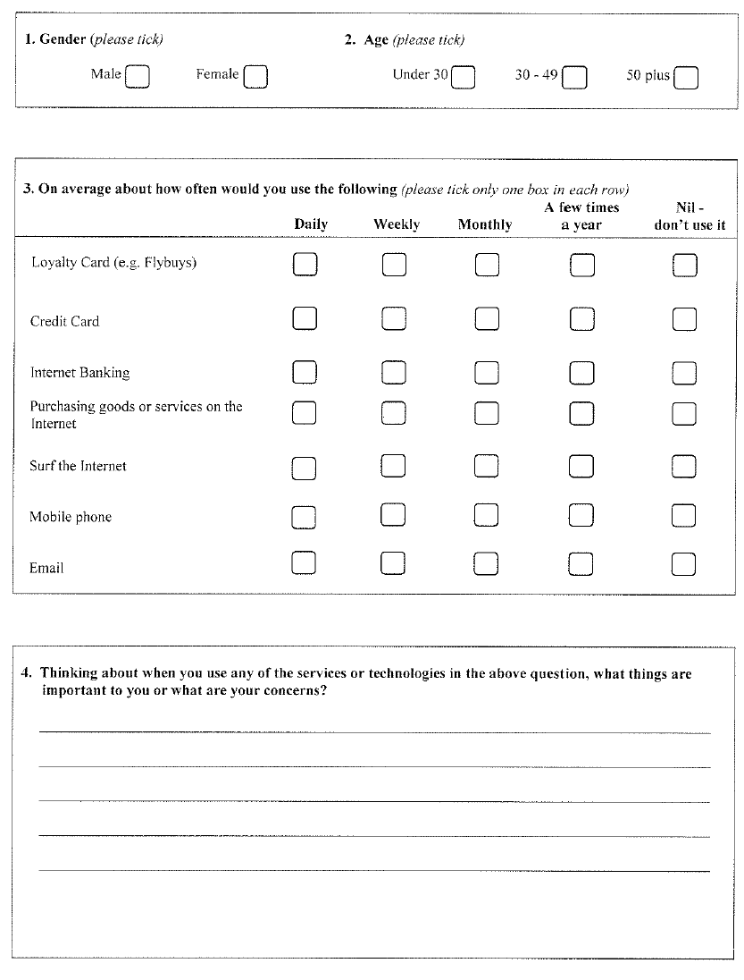
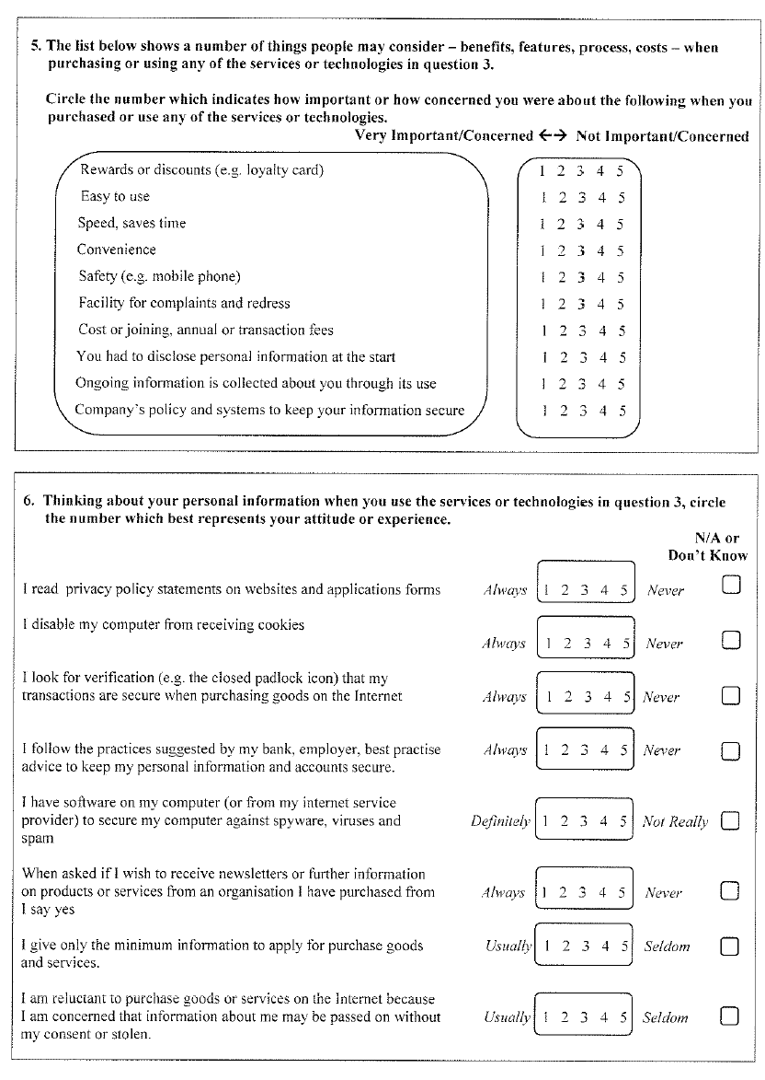

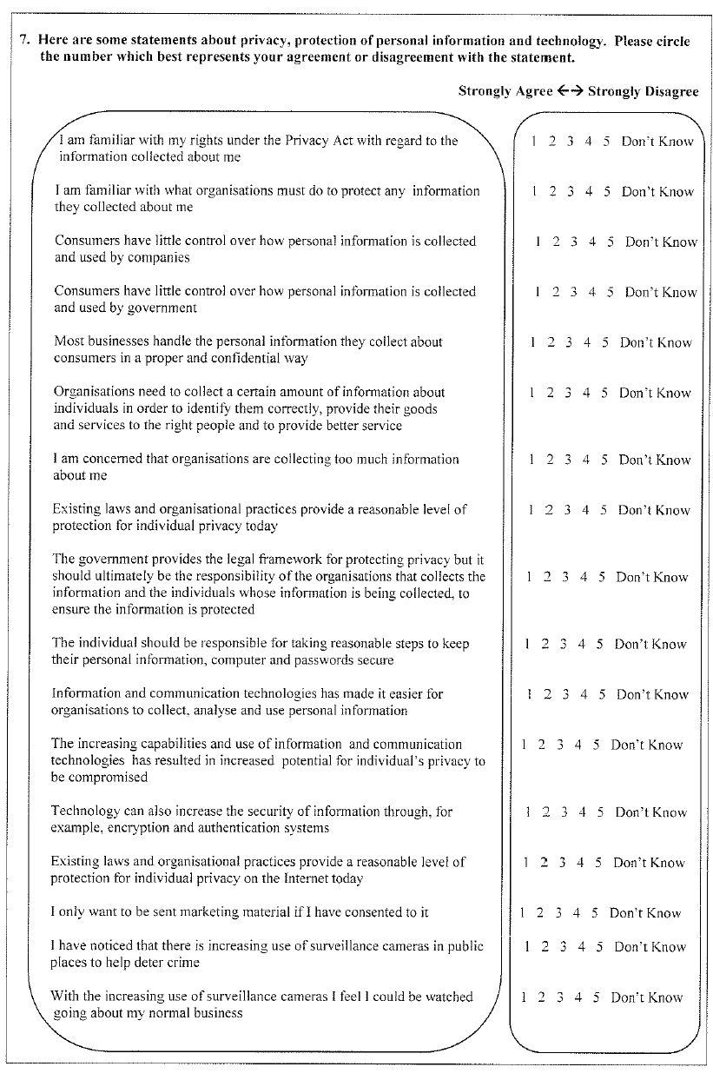
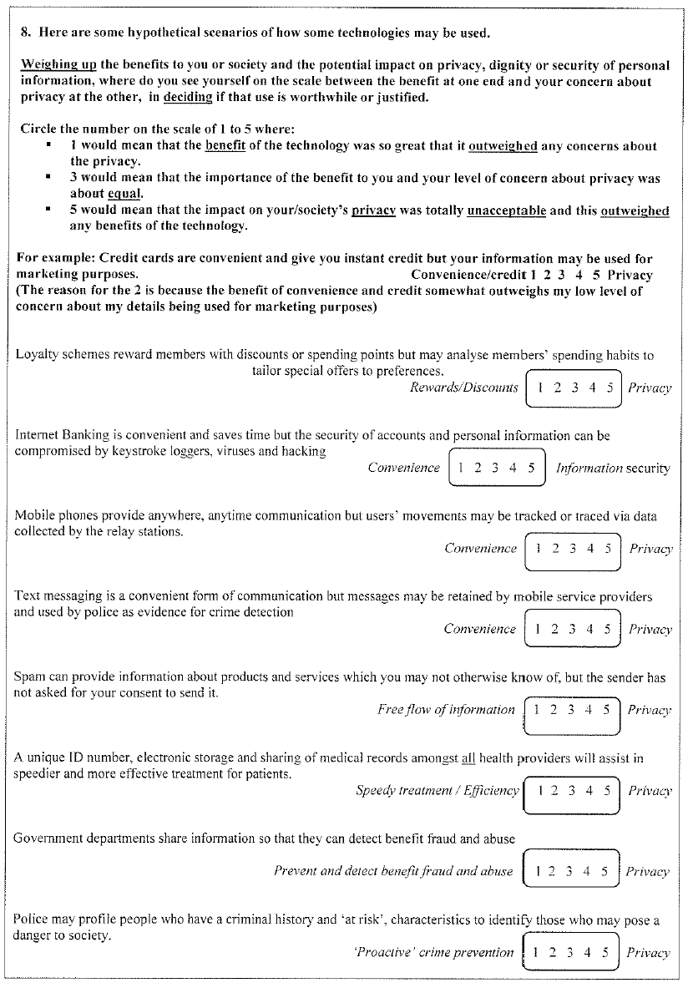
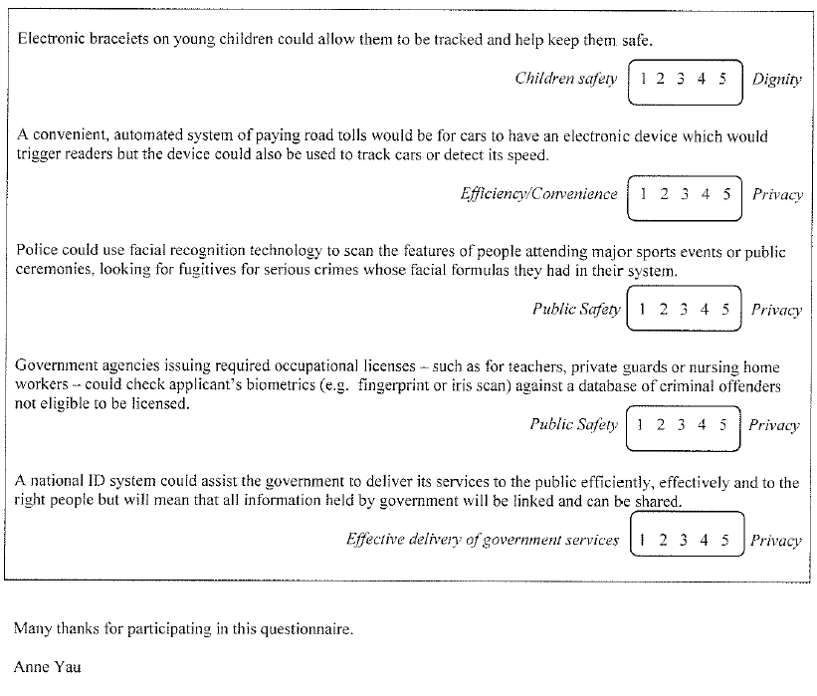

Appendix 2: ANOVA – Importance of or concern for collection of personal information
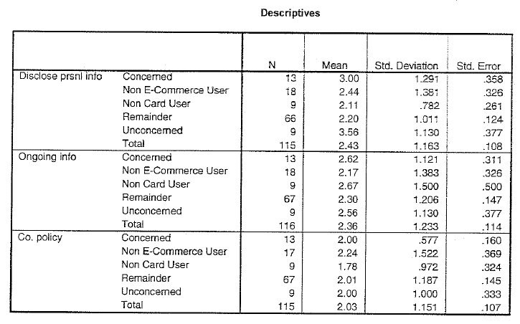

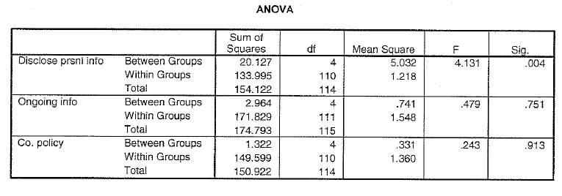
Appendix 3: ANOVA – Attitude regarding the control or handling of the collection of personal information
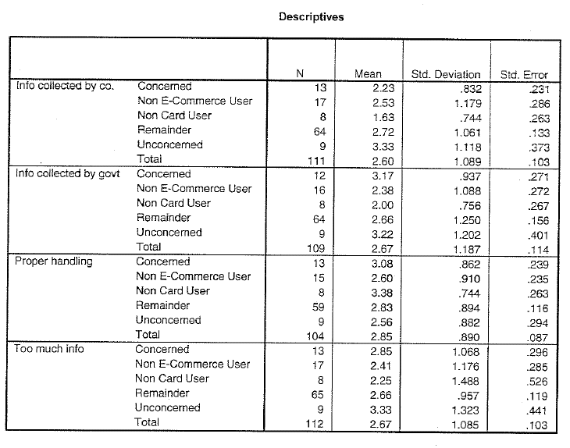
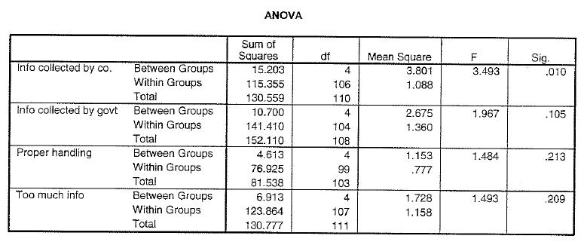
Appendix 4: ANOVA – Practices to protect personal information
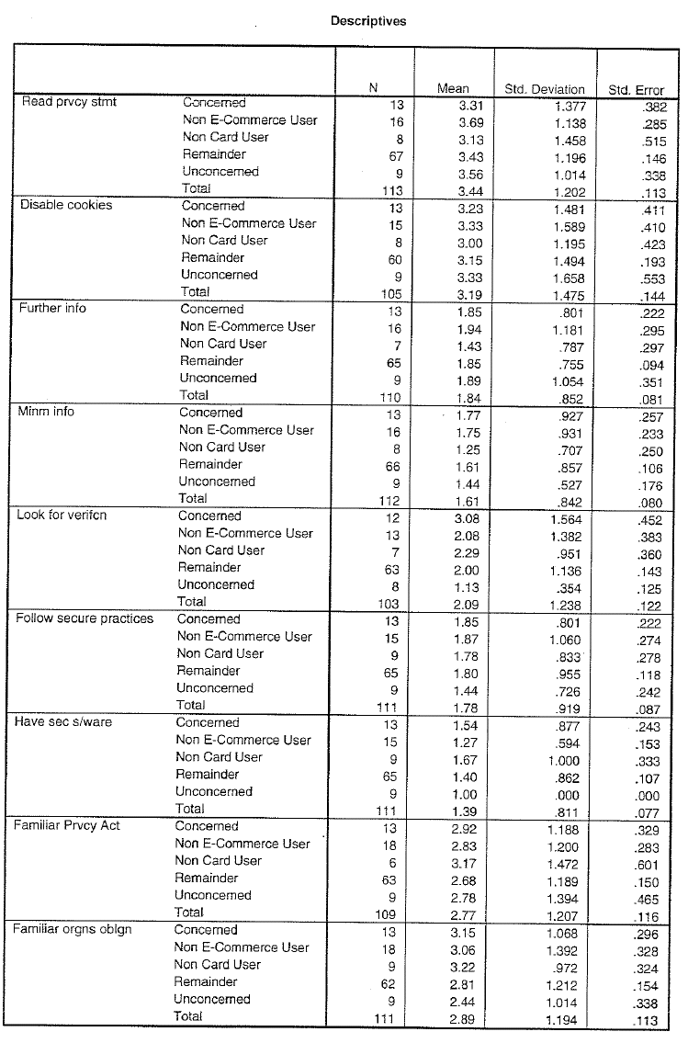
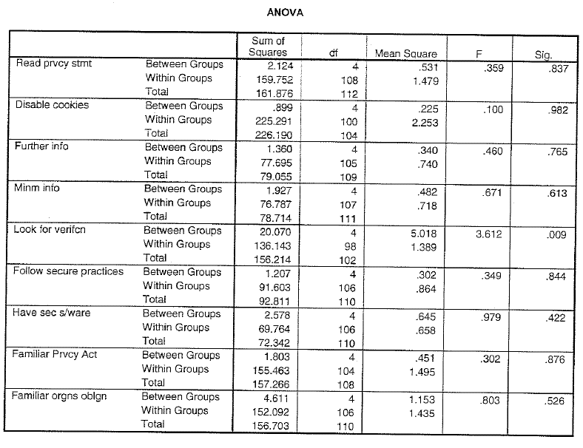
Appendix 5: ANOVA – Relative importance (trade-offs) of the benefits versus the privacy implications of technology use
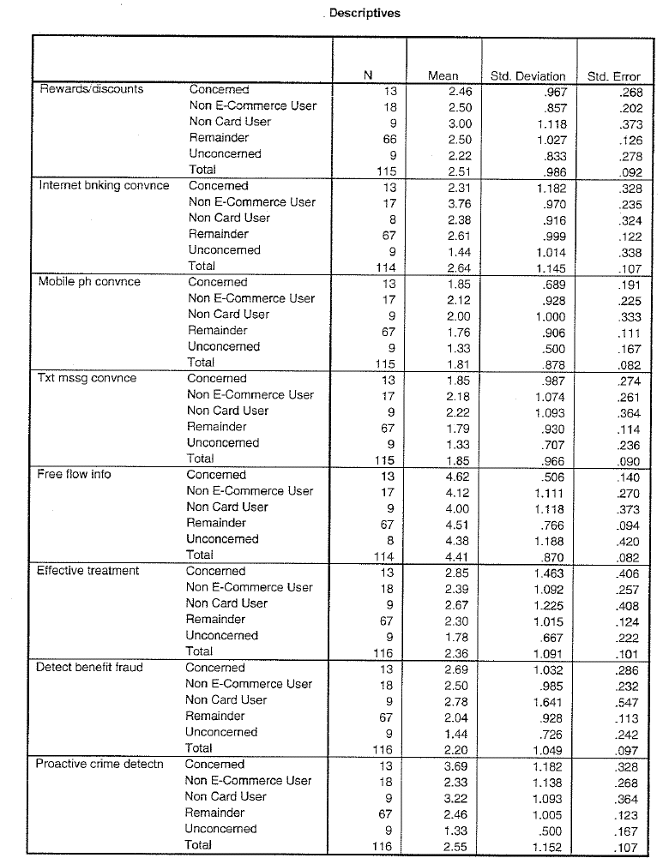
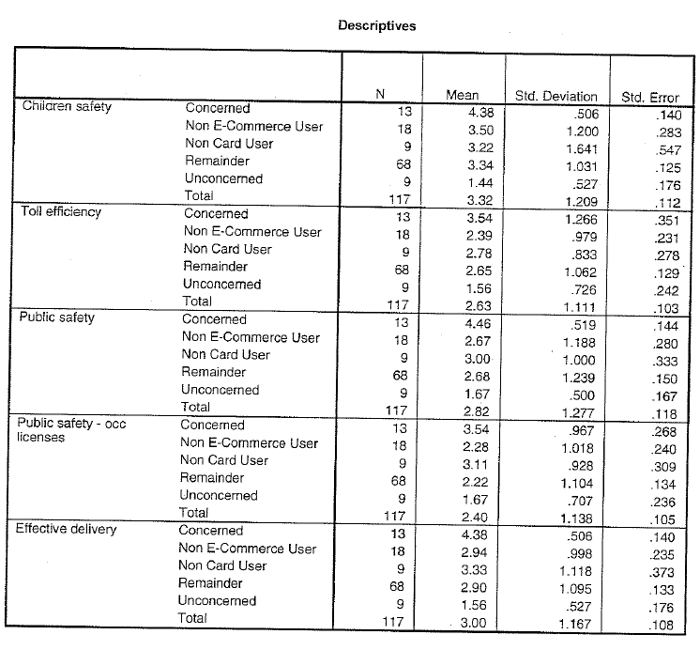

Appendix 6: Example correlations – total sample
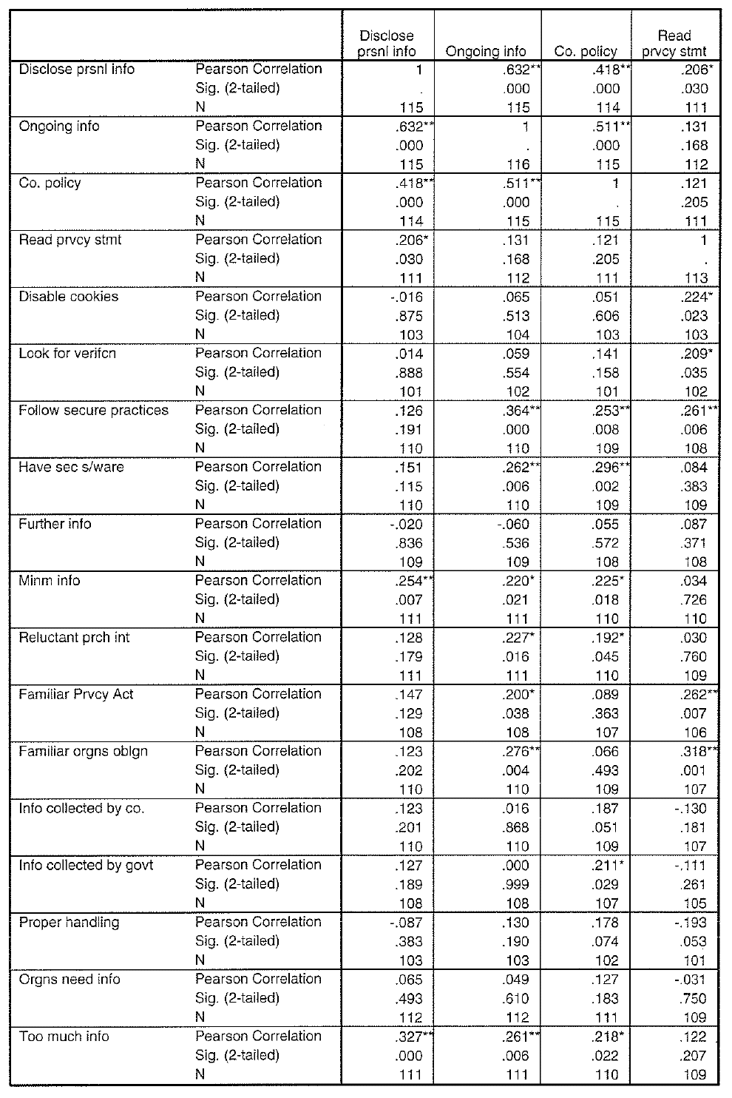
Appendix 7: Example correlations – collection, handling and use of personal information
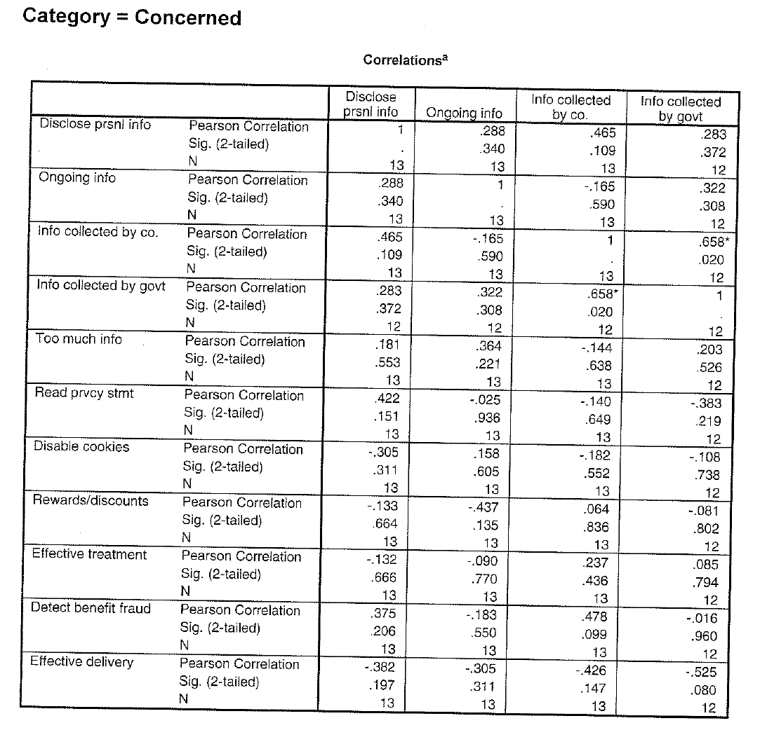
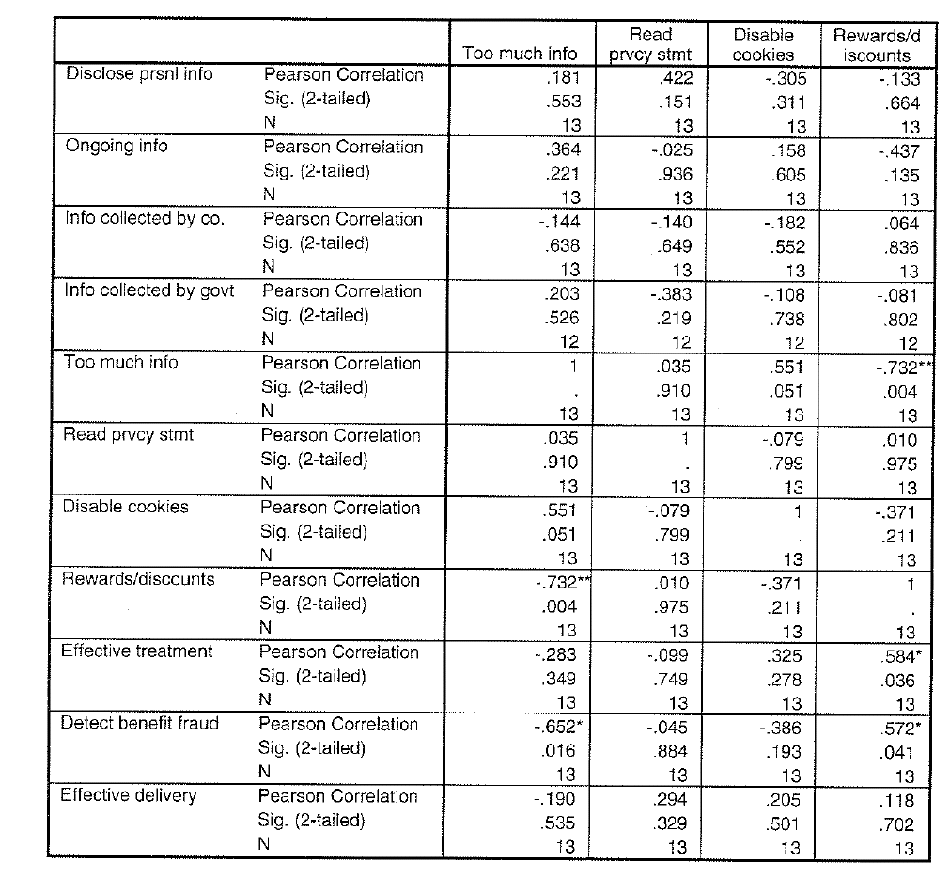

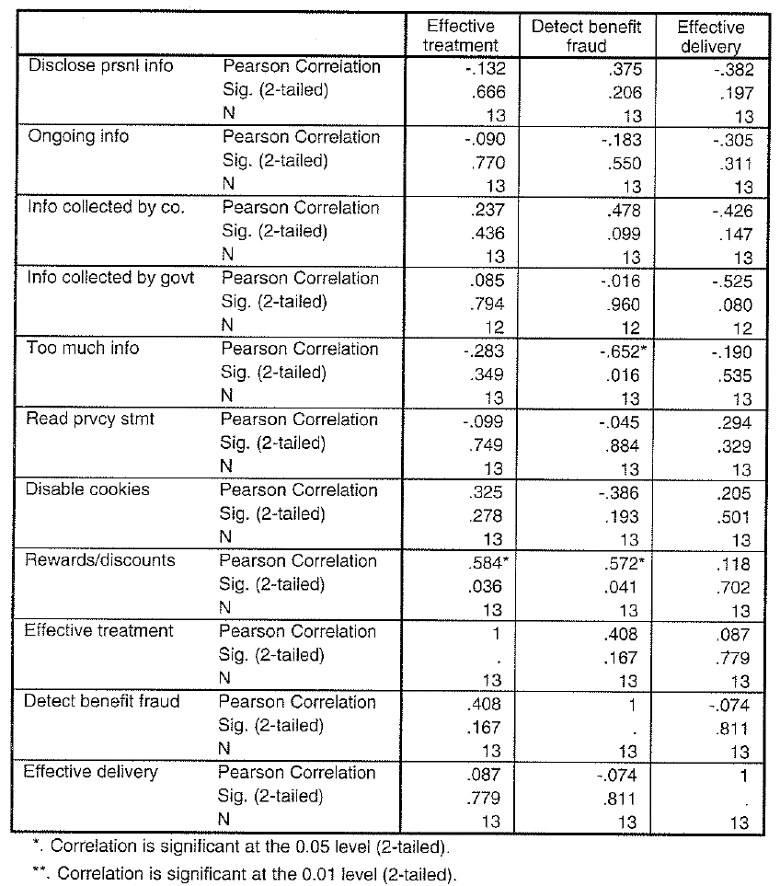

Appendix 8: Example correlations – E-commerce and information security Concerned category:
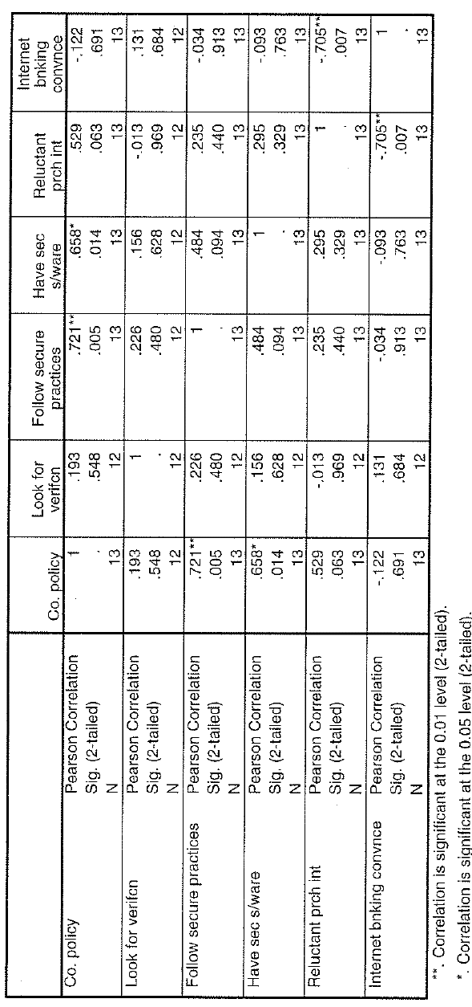
Non E-commerce User category:
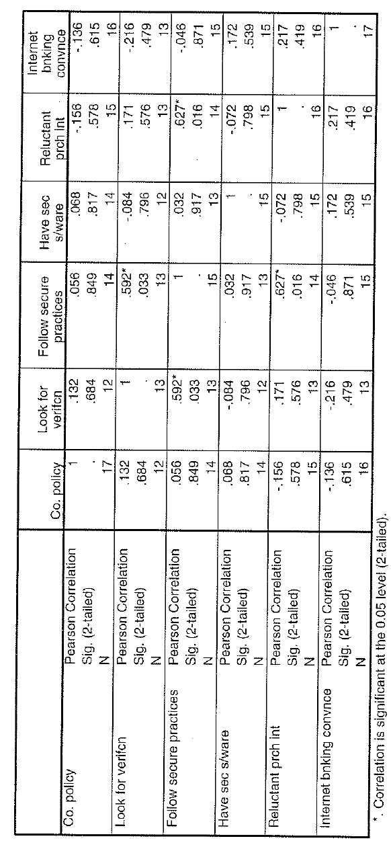
Appendix 9: Sample correlations – concerns and behaviour
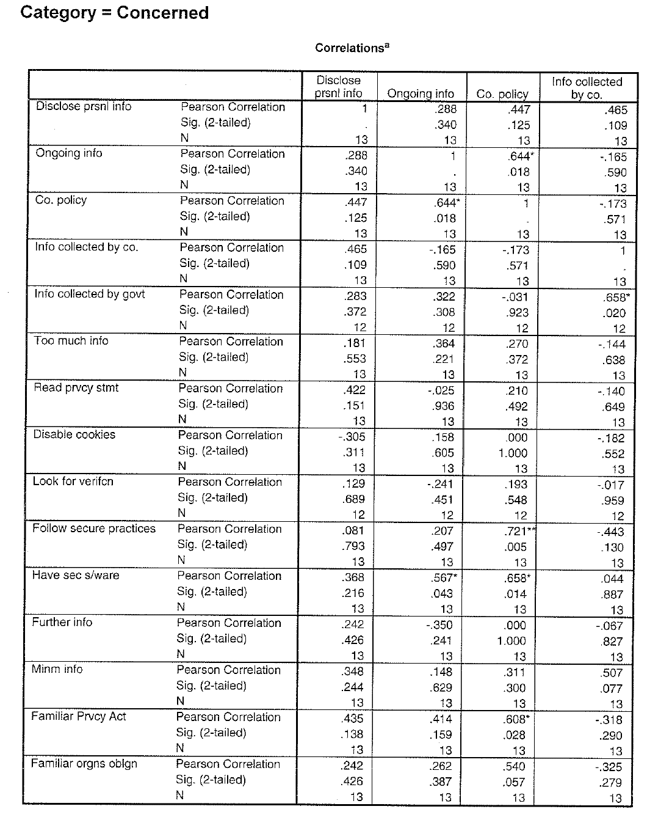
Appendix 10: Example correlations – Trade-off scenarios – Remainder category
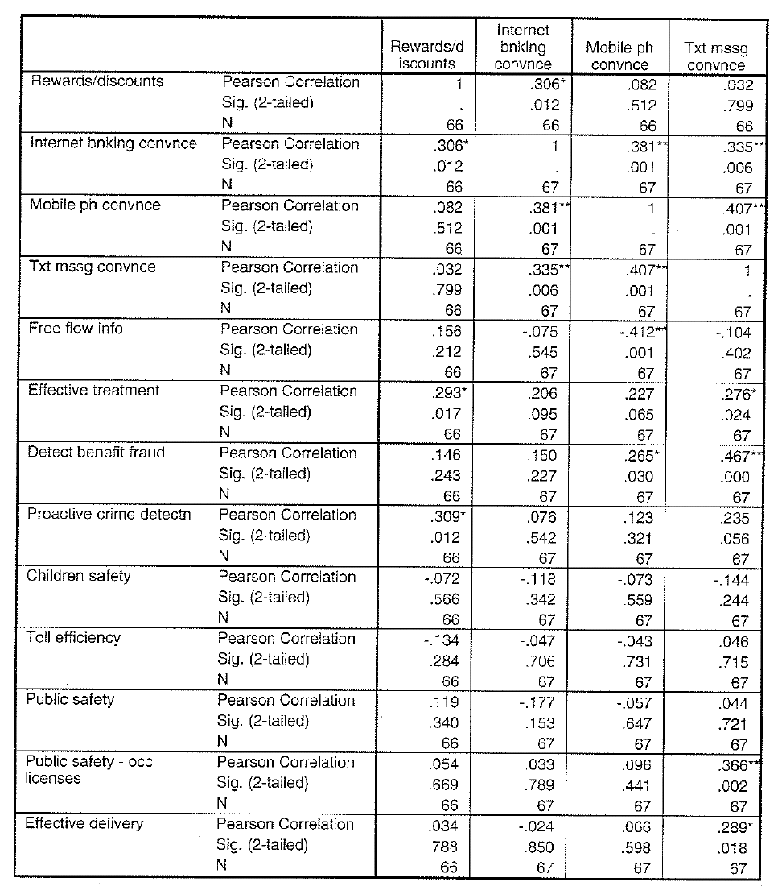
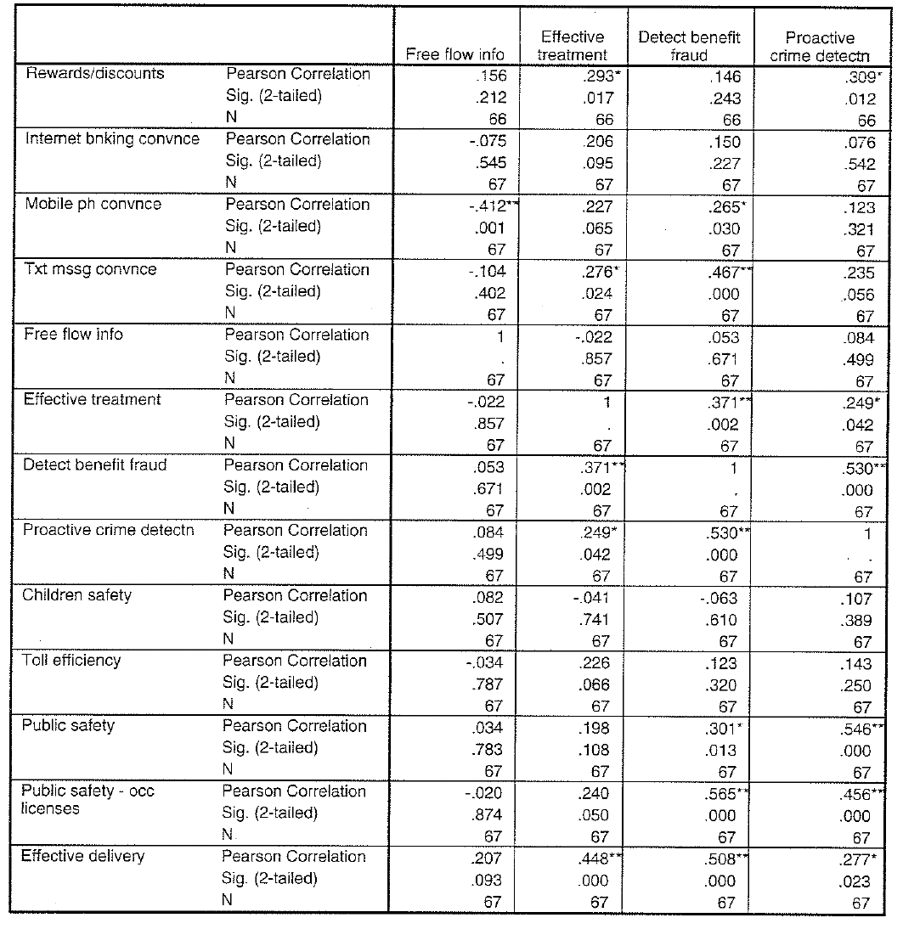

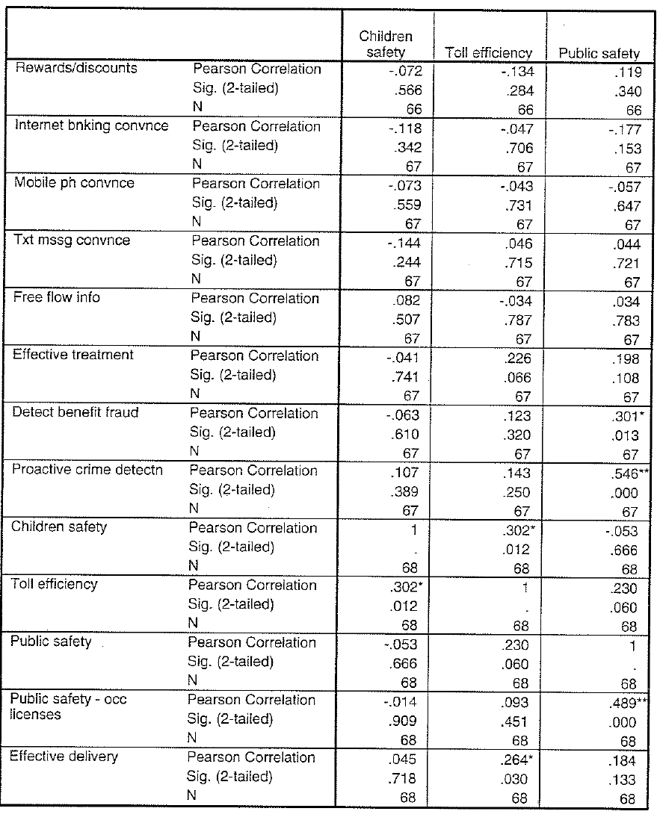

Based on Geert Hofstede’s model that identified five primary dimensions to assist in differentiating cultures: power distance, individualism, masculinity, uncertainty avoidance, and long-term orientation.
It has been argued that strong lobbying by the marketing industry and businesses in the United States resulted in the Can-Spam Act 2003 taking an opt-out approach to the consent issue of spam, against recommended best practice.
A public interest group established to focus public attention on emerging civil liberties issues and to protect privacy, the First Amendment, and constitutional values.
According to the 2006 Corruption Perceptions Index (Transparency International, 2006), New Zealand along with Finland and Iceland are perceived to be the world’s least corrupt countries (out of 163 countries surveyed).

