
Greenfield Public Schools
141 Davis Street
Greenfield, MA 01301
Tel: 413.772.1310; Fax: 413.774.7940
Susan D. Hollins, PhD
Superintendent of Schools

GREENFIELD SCHOOLS
PROFESSIONAL DEVELOPMENT PROGRAM

Using the iPad 2 for Curriculum: An Introduction
June 26-27, 2012
Beth Dichter, M.Ed., Tech. Integration Specialist, Northampton High School (bethdichter@gmail.com)
Carol S. Holzberg, PhD, Technology Coordinator, Greenfield Public Schools (cholzberg@gmail.com)

Creating an Apple ID for iPad App Store Purchases without a Credit Card

- Open the App Store on your device.
- Find a free application on the App Store.
- Important: Before proceeding to the next step, you must download and install the free application by tapping Free followed by tapping Install.
- Tap Featured in the App Store
- Type Calculator Pro for iPad Free in the App Store Search field
- Tap the Free Button
- Tap Install App
- Tap Create New Apple ID.

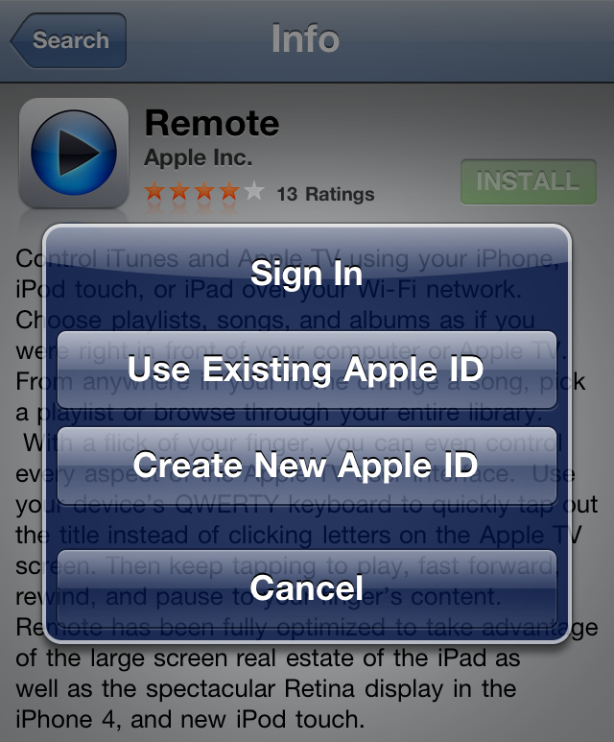

- Choose your country, then tap Done.

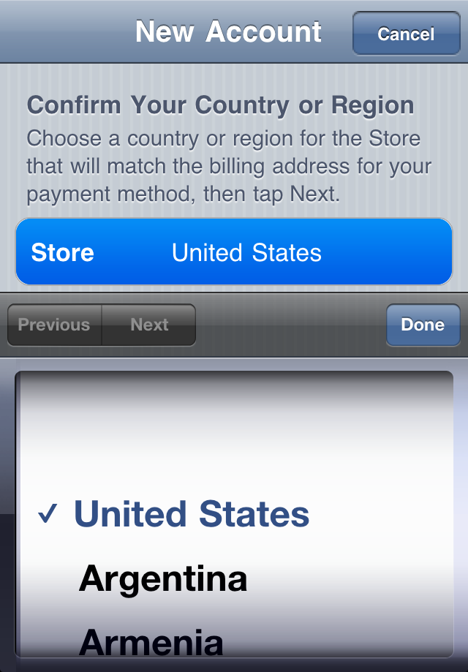

- You'll need to read and agree to the iTunes Store Terms & Conditions. Tap Agree located at the bottom of the page to continue.
- Enter your email address, security questions, birthday, and create your password.
- You can also enter an optional rescue email address. If you frequently change email addresses, this is recommended.
- Once you are satisfied with the information entered, tap Next.
- Select None as your payment option.

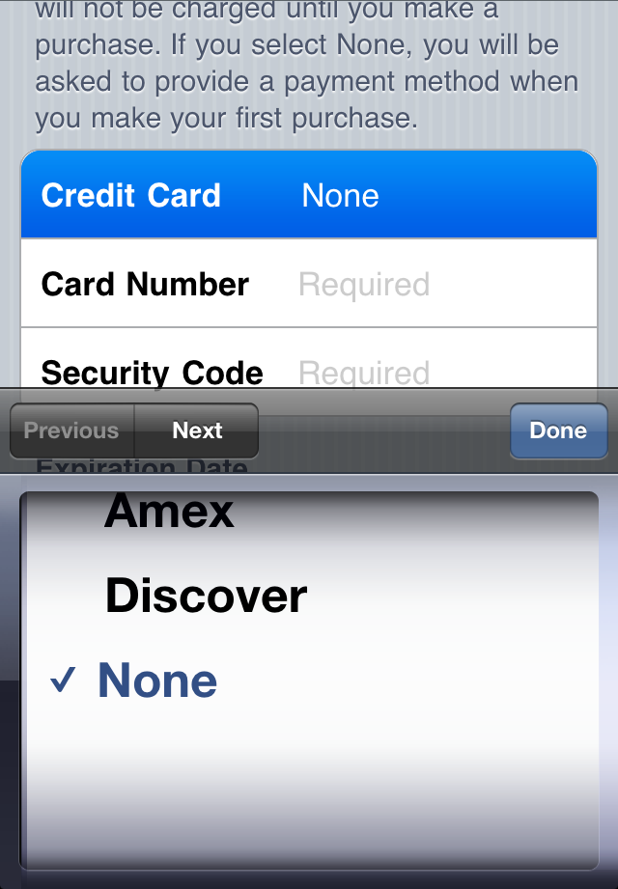

- Continue to fill out the required email, address, and phone number fields. Tap Next.
- You'll then see a screen that says "Verify your Account." Tap Done and check your email for a verification email from iTunes Store.

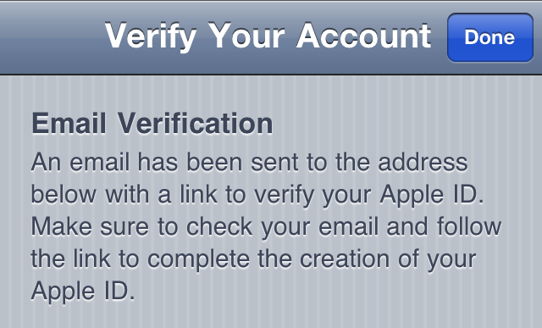

- Open the email, and click the link enclosed in the email to activate your account.
- Once you tap the link, the App Store should automatically open and prompt you to sign in with your account name and password.

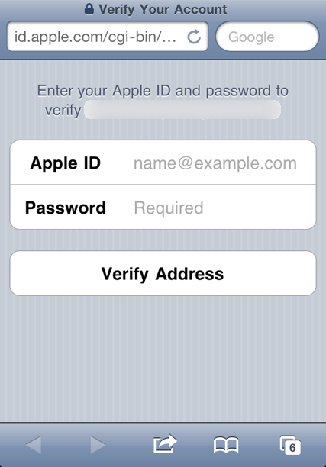

- Tap Sign In and you will see a thank you screen.

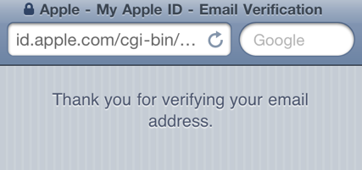

- You have set up your account successfully



