UMEÅ UNIVERSITY
Department of Computer Science
New Media, spring term 2005
Lecturer: Thomas Pederson
2005-05-05

Assignment 2

Multi-user networked game architectures

Frida Bergman, dit01fbn
Karin Fossum, dit01kfm
Britta Löfvenberg, dit01blg

Abstract
This paper introduces the field of multi-user networked games. The main difficulties with the development of the games are discussed. Architectures such as client-server, peer-to-peer, and server network are presented. Also three types of communication between client and server are examined. Furthermore, the paper describes examples of multi-user network games. Finally some suggestions are presented of what the future might bring in the field of multi-user network games.

Table of Contents
1. Introduction 1
2. History/Background 1
3. Problems with multi-user network games 2
3.1 Response time 2
3.2 Protection against cheating 2
3.3 Fault tolerance 2
3.4 Maintainability 2
4. Architectural description 3
4.1 Network structures 3
4.1.1 Client-server 3
4.1.2 Peer-to-peer 4
4.1.3 Server network 4
4.2 Communication 5
4.2.1 Communication paradigm 5
4.2.2 Communication between server and client 5
4.2.3 Desired features for a game application 6
5. Relation to course literature 6
5.1 “Video Games and Computer Holding Power” 6
5.2 The Idea of Cyberspace 7
6. Example of a multi-user network game 7
6.1 World of Warcraft 7
6.2 Pac-Manhattan 8
7. Playing-fee 9
8. The future of multi-user networked games 10
8. References 11

1. Introduction
Multi-user network games are games in which each player controls one or many entities and interact in a shared virtual environment [1]. An entity is an object within the game: a character run by a player, a character run by a computer, an passive object such as money or weapons, or the world in the form of a road or a house. Each entity has a state that is changeable in time. The games use a distributed system in which nodes cooperate to simulate a world. Several players compete against each other (person against person, or in teams), or together against the computer.

There are three kinds of multi-user network games [1]: Turn-based, Real time, and large-scaled games.

- In turn-based games only one player can act at the same time. When one player is done with the current move, the state of the game is updated and the turn is passed on to the next player. MultiPoker is an example of a popular turn-based game.

- Real time games, such as Counter-Strike, are updated continually and the players can act whenever they want to.

- Large–scaled games, also called MMPOG (Massively Multiplayer Online Games), use a persistent world, which means that the game is never restarted. There can be thousands of people playing at the same time and the area of the world is huge. It therefore can take hours to move oneself between different places. World of Warcraft, which will be described later, is a popular example of a large-scaled game.

2. History/Background
“Today the most sophisticated, responsive interactive simulations are found in the engines built to power games” [2, p. 27]. Through games, the importance of advanced graphics has increased, which is very expensive for the developers. It is no longer possible that the profit will repay the development of the game. Therefore developers have to write code that could be reused for a family of similar games.

The first multi-user game was called MUD (Multi-User Dungeons) [3] and was developed by Rob Trubshaw and Richard Bartle at Essex University. The game made it possible to chat and to move between locations connected to each other. In 1980, MUD was available for external players, which led to that people started to create their own MUDs and the development of MUDs proceeded.

A new era in the field of computer games started in 1993 when Doom was released by id Software [2]. Doom was the first game that successfully introduced the first person-perspective and also the multiplayer game over network. Quake was the next game released by id Software and the extension provided an editor for changing layouts and a scripting language for changing behaviour in the simulation.

Year 2002, there existed more than 600 commercial game engines [2]. The games that provided the most developed, flexible and usable engines for research purposes were QuakeIII, Everquest, and Unreal Tournament. Today, World of Warcraft is one of the most popular games among the players [4]. The game is so popular that the supplier has not been able to deliver all versions because of server overload [5].

3. Problems with multi-user network games
There are four important problem areas that affect the developing of multi-user network games [1]. Those are response time, protection against cheating, fault tolerance, and maintainability.

3.1 Response time
The time it takes for a player to make a command and the actual time it takes for the command to be processed should not differ in a large number, in ability to give the player the feeling of direct manipulation [1]. This is necessary to generate the expected experience. Also the time it takes for the command to reach other players should be as short as possible. Of course the time limit is different depending on what kind of game the players are playing.

3.2 Protection against cheating
There are always going to be players who do not follow the rules of the game in order to increase their chances of winning, or simply to ruin the game for others. This is a big problem in today’s games [1], because “honest” players will stop playing. One example of cheating is to retrieve information that is supposed to be hidden to the players, for example information about the state of the world. The player can also use other software to perform specific tasks such as aiming. Furthermore it is possible to change different states of the game (for example when a player has been shot) by sending false information to other players’ nodes. Almost all games include some sort of bugs. These can give rise to opportunities such as duplicating objects. Money or armour that suddenly doubles leads to opportunities that do not follow the rules.

3.3 Fault tolerance
While a game is running there may arise some errors. Sometimes nodes crash. If that happens the game must continue as ordinarily, at least to the user. Thus, a slightly degradation is sometimes acceptable but it depends on what game it’s about [1].

3.4 Maintainability
The players of a game expect that the game always is available, and that they can play at any time. Sometimes in order to improve the game maintenance is necessary. There might be bugs that need to be corrected, rules that need to be changed, or entities that need to be added. Therefore a game must be developed in such way that maintenance is possible without affection on the players [1].

4. Architectural description

4.1 Network structures
In [6], Palazzi et al. as well as Grimm [1], state that network communications generally can be divided into three kinds of architectures: Client-server, Peer-to-peer and Server network.

4.1.1 Client-server
A client-server architecture is based on a server to which clients are connected [1], see Fig. 1. Therefore, there is no communication between the clients themselves. A client-server architecture can either be centralized or decentralized. A centralized server provides limited efficiency and scalability [6], due to the fact that everything lies on one server. An advantage of using centralized servers is the control the system provides over the clients, especially in games where it makes cheating difficult. Another benefit is that a centralized client server is easy to maintain.

Fig. 1: Centralized client-server [1]
S
C
C
C
C

Decentralized client-server architectures do not provide as much control as the
centralized ones. Grimm [1, p. 19] states: “With a decentralized client/server architecture, all or part of the game state is handled by the clients, reducing the requirements on the server. For example, movement and collision detection of a player’s entities can be handled by the client, which then sends the new coordinates of the entities to the server.” Due to the reduction of control in decentralized client-server architectures, it is fairly easy for players to cheat.

Since these kinds of architectures are dependent on a single server, a failure in the later can cause chaos, since there is no way for the clients to communicate directly. The server is therefore a so-called “single point of failure” [1, p. 19]. Client-server architectures can also be the cause of delays, since all traffic has to go through the servers.

4.1.2 Peer-to-peer
A peer-to-peer architecture consists only of clients (peers), connected to each other [7], see Fig. 2. The traffic is transferred directly between the connected clients, where one of the clients acts as a server. This kind of architecture provides better efficiency and scalability than the client-server architecture [6], due to the many nodes on which the traffic can be spread. To work properly, there is need for some kind of coordination scheme, which makes sure that each client gets the right information at the right time. Since there is no control over the peer-to-peer-network, cheating is fairly easy [1].
Fig. 2: Peer-to-peer [1].
C
C
C
C
C

4.1.3 Server network
Server network [1] or Mirror game server [6], as Pilazzi et al. refers to it, is a mix between the two methods above. The idea is that a couple of servers combined in a server cluster are distributed over the network, see Fig. 3. Whenever a client wants to connect, it chooses the one that is closest. [6]. For security reasons the servers control some parts of the game, such as event handling and game state.

The network servers are considered to be one of the best solutions for online multiplayer games [1]. They avoid the problem with limited efficiency and scalability, and because of the many distributed servers, an error on one of them will not cause that big of a problem. Network servers can still be rather easy to maintain, since the number of servers are limited.
Fig. 3: Server network [1].
C
C
C
S
S
S
C
C
C
C
C

Server network architecture use the state-based paradigm [1], described next, to send information from the servers to different nodes or other servers.

4.2 Communication

4.2.1 Communication paradigm
There are two ways in which the game state can be transmitted to the nodes in the game [1]. They are called event paradigm and state paradigm. If the system uses the event paradigm, the game state is updated to the nodes every time there is an event. By using the state paradigm, the game state is frequently updated.

4.2.2 Communication between server and client
Macedo and colleagues [8] have tested three architectures for action games. All architectures were based on CORBA (Common Object Request Broker Architecture). The three architectures were: Active Client (AC), Call-Back (CB), and Event Service (EV). AC is based on a single server and the clients send movement signals to the server, and the request for the system’s current state, see Fig. 4. The difference between AC and CB is that in CB the server is responsible to send the current state to the clients, see Fig. 5. In EV, all clients are connected to an event channel, which is always open. When the systems state changes, the server sends a single event to the event channel, which multicasts the updated state to all clients, see Fig. 6.

Fig. 4: Active Client architecture (AC). 1 is the movement request and 2 is the request for current state [8].
Clients
Server
1
2

Fig. 5: Call-Back architecture (CB). 1 is the movement request and 2 is when the server sends a state update [8].
1
2
Clients
Server

1
2
Clients
Server
Event channel

Fig. 6: Event Service architecture (EV). 1 is the movement request and 2 is the multicasting of the event [8].
Macedo and colleagues [8] tested the three architectures on the game NetMaze by measuring the network traffic. The network traffic was analysed on the number of packets to and from the client. The result showed that there was a slightly less amount of packets that reached the clients about the state updating in the EV architecture. They also measured the bandwidth consumption for the architectures by computing the length, in bits, of all packets. AC and CB got similar results, with a small reduction on the total number of sent messages by the client to the server on the CB architecture [8].

4.2.3 Desired features for a game application
Macedo et al. [8] have presented some desired features for a game application. One of these features is that an interactive application must have a fast respond to each action a user makes. If there is a delay in the update, the user presentation quality may degrade, and also cause errors in future actions. The synchronization of the game is crucial because if one user has a delay and the others have not, the game will not be sequential. Even more complex is the synchronization among the clients, since the clients can perform actions at the same time. A centralized server may solve some of these problems, because it is responsible for all clients’ requests and keeping the game state, and it can also guarantee consistent information back to the client. But, centralization like this may create problems related to performance and scalability.

Transferring game data in a network involves sound, video and images, which makes the traffic in the network a critical issue to deal with. To reduce the network traffic, the clients can keep all the necessary media inside them. Furthermore, they should be able to translate the messages between clients and servers to useful information about a state change [8].

5. Relation to course literature

5.1 “Video Games and Computer Holding Power”
Sherry Turkle wrote in 1984 an article called “Video Games and Computer Holding Power” [9] where she discusses what influence computers have on the human culture from a psychoanalytic approach. At this time many people were against the introduction of computers into their homes. They were concerned that computer games would inflect the society in the same way that television has. Turkle, instead asked the players of why they were playing and found out that “games provide a way in which children as well as adults can take on different roles that are important to them psychologically”. When describing games, game players do not compare the computer games with television. “They try to describe the games in terms of other things, the comparison is more likely to be with sports, sex or meditation. Television is something you watch, computer games are something you do”.

Turkle [9] explains further that the computer is not just a tool to accomplish tasks, but has also become an object in our individual and social life. In the article Turkle states that computer games based on stories affect children more than adults. Children tend to find it easier to identify with the characters of the game, while adults rather play games in order to work on a specific skill.

Today we believe that this separation has dissolved, because of the more realistic characters or of characteristics that better appeal adults. Also, since the article was written (more than 20 years ago) the fear of computers has substantially diminished, which might have led to the increased amount of adult game players.

5.2 The Idea of Cyberspace
Multi-user network games can offer players an entry to Cyberspace. Many of the stories of the games, e.g. in World of Warcraft, which is described next, take place in virtual worlds where the players can do almost anything: they can communicate, dig for information, create new products etc., all phrases that Janlert uses to describe Cyberspace [10].

Janlert also states that in a virtual world answers to the questions about the users themselves, such as where am I?, what am I?, what can I do?, are indirectly answered by the surroundings. This is a typical situation in a multiplayer network game, where the user plays a character different from their physical self.

6. Example of a multi-user network game

6.1 World of Warcraft
World of Warcraft is not a game of high technological functions [11]. Furthermore it is not considered the best looking game, but still World of Warcraft is today (April 2005) rated as the best multi-user network game by many game websites. Over one million players are registered in this online game. Blizzard Entertainment is the company behind World of Warcraft. Other famous games they have created are: Starcraft, Diablo and Warcraft (earlier versions of World of Warcraft). However, this is the first MMORPG (Massively Multiplayer Online RolePlaying Game) they have made and Blizzard has allocated a lot of resources on the development of the game, servers, and network staff.

As usual in MMORPG games, the story is not the centre point of World of Warcraft [11]. The ambition of the game is to choose and create a character that is either good (Alliance) or evil (Horde), see Fig. 7. Then the player’s character set out for the world to solve missions that will benefit it self and its colleagues on the same side. During this journey the character develops, both in statistics and equipment, and can choose between two professions to specialize on, see Fig. 8.

The enormous world, in which the game is executed in, is called Azeroth. The world consists of two continents, where each continent contains ten to fifteen countries. Each country is so huge that it takes about a half-hour to cross it. Furthermore every country is full of details, missions, and inhabitants that make them unique.
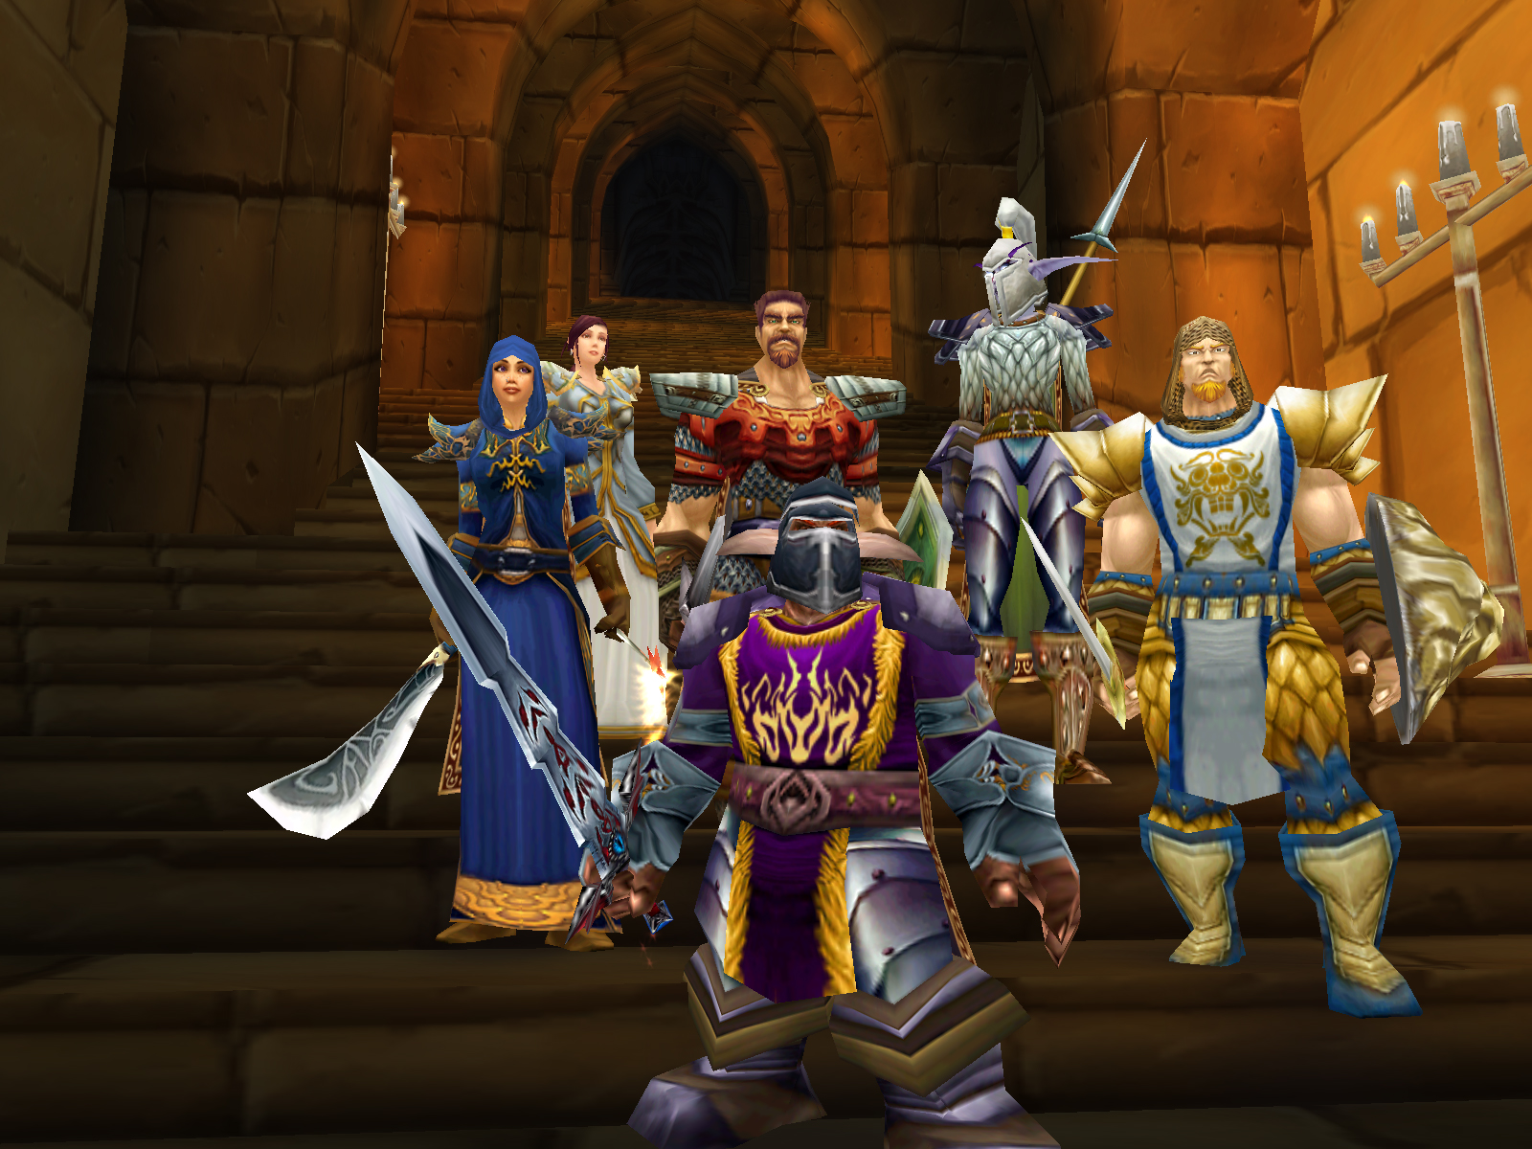
Fig. 7: Charactes in the multi-user network game World of Warcraft.

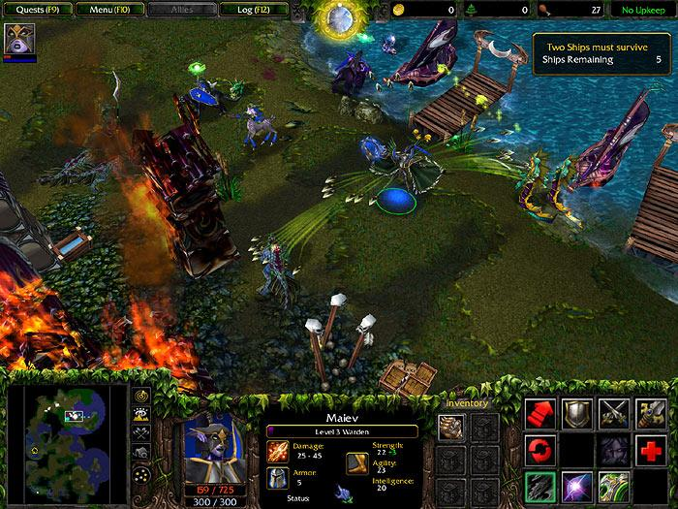

Fig. 8: An overview of the multi-user network game World of Warcraft.

6.2 Pac-Manhattan
Pac-Manhattan is a location-based mobile game developed to explore what happens when games are removed from their small world of computers and placed in the real world [12]. The players run around Manhattan trying to collect all of the virtual "dots" that are placed along the streets. Four players dressed as the ghosts Inky, Blinky, Pinky and Clyde will attempt to catch Pac-Man before all of the dots are collected. To be able to play all players need a cell-phone with wireless internet connection and software designed by the developers. The Pac-Man and the ghosts are tracked from a central location. Ten players are needed, one Pac-Man, four ghosts, and five players situated in a control room. Each of the players in the control room are in constant connection with a specific player in the street and updates that player’s position (and if the player has collected a dot). The ghosts eat Pac-Man, and vice versa, by placing a tag on the player.

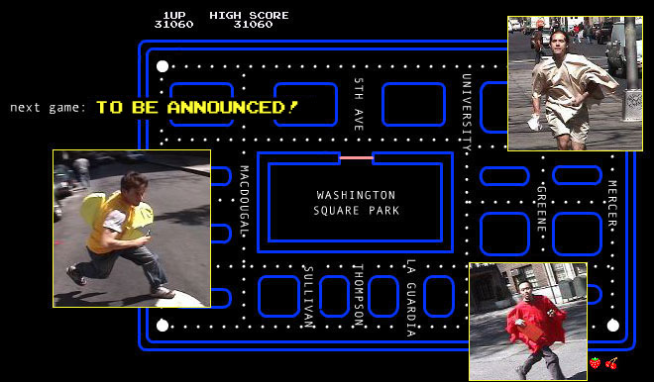
Fig. 8: An overview of PacManhattan.

7. Playing-fee
In network games it is common to pay a monthly fee to the game developers. These fees are used to support the costs associated with service, support, and development. The monthly fee is usually from $12.95 to over $30 [13]. In World of Warcraft the fee is $14.99, but you can also choose two other alternatives to pay for your playtime. The first of those two is to have a three-month plan at $13.99 per month, or the second alternative with a six-month plan at $12.99 per month [14].

The most common way to pay is with an electronic credit card, for example VISA. This works exactly like shopping on the net. Blizzard Entertainment, the creators of World of Warcraft, have plans to use a payment method called PayPal [14]. PayPal uses the existing financial infrastructure of bank accounts and credit cards and utilizes an advanced security system to avoid fraud [15].

8. The future of multi-user networked games
The future of multi-user networked games lies among others in networking mobile games [16]. Currently there exists a multi-player mobile network real time game called “Multi-User Dungeon”, which is a text-based MUD story. This is a popular game used by over 50.000 users. However, the most exciting mobile game in the future is Mtone, which is a large-scale mobile network game. Mtone provides a huge amount of pictures and music, furthermore it can achieve interconnectivity with Multi-User Dungeon. At least in mobile games the future lies in networking rather than downloading.

The last years the online games have had a huge development, and with bandwidth improvements the industry will grow even more. The online games have made a new medium for interactive entertainment and it can change the way we think about the creation, distribution, and consumption of gaming experiences [17]. Furthermore it pushes our skills forward to develop new hardware, software, and mediums not only to revolutionize the game experience, but the process of making the game. According to Allard, the game developers have to answer the question on how to make better games faster.

8. References
- Grimm, H., Distributed database support for networked real-time multiplayer games, University of Skövde, 2002

- Lewis M., Jabobsen J., Game Engines in Scientific Research. Communications of the ACM, Vol. 45, No.1, January 2002

- The History of Networked Gaming, 2001, Niall O’Flanagan,
http://ntrg.cs.tcd.ie/undergrad/4ba2.02/gaming/index.html

- TV-spelhuset’s website, www.tvspelhuset.se, accessed on 2005-04-26

- The Ginza website: http://www.ginza.se/index.aspx?artnr=50580, accessed on 2005-04-29.

- Palazzi, C. E., Feretti, S., Cacciaguerra, S., Roccetti, M. On Maintaining Interactivity in Event Delivery Synchronization for Mirrored Game Architectures. 2004.

- Kurose, J. F., Ross, K. W., Computer Networking: A Top-Down Approach Featuring the Internet, 2nd Edition. Addison Wesley, USA, 2003

- Macedo, H. T., de Araújo, A. C. M., Cavalcanti, D. A. T., Andrade, R. de C., Madeira, C. A. G., Ferraz, C. A. G., 2000. Evaluating multi user distributed action games architectures on CORBA platform. Center of Computer Science, Federal University of Pernambuco, Recife-PE, Brazil.

- Turkle, S., Video Games and Computer Holding Power, 1984. Article no. 34 in The New Media Reader, Edited by Wardrip-Fruin, N. and Montfort, N., The MIT Press, Cambridge, London, England, 2003.

- Janlert, L-E., The Idea of Cyberspace, University of Umeå, Sweden, 2005.

- Kreku, M. Review of World of Warcraft on Nordic Games website, 2005-02-24
http://www.nordicgamers.se/sektion/nordicgamers/recen/index.php?rec_id=479 accessed on 2005-04-29

- Pac-Manhattan website, http://www.pacmanhattan.com, accessed on 2005-05-05.

- Coleman, K., All RPG: The future of RPG Intelligence, http://www.allrpg.com/editorials/mmorpgstereotype.php3, accessed on 2005-05-05.

- Official World of Warcraft FAQ, http://www.worldofwarcraft.com/info/faq, accessed on 2005-05-05.

- PayPal’s official website, http://www.paypal.com/cgi-bin/webscr?cmd=p/gen/about-outside, accessed on 2005-05-05.

- Mtone’s website, http://www.mtone.com/news/new06.html, accessed on 2005-05-02.

- Allard, J., 2005-03-9, Speaker at the Game Developers Conference 2005, “The Future of Games: Unlocking the Opportunity” http://www.cmpevents.com/GD05/a.asp?option=C&V=11&SessID=5116, accessed on 2005-05-02.

