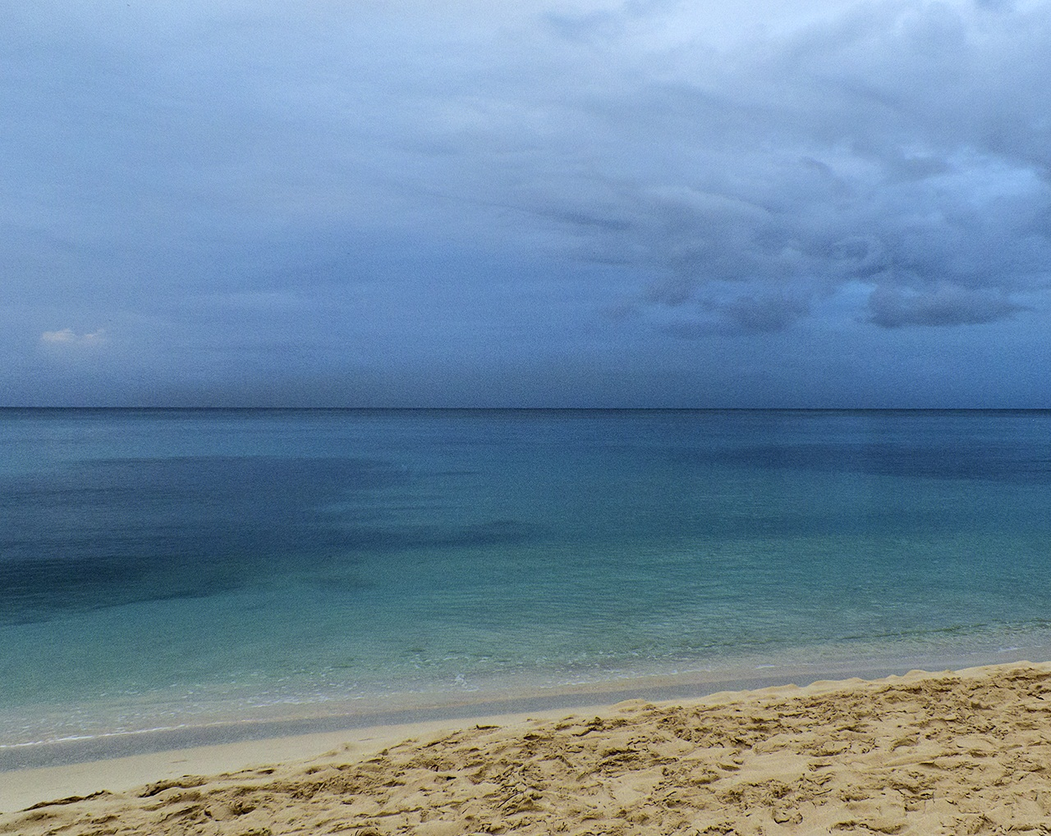

Athletes Guide-Bridgetown
Sunday April 23rd, 2017


Race Schedule 3
Race Briefing 3
Venue 4
Elite Athletes Lounge 5
Doping Control 5
Medical Services 5
Bike Mechanic Service 5
Security 6
Information 6
Accommodation 6
Bank 7
Transportation 7
Training 7
Public Transportation 7
Bike Training 8
Run Training 8
Bike / Run Course Familiarisation 8
Swim Course Familiarisation 8
Competition Information & Rules 9
Information about the FOP 9
Start 9
Transition Area Map 10
Swim Course Map 11
Bike Course Map 12
Wheel Stations 12
Penalty Box 12
Run Course Map 13
Aid Stations 13
Weather Conditions 13
Results 14
Protests & Appeals 14

Race Schedule
Saturday 22nd April 2017:
5:30PM (1730 Hrs) Briefing & Race Kit pickup at Barbados Olympic Association Building, Wildey, St. Michael, Barbados
Sunday 23rd April, 2017:
7:00am | Equipment Check (Female)
7:30am | Equipment Check (Male)
7:00am – 8:15am | Swim Warm-up (Female)
8:30am | Female Sprint Start
9:00am – 10:15am | Swim Warm-up (Male)
10:30am | Male Sprint Start
Race Briefing
Venue: Barbados Olympic Association Building, Wildey, St. Michael, Barbados
Date: Saturday 22nd April 2017
Start time: 5:30pm (1730 Hrs)
Triathletes/Coaches/Team Managers will be picked up from their hotel and transported to/from the venue, unless you are at a ‘homestay’ or made your own arrangements. NB: There are NO credit card facilities at the Briefing site. Please pay in US$ cash.
Technical Delegate: Winston Crookes
Assistant Technical Delegate: Adrian Sinckler

Venue

The Spring Garden course is situated on one of the calmest coasts in Barbados, situated a stone’s throw out of the capital, Bridgetown. The crystal clear Caribbean Sea gives triathletes the opportunity to view beautiful coral reefs while swimming and the chance to spot a turtle, very likely.

The Bike & Run courses share the same tarmac with almost zero elevation except for a small incline at the north turn on the Bike.

Barbados also boasts some of the best weather conditions in the world with an average yearly temperature of 28 degrees C and water temperature of 26 degrees C at race time.

This beautiful island provides the perfect opportunity for competitors and non-competing partners and families to stay and enjoy the relaxed environment and attractions.

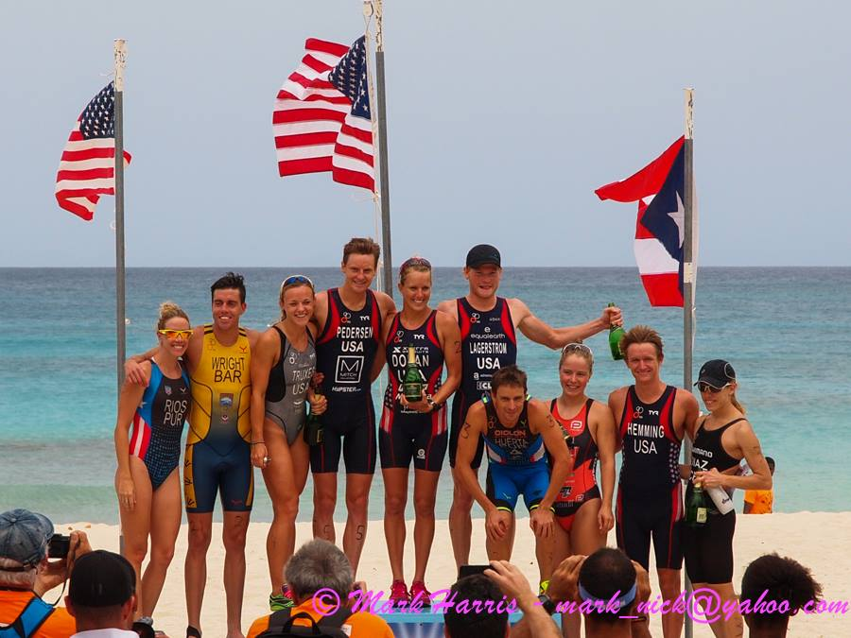

Elite Athletes Lounge

The Athletes Lounge area, under tents, and toilets will be adjacent to the transition area.

Doping Control
Doping Control will be performed according to ITU/WADA rules. They will be located adjacent to the transition area next to the Athletes Tents. Two triathletes of each gender will be tested.

Medical Services

First Aid will be available throughout the event and located next to the Athletes Tents. There will be two Ambulances on the course during the races.

Required medical services at the venue are free of charge. Treatment in clinics and at private offices is to be paid by the participants. Athletes / teams should ensure that they have appropriate medical insurance.

For any other medical attention needed outside of the competition, please contact the front desk of your Hotel for a local doctor’s details.

Bike Mechanic Service

Taylor’s Cycle Centre (246-426-3421) – closed on weekends

Mechanic (Private) Michael Thorpe (246-820-5533 or 438-2453)

Security

There will be security personnel in the event area overnight and throughout the event. Marshals will assist and
patrol the Field of Play on race day and Traffic management services will be employed in conjunction with the Royal Barbados Police Force.

Information

Contact Numbers for key persons on the Organising Committee:
[ Area Code: 246 ]
Derek Wilson: 429-1414 (Cell); 243-8382 (Home)
Christine Choy: 239-5955 (Cell); 416-9238 (Home)
Darren Treasure: 230-0724 (Cell)
Rene Delmas: 253-1843 (Cell)

Accommodation

There is no official hotel for the Event. The recommended hotels are:

Plum Tree Rockley Resort
www.plumtreeclub.com
246-435-7606

Rostrevor Hotel
reservations@rostrevorbarbados.com.bb
246-628-9298

Paradise Villas
Christine@barbadosapartments.net
(246) 424-4581

A limited number of ‘home-stays’ and complimentary hotel rooms are available. Please indicate your interest by emailing triathlonbarbados@gmail.com or, kris.creations@yahoo.com as soon as possible, providing Flight details. These will be allocated on a first-come-first-awarded basis.

Bank

There are various ATM facilities across the island. Main Banks are Nova Scotia, CIBC FirstCaribbean, Republic Bank, Royal Bank of Canada, & First Citizens Bank.

Note: US$1 = 2 Barbados Dollars

Transportation

Airport transfers, to and from, will be provided free of charge by the LOC for Elite athletes. Transportation will also be provided to and from Hotels to the Briefing, and to and from the race-site on race-day. Bike transportation will be provided to and from the airport and to and from the race-site.

All airport transfers should be registered with triathlonbarbados@gmail.com well before arrival. (no later than April 16th )
(Note: Transport Company used is Suntours and/or Barbados Olympic Association vans)

Training

The Barbados Aquatic Centre is located at the Garfield Sobers Sports Complex, Wildey, St. Michael. A pay-to-swim fee of US$10/day is the usual charge. We are trying to negotiate a special rate for visiting triathletes. The facility has a 50m x 25m pool (10 lanes) and a smaller 25m x 10m shallow pool. Opening hours are: 9:00am – 7:00pm (Note: 3:00pm – 6:00pm is reserved for local Age-Group clubs only). Tel: 429-SWIM.

Public Transportation

All public transport on the island is US$1 per trip.

Bike Training

The roads are used by cyclists, but are narrow and may be bumpy! Roads are not closed to traffic, so you will be riding at your own risk. It is best to avoid early morning and late evening traffic (rush hours: 7:00am – 9:00am & 3:00pm – 6:00pm). Less traffic will be outside of town areas.

Run Training

Running on our roads is not recommended. It is best to seek a traffic-free area close to where you are staying. Consult with your hotel Front Desk or one of the members of the Organising Committee.

Bike / Run Course Familiarisation

There are no official familiarisations for the bike and run courses as the race-site is an open and busy highway and will not be closed prior to race day. The course cannot be ridden during normal operation as bikes are not normally allowed on the Spring Garden Highway.

Please note that the official Bike & Run courses are otherwise not open for training before the races. The race courses are in general NOT suitable for training except for the Swim course.

Swim Course Familiarisation

You will be able to familiarize yourself with the swimming course on Friday 21st April (9:00am – 12 Noon) & Saturday 22nd April (9:00am – 12 Noon).

Competition Information & Rules

The race will follow the latest published competitions rules of the International Triathlon Union.

Elites should be aware that uniforms and bikes will be checked according to ITU specifications. Please come with "legal" gear accordingly.

Information about the FOP
Start
A Start Platform will be located along the beach, approximately 10m from the sea and visible from the Transition Area and the Athletes Lounge/Tent. Access will be via the swim exit chute located on the beach.
Athletes will be required to leave their last minute gear under the Athletes Tent, approximately 20m from the Start Platform. Security will be assigned.

Transition Area Map
Athletes will need to run approximately 100m – 150m to reach their bike. They must exit and enter the TA zone heading North. Most of the surface of the path from the swim exit to the TA Zone will be covered with Astroturf/carpet.

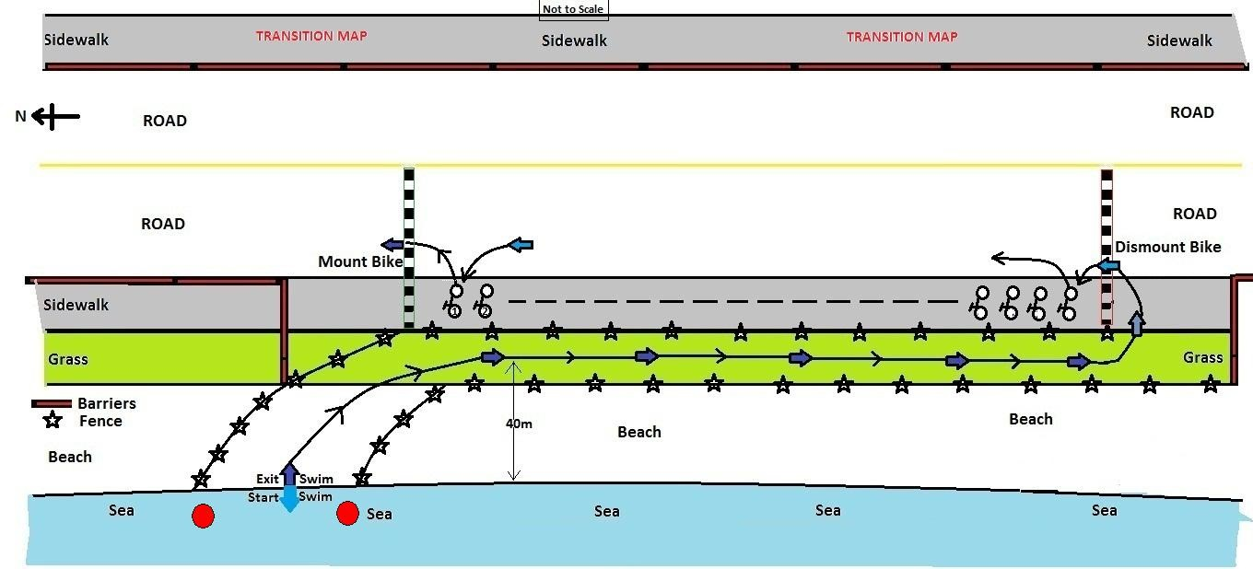

Swim Course Map (See below)
The swim course is a triangular shaped course that runs in a clockwise direction. The course starts and ends directly in front of the tents on the beach. The first turn buoy (#3, right) is at 300 metres. There will be 2 additional right-handed turns (#4 & #5) and the final turn is a left-handed turn (#7), before returning to shore between two #1 buoys. Note: Buoys #2 and #6 are for guidance & safety only and may be passed on either side. It is recommended however, that you pass them on your left shoulder to avoid the coral reefs.
The complete perimeter of the course will be patrolled by marshals on SUP boards, surf boards, kayaks, and there will also be a boat on the course.
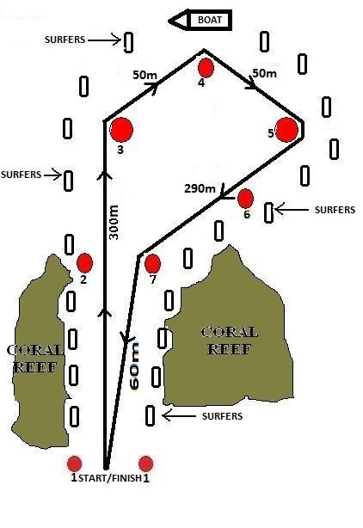

Bike Course Map
The bike course is a 5 lap, 4km long course. The course follows a flat portion of the Spring Garden Highway (SGH) with a small hill/incline (approx. 25m above sea-level) at the North turn.
The “first runner, last rider” scenario is applicable for this event. In this case, the rider will be taken off the course.

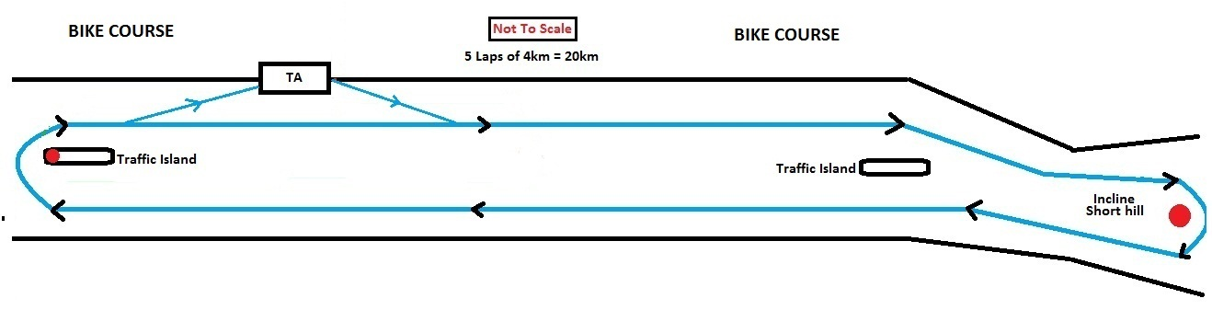
Wheel Stations
There will be one wheel station on the bike course which will be located approximately 100m after passing the TA zone. You must provide your own wheel(s) suitably labelled.

Penalty Box
The penalty box will be situated approximately 150 metres before the TA zone.

Run Course Map
The course is a flat 2-lap course on the same portion of the SGH as the bike course. Each lap is 2.5km. There will be distance markers indicating the distance “to the Finish”.
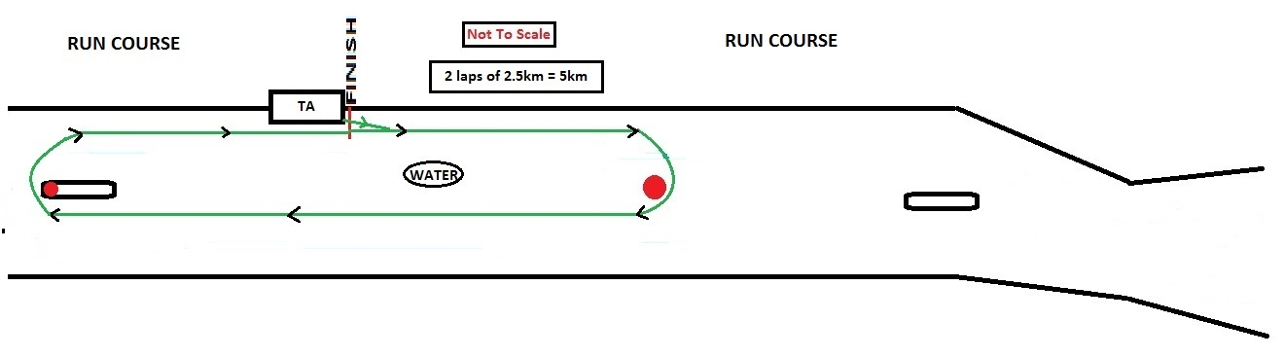
Aid Stations
There will be one water station (bottle water) on the course (during the run) that will be situated approximately mid-point on the loop. Another Water station may be added, depending on conditions. Bottle Water & Powerade will be available also at the Finish Line. Fruits & food will also be available to athletes in the Athletes Tent after the race.
Weather Conditions
Expected weather conditions – Sunday 23rd April 2017
The sun will rise in Bridgetown at 5:44 am and sunset will be at 6:12 pm.
The first High tide will be at 2:24 am and the next High tide at 3:43 pm.
The first Low tide will be at 9:48 am and the next Low tide at 10:16 pm.
There will be 12 hours and 28 minutes of sun. The solar transit will be at 11:58 am.
Results
Unofficial Results will be posted under the Athletes Tent, as soon as possible, after each race.
Official Results will be uploaded at the ITU’s official website: www.triathlon.org

Protests & Appeals
Standard procedures will be followed according to the ITU Competition Rules.

