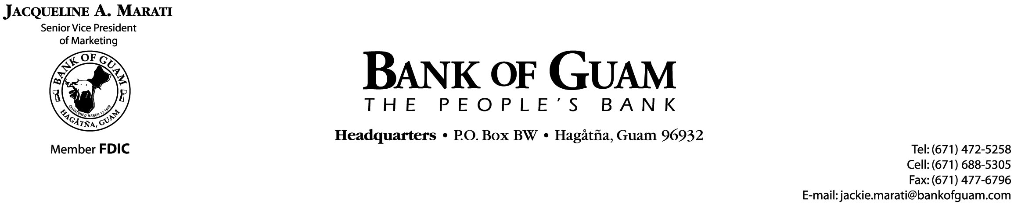

FOR IMMEDIATE RELEASE

WHAT HIGH SCHOOL SENIORS SHOULD KNOW ABOUT CREDIT AND IDENTITY THEFT?
15th Annual Get Smart About Credit Day is October 19, 2017

October 19, 2017 – Hagatna, Guam- Bank of Guam, along with ANZ Bank and Guam’s Association of Government Accountants teamed up with the American Bankers Association’s Get Smart About Credit program as part of an ongoing effort to teach the local community how to effectively use credit.
The program, now in its 15th year, is a national campaign of volunteer bankers who help young people develop responsible credit habits. This year, the Get Smart Credit Program reached 830 students at 9 schools – Academy of Our Lady of Guam, Evangelical Christian Academy, George Washington High School, Simon Sanchez High School, Southern High School, St. John’s School, Okkodo High School, Notre Dame High School and Harvest Christian Academy. A total of 31 bank volunteers participated in the classroom activity. The program focuses on the following important financial obstacles facing teens: paying for college, building good credit habits, and protecting their identity.
“Few young people have access to financial education through their school,” said Lou A. Leon Guerrero, Bank of Guam President, Board Chair and Chief Executive Officer. “This program is an opportunity for our Bank to participate on a national effort to equip students with ways to ensure a financially fit future.”
Bank of Guam offers these top seven tips designed to give students an edge in mastering personal finance:
- You are in charge. You are responsible for your finances and you should act accordingly by creating a realistic budget or plan and sticking to it.
- Watch Spending. You control your money, determining how you spend or save it. Pace spending and increase saving by cutting unnecessary expenses like eating out or shopping so that your money can last throughout the semester.
- Use Credit Wisely. Understand the responsibilities and benefits of credit. How you handle your credit in college could affect you well after graduation. Shop around for a card that best suits your needs.
- Utilize Your Bank Account. Banks are more than money in a vault. They offer valuable services that students can benefit from like check cashing, debit cards, online banking, balance alerts, personal loans, direct deposit, financial education and some offer identity theft protection.
- Be particular when it comes to money. Don't just trust anyone with your money. Be skeptical of classmates, friends or salespeople that have ideas for your money.
- Save. Things happen, and it's important that you are financially prepared when your car or computer breaks down or when you have to buy that unexpected bus ticket home. No matter how small the amount you should start putting some money away immediately.
- Ask. This is a learning experience, so if you need help, ask. Your parents or your banker are a good place to start and remember, the sooner the better.


