

Board of Regents for Higher Education

Request for Proposal (RFP) BOR-1513

LIBRARY MANAGEMENT SYSTEM AND DISCOVERY SERVICES

Due date: Monday, May 18, 2015, by 2:00 PM EST

Table of Contents:

Section
- Statement of Objectives
- Background
- Proposal Options
- RFP Phases, Projected Timetable, and Key Dates
- Submission Requirements
- Scope of Services (See also Attachment L, which is the Appendix of Section 6)
- Security Requirements (Applications and Data Information, Operations, Audit and Compliance, Incident Handling, Legal and Regulatory)
- Technical Support Requirements
- Services and Business Support Requirements
- Business Maturity
- Pricing
- Format of Proposals
- Evaluation of Proposals
- Conditions
- Insurance
16. Freedom of Information

Attachments
Attachment A - Contract Proposal
Attachment B - Gift and Campaign Contribution Certification
Attachment C - Consulting Agreement Affidavit
Attachment D - Affirmation of Receipt of State Ethics Laws Summary
Attachment E - Iran Certification Form
Attachment F - Nondiscrimination Certification Affidavit Form C
Attachment G - Commission on Human Rights and Opportunities Form
Attachment H - SEEC Notice to Executive Branch State Contractors and Prospective State Contractors of Campaign Contribution and Solicitation Limitations
Attachment I - Contract Provisions
Attachment J - Connecticut General Statutes Sec. 36a-701b
Attachment K - Connecticut General Statutes Sec. 11-25b
Attachment L - Appendix: Scope of Services (Appendix of Section 6 of this RFP)

1. STATEMENT OF OBJECTIVES

Connecticut’s Board of Regents for Higher Education (“BOR” or “Board”) on behalf of the Connecticut State Colleges and Universities (hereafter “CSCU”), which comprises the Connecticut State University System, the Connecticut Community Colleges, and Charter Oak State University, is seeking proposals from vendors to provide a single, easy-to-use, state-of-the-art library system (hereinafter, “Solution”) for all of the students, faculty, and staff of CSCU and patrons of the participating libraries, creating greater operating efficiencies, streamlining workflows, and improving resource sharing.

The solution will provide an effective and user-focused interface to discover print and electronic library resources across the libraries of the entire CSCU system and the Connecticut State Library, these together comprising the Consortium (“Consortium”). The solution will facilitate and support the sharing of materials seamlessly and extensively across the state of Connecticut, will reduce acquisition of redundant materials among member libraries, and provide ease of navigation to library resources for students, regardless of which institution they attend.

The anticipated outcomes of the project include:
- A single shared library system
- A unified set of services that exceeds traditional Integrated Library System capabilities
- Improved support for users’ research needs, by enabling them to locate and access relevant resources efficiently
- Reduced technical support requirements due to a cloud-based hosted system
- Streamlined workflows to provide efficiencies and reduction of staff time devoted to traditional library functions
- Increased opportunities for cooperative collection development and assessment

2. BACKGROUND

In 2011, Public Acts 11-48 and 11-61 instituted consolidated governance of Connecticut higher education, creating the Connecticut State College and University (CSCU) system. The Board of Regents for Higher Education serves as the governing body for CSCU, which comprises the regional community-technical college system, the Connecticut State University System and Charter Oak State College pursuant to Subsection (a) of Section 211 of PA 11-48. On January 1, 2012, the Board of Regents is also authorized to act, as necessary, as the Board of Trustees for the Community-Technical Colleges, the Board of Trustees for the Connecticut State University System and the Board for State Academic Awards (which is the Board for Charter Oak State College) pursuant to sections 10a-71, 10a-88 and 10a-143 of the Connecticut General Statutes, as amended. The specific powers and duties of the Board are prescribed in Title 10a of the Connecticut General Statutes and are further delineated in policies adopted by the Board from time to time.

2.1 Connecticut State Colleges and Universities. The Connecticut State Colleges and Universities maintain distinct mission statements to serve their constituents while collectively working to achieve a system-wide vision and mission. Together, the colleges and universities currently employ approximately 11,400 full- and part-time staff (including student workers), and provide services and instruction to approximately 90,000 students (55,000 full-time enrolled equivalent), alumni, and community affiliates. The CSCU institutions are located throughout the State of Connecticut:
- BOR System Office Hartford
- Asnuntuck Community College Enfield
- Capital Community College Hartford
- Central Connecticut State University New Britain
- Charter Oak State College New Britain
- Eastern Connecticut State University Willimantic
- Gateway Community College New Haven
- Housatonic Community College Bridgeport
- Manchester Community College Manchester
- Middlesex Community College Middletown
- Naugatuck Valley Community College Waterbury
- Northwestern CT Community College Winsted
- Norwalk Community College Norwalk
- Quinebaug Valley Community College Danielson
- Southern Connecticut State University New Haven
- Three Rivers Community College Norwich
- Tunxis Community College Farmington
- Western Connecticut State University Danbury

For additional information, please visit our website: www.ct.edu

The CSCU Libraries are led by a Council of Library Directors representing each of the institutions, with each participating director reporting to deans or provosts within their respective institutions. The council has created an Executive Committee from its membership to provide leadership on issues of collaborative interest. While all students, faculty and staff of the CSCU institutions are provided access to a set of licensed e-resources through iCONN, a program funded by the Connecticut State Library, each CSCU Library maintains a discrete collection of e-resources acquired through license or one-time purchase.

2.2 Existing LMS Systems. The four Connecticut State Universities and the State Library consortially operate a shared, hosted instance of Innovative Interfaces, Inc.’s Millennium LMS branded with the name CONSULS. In addition, all libraries contribute their holdings to the statewide library catalog, reQuest. The State Library is a constituent library in the Millennium LMS and provides a variety of library, information, archival, public records, museum, and administrative services for citizens of Connecticut, as well as for the employees and officials of all three branches of state government. The State Library subscribes to a number of licensed resources and maintains a growing series of digital collections and digital archives. The State Library administers iCONN.org - Connecticut's re-search engine, including the statewide library catalog, in conjunction with local libraries. The twelve community colleges each operate an instance of Ex Libris’ Voyager LMS. Charter Oak College does not have a physical library; however, it has an online library of databases, e-books, and a virtual support system for its students. Combined, the LMS systems of the CSCU institutions contain over 3 million bibliographic records, 1.7 million authority records, and approximately 6 million item records.

3. PROPOSAL OPTIONS

In consideration participating libraries and of the existing technical environment and the goals of the organizations and their constituents, the Board of Regents is issuing this request for proposals for library management services (LMS) in a shared environment and/or Discovery Service. Bids will be accepted and contracts may be awarded for the Discovery Service alone, the LMS alone, or for both the Discovery Service and LMS together as a package bid.

4. RFP PHASES, PROJECTED TIMETABLE, AND KEY DATES

The RFP will proceed in three phases. Each proposal will be evaluated by a screening committee to determine which vendors are most capable of implementing the requirements.

  - Phases

    - Phase One: Written Proposals. Proposers may submit proposals that are responsive to the Discovery part of the RFP, the LMS part of the RFP, or both parts. The CSCU RFP Steering Committee will score proposals and invite those submitting the strongest (highest scoring) proposals to proceed to Phase Two. CSCU will inform each proposer as to whether or not they have been selected to provide product demonstrations and will provide an opportunity for comment.

    - Phase Two: Product Demonstrations. Proposers selected from Phase One will be required to conduct a series of web-based product demonstrations. Each demonstration will focus on an area of functionality determined by CSCU. Proposers will be assigned times and topics and will be required to supply web-based conference technology and provide a recording of each session to CSCU. CSCU may contact proposers to seek clarification or ask follow-up questions before scoring product demonstrations. Proposers selected from Phase One that are bidding on the Discovery solution must provide the Steering Committee with access to an acceptable test instance of your solution for evaluative purposes for a period of at least two (2) weeks.

CSCU will consider comments from individual libraries and other stakeholders when evaluating and scoring product demonstrations. The scores for Phase One and Phase Two will be cumulated and used to inform recommendations for Phase Three, Negotiation and Award. CSCU will inform each proposer as to whether or not they have been selected for negotiation.

    - Phase Three: Negotiation and Award. The CSCU RFP Steering Committee will present a recommendation, based on proposers’ scores from Phases One and Two, to the Council of Library Directors, the Vice-President for Academic and Student Affairs of the Board of Regents, the Chief Financial Officer, and the Chief Information Officer of the Board of Regents for approval. Based on this recommendation, CSCU will enter into negotiation with the recommended proposers. The final contract(s) will be a separate agreement, incorporating relevant provisions of the RFP, proposal, and subsequent negotiation. CSCU will publicly announce any contracts awarded as a result of this RFP.

4.2 Projected Timetable and Key Dates

4.2.1 Phase One: Written Proposal Submission Timeframe

4.2.1.1 All questions and requests for clarification must be in writing and submitted on or before Thursday, April 30, 2015. to Douglas Ginsberg (dginsberg@commnet.edu), copy to Sharon Kromas (skromas@commnet.edu). All questions will be answered as an addendum to this RFP only. No verbal questions will be accepted or answered.

4.2.1.2 Clarifications from BOR (i.e. proposer questions, with BOR answers) will be posted on the Board of Regents for Higher Education website, www.ct.edu/about/rfp on or before Monday, May 4, 2015.
It is the responsibility of the proposers to visit the website to retrieve the questions and answers.
4.2.1.3 Proposals must be received by the Board of Regents, System Office Finance Department by Monday, May 18, 2015 no later than 2:00 PM, EST. Send all proposals to:

Board of Regents for Higher Education
Attention: Douglas Ginsberg – Finance Department
39 Woodland Street, 2nd floor
Hartford, CT 06105

One original and three (3) copies of the proposal, along with a CD / DVD or USB flash drive containing the proposal must be submitted in a sealed envelope or package, labeled as follows:

Library Management System and Discovery Services
RFP BOR-1513
Bid due date and time: May 18, 2015 by 2:00 PM, EST.

Late, E-Mailed or faxed proposals are not acceptable and will be rejected.
The BOR is not responsible for delivery delays by any type of delivery carrier.

4.2.1.4 The Public Bid Opening for this RFP will take place on Monday, May 18, 2015 at 2:30 PM EST. at the office of the Board of Regents for Higher Education, 39 Woodland Street, Hartford, CT 06105. Attendance at this bid opening is not mandatory.
NOTE: There shall be no discussion of any proposal submitted.

4.2.1.5 Phase One Review of Proposals – Proposals will be distributed by CSUS to the RFP Steering Committee no later than May 19th, for each committee member’s review. At its discretion, the BOR may request point-specific clarifications from individual proposers in order to gain a fuller understanding of the proposals.

4.2.2 Phase Two Dates: Proposal Demonstration (June 15-24, 2015). Product demonstrations from selected proposers. Each day will be devoted to topical product demonstrations by proposers identified in Phase One. Proposers will be assigned times and topics and will be required to supply web-based conference technology and provide a recording of each session to CSCU. CSCU may contact proposers to seek clarification or ask follow-up questions before scoring product demonstrations.

4.2.3 Phase Three Dates: Negotiation and Award (July - August 2015). Evaluation committee recommends vendor or vendors for negotiation. Negotiators are appointed. Award is based on successful negotiation.
5. PROPOSAL SUBMISSION REQUIREMENTS

5.1 Specific requirements per the three Proposal Options

5.1.1 Every submission is required to provide responses to:
- Section 7: Security Requirements
- Section 8: Technical Support
- Section 9: Services and Required Business Support
- Section 10: Business Maturity
- Section 11: Pricing

5.1.2 In addition to Section 5.1.1, any submission for a combined discovery service and LMS is required to provide responses to Attachment L (i.e., Appendix of Section 6): Scope of Services, Parts A-F

5.1.3 In addition to Section 5.1.1, any submission for a combined discovery service and LMS is required to provide responses to Attachment L: Scope of Services, Parts A, F & G

5.1.4 In addition to Section 5.1.1, any submission for a combined discovery service and LMS is required to provide responses to Attachment L: Scope of Services, Parts A-E & H

5.1.5 Each proposal may also include responses to Attachment L: Scope of Services, Parts I: Other product or service information. Information from this section will not be used to score proposals.

6. SCOPE OF SERVICES
The Scope of Services is presented in a 25-page document attached to this RFP as ATTACHMENT L, also labeled APPENDIX – SCOPE OF SERVICES, and is predicated on a set of ten Expectations:

- Reliability
- Scalability and Performance
- Manageability
- Security
- Robust Identity Management
- Robust Authorization Model
- Integration Flexibility
- Analytics and Extensibility
- Migration Feasibility
- Comprehensive Support

SECURITY REQUIREMENTS
As a consortium of libraries that serves higher education institutions within the state of Connecticut, we value the privacy of our students, staff, faculty, and community partners. We work to protect their right to information and access to materials and as such need a solution that will allow us to ensure the privacy of their borrowing habits and requests for library materials. The vendor must support this work and respect the privacy of our patron and library data.

  - Applications and Data

    - Please identify data elements necessary to your solution that would be subject to security protections and restrictions.

    - Please describe how information necessary to the service will be exchanged securely.

    - Please describe how information subject to security protections will be stored securely. Specifically,

      - Is personally identifiable information encrypted in storage?

      - How are encryption keys secured and escrowed?

    - Please describe how our information is kept separate from the information of other customers.

    - Briefly describe the application architecture. Include a description of architecture components and design aimed toward high-availability, survivability against denial-of-service, and application performance.

    - Does your company use content monitoring and filtering and/or data loss prevention (DLP) processes and controls to detect inappropriate data flows?

    - Describe how the security of applications you develop or use (including supporting code, such as Ajax/JavaScript, ActiveX controls, and Java applets) is evaluated?

    - Does your company have documented procedures for system hardening and configuration management, including installing security patches, for all applications?

    - Can your company show a documented process for evaluating and remediating security alerts from operating system and application vendors? If possible, please provide a narrative of how you handled a recent alert.

    - Please describe how our information will be transferred the Consortium and purged from your systems after contractual services end. Include reference to encrypted data and keys.

  - Operations

    - Please provide information on policies regarding:
- the conduct of administrators who will have access to our information.
- the process for CSCU approval/authorization.

    - Does your company perform background checks on personnel with administrative access to servers, applications, and customer data? If yes, please provide relevant details on the background checking process.

    - Does your company require the use of two-factor authentication for the administrative control of your infrastructure (e.g. servers, routers, etc.)?

    - Please provide information as to the experience and certification of individuals at your company that develop and implement security policies and controls.

    - What security verifications do you perform and how often are they performed? Examples include:
- Dynamic vulnerability scanning
- Static analysis
- Manual penetration testing
- Manual code review
- Threat modeling
- Security architecture review
- Malicious code analysis

    - Please provide and/or demonstrate your company’s procedures for business continuity and disaster recovery that include your applications and data, as well as evidence to when those procedures have been tested most recently?

    - Please provide and/or demonstrate documented identity management and help-desk procedures for authenticating callers and resetting access controls, as well as establishing and deleting accounts?

    - Describe any other relevant background information about your company with respect to security.

  - Audit

    - Do you have an assurance and audit process to ensure your service is meeting your security program requirements? Please describe.

    - How and by whom is compliance audited?

    - How often are formal audits conducted?

    - What audit and security information is reported as part of your standard Service Level Agreement?

  - Incident Handling

    - Describe your company’s incident handling process.

    - Describe how your company protects and stores incident data (e.g. audit trails, logs, etc.).

    - If Personally Identifiable Information (PII) with confidential data is breached describe the data notification your company provides as part of the service.

    - What are the notifications standards by which security breaches are communicated to clients?
- Triggers
- Time frames
- Others?

  - Legal and Regulatory

    - Please provide a list of regulatory requirements your service is required to comply with and how your security program is designed to meet the requirements.

    - What control does CSCU have over the retention of data records used within your service?

    - If relevant to your service, describe how your organization can support requests for data retention under e-Discovery and/or FOIA regulations.

      - How can data be protected from manual or automatic deletion/modification after a litigation hold has been issued?

      - How is data provided or access granted to process an e-discovery requirement?

      - If this is not relevant to your service, explain why it is not.

    - Our organizational information is subject to regulation under FERPA. Do you represent that your services meet FERPA regulations with regard to the protection of educational records?

    - Services using PII and confidential data must comply with Connecticut General Statute Sec. 36a-701b. Breach of security re: computerized data containing personal information. Do you represent that your services meet Connecticut General Statute Sec. 36a-701b.

    - Patron records of public libraries in the State of Connecticut are protected information under Connecticut General Statutes (Section 11-25(b)). Please describe how your service protects the contents of circulation records and patron reading histories, and what process is followed when requests for these records are submitted by governmental agencies.

TECHNICAL SUPPORT

The solution must be supported through a technical support service level agreement (SLA) that defines support hours, availability targets and provides reported metrics on service availability, responsiveness and resource utilization.

  - Please provide a sample SLA being used with a current client. You may redact information that identifies the client. The SLA should include:
- response targets for primary user functions
- response targets for scheduled functions (batch jobs), support hours and contact methods (toll-free phone, email)
- 7x24 emergency support capability
- list of supported communication options
- response targets for initial response to reported incidents and service requests
- response targets for resolution of reported incidents and service requests
- description of maintenance windows
- system availability/uptime percentage (calculated as the percentage of time unimpaired over possible service hours (excluding scheduled system maintenance windows)
- a schedule of delivered reports with report samples and delivery dates
- recovery time and recovery point objectives for business continuity

SERVICES AND REQUIRED BUSINESS SUPPORT.

The solution must be initiated and maintainable with limited availability of CSCU library personnel.

  - Describe the scope of initial set-up work for a consortium of our scope. What data must be migrated and what must be set-up/initialized by CSCU library staff?

  - What is the estimated time required to set up the service for a consortium the size and breadth of the CSCU Libraries?

  - Do you provide services to help with initial set-up? Please provide an estimate of time and cost required to complete the initial service set up.

  - What is the estimated staff support we must provide to maintain optimal operation of the service? List skillsets required and approximate number of staff (in terms of full-time employees).

  - Outside of data entry and management, what regular activities are required to maintain the solution?

  - What is the estimated time required for each activity described above?

  - What services can be provided to reduce the staff required to accomplish these tasks, and what would be the expected cost?

10 BUSINESS MATURITY

10.1 Incorporation and History. Please provide the following information,
- Company Name
- Primary Contact at the Company
- Location
- Year business started
- Year that company began providing the product
- Year that company began hosting the product as a service

  - Library Business Focus. The solution provided by the proposer must be a significant aspect of the proposer’s business.

    - Is the provision of library services your primary business?

    - What percentage of your business revenue is earned from providing the proposed solution?

    - What is your company’s annual revenue from developing, licensing and maintaining deployments of the proposed solution?

    - Please describe the current financial status of your company, listing total liabilities, total assets and total revenues for the last two years.

    - Please provide a current report of your organization’s credit rating with a well-known and reliable business credit rating service (such as Dun & Bradstreet) as of the date of your response.

    - Please provide the names of any companies or subcontractors that your company employs to provide:

      - Development of software for the proposed solution

      - Maintenance of software and configuration of the proposed solution

      - Hosting of servers providing the proposed solution

      - Development, migration, configuration or installation services for on-boarding clients using the proposed solution

  - Client References. The proposer must provide references from higher education and consortial clients illustrating the successful adoption and use of the services

    - Please list the academic libraries currently providing their library services using the version of your software that you are proposing. Note which of these are single site installations and how many are consortia?

    - Please describe your company’s experience with clients in higher education. Include at least three years’ worth of examples.

    - Please describe your company’s experience with supporting heterogeneous consortia as clients. Provide examples.

    - Please list between three and five references of clients using the solution being offered in your response to this RFP. Preference will be given to examples demonstrating a solution to our specific need for creating a shared consortial resource from pre-existing library entities.

    - Please provide a project staffing plan that defines all proposed full- and part-time employees that will work to provide and maintain the solution offering to CSCU, if awarded. Include in this context a description for each employee/resource of the type of professional services (i.e., design, development, implementation, project management, et al) in which to be engaged in the project.

    - For each of the employee resources listed above, please note any relevant certifications, library degrees or higher education library work experience within your development and support staff.

PRICING

Pricing will be taken into account after the determination of the technical suitability of the proposed solution. Scoring will favor bids whose pricing models are straightforward, inclusive of all charges, and that provide a highly predictable basis for budget planning purposes.

A preferred approach to pricing is to:
- price for a 3-year contract with two (2) one year extensions;
- include options to renegotiate and renew on similar terms,
- show a pricing calculation based on stable, objective and reliable third-party information,
- define rates of annual price increases (if any).

Proposers may present alternative pricing models that offer potential advantages, provided that the pricing models are straightforward and predictable.

12 FORMAT OF PROPOSALS

The proposal must be submitted in the format outlined as follows:

12.1 Media. Proposals are required to be submitted in written and electronic form, per Section 4.2.1.3; that being in Microsoft Word format. Electronic files must be no larger than 8MB each. Files of larger size will incur file transfer issues and inconvenience the Committee.

  - Provide all the applicable information found in Sections 6 (including Attachment L [Appendix]), 7, 8, 9, 10 and 11.
  - The proposal must be signed by an authorized official, and must provide the following information:
    - The name and location of the bidding company;
    - The name, title, telephone number, and e-mail address of the appropriate person to contact concerning the proposal
    - The location of the office that will be serving the BOR;
    - The number of years the proposing company has been in business under this name;
    - If the company is a subsidiary of another corporation, the name of the parent company;
    - Financial rating of the company, or other indicator of financial strength and stability.
  - The proposal package must include:
    - Fully completed Contract Proposal form (Attachment A);
    - Fully completed OPM Ethics forms (Attachments B,C, D and E);
    - Fully completed Nondiscrimination Certification (Attachment F);
12.4.4 Fully completed Commission on Human Rights and Opportunities form (Attachment G).
12.5. The System is exempt from payment of excise, transportation, and sales taxes imposed by the federal government and/or the state. Such taxes must not be included in the costs.
12.6. Bid must conform to all instructions and conditions outlined in this RFP.
12.7. Formal acknowledgement that the proposer has reviewed and accepts the contract provisions including its terms and conditions (Attachment I).

BIDDERS MUST CERTIFY THAT THEIR BID WILL REMAIN VALID FOR A PERIOD OF 120 DAYS

FROM THE BID DUE DATE APPEARING IN SECTION 4.2.1.3.

- EVALUATION CRITERIA.
Evaluation of the technical suitability of RFP bid offerings will be based upon the demonstrated effectiveness of the solution and its delivery in meeting the goals of the BOR, the CSCU institutions and the Consortium of libraries, as described in Sections 1 and 2. Bids will be accepted and contracts may be awarded for the Discovery Service alone, the LMS alone, or for both the Discovery Service and LMS together as a package. Evaluation criteria will include (but may not be limited to):

  - Completeness of solution with respect to library acquisitions, cataloging, circulation, serials management and system management (for packaged bids or for standalone LMS – Section 6, excluding Discovery).

  - Completeness of solution with respect to discovery functionality (for packaged bids or for standalone discovery services – Section 6, Part F).
  - Ability to effectively work with complementary offerings of other vendors (especially for standalone LMS or standalone discovery services - Section 6, Parts G & H).
  - Acceptability of security response (Section 7).
  - Acceptability of solution support (Section 8).
  - Quality of services available for adoption of the solution (Section 9).
  - Corporate maturity, risk assessment and quality of client references (especially consortia of academic libraries) (Section 10).
  - Demonstrated ability to fully comply with State of Connecticut RFP and contracting requirements (including, but not limited to, responsiveness in requests for information, contract terms and conditions, ethics affidavits, and non-discrimination certification).
  - Suitability Separate from Cost. Cost is not a factor in determining the technical suitability of a response, but is a critical part of the decision to conduct negotiations. The final price bid by the respondents will be considered after the determination of technical suitability (Section 10).

14. CONDITIONS

14.1 The Board of Regents for Higher Education reserves the right to make an award in whole or in part, and to contract with one or more proposers for services
14.2 Any contract awarded as a result of this RFP shall be in full compliance with the statutes and regulations of the State of Connecticut and include the Contract Provisions required by the State. Any portion of the contract determined to be in conflict with said statutes and/or regulations will be interpreted so as to be in compliance.
14.3 Proposals are subject to rejection in whole or part if they limit or modify any of the terms and conditions and/or specifications of the RFP.
14.4 Proposals are binding commitments and may be incorporated into any contract awarded.

14.5 As part of the evaluation process, the BOR may require presentations from the highest ranked proposers. If a bidder is requested to make a presentation, the bidder will make the necessary arrangements and bear all costs associated with the presentation.
14.6 The successful bidder shall comply with all applicable Board of Regents for Higher Education Policies including the Ethical Conduct Policy, which may be found by visiting: www.ct.edu/hr/policies. The successful bidder shall also comply with all federal and state statutes and regulations including, but not limited to, Gramm-Leach-Bliley Act and the Family Educational Rights and Privacy Act (“FERPA”) in the protection of all data.
14.7 All proposals submitted in response to this RFP become the property of the State of Connecticut, and are subject to the provisions of section 1-210 of the Connecticut General Statutes (Freedom of Information). See Section X below.
14.8 Any and all prices quoted in a proposal shall be valid for a period of 120 days from the due date of the Proposal.
14.9 Any oral agreement between any agency or employee and a bidder shall be superseded by the written agreement.
14.10 The BOR reserves the right to:
14.10.1 amend or cancel this RFP;
14.10.2 award in part; reject any and all proposals, in whole or in part;
14.10.3 contract with one or more proposers for services;
14.10.4 correct any and all inaccuracies due to clerical error in any contract awarded.
14.11 Proposer warrants that:
14.11.1 proposer did not participate in the RFP development process;
14.11.2 proposer had no knowledge of the contents of this RFP prior to its issuance;
14.11.3 no employee of the proposer participated, in any way, in the preparation of this RFP;
14.11.4 proposal was not made in connection with any competing vendor submitting a separate response to this RFP;
14.11.5 proposal is submitted without collusion or fraud of any kind.
14.12 Proposer shall bear any and all cost incurred in responding to this RFP.
14.13 Any subsequent contract(s) arising from this RFP may be extended to other constituent units of higher education. The use of this award is voluntary and is contingent upon acceptance by the contractor.

14.14 Any contract awarded is subject to contract compliance requirements mandated by Section 4a-60, 4a-60a, and 46a-68j of the Connecticut General Statutes.
14.15 Any contract awarded shall be subject to Executive Orders of the Governor, State of Connecticut:
14.15.1 Executive Order No. 3 regarding nondiscrimination promulgated June 16, 1971, and to the guidelines and rules of the State Labor Commissioner implementing said Executive Order;
14.15.2 Executive Order No. 17, promulgated February 15, 1973, requiring contractors and subcontractors to list employment openings with the Connecticut State Employment Service;
14.15.3 Executive Order No. 16, promulgated August 4, 1999 regarding Violence in the Workplace Prevention Policy; and
14.15.4 Executive Order No. 7C, promulgated July 13, 2006 regarding State Contracting.
Said Executive Orders are incorporated herein and made a part of this RFP,
as though fully set forth herein.
14.16 For all state contracts as defined in Connecticut General Statutes §9-612(g)(2), as amended by P.A. 10-1 having a value in a calendar year of $50,000 or more or a combination or series of such agreements or contracts having a value of $100,000 or more, the authorized signatory to this Agreement expressly acknowledges receipt of the State Election Enforcement Commission’s notice advising state contractors of state campaign contribution and solicitation prohibitions, and will inform its principals of the contents of the notice. See Attachment H - SEEC Form 11.

15. INSURANCE
A Certificate of Insurance (“Certificate”), certifying that the vendor carries Commercial General Liability insurance. An original Certificate shall be submitted to the System prior to commencement of work. The Certificate shall provide evidence of coverage in the amount of $1,000,000 Combined Single Limit (CSL) per occurrence for bodily injury, personal injury and property damage. Coverage shall include Premises Liability, Operations, Independent Contractors, Products and Completed Operations, Contractual Liability and Broad Form Property Damage coverage. If an aggregate limit applies, said limit shall apply separately to the project, or the general aggregate limit shall be twice the occurrence limit. Worker’s Compensation and Employer’s Liability is required and must meet statutory coverage requirements prescribed by the Worker’s Compensation statutes of the State of Connecticut. The Employer’s Liability coverage must provide minimum limits of $100,000 each accident, $500,000 Policy Disease Limit, $100,000 each employee. Policies shall list the State of Connecticut, its officers, officials, employees, agents, Boards and Commissions as Additional Insured. The coverage shall contain no special limitations on the scope of protection afforded to the System and the State of Connecticut. The vendor shall assume liability for any and all deductibles in any and all insurance policies. Vendor warrants that he/she will maintain in force all insurance coverage cited in this section while providing services to the System.

- FREEDOM OF INFORMATION

The Board of Regents for Higher Education is a public entity and its records including responses to this RFP, are public records. See Conn. Gen. Stat. §§1-200, et seq., and especially §1-210(b)(24). Due regard will be given for the protection of proprietary or confidential information contained in all proposals received. Conn. Gen. Stat. §1-210(b)(5). However, all materials associated with this RFP are subject to the terms of the Connecticut Freedom of Information Act (“FOIA”) and all applicable rules, regulations and administrative decisions. If a firm is interested in preserving the confidentiality of any part of its proposal, it will not be sufficient merely to state generally that the proposal is proprietary or confidential in nature and not, therefore, subject to release to third parties. Instead, those particular sentences, paragraphs, pages or sections that a firm believes to be exempt from disclosure under FOIA must be specifically identified as such. Convincing explanation and rationale sufficient to justify each exemption consistent with Section 1-210(b) of FOIA must accompany the proposal. The rationale and explanation must be stated in terms of the reasons the materials are legally exempt form release pursuant to FOIA. Firms should not require that their entire proposal, note the majority of the proposal, be confidential. Any submitted proposal, once execution of a contract is complete and any completed contract will be considered public information. The Board of Regents has no obligation to initiate, prosecute or defend any legal proceeding or to seek a protective order or other similar relief to prevent disclosure of any information that is sought pursuant to a FOIA request. The contractor has the burden of establishing the availability of any FOIA exemption in any proceeding where it is an issue. In no event shall the Board of Regents have any liability for the disclosure of any documents or information in its possession which the Board of Regents believes are required to be disclosed pursuant to FOIA or other requirements of law.

Attachment A

CONTRACT PROPOSAL

Please read carefully
Board of Regents for Higher Education
Finance Department
39 Woodland Street
Hartford, CT 06105-2337

THIS FORM MUST BE RETURNED WITH PROPOSAL
RFP NUMBER  BOR-1511 |  | DATE OF OPENING  February 27, 2015 | TIME OF OPENING  2:30 P.M. E.S.T. |  |  |  |  | AMOUNT OF SURETY (if required)  - None - |  |  |  |  |  |  |  | DATE ISSUED  January 22, 2015
COMMODITY CLASS/SUBCLASS AND DESCRIPTION  Library Management System and Discovery Services |  |  |  |  |  | PRE-BID SITE VISIT:
oONTACT:  Douglas Ginsberg |  |  |  | E-MAIL:  dginsberg@commnet.edu
FOR  Board of Regents for Higher Education |  |  |  |  |  |  |  |  | CONTRACT PERIOD:  To be determined
REQUEST FOR PROPOSAL
Pursuant to the provisions of Sections 10a-151b and 4-217 of the General Statutes of Connecticut as amended. SEALED PROPOSALS WILL BE RECEIVED by the Finance Department of the Board of Regents for Higher Education, for furnishing the services herein listed.
AFFIRMATION OF PROPOSER
The undersigned affirms and declares:
- That this proposal is executed and signed with full knowledge and acceptance of the provisions of the laws of the State of Connecticut, and the terms and conditions listed herein.
- That should any part of this proposal be accepted in writing by the Board within one hundred twenty (120) calendar days from the date of opening unless an earlier date for acceptance is specified in proposal schedule, said proposer will furnish and deliver the commodities and / or services for which this proposal is made, at the rates offered and fee schedule proposed, and in compliance with the provisions listed herein. Should award of any part of this proposal be delayed beyond the period of one hundred twenty (120) days or an earlier date specified in proposal schedule, such award shall be conditioned upon proposer’s acceptance.
PROPOSAL. The undersigned, accepting the conditions set forth herein, hereby agrees in strict accordance therewith, to furnish and deliver the services to the state agency or state agencies named in the proposal at the prices bid therein.
 | TYPE OR PRINT NAME OF INDIVIDUAL |  |  |  |  |  |  |  |  |  |  |  |  | DOING BUSINESS AS (Trade Name)
SIGNATURE  WHEN PROPOSER | BUSINESS ADDRESS STREET CITY STATE ZIP CODE
IS AN  INDIVIDUAL | WRITTEN SIGNATURE OF INDIVIDUAL SIGNING THIS PROPOSAL |  |  |  |  |  |  |  |  | SOCIAL SECURITY NUMBER |  |  |  |  |  |  |  | DATE EXECUTED
 | TYPEWRITTEN NAME |  |  |  |  |  |  |  |  |  |  |  |  |  | TELEPHONE NUMBER
 | NAME (Type or print names of all partners ) TITLE |  |  |  |  |  |  |  |  |  |  |  | NAME TITLE
 | NAME TITLE |  |  |  |  |  |  |  |  |  |  |  | NAME TITLE
SIGNATURE  WHEN PROPOSER  IS A FIRM | DOING BUSINESS AS (Trade Name) |  |  |  |  |  | BUSINESS ADDRESS STREET CITY STATE ZIP CODE
 | WRITTEN SIGNATURE OF PARTNER SIGNING THIS PROPOSAL |  |  |  |  |  |  |  |  |  | F.E.I. NUMBER |  |  |  |  |  | DATE EXECUTED
 | TYPEWRITTEN NAME |  |  |  |  |  |  |  |  |  |  |  |  |  | TELEPHONE NUMBER
 | FULL NAME OF CORPORATION |  |  |  |  |  |  |  |  |  |  |  |  |  | INCORPORATED IN WHAT STATE
SIGNATURE  WHEN PROPOSER | BUSINESS ADDRESS STREET CITY STATE ZIP CODE |  |  |  |  |  |  |  |  |  |  |  |  |  | F.E.I. NUMBER
IS A  CORPORATION | PRESIDENT |  |  |  | SECRETARY |  |  |  |  |  |  |  |  |  | TREASURER
 | WRITTEN SIGNATURE OF CORPORATE OFFICIAL OR PERSON DULY AUTHORIZED TO SIGN PROPOSALS ON BEHALF OF THE ABOVE CORPORATION |  |  |  |  |  |  |  |  |  |  |  |  |  |  |  |  |  | TITLE
 | TYPEWRITTEN NAME |  |  |  |  |  |  |  |  |  |  | TELEPHONE NUMBER |  |  |  |  |  |  | DATE EXECUTED
FOR ALL PROPOSERS | NAME AND TITLE OF INDIVIDUAL TO CONTACT CONCERING THE PROPOSAL |  |  |  |  |  |  |  |  |  |  | E-MAIL |  |  |  |  |  |  | TELEPHONE

OPM Ethics Form 1
 | STATE OF CONNECTICUT Attachment B  GIFT AND CAMPAIGN CONTRIBUTION CERTIFICATION
Written or electronic certification to accompany a State contract with a value of $50,000 or more
in a calendar or fiscal year, pursuant to C.G.S. §§ 4-250 and 4-252(c); Governor M. Jodi Rell’s Executive Orders No. 1, Para. 8, and No. 7C, Para. 10; and C.G.S. §9-612(g)(2)

INSTRUCTIONS:

Complete all sections of the form. Attach additional pages, if necessary, to provide full disclosure about any lawful campaign contributions made to campaigns of candidates for statewide public office or the General Assembly, as described herein. Sign and date the form, under oath, in the presence of a Commissioner of the Superior Court or Notary Public. Submit the completed form to the awarding State agency at the time of initial contract execution and if there is a change in the information contained in the most recently filed certification, such person shall submit an updated certification either (i) not later than thirty (30) days after the effective date of such change or (ii) upon the submittal of any new bid or proposal for a contract, whichever is earlier. Such person shall also submit an accurate, updated certification not later than fourteen days after the twelve-month anniversary of the most recently filed certification or updated certification.

CHECK ONE:  Initial Certification  12 Month Anniversary Update (Multi-year contracts only.)
 Updated Certification because of change of information contained in the most recently filed certification or twelve-month anniversary update.

GIFT CERTIFICATION:

As used in this certification, the following terms have the meaning set forth below:

- “Contract” means that contract between the State of Connecticut (and/or one or more of it agencies or instrumentalities) and the Contractor, attached hereto, or as otherwise described by the awarding State agency below;
- If this is an Initial Certification, “Execution Date” means the date the Contract is fully executed by, and becomes effective between, the parties; if this is a twelve-month anniversary update, “Execution Date” means the date this certification is signed by the Contractor;
- “Contractor” means the person, firm or corporation named as the contactor below;
- “Applicable Public Official or State Employee” means any public official or state employee described in C.G.S. §4-252(c)(1)(i) or (ii);
- “Gift” has the same meaning given that term in C.G.S. § 4-250(1);
- “Principals or Key Personnel” means and refers to those principals and key personnel of the Contractor, and its or their agents, as described in C.G.S. §§ 4-250(5) and 4-252(c)(1)(B) and (C).

I, the undersigned, am a Principal or Key Personnel of the person, firm or corporation authorized to execute this certification on behalf of the Contractor. I hereby certify that, no gifts were made by (A) such person, firm, corporation, (B) any principals and key personnel of the person firm or corporation who participate substantially in preparing bids, proposals or negotiating state contracts or (C) any agent of such, firm, corporation, or principals or key personnel who participates substantially in preparing bids, proposals or negotiating state contracts, to (i) any public official or state employee of the state agency or quasi-public agency soliciting bids or proposals for state contracts who participates substantially in the preparation of bid solicitations or request for proposals for state contracts or the negotiation or award of state contracts or (ii) any public official or state employee of any other state agency, who has supervisory or appointing authority over such state agency or quasi-public agency.

I further certify that no Principals or Key Personnel know of any action by the Contractor to circumvent (or which would result in the circumvention of) the above certification regarding Gifts by providing for any other Principals, Key Personnel, officials, or employees of the Contractor, or its or their agents, to make a Gift to any Applicable Public Official or State Employee. I further certify that the Contractor made the bid or proposal for the Contract without fraud or collusion with any person.

OPM Ethics Form 1

CAMPAIGN CONTRIBUTION CERTIFICATION:

I further certify that, on or after December 31, 2006, neither the Contractor nor any of its principals, as defined in C.G.S. § 9-612(g)(1), has made any campaign contributions to, or solicited any contributions on behalf of, any exploratory committee, candidate committee, political committee, or party committee established by, or supporting or authorized to support, any candidate for statewide public office, in violation of C.G.S. § 9-612(g)(2)(A). I further certify that all lawful campaign contributions that have been made on or after December 31, 2006 by the Contractor or any of its principals, as defined in C.G.S. § 9-612(g)(1), to, or solicited on behalf of, any exploratory committee, candidate committee, political committee, or party committee established by, or supporting or authorized to support any candidates for statewide public office or the General Assembly, are listed below:

Lawful Campaign Contributions to Candidates for Statewide Public Office:

Contribution Date Name of Contributor Recipient Value Description
______________________________________________________________________________________
______________________________________________________________________________________
______________________________________________________________________________________
______________________________________________________________________________________
______________________________________________________________________________________
______________________________________________________________________________________
______________________________________________________________________________________
______________________________________________________________________________________

Lawful Campaign Contributions to Candidates for the General Assembly:

Contribution Date Name of Contributor Recipient Value Description
______________________________________________________________________________________
______________________________________________________________________________________
______________________________________________________________________________________
______________________________________________________________________________________
______________________________________________________________________________________
______________________________________________________________________________________
______________________________________________________________________________________
______________________________________________________________________________________

Sworn as true to the best of my knowledge and belief, subject to the penalties of false statement.

__________________________________ _________________________________________
Printed Contractor Name Printed Name of Authorized Official

___________________________________
Signature of Authorized Official

Subscribed and acknowledged before me this ______ day of __________________, 20___.

__________________________________________
Commissioner of the Superior Court (or Notary Public)

______________________________
My Commission Expires
OPM Ethics Form 5

STATE OF CONNECTICUT Attachment C
CONSULTING AGREEMENT AFFIDAVIT

Affidavit to accompany a bid or proposal for the purchase of goods and services with a value of $50,000 or more in a calendar or fiscal year, pursuant to Connecticut General Statutes §§ 4a-81(a) and 4a-81(b). For sole source or no bid contracts the form is submitted at time of contract execution.

INSTRUCTIONS:

If the bidder or vendor has entered into a consulting agreement, as defined by Connecticut General Statutes § 4a-81(b)(1): Complete all sections of the form. If the bidder or contractor has entered into more than one such consulting agreement, use a separate form for each agreement. Sign and date the form in the presence of a Commissioner of the Superior Court or Notary Public. If the bidder or contractor has not entered into a consulting agreement, as defined by Connecticut General Statutes § 4a-81(b)(1): Complete only the shaded section of the form. Sign and date the form in the presence of a Commissioner of the Superior Court or Notary Public.

Submit completed form to the awarding State agency with bid or proposal. For a sole source award, submit completed form to the awarding State agency at the time of contract execution.

This affidavit must be amended if there is any change in the information contained in the most recently filed affidavit not later than (i) thirty days after the effective date of any such change or (ii) upon the submittal of any new bid or proposal, whichever is earlier.

AFFIDAVIT: [Number of Affidavits Sworn and Subscribed On This Day: _____]

I, the undersigned, hereby swear that I am a principal or key personnel of the bidder or contractor awarded a contract, as described in Connecticut General Statutes § 4a-81(b), or that I am the individual awarded such a contract who is authorized to execute such contract. I further swear that I have not entered into any consulting agreement in connection with such contract, except for the agreement listed below:

__________________________________________ _______________________________________
Consultant’s Name and Title Name of Firm (if applicable)

__________________ ___________________ ___________________
Start Date End Date Cost

Description of Services Provided: ___________________________________________________________

______________________________________________________________________________________

Is the consultant a former State employee or former public official?  YES  NO

If YES: ___________________________________ __________________________
Name of Former State Agency Termination Date of Employment

Sworn as true to the best of my knowledge and belief, subject to the penalties of false statement.

___________________________ _____________________________________________________
Printed Name of Bidder or Contractor Signature of Principal or Key Personnel Date

______________________________________________________
Printed Name (of above) Awarding State Agency

Sworn and subscribed before me on this _______ day of ____________, 20___.

___________________________________
Commissioner of the Superior Court or Notary Public
OPM Ethics Form 6
Attachment D
STATE OF CONNECTICUT
AFFIRMATION OF RECEIPT OF STATE ETHICS LAWS SUMMARY

Written or electronic affirmation to accompany a large State construction or procurement
contract, having a cost of more than $500,000, pursuant to Connecticut General Statutes §§ 1-
101mm and 1-101qq

INSTRUCTIONS:

Complete all sections of the form. Submit completed form to the awarding State agency or contractor, as directed below.

CHECK ONE:

- I am a person seeking a large State construction or procurement contract. I am submitting this affirmation to the awarding State agency with my bid or proposal. [Check this box if the contract will be awarded through a competitive process.]

- I am a contractor who has been awarded a large State construction or procurement contract. I am submitting this affirmation to the awarding State agency at the time of contract execution. [Check this box if the contract was a sole source award.]

- I am a subcontractor or consultant of a contractor who has been awarded a large State construction or procurement contract. I am submitting this affirmation to the contractor.

- I am a contractor who has already filed an affirmation, but I am updating such affirmation either (i) no later than thirty (30) days after the effective date of any such change or (ii) upon the submittal of any new bid or proposal, whichever is earlier.

IMPORTANT NOTE:

Within fifteen (15) days after the request of such agency, institution or quasi-public agency for such affirmation contractors shall submit the affirmations of their subcontractors and consultants to the awarding State agency. Failure to submit such affirmations in a timely manner shall be cause for termination of the large State construction or procurement contract.

AFFIRMATION:

I, the undersigned person, contractor, subcontractor, consultant, or the duly authorized representative thereof, affirm (1) receipt of the summary of State ethics laws* developed by the Office of State Ethics pursuant to Connecticut General Statutes § 1-81b and (2) that key employees of such person, contractor, subcontractor, or consultant have read and understand the summary and agree to comply with its provisions.

* The summary of State ethics laws is available on the State of Connecticut’s Office of State Ethics website.

________________________________________________ ____________________
Signature Date

________________________________________________ ____________________________________
Printed Name Title

________________________________________________
Firm or Corporation (if applicable)

________________________________________________ ____________________ ____ ______
Street Address City State Zip

____________________________________
Awarding State Agency
OPM Iran Certification Form 7 (Rev. 3-28-14)
Attachment E
STATE OF CONNECTICUT
Written or electronic PDF copy of the written certification to accompany a large state contract pursuant to P.A.
No. 13-162 (Prohibiting State Contracts With Entities Making Certain Investments In Iran)
Respondent Name: __________________________________

INSTRUCTIONS:

CHECK ONE: Initial Certification.
Amendment or renewal.

A. Who must complete and submit this form. Effective October 1, 2013, this form must be submitted for any large state contract, as defined in section 4-250 of the Connecticut General Statutes. This form must always be submitted with the bid or proposal, or if there was no bid process, with the resulting contract, regardless of where the principal place of business is located.

Pursuant to P.A. No. 13-162, upon submission of a bid or prior to executing a large state contract, the certification portion of this form must be completed by any corporation, general partnership, limited partnership, limited liability partnership, joint venture, nonprofit organization or other business organization whose principal place of business is located outside of the United States. United States subsidiaries of foreign corporations are exempt. For purposes of this form, a “foreign corporation” is one that is organized and incorporated outside the United States of America.

Check applicable box:

 Respondent’s principal place of business is within the United States or Respondent is a United States subsidiary of a foreign corporation. Respondents who check this box are not required to complete the certification portion of this form, but must submit this form with its Invitation to Bid (“ITB”), Request for Proposal (“RFP”) or contract package if there was no bid process.

 Respondent’s principal place of business is outside the United States and it is not a United States subsidiary of a foreign corporation. CERTIFICATION required. Please complete the certification portion of this form and submit it with the ITB or RFP response or contract package if there was no bid process.

B. Additional definitions.

- “Large state contract” has the same meaning as defined in section 4–250 of the Connecticut General Statutes;
- “Respondent” means the person whose name is set forth at the beginning of this form; and
- “State agency” and “quasi-public agency” have the same meanings as provided in section 1–79 of the Connecticut General Statutes.

C. Certification requirements.

No state agency or quasi-public agency shall enter into any large state contract, or amend or renew any such contract with any Respondent whose principal place of business is located outside the United States and is not a United States subsidiary of a foreign corporation unless the Respondent has submitted this certification.

Complete all sections of this certification and sign and date it, under oath, in the presence of a Commissioner of the Superior Court, a Notary Public or a person authorized to take an oath in another state.

CERTIFICATION:

I, the undersigned, am the official authorized to execute contracts on behalf of the Respondent. I certify that:

 Respondent has made no direct investments of twenty million dollars or more in the energy sector of Iran on or after October 1, 2013, as described in Section 202 of the Comprehensive Iran Sanctions, Accountability and Divestment Act of 2010.

 Respondent has either made direct investments of twenty million dollars or more in the energy sector of Iran on or after October 1, 2013, as described in Section 202 of the Comprehensive Iran Sanctions, Accountability and Divestment Act of 2010, or Respondent made such an investment prior to October 1, 2013 and has now increased or renewed such an investment on or after said date, or both.

Sworn as true to the best of my knowledge and belief, subject to the penalties of false statement.

__________________________________ _________________________________________
Printed Respondent Name Printed Name of Authorized Official

___________________________________
Signature of Authorized Official

Subscribed and acknowledged before me this ______ day of __________________, 20___.

___________________________________________
Commissioner of the Superior Court (or Notary Public)

_____________________________
My Commission Expires

Nondiscrimination Certification Affidavit Form C Attachment F


STATE OF CONNECTICUT

NONDISCRIMINATION CERTIFICATION — Affidavit
By Entity
For Contracts Valued at $50,000 or More

Documentation in the form of an affidavit signed under penalty of false statement by a chief executive officer, president, chairperson, member, or other corporate officer duly authorized to adopt corporate, company, or partnership policy that certifies the contractor complies with the nondiscrimination agreements and warranties under Connecticut General Statutes §§ 4a-60(a)(1) and 4a-60a(a)(1), as amended

INSTRUCTIONS:

For use by an entity (corporation, limited liability company, or partnership) when entering into any contract type with the State of Connecticut valued at $50,000 or more for any year of the contract. Complete all sections of the form. Sign form in the presence of a Commissioner of Superior Court or Notary Public. Submit to the awarding State agency prior to contract execution.

AFFIDAVIT:

I, the undersigned, am over the age of eighteen (18) and understand and appreciate the obligations of

an oath. I am_________________________ of _______________________________ an entity
Signatory’s Title Name of Entity

duly formed and existing under the laws of ______________________________________
Name of State or Commonwealth I certify that I am authorized to execute and deliver this affidavit on behalf of

and that _______________________________ Name of Entity Name of Entity

has a policy in place that complies with the nondiscrimination agreements and warranties of Connecticut General Statutes §§ 4a-60(a)(1)and 4a-60a(a)(1), as amended.

Authorized Signatory

Printed Name

Sworn and subscribed to before me on this _______ day of____________, 20____.

Commissioner of the Superior Court/ Commission Expiration Date Notary Public

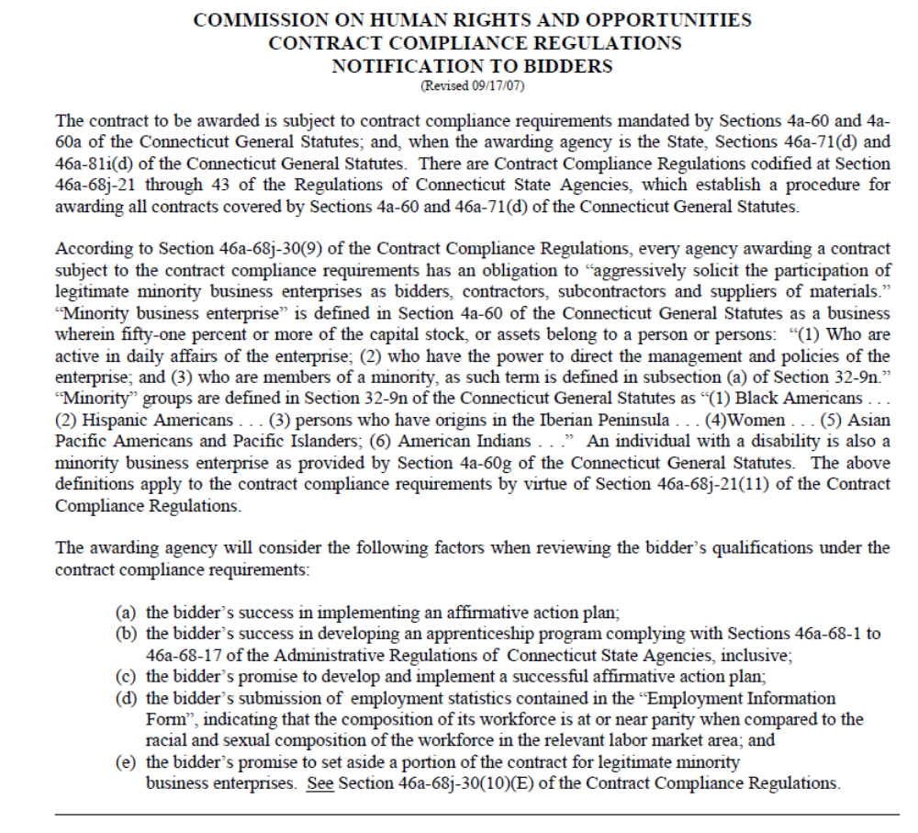
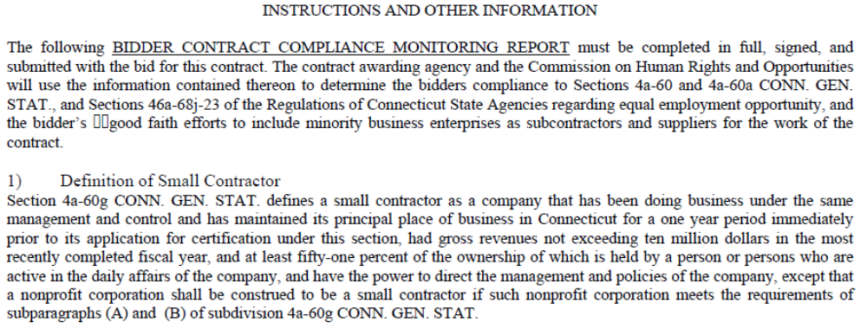
Attachment G
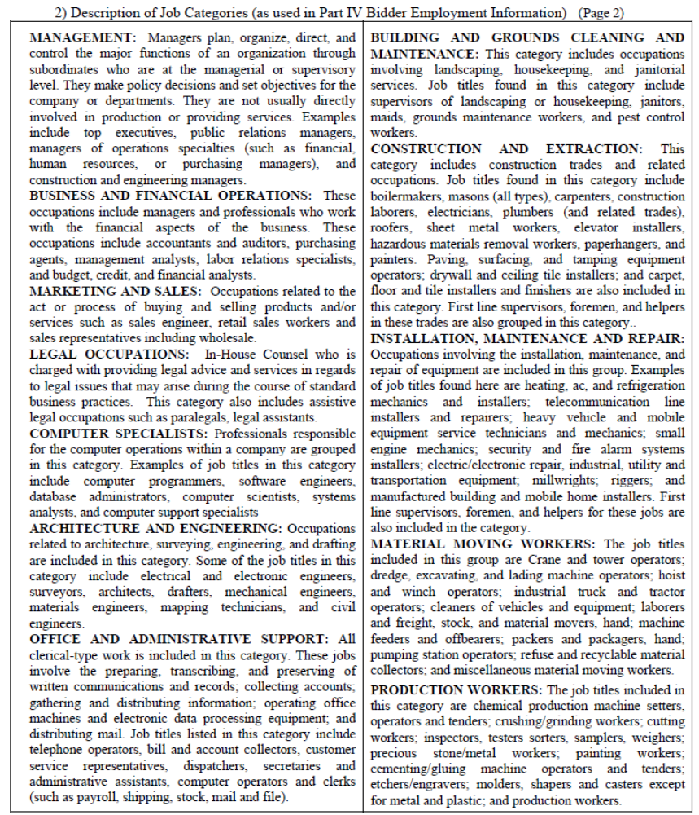

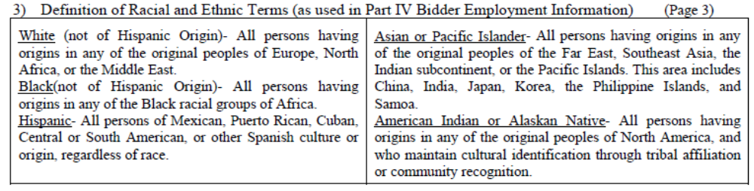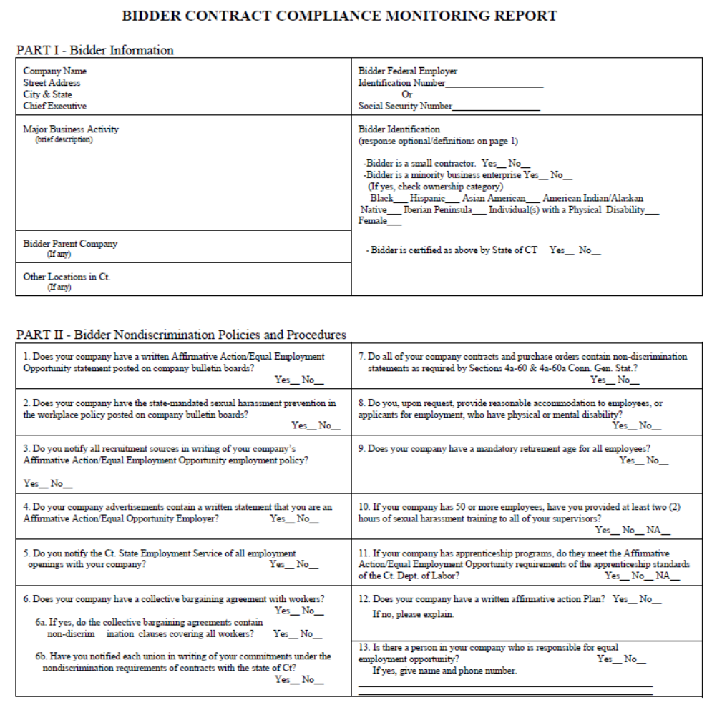

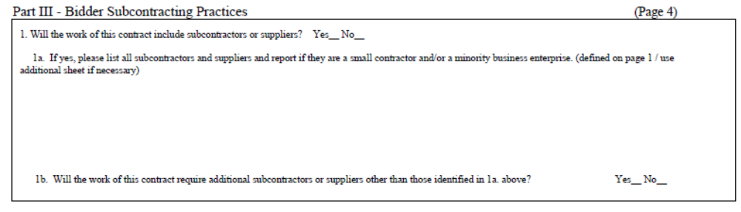

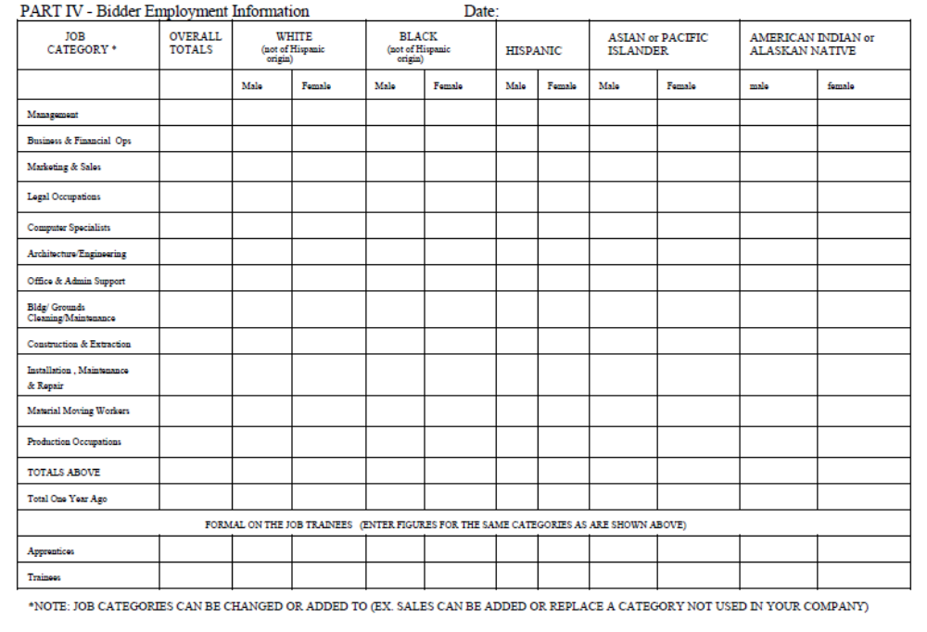

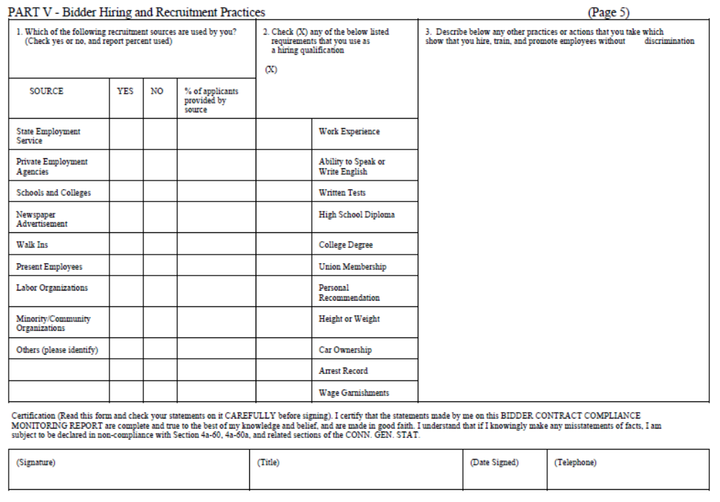

Contract Provisions Attachment I

1. Claims Against The State:
The Contractor agrees that the sole and exclusive means for the presentation of any claim against the State arising from this Agreement shall be in accordance with Chapter 53 of the Connecticut General Statutes (Claims Against the State) and the Contractor further agrees not to initiate legal proceedings in any state or federal court in addition to, or in lieu of, said Chapter 53 proceedings.

2. Indemnification and Insurance:
- The Contractor shall indemnify, defend and hold harmless the State and its officers, representatives, agents, servants, employees, successors and assigns from and against any and all (1) claims arising, directly or indirectly, in connection with the Contract, including the acts of commission or omission (collectively, the “Acts”) of the Contractor or contractor parties; and (2) liabilities, damages, losses, costs and expenses, including but not limited to, attorneys’ and other professionals’ fees, arising, directly or indirectly, in connection with claims, Acts or the contract. The Contractor shall use counsel reasonably acceptable to the State in carrying out its obligations under this section. The Contractor’s obligations under this section to indemnify, defend and hold harmless against claims includes claims concerning confidentiality of any part of or all of the Contractor’s bid, proposal or any records, any intellectual property rights, other proprietary rights of any person or entity, copyrighted or uncopyrighted compositions, secret processes, patented or unpatented inventions, articles or appliances furnished or used in the performance.
- The Contractor shall not be responsible for indemnifying or holding the State harmless from any liability arising due to the negligence of the State or any third party acting under the direct control or supervision of the State.
- The Contractor shall reimburse the State for any and all damages to the real or personal property of the State caused by the Acts of the Contractor or any contractor parties. The State shall give the Contractor reasonable notice of any such claims.
- The Contractor’s duties under this section shall remain fully in effect and binding in accordance with the terms and conditions of the Contract, without being lessened or compromised in any way, even where the Contractor is alleged or is found to have merely contributed in part to the Acts giving rise to the claims and/or where the State is alleged or is found to have contributed to the Acts giving rise to the claims.
- The Contractor shall carry and maintain at all times during the term of the Contract, and during the time that any provisions survive the term of the Contract, sufficient general liability insurance to satisfy its obligations under this Contract. The Contractor shall cause the State to be named as an additional insured on the policy and shall provide (1) a certificate of insurance, (2) the declaration page and (3) the additional insured endorsement to the policy to the Client Agency prior to the Effective Date of the Contract evidencing that the State is an additional insured. The Contractor shall not begin Performance until the delivery of these 3 documents to the Client Agency. State shall be entitled to recover under the insurance policy even if a body of competent jurisdiction determines that State is contributorily negligent.
- This section shall survive the termination of the contract and shall not be limited by reason of any insurance coverage.

3. Sovereign Immunity:
The parties acknowledge and agree that nothing in this Contract shall be construed as a modification, compromise or waiver by the State of any rights or defenses of any immunities provided by Federal law or the laws of the State of Connecticut to the State or any of its officers and employees, which they may have had, now have or will have with respect to all matters arising out of this Contract. To the extent that this section conflicts with any other section, this section shall govern.
4. Forum and Choice of Law:
The parties deem the Contract to have been made in the City of Hartford, State of Connecticut. Both parties agree that it is fair and reasonable for the validity and construction of the contract to be, and it shall be, governed by the laws and court decisions of the State of Connecticut, without giving effect to its principles of conflicts of laws. To the extent that any immunities provided by Federal law or the laws of the State of Connecticut do not bar an action against the State, and to the extent that these courts are courts of competent jurisdiction, for the purpose of venue, the complaint shall be made returnable to the Judicial District of Hartford only or shall be brought in the United States District Court for the District of Connecticut only, and shall not be transferred to any other court, provided, however, that nothing here constitutes a waiver or compromise of the sovereign immunity of the State of Connecticut. The Contractor waives any objection which it may now have or will have to the laying of venue of any claims in any forum and further irrevocably submits to such jurisdiction in any suit, action or proceeding.

5. Termination:
      - Notwithstanding any provisions in this contract, the College, through a duly authorized employee, may terminate the contract whenever the College makes a written determination that such termination is in the best interests of the State. The College shall notify the Contractor in writing of termination pursuant to this section, which notice shall specify the effective date of termination and the extent to which the Contractor must complete its performance under the contract prior to such date.
      - Notwithstanding any provisions in this contract, the College, through a duly authorized employee, may, after making a written determination that the Contractor has breached the contract, terminate the contract in accordance with the following breach provision.
- Breach. If either party breaches the contract in any respect, the non-breaching party shall provide written notice of the breach to the breaching party and afford the breaching party an opportunity to cure within ten (10) days from the date that the breaching party receives the notice. In the case of a Contractor breach, any other time period which the College sets forth in the notice shall trump the ten (10) days. The right to cure period shall be extended if the non-breaching party is satisfied that the breaching party is making a good faith effort to cure but the nature of the breach is such that it cannot be cured within the right to cure period. The notice may include an effective contract termination date if the breach is not cured by the stated date and, unless otherwise modified by the non-breaching party in writing prior to the termination date, no further action shall be required of any party to effect the termination as of the stated date. If the notice does not set forth an effective contract termination date, then the non-breaching party may terminate the contract by giving the breaching party no less than twenty four (24) hours’ prior written notice. If the College believes that the Contractor has not performed according to the contract, the College may withhold payment in whole or in part pending resolution of the performance issue, provided that the College notifies the Contractor in writing prior to the date that the payment would have been due.
      - The College shall send the notice of termination via certified mail, return receipt requested, to the Contractor at the most current address which the Contractor has furnished to the College for purposes of correspondence, or by hand delivery. Upon receiving the notice from the College, the Contractor shall immediately discontinue all services affected in accordance with the notice, undertake all College all records. The records are deemed to be the property of the College and the Contractor shall deliver them to the College no later than thirty (30) days after the termination of the contract or fifteen (15) days after the Contractor receives a written request from the College for the records. The Contractor shall deliver those records that exist in electronic, magnetic or other intangible form in a non-proprietary format, such as, but not limited to, ASCII or .TXT.
      - Upon receipt of a written notice of termination from the College, the Contractor shall cease operations as the College directs in the notice, and take all actions that are necessary or appropriate, or that the College may reasonably direct, for the protection, and preservation of the goods and any other property. Except for any work which the College directs the Contractor to perform in the notice prior to the effective date of termination, and except as otherwise provided in the notice, the Contractor shall terminate or conclude all existing subcontracts and purchase orders and shall not enter into any further subcontracts, purchase orders or commitments.
      - The College shall, within forty-five (45) days of the effective date of termination, reimburse the Contractor for its performance rendered and accepted by the College in accordance with the terms of this contract, in addition to all actual and reasonable costs incurred after termination in completing those portions of the performance which the notice required the Contractor to complete. However, the Contractor is not entitled to receive and the College is not obligated to tender to the Contractor any payments for anticipated or lost profits. Upon request by the College, the Contractor shall assign to the College, or any replacement Contractor which the College designates, all subcontracts, purchase orders and other commitments, deliver to the College all records and other information pertaining to its performance, and remove from State premises, whether leased or owned, all of Contractor’s property, equipment, waste material and rubbish related to its performance, all as the College may request.
      - For breach or violation of any of the provisions in the section concerning representations and warranties, the College may terminate the contract in accordance with its terms and revoke any consents to assignments given as if the assignments had never been requested or consented to, without liability to the Contractor or Contractor parties or any third party.
      - Upon termination of the contract, all rights and obligations shall be null and void, so that no party shall have any further rights or obligations to any other party, except with respect to the sections which survive termination. All representations, warranties, agreements and rights of the parties under the contract shall survive such termination to the extent not otherwise limited in the contract and without each one of them having to be specifically mentioned in the contract.
      - Termination of the contract pursuant to this section shall not be deemed to be a breach of contract by the College.

6. Entire Agreement:
This written contract shall constitute the entire agreement between the parties and no other terms and conditions in any document, acceptance or acknowledgment shall be effective or binding unless expressly agreed to in writing by College. This contract may not be changed other than by a formal written contract amendment signed by the parties hereto and approved by the Connecticut Attorney General.

7. Nondiscrimination:
The following subsections are set forth here as required by section 4a-60 and 4a-60a of the Connecticut General Statutes:
(a) For purposes of this Section, the following terms are defined as follows:
    - “Commission” means the Commission on Human Rights and Opportunities;
    - “Contract” and “contract” include any extension or modification of the Contract or contract;
    - “Contractor” and “contractor” include any successors or assigns of the Contractor or contractor;
    - “Gender identity or expression” means a person’s gender-related identity, appearance or behavior, whether or not that gender-related identity, appearance or behavior is different from that traditionally associated with the person’s physiology or assigned sex at birth, which gender-related identity can be shown by providing evidence including, but not limited to, medical history, care or treatment of the gender-related identity, consistent and uniform assertion of the gender-related identity or any other evidence that the gender-related identity is sincerely held, part of a person’s core identity or not being asserted for an improper purpose;
    - “good faith” means that degree of diligence which a reasonable person would exercise in the performance of legal duties and obligations;
    - “good faith efforts” shall include, but not be limited to, those reasonable initial efforts necessary to comply with statutory or regulatory requirements and additional or substituted efforts when it is determined that such initial efforts will not be sufficient to comply with such requirements;
    - “marital status” means being single, married as recognized by the state of Connecticut, widowed, separated or divorced;
    - “mental disability” means one or more mental disorders, as defined in the most recent edition of the American Psychiatric Association’s “Diagnostic and Statistical Manual of Mental Disorders”, or a record of or regarding a person as having one or more such disorders;
    - “minority business enterprise” means any small contractor or supplier of materials fifty-one percent or more of the capital stock, if any, or assets of which is owned by a person or persons: (1) who are active in the daily affairs of the enterprise, (2) who have the power to direct the management and policies of the enterprise, and (3) who are members of a minority, as such term is defined in subsection (a) of Connecticut General Statutes § 32-9n; and
    - “public works contract” means any agreement between any individual, firm or corporation and the State or any political subdivision of the State other than a municipality for construction, rehabilitation, conversion, extension, demolition or repair of a public building, highway or other changes or improvements in real property, or which is financed in whole or in part by the State, including, but not limited to, matching expenditures, grants, loans, insurance or guarantees.
For purposes of this Section, the terms “Contract” and “contract” do not include a contract where each contractor is (1) a political subdivision of the state, including, but not limited to, a municipality, (2) a quasi-public agency, as defined in Conn. Gen. Stat. Section 1-120, (3) any other state, including but not limited to any federally recognized Indian tribal governments, as defined in Conn. Gen. Stat. Section 1-267, (4) the federal government, (5) a foreign government, or (6) an agency of a subdivision, agency, state or government described in the immediately preceding enumerated items (1), (2), (3), (4) or (5).
(b) (1) The Contractor agrees and warrants that in the performance of the Contract such Contractor will not discriminate or permit discrimination against any person or group of persons on the grounds of race, color, religious creed, age, marital status, national origin, ancestry, sex, gender identity or expression, mental retardation, mental disability or physical disability, including, but not limited to, blindness, unless it is shown by such Contractor that such disability prevents performance of the work involved, in any manner prohibited by the laws of the United States or of the State of Connecticut; and the Contractor further agrees to take affirmative action to insure that applicants with job-related qualifications are employed and that employees are treated when employed without regard to their race, color, religious creed, age, marital status, national origin, ancestry, sex, gender identity or expression, mental retardation, mental disability or physical disability, including, but not limited to, blindness, unless it is shown by the Contractor that such disability prevents performance of the work involved; (2) the Contractor agrees, in all solicitations or advertisements for employees placed by or on behalf of the Contractor, to state that it is an “affirmative action-equal opportunity employer” in accordance with regulations adopted by the Commission; (3) the Contractor agrees to provide each labor union or representative of workers with which the Contractor has a collective bargaining Agreement or other contract or understanding and each vendor with which the Contractor has a contract or understanding, a notice to be provided by the Commission, advising the labor union or workers’ representative of the Contractor's commitments under this section and to post copies of the notice in conspicuous places available to employees and applicants for employment; (4) the Contractor agrees to comply with each provision of this Section and Connecticut General Statutes §§ 46a-68e and 46a-68f and with each regulation or relevant order issued by said Commission pursuant to Connecticut General Statutes §§ 46a-56, 46a-68e and 46a-68f; and (5) the Contractor agrees to provide the Commission on Human Rights and Opportunities with such information requested by the Commission, and permit access to pertinent books, records and accounts, concerning the employment practices and procedures of the Contractor as relate to the provisions of this Section and Connecticut General Statutes § 46a-56. If the contract is a public works contract, the Contractor agrees and warrants that he will make good faith efforts to employ minority business enterprises as subcontractors and suppliers of materials on such public works projects.
(c) Determination of the Contractor's good faith efforts shall include, but shall not be limited to, the following factors: The Contractor's employment and subcontracting policies, patterns and practices; affirmative advertising, recruitment and training; technical assistance activities and such other reasonable activities or efforts as the Commission may prescribe that are designed to ensure the participation of minority business enterprises in public works projects.
(d) The Contractor shall develop and maintain adequate documentation, in a manner prescribed by the Commission, of its good faith efforts.
(e) The Contractor shall include the provisions of subsection (b) of this Section in every subcontract or purchase order entered into in order to fulfill any obligation of a contract with the State and such provisions shall be binding on a subcontractor, vendor or manufacturer unless exempted by regulations or orders of the Commission. The Contractor shall take such action with respect to any such subcontract or purchase order as the Commission may direct as a means of enforcing such provisions including sanctions for noncompliance in accordance with Connecticut General Statutes § 46a-56; provided if such Contractor becomes involved in, or is threatened with, litigation with a subcontractor or vendor as a result of such direction by the Commission, the Contractor may request the State of Connecticut to enter into any such litigation or negotiation prior thereto to protect the interests of the State and the State may so enter.
(f) The Contractor agrees to comply with the regulations referred to in this Section as they exist on the date of this Contract and as they may be adopted or amended from time to time during the term of this Contract and any amendments thereto.
(g) (1) The Contractor agrees and warrants that in the performance of the Contract such Contractor will not discriminate or permit discrimination against any person or group of persons on the grounds of sexual orientation, in any manner prohibited by the laws of the United States or the State of Connecticut, and that employees are treated when employed without regard to their sexual orientation; (2) the Contractor agrees to provide each labor union or representative of workers with which such Contractor has a collective bargaining Agreement or other contract or understanding and each vendor with which such Contractor has a contract or understanding, a notice to be provided by the Commission on Human Rights and Opportunities advising the labor union or workers’ representative of the Contractor’s commitments under this section, and to post copies of the notice in conspicuous places available to employees and applicants for employment; (3) the Contractor agrees to comply with each provision of this section and with each regulation or relevant order issued by said Commission pursuant to Connecticut General Statutes § 46a-56; and (4) the Contractor agrees to provide the Commission on Human Rights and Opportunities with such information requested by the Commission, and permit access to pertinent books, records and accounts, concerning the employment practices and procedures of the Contractor which relate to the provisions of this Section and Connecticut General Statutes § 46a-56.
(h) The Contractor shall include the provisions of the foregoing paragraph in every subcontract or purchase order entered into in order to fulfill any obligation of a contract with the State and such provisions shall be binding on a subcontractor, vendor or manufacturer unless exempted by regulations or orders of the Commission. The Contractor shall take such action with respect to any such subcontract or purchase order as the Commission may direct as a means of enforcing such provisions including sanctions for noncompliance in accordance with Connecticut General Statutes § 46a-56; provided, if such Contractor becomes involved in, or is threatened with, litigation with a subcontractor or vendor as a result of such direction by the Commission, the Contractor may request the State of Connecticut to enter into any such litigation or negotiation prior thereto to protect the interests of the State and the State may so enter.

8. Executive Orders:
This Contract is subject to the provisions of Executive Order No. Three of Governor Thomas J. Meskill, promulgated June 16, 1971, concerning labor employment practices, Executive Order No. Seventeen of Governor Thomas J. Meskill, promulgated February 15, 1973, concerning the listing of employment openings and Executive Order No. Sixteen of Governor John G. Rowland promulgated August 4, 1999, concerning violence in the workplace, all of which are incorporated into and are made a part of the Contract as if they had been fully set forth in it. The Contract may also be subject to the applicable parts of Executive Order No. 7C of Governor M. Jodi Rell, promulgated July 13, 2006, concerning contracting reforms and Executive Order No. 14 of Governor M. Jodi Rell, promulgated April 17, 2006, concerning procurement of cleaning products and services, in accordance with their respective terms and conditions. If Executive Orders 7C and 14 are applicable, they are deemed to be incorporated into and are made a part of the Contract as if they had been fully set forth in it. At the Contractor’s request, the Department shall provide a copy of these orders to the Contractor.

9. Contracting with State Employees or Related Family/Business
Section 1-84 (i) of the Connecticut General Statutes prohibits the College to engage in contracts over $100 with State employees and certain related family or businesses as defined by Sections 1-79 (b) and (f), unless awarded through an open and public process. Contractor has disclosed to State whether it is an employee, related family member or associated business as defined by the statute. The Contractor and State each represent that they have fully complied with all applicable requirements of this statute, which is set forth below (emphasis added), or as it may be amended from time to time:
C.G.S. 1-84 (i) No public official or state employee or member of the official or employee's immediate family or a business with which he is associated shall enter into any contract with the state, valued at one hundred dollars or more, other than a contract of employment as a state employee, or a contract with a public institution of higher education to support a collaboration with such institution to develop and commercialize any invention or discovery, or pursuant to a court appointment, unless the contract has been awarded through an open and public process, including prior public offer and subsequent public disclosure of all proposals considered and the contract awarded. In no event shall an executive head of an agency, as defined in section 4-166, including a commissioner of a department, or an executive head of a quasi-public agency, as defined in section 1-79, or the executive head's immediate family or a business with which he is associated enter into any contract with that agency or quasi-public agency. Nothing in this subsection shall be construed as applying to any public official who is appointed as a member of the executive branch or as a member or director of a quasi-public agency and who receives no compensation other than per diem payments or reimbursement for actual or necessary expenses, or both, incurred in the performance of the public official's duties unless such public official has authority or control over the subject matter of the contract. Any contract made in violation of this subsection shall be voidable by a court of competent jurisdiction if the suit is commenced not later than one hundred eighty days after the making of the contract.

C.G.S. 1-79 (b) provides: "Business with which he is associated" means any sole proprietorship, partnership, firm, corporation, trust or other entity through which business for profit or not for profit is conducted in which the public official or state employee or member of his immediate family is a director, officer, owner, limited or general partner, beneficiary of a trust or holder of stock constituting five per cent or more of the total outstanding stock of any class, provided, a public official or state employee, or member of his immediate family, shall not be deemed to be associated with a not for profit entity solely by virtue of the fact that the public official or state employee or member of his immediate family is an unpaid director or officer of the not for profit entity. "Officer" refers only to the president, executive or senior vice president or treasurer of such business.

C.G.S. 1-79 (f) provides: "Immediate family" means any spouse, children or dependent relatives who reside in the individual's household.

10. Quality Surveillance, Examination of Records and Inspection of Work:
Pursuant to C.G.S. 4e-29 and 4e-30, all services performed by the Contractor and all records pertaining to this contract shall be subject to the inspection and approval of the State and the State Contracting Agency at reasonable times.

11. Assignment:
This contract shall not be assigned by either party without the express prior written consent of the other.

12. Professional Standards:
In rendering services under this contract, the Contractor shall conform to high professional standards of work and business ethic. The Contractor warrants that the services shall be performed: 1) in a professional and workmanlike manner; and 2) in accordance with generally and currently accepted principles and practices. During the term of this contract, the Contractor agrees to provide to the College in a good and faithful manner, using its best efforts and in a manner that shall promote the interests of said College, such services as the College requests, provided in this contract.

13. Confidential Information
  - The Contractor acknowledges that it may have access to Confidential Information (as hereinafter defined). The Contractor agrees that it will use the Confidential Information solely for the purpose of performing its duties as a consultant and agrees that it will not divulge, furnish, publish or use for its own benefit or for the direct or indirect benefit of any other person or entity, whether or not for monetary gain, any Confidential Information.
  - For purposes of this Agreement, the term “Confidential Information” shall mean (i) all information related to the business operations, marketing plans, financial position and (ii) other business information and any other information disclosed to the Contractor. Confidential Information shall not include information which (i) is or becomes part of the public domain through no act or omission attributable to the Contractor, (ii) is released after prior written authorization or (iii) the Contractor receives from any third party who is unrelated to it and who is not under any obligation to maintain the confidentiality of such information.

14. FERPA:
In all respects, Contractor shall comply with the provisions of the Family Educational Rights and Privacy Act (FERPA). For purposes of this contract, FERPA includes any amendments or other relevant provisions of federal law, as well as all requirements of Chapter 99 of Title 34 of the Code of Federal Regulations, as amended from time to time. Nothing in this agreement may be construed to allow Contractor to maintain, use, disclose or share student information in a manner not allowed by federal law or regulation or by this contract. Contractor agrees that it shall not provide any student information obtained under this contract to any party ineligible to receive data protected by FERPA. This section shall survive the termination, cancellation or expiration of the contract.

15. SEEC:
For all state contracts as defined in Connecticut General Statutes §9-612(g)(2), as amended by P.A. 10-1 having a value in a calendar year of $50,000 or more or a combination or series of such agreements or contracts having a value of $100,000 or more, the authorized signatory to this Agreement expressly acknowledges receipt of the State Election Enforcement Commission’s notice advising state contractors of state campaign contribution and solicitation prohibitions, and will inform its principals of the contents of the notice. See Notice below.


CONNECTICUT STATE ELECTIONS ENFORCEMENT COMMISSION Attachment H
Rev. 1/11
Page 1 of 2

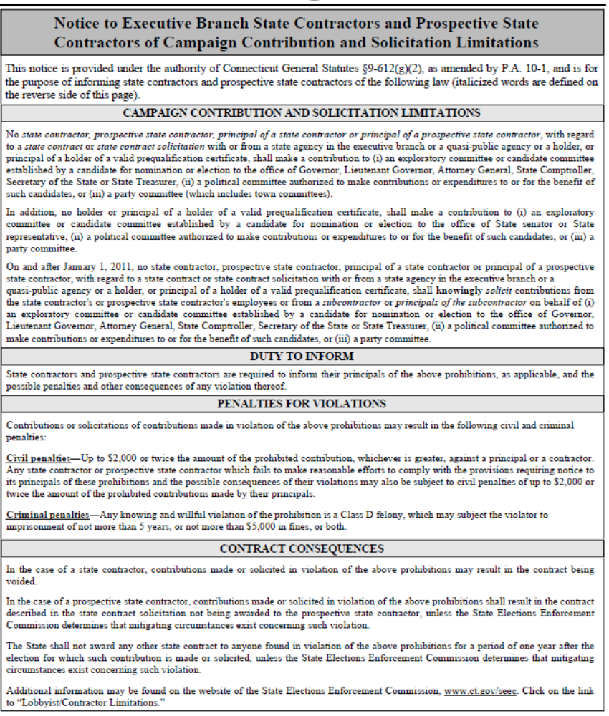

CONNECTICUT STATE ELECTIONS ENFORCEMENT COMMISSION
Rev. 1/11
Page 2 of 2
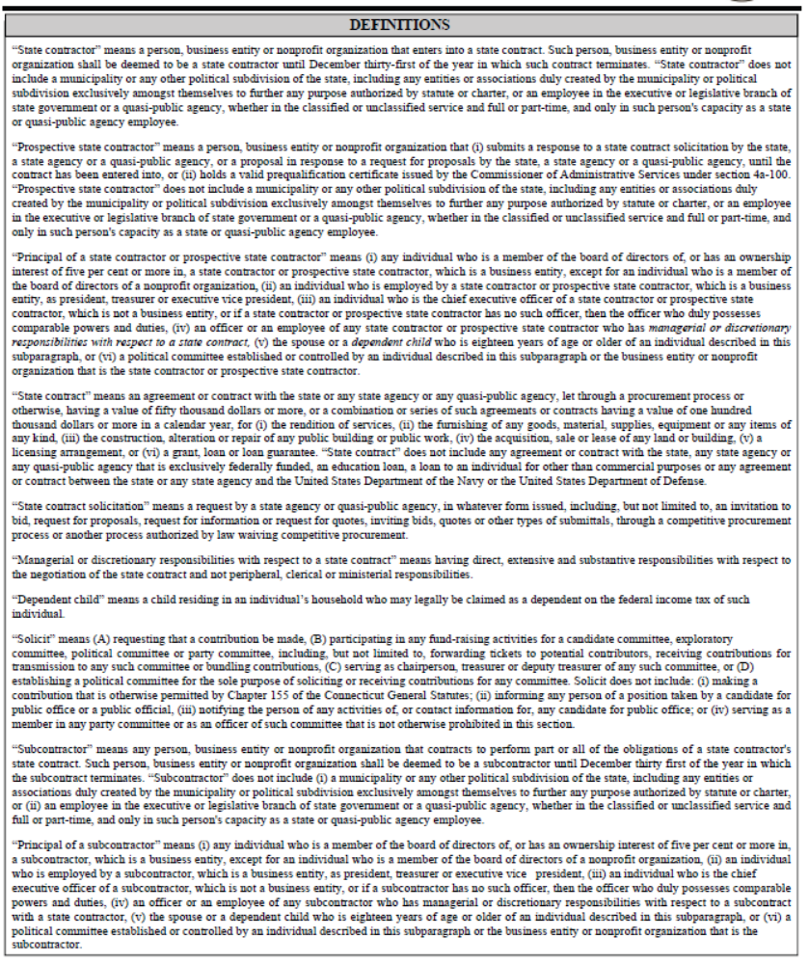

16. Summary of State Ethics Laws:
Pursuant to the requirements of section 1-101qq of the Connecticut General Statutes, the summary of State ethic laws developed by the State Ethics Commission pursuant to section 1-81b of the Connecticut General Statutes is incorporated by reference into and made a part of the contract as if the summary had been fully set forth in the contract.

17.Whistleblower:
This contract may be subject to the provisions of Section 4-61dd of the Connecticut General Statutes. In accordance with this statute, if an officer, employee or appointing authority of the Contractor takes or threatens to take any personnel action against any employee of the Contractor in retaliation for such employee’s disclosure of information to any employee of the contracting state or quasi-public agency or the Auditors of Public Accounts or the Attorney General under the provisions of subsection (a) of such statute, the Contractor shall be liable for a civil penalty of not more than five thousand dollars for each offense, up to a maximum of twenty per cent of the value of this contract. Each violation shall be a separate and distinct offense and in the case of a continuing violation, each calendar day’s continuance of the violation shall be deemed to be a separate and distinct offense. The State may request that the Attorney General bring a civil action in the Superior Court for the Judicial District of Hartford to seek imposition and recovery of such civil penalty. In accordance with subsection (f) of such statute, each large state contractor, as defined in the statute, shall post a notice of the provisions of the statute relating to large state contractors in a conspicuous place which is readily available for viewing by the employees of the contractor.

18. Disclosure of Records:
This Contract may be subject to the provisions of section 1-218 of the Connecticut General Statutes. In accordance with this statute, each contract in excess of two million five hundred thousand dollars between a public agency and a person for the performance of a governmental function shall (a) provide that the public agency is entitled to receive a copy of records and files related to the performance of the governmental function, and (b) indicate that such records and files are subject to the Freedom of Information Act (FOIA) and may be disclosed by the public agency pursuant to FOIA. No request to inspect or copy such records or files shall be valid unless the request is made to the public agency in accordance with FOIA. Any complaint by a person who is denied the right to inspect or copy such records or files shall be brought to the Freedom of Information Commission in accordance with the provisions of sections 1-205 and 1-206 of the Connecticut General Statutes

Connecticut General Statutes Attachment J
Sec. 36a-701b.
Breach of security re computerized data containing personal information. Disclosure of breach. Delay for criminal investigation. Means of notice. Unfair trade practice.

(a) For purposes of this section, "breach of security" means unauthorized access to or acquisition of electronic files, media, databases or computerized data containing personal information when access to the personal information has not been secured by encryption or by any other method or technology that renders the personal information unreadable or unusable; "personal information" means an individual's first name or first initial and last name in combination with any one, or more, of the following data: (1) Social Security number; (2) driver's license number or state identification card number; or (3) account number, credit or debit card number, in combination with any required security code, access code or password that would permit access to an individual's financial account. "Personal information" does not include publicly available information that is lawfully made available to the general public from federal, state or local government records or widely distributed media.
(b) Any person who conducts business in this state, and who, in the ordinary course of such person's business, owns, licenses or maintains computerized data that includes personal information, shall disclose any breach of security following the discovery of the breach to any resident of this state whose personal information was, or is reasonably believed to have been, accessed by an unauthorized person through such breach of security. Such disclosure shall be made without unreasonable delay, subject to the provisions of subsection (d) of this section and the completion of an investigation by such person to determine the nature and scope of the incident, to identify the individuals affected, or to restore the reasonable integrity of the data system. Such notification shall not be required if, after an appropriate investigation and consultation with relevant federal, state and local agencies responsible for law enforcement, the person reasonably determines that the breach will not likely result in harm to the individuals whose personal information has been acquired and accessed.
(c) Any person that maintains computerized data that includes personal information that the person does not own shall notify the owner or licensee of the information of any breach of the security of the data immediately following its discovery, if the personal information was, or is reasonably believed to have been accessed by an unauthorized person.
(d) Any notification required by this section shall be delayed for a reasonable period of time if a law enforcement agency determines that the notification will impede a criminal investigation and such law enforcement agency has made a request that the notification be delayed. Any such delayed notification shall be made after such law enforcement agency determines that notification will not compromise the criminal investigation and so notifies the person of such determination.
(e) Any notice required by the provisions of this section may be provided by one of the following methods: (1) Written notice; (2) telephone notice; (3) electronic notice, provided such notice is consistent with the provisions regarding electronic records and signatures set forth in 15 USC 7001; (4) substitute notice, provided such person demonstrates that the cost of providing notice in accordance with subdivision (1), (2) or (3) of this subsection would exceed two hundred fifty thousand dollars, that the affected class of subject persons to be notified exceeds five hundred thousand persons or the person does not have sufficient contact information. Substitute notice shall consist of the following: (A) Electronic mail notice when the person, business or agency has an electronic mail address for the affected persons; (B) conspicuous posting of the notice on the web site of the person, business or agency if the person maintains one; and (C) notification to major state-wide media, including newspapers, radio and television.
(f) Any person that maintains such person's own security breach procedures as part of an information security policy for the treatment of personal information and otherwise complies with the timing requirements of this section, shall be deemed to be in compliance with the security breach notification requirements of this section, provided such person notifies subject persons in accordance with such person's policies in the event of a breach of security. Any person that maintains such a security breach procedure pursuant to the rules, regulations, procedures or guidelines established by the primary or functional regulator, as defined in 15 USC 6809(2), shall be deemed to be in compliance with the security breach notification requirements of this section, provided such person notifies subject persons in accordance with the policies or the rules, regulations, procedures or guidelines established by the primary or functional regulator in the event of a breach of security of the system.
(g) Failure to comply with the requirements of this section shall constitute an unfair trade practice for purposes of section 42-110b and shall be enforced by the Attorney General.
Attachment K
Sec. 11-25. Reports by Libraries. Confidentiality of Records.

Sec. 11-25. Reports by libraries. Confidentiality of records. (a) The libraries established under the provisions of this chapter, and any free public library receiving a state appropriation, shall annually make a report to the State Library Board.
(b) (1) Notwithstanding section 1-210, records maintained by libraries that can be used to identify any library user, or link any user to a library transaction, regardless of format, shall be kept confidential, except that the records may be disclosed to officers, employees and agents of the library, as necessary for operation of the library.
(2) Information contained in such records shall not be released to any third party, except (A) pursuant to a court order, or (B) with the written permission of the library user whose personal information is contained in the records.
(3) For purposes of this subsection, "library" includes any library regularly open to the public, whether public or private, maintained by any industrial, commercial or other group or association, or by any governmental agency, but does not include libraries maintained by schools and institutions of higher education.
(4) No provision of this subsection shall be construed to prevent a library from publishing or making available to the public statistical reports regarding library registration and use of library materials, if such reports do not contain personally identifying information.
(1949 Rev., S. 1663; February, 1965, P.A. 490, S. 8; P.A. 75-316, S. 15; P.A. 81-431, S. 4; P.A. 07-227, S. 20.)
History: 1965 act substituted state library committee for state board of education; P.A. 75-316 substituted state library board for state library committee; P.A. 81-431 added Subsec. (b) concerning confidentiality of library circulation records; P.A. 07-227 replaced former Subsec. (b) re confidentiality of personally identifying information with new Subsec. (b) re confidentiality of records that can be used to identify library user or link user with library transaction and release of records, effective July 1, 2007.
Attachment L

APPENDIX – SCOPE OF SERVICES
(Appendix of Section 6 of this Request for Proposals)
PREAMBLE

Reliability. Patrons and staff expect a very high degree of system availability and response time 24/7/365. The solution must meet very high reliability expectations. The vendor must be capable and ready, when failures do occur, to mitigate and resolve them quickly and accurately.

Scalability and Performance. The consortium includes twelve (12) Community Colleges, four (4) State Universities, one fully-online college (Charter Oak State College), and the Connecticut State Library; all of which are located at sites across the State. The solution must be able to accommodate a consortium of this size, and of the diverse set of demands that would be placed on it.

Manageability. Member libraries maintain lean, cost-effective systems staffing levels within a complex and constantly changing environment. We, therefore, require an easily managed solution with low administrative overhead. The solution should also generally be designed with configuration flexibility in mind, with a minimum of irrevocable configuration or design decisions.

Security. We will entrust an extremely large amount of critical data to our shared solution. The solution should offer strong mechanisms for data backup and recovery, as well as safeguards against data tampering and theft. In addition, the solution must allow us to manage data security and privacy at multiple levels: individual staff or patron user, single institution, subset of the consortium, and consortium-wide.

Robust Identity Management. The Consortium has a large patron and staff population; many of those patrons and staff already represented in institutional identity management systems. The solution should allow us to leverage those identity stores, instead of requiring their re-creation. The solution should also provide for solution-hosted identities for institutions with no identity store of their own.

Robust Authorization Model. The consortium strongly embraces a cooperative management model, and the solution should allow for administrative and functional authorization at multiple levels: individual staff or patron user, single institution, subset of the consortium, and consortium-wide.

Integration Flexibility. Consortium members rely on strategically important integrations between their LMS and other institutional platforms, including Learning Management and Student and Financial information systems, interlibrary loan systems, and bibliographic utilities to support strategic workflows.

Analytics and Extensibility. Consortium members perform analysis, reporting, and management on the LMS-related data they collectively hold. The solution should offer flexible, powerful capabilities for large-scale data extraction, manipulation, reporting, and automation. These capabilities might include native reporting tools, integration with external reporting tools, application programming interfaces (APIs), and scripting functionality.

Migration Feasibility. The Consortium would like to complete the migration of all libraries in an elapsed time of one (1) year or less, to commence no later than January, 2016. Both the solution and its vendor should be prepared to support such a migration plan, or be able to offer an equally suitable plan.

Comprehensive Support. The Consortium desires long-term partners who can not only deliver a sound, useful solution with a strong documentation set, but also deliver services, training, and support when called upon. The Consortium also seeks partners with a history and culture of proactively responding to customer needs and suggestions, and supporting the activity of user groups and communities.

Systems

Reliability

The consortium intends to share a solution across multiple institutions.

The consortium seeks to maintain the highest possible level of service availability and

response times to all consortium participants in all locations.

Describe how the solution minimizes business disruption and maximizes system availability. What kind of “up” time do you typically deliver (also define any terms within your answer as appropriate)? What are the biggest risks to the solution, in terms of availability, and how are these risks mitigated? Provide any examples you can of large outages that have occurred, how long they lasted, and how you resolved them.

Describe how the solution monitors and reports on system reliability and performance, and provide sample reference data or screenshots, as appropriate, of monitoring feedback.

Describe what kind of scheduled down time, or “quiet time,” the solution requires, noting the frequency, duration and purpose. What tools are available to continue core functions during down times? How are jobs that are scheduled to run during down times handled?

Scalability and Performance

The systems workload of the consortium varies dramatically, on a minute-by-minute,

hourly, daily, weekly and monthly basis.

Describe how the solution addresses the need to add new institutions over time, with the accompanying -- often immediate and large -- increases in users served and collections managed that such additions require.

Describe how the solution manages peaks and spikes in workload over varying periods of time, including seconds, minutes and hours.

Describe how the solution enables simultaneous batch operations across multiple institutions, including any limits on such operations.

Describe how the solution insures that identifiers that are unique within an institution are also unique across all institutions. Areas where this issue may manifest itself include but are not limited to item and patron barcodes, university identification numbers, and user names.

Describe the hard and soft limits on the number of records of various types which the solution can manage. What is involved in changing the soft limits?

Describe the hard and soft limits on both the size of and the number of values in data elements within records of various types which the solution can manage. What is involved in changing the soft limits?

Describe any performance vs. workload relationships inherent in the solution, citing specific examples. For example, if cataloging transaction load is higher than normal, does this affect search and display? How do you monitor and adjust the solution to address competing needs?

Architecture

Do you provide the solution as a hosted service, a local service, or either, depending on customer preference? If you support both, what is your recommended architecture, and why?

Describe the expected level of local systems staffing required for the solution, given the size of the consortium and diversity of its members.

What is the largest implementation (e.g., sites, record counts) you have as a single installation? When did you implement it? Describe any significant hurdles you encountered in its implementation.

Describe any initial configuration or implementation decisions that cannot be later changed, or altered only with great effort or expense.

Explain which system profiling/configuration decisions apply globally across the system, and which can apply to a subset of institutions.

What portions of your proposed system(s) are separable? E.g., is it possible to use an alternate discovery environment but still use your solution for fulfillment and for back-end processing? Which specific third-party discovery solutions does your solution work with? Describe any interfaces and APIs that are available to support such integration/interoperability.

The consortium desires the ability to roll out upgrades, feature enhancements, updates and fixes for the solution quickly and easily. For example, if a staff client component needs to be upgraded on a local PC, the consortium would like the update to take place automatically, on a scheduled basis. Describe how the solution meets this goal.

Describe how staff interact with the solution (e.g., browser-based client, locally installed client). Describe any related system requirements for the staff client (e.g., operating systems, memory, drive space). For locally executed clients, describe the client’s ability to run from a virtual desktop platform and from a non-administrator account. For Windows clients, does the client possess a “known publisher” security certificate from Microsoft?

From what operating systems (e.g. Windows, OS/X, Linux) can staff interact with the solution? Describe any functional differences or limitations that might exist for particular platforms. For browser-based systems, what browsers do you officially support? How do you determine which platforms and browsers you will support?

Data Security and Data Access

Describe the data management practices to which the solution adheres, including those for patron and circulation transaction information. Include relevant information on standards compliance (such as ISO 27001) and any organizational information technology audits that have been completed. Can data access be segmented -- for example, can institutions decide what patron information is viewable by staff at other institutions?

Describe the solution's use of and support for secure protocols to safeguard data in transit.

Describe the solution's support for encryption in backups and in replica sets.

Describe how the solution prevents loss of data, and how it provides data recovery or rollback to specific points in time in the event data loss does occur. Also describe the process through which data is recovered. For example, is the recovery process a self-service mechanism or must the customer contact your organization to request data recovery?

What protocols have been established for dealing with unauthorized access to or disclosure of confidential data?

Describe what data validation the solution performs on records as they are created or edited, and indicate whether this is different for batch jobs as compared to single records.

Describe how the solution tracks changes to records. Is there an audit trail for edits? Is it possible to revert to previous versions of a record?

Describe the extent to which the solution has been designed to comply with laws and regulations governing the storage and use of “protected” user data. Examples of such laws and regulations include: Family Educational Rights and Privacy Act (FERPA), Health Insurance Portability and Accountability Act (HIPAA), and Payment Card Industry Data Security Standards (PCI-DSS).

Authentication, authorization and identity management

Some of our institutions have significantly invested in the development and management of existing identity-related data stores (e.g., Active Directory, LDAP). Describe how the solution can leverage these identity stores, both for staff and patron accounts. Describe also how such capabilities can co-exist alongside identities natively managed within the proposed solution.

Describe how administrative rights and staff permissions are assigned within the system. Can rights be assigned to identities stored in external identity stores, such as Active Directory? Can permissions be assigned to groups, as well as users? Does the solution allow compartmentalizing of rights and permissions on a per-institution basis? For example, can you limit the effect of administrative rights assignment to a single institution?

Describe the level of granularity of access controls for staff functions (principle of least privilege). E.g., can certain data elements be made read-only for some staff and read-write for others?

Some consortium staff and patrons have multiple identities. How would users with multiple affiliations be supported in the system, with respect to authentication, permissions assignment to their account, and permissions on their accounts?

Describe your support for single sign-on authentication and authorization solutions (e.g., CAS, Shibboleth, and Microsoft’s Identity and Access Management solution).

Describe alternative patron authentication path, if primary path fails, or if exceptional access is necessary.

Integration and Extensibility

Describe the integration the solution provides with respect to related services such as self-check, resource sharing (ILL), link resolution, proxy services, collection agency services, discovery, learning management and student information systems, etc.

Describe the integration the solution provides with campus financial systems, as used for ordering, invoicing and other functions.

Describe the integration the solution provides with report writing platforms, such as Crystal Reports.

Describe the ability of the solution to process transactions via NCIP and SIP2.

Describe how the solution exposes data through documented web services and APIs, including supported data operations (read, write, update, delete, and so on). Describe any licensing or technical restrictions or constraints placed on the use of these tools and services. Are business rules and access controls applied?

Describe any facility the solution provides for staff client automation, using such techniques as keyboard shortcuts, task-oriented macros, and keystroke recording.

Describe the product’s support for the Library Linked Data model, including the Resource Description Framework (RDF) and RDFa. For example, does the solution possess the ability to expose, as linked data, authority-controlled names and holdings in the shared management system?

Consortium libraries rely on a variety of data presentation and reporting beyond the traditional per-record views typically available in an LMS staff client. Describe how the solution delivers customizable, relational views of data. Include information about what data are available through these views, whether the views are read-only or provide update capabilities, and any export or scripting capabilities.

Describe how the solution supports batch loading and batch updates of records (all types).

For all reporting, updating, importing and exporting functions, describe the level of staff expertise needed to perform the operation. In particular, identify which functions require the intervention of a database administrator or Systems/IT personnel as opposed to functions that library staff can perform on their own.

Migration

Describe a recommended or typical migration timeline for an organization such as the consortium. Include recommendations regarding the grouping of libraries, and the number of stages.

Describe the typical or recommended amount of LMS downtime for the migration, based on institutional size, number of patron or bibliographic records, or some other applicable metric.

Describe the migration services you offer, including data migration services, training, and configuration and policy planning.

Describe your experience migrating data from Innovative Interfaces Millennium and Ex Libris Voyager. Describe any specific considerations or difficulties in migrating bibliographic, acquisitions, serials, check-in, electronic resource, content license, patron and circulation records and data from these systems into your solution.

Describe the ability to retain and preserve transient or temporal data, such as checkouts, holds, item status, item statistics (such as total checkouts), patron status and patron blocks, through the migration process.

Describe the ability during migration to merge similar bibliographic records without loss of locally-created data.

Describe the ability during migration to handle and resolve duplicate barcodes.

Vendor support

The Consortium seeks a long-term solutions partner committed to

customer service and open to customer feedback.

Describe any proactive monitoring of the solution by your organization, and any actionable communications to the customer that result from this monitoring. For example, do you warn the customer if certain system limits are being reached, such as record counts or processing availability? How do you alert the customer in the event of planned downtime and unplanned system anomalies?

Describe your customer support venues (e.g., web, phone, email), periods of coverage, and expected response times.

Describe your customer support model. For example, would you accept support requests from any consortium staff member, or only from designated representatives? Do you provide a primary contact(s) for a given customer account, or do you provide support by geographic region, or by area of specialty (e.g., circulation, cataloging)?

Consortium member libraries have a history of actively participating in vendor-centric user community groups to help positively steer product direction and enhance the usefulness of a solution for all community members. Describe any customer community activities you sponsor or support, such as online or in-person venues to allow customers to share ideas and solutions. Include information about annual conferences and attendance, and regional interest groups.

Describe the product enhancement process, and the role that customers play in determining and prioritizing new features and enhancements. Describe any changes or updates you have made to your solution in the past year as a direct result of customer feedback.

Describe the frequency and scope of both major and minor releases. How long do you support a major platform release after it has been superseded by a new version?

Describe the content and delivery method (context-sensitive, online, knowledgebase, etc.) of administrative and end-user documentation sets, as well as the frequency of documentation updates. Also describe the availability of user-authored content, such as community wikis.

Describe how the solution reports transaction errors and other errors, so that staff may take action on them.

Describe the support (including documentation and online forums) provided for APIs and web services that enable the customer to extend management system functionality.

Circulation and Resource Sharing

Borrowing & Lending Processing
The consortium seeks a solution that enables efficient, transparent circulation and resource sharing as if each institution were a member of a single, large multi-branch library system, and that allows members to service extra-consortial borrowing and lending workflows.

Local (single institution)

Describe the workflow from the point of an item-level request made by a patron on a local item, through to delivery of the item to the patron at the patron’s specified pickup location, and circulation of the item to the patron.

Describe how the solution handles multiple branches, potential remote storage facilities, and special collections within a single institution with respect to requesting, circulation, and delivery.

Consortial

Describe the borrowing and lending workflow of an item-level request made by a patron on a consortial item, through to the delivery of the item to the patron’s specified pickup location, circulation of the item to the patron, and then the return of that item to the home library.

Describe how the solution determines due dates and hold priority at the consortial level given numerous global and library-specific shelving locations, categories of patrons, and material formats.

Describe the mechanisms for tracking items in transit for delivery from and to their home libraries.

Describe the tools available to manage and balance borrowing requests across member libraries, to target outcomes such as workload fairness and speed of delivery. Include information about how quickly such changes take effect.

Interlibrary Loan (non-consortium)

Describe how the solution federates with other circulation platforms, including traditional interlibrary loan systems (ILLiad, Odyssey, etc.), for the delivery of electronic and physical materials of items not owned by the consortium.

Describe any copyright and licensing agreements, procedures, and compliance tracking that the solution offers.

Circulation

The consortium desires an “any item, any patron, any library” circulation model within a complex environment. The consortium therefore anticipates the need to implement a mix of consortium-wide circulation lending rules, alongside rules that apply to just one, or a subset of institutions.

Administrative

Describe how the solution enables distributed responsibility for maintaining permission to specific circulation functions.

Describe how the solution provides for the coexistence of consortial lending rules and local lending rules.

Describe how the solution provides the ability to view-only, edit and manage lending rules.

Describe how the solution manages a variety of library hours and closures.

Billing and Payments

Describe how the solution manually and automatically generates bills and fees for services, fines, and lost items.

Describe the history and detail that is kept on bills and fines.

Describe how the solution allows libraries to accept payment for services, fines, and materials at a service desk in the library and also waive fines, and in what formats (credit card, cash, campus cards, etc.).

Describe how the solution handles integration with multiple financial information systems.

Describe how the solution can facilitate billing between consortium libraries.

Bookings / Scheduling

Describe how the solution provides for the booking and scheduling of equipment, materials, and rooms.

Check-in / Check-out

Describe how the solution determines due dates, due times, and fines for checkouts, renewals, recalls (local and consortial), holds, and bookings.

Describe the ability to support offline circulation transactions when the system is unavailable. If a site loses access to the shared solution, what kinds of activities (e.g., checkout, check-in, cataloging) would the site be able to continue? Describe the process involved in resynchronizing the local site with the shared solution after the issue has been resolved.

Describe what mechanisms are supported to scan or read material and patron identifiers into the system (barcodes, RFID tags, mag strips, etc.).

Describe the solution’s ability to integrate with other systems (such as 3M RFID) for the purposes of item security and patron self-check stations. Provide examples of how the solution integrates material inventory sorting systems.

Describe the hold/holdshelf management capabilities of the solution, including holds on large numbers of items and across multiple institutions.

Collection Management

Describe the mechanisms you offer for Floating Collections.

Describe the inventory/collection management tools available in the solution, including integration with third party collection management tools.

Course Reserves

Describe the solution’s course reserves functionality (print, electronic, and streaming media), including the ability to cross-link courses and items, and to suppress temporary items.

Describe any copyright and licensing agreements, procedures, and compliance tracking that your system offers.

Describe the solution’s mechanism for tracking usage of reserve items (both print and electronic) and the ability to generate reports searchable by professor, course, and location.

Describe the solution’s functionality integration with third-party course reserves systems and/or learning management systems.

Patrons

Describe how the solution allows automatic and manual blocks of patrons from borrowing and other services both at the consortial and local level.

Describe how the solution allows management of patrons (alumni, community borrowers, etc.) who have local privileges, but not consortial privileges or remote access to licensed databases.

Describe the elements and structure of a patron record in the solution and how patron records are created.

Patron Self-Service

Describe the patron self-service features of the solution, including holds, bookings, renewals, notice preferences, self-updates of patron information, etc.

Statistics and Reporting
The consortium engages in a continual process of modifying services and workflow based on empirical data. Therefore, the consortium expects the solution to deliver statistical data and metrics in a timely, actionable manner.

Describe the reporting tools available, including use of the collection and its services (lending/borrowing, logins to e-resources, etc.).

Describe the ability of the solution to retain transaction-oriented information (without patron-identifiable data) indefinitely for statistical reporting purposes, even if the associated item or patron has been removed from the system.

Communications and Notifications
The consortium considers communication with and among its staff and patrons to be of critical importance and therefore requires a solution that provides tools for information and notification delivery to staff and patrons in both electronic and printed form.

Describe the types of notices and print products which the solution provides (receipts, paging slips/lists, book bands, hold shelf tags, pickup and overdue notices, and replacement bills) on all materials, including course reserves.

Describe the ability to customize, design, and brand print and electronic notices (templates).

Describe the types of automated patron notifications the solution provides (e-mail, SMS, etc.).

Describe the ability for staff communication (local and inter-institutional) about individual transactions (message alerts in records, as an example).

ACQUISITIONS AND COLLECTION ANALYSIS

General Acquisitions Functionality
    - Describe the solution’s acquisitions workflow, including non-purchased materials, such as gifts or government documents.
    - Describe how the solution supports multiple secured acquisitions instances, but still allows the flexibility to share data consortially.
    - Describe the local options for customizing workflows (For example: Can the system support creation of customized fund types, order types, or payment options locally? Can the system support creation of multiple queues?)
    - Describe the system support for ordering item status display within the OPAC/discovery layer, such as information on order processing, order status (i.e. backordered or out of print), receipt of item, and status during the cataloging process.
    - Describe the interaction or linking between acquisitions functions and the other system functions.
      - Describe how order data is stored in relationship to bibliographic and item data, including linking a purchase order record to multiple bibliographic records.
      - How does the acquisitions function interact with the circulation functions? Are there any automated mechanisms to place items on hold or notify patrons when new items arrive?
      - How does the acquisitions function interact with the serials/electronic management function? Can you reference licenses/user agreements from within the acquisitions function?
    - Describe how the solution supports the integration between interlibrary loan and acquisitions to provide support for patron driven acquisitions/purchase-on-demand programs of both print and electronic content (i.e. articles and eBooks).
    - Describe the creation of a fund structure including the various functions used to create the structure including the ledger, fund types, etc.
    - Describe the solution’s fund management system allowing the monitoring of allocations, encumbrances, and expenditures. Include descriptions of fund types such as summary, allocating, and reporting funds. Does solution allow for nesting of funds within another fund?
    - Describe the solution’s support for the budget planning and assessing future costs using historical expenditure data.

  - Ordering/Claiming
    - Describe the solution’s support for automated selection, ordering, and claiming, using standards like EDIFACT and X12. Which of these transactions can be completely automated?
    - Describe how acquisitions transactions can be integrated with campus financial accounting systems.
    - Describe the solution’s ability to automatically create order, invoice, and/or item records.
    - Describe how the solution supports ordering workflow within a consortium. Discuss process in which multiple institutions can purchase the same item at different times and using different vendors while maintaining existing bibliographic data.
    - Describe how the solution handles tracks tax exempt status and assists in the tracking of taxes charged but later refunded.
    - Describe the solution’s ability to track and handle credit memos. Will the system be capable of applying a given credit memo to a particular item?
    - Describe your solution’s support for claiming print and electronic materials.
  - Receiving
    - Describe the solution’s receiving capabilities for the acquisition of various formats including books, periodicals, standing orders, and eBooks.
    - Describe the solution’s support for holdings or item records created at the time of receipt.
  - Invoicing
    - Describe the solution’s support for the invoicing process.
    - Describe the solution’s flexibility while expending funds during the invoicing process.
    - Describe the system’s support for receiving and paying electronic invoices from vendor, using standards like EDIFACT and X12.

  - Vendor Information
The consortium requires a vendor file that will allow each library to maintain vendor contact information.
    - Describe the set up and various aspects of the vendor information stored for each vendor including storing multiple addresses, various contact information, and notations.
    - Describe the solution’s support for making vendor data available to staff in other functional areas.
  - Reporting/Statistics
As one of the essential parts of acquisitions work now and in the future, CSCU libraries require the ability to make full use of acquisitions and other LMS systems data in order to report and project expenditures for institutional stakeholders. We would like a system that allows each library to build or create reports needed on a case by case basis.

    - Describe how the solution supports and creates an audit trail for all financial data held within the acquisitions function. How does it treat fund adjustments or account for varying kinds of fees such as processing fees or unexpected charges?
    - Describe the solution’s financial reporting functionality, including, but not limited to, granularity of data retrieval and level of local and consortia customization, without intervention by solution vendor.

  - End of Year Functionality/Records Retention
    - Describe the solution’s support for fiscal-year closing functionality. Will the solution be capable of closing by a variety of fiscal-year options? In what format and for how long can fiscal close records be retained?
    - Describe what records or data are stored in the solution from acquisition processes and for how long. Describe if the solution allows for the inclusion of established state and local records retention periods for records and data held in the solution.

  - Collection Analysis
    - Describe the solutions support for collections assessment based on various factors including subject area, format type, circulation statistics, and holdings within other consortial libraries.
    - Describe how the solution supports external statistical reporting needs, such as IPEDS, ACRL, and NCES
    - Describe how the solution supports the marketing and communicating of new library resources (i.e. new book lists) to our librarians and institutional stakeholders.

CATALOGING AND METADATA.

We are seeking a union database of bibliographic and authority records which applies to all

libraries in the consortium, and provides an integrated, streamlined, efficient workflow.

The solution must be capable of supporting manual and batch loading, exporting, editing,

deletion, and manipulation of bibliographic, authority, and holdings data.

Functional basics.

Describe how the solution supports a database of shared institutional records of all types (i.e. bibliographic, item, order, serials, etc.) while allowing libraries to add, maintain, and view fields and data unique to each site.

Describe how to search entire database, and how to limit searching to one or more specific sites.

Describe both “out-of-the-box” and customizable statistical reporting capabilities.

Describe how physical materials processing is supported. Describe whether spine label printing is available for all supported classification schemes, with correctly formatted location designations. List supported label layouts

Formats supported.

Specify which metadata formats and content standards are supported and how solution ensures extensibility to future formats and content standards, such as BIBFRAME, RDA, and linked data developments. Specify those formats for which support is under consideration or in development.

Describe library classification scheme support, including Library of Congress, Superintendent of Documents, Dewey, and locally-developed schemes.

Describe subject heading and subject term support, including Library of Congress Subject Headings, Medical Subject Headings (MeSH), and controllable genre/form terms.

Verify support of non-Roman script, including bidirectional display where required.

Explain how the solution executes “transformations” or “cross-walks” between and among supported metadata formats. Provide a list of crosswalks provided “out of the box”, and describe how libraries can load and edit locally developed crosswalks.

Record management.

Importing/Loading

Describe how the solution allows efficient batch importing, including interoperability with third party tools, if necessary. Explain how batches can be reviewed and tested before processing.

Describe how the system handles duplicate detection and reporting for all types of records, such as overlay and merge processes. Explain how locally-designated fields are protected in the overlay/merge processes, and how locally selected record overlay match points are implemented and maintained.

Explain how to create and store templates for new records and for editing existing records.

Editing/Record manipulation

Describe how solution allows efficient editing and deletion of individual records and fields or metadata elements within records. Explain how to save draft records without committing them to the catalog.

Describe batch and bulk editing and deletion of records and subsets of records. Explain how modifications of these sets can be reviewed and tested before processing.

Describe any embedded assistance in enforcing formally adopted bibliographic editing policies. Explain how to restrict editing privileges for specific types of records, e.g. MARC records subscriptions for e-journals.

Exporting

Describe how to export bibliographic, holdings, and item records both individually and in batch mode.

Verify that the solution allows exporting both bibliographic and holdings data in the same file.

Holdings management.

Describe how to create holdings and item records for physical and electronic resources.

Describe how the solution maintains bibliographic records that include multiple holdings and item records. Describe any limitations in the number of holdings or items associated with a single bibliographic record.

Describe how the solution maintains single holdings or item records associated with multiple bibliographic records. Describe any limitations in the number bibliographic records associated with a single holdings or item record.

Authority control.

Describe the solution’s approach to authority control within a consortial environment, and support for emerging environments such as linked data.

Describe how libraries create, edit, and load local authority records.

Describe how the solution automatically authorizes bibliographic headings and thesaurus terms – individually or in batch – against authority files local or remote. Describe how these processes change discrete elements of partially-validated headings, and how those changes are reported.

Describe how a subset of unauthorized bibliographic records can be authorized by automated comparison of that subset against a set of authorized records.

Staff Searching/ Indexing

Describe real-time indexing/re-indexing of data.

Describe how to save and manage results sets from staff queries.

Explain how to filter large result sets by date of material, type of material, format, or other limiting parameters.

Provide a list of indexed and searchable fields. Describe how to create custom indexes.

Describe what fields are included in the keyword index and verify that the keyword index is customizable.

Describe filtering by date, material type, format, or other parameters.

Describe how to save the last few searches from a session for ease of navigation.

SERIALS MANAGEMENT AND ELECTRONIC RESOURCES MANAGEMENT

The consortium seeks to reduce repetitive tasks whenever possible, while meeting the needs of

individualized license requirements. The solution must be flexible enough to accommodate varied

workflows and authentication requirements vis-à-vis serials and electronic resources acquisitions

and management, and allow for the possibility of sharing data when desired.

Serials

Describe the solution’s support for material management at the issue level, including receiving, item generation, labeling, routing, claiming, and binding.

Describe the solution’s support for the creation of date prediction patterns and enumeration patterns for check-in purposes, and migrating from current systems.

Describe how the solution supports externally supplied holdings data, for example data coded in bibliographic MARC tag 891.

Does the solution provide access to the continuous record of receipt for each issue of a title?

Describe the solution’s support for the check-in of multiple instances of a given title; for example, one subscription to a title might include individual issues, bound volumes, pocket parts, pamphlet supplements, legislative service, and possibly other parts, each received on a regular or irregular basis.

Describe how each of these parts can be accommodated and distinguished, either within a single record or on separate records.

Describe the solution’s ability to display the status of an individual issue of a serial publication. For example, “arrived” or “available online.”

Describe the solution’s support for recording and receipt of issues via SISAC and/or UPC codes.

Describe the solution’s integration of serials claiming across workflows, including EDI.

Describe how the system’s serials check-in system can provide the option to automatically update the MARC 21 holdings record, including all content related to the 85X/86X paired fields, either during receiving or as a separate function.

Describe how the solution will display print holdings’ location and statuses such that the current holdings of each institution are clearly identified.

Describe system support for generating statistics from serial records (number of active subscriptions, number of pieces received, etc.).

Does the solution support binding element information for both serial and non-serial materials?

Describe the functionality of identifying and collapsing serial binding units. Does the solution provide optional automated alerts for serial binding?

Describe which bindery communication protocols are supported.

Describe how the solution generates binding preparation reports or reports which facilitate preservation assessment.

Describe the invoicing workflow for print and electronic subscriptions.

Describe how the solution processes invoices with detailed begin and end dates.

Describe the solution’s support for alerts when loading large electronic invoices for subscription renewals.

Electronic Resource Management (ERM)

Describe the creation of an electronic resource record.

Can these records be created at different hierarchical levels to support electronic resource package and combination purchases?

Can these records be created at the local and the consortial level?

How do these records link to license documents and acquisition information?

Describe the solution’s support for the management of license agreements, for local and consortial purchases.

How are license and related documents stored and displayed in the solution?

Does the solution support the sending of license terms electronically? Does it support any standards, such as ONIX-PL?

What fields are available for license terms and how can these be available for viewing in other areas of the solution (e.g. ILL, course reserves, and authorized users)?

Describe the solution’s ability to manage administrative information for electronic resources and explain its relationship with the acquisitions vendor file.

Describe the workflow management available for electronic resources. This might include reminders for renewal or the ability to track new resources from trials through to access setup.

Describe how the solution assigns accurate rights to the correct populations of users given the complex nature of electronic resource management in a consortial environment.

Describe the solution’s OpenURL resolver. Is the menu customizable by institution?

If there is no integrated OpenURL resolver, describe the solution’s interactions with third-party OpenURL applications.

Describe how both system administrators and end users can report broken links or other service problems.

Describe the solution’s ability to ingest and manage usage statistics for electronic resources at the local and consortial level. Can these statistics be reported out at both levels in a flexible customizable format?

Describe how the solution supports the ability to evaluate both trials and existing resource subscriptions based upon usage statistics, cost, cost-per-use, and changes in license or changes in title lists to a package.

Describe the solution’s ability to output electronic resource records in customizable ways for integration into library web spaces and catalogs.

Does the solution provide a means of notifying staff and end users of non-access to resources and does this display in real time?

DISCOVERY

Content
The content of your solution’s central index must include both open and licensed materials contained in local and consortial collections and beyond. Proposers must provide rich descriptive metadata for all indexed content to enhance discoverability.

Define the scope of your pre-harvested, centralized index.

Outline what type of content is, and is not, included in the index.

Describe how your solution merges and normalizes metadata from multiple sources.

Describe what level of metadata your solution provides.

Describe the frequency of content updates. Describe how content is maintained and how the customer is notified of any substantive changes in the central index.

Describe how your solution integrates content purchased or licensed by individual or groups of libraries that has not been ingested into your index into the search results.

Provide a list of content providers included in your centralized index, noting any exclusive agreements or ones in which the agreements have a fixed expiration date.

The top ten resource providers whose content our libraries license and consider ‘key’ for inclusion in a central index are: CQ Press, Credo, EBSCO, Elsevier, Facts on File, Gale, JSTOR, Lexis-Nexis, ProQuest, Sage. Describe in general the scope of your agreements with these content providers.

Vendor must provide a statement affirming the neutrality of their algorithms for generating result sets, relevance rankings, and link order with respect to ideological/political viewpoint and content provider source.

In cases where the same content is available through multiple content sources, the solution provider must permit the customer to establish preferences regarding the order of sources to present to users.

The solution must be able to ingest local resources, such as content from traditional OPACs, institutional repositories and other digital collection management systems.

Briefly explain the process of ingesting content, including any pre-processing requirements and data formats/schemas supported.

Describe how users would be able to determine availability, access full-text, place holds, etc. without leaving the discovery environment.

User Interface
We envision a service that will embody the principles of universal design by providing a simple, intuitive, functional, and attractive user interface for all library patrons.

Has the system been subjected to professional usability testing with students? Did the usability testing include mobile devices? Is this testing conducted on an ongoing basis? Describe how feedback gathered through usability testing is incorporated into UI changes.

At what point is the remote user required to authenticate, before or after searching?

Solution must meet the most current accessibility standards defined by Section 508 of the U.S. Rehabilitation Act of 1973 (the “Rehabilitation Act”).

Describe how the user interface and system defaults can be customized:

On a consortium-wide basis

On an individual library basis

By an individual user

Navigation between the discovery system and individual licensed resources should be seamless and not confuse the patron. Describe how your solution accomplishes this.

Describe what embeddable widgets are provided and whether it is possible to integrate 3rd party content (e.g., LibGuides, Ask-a-Librarian, etc.) in your solution. Can other web-based content be incorporated per the organization’s preference? If so, how and by whom?

The user experience should be platform agnostic so that it works regardless of the device used to access and does not require an app for use on mobile devices. Describe how your end-user interface will meet this need.

Users must be able to manage their own experience from any location or device.

Describe what features are available for individual user accounts (e.g., saving searches, search results, and citations).

Describe how users might interact with your solution through tagging, recommendations or writing reviews.

Search

Search Queries

Vendor’s solution must accommodate the needs of both novice searchers (e.g., first-year students) and experienced/advanced users (e.g., librarians, graduate students, professors, etc.). Initial search page must be simple enough for a novice user to navigate successfully without assistance.

Discovery solution must contain an advanced search feature, facets and limiters. Describe the advanced search functionality of your solution.

Describe how users can limit their searches to a given library location’s physical collection.

Describe what types of index searches (e.g. author, subject, ISBN) are available. Are indices browseable?

Describe how users are informed what resources are included by default in their searches.

Describe what assistance the system provides to novice users in constructing their searches.

Describe how the system helps students select the specific database(s) most relevant to their needs.

Search Results

Solution must provide comprehensive search results quickly and in a format that highlights the most critical information about the result item and provides visual cues on how to take further action.

Describe the standards by which you measure the solution’s responsiveness to query input. What percentage of queries meet those standards when testing service application performance?

Describe what information is included in the default format of search results and how they can be filtered and sorted.

Describe the actions that can be taken from search results items. Can available actions be configured or customized, and in what ways?

Describe how users can modify searches from the search results screen.

Describe how relevancy is determined and whether the relevancy algorithm can be customized.

Describe how your solution enables users to create, share, and export individual items, lists of items, and search queries to social media, citation managers, and word processors. Describe any permalinking features.

Describe what supplemental and contextual information your solution provides about items such as book covers, tables of content, indexes, reviews, and other content previews that enrich the user’s understanding of the nature and content of items and collections.

Describe how multimedia content is displayed to the user.

Describe how the discovery solution ensures by default that the user’s search results reflect all and only the licensed content which the user’s institution is authorized to provide.

Describe how users would be able to determine availability, place holds, and requests, etc. without leaving the discovery environment.

Describe the guidance and support provided to novice users in the context of displaying search results.

Describe what guidance the system provides when no search results are returned.

Describe how your solution guides the user to related content based on the search terms entered and/or citation data.

Statistics and Reports

The solution must provide a suite of reports robust enough to inform collection development decisions, improve the user experience at both the consortial and campus levels, and assess student learning. The solution must provide a means to produce custom reports, be compliant with NISO usage statistics standards, and integrate with third-party report writers.

List the reports you provide on usage.

Statistics should have the ability to be broken down by resource used.

Reports must have the ability to be filtered by individual library, groups of libraries (e.g., community colleges or universities), and by devices and browsers used to access the discovery solution.

Usage statistics must be COUNTER Release 4-compliant.

List the tools you provide for assessment (e.g., review student searches and results).

List what reports you provide for collection analysis.

Technical

The solution must be supported through a technical support service level agreement that defines support hours, availability targets and provides reported metrics on service availability, responsiveness and resource utilization.

System maintenance

Describe how your system handles consortial implementations and initial setup work.

Describe the time needed to build full index.

Estimate the amount of staff time required to maintain the solution for the local library clientele. Describe how MARC records are kept up-to-date, particularly in a consortial implementation of your discovery tool.

Describe your data backup system and data recovery plan.

Devices & interfaces

User devices interacting with the discovery service must be broadly supported with a minimum of maintenance.

The user interface should be web-based and not require special plugins or client software to use on all devices.

Verify that all discovery features will work with the top ten browsers for North America in January 2015 (combining all versions of Chrome and Firefox versions 5+) as identified by StatsCounter Global Stats (http://gs.statscounter.com).

Verify that mobile apps, if provided, will be available for both the iOS and Android mobile environments with equal functionality.

Interoperability.

The solution must interoperate with student services platforms (e.g., Blackboard, Banner) and other library discovery and access tools, such as OPACs, link resolvers, institutional repositories, ILL products, and digital management software. Describe how this is accomplished.

Verify that the solution is LTI (Learning-Tools-Interoperability) standard-compatible? If so, which version?

Provide a list of third (3rd) party library discovery and access tools with which your solution interoperates. Describe what technologies, protocols, etc. are used to achieve this integration.

Describe what APIs are available and any policies governing their use.

APIs must come with good supporting documentation. Is there a product listserv or forum?

Verify that an active development community exists and describe what mechanisms are available to gather input from the user community (e.g., user group ballot processes, etc.).

Describe how your solution might integrate the use of other vendor APIs.

Provide a list of UI elements available for customization and briefly outline the methods by which they may be customized.

REQUIRED FOR STANDALONE DISCOVERY BIDS

The Discovery solution proposer has sole responsibility for delivering and maintaining the services proposed for Section F.1.5.2 that require close integration with the back office staff functions, regardless of the chosen LMS vendor. Describe how your solution will satisfy this requirement for the term of the contract, including any partnership agreements you have with LMS vendors and how those agreements ensure that this requirement will be met. Provide a list of clients that have successfully integrated your Discovery solution with a different vendor’s LMS in a production environment.

REQUIRED FOR STANDALONE STAFF FUNCTIONS BIDS

Proposers that bid on the staff functions only will be required to cooperate with discovery-only proposers to enable close integration between the discovery solution and the back office as indicated in Sections A.3.6 and A.6.5. Describe how your solution will satisfy this requirement for the term of the contract, including any partnership agreements you have with Discovery vendors, and provide a list of clients that have successfully integrated your back office solution with a different vendor’s Discovery solution in a production environment.

OTHER (INFORMATION NOT USED TO SCORE PROPOSALS)

Proposers are welcome, but not required, to provide information about related products and services.

