Fudge Factory
2006



Prepared by:

Leigh Anderson
Amanda Hoehn
Jeremy Olthof
Glenn Stacey

Ag Ec 495.3 Agribusiness Venture Management
College of Agriculture and Bioresources
University of Saskatchewan

Executive Summary
The Fudge Factory is a Saskatchewan based business. The business currently manufactures over the counter fudge at its facility. The new venture is to introduce a retail wrapped fudge bar into an untapped Western Canadian market.

The retail fudge bar will be an 80g packaged bar that will come in twelve regular flavors and two sucrose free flavors. Manufacturing will take place at the present facility. The intention is to sell 110,000 bars in the first year, distributed through gift shows, certain PharmaChoice® stores, and the SaskMade Marketplace®.

The retailers will pay FF $2.59 per bar. The fudge bar will then be premium priced to the consumer at $3.99 per bar at a 35% margin for the retailer. The use of quality ingredients will make this a top of the line product.

FF will employ a General Manager/President, Co-manager, Sales Representative, Fudge Chef and one fudge worker in its first year of operation. Additional fudge workers will be added as production increases over the ten year planning horizon.

The initial capital investment required for this operation is $50,000. This will come from retained earnings of the existing business. The projected internal rate of return for the FF expansion is 38.6% with a net present value of $137,172.

Table of Contents
1.0 Executive Summary i
2.0 Table of Contents ii
2.1 List of Figures v
2.2 List of Tables vi
2.3 Table of Appendices vii
3.0 Introduction 1
3.1 The Business Overview 1
3.2 Mission Statement 1
3.3 Purpose 1
4.0 Operations Plan 2
4.1 Organizational Structure 2
4.2 Site Plan and 10 year Development Plan 2
4.3 Building and Floor Plan 3
4.4 Work Plan and Flow of Work 6
4.4.1 Technical processes 6
4.4.2 Physical product flow of Manufacturing Fudge 6
4.4.3 Average Business Day/Month/Year 7
4.4.4 Quality Control Program 8
4.4.5 Supply Service Analysis 8
4.4.6 Environmental Limitations 8
4.5 The Capital Budget 8
4.6 Working Capital Planning and Management 10
4.6.1 Cost of Goods Sold for Manufacturing 10
4.6.2 Administration, Marketing, and General Expenses 12
4.6.3 Cash Management 13
4.6.4 Inventories 13
4.6.5 Accounts Receivable 13
4.6.6 Accounts Payable 14
4.6.7 Cash Conversion Cycle 14
5.0 Human Resources Plan 15
5.1 Job Descriptions 15
5.1.1 President/General Manager 15
5.1.2 Co-Manager 15
5.1.3 Fudge Chef 15
5.1.4 Fudge Workers 15
5.2 Planned Additions/Deletions 15
5.2.1 Sales Representative 15
5.2.2 Fudge Workers 16
5.3 Training 16
5.4 Compensation 16
5.5 Human Resources Strategy 17
5.6 Line of Authority 17
6.0 Marketing Plan 18
6.1 Marketing Mix 18
6.1.1 Products 18
6.1.2 Price 19
6.1.3 Promotion 19
6.1.4 Place 20
6.2 Segmentation, Targeting and Positioning 21
6.3 Market analysis 22
6.3.1 Past Performance 22
6.3.2 The Market 23
6.3.3 Competition Analysis 23
6.3.4 Customers 23
6.3.5 Target Markets 24
6.3.6 The Opportunity 24
6.4 Marketing Strategy 24
6.4.1 Sales and Profit Objectives 24
6.4.2 Channels of Distribution 24
6.4.3 Pricing Policy 25
6.4.4 Select Markets and Product 25
6.4.5 Selling and Advertising 25
6.4.6 Marketing Plan Budget 26
7.0 Financial Plan 27
7.1 Financing 27
7.2 Financial Performa’s 27
7.3 Dividend Policy 28
7.4 Sensitivity and Risk Analysis 28
7.4.1 Critical variables 28
7.5 Scenario Analysis 28
8.0 Conclusion 31
9.0 References 32
10.0 Appendix 33

List of Figures
Figure 1 Organizational Structure 2
Figure 2 Site Plan 3
Figure 3 Floor Plan of Business 4
Figure 4 Floor Plan for Fudge Operations 5
Figure 5 Flow of Work 6
Figure 6 Line of Authority 17
Figure 7 Positioning Map of Pricing Positions for Various Premium Chocolate Bars 21
Figure 8 Break-Even Sales 29
Figure 9 Break-Even Price 29

List of Tables
Table 1 Capital Budget for Ten Years 9
Table 2 Capacity Limits 10
Table 3 Cost of Goods Manufactured Calculation in the First Year of Operation 10
Table 4 Cost of Goods Manufactured Calculation for Ten Year Average 11
Table 5 First Year Cost of Goods Sold Calculation 12
Table 6 Ten Year Average Cost of Goods Sold Calculation 12
Table 7 Employee Time Allocation 13
Table 8 Salary/Wage Projections for the First Year of Operation 16
Table 9 Fudge Varieties 18
Table 10 Estimation of FF’s Targeted Population 21
Table 11 SWOT Analysis 22
Table 12 Competition in the Premium Chocolate bar Market 23
Table 13 Marketing Budget 26
Table 14 Statement of Financial Results 27
Table 15 Critical Variables 28
Table 16 Scenario Analysis for Price and Sales 28
Table 17 Scenario Analysis for Sales 29
Table 18 Scenario Analysis for Price 29

Table of Appendices
Statement of Income and Retained Earnings 33
Balance Sheet 34
Statement of Cash Flows 35
Schedule 1 36
Schedule 2 36
Schedule 3 37
Schedule 4 38
Schedule 5 39
Schedule 6 40
Schedule 7 41
Schedule 8 41
Schedule 9 41
Schedule 10 42
Schedule 11 42
Schedule 12 43
Sensitivity of Net Present Value: Price and Sales 44
Sensitivity of Internal Rate of Return: Price and Sales 44
Sensitivity of Net Present Value: Price 44
Sensitivity of Internal Rate of Return: Price 45
Sensitivity of Net Present Value: Sales 45
Sensitivity of Internal Rate of Return: Sales 45

Introduction

The Business Overview
The FF is a business within a gift. The business is family owned and operated. The FF was established nine years ago. They began making fudge nine years ago in their first business. In 2001 they ventured the fudge factory to the current location. There is currently a gift shop which contains locally made items and is run as a separate enterprise within the same store as the FF. Products of the FF include: over the counter fudge, gelato (Italian ice-cream), soft serve ice cream, hot and frozen beverages, Saskatoon berry pie and crepes, and cinnamon buns. The retailing of gourmet fudge bars will be the focus of this business plan.

Mission Statement
“To provide retail gourmet fudge bars made from high quality ingredients while promoting the Fudge Factory as a premium brand”

Purpose
The business proposal is to concentrate on the feasibility of moving a packaged fudge bar into the premium retail market. The primary target market will be retailers across Western Canada. The retailers within these areas are high-end gift stores that sell similar gourmet products. To achieve this, the company has decided to target two venues. The first venue to be targeted is the gift show circuit. Gift shows allow business owners to be targeted for retail sales of the fudge bars.
Value added stores specifically the PharmaChoice® chain and SaskMade Marketplace® will also be approached as wholesale customers.

Operations Plan

Organizational Structure
There are two members on the FF’s board of directors that comprise the organizational structure of this business. The President/General Manager and the Co-Manager. There is a Sales Representative. FF is a family run business with positions that often overlap each other. Figure 1 is the organizational structure of FF and it shows the flow of authority within the business depicting overlapping business positions.
Figure 1 Organizational Structure
Board of Directors
Sales Representative
President/General Manager

Co-Manager

Factory Staff

Site Plan and 10 year Development Plan
The business operates in the first floor of a two storey building. The ten year development plan is to remain in the current location primarily because it attracts numerous tourists.

Figure 2 Site Plan
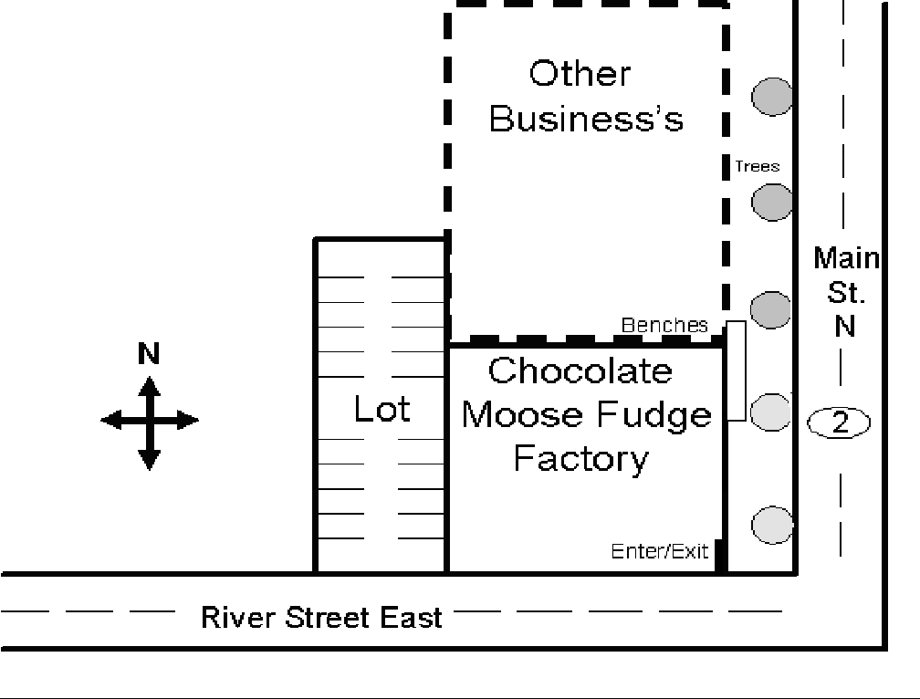

Building and Floor Plan
A detailed floor plan of the entire store including the Lasting Impressions Gift Store and the FF, is shown in Figure 3. Figure 4 shows the layout of the FF where the production of the fudge bars will take place.

Figure 3 Floor Plan of Business
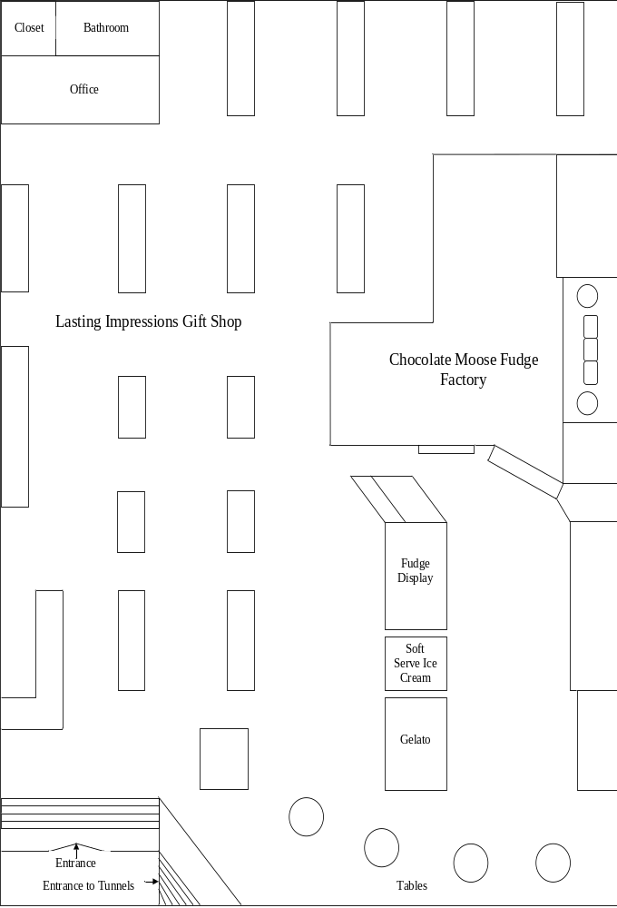

Figure 4 Floor Plan for Fudge Operations
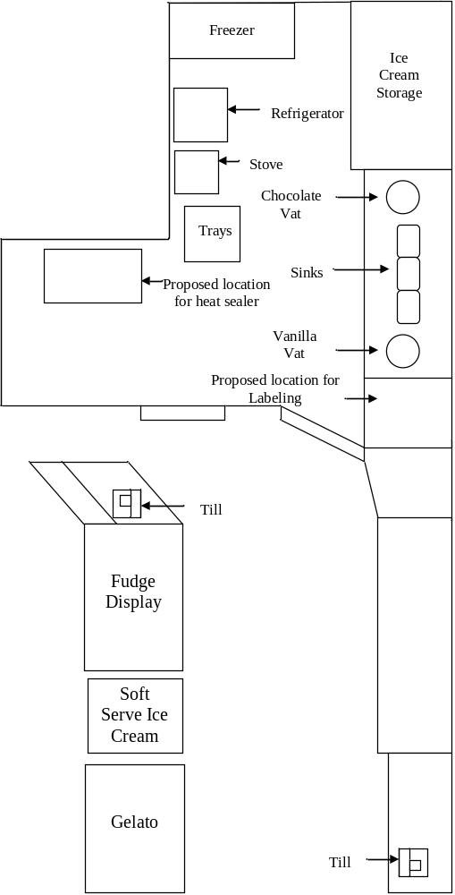

Work Plan and Flow of Work

Technical processes
The primary technical processes involved in the FF are fudge production and fudge packaging. The General Manager/President, Co-Manager and Fudge Chef will be responsible for producing the fudge. The second technical process involved is the packaging and labeling of the fudge. Figure 5 shows the detailed steps in the fudge making and packaging process.
Figure 5 Flow of Work
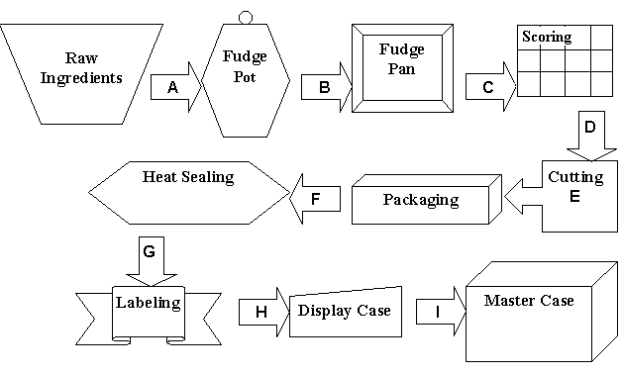

Physical product flow of Manufacturing Fudge
Step A. At the start of a fudge process the raw ingredients are measured according to the fudge recipe and added to the fudge pot for mixing and heating.
Step B. Once the fudge has been heated it is transferred to 9 x 13 inch fudge pans.
Step C. After pouring the fudge into the fudge pans, the fudge is scored with a grid in order to make lines for cutting in a later step.
Step D. The fudge pans are placed into cooling racks for 24 hours, this allows for the fudge to harden before it is cut and packaged. After 24 hours the fudge is cut into twelve 4 x 2 pieces, this is done by following the scored lines that were previously marked in the fudge prior to cooling. This allows for a uniform cut each time.
Step E. Once the fudge has been cut into pieces it is placed onto a piece of packaging cardboard the same size as the fudge piece. The cardboard and the fudge together are then inserted into a fudge wrapper. This wrapper comes sealed on three sides allowing insertion of the bar only on the one side.
Step F. Before the packages can be labeled, the fudge package is heat-sealed to close the open end on the package.
Step G. The packaged fudge bars are labeled on the front and back of the wrapper. On the front of the package the bars are labeled according to the flavour and weight of 80 grams. The back of the bar is labeled with a list of the ingredients as well as nutritional information. The expiry date is printed and placed on the back label.
Step H. Once the fudge bars are labeled, thirty-six fudge bars are packaged into a display box by flavour.
Step I. Six display boxes are then packaged into a master box. The master boxes are then held in inventory before being sold to retailers.

Average Business Day/Month/Year
During an average year the fudge business can be broken into the busy and slow seasons. The busy season consists of the months of February, July-August and October-December. These months are busy because of Valentines Day, gift shows, and Christmas. The remaining months January, March-April, May-June and September make up the slow season. One of the goals of the business is to have the fudge produced at a steady rate year round. The year-end for the business is August 31st.

Although the FF has regular store hours, fudge bars will be produced between 9:30am and 5:30pm Monday-Friday. A typical eight hour shift per three employees will produce 2400 uncut fudge bars. The three employees consist of the Fudge Chef, fudge worker and either the President/General Manager (20% of time) or Co-Manager (80% of time). The cutting and packaging of the fudge takes place at least 24 hours after the fudge is made.

A typical week during the slow period has operating hours of 9:30-5:30pm Monday-Saturday with hours of 9:30am-9:00pm on Thursdays and 12:00pm-5:00pm on Sunday in April-December. For most of the busy season (July-August) the operating hours of the business are from 9:30am-9:00pm Monday-Sunday. The fudge bars are produced every second day or as needed according to demand during the slow months. Fudge will be produced Monday, Wednesday and Friday to meet expected capacity limits. The cutting and packaging of the fudge during the slow months will take place 2-3 times a week. During the weekends for the months of September-December the President/General Manager and the Sales Representative attends gift shows to promote the fudge bars to the retailers.

Quality Control Program
The FF will be implementing a Hazardous Analytical Critical Control Points (HACCP) program in the first year of operation. The cost of implementing HACCP will be $30,000 for the first year with a rebate of $15,000 in the second year of operation. After the first year, there will be an annual cost of $1,000 to comply with HACCP regulations. HACCP is needed for the fudge bars to be sold out of province. The business property is currently approved for food production by the city of Moose Jaw.

Supply Service Analysis
Several ingredients are used in the fudge making process. Mrs. Nicholson has utilized several suppliers to produce the fudge she sells in her store. The same ingredients will be used in the packaged product that will be delivered to the retail sector. The main supplier of the ingredients, herein called the New York supplier due to confidentiality, supplies the business with the basic raw materials. The basic raw materials from this supplier include: cream, sugar, food colorings, all flavorings (extracts), and potassium sorbate. Other suppliers used at present include: Safeway®, Costco®, and Harlan Fairbanks®. Safeway® supplies the butter that is used in the fudge while Costco® provides the walnuts, pecans and chocolate chips. Safeway® and Costco® are used because they provide these ingredients cheaper than other companies. Harlan Fairbanks® provides the Oreo® cookie bits and crushed Skor® bar.

Environmental Limitations
There are no environmental limitations for FF as the building has already been approved for use by the city and is in compliance with all regulations.

The Capital Budget
Table 1 shows the capital budget for the FF including both assets to be purchased and current assets. One heat sealer will be purchased for the packaging line primarily because of the limited space; the cost of the heat sealer is $7,500. This machine is classified as a class 10 asset according to Capital Cost Allowance (CCA) rates to be depreciated at 30%. A custom made inkjet printer will be purchased for $10,000, to be used for printing expiry date labels for the fudge bar wrapper. This printer is classified as a class 12 asset according to CCA rates to be depreciated 100%. A computer plus software and a Blackberry™ will be purchased in the first year and replaced every four years. The computer and software are valued at $800 and the Blackberry™ is valued at $100. These values were calculated based on average costs of the products and a 40% allocation to the fudge bar venture.

In the production of the fudge bars, current assets already owned by the FF will be utilized. These assets are two fudge pots valued at $20,000, however only 50% is allocated to the fudge bar venture. These fudge pots are classified as class 8 assets according to CCA rates to be depreciated 20%. Under class 10 assets there is $2,000 allocated to the company’s fridge and freezer, 25% of which is used by the fudge bar venture. Under class 12 assets there are miscellaneous equipment valued at $10,000 including small hardware (e.g. knives, pans, scoring grid, racks), 50% of which is allocated to the fudge bar venture.
Table 1 Capital Budget for Ten Years
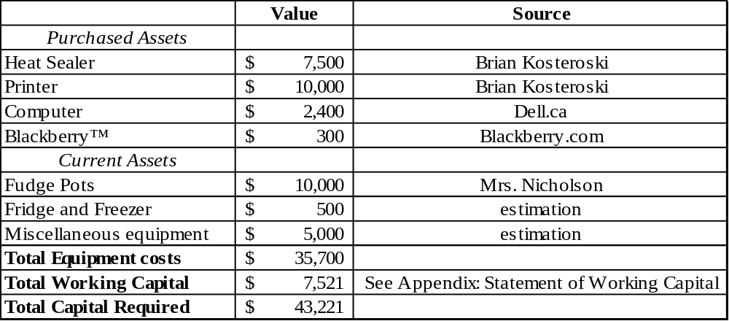
The capacity limits are based on fudge production for 3 employees producing 3 days a week shown in Table 2. Fudge is made every other day because it requires 24 hours to dry before more fudge can be made. The expected sales through year 10 (Schedule 2 in the Appendix) are within capacity limits.

Table 2 Capacity Limits
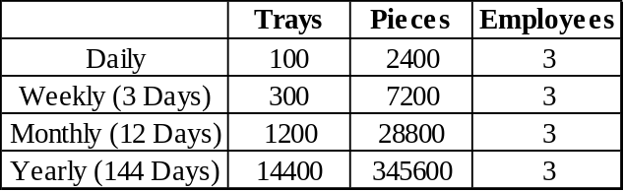

Working Capital Planning and Management

Cost of Goods Sold for Manufacturing
Table 3 Cost of Goods Manufactured Calculation in the First Year of Operation
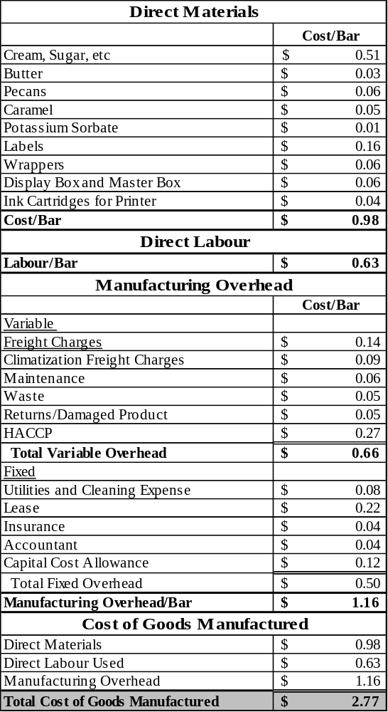
Table 4 Cost of Goods Manufactured Calculation for Ten Year Average
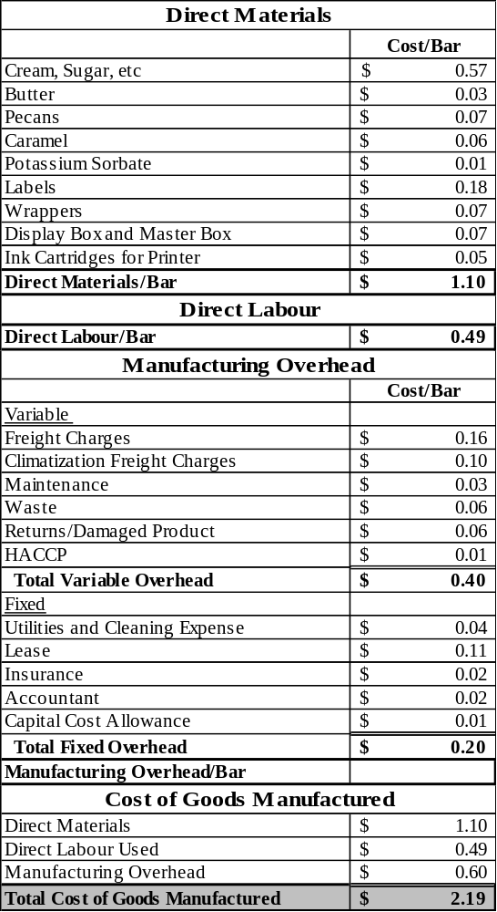
The cost of goods sold is calculated for the first year as well as using a ten year average. A ten year average was used because the cost of goods sold during the first year did not reflect the true cost of goods sold as it included the full sunk cost of implementing HACCP. The cost of goods sold in Table 5 is the first year cost of goods sold calculation. Table 6 is calculated based on a ten year average including inflation.

In Table 6 the beginning raw goods, goods in progress and finished goods inventory have an annual average cost of $6,017 over ten years. The fudge bars have average total days in inventory of 12 days, which is broken down by the following, raw inventory 5 days, goods in progress 2 days and finished goods 5 days. The total average cost of goods manufactured in a year using a ten year average is $512,098. Ending raw goods, goods in progress and finished goods inventory have an annual average value of $7,015. The total cost of goods sold per year based on a ten year average from 233,103 fudge bars is $511,100. The cost of goods sold per fudge bar works out to be $2.19. The cost of goods manufactured calculation is shown below for the first year and the ten year average.
Table 5 First Year Cost of Goods Sold Calculation
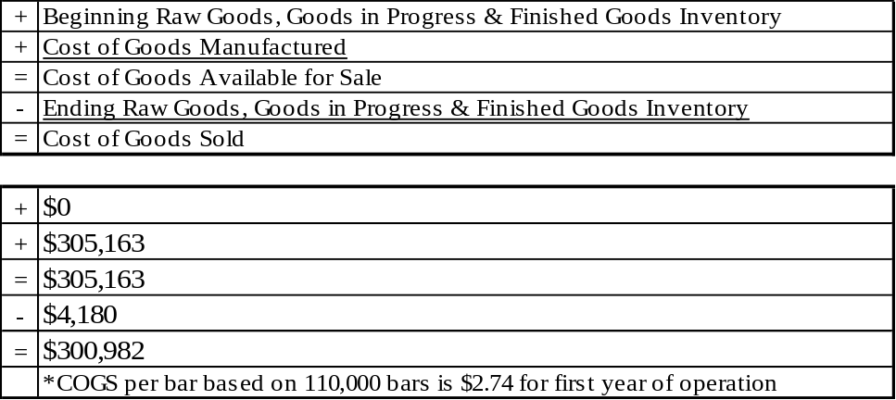
Table 6 Ten Year Average Cost of Goods Sold Calculation
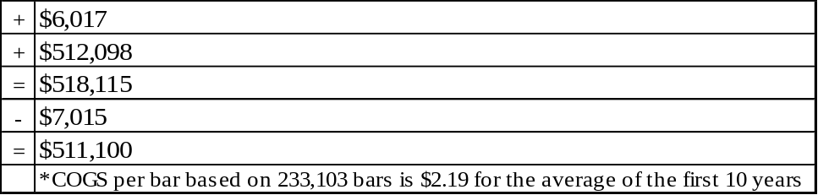
The retailer will make a 35% gross profit margin for each fudge bar sold. In the first year of production the bars will be sold at $2.59 per bar with a retail price of $3.99. The FF will make an average gross profit margin of 20.96%. This percentage is based on the difference between sales and cost of goods sold.

Administration, Marketing, and General Expenses
The salary costs associated with administration and marketing are $43,625. This is calculated by 20% of the Co-mangers salary from being the Treasurer and 40% of the President/General Managers time marketing/gift shows. The remaining 40% comes from the managing/administration cost from the President/General Manager Managers salary. Employee time allocation for each position is shown in Table 7. The Sales representative’s full salary including commission is also in the salary costs associated with administration and marketing. The contract services supplied by the Chartered Accountant are $4,000 per year which is included in fixed overhead costs (Schedule 3). Marketing costs associated with the gift shows includes the following; display rack, pamphlets, signs, costs of attending the gift shows including mileage and hotels. The administration, marketing and general expenses can be found in Schedule 5 of the Appendix.
Table 7 Employee Time Allocation
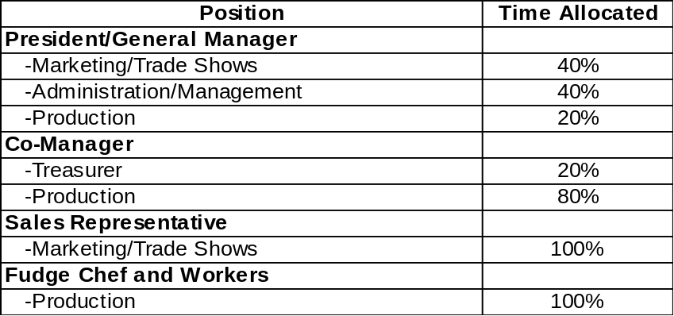

Cash Management
The FF will reinvest all cash flow over and above what covers off expense. A line of credit will be used to facilitate shortfalls in income during slow sale periods if needed.

Inventories
The planned inventory for the first year of operation for the FF is to hold $1,482 in raw goods every five business days, $1,672 for goods in progress every two days and $4,180 in finished inventory every five days period of time. Over the ten year average FF will hold $3,503 of raw inventory, $2,806 of goods in progress and $7,015 in finished inventory. Inventories are regulated by using first in first out (FIFO). This just in time method will allow for smooth product flow, low inventory cost, and expiration dates are not a problem.

Accounts Receivable
Sales made to PharmaChoice® and consignment sales made to SaskMade Marketplace® will be the only customers that will have accounts receivable. The calculated accounts receivable for the FF is based on a percentage of sales made by SaskMade Marketplace® and PharmaChoice®. The estimated percentage of total sales made by these businesses is 40%. This percentage is then multiplied by 30 days to get a 12 days accounts receivable period. Sales that will occur at the gift shows will have no accounts receivable as sales will be made by credit card. The FF feels that by not offering accounts receivable to its customers at the gift shows the advantage of having no bad debts outweighs the loss of customers.

Accounts Payable
The FF has two accounts payable, their New York supplier and Harlan Fairbanks, both offering discounts. From the New York supplier, discounts are offered at 2/10 net 45. Harlan Fairbanks offers terms of 2/10 net 30. These are the only two suppliers that offer discounts.

Cash Conversion Cycle
The cash conversion cycle for FF is positive due to the fact that its average day’s inventory plus its accounts receivables are larger than its accounts payable. A positive cash conversion cycle means that the company has a shortage of cash available to be used in the process of making the fudge from raw material to finished product before its receivables come in. In FF’s case the cash conversion cycle is a positive fourteen. The President/General Manager has set a target cash conversion cycle between 10 -15 days, so having a cash conversion cycle of 14 days falls within an acceptable level. The cash conversion cycle for FF is calculated below:
CCC = Average Days Inventory + Average Collection Period – Average Days Payables
CCC = 12 days inventory + 12 Collection Period – 10 Days Payable = 14 days

Human Resources Plan

Job Descriptions

President/General Manager
The President/General Manager and is also one of the owners who sits on the board of directors. Responsibilities will include making the major management decisions regarding the day-to-day operations. This position will also assume the role of marketing the product, production, and hiring employees for the business. The President/General Manager will have excellent management skills, especially in the areas of product knowledge and marketing.

Co-Manager
The primary role of the Co-Manager will be to manage the production of the fudge bars. The Co-Manager, will also assume the role of treasurer, being responsible for the cash deposits and paying the bills. The Co-Manager will have experience in financial accounting, production, as well as day to day operations. The co-manager is the second owner of the business and will also sit on the board of directors.

Fudge Chef
The Fudge Chef will be an employee that has worked for the company long enough to know the whole fudge making process including all the recipes. This position will have seniority over the fudge workers and will be responsible for fudge production in the absence of the President/General Manager or Co-Manager.

Fudge Workers
The workers will be responsible for cutting and packaging the fudge as demonstrated during on the job training. The fudge workers will be highly motivated people with good work ethic and good at working with others.

Planned Additions/Deletions

Sales Representative
There will be the Sales Representative for the fudge bar product line to be implemented in the first year of production. The Sales Representative will attend gift shows with the President/General Manager. The Sales Representative will have excellent public relations skills, knowledge of the product and marketing skills.

Fudge Workers
An additional employee will be hired in 2009, 2011 and another in 2013 shown in Schedule 3 in the Appendix. These employees will be paid minimum wage and will require on the job training.

Training
The employees of FF will be trained on the job for cutting and packaging. A training manual will be developed to train employees on the steps involved in making the fudge including standardized recipes. This fudge manual will be created with the goal of reducing training time and errors in the fudge making process.

Compensation
Compensation is salary based for management and wage based for employees. The Sales Representative will receive a base salary plus commission with benefits located under salary based employees (Table 8).
Table 8 Salary/Wage Projections for the First Year of Operation
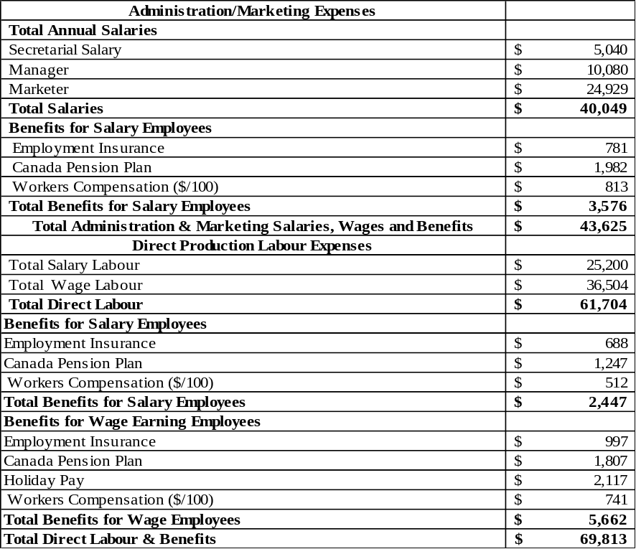

Human Resources Strategy
Motivating employees will not be a major issue since there are a small number of employees, primarily family members. The company will have staff parties which will include employees from FF as well as the Gift store.

Line of Authority
Figure 6 show the line of authority where the President/General Manager has overall seniority; the Co-Manager and Sales Representative report directly to the President/General Manager. The Fudge Chef will report to either the Co-Manager or the President/General Manager. Fudge workers will report to the Fudge Chef, Co-Manager or President/General Manager.
Figure 6 Line of Authority
President/General Manager

Co-Manager
Sales Representative

Fudge Chef
Fudge Worker

Marketing Plan

Marketing Mix

Products
The FF will sell a 4”x 2”, 80 gram fudge bar. The fudge bars will be available in twelve regular and two sucrose-free varieties. These varieties are outlined in Table 9 below. Each fudge bar will be wrapped in a glossy package with labels displaying weight, flavour, ingredients and expiry date. These will be sold in display boxes containing 36 fudge bars; six of the display boxes will be placed into a master box for shipping.
Table 9 Fudge Varieties
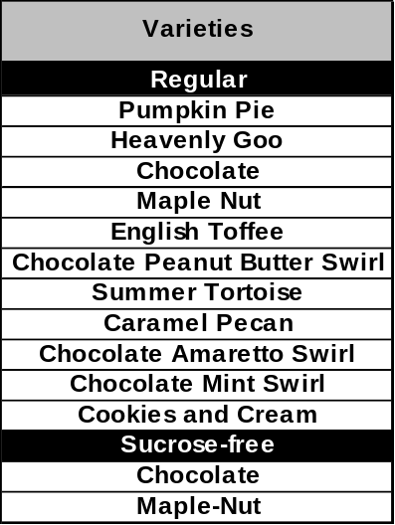
The regular flavours will be produced with high quality ingredients such as real cream and butter compared to other fudge producers who use condensed milk and margarine. The use of cream and butter provides for a smooth and creamy taste. Sucrose-free fudge bars are made with more butter than the regular fudge bars. “Pumpkin Pie” is currently the top selling fudge flavour for the FF. This flavour is unique to this company and it is not produced by the majority of competitors. “Heavenly Goo” is a chocolate and vanilla based fudge with a mixture of caramel. “Chocolate” is a recognizable flavour for new consumers making it a good flavour choice. “Maple Nut” is a popular flavour in Canada because of this countries recognized maple industry. Both “Chocolate” and “Maple Nut” are available in a sucrose free variety. The sucrose free variety appeals to diabetics as well as dieters. “English Toffee” is a good choice for the market because there are toffee based confectionary products such as Toffifee® and Macintosh Toffee®. This fudge bar is primarily made with vanilla fudge and Skor™ bar. For the peanut butter lovers there is the flavour “Chocolate Peanut Butter Swirl”. This particular flavour will compete with products like Reese’s Pieces®. Another fudge flavour that is based on a popular chocolate bar is the “Summer Tortoise”. This flavour has many of the same ingredients as the Turtles® chocolate bar by Nestle®. “Caramel Pecan” is similar to the “Summer Tortoise” but vanilla is used rather than chocolate. “Chocolate Amaretto Swirl” is made with the amaretto liqueur which has the distinct flavour of almonds. “Chocolate Mint Swirl” is a combination of chocolate and green mint similar to popular chocolate mints currently on the market such as Ovation®. “Cookies and Cream” is made with Oreo® cookies and vanilla chocolate.

Price
The FF’s pricing strategy will be to target a high end retail market. The fudge bars will retail at $3.99 each. The twelve regular and two sucrose free bars are equally priced. These bars wholesale for $2.59 resulting in a 35% retail margin. These retailers will cater to middle-class customers as well as wealthier customers who are looking for quality products. The fudge bars will be sold in a premium but competitive market for chocolate bars. The fudge bars labeled “Chocolate Moose Fudge Factory” will compete with chocolate bars that are made by Cadbury®, Hershey®, Laura Secord®, Bernard Callebaut®, Cote d’Or®, Poulain® and Lindt®. The FF will be the only provider of gourmet fudge bars in the retail market; this differentiation allows for the higher price relative to other premium chocolate bars.

The fudge bars will also retail in the SaskMade Marketplace® for $3.99 on consignment. The SaskMade Marketplace® is an outlet for locally produced goods from the province of Saskatchewan. The FF is the only provider of fudge to the SaskMade Marketplace®.

Promotion
The FF will use gift shows, display rack, website, pamphlets, signs and the fudge program to promote the fudge bars. The fudge program will be the primary marketing tool used at the retail level. Retailers will be encouraged at the gift shows to provide samples for customers, at their expense. By providing samples of the product, the sale of fudge bars within the store is expected to increase by approximately 70% (Kosteroski, personal communication 2006). The program will target specific holidays of each season such as Mother’s day, Valentine’s Day, Christmas, Easter, and Halloween.

A large display booth currently owned by the FF will be used at the gift shows. These gift shows are located in Alberta, British Columbia and Ontario. The gift shows provide retailers across Canada a chance to buy merchandise for their stores. The costs of the Edmonton Gift Show are: booth rental at $2000, mileage at $800, and food and hotel at $1500 which sums to $4300. The costs to attend each of the annual Vancouver Gift Show and Toronto Gift Show will be: $2000 for booth rental, $1500 for flights, $600 for booth shipment, and $1500 for food and hotel. These are the costs for the first year, inflated cost are shown in Table 13.

A full rack of the 12 fudge flavours and 2 sucrose free flavours will be displayed on a spinner rack. The rack will be designed to take up minimal space in the store. Although the rack takes up minimal space PharmaChoice® does not charge a direct shelf space cost (this is calculated in the 35 % retail margin). The cost of a display rack is $80 covered by the FF. In the first year of operation the FF will provide display racks to the 24 PharmaChoice® locations and the one SaskMade Marketplace® location. This will total $2000 in the first year. Every year after the FF will provide 10 display racks to gift stores shown in Table 13 (based on expected increase in clientele).

The FF currently operates a website (www.fudgefix.com) designed to promote over the counter fudge, gelato (Italian ice-cream), soft serve ice cream, hot and frozen beverages, Saskatoon berry pie, crepes, and cinnamon buns. A new section will be added promoting the retail fudge bars. Online ordering for over the counter fudge is currently available via e-mail; this will also be available for the retail fudge bars. There is no cost for website setup or maintenance since this service will be provided for by Mr. Squires. The cost for accessing the internet in order to operate the website is priced out under the cost of utilities.

Signs and pamphlets will be provided to retailers by the FF to promote the fudge bars in each location. These signs will have the store logo for the FF. The sign will display all retail fudge flavours provided. The costs of signs will be $2000 in the first year and will be replaced every three years at the inflated cost (Table 13). Pamphlets will be distributed at a cost of $600 for the first year and at the inflated cost every year after (Table 13).

Place
The geographical target market includes targeting the retailers at the gift shop gift shows. The fudge bars will be located in 24 stores of the PharmaChoice® stores across Western Canada. SaskMade Marketplace® will sell the packaged fudge bars on consignment in its Saskatoon location. FF will also sell the packaged fudge on the company website with an online ordering form. The payment method for online ordering will be done by MasterCard/Visa credit cards.

Segmentation, Targeting and Positioning
The prospective buyers for the fudge bars are retail consumers in Western Canada. The FF will target middle to upper class consumers who desire premium and high quality products. Table 10 displays the approximate target population for consumers who will purchase the fudge bars. These consumers (96,800) make up an estimated 1% of the Western provinces population. Figure 7 compares the FF fudge bars to that of its competitors. The fudge bars are positioned based on two factors; which are low to high quality and low to high pricing. The FF is positioned on the right side of the quality scale and the high end of the price scale. This positioning strategy is intended to maximize profits based on the potential target market.
Table 10 Estimation of FF’s Targeted Population
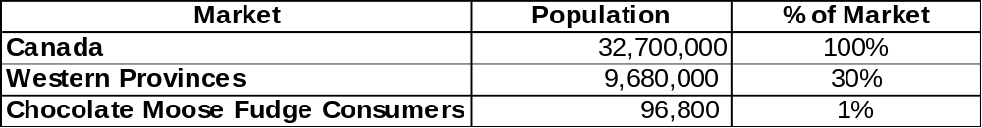
Figure 7 Positioning Map of Pricing Positions for Various Premium Chocolate Bars

Expensive

Affordable

Cadbury/Hershey

Bernard
Callebaut
& Laura Secord

High Quality

Low Quality

CMFF

Cote D’or, Poulain & Lindt

*Source: Primary Market Research

Table 11 SWOT Analysis
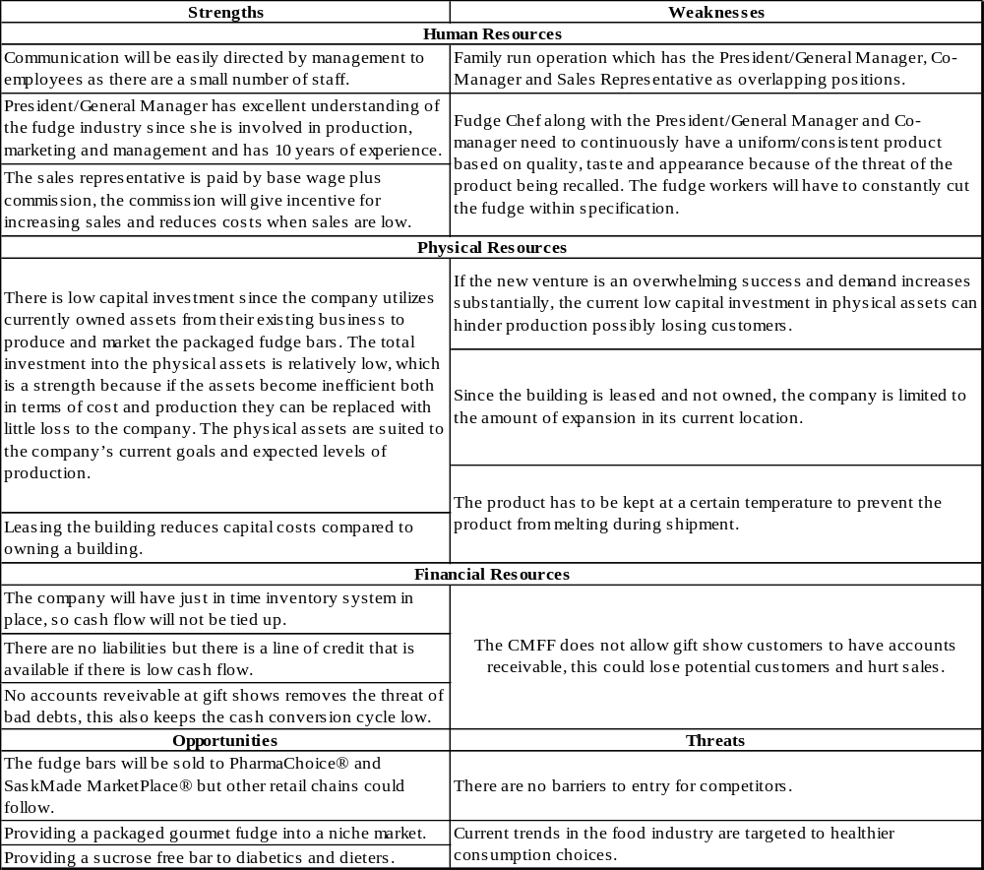

Market analysis

Past Performance
In the past, there has been no retail market for gourmet fudge bars. Fudge has been primarily sold in small pieces cut from large fudge slabs. Fudge pieces have been typically sold in gift shops common in tourist locations. The fudge market is divided into two niche markets: 1. gourmet fudge, made from high quality ingredients such as butter; 2. regular fudge made with low cost ingredients like margarine. The FF has had great success selling fudge locally and has been approached several times with interest to franchise or sell fudge wholesale. The local success the company has had led to the interest of selling the fudge in a packaged bar.

The Market
The fudge market in Canada is relatively small with a number of large fudge producers; however it is in direct competition with the relatively large chocolate market. Within Western Canada there are only a limited number of company’s that sell a comparable gourmet fudge bar as direct competition. The largest market potential is selling wholesale to other gift shops across Western Canada wherein similar high quality products will be sold.

Competition Analysis
In the retail market for gourmet chocolate bars, the competition is mid to premium priced bars as shown in Table 12. Currently there are no direct competitors providing a similar fudge product within the target market of the FF. PharmaChoice® stores currently sell only the mid priced chocolate bars.
Table 12 Competition in the Premium Chocolate bar Market
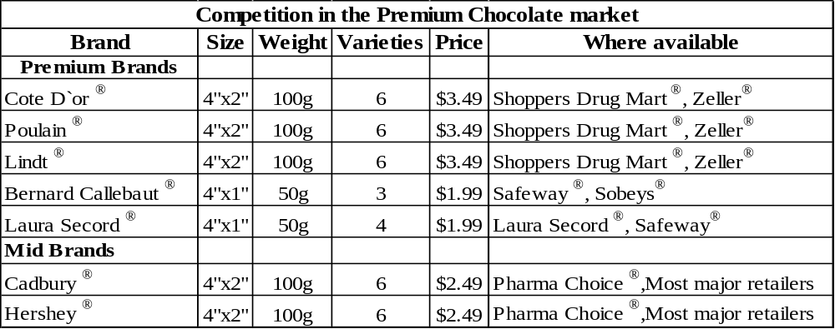

Customers
Typical customers in the gift shops are tourists who will generally only buy once and locals who may make multiple purchases. Customers will purchase the most during holiday seasons. The fudge bars will also appeal to customers looking for fudge that they can take home and eat later. The main factor that influences a customer’s decision to buy the FF fudge bars is that the bars are made with high quality premium ingredients which no product currently provides.

Target Markets
The target markets will include the following: retail gift/tourist stores, PharmaChoice® retail stores, and SaskMade Marketplace®. Targeting the gift/tourist retail stores at gift shows will be the largest market size and has the largest potential for future growth. Concentrating mainly on the gift/tourist retail stores will be the easiest and cheapest market to enter with the packaged fudge bars. Many of these gift/tourist stores are independently owned by individual families and do not charge a fee for shelf space but are willing to sell your product just to make a little profit from it. The gift/tourist stores are the easiest to get into as these retailers attend gift shows looking for products that will get customers into their gift/tourist stores. The competition is the weakest in premium fudge bars at the gift/tourist store level, as many of the main competitors do not provide a premium fudge bar and also do not go after the independent gift/tourist retailers making this the best niche market.

The Opportunity
There is currently an undersupplied market for premium fudge bars at the gift/tourist retailer level across Western Canada. With only a small number of other companies selling comparable gourmet fudge bars, FF will be able to supply approximately 1% of the Western Canadian gift/tourist stores where other high quality products will be sold. Potential future opportunities also include expanding into more franchised drugstore type stores such as PharmaChoice®.

Marketing Strategy

Sales and Profit Objectives
From the sale of fudge bars, the expected sales revenue in year one is $284,900. This is calculated in Schedule 2 of the Appendix by selling 110,000 bars at a price of $2.59 to the retailers (retail of $3.99 for a 35% margin). The $284,900 is broken down from three sources: $170,940 from the gift shows, $103,960 from value-added chains, and $10,000 revenue is contributed from SaskMade Marketplace®. For the next five consecutive years, the sales are expected to increase by 20% per year. After five years, sales are anticipated to increase 5% per year up to the year 2016.

Channels of Distribution
The distribution strategy that FF will use is through a private courier. The cost of an independent courier is 14 cents per bar (Kosteroski, personal communication 2006). This method of transportation will be for the majority of the sales made, including big orders obtained from gift shows and small orders done over the internet. A courier with climatized transport will be used in order to protect the fudge bars during cold and hot weather (Nov.-Mar. and Jul.-Aug.) This will cost an additional 15 cents per bar shown in Schedule 3 of the Appendix (Kosteroski, personal communication 2006). The methods of distribution that many of competitors use are contract trucking companies, couriers and distribution companies.

Pricing Policy
FF will choose a market based approach to its pricing policy. The fudge bar will retail at $3.99 which will be a markup of 35%. $3.99 multiplied by 35% gives a value of $1.40 which is then subtracted from the $3.99 to get the wholesale price of $2.59. At this price the customer will perceive a high value product.

The competitor prices range between $2.49 and $3.49 (100 g chocolate bars, Table 12). The price of the fudge bar is $0.50 higher than the highest valued chocolate bar. The ingredients used and the concept of the gourmet fudge, justify the retail price charged. There will be no price discrimination and no discounts offered to the retailer.

Select Markets and Product
The goal of FF is to be a small supplier of premium gourmet fudge bars in a particular target market. The target market is the retail gift/tourist shops across Western Canada along with value-added chains such as PharmaCoice®; the goal is to sell to approximately 1% of the Western Canadian population. The advantage the FF has over its competition is its main supplier from New York. This supplier’s business is kept as proprietary information and supplies only the FF within its region. The fudge bars are not easily duplicated for this reason.

Selling and Advertising
The selling and advertising program for FF is as follows: (1) personal promotion at gift shows; (2) the fudge program; (3) retail display rack; (4) website; (5) pamphlets and signs. Gift shows are the main selling and advertising for FF, as the Sales Representative meets the majority of the target market at the gift shows. Attending the gift shows by the Sales Representative and the President/General Manager makes personal promotion the most effective way to promote the product. The fudge program is a marketing strategy that Mrs. Nicholson developed to increase sales through sampling. The retail display rack is for advertising as it will catch the consumer’s eye on the shelf beside competing products. The pamphlets are provided for retailers at the gift show and include all of the information regarding the fudge bars; the website will be included on the pamphlet. The selling and advertising budget is included in the marketing budget (Table 13).

Marketing Plan Budget
Table 13 Marketing Budget*
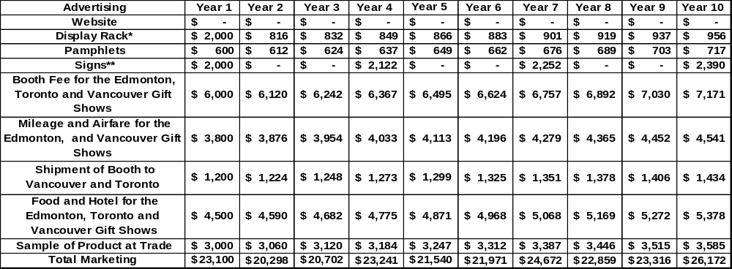
* Based on an annual inflation rate of 2%
**This is based on a one time fee of $80 per display rack for 25 retail stores
***The signs are replaced every three years.

Financial Plan

Financing
FF will use internal investment equity for the retail fudge bars venture. The initial $50,000 will come from retain earnings out of the existing business. FF will also have access to a line of credit that is already tied to the existing business through TD Canada Trust (not currently used). There is also no long-term debt for FF.

Financial Performa’s
Table 14 shows that FF will lose money for the first two years, and has negative retained earnings until year four. The cost of goods sold in year one take into account the full cost of implementing HACCP certification. In year two the cost of goods sold decreases due to the 50% rebate of the original HACCP cost. Administration costs fluctuate over time. The marketing expenses change due to sign and promotional replacements. As this project is being funded on internal equity there is no long term financing and hence there is no interest on long term debt. Its NPV is $137,172.00 and has an IRR of 38.6%. There is an external rate of return of 33.3%
Table 14 Statement of Financial Results
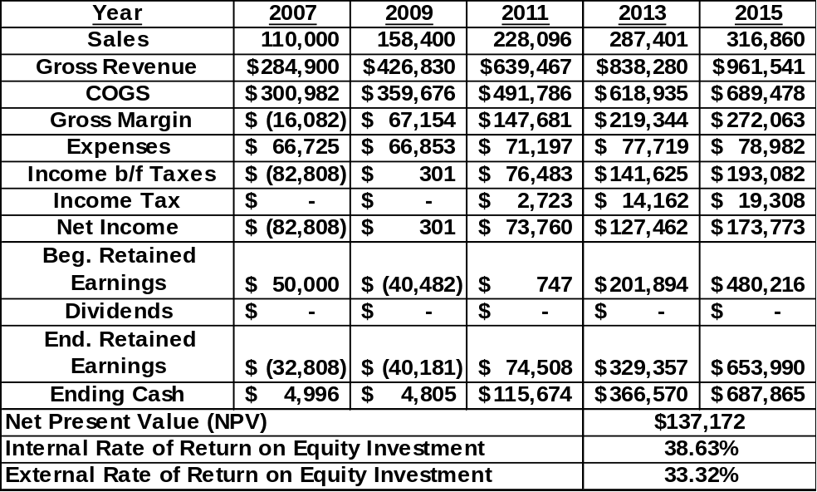

Dividend Policy
The dividend policy is to not pay dividends to the shareholders until 2016. This means all retained earnings will be reinvested back into the company up until that year.

Sensitivity and Risk Analysis

Critical variables
Through analysis of five different variables FF has determined two critical variables. The five variables analyzed are: unit sales of bars, price of bars, fudge workers hourly wage, cost of the main ingredients (cream, sugar, etc.) and total freight charges. The two that showed as the most critical are price and unit sales. The other variables had a fairly large percentage change to set IRR = 0. Table 15 shows the critical variables tested and the percentage change result
Table 15 Critical Variables
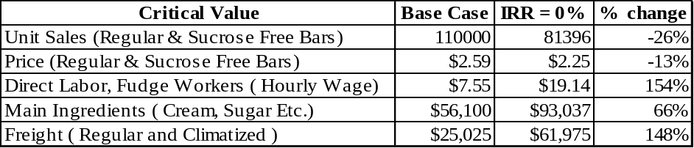

Scenario Analysis
Table 16, 17 and 18 illustrates the sensitivity of the fudge bars for FF for the worst, base and best case scenarios. Table 16 shows the effects on net present value (NPV) and the internal rate of return (IRR) when both price and quantity of sales analyzed for best and worst case scenarios. Table 17 shows the effects on NPV and IRR when quantity of sales is analyzed for best and worst case scenarios. Table 18 shows the results price has on NPV and IRR analyzed for best and worst case scenarios.
Table 16 Scenario Analysis for Price and Sales
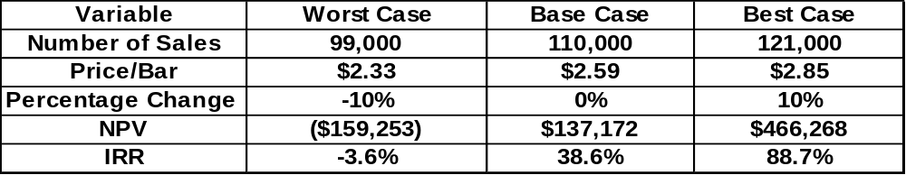

Table 17 Scenario Analysis for Sales
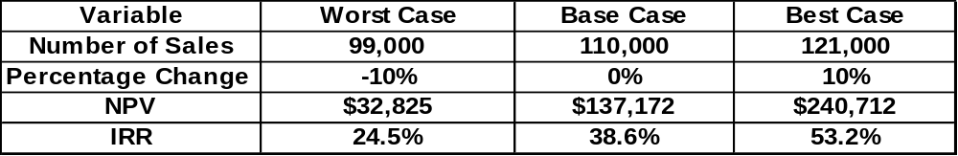
Table 18 Scenario Analysis for Price
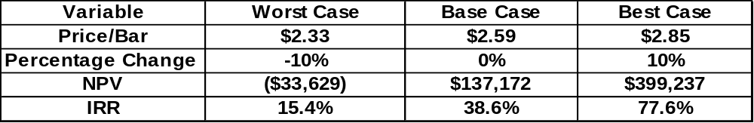
Figure 8 Break-Even Sales
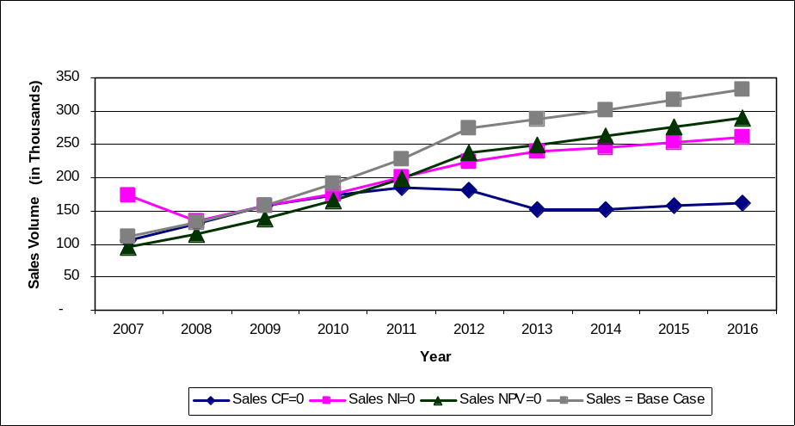
Figure 9 Break-Even Price
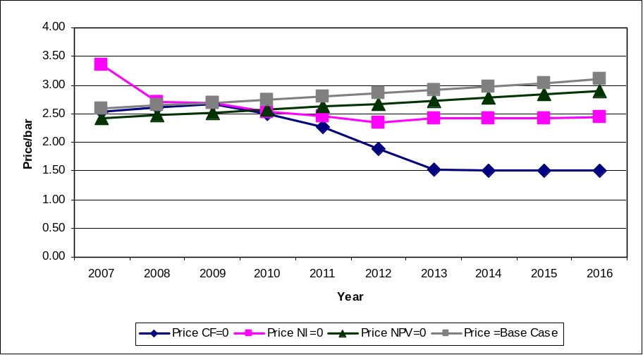
The break-even analysis for the two critical variables is shown in figures 8 and 9 for the quantity of sales and price. The sales quantity and price are each compared against cash flow, net income and net present value. For the break-even analysis of unit sales, net present value and net income are both very sensitive over the entire ten year period. For the price break-even analysis, net present value and net income are also sensitive over the ten year period. Cash flow is very sensitive for the number of sales and price until 2011, after which it is less sensitive. The sensitivity of internal rate of return and net present value for price and sales are shown separately in more detail in figures 10-16 in the Appendix.

Conclusion
After completing the business plan for FF, it has been concluded that the packaging of premium fudge bars is a feasible venture. The financial analysis performed has revealed an NPV of $137,172 and an IRR of 38.6% given the recommended wholesale price and forecasted sales, making this venture viable. The business’s main barrier in achieving economic success will be reaching the desired level of sales in an undeveloped premium packaged fudge market. Failure to meet projected sales may result in infeasibility of the venture. Providing that the sales are not a problem FF appears to have an excellent expansion opportunity into the premium fudge bar market for its existing business.

References
Blackberry. Product Pricing. Available at http://www.blackberry.com. Accessed Dec. 1, 2006.
Dell. Product Pricing. Available at http://www.dell.ca/. Accessed Dec. 1, 2006.
Kosteroski, Brian. Saskatchewan Council for Community Development. Personal Communication. November, 2006.
Laura Secord store. Midtown Plaza, 1st ave and 22nd st., Saskatoon, Sask. Pricing comparisons on premium chocolate bars, Oct 14, 2006.
Nicholson, Tricia, President/General Manager. Chocolate Moose Fudge Factory and Lasting Impressions Gift shop. Moose Jaw, Sask. Personal interview, Sept. 20, 2006, 10:00a.m.
PharmaChoice store. Saskatoon, Sask. Lakeview Square Mall. Pricing comparisons on premium chocolate bars, Oct 1, 2006.
Safeway. Centre mall, 8th Street and Acadia, Saskatoon, Sask. Pricing comparisons on premium chocolate bars, Oct 11, 2006.
Shoppers Drug Mart. Centre mall, 8th street and Acadia, Saskatoon, Sask. Pricing comparisons on premium chocolate bars, Oct 1, 2006.
Sobey’s store. 8th Street and McKercher Drive, Saskatoon, Sask. Pricing comparisons on premium chocolate bars, Oct 10, 2006.
Zellers. Centre mall, 8th street and Acadia, Saskatoon, Sask. Pricing comparisons on premium chocolate bars, Oct 1, 2006.

Appendix
Statement of Income and Retained Earnings

Balance Sheet

Statement of Cash Flows

Schedule 1
Schedule 2

Schedule 3

Schedule 4
Schedule 5

Schedule 6

Schedule 7
Schedule 8
Schedule 9

Schedule 10

Schedule 11

Schedule 12

Sensitivity of Net Present Value: Price and Sales
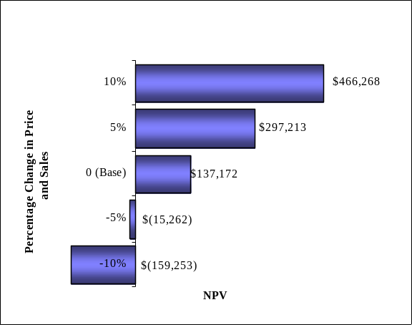
Sensitivity of Internal Rate of Return: Price and Sales
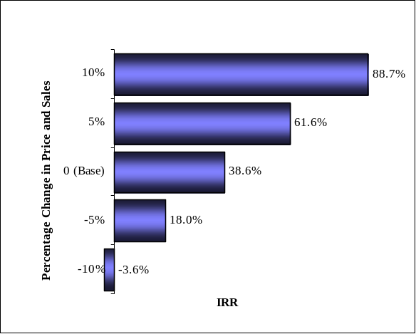
Sensitivity of Net Present Value: Price
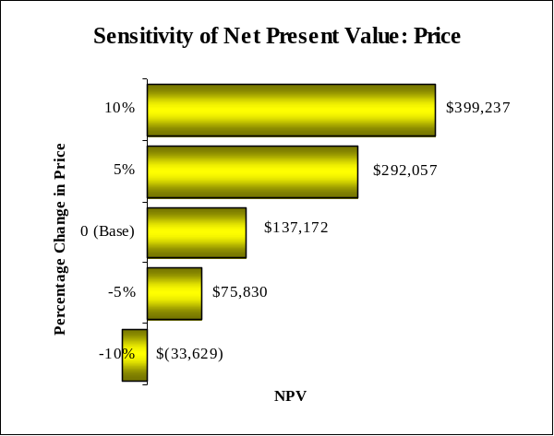

Sensitivity of Internal Rate of Return: Price
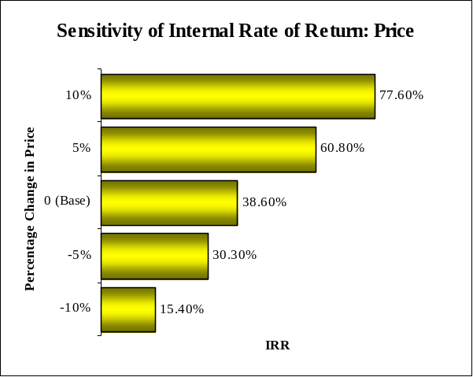
Sensitivity of Net Present Value: Sales
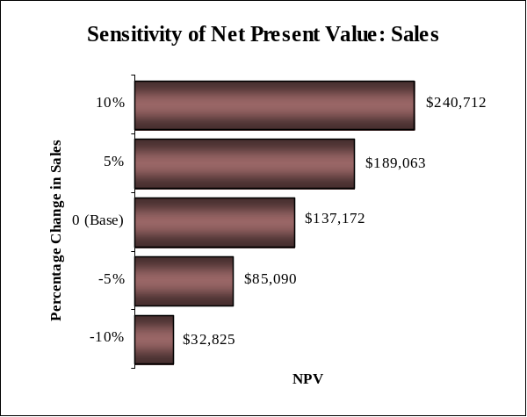
Sensitivity of Internal Rate of Return: Sales


