THE NEGATIVE IMPACT OF DEVELOPMENT ON WOMEN
RECONSIDERED: A STUDY OF THE WOMEN’S EDUCATION PROJECT
IN UPPER VOLTA

A Thesis
Presented to the Faculty
of the
Fletcher School of Law and Diplomacy

by
Brenda Gael McSweeney

In partial fulfillment of the requirements for the
Degree of Doctor of Philosophy

October 1979

© Brenda Gael McSweeney
1979

VITA

BRENDA GAEL MCSWEENEY

Place of Birth Boston, Massachusetts, U.S.A.

Date of Birth 23 July 1943

Education FLETCHER SCHOOL OF LAW AND DIPLOMACY,
Medford, Massachusetts

1965-1967; Ph.D., 1979; M.A.L.D. (Master of Arts
1969-1971 in Law and Diplomacy), 1970; M.A.,
1966; concentration in the field of development economics; Fletcher fellowship.

  - FULBRIGHT SCHOLAR, Paris, France
Purpose of grant: study and research in the area of international develop-
ment assistance; affiliated with the Institute of Political Science (Univer-sity of Paris).

Spring 1968 Conducted field research in Upper Volta
Summer 1969 on the topic of aid and development.

1961-1963; SMITH COLLEGE, Northampton, Massachu-
1964-1965 setts.

Bachelor of Arts in history, minor in French.

  - UNIVERSITY OF GENEVA, Geneva, Switzer-land.

Enrolled in the Faculty of Economic and

Social Sciences; also attended courses
at the Graduate Institute of International Studies and the Institute of European Studies.

Professional UNITED NATIONS DEVELOPMENT PROGRAMME,
Experience Ouagadougou, Upper Volta

Oct. 1977 - Special leave for research in the area
Oct. 1979 of women and development.

Apr. 1974 - Assistant Resident Representative.
Sept. 1977

2

Jan. 1972-Mar. ‘74 Programme Officer.

Spring-Fall 1971 HARVARD UNIVERSITY, Cambridge, Massa- chusetts

Research Associate to Dr. Edward E. Leamer, Assistant Professor of Econometrics and Quantitative Methods.

Spring 1971 AFRICAN-AMERICAN LABOUR CENTRE, New
York, New York

Consultant.

1970-1971 FLETCHER SCHOOL OF LAW AND DIPLOMACY, Medford, Massachusetts

Research Aide to Dr. D. Humphrey,
William L. Clayton Professor of International
Economic Affairs.

Summer 1970 Research Associate to Dr. William Sprague Barnes, American Delegate to the Inter-American Juridical Committee of the Organization of American States.

Summer 1967 STANDARD OIL COMPANY OF NEW JERSEY,
New York, New York

Economic Analyst in the International Economics Division.

  - TUFTS UNIVERSITY, Medford Massachustts

Teaching Assistant in the Department of Economics.

1966-1967 FLETCHER SCHOOL OF LAW AND DIPLOMACY,
Medford, Massachusetts

Research Assistant to Dr. Ruhl J. Bartlett, Professor of Diplomatic History.

Summer 1966 EXECUTIVE OFFICE OF THE PRESIDENT,
Washington, D.C.

Economist in the Office of the Special Representative to the President for Trade Negotiations.

Summer 1965 FERMETURE ECLAIR S.A., Rouen, France
3

AIESEC (Association Internationale des Etudiants en Sciences Economiques et Commerciales) Executive Traineeship.

Missions ADVISOR, UNDP DELEGAION TO THE WORLD
June-July 1975 CONFERENCE OF THE INTERNATIONAL WOMEN’S YEAR, Mexico City, Mexico

Participated on behalf of the UNDP’s Regional Bureau for Africa in the AAS/ UNDP/UNITAR/CONACYT Seminar on Women in Development (Workshop on Food Produc- tion and the Introduction of Small-Scale Technologies into Rural Life).

Assisted on behalf of the UNDP at the deliberations of the Conference’s First (World Plan of Action) Committee.

Sept.-Oct. 1977 UNDP DELEGATION TO THE REGIONAL CON-FERENCE ON THE IMPLEMENTATION OF NA-TIONAL, REGIONAL AND WORLD PLANS OF ACTION FOR THE INTEGRATION OF WOMEN IN DEVELOPMENT, Nouakchott, Mauritania.

Represented UNDP at the conference pro- ceedings, the meeting of representatives of the United Nations Family, and the meeting of representatives of the UN Economic Commission for Africa’s Training and Research Centre for Women donor agencies.

Mar.-Apr. 1978 UNDP DELEGATION TO THE FIRST MEETING OF THE INTER-AGENCY WORKING GROUP ON THE INTEGRATION OF WOMEN IN DEVELOPMENT IN AFRICA, Addis Ababa, Ethiopia

Alternate UNDP delegate; rapporteur.

Papers, “African Women in Rural Development:
Publications The Role of Women in Development in
Upper Volta," (with Scholastique Kompaoré), paper presented at the Seminar on Women in Rural Development in Africa: Implications for Donor Organizations, sponsored by the Overseas Liaison Committee of the American Council on Education, Washington, D.C., April 1976.

4

“An Approach to Collecting and Examining Data on Rural Women’s Time Use and Some Tentative Findings: The case of Upper Volta, “paper presented for the seminar on Rural Women and the Sexual Division of Labor, organized by the Population Council, New York, New York, March 1979.

“Collection and Analysis of Data on Rural Women’s Time Use,” article in Studies in Family Planning 10, no. 11, special issue on the topic of learning about rural women (November 1979).

The Impact of Intermediate Technology on the Integration of Women in the Development Process (with Scholastique Kompaoré), forthcoming report being prepared for the United States Agency for International Development.

ABSTRACT

(Doctoral dissertation, Brenda Gael McSweeney)

The focus of this study is a development effort
which was unique in Africa, the ten-year Upper Volta/ UNESCO/UNDP Project for Equal Access of Women and Girls
to Education. This experimental project aimed at achiev-
ing more equitable school enrollments for girls, at pro-
viding educational opportunities for women, and at strength-ening their contribution to the country’s socioeconomic development. Results in one of the Project’s three pilot
zones are analyzed in order to assess the impact of de- velopment on women, and also on men, when women’s roles and needs are built into the design of a development pro-
gram. The major components of the Women’s Education Pro-ject are evaluated and a comparison made of change in tar-
get villages and neighboring control villages.
A school of thought associated with such scholars of development as Ester Boserup and Irene Tinker posits that
in the majority of cases development has had a negative
impact on women in comparison to its effect on men. This study reflects this concern about the consequences of development for women, yet takes a somewhat different approach. The principal hypothesis is that if a develop-
ment project is judiciously formulated and its activities carefully selected, women as well as men can benefit from development. In order to test this proposition, the re-
sults of the Women’s Education Project have been

2

investigated within the socioeconomic areas of a set of in-
dicators formulated by the African Training and Research
Centre for Women (ATRCW) of the United Nations Economic Commission for Africa. The indicators measure women’s par-ticipation in development as well as their access to its
means and rewards. The study concentrates on findings in
two of the ATRCW’s six indicator areas, employment and ed-ucation, with a summary review in the areas of health/ma-
ternity and rural technologies. An assessment is made of
the appropriateness of the indicators from the point of
view of the villagers, to determine whether the indicator
areas correspond to the revealed aspirations and priorities
of rural populations in Upper Volta. An examination is
also made of the capacity of the indicators themselves to
capture the subject areas, and expansions of the indicators
are suggested.

Launched in 1967, the Upper Volta Women’s Education
Project personnel had identified women’s overwhelming work-
loads, coupled with poor hygienic conditions and low stan-
dards of living, as obstacles to women’s eventual parti-
cipation in new educational opportunities and income-
generating activities. Technologies such as mechanical grain
mills, carts, and readily accessible water wells were in-
troduced, in order that women might allocate a portion of
the time thus saved to educational activities such as
learning modern agricultural methods, health and civic
education, professional training, and to lucrative
activities such as collective fields. Dynamic village

3

women or animatrices and traditional midwives were chosen
by the villagers themselves to attend special courses to
reinforce their roles as leaders in change.
To permit comparison of the rapidity of change in target villages and control villages, and to assess the
differential impact of the Project in target villages,
an eighteen-month study was conducted in eight of the
eighty-three villages reached by the Project in 1976 and
in four control villages in the three pilot zones. Data
was generated by a combination of overview and intensive
survey techniques, including questionnaires, time budgets prepared by direct observation, less structured all-village interviews, and individual interviews with women leaders.
One methodological finding was that time budgets prepared
by direct observation captured about twice as much informa-
tion on women’s work as did the recall technique.
In the socioeconomic area of employment, the ATRCW’s proposed informal sector indicators are pertinent to 98.6
percent of the active Voltaic population. They include
calculations of women’s participation in a schedule of
work classified under production/supply/distribution and household/community factors. Exploration with field data suggested the need for a more comprehensive schedule of
activities; the framework was therefore revised to include
cash crops, crafts and other professions, and measurements
of time for personal needs and of free time. Data from a
small sample of time budgets prepared by direct observation
of women and their husbands in the Kongoussi region, the

4

north-central zone of the Project, indicated that women
undertake fifty-six percent of total work, which includes
forty-nine percent of agricultural production, with only
some 1.3 hours of free time per day. Dramatic differences
were found between workloads of girls and boys, with girls averaging twice as much work as boys from ages seven to
fifteen. Even the older women undertake important work-
loads. Women in polygynous households were found to have somewhat more free time available.
Given substantial labor inputs of girls and women
which inhibit women’s participation in educational activi-
ties and at the same time the women’s willingness to have
their young female helpers attend school, the accent which
the Project personnel placed on the introduction of work-
load-lightening technologies is understandable. However,
the data revealed the technologies, rather than creating
free time, led to activities which otherwise would have
been foregone. For example, mill availability permitted
additional meals, the preparation of which would have been forfeited owing to fatigue, and wells permitted water fil-
tering which otherwise would have been neglected.
In the area of non-formal education, differences in
behavior and attitudes toward educational activities
emerged from the comparison of a target and a control
village in the Kongoussi zone of the Project. Analysis
showed that the Project was responsible for women’s sub-
stantially greater participation in educational activities
in the target villages, as measured by the time allocated

5

to the following activities: attendance at functional
literacy classes, listening to the Project-sponsored
radio broadcasts, and implementation of health education
advice through water filtering. Time pressures and dis-
tance to courses were found to be ongoing obstacles to
women’s participation. Health education was most fre-
quently cited as the Project’s most beneficial activity.
However, the hypothesis that significant differences would
exist between Project and control villages with regard
to sending of children to school, and particularly girls,
was not upheld.
Content analysis of the less structured interviews
with populations of the four survey villages in the Kon-
goussi zone, and also with women leaders in the Project
villages, concerning change in their villages since in-
dependence revealed an emphasis on the theme of economic conditions. This area, along with the issue of income-
generating activities, is not treated per se by the ATRCW’s indicators. Social, political, and attitudinal changes
were perceived by the women leaders and populations of four villages to have been primarily favourable, while economic conditions was the only category in which changes were de-
clared to have been overwhelmingly unfavorable. Women made
the majority of these statements on negative changes in
economic conditions during the all-village interviews, and
virtually all of the statements made by women leaders on
this subject were on unfavorable changes. The findings
suggest the appropriateness of a disaggregation of the

6

negative impact thesis as follows: while development
seems to have had an especially negative impact on women in
the economic sphere, it has been accompanied by positive
changes for all members of the community in socio-political conditions. Such a disaggregation leads to the policy con-
clusion that future efforts should give additional atten-
tion to the economic side of the equation, particularly in
response to women’s needs.

International and national assessments, and the views
of the villagers themselves, have shown that the Upper Volta/UNESCO/UNDP Women’s Education Project has made a difference in the lives of the villagers reached. The
Women’s Education Project has involved women in the cul-
tivation of cash crops and contributed to reducing the
gap in agricultural training, whereas the baseline socio-
logical studies for the Project had shown that agricultural extension programs were addressed primarily to men. The introduction of technology, lauded by the users as energy
and time saving, involved in part a redistribution of por-
tions of women’s traditional workloads to men, which helped
to redress the imbalance in the sexual division of labor.
Efforts to heighten the impact of the Women’s Education
Project in the time-saving and income-generating areas
have been intensified. Lightening of food processing and
various portage tasks not only for women but also for girls
should influence their access to training and school, and achievement once enrolled. In summary, the Upper Volta/ UNESCO/UNDP Project for Equal Access of Women and Girls

7

to Education has served as a catalyst for change in target
villages and made progress in the crucial areas of employ-
ment and education, which the Boserup-Tinker school and the African Training and Research Centre for Women emphasized
as areas in which development has usually left women be-
hind. As stated by the head of the women’s group in one
village, a spokesperson for those most concerned, “Educa-
tion is on the right track.”

TABLE OF CONTENTS

LIST OF ILLUSTRATIONS ……………………………………. vi
LIST OF TABLES ……………………………………………… vii
ACKNOWLEDGEMENTS ……………………………………… x

PART ONE
INTRODUCTION
Chapter
I. OBJECTIVES OF THE STUDY……………………………….. 1
The Issue of the impact of Development
on Women ………………………………………………… 4
Overview of the Background and Aims of
the Upper Volta Project for Equal
Access of Women and Girls to
Education ………………………………………………. 8
Analytic Framework : The African Training
and Research Center for Women’s
Socioeconomic Indicators of the
Participation of Women in Development
and Their Access to the Means and
Rewards of Development …………………………. 11
Method of Approach ………………………………….. 13

II. THE UPPER VOLTA WOMEN’S EDUCATION PROJECT…18
Government Policies Toward Women and
Development….………………………………..……….. 19
Justification and Objectives of the
Women’s Education Project…………………….. 25
Initial Project Implementation………………… 28
Presentation and Assessment of
Activities in the Kongoussi Zone…………………… 32
Extension of the Project and Structural
Changes…………………………………………… 58

iii

III.DATA COLLECTION METHODOLOGY ……………….. 62
Data Collection Strategy ……………………………. 64
Research Program and Data Collection
Instruments………………………………………………. 66
Women’s Activities : Questionnaire
(Interview)Versus Time Budget
(Direct Observation) ………………………………… 76
Less Structured Interview Methodology…………. 81
Factors Influencing Interpretation of
Survey Results ……………………………..………… 83

PART TWO
ANALYSIS OF THE WOMEN’S EDUCAITON PROJECT IN THE
SOCIOECONOMIC AREAS OF THE AFRICAN TRAINING AND RESEARCH
CENTRE FOR WOMEN’S INDICATORS

IV. EMPLOYMENT………………………………………………… 94
Overview of the Problem ………….…………………… 96
Employment Indicators of the African
Training and Research Center for
Women …………………………………………………… 101
Proposed Revised Framework for the
Examination of the Allocation of
Rural Women’s Time ………………………………… 110
Findings and Directions of Further
Analysis……………………………………………………… 112

V. EDUCATION ……………………………………………. 139
Women and Education : The Phenomenon …... 140
Education and Training Indicators of
the African Training and Research
Center for Women……………………………………… 143
Examination of Education Sector Data
In Rural Upper Volta ……………………………… 151
Attitudes and Behavior Towards Education :
Explanatory Factors ………………………………. 175
Finding and Implications for Planners ……… 182

VI. PRECIS OF OTHER SOCIOECONOMIC INDICATOR
AREAS……………………………….………………………… 189
Health and Maternity ………………………….. 190
Rural Technologies …………………………….. 196
Law ……………………………….…………………….. 201
Participation in Decision-Making……….. 203

iv

PART THREE
CONCLUSIONS

VII. EXPRESSED CONCERNS OF VOLTAIC RURAL
POPULATIONS AS THEY RELATE TO WOMEN’S
EDUCATION PROJECT ACTIVITIES, ATRCW
INDICATORS AREAS, AND THE IMPACT OF
DEVELOPMENT ON WOMEN…………………………… 206

Review of Hypothesis Testing in the
Socioeconomic Areas of the African
Training and Research Centre for
Women’s Indicators…………………………………….. 208
Approach to the Analysis of the Less
Structured Interviews………………………………… 212
Content Analysis of Interviews with
Women Leaders …………………………………………… 215
Analysis of the Responses of Populations
in Four Villages ……………………………………… 229
Findings and Their Relevance for the
Set of Indicaors and for the Theory
of the Negative Impact of Development
on Women …………………………………………………… 242

VIII. THE WOMEN’S EDUCATION PROJECT : CATALYST
FOR CHANGE ……………………………..…………………… 254
International Appraisals………..…………………… 255
National Assessments ……………….………………… 256
Views from the Villages …………..………………… 258
Policy and Program Implications………………… 261

APPENDIX I RESEARCH SITE…………….………………… 267
APPENDIX II RESEARCH MATERIALS …………..………… 274
APPENDIX III RESEARCH AUTHORIZATION ……………… 311
SOURCES CONSULTED ………………………………..…………… 315
LIST OF ABBREVIATIONS………………………..……………… 329

v

LIST OF ILLUSTRATIONS

1. Comparison of Time Allocated by Voltaics (Kongoussi Zone) by Sex to Various
Types of Activities in the First Four-
teen Waking Hours of the Day…………………… 120

- Comparison of Aggregated Time Alloca-
tions of Voltaics (Kongoussi Zone) by
Sex in the First Fourteen Waking Hours
of the Day………………………………………………… 121

3. Rank Ordering of Themes Expressed by
Women Leaders in Response to the
Interview Question Concerning Change……… 217

4. Location of the Three Pilot Zones of
the Women’s Education Project in the
Republic of Upper Volta…………………………… 268

vi

LIST OF TABLES

1. Primary School Enrollments in the Kongoussi
Zone in 1968………………………………………..…..….. 36

2. Sample Time Budget, Upper Volta Women
and Development Study (1976-1978) …………….. 73

3. Comparison Between Questionnaire and
Time-Budget Results Concerning the
Activities of Kalira, a Traditional
Midwife from the Village of Konkuyan
in the Pô Zone, on 25 October 1978…………….. 78

4. Estimates of the Participation of Women
in Traditional Rural and Early
Modernizing Africa………………………….…..…..…. 109

5. Rural Activities (Kongoussi Zone): Indices
of Femaleness …………………………………………….. 115

6. Rural Activities (Kongoussi Zone): Com-
parison of Time Allocations by Sex…………….. 116

7. Comparison of Phasing into Workloads
(Kongoussi Zone) by Sex ……………………………. 129

8. Education at the First Level in Upper
Volta ………………………………………………………… 143

9. Education at the Second Level in Upper
Volta …………………………………………………………. 145

10. Education at the Third Level in Upper
Volta………………………………………………………….. 146

11. Third Level Students by Field of Study
in Upper Volta……………………………………………. 147

12. Status of the Rural Education Program in
Upper Volta Following a Decade of
Implementation…………………………………………… 149

vii

- Functional Literacy : Reasons for Which Women
Do not Attend Courses(Project Villages) or Are Not
Interested in Attending (Control Village) ……………… 162

14. Radio Programs : Reasons for Not
Listening to “The Woman Is the
Home” ……………………………………………………… 169

15. Factors Affecting Time Use and Behavior…… 177

16. Expression of Interest by Women of
the Kongoussi Zone in Technologies
Not Currently at Their Disposal……………. 199

17. Classification by Theme of Statements
by Women Leaders on Favorable and
Unfavorable Changes ………………………………… 218

18. Statements by Women Leaders on Per-
ceptions of Changes in Women and
Men and in Male/Female Interactions……….. 221

19. Statements by Women Leaders on Health………… 224

20. Statements by Women Leaders on Economic
Conditions………………………………………………… 226

21. Statement by Women Leaders on Political
Conditions ……………………………………………….. 226

22. Classification by Theme of Statements on
Change by the Populations of Four
Villages……………………………………………………. 230

23. Rank Ordering of Themes Expressed by
Populations in Four Villages …………………. 231

24. “Negativeness” of Statements by Popula-
tions of Four Villages……………………………… 233

25. Project-Related Statements by Popula-
tions of Four Villages……………………………… 235

26. Populations of Four Villages on the
Theme of Economic Conditions…………………… 239

27. Data Sheet on Comparative Access of
Women to the Means and Rewards of
Development: Economic Conditions …………… 248

viii

28. Rank Ordering by Theme of Total State-
ments Made by the Populations of Four
Villages and Women Leaders in the
Kongoussi Zone ……………………….…………….. 251

29. Socioeconomic Profile of the Republic of
Upper Volta ……………………………..……..…….. 269

30. Socioeconomic Profile of the Kongoussi
Zone of the Women’s Education Project….. 271

31. Socioeconomic Profile of the Village
of Zimtenga ……………………………..……..…….. 272

32. Socioeconomic Profile of the Village
of Bayend-Foulgo …………………..……..……..… 273

ix

ACKNOWLEDGEMENTS

Initial discussions were held at the Flecther School
of Law and Diplomacy on my proposed doctoral research with
Dr. Arpad von Lazar, my director, and Dr. Robert L. West, my second reader, in 1974. They have contributed gen-
erously of their time and ideas in all phases of the study.
I am enormously indebted to them for their assistance.
My work has also benefited from the valuable suggestions of Dr. Rosemarie S. Rogers of the Fletcher School.
Authorization to undertake my research project on
women in development in Upper Volta, based on the Upper Volta/UNESCO/UNDP Project for Equal Access for Women and Girls to Education, was accorded in early 1976 by Prof.
Ali Lankoande, Minister of National Education and Culture.
I owe to him special thanks for his sustained interest and encouragement both to undertake the project and to carry
it through to completion. His dedication to educational
reform and innovation in approaches to development have
been a constant inspiration.
Scholastique Kompaore supported my interest in con-
ducting research in this area, and was instrumental in my
decision to focus my investigation on the aforementioned
Women’s Education Project of which she was the National Coordinator. Her daily collaboration in research and pro-
grams aimed at women’s needs has been, in a word, invalu-
able; her devotion to the goal of the promotion of women
is boundless, and the support of her husband, Julien, and

x
her family for this endeavor, is unmatched in my experience.
Her friendship has extended far beyond the professional
realm. I have been honored to have been absorbed into the Tapsoba clan by her parents, who constructed for me a small
house in their courtyard in Pô, one of the zones of the
Women’s Education Project, to provide me with a home in the largest sense of the word.
Marcel Poussi, as Director of the Voltaic Scientific
Research Center (CVRS), reviewed my initial research design
and contributed to sorting out the issues of data collec-
tion in the Voltaic context. His guidance and moral sup-
port have been immeasurable. The advice of Sidiki Coulibaly
of CVRS during the coding phase of the study is also much appreciated.
I am grateful to the United Nations Development Pro-
gramme (UNDP) for authorization of my special leave to
undertake this study, and additionally for financial
support during my field research. For his personal in-
terest in the study, I am indebted to Bradford Morse, UN
Under Secretary-General and Administrator of UNDP, who throughout his career has supported the notion of popular participation in development. I thank Michel Doo Kinguė, Assistant Administrator and Director, Regional Bureau for
Africa; Eugene Youkel, Director of Personnel; and their
colleagues for their encouragement of this undertaking.
I also appreciate the endorsement of my research received from Jens Hogel, Resident Representative of the UNDP in
Upper Volta, and the general support of the UN family.

xi

I feel privileged to have been able to participate
parallel to my dissertation work in a separate Voltaic
Government project directed by Scholastique Kompaoré to
study the impact of intermediate technologies on the inte-
gration of women in the development process. This project
was financed with the assistance of the United States
Agency for International Development (USAID). Aime Meliman
Da, Cabinet Director of the Ministry of National Education
and Culture, was most helpful. U.S. Department of State personnel, and in particular John Hoskins, Director of
USAID in Ouagadougou, never ceased to facilitate the pro-
gress of this project. I am grateful to Arvonne Frazer,
Coordinator of USAID’s Office Women in Development, for
her interest both in my own research project and that under-
taken in collaboration with Scholastique Kompaoré.
For assistance in the research for both studies, I
wish to acknowledge in particular Mariam Konate and Gabriel Tamini of the Women’s Education Project, who gave to these undertakings of their time and effort above and beyond the
call of duty. Gratitude is also owed to Gérard Adouabou,
Gabriel Ouédraogo, Monique Kaboré, Christine Ouedraogo,
Brother Jean–Baptiste Bunkungu, Felix Kalmogho, Eugenie Kassalom, Jean Zigani, Julienne Napon, and the other
staff members of the Women’s Education Project. It was
through the effort and talents of these individuals,
coupled with those of the enumerators who are to be con-gratulated on their endurance and results, that rapport
with the village authorities and populations never waned.

xii

Recognition is due to the villagers for their understanding
and collaboration in our joint undertaking, and particularly
to those encompassed in the sample, and to the women leaders
for the additional insights they shared in the course of
extensive interviews. Special thanks go to all of those
who made my time in the villages inforgettable, and es-
pecially to my “husband” the rain chief of the village of
Tôrem in the Pô zone; my “friend” the “Radio” (Minister of Communications) of the Women’s Group of Zoagha; my “cowife” from the Kongoussi zone, Mrs. Tidébamba, Head of the
Women’s Group of Douré; the traditional midwife from the
village of Fabédougou, Adama Camara, who reserved for me
her “leftovers”; and the women’s minstrel, Maimouna, also
of the Banfora zone.
It was a pleasure to undertake research with assis-
tants such as Yambénogo Ouédraogo, now of the Pan-African Institute for Development; Abdoulayue Diallo, Camille Kaboré,
and Jean-Baptiste Bonkoungou, all of the CVRS; Peter Kazoni
of the Ministry of National Education; and all of their
colleagues who assumed the exacting tasks of coding,
transcribing, typing, and other seemingly endless assign-
ments. They put in inhuman overtime to meet deadlines and worked efficiently and with good humor even when budgetary constraints obligated them to work in less than ideal
conditions from a base in my living room and patio.
The felicitous idea of undertaking dissertation work
in Upper Volta I owe to Dr. Robert Meagher of the Fletcher
School, and I thank him for this and much other advice.

xiii

For my initial introduction in Upper Volta in 1968, I am
grateful to Prof. Daniel Pépy of the Institut d’Etudes
Politiques of the University of Paris, with whom I began
my studies on aid to Upper Volta during the two-year period
of my Fulbright grant. Professor Pépy presented me to many Voltaics, the first of whom in Upper Volta was Dr. Joseph
Issoufou Conombo, now Prime Minister, whose ongoing friend-
ship and support of my work are highly valued.
I am indebted to Dr. Carl K. Eicher of Michigan State University for contributing thoughts on my dissertation
theme during his numerous visits to Upper Volta. Both
Dr. Eicher and Dr. Shirley Fisher made it possible for
Scholastique Kompaoré and me to present an earlier study on
the role of women in development in Upper Volta at the
Seminar on Women in Rural Development in Africa: Implica-
tions for Donor Organizations, sponsored in Washington, D.C.
in 1976 by the Overseas Liaison Committee of the American Council on Education. As discussants of this paper, Moise Mensah, then Vice President and Executive Secretary of the Consultative Group on Food Production and Investment, and
John Hoskins advanced our thinking on these broader issues.
Dr. Philip J. Stone of Harvard University, who visited
the research site, generously shared his expertise and
personal library in the area of time budget. Dr. Jonathan Silverstone, of USAID and a member of its initial task
force on women in development, offered valuable insights
following a review of all of the research instruments and
a visit to one Project zone while on mission in Upper Volta.

xiv

Judith Bruce and Achola Pala Okeyo of the Population Council provided me with the opportunity to present for
discussion several aspects of rural women’s time use in
Upper Volta at the Seminar on Rural Women and the Sexual Division of Labor, held at the Council in early 1979.
Dr. Hanna Papanek of Boston University and Brigid O’Farrell
of the Wellesley College Centre for Research on Women
kindly offered helpful comments on this and other aspects
of my work.
I am indebted to Althea Duersten of the World Bank;
Dr. Mayra Buvinić of the International Centre for Research
on Women; Dr. Ralph Harbison and Adrienne Germaine of the
Ford Foundation; Dr. Christopher L. Delgado of the Center
for Research on Economic Development; Dr. Charles P.
Humphreys of the Food Research Institute; and Edmund
Sullivan, Laura McPherson, and Don Atwell of USAID for
sharing both ideas and documentation.
I am grateful to David Charles Ganao, who as Deputy Executive Secretary of the United Nations Economic Com-
mission for Africa (UNECA) encouraged me in my research
project and also to the Head of the UNECA’s Training and
Research Centre for Women, Mary Tadesse, and her former and current colleagues, notably Margaret Snyder, Marilyn Carr,
and Nancy Hafkin.
To Dr. William Sprague Barnes, Dr. Ruhl J. Bartlett,
Dr. Don D. Humphrey, and Dr. John Spencer of the Fletcher
School of Law and Diplomacy I owe special thanks; also appreciated is the assistance of other members of the

xv

faculty and staff which I have received these many years
in conjunction with this endeavor. In addition the per-
sonnel of the Tufts University Computer Center have been
most helpful, notably Patricia Bensetler. The Thomas
More Bookstore kindly coordinated my requests for pro-
fessional books during my seven years stay in Africa.
William Martin Cloherty of the Executive Office of the President is to be decorated for his perseverance as Pro-
duction Manager. I am extremely grateful to Marion Freedman
for taking on the task of editing the manuscript. Jo Ellen
Milkovits of the Institute for Foreign Policy Analysis is
to be credited for the professional preparation of the final
typed manuscript.
For their unfailing encouragement, I am indebted to
family and friends here and abroad, and special mention is
to be made of my sister and brother-in-law, Nancy and Ronald
Pink, and in Upper Volta, of Julien Yougbaré of UNDP and
Larba Ziba of Boala.
In a work of this duration, many individuals con-
tribute. It is only with the support and consideration
of many friends and colleagues that this endeavour has
been brought to completion. I thank them all. Any short-
comings in the final product are my own.
This effort is dedicated to the memory of my parents.

xvi

PART ONE
INTRODUCTION

CHAPTER I

OBJECTIVES OF THE STUDY

Nos préoccupations sont également de rechercher
la meilleure formule de la promotion féminine.
La femme joue un rôle moteur dans la vie sociale
et économique....
Le droit de la femme, en tant que citoyenne à
part entière, sera respecte pour lui permettre
d’apporter sa contribution revalorisée au develop-
pement national . . . .

Gen. El Hadj Aboubacar Lamizana, President of the Republic of Upper Volta, in his address to the
Nation on the Action Program of the Government of National Renewal, 30 May 1974.

Du reste en Afrique, la société n’a jamais
semble-t-il limité la participation des femmes
au developpement. Ce qui par contre, a de tout,
temps fait cruellement défaut, c’est la volonte
de “promouvoir l’égalité entre l’homme et la
femme”. Le moment est venu de s’engager resolu-
ment dans cette voie. Il faut permettre à la
femme d’assumer pleinement ses responsibilitiés.

Prof. Ali Lankoandé, Minister of National Educa-
tion of the Republic of Upper Volta, in his open-
ing address on the occasion of the Subregional Colloquium on Women’s Education and Community Development in Francophone West Africa,
Ouagadougou, 11 June 1974.

2
3

This study examines a development effort which was unique in Africa, the Upper Volta/UNESCO/UNDP Project for Equal Access of Women and Girls to Education, a ten-year systematic program to promote educational opportunity for girls and women and to increase their contribution to the economic and social development of the country.¹ One of the three pilot zones reached by this experimental project was chosen as a setting in which to examine the impact of development on women, and also on men, when women’s roles and needs are taken into account by development planners. Using as an analytic framework a set of “socio-economic indicators of women’s participation in development and their access to the means and rewards of development”² designed by the Training and Research Centre for Women of the United Nation Economic Commission for Africa (UNECA), the study has generated data permitting assessments of the Project’s major components and the comparison of change in Project villages and neighboring control villages. It focuses on findings in two of the indicator

________________
¹République de Haute-Volta, “Plan d’opération; Projet Expérimental pour 1’Egalité d’Accès des Femmes à 1’Education,” Ouagadougou, 1968, p.1.

²For a development of the rationale for, and a complete description of the set of indicators which are sketched out here, see United Nations, Economic Commission for Africa, The New International Economic Order: What Roles for Women? (E/CN.14/ATRCW/77/WD3), 31 August 1977, especially the section entitled, “Expediting balanced development: measuring and monitoring the participation of women as compared to that of men” (pp. 26-31, plus the annex). This document is hereafter referred to as The NIEO.

4

areas, employment and education, based on data from time budgets prepared by direct observation and on questionnaire response. The results of a content analysis of comple-
mentary interviews provide further insights which assist
in the interpretation of these findings, and in drawing
conclusions relevant to development program and policy formulation.

The issue of the Impact of Development on Women
A school of development thought associated with such scholars as Ester Boserup and Irene Tinker maintains that
in the majority of cases development has had a negative
impact on women. Ester Boserup, in Woman’s Role in Eco-
nomic Development,³ presents the traditional patterns in
the sexual division of labor in rural areas, and the
changes which occur in these patterns with increasing pop-
ulation density, modernization and urbanization. Data
from studies in ten African countries presented by Boserup
show that women’s contribution to agriculture represents
more than one-half of the total labor input in virtually
all of the countries, and up to seventy to eighty percent

_______________
³Ester Boserup, Woman’s Role in Economic Development
(New York: St. Martin’s Press, 1970). See also her earlier
work, Conditions of Agricultural Growth: The Economics
of Agrarian Change Under Population Pressures (New York:
Aldine, 1965), and the more policy-oriented monograph,
Ester Boserup and Christina Liljencrantz, Integration of
Women in Development: Why, When, How (New York: United Nations Development Programme, 1975).

5
in some cases.⁴ These finding can be generalized to other
regions characterized by a shifting cultivation system of
farming. This pattern is often accompanied by a high rate
of polygyny,⁵ payment of bride wealth by the future hus-
band or his relatives, and heavy workloads for women yet
some economic independence.⁶
Boserup then contends that with modernization, men monopolize the use of new agricultural equipment and meth-
ods, and often predominate in the cultivation of newly
introduced cash crops, while women continue to farm sub-
sistence crops using traditional methods; therefore,

. . .in the course of agricultural development
men’s labour productivity tends to increase while
women’s remains more or less static. The corollary
of the relative decline in women’s labour produc-
tivity is a decline in their relative status with-
in agriculture . . .⁷

Boserup attributes this phenomenon largely to the dis-
criminatory policy in education and training practiced by
European settlers, colonial administrators, and technical
advisors, who overlooked the female agricultural labor
force when introducing modern commercial agriculture and extension services. Further, with the spread of primary
schooling, boys were sent to school before girls and in

_________________
⁴Boserup, Woman’s Role, p.22.
⁵Polygyny is the practice of having more than one
wife at one time.
⁶Boserup, Woman’s Role, p. 50
⁷Ibid,p.53.
6
larger numbers.⁸
Boserup prefaces the above-referenced book specifying
that many of her conclusions are necessarily provisional,
and expresses her hope that further investigation would be stimulated.⁹ This sequence which she outlines has come to
be known as theory of “the negative impact of development
on women.”¹⁰ Research has been undertaken to corroborate
it.¹¹ Boserup restates in a later piece that while
_____________________
⁸Ibid., pp. 53-56.

⁹Ibid., p. 5

¹⁰Carolyn M. Elliott in her paper, “Theories of Develop-
ment : An Assessment”, appearing in the volume, Wellesley
Editorial Committee, Women and National Development: The
Complexities of Change (Chicago: University of Chicago
press, 1977), pp. 1-8, classifies a related school of
thought as “developmentalism.” Starting from the premise
that modernization has had a differential impact on women
and men, the developmentalists attempt to identify the
various obstacles to women’s full participation in national
development. In Elliott’s words, the developmentalist
school “. . .rests on the assumption that more enlightened
planning will remove the obstacles to women’s participation.
If false views are exposed, new statistics gathered, and
better arguments devised, development can benefit women.”
She questions, however, whether such an approach will lead
to the inclusion of women in development unless more atten-
tion is devoted to economic structure and power relation-
ships (ibid., pp.4-5).

¹¹One example in the Upper Volta context is the impact
on women of the Volta Valley Authority (AVV) development
scheme in its early stages. This subject was outlined in a
paper entitled “African Women in Rural Development: The
Role of Women in Development in Upper Volta,” which I co-
authored with ßcholastique Kompaoré for presentation at the
Seminar on Women in Rural Development in Africa: Implica-
tions for Donor Organization, sponsored by the Overseas
Liaison Committee of the American Council on Education in
April 1976. Briefly, the scheme for resettlement of fer-
tile land opened up by a vast campaign of control of the
onchocerciasis (river-blindness) vector neglected in its

7

. . .both men and women may become victims of
development, it is more difficult for women to
adapt to new conditions, because (1) family
obligations make them less mobile than men,
(2) their occupational choice is more narrowly
limited by custom, (3) they usually have less
education and training, and (4) even without
these handicaps they often face sex discrim-
ination in recruitment.¹²

Along similar lines, in her paper “The Adverse Impact
of Development on Women,”¹³ Irene Tinker contends that
“. . .development, by widening the gap between incomes of
men and women, has not helped to improve women’s lives,
___________________
early phases to provide land for women’s plots, which exist
in the traditional farming systems of many of the ethnic
groups in Upper Volta, including the Mossi. This denial in
the resettled areas of a source of revenue for women,
coupled with a lack of wells, markets, health and education
facilities, not to mention the familiar supportive social
structure, led many women to return to their villages of
origin, risking to undermine the entire scheme. Errors
stemmed partly from the procedures of interviewers, who did
not include the women in meetings. To mitigate the situa-
tion, female extension agents were recruited for the AVV
villages, and women’s fields were introduced. Donor as-
sistance permitted funding of mechanical mills, small-scale
enterprises, and pharmacies (source: interview with Siméon
Sorgho, Director-General of the AVV, 23 January 1976).
Upon the recommendation of the UNDP/FAO sociologist as-
signed to AVV, a full study of the problem was commissioned,
with financing from the United States Agency for Interna-
tional Development (USAID), and appears in Societe Afri-
caine d’Etudes et de Développement (S.A.E.D), Etude sur
les besoins des femmes dans les villages de l’A.V.V. et
proposition d’un programme d’intervention (Ouagadougou:
Ministère du Développement Rural, Avril 1977).

¹²Ester Boserup, “Preface” to the volume Women and
National Development: The complexities of change, p.xii.

¹³Information cited is paraphrased from Irene
Tinker, “The Adverse Impact of Development on Women,” in
Irene Tinker and Michele Bo Bramsen, eds., Women and World Development (Washington, D.C. : Overseas Development Coun-
cil, 1976), pp 22-27.
8

but rather has had an adverse effect upon them.”¹⁴ She
argues that colonial regimes have introduced modern farming techniques and the cultivation of cash crops favoring men,
and in some cases dispossessed women of their land. She
further postulates that owing to the manner in which na-
tional income statistics are compiled and in which work
is defined, that is, work being performed for money and in
the modern sector, the economic contributions of women are frequently unacknowledged. Development planners, mis-
guided owing to erroneous stereotypes concerning the sexual division of labor, neglect women in formulating new pro-
jects. Training, technologies, and credit are directed overwhelmingly to men, often in areas in which women were traditionally active. New technologies, while often alle-
viating the physical burdens of women’s work, tend to be
managed by men. Tinker’s argument is not that women have
never benefited from development, but rather that in virt-
ually all cases they have lost out in comparison with men
in the modernization process.

Overview of the Background and Aims of the Upper Volta
Project for Equal Access of Women and Girls
to Education.

In the Republic of Upper Volta¹⁵ the Project for Equal
Access of Women and Girls to Education, and hereafter often

___________________
¹⁴Ibid., p.22
¹⁵A socioeconomic profile of the Republic of Upper
Volta is found is appendix one.
9

referred to as simply the Women’s Education Project, had
its origins in conceptual thinking paralleling one of the
major concerns elaborated above. Policymakers recognized
that Voltaic women and girls were not benefiting equally
from increased educational opportunities which accompanied development, despite the absence of any articulated policy
of discrimination against them. Launched in 1967, the
Project aimed primarily at creating the preconditions for
education of women in remote rural areas and at designing education programs which would contribute to rural develop-
ment.¹⁶ Its objectives as stated in the plan of opera-
tions included assembling data on obstacles preventing
full access of girls and women to education, and initiating experimental programs in one or several pilot zones to
overcome these barriers and hence to augment the educa-
tional possibilities available to girls and women.¹⁷
The Project, based upon the finding of sociological
studies undertaken in three regions of the country with
different levels of economic prosperity, climatic condi-
tions, and ethnic groups, aimed initially at lightening

______________________
¹⁶Women, Education, Equality : A Decade of Experiment
(Paris: The UNESCO Press, 1975), p.12 The Upper Volta
effort was one of three major experimental projects on
different continents assisted by UNESCO. A project in
Nepal encouraged the enrollment of girls in rural primary
schools by training female teachers, while a project in
Chile prepared women for employment in the modern sector through secondary technical education.

¹⁷République de Haute-Volta, “Plan d’opération, “pp.
1-2.

10

women’s workloads and improving basic health conditions and standards of living. Labor-saving technologies were in-
troduced: mechanical grain mills, carts, and readily
accessible water wells. It was thought that women could
then allocate a portion of the time thus saved to educa-
tional activities such as learning modern agricultural
methods, health and civic education, and professional
training. Knowledge was to be disseminated through women leaders (animatrices and traditional midwives) designated
by the villagers themselves to attend special courses
which would enhance their roles as catalysts for change. Functional literacy classes and radio clubs were also or-
ganized in the villages. Another portion of the newly
available time might be allocated to income-generating
activities introduced by the Project, such as collective
fields. The receipts from these enterprises would be
managed by the women themselves.
One of the thirty-seven women-related activities under-
taken with the assistance of the United Nations Educational, Scientific, and Cultural Organization (UNESCO) during the
decade 1965-1975,¹⁸ the Upper Volta Project was exceptional
in that its activities were multifaceted and planned from
the outset to last for ten years. As early as 1968, the
United Nation Development Programme (UNDP) participated

_________________________
¹⁸”Rapporteur’s Report on UNESCO’s Contribution To-
wards Improving the Status of Women” (submitted by the
United States Executive Board Member, Paris, May 1975),
p. 46.

11

in the financing of the Project, and many other donors
were later to cooperate with the government in its exten-
sion. The plan of operations indicated that data were to
be gathered in order to permit eventual utilization of the
results by other countries.¹⁹

Analytic Framework: The African Training and Research Centre
for Women’s Socio-Economic Indicators of the Participation
of Women in Development and Their Access to the Means and
Rewards of Development

Inspired by a recognition of the need to take into
account women’s economic contributions so that relevant development programs could be designed, the United Nations Economic Commission for Africa has over the years been
gathering and collating qualitative and quantitative in-
formation on women’s work in all parts of Africa.²⁰ Its
strategy has been to provide development planners with the empirical evidence necessary to formulate programs which
address women’s real roles and needs. In recent years,
in order to accelerate the translation of these empirical
findings into “balanced development,” the UNECA’s Training.

____________________________
¹⁹République de Haute-Volta, “Plan d’opération,” p.2.
²⁰See United Nations, Economic Commission for Africa, Origin and Growth of the African Training and Research
Centre for Women of the Economic Commission for Africa (E/CN.14/ATRCW/77/BD.7), 5 September 1977, which traces
the evolution of UNECA’s activities addressed to the needs
of African women and girls. The ATRCW came into being in
1975, and it is anticipated that it will assume the status
of a full division in the near future.

12

and Research Centre for Women has proposed a “model” for measuring and monitoring women’s contributions and needs
by means of a set of “socio-economic indicators of women’s participation in development and access to the means and
rewards of development.”²¹ The set of indicators proposed
is for use by laypersons such as members of women’s national commissions and bureaus, to enable them to gather quantita-
tive evidence to support their policy and program recommen-
dations. The indicators are meant to complement more sophisticated tools used by development planners. The ob-
jective is to increase awareness of women’s economic con-tributions and to encourage correlative access to incen-
tives and returns.
The proposed African and Training Research Centre for Women (ATRCW) indicators concern employment (formal and informal sectors, including subsistence agriculture), for-
mal and non-formal education and training, health and
maternity (including water supplies and maternal and child
health facilities), law (including land ownership and
__________________________

²¹The following information in this section is drawn
from United Nations, Economic Commission for Africa, The
NIEO, pp. 29-31, plus the annex. In addition, see the prior
work, United Nations Economic and Social Council Economic
Commission for Africa, The Data Base for Discussion of the Interrelations Between the Integration of Women in Develop-
ment, Their Situation and Population Factors in Africa (E/CN.14/SW/37), 13 May 1974, for an earlier description
of the conceptual basis for the set of indicators. A
complementary model has been developed by the ATRCW for measuring women’s contribution to Gross Domestic Product.
This model is presented in detail in United Nations,
Economic Commission for Africa, The NIEO, pp.27-28.

13

access to credit), rural technologies, and participation
in decision-making. This set of indicators has been util-
ized in my research project as a framework for the analysis
of the major components of the Upper Volta Women’s Educa-
tion Project. My study focuses on findings in the first
two of the indicator areas, employment and education. The variables selected by the ATRCW to define the indicator
areas are reviewed in part two. The Voltaic data is then
presented according to this format. In addition, variants
of the ATRCW’s units of measurement which have also been
used to represent the indicator areas in my study are in-
troduced.

Method of Approach

This study shares the Boserup-Tinker concern about the consequences of development for women, yet takes a some-
what different approach. My principal hypothesis is that
if a development project is judiciously formulated and
its activities carefully selected, women –- and well as
men -- can benefit from development. In order to test
this proposition, I have chosen to investigate the results
of the Upper Volta/UNESCO/UNDP Women’s Education Project within the areas of concern encompassed by the ATRCW’s set
of socio-economic indicators presented above. Data gen-
erated in Project villages and control villages permits
a comparison of the rapidity of change in the target and
control villages, as well as an assessment of the differ-
ential impact of the Project in the target villages.
14

While data has been collected in the three zones of the
country reached by the Project, and in four of the major
indicator areas proposed by the ATRCW (employment, educa-
tion, health and maternity, rural technologies), with
partial data available in the two other areas (law, par-
ticipation in decision-making), this study concentrates
on results in the first two of indicator areas, namely
employment and education. It focuses one of the pilot
zones of the Project, the Kongoussi zone,²² which is
situated in the north-center of the country and populated
by the majority ethnic group, the Mossi. The study responds
to one of the objectives of the Project itself, that data
be collected to permit the sharing of the results of the
experiment with other countries.
The research design also permits an assessment of the appropriateness of the ATRCW’s indicators from the point of view of the villagers,²³ to determine whether the indicator
areas correspond to the revealed²⁴ aspirations and priori-
ties of rural populations in Upper Volta. An issue

____________________________

²²A data sheet on the Kongoussi zone is found in
appendix one.

²³I am especially grateful to Dr. Robert L. West for
suggesting that important emphasis also be given to an ex-amination of the indicators themselves.

²⁴Indicated in questionnaire response and less struc-
tured group interviews; the study enumerators and linguists assisted in the interpretation of this data, as will be
further detailed in chapter three.

15

reflected in the indicator literature is that “ . . .the
identification of demands, of aspirations, of social con-
cerns in general, should influence and consequently pre-
cede the collecting and marshalling of relevant data.”²⁵
Such an examination of the indicators coincides with the intentions of the ATRCW to have the proposed model serve
“. . .in the development of indicators of the participation
of women in the development process,”²⁶ and with stated
policy of the Economic Commission for Africa, that its
strategies and programs represent what the women of Africa
want, and not merely what the bureaucrats of ECA think
they want.²⁷ To this end, regional machineries giving a
formal voice to women have been established, and the crea-
tion of national bureaus and/or commission for women and development has been encouraged.²⁸ Many such bureaus and
___________________________
²⁵Social Indicators: Problems of Definition and Selec-
tion (Reports and Papers in the Social Sciences, No. 30)
(Paris: UNESCO, 1974], p. 8. Achola Pala has developed a
related theme concerning the formulation of research
efforts to address the priorities of the research subjects
in her paper, “Definitions of Women and Development: An
African Perspective, “in Women and National Development:
The Complexities of Change, pp. 9-13.

²⁶United Nations, Economic Commission for Africa, The ,NIEO, p.29.

²⁷UNECA Executive Secretary at the Regional Conference
on the Implementation of National, Regional, and World
Plans of Action for the Integration of Women in Development, Nouakchott, Mauritania, 27 September-2 October 1977.

²⁸See United Nations, Economic Commission for Africa, National Machinery for the Integration of Women in Develop-
ment in African Countries (E/CN.14/ATRCW/77/WD2), 1977.
16

commissions have been formed, and in several countries at
least a partial application of the ATRCW’s indicators has
been undertaken. Use of the ATRCW’s proposed indicators as
an analytic framework in this study permits the presentation
of Voltaic data in a format comparable to that being used
in other countries, and facilitates the formulation of
suggestions for eventual revision of the indicator follow-
ing their field testing.
In the chapter which follows, the Upper Volta Women’s Education Project is first delineated, including an histor-
ical overview of government policies toward women and development and a description of the rationale for the
Project, its objectives, and its initial implementation.
Project activities falling in the areas of the ATRCW’s
socio-economic indicators are then presented for the
Kongoussi zone, the first region of the country in which
the project was launched. Evaluations of effectiveness
from the point of view of the Project’s international
personnel in earlier years and of national personnel in
later years are given. This presentation permits compari-
son among the assessments made at different points in the
life of the Project, in addition to a comparison with the
opinions of the populations concerned which are elaborated
in parts two and three of the study.
The data collection methodology outlined in chapter
three is a composite one. Data was generated by interviews
with government policy-makers and technicians spanning a
period of ten years and by an eighteen-month survey

17

conducted in twelve villages located in the three zones
of the Women’s Education Project. The data collection
strategy is outlined, and the research program and data
collection instruments (structured questionnaire inter-
views, time budgets prepared by direct observation, and
group interviews) reviewed. The results derived from the
use of two different research techniques for generating
data on women’s activities are compared, and factors in-
fluencing the interpretation of survey results indicated.
In part two, the ATRCW indictors in the areas of
employment and education are fully explored using nation-
wide statistics and data from the Kongoussi zone. Data
are analyzed to draw inferences about the effect of de-
velopment on women, and also to assess the appropriateness
of the indicators for Upper Volta. An overview of pro-
visional findings in the other four indicator sectors is
presented. In part three the findings are reexamined based
upon a content analysis of data generated using a different methodology. In a final section, summary appraisals of
the impact of the Project from international, national,
and local points of view are presented, and policy and pro-
gram implications reviewed.

CHAPTER II

THE UPPER VOLTA WOMEN’S EDUCATION PROJECT

The time has come for women to be in the fore-
front, for perhaps women will bring to the de-
velopment of this village elements which we
men have not yet thought of.

Chief of Magniassin, Village recently
reached by the Women’s Education Project
at the request of the population, Pô zone,
at a meeting on 14 May 1977

It is to assist the Project activities that I
am greeting you. As for me, I am well, as well
as all the family, and my name is Julien. My-
self, I don’t have a lot to say to you, except
that we continue to count on you, what we all
want is that you not forget us, we continue to
request to learn. Why do we want to learn? It
is said that the horse unseats the one he knows
best. If someone tells you that you are erudite,
yet you yourself know that you are not, you are
only trying to fool yourself.

Letter written in Moré by a peasant from
the village of Kilou to the Kongoussi
zone director of the Women’s Education
Project (1978)
_____________________________

NOTE : The citations appearing on the chapter two
title page, as well as all other sources referred to in
this study which were originally written or spoken in a
national language (Moré, Dioula, Kassem), were translated
or interpreted into French by linguists the Voltaic
Scientific Research Center and the Women’s Education Pro-
ject. All translations from French to English throughout
the study are by the author.

18
19

This chapter begins with an overview of government
policy on women and development in Upper Volta from inde-
pendence in 1960 through the creation of the Women’s Edu-
cation Project in 1967, in order to provide the setting
which the Project was launched. Emphasis is given to
policy in the education sector, and to the reasons which
led government authorities to request UNESCO to select
Upper Volta as the site for implementation of the Project
for Equal Access of Women and Girls to Education. The
rationale for the creation of the Project and its objec-
tives are then outlined. Following a review of its initial implementation,the African Training and Research Centre
for Women’s set of socioeconomic indicators is used as
an organizational framework to present the situation
existing in one pilot zone at the outset of the Project.
Activities sponsored by the project are reviewed, including assessments of their effectiveness undertaken at various
stages in the Project’s life. The chapter concludes with
a note on Project extension into other zones of the coun-
try and on structural changes which occurred at the end
of its experimental phase.

Government Policies Toward Women and Development
In the early years of the First Voltaic Republic, a
strong coordination, if not to say identity, existed be-
tween the government and the majority party, the Union
Démocratique Voltaïque, local section of the Rassemblement
20

Démocratique Africain (UDV-RDA). ¹ One aspect of their
overall policy was the promotion and improvement of the
status of women. At a Party Congress in Banfora in the
early 1960s, the concerns of women, and notably the ela-
boration of a marriage code, were treated at length.²
At this time, the representation of women in the National
Assembly increased from one to two. In short, during this
period, decisions concerning the evolution of the status
of Voltaic women were made at the level of the party, which controlled the direction of government policy.
In 1966 at the request of the trade unions the military
came to power.³ It does not seen that there was a particu-
lar program regarding Voltaic Women during the early years
_________
¹Information presented in the first two paragraphs
of this section is drawn from an interview on 24 January
1976 with Prof. Ali Lankoande, Minister of National Educa-
tion.

²Hanna Papanek has pointed out that while women’s interests tend to be overshadowed by broader loyalties to
class or political movements, such issues as the reform
of marriage laws often unite women (source: Hanna Papanek, “Development Planning for Women,” in Wellesley College
Editorial Committee, Women and National Development:
The complexities of Change, pp 14-15).

³In other sources, it is further specified that the
government in power was increasingly criticized for finan-
cial mismanagement. Austerity measures which it finally introduced precipitated a general strike led by the labor
unions and street demonstrations which brought about the
change in government. For further details see Francois
Djoby Bassolet, Evolution de la Haute-Volta de 1898 au
3 Janvier 1966 (Ouagadougou: Imprimerie Nationale de la
Haute-Volta, 1968), pp.116-33; and Elliott P. Skinner,
“Politics and Government, “African Urban Life: The Trans-
formation of Ouagadougou (Princeton, New Jersey: Princeton University Press, 1974), pp.429-37.

21
of the military regime.⁴ Yet, despite the absence of a
specific policy for the promotion of women, the idea was
in the air that some action ought to be taken.
With regard to women’s legal rights, ⁵ since indepen-
dence all Voltaics have been fall citizens and the prin-
ciple of equiquality has been recognized as fundamental in
Voltaic institution. Two juridical systems exist: cus-
tomary law varying from region to region and from ethnic
group to ethnic group and and not written for the most part,
along side of modern law introduced during the colonial
period. One national authority on legal rights contends
that this equality has proven on the whole to be theoretical,
since the law applied in customary tribunals is fundamentally
___________________________
⁴Interviews conducted with over two dozen policy-
makers, including government ministers, directors of govern-
ment services, and members of women’s associations, corrob-
orated this central point, that no special policy existed
with regard to women, either overall or in specific sec-
tors. For further development of this theme, see Brenda
Gael McSweeney and Scholastique Kompaoré, “African Women
in Rural Development: The Role of Women in Development
in Upper Volta,” paper presented at the Seminar on Women
in Rural Development in Africa: Implications for Donor Organizations, sponsored by Overseas Liaison Committee
of the American Council on Education, Washington, D.C.,
April 1976.

⁵The following information on women’s legal rights is paraphrased from Emile Sawadogo, “La situation de la femme voltaique devant les tribunaux,” paper presented at the
symposium “Formation et intégration socio-économique des femmes voltaïques dans une société en évolution,” organized
by the Voltaic Women’s Federation, 30 November to 6 December 1974. See also Tintinga Frédéric Pacéré, La famille
voltaïque en crise (Ouagadougou: Imprimerie Nationale, 1975),
on this topic.
22

based on inequality of men and women. Several proposed
reforms have been elaborated since independence, but a new common law has yet to be adopted.
In the area of education, while there was not a policy
of discrimination, the authorities noted in the mid-1960s
that the policy followed until that time reflected a
disparity in educational opportunities for the two sexes.⁶
As in many African countries, the development of education
in Upper Volta initially aimed at quantitative growth: in
the 1960s, available places in primary schools could not accommodate even ten percent of school-aged children. Yet
the question of whether this expansion was being undertaken
in a fashion which would assure equal access to education
in the different regions and between the two sexes was not addressed. The results, namely that more boys were sent
to school than girls, reflected a situation inherent in
the traditional society itself which was translated into
the educational system, rather than an intention of the
department of education.
Special consideration had not been given to the ques-
tion of women’s education in Upper Votla through the mid-
1960s; there was no specific action with regard to women
_____________________________
⁶Information in the paragraphs which follow on educa-
tional policy has been drawn from an interview with Aimé
Damiba, Director of Educational Planning, 17 January 1976.
Note also that in 1962, an estimated 98.5 percent of all
Voltaics fifteen years and over (men: 98 percent; women:
99 percent) were illiterate (source: UNESCO Statistical
year book 1977 [Paris : UNESCO, 1978] , p. 44).

23
at that time. However, during international conferences
in 1965 and 1966, the specific problems of women were raised,
and notably that women did not have possibilities for equal
access to education with men. A ten-year experimental
Project for the access of women to education was proposed
for adoption at the Fourteenth UNESCO General Conference
in 1966.⁷ The Voltaic authorities, recognizing that this
was a problem they had not addressed with sufficient
diligence, felt that the Project was of utmost interest
for Upper Volta.⁸
____________________________
⁷UNESCO’s efforts initially concentrated on the “ac-
cess” question of increasing the participation rate of
girls in formal schooling; later a more comprehensive
approach was developed with a view of opening all educa-
tional opportunities to women and strengthening their
ability to take advantage of these opportunities (see
Women, Education, Equality, p. 11). In the implementation
of the Upper Volta Women’s Education Project, concern with equalizing access to education and also with the com-
plementary question of enhancing the opportunities for achievement is reflected.
⁸Policy-makers interviewed in 1976 attributed to Prof.
Joseph Ki–Zerbo a key role in bringing the Project to
Upper Volta. Ki-Zerbo had long taken a stand for compre-
hensive educational reform. As Secretary-General of the
Conference of National Education Ministers of Francophone
African and Malagasy States, he said in 1965,“Savey-vous
que les écoles d’Afrique Noire sont freins plutôt que
moteurs de développement?” (“Do you know that the schools
of Black Africa are brakes rather than motors of develop-
ment?”) He stressed the exhorbitant cost to educate only
a small percentage of school-aged children; high drop-out
rates; and the esoteric, alienating, superficial quality of
the teaching. The African School was too often a dead-end
rather than a road to anticipated civil service jobs.
Wondering whether school such as it was in African coun-
tries did not create more problems than it resolved, he
called for the invention of a new education (source: Anne
de Lattre, Problèmes d’enseignement et d’éducation: Notes
sur certaines expériences en cours dans quatre pays franco-
phones d’Afrique Noire [Lagos: The Ford Foundation, 1970],
24
This initial interest in the Women’s Education Pro-
ject resulted in an official request by the government of
Upper Volta to UNESCO in August 1966 for the selection of
Upper Volta as the site of this ten-year experience de-
signed to promote education for girls and women. The
Minister of National Education cited several reasons for
proposing Upper Volta as a site for the Project.⁹ Firstly,
Upper Volta had not greatly benefited until that time from UNESCO’s regular program. In addition, the post of an ex-
pert in women’s technical training, whose task would be to
prepare systematic action in this area, had been included
in the program of technical assistance to be furnished by
United Nations agencies to Upper Volta.¹⁰ In comparison
with neighboring countries, infant mortality was still
high in Upper Volta, owing particularly to the absence of
nations of elementary hygiene among mothers.¹¹ Finally,
___________________________

pp.1-4). Ki-Zerbo recognized the potential of the Women’s Education Project to contribute to such a reform in Upper
Volta.

⁹Letter No. 3212/EN/CNU of 12 August 1966 addressed by the Minster of National Education to the Director-General
of UNESCO.

¹⁰Over time UNESCO’s own efforts for the promotion of women turned increasingly to the education-employment link. Field research was undertaken on this subject in collabor-
ation with the United Nations International Labour Organ-
ization (UNILO).

¹¹More recent comparative data available to the author
would seem to corroborate the Minister’s statement (source:
Club des Amis du Sahel, Sous-commission “Eau-Santé-
Nutrition”).
25

Upper Volta was undertaking a unique program in the area
of rural education; this setting would strengthen the re-
sults of the Project, which was destined especially for
rural regions.¹² The last three reasons cited by the
Minister fall into the African Training and Research Cen-
tre for Women’s socio-economic indicator areas of employ-
ment, health, and education. Project activities addressed
to these problems are reviewed further on in this chapter.

Justification and Objectives of the Women’s
Education Project

Following the adoption of the Project at the Fourteenth UNESCO General Conference, the Director General responded favorably on 18 July 1967 to the request of the government
of Upper Volta. The following reasons justifying the
creation of the Project are given in the plan of opera-
tions. The Project is an integral part of UNESCO’s long
term program to ensure equal educational opportunities
__________________________
¹²The Voltaic experience with rural education centers
has been reviewed at length elsewhere (see “Upper Volta:
A Rural Alternative to Primary Schools,” in Manzoor Ahmed
and Philip H. Coombs, eds., Education for Rural Develop-
ment: Case Studies for Planners [Praeger: New York, 1975],
pp. 335-364). Briefly, this program aimed at the provision
of three years of rural vocational training, including a
minimum of literacy in French and numeracy, for youths to
be recruited at age fourteen or fifteen. Given Upper
Volta’s low primary school enrollment ratio and limited
resources, and also that only some two thousand of its approximately seven thousand villages were reached by the
primary school network, this program attempted as a medium- term strategy to assure widespread basic education at low
cost. The program, and particularly its implications for
girls, will be further considered in chapter five on educa-
tion in part two.
26

for women and to accelerate their full participation in
the joint task of development. The Project is in keeping
with the general pattern of the structural reform being
undertaken by the government of Upper Volta, which in the
area of education aims at adapting education to the develop-
ment needs of the country. Educational reform focuses on
rural regions, and on the promotion of technical training
and mass education. Since girls constitute a low portion
of an already low percentage of children attending school,
and since appropriate education for most adult women is nonexistent, the Voltaic government proposes to undertake
a systematic program to facilitate the access of girls and
women to education and increase their contribution to the economic and social development of the country.¹³ The
rationale thus includes as an explicit reason for the
creation of the Project the same goal which inspired the
African Training and Research Centre for Women to attempt
to quantify the participation of women in development and
their access to its means and rewards.
The plan of operations of the Project signed on 14
February 1968 lists the following objectives:
1. establish in one or several pilot zones a pro-
gram of activities to augment the educational possibilities
available to girls and women ;

2. assemble data on factors preventing full access
of girls and women to education and experiment methods to eliminate them;

___________________________

¹³République de Haute-Volta, “Plan d’ opération, “p.1.
27

3. promote in pilot regions with different levels
of development literacy and education for women, as well as
the improvement of educational programs for girls by pro-
viding them with access to technical training adapted to
the living standards and development needs of the country;

4. obtain additional resources permitting the exten-
sion of the Project throughout the country, subject to
an evaluation of the Project’s impact;

5. gather data permitting the eventual utilization
by other countries of the results of the experimental
Project.¹⁴

The Project was assigned top priority in the education
sector in the government’s Five-Year Plan, 1972-1976.
Those components directed toward the improvement of formal school curricula will not be treated in this study.
Briefly, activities in this area consisted of the intro-
duction of domestic science programs into the curricula
at all levels, as well as the organization of trainee-
ships for teachers, to sensitize them to problems posed
by education for women and improve their capacity to teach practical skills in girls schools. High school students
and student-teachers participated in training programs
organized in the villages, to narrow the gap between the
villagers and “the educated.”¹⁵ These programs were
designed to respond to the preoccupations of girls, in
an attempt to lower their drop-out rates. A survey of
____________________________

14 Ibid., pp. 1-2.

15 Oulimata Fall-Bâ, “Résumé du rapport de fin de
mission: Project expérimental d égalité d’accès des femmes
et des jeunes filles à 1’éducation,” pp. 4-5.
28

employment possibilities for girls other than in the civil
service (teaching, secretarial, and paramedical posts)
had identified only jobs as monitresses for the Women’s
Education Project.¹⁶ It would appear that current thinking
on educational reform, whose implementation is now being orchestrated by the National Institute for Education cre-
ated in 1976, favors equal access of both sexes to all
programs, irrespective of traditional stereotypes. A
National Office for Employment Promotion (ONPE) is now
primarily responsible for manpower planning.

Initial Project Implementation
The first UNESCO principal technical advisor for the
women’s Education Project arrived in Upper Volta in July
1967. She contacted interested departments and services
to obtain information ongoing educational programs and
their effectiveness and to exchange ideas on the Project
with a view to defining the scope of its activities. ¹⁷
An ad hoc inter-ministerial technical committee for the
___________________________
¹⁶République de Haute-Volta/UNESCO, Projet expéri-
mental “Egalité d’accès des jeunes filles et des femmes
à l’education”: Document de travail dans le cadre de la
participation de l’UNESCO à la célébration de l’année in-
ternationale de la femme (1975) [Ouagadougou: Ministère
de l’Education Nationale, Mai 1974], p.37.

¹⁷Information furnished in the first three paragraphs
of this section is drawn from Fall-Bâ “Résumé du rapport,”
passim.

29

Project was established. Missions were undertaken through-
out the country, to provide information on the Project to
local authorities, and to study the roles and situation
of women in the various regions of the country as a basis
for selection of the zones for Project implementation.
Three pilot zones were provisionally chosen, representing
different levels of economic prosperity, geographic regions,
and ethno-linguistic groups:
- Banfora: south-west of the country; relatively
advanced economically; favourable rainfall; populated by a
variety of ethnic groups; 10.7 percent primary school
enrollment ratio;

- Kongoussi: north-center of the country; less prosperous than Banfora, irregular rainfall; populated
by the predominant ethnic group of Upper Volta, the
Mossi; 7.5 percent primary school enrollment ratio;

- Pô: south-center of the country; relatively dis-advantaged; average rainfall; high emigration (proximity
to Ghana) ; populated by a minority ethnic group, the
Kassena; 15.9 percent primary school enrollment ratio.¹⁸

In addition, each of these zones could pick up radio broad-
cast and had been the site of prior research. French
sociologists then undertook studies in Kongoussi and
Banfora to determine the status of women, the receptivity
of the populations to the proposed activities, factors
_____________________________
¹⁸In later reports, Kongoussi was classified as the
most disadvantaged of the zones, while Pô was ranked as the average region. This was perhaps owing to the impact of
one period of drought in the early 1970s which had par-
ticularly devastating effects on the Kongoussi zone.
Kongoussi might initially have seemed especially promising
due to the agricultural possibilities offered by its situ-
ation on a lake. Alternatively, more importance may later
have been assigned to socio-cultural factors, Kassena
women from Pô enjoying a far more privileged status than
their Mossi sisters from Kongoussi.
30

favoring or inhibiting schooling for girls and adult
literacy, as well as any aspects of the societies in ques-
tion which would affect the content of Project activities
and/or modes of implementation. A Voltaic sociologist¹⁹
was trained for the Pô zone. She later undertook the so-
ciological studies in this third pilot area in collabora-
tion with an American Social anthropologist, concurrently
with Project implementation.
UNESCO also provided international personnel who were specialized in functional literacy, technical training
and audiovisual methods. The national personnel who were
to staff the project at the central level (national co-
ordinator;²⁰ specialists in adult education and functional
literacy, audiovisual methods, and technical training),
and staff filling parallel positions in the pilot zones
were trained in the country and abroad. The majority of
the fellowships given were for training with the frame-
work of non-formal education projects in other African
countries. An initial effort to train local volunteers
to teach the literacy classes was later replaced by the
____________________________

¹⁹The sociologist was Scholastique Kompaoré, who later served as national coordinator from December 1975 to No-
vember 1978.

²⁰The highest ranking national Project post, equivalent
to the level of a government service director. This first
national coordinator (April 1968-March 1972) was Jacqueline
Ki-Zerbo, who has since served as a consultant to the
ATRCW on various aspects of women and development.

31

recruitment, in-country training, and placement in the
villages of girls with primary school certificates. These
young women became the project’s monitresses, the agents responsible for conducting the literacy classes and other educational and community activities at the village level.
Working sessions were organized in the capital with technicians of various disciplines to review problems
identified by the sociologists. Meetings were organized
with the local authorities and populations in the country-
side to obtain their cooperation in the Project activities,
to persuade them of the value of promotion of women,
and to change their fatalistic attitudes toward sickness
and poverty. A series of such meetings were held in the
villages selected for the implementation of the Project
during the initial phase.
Funded at the outset from UNESCO’s regular budget,
UNDP joined in the financing of the Project’s activities
in 1968. The project later was to figure prominently in
UNDP’s cooperation with Upper Volta within the framework
of the first and second country programs (1972–1976; 1977–
1981 ). UNESCO’s mutual assistance coupon program, UNICEF,
the Peace Corps, and many private voluntary organizations
also participated in the realization of the Project’s
multidisciplinary operations.²¹
__________________________

²¹International assistance to the Project in the
first ten years totaled somewhat over one million U.S.
dollars.
32

Presentation and Assessment of Activities
in the Kongoussi Zone
In this section, activities of the Project in the
areas of the African Training and Research Center for
Women’s indicators are presented for the first of the
zones in which the project was launched, Kongoussi.
Emphasis is given to the sectors of employment and educa-
tion. The situation which the Project sociologist iden-
tified in 1968-1969 is reviewed, including factors favor-
able and unfavorable to the realization of project objec-

ives. This is followed by a brief description of the a
ctivities introduced and assessments of the results. Al-
though the international and national personnel worked as
a team, in the early years of the experimental Project
when the national personnel was in the process of being
recruited and trained in the various specialties, the
international technicians played a more important role in
Project decision-making. In 1974, Project evaluations
were undertaken. In 1975, the international post of prin-
cipal technical advisor was phased out; since that time,
the national coordinator and regional directors have pre-
dominated in the conduct of Project operations. The data
which follows is drawn from reports by the international
team members through 1975, from the national technical
committee’s evaluation of the Project in 1974, and from
documentation prepared by the national coordinator and
interviews conducted with Kongoussi team members for sub-
sequent years.
33

Situation at the Outset of the Project
In reviewing the division of labor in the Kongoussi
zone²², the sociologists underscored that the women assume enormous agricultural workloads, in addition to household
activities including pounding of grain two to three hours
per day, fetching of water and wood, and the preparation
of meals morning and evening. Traditional technologies
were used in the fields, principally a short-handled hoe,
and household technologies to carry out daily workloads
were also traditional: wooden mortars and pestles, grind-
ing stones, pottery jars in all sizes, tin plates, and a
battery of calabashes.²³ Men of the Moslem and traditional
African religions had economic reasons for seeking many
wives, as a substantial part of the farm work fell on the
women.²⁴ Generally speaking, Mossi women worked in a con-
diment garden next to the compound, in the family fields,
and in personal fields for themselves and their husbands.
Some of the family and personal plots were close to the
compound while others were at a distance. Men did not
__________________________
²²Information on activities in the employment sector
is drawn from Suzanne Lallemand, Projet d'accès des femmes
à l'éducation (Paris: UNESCO, November 1971), pp. 8-10,
unless otherwise indicated.

²³Utensils made from the hard shells of gourds.

²⁴See Ester Boserup, "The Economics of Polygamy,”
Woman's Role, pp. 37-52 on this theme.
34
cultivate in the fields of their wives. The women them-
selves described the advantage of polygyny: the lightening
of workloads²⁵, owing to mutual aid in their personal
fields, taking turns cooking, and sharing of keeping an
eye on children. According to the sociologists, with a
minimum of internal organization women from polygynous
households had more time for themselves and others.
The sociologists found differences among the villages
as related to cash crop farming, notably of cotton, re-
ceipts from which substantially increased yearly revenues.
In villages which were more conservative with regard to
agricultural techniques, women tended to cultivate cash
crops only in the family fields and the husband's personal
fields. In villages which had adopted a "policy of agri-
cultural modernization," such as Zimtenga, many women
planted cotton for themselves in addition to the usual
food crops, thereby increasing both their workloads and
their incomes. This phenomenon of "economic emancipation"
was endorsed by their husbands, since they authorized the
actual planting and use of time to care for the cotton
crop. The women's earnings in more agriculturally "con-
servative" villages were estimated at 500 to 1,000 CFA
francs²⁶ per annum. In more "progressive" villages,
___________________________
²⁵Boserup makes this same point (ibid., pp. 43, 47),
citing data from the neighboring Ivory Coast.
²⁶The exchange rate prior to August 1969 was 247 CFA
francs per U.S. $1.00.
35

women's earnings were double these sums, largely owing to
cotton production. Women spent their incomes primarily on
inexpensive food items in the market, on kola and tobacco,
and on clothing for special occasions. Sometimes they
bought domestic animals such as chickens; more rarely,
sheep; and very exceptionally, cattle.
The sociologists further noted that profits from
family field cotton were first utilized to pay taxes,
while the remainder was divided up among the men in the
compound.²⁷ If profits were high, women who participated
in this farming would be offered cloth. It thus seemed,
which the men acknowledged, that women worked more over-
all in the fields, yet earned less, than their male
counterparts.
In the education sector²⁸, national data showed that
girls constituted one-third of enrollments at the primary
level in the late 1960s. The situation of the schooling
of girls in the Kongoussi zone in 1968 is well illustrated
by the data in table 1:
____________________________

²⁷Suzanne Lallemand, "Rapport de mission du 15 Juin
au ler Avril 1968 (Projet d'accès des femmes mossi à
l'éducation)," pp. 8-9.

²⁸Data in this section is drawn from Lallemand,
Projet d'acces des femmes à l'éducation, pp. 17-23, un-
less otherwise noted.

36
____________________________________________________________
TABLE 1
PRIMARY SCHOOL ENROLLMENTS IN THE KONGOUSSI ZONE
IN 1968
Total Kongoussi  Schools  (Zimtenga School  only) | Grades 1-2 |  | Grades 3-4 |  | Grades 5-6
Total Kongoussi  Schools  (Zimtenga School  only) | Girls | Boys | Girls | Boys | Girls | Boys
Total Kongoussi  Schools  (Zimtenga School  only) | 153  (15) | 388  (39) | 103  (9) | 299  (32) | 56  (4) | 274  (29)
Source: Lallemand, Projet d'accès des femmes à L'éducation,
p. 17.

The data are shown for total enrollments at the seven public
primary schools in the zone concerned, and separately
for the Zimtenga school to which the children from the
villages which will be examined in depth in chapter five,
Zimtenga and Bayend-Foulgo, are sent. While among total
zone enrollments at the primary level, girls constituted
28 percent in the first two grades, their numbers de-
creased to 26 percent in the third and fourth grades, and
to 17 percent in the fifth and sixth grades. Female en-
rollments fell even more dramatically in Zimtenga than for
the zone as a whole, from 28 percent of enrollments in the
first and second grades, to 22 percent of enrollments in the
third and fourth grades, and then to 12 percent in the
fifth and sixth grades. The sociologists stressed that
even these proportions occurred only owing to the policy
of the school directors, to close first grade enrollments

37

to boys at a certain point and reserve the remaining places
for girls.
In offering reasons for the disparities between girls
and boys in enrollments, the sociologists indicated that
the situation of women did not dispose the head of house-
hold to make sacrifices for girls. One reason was eco-
nomic. Sending girls to school would involve losing an
extremely productive member of the compound. The work-
loads assumed by girls will be further detailed in chapter
four based on data drawn from time diaries prepared by
direct observation of their day-long activities. The
sociologists also linked the high drop-out rate of girls
from school to their arduous workloads, notably grain
processing and water portage. Not only was the opportu-
nity cost of sending girls to school high, in addition
school equipment cost on the order of 1,500 to 3,000
CFA francs per annum.
Social and psychological reasons also played a role
in educational disparities. The Mossi perceive a link
between schooling of girls and refusal of prearranged
marriages. Although the bride wealth was modest, the im-
portance of woman exchange between lineages in the main-
tenance of the traditional socio-economic system has been
underlined by such scholars of the Mossi as Elliot
Skinner.²⁹ Catholics and Moslems sent girls to public
________________________
²⁹Elliott P. Skinner, The Mossi of Upper Volta: The

38
school far more frequently than parents practicing the
traditional African religions. In addition, social status
influenced behavior in this domain. The professions of
parents of twenty-two girls attending school in Zimtenga
in 1968 were identified. Five of these pupils were daugh-
ters of civil servants; ten, of traditional authorities;
two, of former military men; and only five, of farmers.³⁰
In the health sector³¹ the Kongoussi zone was
equipped with three dispensaries, three maternities, and
limited supplies, yet no medical transport facilities.
Infant mortality was high: traditional midwives ignored
basic hygiene, and weaning was not practiced. Disease
stemmed largely from the water problem. The water situa-
tion in certain villages was "catastrophic,” necessitating
very long journeys in the dry season even to fetch a jug
of muddy swamp water; in the rainy season, rain run-offs
which collected in low-lying areas served as water
sources. The connection between the unclean water and
sickness such as affliction with Guinea worm and dysentary
was not made by the villagers. Even in the villages
___________________________
Political Development of a Sudanese People (Stanford, California: Stanford University Press. 1964), pp. 22-23, 123, 169-70.

³⁰Suzanne Lallemand. "Rapport de mission du ler Aout
au 15 Septembre 1968 (Projet d'accès des femmes à l'éduca-
tion)," p. 3.

³¹The source of data for this section is Lallemand.
Projet d'accès des femmes à l'éducation, pp. 8-13.
39

fortunate enough to have wells, they were often dry a few
months after the rains. Malnutrition was exacerbated by
certain eating habits and religious taboos. The socio-
logists felt that water filtering and basic notions of
medical hygiene and nutrition could improve the situation,
and were within the means of the villagers. Another major
problem, malaria, would be more costly to resolve.
The sociologists pointed out in the area of legal
rights and responsibilities that a woman in the Kongoussi
zone did not have an automatic right to work the land.
As a girl, her family would provide her with a field for
her personal crops, and once married, her husband's family
would do the same. If she were divorced or a widow for
whom a new husband in the compound of her in-laws had not
been arranged, she immediately lost all rights to use the
plot of land earlier at her disposal.³² In the area of
participation in decision-making³³, many villages did not
have any women's group or female dignitary. In villages
reached by the Catholic missionaries, however, girls' clubs
were formed by age group and recognized by the traditional
authorities.

Activities and Their Results

Before the Project staff could attempt to modify
________________________
³²Ibid., p. 4.
³³Ibid., pp. 5, 17.

40

attitudes toward sending girls to school or introduce
literacy classes for women, a certain number of preoccupy-
ing problems had to be addressed. In the Kongoussi zone,
given women's exhausting workloads, coupled with low
standards of living including serious basic health prob-
lems, even functional literacy could not be considered an
immediate concern.³⁴ Priority was therefore given to the
reduction of women's workloads and physical fatigue. A
well-digging program was sponsored, to be undertaken by
the villagers themselves, with materials furnished by
the Project. Subsequently new technologies were intro-
duced, ten mills³⁵ and ten carts at the outset to be
shared among closely-grouped villages. To alleviate low
standards of living and agricultural productivity attrib-
uted largely to lack of water, use of traditional agri-
cultural techniques, soil erosion, and high population
density, an effort was made to stabilize and augment
revenues, principally through the introduction of collec-
tive fields which served as training vehicles for women
in modern agricultural methods.³⁶ Non-formal education
________________________
³⁴Republique de Haute-Volta/UNESCO, Projét expéri-
mental, pp. 16-17. Much of this background information
has been restated in several different documents. The
principal source is referenced.
³⁵These portable mills were a Monto brand, type
239A, with a 4.5 horsepower Bernard motor.
³⁶Oulimata Fall-Bâ, Project expérimental d'égalite
d'accès des femmes et des jeunes filles à l'éducation:
Juillet 1967 - Juillet 1971 (Paris: UNESCO, Juin 1972), p.13.
41

was to be transmitted in the villages through a system of
leadership training: village animatrices³⁷ and traditional
midwives were chosen by the villagers themselves to par-
ticipate in traineeships lasting from two to four weeks.
These women then served as catalysts for change in their
villages.
In 1968 and 1969, ninety women from twenty-six vil-
lages (two to four per village) in the zone were trained
to serve as animatrices by technicians from the region in
health, agriculture, livestock, and education. These
women leaders discussed problems of their region and
villages, and the possibilities for change. Training
included civic education, child care, hygiene, housing
sanitation, nutrition, first aid, modern agricultural
methods, and crafts.³⁸ Once back in their villages, the
animatrices organized the women into groups, to farm
collective fields, and attend radio clubs and classes.
The farming of women's group collective fields was
launched in Project villages. As Mossi women farmed as
much, or more, than men, it was especially important that
they be taught modern agricultural methods. Yet they had
been left out of early programs for the promotion of rural
_________________________
³⁷Dynamic women designated by their peers to serve
as leaders and spokespersons.
³⁸Fall-Bâ, Projet expérimental d'égalité; p. 33.
42

areas, notably those associated with market gardening in
the irrigated perimeter of the Kongoussi Lake.³⁹ The
farming of collective fields, usually of a surface of one-
half to one hectare lent by the village chief, provided
an opportunity to practice new techniques and to generate
revenues for the women's group. They could utilize pro-
fits to finance village pharmacies, buy materials to con-
struct filters, buy radio batteries, maintain their tech-
nologies, or undertake other activities of their choice.
Profits varied between approximately 2,000 to 10,000
CFA francs per annum. Those villages realizing higher
gains had hired plows to turn the land and used fertilizer
and insecticides.⁴⁰ In most villages, cotton was planted
in the collective fields, although several women's groups
chose to cultivate millet, the staple crop of the region.
Union and solidarity among the women resulted from their
common undertaking⁴¹ and frequently husbands assisted
their wives. In later years in a period of Sahelian
drought, the efforts of the women in this area were
meagerly rewarded; for example in 1973, receipts from
_________________________
³⁹Ibid., p. 13. It has been stated elsewhere that
the female labor force is preponderant in agriculture in
Upper Volta (source: République de Haute-Volta/UNESCO,
Projet expérimental, p. 3).
⁴⁰Lallemand, Projet d'accès des femmes à l'education,
Annexe, p. 6.
^{4l}République de Haute Volta/UNESCO, Projet expéri-
mental, p. 68.
43

collective field cotton were only 64,000 CFA francs.⁴²
Radios were distributed to twenty villages⁴³, and a
radio series entitled "The Woman Is the Home," was prepared
in Moré, the language of the vast majority of the inhabi-
tants of the region. Programs were designed and broadcast
on themes which would reinforce functional literacy train-
ing. Program topics included UNESCO and its objectives
in the Kongoussi zone, the interest of literacy, water-borne
diseases, agriculture, and the like.⁴⁴ The head of each
women's group was to assemble the women for the weekly
evening program, to be followed by discussion. This com-
ponent of the Project met with difficulties early on,
owing in part to a mix-up in the model of radio which was
delivered, which was too complicated for the villagers.⁴⁵
_____________________________________________________________

⁴²Ibid., p. 48. Data on profits was not furnished.
Based on earlier data provided by the sociologists, if
fertilizer and insecticides were used, profits would
approximate two-thirds of this figure; if in addition
hired labor was used, profits would fall to one-half.
⁴³Nationwide data show that in 1968, one radio was
available for every 100 to 170 persons (source: République
de Haute-Volta, Plan Cadre 1967-1970, Tome 1 [Paris,
Imprimerie ATIT, 1968], p. 249). However, substantial ur-
ban-rural disparities in the distribution of these radios
certainly existed.
⁴⁴Lallemand, Projet d'accès des femmes à l'éducation,
ibid.
⁴⁵Ibid., Annexe, p. 5. The radios which were in fact
delivered were Philips model 22RL.575 (source: République
de Haute-Volta/UNESCO, Project expérimental, ibid).
44
Radio utilization in the early years was virtually nil.⁴⁶
Toward the mid-1970s, although thirty listening groups
were then organized, the participation of the women was
still only moderate, given the time at which the program
was broadcast (5:45 to 6:00 P.M.), which conflicted with
preparation of the evening meal.⁴⁷ Eventually the pro-
gram was rescheduled later in the evening at a time more
compatible with women's responsibilities. The broadcasts
also began to include tape-recorded interviews with the v
illagers themselves, in addition to presentations by na-
tional Project personnel.
In the area of functional literacy, the Moré language
was transcribed and didactic documents and materials pre-
ared. They treated those aspects of concern for the
region of themes related to water, the household, crop
production and livestock, and civic education.⁴⁸ The
programs aspired to address the priority problems of the
populations and offer possible solutions. Available vol-
untary personnel was trained for the first years of the
functional literacy effort, including agricultural extension
agents, catechists, and former primary school students.
__________________________
⁴⁶Fall-Bâ, Projet expérimental d'égalité, p. 34.

⁴⁷République de Haute-Volta/UNESCO, Projet expéri-
mental, ibid.

⁴⁸The source for information on initial activities in
the area of literacy, was Fall-Bâ, Projet expérimental
d'égalité, pp. 37-39.
45

Fourteen classes began in 1970 with approximately
twenty-five adults per class. One class was for men and
two were coeducational. Classes were held in buildings
constructed by the villagers from straw mats; these struc-
tures were later replaced in many villages by buildings
in banco. At the end of the first year, 49 of 355 parti-
cipants had dropped out of the classes. Attendance was
irregular, owing, according to the instructors, to sick-
ness among the pupils or in the family; funerals; the
water problem, which in the dry season often necessitated
fetching water at a distance of four kilometers; market
day; visits to families for various events; lucrative ac-
tivities (notably pottery-making); stocking wood for the
rainy season; and unforeseen circumstances.
Initially a three-year training cycle was thought
sufficient to teach the women to read and write. The
first two years were to be in Moré, with transition to
French in the third year. However, classes were only
scheduled from January to May, that is, from after the
harvest through until the rains, to meet exigencies of the
agricultural cycle. In addition attendance was irregular
owing to innumerable demands on women's time. A national
evaluation team which reviewed the progress of the Project
in 1974 therefore recommended a four- to five-year cycle.⁴⁹
__________________________
⁴⁹"Rapport d'évaluation nationale du Projet expéri-
mental UNESCO/Haute-Volta d'égalite d'accès des femmes
et des jeunes filles à l'éducation," (Ouagadougou:

46
The evaluation team members were impressed by the indus-
triousness of the women, especially the younger partici-
pants. Owing to the problems which accompanied the use of
voluntary personnel, in later years a system of paid
monitresses was developed for the village-level training.
They were paid initially on the rural development depart-
ment budget, and later recruited directly by the educa-
tion department.
In addition, the desirability of including men in
the training and cultural aspects of the Project was ex-
plicitly raised:
Le Projet avait été établi dès l'origine sur
une option fondamentale qui visait à apporter
specifiquement aux femmes un programme educatif
qui leur permettrait de se hisser quelque peu
à la hauteur des hommes qui, pensait-on, étaient
déjà trop en avance sur elles. On voulait combler
une cart de niveau qui paraissait préjudiciable au développement harmonisent des familles et de la
nation. Mais on se rendait compte dans la pratique
de l' hostilité des hommes qui dans ce milieu gén-
éralement défavorisé, n'ayant bénéficié d'aucun
changement sensible dans leur propre Sort, se
croyaient plutôt menacés dans leur prestige. En
effet, tant que ce sont les cours de puériculture
et d'économie familiale qu'on dispense aux femmes
il n'y a pas de conflit avec les hommes; mais
l'éducation civique et l'alphabétisation font des
femmes des citoyennes eclairées qui montreront
bientôt le chemin aux hormmes restés à l'écart de
l'action. ⁵⁰
__________________________
Ministère de 1'Education Nationale, 9 Février 1974), p. 11.
It is interesting to note that this national evaluation
mission report identified precise difficulties and offered
concrete suggestions for reorientation, in sharp contrast
with an international evaluation mission report prepared
several months later.
⁵⁰République de Haute-Volta/UNESCO, Projet expéri-
mental, pp. 55-56. "The Project had been established
47

It was felt that it might be more efficient to address
the Project to both men and women, notably the literacy
courses, especially since the men had expressed the desire
to participate. Based on a survey on this question, the
sociologists recommended the introduction of separate
classes for men. Experience supported this approach. The coeducational literacy class in the village of Douré had
the least participants of all classes in the zone, approx.-
imately one-half the number in the other classes.⁵¹
Given high infant mortality and disease, lack of
government-employed midwives and nurses, and the prevalence
of malnutrition, an important component of the Project was
the training of traditional midwives, who already enjoyed
great prestige in their villages. In an initial phase,
seventeen midwives were chosen in their villages to attend
a one-month training program, part of which was conducted
__________________________
since the outset on a basic option which aimed at bringing
specifically to women an educational program which would
permit them to raise themselves a bit to the level of the
men, who, it was thought, were already too far ahead of
them. The objective was to close the gap in level which
appeared prejudicial to harmonious development of families
and the Nation. But in practice the hostility of the men
became evident, for, in this generally unfavored milieu,
they had not benefited from any significant change in their
own lot, and believed their prestige to be threatened.
In fact, as long as it is a question of courses in child
care and domestic science that are offered to the women,
there is no conflict with men, yet the civic education and
literacy make the women enlightened citizens who will soon
show the way to the men who remained apart from the ac-
tion."
⁵¹Lallemand, Projet d'accès des femmes à l'éducation,
Annexe, p. 9.
48

in a maternity clinic.⁵² Their program included profess-
sional training in child care; nutrition, including the
preparation of porridges with local products for weaning;
hygienic practices; and, in addition, pre-literacy train-
ing, since these women were also to serve as catalysts for
change beyond the health sphere in their villages. The
women were forty-five to sixty-five years old. In the
Mossi region, only older women become midwives, generally
after having had many children themselves.⁵³ The sociolo-
gists were struck by the interest and diligence in apply-
ing the newly-learned techniques on the part of women who
were so far beyond school age.
The community was responsible for the construction of
maternity clinics to be equipped by the Project, and tra-
ditional methods of payment, such as a chicken, millet,
kola nuts, or twenty-five CFA francs, were to continue.
In five villages where midwives were trained and maternity buildings constructed, four hundred babies were delivered
by 1971, with less than a five percent mortality rate.
Equipment difficulties were encountered, however. The
__________________________
⁵²Fall-Bâ, Projet expérimental d'égalité, pp. 30-31.

⁵³This accounts for the frequent lack of success of
the young midwives with diplomas hired by the government
to work in rural areas, for the villagers do not have con-
fidence in these young women (source of information con-
cerning the age factor: Suzanne Lallemand, "Rapport de
mission: Projet d'égalité d'acces des femmes à l'education
[15 Décembre au 31 Janvier 1969] ," pp. 1, 5).
49

banco construction gave in and termites attacked the beds
and water filter stands.⁵⁴ In later years it became clear
that the women in the Kongoussi zone preferred to give
birth at home with the assistance of the midwife rather
than at the maternity buildings, given the latter's dis-
tance and isolation from the living compounds.⁵⁵
A water-filtering program was sponsored in the vil-
lages. The principal filtering method which the women
learned was the construction of charcoal filters, a sys-
tem of superimposed clay jugs, utilizing layers of sand,
gravel, and charcoal as the filtering materials. This
system necessitated conscientious washing of these mater-
ials. The projection of films in the villages on the
themes of "drinking water in the Savannah zone,” and
“water hygiene" seemed to faci1itate the task of the women
leaders in popularizing the, use of filters. The sociolo-
gists reported in 1969 that the former film, while con-
taining a scientific explanation that was at times some-
what abstract, seemed very effective among an illiterate
population. Following its projection, village elders
requested that their wives be taught more quickly to make
filters.⁵⁶ Five years later, the national evaluation team
_____________________________
⁵⁴Fall-Bâ, Projet expérimental d'égalité, ibid.

⁵⁵Republique de Haute-Volta/UNESCO, Projet expéri-
mental, pp. 49, 66.

⁵⁶Lallemand, "Rapport de mission (15 Decembre au 31
Janvier 1969)," p. 6.

50

found that filtering had been adopted except in a few
villages, owing to lack of water and the meager re-
sources of the women, preventing purchase of the necessary
clay jugs.⁵⁷ A latrine-building program was also encour-
aged in the villages, but met with virtually no success
in the Kongousssi zone.⁵⁸
Progress was made in the early years on the water
shortage. Fourteen wells were constructed with the
assistance of the Peace Corps in the villages reached by
the Project in Kongoussi.⁵⁹ While it was thought during
this early period that with the assistance of a number of
donors the water problem could be resolved⁶⁰, it continued
to remain critical in many villages. The national evaluat-
ion mission found this to be the most important of the
unmet needs in the 1970s.⁶¹
By 1974, the interest of the women in technologies
such as mechanical mills and carts was apparent. The
___________________________
⁵⁷"Rapport d'évaluation nationale," p. 12.
⁵⁸The national evaluation team attributed this to a custom whereby only the village chief has the right to relieve himself within the compound walls (ibid., p. 12). They suggested a latrine construction program outside of the compound.
⁵⁹Fall-Bâ, Projet expérimental d'égalite, p. 34.
⁶⁰Ibid.
61"Rapport d'évaluation nationale," p. 21.
51

women's groups generally managed the operation of the mill;
fixed the fee, which was nominal in comparison with pre-
vailing commercial prices; and decided upon the utiliza-
tion of receipts. It was felt that the women were begin-
ning to acquire a sense of responsibility for their com-
munal equipment.⁶² Yet many serious problems were en-
countered. The mills broke down frequently. The evalua-
tion mission attributed this phenomenon to lack of main-
tenance, such as neglecting to put oil in the motor, and
carelessness, such as inserting a coin into the mill with
the grain.⁶³ They recommended training millers and rural
mechanics for repairs. The latter personnel were later
trained thanks to the collaboration of the Upper Volta/
UNDP/ILO National Center for the Training of Rural Ar-
tisans Project .
The carts were used by the women to carry water jugs,
bring in the harvest from what was often a distance of
ten kilometers; and transport wood.⁶⁴ Time saved was
relatively important. Sometimes, however, the village
chief or his relatives monopolized the use of "communal"
equipment.
The Project's second UNESCO principal technical
____________________________
⁶²République de Haute-Volta/UNESCO, Projet Expéri-
mental., p. 67.
⁶³"Rapport d'évaluation nationale," p. 13.
⁶⁴Ibid.

52

advisor summed up the overall findings of the 1974 evalua-
tion. In comparison with the situation at the beginning
of the Project, progress for women was first perceived
in the form of increased open-mindedness. Secondly, im-
proved hygiene was noted, in childcare food preparation,
care of the compound, and the seeking out of medical per-
sonnel. Finally, the women had acquired a greater apti-
tude for organizing themselves for teamwork; using the
collective equipment; and identifying their needs and
priorities and ways of fulfilling them.⁶⁵

Later Assessments
Interviews which the author conducted with the na-
tional Project personnel and documentation published
in the last biennium of the Project provide several addi-
tional insights concerning the effectiveness of the Pro-
ject's activities in the Kongoussi zone. In the opinion
of the Kongoussi zone director, health education and pro-
fessional training had been the most successful components
of the Project.⁶⁶ In the area of health, notions of

____________________________

⁶⁵Sira Diop, "L'Accès de la femme africaine à l'éd-
ucation en milieu rural," [1974], p. 11.

⁶⁶Information in this paragraph is from an interview
of the author with Gabriel Ouédraogo on 13 February 1978.
Ouédraogo is himself from the region and has served in the
capacity of director of the Kongoussi zone since 1969. He
thus has an intimate knowledge not only of the Project
operations and their impact but also of the populations
themselves.
53

hygiene, once acquired, were retained; for example, the use
of filters continued in the village of Loulouka even after
the departure of the inresidence monitress. In the area
of employment,training in agriculture and the organiza-
tion of collective fields facilitated association among
women; sometimes neighboring villages would arrange com-
petitions among each other to obtain the largest harvest.
While the regional director confirmed that the women did
not encounter difficulties in acquiring land for their
collective fields, the land they received might not be
cleared, or could be a portion of land allotted after the
members of the chief's compound each had taken a part,
and thus would be distributed late for the season's plant-
ing. The regional director designated functional liter-
acy classes as a less successful activity, attributing the
difficulty not to the participants but to the monitresses
who did not seem convinced of their value. He felt that
the literacy effort suffered from the prevailing interpret-
tation of schooling in general, that school was useful only
if it would lead to wage employment.
In a later interview with the three members of the
Kongoussi regional team, two members argued for sponsor-
ship by the Project of coeducational courses⁶⁷. They

__________________________

⁶⁷Information in this and the following two paragraphs
is drawn from an interview on 22 March 1978 with Gabriel
Ouedraogo and his two colleagues, Félix and Martine
Kalmogho.
54

contended that the educational level of men and women was
similar in rural areas, since schooling had been avail-
able only to an infinitesimal number of them. What the
Project wished to teach women, men did not know either.
Thus while the men might not oppose the participation of
their wives in educational activities, they might not
encourage it either. Several mixed classes had been tried
in Kongoussi, but not a sufficient number to draw infer-
ences for future policy.
The Kongoussi regional team members suggested other implications of having men participate more directly in
the Project. It was thought that if more men participated
in the Project-sponsored village group (which had con-
sisted principally of women and several notables), they
would show greater interest in the activities, for example,
in the maintenance of the communal equipment. The team
felt that free initial provision of equipment was not a
sound policy, even though the villagers were to pay for
operating costs and repairs. In the past, in certain
villages, it had been decided by the population that the
mill or cart should go to the village chief, who might
then use it for his sole profit. Later the villagers
would complain. In addition, the plan for the sharing of
technologies among closely-grouped villages had not been
successful. The mill from one village might break down,
yet the neighboring village with the cart would not lend
the cart for the transport of the broken mill to town for
55

repair. Or the women from the village with the mill would
insist on grinding their grain before the women from nearby
villages. Further, the miller was often merely given a
"tip" from the women rather than a regular salary; he
would either abandon his post, or help himself to a "fair
share" of the profits.
The team members felt that the notion of collective
well-being was not comparable to traditional "mutual
assistance", whereby one villager helped another in his
field today, knowing the other would reciprocate tomorrow.
Individuals were not as prepared to exert themselves for
the group. The team felt that if the technologies were
used rationally, the village could amortize them; that
education on communal equipment should precede transfer
of equipment; and that the village should decide in common
to acquire technologies, and thereby become more conscien-
tious about maintenance and repair. The team was testing
a new system in the zone whereby the villagers themselves
reimbursed the Project for the equipment, deciding the
rhythm at which they could make payments.
The Project's national coordinator for the period
December 1974 to November 1978, Scholastique Kompaoré,
shared this critical view of the manner in which the
technologies had been initially introduced into the
villages.⁶⁸ She outlined the policy, which she had
_________________________
⁶⁸Scholastique Kompaoré, "La coopération technique
entre pays en développement dans le cadre d'un programme

56

established in 1975, that villages wanting technologies
were to make requests, and propose means of managing the
equipment, which had been agreed upon beforehand in a
village meeting. The village would thus commit itself to
maintain, repair, and make reimbursement for the equip-
ment. Responding favorably to an equipment request en-
tailed taking into account the financial possibilities
of the population. The request procedure led to a pre-
ference for less costly equipment, avoidance of overly
sophisticated equipment that the local artisans could
not repair, and development of a sense of creativity of
the artisan and of a sense of communal management in the
village.
The national coordinator stressed that the women
leaders were the most important basic structure of the
Project.⁶⁹ They could inspire and orient decisions, or-
ganize the women for community work, and go directly into
their homes to assist them to understand and practice
hygienic measures and balanced nutrition. The traditional
midwives consistently received praise from the villagers.
In one Kongoussi village, the women stated: "They

_________________________
d'éducation pour l'intégration des femmes au processus
de développement: le Projet d'égalité d'accès des femmes
et des jeunes filles à 1'éducation en Haute-Volta."
[1978]. p. 11. Page references in this and the five foot-
notes which follow direct the reader to the source for
the information on each topic raised.

⁶⁹Ibid., pp. 6, 8.
57

understand us. . .We prefer go to them for they are like
us.”⁷⁰
The national coordinator credited the radio programs
with "almost spectacular" changes in attitudes in the
Kongoussi zone.⁷¹ She cited that Mossi men had urged their
wives to express their point of view during recording
sessions, this in a society where ordinarily the woman
is to be reserved and especially not to speak in public.
In the realm of functional literacy, by 1978, 5,065 women
and men had attended literacy classes.⁷² Of these par-
ticipants, a small sample was encouraged to volunteer to
take "final level" literacy tests being administered on
an experimental basis. Of ninety-two volunteers, sixty-
eight were awarded certificates. Women passing the test
were eligible for the monitress qualifying examinations.
One newly-literate woman from the Banfora zone had become
a Project monitress, a salaried Government position, in
this manner; she has become a role model for her coll-
eagues.
The national coordinator has brought the following
strategy to the Project: to teach populations to manage
without outside assistance when looking for solutions to

__________________________

⁷⁰Ibid., p. 6.
⁷¹Ibid. , p. 4.
⁷²Ibid., pp. 13-14.
58

their problems.⁷³ Project personnel thus serve as a
catalyst for decision-making, not as a substitute for
the villagers' own decisions and actions. Such an
approach prevents the passivity and unreceptive attitudes
which accompany the introduction of innovations con-
ceived without the participation of the population.

Extension of the Project and Structural Changes
Project activities began in the Banfora zone in the
southwest of the country in 1970 and in Pô, to the south,
in 1972. They followed a pattern similar to that in the
Kongoussi zone, a pre-literacy consciousness-raising and
community development phase, followed by the introduc-
tion of functional literacy classes. Program adaptations
were made in accordance with the characteristics of the
milieu. In Po, for example, where women enjoy a higher
status and men and women undertake many activities side
by side, many literacy classes were coeducational.
Other zones, villages, and towns literally brought
themselves into the Project. A group of towns at some
eighty-seven kilometers from Pô initiated activities under
the guidance of the wife of the local school-teacher⁷⁴,
based on advice offered during the Project radio programs

__________________________

⁷³Ibid., pp. 9-10.

⁷⁴This remarkable woman, Monique Kaboré, organized
eleven villages on her own, and later was to become a
Project monitress.

59

and experiences in other zones. Assistance from the Pro-
ject was later requested and received. Additional vil-
lages in the Pô and Kongoussi zones similarly launched
activities and then requested aid.⁷⁵ By 1978, the Project
was directly active in nearly one hundred villages.
Numerous neighborhoods in the capital, Ouagadougou, also
asked to participate in the Project's activities. By
the end of the experimental phase, several major donors
had become interested in assisting the extension of the
Project. Swiss co-financing in a comprehensive World Bank
project for two regions in the west permitted the inclu-
sion of a women's health and education component managed
by the Women's Education Project, and USAID financing
enabled the government to extend the Project to the
Sahel.⁷⁶ Assistance from the United Nations Fund for
Population Activities (UNFPA) for the expansion of the
traditional midwife training component was being nego-
tiated at that time, while other bilateral donors and
private voluntary agencies made contributions to the

_________________________

⁷⁵One such example is the village of Boala in the Pô
zone, which, under the dynamic guidance of Lt. Larba Ziba,
instituted activities with such exceptional results that
other villages in the zone which had already benefited
from the Project renewed their efforts and in some cases
redressed their course.

⁷⁶The Swiss Government financing for the regional de-
velopment organizations of Dédougou and Bobo-Dioulasso
was nearly one million U.S. dollars, while USAID funding
for the Sahel project was on the order of two million U.S.
dollars.
60

realization of a wide gamut of complementary activities.
This study considers mid-1978, exactly ten years
after the Project sociologists took up residence in the
first pilot zone, to be the end of the experimental phase
of the Project for Equal Access of Women and Girls to
Education. In August 1978 a new Upper Volta/UNESCO/UNDP
project for the education and participation of women in
development began, and in the fall of 1978, this project
was transferred to the Ministry of Social Affairs and
Women's Condition.⁷⁷ A Permanent Secretariat of Social
Affairs had been created in 1976, and a full Ministry of
Social Affairs and Women's Condition came into being in
mid-1978. Although the author seriously questions the
wisdom of placing this project outside of the Ministry
of Education, and particularly in a social welfare struc-
ture, that issue is beyond the scope of this thesis.
Given its policy relevance, however, a note of warning
sounded on this general question by a scholar in the area
of women and development, Hanna Papanek is cited:
In most societies the family with a male head is
considered the primary institution where women
and children are concerned. This implies a fun-
damental difference in assumption of social
responsibility by governments concerning the needs

____________________

⁷⁷The fact that a women's education project was
transferred to a department which has virtually no exper-
tise in educational programming, and a focus on problem
elements in society such as social cases and juvenile
delinquents, provides food for thought.
61

of men as compared with those of women and
children. As long as women are considered
the dependents of men, in the economic and
legal sense, it will be difficult to con-
sider women's needs directly in development
planning. An important structural conse-
quence of seeing women as dependents of men
is the location of women's programs in the
administrative structures of many govern-
ments. They are usually located in social
welfare ministries or other bodies dealing
with remedial action, on the assumption that
governments can only intervene when families
have failed. Development planning for
women cannot be based on a social welfare
approach, however, nor should it be located
primarily in a social welfare ministry.⁷⁸

__________________________

⁷⁸Hanna Papanek, ibid. , p. 16. I understand that
the ATRCW plans an evaluation of the effectiveness of the
various women's bureaus, commissions, and other similar
structures of which it has encouraged the establishment.

CHAPTER III

DATA COLLECTION METHODOLOGY

The boy came to talk numerous times with me and my
wives. Each time that he arrives, he takes a hoe and
cultivates for a long time with us, then he takes his
papers and begins to write. . .There are no quarrels,
no discontent, things are going well, that benefits
us and increases our knowledge. . .Because we are
aware that you are here to help us, we are each called
upon to give more good will. It is that we are the
recipients, they are here to help us. The one who
has come for change for the better has the right
that one assist him.

An elder during an all-village interview in
Zimtenga, Kongoussi zone of the Women's
Education Project, 17 September 1977

One asks you a question, and when one calls on you
to speak about something, what you know, that is what
you must say. The beauty of an untrue statement is
not good. With regard to the work of UNESCO, that
has changed people, what they did before, it is not
the same thing as what they do today. It has taken
away something in their manner of acting badly. . .
There is also the village chief who would like that
his population progress by itself. There is also
that the chief, the village chief himself, has per-
haps played an active role in this attitude of change
in the village. . .Now is such and such a change
due to so-and-so, I am not the good Lord to know.

A traditional midwife, Adama Camara, from the
village of Fabédougou, Banfora zone, to the
author in an interview, 19 January 1978

62
63

This chapter reviews the data collection strategy,
research program, and instruments used to investigate
the results of the Women's Education Project within the
areas included in the African Training and Research Centre
for Women's set of socio-economic indicators. A survey
to collect the necessary data was designed and conducted
over an eighteen-month period in the three zones of the
Project, in target and control villages.¹ Results ob-
tained from direct observation of women's activities are
compared to data generated by recall response in inter-
views. Factors which should be taken into consideration
in the interpretation of the survey results are presented.
Survey information is supplemented by a set of interviews
with national policy makers undertaken in early 1976 on
women in development in Upper Volta², and other data
________________________
^{l}Survey data, both for my dissertation work and for a
parallel study on the impact of intermediate technologies
on the integration of women in the development process,
was collected under the auspices of the Ministry of Na-
tional Education and Culture. My participation in these
undertakings was financed during eight months by UNDP.
The Voltaic Government furnished education department per-
sonnel and permitted use of the support services of the
Ministry. A grant agreement between USAID and the Govern-
ment funded additional personnel and the operating costs
of the survey, permitting a more rigorous scientific in-
vestigation than otherwise would have been possible. On
this collaboration, see also the final section of this
chapter.

²A detailed treatment of the content of these inter-
views which I undertook with Scholastique Kompaoré and a
review of secondary documentation are incorporated in our
paper, "African Women in Rural Development: The Role of
Women in Development in Upper Volta”.
64

made available to the author since beginning research in
Upper Volta in 1968.

Data Collection Strategy

A major objective of the data collection was the
generation of data which would provide precise informa-
tion about women's employment and overall time allocation,
including the availability of time to participate in edu-
cational activities. An accurate description was needed
of how women spent their days, including information about
the duration of activities and the time of day at which
various tasks were performed. Detailed data was needed to
properly address the following subjects:
1. Identification of women's labor inputs and the
availability of "free time" to women in comparison to men;

2. Examination of women's extra - and intra-familial
allocation of time and the implications of such time use
for development policies and programs³;

3. Recording of those activities in which women's
participation was substantial, to assess whether the
training programs and technologies furnished by the

____________________________
³A study of the United Nations Food and Agriculture
Organization (UNFAO) classifying information on the situa-
tion of women, indicates in brief that women in sub-Sa-
haran countries, playing predominant roles in agriculture,
and with additional responsibilities in marketing (intense
extrafamilial activity and thus high or medium "extra-
familial visibility"), have little time left for the home
(low "intrafamilial visibility"), time which is first
spent on food preparation with little if any remaining for
care of children or the home. Time-saving facilities
(household utensils, agricultural tools, and proximity of
clean water) could lighten heavy work schedules while
training could be provided in agriculture and home manage-
ment. Resources should be directed toward improving
women's "household visibility": freeing up time and
65

Project were addressing the appropriate problem areas,
for example, should priority attention be paid to in-
creasing efficiency / lightening the burdens of sowing;
weeding, threshing, hulling, grinding, and the like⁴;

4. Analysis of time pressures on women to judge
whether they were in fact an obstacle to access to educa-
tion;
5. Identification of patterns of free time to re-
view the scheduling of activities such as radio listen-
ing groups and literacy classes.

Complementary information was needed on the attitudes
of the populations in Project and control villages toward
available formal and non-formal educational opportunities
for children and adults. The perceptions in Project
villages of the relative usefulness of the various ac-
ativities sponsored by the Women's Education Project (ed-
ucational activities, workload-lightening technologies,
health-related activities, and income-generating activ-
ities), were to be recorded as well as their explanations
__________________________
providing "adequate training to fill their roles as m
others, educators, and household managers." (source:
United Nations, World Conference of the International
Women's Year, Mexico City, 19 June-2 July 1975, The Role
of Women in Rural Development, prepared by the Food and
Agriculture Organization of the United Nations [E/CONF.66/
BP/ll], 24 March 1975, pp. 9-10, 17).

⁴Emmy Simmons has pointed out limitations to the use-
fulness of time allocation studies for development practi-
tioners interested in designing programs to facilitate ac-
tive participation of women in development. For example,
knowing that women allocate more time to farming than their
husbands does not indicate whether they will respond to im-
proved seed varities, nor does it furnish information on
their relative roles in agricultural decision-making
(source: Emmy Simmons, Economic Research and Women in Rural
Development in Northern Nigeria [Washington, D.C.: Overseas
Liaison Committee, American Council on Education, 1977],
p. 2). In the Upper Volta survey, questionnaires and group
interviews were used to probe attitudes.
66

for these attitudes. Another objective was to obtain in-
formation about possible explanatory variables on time use
patterns and behavior (including the sending of children
to school, participation in educational activities, and
the adoption of new techniques and technologies). As a
point of departure, an existing framework was utilized
which portrays time use as being determined by four sets
of factors: personal, role, environmental, and resource.⁵
This framework was adapted to reflect Voltaic conditions,
including the categorization of the Project as a resource
factor. Results of an analysis using the adapted frame-
work may be compared with the villagers' own explanations
of factors which influence their attitudes and behavior.

Research Program and Data Collection Instruments

To meet these various requirements as efficiently
as possible, research resources were allocated to a com-
bination of overview and intensive survey techniques.⁶
__________________________

⁵See John Robinson, How Americans Use Time: A Social-Psychological Analysis of Everyday Behavior (New York:
Praeger, 1977), especially the section entitled, "A Social-
Psychological Conceptual Framework," pp. 27-31. Details
on this model will be presented in chapter five.

⁶The elaboration of the research program and the data
collection instruments benefited greatly from the input of
Christopher L. Delgado, who generously shared information
on the research tools which he had designed for his study
in southeastern Upper Volta. Discussions with the parti-
cipants at the Overseas Liaison Committee Seminar refer-
enced earlier were also helpful. Two documents on research
techniques have been particularly useful: Bryant Kearl, ed.,
Field Data Collection in the Social Sciences: Experiences
in Africa and the Middle East (New York: Agricultural
67

Data was gathered in the following sequence:

1. Village-level survey on educational and community development activities among all Project monitresses;

2. Structured interviews, all women in twelve survey
villages;

3. Preparation of survey village monographs by the
research project supervisors;

4. Follow-up structured interviews, women in the sur-
vey village samples and women leaders;

5. Structured interviews, husbands of women in the
twelve samples and survey village chiefs and notables;

6. Group interviews, survey villages;

7. Repeated administration of all structured inter-
view questionnaires to ten percent of the samples;

8. Preparation of three cross-seasonal time budgets
by direct observation for each woman in the village sam-
ples; preparation of a smaller sample of time budgets for
husbands and children in the Kongoussi zone;

9. Interviews with Women's Education Project per-
sonnel;

10. Second round of group interviews, survey villages;

11. Debriefing interviews with one to two enumerators
from each zone.

The survey was conducted in the three geographic zones of
the Women's Education Project, to permit inferences to be
drawn concerning the impact on different ethnic groups
and in different ecological areas.
____________________

Development Council, 1976), and Eric F. Tollens, "Prob-
lems of Micro-Economic Data Collection on Farms in
Northern Zaire," African Rural Employment Working Paper
No.7, Department of Agricultural Economics, Michigan
State University, East Lansing, Michigan, June 1975.
68

In the Kongoussi and Pô zones, each characterized by
a single predominant ethnic group (the Mossi and the
Kassena respectively), three Project villages and one con-
trol village per zone were selected. In the Banfora zone,
a Project and a control village populated by one ethnic
group, the Turka, plus a Project and a control village
populated by a second ethnic group, the Karaboro, were
chosen. This selection of four survey villages per zone
constituted the first phase of a two-stage sampling design,
the choices being based on the subjective judgments of the
regional directors of the Project. Their intimate know-
ledge of the zones and villages expedited the identifica-
tion of Project villages and comparable control villages.
In the choice of Project villages, preference was given
to those in which a monitress was in residence to facili-
tate supervision of the interviewers. In the Kongoussi and
Po zones, one village profiting from both a Project mechan-
ical mill and a cart was chosen, plus a set of villages
in which one had received the mill and the other the cart,
in the expectation that the technologies could be shared.
In the Banfora zone, the two Project villages selected for
the survey possessed both technologies. In addition,
questionnaires on the educational and community develop-
ment activities of the Project, including the technology
packages, were administered to Project monitresses con-
cerning all of the villages they reached within the three
Project zones.
69

In each zone, there were four posts for interviewers,
or enumerators. The position required a primary school
certificate, and twenty-four candidates were pre-screened
by the Project's regional team directors and sent to Pro-
ject Headquarters in the capital for a ten-day training
course. The monitresses from the survey villages also
participated in this training which was conducted by Marcel
Poussi, Director of the Voltaic Scientific Research Center
(CVRS). The program which he prepared for the training
session is found in appendix one. An initial questionnaire
to gather basic personal and demographic data about the
village women as well as data on schooling of children,
availability and utilization of social services/amenities
and technologies, work and earnings, daily activities (by
recall), and assistance in carrying out workloads was pre-
tested during the training and revised.⁷ Four enumerators
(two female, two male) were hired for each zone, the other
_________________________

⁷The design of the various questionnaires was a
collaborative effort, for which the sequence was as
follows. I prepared initial drafts, which were then re-
viewed and revised for appropriateness to the different
Voltaic milieus by the Project's national coordinator and/
or the director of CVRS. The CVRS supervisors, Camille
Kabore and Abdoulaye Diallo, provided helpful assistance,
in wording the questions for maximum clarity on the part of
the enumerators (and ultimately, villagers). Potentially
sensitive questions (such as asking a woman to state her
husband's name) were reworded. The supervisors were
responsible for training the enumerators to administer the questionnaires in national languages. They received aid
in this task from the Project's regional personnel in
the zones in which a language other than their maternal
languages was spoken.

70

trainees constituting a replacement list. In two zones the
enumerators worked in pairs; a team of two enumerators
was assigned to each two villages, administering a given
questionnaire or observation in one village before moving
on to the second village. In the third zone (Po), each
enumerator was responsible for one village.
In each village the enumerators were introduced at
an all-village gathering, which the Project director for
the zone presided over. On this occasion, the objectives
on the study were presented and the response of the village
chief and notables concerning participation in the survey
obtained. The enumerators then took up residence in the
survey villages. Bicycles, part of the enumerators' sti-
pend, served as the means of transport between their
villages and the main regional town to obtain provisions.
In the Banfora zone, a motorized bicycle was put at the
disposal of each pair of enumerators, given the substan-
tial distance (approximately forty kilometers) between
their villages and the main town of the zone.
The initial questionnaire was administered to all of
the village women, providing practical experience for the
enumerators and the list of women which constituted the
sampling frame from which a random sample of thirty women
per village, plus five eventual replacements, was drawn.
Budget limitations rather than a statistical formula
determined sample size. Following initial hand processing
and tabulation of the first questionnaire, data on avail-
able resources/wealth and agricultural workloads was then
71

collected from women in the sample of each survey village,
and also from women leaders in those survey villages reached
by the Project. More detailed information was sought on
the use of technologies, opinions concerning technology,
the impact of technology on time allocation among various
tasks and alternative use of time thus saved, and the par-
ticipation in and attitudes toward Project-sponsored ac-
tivities (Project villages) or eventual interest in such
activities (control villages). Parallel questions were
asked of husbands of women in the sample, their responses
to be treated as variables possibly having an effect on
the wives' attitudes and behavior. Village chiefs and
elders were also interviewed. The responses of the women
leaders and those of village chiefs and other notables con-
stituted two additional data files which were processed
independently. In some cases these opinion leaders had al-
ready fallen in the random samples, but their responses
were processed again in accord with their functions.
Special emphasis was given to enumerator supervision.
This was carried out by two research assistants from the
CVRS, who were seconded to the survey team part-time over
a two-year period, participating from the initial training
through the coding phase. They were responsible in addi-
tion for the preparation of village monographs. At the
village level, the monitresses verified the completion of
questionnaires, particularly in the initial stages. The
enumerators fell under the general responsibility of the
regional Project teams, who assisted in sorting out the

72

usual difficulties associated with long-term village-level
research. While the initial intention was to have maximum
participation of in-post Project personnel in the survey,
both to profit from their credibility with the villagers
and to afford them experience in a research project as an
ongoing evaluation tool, the hiring of an additional full-
time supervisor who rotated continuously among the zones
proved necessary.
In order to obtain more precise time-allocation in-
formation, three cross-seasonal time budgets were prepared
by the enumerators for sample women and women leaders
based on observation of their daily activities from the
time the women arose. The time budgets encompass the
recording in minutes of the time each activity began and
ended; a description of the major or primary activity;
the technique or technology used; and any assistance in
carrying out the activity. A sample form is found in
table two. The bulk of the observations took place between
June and January, thus encompassing activities toward the
beginning of the agricultural cycle (including sowing)
through the harvest, and into the early months of the dry
season. For reasons of propriety, the enumerators did not
generally continue observations past 7:00 or 8:00 P.M. The
woman being observed was then queried as to her remaining
activities, which were recorded without time values. In
the Banfora zone, where one survey team consisted of two
female enumerators, observations did not cease at a pre-
determined time.
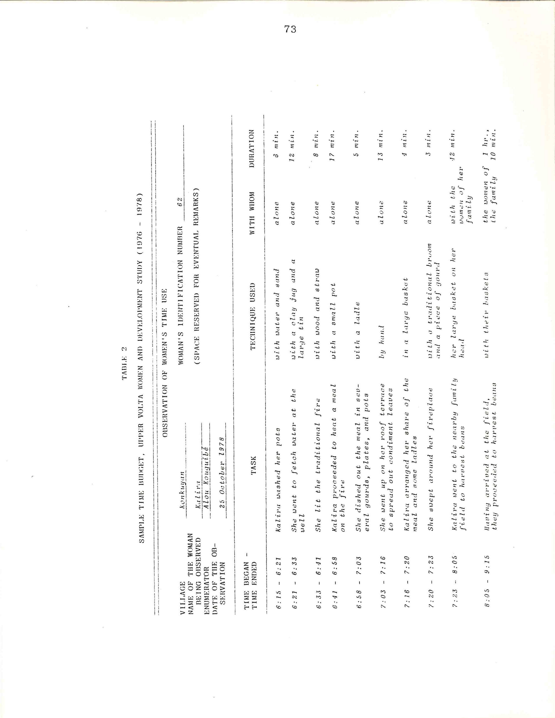
74

In the Kongoussi zone, populated by the Mossi, three
time budgets were also prepared for the husbands of twenty
women in the sample (five from each village) to permit
analysis of the sexual division of labor. A single obser-
vation was also undertaken of five girls and boys from
each village, stratified by age, to furnish indications of
the phasing into these workloads. Group interviews were
conducted with the populations of the villages being sur-
veyed and with women leaders for additional open-ended identification/explanation of problems, needs, priorities,
motivations, and the like.⁸ Their views were solicited
about Project implementation and the strengths and weak-
nesses of the Project. I also interviewed the Project's
regional directors and other Project staff on these topics.
A disproportionate percentage of available research
resources was allocated to the collection of data on
women's, as opposed to men's, activities, notably during
the time-budget phase of the survey. Given that the
principal objective of the Project is equalizing educa-
tional opportunities for women, the research purpose was
to obtain maximum information on women's attitudes and
time patterns, with a view to determining whether time in
____________________________
⁸Scholastique Kompaoré led the first round of group
interviews, which focused primarily on the impact of the
technology package, while I led the second round of group
interviews and those with the women leaders, for which
the methodology is elaborated below.

75

fact constitutes a significant barrier to women's access
to educational activities, and whether the available tech-
nologies are effective in diminishing time barriers. This
approach was taken to a certain degree to compensate for
approaches taken by other researchers in Africa, especially
in farm management and labor utilization studies, who in
the past usually interviewed only the male head of house-
hold, or interviewed the husband concerning his wife's/
wives' activities.
This approach also parallels changes in focus taking
place in research in related fields, such as anthropology.
Two anthropologists have pondered, "How, for example, in
a field that had a long tradition of describing man's place
in society, could we begin to characterize the interest
of women's lives?"⁹ Yet the ATRCW's approach to quan-
tification of the informal employment sector data necessi-
tates computation of the proportion of total hours of
labor devoted to a comprehensive list of tasks which is
female. In addition, the importance of the household
as a unit for the Project's activities cannot be ignored.
For example, the question of labor substitution arises,
and an examination is needed of possible flexibility in
a man's workload which would eventually permit his assuming
__________________________

⁹Michele Zimbalist Rosaldo and Louise Lamphere, eds.,
"Preface," Women, Culture, and Society (Stanford, Califor-
nia: Stanford University Press, 1974), p. v.
76

some of women's traditional tasks, such as wood portage,
an occurrence which is in fact being seen in some regions.
These factors led to the decision to collect a smaller
sample of time budgets for men in the villages of the
majority ethnic group, the Mossi.
Coding and verification was carried out in Upper
Volta by a team led by the research project supervisors,
reinforced by an additional CVRS associate researcher and
other experienced coders and university students. One to
two enumerators per zone were absorbed into the central
team of the research Project for the coding operation,
to assist in the interpretation of responses. The entire
collection of questionnaires and observation sheets is now
housed at the CVRS. The tape-recorded interviews with
village populations and women leaders were translated from
Voltaic languages into French by linguists, each inter-
view being translated independently by at least two
specialists of the language utilized.^{1O}

Women's Activities: Questionnaire (Interview) Versus Time
Budget (Direct Observation)
Although the intensive technique of direct observation
____________________________

^{lO}Initial interpretation was carried out during the
interviews by the Project's regional team directors and
other members. The following specialists of these lan-
guages then undertook painstaking translations of the
tapes: from More, Bro. Jean-Baptiste Bunkungu and Jean-
Christophe Bonkoungou; from Dioula, Gabriel Tamini and
Aimé Dâ; from Kassem, Peter Kazoni and Félicité Pétronille
Diasso.

77

was to be far more costly than recall response by ques-
tionnaire interview, the additional cost seemed justified
by the need for precise information on the activities of
rural women, including their timing and duration. Rural
Voltaic women have difficulties in specifying time, as
pointed out by the first Project principal technical ad-
visor. She noted that this factor created problems for
fixing meetings other than at sun-up or sun-down.¹¹ To
permit a comparison of the results of two survey tech-
niques used in the study, a typical illustration of the
difference in information generated using the questionnaire
(recall) approach and preparation of a time budget from
direct observation is presented in table 3. Thus
we see that of the 603 minutes of work which the enumerator
recorded for Kalira, a traditional midwife in the zone of
Pô on 25 October 1978, 335 minutes were captured in the
"recall" response to the question, "What work did you do,
including household work and lucrative activities, yester-
day since you got up?" Forty-four percent of total work
was unaccounted for. On the whole respondents most fre-
quently listed four activities undertaken the day before.
Although an "intermediate" technique of prompting
extensive recollection seems to furnish more complete
__________________________

^{ll}Oulimata Fall-Bâ. Projet expérimental d'égalité,
p. 25.
78

TABLE 3

COMPARISION BETWEEN QUESTIONNARIE AND TIME-BUDGET RESULTS
CONCERNING THE ACTIVITIES OF KALIRA, A TRADITIONAL MIDWIFE
FROM THE VILLAGE OF KONKUYAN THE PO ZONE.ON 25OCTOBER 1978

Questionaire (by interview)* | Time budget, in minutes(by direct Observation)
Fetched Water | Washed dishes | 006 | -
Harvested dha (condiment) | Fetched water | 012 | x
Prepared food | Reheated food | 137 | x
 | Dried Condiments | 013 | -
 | Harvested beans (in-  Cludingtravel time –  42 minutes) | 167 | -
 | Meal in the field | 012 | .
 | Cut and transported  Wood(simultaneously  Transported beans) | 067 | -
 | Rested | 025 | -
 | Winnowed millet | 007 | x
 | Fetched water | 012 | x
 | Dried condiments | 008 | -
 | Ground millet | 035 | x
 | Personal hygiene | 006 | .
 | Prepared food | 005 | x
 | Ate | 015 | .
 | Rested | 023 | .
 | Shelled peanuts | 035 | x
 | Harvested dha | 075 | x
 | Dried condiments | 007 | -
 | Pounded peanuts | 022 | x
 | Prepared evening meal | 049 | x
 | Heated water | 028 | x
 | Watched fire and con-  Versation | 054 | x/3
 | TOTAL . . . . . . . . . | 720
 | Of which  Work included in interview  response:  Work not mentioned in inter-  view response:  Personal needs and free time |  | 335  268  117
*Question posed: “What work did you do (including household work and
lucrative activities) yesterday since you woke up?”
KEY: x : Work included in interview response
x/3 : One-third considered work and included in interview response:
: two-thirds considered free time.
- : Work not included in interview response
. : Personal needs and free time.

79

reconstruction of activities through recall¹², the search
for accurate time information led to the choice of direct
observation at far less frequent intervals, three obser-
vations of each of the thirty women in the samples of ten
survey villages, including rainy and dry seasons. Two
villages in the southwestern (Banfora) zone of the Women's
Education Project were not included in the observation
phase, owing to overwhelming difficulties which had sur-
faced during earlier phases. These difficulties ranged
from hesitancy on the part of the women to affirm that they
were in the sample to lack of diligence on the part of one
team of enumerators and problems for effective supervision
occasioned by distance.
The use of direct observation necessitated considera-
tion of several particular points, one of which was the
degree of participation of the enumerators. The enumera-
tors were permitted to lend a hand to the women in their
various tasks, in which case "with the enumerator" would
appear in the company ("with whom") column. Thus, for
example, a woman might be accompanied only by the enumera-
tor to the water source, rather than by a daughter or co-
wife, who would assist her in raising the water jug onto
her head. Another phenomenon which came into play in the
________________________

^{l2}See Mead Cain's development of this technique in
"Household Time Budgets, " Village Fertility Study Report
no. 1 (draft), Bangladesh Institute of Development Studies,
February 1977.
80

survey was the so-called "Hawthorne effect,” the impact
of participating in an experiment on worker productivity.
In one control village in particular in the Banfora zone,
it was pointed out by the enumerators that the women ex-
pressed the intention of demonstrating that they worked
day and night to encourage the installation of workload-
lightening technologies in their village. This must be
considered when interpreting the data.
Certain indirect approaches to data collection on
women’s time use in rural areas, such as the interviewing
of the male head of household concerning the activities of
the entire family, prevailed among social scientists in
the past and still persist. Yet researchers now are in-
creasing their utilization of other survey techniques.
Two examples of recent research in Africa using methodol-
ogies different than those employed in the Women's Educa-
tion Project study to assess the allocation of time are of
particular interest here. Christopher Delgado in his re-
source allocation analysis in southeastern Upper Volta,
concerning two ethnic groups including the Mossi employed
a twice-weekly recall procedure.¹³ Edna Loose in her
_________________________

^{l3}In Delgado's work, high cost considerations pre-
vented "ideal" daily interviewing, yet concern for
accuracy regarding inputs and outputs of agricultural pro-
duction processes in the research area led to the choice
of twice-weekly interviewing, whereby each person in the
household was requested to recall all of his/her activities,
sun-up to sun-down, since the previous interview. Linguis-
tic distinctions concerning different times of the day, the
time of school attendance and breaks, the position of the
sun, and religious observances facilitated the recordings.
81

study on women in rural Senegal, dealing with the impact
of innovations in grain processing on villagers, applied a
technique of simultaneously observing a predetermined
sample of women and recording activities at fifteen-minute
intervals.¹⁴ Findings from these two studies will be re-
ferred to in the following chapters.

Less Structured Interview Methodology
To complement the open-ended questions on the stan-
dardized interview schedule, less structured interviews
were conducted in a group setting with virtually the en-
tire population in each survey village, and also with
_________________________

Thus a typical interview might yield the information that
"on Wednesday, Awa weeded field number 5, containing
millet and cowpeas, from sun-up (6 A.M.) until the school,
recreation period (10 A.M.), or a period of four hours.”
(Source: Christopher L. Delgado, "Livestock Versus Food
Grain Production in Southeastern Upper Volta: A Resource
Allocation Analysis"[Ph.D. Dissertation, Cornell Univer-
sity, 1978], pp. 45-46, 49).

¹⁴Edna Loose, "Women in Rural Senegal: Some Economic
and Social Observations," paper prepared for the Workshop
of Sahelian Agriculture, Purdue University, 1-2 February
1979. Loose, in order to assess the impact of a project
designed to benefit women through innovation in grain
processing and storage methods and to provide information
on the socio-economic position of women in rural Senegal,
utilized direct observation of women's activities. The
observation was of a sixteen-hour day and was broken down
into two eight-hour shifts. One household was observed a
day, the morning shift one week and the afternoon shift
the following week; the observer recorded at fifteen-minute
intervals activities of a sample of women of different
ages, marital statuses, and family size. Thus for example,
one might learn that on a certain Thursday, Amy (16 years)
would be threshing millest at 3:00 P.M., while Toua (20
years) was cooking cous-cous, and Diay (42 years) was at
the well. (Source: Loose, ibid., pp. 1, 5).
82

women leaders on an individual basis. A lead-off question
asked that life in the village before independence be
compared with life at present, thus allowing the villagers
to specify their prime concerns. A content analysis of the
responses to this question is presented in chapter seven.
Once views on the first question were exhausted
through "neutral" probing, a more focused interview ap-
proach was followed. Villagers were asked to compare the
past with present conditions in the areas of the ATRCW's
indicators: health, education, employment (workloads),
technologies, and access to land and credit. In order to
avoid any misinterpretation of the fact that the purpose of
the interviews was to determine needs and priorities as
perceived by the villagers and to assess the effectiveness
with which the Women's Education Project had addressed
those needs in target villages, questions in the ATRCW's
"participation in decision-making" area were excluded
since election campaigns began shortly after the survey
was launched.
The women leaders were also asked: ¹⁵
o Specify or expand on any differences the Project
made in life in the village (if this theme had not been
brought up in responses to the initial question on the
interviewee's own initiative);
__________________________

^{l5}I am particularly grateful to Arpad von Lazar for
his assistance in developing this interview schedule.
Gabrief Tamini assisted in presenting the questionnaire in
a manner which would be most meaningful to the villagers,
while Félix Kalmogho by his skillful administration of the
interview schedule during the initial interviews in the
Kongoussi zone improved the instrument for this group.
83

o Which activity or aspect of the Project was most
beneficial? Least beneficial? What potential activities
were overlooked (what was missing)?

o Have there been any fundamental changes? If so,
will they be lasting?

o Have there been changes in the behavior/attitudes
of women and men since the outset of the Project? Has the
Project had an influence on women's status or roles; on
attitudes toward women?

o What influence has assuming the responsibilities of
being a Project leader had on your life? On you?

o If the Project were to continue ten or fifteen years
in your village, in your opinion, what changes would occur
in the village?

Responses to the above questions complemented findings from
the standardized questionnaires, and aided in the inter-
pretation of these findings.

Factors Influencing Interpretation of Survey Results
A major concern in social science research in develop-
ing countries is the obtainment of authorization to under-
take the research, and the obtainment of support from
officials at the national, regional, and local levels and
from traditional authorities and the villagers themselves.
In this particular case, my study of women and development
in Upper Volta was to be based upon the results of the
Women's Education Project, and received fullest support
from the national authorities. Specifically, the Minister
of National Education and Culture in March of 1976 charac-
terized my research project as coinciding with the current preoccupations of the Voltaic authorities (see exchange of correspondence in appendix three). Simultaneously, I had
84

the opportunity to participate in a separate government
research project directed by Scholastique Kompaoré and
financed with the assistance of USAID, which focused on the
impact of intermediate technologies as an element of the
integration of women in the development process. These
two research activities, both based on the Women's Educa-
tion Project, constituted an action-oriented evaluation
tool¹⁶; they received the support of the Project's na-
tional and regional teams and of the monitresses at the
village level. The advantage of direct association with
the Project, which had been conducted in the villages for
many years and that was perceived as serving the well-
being of the populations, cannot be overemphasized.
In each zone, the objectives of the research program
were presented and explained by the Project's regional
director. In Project villages, the research program was
described as a tool which could assist in improving Project
__________________________

¹⁶Undertaken in the last biennium of the experimental
project which the government intended to continue and ex-
pand into other regions of the country, the research ac-
tivities included aspects of summative and formative eval-
uation. Among the objectives of the research was the
identification of those Project approaches and components
which had proved most effective in the original zones so
that they could be initiated in other regions with similar
needs, and information about them disseminated in other
countries. Another objective was to assist the Project
teams in making immediate decisions about the direction
of the Project in the original zones. For an insightful
discussion of issues involved in the determination of
evaluation methods which were to be used in the eleven-
country Experimental World Literacy Programme (EWLP)
undertaken by national governments with assistance from
UNESCO and UNDP, see'—The Experimental World Literacy Pro-
gramme: A Critical, Assessment (Paris: The UNESCO Press
85

activities. In addition, as a vehicle for presenting the
results of the Project's experimental phase to potential
donors, it would hopefully enable neighboring villages to
benefit from the Project and other countries to learn of
the results. In control villages it was explained that
information was also needed from those not reached by the
Project in order to present the Project results to poten-
tial funding sources. It was stressed that funding for
the Project in their villages was not immediately avail-
able. In all cases, control villages in which the survey
was conducted wished to participate in the Project, and
at the end of the survey a monitress was installed in these
villages to launch activities. The survey served in addi-
tion as a baseline study for these new villages.
Perhaps a word should also be said on the manner in
which the Project authorities presented me to the villagers
in order to diminish the effect that the presence of a
foreigner might have, particularly during the group inter-
views. Just as the villagers were enjoined not to make
statements simply to please when the Project's national
coordinator was present, they were asked to consider me,
after many years of residence in Upper Volta, as another
member of the Project team. To further reduce unfamili-
arity and correlative reactions, the national coordinator,
___________________________

and UNDP, 1976), notably the section on evaluation, pp. 151-157.

86

Scholastique Kompaore, in the "joking" mode prevalent in
these cultures, would sometimes during village interviews
refer to me as her "cowife, " or as a friend for whom she
had come to seek a husband. Portrayed as the cowife of
the national coordinator in some villages and adopted as
the "wife" of a village rain chief in one zone and the
leader of a women's group in another zone,
my influence as an outsider seemed to be reduced to a min-
imum.
It is often emphasized in the literature on social
science field data collection that "support of local
leaders is essential in eliciting meaningful answers from
survey respondents."17 The proceedings at the occasion of
the first all-village group interview in the village of
Zimtenga in the Kongoussi zone serve as an example of the
village-level cooperation with regard to the research pro-
gram. Following an introductory explanation of the pur-
pose of the visit of the Project's national coordinator
and the author to Zimtenga, to obtain information on the
progress of the research program and of the Project itself
in the village, the chief appealed to the population as
follows:
It is you who are on the spot who must know
the activities which are most profitable,
those which have been well handled, those
which you have not been able to carry out...
___________________________

l7 Michael Collinson, "Area Preparation: A Vital Ex-
ercise, " in chapter four, "Local Support and Cooperation,”
of Kearl, ibid, p. 50.
87

You who are here present, men and women, if
you have something to say which might aid to
improve the Project, do not hesitate for the
questions are not asked of a single person
but of everyone... It is a discussion; in this
manner one can orient the program of the Project
as the people wish and not continue to under-
take activities for which you do not see any
use or which have not been treated correctly.
For that, I invite you all to speak.
. . . . . . . . . . . . . . . . . . . . . . . . . . . .
If the men were also called together, it is be-
cause we wish to hear their voices and know
what difficulties they encounter, if they find
that it is tiring or if there are Project ac-
tivities which don't suit them. They can
present their problems so that together we can
find the solutions. If it is only the women
who participate and the men say nothing even
if there are negative aspects, one cannot know
this, not to mention finding the solutions.
Your information will be of great value.18
The understanding of the village chief of the objectives
of the research, and his endorsement of it during this and
other meetings undoubtedly encouraged outspokenness on the
part of the villagers. For example, and as will be seen
in later chapters, the women leaders even criticized the
men during group interviews when they felt that they they were
not receiving support in their efforts. Similar coopera-
tion of village chiefs was extended in virtually all of
the survey villages.
Experience in social science research has also led to
recognition of the importance that the enumerator, once
_____________________________
¹⁸Population of the village of Zimtenga (Kongoussi
zone), Republic of Upper Volta, interview, 16 September
1977. The chief of the village of Zimtenga, Jean-Marie
Ouedraogo, was elected to the National Assembly in 1978.
88
assigned to a certain area,
...become genuinely a part of that community.
This is a 24-hour job and may involve "work
participation" in the field, in workshops, or
in the classrooms. Enumerators or research
workers who could not shed their city ways
and dirty their hands and feet proved of
little use.¹⁹
In the case of the Upper Volta research project, enu-
merators were recruited from the zones in which they were
to work; several were young farmers. The enumerators,
asked to administer several rounds of questionnaires
to women in the sample and their husbands and to observe
these same women in their activities from sun-up to the
evening meal on three occasions, were expected to es-
tablish and maintain rapport with the villagers over
eighteen months. Their success in this task would
largely determine the success of the survey. The
villagers of Zimtenga, when asked to comment on the re-
search project and on the work of the enumerators in their
village responded as follows:
A woman: "I want you to know that we are happy
with the arrival of the young man and girl. Their
work pleases us. They have been able to become
aware of all of our suffering.'
A man: "Not only do your interviewers undertake
the work that you have asked them, but they also
help us in the fields. Of course we know that
they have come for their work which consists of
writing, but they ask for a hoe; in our fields,
we never lack a hoe to give to visitors, even if
_________________________
¹⁹Majorie Mbilini, I'Maintaining Acceptability Through-
out the CoIIUDunity," in chapter four of Kearl, ibid., p. 54.
89
they were to be ten. The enumerators have en-
lightened us on many points, we see in that much
aid. They have good will: there is neither
laziness, nor disputes, nor lack of respect.
Our soil is clayey and becomes mud, all of the
paths leading from the village are in this
state, yet the boy leaves his bicycle on the
other side and wades through the mud to come
to work, not only to write but to cultivate.
If it was other people, they would have re-
fused to come, saying that there was too much
mud and that they couldn't come on bicycle.
These ones on the other hand are uncomplicated,
they leave their bicycles in a corner and come
on foot... If you have more work like this,
don't hesitate to come to this village.²⁰
Given the importance of this point, the influence of
enumerator-respondent relations in determining the quality
of the data, the responses in two other villages of the
Kongoussi zone concerning the work of the other team of
enumerators are also presented. In the village of Kora,
the chief who responded:
My opinion is that the two "children" have
conducted themselves very well, they have
asked the women questions about their activities.
If they find you in the midst of working, they
join in and stay until your departure. Since
the questions have been asked, not a single
woman has refused to answer... They follow the
women into the fields. When they find them
occupied, they help them and then they withdraw
to write. I see them each time working. They
manage well. ..Frankly, if people arrive in Kora
for a task, by their behavior, I am able to judge
who works well and who pretends. For the lazy,
when they arrive, they seek a corner to rest
in the shade. That is not the case for these two.²¹
__________________________
²⁰Population of Zimtenga, interview, 16 September
1977.
²¹Population of the village of Kora (Kongoussi zone),
Republic of Upper Volta, interview, 17 September 1977.
90
And in the nearby village of Loulouka populated predom-
inantly by Mossi blacksmiths, the villagers had the
following to say:
A woman: "The girl came one day to find us in
the midst of cultivating, she helped us in the
field to hoe, we talked afterwards, her work
pleases us. We get along well, she is very
patient. She waits for us until the evening be-
fore returning to the village. We are happy
with their work. "

A man: " As for the girl and boy, their work
pleases us. When they arrive and find us in
the process of turning the soil, they partici-
pate. If they find us in the process of sow-
ing, it is the same thing, field if they arrive
when we are in the midst of preparing a field,
if we are in the process of burning, they don't
hesitate to help us. All that they find us
doing, they participate. We are happy with
their work, they don't seek to sit in a corner
and watch us work. They participate in all
our activities."²²
The supervisor of the work of the enumerators was obviously pleased with these responses of the villagers, yet stated
as we were leaving one village that he hoped that the
villagers would be saying the same things once the dust
from our tires settled back onto the road.²³ Other fac-
tors would seem to confirm that these statements reflected
more than an attempt to please. The notables of Loulouka,
________________________
²²Population of the village of Loulouka (Kongoussi
zone), Republic of Upper Volta, interview, 17 September
1977.
²³Yambénogo Ouédraogo, full-time supervisor of the
research program, during the first round of group inter-
views in the Kongoussi zone in September of 1977.
91

a village which shared a monitress who was in residence
in Kora, requested that the girl who served as enumerator
in their village become their monitress and reside in their
village. And in another zone, Banfora, one of the con-
trol villages which was to receive a Project monitress
at the end of the survey held out for one of the enumera-
tors who had worked in their village. They were willing
to wait the time that would be necessary to accomplish the
requisite administrative formalities for the enumerators
to become, monitresses, as long as one of their enumerators,
who "already knows all of our problems was to become
their monitress. Although the "striving to please" or
courtesy factor cannot be ruled out entirely, the behavior
of the enumerators combined with the frequent presence in
the villages of the regional directors in conjunction with
the study led us to believe that the maximum effort had
been extended to obtain frank responses. The directors
were familiar enough figures that the villagers were not
obligated to feign politeness with them.

Following completion of the survey work, one or two
enumerators from each zone were transferred to the central research team, which was then undertaking the coding op-
eration. Enumerators were thus available to offer clar-
ifications on questionnaire responses, and particularly
on interpretations to be given to the villagers' answers.
As two or more coders spoke each of the languages in
which the respondents would have made their replies, they
92

were able to trace back with the enumerator the sorts of
statements which the villagers would have made, and the
probable meaning of their replies. In some cases, seman-
tic ambiguities were uncovered at this stage. One such
case emerged concerning the word "well, " equivalents of
which were used by the villagers to refer to a wide
variety of water sources, ranging from a cemented well
and spring scooped out next to a body of water, each
yielding compapatively clean water, to a non-cemented well
and an earthen pit collecting rain water, the latter yield-
ing stagnant water. Working sessions with the enumera-
tors permitted identification of the various sources of
water available to each village, and their characteristics.
The enumerators were also at hand to offer supple-
mentary information as I studied the approximately one
thousand time diaries. In many cases, the line by line
discussion of a woman's activities and helpers, and of the
techniques or technologies utilized, furnished me with
invaluable insights into practices and conditions in the
villages. The enumerators, who had their origins in the
area and had acquired first-hand knowledge of life in
these particular villages after fifteen to eighteen months
of residence therein, were thus utilized as resource per-
sons. During tape-recorded "debriefing" sessions, the
enumerators were interviewed on numerous aspects of life
in the villages, including their perceptions of income
differentials, status generation, and similar, and often
sensitive, areas in which direct questioning of the
93

villagers might have yielded unreliable responses, or even
have offended the respondents. 24 This information assisted i
n the interpretation of the data.

__________________________
²⁴Credit is owed to Yambénogo Ouédraogo for skill-
fully conducting these interviews based upon a schedule,
which I had prepared.

PART TWO

ANALYSIS OF THE WOMEN'S EDUCATION PROJECT
IN THE SOCIOECONOMIC AREAS OF THE AFRICAN TRAINING
AND RESEARCH CENTRE FOR WOMEN'S INDICATORS

CHAPTER IV

EMPLOYMENT

Un proverbe nous enseigne que "l'abeille
qu'on met de force dans une ruche ne fera
pas de miel ."
Or, il se trouve que chez nous, en Afrique,
cette abeille infatigable, industrieuse et
productive, c'est la femme et plus particu-
liérement la femme paysanne. C'est d'elle
qu'il s'agit et c'est a elle qu'il faut
reconnaitre le droit et faire acquérir la
capacité de poser et résoudre les problèmes
nationaux de développement dans le cadre
d'une concertation de tous les instants avec
son partenaire de toujours.

Prof. Ali Lankoande, Minister of National Educa-
tion, in his closing address, Operational Seminar
on the Situation and Role of Women in African
Economic and Social Development (Banfora, Upper
Volta: 28 November 1975)

Water is scarce, wood is scarce. It happens
that an able-bodied woman wishes to help an
old woman by bringing her water, but that is
not possible. One must get up very early and
return very late to have a single jug of
water. It is the same for wood. One must go
very far in the bush to gain a bundle of fire-
wood. It is only possible to give a very
small part to the old woman who no longer has
any strength.

Woman from the village of Loulouka, Kongoussi
zone, to the author during an all-village
interview, 6 January 1978

95
96

Overview of the Problem

An emerging body of empirical studies on women's

roles in development documents the fact that women account

for a substantial share of production in rural regions of

Africa. Investigations have generated data on African

women's labor inputs into traditional farming systems and

the informal employment sector in addition to work at home.

Field research is thus permitting the testing at the

country level of hypotheses advanced about the extent of

rural women's participation in productive activities, such

as the early estimates of the UNECA that women furnish

sixty to eighty percent of the labor in agricultural pro-

duction¹, and about the impact of development on women.

Frameworks and models to permit analysis of household time

allocation have been set forth by sociologists and
_________________________

^{l}United Nations, Economic Commission for Africa,
"Women: The Neglected Human Resource Factor for African Development," Canadian Journal of African Studies, vol. 6,
no.2 (1972), p. 359. On women's labor inputs into tradi-
tional farming, see Achola O. Pala, African Women in Rural
Development.: Research Trends and Priorities (Washington,
D.C.: Overseas Liaison Committee, American Council on
Education, December 1976), and Delgado, Livestock Versus
Food Grain Production. On women's participation in in-
formal employment, see Simmons, Economic Research and
Women. For findings about rural women's labor allocations
in Africa and the impact of modernization upon women,
see Dunstan S.C. Spencer's two studies, African Women in
Agricultural Development: A Case Study in Sierra Leone,
African Rural Economy Program Working Paper no. 11 (East
Lansing, Michigan: Michigan State University, April 1976)
and Women in a Developing Economy~ A West African Case
Study (forthcoming); and also Loose, Women in Rural
Senegal.
97
economists.² Definitions of “what” constitutes "York" con-
tinue to be refined and include distinctions between work
at home and free time or leisure.³
The need to assess women's contributions to subsis-
tence and early modernizing economies in order to determine
women's actual roles and whether resources are being allo-
cated in light of these roles has long been identified by
the African Training and Research Centre for Women.⁴ The
ATRCW is concerned with redressing apparent imbalances
between women's labor inputs and their access to available
technologies and training. To this end, the ATRCW has
suggested the quantification of women's contributions and
___________________________
²The following works are of particular interest:
Alexander Szalai, Philip E. Converse, Pierre Feldheim,
Erwin K. Scheuch, Philip J. Stone, Eds., The Use of Time:
Daily Activities of Urban and Suburban Populations in
Twelve Countries (The Hague: Mouton, 1972); Robinson, How
Americans Use Time; Gary S. Becker, "A Theory of the Allo-
cation of Time," Economic Journal:, vol. 75, no. 229
(September 1965), pp. 493-517; Reuben Gronau, "Leisure,
Home Production, and Work --The Theory of the Allocation
of Time Revisited," National Bureau of Economic Research
Working Paper no. 137 (May 1976); and Elise Boulding,
"Productivity and Poverty: Problems in Measurement for
Third World Women," paper presented at the International
Center for Research on Women Workshop, 30 April-2 May 1978.

³Interestingly enough, housework was already assigned
value in Hungary's national income accounts prepared by
Matolczy-Vargus in the 1930s. (Source: Paul Rosenstein-
Rodan, personal conversation, 20 March 1979.)

⁴See United Nations Economic and Social Council,
Economic Commission for Africa, Data Base, pp. 1-11.
98

needs using the set of socioeconomic indicators presented
in chapter one to expedite the translation of empirical
evidence into development policies and programs.
The major purpose of this chapter is to explore the
proposed ATRCW formal and informal employment indicators
with Upper Volta data in order to show what the indicators
reveal and to assess their validity in this context. The
ATRCW classifies employment into two categories: 1) formal
or wage employment, and 2) informal or non-wage employment, including subsistence agriculture. This scheme is followed
throughout this study, rather than the more usual classifi-
cation into urban format, urban informal, and rural sector
employment. Either scheme is suited to the definition of
employment spelled out by the director-general of Upper
Volta's National Office for Employment Promotion at the
National Seminar on Employment and Training:
Trop souvent, en effet, dans nos pays en voie
de développement, l’emploi est synonyme d'emploi
salarie, et c'est par rapport au chômage c'est-
a-dire au non emploi qu'on l'apprend [le concept
de l'emploi] mieux. Or l'EMPLOI ou TRAVAIL est
bien toute activité qui procure a celui qui
l'exerce~ un gain lui vermettnnt de satisfaire
ses besoins de la vie.⁵
_______________________________
⁵G. CH. Kam, "Expose introductif: Situation de l'em-
ploi en Haute-Volta," p. 3, Seminaire national sur l'em-
ploi et la formation. (Note: papers in this volume are not
numbered continuously, thus the page number of the particu-
lar paper -on which each citation appears is indicated.)
"Too often, as a matter of fact in our developing countries,
employment is synonymous with wage employment, and it is in
relation to unemployment, that is non-employment, that one l
earns it [the concept of employment] better. Well EMPLOY-
MENT or WORK is in fact any activity which procures for the

99

Although only a tiny percentage of Voltaic employment is
wage employment, the Voltaic situation vis-a-vis the sug-
gested formal employment indicators is briefly reviewed.
A small sample of the data generated in one village
in the Kongoussi zone of the Women's Education Project is
then applied to the ATRCW model concerning women's par-
ticipation in the informal labor sector, the sector in
which approximately 98.6 percent of the Voltaic active
labor force is employed. A possible refinement of this
model is presented in an attempt to; maximize the utility
of such quantitative evidence. Tentative findings regard-
ing Voltaic women's labor allocations based upon the re-
vised model suggest answers to the following questions
about time allocation and the use of technologies:
How in fact do rural Voltaic women employ their time?
To what extent are differences in time-use patterns
associated with type of household (monogynous, poly-
gynous⁶), religion, age, income, and the like; what
impact do these factors have on "free time"?

Can it be confirmed that time pressures hinder women's participation in educational activities, and that

__________________________

one who exercises it earnings permitting satisfaction of
life '8 necessities.'

⁶It has been stated with regard to the rural Mossis
that "although monogamy is necessarily the norm, polygyny
is preferred" (Peter B. Hammond, Yatenga: Teahnotogy in
the CuZture of a West Afriaan Kingdom [New York: Free Press,
1966], p. 120). Slightly less than one-third of all women
interviewed (N = 276) in the village of Zimtenga, from
which the data presented below was collected, indicated in
interview response that they had no cowives.
100
these pressures are linked to factors such as "no
cowife," which is sometimes offered by the villagers
as an explanation⁷?
Had the Project identified the most time-consuming
activities in choosing to try to lighten the grinding/
pounding, hauling, and water-fetching tasks?

What was the impact of the introduction of the technolo-
gies: of mills carts, and wells?

Can it be determined that workloads were in fact
lightened?

Can the use of the mechanical mill be attributed
to the value relative scarcity of time, as implied
by respondents indicating mill use when they have
too much work or are to'.) busy, sick, tired, or
receive an unexpected, visit?

Can use of the mill be linked with income levels,
as implied by respondents indicating mill use on the
condition that they have some money, or alternatively,
use of the grinding-stone due to lack of means or
that the mill is too expensive⁸?

Conclusions are drawn pointing to avenues for the analysis of the full data set of the Upper Volta study to further test the findings about women's roles in rural development
____________________________
⁷In "On Being Up Against the Wall: Women's Time Pat-
terns in Eleven Countries," Philip J. Stone reviews time
pressures experienced by urban women, comparing their sit-
uation in both socialist and capitalist countries, based
upon the findings of the Multinational Comparative Time-
Budget Research Project, undertaken during the mid-1960s, in
W. Michelson, ed., Publia PoZiay in Temporal Perspective
(The Hague: Mouton, 1979).
⁸Commercial mills, primarily for processing grain, and secondarily for processing peanuts and shea nuts, are avail-
able in Voltaic towns, and even in many villages, yet
prices deter regular use. The mechanical mills furnished

by the Project are managed by the women's groups in the
villages; they typically set the fee at 15 to 30 CFA francs
for processing of a 4-liter tin of grain (1 $ U.S. = 245
CFA francs in 1976, the year of the vil1age-level survey).

101

and efforts to lighten their burdens and increase their
productivity.

Employment Indicators of the African Training
and Research Centre for Women

Formal Sector

Within the formal employment sector, the ATRCW has

suggested the tabular presentation of data on women's par-

ticipation as a percent of total employment in manufactur-

ing, commerce, and agriculture, and also in professional/

technical and managerial/'administrative positions.⁹ The

ATRCW suggests that wage comparisons be included and that

there be comparisons over a period of years. The first

three sectors were selected since they represent occupa-

tions in which women traditionally have been employed in

significant numbers in Africa and since they require mini-

mum levels of formal education. The last two sectors per-

mit assessments of how women are faring in employment

requiring higher levels of education and training. Average

annual growth rates and the projected growth in ten years

time at the current growth rate are to be calculated. It

is not specified in the proposed indicators whether it is
_________________________
⁹The source of information in this paragraph is United
Nations, Economic Commission for Africa, The NIEO, p. 29.
For the actual data sheets proposed for use in the develop-
ment of indicators in the employment sector, see the Annex,
"Women's Comparative Access to Increased Inputs and Rewards
of Development Activities," pp. 1-3.

102

the average annual and projected growth over ten years
in the numbers of female workers which is to be calculated,
or the average annual and projected growth over ten years
in the percentage of workers who are female which is to
be calculated.
Analysis of Africa-wide data reveals extremely low par-
ticipation of women in wage employment, not exceeding 10
to 15 percent of the paid labor force in most countries,
and a concentration of women in the "services sector
(teaching, nursing, secretarial positions) and the low-rung
positions in manufacturing and the 1ike.10 The employment
pattern in Upper Volta is not an exception to these find-
ings. Available data show that in the mid-1970s 1.4 per-
cent of the active population (14 to 60 years) was en-
gaged in wage labor, or approximately 0.7 percent of the
total Voltaic population. ¹¹In 1970, women represented
10 percent of total wage employment in Upper Volta.¹²
Women held 13 percent or 2,542 of 18,337 jobs in the public
sector in that year, which was three times the number they
held in the private sector.
These 1970 Voltaic data also support the phenomenon
__________________________
¹⁰Ibid. , p. 12.

^{1l}Kam, "Expose introductif, " p. 3.

¹²Bartelemy Ouedraogo, "Situation de l'emploi dans
le secteur public au 31/12/75," pp. 4-5, in Séminaire
national. Data in the following paragraph is from this
same source.
103

identified by the ATRCW of "concentration of women in
teaching, nursing, and the like." In that year women
represented 70 percent of all civil servants in social
affairs, 26 percent in health, and 20 percent in educa-
tion In what have come to be considered the male-dom-
inated professions, women represented only 10 percent in
rural development; 9 percent in commerce, industry, and
mining; and 4 percent in finance.
Available data show that in 1975, women constituted
4.7 percent of sector employment.¹³ They
were younger than their male colleagues, 57 percent being
under thirty years of age and 32.5 percent from thirty to
forty Of the 894 women employed in the pri-
vate sector in 1975, only 286 were skilled workers.
The situation of Voltaic women in modern employment
is well articulated by Barthelemy Ouedraogo, a director of
the National Office for the Promotion of Employment (ONPE),
in a paper included in the synthesis of the National Sem-
inar on "Employment and Training" held in 1977 :
L'année 1975 aete proclamée l'Anne Internationa-
le de la Femme. Au cours de cette année
de réhabilitation de la femme, des Séminaires
et des exposes se sont succédées pour étudier
le problème de la participation de la femme
dans la vie économique. ...
_____________________
¹³Idem, "Situation et perspectives de l'emploi dans
le secteur prive," p. 7, in Séminaire national.
104

Dans la Fonction Publique donc, les
salaries de sexe féminin sont relativement
peu nombreux. On compte environ 3 408 sur
un total de 22402 Agents de l'Etat.
Cet état de fait pose un problème qu'il
faudra résoudre tôt ou tard si l'objectif
de notre développement est l'utilisation
rationnelle de nos Ressources Humaines á
savoir la promotion de l'emploi féminin
en Haute-Volta.¹⁴

The seminar participants went on to recommend the applica-
tion of an effective policy for the integration of women
in all areas of the national economy, and the use of the
human resources which the female potential represents.
They endorsed the opening of training for all qualifications
and levels to women, the application of an "equal pay for
equal work" principle, and the lightening of family re-
sponsibilities by creating day-care and similar institu-
tions.15 Although comparative wage data is not available,
this working group's recommendation of "equal pay for equal
work" suggests the existence of wage discrimination against
___________________________

¹⁴Idem, "L ' Emploi dans le secteur public, " pp. 4-5.
"The year 1975 has been proclaimed International Women's
Year. In the course of that year of the rehabilitation of
women, seminars and papers followed one after another to
study the problem of the participation of women in economic
life. ..In the Civil Service, then, paid workers of the
female sex are relatively few. One counts approximately
3,468 of a total of 22,402 Government employees. This
accompl ished fact poses a probl em tha t must be resolved
sooner or later if the objective of our development is the
rational utilization of our human resources, that is, the
problem of the promotion of female employment in Upper
Volta.
^{l5}"Rapport des travaux de groupe sur l'emploi salarié
dans le secteur privé,'p. 7, Séminaire national.
105

women. The overall summary of the seminar proceedings also emphasized the necessity of urgent actions aimed at con-
cretely assuring equal access of women to salaried employ-
ment and to responsibilities corresponding with their
training.¹⁶
Unfortunately governmental policy recommendations
Are not consistent in taking into account women's needs.
At the same seminar, industrllization aimed at the man-
ufacture of production materials for the rural labor force
was endorsed, with the exception of that agricultural
equipment which could be produced by artisans in adequate
quality and quantity. Industrialization of the processing
and other agricultural crops was also endorsed.¹⁷
It should be noted that similar protection for artisans
in this area of processing was not mentioned. Processing
is a woman's domain par excellence.
One example is shea-nut butter production which pro-
vides women with considerable revenues, particularly in the
Po zone. The concern to protect male artisans as stated
above did not carryover to women's activities. Further-
more, it appears that the Office for the Promotion of
Voltaic Enterprise (OPEV) with the assistance of the
United Nations Industrial Development Organization (UNIDO)
_____________________________
¹⁶"Synthése generale, .I' p. 8, SeminaiI'e national.
¹⁷Kam, "Expose introductif, " p. 8.
106

is moving ahead with the financing of a shea-nut butter
factory to be created in the industrial park in the capital.
Calculations of the projected market for the factory's pro-
duction include the demand of the rural towns. The pro-
spective factory can therefore be expected to undercut the
earning of the rural women and to serve as yet another ex-
ample of the Boserup-Tinker thesis of the adverse impact
of development on women. The actual processing of shea
nuts into butter using traditional methods is an exhausting
task, involving some thirty-odd independent steps.¹⁸ Shea-
nut presses do exist which could have been introduced, pre-
ferably to women's groups, to lighten their burdens, to in-
crease the yield from the nuts and to maintain their income.
Using the ATRC'V indicators with available public sec-
tor data, one finds that the number of women employed
showed an average annual increase of 7.3 percent during the
period 1970 to 1975. By way of comparison, the total number
of both men and women employed by the Government during
this period increased at an average annual rate of 4.4 per-
cent. Those ATRCW indicators in the formal employment sec-
tor which show the percent of workers who are female and
average annual rates of growth in the numbers of women
____________________________

¹⁸Conversations with Philip Langley and Marie N'Gom
Touré following their visit to the Pô zone of the Women's
Education Project within the framework of a mission for
United Nations Children's Fund (UNICEF) on appropriate technology.
107

employed provide a useful picture of the situation of
women over time. It would be desirable, however, to pre-
sent actual employment figures (total employment, and "of
which female" figures) along with the data on females
as a percent of total workers to avoid misinterpretation.
Projections of growth in ten years based on the current
growth rate, however, must be viewed with great caution
given the generally miniscule base of women currently in
the formal sector in Africa.19 Female employment can be
expected to multiply manyfold at the outset, and to slow
in rate of growth in the decades to come as parity is
approached.

Informal Sector

An example of the ATRCW's proposed data sheet for the measurement of women's participation in the informal em-

ployment sector, including agriculture, is shown in table

4. As in the formal sector, women's participation in each

activity, expressed as a percentage of total labor input

into each activity, is to be calculated over time, for ex-

ample every five years, to show trends in the sexual

division of labor in the informal sector.²⁰ The first
__________________________
¹⁹For example, women constituted only 10 of 1,288
employees in the Voltaic processing industries in 1965.
(Source: Republique de Haute-Volta, PZan-Cadre 1967-1970,
Tome II, p. 262).

20 Elise Boulding calls this procedure for measurement
an "index of femaleness" in her paper "Productivity and
Poverty: Problems in Measurement in Third World Women,"
108

column of figures in the table represents rough estimates
by the UNECA of women's participation in traditional Afri-
can economies.
These proposed indicators concerning informal employ-
ment have been explored with a small sample of data on rural
women in Upper Volta in order to see in what ways such an
application can assist in eventual refinement of the indi-
cators before their suggested Africa-wide application.²¹
The second column of figures in table 4 represents average
amounts of time spent on each of the tasks by a sub-set of
five Voltaic women (hereafter called "the mini sample"), as
observed on three different days over different seasons, in
comparison with time spent by their husbands. The mini
sample was drawn for illustrative purposes from a random
from the village of Zimtenga, reached by the Women's
Education Project in its northern zone of operations.²²
____________________________
and presents over thirty such indicators of the status of
women directly derivable from UN data. The UNECA has in-
dicated that alternatively, women's participation in each
activity may be viewed as a fraction of the total participa-
tion (equivalent to 1.00) of both men and women (see United
Nations Economic and Social Council, Economic Commission for
Africa, Data Base, p. 2).
²¹The ATRCW has suggested assembling such data as an
input into development plans in various geographic and eth-
nic regions of countries including rural and urban areas,
and also for use are national, sub-regional and Africa-wide
levels. (Source: United Nations Economic and Social Council,
Economic Commission for Africa, Data Base, p. 2.
²²See appendix one for a brief description of the major
features of the village from which the sample is drawn.
109

TABLE 4

ESTIMATES OF THE PARTICIPATION OF WOMEN IN TRADITIONAL
RURAL AND EARLY MODERNIZING AFRICA

AREA OF WORK PERCENTAGE OF HOURS OF LABOUR WHICH ARE
FEMALE
Africa as a whole¹ Upper Volta Sample²

PRODUCTION, SUPPLY, AND DISTRIBUTION
1. Food production 70 61
2. Domestic food storage 50 85
3. Food processing 100 93
4. Animal husbandry 50 60
5. Marketing 60 95
6. Brewing 90 100
7. Water supply 90 100
8. Fuel supply 80 76

HOUSEHOLD/COMMUNITY
- Rearing and initial education
of children 100 100
2. Cooking, Cleaning, Washing 100 99
3. House building 30 _³
4. House repair 50 100
5. Community self help project 70 100

- Rough estimates made by the UNECA appearing in Data
Base, p.9.
- Figures based on advance processing for illustrative
purposes of a mini sample of five women and their hus-
bands (three cross – seasonal time budgets per person)
Chosen from a larger random sample for one village.
- Activity which did not occur during mini sample obser-
vations.

110

The calculations are based on recordings of the minutes
of labor allocated to the different activities during
approximately the first fourteen hours after the woman/man
arises. Inspection of the UNECA estimates for Africa as a
whole and calculations based upon the Upper Volta sample
show that in almost two-thirds of the categories the figures
are remarkably similar, the differential between the two
being less than ten percent. Using the actual time allo-
cated to these tasks by women and men in the Upper Volta
sample, women assume 'eighty percent of this workload.
Further examination of the Upper Volta time budgets
shows that this schedule of work accounts for an average
of two-thirds of the total occupations (all activities, in-
cluding free time) of the first fourteen hours of the day
of this sample of women in the village of Zimtenga. As
for their male counterparts, it accounts for only one-
quarter of their total occupations. To furnish more com-
plete information of the total workloads and the sexual
division of labor in Upper Volta" the set of indiaators
would need refinements. Mainly, it would need additional
categories so as to better capture men's time use.

Proposed Revised Framework for Examination
of the Allocation of Rural Women's Time
The Upper Volta data suggest that a more comprehensive framework would be preferable, incorporating into the
schedule of work such activities as crafts, and also inc-
luding measures of time for personal needs (meals,

111

personal hygiene, and the like) and free time. A more
comprehensive set of indicators would permit examination of
the dominant patterns of overall time use and allow deter-
mination of whether men score higher on a more inclusive
schedule of work than on the initial schedule of work sug-
gested by the ATRCW. This procedure would also permit in-
spection of comparative leisure, which might facilitate pro-
posing priorities for the allocation of development re-
sources among alternative programs which would result in a
balanced carrying out of rural task or eventual substitu-
tions of men's labor for women's.
In addition, it would appear that further disaggrega-
tion of the proposed ATRCW indicators might yield informa-
tion which would strengthen them as a prescriptive tool.
Collection of data on the "food production" component of
the informal sector model may confirm quantitatively in
many countries the importance of women's labor inputs in
this area. Yet the information is not sufficiently precise
to show those activities within food production in which
women are actively engaged and hence where training and
technology inputs might most effectively be directed to
enhance women's productivity or lighten their burdens.
It would seem that while retaining the basic ATRCW model format for comparability purposes, that with the addition of small refinements tailored to suit each country's needs, the ATRCW informal sector indicators can go beyond producing an "awareness of the extent and value of the female
112

half of the labor force²³," and attain the additional goal
of assisting in prescribing remedies to the situation.
I therefore propose the following modifications to the
initial model: that indicators concerning food production
and processing be disaggregated~ and that cash crop pro-
duction crafts and other professions personal needs and
free time be incorporated into the model. The inclusion of
a "crafts and other professions" item seems warranted in
the case of Upper Volta following inspection of the full
data set of time budgets from the Women's Education Project
surveyand examination of Delgado's findings concerning
allocation of household labor by task amongst the Mossi over
seasons. 24 The inclusion of a "free time" item seems of
particular importance, since existence of free time would
presumably facilitate attendance at a functional literacy
class or a radio group organized with the village monitress
to listen to and discuss the programs prepared by the
Women's Education Project on themes concerning the villa-
gers.²⁵
____________________________
²³United Nations, Economic Commission for Africa, The
NIEO, p.31.

²⁴Delgado, Livestock Versus Food Grain Production. See
his chapter four on labor (particularly tables 4.4, 4.6, and
4.8).

²⁵While actual listening to the radio programs may also
be a secondary activity taking place in the woman's own
courtyard as she prepares the evening meal (provided the
radio, which in all probability would belong to her husband
or son, is placed within hearing distance), she would not
benefit from subsequent discussion with her comrades and

113

In addition, inclusion of the "free time" and also
"personal needs" items should facilitate eventual comparison
with data and findings from the Multinational Comparative
Time-Budget Research Project, directed by Alexander Szalai,
on time use in urban and suburban industrial settings in
twelve countries, which influenced my decisions during the
design of the classification scheme.²⁶ This investigation
would contribute to the ongoing testing of hypotheses about workloads of women in pre-industrial societies in compari-
son with those of women in industrial societies.²⁷ Many
problems of comparison will nonetheless be encountered;
for example, in the multinational survey, "meal at work-
place" is classified as work. In the Upper Volta data,
a lunch-break in the field would clearly be comparable, yet
the varying patterns of other work (crafts, food processing,
household tasks) do not facilitate neat classification of
“meal at the workplace. II Thus all time for eating is
classified apart in the proposed scheme; eventually a pre- determined portion could be considered as "work" for
___________________________
the monitress.
²⁶See Szalai, Use of Time. Participating countries
were Belgium, Bulgaria, Czechoslovakia, Federal Republic of
Germany, France, German Democratic Republic, Hungary, Peru,
Poland, U.S.A., U.S.S.R., and Yugoslavia.

²⁷See Wanda Minge-Klevana, "Does Labor Time Decrease
with Industrialization? A Theoretical and Methodological
Survey of 38 Time Allocation Studies from Pre-Industrial
and Post-Industrial Societies," Harvard University.
114

comparative purposes. My classification scheme appears in
tables 5 and 6.
One aspect of the scheme, that the first four cate-
gories can be grouped to constitute "work, 'I thus treating
"work at home" as work, merits particular attention, for
it embodies the growing concern of economists to distinguish
work at home and leisure.28 My treatment of leisure is less
clear-cut, however, as I have utliized the broader term
"free time" , owing to the ambiguous nature of many activi-
ties. Some free time activities, for example, prayer,
are presumably obligatory in nature and not leisure; others
might appear to be leisure yet in fact have a civic or so-
cial obligation overtone, such as a conversation of a
woman leader, who might be in the process of transmitting
newly-learned knowledge to her comrades as part of her responsibilities.29 The time budgets do not permit conclu-
sions to be drawn about the probable nature of many free
time activities. One cannot determine if the radio program
being listened to was primarily of an educational nature
____________________________
²⁸See Gronau, "Leisure, Home Production, and Work.”

²⁹A particularly absorbing treatment of division of
"social" labor as distinct from di vision of "productive"
labor is presented in Paul Riesman's study of the Fulani
herdsmen in Upper Volta (Societe et liberte chez les Peul
Djelgobe de Haute-Volta: Essai d'anthropologie introspec-
tive [Paris: Mouton, 1974]), now also available in English.
See especially chapter 4, "Life in the '!Juro' (village):
Categories of persons and their tasks.”
115
TABLE 5

RURAL ACTIVITIES (KONGOUSSI ZONE): INDICES OF FEMALENESS

Women’s participation expressed
as a percentage of total time
allocated by both men and
women to each category.
- PRODUCTION, SUPPLY, DISTRIBUTION
1. Food and cash crop distribution 64
a. Sowing 49
b. Weeding, tilling 95
c. Harvesting 25
d. Travel between fields 86
e. Gathering wild crops 61
f. Other crop production activities 64
2. Domestic food storage 2
3. Food processing 85
a. Grinding, pounding grain 100
b. Winnowing 100
c. Threshing 100
d. Other processing activities 54
4. Animal husbandry 60
5. Marketing 95
6. Brewing 100
7. Water Supply 100
8. Fuel Supply 76
B. CRAFTS AND OTHER PROFESSIONS 23
1. Straw Work 0
2. Spinning cotton 100
3. Tailoring 19
4. Midwifery 100
5. Other crafts/professions (e.g. metal work, pottery, weaving,
Bee – keeping...) 0
C. COMMUNITY 23
1. Community projects 100
2. Other community obligations 0
D. HOUSEHOLD 97
1. Rearing, initial care of children 100
2. Cooking, Cleaning, Washing 99
3. House building -
4. House repair 0
E. PERSONAL NEEDS 37
1. Rest, relaxing 33
2. Meals 42
3. Personal hygiene and other personal needs (including medical) 75
F. FREE TIME 40
1. Religion 25
2. Educational activities (learning to read, attending a UNESCO
meeting or class...) 82
3. Media (radio, reading a book...) 0
4. Conservation 17
5. Going visiting (including such social obligations as funerals)70
- Errands (including going to purchase personal consumption items
Such as Kola or tobacco next door) 11

117

or purely entertainment, or if the book being read was a
manual on market gardening or a detective story being read
for pleasure. Therefore, distinctions between leisure and
other free time activities are not made.
Table 5 includes ratings or percentage of total time
allocated to each activity by women as compared with men,
based upon the Zimtenga mini sample. According to the
revised schedule of work, women carry out 64 percent of the production/distribution/supply tasks, 23 percent of crafts
and other professions, 97 percent of household tasks, and
again 23 percent of community obligations. These tasks
represent 56 percent of all work performed in the first
fourteen hours of the day, in contrast with the 80 percent
portrayed in the ATRCW selection of categories. Expansion
of the food production category into a more comprehensive
category including cash crops has resulted in a decrease of
women's participation in farming from 61 percent to 49 per-
cent, owing to significant amounts of time allocated by men
to cotton production.³⁰
The addition of the "crafts/other professions" item
and the expansion of the community category to include
"other community obligations" such as official ceremonies,
_____________________________
³⁰Cotton, peanuts, rice, sesame, cowpeas, tobacco,
and market garden produce have been coded as "cash crops."
Although portions of the harvest of grains such as millet
and sorghum may also be sold, questionnaire response
showed that the bulk of these crops was directed to home
consumption. Portions of the cash crops are also alloted
to home consumption.
118

time the chief devotes to receiving visitors, and time
of "greeting" the chief, have also had the effect of
greatly increasing men's relative labor inputs into over-
all workloads, as women's average participation in each of
these categories is only 23 percent. The expansion of the
framework also reveals that men fare better in the avail-
ability of both time for personal needs and free time than
women. Using the "first fourteen hour" approach, however, measurements of the distribution of all waking-hour tasks
are not, available, although indications are provided since
enumerators asked the women and men what activities would
be undertaken after their departure, and recorded the an-
swers minus the time values.31 Almost one-half of the ob-
servations in the mini sample ended before preparation of
the evening meal began, and another one-third less than
midway through preparation. A common dish like sagabho³²,
___________________________
³¹For this preliminary analysis, observations are
assumed to last fourteen hours for purposes of comparabil-
ity. For shorter observations, "not specified" was used
for unobserved time; for longer observations, the supple-
mentary information was eliminated. As an option for the
future, some of the procedures being developed for treatment
of "ragged" time budget data, in which the number of ac-
tivities undertaken differs, may be utilized. This problem
is reviewed in Philip J. Stone, "The Analysis of Time-Budget
Data," in Szalai, Use of Time, pp. 89-111, and Philip J.
Stone, "A Data Frame for Time Budgets, Life Histories, and
Other Event Series," paper presented at the IX World Con-
gress of Sociology (1978).

³²Akin to a stiff porridge, most often made from millet
flour and accompanied by sauce.
119

requires approximately one to one and one-half hours pre-
paration time followed by washing up. It can therefore
safely be concluded that the methodology introduced a down-
ward bias in the measurement of women's workloads, espe-
cially household tasks. In the south-western zone, the
enumerators observed women until bed-time, at times past
midnight; these observations provide complete waking-hour
data for women for one ethnic group.
In order to provide a picture not only of the percen-
tage of total time allocated to each of these tasks by
women and men, but also of the distribution of the time
of members of each sex among the different activities, the
same schedule of activities is reproduced in table 6, with
the average time allocated to each activity by the mini
sample of women and their husbands. Alternatively, the
table could be calculated to portray the percentage of wo-
men's total time which is allocated to each category/acti-
vity, with similar computations for men. Ideally, the
table would also include labor inputs of girls and boys.³³
Graphic presentations of the overall sexual division of
labor for this sample are provided in figures l and 2.
________________________
³³Two particularly interesting studies on children's
labor inputs and productive contributions are Mead Cain,
“The Economic Activities of Children in a Village in
Bangladesh,” Population and Development Review, vol. 3, no.
3 (September 1977), pp. 201-27; and Moni Nag, Benjamin N. F. White, and R. Creighton Peet, "An Anthropological Approach
to the Study of the Economic Value of Children in Java and
Nepal," Current Anthropology, vol. 19, no.2 (June 1978),
pp. 293-306.
122

Findings and Directions for Further Analysis
Organization of the data of the mini sample in accor-
dance with the revised framework permits preliminary ex-
amination of a certain number of hypotheses concerning rural
women's time use, including those suggested by the socio-
logists working in the Project. Based upon analysis of
the mini sample, provisional findings are presented here
concerning time pressures experienced by Voltaic women and
the influence of polygyny, age, and technology on time use.
These tentative qualitative findings suggests directions for
the analysis of the entire data set.

Time Pressures Experienced by Mossi Women
The Project sought to promote women's education by en-
couraging the sending of girls to school more systematically
and if possible in the same proportions as boys, and by
training women leaders who would in turn transmit functional training to their colleagues and inspire change in their communities.34 Women's workloads and time patterns could be assumed to greatly influence both of these objectives,
given the importance of the assistance furnished by girls
in carrying out daily tasks. The sociologists hypothesized
that the magnitude of women's workloads, notably their
agricultural and household tasks, would leave little time
for interest and participation in educational activities.
_______________________________

³⁴Lallemand, Projet d'accés des femmes á l'éducation,
p. 1.
123

Mossi women might be accorded a small number of days to
work in their own fields by the family head or husband;
otherwise time could be made between dawn and mid-day or
after 5:00 P.M., provided it did not interfere with meal
preparation. Struck by the "enormous" role of women in
farming, the sociologists recommended training in modern
agricultural methods and felt that in the long run it would
be necessary to narrow the gap between women's economic
importance as farmers and their low social and intra-famil-
ial status.³⁵
Examination of the data shows that this sample of women averages well over twice as much time on the production/ supply/distribution tasks, including food processing, as
on the household tasks of cooking, cleaning, washing, and
childcare. The two women with small infants average only
45 minutes per day on childcare. Although society did seem
to make certain allowances for new mothers, as their over-
all workloads were the lightest and they were the only
women with any time for conversation as a primary activity
and visiting. The free time for women in this sample aver-
ages only 1.3 hours per observation, and increasing the
length of the observation would not be likely to uncover
substantial amounts of additional free time, given the
meal preparation tasks which remained. Szalai, based on the
findings of the multinational time-budget project, notes
_____________________________

³⁵Ibid., pp. 8-9. The latter recommendation was re-
flected in the UNFAO schema referenced above.
124

that during the week, free time ranges from 2.5 hours a day
for employed women to 4 hours a day for housewives; and on
days off employed women enjoy 6 hours of free time and
on Sundays housewives have 6.3 hours. He states that "the
inordinately small amount of free time at the disposal of
employed women and the constraints put on housewives are
two factors that bear heavy responsibility for women's re-
duced participation in civic life, professional training,
and education."36 Should the processing of the larger data
set corroborate the findings of the mini sample, that Mossi
women have only 1.3 hours of free time in the first fourteen
waking hours, then it is little wonder that the sociologists
and other members of the Project team put an accent on the
introduction of workload-lightening technologies in an
attempt to create time in which women might benefit from
the educational opportunities sponsored by the Project, and
so that they might be more amenable to allowing their young
female helpers attend school.

Marital Regime/Religion and Time Use
The Project sociologists also pointed out that it was

________________________

³⁶Alexander Szalai, The Situation of Women in the
Light of Contemporary Time-Budget Research, prepared for
United Nations, World Conference of the International Wo-
men's Year, Mexico City, 19 June -2 July 1975 (E/CONF.66/
BP/6), 15 April 1975, pp. 8, 10.
125

understandable that young Moslems sought several wives given
their important labor input into family agriculture. From
the women's point of view, if they got along, work in
their personal fields, child care and food preparation could
be shared, including the daily fetching of water and the
biweekly portage of wood which fell entirely on women.
The sociologists recorded that young wives expressed the
wish that their husbands take additional wives, while one
young Catholic expressed bitterness at being obligated to
undertake 3.lone the domestic tasks which her neighbors
married under a regime shared.³⁷
Comparison in the Upper Volta mini sample of two
women without cowives (one Catholic, one traditionalist)
with two women with cowives (both Moslem) would seem to
support this hypothesis. The total time allocated to the
food production/ supply/distribution tasks was highest for
the women without cowives, and their total workloads, in-
cluding also household work, community activities, crafts

Total House- Personal Rest Free
work- hold needs time
Loads task

Women without cowives 11.3 0.8 1.7 1.0 0.4
Women with cowives 10.3 2.8 3.0 2.3 0.8

______________________

³⁷Lallemand, Projet d'acces des J~emmes a Z 'education,
p. 9. For a thorough treatment of conflicting opinions of
women toward polygyny, particularly in an urban setting, see
Elliot P. Skinner, African Urban Life: The Transformation of
Ouagadougou (Princeton, New Jersey: Princeton University

126

and other professions, averaged 11 1/3 hours. These figures
stand in comparison with ten hours of work for the women
with cowives, or only 8.8 hours if exceptional Project-
linked responsibilities of the head of the women's group
are excluded. Women without cowives allocated substantially
less of their working time to household tasks than their
colleagues with cowives. For personal needs, they had less
than 13/4 hours in comparison with three hours for the
women with cowives; time for rest accounted for one hour in
comparison with 2 1/3 hours. They averaged one half as
much time for "free time" activities, although one woman
without a cowife averaged 45 minutes per observation for
educational activities.

Age and Time Use
The sociologists pointed out that for old widows with-
out children in the compound, nearby fields were reserved
for growing millet, peanuts, groundnuts which are similar
to chick-peas, and condiments for the sauce, and that
these crops had to suffice to totally meet their needs.³⁸
Overall inspection of the total set of time budgets would
seem to support the hypothesis that age does not strongly
affect women's time use, that young and old alike shoulder
_______________________

Press, 1974), pp. 135-43.

³⁸Lallemand, Projet d'accès des femmes a l'éducation,
p. 7.
127

substantial burdens. In one zone, an enumerator noted un-
der "remarks" on a time-budget sheet that a woman of sixty-
five years was "rather old, who no longer has many activi-
ties in her day"; yet recorded in the observation were
4 1/2 hours of pounding shea nuts and forty minutes of
grinding grain in addition to lighter household tasks such
as sweeping. Another woman, blind and guided in her move-
ments by a small girl, spent 5 3/4 hours harvesting peanuts
plus 45 minutes shelling the peanuts in addition to lighter
household tasks.
Advance processing of the small Zimtenga sample re-
veals that the three older women (average age: forty-eight)
performed the highest total workloads, averaging 11 1/3

Total Personal Rest Free
Work- needs time
Loads

Older Women 11.4 1.9 1.3 0.3
Younger Women 6.9 3.8 2.7 2.8

hours per day, in comparison with seven hours for the two
younger women (average age: twenty-seven, both with young
infants). The younger women benefited from an average of
3 3/4 hours a day for personal needs, of which 2 3/4 was
for rest, in comparison with slightly under two hours, of
which 1 1/4 hours was for the older women, and
almost three hours of free time in comparison with 15 min-
utes daily for the older women. These findings provide
interesting comparisons with those of sociologists such
128

as Robinson, who in his work on time use of Americans dis-
covered that the age variable has surprisingly little in-
fluence, while Szalai indicated that it was for very old
and very young people that the structure of average time
budgets differed from those for average adults.³⁹
Single observations undertaken during the dry season
of a stratified sample of Mossi girls, three of whom are
in households of women in the mini sample, yield illus-
trative information about phasing into these workloads.
They would suggest that already at age seven girls are
contributing several hours of work a day to such tasks as
pounding millet and spinning cotton; 4 112 hours at age
nine, encompassing the additional tasks of fetching water,
and doing laundry and dishes; 6 112 hours at age eleven,
adding on the tasks of fuel portage and fishing; and at
age thirteen, 7 114 hours are allocated to these same
tasks. At age fifteen a girl was considered capable of pre-
paring a full meal on her own and devoted 9 3/4 hours to
productive tasks.
These workloads are compared in table 7 with those
performed during a single observation by a stratified
sample of boys from Zimtenga. None of the children ob-
served attend primary school, which is the case for ninety _______________________

³⁹Robinson, How Americans Use Time, p. 190 and Szalai,
Situation of Women, p. 5.
129

percent of their age cohorts. The younger boys fetch
TABLE 7
COMPARISON OF PHASING INTO WORKLOADS
(KONGOUSSI ZONE) BY SEX
Ages | Hours of Work
Ages | Zimtnga Only |  | Average for Four Villages
Ages | Girls | Boys | Girls | Boys
7 | 3.5 | S1.5 | 5.3 | 0.7
9 | 4.7 | 0.8 | 7.4 | 2.8
11 | 6.6 | 4.0 | 8.5 | 3.2
13 | 7.1 | 6.0 | 6.0 | 5.2
15 | 9.8 | 4.6 | 8.8 | 4.4

straw for fuel and run errands for their mothers; assist
in hauling earth for construction and fertilizer; and
look after the animals. By age thirteen they are active
in market-gardening activities, such as the harvesting of
green beans and preparation of irrigation canals. Two of
the boys were reading the Koran during the observations,
an eleven-year old for a duration of three hours. Average
data, calculated from a single observation of girls and
boys ages seven to fifteen .n four Kongoussi zone villages,
including Zimtenga, is also presented in table 7. In the
three Kongoussi zone villag s other than Zimtenga in which
children's activities were ob girls attended primary school Girls'

130

work inputs were still substantially greater than those
of their male age cohorts in these villages. The observa-
tions were undertaken during the dry season, which the
school year completely encompasses, to provide indications
of the opportunity cost of sending children to school.⁴⁰
The considerably fuller workloads of girls in comparison
with boys clearly have implications for the access of
girls to education, and for achievement once at school --
and for the workloads of the women foregoing portions of
the girls' labor input.⁴¹

Technologies and Time Use
Of the food production tasks of women in this sample,
sowing occupies most time, followed by harvesting and then weeding. According to questionnaire response, men pre-
dominate in the land preparation and tilling tasks. Plows _______________________________
⁴⁰Nag and his colleagues found that the average
work inputs of girls were higher than those of boys in
almost all age groups in a Javanese and a Nepalese village.
In these cases, however, they found that the higher work
inputs of girls were related to the fact that boys attend
school more frequently ("Economic Value of Children, "
p. 296).

⁴¹Emmy Simmons in reviewing future productive oppor-
tunities for Nigerian women suggested that they will be
most influenced by factors external to the sector, such as Universal Primary Education (what will become of "a bean-
cake manufacturer when she finds her sales force in
school”) [Eaonomia Researah, p. 21.] Minge-Klevana's
time allocation study in a transitional Swiss village re-
vealed a positive association between children's time at
school and increases in parental workloads, particularly
those of their mothers ("Does Labor Time Decrease, " p. 20).
131
are being introduced in Upper Volta, yet seeders are un-
known. This corroborates the ATRCW's contention that la-
bor-saving/productivity-increasing technologies do not
reach women frequently enough.42 Of the food processing
activities, the grinding/pounding activity absorbs the
greatest share of time (84 percent of total food-process-
ing time, an average of over 13/4 hours per day). The
sociologists had estimated an even higher figure of 2 to
3 hours per day. Thus the choice of the introduction of
mechanical mills by the Project is understandable. Of
the women in the mini sample, three indicated that they
use the mechanical mill, and for the following reasons:
to have more time, to diminish suffering, and since “it is
easier” although they do not have the means to go regularly.
Two did not use the mill at allowing to lack of money.
In addition, the Project team identified water por-
tage as a time-absorbing factor in the dry season, when
women were obligated to take long journeys to fetch even
muddy swamp water. It was "not rare" for them to go four
kilometers for a jug of water in the very early morning.
___________________________
⁴²The ATRCW cited the example of a country importing
one hundred tractors to one weeder, women doing the weed-
ing (United Nations, Economic Commission for Africa, The
NIEO, p. lQ). In addition, sufficient development re-
sources may not be being directed to the development and
testing of appropriate technologies for women. A technol-
ogy center in Africa developed a seeder, but both its
weight and the force necessary to release the seeds would
lead me to believe that it would inspire little interest
among women such as those in Upper Volta, who sow from a
light calabash hanging on the wrist or merely tuck the
seeds into their cloth skirt.s rolled over at the waist,
132

In the rainy season, pits near the compound retained rain
runoffs^{.43} Women in the mini sample accorded only about
forty minutes per observation to water portage in the per-
iod from June to December; this figure could be expected
to increase substantially further into the dry season.
The head of the women's group of Zimtenga pointed out in
an interview held during the dry season that their ce-
mented well, built with material furnished by the Project
and labor by the villagers, was so crowded that it was
almost dry, and the swamp lacked water. She continued,
"Water has its priority" especially in our surroundings.
Lack of money, and of food, come after the need for water.
Water is the first element of life."⁴⁴ The well-digging
program sponsored by the Project aimed both at saving time
and at furnishing more potable water, even in those cases
in which time was not a particular constraint.
In certain villages, the period just before the rains
was reserved to stock fuel for the duration of the rainy
season, and thus interfered with regular attendance at
_______________________________

accompanied with a pick to make the pockets.

⁴³Fall-Ba, Projet expérimental d'égalité, p. 39, and
Lallemand, Projet d'accès des femmes à l'éduaation, p. 8.

⁴⁴Habibou Ouédraogo, head of the women's group of the
village of Zimtenga (Kongoussi zone), Republic of Upper
Volta, interview, 1 March 1978.
133

literacy classes.⁴⁵ Women leaders pointed out that wood,
which had been plentiful nearby, had become scarce owing
to their own multiple cuttings of trees and to certain of
their animals and then in turn the rains had become
scarce.⁴⁶ Fuel portage absorbed little of the time of the
women in the mini sample. Three women (who were never ob-
served fetching wood) stated in questionnaire response
that they used a cart. Of the other two (observed fetch-
ing wood), one stated that she had no money to pay for the
use of technologies; the other was from a quarter without
a cart. The women who use technologies (carts and the
mill), responded that the "extra" time was used especially
to sp1n cotton, or somet1mes to rest.⁴⁷
Szalai and his colleagues, concerned with the unequal
burden placed on women by household responsibilities, have
rejected the argument that technological development will
"soon '1iberate’ women from household chores.” Their
_____________________________

⁴⁵Fall-Ba, Projet expérimental d'égalité, p. 39.
⁴⁶Mrs. Tidebamba, head of the women's group of the
village of Doure (Kongoussi zone), Republic of Upper Volta,
interview, 22 March 1978. The same point concerning the
increasing distance for wood portage was made by Elisabeth
Belem, Women's Education Project monitress and wife of the
chief of Zimtenga, in a separate interview on the same day.
⁴⁷Of the women in the mini sample, three attended
functional literacy classes; one had been to school; and
one was “too old" to attend. It would appear from the
mini sample that, although interested in educational ac-
tivities, the women did not link what they perceived as
"time saved" to the pursuit of education.
134

findings show that time devoted to housework does not
seem to depend on the level of the availability of tech-
nology.⁴⁸ It seems that clothes may be washed more often
or meals prepared with more variety, but the overall bur-
dens of housework have not been lowered. Resource factors,
including household technology, which were supposed to
have provided more options for the use of time showed sur-
prisingly little impact.⁴⁹
It is my impression from overall inspection of the
Upper Volta data that a similar phenomenon may appear. A
song composed by blind minstrels from the village of
Magniassin in the southern zone of the Project concerning
a mill acquired by the women on credit from the Project
well serves to illustrate this point:
The women of Magniassin have understood that
unity is strength. They now have their
collective field. And they now have their
millet mill. So that when we come late
from the fields, we can now eat. And even
the bachelors no longer have to beg the
women to grind their flour.⁵⁰

The frequency with which women indicated that they use the
mill when tired or sick leads me to believe that the min-
strel's point represents a pattern. The mill permits
_____________________________

⁴⁸Szalai, Situation of Women, p. 12.
⁴⁹Robinson, How Americans Use Time, pp. 27, 31.
⁵⁰Minstrels from the village of Magniassin (Pô zone),
song, Republic of Upper Volta.
135

meals which otherwise would have been foregone. If the
women had intended to prepare in the evening in any case,
their workloads are thus lightened; if not, their tasks
are in fact increased, as cooking time will still take
one to two hours. Thus eventual impact of the mill would
have to be sought not in time savings but rather in im-
proved nutrition increased productivity of the workforce,
and the like reflecting Szalai's findings that with the
household technologies come rising "popular
demands On the quality and quantity of household ser-
vices.”⁵¹
A similar pattern may be discerned with regard to the
proximity of water. If the woman has access to a nearby
well, she may spend the same amount of time to fetch extra
water for personal hygiene or laundry, paralleling the
cleaner clothes phenomenon in the multinational time-bud-
get project. Accessible water would facilitate use of a
filter. One model of filter introduced by the Project re-
quired regular washing of the charcoal and pebbles, and
some women in the Kongoussi zone understandably rejected
"wasting" the 'precious water they had hiked so far to
fetch on preparing the filter:
If one can only find a single jug of water in
the day, and if it is necessary to filter it
through the sand, what would remain to drink?
It is above all the water shortage that

_______________________________

⁵¹Szalai, Situation of Women, p. 12.
136

aggravates everything, otherwise almost
all of the women in this village have
filters.⁵²

Of the women in the Zimtenga mini sample, three used water
filters all year long giving as their reasons: "to be
healthier" ; "to avoid certain microbes Which can attack us
in the dirty water" ; "dirty water makes us sick." One
used a filter only in the dry season, reasoning "there is
not enough charcoal in the rainy season," while one never
filtered and did "not know" why. The link between the
availability of water and filtering was implied by one
old man from Zimtenga in a group interview:
I've been digging a well, you can see that
my hands are wounded, it was in trying to
reach water. The advice of the Project
could be carried out if we had a good num-
ber of wells. The women would filter
water correctly.⁵³

The sociologists such as Szalai suggest that tech-
nology is not a panacea, and suggest looking to a more
equitable division of labor. The findings of Loose in
Senegal would show that of grain processing innovations
introduced, a thresher was most beneficial to the women,

_____________________________
⁵²A women during an all-village interview in Loulouka
(Kongoussi zone), Republic of Upper Volta, 6 January 1978.
Similarly, one Project monitress had reported that a tra-
ditional midwife went to fetch water so that she could
learn to set up a charcoal filter, and only came back in
the evening; "often the women come back empty-handed or
with a calabash of dirty water which does not even suffice
for meal preparation" (cited in Republique de Haute-Volta/
UNESCO, Projet expérimental, p. 53).
⁵³Population of the village of Zimtenga (Kongoussi
zone), Republic of Upper Volta, interview, 5 January 1978.
137

for it transferred the task onto the men's shoulders and
budgets.⁵⁴ The mill experience in Upper Volta would seem
to confirm Szalai's theory, yet the spread of certain tech-
nologies such as carts and bikes seemed to be accompanied
by a redistri-bution of tasks traditionally carried out by
women alone. A man who owing to tradition could not
typically headload water, wood, or the harvest is not ad-
verse to transporting these same commodities by cart or
bike.⁵⁵
The African Plan of Action for the Integration of
Women in Development expresses concern that "women are
fully employed in the economic and social tasks in the
traditional sectors of African life, often to the point
of exhaustion and ill-health, yet little progress has been
achieved in making their tasks less burdensome and more
productive."⁵⁶ The direct observation technique for
____________________________
⁵⁴Loose, "Women in Rural Senegal, " p. 22. She also
found that a grinder was most highly appreciated by the
women, yet too expensive for regular use, and that a
dehuller was rarely used.
⁵⁵The many and fascinating ramifications of the
impact of the technology package in the Project villages
are treated at length in Scholastique Kompaore and Brenda
Gael McSweeney, "The Impact of Intermediate Technologies
on the Integration of Women in the Development Process,"
a report currently being prepared for USAID.

⁵⁶Cited in United Nations Economic and Social Coun-
cil, Economic Commission for Africa, Data Base, p. 80.
138

collecting time budgets on rural activities, combined
with examination of the resulting data in a comprehensive
framework, has yielded valuable insights into the
sexual distribution of work and free time in the northern
zone of operations of the Women's Education Project in
Upper Volta. The detailed information generated by this
approach should facilitate the tasks of planners and
policy-makers attempting to design programs more respon-
sive to women's real roles and needs.

CHAPTER V

EDUCATION

It's thanks to the arrival of the Project that change
has been brought about in life in our midst. We have
begun to listen to the radio programs in our families.
We hear advice from women, similar to us, on child
care, personal hygiene, upkeep of our courtyards.
And since it is our "cowives" who talk to us, that
encourages us to understand the utility. That is
our education. It is the Project that has contri-
buted to these changes.

Mrs. Tidebamba, head of the women's group of
Doure, Women's Education Project village in
the Kongoussi zone, to the author in an in-
terview on 22 March 1978

We have seen the activities which our "cowives" from
the Project undertake, and that pleased us. It's
only last year that we met to take the initiative
to join them. It was when the girl and the young
man (the enumerators] arrived. We invited them to
talk with us, because the Project interests us enor-
mously. We are just sitting while our "cowives"
benefit from the assistance of the Project. It is
above all this reflection that prompted us to come
and we continue to solicit the Project.

Mrs. Rasmata Ouedraogo from Tampelga, a village
not reached by the Women's Education Project, to
the Project's national coordinator during a
meeting in the neighboring village of Zimtenga,
16 September 1977

139
140

Women and Education: The Phenomenon
One noted scholar of rural education wrote in the
early 1970s:
The neglected and disadvantaged position of
rural girls and women has long been recog-
nized and is bemoaned repeatedly at vir-
tually every international meeting where
education is discussed. ..They [the inter-
national agencies] have perennially adopted
ringing resolutions on the subject, but
their actions, it seems fair to say, have
for the most part been on a token scale.¹

By the mid-70's, partly in conjunction with the Interna-
tional Women's Year (IWY), several international organiza-
tions active in education and other sectors had examined
ongoing projects for their impact on women, issued guide-
lines or instructions on the integration of women in
development, and financed new projects aimed at women's
needs or redesigned ongoing programs to include these
needs.² In many cases, programs which had quietly been
launched long before IWY, such as the Upper Volta/UNESCO/
_____________________________
¹Philip H. Coombs, "Opportunities for New Collabora-
tion on Rural Education and Development by International Agencies," presented at the Third Session of the Joint FAO/UNESCO/ILO Advisory Committee on Agricultural Educa-
tion, Science, and Training, Paris, 3-8 December 1973,
pp. 9-10.
²To give one example, the UNDP reports regularly to
its Governing Council on the question of women's participa-
tion in the Programme. In order to report on progress made
in this area, UNDP's Regional Bureau for Africa requested
that each field office identify approved or planned new
projects or project components that take women's interests,
as participants or beneficiaries, into account. Two of
five sectors for this section of the report were formal and
non-formal education which pay attention to girls' and
women's special needs, and vocational training for girls
and women.
141

UNDP Women's Education Project, were publicized so that
other countries could benefit from even the provisional
results, from knowledge of activities which to date had
succeeded and failed.
Major gains need to be made in the school enrollments
of girls and the access of women to training adapted to
their real roles. The African Training and Research Centre
for Women's set of indicators in the education sector are
designed to assess progress in this area and to facilitate
translation of intentions into further action. They en-
compass both formal education and training and non-formal
education. They reflect concerns expressed by African wo-
men at a series of regional conferences beginning in 1964,
and incorporated in 1975 into the African Plan of Action
for the implementation of the objectives of the Interna-
tional Women's Year.³
The purpose of this chapter is to explore the ATRCW's
education sector indicators with Upper Volta data from
the Kongoussi zone, in order to see what insights the in-
dicators might furnish concerning these populations, and
conversely, what insights the data might offer on the
__________________________
³In addition, the Interagency Working Group on the In-tegration of Women in Development in Africa, of which the
ATRCW serves as Secretariat, is preparing a summary of on-
going and proposed projects for the integration of women in development in the region. This summary will include pro-
jects on education and training and in the other areas of
the African Plan of Action, plus special projects in rural development and appropriate technology. For further de-
tails, see "Report of the First Meeting of the United Na-
tions Interagency Working Group on the Integration of Women
in Development in Africa (Addis Ababa, 30-31 March 1978)."
142

appropriateness of the indicators. Focusing on change
associated with the activities of the Women's Education
Project, on the influence the Project has had on these wo-
men, households, and villages, the following are some ques-
tions which will be considered:
What importance was given by rural populations to
educational activities; namely, formal education
for children, and non-formal adult education ac-
tivities such as functional literacy, the Project's
radio broadcasts, and the health-education pro-
gram? Were these structures/activities perceived
to be addressing their overriding problems and con-
cerns? What priority needs of the populations
were not being met? Were there differences in
Project and control villages with regard to send-
ing children to school, listening to the Project's
radio programs, and adopting health improvement
techniques?

Of the various activities introduced by the Pro-
ject, which included workload-lightening tech-
nologies, health-related activities, communal
activities, and educational activities, what
ratings did the educational activities receive
on the "most beneficial activity" scale? On the
"least beneficial activity" scale? Did certain
educational components rate differently than
others? What explanations were offered by the
villagers, and what are the implications for
future programs and policy? Did these explanations
match the Project personnel's early identification
of low income, lack of free time, and persistence
of traditions as defining and limiting the role
of women?

What factors seemed to influence participation in
educational activities: time pressures? wealth or
status? attitude of husband? personal factors
such as age, religion, ethnic group?

Explanatory factors to which inter- and intra-village
variations in attitudes and behavior might be attributed
are then analyzed and conclusions drawn.
143
Education and Training Indicators
of the African Training and Research Centre for Women

Formal Education
The ATRCW has recommended presentation in tabular form of statistics on “percent female" among all students and teachers at the primary, secondary, and university levels over time, accompanied by calculations of average annual increase and projected growth in ten years at the current growth rate. In. Upper Volta, available data for the primary level are table 8:
TABLE 8
EDUCATION AT THE FIRST LEVEL IN UPPER VOLTA
1965 1970 1975
Public enrolled : 33 36 37
% female
Teaching Staff : 18* 16* 18
% female
(Pupils – all (36) (41) (43)
Africa ** : %
female

* Estimates
** Excluding the Arab states
Data from UNESCO Statistical Yearbook 1977

Comparison of these data with continent-wide data (ex-
cluding the Arab states) shows that the "femaleness" of
enrollments in Upper Volta is slightly lower than the
averages for all African countries. Any straight-line
144

projection of growth in "femaleness" in Voltaic enroll-
ments based on average annual increase during the 1965-
1975 period must be viewed with caution, however, as
growth tapered off substantially in the second half of the
period. Growth rates can be expected to decline in any
case as the enrollments of girls approach parity with
those of boys.⁴
It is critical to note that at the primary level in
Upper Volta only ten percent of those in the eligible age
group attend school, 7.9 percent of the girls and 11.2
percent of the boys in 1974.5 A great urban/rural dis-
parity exists, with 70 percent of children residing in
urban areas attending school at the primary level in con-
trast with 9 percent of those in rural areas. Considered
by region, attendance of eligible children ranges from
4.3 to 15.9 percent. The Educational Planning Directorate
had included among the possible explanatory factors for _________________________________

⁴McGrath has pointed out that in Upper Volta, and many
other countries, female enrollments have augmented many-
fold, but that these ". ..enrollment increases are mea-
sured from abysmally small beginnings." She emphasizes
that during the 1950s, the access of girls to primary ed-
ucation improved substantially, but that the pace has since
slowed. Source: Patricia L. McGrath, The Unfinished
Assignment: Equal Education for Women, Worldwatch Paper 7 [Washington, D.C.: Worldwatch Institute, July 1976],
pp. 18, 20.
⁵Information in this paragraph drawn from République
de Haute-Volta, Ministere de l'Education Nationale et de
la Culture, Reforme de Z'Eduaation: Dossier Initial
(Ouagadougou: Ministere de l'Education Nationale et de la
Culture, [circa 1975]), p. 11.
145

these divergences different ethnic-specific attitudes to-
ward schooling and even more importantly the differential
impact of various religions. Dropout and repeater rates
are higher for girls than boys.
As displayed in table 9, female enrollments as a
percentage of total enrollments at the secondary level rose
in Upper Volta from 26 percent to 32 percent in the decade
1965-1975,6 only to decline again in 1976. The 1976 data
portend hazards in prediction of future growth rates. In
the mid-sixties, the percentage of eligible students at the
secondary level was approximately 2 percent for boys and 1
TABLE 9
EDUCATION AT THE SECOND LEVEL IN UPPER VOLTA
1965 1970 1975 1976
Pupils enrolled 26 28 32 29
% female
Teaching staff: *32 ... ... ...
% female
*Estimate
...Data not available
Data from UNESCO Statistical Yearbook 1977
percent for girls, rising in the mid-seventies to 3 percent __________________________________
⁶For the biennium 1973-1975, the "percent female"
among second level students (excluding technical schools)
rose from 26.5 to 29 percent. Numbers of women enrolled
thereby increased at a rate of 34.4 percent in comparison
with a 24.8 percent increase in total enrollments (Répub-
lique de Haute-Volta, Ministere de 1 'Education Nationale,
"Donnees Succinctes sur 1 'Evolution de 1 'Education en Haute-
Volta, 1973-1975," Ouagadougou, 18 Août 1975).
146
for boys but remaining at 1 percent for girls.⁷
In 1975, as shown in table 10, Voltaic women repre-
sented one-fifth of the in-country third-level student
TABLE 10
EDUCATION AT THE THIRD LEVEL IN UPPER VOLTA
1965 1970 1975
Pupils enrolled: 21 15 20
% female
Teaching staff: … ... 13
% female
...Data not available
Data from UNESCO Statistical Yearbook 1977

body. About four-fifths of Voltaic students pursue their
higher education abroad. The ATRCW has stressed the impor-
tance of presenting third-level data by field of study, to
show whether women are moving into non-traditional fields
such as science and technology, or tend to remain in the
more traditional social science and education areas.⁸ Dis-
tribution of students by sex among fields is displayed in
table 11. In 1970, all female students were enrolled in the
social sciences and humanities areas, and in 1975 ninety-
seven percent continued to be enrolled in these same areas.
The ATRCW indicators serve to provide a partial
description of women vis-a-vis formal education. A single
_____________________________
⁷UNESCO Statistical Yearbook 1977, p. 143.
⁸United Nations, Economic Commission for Africa, The
NIEO, p. 30.
147
TABLE 11
THIRD LEVEL STUDENTS BY FIELD OF STUDY IN UPPER VOLTA
Field of 1970 |  |  |  | 1975
Study | Total | Of which female | (% female) | Total | Of which female | (% female)
Natural Sciences |  |  |  | 143 | 5 | (4%)
Engineer-  ing |  |  |  | 56 | 0 | (0%)
Agricul-  ture |  |  |  | 30 | 1 | .
Social  Science | 15 | 2 |  | 391 | 95 | (24%)
Human-  ities | 168 | 25 | (15%) | 447 | 111 | (25%)
TOTALS | 183 | 27 | (15%) | 1067 | 212 | (20%)
.% not computed where N of cases less than 50
Basic data from UNESCO Statistical Yearbook 1977
set of indicators cannot be expected to reveal the many
complex facets of the situation of women in the sector.
The proposed tabular presentation would be enhanced by
the inclusion of absolute numbers of pupils in addition
to the percentages of girls enrolled. Enrollment ratios
and dropout and repeater rates by sex provide useful com-
plementary descriptive information. In addition, reasons
identified by the pupils themselves, parents, the teach-
ing corps, and policy-makers for higher drop-out and re-
peater rates among girls at the primary level would be
useful prescriptive data.
148

Non-Formal Education and Training
The ATRCW has emphasized that the non-formal educa-
tion sector ". . .is especially important, in view of the
growing emphasis on adult learning in most countries of
the region and the low literacy levels among women and
their consequent need for non-formal training, and means
must be found to measure and monitor at least some of the
non-formal education facilities and to assess their
effectiveness."⁹ The ATRCW has recommended collecting
data on adult education in the areas of agriculture,
animal husbandry, trade and commerce, cooperatives, arts
and crafts, and nutrition as well as any other pertinent
areas. In many countries, these data are not readily
available.
Data on women's participation in non-formal education
activities in Upper Volta are, predictably, scarce.¹⁰
Published data are available, however, concerning the ex-
perimental rural education program mentioned in chapter
two which was launched in the early 1960's. Its planners
foresaw that by 1970 approximately 76 percent of all boys
and 24 percent of all girls would have an opportunity to
___________________________
⁹Ibid.
¹⁰The government, in collaboration with UNESCO and the World Bank, is preparing an exhaustive study on training
facilities available under the auspices of each govern-
mental department.

149

participate in this scheme.¹¹ Thus even more of a bias
against girls than the one-third female enrollment ratios
prevalent in formal education was built into the initial
design of the rural education program. The curriculum
for girls included training in health and home economics
in addition to courses in modern agricultural methods.
The sociologists pointed out that in 1966-1967, of 457
Voltaics trained to teach rural education, 438 were male
and 19 female.¹²
Data on the actual execution of the rural education
program by 1972-1973 is displayed in table 12. Thus in

TABLE 12
STATUS OF THE RURAL EDUCATION PROGRAM IN UPPER VOLTA
FOLLOWING A DECADE OF IMPLEMENTATION

No.Enrolled (% of No.of Centers (%of total)
total)
Boys 24,000 (90.6) 737 (90)
Girls 2,500 (9.4) 84 (10)

TOTALS 26,500 (100.0) 821 (100)
Source of data: Ahmed and Coombs, Education for Rural
Development, chapter 9.

¹¹Ahmed and Coombs, Eduaation for Rural Development,
pp. 339-41.
¹²Suzanne Lallemand, "Rapport de mission du..30 Avril
au 15 Juln 1968 (Projet d'accès des femmes voltaïques à
l'éducation),” p. 3.

150

actual implementation only one-tenth as many girls as
boys benefitted from the program. In 1974 the rural ed-
ucation program became the responsibility of the Ministry
of Planning, Rural Development, Environment, and Tourism.
The centers were renamed "Centers for the Training of
Young Farmers," reoriented, and reinforced with additional
external assistance. The troubling disparities in women's
participation, however, seemed to remain. Patricia McGrath
has warned that "almost everywhere the minute percentages
of females receiving agricultural education stand in
striking contrast to the high percentage of female agri-
cultural laborers."13 The Voltaic data well illustrate
this point.
This same situation was reflected in other structures.
An agricultural school set up under the auspices of the
Ministry of Agriculture trained male, but not female,
agriculture extension agents. Reflection and discussions
on the problem have not yet resulted in female enroll-
ments.14 Similarly in the area of professional training,
a National Centre for the Training ("Perfecting") of Rural
Artisans established under the auspices of the Ministry
of Labor with assistance from the UNILO and UNDP initially
planned a program uniquely for male artisans, including _____________________________
^{l3}McGrath, Unfinished Assignment, p. 27.
¹⁴Officials in the Ministry explained that the few
women who have taken entry examinations in recent years
have not passed; also difficulties have been encountered
in planning eventual dormitory space for women.
151

smiths, carpenters, masons, mechanics, and well-diggers.
In later years, following a project revision, a survey of actual and potential female crafts was undertaken in conjunction with the CVRS and the ONPE, with a view to funding a follow-up program of professional training for 15 women.

Examination of Education Sector Data in Rural Upper Volta
The principal hypotheses being tested in this section
are that the Project had a positive impact, and that meas-
urable differences can be noted between target and con-
trol villages in attitudes and behavior toward sending
____________________________
15 High government officials offered differing opin-
ions and reasons concerning attention or lack of atten-
tion to the inclusion of training for women in develop-
ment projects and programs, which seemed to vary by sec-
tor. Prof. Ali Lankoande (Minister of National Education,
interviewed 24 January 1976) and Dr. Rasmane Sawadogo
(Minister of Health and Social Affairs, interviewed 5
February 1976) attributed to UNESCO a catalytic role in
taking into account women's participation in development.
Commdr. Antoine Dakoure (Minister of Planning, Rural De-
velopment, Environment, and Tourism, interviewed 22
January 1976), his technical advisor, Yaya Konate (in-
terviewed 6 January 1976) and his permanent secretary of
the coordinating committee for rural development, Salia
Sanon (interviewed 20 January 1976) pointed out that in
the area of rural development, donors, and notably the
World Bank, had not in earlier years funded programs
addressed to women, their position being that this would
lower the return on a project. They noted that the Bank,
and donors overall, had recognized little by little the
necessity of actions including women and had become more
favorable toward financing such projects.
152

girls to school and facilitating the access of women to
non-formal education programs. The following variables
will be used to compare target and control villages: the
sending of girls and boys to school, and reasons offered
for schooling; the respondent's own schooling or train-
ing, including functional literacy, and reasons offered
about attending functional literacy courses; listening
to the Project's radio programs, and reasons offered for
listening; and acceptance of new practices in the area of
health education, that is, water filtering and latrine
use, and reasons offered. The ratings which the women
assign to the educational activities in comparison with
the other Project-sponsored activities are also examined.
Data presented in this chapter are based principally
upon questionnaire response from women in the sample and
their husbands. Complementary insights are gained from
focused-question interviews with village populations and
women leaders. Data from a survey taken among the Pro-
ject monitresses is also presented.
The analysis concentrates on survey results in two
villages in the Kongoussi zone, Zimtenga, reached by the
Women's Education Project, and Bayend-Foulgo, a neigh-
boring control village. The sample for each village
consists of thirty women randomly selected from the
initial sampling frame for each village which consisted
of all adult women. The Zimtenga sample in fact included
women from a cluster of five villages and neighborhoods
within a two-kilometer radius from the center of Zimtenga,
153

which is defined as the area of the chief's compound and
the centrally-located small village market, and from one
village at four kilometers distance. Women from these
villages were eligible for the functional literacy
classes, radio receivers had been distributed to women
leaders in their neighborhoods, and many women from these
villages participated in the work of the Zimtenga collec-
tive field.
Zimtenga and Bayend-Foulgo are ethnically homogenous,
all of the women in the sample being Mossi except for one
Peul woman in Zimtenga. In Zimtenga, there is more Moslem
influence than in Bayend-Foulgo. Five-sixths of the women
practice Islam in Zimtenga, while only 1/10 practice the
traditional religion. In Bayend-Foulgo, slightly over one-
half of the women follow the traditional religion, while
slightly over 1/4 are Moslem. In each sample, fifteen wo-
men are from polygynous households. Socioeconomic pro-
files of both Zimtenga and Bayend-Foulgo are in appendix
one.

Formal Education
Kongoussi Zone
The women in both the Project and control villages
were asked whether they sent their girls to school and
if not, why; they were then asked the same questions con-
cerning their boys. In Zimtenga, of the twenty-two women
with girls, fifteen sent them to school. Of the seven who
154

did not, six sent the girls to Koranic school, while
one woman stated that “we have no money and can not afford
school." The respondents themselves distinguished be-
tween the Administration's primary schools and religious
schools. In the control village, of the twenty-three
women with girls, nineteen sent them to school. Of those
who did not, three sent their girls to Koranic school, and
one woman stated that, "the girls have to help with work. "
With regard to the education of boys, of the twenty-
four women from the Project village with boys, sixteen sent
them to school. Of the boys not sent to primary school,
the sons of seven women went to Koranic school, while the
one woman who could not afford to send her girls to
school gave the same reason for not sending her boys to
school. In Bayend-Foulgo, of the seventeen women with
boys, eleven sent them to school. Five sent their boys to
Koranic school, while one needed them "to help with work."
Thus within each village, the same reasons were given with
regard to both girls and boys for not sending them to
school. In both villages, virtually all of the children
were sent to school; these particularly high attendance
rates are not surprising in view of the location of a
three-grade school right in Zimtenga, which is only six
kilometers from Bayend-Foulgo. In Zimtenga with the
higher Moslem influence, more children attend Koranic
school. Only one respondent in each village did not send
the children to any school.

155

The husbands of the women in the sample were also
asked whether they sent their children to school, and
why they did or did no send them to school. The number
of husbands without girls or boys is not necessarily the
same as the number of women in the sample without girls
or boys, as men from polygynous households may also be
speaking of their children with wives who did not fall in
the sample. In Zimtenga, of the twenty-eight men with
girls¹⁶, twenty-two sent them to school, while six did
not. Of the latter, two sent their girls to Koranic
school; one "ignored the benefit" ; one stated that there
was no school for girls; one said that the girls were
needed to help with work; and one stated that he did not
think to enroll them quickly, therefore they did not attend
school. Of those sending the girls to school, the majority
stated that it was so that they "would be learned"; that
“in this world it' s necessary to have an education" ; that
"school educates well"; and so that they would know how
to read and write. One stated that it was to "follow the
evolution and especially so as to succeed"; one, so that
his daughters would be educated and create a good house-
hold; and another, that if they succeeded, they could
help him in the future.
In neighboring Bayen.d-Foulgo, seventeen hundreds sent
______________________________
¹⁶Three women were widows, but for two, those who
took over the responsibility for them (usually the hus-
band's younger brother) under the traditional system
responded. One husband had no girls.
156

girls to school, while five did not.¹⁷ Two of those not
sending their girls to school said that they were too
young, two others that they helped with work, and one that
there was no school. The latter response could mean that
there was no school in the vicinity when his girls were of
school age, or alternatively that he understood that
school was only for boys. In Bayend-Foulgo during the
focused-question all-village interviews, it was explained
by one man that when recruitment for school first began,
"Their mothers¹⁸ were afraid and badly advised the girls,
saying that they would disappear, just as they had once
feared for soldiers." Another man explained:
Girls who normally were school-age were promised
to their future husbands. If someone had promised
his infant daughter to a certain family, he
couldn't put her in school, for fear of creating
a disagreement between the girl and her future
spouse. It was especially because of this, that
at the moment of the first recruitment, people
didn't send their girls to school. . .Now we send
_____________________________

^{l7}Four women in the sample were widows, and one was married to a man who was deaf and dumb. One response was missing. Two cowives fell in the sample, and one husband
had no girls.
^{l8}Perdita Huston in Third World Women Speak Out (New
York: Praeger, 1979), a six-country study, found that the
women perceived their fathers as having the determining
influence on their education. In the content analysis
carried out on these interviews by Buvinic and her
colleagues, twenty-four women mentioned the influence
(positive or negative) of their fathers versus thirteen
who spoke of the influence of their mothers. In one zone
of the Voltaic interviews, women stated in response to a
focused question on education that not even the father
determined the schooling of children, but rather that the
Administration chose from birth registers and sent for the
children.
157

our girls to school, girls whom we haven't
promised, they must learn first and then
seek a husband.¹⁹
In Zimtenga, twenty-two of the husbands with boys
sent them to school, while five did not. Three sent their
sons to Koranic school. Of those respondents who did not
send their boys to any school, one stated that he "ig-
nored the benefit" and one that he "didn't go quickly
enough." All but one respondent sending his boys to
school did so in order that they receive an education,
learn to read and write, and the like, while one stated
that it was to "keep up with evolution and succeed. " In
the control village, Bayend-Foulgo, nineteen husbands sent
their sons to school, while five did not. Three of the
latter offered as explanations that the boys were still
too young, one that they were "too old when the school
came, " and the other that. "they help with work." Those
responding positively gave the same most frequent re-
sponses as in Zimtenga (which were also given most commonly
with regard to girls), with one saying that if his sons
succeeded, they could help him in the future. In an all-
village interview in Bayend-Foulgo, one man indicated what
the populations expect from schooling:
______________________________
¹⁹Citations are from an interview with the population
of the Village of Bayend-Foulgo (Kongoussi zone), Republic
of Upper Volta, 1 March 1978. In a survey carried out by
UNESCO prior to 1970, International Education Year, pre-
cocious marriage was cited in twenty countries as a reason
for school drop-outs by girls (source: Jacqueline Chabaud,
Education et promotion de Za femme [Paris: UNESCO, 1970],
p. 34).

158

If you send your son to Koranic school, you
wish that he become like the Moslem. Similarly,
if one sends a child to school, one wishes that
he resemble the white man, that he is able to
work like him.²⁰

Cross-Regional Comparison
To furnish additional information on the obstacles
to children's education as viewed by their parents, the
area of formal education has also been examined with the
data from another zone with lower attendance rates. In
the Banfora zone in the southwest of the country, in the
village of Fabedougou which is reached by the Women's Ed-
ucation Project, only one respondent in the sample sends
her girls to school, while four respondents send boys to
school. Reasons most commonly furnished for not sending
girls to school were: "farm work," followed by "not for
me to decide, "too young, II and "household work.” Reasons
for not sending boys to school were: "too young," followed
by "farm work," "not for me to decide," "only child" and
"household work."
In the control village of Mallon, more children are
in fact sent to school among the thirty respondents in the
sample: four respondents send girls to school, and two,
boys. Reasons given for not sending girls to school were:
"too young, " followed by “husband decides" or "school-
master chooses, " "no school, " "household work, " and
___________________________
²⁰Interview, population of Bayend-Foulgo, 1 March
1978.

159

"already grown up" (presumably, when schooling became
available). Again for boys, the reasons most frequently
given were: "too young,'1 followed by "already grown up, "
"husband decides" or "school-master chooses, " and "no
school." For both of the villages under examination,
Fabédougou and Mallon, the primary schools to which chil-
dren are sent are not located in the village itself. The
hypothesis that more children, and particularly girls,
would be sent to school in the Project village than the
control village, did not hold. After the age factor,
the fact that children helped with the work was the
most important obstacle cited for not sending them to
school, and was cited more frequently with reference to
girls than to boys.

Non-Formal Education

Functional Literacy

Women's Education Project monitresses stationed in

the villages in the Kongoussi zone indicated in survey re-

sponses that functional literacy classes had been organized

in nineteen of the twenty-four villages which they then

reached. Average class size is twelve participants. In

only one of these villages did another group, the Catholic

Mission, organize a literacy class, and this served

approximately ten women. The monitresses from the village

of Zimtenga indicated that an average of fifteen women

attend the functional literacy classes.
160

In the Zimtenga sample, exactly one-half of the
thirty women indicated that they had some education or
training. One woman had been to school for one year,
while six women had attended literacy classes for up to
three years, and eight others for more than three years.
Of the women who had no education or training, twelve
lived in the outlying areas of Zimtenga. In Bayend-Foulgo,
the control village, only two of the women had received
any training, namely over three years of literacy.
Comparing the education of the men with that of the
women, four husbands of women in the Zimtenga sample had
some formal schooling, while only two husbands of women
in the control group had been to school. Within the con-
trol village, the number of men and women who had some
education was the same. For the men, however, the train-
ing was in the formal school system, while for women, it
was in non-formal literacy classes. Leaving aside the
differences between these two kinds of educational train-
ing, findings in these particular villages do not seem
to substantiate the Boserup thesis that women have ". . .
even less training. . .than the male labor force in their
comrnunities."²¹ The Women's Education Project clearly
improved the position of women on an overall training/
education scale given what their position would have been
without the Project. In Zimtenga, the balance sheet is
____________________________
²¹Ester Boserup, "Preface," in Women and National De-
velopment: The Complexities of Change, p. xi.
161

one woman with some formal schooling and fourteen women
with varying levels of literacy training, versus four men
with some formal schooling.
In a follow-up survey administered approximately six
months later, twelve women from Zimtenga said that they
were attending literacy courses, while eighteen said that
they were not attending. The twelve who attended all said
that they did so to learn to read and write. Of the non-
at tenders, nine said that functional literacy had not been
introduced or was not taught. Of these nine, eight lived
at a distance from where courses were held, and three em-
phasized this factor, claiming that the Project had not
been introduced into their neighborhood. Five other women
said that they had no time, three that they were old or
sick, and one that the courses were not beneficial. Thus
over one-half of the women gave distance or lack of time
as the reason for not participating (see table 13). In
the following section, an attempt will be made to isolate
the variables associated with the literacy class partici-
pants and non-participants.
When the husbands of these women, one being a widow,
were asked whether their wives attend functional literacy
courses and why, seventeen responded in the affirmative
and twelve in the negative. These figures do not ne-
cessarily correspond with the responses of their wives in
the sample, as the men's responses may also have concerned
other wives. Of the affirmative responses, thirteen said
that their wives attended the classes to learn to read,
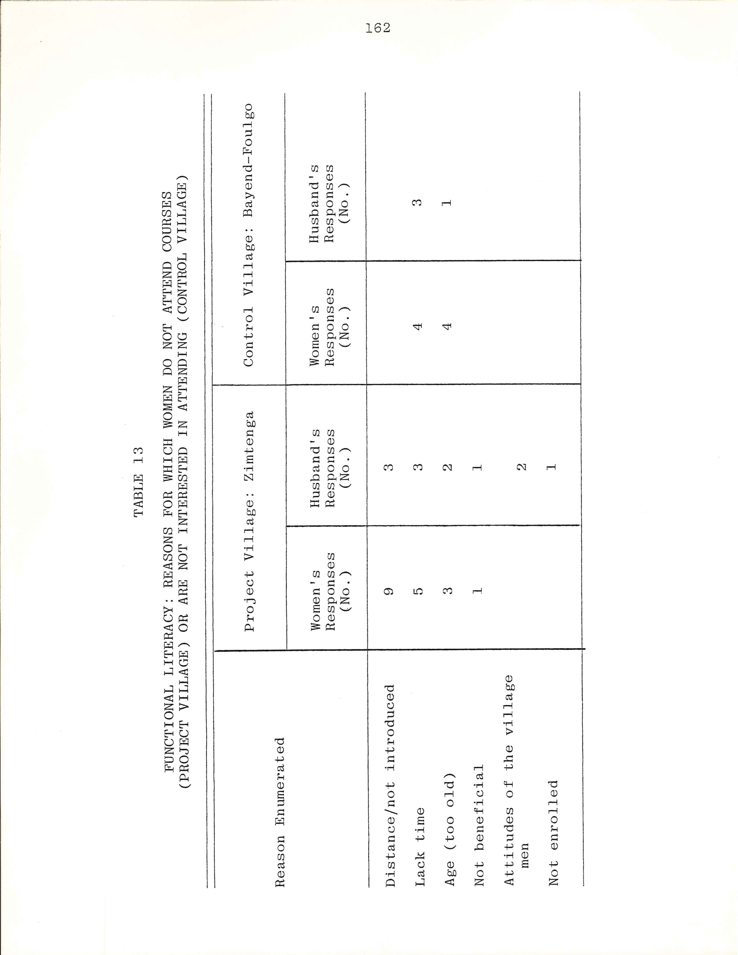
163

read and write, or "read her language" (Moré). Two, hus-
bands said their wives attended to "to know more" and one
said, "I want her to be literate."
Of those twelve men who responded that their wives
did not attend courses, the following reasons were given.
Three said that there were no courses. Three men stated
that their wives had no time, one phrasing his answer as
"I don't prevent them, perhaps they don' t have the time."
Two said that men of that particular neighborhood "under-
stood badly," and thus they only succeed in enrolling
two women. Two said their wives were old and that courses
weren't available. One answered that his wife's name was
not on the list, and one said "I don't let her, it's not
beneficial." Thus setting aside those cases in which
literacy was perceived as not being available, three men
found that lack of time was the major obstacle to parti-
cipation, while three others felt that the men themselves
prevented their wives from attending.
The view of men as obstacles was reinforced during
an all-village interview by the head of the women's group
of Douré, the "cluster" village at the greatest distance
from Zimtenga:
If the men don't participate, the women will
never succeed alone. At the least thing, the
men say that it's work that only concerns the
women, all the while knowing that a woman
doesn't command herself nor does she command
her child. . .It is possible that a young
newlywed wishes to attend the literacy classes,
but it is necessary that she work first for
her husband. ..If the men give their author-
ization, the women will be able to join the
164

others in the literacy classes, what I am
telling you is true, we are pleased, we will
give good will. It is not everyone who will
be able to succeed, but we follow all the
advice which is given.²²

Yet a woman from Zimtenga proper lauded their husbands
for their support, insisting that their spouses did not
prevent them from participating in literacy classes or
other activities. The men from Zimtenga gave as an ex-
ample that they had even planted trees (seedlings) which
had been distributed to the women in an environmental pro-
tection component of the project, which was confirmed by
their wives during this same interview. Thus the per-
ceptions of both men and women of the attitudes of hus-
bands toward the participation of their wives in Project
activities varied from highly positive in Zimtenga proper
to highly unfavorable in distant Doure. The class in
Doure was one of only two coeducational classes in the
zone. In the baseline sociological studies for the Pro-
ject, the fact that the Mossi were unaccustomed to any
public verbal exchange between the sexes had been em-
phaized.²³
________________________________
²²Mrs. Tidébamba, head of the women's group of the
village of Doure, during an interview with the population
of the neighboring village of Zimtenga (Kongoussi zone),
Republic of Upper Volta, 16 September 1977.

²³Suzanne Lallemand, "Rapport de mission du 15
Septembre au 1 Novembre 1968 (Projet d'accès des femmes
à l'éducation)," p. 4.
165

In the follow-up survey in the control village,
women were asked whether they would be interested in
attending functional literacy classes. Eight of the
thirty women in the sample were not interested, one-half
because they were too old, the other half because they
had no time. About three-quarters of the women who
wished to participate gave as their reason wanting to
learn to read and write which was sometimes stated as
"to read in my language, " Others gave such reasons as
"to know other things," "it's beneficial (an aid)," and
"so that others might benefit from my knowing how to
read."
Of the twenty-five husbands, five women being widows,
twenty-one were interested in their wife/wives attending
a course. More than half of those responding positively
said that it was so that their wives would learn to read
and write; more than one quarter, so that their wives
would "know more. " Others stated their reasons as "to
form her mind, " "to know how to read so that others can
benefit, " "to learn much and create a good household,"
and "it's up to her, if she wishes, she is free to do
so." Of those who did not wish their wives to participate,
two said their wives lacked time, one that he no longer
had the force to work and therefore his wife must work,
and one that his wife was old. Thus in both the target
and control villages the women themselves perceived that
they were too busy or too old in more cases than their
166

husbands so perceived them.²⁴ Reasons furnished by
women and their husbands for why the women do not par-
ticipate in literacy classes (Project village) or do not
wish to attend (control village) are displayed in table 13.

Radio Programs
Sponsorship of radio programs and listening groups
is another major component of the adult education program
of the Women's Education Project. According to interview
response in the village of Zimtenga, 5/6 of the women in
the sample listen, either with the group or at home, to
the program "The Woman Is the Home, " while 1/6 do not
listen. Of the non-listeners, four said that they had
no radio. The non-listeners all reside in neighborhoods
where some of their neighbors do listen to the programs.
One woman stated that she had too much work to listen
to the program. These reasons for not listening are pre-
sented in table 14. Three-quarters of those women who
do listen to the program stated that they do so for the
advice. The others specified that they listened to be
informed; for knowledge; that "it is of great interest";
to aid the village; to create a good household; and
to know one's role in the household and the nation ."
________________________________
²⁴Husbands never gave two responses, one concerning
a younger wife or wives and another concerning a senior
wife or wives. Thus in some cases the husbands from the
fifteen polygynous households in each village may have
responded in the affirmative, having in mind their
younger wives.
167

In the control village, seventeen women listen to the
program while thirteen do not. Of the non-listeners, most
gave as the reason not having a radio. One stated that
the program was "not broadcast early now, " while another
stated that she had no radio and her work did not permit
her going to the neighbors. Almost 2/3 of the women lis-
tened for the adyice. The others gave as reasons for lis-
tening, for instruction; that "it is very interesting";
and' or the well-being of the village and to create a good
household. "
In a survey taken among twelve Women's Education Pro-
ject monitresses stationed in the Kongoussi villages in
1976, the monitresses stated that radios had been furnished
in twenty of the twenty-two villages then being served. Of
these twenty radios, distributed in the villages in the
late 1960's, sixteen were still in working order in 1976.
The four radios that were no longer working had been sent
to the central Project team for repair, and had been out
of order for an average of almost one year. This balance
sheet seems quite remarkable if one takes into account the
climatic conditions of humidity during the rainy season
and acute dust storms during the dry season, and also the
complexity of the model of radio furnished. In slightly
over one-half of these villages, the radio was in the care
of the head of the women's group; in one-quarter, the
monitress; and in one village each, of the animatrice,
"the women,” and the chief. The women were said to have
access to all of the radios.
168

With regard to numbers of women listening to the
programs, the monitresses stated that in two of the
villages, all of the women participated in listening
groups. They reported that in slightly over one-half of
the villages, one-half of the women listened, and that in
almost one-third of the villages, few women participated.
Each of the following reasons for modest attendance rates
was cited for at least two villages: the distance between
the compounds; that fact that the women were cooking at the
time of the program; the fact that the husbands had radios
at home, so that the wives could not leave the radios of
their husbands to go to listen with the group. Reasons
relating to only a single village each were: that the wo-
men said that the time of the program was late (8:45 PM);
lack of good will; and the irregularity of the programs.²⁵
Explanations for not listening to the programs offered by
the women themselves and offered by the Women's Education
Project monitresses concerning eight Project villages in
the Kongoussi zone are presented in table 14.

Health Education
The health education component of the Project focused
on environmental sanitation and preventive health measures.
____________________________
²⁵Sometimes the radio communications between the two
major cities were down, preventing transmittal of the pro-
gram. On occasion, the bands were not delivered to the
station on time for any variety of reasons, including
difficulties with old recording equipment.
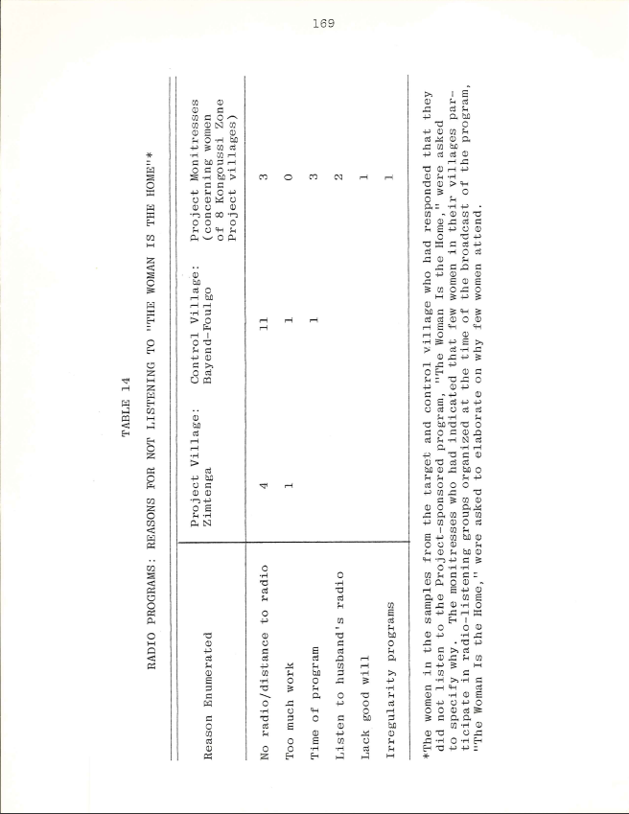
170

Specific themes included water purification and sanitary
waste disposal. Of the thirty women in the sample in the
village of Zimtenga. one-half filter water during the
rainy season, including one woman who uses a clean towel
to filter. Reasons given for filtering water revealed
the health-improvement message: to avoid sickness and
microbes; to have good health ("clean water gives good
health”); to remove the impurities from the water; "be-
cause the rains bring many diseases"; and to have clean or
potable water. The predominant reason for not filtering
was no time (6 respondents), followed by a lack of means
(4 respondents), and not knowing how to filter (3 re-
spondents). An additional respondent had no place for
a filter, and another could no longer see due to age.
Two-thirds of the women in the sample filtered water dur-
ing the dry season, and the same health-related reasons
enumerated above were furnished for filtering. The in-
crease in water filtering in the dry season in comparison
with the rainy season was attributed principally to the
time factor; women had less work and so had more time to
filter water.
None of the women in the control village filtered
water. Five-sixths of the women in the sample gave as a
reason not knowing how to filter. Two stated that they
had no filter, and two others that they had no money to
pay for the materials. One woman stated that the water
from the well in her village was clean.
171

The latrine program met with less success; only five
women, one-sixth of the women in the Project village
sample, indicated latrine use. Four women gave health-
related reasons for use of a latrine, namely, to avoid
diseases. One respondent stated that the bush was far
away. Of the twenty-five non-users, fourteen stated that
the bush was nearby. Other reasons were: lack of means
(6 respondents); that the husband had no strength to build
a latrine (3 respondents); that it was up to the men to
construct latrines and "not women's work" (2 respondents).
In the control village, no one used a latrine. Four-
fifths of the women in the sample stated that the bush was
nearby; two, that it was up to the men to construct la-
trines; one, that her husband had no strength to con-
struct a latrine; and one, that they lacked the means.
In addition, one woman stated that they ignored the
benefit, and another that they had no time to construct
and maintain a latrine. The same reasons pertained to both
rainy and dry seasons. In questionnaire response, twelve
Project monitresses stated that latrine-building had only
been adopted in four of the twenty-two villages they
reached in the Kongoussi zone. An elder from the village
of Loulouka offered an explanation in the form of a pro-
verb: "If the head that you have in the pot is not well
boiled, do not attempt to add the feet into this pot.”²⁶
_______________________________
²⁶Interview, population of Loulouka, 6 January 1978.

172

This proverb was cited to indicate that the villagers do
not have the financial means to possess latrines, for they
do not even manage to resolve more pressing problems.

Respondents' Assessments of Project Activities
An attempt was also made in the survey to determine
how the villagers felt about the relative usefulness or
effectiveness of the various activities introduced by the
Project. The respondents were asked which Project activity
they found to be most beneficial and why, and which they
found to be least beneficial and why. Of the women in the
sample²⁷ in Zimtenga, eleven stated that they could not
single out one activity as most beneficial because all were
beneficial. Eight women designated water filtering and
three, hygiene. Four designated childcare, stating that
the children were now in good health. One woman mentioned
the collective field, since it yielded many products,
thereby helping them. Of those women who enumerated
specific activities as being most beneficial, fifteen
of sixteen indicated activities in the area of health
education while one mentioned an inoome-generating
activity. The sociologists had recognized during
their preliminary investigations that the participa-
tion of women in health education activities, and
_____________________________

²⁷Three women were from a neighborhood which they did
not consider to be fully "reached" by the Project, and thus
they did not respond to these questions.

173

specifically, in the areas of child care and nutrition,
in which they are relatively autonomous, would be readily
approved by husbands and family heads.²⁸
When queried as to the least beneficial activity,
twenty-one women said that they could not choose one. Of
these, nineteen women said that all were good, and two
women said that although they did not follow the acti-
vities, all were good. Six women did single out activi-
ties. Four named functional literacy, explaining that
they did not understand its importance or benefit. One
mentioning filtering, since she felt that it was unnec-
essary as the well water was clean29, and one mentioned
sewing, as she "couldn't sew." Thus, four activities
enumerated are in the education sector, one is in the
health education sector, and the last is an activity which
these women often perceive as income generating.
The two women leaders were not in the sample but were
interviewed as a function of their roles. When asked to
name the most beneficial activity, the designated filter-
ing explaining "we are healthier" hygiene, "every-
thing we learn is good, but hygiene is indispensable."
______________________________
²⁸Lallemand, "Rapport de mission du 15 Septembre au
ler Novembre 1968," pp. 3-4.

²⁹Various members of the Project's regional teams
differed in their views regarding the advisability of
encouraging the filtering of well water. Some felt that
it was sufficient if the villagers drank well water, and
that Project advice in other areas would have greater
impact. (Source: Interview with Mariam Konate, Banfora
zone director, 13 May 1978.)
174

When asked about the least beneficial activity, they
stated, as had the vast majority of the women in the sam-
ple that they could not name one activity, as all were
beneficial. Hence their views well represented those of
the other village women.
Women in the Project village were also asked what
other activities they would like the Project to introduce.
More than one-half stated "anything you say, " or that they
did not know. They responded, "Come teach us, you should
know those activities which suit us,” "we are at your
disposal, we know that the Project would not introduce
something insignificant," or "all is for our benefit."
Of those women who did specify an activity, five wished
to learn knitting; two, weaving; one, tailoring; and one,
literacy. They gave as reasons "to have a craft"; to be
able to make children's clothing; and to be able to weave,
sew, and read their maternal language.
In those cases in which the women specified an ac-
tivity, the accent was on lucrative activities, and on
activities which would minimize their expenditures, as in
being able to make rather than buy clothing. Of the wo-
men who articulated needs not being met, income-generating
or expenditure-substituting activities were most fre-
quently mentioned. Of the women leaders, one stated that
she wanted the introduction of weaving and knitting, and
the other, knitting. Their views corroborated those ex-
pressed by the other women. Implications of these re-
sponses and explanations for future programs will be
175

reviewed in the final section of this chapter.

Attitudes and Behavior Towards Education:

Explanatory Factors

The analysis which follows is based upon an adapta-
tion of a social-psychological conceptaul framework
utilized by John Robinson in his work on time use. The
model is built of four sets of factors: personal, role,
resource, and environmental, which Robinson posits as
determinants of the allocation of time.³⁰ He states
that mathematical functions were not specified for these
sets of factors, which are treated as mutually interacting.
In this section, I have used these sets of factors as a
checklist of variables whose influences on women's alloca-
tion of time to educational activities are examined.
Other scholars have listed similar factors as crucial to
access to education.³¹ I have retained those variables
pertinent to the Voltaic context, and in some cases, have
modified the definitions of the variables to make them locale
appropriate. In my analysis, I have also added the var-
iable of village type (target or control) as a resource
factor, since target villages have been the focus of
development activities.
____________________________
³⁰Robinson, How Americans Use Time, pp. 27-28.
³¹McGrath for example lists age, religion, ethnic
group, economic class, and urban or rural location as
affecting chances of becoming literate (source: McGrath,
Unfinished Assignment, p. 15).
176

The adaptation of this model (see table 15) has
been used to investigate the variables which influence
whether women use their time for the educational activi-
ties of attending functional literacy classes or school,
listening to the Project's radio programs, and implementi-
ng health education advice by water filtering. Use of
the adapted framework also makes it possible to determine
whether those explanations offered by the women themselves
for their behavior are matched by the results of a con-
tingency table analysis. Although the sending of children
to school means that women's workloads increase, this
formal education activity is not being treated in this
analysis since no significant differences in behavior
with regard to the sending of children to school were
found between the Project village, Zimtenga, and the
control village, Bayend-Foulgo.
While ethnicity is listed as a personal factor, it
does not come into play in the analysis of these two
particular villages, Zimtenga and Bayend-Foulgo, as all
women but one falling in the sample are of the Mossi
ethnic group. The single exception is a Peul woman living
in Zimtenga. However, her activities do not reflect
the pastoral behavior often associated with her ethnic
group, her household being sedentarized. She is involved
in agriculture, just like her Mossi neighbors, and in
fact works in all of the various sorts of fields.

177

TABLE 15

FACTORS AFFECTING TIME USE AND BEHAVIOR*
PERSONAL FACTORS
O Age
O Religion
O Ethnic group

ROLE FACTORS
Marital status:
O Influence of husband's attitudes (toward literacy, schooling)
O Influence of husband's education oInfluence of l1usband's age
OType of household (monogynous/polygynous) Size of family:
O Number of helpers
O Number sharing meals
OEmployment (time pressures): number of lucrative ac-
tivities undertaken + number of different kinds of
fields in which respondent works (computed variable)
O"Status" (woman leader, wife of chief or notable/
others)

RESOURCE FACTORS

OWealth: ownership of animals + modern equipment (com-
puted variable)
OVillage type (Project/control)

ENVIRONMENTAL/GEOGRAPHIC FACTORS
OGeographic location: distance of Project-linked villages/
neighborhoods from center of activities

_____________________________
* Source of the model from which the above framework has
been adapted: Robinson, How Americans Use Time, p. 28.
178

As with ethnic group, the "status" variable is mar-
ginal in the analysis regarding these two villages, as
only one of the women falling in the samples is married
to a notable. Neither of the two women leaders in Zim-
tenga fall in the sample for that village. While they
were also interviewed as a function of their roles, the
data concerning them is reported separately.

Functional Literacy
To test the relationship between the Project and
women's access to education, the values for the dependent
variable training (functional literacy or formal school-
ing³²) for each of the women in the samples of Zimtenga
and Bayend-Foulgo were first crosstabulated with each of
the independent variables constituting the framework
presented in table 15 (except for ethnic group and status,
for the reasons cited above). Strong association was
found between training and village type. This relation-
ship was statistically significant.
Subsequent analysis was then carried out on the
level of training/type of village relationship by testing
for the influence of other variables in the framework.
The relationship persists even after controlling for these
variables. Yet age was also shown to have an influence.
Relatively younger women, age 44 or less, called "early
__________________________

³²Only one of the women concerned had some formal education, for the others it was literacy courses.

179

active labor force," participated in literacy courses far
more often than the older women. They accounted for thir-
teen of sixteen participants. Advanced age was often given
by the women themselves as a reason for not participating
in Zimtenga, the Project village, and for not being in-
terested in eventual classes in the control village³³
(refer back to table 13).
In addition, women living in polygynous households
were more frequent participants than their neighbors from
monogynous households; ten of fifteen women from polygynous households in Zimtenga had some training, whereas five of
thirteen from monogynous households attended the literacy
classes. This substantiates chapter four findings show-
ing higher workloads for women without cowives. Again,
the women themselves often specified lack of time as
preventing their participation.
The analysis therefore shows that the most influential
of these variables on women's education is the existence
of the Project, a resource factor, with age, a personal
factor, and type of household, a role factor, also
_____________________________
³³Subsequent bivariate analysis of the data from the
control village sample showed that the younger women were overwhelmingly interested in attending a functional liter-
acy course (fifteen of sixteen or 93.8%), in comparison
with five of nine of the "later active labor force" women,
and two of four of the senior women. Their husbands used
this same age criterion: sixteen of seventeen husbands of
the younger women were interested in their attending
classes, while four of six expressed interest for wives
falling in the "later active labor force" category, and one
of two of the husbands of the senior women wished the par-
ticipation of his wife/wives. It is however true that

180

affecting enrollment in literacy classes. Within the Pro-
ject village, Zimtenga, women under 45 from polygynous
households were most likely to be the participants. These
variables had all been identified by the women themselves,
along with distance, a variable which did not prove to be
influential in the contingency table analysis.

Radio Programs
With respect to listening to the Project-sponsored
radio programs, village type proved to be the most in-
fluential of the variables. Twenty-five women listened
to the program in the Project village, while seventeen
listened in the control village. Controlling for the
other variables in the framework, the results showed
that advanced age, in contrast to its impact on functional
literacy, was not a negative factor in determining radio
listening. Higher percentages of the total number of
women falling in the "later active labor force" (ages 45
to 64) listened to the radio, than of the younger neighbors;
of the 'oldest women (over 65), four of seven still
listened. The analysis showed that even women who did
not usually have helpers available to assist them with
their daily tasks were able to listen to the program. Thus
the women themselves had emphasized the factor which
emerged as the determining one: no radio.
_____________________________
these husbands could have had in mind other younger wives, although this was not specified in their responses.
181

The hypothesis that the same women would be the
innovators, that is attend literacy classes and listen to
the radio programs, was also tested. The association
was found to be weak, but the results were not statis-
tically significant. Eleven of twelve literacy class par-
ticipants versus twelve of fifteen non-participants
listened to the radio in the Project village and related
clusters.

Health Education
Dramatic differences in the numbers of women in Pro-
ject and control villages who filter water resulted from
contingency table analysis. In the Project village,
nineteen women filter in the dry season, and sixteen in
the rainy season. Women in the control village never
filter water. In the crosstabulation of water filtering
by village type, controlling for the other variables in
the framework, the relationship remained strong, and was
found to be significant in all cases except for the "in-
active women" and women with educated husbands. Six of
seven women over 65 did not filter water, and only two
of six women married to men with some education filtered.
While advanced age can be expected to playa role, in the
case of the women with educated husbands, the small number
of cases may explain the results. In a separate analysis,
water filtering was also found to be associated positively
with level of training and listening to the Project's
radio programs.

182

Findings and Implications for Planners

ATRCW Indicators

The ATRCW’s proposed education indicators have the

advantage, at least in the formal education sector, of

requiring data which is readily available to measure pro-

gress. Yet these indicators do not furnish information

on the obstacles which actually prevent enrollment and

achievement of girls, or on explanations for non-partici-

pation of women when training is available. Knowing per-

cent femaleness in the education sector is an important

beginning. By supplementing the ATRCW's proposed in-

dicators with focused group interviews or open-ended ques-

tions, however, additional prescriptive information on

actual obstacles to education for girls and women may be

obtained.

Formal Education
In the two villages examined in depth in the Kon-
goussi zone, virtually all respondents sent their children,
both boys and girls, to school. In the Banfora zone, by
way of contrast, only approximately one-fifth of the
women in a Project village sample and a control village
sample sent their children to school. Anticipated
differences between the two types of village, that is,
that more women from the Project village would send
children to school, and notably girls, than in the control

183

village, did not emerge from the analysis of question-
naire response. The obstacle which was most frequently
cited as preventing the sending of children to school was
work, especially farm work. This obstacle was cited more
often in regard to girls than boys. The workload factor
can be expected to influence not only initial enrollments
but also achievement for those sent to school.³⁴

Non-Formal Education
Significant differences were found between women in
the samples of the Kongoussi zone Project and control
villages with regard to levels of training, including
functional literacy; numbers listening to the radio pro-
grams sponsored by the Women's Education Project; and the
adoption of advice about water filtering and latrine
construction offered in the health education component of
the Project. Within the Project village itself, question-
naire response showed that major obstacles to participa-
tion in functional literacy classes and listening to the
Project's radio programs were distance to the class or
radio and lack of time. Principal obstacles to water
filtering were lack of time and means. At the outset
of the Project, the Kongoussi zone sociologists had
________________________________
³⁴See John Simmons, "Towards a Technology of Education: Predicting School Achievement in Rural Africa," Economic Development Report No.212 (Cambridge, Mass.: Development Resources Group, Center for International Affairs, Harvard University, April 1972).
184

identified low income, time pressures, and attitudinal
factors as important barriers to women's participation in
eventual non-formal education schemes, and to sending
girls to school. The time and income factors continued to
prevent some women from participating in Project acti-
vities or following Project advice. These were obstacles
toward which the efforts of the Project personnel con-
tinued to be directed in the last years of the experimen-
tal phase, namely, to perfect the management of workload-
lightening technologies and to strengthen programs to gen-
erate income.
Analysis did not reveal that the slightly better-off
women differed in their participation in Project activi-
ties from the slightly poorer women. The experience of a
comprehensive development scheme in former East Pakistan
showed that, "It was mostly the poorer women who were
willing to admit they needed to learn, would listen to
new ideas, and try new methods.”³⁵ Income disparities are
minimal in rural Upper Volta, and perhaps it is the across-
the-board low standards of living which account for the
fact that even the slightly better-off women were among
the participants.
_________________________
³⁵Arthur F. Raper et al. Rural Development in Action:
The Comprehensive Experiment at Comilla, East Pakistan
(Ithaca: Cornell University Press, 1970), p.165.

185

The Women's Education Project: Meeting Felt Needs?
A series of questions were asked of the respondents
reached by the Women's Education Project in an attempt to
determine their views about the relative usefulness of the
Project's activities at the end of the ten-year experi-
mental phase. Although many women did not single out one
activity as being more beneficial than another, fifteen
of the sixteen women who did mentioned actions in the
health education component of the Project such as water
filtering and hygiene. Most women elected not to specify
a "least beneficial" activity, saying the "all were good,"
but four women stated that they did not understand the
benefits of functional literacy. In cases in which the
women articulated unmet needs, they gave an accent to in-
come-generating activities.
One expatriate technician undertook in 1975 an assess-
ment of all activities assisted by UNESCO in Upper Volta.
Concerning the Women's Education Project, he suggested:
It would appear that some of the village people
and many of the development people on the local
scene may feel that more could be accomplished
for more people in a shorter time by focusing
on functional learning rather than on functional
literacy.³⁶
Yet the testimony of those who have succeeded in the func-
tional literacy courses seems somewhat different. A
newly-literate man from the village of Kilou, whose
________________________
³⁶"Rapporteur's Report on UNESCO’s Contribution,"
p. 50.
186
literacy class participants were more successful in
"final" level literacy examinations than those from any
other Kongoussi zone village in 1977, wrote the following
in a letter in More addressed to the Project's regional
director:
We apply all that you have taught us to do.
Personally, I want to go to Ouagadougou; if
I am still here, it is mainly because I wish
to make myself literate, if not, I would have
been in Ouagadougou a long time ago.
I don't have a lot to say to you; what I
have to say is this: here in Kilou, I have in-
sisted that young boys enroll in the UNESCO
Project literacy classes, for that has great
advantages. It is something which certainly
brings advantages. What are the advantages?
One of the advantages, you see, we came into
this world and our parents did not enroll
us in school and we don't even know how to
write our names; with the help of God, we
are able to write our names in our maternal
language. Isn't this already a great ad-
vantage? That God give to UNESCO strength
and courage so that it is able to work for
the development of the country. That God
help us, all those who are working in the
framework of the Project for Equal Access of
Women and Girls to Education, to benefit from
their efforts. That God aid us to profit
from literacy. The truth is that here in
Kilou, all those whom I have heard praise
the UNESCO Project, and I am the first. . . .³⁷
And in the words of one woman leader, "We are receiving
an education (reading and writing), if among us several
distinguish themselves, they will continue to teach the
others, and so on."³⁸
__________________________
³⁷Letter written by a peasant named Julien from the
village of Kilou to the Kongoussi regional director of
the Women's Education Project, Republic of Upper Volta,
1978.
³⁸Interview, Tidebamba, 22 March 1978.
187
At the national level, the Director of Educational
Planning has written the following concerning the inte-
grated formula elaborated and tested by the Women's Ed-
ucation Project for the promotion of education for women
and girls:
Commencé en 1967 le projet d’égalité d'accès
des femmes et des jeunes filles à l ' éducation
se préoccupe du cas particulier des femmes
et des jeunes filles pour que celles-ci
partagent réellement les efforts et fruits
de développement au sein de communautés
en progrès. Le véritable accès de la femme
et de la jeune fille à l ' éducation passe par
un changement de mentalité; par la libération
du temps de la femme grâce à l'utilisation
de techniques adaptées allégeant les travaux
agricoles et ménagers; par l'accroissement
des revenus propres des femmes grâce à
des activités lucratives entreprises de
préférence en commun; par l'amélioration de
l'état sanitaire familial par le recours à
de meilleures pratiques d'hygiène (con-
struction de filtres à ' eau, formation
d'accoucheuses de village, éducation nutri-
tionnelle, etc.). C'est dans un tel environ-
nement que le désir d'instruction (alphabé-
tisation) et d ' éducation permanente devient
réel en même temps que les possibilités de
le satisfaire.
Le projet a donc développé une nouvelle
approche éducative particulièrement signifi-
cative dans la perspective de l ' éducation de
masse.³⁹
_____________________________
³⁹Appears in "Institute National d' Education: Document d'Assistance Preparatoire," Projet du Government de la
Haute-Volta/PNUD/UNESCO, Octobre 1976, p. 5. "Begun in
1967, the Project for Equal Access of Women and Girls to
Education preoccupies itself with the specific case of
women and girls in order that they unquestionably share the
efforts and results of development in modernizing communi-
ties. The true access of women and girls to education pro-
ceeds through a change in mentality; through the liberation
of women's time thanks to the use of adapted technologies lightening agricultural and household work; through the
growth of women's own incomes thanks to lucrative activities undertaken preferably in common; through an improved state
188

Results from the experimenta1 phase o f the Women’s Educa-
tion Project can thus serve in the ongoing efforts to re-
design the entire educational system in Upper" Volta.

____________________________
of family health (sanitation); by recourse to better hy-
genic practices (building of water filters, training of
village midwives, education in nutrition, and the like).
It is in such an environment that the desire for learning
(literacy) and continuing education becomes real at the
same time as the possibilities to realize it. The Project
had thus developed anew educational approach particularly
significant in the perspective of universal education."

CHAPTER VI

PRECIS OF OTHER SOCIOECONOMIC INDICATOR AREAS

Today things are easier for us and we don't
experience any shame outside. The kind of shame
I mean is concerning the deliveries of our
wives. Before we used to send our wives to
deliver, but now with the assistance we have
received from the UNESCO-trained midwives, when
our wives are in labor, the midwives come
to the house and deliver the woman instead of
taking her to Pô where we expose our poverty.

Man from the village of Tôrem, Pô zone, during an
all-village interview, 22 April 1978

What we want this year is that you check to find
what we can do to enlighten ourselves.
Because the work that we are undertaking here now,
we don’t see the [material and financial] interest.
You have supplied us with a cart. There is no
doubt that the cart has in fact been used. But
what has it brought us from a financial point of
view?
We have cultivated millet this year, but we haven't
been rewarded for our efforts [drought] .

Letter written in Moré by a newly-literate
woman from Kilou village in the Kongoussi
zone (1978)

189
190

The Upper Volta Women's Education Project, in addi-
tion to programs in the sectors of employment and educa-
tion, sponsored activities falling in the areas of health
and technology. The Project did not intervene as directly
in the indicator areas of law and participation in decision-
making. However, the legal issues of land ownership and
access to credit were addressed through sponsorship of the
farming of collective fields and provision of technologies.
Finally activity in the area of participation in decision-
making was implicit in leadership training for women. The
ATRCW's proposed indicators in the areas of health, tech-
nology, law and participation in decision-making
are reviewed in this chapter, and Upper Volta findings
based on nationwide and Kongoussi zone data are presented.

Health and Maternity
In the area of health, the ATRCW has suggested presen-
tation in tabular form of data on average distance from
water points and on the availability of maternal and Child
Health (MCH) centers or clinics per 100,000 women of child-
bearing age in rural areas.¹ Average annual change can be calculated, as well as the projected situation in ten years
at the current rate of change. Data collection on infant,
young child, and maternal mortality and on protein and cal-
orie intake for both men and women is also suggested.
________________________
¹United Nations, Economic Commission for Africa, The
NIEO, p. 30.
191

In Upper Volta, the water problem has been so drama-
tic in recent years that rural development and mastery of
water were designated as the first priority of the coun-
try's development strategy in a presidential circular of
1975 concerning the preparation of the 1977- 1981 Five-
Year Plan.² Rural regions in Upper Volta suffer from an
alarming lack of water; water points are rare, their capa-
city often insufficient, and the sanitary conditions of the
water generally lamentable.³ It is estimated that at the
end of the dry season Voltaic populations have at their
disposal barely five liters of water per person per day.
In the Kongoussi zone, in the Project village of
Zimtenga, questionnaire response has shown that one-third
of the women falling in the survey sample fetch all their
water from a well. Slightly more than one-half of the
women fetch water only from a body of standing water; the
others utilize both a well and available pools of water.
One-half of the women travel less than 800 meters for
water, while others journey 900 meters to 2 kilometers.
The one cement well in Zimtenga dries up around January,
and cannot be used again as a water source until about
______________________________
²République de Haute-Vo1ta, Présidence de la Répub-
lique Circulaire No. 75/017/PRES/PL/DR/ET portant direc-
tives gouvernemen'talespa.urla préparation du prochain plan quinquenna1 1977- 1981 a tous ministres et services
(Ouagadougou: 9 Décembre 1975).

³Bernard Comby, Analyse prospective de la consommation
d'eau en Haute-Volta (Ouagadougou: Ministère du Développe-
ment Rural, Juin 1976), p. 33.
192

July, during the rains.⁴ A few women specified that their
most convenient water source was usable for only seven to
eight months a year; their second source of water was
located at a distance of up to three kilometers.
In the neighboring control village of Bayend-Foulgo,
5/6 of the sample women seek water from a cement-lined
well, and the others from a body of standing water. For
almost 2/3 of these women, water is located at a distance
of 700 to 800 meters. For slightly less than 1/3 of the
women, the distance is less than 700 meters, while two
women travel over 800 meters for water. For all of the
women, their most convenient water source never dries up.
The responses of women in the Kongoussi zone would
suggest that while the ATRCW's proposed frequency counts
of average distance to water points provide useful infor-
mation, they could well be complemented by data on the
number of months per year that water is actually available
and on the sanitary condition of the water. One man in the
village of Loulouka in the Kongoussi zone stated during
an all-village interview:
We always drink swamp water except in the rainy
season. If water collects in our wells, then
we begin to drink well water. Unfortunately our
subsoil does not contain water. One can count
almost twelve wells in the village but it happens

____________________________

⁴Debriefing interviews with the Kongoussi zone enu-
merators, Joseph Ouedraogo and Madeleine Ouedraogo,
Ouagadougou, Republic of Upper Volta, November 1978.
193

that only One contains water. The others are
almost dry.⁵

It is not infrequent in Upper Volta to see thirty-meter
deep cement-lined wells which are virtually dry year-
round. According to the Women's Education Project mon-
itresses, wells in the villages in which they work in
the Kongoussi zone supply water anywhere from one month a
year (usually the wells dug by the villagers themselves)
to twelve months. As was pointed out in chapter three,
attention must also be paid to the variety of definitions
attributed by the rural populations, and enumerators, to
equivalents in their languages of the word well. In addi-
tion, in some cases, a well may exist at proximity to a
village, but socio-cultural factors may prevent the women
from actually utilizing the well.⁶
With regard to Maternal and Child Health clinic infor-
mation, Upper Volta data relates the number of available
beds to the number of pregnant women rather than to the
number of women of childbearing age, which is the ATRCW's
proposed indicator. The data show that while at the na-
tional level an average of one maternity bed is available
___________________________

⁵Population of Loulouka, interview, 6 January 1978.

⁶For example, an international technician has spoken
to me of a situation in a village in southeastern Upper
Volta, where a well was dug with donor assistance near the
chief's compound, at the latter's insistence. Women who
then used the well were expected to make payment in the
form of kola nuts, tobacco, or the like; they thus pre-
ferred to continue to journey several kilometers for their
water. One ATRCW-sponsored study probes Ethiopian vil-
lagers’ I attitudes toward improving water supplies with a

194

per 308 pregnant women, in the north-center department
in which Kongoussi is situated, one bed is available per
2,887 pregnant women.⁷ Infant mortality, based on 1960 –
1961 data, is 189.7 per 1,000 births.⁸ It has been
estimated by the long-time Representative of the United
Nations World Health Organization (UNWHO) in Upper Volta
that later data will at best show a slight decrease in
infant mortality.
Three State-run maternity clinics are located in the
Kongoussi zone, including one in the village of Zimtenga.
Four-fifths of the women in the Zimtenga sample go to the
maternity clinic, established in the village in 1961, to
give birth. Several of the women have never given birth,
and one specified that she seeks advice from the Project-
trained midwives. In Bayend-Foulgo, one-half of the
sample women seek assistance from "the old women," the
practitioners of midwifery; slightly less than half go the
maternity clinic in neighboring Zimtenga. During an all-
village interview in Bayend-Foulgo, villagers requested
assistance in this area:
_____________________________
view to directing into more productive uses the time saved
by women in water portage (see Hanna Kebede, with Dejen
Abate and Tsengaye Fesseha, "Improving Village Water
Supplies in Ethiopia: A Case Study of the Socio-Economic
Implications,” [Addis Ababa: UNECA/UNICEF], 1978.

⁷Dr. F. Martin-Samos, La Santé publique en Haute-
Volta: situation actuelle (1976) [Ouagadougou: 6 Mars
1977], p. 22.

8 Ibid., p. 12.

195

A woman: "It is different from before, at
present there are maternity clinics, but our
problem is delicate. Our maternity clinic is
in Zimtenga. In an emergency, if we try to
bring a woman to Zimtenga, she will deliver
en route, it is very far from us. If we
could benefit from a maternity in the village,
all of the women would give birth there.
Zimtenga is very far off for an emergency."

A second woman: "We try each time to go to the
maternity clinic, but the number of births at
home is greater, it is our old mothers who play
the role of midwife.”⁹

Project-sponsored maternities are functioning in at
least eight of the Kongoussi zone villages. However, the
villagers in some cases express a preference for address-
ing themselves to the traditional midwives, trained by
the Project, over journeying to the health facility sit-
uated in the main town. This preference was noted even
more strongly in the Po zone. Reasons offered were dis-
tance and cost associated with deliveries in the town
(to hire transport, and to purchase the appropriate
clothing, soap, and the like) , and to hide their "shame"
(poverty).10 These views of the villagers would suggest
that while computation of the available maternity clinic. ______________________________
⁹Population of Bayend-Foulgo, interview, 1 March 1978.

¹⁰Population of the village of Tôrem (Pô zone), Repub-
lic of Upper Volta, repeatedly during meetings and inter-
views, 1976- 1978. Michael Sharpston found a similar
phenomenon in Ghana which borders on Upper Volta immedi-
ately to the south of Po. Although relatively unsophis-
ticated health facilities were available, they remained
underutilized, for rural Ghanaian women seemed to prefer
delivery at home (source: M.J. Sharpston, "Health and
Development," Journal of Development Studies, vol. 9,
no.3 [April 1973], pp. 455-56).
196

infrastructure provides important data on one option open
to the population, consideration should also be given to
the inclusion of measurement indicators of the less-costly
option of upgrading the skills of unsalaried village-level
personnel.¹¹

Rural Technologies
The ATRCW has pointed out that data on the spread of
rural technologies is seldom available at present, yet is
particularly important since lack of access to technolo-
gies seems to inhibit women's potential to increase pro-
ductivity, particularly in agriculture.¹² The ATRCW
suggests collecting data over time on number of grinding
mills, carts, and weeders per 100,000 population, plus the
percentage of women using the traditional hoe to till land.
Such macro-level data are not available in Upper Volta.¹³
At the regional level, monitresses interviewed in the
last biennium (mid-1976 to mid-1978) of the Upper Volta
Women's Education Project indicated that of the ten mills
___________________________
¹¹On this topic see V. Djukanovic and E.P. Mach,
eds., Alternative Approaches to Meeting Basic Health Needs
in Developing Countries: A Joint UNICEF/WHO Study (Geneva:
World Health Organization, 1975).

¹²United Nations, Economic Commission for Africa,
The NIEO, p. 31; see also the Annex, p. 8.

¹³For an innovative and perceptive treatment of the
traditional technology of the Mossi and its relation to
their economic, social, and political organization and
religion, see Hammond's earlier-referenced volume,
Yatenga: Technology in the Culture of a West African King-
dom.
197

furnished in the Kongoussi zone in 1972, five were in work-
ing order; four were broken down; and one ground, albeit
slowly. All mills were at the disposal of the women, and
usually kept by someone designated by the women, the ex-
ceptions being two villages where they were kept by the
sons of the chief, and two villages where they were kept
by the women themselves. Mill receipts were entrusted in
each village to the president or treasurer of the women's
group. These receipts were usually used by the women to
repair the mill or buy gasoline and oil, and occasionally
to purchase medicine for the midwives, meet community
needs, increase savings of the women's group, and to buy
salt "to encourage the women.”¹⁴
The monitresses further indicated that six of the
ten Project carts were in working order. They were stored
in of the villages by the chief or his sons, and
in the others by the women themselves or someone they
designated. They were used most often to transport water,
the harvest, and wood, and in one village to transport
clay. Revenues were usually used to repair the cart or
buy tires, and occasionally to pay for batteries for the
women's group radio; to assist the women in case of
marriages, sickness, and funerals; to make expenditures in
the general interest of the village; and to buy salt.
____________________________

^{l4}This would represent a departure from tradition, for
according to the Project sociologists, the men generally
furnish salt for the household. (Lallemand, Projet d'accès
des femmes à l'éducation, p. 10).
198

In the village of Zimtenga, fourteen of thirty women
in the sample indicated in questionnaire response that
they use a mill to grind grain. The reason most frequently
given for not using a mill was lack of money, followed by
distance, and in one case the fact that the mill was broken
down. Three women expressed conditions for mill use: if
they had too much work or if they were tired. One-half of
the mill users gave as explanations for their utilization
of this technology reasons related to saving energy: that
it was less tiring, that they suffer less, to rest, and
that it was easier. Three women spoke of gaining time.
Over one-half of the Zimtenga sample women use a cart.
Most often the women spoke of its energy-saving advantages:
it was easier, they suffered less. Four respondents fo-
cused on the time-saving aspects: it was faster, and they
could carry a large supply. Again the non-users most fre-
quently emphasized lack of money.
Of the technology users in Zimtenga, over one-half
devoted time saved to other household activities, one
specifically mentioning water portage. About one-quarter
of the women utilized time saved to spin cotton, which
could be for household consumption or sale. Two women used
the newly-found time to rest.
When asked if there were technologies which were
not currently at their disposal but which were of interest
to them, the women from Zimtenga most frequently mentioned
199

a cart, followed by a well, plow, mill, and irrigation
pump. Their responses are displayed in table 16.

TABLE 16
EXPRESSION OF INTEREST BY WOMEN OF THE KONGOUSSI ZONE IN TECHNOLOGIES NOT CURRENTLY AT THEIR DISPOSAL
Technology | Number of Women Expressing Interest  in the Technology
Technology | Project Village: Zimitenga | Control Village: Bayend-Foulgo
Cart | 21 | 22
Mill | 11 | 14
Well | 14 | 6
Plow | 12 | 9
Irrigation Pump | 8
Large Enamel Basins |  | 2
Aluminum Cooking Port |  | 1

Individual respondents specified from zero to four tech-
nologies.
In neighboring Bayend-Foulgo, the control village,
only a single woman in the sample utilizes a grain mill,
while one-third of the women use a cart. Three-quarters
of the women in the sample do not use a mill because it is
located too far away; one-fifth stated that they have no
money. Of the women using a cart, eight offered as ex-
planations the energy-saving factor, and two, the time-
saving aspect. One-half of the non-users stated that they
200

have no cart, the other half, that they have no money.
Nine women felt that time is saved by technology use: seven
utilize this time for other household tasks, and two, to
rest. The technology not currently at their disposal for
which interest was expressed most often was a cart,
followed by a mill, plow, well, large enamel basins, and
aluminum cooking ware. These responses are also displayed
in table 16.
Kongoussi zone data suggest that counting the number
of technologies per 100,000 population does not necessarily
furnish sufficient information on the actual access of
women to these technologies, which is the ATRCW's objec-
tive. If the data concern privately-owned technologies,
such as mills, one might assume that the mills run and
cared for by a private entrepreneur are in working order
most of the time, thus reliably available as a workload-
lightening option. Yet commercial mills may not be priced
within the means of most of the women. Kongoussi zone data
support this proposition, since some of the women could not
even afford to use the Project mill, the fee for which was
fixed below prevailing commercial prices. Communally-
owned mills are more likely to be priced so that the
women can afford to use them, at least occasionally. As
one man in Zimtenga stated,
If it wasn't for the fact that the mill has
stopped, our wives had the time to go to
cultivate, and in the evening they had flour
201

ready for the meal. The mill was for us
a great advantage.¹⁵
Experience has shown that negligence prevails in the care
of community-owned equipment, and that in some cases the technologies have been hoarded by village notables.
Similar problems have been encountered with communally-
owned carts. At the very least, cautioning notes should
accompany the frequency of technologies per 100,000 pop-
ulation data.

Law
In the area of law the ATRCW has selected comparisons
between women and men in land ownership and access to cre-
dit and loans as the indicators. The Upper Volta Women's
Education Project did not undertake activities which
touched directly on these subjects. The question of
access to land did arise, however, in conjunction with the
introduction of the farming of collective fields for
women. In group interviews in all of the survey villages
reached by the Project, the women indicated that they did
not encounter difficulties in obtaining land from their
"husbands" for this purpose. The question of the quality
and location of their plot of land was raised not by the
women themselves but by the Kongoussi regional director
__________________________
¹⁵Population of Zimtenga, interview, 16 September
1977.

202

of the Project, as mentioned in chapter two.¹⁶
In the area of credit, official government corres-
pondence has indicated that salaried women benefit from
the same rights as their male counterparts vis-a-vis all
credit organizations in Upper Volta. It further stated
that while agricultural credit was given in principle
without distinction based upon sex, it was accorded through
the intermediary of cooperatives, which the family head
joins. If a woman with two or three dependents assured
the cooperative of her ability to meet the reimbursement
schedule, ordinarily there was no difficulty in admitting
her into the village cooperative in order that she benefit
from a loan.¹⁷
The Women's Education Project did not directly spon-
sor activities involving credit disbursement and reim-
bursement until recent years. In the Kongoussi zone it was
in the last biennium of the Project that carts costing
21.000 CFA francs were supplied to Project villages upon
__________________________
¹⁶For a thorough treatment of the entire question of
land tenure in Upper Volta see J.-L. Boutellier, ”Les
Structure foncieres en Haute Volta, “Etudes Voltaïques,
Nouvelle Série, Memoire no. 5 (1964), pp. 1-181. This
study emphasizes the contrast between the rarity of good
land close to the villages and the abundance of scattered
scrub-covered land, each with a distinct system of tenure
(ibid., pp. 178-79).
¹⁷Letter No. 03443/PL/PLAN/Y.JB of 29 November 1976 addressed by the Minister of Planning to the Resident
Representative of UNDP in Upper Volta, transmitting a
completed ATRCW survey questionnaire on women's access
to credit.

203

their request and on terms decided by the villagers
themselves. In one village, for example, the population
elected to reimburse 5,000 CFA francs per annum, while in
the village of Zimtenga the women's group decided to
reimburse the totality of the 21.000 CFA francs in one
year.18 It is too early to assess the outcome of this
new policy, that the villagers take the initiative in
defining their needs and assuming financial implications.
The Project personnel, however, believe that this strategy
will result in more conscientious management equipment.¹⁹

Participation in Decision-Making
In the area of decision-making, the ATRCW has
recommended calculation of the number of women as a per-
centage of total government ministers/ambassadors, mem-
bers of parliament, directors/permanent secretaries in
government service, members of local councils, and other
posts as appropriate.²⁰ In Upper Volta at the national
______________________________
¹⁸Members of the Kongoussi regional team of the Wo-
men’s Education Project, Republic of Upper Volta, inter-
view, 22 March 1978.

¹⁹Ibid.
²⁰United Nations, Economic Commission for Africa, The
NIEO, Annex, p. 9.
204

level, in recent years the only cabinet-level post held
by a woman was in social affairs.21 A single major direc-
torship has been held by a woman, in the Ministry of For-
eign Affairs, and only one woman was elected to the Na-
tional Assembly in 1978. This situation is well ex-
pressed by the oldest member of the National Assembly
elected in 1978 in his opening statement at its inaugural
session:
Je ne voudrais pas terminer sans évoquer le
taux insignifiant de la participation fém-
inine au sein de notre Assemblée; plus que
des "Année de la Femme" et des commémorations
sans lendemain, nous, représentants politiques
de l'ensemble de la sensibilité populaire,
avons le devoir d'ouvrer concrètement, à ce
que la femme voltaïque ait sa juste place dans
les responsabilités nationales.²²

At the municipal level, a decree of June 1975 in effect
until 1978 named membership of each of ten special
delegations responsible for municipality adrninistration.²³
_____________________________
²¹The creation of the Ministry of Social Affairs and
Women's Condition was accompanied by an increase in di-
rector-level posts for women.

²²L'Observateur (Ouagadougou), 6ème année, no. 1366,
31 Mai 1978, p. 6. "I would not end without raising the
insignificant rate of female participation in our Assembly;
more than 'women's years' and short-lived commemorations,
we, the political representatives of the entirety of pop-
ular feeling, have the duty to work together, concretely,
so that the Voltaic woman has her just place in national responsibilities."

²³Republique de Haute-Volta, Présidence de la Répub-
lique, Décret no. 75/239/PRES/IS/DGI/C. portant dissolu-
tion et nomination des délégations spéciales chargées de l'administration des communes de Haute-Vo1ta (Ouagadougou:
23 Juin 1975).

PART THREE
CONCLUSIONS

205

As a result of discussion in the Council of Ministers
preceding the nominations, each prefect was required to
include at least two women in the delegation for his
department.
As indicated in chapter two, the village-level survey
within the framework of the Women's Education Project did
not include questions on decision-making in the nation-
wide context. It became apparent, however, during the con-
duct of the all-village interviews, that the Project had
brought innovation in women's roles. Through the leader-
ship training of animatrices and traditional midwives,
and the organization of women's groups (which generally
included several male notables from the village), new
decision-making structures were created for women. As the
porte-parole for the other women, the women leaders took
their turns at all-village meetings in presenting the views
of the women. In these roles, they were able to ex-
press views differing from or critical of the attitudes
and behavior of men. Gradually, the other women followed
with decreasing timidity in offering their opinions at
the meetings. The contrast between Project and control
villages in the proceedings at these meetings becomes
apparent in the in-depth analysis of the interviews pre-
sented in the next chapter

CHAPTER VII

EXPRESSED CONCERNS OF VOLTAIC RURAL POPULATIONS A THEY RELATE TO WOMEN’S EDUCATION PROJECT ACTIVITIES, ATRCW INDICATOR AREAS, AND THE IMPACT OF DEVELOPMENT ON WOMEN

Concerning the assistance you are requesting:
we who are before you now, even the foreigners,
it is in regard to this cooperation. But it
is said, “If someone asks for a chicken, even
if one were to give him a goat, he would still
be seeking his chicken.”

Felix Kalmogho, Kongoussi regional team, during
a meeting with the population of Loulouka,
Kongoussi zone, 17 September 1977

In the past, if a woman so much as saw a small
group of two or three men, she would not dare
to join them, it would have been impolite. . . .
Today we see that men and women are almost equal,
it is only in physical appearance that one is
aware of the difference between the sexes. What
men do, women do as well, be it in the fields,
in education, in travel, in behavior, in commer-
cial activities. This is what I want to draw
your attention to, I can positively tell you
that what took place in my mother’s days is
no longer found today.

Habibou Ouedraogo, head of the women’s group
of Zimtenga, during an individual interview,
1 March 1978

207

208

This chapter begins with a review of the findings
from hypothesis testing undertaken in part two in the
African Training and Research Centre for Women’s socio-
economic indicator areas of employment and education,
and a summary of preliminary results in health and tech-
nologies. Next the content of responses to less struc-
tured interviews of women leaders and the populations of
four villages in the Kongoussi zone concerning change in
their villages is analyzed. The results of the content
analysis are then compared with part two findings, and
their relevance for the ATRCW’s set of indicators and for
the theme of the negative impact of development on women
examined.

Review of Hypothesis Testing in the Socioeconomic Areas of the African Training and Research Centre for Women’s Indicators
At the outset of this study the theory concerning the
negative or adverse impact of development on women was
presented. The major purpose of the study has been an
attempt to determine whether a development project with
judiciously chosen inputs and activities can in fact be
beneficial not only for women but also for other members
of the community. In part two, the activities of the
Women’s Education Project in Upper Volta falling within
the areas of the ATRCW’s socioeconomic indicators of
the participation of women in development and their
access to the means and rewards of development were

209

analyzed. Based on the points of view of villagers as in-
dicated in questionnaire response, and on time budgets
prepared by direct observation, the overall findings thus
far may be summarized as follows.
Employment : At the outset of the Project the socio-
logists hypothesized that woman’s overwhelming workloads
would hinder access to educational or income-generating
activities which might be introduced by the Project into
the villages. This hypothesis been substantiated.
Analysis of the Kongoussi zone time budgets also corrob-
orated the Boserup-Tinker proposition that the introduc-
tion of cash crops accompanying modernization was directed
primarily toward men, while women remained in subsistence
farming. Women in the mini sample undertook sixty-one
percent of total food crop production, yet they undertook
only forty–nine percent of total crop production, includ-
ing cash crops in addition to food crops. It is therefore
not surprising that in target villages in the Kongoussi
zone, women indicated strong interest in income–generating
activities introduced by the Project.
Education : The hypothesis that children in target
villages, and particularly girls, would attend school in
more important numbers that in control villagers was not
upheld. In the kongoussi area the vast majority of
parents, in both the Project village of Zimtenga and the
control village of Bayend–Foulgo, allow children to
attend primary school. However, the workloads of the

210

girls are such that their high drop-out rates at the pri-
mary level in comparison with those of boys are not sur-
prising. Comparison of the phasing into workloads of
girls with boys, based on samples stratified by age,
shows that girls averaged twice as much time as boys on
chores and that the sexual division of labour begins at
an early age.
With regard to adult education, the proposition that
the Women’s Education Project in fact increased women’s
levels of training and altered their behavior was upheld.
An in–depth comparison of one target and one control
village showed that exactly one –half of the women in the
Project village had some education or training, including
functional literacy. One reason they frequently
gave for not attending literacy classes was having “too
much work.” Only two women in the control village had
any education, namely literacy. With regard to “The
Woman is the Home.” The Project- designed radio programs
which gave advice on issues of concern to rural popula-
tions, women in the Project village listened with much
greater frequency than women in the control village.
In the area of health education, variety of health-
improvement techniques and technologies were introduced
by the Project. About one–half of the women in the
Zimtenga sample stated that they filter water during the
dry season, and two – thirds these women filter during
the rainy season. Use of latrines was indicated by
211

one-fifth of the women in the sample. Health-education
activities were most frequently specified as the Pro-
ject’s “most beneficial” activity. In the control vil-
lage, not a single woman in the sample filtered water or
used a latrine.
Health : Analysis in this area showed that the well-
digging program undertaken with project assistance was
appreciated by the populations, yet had not resolved the
water problem in many villages. The training of tradi-
tional midwives was not of greatest priority in the Pro-
ject village of Zimtenga owing to the pre-existence there
of a maternity clinic. Yet in another Project village of
the zone included in the survey, this activity was highly
lauded in group interviews.
Techonologies : Technologies were considered highly
desirable. The users considered them time–saving and en-
ergy saving, freeing time for other activities. Lack of
money was cited as the most frequent factor inhibiting
use. The problem of the technologies has been to keep
them in working order despite communal use.
The above findings are based on individual responses
to structured questionnaire interviews and on responses
in a group setting to focused interview questions. The
group interviews with the total village populations and
the individual interviews with women leaders began with
the question on changes in life in the village over time.
What complementary information do the responses furnish?

212

Do they shed light on area not included in the set of
socioeconomic ATRCW indicators, or on needs not being
addressed by the Project? What information does a com-
prehensive analysis of the responses to this initial ques-
tion yield which is pertinent to the theory of the nega-
tive impact of development on women; to the thesis that
a Project with carefully chosen activities can benefit
both women and the other members of the community? A
quantitative analysis of the content of these responses
had thus been under taken, to see whether it offers in-
sights on the theses presented in part one, and whether
it confirms the part two findings or points to certain
areas of investigation which have been neglected.

Approach to the Analysis of the Less Structured Interviews

The initial question posed within the framework of
the less structured interviews was so phrased as to per-
mit the voicing of priorities by the project and control
village populations in a group setting, and by women
leaders from the Project village in individual inter-
views. The initial question was: “Compare life in the
village before independence and now; is life now easier
or more difficult?” The period before the year of in-
depedence, 1960, was chosen as a point of comparison
in order to avoid biasing responses by calling attention
to the beginning of Project implementation in the villages
in 1968. Thus the villagers had the opportunity to
213

address those issues or problems which were uppermost in
their minds. Prompting on this initial question was de-
signed to avoid influencing choice of theme: “Do you see
other differences between the two periods?”; “What does
one do today that one did not see in the ‘white man’s’
period?”; “What was there before that one no longer finds
today?” ; “What other points would you like to bring up?”
To link Voltaic findings with existing data on needs
and priorities of rural populations, a general classifica-
tion scheme designed by Mayra Buvinic and her colleagues
from the International Center for Research on Women to
analyze interviews conducted by Perdita Huston with wo-
men in six countries has been utilized here. Comparison
of the concerns of Voltaic rural populations with those ex-
pressed in other countries is thus facilitated. The
Buvinic et al. classification scheme consisted of the
following themes: economic conditions; family relations;
education; health, nutrition, and family planning; percep-
tions; and aspirations. In this classification scheme,
health education is categorized under health, whereas
in part two it was included in the education sector analy-
sis. Certain themes in this scheme do not apply to the
Voltaic populations, while others have been added to re-
flect Voltaic concerns not touched upon in the six-coun-
try interviews. Analysis of the responses to the initial
question in the Upper Volta interviews has permitted rank
ordering of themes based upon the revised Buvinic frame–
work; subthemes, which frequently did not correspond to
214

the six –country categorization, were created as a function
of the responses of the Voltaic populations.¹ Huston ‘s
lead-off question, “How does your life differ from that of
your mother of grandmother?,”² was not unlike that of the
Voltaic interviews.
In the first instance, this analysis has concentrated
on the Kongoussi zone, where group interviews were tape-
recorded in the survey villages (three Project villages
and the control village), and also with three women lead-
ers from one of the Project villages or more precisely,
a cluster of closely – situated villages. This examination
allows determination of whether the Project identified
the same problems, and attempted to address them, and
gives notions to those Project activities which seem to
be most appreciated by the women leaders and other vil-
lages. Similarities and differences in stated percep-
tions in the two sorts of villages, between men and wo-
men, and in the views expressed in the group setting and
____________________________
¹In the Upper Volta analysis, rank ordering has been
based on number of statements made on a theme or subtheme,
while in the six-country analysis it was based on number
of women speaking on a theme or subtheme. The latter
approach is not practicable with the Upper Volta data, as
speakers were not asked to identify themselves during the
tape-recorded sessions with the village populations, to
encourage maximum openness in responses. For details on
the Buvinic et. Al. methodology see annex A, “Behind the
Scenes: A content Analysis of the Interviews, “ in Huston,
Third world women, pp. 129-31.

²Huston, Third World Women, p. 12.
215

those advanced by women leaders, can be determined. Com-
parisons can be made between the themes and subthemes
raised by the villagers and the areas included in the ATRCW set of indicators.

Content Analysis of Interviews with Women Leaders
Examination of the transcripts of responses to the
initial question by three women leaders in the Kongoussi
area has led to several modifications in the classification
framework for this group. Statements were not made in
the area of “family relations, “so this theme was elimi-
nated. This may be explained in part by the fact that the
women spoke at length on perceptions of changes in male/
female interactions in the village and of women and men
in general terms, yet did not speak of the ramifications
of these changes within their own households. Two addi-
tional categories were added, “ change in general,” and
“political conditions.” Change in general was added to
accommodate responses which were not linked to a single
category; for example, “Since independence, life in the
village has changed”; “The two periods are different in
many ways”. “Political conditions” was added since many
statements concerned phenomena of an essentially political
nature, associated with changing types of governance;
for example, “Before independence there was forced labor”;
“Since independence the traditional chief no longer has
authority over his subjects.”

216

The three women leaders made a total of 154 state-
ments³ in response to the initial question on change in the
village since independence: 91 on favorable change, 46
on unfavorable changes, 10 on changes to which a value
could not be attributed, and 7 on aspirations for the fu-
ture. Most statements concerned perceptions of changes
in women and men and of changing male/female interactions,
followed by statements on health, economic conditions,
and political conditions (see figure 3) .
Further analysis by theme indicates that all state-
ments concerning perceptions of changes in women and men
of male/female interactions are of a positive nature,
as are virtually the totality of the statements regarding
health. Of all statements on favorable change, eighty
percent concerned social change (see table 17 and tables
18 to 21 which are on expansion by subtheme of the content
of table 17). Virtually all (twenty-seven of twenty – eight)
statements on economic conditions, however, concerned
negative changes. Of all statements on unfavorable changes,
fifty-nine percent concerned economic change. Recalling
that the Project sociologists identified traditional
___________________________
³Of these statements, the head of the women’s group
of the village of zimtenga, who had passed a functional
literacy test in her mother tongue (More ) in 1978, made 87;
the head of the women ‘s group from a nearby village, who
was enrolled in the literacy classes, made 42; while the
wife of the chief of Zimtenga who later became a Project
monitress and who had attended school for six years, made
25 statements.

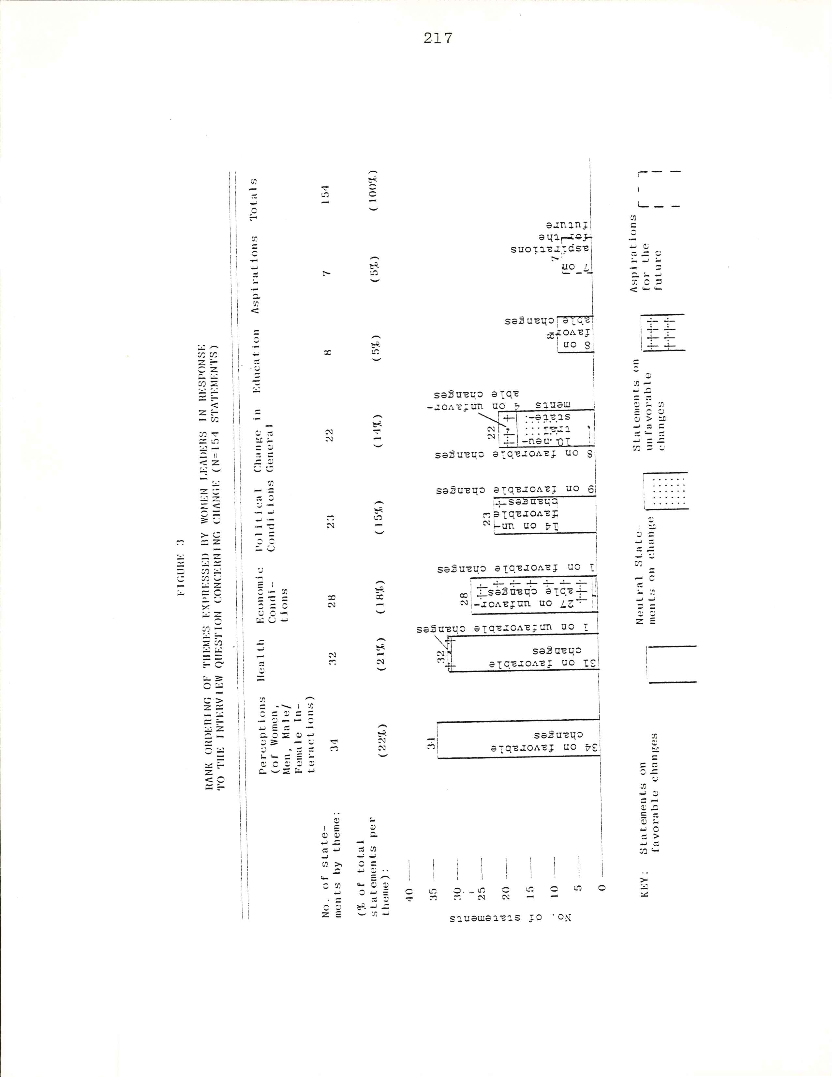
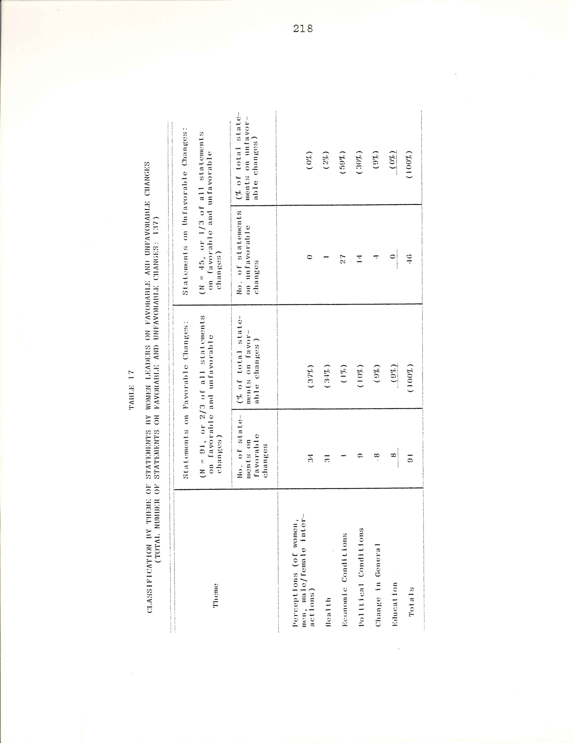
219

attitudes, lack of free time, and low income as defining
and limiting the role of women, and poor health conditions
as impeding women’s access to education, it is apparent
that in the eyes of the women leaders progress had been
made over time in the areas of attitudes/perceptions and
health conditions. Economic conditions appear to have
regressed. Examination of the responses of these women
leaders yields findings which parallel those of Buvinić
et al. resulting from their analysis of Hunton’s six-
country interviews. They found that while the women
described modernization as having had both positive and
negative effect on their liver, they generally described
these changes in quite positive terms.⁴ In the Upper Volta
case, 2/3 of all statements by women leaders in the Kon-
goussi zone on changes independence concerned favor-
able changes.

Perceptions of Women and Men and of Male/ Female Interactions
One women leader devoted almost three-quarters of her
statements on the opening question to the theme of improve-
ment in male /female interactions and to changes in attitudes
limiting the behavior of women. With regard to male/female
interactions, she pointed out: “Women couldn’t approach
men before; but now all has changed.”⁵ The crux of her
_________________________
⁴Buvinić et al., “Behind the Scenes,” p. 146.

⁵Elisabeth Belem, interview, 22 March 1978.

220

argument, however, concerned charges in the roles and
status of women, including increased freedom, mobility,
and privileges⁶, for she went on to state:
Before, women they weren’t free; there were
places where they couldn’t go. Even meetings,
they couldn’t attend certain meeting; even going
to market, there were certain woman who couldn’t
go easily to market. Now all has changed.
Before men didn’t like that woman go walking, go
out, go to this spot, go to that spot. But
now men have understood. . .Women can do as
them like now; because men, truly, they are not
rigid like before. Before there wasn’t a
women who would dare to go out in the evening,
say, to visit a neighbor; but now this happens.⁷
In addition to these changes in the social, economic, and
political participation, she also indicated that men, and
women, had become more understanding.
One other women leader made almost one-fifth of her
statements on this theme. She stressed the same point:
“Formerly, if a women saw even a small group of only two
to three men, she would not dare to join them, it would
have been impolite” ; she felt that at present men and
women were “almost equal, “that woman did what men did.⁸
____________________________
⁶It interesting to note that in Huston’s six-coun-
try interviews, reasons expressed by women for wishing to
be born male instead of female (in response to a directed
question) included having greater mobility and freedom, as
well as education and privileges. The three Voltaic women
leaders in the Kongoussi Zone perceived women in the Pro-
ject villages as having benefited from changes in the above-
mentioned areas over time.
⁷Belem, interview, 22 March 1978.
⁸Habibou Ouédraogo, interview, 1 March 1978.

221

She went on to discuss differences in the status of wo-
men, and in particular, in attitudes and behavior toward
tomorrow’s women :
In the past women weren’t respected; they
weren’t trained, weren’t knowledgable.
Their position today is better, because
they have gained ground. In the past,
it wasn’t accepted that girls go to
school; in our days, they are more
profitable to the country. They are
educated for the same reason as men.⁹
The interest of developing all of a country’s a country’s human re-
sources was thus articulated by this women leader.

TABLE 18
STATEMENTS BY WOMEN LEADERS ON PERCEPTIONS OF CHANGES IN WOMEN AND MEN AND IN MALE/FEMALE INTERACTIONS
Subtheme No. of Statements

Changing roles /status of women 18
Perceptions of women 5
Perceptions of men 5
Changing roles /status of girls 3
Male /Female interactions 3

Total statements on perceptions,
All on positive charges: 34

Health
Following the perceptions theme, statements of the
___________________________

⁹Ibid.

222

women leaders fell most frequently in the area of health.
All but one of these statements concerned positive
changes.¹⁰ The three women leaders commented in this
area, but one women made seventy–eight percent of her total
statements on health, which was equivalent to almost two-
thirds of all statements on health. One quarter of health-
related advances were specifically attributed to aid
received. They concerned improved sanitation and health
habits, and especially the introduction of water filtering
and subsequent reduction of water–borne diseases. As
stated by one woman leader:
But thanks to the aid received today, the
change in life in the village is clearly
superior, look! I got up to come here.
Thanks to the education received, I thought
to dress myself with a good outfit to pro-
tect against filth. I have learned to sweep
my courtyard and to filter water for drink-
ing. In the past, in this village, if you
arrived at this period you would find many
people lying about because they were
afflicted by Guinea-worm. It’s obvious
proof of progress in water hygiene and
cleanliness.¹¹
Other statements touched upon improved nutrition and
reduced infant morality. These subthemes were to reappear
again in the interviews in connection with the focused
_____________________________
¹⁰It should be noted, however, but, that certain of the
responses on the high cost of living classified under the
category of “economic conditions” concern payment for med-
icines since independence, and also the cost of equipping
children for school.

¹¹Tidebamba, interview, 22 March 1978.
223

question on changes in health since independence. A re-
sponse to this initial question, which was to be echoed
by other interviewees, was:
Infant mortality has diminished. Formerly, a
young woman could have one, two, three, or even
four childbirths and the children died. She has
no child. And why so? It is because of ignor-
ance, lack of dispensaries, lack of maternity
clinics, lack of health care in general. Food
was neither sufficient nor well prepared. Poorly
prepared food given to the child could cause
illness, and even led to death. Now of course we
see all that.¹²
The only statement on negative change implied that in the
past the villagers knew how to make the appropriate sac-
rifices to the various deities to obtain their assistance
in order to have good health and abundant rains.¹³
Not a single statement touched on family planning,
in sharp contrast with responses made during the
Huston six-country interviews. In the Buvinic et al.
analysis, almost eighty percent of the health/nutrition/
family planning theme statement were on obstacles to
and reasons for family planning.¹⁴ It should
be noted that the infant morality rate in Upper Volta
is far higher than the rates in the six countries.
_____________________________
¹²Ibid.

¹³Along these lines, Skinner in African Urban Life
describes the role of earth priests in intervening on be-
half of the villages with local manifestations of a fe-
male deity, “ for help in sickness, for rain and good crops,
and for children” (p. 17).

¹⁴Derived from Buvinic et al . , “Behind the Scenes,”
figure one, “Rank Ordering of Themes and Subthemes Ex-
pressed by 123 Women,” p. 134.

224

The 1960-61 Upper Volta demographic census showed the in-
fant mortality rate (Per 1,000 live births) to be 189.7;
results from the 1975 census will probably show a slight
decrease.¹⁵ Yet mid – 1970’s infant mortality figures for
the six-countries range 47 to 141 (Per 1,000 live
births).¹⁶ These facts are well reflected in the different
concerns of the women.
TABLE 19
STATEMENTS BY WOMEN LEADERS ON HEALTH

Subtheme No. of Statements

Attributed to aid ( the Project) : water
Filtering, sanitation, improved health habits. 8

Nutrition 5

Reduced infant mortality 4

Maintenance of family /child care 4

Personal hygiene /health practices 4

Improved general health ( less epidemics,
Improved health education ) 3

Health facilities 3

Only statement on negative change:
Sacrifices in past brought health 1

Total statements on health: 32

___________________________
¹⁵F. Martin–Samos, La Santé publigue, p. 12.
¹⁶Huston, Third world women, Annex B, Table 1, “Eco-
nomics and Social Indicators of Development,” pp. 150-51.

225

Economic Conditions
Responses of women leaders on economic conditions fo-
cused overwhelmingly on unfavorable changes. The intro-
ductory remarks of the head of the women’s group of Zim-
tenga incorporate the thrust of these statements:
First of all, I want simply to tell you that the
two periods don’t resemble each other. I was
young at that time, there was abundance, people
had enough to eat, it was the good life. It was
when I was grown up that independence came, where
Blacks led themselves. Now, I notice that life
has become more difficult. We sense these diffi-
culties severely with regard to food, clothing,
medical care…. I don’t know where numerous
difficulties come from, I don’t know if it ‘s the
world that turns and that this happens. I also
don’t know whether it’s independence which aggra-
vated the situation. Everything had become
expensive, life is more difficult.¹⁷
Special attention was given to current – day expenses
in the areas of health and education. Care at the dispen-
sary was no longer free as it had been under the colonial
administration; it was now necessary to buy medicines.
Similarly in the area of education, schooling in the past
involved no great expense. In the words of one woman,
“It was not a question of money.” But in modern days,
it was necessary to equip the children with school bags,
books, notebooks, and pens: life had become expensive.¹⁸
The single statement on positive change concerned women’s
present–day freedom to participate in trading.
_____________________________

¹⁷Habibou Ouédraogo, interview, 1 March 1978.

¹⁸Ibid. In another village, an old man stressed that
now that they were independent, it was their responsibility
to pay for medicines.
226

TABLE 20
STATEMENTS BY WOMEN LEADERS ON ECONOMIC CONDITIONS

Subtheme No. of Statements

Medical expenses 6
Schooling expenses 6
Before: crops, food, abundance 6
Before: plentiful rains 5
Increased cost of living 4
Participation in marketing (only positive
Change stated) 1
Total statements on economic conditions: 28

TABLE 21
STATEMENTS BY WOMEN LEADERS ON POLITICAL CONDITIONS

Subtheme No.of Statements

Negative Changes:
Decline traditional authority 13
Association Independence – difficulties 1

Positive Changes:
Before: forced labor, onerous taxes 8
Today: women’s participation in meetings 1

Total Statements on political conditions 23

227

Political Conditions

Almost one-third of all statements unfavorable

changes concerned unfavorable political changes. One

women leader made the vast majority of the statements on

political Conditions, and slightly over one-fifth of all

of her remarks were addressed to this point. Her major

subtheme was concern over the decline of the authority of

the chief since independence.19 She stated that today,

“Everyone is independent and does as he wishes. The

chief no longer commands . . . Knowing Mossi customs, I

affirm that things have deteriorated.”²⁰ This concern was

linked with the fact that certain village work was no

longer accomplished upon request.

Yet duality of views was visible on this theme. Two-

fifths of the statements on this point were positive. The

aforementioned wonen leader also poited out that in the

past there was arrest for non-payment of onerous taxes;

another women stressed forced labor of the Past. The third

women pointed out that women had acquired the privilege of

attending meetings.

Change in General, Education, Aspirations

More statements on change in general were neutral than

either positive or negative. Twice as many statements.
________________________

¹⁹On this point, see Skinner’s The Mossi of Upper
Volta, especially chapter eleven, “ Chiefs and Politician.”
²⁰Habibou Ouédraogo, interview, 1 March 1978.
228

were made qualifying life as improved or easier than as
having become more difficult . All statements in the area
of education were on positive changes: on eliminating the
“ignorance” of adults, on the education of children. One
statement specifically attributed this education to the
Project. It was stressed that people did not hesitate to
send their children to school, despite all their diffi-
culties in paying for school equipment.²¹
With regard to the future, one woman presented her
conception of the ideal life. She wanted people to change
their behavior toward one another, to have abundance of
food, and to have respect for the authority of the chief
and of the Administration. She would incorporate positive
charge that had come with the era of independence, trans-
formations which had come with development.²²
These were the views of only three women, a point
which must be kept in mind when reading the above analysis,
since a single woman’s insistence on one theme or subtheme
significantly affects the totals. Yet these are highly in-
fluential women. As leaders of the women’s groups in two
villages and Project monitress /wife of the chief in one
village, they are the spokespersons for the other women.
They speak out at all-village events, and thus their influ-
ence extends beyond the specific activities of the Project.
___________________________

²¹Ibid.
²²Ibid.

229

Analysis of the Responses of Populations of Four Villages,
Kongoussi Zone

The classification scheme utilized for the responses
of the women leaders was found to be equally appropriate
for the populations of four villages in the Kongoussi zone
(three Project villages and one control village), although
no statements were specifically made on “ aspirations.”
Classification by theme of the statements of these popula-
tions is found in table 22. For analysis purposes, two of
the Project villages, Zimtenga and Kora, are considered to
be “more successful” Project villages, while Loutouka is
considered a “less successful” Project village. These
designations are based on the optinions of the villagers
themselves. The villagers in Loulouka have stated that
whereas they originally benefited from a monitress resid-
ing in the village, later on they were only reached by a
monutress residing in a nearby village. They felt that
this latter scheme was detrimental to progress in their
village.²³
Inspection of table 22, and of table 23 in which the
themes expressed by the populations in the four villages
are rank ordered, reveals closer association of the re-
sponses made in Loulouka with those in the control village,

______________________________

²³Based on questionnaire response, reports of the sur-
vey supervisors, and the interview with the population of
the village of Loulouka held on 6 January 1978.
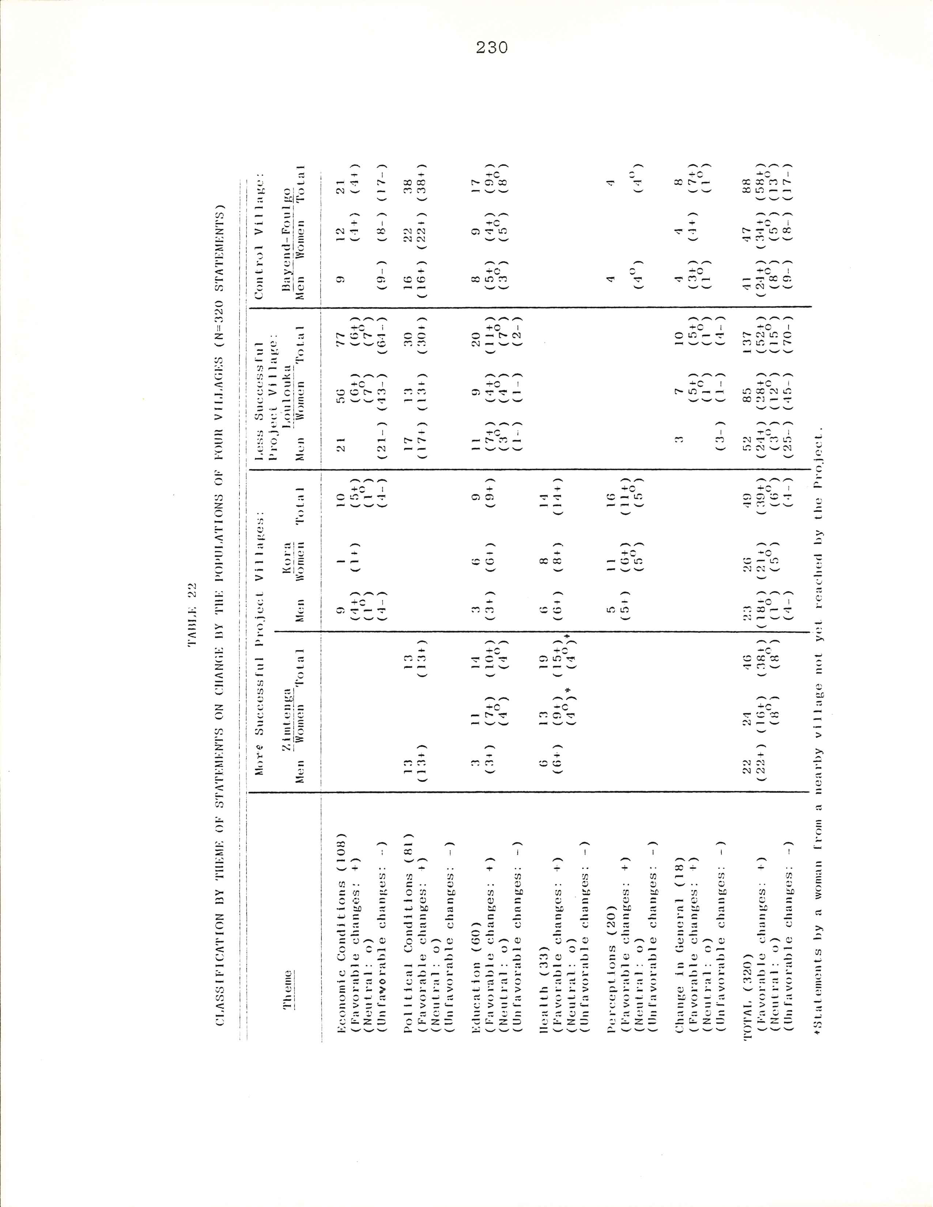
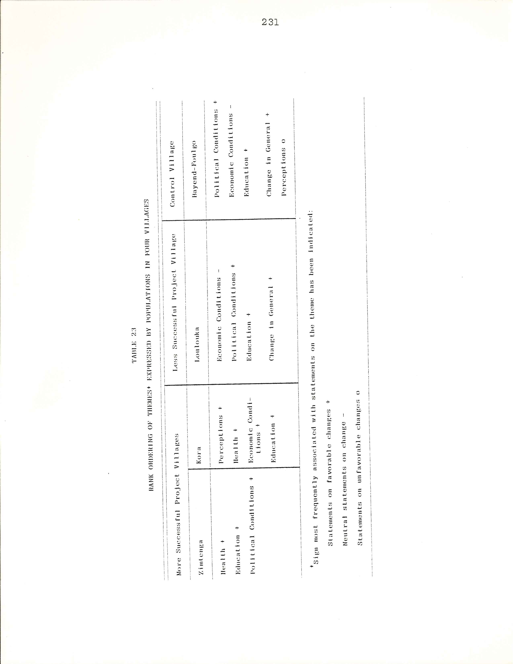
232

Bayend-Foulgo, than in the two more successful Project
villages. In the latter two villagers, health is one of
the predominant themes, touched upon in Zimtenga and Kora
in approximately four–tenths and three–tenths respectively
of the responses. All health-related improvements were
linked to the Women’s Education Project. In the less
successful Project village and the control village, health
issues were mentioned in response in response to the initial
question. In one of the two more successful Project
villages, perceptions on Project-inspired changes in the
behavior of women were the most frequently–mentioned theme.
This theme was raised in only one other village, the con-
trol village, and as the fifth most popular theme.
In the less success full Project village and the control
village, the predominant theme were economic conditions
(touched upon approsimately ½ and ¼ of responses re-
spectively), and political conditions (focused on in
approximately 1/5 and 2/5 of responses respectively) .
Of the more successful Project villages economic conditions
were mentioned only in Kora, and then as the third most
frequent theme. Similarly, Political conditions were men-
tioned only in Zimtenga, again as the third most frequent
theme.
Table 23 also shows that only in the less successful
Project village and the control village did statements on
unfavorable change predominate within a theme category,
the theme being economic conditions. In the less success-
ful Project village, women made over twice as many of these

233

statements on negative changes as men (forty –three versus
twenty –one ), while in the control village men and women
made approximately an equal number. Ninety–three percent
of all statements on unfavorable change were in the
category of economic conditions. This figure from the
village populations is even more striking than the con-
siderable proportion (three –fifths ) of total statements
on negative change which the women leaders allocated to
the theme of economic conditions. 24 The “negativeness”
(proportion of total statements on negative and positive
changes which are negative) of responses across villages
is displayed in table 24.

TABLE 24
“NEGATIVENESS”* OF STATEMENTS BY POPULATIONS OF FOUR VILLAGES

More successful Project villages:
Zimtenga ( N= 46 statements ) 0%
Kora ( N= 49 statements ) 0%
Less successful Project village:
Loulouka (N=137 statements)
Control village: 57%
Bayend- Foulgo ( N=88 statements ) 23%

* Percent of total statements on negative and positive changes (neutral statements and statements on aspirations eliminated) which are negative.

___________________________
²⁴Yet in contrast with total absence of statements
on negative changes during the group interview with the
population of Zimtenga, one-third of the statements of

234

A remaining difference between the responses of the
more successful Project villages and those of the less
successful Project village and the control village is the
percentage of total statements related to the Project and
its activities, its successes and its failures. This
information is indicated in table 25. In the more success-
ful Project villages the majority of the references con-
cerned positive change. In the less successful Project
village more than one-quarter of the statements related
to the Project concerned requests for additional assis-
tance, while one-fifth of the statements reflect criticism
of Project activities. Approximately two –thirds of the
statements at Bayend –Foulgo, the control village, were
requests for project assistance.

Perceptions
The women of Kora made most of their statements on
their perceptions of themselves. They felt that they were
“awakened”²⁵ now. They had a women’s group, which per-
mitted them to work together. One woman stated, “The
status of women has completed changed. We have been given
____________________________
the women leaders of Zimtenga were on negative changes.

²⁵All citations and paraphrasing of statements of
the villagers of Kora in this chapter are draw from the
interview held on 4 January 1978.

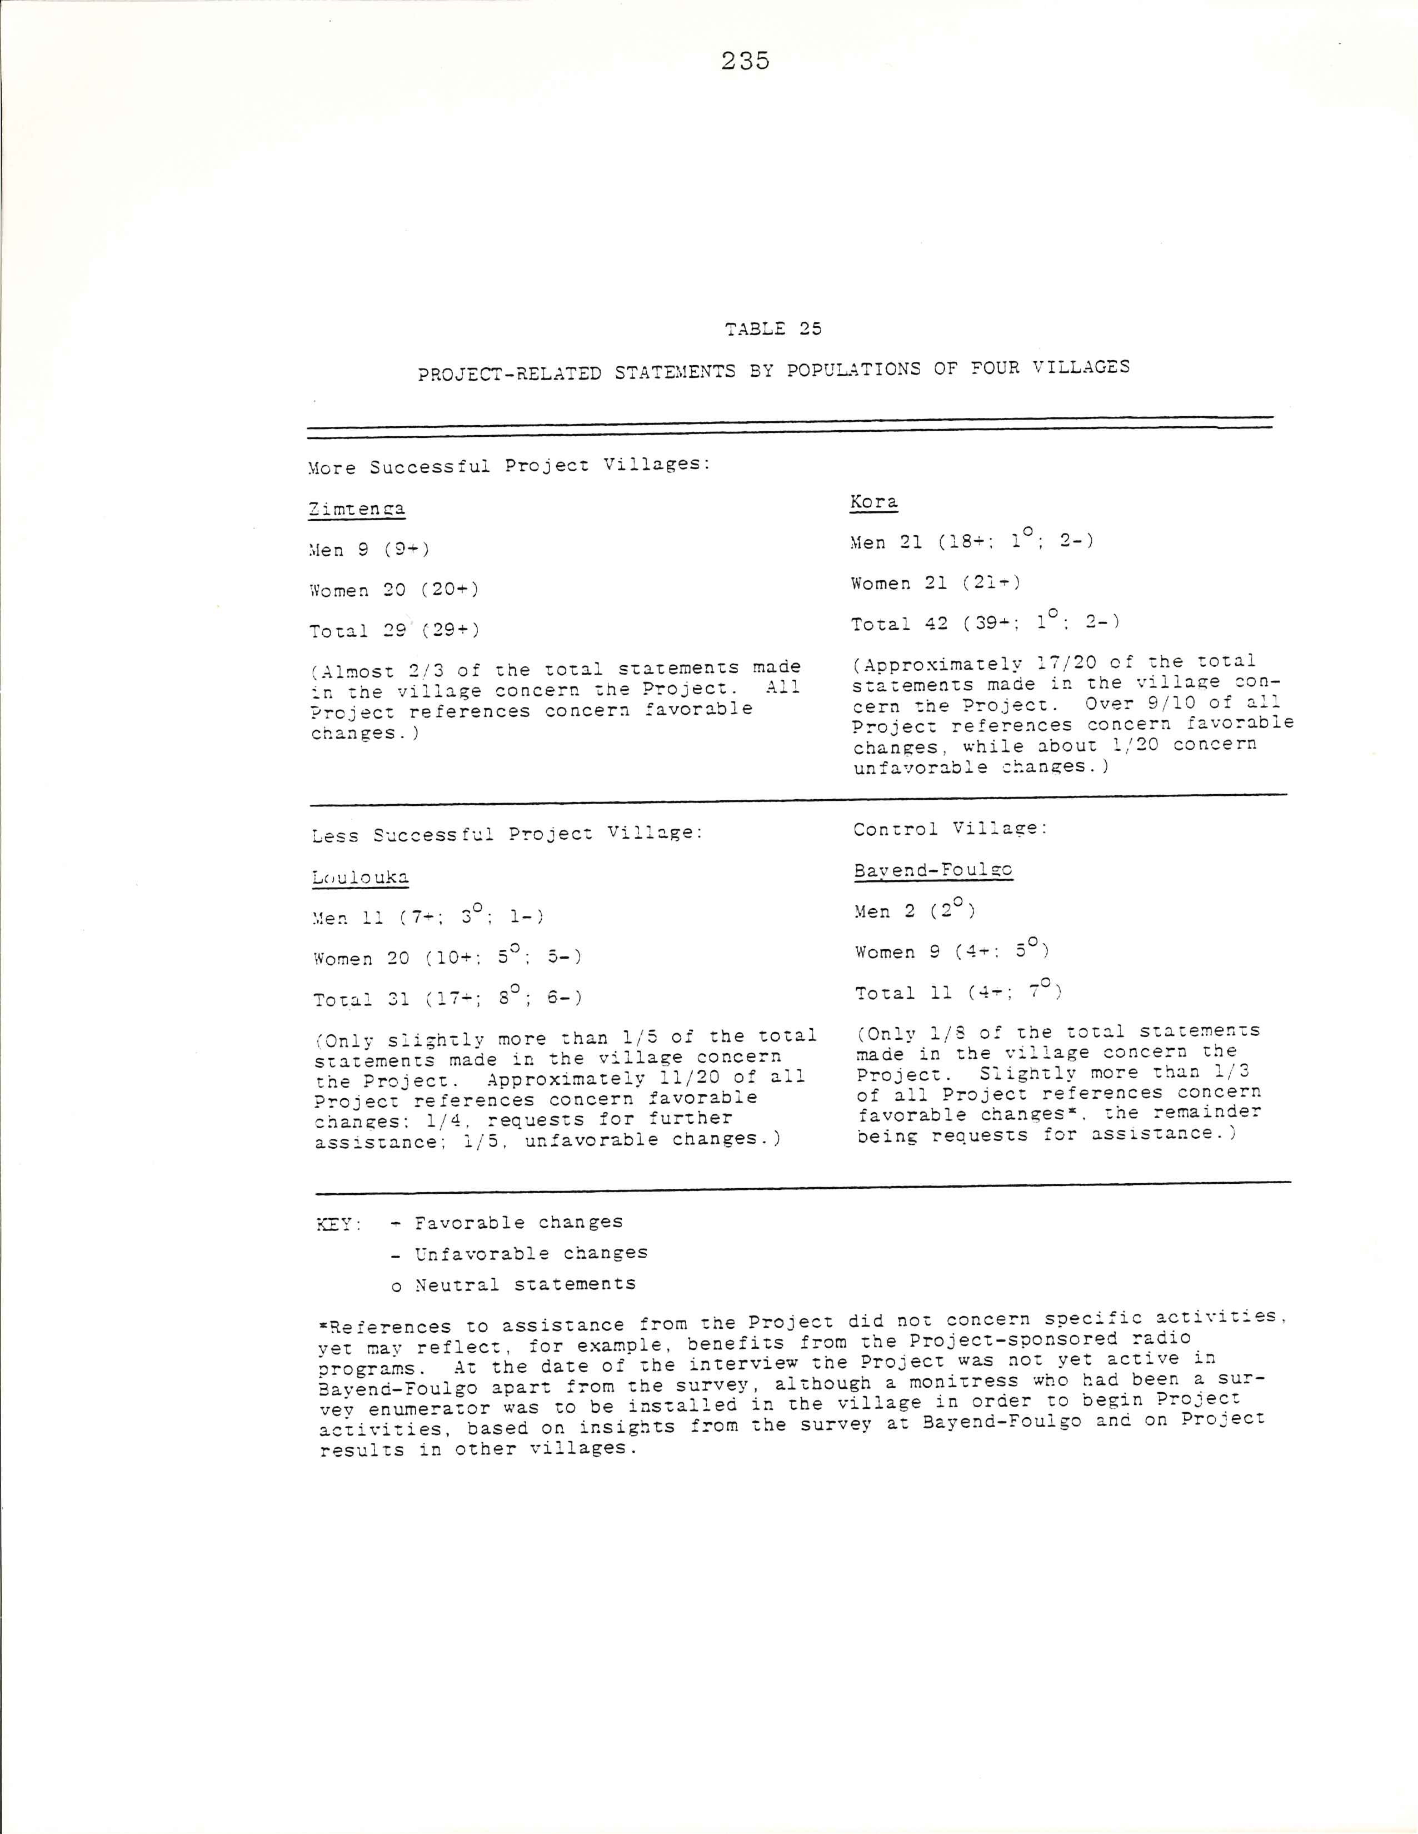
236

a certain civilization which we didn’t have before, thanks
to the literacy classes and meetings organized by the Pro-
ject.” Yet other women said that they “weren’t partici-
pating” in the interview because they were not sufficiently
“civilized” to speak without shame in such a milieu, in
front of their husbands and children; if the encourage-
ment continued, little by little, they would succeed. The
men noted that the Project had brought understanding and
unity among women, that they knew one another better than
before. One stated that “even a woman who cannot yet read
and write is more educated than before.”
In the control village of Bayend-Foulgo, when the
women were invited to speak, one responded: “We have noth-
ing to add to what the men have just said. The opinion
of the men is ours, there is nothing to add.”²⁶ After much
encouragement and insistence, many did in fact comment.
One of the male dignitaries of the village then stated:
The women were here waiting for you, they were
advised of your arrival; if not, they would have
gone off to work (“to the bush”). Help us to
progress toward development. The women think
that if they are to get up and anser, the men
are perhaps going to criticize them. There is
no question of that.
The difference between the facility with which most
Women from Project villages took the floor and the timidity
of the control village women in expressing their views
was striking.
____________________________
²⁶All citations and paraphrasing of statements of
the villagers of Bayend-Foulgo in this chapter are drawn

237

Hea1th
One-third of all statements in the more successful
Project villages were on the theme of health, including
health education. The following statement by an elder from
Zimtenga exemplifies their thrust. After extolling the
halting of forced labor with independence, he continued:
Another very remarkable change is the creation
of the UNESCO Project which has educated our
wives. They now know how to filter water, care
for children; they take the care to sweep the
courtyards. It is in this that we see that
independence has been useful for us. In the past
we drank swamp water; thanks to the UNESCO Pro-
ject we drink well water. In drinking good
water, we see that illness had diminished. That
is all that I note as change since independence.²⁷
Time and time again, these same themes were stressed, and
in the following order: more sanitary conditions in the
courtyard, cleaner water, and improved hygiene and child
care. A woman from a neighboring village without a well
emphasized that despite water filtering, they faced the
dilemma of water shortage.
Another point which received priority attention and
which was raised in Kora was the training of traditional
midwives by the Project.28 Before, women went to the chief ______________________________
from the interview held on 1 March 1978.

²⁷All citations and paraphrasing of statements of the
villagers of Zimtenga in this chapter are drawn from the
interview held on 5 January 1978.

²⁸A maternity clinic with a State-paid midwife is
located in Zimtenga, the other more successful Project
village.

238

town of the subprefecture, Kongoussi, for childbirth.
Since the training of the midwives, it was only necessary
of to Kongoussi for difficult childbirths. The services
these midwives to the community were similarly lauded in
Project villages in the other zones of the country.

Economic Conditions
One-third of all statements made in the four villages
were on the theme of economic conditions. These statements
were made principally in the less successful Project vil-
lage and the control village, and they were overwhelmingly
negative. The remarks of one woman in the less successful
Project village, which could be considered the refrain of
the session, went as follows: "There is no water, no wood,
we don't have enough food this year, we are apt to run
away and leave our husbands. If we stay, what will we con-
sume? No food, no water, no wood²⁹," Subsequently, a
man added that their current difficulties, caused mainly
by lack of rain, did not depend on anyone, but rather
that it was the will of God. Of the statements on unfavor-
able changes (see table 26), one-third centered on the lack
of food; also listed were the lack of rain, wood and basic
needs in general, and the fact that the modern equipment of
a mill and a cart supplied by the Project had broken down. ___________________________
²⁹All citations and paraphrasing of statements of the
villagers of Loulouka in this chapter are drawn from the
interview held on 6 January 1978.
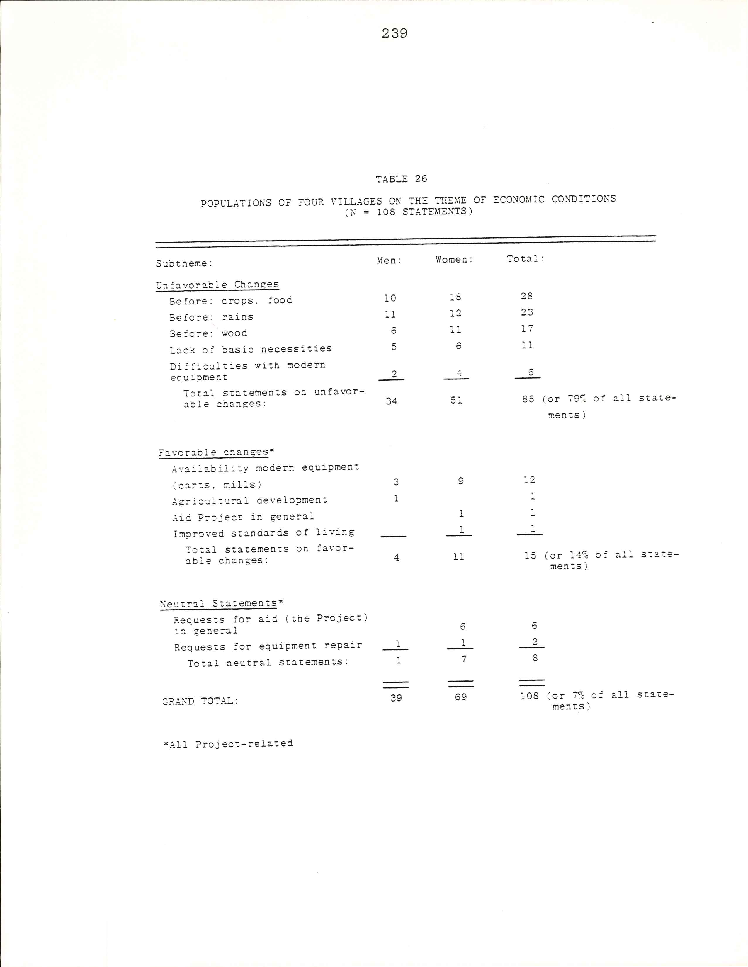
240

The availability of modern equipment nonetheless pre-
dominated amongst the statement on favorable changes. A
woman from Bayend-Foulgo stated, "Life now is better than
that of the past. We have many advantages. There are
carts for transport, there are mills to grind grain. Life
has become more beautiful." The men of Kora pointed out
that the mill furnished by the Project had been a great
help before it broke down; now their wives suffered. And
women of Loulouka in a similar vein stated that when their
cart was in good condition, they were able to stock wood,
and distribute it to each woman in exchange for a certain
sum. Now that the cart was broken, they could no longer
help one another.
In comparison with the statements of the women leaders
on the theme of economic conditions, the populations of the
four villages, and especially those of the less successful
Project village sand the control village, devoted more atten-
tion to the subtheme of lack of basic needs, namely of
food, water, and wood. In addition, they brought up the
topic of technologies in three villages. The area of tech-
nologies was not raised at all by the women leaders in
response to the initial question.

Education
Almost one-fifth of all statements centered on the
theme of education. The majority of the statements con-
cerned favorable changes, particularly those owing to the

241

Project such as knowledge, advice, women's education in
general, literacy classes and meetings. These statements
were made by men and women. Only two statements concerned
increased availability of educational facilities, and two
the education of children. Thus most of the statements
on positive changes concerned the education of adult
women. About one-third of the statements were "neutral,"
primarily requests for assistance, or additional assis-
tance, from the Project.
The negative statements on unfavorable changes came
from the villagers of Loulouka. Three buildings had been
built by the population to house the Project monitress and
the literacy classes and other activities. While initially
a monitress lived in the village, it later became necessary
for each monitress to serve several villages, and thus a
monitress from a nearby village was assigned to cover
Loulouka. But the "villagers did not approve of the sharing
formula. In the words of one woman, "When we had the
monitress to teach, it was good; the women came, and the
youth also. That assisted us enormously. There is no
longer a monitress. Help us to have one." This problem
of effective coverage of several villages by a single
monitress is a crucial one, for it is inconceivable
that the Project will ever have the means to pay salaries
permitting placement of one monitress in each of the
country's seven thousand or so villages. Care can only
be taken at the time of the initial placement of each
242

monitress to assure that she is located central
village. This will facilitate later coverage of addi-
tional villages, and minimize the necessity of subsequent
relocation, which gives the villagers the impression of
having been abandoned.

Findings and Their Relevance for the Set of Indicators and
for the Theory of the Negative Impact of Development on
Women

Comparison with Part Two Findings
The content analysis has confirmed part two findings.
It has furnished additional insights and complementary
information on several themes. Results in four socio-
economic areas compare as follows.
Employment: In response to the opening question, an
accent was placed on the magnitude of women's workloads,
notably associated with water portage and the search for
wood, particularly in the village of Loulouka. Both men
and women emphasized this theme. Men's workloads per se
were never touched upon. The number of statements made
on this point, and the insistence with which they were
made, confirms the quantitative part two findings which
revealed imbalance in the sexual division of labor.
Education: Increased availability of educational
facilities for children was raised, but greater emphasis
was given to benefits from women's education, particularly
in more successful Project villages. In the control
village, one-half of the statements on this theme

243

incorporated requests for Project assistance, and in the
less successful Project village, one-third of the state-
ments requested additional assistance. In part two sig-
nificant differences, associated with the presence or
absence of Project assistance, were found between a
target and a control village with respect to educational
level and behavior of women.
Health: An accent was placed on Project-related
health advances, particularly by the women leaders. This
reaffirmed the first-place ranking of health education
activities on the "most beneficial Project activity"
scale which was presented in part two. Appreciation of
the services rendered by the midwives trained by the
Project, and those wells built with Project assistance,
also confirmed earlier findings, as did the lack of men-
tion of the latrine program.
Technologies: The interest found in part two with
regard to workload-lightening technologies was confirmed.
The frustrations experienced when these technologies break
down were also expressed. The statements seemed to indi-
cate the Project had taken the sound route, in re-
thinking the necessary preconditions for the successful
communal operation of these technologies, and in giving
priority to the search for less sophisticated technolo-
gies, especially mills.³⁰
__________________________
³⁰In the case of the mills, major difficulties reside
in the level of the technology itself, which requires

244

Comparison of Voltaic and Six-Country Priorities
To the extent that the needs and priorities of the
populations can be considered to have been reflected in
their statements, one important similarity holds for the
Upper Volta and six-country findings. This is the impor-
tance attached to the theme of economic conditions. In
Upper Volta, more statements were made on this theme than
on any other; in the six-country interviews, more women
spoke on this theme than on any other. Given the differ-
ences in approach to the analysis, however, it is diffi-
cult to compare relative importance accorded to other
themes.³¹
____________________________

rather sophisticated maintenance for the rural milieu.
Negotiations with suppliers also need to be strengthened
to assure availability of spare parts. With regard to
the carts, the problem resides particularly in the com-
plex process of arriving at more effective communal manage-
ment which will permit replacement of parts from receipts.
This latter aspect is critical, and concerns all community-
owned technologies. Arpad von Lazar and John C. Hammock,
in isolating elements which they feel are essential to
the implementation of an effective community development
program, have emphasized the importance of the timing of
external assistance. Inputs of machinery and money prior
to adequately organizing the community can lead to waste
(source: Arpad von Lazar and John C. Hammock, "Community Development in the Dominican Republic: Summary Reflections
on Four Case Studies," Journal of Community Development
Society, vol. 1, no.2 [Fall 1970], p. 98).

³¹Additional future comparisons would be possible,
however, if the six-country data were to be reprocessed
and ranked by numbers of statements on each theme rather
than numbers of women speaking on a theme.

245

Refinements in the Areas of the Set of ATRCW Socioeconomic Indicators Suggested by the Content Analysis
Three themes raised by the populations of Upper Volta
in the less structured interviews are not directly re-
flected in the areas of the ATRCW's set of indicators.
Two of these themes were accorded priority attention by
the rural populations: economic conditions (29 percent
of the total of 474 statements) and political conditions
(22 percent of total statements). The third, perceptions,
was mentioned in around one-tenth of all statements.
While the ATRCW's formal employment indicators
encompass economic issues as reflected in salaried posi-
tions held by women and comparative wages earned, the
formal employment indicators only concern around 1.4 per-
cent of the active Voltaic population at present. The
suggested informal sector indicators furnish data on
the sexual division of labor; yet do not treat the issue
of economic conditions or income-generating activities
per se. Responses of the Voltaic women leaders and
villagers on unfavorable changes (112 statements) in the
economic conditions category concentrated on lack of crops
(30 percent of these statements), or rains (1/4 of the
statements), and of wood and basic necessities in general
(1/4 of the statements). Difficulties attributed to
modernization, such as medical expenses, schooling ex-
penses, breakdown of modern equipment, and the rising
cost of living in general constituted 1/5 of these state-
ments.
246

New sources of revenues are required to facilitate
meeting new needs: modern-day school and medical expenses,
"renting of carts to haul wood over longer distances, costs
of irrigated farming and of running water pumps in deeper
wells. Initiatives taken to reform education³², revalorize
traditional medicine³³, and introduce resource-saving
technologies³⁴, such as solar cookers, mills, and pumps,
will hopefully narrow the "cash" gap felt by the villagers.
Favorable changes stated by the villagers and women leaders
in fact stress developments, principally owing to the
Project, which are perceived as lightening their burdens,
including the lack of cash: availability of modern equip-
ment, agricultural development, participation in market-
ing and assistance in improving standards of living. _________________________
³²As pointed out by the Minister of National Educa-
tion, Prof. Ali Lankoande, in his end of the year statement
in 1974, the budget for his department, despite absorbing
about one-quarter of the resources of the National Budget,
permits virtually no equipping of the students (with
materials which are only manufactured abroad).. The entire
educational system requires fundamental revision, in-
cluding the establishment of a link between the act of
learning and the act of producing.

³³Substantial research had been undertaken in this
area by the Centre Africain et Malgache des Etudes Supér-
ieures (CAMES).

³⁴Solar cooker experimentation, financed with the
assistance of DANCHURCHAID, is being undertaken within
the framework of the Women's Education Project. A far
more sophisticated (and, at present, costly) solar sys-
tem which runs a pump and a mill is being tested in
the Fada N'Gourma region to the east of Upper Volta,
financed by USAID.
247

It would therefore seem useful to develop indicators to
measure efforts addressed to men and women or to rural
populations in general to meet expenses associated with
modernization, or to reduce the very cost. Table 27
might be used as a point of departure in developing in-
dicators in this area in the ATRCW format.
A second area of major concern to the Voltaic popula-
tions was the change in the political system, and espec-
ially the halting of forced labor, and the forced payment
of onerous taxes. The ATRCW set of indicators does in-
clude a table for computing participation in decision-
making, which it suggests be adapted to the needs of the
political system in each country.³⁵ This table, which
calculates the percentage of women in government, in par-
liament, and the like, assumes political independence and
the favorable changes raised by the villagers. Possible
adaptations to the table might reflect women' participa-
tion in village councils, in women's associations, and in
village and household decision-rnaking.³⁶
Another aspect of the dependency question raised by
the villagers in comments on economic conditions is that ___________________________
³⁵United Nations, Economic Commission for Africa,
The NIEO, p. 31.

³⁶One approach to documenting the role of women in
household decision-making in Africa appears in Spencer,
“Women on a Developing Economy,” pp. 42-50, plus the
annex, “Questionnarie on Female Participation in Decision-
Making in the Sierre Leone Household.”
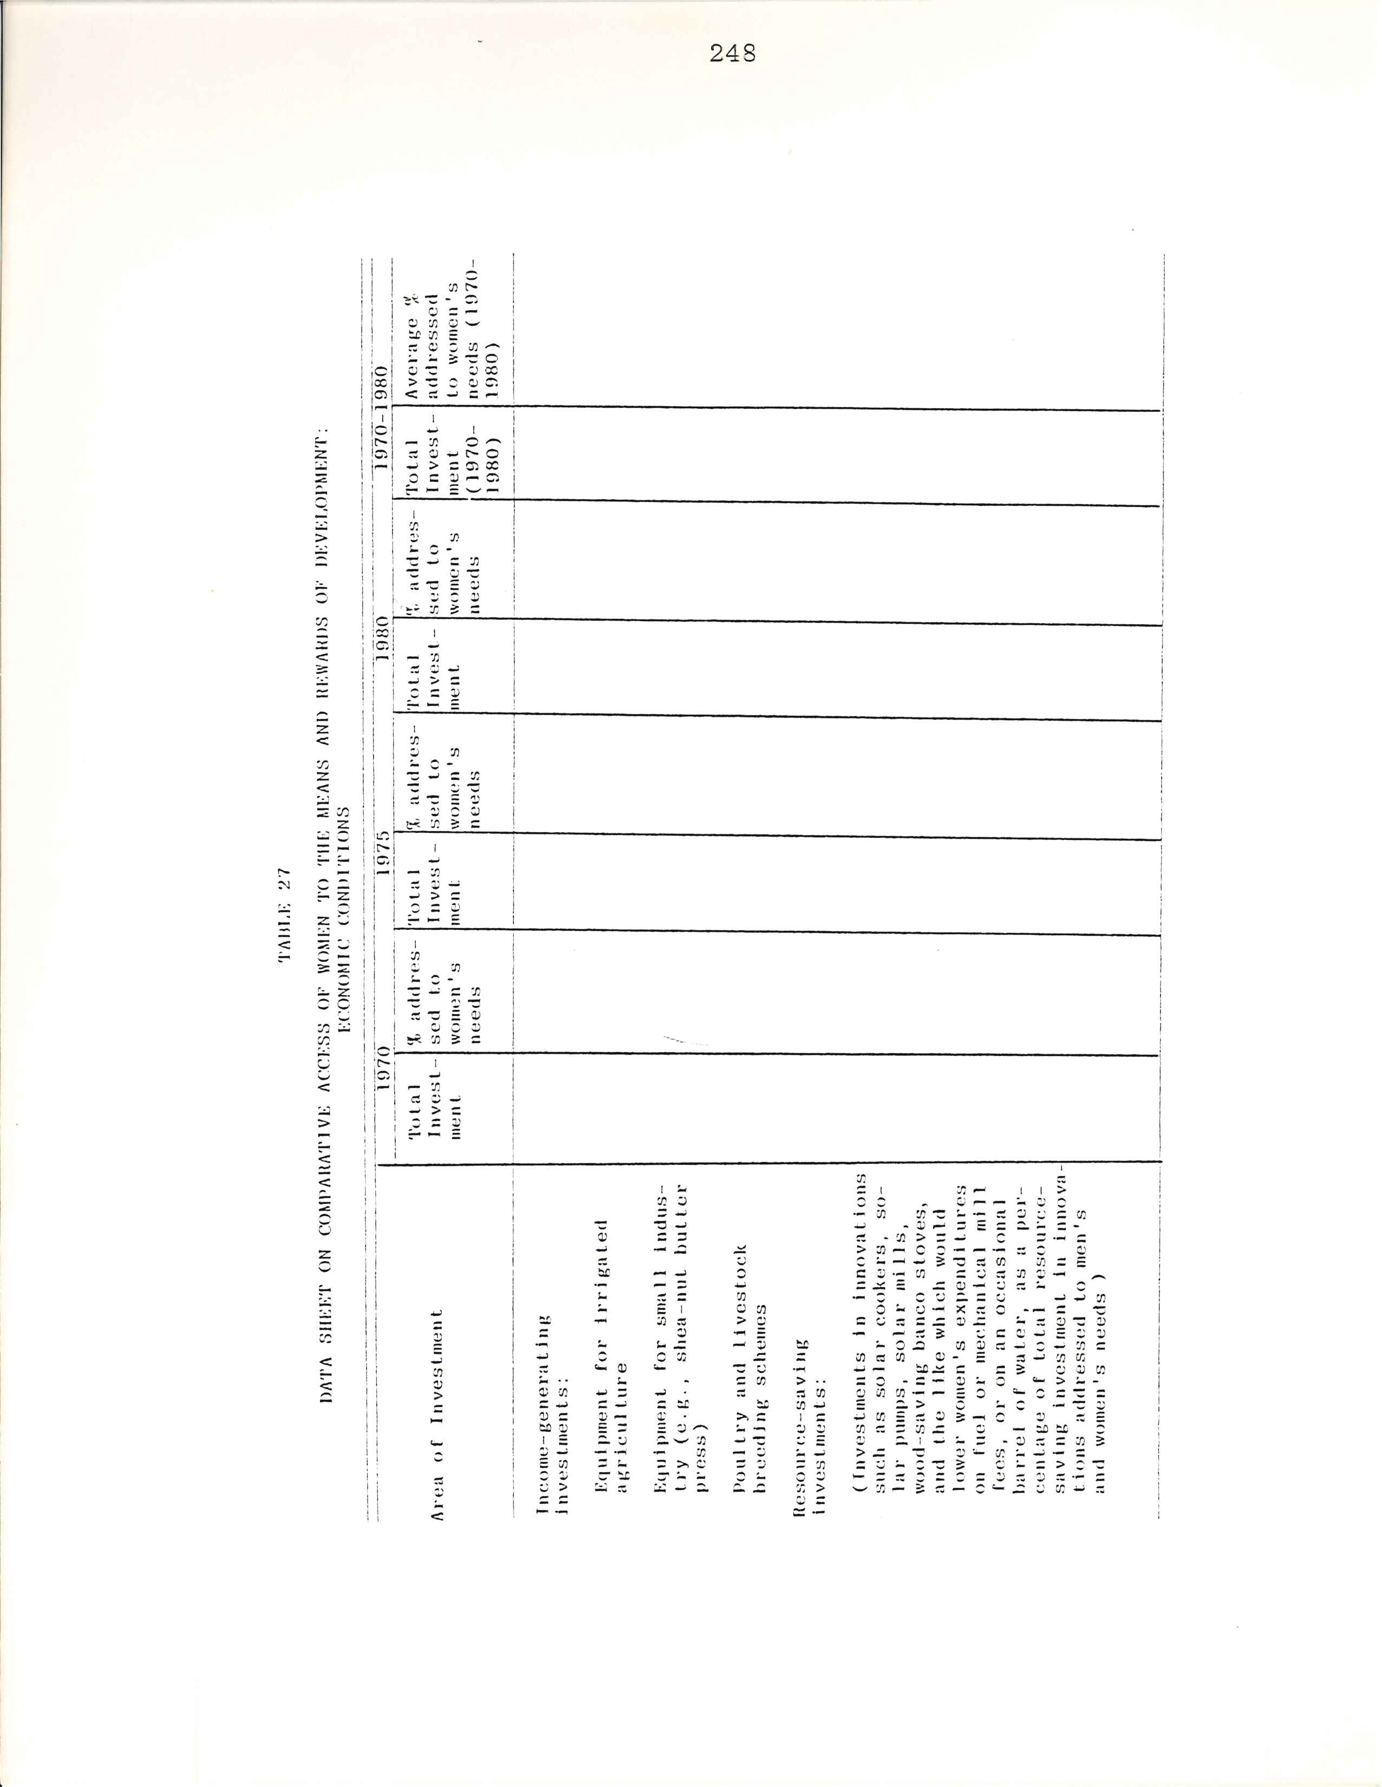
249

of economic dependence. Issues debated on a more theor-
etical level in world bodies, for example, discussions on
the establishment of the New International Economic Order,
have many concrete manifestations in the villages. The
problems are well illustrated by the seemingly endless
shipping and overlanrl transportation delays encountered
in acquiring spare parts for broken-down mills, not to
mention the cost of spare parts.³⁷ This same phenomenon
occurs in any sizeable delivery of equipment of volume and
weight which prohibits air-freight. Whereas the Voltaic
government has moved in collaboration with the ILO/UNDP
for the local production of plows, similar results concern-
ing local mill production have yet to be achieved. Lessen-
ing the dependence on imported goods, be it medical sup-
plies, school equipment or technologies, all of which are
exorbitantly costly given the meager resources of the
villagers, might also be an appropriate area for the de-
velopment of indicators.
The final theme raised by the rural Voltaic popula-
tions which is not included in the ATRCW's set of indica-
tors is the area of the changing roles and status of wo-
men and girls, attitudes toward women, perceptions of
changes in women and men, and changing male/female inter-
actions. Slightly more than one-half of the fifty-four
statements on this theme reflected favorable changes, the ____________________________
³⁷Suppliers in the capital can at virtually any time
furnish new mills, but seldom stock spare parts.

250

remainder being neutral. As pointed out by the Project
sociologists, attitudes and behavior are among the most
intractable factors hindering equal access of women and
girls to education. The disparity between women's status
before the law and in practice has long been recognized
by Voltaic educational planners. This area is undoubtedly
one in which it is far more difficult to design indicators
to measure change than in the areas characterized by con-
crete phenomena, such as the percentage of girls amongst
total enrollments. An attempt might be made to monitor
the influence of the media on women's status, and might
include, for example, the percentage of radio time devoted
to programs designed to change perceptions of women and
their roles.

The Negative Impact of Development on Women Reconsidered
Content analysis of the initial question in less
structured interviews with the populations of sample
villages in the Kongoussi zone and with women leaders in
this same zone has yielded the quantitative information
displayed in table 28 with regard to statements on change.
Of the total of 474 statements, 278 were on favorable
changes, 137 on unfavorable changes, 52 statements were
neutral, and 7 statements were on aspirations. Twice as
many statements were thus made on favorable changes as on
unfavorable changes. Similarly Buvinić and her colleagues
found that the women interviewed in six countries by Huston
generally characterized changes accompanying development in

251

quite favorable terms. Yet more specifically they de-
scribed its effects on their well-being in terms of posi-
tive health and social changes and negative economic
changes. Thus Buvinic et al. contend that these findings
are not necessarily contradictory with the negative impact
of development on women thesis, of which the thrust is
economic.³⁸

TABLE 28
RANK ORDERING BY THEME OF TOTAL STATEMENTS MADE BY THE POPULATIONS OF FOUR VILLAGES AND WOMEN LEADERS IN
THE KONGOUSSI ZONE (N = 474 STATEMENTS)

Theme Populations Women Total (%of Total
Of Four Leaders Statement)
Villages
Education conditions 108 28 136 (29%)
Political conditions 81 23 104 (22%)
Education 60 8 68 (14%)
Health 33 32 65 (14%)
Perceptions 20 34 54 (11%)
Change in general 18 22 40 (8%)
Aspirations 0 7 7 (2%)
Total: 320 154 474 (100%)

A comparable finding results from the investigation
by theme of the Upper Volta interviews. Social, political,
and attitudinal changes which accompanied modernization
were perceived as having been primarily favorable, while
____________________________

³⁸For a full development of this theme, see Buvinić
et at. , "Behind the Scenes,” pp. 146-47.

252

economic conditions was the only category in which changes
were declared to be overwhelmingly unfavorable. During
interviews with the populations of four villages in the
Kongoussi zone, women made sixty percent of the statements
on negative changes in economic conditions. In addition,
virtually all of the statements made by women leaders on
economic conditions were on unfavorable changes.
One might be tempted to explain the "negativity" of
women's responses by the roles usually associated with
them. Women are heavily involved in sowing; therefore,
they are more preoccupied than men by lack of rain. Women
are heavily involved in marketing; therefore, they are
more concerned than men with economic deterioration. Yet
questionnaire responses showed that sowing in the husband's
field was undertaken by all members of the family, there-
fore, the men would also be directly preoccupied with rain-
fall. Furthermore, the sale of crops from men's personal
fields was generally undertaken by the men themselves,
therefore, they would also be closely aware of price trends.
Thus, the Boserup-Tinker thesis, substantiated by Kongoussi
zone time budgets, that the encouragement of cash crops
favored men, remains a more likely explanation for women's
greater negativity in comparison with men in the realm of
economic conditions.
However, the overall thrust of all statements in the
Kongoussi interviews was placed on favorable changes. These
findings suggest the appropriateness of a restatement of

253

the negative impact thesis as follows: while development
is perceived particularly by women to have had a negative
impact in the economic sphere, it has been accompanied by
positive changes for all members of the community in socio-
political conditions. Such a disaggregation would lead to
the policy conclusion that future efforts give additional
attention to the economic side of the equation, particu-
larly in response to women's needs.

CHAPTER VIII
THE WOMEN'S EDUCATION PROJECT: CATALYST FOR CHANGE

We all know that the Project has been the major
factor of change in the condition of women. It
has played the key role.

Mrs. Tidebamba, head of the women's group of
Doure, to the author in an interview on
22 March 1978

Cependant, si les éléments statistiques sont
des points de repères, ils se peuvent rendre
totalement compte d'un programme d’éducation,
visant avant tout un changement de mentalités,
qui n'est pas aisément mesurable. . . .Les
structures mises en place dans chaque village
(comité de village, compose d'hommes et de
femmes qui décident de ce qu'il est opportun
d'entreprendre dans le village), la formation
des leaders (accoucheuses et animatrices) qui
guident les autres et leur apprennent à réaliser
un certain nombre de travaux pratiques (montage
de filtres, couture, organisation de réunions,
etc.), et surtout la poursuite de certaines
activités du Projet quand la monitrice, la seule
personne rémunérée dans le village pour ses ac-
tions dans le Projet [est partie], nous
autorisent à croire que le but ultime du Projet,
qui est l'auto-suffisance des populations en
matière de développement, est chose réalisable.

Mrs. Scholastique Kompaoré, national coordinator
of the Women's Education Project, at a ceremony
on the occasion of International Literacy Day,
September 1978

254
255

What are the factors which have distinguished the
Upper Volta/UNESCO/UNDP Women’s Education Project from
so many other development projects and programs? What led
it to earn an honorable mention at UNESCO in Paris in 1977,
a year in which no literacy prizes were awarded; to be
the unique project listed as an example in UNDP's initial
Programme Guidelines on the Integration of Women in De-
velopment? What led the Government to classify it in
their education sector of the Five Year Plan 1972 –1976
as "Priority I, Urgency I", and to classify it in UNDP's
Directory of Services available for Technical Cooperation
among Developing Countries (TCDC) in order to share its
experiences and technicians with other countries of the
region? And, most importantly, what led villagers to
send delegates to the capital to request that the Project
be installed in their villages?

International Appraisals
UNESCO, in selecting the Women's Education Project
for an award in 1977, put an accent on the Project's en-
dogenous approach and the appropriateness of its metho-
dology in identifying educational needs of populations
at the village level. The Project was singled out for the
important participation of women in its programs; for its
contribution toward eliminating obstacles which prevent
girls and women in rural regions from having access to
education; for having facilitated the participation of

256

women and girls in the development of the country; for
having produced didactic materials in three national
languages; and for constituting an example of cooperation
among different national and international institutions
and bilateral donors. UNDP in issuing its Guidelines
on the Integration of Women in Development stated that it
would like to illustrate them with examples of specific
projects, “. . .but the plain fact is that few exist
(one particularly successful one in Upper Volta is men-
tioned). 2 The Upper Volta Project was cited as having
developed a workload-lightening program, thus making
possible women's access to education in agriculture,
health, nutrition, and civic activities.³

National Assessments
Voltaic education specialists, reviewing the role
of education in rural development in Upper Volta, enum-
erated the provisional results of the Project in 1975
as follows:
_________________________
¹UNESCO citation accompanying the award, quoted by Scholastique Kompaore, address on the occasion of the
celebration of International Literacy Day, Ouagadougou,
September 1978.

²I. G. Patel, "Programme Guidelines on the Integra-
tion of Women in Development" (G3100-lfTL.2), United Na-
tions Development Programme, 25 February 1977.

³United Nations Development Programme, Programme
Policy and Evaluation Division, "Guidelines on the Inte-
gration of Women in Development" (G3100-1, Rev. 0), 25
February 1977, p. 1/103.

257
A première vue si l'on s'en tenait à
l' aspect alphabétisation les résultats du
projet seraient bien minces tant sur le
nombre de femmes touchées par l'alphabéti-
sation que sur ce qu'elles en ont tiré et
conservé. Certains ont pu conclure que le
projet était un échec. C'est une vue
erronée qui donnerait au fait de lire et
d'écrire une valeur en lui-même en dehors
de tout contexte. Lire et écrire est un
fait de société, la besoin ne s'en fait
sentir qui si le contexte social se trans-
forme dans une certaine mesure et c'est
cela que le projet a mis fortement en
lumière, la nécessite d'un changement de
mentalité au niveau de toute la société
en ce qui concerne le statut de la femme;
l'amélioration des conditions de vie de
la femme par l'acquisition de revenus
autonomes; la libération du temps de la
femme.
L'acquisition de moulins à mil, de
charrettes qui économisent le temps et
l'effort, la création de champs collectifs
dont les revenus permettent d'acheter
des médicaments, du matériel d'alphabétisa-
tion, des piles pour écouter les émissions
radiophoniques, la formation des accoucheuses
de villages sont autant d'éléments de promo-
tion de la femme rurale sans lesquels le fait
de savoir lire et écrire ne signifierait pas
grand chose.⁴
___________________________
⁴Aimé Damiba and Ousmane Tontorogobo, “Les Pierres d'attente d'une éducation de masse pour Ie développement rural," paper presented at the Seminar on the Role of Education in Rural Development, Ouagadougou, 21-31 October 1975. "At first glance, if one restricts oneself to the literacy aspect, the results of the Project would be scanty, either with respect to the number of women reached by literacy or by what they have gained and retained. Some would have been able to conclude that the Project was a failure. This is an erroneous view which would give the fact of reading and writing a value to itself outside of any context. To read and write is a fact of society; the need only makes itself felt if the social context is evolving to a certain degree, and it is this that the Project has strongly brought to light, the need for a change in mentality at the level of the whole society with regard to the situation of women; improvement in standards of living for women through the acquisition of autonomous incomes; the freeing up of women's time. The
258

The implications of the formula which the Project has
developed and tested for the promotion of education for
women and girls go beyond recommendation of mere exten-
sion of the Project iself. The experience of the Pro-
ject has left a legacy for the continuing efforts of fun-
damental reform of education in Upper Volta, for innova-
tion in education in other countries of the region.

Views from the Villages
The key to the Project's impact, its successes and
failures, lies at the village level, with the populations
reached. The women leaders, spokespersons for those most
concerned, are well placed to assess its strengths and
weaknesses. In comprehensive interviews, after specify-
ing differences the Project had made in life in their
villages, women leaders were asked to identify those com-
ponents of the Project which really accounted for these
changes. In the Kongoussi zone of the Project, Mrs.
Tidebamba, Head of the Women's Group of Douré, responded
as follows:

Change came about from the moment that we
listened to the advice of the radio program,
__________________________

acquisition of mechanical mills, of carts which economize
time and effort; the creation of collective fields which
generate revenues permitting the purchase of medicine,
literacy material, batteries to listen to the radio broad-
cast; the training of traditional midwives are so many el-
ements for the promotion of rural women without which the
fact of knowing how to read and write would mean little."
259

"Women Is the Home. " That is what led to
the organization of the women's group.
Since the creation of the group, there has
been agreement among us. For we know that
united, we will succeed in all. We have
never let an agricultural cycle pass by
without cultivating together. We have pro-
duced high yields. Except in the case of
lack of rain. It is only these last years
that the women didn't state the results,
at the time of the tragedy.⁵ But someone
passing through, if he sees the women meet-
ing, will say that there is truly understand-
ing in this village, which encourages
those who weren't signed up in the beginning
to follow us and wish to join us. That
proves that education is on the right track.
Our knowledge is increasing and there is
joie de vivre.

Thus this woman leader emphasized the impact of factors
falling in the areas of education (radio program), par-
ticipation in decision-making (organization of the women's
group), and employment (collective fields). Her colleague
Mrs. Habibou Ouedraogo, Head of the Women's Group of
neighboring Zimtenga, responded that all of the activities
favored development in the village, that she could not
__________________________
⁵Mrs. Tidebamba is referring to the catastrophe of
March 1976, when eighteen of the Project's women leaders
from the Kongoussi zone, five children, and their driver
were killed in a automotive accident. The village of
Zimtenga lost nine women, four children, and their mon-
itress. In a meeting organized by the Chief two days
later, the women decided that because of this enormous
loss they would work all the more toward the goals of the
Project. An African proverb was cited: "If a child loses
a parent in battle, and he does not pick up the arms and
continue the struggle, then that life has been given in
vain.”
⁶Mrs. Tidebamba, interview, 22 March 1978.
260
choose certain activities over the others. She went on to explain:

Each one has as much value and utility as
the next, and I'll explain it to you. If
a woman manages to keep her courtyard clean,
when a visitor arrives he is pleased, and
those from the courtyard are happy to live
there.
The Project has taught us to sew, and that
is very profitable for us. Before the
arrival of the Project, if clothing was
torn, it was obligatory to spend 10 or
25 francs for a tailor to repair it. In
the period before the sewing machine, it
was necessary to ask someone who knew how
to sew by hand to repair it. In exchange
one had to give him 25 francs, or kola
nuts for an older person, all the while
thanking him profusely. In the past,
when children's clothing was torn, we threw
it out. It was necessary each time to
suffer, struggle in order to obtain other
garments. Many of us didn't know how to
sew. Thanks to the Project we have learned
sewing and knitting.
Education, when one sends the children to
school, girls and boys can't all succeed,
but most become awakened and manage to get
along. The functional literacy that we the
women receive raises our level of comprehen-
sion, our knowledge only: grows. That is
useful to us, but the benefit of education
is very remarkable vis-a-vis the children
whom we send to school. All boys and girls
cannot end up in a paid job, but they
manage to understand life and can get along.
Certain ones will have the luck to succeed
and will be able to teach the others. They
are called to progress at the rhythm of life.
In the area of hygiene, it is no longer
like before. In our days we take care that
drinking water is always clean. It is the
best advantage. For it is with good health
that one can work.
Take also the example of the women's group
for farming. It is only these last five
years that we no longer managed to gain
many crops. During the previous years,
the harvest was very substantial. We would
get a lot of money for the sale of our pro-
ducts. That would permit us to buy sacks
of maize in Kongoussi. Those sacks were.
261

to distribute among the different women,
that was a good help to the villagers. It
is in taking into account the profitability
of the different activities of the Project
that it is very difficult for me to designate
a single one.⁷
This second woman leader touched upon activities in the
areas of health education (sanitation, hygiene, water
filtering), employment (sewing and knitting to reduce ex-
penditures, collective fields), and education (schooling
for girls and boys, functional literacy for women).

Policy and Program Implications

How does this information on components of the Wo-

men's Education Project pointed out by the women leaders

as having made the difference in life in their villages

compare with findings based upon the analysis of the Wo-

men's Education Project activities in the areas of the

African Training and Research Centre for Women's socio-

economic indicators? Using the ATRCW's set of indicators

to examine the division of labor in rural Upper Volta, I

found that women working in one setting in the Sudanic

belt undertake sixty-one percent of the food production

activities; they perform only forty-nine percent of agri-

cultural work if cash cropping is also introduced into the

model. This finding supports the Boserup-Tinker hypothesis

that the introduction of cash crops in the course of the
__________________________
⁷Habibou Ouédraogo, interview, 1 March 1978.
262

development process was principally addressed to men.
This receives support in the sociological studies under-
taken at the outset of the Project which emphasized that
women were left out of programs for the promotion of rural
areas.⁸
The Women’s Education Project has contributed in the Kongoussi zone to reduce this gap in agricultural train-
ing available to women, whose farm workloads are virtually equivalent to those of men. Participation in collective
fields gave the women practical experience in modern
agricultural techniques, involved them in the cultivation
of cash corps (which they might then be more disposed to
undertake in their personal fields), and when the vagaries
of weather so permitted, furnished them with additional
revenues, secondary benefits included a sense of unity
among the women, and even among all of the villagers,
given the frequent participation of the men in certain
operations of the collective fields, and the solidarity
brought about by friendly “challenges” to neighboring
villages to produce the highest yields.
Analysis in the employment sector using Kongoussi
zone data also showed Mossi women’s total work inputs to
be higher than those of their male counterparts. The
Project sociologists suggested the introduction of
__________________________
⁸Lallemand, “Rapport do mission, 30 Avril au 15 Juin
1968, “p. 5, ad “Rapport de mission, 15 Septembre au 1
Novembre 1968,” p.3.

263
activities to lighten women’s workloads and burdens in
order to facilitate their participation in educational
activities. Alexander Szalai, prominent for his multi-
national time-budget work has pointed out that women with
only 2.5 to 4 hours of leisure time per day are inhibited
by this “inordinately small amount of free time” from
participating in educational and civic activities.⁹ These
Voltaic women and only 1.3 hours of free time.
In principle, therefore, the introduction of tech-
nologies to lighten women’s workloads was a sound policy.
In practice, insufficient attention was devoted to pre-
paring the village for the acquisition and management of
communal equipment, including the training of the millers
and mechanics. In later years, steps were taken to over-
come these difficulties. The introduction of technologies
also involved a redistribution of workloads: the actual
carrying of the harvest, wood, and water with the cart was undertaken by men.10 With a mill in the village, the
women could deposit their calabashes of grain, undertake
other tasks, and return to find their flour in the
________________________
⁹See chapter four above, the section entitled “Time
Pressures Experienced by Mossi Women” and footnote 36.

¹⁰During an all-village interview in Torem in the Pô
zone, I asked my “husband” the rain chief if he helped
his wives to fetch wood. His reply was, “I don’t know how
to ride a bike.” The assumption by men of tasks which
traditionally fall upon women is clearly associated with
the advent of new technologies. See section entitled
“Technologies and Time Use” in chapter four above.

264

evening, Technology users lauded the innovations as
energy and time saving. Non-users were unable to profit
from them primarily owing to distance and inability to
pay for their use.
In the area of education, examination of the data
using the ATRCW’s conceptual model revealed that at the
national level, six boys were profiting from schooling
for every four girls11, and that nine of ten rural educa-
tion pupils were boys. Again, the Boserup-Tinker thesis
concerning the impact of development on women in this
realm is substantiated. This discrepancy in rural educa-
tion is particularly disturbing, since Kongoussi zone data
suggest that as adults, women have higher workloads in sub-
sistence farming than men, and virtually equal overall
agricultural workloads. National data show higher drop-
out and repeater rates for girls at the primary level, and
again Kongoussi zone time budgets based on direct observa-
tion show far more important workloads for girls than for
their male age cohorts, which unabatedly influences.
________________________
¹¹In République de Haute-Volta, Projet expérimental,
it is stated that the fact that in general boys constitute
two-thirds and girls one-third of school enrollment seemed
to be a deliberate choice; the document mentions a decree
of 22 August 1945 which is still on the boos (ibid., page
33). My impression, however, is that the intention of
this decree was to reserve at least one-third of the avail-
able places for girls, as the villagers preferred sending
boys to school. See the views of the sociologists on this
point, cited in the section “Situation at the Outset of
the Project” of chapter two above. In recent years the
enrollment of girls at the primary level has in fact ex-
ceeded thirty-three percent.
265

school achievement. Any progress made in lightening the
grinding and water/wood fetching tasks not only relieves
the mother but also her small female helpers.
Kongoussi zone data show that the Project’s efforts
did make a difference for the populations of Project
village in comparison with a control village. One-half of
the women in the sample from Zimtenga, a Project village,
has some education (including functional literacy), com-
pared with one-fifth of the women in Bayend-Foulgo, a con-
trol village. Five-sixths of the sample women in Zimtenga
listened to the Project-sponsored radio programs, in com-
parison with less than two-thirds of the sample women in
Bayend-Foulgo. In the Project village, women classified
the health/health education (especially water filtering
and hygiene) activities as most beneficial to their lives,
and functional literacy as a less successful activity.
The majority of women in the sample in Zimtenga filtered
water; no women in the control village practiced water-
filtering. Two-thirds of the sample women in the village
of Zimtenga participated in the work of the collective
field, and they wanted more income-generating activities
to be introduced.
The Upper Volta/UNESCO/DNDP Women’s Education Project has made a difference in the lives of the villages
reached. It has created progress in the crucial areas of
employment and education which the Boserup-Tinker school
and the UNECA’s training and Research Centre for Women

266

emphasized as socioeconomic areas in which women have been
left behind in the process of development. It has created
progress in health and women’s participation in decision-
making. Efforts to improve results of the Women’s Educa-
tion Project in the time-saving and income-generating
areas were intensified in the Project’s last biennium.
As stated by a spokesperson for those most concerned, the
rural women, “Education is on the right track.”

APPENDIX I

RESEARCH SITE

This appendix contains information on the research
site. Figure 4 shows the location of the three pilot
zones of the Women’s Education Project in the Republic of
Upper Volta. The four tables present socio-economic pro-
files of the research site: table 29, of the Republic of
Upper Volta; table 30, of the Kongoussi zone of the Women’s Education Project; table 31, of the Project village of
Zimtenga; table 32, of the control village of Bayend-
Foulgo.

267
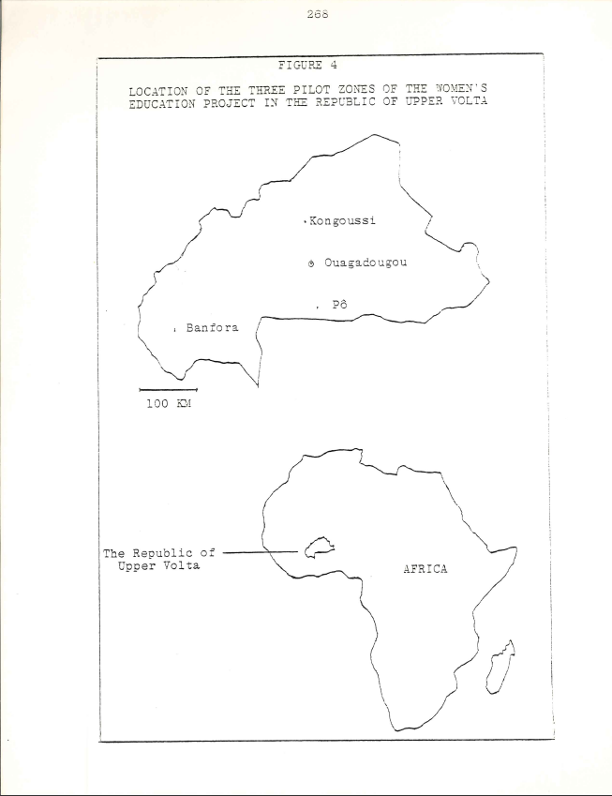

269

Table 29

SOCIOECONOMIC PROFILE OF THE REPUBLIC OF UPPER VOLTA

Area : 274,200 square kilometers; 106,000 square miles
Political status : Independent since 5 August 1960
Demographic data:
Population: 6.1 million; of which resident population 5.6 million (December 1975 general population census)
Population growth rate: 2.1% (1962-1971)
Infant mortality rate (per 1,000 live births); 139.7 (1960-1961 estimate) Life expectancy at birth: 35 year estimate based on 1965-1970)
Economic Data:
GNP: 629.9 million U.S. S (1975 estimate, at market prices)
GNP per capita: 103 U.S. S (1975 estimate)
Main exports: livestock and livestock products (45%) cotton (ginned) and cotton seed 20%); vegetable oils (15%)
Main imports: machinery, vehicles, spare parts; chemical products; food stuffs, beverages and tobacco; manufactured goods.
Major development constraints; rainfall deficits, poor soils, distance from the sea, Uneven population distribution.

Economic potentialities: integrated rural development projects (increased subsistence and export crop production); resettlement of the volta valleys, following control of the onchocerciasis vector (increased agricultural production); livestock development; irrigation programs (complementary food production); reform of education (combining production with training)

Social indicator:
Wage employment (mid –1970’s): 41,609 (0.7% of the total population: 1.4% of the active population, 14 to 60 years)

Health (1970):
Population per physician 92,760
Population per nursing person 4,230
Population per hospital bed 1,670

Education:
Formal education: Male Female Total
Adjusted primary school enrollment ratio 11.25% 7.91% 9.58%
Adjusted secondary school enrollment ratio 1.17% 0.31% 0.82%

Unadjusted third level enrollment ratio .. .. 0.05%
Esti mated adult literacy(15 years and over) Male Female Total
1962 2% 1% 1.5%
1975 .. .. 5.0%
Radio receivers per 1.000 population:
1960 - 1
1965 – 10
1970 – 16
1975 – 17

270

Development planning;
Plan Cadre, 1967-1970 and Five-Year Plan for Economic and Social Development, 1972-1976 Emphasis on development of rural production.

Five-Year Plan for 1977-1981: Rural development and water management designated as first priority: education (reform of education and training in function of a community development option and a new employment strategy) second priority (source : Republique de Haute – Vita, Oresudebce de ka Republique Criculaire No. 75/017/PRES/PL/DR/ET, 9 Decembre 1975).
____________________________

. . .Data not available

Sources: Statistical Directorate, Ministry of Planning : National Office
for the Promotion of Employment : UNDP : World Bank :UNESCO:
WHO Representative in Upper Volta.

271

TABLE 30
SOCIOECONOMIC PROFILE OF THE KONGOUSSI ZONE

Geographic situation of Kongoussi, main town of the sub-prefecture of Kongoussi: l12 kilometers north of the capital, Ouagadouou (unpaved road)

Population (source. 1975 census):
Kongoussi sub-prefecture
Total: 145.767
Male: 70.761
Female. 76.006
Town of Kongoussi
Total. 3.809
Male: l.878
Female: 1.931
Ethnic groups:
Predominant group: Mossi
Others: Ful1ni, Si1mi-Mossi. Yarse
Principal crops:
Subsistence: millet, red and white sorghum. beans
Cash: cotton, peanuts. market garden produce ( favored
by the presence of a lake)
Livestock (estimates):
Goats. 230.000
Sheep: 180.000
Cattle. 110.000
Donkeys: 1,700
Horses: 400

Agricultural equipment:
Irrigation pumps
Plows
Carts

Facilities/services:
Ministry of Rural Development program for community development/ agricultural extension agents
Ministry of National Education Project for Equal Access of Women and Girls to Education imonitresses
Health infrastructure: health centers. maternity clinics.

Miscellaneous:
Dramatic water problem except for the town of Konioussi and
those villages situated on the lake.
__________________________

Sources: Zone monograph prepared by Camille Kabor, survey supervisor, based on ~lin1stry of Rural Development's Regional Development Orian1zatio~ (ORD) reports and information furnished by Women's Education Project and ORD personnel; Statistical Directorate. Ministry of Planning.
272

TABLE 31

Geographic Situation: 130 kilometers north of the capital, Ouagadougou (unpaved road): 18 kilometers north of Kongoussi, main town of the sub-prefecture

Population (source: 1975 census).
Total: 652
Male: 323
Female: 329

Ethnic groups (estimates):
Mossi (excluding Mossi blacksmiths) .70 percent
Mossi blacksmiths: 25 percent
Yarse: 5 percent

Religions:
Traditional (majority)
Islam (important minority)
Catholic (small minority)

Major crops .
Subsistence: millet, sorghum, groundnuts; some rice and beans Cash: Cotton, peanuts. sesame: vegetables (green beans, potatoes onions, tomatoes. carrots, cabbage, etc. )

Livestock:
Sheep, goats, poultry: Cattle confided to the Fulani

Dry season activities:
Market-gardening; weaving (straw. cloth), pottery: house repair

Faci1ities/services:
Agricultural extension agent -1958
Dispensary (nurse) -1960
Maternity clinic (midwife) -1961
Primary school (grades 1 to 3, 3 teachers) - 1962
Women's Education Project (2 monitresses) -1968

Miscellaneous.
High migration among youth: youth club since 1973
Heavy reliance on traditional medicine, owing to paucity of supplies
at the dispensary
Several trading stalls.

__________________________________

Sources: Village monograph prepared by the survey supervisor, Camille Kabore, in consultation with the village authorities; supplementary information furnished by Yambenogo Ouedraogo and Joseph Ouedraogo; Statistical Directorate, Ministry of Planning.
273

TABLE 32

SOCOECONOMIC PROFILE VILLAGE OF BAYEND-FOULGO

Geographic situation: 124 kilometers north 0! the capital. Ouagadougou
(unpaved road); 12 kilometers north ot Kongoussi, main town of the sub-
prefecture; 6 kilometers south ot Zimtenga

Population (source: 1975 census)
Total: 462
Male: 232
Female: 230

Ethnic groups (estimate):
Mossi: 100 percent

Religions:
Traditional (majority)
Islam (important minority) Catholic (small minority)

Major Crops:
Subsistence: millet, sorghum. corn: some beans, groundnuts, rice
Cash: peanuts, cotton, sesame; absence of market gardening

Animal husbandry.
Sheep, goats, cattle, donkeys; recent introduction of pigs; poultry

Dry season activities:
Weaving (cloth, straw): house repair

Facilities/services:
(Dependent upon the chief village the canton, Zimtenga)

Miscellaneous:
High migration to the Ivory Coast, often for a duration
of two to five years
Presence of a catechist and a local chapter of the Red
Cross
Two trading stalls
Two wells (greatly alleviating the-after problem), the
first drilled with the assistance the Catholic
mission; toe second. with the assistance of the Peace
Corps
Serious drain on the nearby wood supply by Kongoussi
residents.

__________________________

Sources: Village monograph prepared by the survey supervisor, Camille
Kabore. in consultation with the village authorities; Statistical
Directorate, Ministry of Planning.

APPENDIX II
RESEARCH MATERIALS

This appendix contains the program for the enumerator
training course conducted by the Director of the Voltaic
Scientific Research Center, and the questionnaires by which
data reported in the study was generated. Four of the
questionnaires (Ql, Q4, Q5, Q6) were utilized by the enu-
merators to conduct interviews with respondents in the
twelve survey villages. Questionnaire 1 was administered
to all women in the survey villages. Questionnaire 4 and
questionnaire 6 were administered to thirty women consti-
tuting the sample in each village, and to women leaders.
Questionnaire 5 was administered to husbands of women in
the village samples, and to the chiefs and elders of the
twelve survey villages. Two of the questionnaires (Q2,
Q3) were completed by the Women's Education Project moni-
tresses. A sample time-budget form and the schedule for
the less structured interviews are presented in chapter two.

274
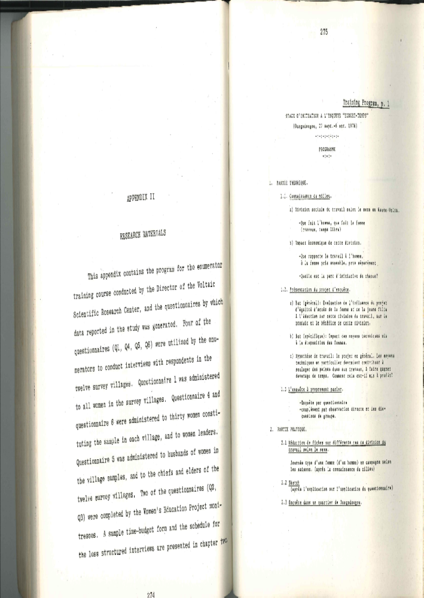
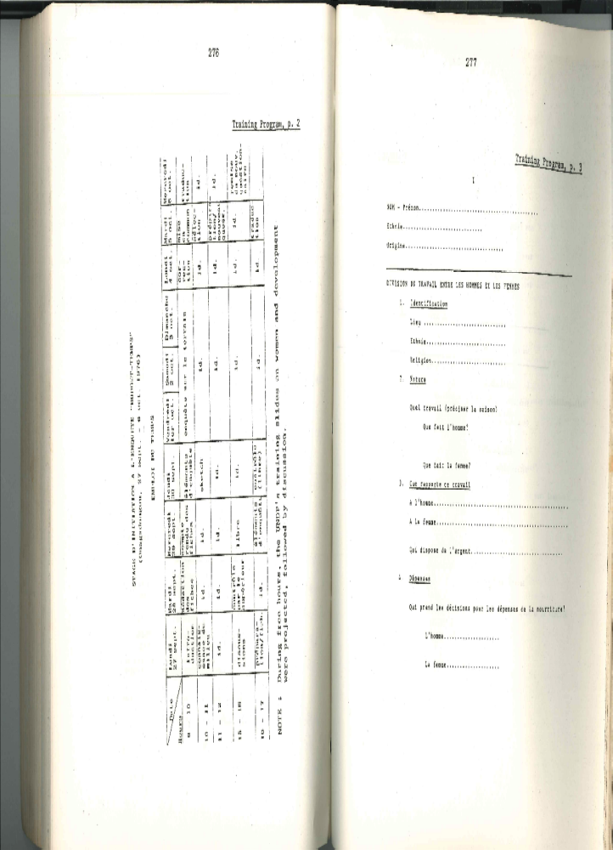
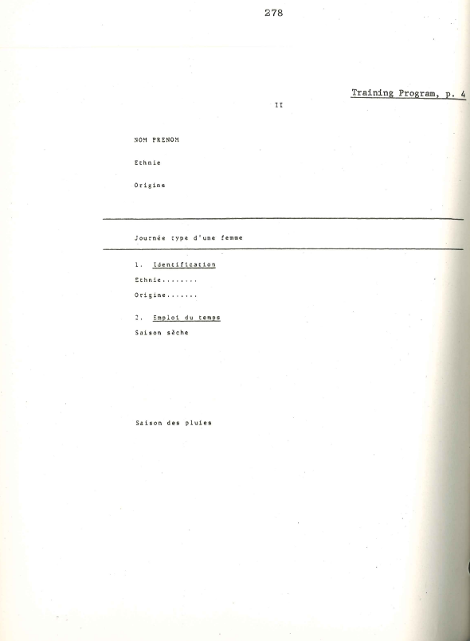
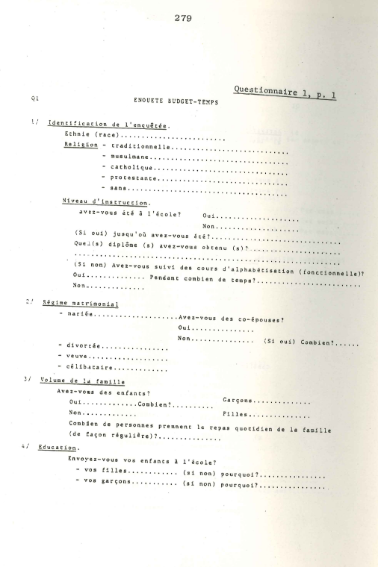
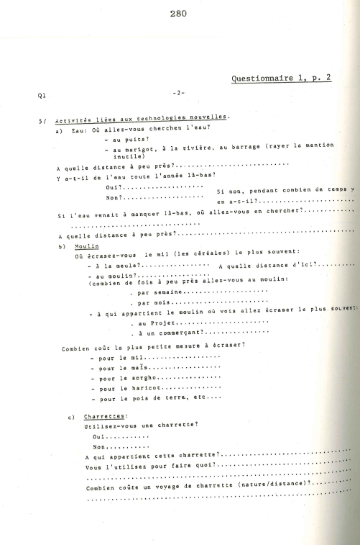
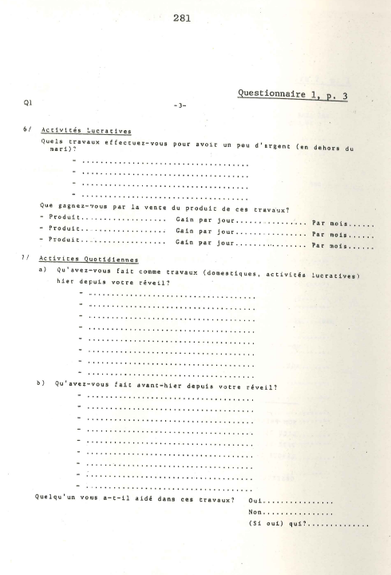
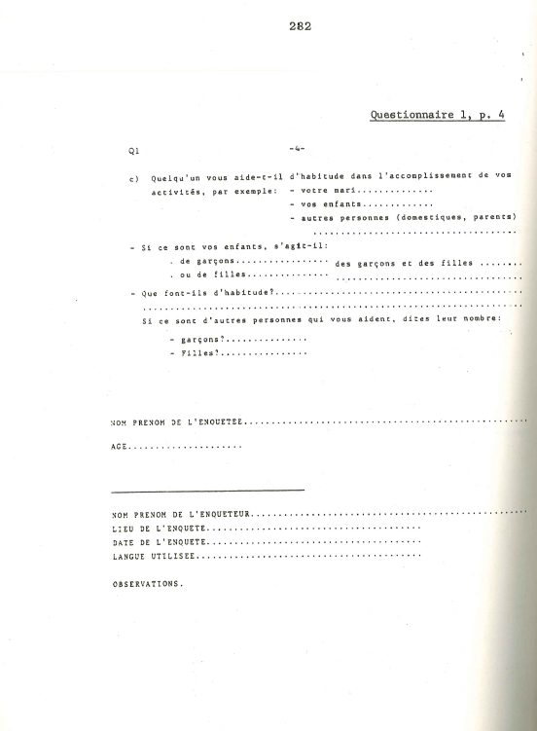
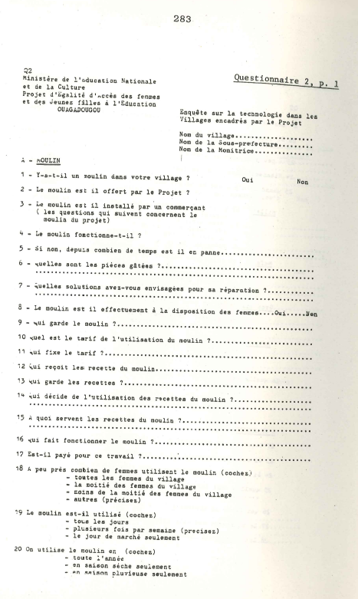
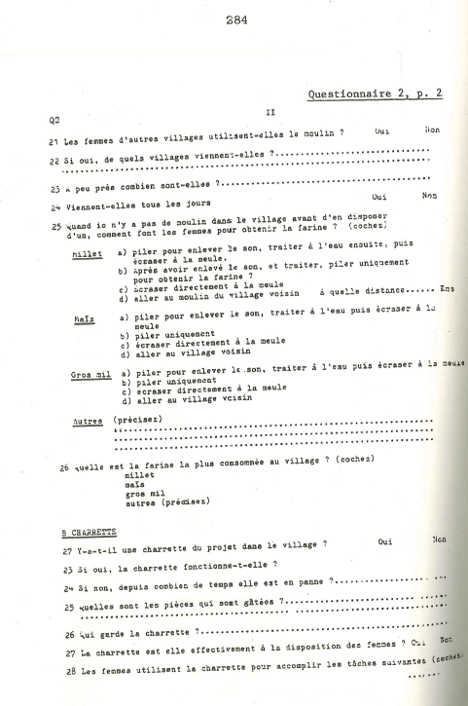
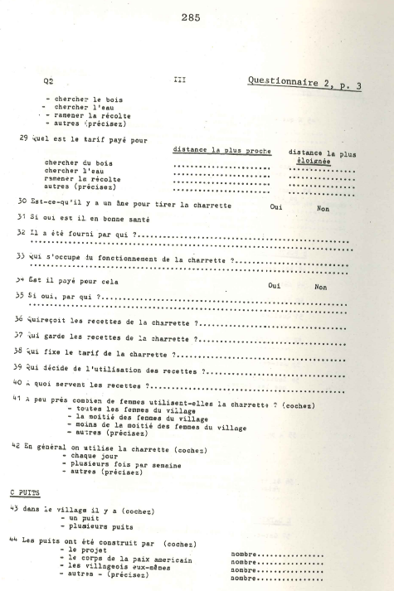
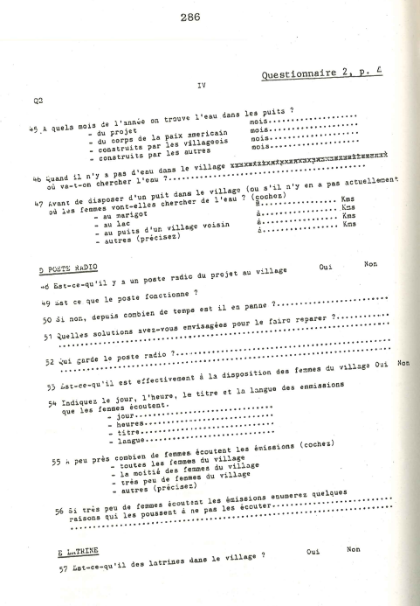
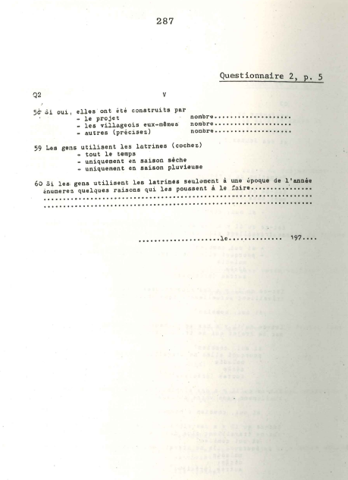
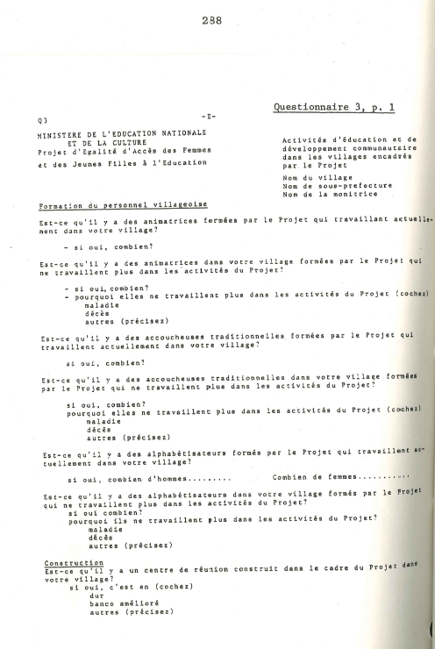
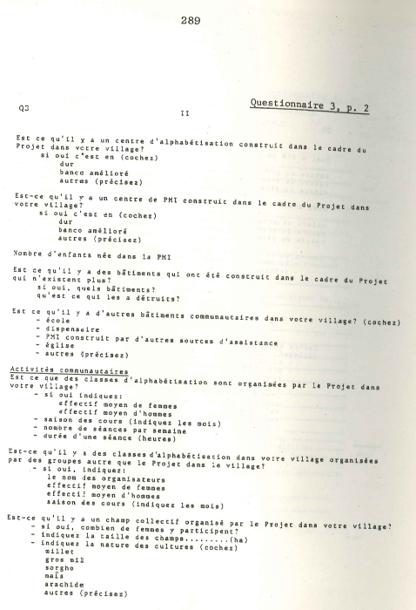
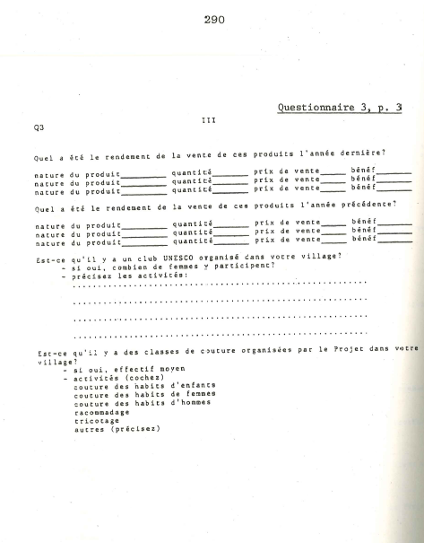
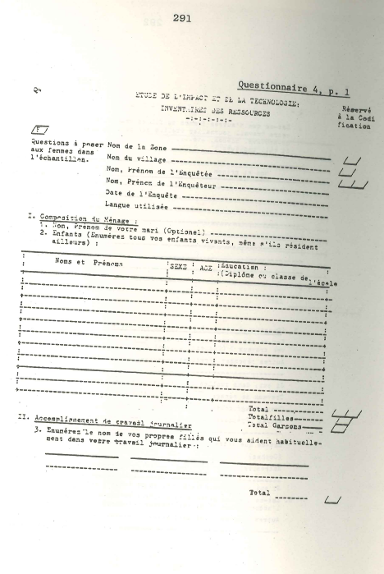
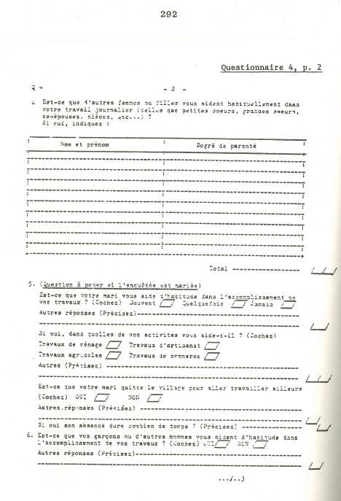
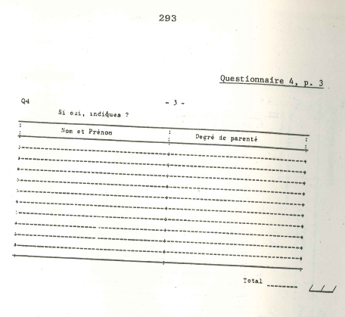

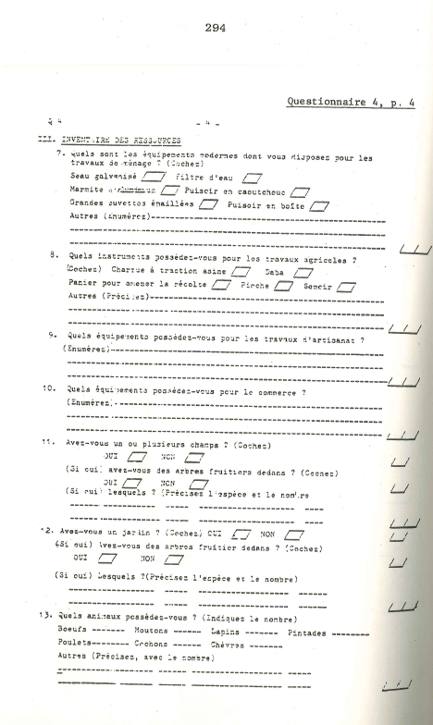
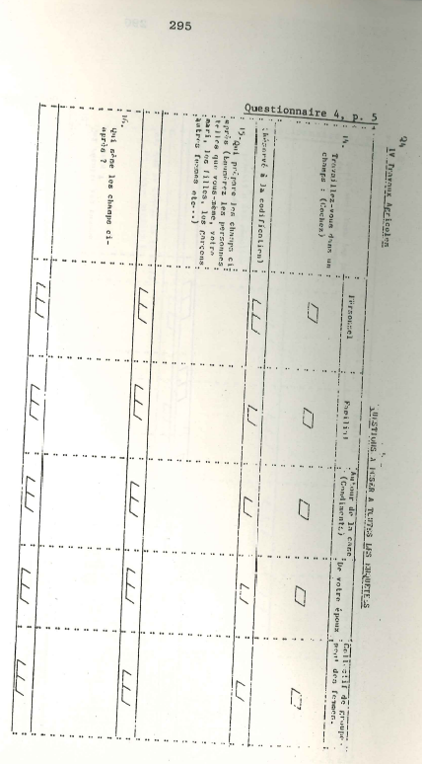
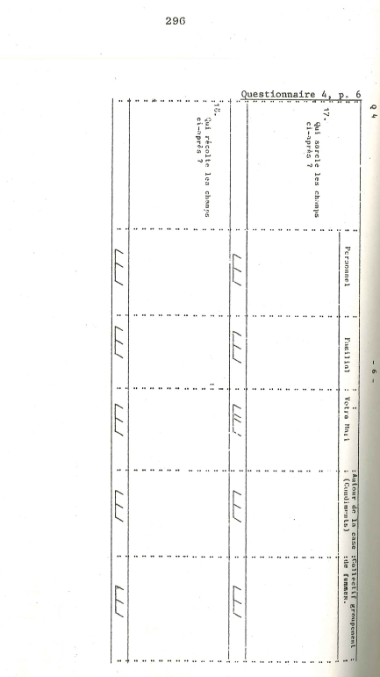
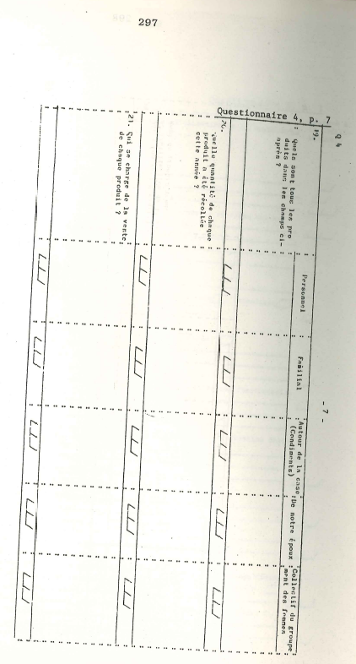
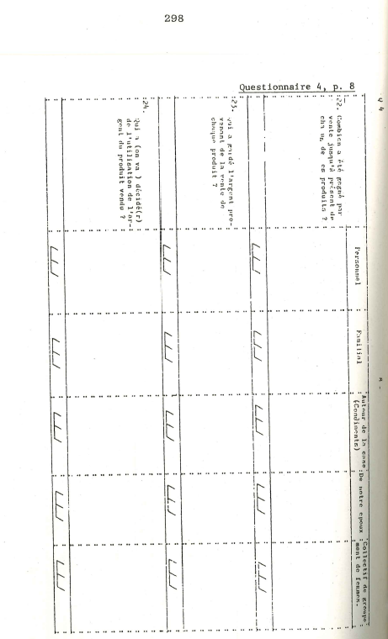
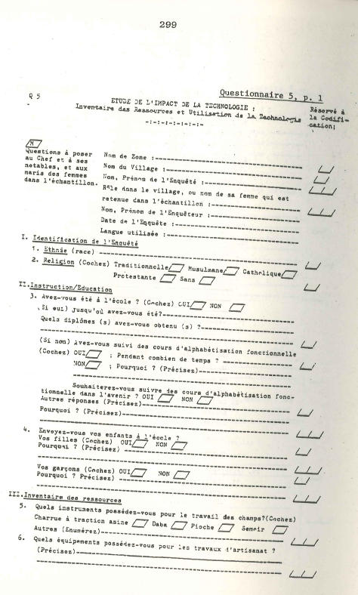
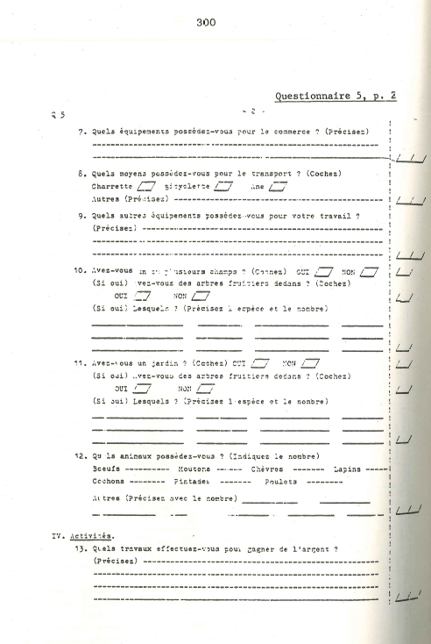
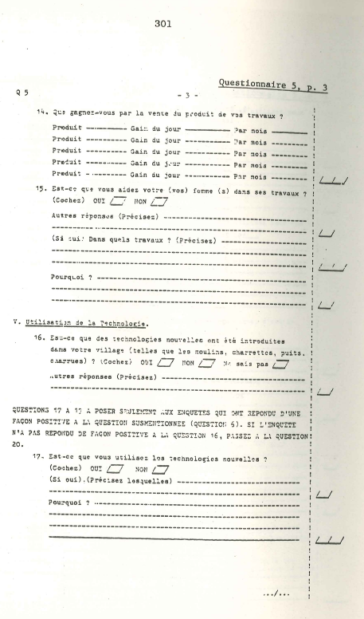
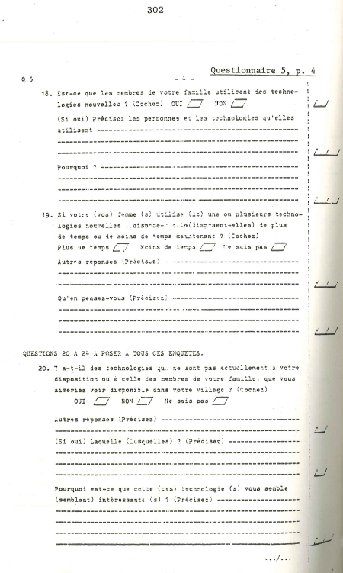
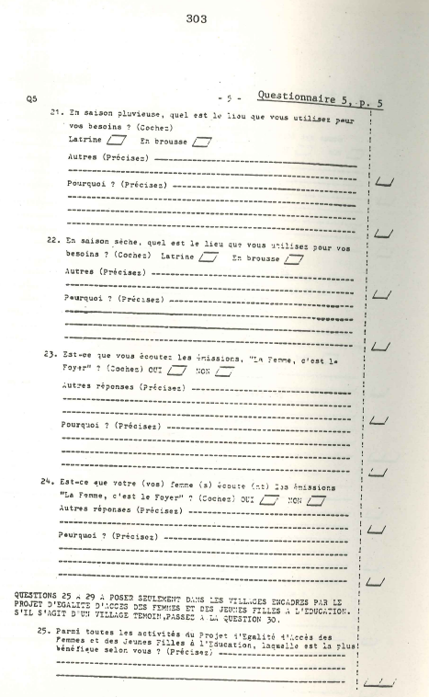
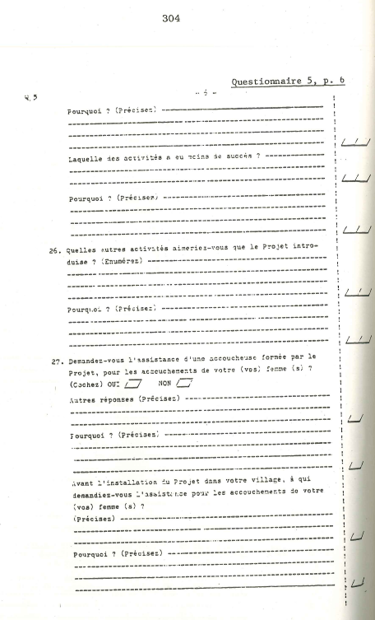
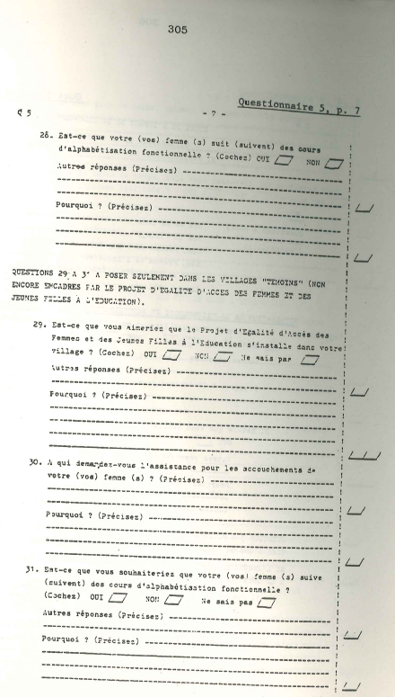
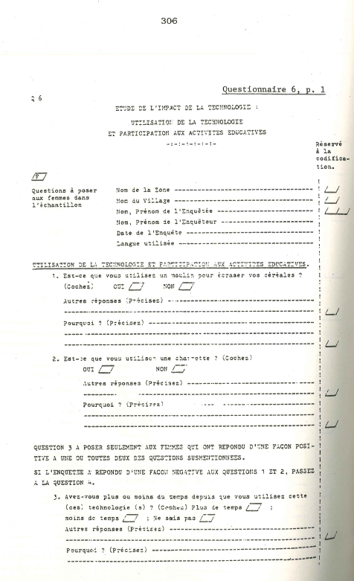
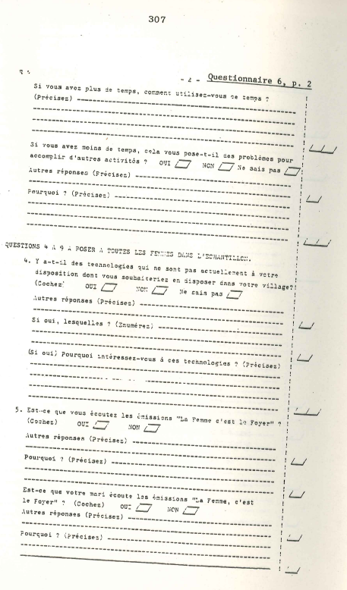
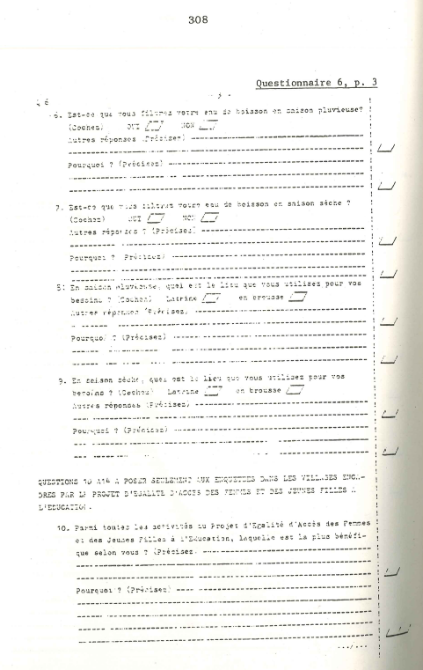
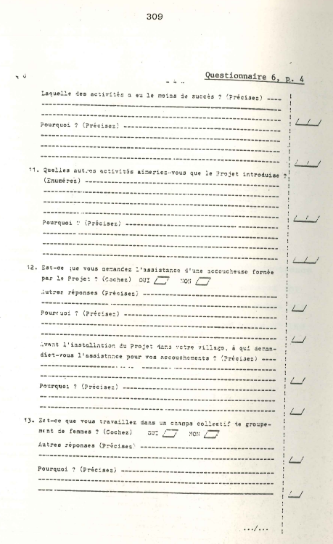
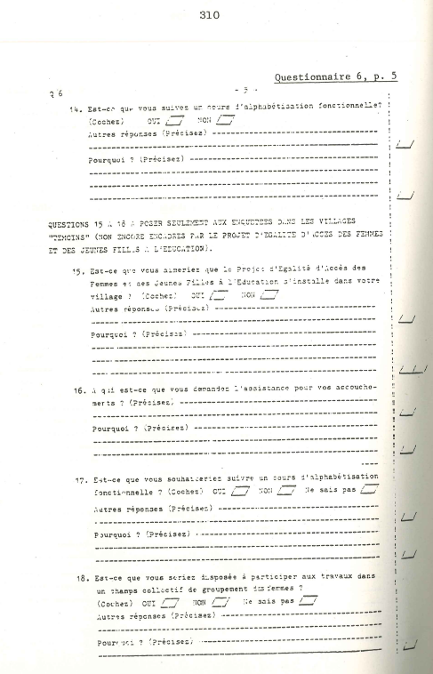

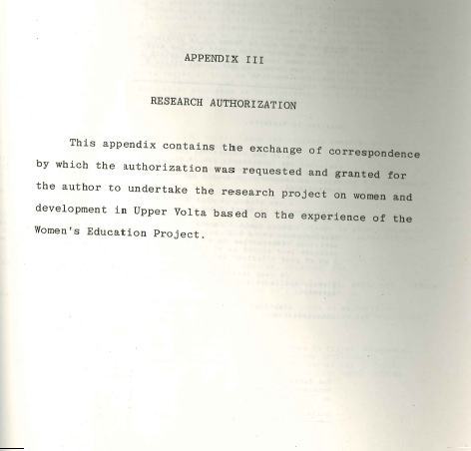

311
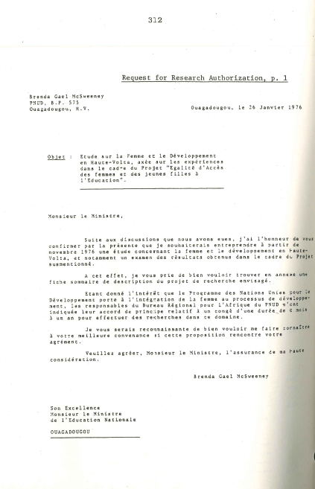
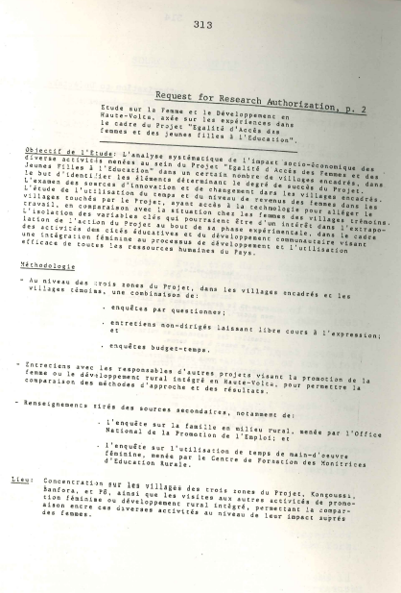
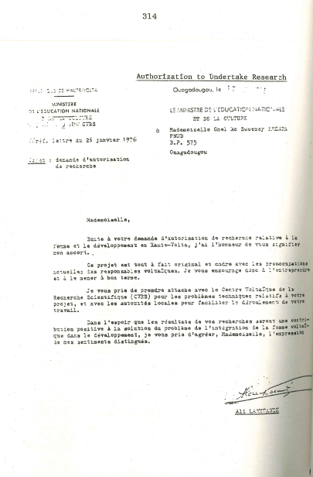
SOURCES CONSULTED

Abanon, Agoubaoui. Pô zone enumerator, Women's Education Project study, Republic of Upper Volta. Series of debriefing interviews, October 1978.
Adouabou, Gérard. Pô zone Director, Project for Equal Access of Women and. Girls to Education, Republic of Upper Volta. Interviews, 23-24 May 1978.
Ahmed, Manzoor and Coombs, Philip H., eds. Education for Rural Development: Case Studies for Planners. Praeger: New York, 1975.
Balima, Albert Salfo. Génèse de La Haute-Volta. Ouagadougou: Presses Africaines [circa 19721.
Bassolet, François Djoby. Evolution de La Haute-Volta de 1899 au 3 Janvier L966. Ouagadougou: Imprimerie Nationale de la Haute-Volta, 1968.
Becker, Gary S. "A Theory of the Allocation of Time. I' Economic JournaL, vol. 75, no.229 (September 1965), pp.493-517.
Belem, Elisabeth. Monitress, Project for Equal Access of Women and Girls to Education and wife of the chief, village of Zimtenga, Kongoussi zone, Republic of Upper Volta. Interview, 22 March 1978.
Boserup, Ester. Conditions of Agricultural Growth: The Economics of Agrarian Change Under population Pressures. New York: Aldine, 1965.
Boserup, Ester. Preface to Women and NationaL Development: The Complexities of Change, pp. xi-xiv, Wellesley College Editorial Committee. Chicago: University of Chicago Press, 1977.
Boserup, Ester. Woman's Role in Economic Development. New York: St. Martin's Press, 1970.
Boserup, Ester and Liljencrantz, Christina. Integration of Women in Development: Why, When, How. New York: United Nations Development Programme, 1975.
Boulding, Elise. "Productivity and Poverty: Problems in Measurement for Third World Women." Paper presented at the International Center for Research on Women Workshop, 30 April-2 May 1978.

315
316

Boutellier, J.-L. “Les Structures foncieres en Haute- Volta.11 Etudes Voltaïques, Nouvelle Serie, Memories no.5 (1964), pp. 1-181.
Buvinic, Mayra, with Anwy1, Pandora; Mart in, Luann; and Sebstad, Jennefer. "Behind the Scenes: A Content Analysis of the Interviews." Annex A in Third World Women Speak Out, pp. 129-48, by Perdita Huston. New York: Praeger, 1979.
Byerlee, Derek and Eicher, Carl K. Rural Employment-, Mi- gration and Economic Development: Theoretical Issues and Empirical Evidence from Africa. African Rural Employment Paper no. I. East Lansing, Michigan: Michigan State University, September 1972.
Camara, Adama. Traditional midwife, village of Fabedougou, Banfora zone, Republic of Upper Volta. Interview, 19 January 1978.
Cain, Mead. “The Economic Activities of Children in a Village in Bangladesh." Population and Development Review~, vol. 3, no.3 (September 1977), pp. 201-27.
Cain, Mead. "Household Time Budgets,” Village Fertility Study Report no. 1 (draft), Bangladesh Institute of Development Studies, February 1977.
Chabaud, Jacqueline. Education et promotion de la femme. Paris: UNESCO, 1970.
Cloud, Kathleen. "Sex Roles in Food Production and Food Distribution Systems in the Sahel. Paper prepared for the United States Agency for International Development, 15 December 1977.
Collinson, Michael. "Area Preparation: A Vital Exercise. I' In Field Data Collection in the Social Sciences: Experiences in Africa and the Middle East, pp. 50-51. Edited by Bryant Kearl. New York: Agricultural Development Council, 1976.
Comby, Bernard. Analyse prospective de la consummation d'eau en Haute-Volta. Ouagadougou: Ministere du Developpement Rural, Juin 1976.
Coombs, Philip H. "Opportunities for New Collaboration on Rural Education and Development by International Agencies." Presented at the Third Session of the Joint FAO/UNESCO/ILO Advisory Committee on Agricultural Education, Science, and Training, Paris, 3-8 December 1973.

317

Dacher, M. L 'Egalite d'accès à l'éducation des femmes et des jeunes filles, Décembre 1969-Janvier 1971. Paris: UNESCO, Juin 1971.
Dakoure, Antoine. Minister of Planning, Rural Development, ~ Environment and Tourism; Republic of Upper Volta. ,~ Interview, 22 January 1976.
Damiba, Aimé. Director of Educational Planning, Ministry of National Education, Republic of Upper Volta. I' Interview, 17 January 1976.
Damiba, Aimé and Tontorogobo, Ousmane. “Les Pierres attente d'une éducation de masse pour le développement rural.” Paper presented at the Seminar on the Role of Education in Rural Development, 21-31October "-1975.

de Lattre , Anne. Problèmes d’enseignement et d’éducation (n Notes sur certaines experiences en cours dans quatre ays francophones d'Afrique Noise. Lagos: The Ford" Foundation, 1970.
Delgado, Christopher L. "Livestock Versus Food Grain Production in Southeastern Upper Volta: A Resource Allocation Analysis." Ph.D. dissertation, Cornell University, 1978.
de Wilde, John C. assisted by McLoughlin, Peter F.M.; Guinard, Andre; Scudder, Thayer; and Maubouche, Robert. Experiences with Agricultual Development in Tropical Africa. 2 vols. Baltimore, Maryland: The Johns Hopkins Press, 1967.
Diop, Sira. "L'Accès de la femme africaine à l'éducation en milieu rural. " [1974].
Djukanovic, V. and Mach, E.P., eds. Alternative o Meeting Basic Health Needs in Develop ries: A Joint UNICEF/WHO Study. Geneva: earth Organization, 1975.
Elliott, Carolyn M. "Theories of Development: An Assessment." In Women and National Development: The Complexities of Change, pp. 1-8. Wellesley College Editorial Committee. Chicago: University of Chicago Press, 1977.
Experimental World Literacy Progamme: A Critical Assessment. Paris: The UNESCO Press and UNDP, 1976.
Fall-Ba, Oulimata. Frojet expérimental d'égalité d'acces des femmes et des jeunes filles à l’éducation: Juillet 1967-Juillet 1971. Paris: UNESCO, Juin 1972.
318
Fal1-Bâ, Oulimata, "Résumé du rapport de fin de mission: Project expérimental d'égalité d'accès des femmes et des jeunes filles à l'éducation." [Ouagadougou, 1971.]
Fonseca, Claudia. "Alphabétisation fonctionnel1e des villageoises: Une expérience en Haute-Volta." Perspectives, vol. 5, no.3, 1975.

Fonseca, Claudia. "Egalité d'acces des femmes et des
jeunes files à l'éducation, November 1971-novembre 1972. "
Gronau, Reuben. "Leisure, Home Production, and Work -The Theory of the Allocation of Time Revisited." National Bureau of Economic Research Working Paper no. 137 (May 1976).
Hammond, Peter B. .Yatenga: Technology in the Culture of a West African Kingdom. New York: Free Press, 1966.
Harbison, Frederick H. A Human Resources Approach to the Development of African Nations. Washington, D.C.: Overseas Liaison Committee of the American Council on Education, 1971.
Harman, David. "Development of a Community-Based System of Fundamental Education and Its Application to an Israeli Village." Ph.D. dissertation, Harvard University, 1971.
Huston, Perdita. Third World Women Speak Out.: Interview in Six Countries on Change, Development, and Basic Needs. Foreword by Arvonne Fraser. New York : Praeger, 1979.
"Institut National d'Education: Document d'Assistance Préparatoire," Project du Government de la Haute-Volta/ PNUD/UNESCO, Octobre 1976.
Jéquier, Nicolas, ed. Appropriate Technology: Problems and Promises. Paris: Organization for Economic Cooperation and Development, 1976.
Kaboré, Monique. Monitress, Project for Equal Access of Women and Girls to Education, village of Zoagha and surroundings, east of the Pô zone, Republic of Upper Volta. Interview, 17 May 1978.
Kam, G. CH. "Exposé introductif: Situation de l'emploi en Haute-Volta." Séminaire national sur l'emploi et la formation. Ouagadougou: République de Haute-Volta, Ministère de la Function Publique et du Travail, Office National de la Promotion de l'Emploi/BIT, 1977.
319

Kearl, Bryant, ed. Field Data Collection in the Social Sciences: Experiences in Africa and the Middle East. New York: Agricultural Development Council, 1976.

Kebede, Hanna, with Abate, Dejen: and Fesseha, Tsengaye. "Improving Village Water Supplies in Ethiopia: A Case Study of the Socio-Economic Implications." [Addis Ababa: UNECA/UNICEF, circa 1977].

Kidd, J. Ruby. Whilst Time Is Burning: A Report on Education for Development. Ottowa: International Research Centre, 1974.

Kompaoré, Scholastique. "La coopération technique entre pays en développement dans le cadre d'un programme d'education pour l'intégration des femmes au processes de développement: le Projet d'égalité d'accès des femmes et des jeunes filles à l'éducation en Haute-Volta" [Ouagadougou, 1978].

Kompaoré, Scholastique. "Enquête sociologique à Pô (Haute-
Volta) en vue de 1 'implantation du Projet pilot d'égalité d'accès des femmes et des jeunes filles à l'éducation." Rapport préliminaire; rapport final. [Ouagadougou, circa 1972].

Kompaoré, Scholastique and McSweeney, Brenda Gael. "The Impact of Intermediate Technology on the Integration of Women in the Development Process" (forthcoming). Report being prepared for the United States Agency for International Development.

Konaté, Mariam. Banfora zone Director, Project for Equal Access of Women and Girls to Education, Republic of Upper Volta. Series of interviews, May 1978.

Lallemand, Suzanne. "Une famille mossi." Thèse de 3ème cycle, Université de Paris, année scolaire 1971-1972.

Lallemand, Suzanne. Projet d'accès des femmes à l'éducation. (Mai 1968-Mai 1969; Mars 1970.) Paris: UNESCO, Novembre 1971.

Lallemand, Suzanne. "Rapport de mission du 30 Avril au
15 Juin 1968 (Projet d'accès des femmes voltaïques à l'éducation)." [Ouagadougou,1968].

320

Lallemand, Suzanne. "Repport de mission du 15 Juin au ler Août 1968 (Projet d'accès des femmes à l'éducation).” [Ouagadougou,1968].

Lallemand, Suzanne. "Rapport de mission du ler Août au 15 Septembre 1968 (Projet d’accès des femmes à l' éducation).” [Ouagadougou, 1968].

Lallemand, Suzanne. "Rapport de mission du 15 Septembre au 1 Novembre 1968 (Projet d’accès des femmes à l'éducation. " [Ouagadougou, 1968].

Lallemand, Suzanne. "Rapport de mission du 15 Decembre au 31 Janvier 1969 (Projet d'égalité d'accès des femmes à l' éducation) ." [Ouagadougou, 1969].

Lankoandé, Ali. Minister of National Education, Republic of Upper Volta. Interview, 24 January 1976.

Loose, Edna. "Women in Rural Senegal: Some Economic and Social Observations." Paper prepared for the Workshop of Sakhalin Agriculture, Purdue University, 1-2 February 1979.

McGrath, Patricia L. The Unfinished Assignment: Equal Education for Women, Worldwatch Paper 7. Washington; D.C. : Worldwatch Institute, July 1976.

McLoughlin, Peter F.M., ed. African Food Production Sys-
tems: Cases and Theory. Baltimore, Maryland: The Johns Hopkins Press, 1970.
[McSweeney, Brenda Gael, Rapporteur] ."Report of the First Meeting of the United Nations Interagency Working Group on the Integration of Women in Development in Africa (Addis Ababa, 30-31 March 1978)."
McSweeney, Brenda Gael and Kompaoré, Scholastique. "African Women in Rural Development: The Role of Women in Development in Upper Volta." Paper presented at the Seminar on Women in Rural Development in Africa: Implications for Donor Organizations, sponsored by the Overseas Liaison Committee of the American Council on Education, Washington, D.C., 23-25 April 1976.
Martin-Samos, F. La santé publique en Haute-Volta: Situation actuelle (1976). Ouagadougou: 6 Mars 1977.
Martin-Samos, F. La santé publique en Haute-Volta: Profil sanitaire. Ouagadougou, 1976.
321

Mbilini, Marjorie. "Maintaining Acceptability Throughout the Comrnunity." In Field Data Collection in the Social Sciences: Experiences in Africa and the Middle East, pp. 54-55. Edited by Bryant Kearl. New York: Agricultural Development Council, 1976.
Minge-Klevana, Wanda. "Does Labor Time Decrease with In- dustrialization? A Theoretical and Methodological Survey of 38 Time Allocation Studies from Pre-Industrial and Post-Industrial Societies." [Cam- bridge: J Harvard University [circa 1978].
Nag, Moni; White, Benjamin N.F.; and Peet, R. Creighton. "An Anthropological Approach to the Study of the Economic Value of Children in Java and Nepal." Current Anthropology, vol. 19, no.2 (June 1978), pp. 293-306.
L'Observateur (Ouagadougou), 6ème année, no. 1366, 31 Mai 1978.
Ouédraogo, Barthélemy. "Situation de l'emploi dans le secteur public au 31/12/75." Séminaire national sur l'emploi et la formation, Ouagadougou: République de Haute-Volta, Ministère de la Fonction Publique et du Travail, Office National de la Promotion de l'Emploi/BIT, 1977.
Ouédraogo, Barthélemy. ."Situation et perspectives de l'emploi dans le secteur privé." Séminaire national sur l'emploi et la formation. Ouagadougou: République de Haute-Volta, Ministère de la Fonction Publique et du Travail, Office National de la Promotion de l'Emploi/BIT, 1977.
Ouédraogo, Gabriel. Kongoussi zone Director, Project for Equal Access of Women and Girls to Education, Republic of Upper Volta. Interview, 13 February 1978.
Ouédraogo, Gabriel; Kalmogho, Felix; and Kalmogho, Martine. Kongoussi zone team, Project for Equal Access of Women and Girls to Education, Republic of Upper Volta. Interview, 22 March 1978.
Ouédraogo, Habibou. Head of the women's group of the village of Zimtenga (Kongoussi zone), Republic of Upper Volta. Interview, 1 March 1978.
Ouédraogo, Joseph. Kongoussi zone enumerator, Women's Education Project study, Republic of Upper Volta. Series of debriefing interviews, November 1978.

322

Ouédraogo, Madeleine. Kongoussi zone enumerator, Women's Education Project study, Republic of Upper Volta. Series of debriefing interviews, November 1978.

Pacere, Tintinga Frederic. La famille voltaïque en crise. Ouagadougou: Imprimerie Nationale, 1975.

Pala, Achola O. African Women in Rural Development: Research Trends and Priorities. Washington, D.C.: overseas Liaison Committee of the American Council on Education, December 1976.

Pala, Achola O. "Definitions of Women and Development: An African Perspective.” In Women and National Development: The Complexities of Change, pp. 9-13. Wellesley College Editorial Committee. Chicago: University of Chicago Press, 1977.

Papanek, Hanna. "Development Planning for Women.” In Women and National Development: The Complexities of Change, pp. 14-21. Wellesley College Editorial Committee. Chicago: University of Chicago Press, 1977.
Population of the village of Bayend-Foulgo, Kongoussi zone Republic of Upper Volta. Interview, 16 September 1977.
Population of the village of Bayend-Foulgo, Kongoussi zone Republic of Upper Volta. Interview, 1 March 1978.
Population of the village of Kora, Kongoussi zone, Republic of Upper Volta. Interview, 17 September 1977.
Population,of the village of Kora, Kongoussi zone, Republic, of Upper Volta. Interview, 4 January 1978.
Population of the village of Loulouka, Kongoussi zone, Republic of Upper Volta. Interview, 17 September 1977.
Population of the village of Loulouka, Kongoussi zone, Republic of Upper Volta. Interview, 6 January 1978.
Population of the village of Tôrem, Pô zone, Republic of Upper Volta. Repeated meetings and interviews, 1976-1978.
Population of the village of Zimtenga, Kongoussi zone, Republic of Upper Volta. Interview, 16 September 1977.

323

Population of the village of Zimtenga, Kongoussi zone, Republic of Upper Volta. Interview, 5 January 1978.
Raper, Arthur F. assisted by Case, Harry L.; Niehoff, Richard O.; Ross, William T.; and Schuler, Edgar A. Rural Development in Action: The Comprehensive Experiment at Camilla, East Pakistan. Ithaca, New York: Cornell University Press, 1970.
"Rapport d’ évaluation nationale du Projet expérimental UNESCO/Haute-Volta d'égalité d'accès des femmes et des jeunes filles à l'éducation." Ouagadougou: Ministère de l'Education Nationale, 9 Février 1974.
Rapport du séminaire opérationnel régional d'alphabétisation fonctionnelle sur la place de la femme et son rôle dans le développement économique et social de l'Afrique, 10-28 Novembre 1975. Banfora, Haute-Volta: Projet Haute-Volta/UNESCO, 1975.
"Rapport des travaux de groupe sur l'emploi salarié dans le secteur privé." Séminaire national sur l 'emploi et la formation. Ouagadougou: Republique de Haute-Volta, Ministère de la Fonction Publique et du Travail, Office National de la Promotion de l'Emploi/BIT, 1977.
République de Haute-Volta. Ministère de l'Education Nationale. "Données succinctes sur l'évolution de l'éducation en Haute-Volta, 1973-1975." Ouagadougou, Ministere de l'Education Nationale, 18 Août 1975.
République de Haute-Volta. Ministère de l'Education Nationale et de la Culture. Projet Haute-Volta/UNESCO d'acces des femmes et des jeunes filles à l'éducation: Phase expérimentale 1967/1976. [Ouagadougou: Ministère de l'Education Nationale et de la Culture, 1976] .
République de Haute-Volta. Ministère de l'Education Nationale et de la Culture, Direction de la Planification. Réforme de l'Education: Dossier Initial. Ouagadougou: Ministère Nationale et de la Culture [circa 1975] .
République de Haute-Volta. Ministère de l'Education Nationale et de la Culture, Direction de la Planification. Séminaire sur le réforme de l'éducation et le développement communautaire. Ouagadougou: Ministère de l'Education Nationale et de la Culture, Janvier 1976.
324
République de Haute-Volta. Plan Cadre 1967-1970, 2 tomes. Paris: Imprimerie ATIT, 1968.
République de Haute-Volta. "Plan d'opération: Projet Expérimental pour l'Egalité d'Accès des Femmes à l' Education." [Ouagadougou, 1968.]
République de Haute-Volta. Présidence de la République Circulaire no. 75/017/PRES/PL/DR/ET portant directives gouvernementales pour la préparation du prochain plan quinquinnel 1977-1981, à tous ministères et services. Ouagadougou, 9 Décembre 1975.
République de Haute-Volta. Présidence de la République,
Décret no. 75/239/PRES/IS/GDI/C. portant dissolution et nomination des délégations spéciales chargées de l'administration des communes de Haute-Volta. Ouagadougou, 23 Juin 1975.
République de Haute-Volta/UNESCO. Projet expérimental "Egalite d'accès des jeunes filles et des femmes à l 'éducation": Document de travail dans le cadre de la participation de l'UNESCO à la célébration de l'année internationale de la femme (1975). Ouagadougou: Ministère de l'Education Nationale, Mai 1974.
Republic of Kenya. Ministry of Finance and Planning, Central Bureau of Statistics. Women in Kenya. [Nairobi], July 1978.
Riesman, Paul. Société et liberté chez les Peul Djelgôbé de Haute-Volta: Essai d'anthropologie introspective. Paris: Mouton, 1974.
Robinson, John. How Americans Use Time: A Social-Psychological Analysis of Everyday Behavior. New York: Praeger, 1977.
Rogers, Everett. Modernization among Peasants: The Impact of Communication. New York: Holt, Rinehart, Winston, 1969.
Rosaldo, Michele Zimbalist and Lamphere, Louise, eds. Women Culture, and Society. Stanford, California: Stanford University Press, 1974.
Sanon, Salia. Permanent Secretary of the Coordinating Committee for Rural Development; Ministry of Planning, Rural Development, Environment and Tourism; Republic of Upper Volta. Interview, 20 January 1976.
325

Sawadogo, Mathieu. Kongoussi zone enumerator, Women's Education Project study, Republic of Upper Volta. Series of debriefing interviews, November 1978.
Sawadogo, Rasmané. Minister of Health and Social Affairs, Republic of Upper Volta. Interview, 5 February 1976.
Schultz, Theodore W. "The Increasing Economic Value of Human Time." American Journal- of Agricultural- Economics, November 1972, pp. 843-50.
Sharpston, M. J. "Health and Development." Journal of Development Studies, vol. 9, no.3, April 1973.
Silverstone, Jonathan. "Participation of Women in Development." A Background Paper on the New Foreign Assistance Act Provision (Percy Amendment). Washington, D.C.: Agency for International Development, 11 February 1974.
Simmons, Emmy. Economic Research and Women in RuraL Development in Northern Nigeria. Washington, D.C.: Overseas Liaison Committee, American Council on Education, 1977.
Simmons, John. "Towards a Technology of Education: Predicting School Achievement in Rural Africa," Economic Development Report no.212. Cambridge, Massachusetts: "Development Resources Group, Center for International Affairs, Harvard University, April 1972..
Skinner, Elliott P. African Urban Life: The Transformation of Ouagadougou. Princeton, New Jersey: Princeton University Press, 1974.
Skinner, Elliott P. The Mossi of Upper Volta: The Political Development of a Sudanese People. Stanford, California: Stanford University Press, 1964.

326

Social Indicators: Problems of Definition and Selection . (Reports and Papers in the Social Sciences, No. 30). Paris: UNESCO, 1974.
Société Africaine d 'Etudes et de Développement. Etude sur les besoins des femmes dans les villages de l 'A.V.V. et proposition d'un programme d'intervention. Ouagadougou: Ministère de Developpement Rural, Avril 1977.
Sock, Boubocar. Projet expérimental d'égalité d'accès des femmes à l'éducation, août-octobre 1972. Paris: UNESCO, Novembre 1972.
Sontie, Sita. Banfora zone enumerator, Women's Education \ Project study, Republic of Upper Volta. Series of debriefing interviews, October 1978.
Spencer, Dunstan S.C. African Women in Agricultural Development: A Case Study in Sierra Leone, African Rural Economy Program Working Paper no. 11. East Lansing, Michigan: Michigan State University, April 1976.
Spencer, Dunstan S.C. Women in a Developing Economy, A West African Case Study (forthcoming).
Stone, Philip J. "The Analysis of Time-Budget Data, " in ~ The Use of Time: Daily Activities of Urban and Suburban Populationss in T~elve Countries, pp. 89-111. ~ Edited by Alexander Szalai et al. The Hague: Mouton, , 1979.
Stone, Philip J. "On Being Up Against the Wall: Women's, Time Patterns in Eleven Countries." In Public Policy. in Temporal Perspective. Edited by W. Michelson. The Hague: Mouton, 1979.
Stone, Philip J. "A Data Frame for Time Budgets, Life , Histories, and Other Event Series." Paper presented . at the IX World Congress of Sociology (1978).
Szalai, Alexander. The Situation of Women in the Light of Contemporary Time-Budget Research. Prepared for United Nations, World Conference of the International Women's Year, Mexico City, 19 June-2 July 1975 (E/CONF.66/BP/6), 15 April 1975.
Szalai, Alexander; Converse, Philip E.; Feldheim, Pierre; Scheuch, Erwin K.; and Stone, Philip J., eds. The Use of Time: Daily Activities of Urban and Suburban Populations in Twelve Countries. The Hague: Mouton, 1972.

327
“Synthèse générale.” Séminaire national sur l’emploi et la formation. Ouagadougou: République de Haute-Volta, Minstère de la Foncion Publique et du Travail, Office National de la Promotion de l’Emploi/BIT, 1977.
Tamini,Gabriel. Linguist/Specialist in Community Development, Project for Equal Access of Women and Girls to Education, Republic of Upper Volta. Series of Interviews, February and May 1978.
Tidébamba, Mrs. Head of the women's group of the village of Douré (Kongoussi zone), Republic of Upper Volta. Interview, 22 March 1978.
Tinker, Irene. "The Adverse Impact of Development on Women." In Women and World Development, pp. 22-34. Edited by Irene Tinker and Michele Eo Eramsen. Washington, D.C.: Overseas Development Council, 1976.
Tinker, Irene and Eo Eramsen, Michele, eds. Women and World Development. Washington, D.C. : Overseas Development Council, 1976.
Tollens, Eric F. "Problems of Micro-Economic Data Collection on Farms in Northern Zaire," African Rural Employment Working Paper No.7, Department of Agricultural Economics, Michigan State University, East Lansing, Michigan, June 1975.
UNESCO Statistical Yearbook. Paris,United Nations Development Programme. Programme Policy and Evaluation Division. "Guidelines on the Integration of Women in Development" (G3100-1, Rev. 0), 25 February 1977.
United Nations. Economic Commission for Africa. "Women: The Neglected Human Resource for African Development." Canadian Journal of African Studies, vol. 6, no.2 (1972).
United Nations. Economic Commission for Africa. The New International Economic Order: What Roles for Women? (E/CN.14/ATRCW/77/WD3), 31 August 1977.
United Nations. Economic Commission for Africa. Origin and Growth of the African Training and Research Centre for Women of the Economic Commission for Africa (E/CN.14/ATRCW/77/BD.7), 5 September 1977.
328
United Nations. Economic and Social Council. Commission on the Status of Women, 23rd Session. Study on Equal Access of Girls and Women to Literacy. Report prepared by the United Nations Educational, Scientific, and Cultural Organization (E/CN.6/538), 13 February 1970.
United Nations. Economic and Social Council, Economic Commission for Africa. The Data Base for Discussion of the Interrelations Between the Integration of Women in Development, Their Situation and Poputation Factors in Africa (E/CN.14/SW/37), 13 May 1974.
United Nations. Research Institute for Social Development. "Testing Scalogram Analysis of Distribution and Change of Levels of Living: Objectives and Research Design." Geneva, August 1976.
United Nations. World Conference of the International Women's Year, Mexico City, 19 June-2 July 1975. The Role of Women in Rural Development (E/CONF.66/BP/11), prepared by the Food and Agriculture Organization of the United Nations, 24 March 1975.
von Lazar, Arpad and Hammock, John C. "Community Development in the Dominican Republic: Summary Reflections on Four Case Studies." Journal of Community Development Society, vol.1, no.2 (Fall 1970), pp. 89-99.
The Wellesley College Editorial Committee. Women and National Development: The Complexities of Change. Chicago: University of Chicago Press, 1977.
Women Education, Equality: A Decade of Experiment. Paris: The UNESCO Press, 1975.
World Bank. Health: Sector Policy Paper. Washington, D.C.: The World Bank, March 1975.
Ziba, Larba. Promoter of the village of Boala, Pô zone, Republic of Upper Volta. Interview, 27 May 1978.

LIST OF ABBREVIATIONS

ATRCW African Training and Research Centre for Women
AVV Autorité pour l’Aménagement des Vallées des
Voltas (Volta Valley Authority)

CVRS Centre Voltaïque de la Recherche Scientifique
(Voltaic Scientific Research Center)

IWY International Women’s Year
MCH Maternal and Child Care
NIEO New International Economic Order
ONPE Office National de la Promotion de l’Emploi
(National Office for Employment Promotion)

ORD Office Régional de Développement
UNDP United Nations Development Programme
UNECA United Nations Economic Commission for Africa
UNESCO United Nations Educational, Scientific and Cul-
tural Organization

UNFAO United Nations, Food and Agriculture Organization
UNICEF United Nations Children’s Fund
UNIDO United Nations Industrial Development Organiza-
tion

UNILO United Nations, International Labour Organiza-
tion

UNITAR United Nations Institute for Training and
Research

UNWHO United Nations, World Health Organization
USAID United States Agency for International Develop-
ment

329

