

Dear Guests

The Peaceful Pelican is on the market, but continues to do business that lives up to the reputation we have established. We continue to build the business and take reservations as usual and will expect the next owners to honor our commitment to you. There is a possibility that the property could sell as a private residence rather than a bed and breakfast, so during this transition period we will not take any deposits for reservations made by phone. Our on-line booking engine automatically takes a night’s deposit, so if you are booking for several months out and have any hesitation, please give us a call to book and we will not take any deposit. We surely anticipate having months to notify you of a sale and to introduce you to new owners or help you find alternative accommodation if necessary.

We thank you for your continued and wonderful support!
Introduction

The Peaceful Pelican Waterfront Bed and Breakfast opened in 2008, in a newly renovated, historic property in the tranquil town of Palacios, Texas, half way between Galveston and Corpus Christi. It has 5 guest rooms all with private baths, each with a claw foot tub and separate shower. The clientele is mostly couples from Houston, Austin, and San Antonio stealing a weekend away to celebrate a special occasion or just to wind down by rocking on the porch and watching the water and exploring the beaches and seawall.

The real estate is for sale along with all furniture, furnishings, and accessories, (except some personal items that the present owners have temporarily contributed to the business). Also included are the computer with its property management and financial management software, the credit card set up, website, memberships, client list, general goodwill, and Pearl, the Peaceful Pelican, bronze statue that graces the entrance to the driveway. The asking price is $465,000.

The Business

- Opened 2/14/08
- Occupancy rate 27.13%
- Average Daily Rate $126.96
- Revenue from 2/14/08 to 10/31/11 - $233,295
- 1,000+ contacts in customer database

The online reviews speak for themselves as does a guest book full of the same. We’ve worked out the kinks and experienced the growing pains of a new business so that you don’t have to.

Location

The Peaceful Pelican Waterfront Bed and Breakfast is located in Palacios, Texas, a laid-back shrimping and farming community of 5,000 on the waters of Matagorda Bay, off of the Gulf of Mexico. We are the only B & B right on the waters of the Texas coast for miles in either direction. There are also no chain hotels within 30 miles. The monster metropolis of Houston is only an hour and a half away, and San Antonio and Austin are also within easy driving distance. People regularly arrive from the Dallas/Fort Worth area as well.
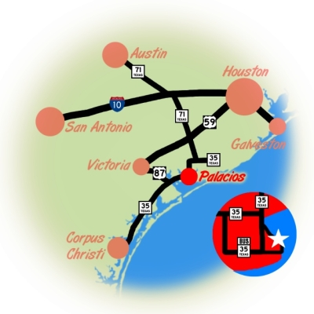

Clientele

The clientele is mostly couples from Houston, Austin, and San Antonio stealing a weekend away to celebrate a special occasion or just to wind down by rocking on the porch and watching the water and exploring the beaches and seawall.

Given the lack of name-brand hotels within 30 miles, many people, including lots of business people, try the bed and breakfast experience here for the first time. It’s gratifying to introduce so many folks to a new and better way of traveling.

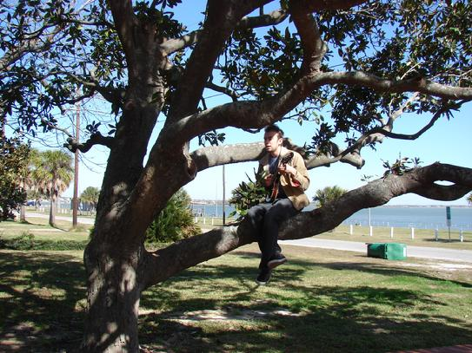

The Peaceful Pelican has established relationships with the local school district, the local hospital and a new land developer which provide a steady flow of guests from out-of-town with whom they do business. We’ve worked hard to be very visible in the community so that residents will send their guest overflow our way and family and school reunion planners will think of us too.

Although most of our guests are from Texas, the power of the Internet has provided us with a large contingency from all around the country and the world. Within the span of a week this fall we had people from Germany, Austria and Scotland. The wall maps on display in the sunroom where guests put pins in the places they’ve come from are a testament to this international clientele.

We have prided ourselves in being inclusive, welcoming people from all walks of life with their children and pets, and have aspired to have an ADA accessible room one day. We offer a facility where people can come together on a level playing field to relax regardless of their stations in life at home.



Local groups have also used our common rooms for meetings and luncheons and we have held community events outside.

Surroundings

We are located in the heart of the area where more bird species are counted during the Audubon Christmas Bird Count than anywhere else in the country!

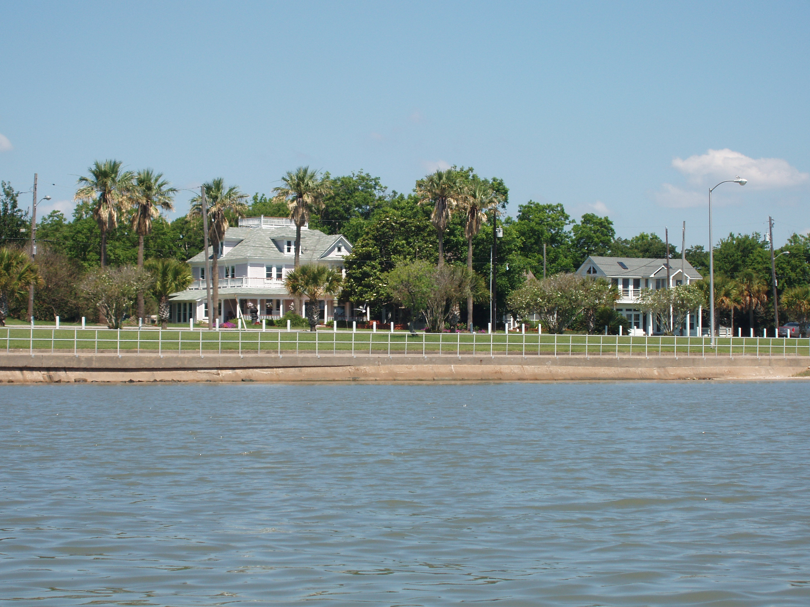

Guests love walking the two mile seawall walk just outside the front door. Free fishing piers (lit all night), plus a boat ramp and pocket beaches are also right across the street. Guests sit on the large front porch and patio and watch dolphins and birds, especially pelicans!

Kite Man, a senior snow bird from Kansas, sometimes takes off and lands right out front on his giant kite-powered surf board. Push Up Man reliably shows up on the pier every Sunday morning doing vigorous exercises on everyone’s behalf.

With the city greenbelt across the street, we are fortunate to have a spectacular water view, but not have to worry about maintaining a bulkhead or worry about anyone building there.

The town boasts several good restaurants, a coffee shop/bookstore, a few shops including an antique store, and a museum. There are also many murals and historic markers in town. Palacios hosts many special events as well (see www.palacioschamber.com), including 4th of July fireworks on the pier right across the street from The Pelican. Our guests have the best seats in town and don’t have to drive anywhere afterwards!

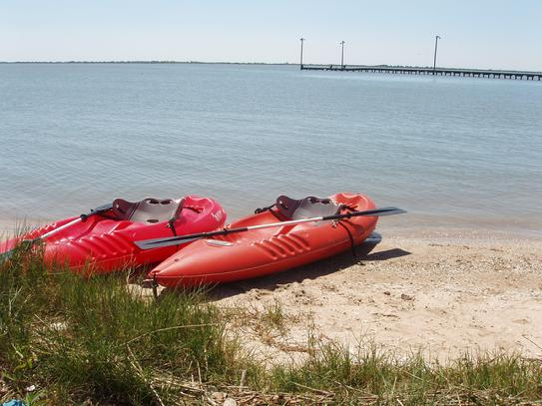

Bigger towns of Bay City, El Campo and Port Lavaca are each only a half hour away. Guests who spend more than one night usually travel to Matagorda Beach, the nearest Gulf beach with miles of sand, waves, and seashells.

The Property

The house sits on almost an acre of land including a spacious side yard. It has six towering sky duster palm trees that were planted by the original owners almost 100 years ago. It also boasts what is likely the town’s oldest and biggest magnolia tree. The ample front porch is augmented by a brick patio for additional outdoor seating.

Pearl, the Peaceful Pelican, a life-size bronze statue, graces the entrance to the driveway. Folks driving by not only stop to read the Texas marker, but to take a photo of Pearl. Guests are always having their picture taken with her. She has quite a wardrobe which includes bunny ears, a Statue of Liberty crown, a witch’s hat, antlers, and a yellow slicker.

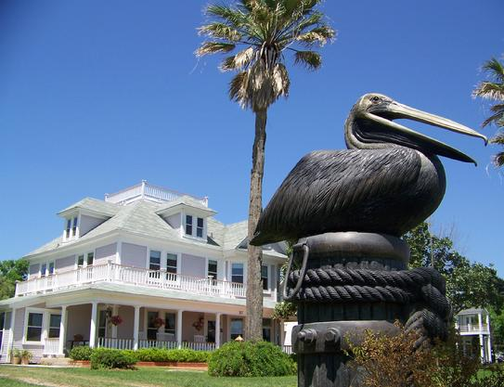

The yard is home to a colony of feral cats which often draws the attention of our guests. Multiple cats often lounge in sunshine of the side yard as if it were a great savannah! They are a lovely attraction without any responsibilities on our part, as the neighbors feed them and have them fixed. They enjoy bird watching as much as our guests, but aren’t very good hunters, so there is no concern that we are just indirectly feeding the cats by feeding the birds.



The side yard is also the home a giant, antique Aerormotor windmill. A large fountain, birdfeeders, a bird bath, a stone bench and some Asian statues a scattered throughout the garden as well. The yard also affords convenient shaded guest parking and turn around space, with plenty of room to park and maneuver boat trailers. There is a two car detached garage near the back of the property, currently used for storage.

The property has a Texas historic marker commemorating its being the site of the Palacios Preparatory School, the first private school in the county. (See www.rootsweb.ancestry.com/~txmatago/hmn_pa_prep_school.htm)

The House

The home of The Peaceful Pelican Waterfront Bed and Breakfast is a 3 storey, Victorian/Queen Anne house built in 1910. There is a back suite, breakfast or mud room, (now used as an office), and a sunroom that were added on, all before 1950. There is also a screened in back porch. The widow’s walk on the roof is a unique feature in this part of the country, great for dolphin and bird watching, as well as star gazing.

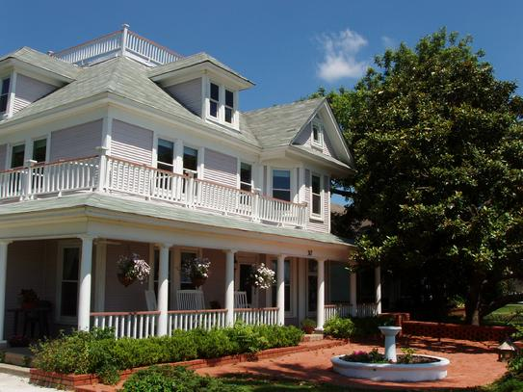

The house was completely renovated between 2006 and 2008. The renovation included new windows, new heat and air, new plumbing, new electricity, and insulation, both for energy savings and noise abatement. There are 4 different heating and cooling systems so the whole house is not unnecessarily heated or cooled. The hot water comes from 2 tankless, gas water heaters outside which provide an endless supply of hot water and only costs around $20 a month.

Virtually all trim work was stripped and repainted and reused where possible. Some stain glass windows, the front door, pocket doors, and much hardware can be found in the Sears 1910 builders catalog. Details such as crown molding, decorative hinges adorned with water birds, and antique bronze electrical plates were added.

Guests sip afternoon wine in the sitting room, in the sunroom or out on the porch or patio. The dining room has a built in buffet where guests can serve themselves coffee, tea and juice. The dining table is actually four tables together which seats 8 comfortably, but can be split to seat 16.

The back hall houses a museum of photos of the first owners and of the house down through the years, as well as relics found behind the walls during the renovation. We also have many items from the yard found with a metal detector. The back hall also has a dumb waiter to help guests transport luggage to the 3rd floor, a public restroom and a storage room. The laundry is conveniently located on the 2nd floor where most of the beds are.

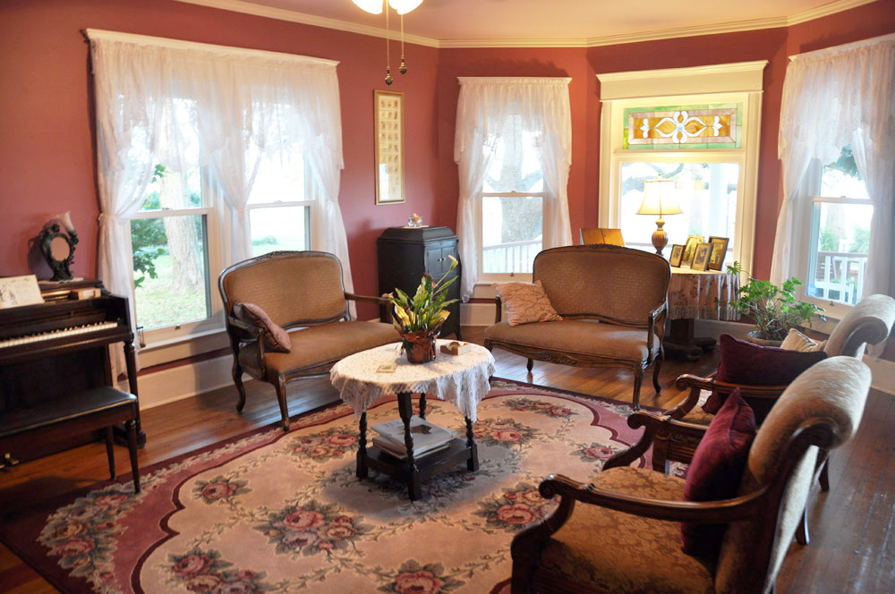

There are 5 guest rooms able to sleep up to 17 people. Each has two extra-long adjustable firmness twin beds that can be made up separately, or put together to form a king-size bed. This means you never lose a sale because you lack the right bed configuration. There are also 7 roll-away beds and a portable crib.

Potential

Coastal property in Matagorda County is said to be the most undervalued coastal property in the whole United States! There is a new development in town offering a gated community with all the amenities aimed at retiring baby boomers. The Pelican has already benefited from a relationship with them and should continue to in the future. The power plant in the area will be expanding in the next few years, providing 3,000 jobs during construction and another 1,000 once completed. The Matagorda County Convention and Visitors Bureau is currently very active in promotion of the travel amenities in this area.

The potential to continue to develop the property itself is endless. The Pelican’s side yard would be a perfect wedding venue against the backdrop of the sparkling bay waters. The yard also provides the opportunity for expansion in that more rooms or innkeepers quarters could be built or very inexpensive period houses close by could be moved to the property. The sturdy, vintage garage could also be converted to an accessible guest room or innkeepers quarters.

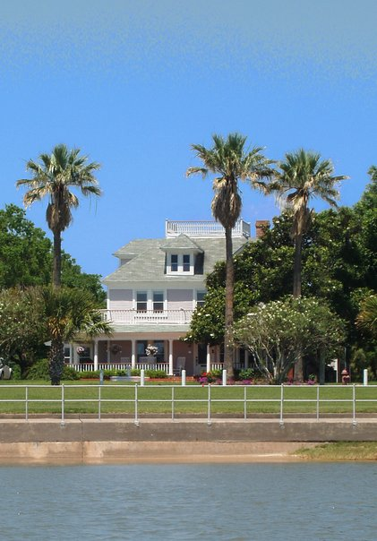

An Invitation

Please peruse the website to understand how the business is perceived by potential guests. We constantly get compliments on the website. If you are seriously thinking this may be the adventure for you, please contact us at 1-888-973-0317 or edith@thepeacefulpelican.com. We would be pleased to offer you a complimentary night’s stay to come see this gem for yourself!

