MASARYK UNIVERSITY BRNO
FACULTY OF EDUCATION

DEPARTMENT OF ENGLISH LANGUAGE AND LITERATURE

COMPUTER ASSISTED LANGUAGE LEARNING
AT THE DEFENSE LANGUAGE INSTITUTE
DIPLOMA THESIS

BRNO 2008

Supervisor: Written by:
PhDr. Tamara Váňová Martin Javora

ANOTACE
Javora, Martin: Výuka anglického jazyka na počítačích na Ústavu jazykové přípravy, diplomová práce. Brno, MU 2008, s.60
Diplomová práce zdůrazňuje rostoucí význam moderních technologií v rámci vzdělávacího procesu v prostředí Ústavu jazykové přípravy ve Vyškově. Zabývá se možnostmi začlenění počítačů do výuky anglického jazyka, vyzdvihuje jejich přínos z hlediska nového a interaktivního přístupu a popisuje měnící se roli učitele.

ANNOTATION
Javora, Martin: Computer Assisted Language Learning at the Defense Language Institute, diploma thesis. Brno, MU 2008, p.60
This thesis explores the realms of computer assisted English instruction at the Defense Language Institute in Vyškov. It is concerned with the growing importance of technology in the educational process, accentuates its novel and interactive teaching approach, and represents the changing role of an educator.

KLÍČOVÁ SLOVA
anglický jazyk, učitel, student, počítač, Internet, výukový program, interaktivní tabule …

KEYWORDS
English, teacher, student, computer, Internet, courseware, interactive whiteboard...

ACKNOWLEDGEMENTS
I would like to express my thanks to PhDr. Tamara Váňová who kindly assisted my endeavour and brought in many cogent comments as the supervisor of this diploma thesis.

DECLARATION
I declare that this work is original and based on the sources appended.
I agree with the storing of this work at the library of Masaryk University in Brno for study purposes.
……………………………………………
CONTENTS
GLOSSARY OF TERMS 5
INTRODUCTION 9
1. MODERN DEVICES APPLIED IN EDUCATION 11
1.1 Teaching with Information and Communications Technology 14
1.2 Computer Assisted Language Testing 23
2. DEFENSE LANGUAGE INSTITUTE OF THE CZECH ARMED FORCES 26
3. E-LEARNING (DISTANCE LEARNING) 30
3.1 E-learning (Distance Learning) at the Defense Language Institute 32
4. THE INTERNET IN EDUCATION 36
4.1 The Internet sites used by students at the Defense Language Institute 39
4.2 Internet sites used by teachers at the Defense Language Institute 46
4.3 Conclusion of Internet sites using 52
5. COUSEWARE IN EDUCATION 53
5.1 Courseware at the Defense Language Institute 57
6. INTERACTIVE WHITEBOARD (SMART BOARD) IN EDUCATION 60
CONCLUSION 64
RESUMÉ 67
RESUMÉ 68
WORKS CITED 69
APPENDICES 71
LIST OF FIGURES 82
LIST OF GRAPHS 83
LIST OF TABLES 84
GLOSSARY OF TERMS
The glossary below was taken from the following sources: Integrating Technology and Digital Media in the Classroom by Shelly, G. B., Cashman, T. J., Gunter, R. E. and Gunter, G. A., Amazon Encyclopedia, Microsoft Computer Dictionary, Wikipedia: The free encyclopedia
Bookmark: method of keeping track of Web pages that have been viewed; records the Web page title and URL, on a computer for use in future Web sessions; also called favorites.
Broadband: technologies that transmit signals at much faster speed than traditional network configurations.
Browser: program that interprets HTML and displays Web pages and enables user to link to other Web pages and Web sites; also called Web browser.
Chat: real-time typed conversation that takes place on a computer.
Clicking: mouse operation that involves pressing buttons on the mouse.
Communications: process in which two or more computers or devices transfer data, instructions, and information.
Computer: an electronic device, operating under the control of instructions stored in its memory, that can accept data, process the data according to specified rules, produce results, and store the results for future use.
Computer lab: designated classroom filled with computers and technology for groups of students to use.
Computer literacy: knowledge and understanding of computers and their uses.
Content: refers to information a Web page provides.
Cooperative learning: method of instruction where students work collaboratively in groups to achieve learning objectives and goals.
Copy: process of duplicating a portion of a document and electronically storing it in a temporary storage location called the Clipboard.
Courseware: interactive computer-based training (CBT) software usually available on CD, DVD, or the Web.
Creativity: elements of originality, imaginative and innovative approaches, and artistic abilities in student projects.
Curriculum: the knowledge, skills, and performance standards students are expected to acquire in particular grade levels, or through sequences or clusters based on subject matter units of instruction, such as language arts, mathematics, science, history, etc.
Data: a collection of unorganized facts that can include words, numbers, images, and sounds.
Design: arrangement of a Web site; the way it uses instructional design principles to deliver content to the user.
Digital media: those technologies that allow users to create new forms of interaction, expression, communication, and entertainment in a digital format.
Distance learning: delivery of education from one location to another; the learning takes place at this other location.
Download: process of copying files to your computer.
Education: all the experiences, knowledge, and skills a learner gains from both school and society.
Edutainment (also educational entertainment or entertainment-education): a form of entertainment designed to educate as well as to amuse.
E-mail: electronic exchange of messages and files to and from other computer users via a computer network.
Facilitator of learning: person who motivates students to want to learn, guides the student learning process, and promotes a learning atmosphere and an appreciation for the subject.
File(s): named collection of related data, instructions, or information, such as a document, a program, or a set of data used by a program.
Freeware: software provided at no cost to a user by an individual or company.
Graphic: a digital representation of nontext information, such as images, drawings, charts, pictures, photographs, animations, illustrations, and other images added to enhance Web pages and are essential for digital media applications.
Hardware: electronic and mechanical equipment that makes up a computer.
HTTP (HyperText Transfer Protocol): communication protocol used to transfer pages on the Web.
Information: data that is organized, has meaning, and is useful.
Interactivity: one of the essential features of digital media applications that allows for individualized instruction and exploration.
Internet: world’s largest network, a worldwide collection of networks that link together millions of businesses, governments, educational institutions, and individuals using modems, telephone lines, and other communications devices and media.
Learning objective: specific, measurable learning objective or indicator that usually is tied to a curriculum standard.
Microsoft PowerPoint: presentation graphics program that allows teachers and students to create multimedia presentations that can incorporate text, graphics, animation, audio, video, links, and most importantly interactivity.
Microsoft Windows: most used personal computer operating system and graphical user interface in the world.
Multimedia: means more than one media and incorporates a variety of elements, including text, graphics, audio, video, virtual reality, and animation.
Notebook (laptop) computer: portable, personal computer small enough to fit on a user’s lap.
Online (Web-based) course: a course that is taught mostly or completely on the Web, rather than in a traditional classroom.
Operating system: one of the more important programs on a computer that contains instructions that coordinate all of the activities of the hardware devices.
Output: data that has been processed into a useful form called information. Four common types of output are text, graphics, audio, and video.
Peripheral: a device that connects to the system unit and is controlled by the processor in the computer.
Player: a program that can play audio files on your computer.
Presentation: document created with presentation graphics software, used to communicate ideas, messages, and other information to a group.
Program (software): series of instructions that tells the computer how to perform the tasks necessary to process data into information.
Record: collection of fields (related facts) in a database.
Server: a computer that manages the resources on a network and provides a centralized storage area for software programs and Web.
Slide: document produced using presentation software that is displayed on a computer’s monitor or a large-screen television, or projected on a screen; can be made into traditional overhead transparencies, or printed and given as handouts.
SMART board: interactive whiteboard produced by Smart Technologies that can be used to access and control any computer application.
Speech (voice) recognition: computer’s capability of distinguishing spoken words.
Technology: the term first associated with computer use in the classroom.
Text: output that consists of characters that are used to create words, sentences, and paragraphs. A character is a letter, number, punctuation mark, or any other symbol that requires one byte of computer storage space.
Touch screen: monitor that has a touch-sensitive panel on the screen, used for input.
Video: photographic images or visual frames that are played back at speeds of 15 to 60 frames per second and provide the appearance of full motion in real time.
Web page (Web site): electronic document viewed on the Web.
Whiteboard: electronic whiteboard that turns a computer and data projector into a powerful tool for teaching and learning.
World Wide Web: a worldwide collection of electronic documents that have built-in hyperlinks to other related documents.
INTRODUCTION
The ever increasing development of modern technology in the world plays an important role in how people work, live and play. People use such technology for entertainment, information management, business purposes and communication but, from the interest of this paper, it is their mark on education that is to be scrutinized.
The motive that inspired my choice of themes was to state Computer Assisted Language Learning (CALL) in part generally and in part in the concrete at the Defense Language Institute of the Czech Armed Forces in Vyškov (DLI) from the perspective of its possibilities, objectives, and resources.
The underlying theme of this work is to present known possibilities open to English instructors in the application of modern technology to language learning. Computers and other technologies provide unique, effective, and powerful opportunities for many different types of teaching and learning. Technology has, for example, the potential to increase student motivation and class attendance, and serves as an extremely powerful tool that helps alleviate some of the problems of today’s schools. The thesis will encourage a degree of computer literacy across the board for educators; the incentive being, that the implementation of both current and emerging computer technologies compounds not only an instructor’s professional development but, more importantly, their ability to facilitate.
Further part deals with the objectives of CALL. Will more students pass their exams and will the English lessons be more interactive when using Information and Communications Technology (ICT)? The question now is how, to what extent and when such media should be integrated into the work of language acquisition.
Another part of thesis is to describe the DLI, the utilization of computer based learning, and stress that modern devices are not used only in language teaching but in language assessment as well, and that Computer Assisted Language Testing (CALT) is an inseparable part of language learning process.
The last object of the work is to briefly provide an index of ICT sources for language instructors (the Internet, e-learning, courseware, and interactive whiteboards), and find out students’ ideas and problems. Opinions and issues concerning ICT are hence addressed from the perspective of both instructors and students. The research is related to the Internet sites students use and why, experience of students in a combined course with e-learning education, students’ attitude to courseware, and the ways teachers can use an interactive whiteboard. The thesis also presents a broad range of courseware and websites a Czech educator of English can choose from. My findings will contribute to make the teaching process at DLI more effective because by bringing English more into contact with technology classes will be more interesting, students more involved and therefore more successful with their exams.
With the right approach, educators can integrate technologies such as computers, CDs, DVDs, digital cameras, application software (SW), digital media applications and devices, e-books and electronic references, handheld computers, iPods, and the Web into almost any classroom situation. The key to successful technology integration is identifying what should be accomplished within the curriculum. Using modern technology tools with students with varying abilities has helped to address different learning styles and reach diverse learners. By engaging students in different ways, technology encourages them to take a more active role in the learning process. Teachers are expected to shift from being the dispenser of knowledge to being the facilitator of learning. Rather than dictating a learning process, a facilitator of learning motivates students to want to learn, guides the student learning process, and promotes a learning atmosphere and an appreciation for the subject.
The quotation that expresses the general message of this diploma follows Major Owens’s words:
Therefore, you are not training young people for the world of today and the world of tomorrow unless you are doing proven technology training. That is one of the reasons I am so concerned.

MODERN DEVICES APPLIED IN EDUCATION
Computing is not about computers any more. It is about living.
Nicholas Negroponte

Every time when some device was invented in the past, whether it was a film, radio, gramophone, tape recorder, television or video, people thought that it would be used in teaching instead of textbooks. It is considered today that this opinion was wrong because a time-proven teaching media can hardly be replaced. The instruments were relegated to a supplemental use due to their mass transmission and sequential presentation.
”Teaching machines, television, taped courses, and other artifacts are often promoted as ways to solve the teacher shortage, yet their net result is a greater need for better-prepared teachers, since the teacher must use these new gadgets as well as new techniques. Even as great libraries with all sorts of aids for the reader have not reduced the need for good teachers, so the new gadgets will eventually assume an appropriate role as aids to the learner and to the teacher. It is important at this time that we reempahasize the crucial role of the teacher.” (Lado 1964.vii)

Figure 1. The original IBM Personal Computer was introduced in 1981
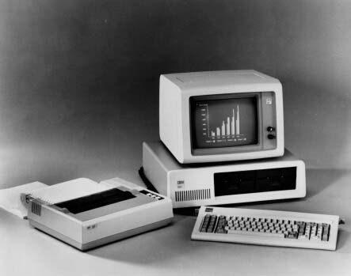
When speaking about new trends in technology, computers are mentioned and used foremost. Since their inception, computers have been seeking a place in the field of education. People, especially scientists, used huge mainframe computers for teaching about thirty-five years ago. Large rooms and special conditions were needed for placement in a location. These facts, apart from costs, were certainly reasons why schools could not afford to have them. Gradually expenses were becoming lower and computers were becoming smaller. The computers that appeared in the 1970s and 1980s were believed by some enthusiasts that they would substitute not only for textbooks but also for teachers. A teaching process, led by a computer, was undertaken but after some attempts people quickly left this idea. It is only in recent years that they have become an accepted (if not key) part of the classroom. There is more about history of computers in Appendix 1.

Figure 2. A modern personal computer
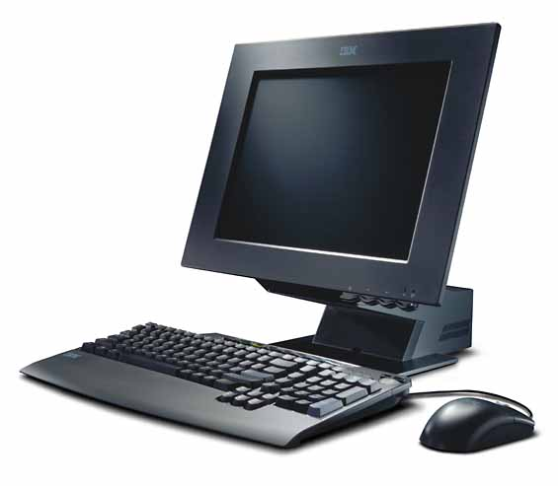
Modern computers provide multiple possibilities compared to their ancestors. There are so called microcomputers which are omnipresent nowadays and help people in ways that previously were not possible. Computer technology is involved whenever we are sending an e-mail, paying with a credit card, driving a car, using cordless telephones, digital cameras, DVD players, etc. After connecting various appliances, computers can be used as radios, televisions, videos, textbooks, phones. Even though computers are much better nowadays and this industry is continually developing, computers and digital media still do not play the key role in the teaching process. The question now, is if modern devices make learning language better or just different.

There are three basic types of computers (Shelly, Cashman, Gunter, Gunter 2008.7-10):
- Personal (desktop) computers (PCs)
PCs process input into output, contain processors, memory, and storage devices. They have an operating system – usually Microsoft Windows or Mac OS, therefore experts often refer to the two basic subcategories of PCs as Windows environment and Mac environment.
- Mobile computers (notebook, laptop computers) and mobile devices
A mobile computer is a personal computer which can be carried from place to place. It is a portable, personal computer small enough to fit on one’s lap. Today’s computers are lightweight, yet they can be as powerful as the average desktop computer. Notebook computers are normally more expensive than desktop computers with equal capabilities. A mobile device is a computing device small enough to hold in your hand and usually does not have disk drives (e.g. handheld computers, personal digital assistants (PDAs), and smart phones). Many mobile devices are Internet-enabled, and they can connect to the Internet wirelessly.

Figure 3. A laptop computer
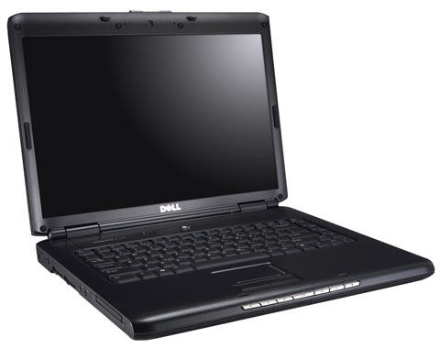
- Servers, supercomputers and embedded computers
A server manages the resources on a network and provides a centralized storage area for software programs and data. A supercomputer is the fastest, most powerful, and the most expensive. They are used for tasks such as analyzing weather patterns, tracking hurricanes, and identifying safety issuses regarding the space shuttle. An embedded computer is a special-purpose computer that functions as one component in a larger product. Embedded computers are everywhere – at home, in your car, at work, and at school.

The terms technology, multimedia, and digital media are used interchangeably in the thesis, although they are not mutually exclusive. Technology was the term first associated with computer use in the classroom. Multimedia incorporates a variety of elements, including text, graphics, audio, video, and animation. Digital media uses all the elements of multimedia but in a digital format.
Prevalent modern basic devices used in CALL at DLI in Vyškov include desktop computers, laptop computers, and a few servers, all of which possess Microsoft Windows operating system. Interactive whiteboards, wireless headphones, and printers are outstandingly useful peripheral equipment for the interest of language acquirement. Most popular and most used older technology tool is the video being often replaced by much more comprehensive SMART Boards at DLI.

Teaching with Information and Communications Technology
The most important issue, as it is felt, is whether ICT can be used to teach English which can be looked at as a multi-layered array of skills, and “… a system of mutually interrelated and interdependent subsystems through, of course, one should never overlook the specific character of each of these sub-systems.” (Vachek 1976.69) The efficiency of ICT in a particular classroom depends on an educator’s preparatory work and planning which demands new and uncharted routines and skills on the part of the teacher. Classes today are focused on achievement, full of pace, drawing on a wide range of resources, strategies, devices and games which digital technologies can contribute to.
“Extensive research conducted over a period of more than twenty years confirms that the effective integration of multimedia application, and now digital media, into the classroom curriculum can revolutionize the way today’s digital students learn core and other subjects.” (Shelly, Cashman, Gunter, Gunter 2008.271)
Teachers should use ICT: “to model and reflect the very concepts on which pedagogical content knowledge needs to draw – using the speed, automatic functions, capacity, range, provisionality and interactivity of ICT to support capability in researching information, developing ideas and trying these out, exchanging and sharing information and critically reflecting on the quality of the process of developing knowledge from a variety of sources of information.” (Adams, Brindley 2007.24)
Instructors can shift from traditional learning approaches to new technology-enriched learning environments by implementing ICT (see Table 1)

Table 1. Establishing new learning environments by incorporating new strategies (Shelly, Cashman, Gunter, Gunter 2008.2)
Traditional learning environments | New learning environments
Teacher-centered instruction | Student-centered learning
Single-sense stimulation | Multisensory stimulation
Single-path progression | Multipath progression
Single media | Multimedia
Isolated work | Collaborative work
Information delivery | Information exchange
Passive learning | Active/exploratory/inquiry-based learning
The Table continues on the following page.
Factual, knowledge-based learning | Critical thinking and informed decision making
Reactive response | Proactive/planned action
Isolated, artificial context | Authentic, real-world context

Most new learning environments are already applied in ELT lessons at DLI. Classes are usually student-centered, multimedia is used for multisensory stimulation, there is a lot of collaborative work and inquiry-based learning. Some traditional learning environments, like teacher-centered instruction, isolated work, and knowledge-based learning, are also used because they are better for certain purposes or activities.
When using modern technologies (especially computers), teachers should understand all the possibilities and repeat prescribed procedures. Both global and local written standards are long lists which define skills that every teacher should know. It is the length of the lists that causes the feeling of excessive requirements which discourage teachers. The biggest disadvantage is the fact that modern technologies evolve very fast, and thus procedures change. Therefore it would be better if teachers learn the possibilities of applications. “Nothing is so likely to spoil the smooth working of a lesson as interruptions or hesitations arising from the absence of the necessary ‘properties’.” (Palmer, Palmer 1959.31)
Mr.G.L.Bledsoe presented the hierarchical structures of teaching processes which substitute the description of concrete skills. A teacher’s attitude and knowledge is divided into several levels. The highest level is not considered as the only and final goal. Each level has its significance and provides various possibilities in the teaching process (see Table 2).

Table 2. The impact of educator' technology on students' learning (Bledsoe 2006)
Level | Teacher Behaviors | Description | Impact on students
6 | Teacher determines students' needs and creates software to assess and catalyze learning. | Teacher is fundamentally changed. Now sees and models technology as an open-ended tool. Feels confident to directly create software with a high level of interactivity to meet student needs. | Students are deeply involved with the development and use of software to meet their learning needs. They see technology as an open-ended tool that can be manipulated to serve many purposes.
The Table continues on the following page.

5 | Teacher uses commercial, shareware, freeware software in unexpected and creative ways to enhance learning. | Teacher sees beyond the intended use of canned software and makes unusual connections and interconnections between software applications to enhance student learning. Becomes a technology leader. | Students are seeing the imaginative use of technology modeled and are directly involved in that process.
4 | Teacher uses a wide range of software (multimedia, video, audio) to enhance student learning, for assessment and record-keeping. | Teacher acquires strategies to learn new software. Teacher puts learning first and finds software to support that learning. | Activities directly meet students' educational and possibly personal and creative needs.
3 | Teacher uses a set tool box of applications to create spread sheets, databases, Web pages, slide shows. Teacher may use some form of software for record-keeping. | Teacher's confidence and understanding begins to improve. Teacher may become proficient in a limited number of tasks but has significant holes in understanding a wider application of software for education. Teacher may evangelize his or her limited application of technology to those lower on the taxonomy. Teacher may resist moving above this level. | Students experience technology as artifacts of the teacher's involvement. Students are fit to the software and not the software to the students. In secondary education, students' involvement with technology may be strictly vocational and may not address their creative, personal or learning needs.
2 | Teacher performs minimal number of software functions (e.g. e-mail, word process, Web browse) step-by-step. | Teacher doesn't explore, doesn't have an overall understanding or strategy to permit the discovery of uses other than those memorized or written down. | Students are not a part of the teacher's computer practices.
1 | Teacher provides educational "games" for students, usually via CD-ROM. | Teacher either avoids technology or has no idea that it can be used in any other capacity. Either way, no real teacher involvement in the use of computers in the classroom occurs. | The software babysits students. May not address student learning needs. Students are likely aware of their teacher's avoidance of technology. Students who are used to arcade style games may be reluctant to engage in reflective computer uses such as writing.

Wellivers Instructional Transformation Model (WITM) describes five hierarchical stages for technology integration, through which all teachers must progress in order to integrate technology effectively (Technology Infusion 2006):
- Familiarization – Teachers become aware of technology and its potential uses.
- Utilization - Teachers use technology, but minor problems will cause teachers to discontinue its use.
- Integration - Technology becomes essential for the educational process and teachers are constantly thinking of ways to use technology in their classrooms.
- Reorientation - Teachers begin to rethink the educational goals of the classroom with the use of technology.
- Revolution - The evolving classroom becomes completely integrated with technology in all subject areas. Technology becomes an invisible tool that is seamlessly woven into the teaching and learning process.
Almost all levels of computer literacy concerning educators can be found at DLI nowadays, with the exception of stage six (the Revolution stage in WITM). Technology knowledge is not innate for some teachers, so they do not understand and therefore avoid ICT. In most cases there is some level of proficiency which teachers are further improving (the Utilization and Integration stages in WITM). Several colleagues are able to prepare appropriate ICT after realizing lesson objectives (the Integration stage in WITM), and one educator can be named “a technology leader” because he can make unusual connections between applications to enhance student learning (the Reorientation stage in WITM). The good thing is that due to computer courses there will soon be no instructors on levels one and two.
There are more relevant concerns relating to today’s digital generation. Above all, learners are hypercommunicators and multitaskers. The first means that they use multiple tools to communicate, the second that they are able to do several things at once. Further differences are described in Table 3.
“Today’s students are different from previous generations in the way they access, absorb, interpret, process, and apply information and in the way they view, interact, and communicate in this technology-rich world.” (Shelly, Cashman, Gunter, Gunter 2008.15).

Table 3. Differences between today's students and students in the past (Shelly, Cashman, Gunter, Gunter 2008.16)
Students from previous generations | Today’s digital students
Passive communicators | Hypercommunicators
Single taskers | Multitaskers
Work oriented | Play oriented
Linear thinking | Random access
The Table continues on the following page.

Nonrelevancy thinking  (relevancy was not critical to learning) | Learning has to be relevant and fun
Single sensory input | Multisensory input
Text-based first | Digital and graphics first
Reality-based | Fantasy-based learning
Conventional speed | Twitch speed

The age limits of learners at DLI ranges approximately from twenty-three to fifty-five years, so there can be quite a stark contrast between ages of students within one group, and some changes between generations can be seen. Generally, younger military are more technologically savvy, they are play-oriented, prefer graphics to text, and learning has to be relevant and fun.
J.M.Keller and R.Žilová state that modern devices can offer new information and stimulation to trainees, and a variety of learning styles. The subject matter educators provide is expected to be well-arranged and didactically organized. Žilová claims that multisensory learners would be able to memorize about ninety percents of the information in this case.

According to J.M.Keller and R.Žilová, present-day devices can optimize teaching from several points of view:
- New learning impulses can capture students’ attention
Modern devices can segment lessons and thus eliminate boredom. This division can serve for activation in a class. R.Žilová writes that, from this point of view, it is not necessary to use modern devices merely for teaching purposes and that it is sometimes appropriate just to relieve learners. For an experience meant to be both educational and entertaining, the term edutainment is being used latterly.
“Lessons content created with digital media can be levelled to challenge multiple skill levels, to generate positive expectations, to provide feedback, and to support internal attributions for success – all of which means students are working at a level at which they can achieve success and gain confidence.” (Shelly, Cashman, Gunter, Gunter 2008.24)
“In the first place, a change of work is always productive of interest; apart from considerations of interest, however, variety is essential.” (Palmer, Palmer 1959.30)

- Teaching relevance
Using up-to-date devices in lessons is valued by students and good for keeping them motivated. However, it is unlikely that everyone in the class will have the same motivation, and motivational factors can be various for different age groups and different levels.
“Language learning is related to human motivation moderated and partly controlled by the will. High motivation increases learning. … When a person is shown that language learning is relevant to his motivation, the result will be more learning.” (Lado 1964.42)
“Language learners who are motivated perceive goals of various kinds. We can make a useful distinction between short-term goals and long-term goals. Long-term goals might have something to do with a wish to get a better job at some future date, or a desire to be able to communicate with members of a target language community. Short-term goals might include such things as wanting to pass an end-of-semester test or wanting to finish a unit in a book.” (Harmer 1991.3)
“Without students’ active work and without the incorporation of their whole personality into the language teaching process, satisfactory results cannot be reached.” (Malíř 1971.90)
Modern devices make teaching more effective and easier through their audio-visual capabilities. The things teachers can describe only verbally, modern devices can present in audiovisual ways, they can use acoustic and visual scenes. Students can interact with and become part of learning adventures without setting foot outside of the classroom.
- Communication in a foreign language
A teacher can avoid using a mother language because modern devices are able to convey authentic materials in a foreign language. It is very essential and signals quality teaching.
New learning impulses which activate students and prevent boredom are brought into lessons at DLI by using modern devices. Learning is definitely more relevant due to fruitful audio-visual capabilities of technology, and both short-term and long-term goals are desirable to be fulfilled by many learners.

Factors which are important for determining the educational value of activities at the computer (Adams, Brindley 2007.14):
- The teacher’s preparation and structuring of the activity to create the conditions for educationally effective interaction between computers and learners.
- The ability of the learners to interact effectively through talk or online communication, and their understanding that this is a critical aspect of the activity.
- The design of the software as a stimulus and frame for joint activity.
It is thought that the first point is the most crucial for effectiveness of computer-assisted lessons at DLI. The latter two can be at least partly derived from a teacher’s preliminary work because the better prepared class the easier for learners to understand subject matter, and the SW can be chosen in advance according to needs of a particular lesson.

The most productive computer-based collaborative activities are likely to have several of the following features (Adams, Brindley 2007.14):
- Before the activity, the teacher will have raised students’ awareness of ways of talking together, and ideally have enabled them to develop their skills in using exploratory talk.
- Students must have to talk to complete the activity, rather than conversation being merely an optional or incidental accompaniment.
- The activity should be designed to encourage cooperation, rather than competition, between partners.
- The activity should be demanding enough to ‘stretch’ students, but be within the limits of their possible achievement.
- Students should begin with a clear, shared understanding of the point and purpose of the activity, including why they are being asked to talk and work together.
Computer-assisted lessons supporting speaking are more likely applied in SLP3 courses in SAC. After some conversational topic is stated, students talk for a certain period of time, and further, more facts and details are searched for on the Internet. Cooperation can be invoked when a class is divided into pairs or groups. The objective of such a computer-assisted lesson is that learners have enough ideas and vocabulary connected with the appropriate topic.

There are some recommended strategies to manage computer-assisted classes (Shelly, Cashman, Gunter, Gunter 2008.299):
- Effective Computer Scheduling – Break projects into well-defined tasks, not huge projects, so students can use lab or computer time wisely.
- Use Project Management Techniques – Discuss with your students the amount of time their project will involve. Give point/grade for productive lab time.
- Storyboarding – Have the groups create a visual plan before going to the computers.
- Effective Research Strategies – Assign searching and investigations as homework since this can erode valuable computer lab time.
- Utilize Student Experts – Train classmates to assist others on the computer(s).
- Ensure Student Participation – Assign individual and group projects so all types of knowledge is evaluated and all students participate.
- Maximize One-to-One Computing – Use e-books, iPods, Zunes, NEOs, PDAs, cell phones, etc.
- Help Students – Use color flags or cups on the computers (green = I am okay, yellow = help needed, red = urgent matter).
- Handle Technical Questions – Have students ask two students a question before they can ask you.
- Visible Classroom Rules – Post a list of all your procedures and guidelines for technology use in a visible place.
These recommended strategies deal mainly with the issue of projects which are not implemented into curriculum at DLI yet but their using is thought about in the future. Two matters of interest – ‘Help Students’ and Storyboarding’ – are considered to be more suitable to motivate primary school learners. ‘Effective Research Strategies’ mean ordering computer-assisted homework which cannot be applied in ELT classes as most students do not have access to a computer in their freetime during the week. The strategy using cell phones, iPods, PDAs etc. cannot be exerted since all mobile devices are not allowed in ELT classes. The list of rules in the computer classroom is already posted on the wall and the strategies ‘Utilize Student Experts’and ‘Handle Technical Questions’ function because students usually ask and help one another in SAC.

Effective teaching with technology also involves an instructional model which is a systematic guide for planning instruction or a lesson. The popular educational instructional model called ASSURE Model is described (Prentice Hall Companion Website 2008):
- Analyze Learners - The first step in planning is to identify the learners. Your learners may be, for example, students, trainees, or members of an organization such as a Sunday school, civic club, youth group, or fraternal organization. You must know your students to select the best medium to meet the objectives. The audience can be analyzed in terms of (1) general characteristics, (2) specific entry competencies (knowledge, skills, and attitudes about the topic), and (3) learning style.
- State Objectives - The next step is to state the objectives as specifically as possible. The objectives may be derived from a course syllabus, stated in a textbook, taken from a curriculum guide, or developed by the instructor. They should be stated in terms of what the learner will be able to do as a result of instruction. The conditions under which the student or trainee is going to perform and the degree of acceptable performance should be included.
- Select Methods, Media, and Materials - Once you have identified your audience and stated your objectives, you have established the beginning points (audience’s present knowledge, skills, and attitudes) and ending points (objectives) of instruction. Your task now is to build a bridge between these two points by choosing appropriate methods, technology, and media formats, then deciding on materials to implement these choices. There are three options: (1) select available materials, (2) modify existing materials, or (3) design new materials.
- Utilize Media and Materials - Having either selected, modified, or designed your materials, you then must plan how the media, materials, and technology will be used to implement your methods. First, preview the materials and practice the implementation. Next, prepare the class and ready the necessary equipment and facilities. Then conduct the instruction using the utilization techniques described in this and later chapters. Students may use the media and materials individually, as in self-instruction, or in small groups, as in cooperative learning. They may use printed materials, such as workbooks, or computer-based technology, such as the Internet.
- Require Learner Participation - To be effective, instruction should require active mental engagement by learners. There should be activities that allow learners to practice the knowledge or skills and to receive feedback on the appropriateness of their efforts before being formally assessed. Practice may involve student self-checks, computer-assisted instruction, Internet activities, or group games. Feedback may be provided by the teacher, a computer, other students, or self-evaluation.
- Evaluate and Revise - After instruction, it is necessary to evaluate its impact and effectiveness and to assess student learning. To get the total picture, you must evaluate the entire instructional process. Did the learners meet the objectives? Did the methods, media, and technology assist the trainees in reaching the objectives? Could all students use the materials properly? Wherever there are discrepancies between what you intended and what you attained, you will want to revise the plan for the next time.
In accordance with the ASSURE Model, the learners at DLI have been identified as military, mainly men, aged between twenty-three and fifty-five years, from pre-intermediate to advanced level of English. There are both short-term objectives (to pass the Book Quizzes, for example) and long-term objectives (to pass the STANAG exam, mainly). Common cassette or CD players, videos, computers (in connection with software, the Internet, and SMART Boards), and wireless headphones must be stated as the most used and available ICT at DLI. Although someone is even able to design new technology, not all educators can modify existing materials. ‘The Utilize Media and Materials phase’ depends on the consideration of a particular teacher who is expected to reach the objectives in a technology environment-based lesson. Learners’ participation is guaranteed as they are highly motivated, and either instructors or computers provide feedback in computer-assisted classes. The last step (Evaluate and Revise) is thought to be fulfilled since the colleagues working with ICT realize whether they reached the objectives, and constantly and immediately change their methods if necessary.

Computer Assisted Language Testing
Computer Assisted Language Testing (CALT) involves the use of computers for language assessment. Tests are created and modified by word-processing software with the Internet providing feedback for potential test takers who now take tests via computers across the globe. CALT is being used in many testing programs and situations, expanding the test developer’s options for constructing test tasks. The Test of English as a Foreign Language (TOEFL) is probably the most widespread second language testing program in the world. CALT is different from other types of language tests in the method characteristics of the input and response, the interaction between them, and assessment. The advantages, disadvantages and characteristics of CALT are presented in Table 4.

Table 4. Test method characteristics and CALT advantages and limitations (Chapelle, Douglas 2006.23)
Test method  characteristics | CALT advantages | CALT limitations
Physical and temporal  circumstances  Location, time, personnel | CALTs can be taken at many  convenient times, and largely  without human intervention. | Security is an issue in high-stakes  tests; equipment not standardized  nor universally available; IT expertise  required for establishment,  maintenance.
Rubric/Instructions  Procedures for responding | Test tasks are presented in a  consistent manner for all test  takers and instructions and  input are presented  automatically and uniformly,  making for enhanced fairness. | Different levels of Instructions,  voluntary help screens, different  languages of instructions can detract  from uniformity.
The Table continues on the following page.

Input and expected response  Features of the context:  Setting, participants, tone  Format: visual/audio/video | Multimedia capabilities allow  for a variety of input and  response types, enhancing  contextualization and  authenticity. | Input and response types are  limited by available technology.
Interaction between the  Input and Response  Reactivity: reciprocal | Computers can adapt input in  response to test takers’ responses  and actions, allowing for  computer-adaptive tests and  rapid feedback. | Interactiveness is more controlled  than certain other formats; computer’s  ability to sample fairly may be limited;  CATs are expensive to develop.
Characteristics of  assessment  Construct definition  Criteria for correctness  Scoring procedures | Natural language processing (NLP)  technology allows for automated  scoring of complex responses,  affecting the construct definition,  scoring criteria, and procedures. | NLP technology is new, expensive,  and limited, thus creating potentional  problems for construct definition  and validity.

The physical and temporal test circumstances include the place where the test is taken, the personnel responsible for administering the test, and the time that the test is taken. Rubric refers to the information given to the test taker about how to proceed with taking the test: instructions, time allocation, test organization, and how to respond to the test tasks. Test input is the material that the test taker is presented with and is expected to comprehend and respond to in some way in carrying out the test tasks. The main aspect of the interaction between the input and response is the computer’s ability to change subsequent input in light of each of the test taker’s responses. The characteristics of assessment refer to the definition of what is to be measured by the test, the criteria by which the performance will be evaluated in terms of that definition, and the process by which the performance will be scored or rated.
“New technology will permit [a] transformation [in assessment] by allowing us to create tests that are more firmly grounded in conceptualizations of what one needs to know and be able to do to succeed in a domain; by making performance assessment practical and routine through the use of computer-based simulation, automatic item generation, and automated essay scoring; and by changing the ways in which we deliver, and the purposes for which we use, large-scale tests.” (Chapelle, Douglas 2006.103)
CALT is still not without “...potential problems … in terms of the way they affect validity. We noted six concerns that are often expressed as potential threats of CALT: different test performance, new task types, limitations due to adaptive item selection, inaccurate automatic scoring, compromised security, and negative impact.” (Chapelle, Douglas 2006.105)
Technology has not yet radically reconfigured the role of assessment in teaching and learning but many language tests are delivered by computers and books on every aspect of language assessment predict a profound role for technology in the future. Technology will definitely have a transformative impact on large-scale educational assessment.
At present STANAG tests at DLI are taken without modern technology assistance although computers are being considered to be realized in the assessment of the written part of the exam. The advantages of CALT are agreed upon by both teachers and testers in this case:
- tests taken without human intervention
- input presented automatically and uniformly
- possible rapid feedback
- consistent and readable output
Generally most feared imperfections of CALT are being discussed at DLI and it is believed that security will not be compromised and the level of instructions will not be different.

DEFENSE LANGUAGE INSTITUTE OF THE CZECH ARMED FORCES
When we study human language, we are approaching what some might call the ‘human essence’, the distinctive qualities of mind that are, so far as we know, unique to man.
Noam Chomsky

The institute was established in Brno on September 1, 2003 and, in 2005, it was moved to Vyškov where it has been since. It is the central institute for language education in the Czech military department. It participates on processing the conception of language preparation within the Czech Army, coordinates the implementation of language preparation, and offers methodical and organizational arrangements to enhance the efficiency of language preparation.

There are two basic types of courses at DLI:
- intensive (which involves five to seven lessons every day for aproximately five months)
- combined (one week per month supplemented by self-study)

Military can be taught English, French, German, Russian, Arabic and Czech languages at DLI at present. English is senior to other languages because it is the official language of NATO, and we educate according to NATO requirements. The desired target language capability of DLI students is Standardized Agreement 6001 (STANAG 6001) Standardized Language Profile (SLP) 2 and SLP 3 for English language, and STANAG 6001 SLP 1, SLP 2 and SLP 3 for French, German, Russian, Arabic and Czech languages.
More information about STANAG 6001 can be accessed on the Bureau for International Language Coordination site (http://www.dlielc.org/bilc).
In terms of cenceptual activity, DLI participates in the outcome evaluation of language preparation, form and content analysis of language preparation in the context of up-to-date needs of the military department, and it processes criteria, according to STANAG 6001, for unbiased evaluation of language qualification of military department employees.
Methodical activity is directed to better the preparation of language experts (teachers, methodists, testers, translators and interpreters) in the military department. Methodical seminars about language preparation in the military department and testing according to STANAG 6001 are regularly held.
DLI methodologists and testers participate in special seminars, organized by various institutions both in the Czech Republic and abroad, about testing methodology and language tests production. New testers are taught and accredited and standardized tests for exams according to STANAG 6001 are made at DLI.
DLI guarantees continious methodological and tutorial consultancy for language workplaces and individuals in the Czech Army.
DLI plans and coordinates terms of language exams, supplies testing and statistically assesses the outcome of testing.
DLI develops cooperation with departmental educational institutions, analogous military institutions in NATO member states, civilian educational institutions in the Czech Republic and representatives of prominent foreign language workplaces.

The STANAG 6001 language exam is concentrated on the language skills below:
- Listening with understanding
- Reading with understanding
- Writing display
- Speaking utterance

Those who are tested are allocated SLP from the lowest level (SLP 0) to the highest level (SLP 5) for every skill.

The proficiency skills are broken down into six levels coded 0 through 5. In general terms, skills are defined as follows:
Level 0 No practical proficiency
Level 1 - Elementary
Level 2 - Fair (Limited working)
Level 3 - Good (Minimum professional)
Level 4 - Very good (Full professional)
Level 5 - Excellent (Native/bilingual)

The headquarters of DLI is in Vyškov and we have branches in Praha, Brno, Liberec, Olomouc, and Náměšť nad Oslavou.
At present, there are eight courses out of which four are SLP 3 intensive courses; two are SLP 2 integrated courses, one SLP 2 intensive course for warrant officers, and one SLP 2 combined course.
A weekly schedule (see Appendix 2) usually consists of thirty lessons which last fifty minutes with the exception of the last lesson on Wednesday that is ten minutes shorter. Twenty lessons are devoted to teaching according to the American Language Course (ALC) books. This textbook is designed primarily for an intensive language training program. However, these materials can also be used in nonintensive programs. ALC consists of six progressive levels of language proficiency training. Levels I through V consist of six separate instructional packages each. Level VI contains four.
Level I Books 1-6
Level II Books 7-12
Level III Books 13-18
Level IV Books 19-24
Level V Books 25-30
Level VI Books 31-34

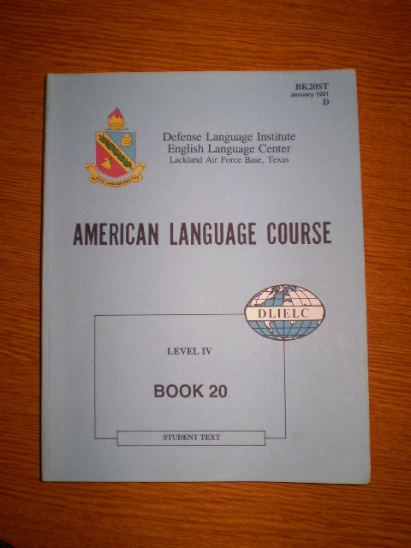
Figure 4. The older version of ALC books from 1991
Books one to thirty consist of Instructor Text, Student Text, Audio Recordings, Language Laboratory Activities Instructor Text, Language Laboratory Activities Student Text, Quiz Kits, and Optional training aids. For the remaining ten lessons supplementary materials which depend on the level of a particular class are used. Students must spend at least one lesson every day with a native speaker and in the listening laboratory. Native speakers spend much more time than one lesson a day in SLP 3 courses and are utilized as much as possible. Listening exercises are conducted on wireless headsets and compounded by one or two lessons in a computer-supported classroom. Every week of an English course is finished with a test called the Book Quiz.

Figure 5. The newer version of ALC books from 2002
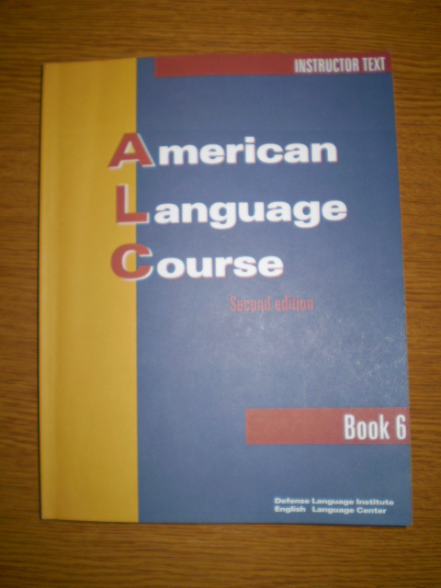
There is a technology-supported classroom at DLI where students have classes or can voluntarily come after lessons. In the lessons led by our instructors, they can use the Internet with many sites, learn English through courseware, present their Power Point presentations on given topics or watch videos on the interactive whiteboard. The Self Access Centre room enables them using ICT in school in the unofficial activities (e.g. email friends). The computer room is about fifty square meters big with a good layout for individual work and activities. The computer room has twenty computers for learners plus one for a teacher (a server), an interactive whiteboard, a traditional magnetic whiteboard, a printer, printed dictionaries and textbooks. Twenty students can have a computer-assisted lesson at the same time. Apart from multicomputer SAC, there are four one-computer classrooms including SMART Boards at DLI.

Figure 6. Self Access Centre at the Defense Language Institute
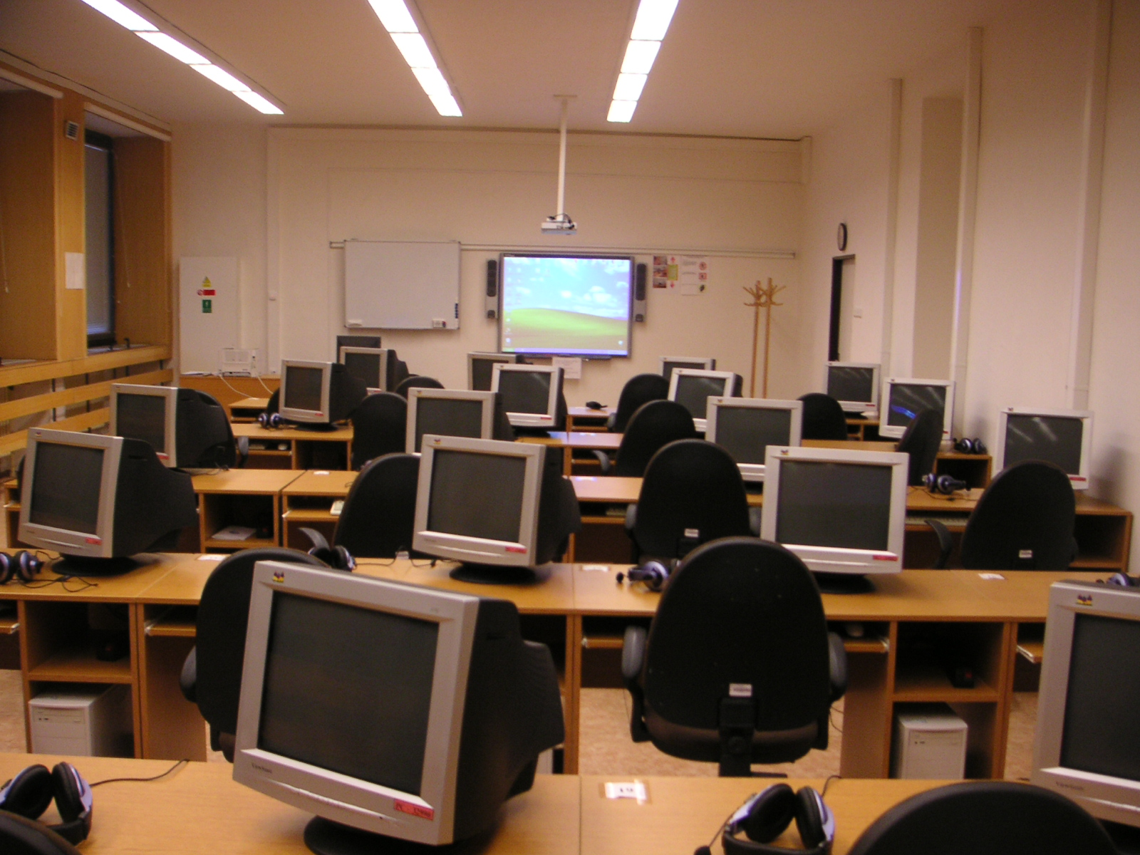

E-LEARNING (DISTANCE LEARNING)
We need to bring learning to people instead of people to learning.
Elliott Masie

“Electronic learning or e-learning is a general term used to refer to computer-enhanced learning. It is used interchangeably in so many contexts that it is critical to be clear what one means when one speaks of 'e-learning'. In many respects, it is commonly associated with the field of advanced learning technology (ALT), which deals with both the technologies and associated methodologies in learning using networked and/or multimedia technologies.” (Wikipedia: The Free Encyclopedia 2008)
“Distance learning is an educational system in which learners can study in a flexible manner in their own time, at the pace of their choice and without requiring face-to-face contact with a teacher.” (Shelley 2000.651)
The traditional model of education takes place in close proximity, at a particular point of time. E-learning (distance learning) is a reasonable and beneficial implementing of modern technologies into education because the focal point of learning is no longer the classroom but has shifted to the home, workplace, or a study context. It can be led online or offline depending on whether the computer is connected to the Internet or not. The offline way requires just appropriate SW on some data carrier and HW.

There are two basic forms of communication in online e-learning education which are usually combined in reality:
- Asynchronous – work is not planned; students can use study materials whenever they want; activities are not coordinated in time (e.g. e-mail, discussion lists, computer conferencing, and bulletin boards)
- Synchronous (‘realtime’) – regular online meetings of teachers and students are arranged; they agree on certain work time in advance (e.g. telephone or chat rooms)
Many distance education providers combine synchronous and asynchronous forms of delivery in order to bring together the benefits of both forms of provision. Multi-synchronous learning is the most common way in which different media are used in distance language learning. One example is a satellite television Internet-based distance language program combining the following elements:
- interactive satellite television linking remote classes (synchronous)
- Internet-based web board for holding chats during office hours (synchronous), for posting and reviewing homework and for class announcements (asynchronous)
- e-mail for sending messages, homework, and feedback on submitted work (asynchronous)
- face-to-face meetings held at the start of the course as part of an orientation week (synchronous)

Advantages of e-learning (EducationTimes.com 2008):
E-learning allows you to work at any place with an internet connection, at your own pace. It is a highly flexible and convenient method of learning. As e-classes are asynchronous, learners can study according to their daily commitments. Therefore, this is a feasible option for those that have other responsibilities. This form of learning also reduces transportation expenses and wastage of time. Users can also repeat the e-learning courses as often as they want, without additional cost. Other advantages of e-learning include the ability to communicate with peers all over the world, and greater diversity in learning due to multimedia tools.
Disadvantages of e-learning (EzineArticles 2008):
One major drawback in online education is the lack of technical skills required to pursue an online degree. Most people are still not that technologically advanced to cope up with the methods that are used to make online education better. Secondly, the most important thing required to student online is a computer and internet connection. However people in regional and far flung areas still don't have access to this commodity. It is quiet expensive for them to purchase a computer. And lastly, online course designers can sometimes wrongly anticipate computer technology advances. This leads to courses being developed for implementation on computers which were expected to become available in the future, but which did not become available.

E-learning (Distance Learning) at the Defense Language Institute
This method was consulted with my colleague Ing.Eva Klausová, who is in charge of e-learning, and a head teacher of students in combined courses at DLI. The way we work with computers at DLI is quite a new matter within our institute because we have been using it for just one year. It has so far been applying only for teaching students in combined courses. These students come here to be taught English for only one week every month. During this one-week workshop they may consult the teachers directly with their questions. Because they are not here most time in a month, we came up with a necessity of an off-campus educating, which means giving them tasks while they are not present.
In cooperation with the language school Albion Brno, e-learning lessons were introduced in the autumn of 2006. The method is aimed at preparing students for the SLP 2 exam in accordance with the STANAG 6001 norms. Teachers at the language school correct students’ exercises and return the results at the end of every week.
One can find the tasks on this site: http://learn.albionbrno.cz/iTutor/student/login.asp
After logging on, it looks like this:

Figure 7. The site used for distance learning by students in combined courses
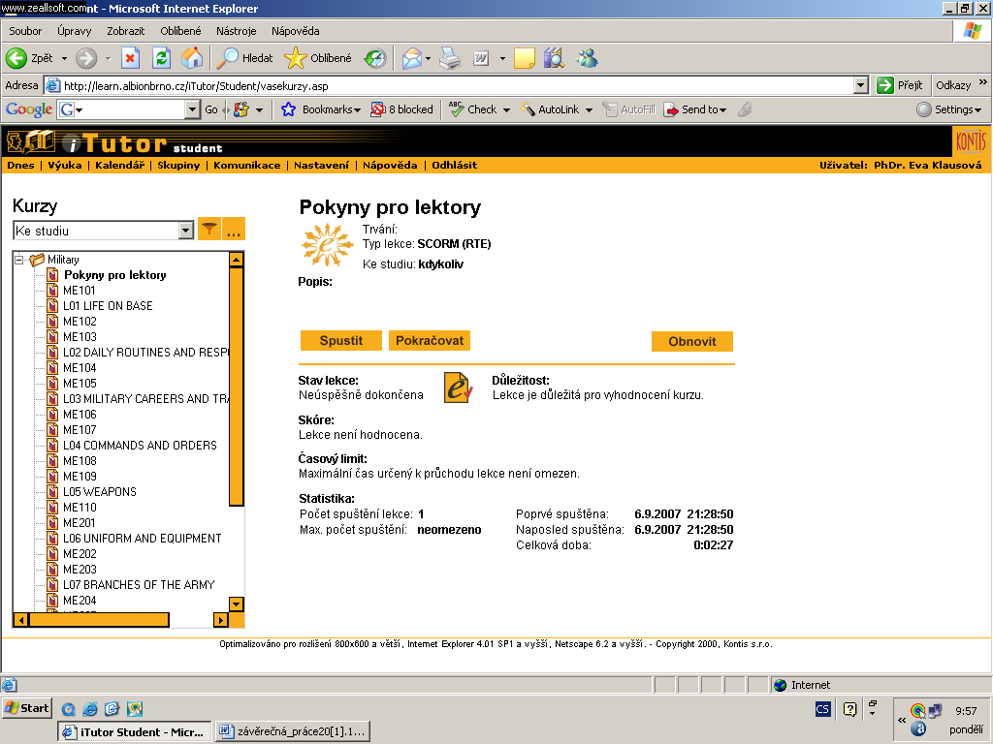
Exercises in e-learning concentrate on practicing grammar, vocabulary (mainly military terminology), listening and reading with understanding in various ways (e.g. gap-filling exercises where students can either have no options or given options, matching words from a certain number of given options and indicating sentences as true or false). Writing is practiced as a concise text according to directions. Students receive approximately ten tasks via e-mail once every week. They can fill them out at their own pace without a time limit and it is possible to come back to each exercise and correct it.
Ten students in a combined course were given a questionnaire. They were at the pre-intermediate level of English at the beginning of their course. My aim was to learn their e-learning awareness and numbers of hours they want to spend learning English with e-learning.
Of the ten questioned students who were involved in the course mentioned above, only seven learners came across the term of e-learning, one of them participated in an e-learning course earlier, while 3 stated that they had never heard of e-learning.

Graph 1. The students' awareness of e-learning
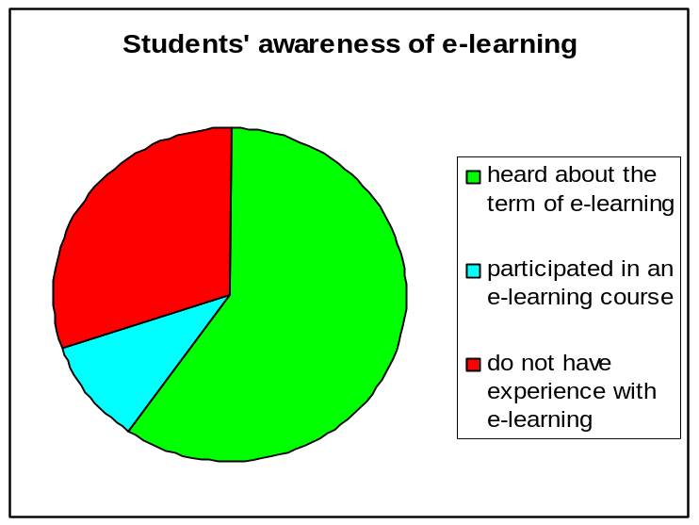

The e-learning method puts great demand on self-study, discipline and motivation. Those students who require management during class-time should give preference to an on-campus form of study. Students in the preliminary questionnaire stated that they would like to spend seven and half hours a week on average with e-learning.

Graph 2. The number of lessons per week a particular learner would like to work with e-learning
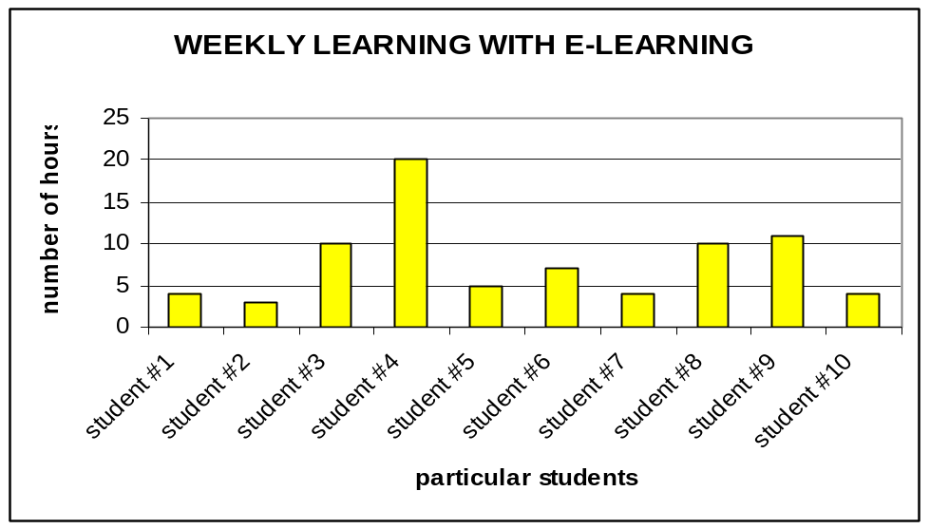

The learners were also asked whether they had any concrete problems working with our e-learning site during their course. Students stated technical problems, like:
- slow connection to the internet
Seven students informed me that the speed of their internet connection was sufficient for their e-learning work. One student has a very quick internet connection and two of them unfortunately possess quite a slow internet connection.

Graph 3. The speed of the Internet connection possessed by students
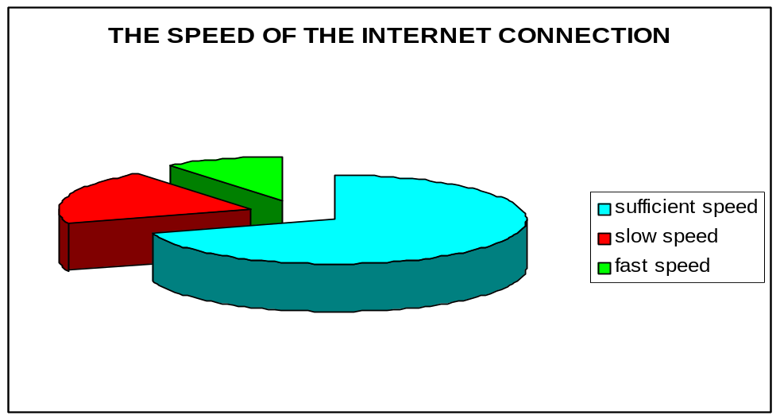

- computers with obsolete hardware causing the working with e-learning quite time consuming
One learner has bought a computer recently, three examined have two-year old hardware, four trainees have access to computers that are approximately three years old, and two people can only work with machines that are more than five years old.

Graph 4. The age of students' computers
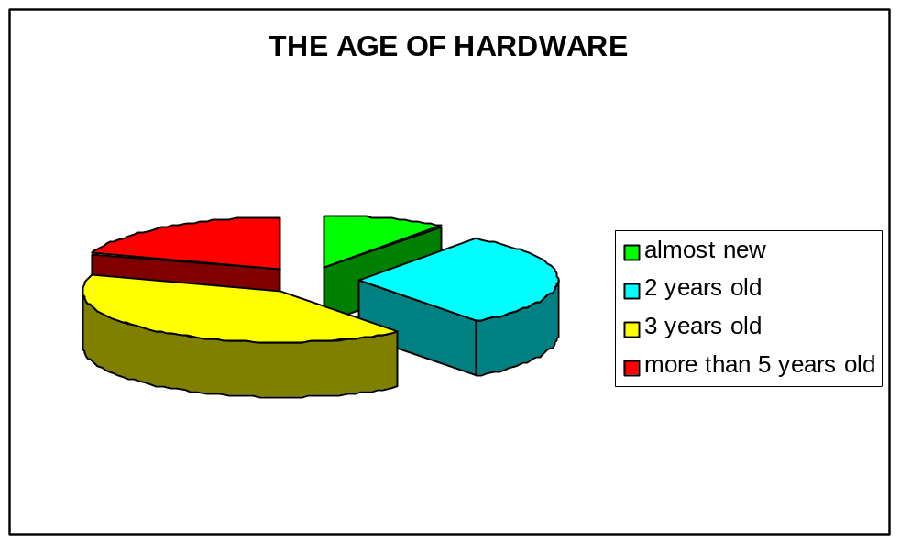

- restricted possibility to work with a computer connected to the internet
Five people have an all-the-time access to a computer with the internet whereas the rest do not.

Graph 5. Students' access to the Internet
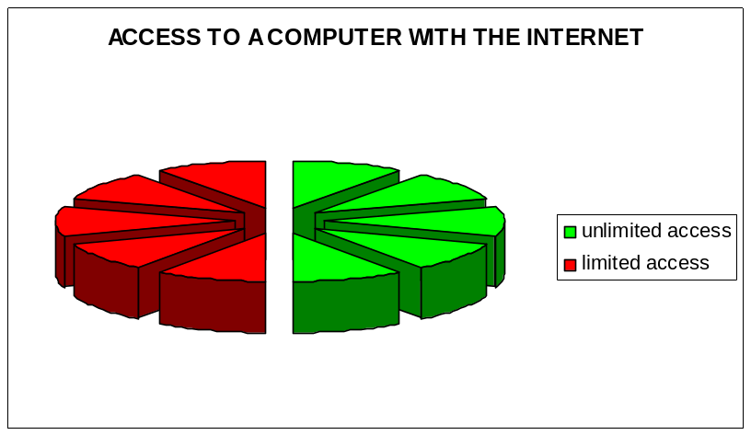

THE INTERNET IN EDUCATION
Nowadays, anyone who cannot speak English and is incapable of using the Internet is regarded as backward.
Al-Waleed bin Talal

The Internet evolved from a basic network system which consists of the following equipment (Shelly, Cashman, Gunter, Gunter 2008.62):
- Two computers, one to send and one to receive data
- Communications devices that send and receive data
- A communications channel over which data is sent. A communications channel is the path that data follows as the data is transmitted from the sending equipment to the receiving equipment in a communications system.
- Communications software, which are programs that manage the transmission of data between computers
“The Internet, sometimes called the ‘Information Superhighway’, is a worldwide, publicly accessible series of interconnected computer networks that transmit data by packet switching using the standard Internet Protocol (IP). It is a ‘network of networks’ that consists of millions of smaller domestic, academic, business, and government networks, which together carry various information and services, such as electronic mail, online chat, file transfer, and the interlinked web pages and other resources of the World Wide Web.” (Wikipedia: The Free Encyclopedia 2008).

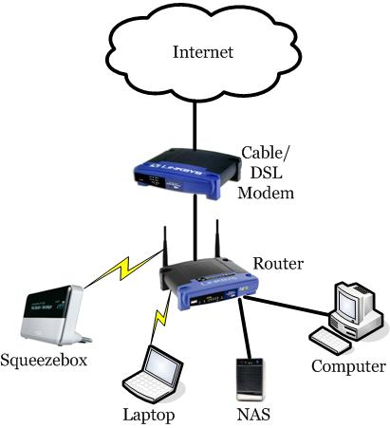
Figure 8. Here the Internet connection is shared among all the devices connected through patch cable or wirelessly to the router
Even that the history of the primary communication channel – the Internet – is relatively short, no technology before has provided so many opportunities for learning. “The first recorded description of the social interactions that could be enabled through networking was a series of memos written by J.C.R. Licklider in August 1962 discussing his ‘Galactic Network’ concept. He envisioned a globally interconnected set of computers through which everyone could quickly access data and programs from any site.” (Internet Society 2003) His visions became true and the original network was increased steadily and, within the last few years, explosively. Currently there are many Internet services out of which especially World Wide Web and e-mail are used. Other services include File Transfer Protocol (FTP), newsgroups, message boards, mailing lists, instant messaging, chat rooms, and Internet telephony. The Internet expands student learning beyond the covers of a textbook to include interactive, up-to-date, Web-based content.

There are many reasons why over one billion users around the world connect to the Internet (Shelly, Cashman, Gunter, Gunter 2008.69-70):
- Access a wealth of information, news, research, and educational material.
- Conduct business or complete banking and investing transactions.
- Access sources of entertainment and leisure, such as online games, magazines, and vacation-planning guides.
- Shop for goods and services.
- Explore virtual worlds.
- Meet and converse with people around the world through discussion groups, instant messaging, blogs, wikis, or chat rooms.
- Access other computers and exchange or share files.
- Send messages to or receive messages from other connected users.
- Download and listen to music or download and watch movies.
- Take a course or access educational materials.

There are many useful and popular education-related search engines on the Internet, e.g.:
- Education World on http://www.education-world.com
The Educator’s Reference Desk provides high-quality resources and services to the education community. Included are more than 2,000 lesson plans, 3,000 plus links to online education information, and more than 200 question archive responses.
- em Tech on http://www.emtech.net/index.html
This web site contains more than 15,000 resources organized by topics for teachers, students, parents, and other education professionals.
- Sites for Teachers on http://www.sitesforteachers.com
Sites for Teachers include links to Web sites that contain teacher resources and educational materials. Web sites are ranked according to popularity.
- The Gateway to Educational Materials on http://www.thegateway.org
The Gateway to Educational Materials, sponsored by the U.S. Department of Education, is a consortium effort to provide educators with quick-and-easy access to thousands of educational resources, such as lesson plans and curriculum units found on various federal, state, university, nonprofit, and commercial Web sites.
One of the biggest assets of the Internet from the point of view of this thesis is that it allows teachers and students to communicate with other teachers and students all over the world. For example, ePALS Classroom Exchange (http://www.epals.com) is a global community of collaborative learners, teachers, and academic experts in two hundred countries and territories.
When applying Internet sites in lessons, educators should always bear in mind that as easily as the site can appear, it can disappear. The best strategy is then to have some back-up and prepare other sites of the same theme, leaving the lesson plan adaptable. Educators should also count with unexpected technology problems, like incidental machinery break down or power cut.

There are some possible ways that students can be positively influenced (eSchool News 2007):
- Make on-line tests. Lead students to self-teaching. Give them correct solutions of difficult tasks.
- Demand a written exercise every week. Drive students to react on your questions or comment on classmate’s work. It can broaden knowledge.
- Make questions carefully. Use a proof model, i.e. begin with questions based on knowledge and understanding, continue with application and analysis, and finish with synthesis and evaluation.
- Find connections. Do not allow learners to answer in a simple way. Press them to look at the problem from various points of view.
- Store results. It enables you to follow a learner’s progress within a certain period of time.
- Bear in mind student’s opinions. Find out what they think about a topic before and after going through it.
- Make up roleplays. Students learn by not only getting to know real facts, but also by looking for compromises.
A few Internet-based activities can be found in Appendix 4.

The Internet sites used by students at the Defense Language Institute
A survey among Czech students and teachers at the Defense Language Institute in Vyškov was done in November 2007 to learn the internet sites they use for practicing English, in the concrete for practicing listening, grammar, vocabulary, reading and the internet sites they use for searching for news. Writing down one site for every skill was sufficient but they could mention as many sites as they wanted. Finally, seventeen students and six teachers were willing to fill the questionnaire for me. Four basic questions within a particular skill were demanded in the survey.

They were asked:
- What internet site / sites they use for practicing listening / grammar / vocabulary / reading and searching for news.
- Why they choose this site / these sites.
- What they like about it / them.
- What they dislike about it / them.

The inquired students were all military, mainly men and they were students in SLP3 courses, which means that their level of English was advanced and profficiency.

Graph 6. The Internet sites used by students to practice listening
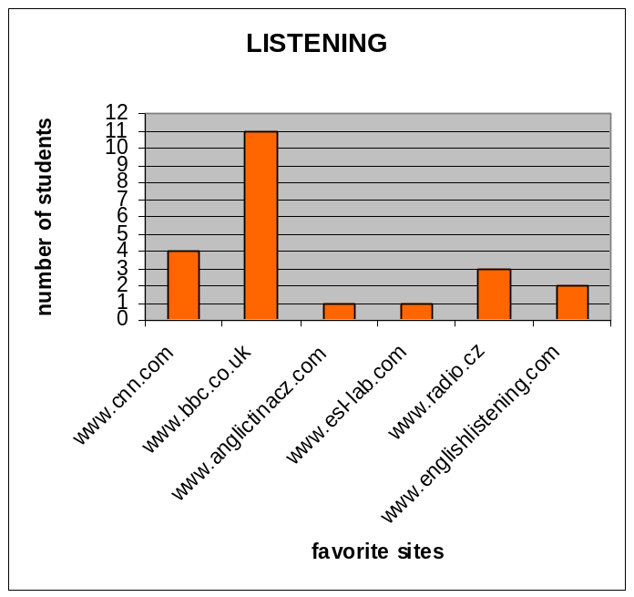

1. Eleven students work with http://www.bbc.co.uk. Here are the reasons for using it they stated:
- wide range of news in many fields (e.g. policy or science)
- easy operating
- quality pronunciation
- good choice of topics throughout the world
- understandable and plain English
- the availability of transcripts for easier understanding of new vocabulary
- it is updated all the time
- “I just saved it as one of my bookmarks”
They preffered it especially because of well-arranged division, understandable approach, a variety of exercises, seriousness of news, possibility of listening and reading at the same time, information from all over the world, the possibility of watching clips.
However, they commented listening files for not being in the mp3 format, which means they are useless for playing aside a computer without converting. Not many topical subjects suitable for lessons was another drawback they stated.
2. Four students use http://www.cnn.com. Their reasons for working with it are:
- news in target language
- good choice of many news on various topics
- good pronunciation
They appraise its graphics, well-arranged division, understandable approach, and seriousness of news, the possibility of listening and reading at the same time.
3. Three students work with http://www.radio.cz/en because:
- they can hear easy English concerning issues in the Czech Republic
- it contains current Czech news
- of appropriate level of English
- of quality listening
4. Two students like working with http://www.englishlistening.com because of its well-arranged layout. They do not like the necessity to check in before they can start to use it.
5. One student prefers http://www.esl-lab.com because of an easy operating and good choice of exercises. He/she dislikes that the listening files are not in the mp3 format.
6. Another student likes http://www.anglictinacz.com best because there is enough listening material for him/her.

Graph 7. The Internet sites used by students to practice grammar
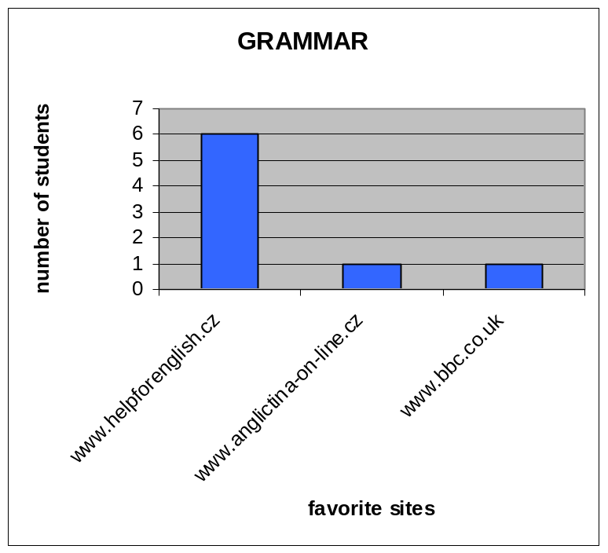

It seems that SLP3 students do not need to practice grammar, at least not with the help of the Internet. For seventeen students there were only eight answers in this case.
1. Six of them work with http://www.helpforenglish.cz because:
- it is well-done and well-arranged
- it is complex
- it contains logical and understandable explanation of grammar theory
- grammar is explained in Czech
- it was recommended to him/her
They like it mostly because there are vivid examples including graphic conduct, and because grammar is explained understandably and in Czech. They dislike quite a few listening exercises. One student considers it flawless.
2. One student uses http://www.anglictina-on-line.cz. He/she claims that this site contains everything he/she needs.
3. Another one likes http://www.bbc.co.uk because of its live information. His/her reason for using it for practicing grammar is not so clear because there is not an obvious connection between up-to-date information and improvement of his/her grammar knowledge.

Graph 8. The Internet sites used by students to practice vocabulary
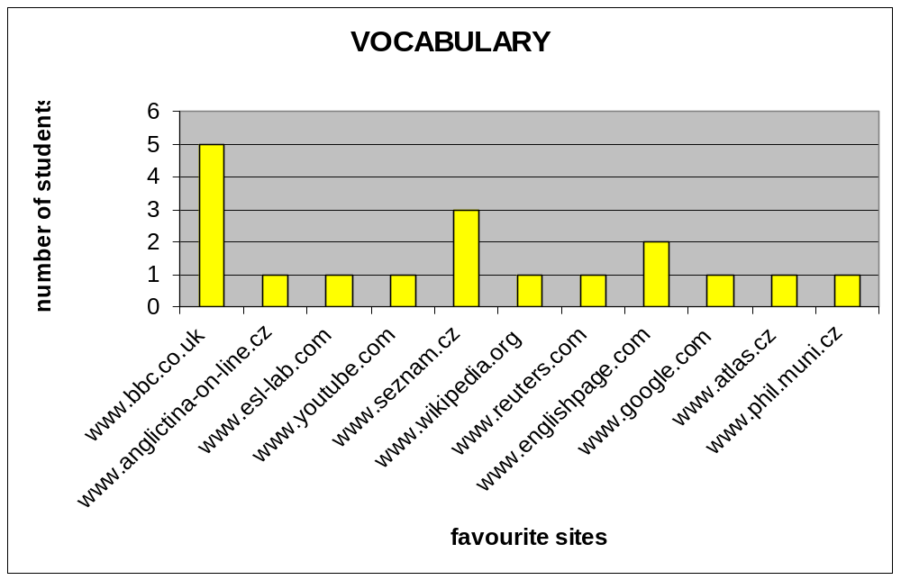

1. Five students prefer http://www.bbc.co.uk for practicing vocabulary because it:
- is very well-arranged
- is up-to-dated (always contains some new expressions to practice)
- contains transcriptions of selected news, articles and stories which one can listen while reading
2. One student prefers http://www.anglictina-on-line.cz because there is news he/she can read, which is enough for him/her to practice vocabulary.
3. Another one chooses http://www.esl-lab.com for it always has a new expression to practice.
4. http://www.youtube.com offers a great variety of choice according to one person.
5. Three examined students wrote that http://www.seznam.cz is their favorite site because it is easy to work with it, and that it contains even listening. One wrote that he/she does not know any other site for practicing vocabulary and for another it is just enough that the site functions.
6. One person works with http://www.wikipedia.org.
7. Another person prefers http://www.reuters.com.
8. Two learners often choose http://www.englishpage.com for it enables them to practice many uses of vocabulary, for it has dynamic link labels to other sites. But they do not like that it has a tougher looking up for a particular word.
9. For practicing vocabulary one trainee uses http://www.google.com because he/she can look for and read real articles.
10. Another trainee prefers http://www.atlas.cz. His/her reasons are simple: this site functions and he/she knows only this one when learning new vocabulary.
11. The student that chooses http://www.phil.muni.cz likes it because of its well-arranged layout and quality dictionary.

Graph 9. The Internet sites used by students to practice reading
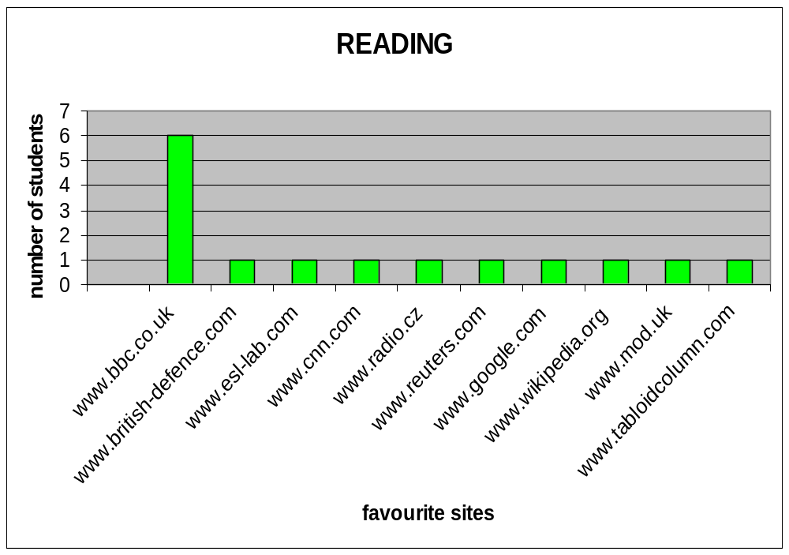

1. A majority of students (six) prefers working with http://www.bbc.co.uk when reading on the internet. They use it because there is a reasonable number of new words, nowadays articles and a good overview of policy in the world. The students like the site for its neatness and clearness.
2. The site http://www.mod.uk carries interesting information about British defense according to one learner.
3. Another trainee prefers http://www.esl-lab.com since there is a reasonable number of new words.
4. One student practices while reading tabloid, so he uses articles on http://www.tabloidcolumn.com when practicing reading.
5. The site http://www.cnn.com is interesting for just one person.
6. The student that likes http://www.radio.cz/en the best praises it for interesting articles especially about the history of the Czech Republic.
7. One reads English articles on http://www.reuters.com.
8. Another trainee practices reading on http://www.google.com.
9. There is also a learner that reads in English on http://www.wikipedia.org.

Graph 10. The Internet sites used by students to search for news
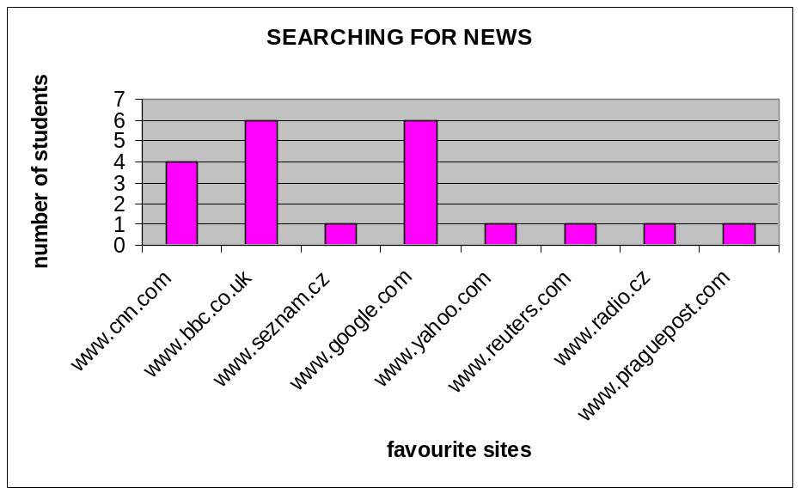

1. Four students use http://www.cnn.com for the possibility of comparison with the news on the BBC site. They like a well-arranged searching for news even from other sources, but one dislikes a slow downloading.
2. Six trainees prefer http://www.bbc.co.uk to other sources. There is interesting information, a lot of news, news from all over the world in English. One student likes that every article is located on a separated page.
3. When searching for news, one learner uses http://www.seznam.cz. He/she probably did not realize that news should be written in English.
4. Six students use http://www.google.com for searching for news. Some of them consider it the best and most widespread internet browser. Others think that it is a proper browser with a huge amount of actual information.
5. One trainee searches for news on http://www.yahoo.com.
6. Another person likes http://www.reuters.com.
7. The combination of reading news and listening to news is well done on http://www.radio.cz/en according to one person. He/she likes its universality but notices frequent mistakes in tape scripts.
8. One student uses http://www.praguepost.com.

Graph 11. Most favorite Internet sites used by students
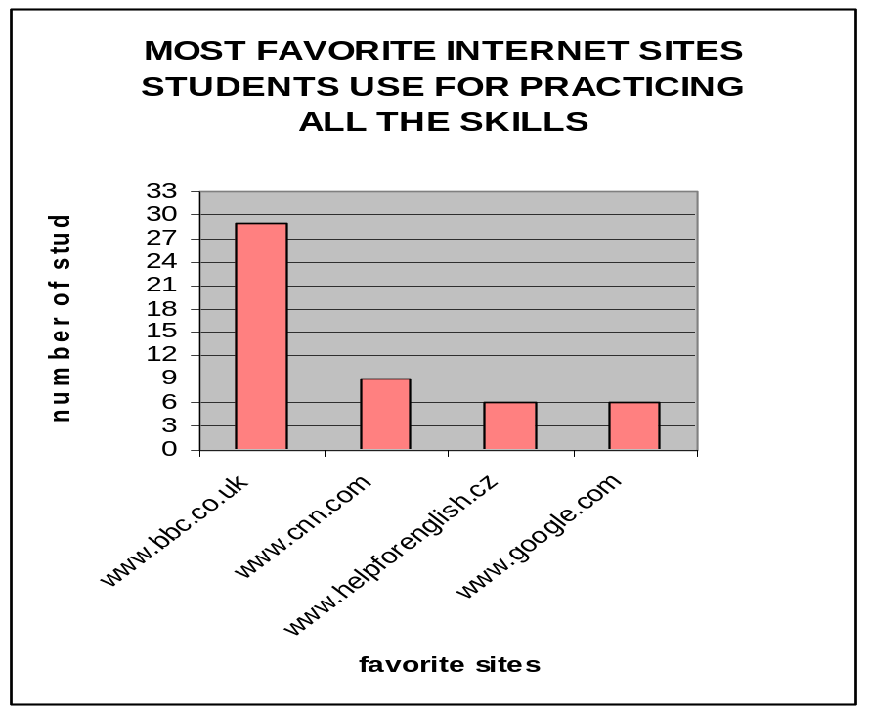

Internet sites used by teachers at the Defense Language Institute
Ten colleagues of mine were asked to fill the questionnaire for me. Only six of them were willing to do that, so my favorite internet sites are included as well. The questionnaire had the same form as the one the students were given and they were supposed to state the Internet sites they use for teaching English.

Graph 12. The Internet sites used by teachers to teach listening
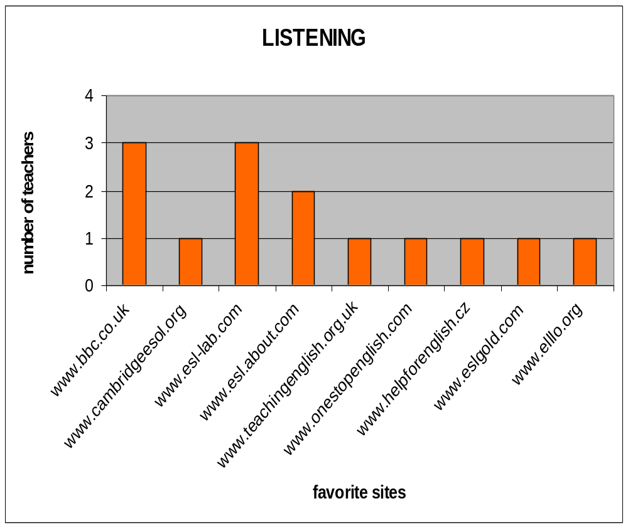

1. Three teachers use http://www.bbc.uk.com when teaching listening because it:
- possesses actual, nowadays information
- is very good for enrichment of vocabulary
- enables the possibility of downloading audio recordings
- has a broad scope and variety of topics (including keys to exercises)
2. One colleague works with http://www.cambridgeesol.org. He/she chooses it because it enables the possibility of downloading audio recordings, has a good choice of actual matters, and keys to exercises.
3. Three people including me like using http://www.esl-lab.com. It is good because there are levels one can choose from and both pre-listening and after-listening activities. Someone does not like its graphics.
4. Two colleagues prefer http://www.esl.about.com for teaching listening because of many topics on various levels, both pre-listening and after listening activities, quality pronunciation, and quizzes. One does not like its graphics and the other one thinks there is not enough material for every level.
5. One teacher works with http://www.teachingenglish.org.uk because there are good topics for all language levels, quality pronunciation and quizzes. He/she does not like it for not having enough topics.
6. The site http://www.onestopenglish.com is preferred by another colleague. He/she likes that it is divided into levels, that there are good topics and quizess, and quality pronunciation, but he/she does not like the fact that it provides not so many topics that he/she would like.
7. One person uses http://www.helpforenglish.cz for teaching listening.
8. The last site mentioned is http://www.elllo.org, which is my favorite listening site because it contains many exercises on various levels.

Graph 13. The Internet sites used by teachers to teach grammar
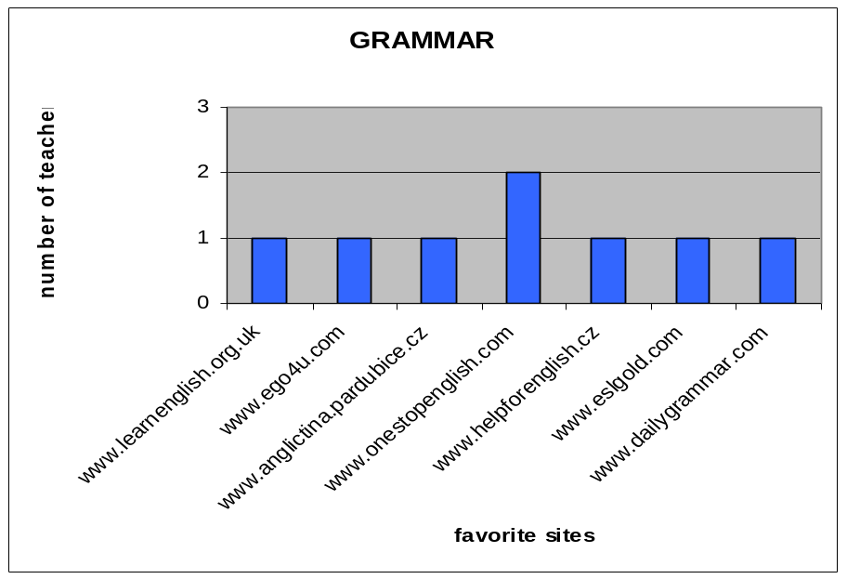

1. The colleague who works with http://www.learnenglish.org.uk wrote that the site is full of interactive games, puzzles, and that there are no mistakes in grammar on this site. He/she likes the possibility to choose from various levels of difficulty.
2. The same person likes another site, which is http://www.ego4u.com, for teaching grammar. He/she gives the same reasons. There are interactive games, puzzles, no mistakes in grammar on this site.
3. The person working with http://www.anglictina.pardubice.cz likes the possibility of using the site in Czech when necessary. He/she claims there are many grammar tests, one can work online or download tests, but he/she does not like vocabulary tests.
4. Two colleagues of mine prefer http://www.onestopenglish.com because they think it contains all the skills, which they like. In their opinion, a good choice is the best advantage.
5. The site http://www.helpforenglish.cz is chosen by another colleague because it contains very good explanations of grammar terms, the site is often updated and the author of the site answers questions willingly.
6. One colleague uses http://www.eslgold.com for teaching grammar.
7. Another colleague uses http://www.dailygrammar.com when teaching grammar.

Graph 14. The Internet sites used by teachers to teach vocabulary
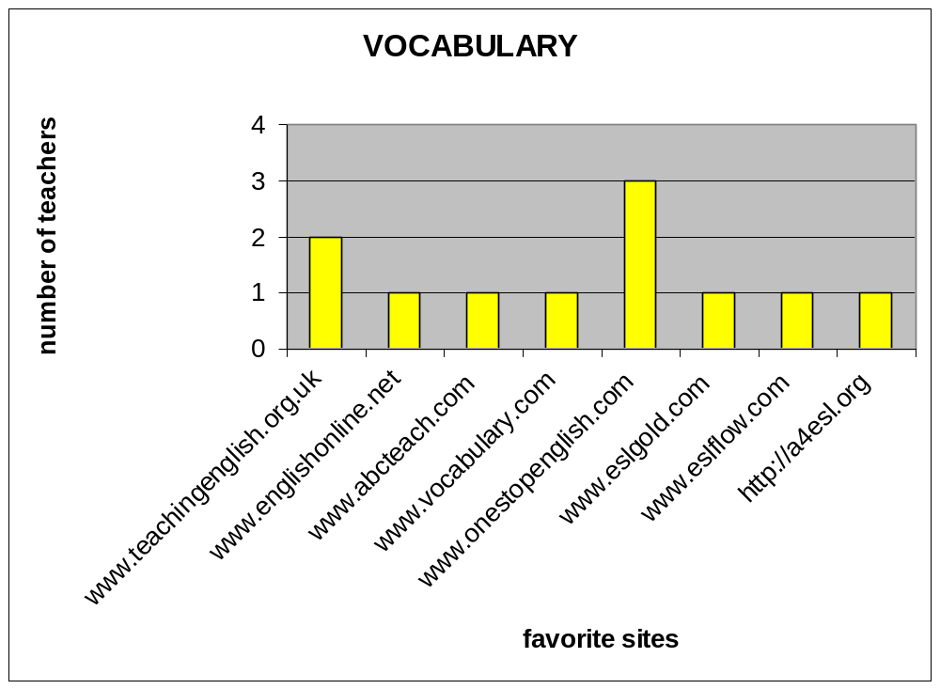
1. Two teachers like http://www.teachingenglish.org.uk when practicing vocabulary with students. They like its well-arranged layout and practical use in classes. There are many various activities to practice vocabulary with.
2. One colleague works with http://www.englishonline.net because of nice interactive exercises and simple operating. He/she does not like it because of a lot of pop-ups.
3. Another person prefers http://www.abcteach.com for its well-arranged layout and nice flashcards.
4. The site http://www.vocabulary.com is preferred by one teacher because of many topics and vocabulary. He/she thinks it can enrich students’ word-stock but the disadvantage in his/her opinion is that exercises are not interactive and must be printed before using.
5. Three people including me prefer http://www.onestopenglish.com for teaching vocabulary. They think the site contains all the skills, which they like. In their opinion, a good choice is the best advantage. I just think it is a very suitable site for practicing vocabulary.
6. One colleague chooses http://www.eslgold.com when practicing vocabulary with his/her students.
7. Another teacher uses http://www.eslflow.com.
8. I like using http://a4esl.org because vocabulary exercises are divided into three levels of difficulty and one can choose from many topics as well.

Graph 15. The Internet sites used by teachers to teach reading
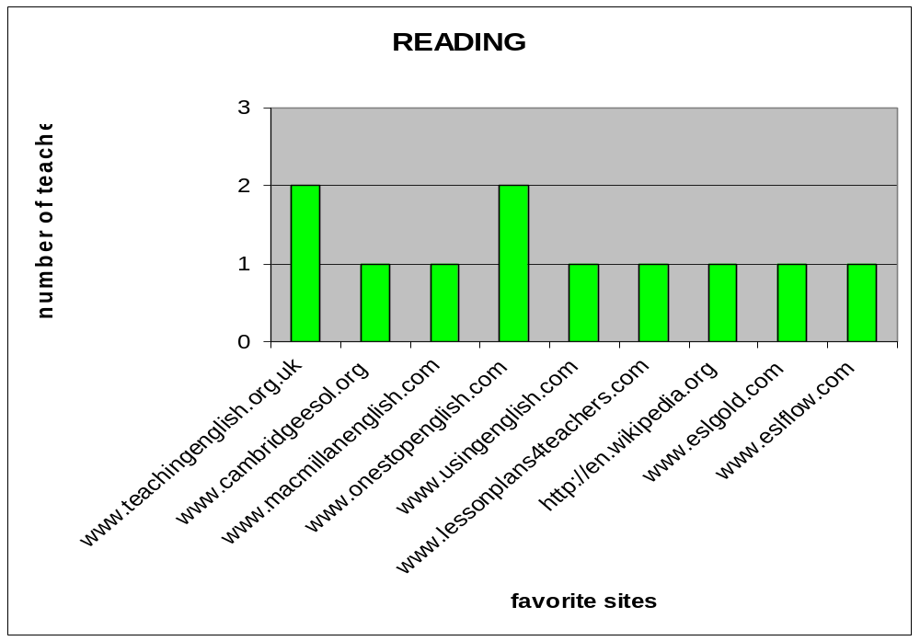
1. Two people usually choose the site http://www.teachingenglish.org.uk because they can find articles even with preparations on various topics there.
2. One colleague works with http://www.cambridgeesol.org because there are tests with questions and keys. He/she likes texts being on various levels of difficulty and the possibility to look in the system of exams.
3. Another person prefers http://www.macmillanenglish.com because one can find a new e-lesson containing text and activities every week there. He/she likes it for it is well-arranged and offers activities for every skill.
4. I and one of my colleagues usually use http://www.onestopenglish.com when we are in need of some reading material. My colleague likes this site because it contains exercises for practicing all the skills. I use it mainly for practicing reading. There are better sites for practicing listening, grammar or vocabulary in my opinion.
5. The sites below were also stated but unfortunately without any comments.
- http://www.usingenglish.com
- http://www.lessonplans4teachers.com
- http://en.wikipedia.org
- http://www.eslgold.com
- http://www.eslflow.com

Graph 16. The Internet sites used by teachers to search for news
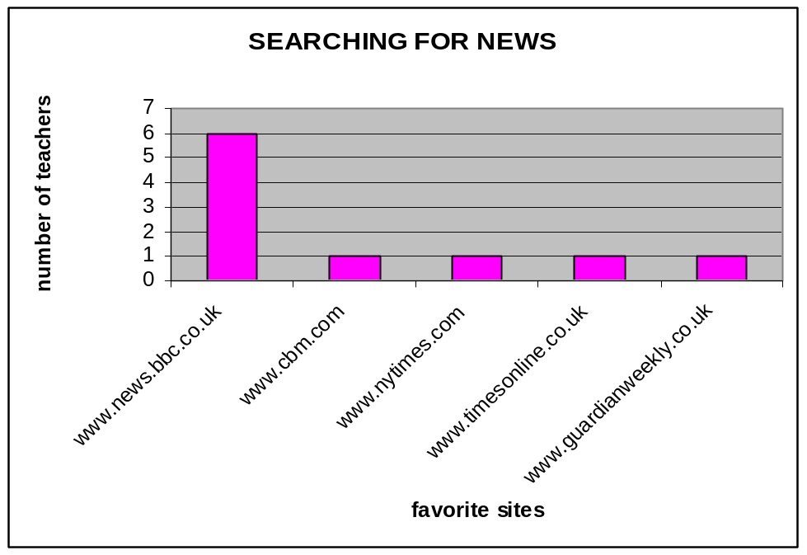

1. Six people prefer the site http://www.news.bbc.co.uk when searching for news in English. They choose it because of well-arranged world events, easy searching, actual matters of interest, all the time updating, authentic texts and recordings, and the possibility of downloading. The topics one can find here can cover a broad scope of students’ interests. Some colleagues did not like the fact that more than one player was needed for playing audio and video recordings.
2. The site http://www.cbm.com is used by one teacher because there is a good choice of current news.
3. Other sites that are usually chosen by my colleagues when searching for news are:
- http://www.nytimes.com
- http://www.timesonline.co.uk
- http://www.guardianweekly.co.uk
They did not put down any additional comments in the questionnaires.

There is the summary of the most favorite internet sites that teachers use for all the skills in the following graph.

Graph 17. Most favorite Internet sites used by teachers
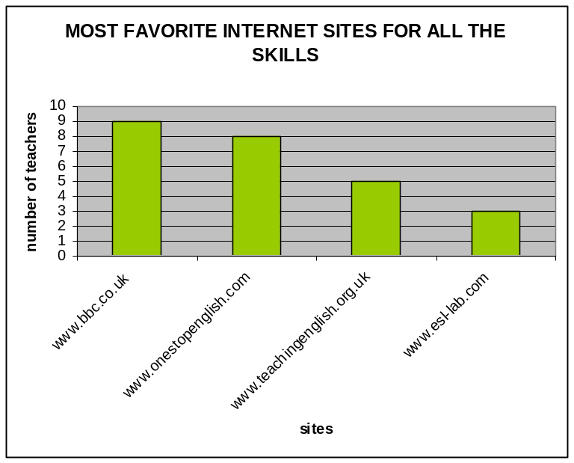

Conclusion of Internet sites using
People using the Internet sites for learning or teaching all English skills at DLI stated the site http://www.bbc.co.uk thirty eight times. It was the most favorite one both by teachers and students which is not a surprise because very quality material for listening, reading, and also practicing grammar can be found there. Then with quite lower scores the following sites are being used:
- http://www.cnn.com
- http://www.onestopenglish.com
- http://www.helpforenglish.cz
- http://www.google.com
- http://www.teachingenglish.org.uk
- http://www.esl-lab.com
It seems that for several colleagues, who did not fill the questionnaire, it was painful to incorporate ICT into their classroom work. Those who were a bit reluctant concerning using ICT gave interesting reasons:
- Most widespread and obvious one was that they do not work with Internet sites and ICT at all. They claim on behalf of ICT that they can be more fun than ordinary learning.
- Then that the Internet is not a timesaver – it takes a lot of time to find some quality material. Some think that the Internet is a bottomless source of misinformation and there is a lot of inaccurate material out there.
- Further reason was that ICT is an expensive way of doing what can be done just as well in more traditional ways. To practice listening they regularly work with televised extracts and support tapes but computers might prove to be as efficacious as them, whether we use Internet sites or courseware.
- And lastly the teachers stated that they needed time outside of class to learn about using technology in their teaching.
The obvious and most important fact that teachers should have in mind when working with the Internet in classroom is that websites should be related to the classroom objective. Further careful planning is required at all levels for technology integration to be successful, in other words effective ICT use requires new teaching and learning strategies and a willigness to learn a basic understanding of various technology tools and applications. For those less familiar with ICT, learning these basics is an essential element of their professional development. Some colleagues consider the lack of time to develop technology-based lessons a concern. It is true that with so many tools and applications to learn, teachers must have the time to develop technology skills that they can then use to get the most out of teaching and learning in the classroom.

COUSEWARE IN EDUCATION
Those involved in the program are interested in how to use photography, videos, the Internet, film, and anything related to communications and transmission of information in the most up-to-date modern ways.
Major Owens

“Courseware can concentrate on one skill at a time, in a manner impossible for a textbook and hardly available to the classroom teacher, namely by asking the student to handle only that part of a procedure on which pedagogical stress is to be laid, while other aspects of the same procedure are handled automatically by the computer. . . This scheme, which combines student interaction with computer assistance, has the merit of focusing attention on the key strategic and conceptual decisions needed to handle a problem. . . This should be of significance to both the strong student. . . and the weak student.” (Jerry Uhl's favorite quotations 2000)
Courseware as computer programs intended for teaching belongs to a much bigger group called software. Other subgroups can be system software (SW), especially operating systems (most common are Microsoft Windows, Mac Os, UNIX, and Linux), and application SW, especially productivity SW (e.g. word processing, spreadsheets, and e-mail programs can be used for creating documents, doing research, and managing projects).

Even SW for school use can be further divided into several groups (Shelly, Cashman, Gunter, Gunter 2008.163-6):
- School management SW is a centralized program that allows district and school personnel to manage the school district operations, such as budgeting, inventory, and expenses.
- Student management SW is a centralized program that allows administrators, teachers, and other staff to manage and track information about students, which includes attendance and academic records.
- Grade book SW allows teachers to track and organize student tests, homework, lab work, and other scores.
- Reference SW provides valuable and thorough information for everyone in an educational setting and in the family. Popular reference SW includes encyclopedias, dictionaries, health/medical guides, and travel directories (e.g. Encarta Encyclopedia Premium, Wikipedia, Children’s Encyclopedia, Encyclopedia Britannica, and American Sign Language Dictionary).
- Educational SW application refers to computer SW products used to support teaching and learning of subject-related content. Educational SW can be a good tool to support learning objectives and goals, and can be further divided into:
    - Drill-and-practice SW - It first supplies factual information and then through repetitive exercises allows students to continue to work on specific materials to remember or memorize the information. Students can get instant feedback and it can help them improve in areas they are weak at.
    - Educational games - Games can be an effective way to teach content through repetition and practice. They usually include a set of rules, and students can compete against other students or the game itself.
    - Tutorials - They are teaching programs designed to help individuals learn to use a product or concepts. The teaching solutions provided by tutorials range from a structured linear approach with specific content objectives to a nonlinear approach that offers alternative paths through the lesson based on students’ responses, called ‘branching’.
    - Educational simulations - These programs are unique because the user can cause things to happen, change the conditions, and make decisions based on the criteria provided to simulate real-life situations. SimCity, Sim Theme Park, and Sim Coaster can be examples of such kind of SW.
    - Integrated learning systems (ILS) - ILS is a sophisticated SW program usually developed by an established educational SW corporation as a complete educational SW solution in one package. They provide individual student diagnostic data through pretest, instruction based on the diagnostic data, continuous monitoring of student performance with automatic adjustments in instruction when needed, a variety of formats for teaching content, and multilevels of content.

Software which is well suited for encouraging productive discussion is likely to offer at least several of the following features (Adams, Brindley 2007.14):
- Activities will include problems which involve the rational consideration of available information, and which are sufficiently complex to benefit analyzed through joint reflection and discussion.
- Problems and choices are embedded in a motivating narrative or process.
- A clear purpose for the activity is made evident to participants and is kept in focus throughout.
- On-screen prompts remind participants to talk together and encourage them to make predictions, proposals and reasons explicit.
- Information which can be used for reasoning about decisions is clearly presented on the screen.
- Instructions do not encourage rapid decision-making, competition within the group or serial turn-taking.
- Unless the task is expressly concerned with writing development, responses should require simple keystroke responses rather than extensive typing (as this tends to damage the pace and continuity of discussion).

Advantages of CALL programs (nationalforum.com 2006):
- prove practices for students through the experiential learning
- offer students more the learning motivation
- enhance student achievement
- increase authentic materials for study
- encourage greater interaction between teachers and students and students and peers
- emphasize the individual needs
- regard independence from a single source of information
- enlarge global understanding

Disadvantages of CALL programs (nationalforum.com 2006):
- they will increase educational costs and harm the equity of education
- it is necessary for both students and learners to have basic technology knowledge
Before teachers start any computer-based class, they should be very sure that they know the technology themselves. Any such lessons can be started with introducing the students to basic computing skills, e.g. how to start and shut down the computers, how to run a program, move the mouse, etc. It is desirable that learners are relaxed and unafraid to try things out.
- Current computer technology mainly deals with reading, listening, and writing skills. Even though some speaking programs have been developed recently, their functions are still limited. It should be able to diagnose a student’s problems with pronunciation, syntax, or usage and then intelligently decide among a range of options.
- Computers cannot handle unexpected situations. Due to the limitations of computer’s artificial intelligence, computer technology is unable to deal with learners’ unexpected learning problems and response to learners’ questions immediately as teachers do.

Courseware at the Defense Language Institute
Nowadays it seems that some classes at DLI use computers in English lessons less and less. As the attempt to reverse this trend eighteeen students in SLP 2 courses were taken to the Self Access Centre and presented courseware with the title English Effectively. After they were shown the possible ways of using the program, they worked with it, and in the end of the lesson the learners were asked to fill the questionnaires concerning that courseware. They were supposed to like it because English Effectively is quality courseware which is worth working with for at least one lesson a week. Working with computers one period every week is considered to be a minumum by some educators because the computer room has been equipped with both hardware and software.
At first the students were asked if they liked courseware as a whole. Out of eighteen students fifteen liked it and three thought it was average. They thought it was interesting, well-organized, comprehensive, manageable, and of quality, contained many collocations and understandable listenings. Students specifically liked switching between English and Czech variations of the text, conversation topics, and photostories. One student liked that the level of language could be set in advance and thus slow down the speed of speech. Another learner was dissapointed with the level of listening; He/she thought it was poor.

Graph 18. Students' opinions on the English Effectively program
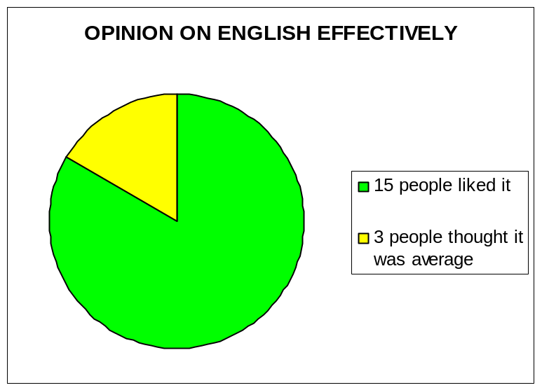

The learners were then asked what they would change. One student would add more reading material there. Another person missed past tenses, mainly present perfect tense and past perfect tense within the grammar part of courseware. Someone did not find explanations of grammar and questions concerning listening there. Next learner would like English Effectively to have more animation and last student did not like the slow running of the program.
The next question asked which language skills could be practiced with English Effectively. Eighteen students stated listening, sixteen grammar, fourteen vocabulary, seven reading, six writing, and six speaking.

Graph 19. Language skills thought by students to be good to practice with English Effectively
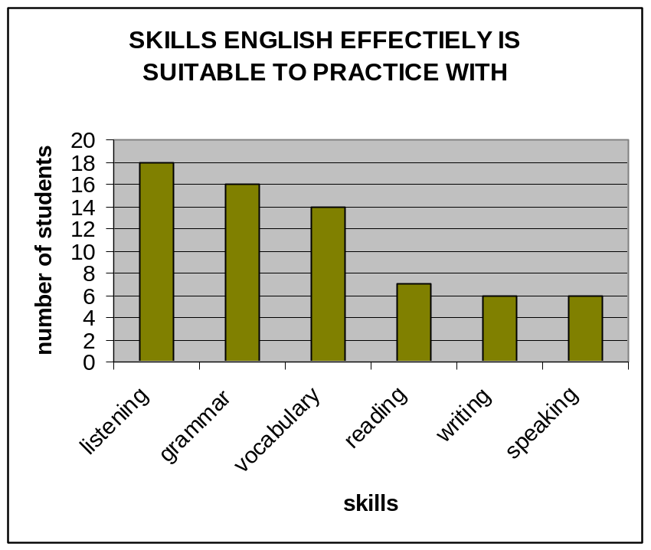

The penultimate inquiry was about time per week they think it would be optimal to spend working with this courseware. Their responses varied from ninety minutes to fifteen lessons per week. Most often time planned to devote to work with English Effectively was five lessons, which is two hundred and fifty minutes per week.

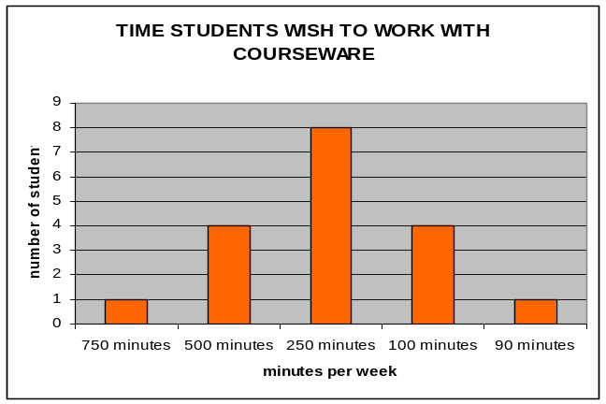
Graph 20. The number of minutes per week imagined by students to work with English Effectively

As the last question they were asked what percentage could courseware contribute to one‘s long-term improvement in English. Answers varied from ten to ninety percent.

Description of the English Effectively program
This Landi Multimedia courseware provides several hundred hours of teaching in a complete multimedial course on 4 CDs. There, one can find multimedial sounded photostories, translation exercises, listening test, commentary on grammar, fifteen thousand sentences, vocabulary, phrases and many topics. There are techniques such as speech recognition, a teaching planner (called Memorganizer), pronunciation instructor and a memory box.
Thanks to the multimedial photostories, conversational phrases, useful words and grammatical constructions are easily remembered. Stories with Czech subtitles can be watched and audiofile lessons created. Teaching grammar is lively, interesting and proceeds with sound animations. Animations are conceived as conversations between a teacher and student. Animations last about 5 minutes, consist of commentary, practise and conclusion.
The voice recognition program unit uses a Microsoft engine and enables recording of sentences within the courseware through a microphone. When being examined, it is possible to choose from several modes: a direct translation, translation with your own evaluation, choosing from alternatives, and dictation. The courseware provides teaching by means of associations between words and pictures.
The teaching planner called Memorganizer follows and optimizes the whole process. Places in which you make more mistakes will be repeated more often. It is meant for every English level which can be set in advance. Minimal system requirements were stated as:Pentium 400 megahertz (MHz) processor, 64 megabytes (MB) of random-access memory (RAM), 500 MB of free space on Hard Disk Drive (HDD).
For further courseware on the Czech market see the Appendix 3.

INTERACTIVE WHITEBOARD (SMART BOARD) IN EDUCATION
Education technology and school construction go together. Modernization, updating education facilities, and making a capital investment in education are all included.
Major Owens

“From data projectors and digital video to interactive whiteboards, educators today have a wide array of multimedia presentation tools at their disposal to enhance visual instruction—allowing them to share ideas, information, charts, images, animations, audio, and video more effectively.” (eSchool News 2008)
“By the term ‘interactive whiteboard’ I mean a large, touch-sensitive whiteboard connected to a digital projector and a computer. The screen of the computer is projected onto this whiteboard and, either by using a special pen or even fingers, images and texts can be manipulated without having to go near the computer.” (Adams, Brindley 2007.23)
“An interactive whiteboard is a ground-breaking tool, providing pupils with a new learning experience and presenting teachers with an opportunity to involve young people as never before.” (EducationGuardian.co.uk 2007)
The type of the electronic whiteboard at DLI is produced by Smart Technologies and is therefore called SMART Board, but the terms ‘interactive whiteboard’ and ‘SMART Board’ are used interchangeably in the thesis.

Figure 9. The SMART Board in SAC at DLI
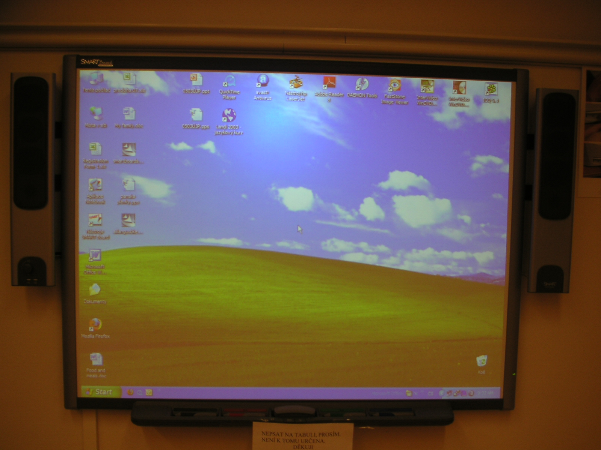

A SMART Board is connected to a computer and to a projector which displays the image seen on the computer screen. First the software and hardware must be engaged, and then the board must be oriented. Once this is accomplished, the user can control all Windows applications with the touch of a finger. Using an interactive whiteboard as an extension of a computer can be a very useful way of teaching students because the image can be clearly seen on a large screen. After linking a computer or a laptop to the Internet, it can offer even more possibilities. It can also be used exactly the same way as an ordinary whiteboard, except that pens and erasers are substituted by electronic tools performing the same function.
Using a projector system to display the images on an interactive whiteboad is an excelent way to allow all students to see what displays on the instructional computer’s monitor, to see and hear interactive digital media applications, and to interact with the Web and educational SW, while at the same time asking questions. The SMART Board can facilitate certain types of conversations in that all members of the classroom may concentrate on the same item at the same time and conversation may then spring from that. Another possibility is that only a teacher works with the equipment and thus has full attention of students who do not need to care about the operation with computers.
The two basic activities used at DLI are a demonstration and digital video playing. Watching something on a big screen can be both entertaining and engaging the whole class. Many studies indicate that such excitement and positive attitude are important for learning. Movies, videos, trailers, adverts, scenes can be either looked at by connecting a peripheral device (a DVD player or video, for example) or can be downloaded from the Internet. Especially more advanced students at DLI use this technology for their PowerPoint presentations (slides). PowerPoint allows learners to create multimedia presentanions that can incorporate text, graphics, animation, audio, video, links, and most imortantly, interactivity. The big advantage is that all data can be saved and used in further lessons, or we can copy e.g. students’ projects to more than one computer so students can watch their presentations in groups. The teacher can prepare a lesson as usual in a Notebook file or Word Document, and is then able to use the features of the SMART Board interactive whiteboard to his advantage. The instructor can use the SMART Board to overwrite, underline, highlight or circle the elements that he wants to emphasize. Because the document is typed, it is very readable, and it – along with changes and new emphases – can be saved and displayed again at any time.

Figure 10. The teachers' devices in SAC
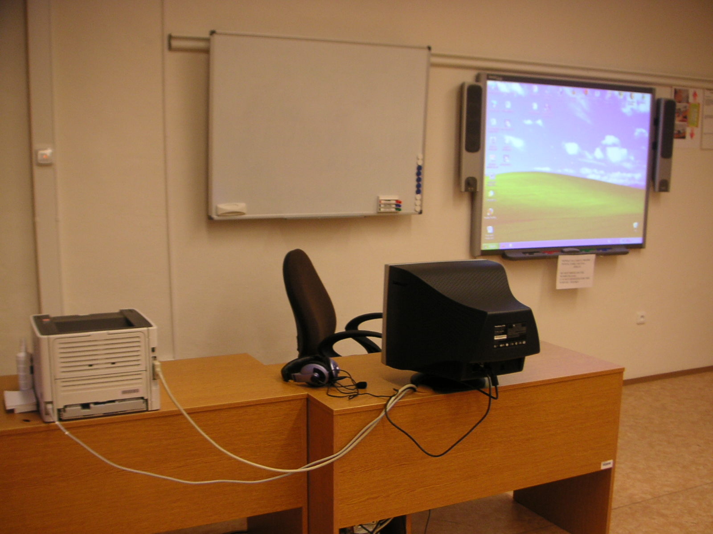
The research from the report by Cox et al. (2003) sees ICT as a tool to develop skills. The report states: “studies show that the most effective uses of ICT are those in which the teacher and the software can challenge pupils’ understanding and thinking, either through whole-class discussions using an interactive whiteboard or through individual or paired work on a computer. If the teacher has the skills to organize and stimulate the ICT-based activity, then both whole-class and individual work can be equally effective.” (Adams, Brindley 2007.25)
Reasons for integrating video (Shelly, Cashman, Gunter, Gunter 2008.466):
- Students learn more and retain information longer when video technology is integrated into lessons and instruction.
- Brain research is showing that the human brain processes visual images thousands of times faster than written text.
- You can reach students with different learning styles by adapting your instruction to match the needs of your students, in other words, learner-centered.
- The majority of today’s students are visual learners, not text-based learners like previous generations.
- Integration videos can increase student retention of information.
- Student excitement is contagious and fosters enhanced learning. Cognitive skills are greatly improved when students are involved in creating a video screen cast.
After wireless headphones are attached to the server, this teaching method is multiplied. The quality of hearing is much better than without them because the acoustics in the room is not the best.

Figure 11. The system of wireless headphones used by teachers can be attached to a cassette player, CD player or a computer
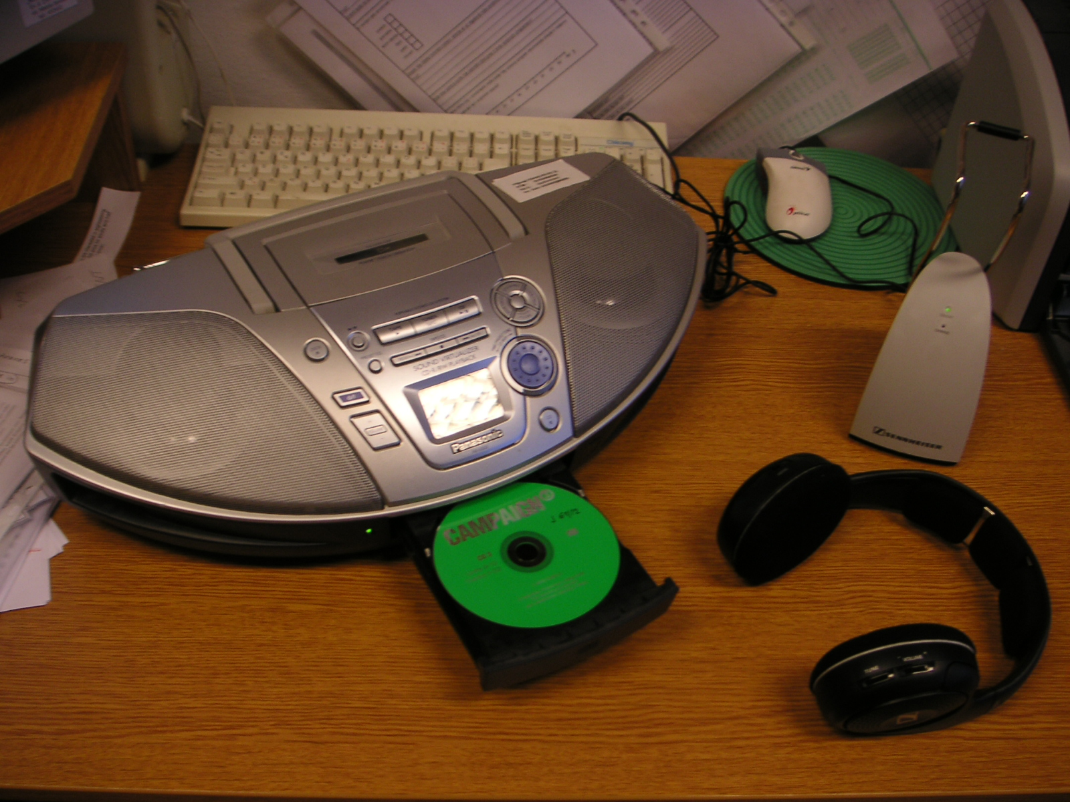

The SMART Board is a very innovative and powerful support for language acquisition. First of all, it provides a bridge that allows using the features of computers without breaking communication – it even supports it. Secondly, it may enhance new kinds of learning processes. Instructors who want to educate according to modern approaches should incorporate an interactive whiteboard within their classes and undergo a proper pedagogical shift toward using new devices. Lessons, where the SMART Board is used, should be planned in advance as well as any other lesson. The difference from traditional way is that the objectives and outcomes can be presented with the help of overhead projectors. Even that we work with technology, we must not forget that it is just a teaching tool, which serves to the development of English skills.
CONCLUSION
ICT have already changed the way we communicate with relatives, colleagues, and friends. Indeed, we are taking part in the revolution that is sweeping the world and is just beginning to change and influence the way we teach and learn in our schools. The infusion of technology like modern digital media computers, high-speed networks and Internet access, and higher-guality educational SW into schools will continue explosively in the following years.
The first aim of my thesis was to stress the fact that English educators should have some knowledge of modern educational technologies, and that they should implement them into English lessons. This item permeates through the whole work and is especially described in chapter one. New devices are ubiquitous and influence education more and more, but using them does not mean that learners will be better educated. Schools equipped with better technology can follow the newest educational trends and such good technology at schools should help an educator to teach English well and in an interesting and entertaining way. ICT can transform the education process, putting learners at the heart of the system which does not advocate learning about technology, but rather using technology to learn. I think teachers are expected to make a positive contribution so that students will be technology knowledgeable. They must willingly embrace new opportunities and foster students’ thinking. The acceleration and exponentiation of the teaching process is the greatest asset of computers but the way technology in teaching is used depends on an educator’s knowledge, abilities and sense.
The first chapter deals with kinds of modern devices – especially computers – that can be applied in education. Integrating technology effectively into the curriculum can create new learning environments but requires planning, time, dedication, resources, and practice. Digital media can be highly effective teaching tools when properly evaluated and integrated into teaching, and they can appeal to a variety of learning styles. The differences between today’s students and students in the past are described. Teachers must adjust to the fact that today’s media-centric students are different from previous generations in more ways. Learners nowadays are hypercommunicators and multitaskers, and prefer being active participants rather than passive recipients of information. The task of the teachers should be to constantly search for innovative ways to keep students motivated to learn. The chapter further stresses that CALT is an important part of English learning process, and that its importance is increasing because more and more learners all over the world nowadays take tests via computers. CALT is different from other types of language tests in the method characteristics of the input and response, the interaction between them, and assessment.
The description of DLI and CALL at DLI is included in the second chapter. Its importance, educational and methodical tasks, types of courses, description of a weekly schedule including the core teaching material, and branches can be found here. Terms like SLP and STANAG are explained, and the language exam is written about. The chapter also contains a description and photograph of SAC.
In part three, four, five and six the thesis deals with many of the possibilities that one can teach English with computer assistance. These parts contain theoretical fundamentals of teaching with the Internet, e-learning, courseware, and SMART Boards. Educators can nowadays choose from a fascinating array of resources. They can, for example, enrich teaching and choose from a lot of quality courseware. Teachers can work with the Internet and use a great variety of ELT websites. The Internet can teach students global thinking and cooperation. Interactive whiteboards can help make classroom lessons more engaging and effective, and well-prepared and well-organized e-learning education is a very good possibility for students who cannot study in intensive courses. Further, students’ and teachers’ opinions on working with ICT at DLI in English acquisition process are stated.
The main output of the surveys was that apart from working with PowerPoint presentations and Internet sites in unofficial activities, the use of modern devices is not very widespread at DLI in Vyškov. Students in SLP2 courses rarely worked with SMART Boards, they had only few lessons where they worked with presentations or video extracts. Their knowledge of using courseware in English learning is poor because only English Effectively program is being used at DLI at present. In addition, it unfortunately seems that there are fewer and fewer lessons spent in computer-assisted classroom. Learners have some experience with Internet sites but in instructor-assisted lessons they often choose them without realizing lesson objectives. In spite of a big effort of my colleague Mrs.Klausová, many students do not consider the e-learning method as very efficient. Here the problem is caused by both HW and SW imperfections and learners’ willigness to devote sufficiency of time to study via the Internet. “A teaching process led by an instructor is usually more efficient than self-study because one can correct or deepen an interpretation immediately.” (Choděra, Ries 1999.130) To my astonishement, some learners have never been taught with the assistance of simple video or wireless headphones. To conclude my findings, there is a great deal of work ahead to improve this state. Even that English courses cannot be based on computers the lessons could be much more interactive than they are at present.
My overall intention was the using of modern technologies to become an integral part of education at DLI even that I realize that the use of computers and other technologies are not without controversy. Using digital media will be natural for some people but a struggle for others because not everyone is at the same skill level, or because of some physical, cognitive or sensory disability. “…., the language teacher cannot ignore the results of linguistics …... the psychology of human learning, the age and education of the pupils, or the personality and capacity of the individual student.” (Lado 1964.8) I was trying to provide some possibilities of computer use in English teaching process. The teacher’s main task is to stream-line the using of ICT so that they are educationally worthwhile and negative educational procedures will not prevail. In addition, ICT can change the role of the teacher from an instructor to facilitator in some parts of the curriculum. “Perhaps the most important distinction to be drawn here is between the roles of controller and facilitator, since these two concepts represent opposite ends of a cline of control and freedom. A controller stands at the front of the class like a puppet-master or mistress controlling everything; a facilitator maintains a low profile in order to make the students’ own achievement of a task possible.” (Harmer 1991.235)
Educational technology and digital media can be valuable when they are integrated into lessons appropriately to support learning objectives. “…the solution of any foreign language teaching problem is a complex matter with a didactic decision making in the top.” (Choděra, Ries 1999.27) Educational technologies are tools, and their effectiveness is determined by the knowledge, skill, experience, level of training, and ethics of the user. The educational technology knowledge we acquire should help us participate more effectively in decisions on how to use computers and other educational technologies efficiently and ethically. Teachers must continuously update their technology and technology integration skills. Only then they can use and integrate technology to influence future generations in immensely positive ways. Teachers must be computer literate, information literate, and most importantly, integration literate.
RESUMÉ
English language teaching involves computer assisted language learning. My diploma thesis deals with this subject and tries to assist teachers of English master an interesting and novel tutorial approach. It emphasizes the duty of a good teacher to engage in this sphere since it can help successful language acquisition.
The theoretical part includes fundamentals of using computers in teaching, various courseware, Internet sites, interactive white boards, and e-learning.
The practical part contains educators’ and learners’ personal experience and opinions concerning computer assisted language learning.
RESUMÉ
Výuka anglického jazyka zahrnuje výuku pomocí počítačů. Moje diplomová práce se zabývá tímto tématem a snaží se pomoci učitelům anglického jazyka zvládnout bezesporu zajímavý a inovační výukový přístup. Zdůrazňuje povinnost dobrého učitele zajímat se o tuto sféru, protože může pomoci k osvojení jazyka.
Teoretická část zahrnuje základy použití počítačů ve výuce, různé výukové programy, Internetové stránky, interaktivní tabule a e-learning.
Praktická část obsahuje osobní zkušenost a názory učitelů i studentů na výuku anglického jazyka pomocí počítačů.
WORKS CITED
BOOKS

Adams, A. & Brindley, S. Teaching Secondary English with ICT. London, 2007
Chapelle, C.A. & Douglas, D. Assessing Language through Computer Technology. Cambridge, 2006
Choděra, R., Ries, L. Výuka cizích jazyků na prahu nového století. Ostrava, 1999
Dexter, S. & Anderson, R. Teachers’ views of computers as catalysts for changes in their teaching practice. Journal of Research on Computing in Education, 1999. 31(3), 221-239
Dudeney, D. The Internet and the Language Classroom. Cambridge, 2007
Forcier, R. & Descy, D. The computer as an educational tool: productivity and problem solving. Columbus, 2002
Grable, M. & Grable, C. Integrating the Internet for meaningful learning. Boston, 2007
Harmer, J. The Practice of English Language Teaching. UK, 1991
Keller, J.M., & Suzuki, K. Use of the ARCS motivation model in courseware design. Instructional designs for microcomputer courseware, Chapter 16. USA, 1988
Lado, R. Language Teaching. USA, 1964
Lever-Duffy, J., McDonald, J., & Mizell, A. Teaching and learning with technology. Boston, 2004
Malíř, F. Didaktiky cizích jazyků jako vědní obory. K problematice jejich předmětu. Praha, 1971
Meyer, K. The Web’s impact on student learning. T.H.E. Journal, 2003. 30(10), 14-24
Morrison, G. & Lowther, D. Integrating computer technology into the classroom. Columbus, 2005
Newby, T., Stepich, D., Lehman, J., & Russel, J. Instructional technology for teaching And learning: Designing instruction, integrating computers, and using media. Columbus, 2006
Palmer H.E., Palmer D. English through Actions. London, 1959
Robyler, M. Integrating educational technology into teaching. Columbus, 2006
Shelly, G., Cashman, T., & Vermaat, M. Discovering computers 2008: A gateway to information. Boston, 2008
Shelly, G. B., Cashman, T. J., Gunter, R. E. and Gunter, G. A. Integrating Technology and Digital Media in the Classroom. Boston, 2008
Shelley, M.A. Distance Education. London, 2000
Smaldino, S.E., Lowther, D.L., & Russel, J.D. Instructional media and technologies for learning. Columbus, 2008
Vachek, J. Selected Writings in English and General Linguistics. Prague, 1976
White, C. Language Learning in Distance Education. Cambridge, 2003
Žilová, R. Počítač a vyučovanie cudzieho jazyka. Nitra, 2001

INTERNET SOURCES

Bledsoe, Glen L., Technology Taxonomy. Dostupné na:
http://www.nea.org/teachexperience/gb050201.html, cit. 25.3.2006
Peirc, William, Seven ways to positively influence students’ thinking. Dostupné na:
http://www.eschoolnews.com/news/showStory.cfm?ArticleID=1979, cit. 15.2.2006
EducationTimes.com. More Power to You, 2008. Dostupné na:
http://timesofindia.indiatimes.com/articleshow/msid-2550842,prtpage-1.cms, cit. 13.2.2008
EzineArticles. Disadvantages of Online Education, 2008. Dostupné na:
http://ezinearticles.com/?Disadvantages-Of-Online-Education&id=941967, cit. 12.2.2008
Branigan, C. Schools urged to teach ‘21st-century’ skills, 2003. Dostupné na:
http://www.eschoolnews.com/news/showStoryalert.cfm?ArticleID=4506, cit. 5.1.2008
Internet Society. A Brief History of the Internet, 2003. Dostupné na: http://www.isoc.org/internet/history/brief.shtml, cit. 10.1.2008
Jerry Uhl’s favorite quotations, 2000. Dostupné na: http://www.dougshaw.com/uhl, cit. 9.12.2007
eSchool News. Multimedia / Video Tools, 2008. Dostupné na:
http://www.eschoolnews.com/resources/multimedia, cit. 5.1.2008
EducationGuardian.co.uk. Free your creativity, 2007. Dostupné na:
http://education.guardian.co.uk/getonboard/story/0,,1679892,00.html, cit. 22.11.2007
Pt3.org. Preparing Tomorrow’s Teachers to Use Technology, 2006. Dostupné na: http://www.pt3.org, cit. 28.11.2007
Technology Infusion. Points to Ponder about Technology Integration in Your Classroom, 2006. Dostupné na:
http://www.technologyinfusion.org/pointstoponder.html, cit. 22.2.2008
Prentice Hall Companion Website. A Model to Help ASSURE Learning, 2008. Dostupné na: http://wps.prenhall.com/wps/media/objects/1579/1617793/ASSURE/ASSURE.PDF, cit. 25.2.2008

DICTIONARIES

Collins Cobuild English Dictionary (1997) GB: HarperCollins Publishers.
Dictionary of Contemporary English (2005) GB: Longman.
Microsoft Computer Dictionary (2002) USA: Microsoft Press.
Oxford Advanced Learner’s Dictionary (1997) GB: Oxford University Press.
Webster’s New World Dictionary (1998) USA: John Wiley & Sons.
APPENDICES
Appendix 1. An overview of inventors and evolving of computers from 1936 to the production of Microsoft Windows

Year | Inventors  Inventions | Description of event
1936 | Konrad Zuse  Z1 Computer | First freely programmable computer.
1942 | John Atanasoff & Clifford Berry  ABC Computer | Who was first in the computing biz is not always as easy as ABC.
1944 | Howard Aiken & Grace Hopper  Harvard Mark I Computer | The Harvard Mark 1 computer.
1946 | John Presper Eckert & John W. Machly  ENIAC 1 Computer | 20,000 vacuum tubes later...
1948 | Frederic Williams & Tom Kilburn  Manchester Baby Computer & The Williams Tube | Baby and the Williams Tube turn on the memories.
1947 / 1948 | John Bardeen, Walter Brattain & Wiliam Shockley  The Transistor | A transistor is not a computer, but this invention greatly affected the history of computers.
1951 | John Presper Eckert & John W. Mauchly  UNIVAC Computer | First commercial computer & able to pick presidential winners.
1953 | International Business Machines  IBM 701 EDPM Computer | IBM enters into 'The History of Computers'.
1954 | John Backus & IBM  FORTRAN Computer Programming Language | The first successful high level programming language.
1955 | Stanford Research Institute, Bank of America, and General Electric  ERMA and MICR | The first bank industry computer - also MICR (magnetic ink character recognition) for reading checks.
1958 | Jack Kilby & Robert Noyce  The Integrated Circuit | Otherwise known as 'The Chip'
1962 | Steve Russell & MIT  Spacewar Computer Game | The first computer game invented.
1964 | Douglas Engelbart  Computer Mouse & Windows | Nicknamed the mouse because the tail came out the end.
1969 | ARPAnet | The original Internet.
1970 | Intel 1103 Computer Memory | The world's first available dynamic RAM chip.
1971 | Faggin, Hoff & Mazor  Intel 4004 Computer Microprocessor | The first microprocessor.
1973 | Robert Metcalfe & Xerox  The Ethernet Computer Networking | Networking.
1974 / 1975 | Scelbi & Mark-8 Altair & IBM 5100 Computers | The first consumer computers.
1976 / 1977 | Apple I, II & TRS-80 & Commodore Pet Computers | More first consumer computers.
1978 | Dan Bricklin & Bob Frankston  VisiCalc Spreadsheet Software | Any product that pays for itself in two weeks is a surefire winner.
1979 | Seymour Rubenstein & Rob Barnaby  WordStar Software | Word Processors.
1981 | IBM  The IBM PC - Home Computer | From an "Acorn" grows a personal computer revolution
1981 | Microsoft  MS-DOS Computer Operating System | From "Quick And Dirty" comes the operating system of the century.
1983 | Apple Lisa Computer | The first home computer with a GUI, graphical user interface.
1984 | Apple Macintosh Computer | The more affordable home computer with a GUI.
1985 | Microsoft Windows | Microsoft begins the friendly war with Apple.
Appendix 2. An example of a weekly schedule at DLI

 | 8:00-8:50 | 9:00-9:50 | Break#1 | 10:20-11:10 | 11:20-12:10 | Break#2 | 13:05-13:55 | 14:05-14:55 | 15:05-15:45
Mo | ALC 1 L 1 | ALC 1 L 1 |  | ALC 1 L 1 | ALC 1 L 1 |  | Listening | Speaking
Tue | ALC 1 L 2 | ALC 1 L 2 |  | ALC 1 L 2 | ALC 1 L 2 |  | Listening | Speaking
Wed | ALC 1 L 3 | ALC 1 L 3 |  | ALC 1 L 3 | ALC 1 L 3 |  | Listening | SAC | SAC
Thu | ALC 1 L 4 | ALC 1 L 4 |  | ALC 1 L 4 | ALC 1 L 4 |  | Listening | Speaking
 | 8:00-8:50 | 9:00-9:50 | 10:00-10:50 | 11:00-11:50 | 12:00-12:50
Fri | ALC 1 L 5 | ALC 1 L 5 | ALC 1 L 5 | ALC 1 L 5 | ALC 1 BQ

Appendix 3. Courseware available on the Czech market

Table 5. The outline of producers and their courseware
Producer | Courseware
Langmaster | English Elements  English Express  English Millenium Line  English the Heinemann TOEFL  English for Children  Zak’s Wordgames  Mean City English
Leda | Talk to me  Tell me more
Terasoft | English for Pupils 1  English for Pupils 2  English for Pupils 3  English for Pupils 4  English for Pupils 5
Silicom | English 1  English 2

Description of English Elements (Langmaster)
This courseware consists of a course outline and a dictionary on 7 CDs. The complete English course is based on the newest textbook series called English Elements printed in Max Hueber Verlag GmbH publishing house. Textbooks were modified for computers and enlarged by further exercises. The course uses the speech recognition technique called ViaVoice that enables one to control exercises with the help of his/her voice. You can work according to the prepared teaching plan or your own decisions. When doing an exercise, you can use the mouse when needed to find out the grammatical interpretation of a concrete event. There are two ways you can look a word up in the dictionary. One way is to click on it with the mouse and the other just to say the word to a microphone. There is also a Re-Wise method that serves for learning English vocabulary and phrases. Its task is to keep them as long as possible in the student’s memory. Vocal curves help to practise the right pronunciation so that even native speakers could understand you. The courseware further provides 380 intensive hours of learning, 1.700 exercises, over 4.800 new words and phrases, 2.650 pictures and photos, 75.000 entries (40.000 of which are spoken), 100.000 connotations and denotations, and 200.000 translations. It can be used for students on all levels (beginners, pre-intermediate, intermediate, upper-intermediate and advanced). Minimal system requirements: PC Pentium 166 MHz, 64 MB RAM, 30 MB free space on HDD, High Color (16bit) 800x600 graphics resolutions, 8x CD-ROM drive, sound card compatible with Sound Blaster, microphone, Microsoft Internet Explorer 5.5 or higher (part of the installation CD), Windows 95, 98, ME, 2000, XP, NT 4.0

Description of English express (Langmaster)
This is actually the first part of the English elements courseware. English Express is for all who want to learn English quickly. It provides 80 intensive teaching hours, basic grammar knowledge, simple texts, 800 words and phrases, native speakers’ audio recordings, vocal curves (for correct pronunciation), exercises, tests, pictures, photos, and the Re-Wise method for long-term memory keeping. What about topics we can find Greetings, Introducing, Numerals, Colors, Drinks and Food, Jobs, Travelling, Sport, Weather and many other there. It can be called the English language cookbook for beginners.Minimal system requirements: PC Pentium 166 MHz, 64 MB RAM, 150 MB free space on HDD, High Color (16bit) 800x600 graphics resolutions, 8x CD-ROM drive, sound card compatible with Sound Blaster, microphone, Microsoft Internet Explorer 5.5 or higher (part of the installation CD), Windows 95, 98, ME, 2000, XP, NT 4.0

Description of English millenium line (Langmaster)
The English millenium line is comprised of 13 CDs with interactive books and an English explanatory dictionary. It has the most extensive series of English teaching titles. The cohesion between the courses and the dictionary, the attractive visual appearance and the simple control are unique. Thanks to clear instructions and the help list, you will learn the courseware very soon. The authors’ attitude is not based on boring articles and conversations, but on books adjusted for specific language levels. You can choose from different kinds of stories (detective, adventure, love, horror). The basic activity is listening to the texts, not reading. One can shuffle sentences and paragraphs as he/she needs. Apart from practising the correct pronunciation, you can learn vocabulary and grammar. There are over 20 various types of exercises, 5.000 interesting pictures, 33 hours of sound and correct answers are part of 1.000 interactive exercises. We can find there items written by various authors: The Long Tunnel (John Milne), The Garden (Elizabeth Laird), Dangerous Journey (Alwyn Cox), Rich Man Poor Man (T.C. Jupp), The Stranger (Norman Whitney), Room 13 and Other Ghost Stories (M.R. James), The Picture of Dorian Gray (Oscar Wilde), Riders of the Purple Sage (Sir Arthur Conan Doyle), The Sign of Four (Sir Arthur Conan Doyle), Dracula (Bram Stoker), The Speckled Band and Other Stories (Sir Arthur Conan Doyle), The Woman Who Disappeared (Philip Prowse). What about the dictionary, it is the LANGMaster Collins COBUILD Student’s Dictionary. There are over 40.000 entries. Every word has its written explanation, usage within sentences or phrases and even sound. There are 283.000 sounds and 50 hours of audio. You can find any word in a special user-dictionary and then learn it with the help of the Re-Wise method. There are courses for beginners, pre-intermediate and intermediate learners. Minimal system requirements: PC Pentium, 32 MB RAM, 15 MB free space on HDD, High Color (256 colors) 800x600, 8x CD-ROM drive, sound card compatible with Sound Blaster, microphone, Microsoft Internet Explorer 5.5 or higher (part of the installation CD), Windows 95, 98, ME, 2000, XP, NT 4.0

Description of English in action (Langmaster)
This courseware on 6 CDs deals with authentic videos provided by Sky News TV station. You can learn and improve your English with 18 well-known persons, e.g. Bill Clinton, Bill Gates, Stephen King, Kim Basinger, music group Genesis, or members of the British royal family. You can find these titles there: Businessmen & Politicians, Famous Writers, Film Stars, Pop Stars, and The Royal Family. The main aim of English in Action is to teach English with understanding to the spoken texts. You can also record your own speech and compare it with the original. There are Czech translations at your disposal. It is a perfect preparation for the encounter with the ‘real’ English that we know from radio or TV. Apart from learning English, you will learn a lot of interesting information about the lives of people. There is also a supplemental on-line study on the Internet. Teachers can find many subject matters for their classwork. These videos are suitable both for self-taught individuals and learners in groups. Minimal system requirements: PC Pentium, 32 MB RAM, 15 MB free space on HDD, High Color (256 colors) 800x600, 8x CD-ROM drive, sound card compatible with Sound Blaster, microphone, Microsoft Internet Explorer 5.5 or higher (part of the installation CD), Windows 95, 98, ME, 2000, XP, NT 4.0

Description of English the Heinemann TOEFL (Langmaster)
TOEFL is an internationally accepted exam in English. A TOEFL certificate is often considered as a standard showing a level of English nowadays. Some foreign universities will not accept an applicant without this certificate. It has four parts: listening comprehension, structure and written expression, reading comprehension and a test of written English. TOEFL is prepared by Educational Testing Service (ETS) in Princeton, New Jersey USA. There are two parts, each on a separate CD: The Heinemann TOEFL Preparation Course and The Heinemann TOEFL Practice Tests. Preparation Course is connected with TOEFL exam methodics. It consists of exercises for each TOEFL part (listening comprehension, structure and written expression, reading comprehension, a test of written English), ‘real’ TOEFL tests, a complete diagnostic test, 2 complete mock tests, short checkup tests, and an overview of grammar. Practise tests contain 5 complete tests, recommended strategy, and correct answers with commentary. It is about practising the knowledge that you acquired in the Preparation Course. The courseware gives your results. It can then suggest exercises and a plan that will help you not to make the same mistakes again. This product is for advanced students who want to check and improve their skills or prepare for the TOEFL exam. Minimal system requirements: PC Pentium, 32 MB RAM, 15 MB free space on HDD, High Color (256 colors) 800x600, 8x CD-ROM drive, sound card compatible with Sound Blaster, microphone, Microsoft Internet Explorer 5.5 or higher (part of the installation CD), Windows 95, 98, ME, 2000, XP, NT 4.0
Description of English for children (Langmaster)
This is an interactive English teaching courseware on 1 CD. It is special because there are many animations, sound effects, and modern graphics. There are about 700 basic words and expressions, several interactive exercises and 25 English poems (after or during hearing a poem, young learners very often imitate native speakers’ voices). Exercises can be done orally thanks to the ViaVoice method. Children can play and learn at the same time. There are funny pictures and many animated surprises which can motivate children to do creative work. Some animations start only after a child says a correct word. Vocabulary is divided into topics (e.g. Family, Home, Animals etc.), and it is in alphabetic order. This division makes learning easier for children. There are over 50 basic grammatical topics (e.g. possessive pronouns, singular and plural forms of nouns, modal verbs, present continuous etc.). It is intended for children from 6 to 9 years old. Both grammar and vocabulary are optimized for the age from 6 to 10 years. Minimal system requirements: PC Pentium 166 MHz, 32 MB RAM, High Color (256 colors) 800x600, 8x CD-ROM drive, sound card compatible with Sound Blaster, microphone, Microsoft Internet Explorer 5 or higher (part of the installation CD), Windows 95, 98, ME, 2000, XP

Description of Zak’s wordgames (Langmaster)
This Langmaster courseware is about learning English through playing a game with an attractive background. There are actually 24 games in which one should help the alien Zak with saving the planet Zalphon. The game is divided into 3 stages where you have to fulfil the tasks in English. You can enter the Zak’s onboard dictionary. There are 2.000 English words with pronunciation and pictures. It is a perfect entertainment. It is for children from 6 to 12 years old. Minimal system requirements: PC Pentium, 16 MB RAM, 40 MB free space on HDD, 4x CD-ROM drive, sound card compatible with MPC, Windows 3.1, 95, 98, ME, 2000, XP, NT 4.0

Description of Mean City English (Langmaster)
Mean City is about solving difficult situations which can happen to you when being abroad. The courseware is on the border between being an adventure game and multimedial education where you have to solve a lot of problems being at an airport, in a taxi, hotel, bank, restaurant, or prison. It is based on observing, listening and reading. There are more than 1.000 new words, 1.700 phrases, 11 language games, 600 short video recordings, 14 animated figures narrated by real actors, 1.000 pictures and photographs, and also humor and comical situations. A learner should be at least 12 years old. You can use this courseware if your English is on a pre-intermediate or intermediate level and if you need more than common exercises. Minimal system requirements: PC 486DX2/66MHz, 12 MB RAM, SVGA graphics card (640x480, 256 colors), CD-ROM, sound card, Windows 95, 98, ME, 2000, XP, NT 4.0

Description of Talk to me (Leda)
There are 3 CDs, and each level is burned on one CD. Every level works with 6 topics where we can find about 550 sentences and phrases which means from 50 to 100 teaching hours. The courseware options can be easily adapted to personal needs. It is based on the newest techniques, especially voice recognition, intelligent scoring procedures and highly sophisticated language content. A dynamic graph of speech shows the differences between a learner and a native speaker. It is aimed to understanding spoken English, responding to various situations, and enlarging vocabulary. Talk to me can be used at schools to enhance teaching but also for self-taught learning. A learner should be at least 12 years old and should have preliminary English knowledge. This software is intended for intermediate and advanced learners. Topics suitable for beginners: Describing oneself, How to count, Nouns and adjectives, Introductions (Arriving to England), Losing one’s way, Swinging with ‘ings’ (using words which end in ‘ing’ and English verbs). Topics suitable for intermediate learners: Ordering breakfast (Having breakfast), Ordering a meal (At a restaurant), Renting a villa (Enquiring about and taking a summer villa), The weather, Inviting friends, Entertainment (Going out to a concert). Topics suitable for advanced learners: Travelling by car, Travelling by air, Travelling by train, At customs, At the hotel, Sightseeing. Minimal system requirements: PC IBM or compactible, Pentium 120 MHz, SVGA graphics card (65.536 colors, 1024 x 768), 16 MB RAM, 105 MB free space on HD, 8x CD-ROM drive, mouse or trackball, 16 bit sound card compactible with Windows, microphone, speakers or earphones, Microsoft Windows 95 or higher

Description of Tell me more (Leda)
Tell me more is a complex multimedial courseware for teaching English. The main advantages are new effective teaching methods, e.g. voice recognition. There are 4 CDs containing over 550 sentences, 2.000 words, 35 hours of practicing pronunciation, video recordings with real-life situations, commentary on grammar rules, and almost 1.000 exercises and language games. There are two versions of Tell me more. One is for self-taught learners. The other is a network version suitable for group teaching at schools, courses or firms. No other teaching materials are needed for successful teaching. Each CD is aimed at a different level of English. Every level has its own topics. Learners should be older than 12 years. Levels suitable for beginners: Describing oneself, How to count, Nouns and adjectives, Introductions (Arriving in England), Losing one’s way, Swinging with ‘ings’(using words which end in ‘ing’ and English verbs). Topics suitable for intermediate level: Ordering breakfast (Having breakfast), Ordering a meal (At a restaurant), Renting a villa (Enquiring about and taking a summer villa), The weather, Inviting friends, Entertainment (Going out to a concert). Topics suitable for advanced level: Transport 1 (Travelling by car), Transport 2 (Travelling by air), Transport 3 (Travelling by train), At customs, At the hotel, Sightseeing. Topics suitable for business English level: First Contacts, At the Trade Fair, Taking a first Order, Handling Complaints, Overdue Invoices, Arranging a Visit. Minimal system requirements: PC IBM or compactible, Pentium 120 MHz, SVGA graphics card (65.536 colors, 1024 x 768), 16 MB RAM, 105 MB free space on HD, 8x CD-ROM drive, mouse or trackball, 16 bit sound card compactible with Windows, microphone, speakers or earphones, Microsoft Windows 95 or higher

Description of English for pupils 1 (Terasoft)
This is an interactive courseware with a lot of grammar exercises, sounds and native speakers’ utterances as well. One can print translations of sentences, vocabulary and grammar exercises. Children especially like practicing vocabulary and pronunciation in an enjoyable way. It is made for the 1st year of English teaching at primary schools which means that it would be taught in the 4th grade. It is the only product that follows an elementary school’s curriculum. But it can be also used for preschool education. Minimal system requirements: Pentium 100 MHz, 16 MB RAM, graphics card 256 colors (High Color 65.535 colors), mouse, sound card, CD-ROM drive, MS Windows 95/98/ME/2000/XP

Description of English for pupils 2 (Terasoft)
Its vocabulary is similar to that in the textbooks Project English 1 (second part), Angličtina pro 5.ročník ZŠ (Lacinová, Kadlecová), Angličtina pro 5.ročník ZŠ (Zahálková). It deals with the practicing of vocabulary and the main grammar topics (e.g past simple tense, present continuous tense, future tense). The second part is aimed at the 2nd year (5th grade) of primary school English teaching. Minimal system requirements: Pentium 100 MHz, 16 MB RAM, graphics card 256 colors (High Color 65.535 colors), mouse, sound card, CD-ROM drive, MS Windows 95/98/ME/2000/XP

Description of English for pupils 3 (Terasoft)
The courseware goes along with curriculum, has a unique thematical purpose and supports the most used textbooks (Project English 2/1st part, Angličtina pro 6. ročník základní školy) according to which the program can be set. The vocabulary is divided into 18 topics (e.g. public transport, money, electrical appliances, police etc.), is practised in a funny way and for every word there is a picture. Understanding the spoken words and written texts is also emphasized. Further, there are 16 interactive animated topics familiar to children (e.g. holiday, sports, children, world etc.), poems and fairy tales. We can work with 40 grammatical topics full of interactive exercises. You can print whatever you wish. The third part of English for pupils should be taught in the 6th grade of primary schools but it can be used for teaching at secondary schools or gymnasiums as well. Minimal system requirements: Pentium 100 MHz, 16 MB RAM, graphics card 256 colors (High Color 65.535 colors), mouse, sound card, CD-ROM drive, MS Windows 95/98/ME/2000/XP

Description of English for pupils 4 (Terasoft)
Its vocabulary relates to that in textbooks Project English 2/2nd part, Project 4 and Angličtina pro 7.ročník základní školy. The English words are divided into 18 topics (e.g. shops, army, Christmas, fairy-tales etc.). Practicing the vocabulary can be enjoyable for children thanks to many funny pictures. Young learners can practise listening and reading. Next, they can choose from one of 16 interactive animated themes (e.g. London, human body, space, famous people, occupations etc.), many poems and fairy-tales. There are 30 grammatical topics (e.g. present perfect tense, prepositions of direction and place, regular and irregular verbs, passive voice etc.). The 4th part of English for pupils contains teaching themes for the 7th grade of primary schools, secondary school students and gymnasium students. Minimal system requirements: Pentium 100 MHz, 16 MB RAM, graphics card 256 colors (High Color 65.535 colors), mouse, sound card, CD-ROM drive, MS Windows 95/98/ME/2000/XP

Description of English for pupils 5 (Terasoft)
The vocabulary is almost the same as in these textbooks: Project Plus, Project English 3/1st part, Angličtina pro 8.ročník základní školy. Teaching of listening and reading is emphasized. We have 16 interactive animated topics at our disposal (e.g. Family, The ways of transport, Luggage, Exercises, Car crashes, TV timetables etc.). Grammar is separated into 42 events (e.g. reflexive pronouns, wishes, question tags, conditional mood, gerund, past perfect tense, indefinite relative sentences etc.). The CD containing this software should be used for primary school learners (8th grade), students at gymnasiums and secondary schools. Minimal system requirements: Pentium 100 MHz, 16 MB RAM, graphics card 256 colors (High Color 65.535 colors), mouse, sound card, CD-ROM drive, MS Windows 95/98/ME/2000/XP

Description of English 1 and English 2 (Silicom)
Courseware with titles English 1 and English 2 covers all the grammar taught at an elementary school level. Curriculum is divided into several basic units which are further subdivided into concrete grammatical events. English 1 contains issues like articles, nouns (students practise them in sentences), pronouns (personal, possesive, indefinite), verbs (especially modal), present simple tense and past simple tense, prepositions, conjunctions, a chapter about making questions, answers and negative sentences. There are also tests checking your vocabulary, tenses, gradation of adjectives and translation. English 2 focuses on more difficult grammatical events, eg. regular and irregular verb forms in past tense, future tense, and present perfect tense. The next unit deals with inflection and negative forms of modal verbs, and a sequence of tenses in indirect speech. Another unit teaches conditional mood, passive voice, conversion from active to passive voice and vice versa, time prepositions, structures of verbs and prepositions, and structures of nouns and prepositions. The biggest advantage of this courseware is that it can check your knowledge. Before testing grammatical events, you can choose from 10 to 30 settings. Resulting schedules can inform you about the best records. All the details (a type of a task, date, good and bad answers, a mark) are saved in a special file. One can also print blank sheets with tests and fill in his/her answers without the need of a computer. English 1 is intended for beginners and intermediate students. The second part is aimed at advanced students. Minimal system requirements: Pentium, 8 MB RAM, 800x600 High Color, CD-ROM drive, Windows 95/98/ME/2000/NT/XP
Appendix 4. Some Internet-based activities (Dudeney 2007.49, 64, 69, 73, 82, 88, 96)
Aim: | To find out about US and UK English
Focus: | American and British English variants
Level: | Lower-intermediate and above
Time: | 60 minutes
Sites: | http://www.english-hilfen.de/en/words/ae-be2.htm

Aim: | To describe people
Focus: | Adjectives, activities, present continuous tense
Level: | Elementary and above
Time: | 60 minutes
Sites: | http://www.onlinephotogallery.com/people.htm

Aim: | To prepare songs to present to the rest of the class
Focus: | Vocabulary connected with music
Level: | Lower-intermediate and above
Time: | 60 minutes
Sites: | http://lyrics.astraweb.com  http://www.lyricsworld.com

Aim: | To talk about holidays – good and bad
Focus: | Past tenses, travel vocabulary
Level: | Upper-intermediate and above
Time: | 60 minutes
Sites: | http://www.ivillage.co.uk/travel/community/essentials/articles/0,,598871_676057,00.html

Aim: | To plan the perfect holiday
Focus: | Talking about holidays and travel plans
Level: | Upper-intermediate and above
Time: | 60 minutes
Sites: | http://www.lonelyplanet.com

Aim: | To talk about clothing and fashion
Focus: | Vocabulary connected with clothing and fashion
Level: | Elementary and above
Time: | 60 minutes
Sites: | www.riverisland.com  http://www.fcukbuymail.com

Aim: | To talk about world problems
Focus: | Global issues
Level: | Advanced
Time: | 60 minutes
Sites: | http://dir.yahoo.com/Society_and_Culture/Issues_and_Causes/

LIST OF FIGURES
Figure 1. The original IBM Personal Computer was introduced in 1981 11
Figure 2. A modern personal computer 12
Figure 3. A laptop computer 12
Figure 4. The older version of ALC books from 1991 28
Figure 5. The newer version of ALC books from 2002 28
Figure 6. Self Access Centre at the Defense Language Institute 29
Figure 7. The site used for distance learning by students in combined courses 32
Figure 8. Here the Internet connection is shared among all the devices connected through patch cable or wirelessly to the router 36
Figure 10. The SMART Board in SAC at DLI 60
Figure 11. The teachers' devices in SAC 61
Figure 12. The system of wireless headphones used by teachers can be attached to a cassette player, CD player or a computer 62

LIST OF GRAPHS
Graph 1. The students' awareness of e-learning 33
Graph 2. The number of lessons per week a particular learner would like to work with e-learning 34
Graph 3. The speed of the Internet connection possessed by students 34
Graph 4. The age of students' computers 35
Graph 5. Students' access to the Internet 35
Graph 6. The Internet sites used by students to practice listening 39
Graph 7. The Internet sites used by students to practice grammar 41
Graph 8. The Internet sites used by students to practice vocabulary 42
Graph 9. The Internet sites used by students to practice reading 43
Graph 10. The Internet sites used by students to search for news 44
Graph 11. Most favorite Internet sites used by students 45
Graph 12. The Internet sites used by teachers to teach listening 46
Graph 13. The Internet sites used by teachers to teach grammar 47
Graph 14. The Internet sites used by teachers to teach vocabulary 48
Graph 15. The Internet sites used by teachers to teach reading 49
Graph 16. The Internet sites used by teachers to search for news 50
Graph 17. Most favorite Internet sites used by teachers 51
Graph 18. Students' opinions on the English Effectively program 57
Graph 19. Language skills thought by students to be good to practice with English Effectively 58
Graph 20. The number of minutes per week imagined by students to work with English Effectively 58

LIST OF TABLES
Table 1. Establishing new learning environments by incorporating new strategies (Shelly, Cashman, Gunter, Gunter 2008.2) 14
Table 2. The impact of educator' technology on students' learning (Bledsoe 2006) 15
Table 3. Differences between today's students and students in the past (Shelly, Cashman, Gunter, Gunter 2008.16) 17
Table 4. Test method characteristics and CALT advantages and limitations (Chapelle, Douglas 2006.23) 23
Table 5. The outline of producers and their courseware 73

