Information for potential volunteer
caretakers at Old Andado

Old Andado Station is a remote tourist and historical homestead and out buildings inside the fringe of the Simpson Desert. We are at least a 5 hour drive from Alice Springs and 20 minutes from Andado Homestead. There is an airstrip on Old Andado land that can land an RFDS plane in the day light should there be an emergency.

At this stage we run the generator for 2 – 3 hours a day to pump water and provide lighting for tourists when they are staying. We run lights in the shower block and a large light for the campground. A few lights run in the homestead as well. Solar power is our ultimate goal.

Due to the limited use of the generator we do not have the facilities to keep fresh or frozen foods. You will need to be 100% self sufficient in this area. The bore water is drinkable and we have recently established a rainwater tank by the generator shed for drinking water – we are just waiting on more rain to fill it up!

You won’t be alone a great deal during the March to September tourist season as in a 7 week period one caretaker welcomed 400 people!

Flies – they WILL drive you mad so bring a fly net with you! They don’t follow you into the homestead thankfully.

Support – Mt Dare are our closest neighbours with supplies and fuel. The majority of our past caretakers have either come through Mt Dare or Alice Springs. If passing through Mt Dare we can arrange a ‘supplies pack’ for you to collect – it will contain such things as powdered milk, bread & or bread making supplies, cleaning products, some foods, biscuits, toilet paper etc… Upon leaving Old Andado a supplies order form will be available in the Caretaker kit at Old Andado to help with Meegan arranging the kit for the next caretakers.

Send your completed application form to:
Meegan Sullivan, 5 Kuhn Court
Alice Springs NT 0870
Or email it to info@oldandado.com.au

Old Andado Caretakers
Position Description

The role of the Caretaker(s) is to greet tourists, handle fees and maintain the Homestead.
More specifically the role entails:

- Greeting tourists – showing around the Homestead, as it is a museum, advising on camping/accommodation and facilities
- Make tea, coffee, morning and afternoon tea – all supplies provided. Emergency supplies can be sourced from Mt Dare.
- Take camping and house fees
- Clean the facilities
- Maintain the Homestead in a good state of repair to the best of your abilities, keeping it authentic, as it is heritage listed
- Maintain the grounds, establish gardens, vegetable patch etc..
- Maintain generator (diesel)
- Maintain water pump, lights/electrical and plumbing to the best of your abilities
- Assist with ‘Molly’s Bash’ preparations each Mothers Day weekend (May) if you are caretaking at this time
- Report to the Old Andado Charitable Trust.

PROCEDURES MANUAL
There is a procedures manual that has been put together and is kept at Old Andado along with forms to record visitor’s details – names, address, email address for statistical and promotional purposes.

FOOD STORAGE
At present Old Andado is not equipped for cold or frozen food storage. You will need to be self sufficient when keeping food and supplies. The nearest place to get basic supplies is Mt Dare – contact them on 8670 7835, you can buy meat, bread, milk etc from there.

ACCOMMODATION & TRANSPORT
You can provide your own caravan or camper trailer or you are welcome to take a room in the ATCO transportable rooms. You will need your own transport to and from Old Andado. There is a vehicle and trailer which can be used for collecting wood and travelling around the grounds.

ROSTER
As we are in the early days of volunteer caretaking, we need people to let us know when they can be at Old Andado. The span of time ranges from March to October. We try and have a maximum stay of one month.

INSURANCE
Old Andado has public liability insurance but we also recommend that our volunteers take out a Volunteer Accident Insurance Policy (not essential, its your choice)

OLD ANDADO CARETAKERS DAILY DUTIES

MOVE THINGS TO CLEAN BUT DON’T REARRANGE ANYTHING! Molly’s orders!

DOESN’T HAVE TO BE CLEAN – JUST LOOK CLEAN – as we are in a dusty desert environment all your hard work can be undone in 5 minutes!

DAILY JOBS:

- Clean toilets and showers
- Pump water every second day – depends on numbers showering. Pump when people not using shower facilities
- Garden maintenance & watering
- No composting due to attracting ants
- Separate the cans for recycling. These can be dropped off at Mt Dare if you are travelling there for supplies or fuel.
- Remove ash from fire pits and put near the septic outlet (removes odours)
- Spray any ants (chemicals & sprayer in small garden shed)
- Remove ash from the donkey and put ashes in the swamp opposite the kitchen
- Rake/sweep the homestead yard by kitchen
- Sweep outside and inside the homestead
- Collect firewood for kitchen and donkey using the vehicle and trailer provided – all campers MUST supply their own wood for camp fires

AIRSTRIP & FLIGHTS – a rare occasion!

Check the airstrip for pebbles/rocks over 3cm in size & remove from strip and also check for cattle pads (tracks) across the strip and fill them in. Do this job about 1 hour before flights land if you are notified. Suggest a donation of $20 for a landing fee.

OCCASIONAL JOBS:

- wipe out the kitchen cupboards
- polish furniture using O’Cedar polish
- black the kitchen oven (potbelly black in a spray can)
- clean out the guttering on the demountables and outside the kitchen in the breezeway
- wash the covers on kitchen veranda chaise lounges
- clean the demountables (Atco’s) & sweep veranda
- drag the campground
- rake under the campground bough shed

A full procedures manual will be available for you.

You can contact Meegan Sullivan via email preferably at
info@oldandado.com.au or via mobile on 0411 667 110.
Meegan is not always able to answer the phone but leave a
voice message and she will return the call.

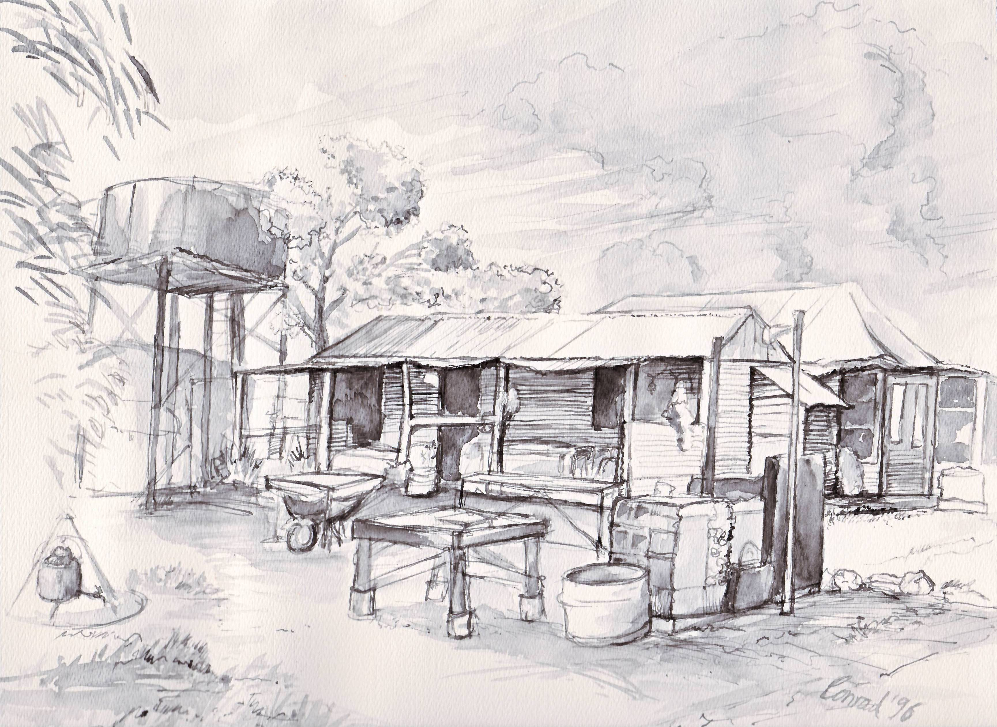
Old Andado Charitable Trust

Volunteer Caretaker

Application Form

What dates are you looking to Caretake for?

…………………………………………………..…..

FIRST APPLICANT:

Name …………………………………………………………………………………………………………

Address …………………………………………………………………………………………………………

…………………………………………………………………………… Postcode ………………

Telephone ……………………………………… Mobile ………………………………………

E-mail ………………………………………………… Date of Birth ……………..Age ………..

SECOND APPLICANT:

Name …………………………………………………………………………………………………………

Address ……………………………………………………………………………………………………………

…………………………………………………………………………… Postcode ..………………

Telephone ……………………………………… Mobile …………………………………………

E-mail ………………………………………………… Date of Birth ……………..Age ………..

What is your preferred contact time and method? Please circle.

Morning afternoon evening Email mobile home phone letter

How did you hear about the volunteering opportunity? (e.g. friend, past/present volunteer, website)
…………………………………………………………………………………………………………………………

Do you hold a current First Aid and / or CPR qualification? YES NO

Do you hold a Volunteer Accident Insurance Policy? YES NO

Do you have any health conditions that could affect your ability to carry out the Volunteer Caretakers role at Old Andado Station? If yes, please provide details.

…………………………………………………………………………………………………………

…………………………………………………………………………………………………………

…………………………………………………………………………………………………………

…………………………………………………………………………………………………………

…………………………………………………………………………………………………………

Please give provide a short description of your working / life experience and how that would suit the Caretaker role at Old Andado Station:

…………………………………………………………………………………………………………

…………………………………………………………………………………………………………

…………………………………………………………………………………………………………

…………………………………………………………………………………………………………

…………………………………………………………………………………………………………

…………………………………………………………………………………………………………

…………………………………………………………………………………………………………

…………………………………………………………………………………………………………

Please give the names of two people who know you well and can provide references

PERSONAL PROFESSIONAL

Full Name ………………………………………

Address …………………………………………

……………………………………………………

Postcode ………… Tel: ………………………

.Email: ………………………………………….
In what capacity do you know him/her?

…………………………………………………..

Full Name ………………………………………

Address …………………………………………

……………………………………………………

Postcode ………… Tel: ………………………

.Email: ………………………………………….
In what capacity do you know him/her?

…………………………………………………..

Your signature ………………………………………… Date ……………………………………

OFFICE USE: Application processed by: ………………………………………….………....

Referee checks done Date: ………………………………………..

First Aid/CPR certificates obtained Date: ………………………………………..
Copy attached

Volunteer Accident Insurance policy obtained Date: ………………………………………..
Copy attached

Applicants approved declined Date: ………………………………………..

Applicants notified of result Date: ………………………………………..

