Community Health Workers’ symposium, 21st to 23rd February 2017, Kampala, Uganda
This document contains useful information to help you during your stay in Uganda.
We provide some details on the following:
- About Kampala
- Symposium venue
- Accommodation
- Visa information
- Money
- Transport from the airport and within Kampala
- Health
- Security
- Weather
- Contact information

1.0 About Kampala
Welcome to Kampala, the capital and biggest city of Uganda situated approximately 44.5 km away from Entebbe international airport. In 2016, Kampala was ranked the best East African city to live in by the 18th annual quality of living ranking done by a New York based global consulting agency. The city has seven hills, each housing an important government or religious building. Kasubi Hill is the home of the Kasubi tombs, a sacred burial ground of Buganda kings. The Uganda museum sits atop Kololo Hill, and features a hands-on collection of ethnological, natural history and traditional life of Uganda’s cultural heritage. Once again welcome to Kampala and feel all that it has to offer: amazing attractions, cool hang out spots, superb culture/nightlife, events, restaurants, hotels and much more.

2.0 Symposium venue
The symposium will be held at Hotel Africana, Plot 2-4 Wampewo Avenue, Kampala, Uganda.
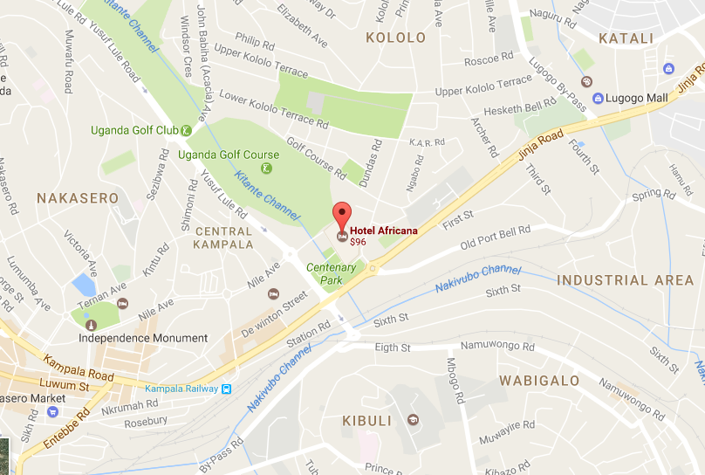
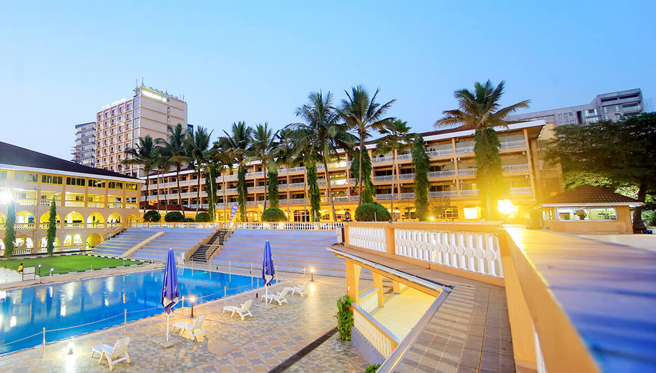
Hotel Africana, Kampala, Uganda
3.0 Accommodation
- We have provided a list of hotels in Kampala that have been pre-approved by the UN security department as meeting minimum standards for use by international guests. However, we encourage participants to stay at the symposium venue that is providing discounted rates if you book using the code “Makerere University School of Public Health (MakSPH)”. Otherwise, we advise you to book a hotel that is close to the symposium venue for easy access.

Table 1: List of hotels pre-approved by the UN security department as suitable for international guests
No. | HOTEL | PHONE CONTACT | E-MAIL ADDRESS | PHYSICAL ADDRESS | APPROXIMATE DISTANCE FROM SYMPOSIUM VENUE (KM)
1 | Fairway Hotel | 256-414-259571 /2 | fairway@starcom.co.ug | Plot 1/2, Kafu Rd | 1.8
2 | Fang Fang Hotel | 256-414-235828; +256-414-233115 | fangfang@africaonline.co.ug | Plot 9, Sezibwa Rd | 2.2
3 | Golf Course Hotel | 256-312-265490 /1 /2 | reservations@golfcoursehotel.com | Plot 6486, Yusuf Lule Rd | 1.0
4 | Grand Imperial Hotel | 256-414-311048; +256-414-250606 | reservation@gihotel.co.ug | Plot No 6/6A, Kampala | 2.3
5 | Hotel Africana | 256-414-477500 ; +256-414-348080 | africana@hotelafricana.com | Plot 2 - 4, Wampewo Ave, Kampala | Symposium venue
6 | Humura Resort Hotel | 256-414-700400 | info@humura.org | Plot 3, Off Yusuf Lule Rd | 2.3
7 | Imperial Royale Hotel | 256-417-111001 | information@irh.co.ug | Plot 7 Kintu Road | 1.7
8 | Kampala Serena Hotel | 256-414-309000; +256-312-309000 | kampala@serena.co.ug | Plot 6/8, Nile Avenue | 1.6
9 | Metropole Hotel | 256-414-391000 /1 /2; +256-312-391000 | gm@metropolekampala.com | Kampala 51/53, Windsor Crescent | 1.5
10 | Protea Hotel | 256-312-550000 | info@protea.co.ug | Kampala, 4 Elgon Terrace Kololo | 1.6
11 | Shangrila Hotel at Nyonyi gardens | 256-772-222622; +256-772-722621 | nyonyi@hotel-apartment-uganda.com | Plot No, Street/Road, Plot 18 Kololo, Wampewo Avenue | 0.9
12 | Sheraton Hotel | 256-414-420000; +256-312-322499 | sheraton@apolohotel.com | Kampala, Ternan Avenue | 2.2

4.0 Visa information
- Nationals from the following countries are exempted from paying for visas while entering Uganda: Angola, Eritrea, Malawi, Madagascar, Seychelles, Swaziland, Zambia, Comoros, Kenya, Mauritius, Zimbabwe, Botswana, Tanzania, Rwanda, Burundi, Antigua, Barbados, Fiji, Granada, Lesotho, Sierra Leone, Solomon Islands, The Grenadines, Vanuatu, Ghana, Cyprus, Bahamas, Belize, Gambia, Jamaica, Malta, Singapore, St. Vincent-Tonga, Ireland and Libya.

- All visa prone nationalities must obtain Uganda visas to facilitate their entry into the country.

- Uganda visas may be obtained at Uganda missions abroad or on arrival at the port of entry in the country. Ensure you obtain information applicable to your country.

- All travellers to Uganda MUST have a valid Yellow Fever Immunisation card.

Table 2: Visa and corresponding fees
Category/description of visa | Cost
Single entry | US$ 50 per individual
Multiple entry visa 6-12 months | US$ 100
Multiple entry visa 24 months | US$ 150
Multiple entry visa 36 months | US$ 200
Students (Entry visa for students who are not nationals of East African cooperation) | US$ 100
East African Tourist Visa (Three months multiple entry for Kenya, Rwanda and Uganda) | US$ 100

- Money
- There is a wide array of banks and forex (foreign currency exchange) bureaus to choose from in Kampala, with several international banks represented (Barclays, Standard Chartered and Stanbic).

The US dollar and the Pound sterling are the easiest currencies to exchange to Uganda shillings. As US dollar notes dated prior to 1997 are turned away, we recommend if you are using US$ to bring notes issued not earlier than 2000. Also, notes smaller than US$50 attract a far lower exchange rate. All forex bureaus take cash, so please look around for the best exchange rate. We suggest you bring cash and/or credit cards with you as opposed to traveler’s cheques, as the exchange rate (on traveler’s cheques) is much lower.

- You can change money at the airport in Entebbe as it is convenient. However, be aware that the airport exchange rate is currently not as competitive as forex bureaus in Kampala.

- Credit Cards: Despite what some guidebooks claim, credit cards are not widely accepted in Uganda. At times they are used in big hotels and companies. However, some surcharges are common. Barclays Bank (open Mon-Fri, 8.30 am – 4.00 pm), also offers cash advances against credit cards with a small surcharge.

- With Visa cards as well as MasterCard cards you can withdraw money from the several VISA ATMs in Kampala.

- Transport from the airport and within Kampala
- To travel from the airport (which is located in Entebbe, approximately 44.5 Km from Kampala) to your hotel, you can use a taxi or make arrangements with your hotel to pick you up. If you are not staying at the symposium venue, there are a number of options that you can use to get to it:

- There is a global online taxi firm, Uber, a technology company that connects riders and drivers at the touch of a button. All you need is to download the Uber app free from your Appstore for Android, iPhone and blackberry 7. Once your app is open, Uber automatically uses GPS and Wi-Fi to pick up your location. Alternatively, you can enter the address of your exact location to request a ride. All of this can be done from the comfort of your hotel. To ensure you are getting in the right Uber, check that the license plate number of your car and driver match the one shown in the app.

- You can as well use a taxi (city cab) to travel to and from Hotel Africana. Public means of transport such as commuter taxis and commercial motorcycles (Boda boda) are largely discouraged.

- Health
- There are several hospitals and clinics in Kampala. In case of any medical requirements, we recommend you to use hospitals and clinics that accept insurance cards some of which are listed here. These include: SAS clinics, the Surgery hospital, St. Catherine hospital, Case Medical Centre, AAR, International Medical Centre (IMC), International Hospital Kampala, and Nakasero hospital among others. You are also advised to carry anti malaria drugs and your health insurance cards. Do not drink water that has not been boiled. Preferably, use bottled water which is available.

- Mobile communication
- Mobile phones are the cheapest way to make local and international calls. The country code for Uganda is 256. There is no city code needed while making local calls, just dial the number. Local SIM cards are easily available and are sold at Entebbe International Airport. You can also buy them at telecom companies’ services centres in Kampala. You will be required to register with the telecom company to get a SIM card. Most hotels have internet, and most coffee shops have wireless internet.

- Security
- Kampala is generally a safe place. As in all world cities, beware of petty theft.

- Weather
- February is among the hottest months in Kampala. The average daytime temperature will be ranging from 24-33°C.

- Tourist attraction
- There are number of tourist attractions that you may want to check out before leaving Kampala. These include: Kabaka’s lake, the independence monument, Uganda national museum, Kasubi royal tombs, National theatre and craft village, Ndere centre, the Royal mile (Lubiri palace and Bulange parliament), Uganda martyrs shire Namugongo, Rubaga cathedral, Old Kampala national mosque, and Bahai temple.

- Majority of Uganda’s other tourist attractions that you may want to visit are outside Kampala. These include national parks such as: Bwindi impenetrable, Murchison falls, Queen Elizabeth, Kibale, Lake Mburo, Kidepo valley, and Mount Elgon. Others tourist attractions include: source of the Nile, equator, Bujjagali falls, Ssese Island, Lake Mutanda, and Entebbe wildlife sanctuary. More information about these places can be accessed online.

- Shopping
- There a number of famous shopping malls in Kampala for your shopping needs. These include: Acacia mall, Oasis mall, Lugogo mall, Forest mall and Garden City mall. All these are located near the symposium venue. There are also a number of crafts markets for souvenirs as shown below:

- Exposure Africa is a favourite with tourist and Ugandans mainly because of its location. Located in the heart of Kampala city on Buganda road, this craft market has several stalls that sell all kinds of African crafts and souvenirs. Most stalls in the market sell the same items so the bargaining prowess of the shopper determines the price at which they take those African items home.

- Craft Africa also on Buganda Road, it has various stalls that sell numerous African crafts like batiks and Masai. Security is taken seriously at both markets as there are guards at the entrance who check everyone that enters. Both markets are open seven days a week from Monday to Sunday, and shops open from 8am to 6pm except on public holidays when they are closed.

- Uganda Arts and Crafts Village on Dewinton Road next to the National Theatre. This craft market is well organised and has a number of retail stalls arranged in a semi-circle that vend different art and crafts plus souvenirs. The clientele is mixed with a fair range of locals, foreigners and tourists. The Uganda Arts and Craft Village market also is open from 8pm to 6pm seven days a week except on public holidays.

- Other craft shops include: Maridadi crafts, Kyaligonza creative African fashion, Uganda crafts 2000, Banana boat, 1000 Cups Coffee House Craft Shop, MishMash Craft Shop, and Banana Boat.
- Contact Information
- In case you need to contact us about any travel or other related information, below are details of members of the local organising committee. They can also be reached via WhatsApp.
  - Mr. Charles Ssemugabo: +256706066096; cssemugabo@musph.ac.ug
  - Mr. Rawlance Ndejjo: +256777783971; rndejjo@musph.ac.ug
  - Ms. Carol Namata: +256789554254; carolnamata1@gmail.com

