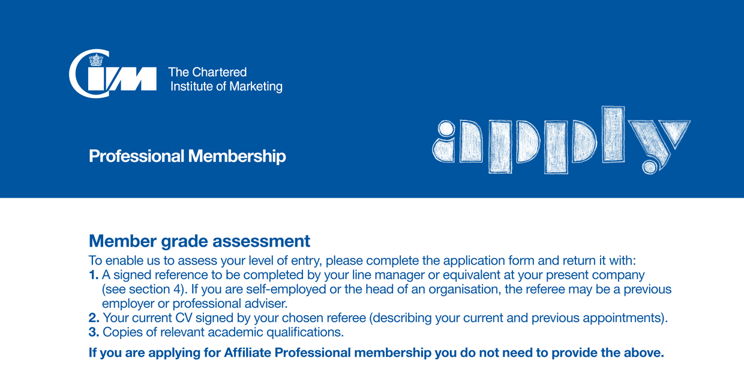

If you have been a member previously, please enter your membership number:
I don’t remember my membership number

Section 1. Personal details
Title | Dr Mr Mrs Ms Miss Other (please specify)  Male Female
First name |  | Family name
Nationality |  | Ethnic origin
Date of Birth (DD/MM/YYYY)
Home address
Town |  | County
Postcode |  | Country
Home  telephone number |  | Mobile
Home email

Section 2. Your current appointment
Job title |  | Date appointed (MM/YYYY)
Job level | Director/Senior Manager Middle Manager Junior Manager  Non-Manager/Executive Other
Industry sector
Company name
Company address
Town |  | County
Postcode |  | Country
Business telephone number |  | Business fax
Business email |  | Business mobile
Do you hold a degree level qualification? Yes No

Section 3. Contact preferences
From your details please indicate your preferred contact choices; tick either Business or Personal for each of the following channels:
 | Business | Personal
Post
Email
Telephone

Section 4. Reference
I have known the applicant for years and support his/her application for membership.
To the best of my knowledge the information supplied in this application is correct.

Name
Position |  | Company
Contact telephone number
Signature |  | Date

Section 5. Chartered CPD Programme
I would like to join the Chartered CPD Programme. (Full details available at www.cim.co.uk/charteredcpd)

Section 6. Where did you hear about us
Marketing Association | Advertising/PR | Careers Advisor | College/University | Direct Marketing
Employer | Exhibition | Marketing Press | Word of mouth
Other (please specify)

Section 7. Declaration
I agree to accept the decision of the assessor as to my grade of membership will be final. I agree to abide by the Institute’s Charter and Bye-laws and to support and promote the Institute’s Code of Professional Standards as described at www.cim.co.uk/governance.
I confirm that all the information supplied in support of my application for membership is correct and that by emailing this form to The Chartered Institute of Marketing it acts as my signature.

Name |  | Date
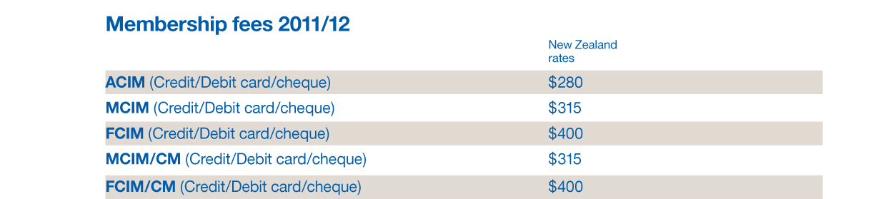

Section 8. Payment details
Direct Debit
(download from MA website under membership or call 0800347328 to request for a form complete and return with application.)
I enclose a cheque for NZ$ in payable to the Marketing Association
I wish to pay by credit card /debit card
Please indicate type of card.
American Express Diner Visa Mastercard
I authorise you to debit my credit/debit card with the amount of $ in

Credit/debit card number
Valid from (MM/YY) |  | Expires (MM/YY)
Issue number  (for Maestro/Switch/Delta) |  | Security code*
* Use the last three digits on the reverse of your card. For American Express use the four digit verification number on the front of your card.)
Section 9. Data protection
Your Privacy: The Marketing Association collects your details to keep you informed about marketing matters including training, education and current issues. Your details are stored securely at our National Office and can only be accessed and used by members of the Marketing Association.
You are welcome to contact us at any time to access and update your personal information or to opt out of receiving further communications from us
P O Box 47681, Ponsonby, Auckland, freephone 0800 347 328 or email marketing@marketing.org.nz
Signature |  | Date

Please send the completed application form, any supporting documents and payment to: Membership Services,
Marketing Association, Level 1, 61 Wellington Street, Freemans Bay, P.O Box 47681, Ponsonby, Auckland 1144
Or email with supporting attachments to membership@marketing.org.nz

For office use only Approved: FCIM MCIM ACIM AP
Signature |  | Date
Thank you. We look forward to welcoming you.
For applications up to 30 June 2012
14500

