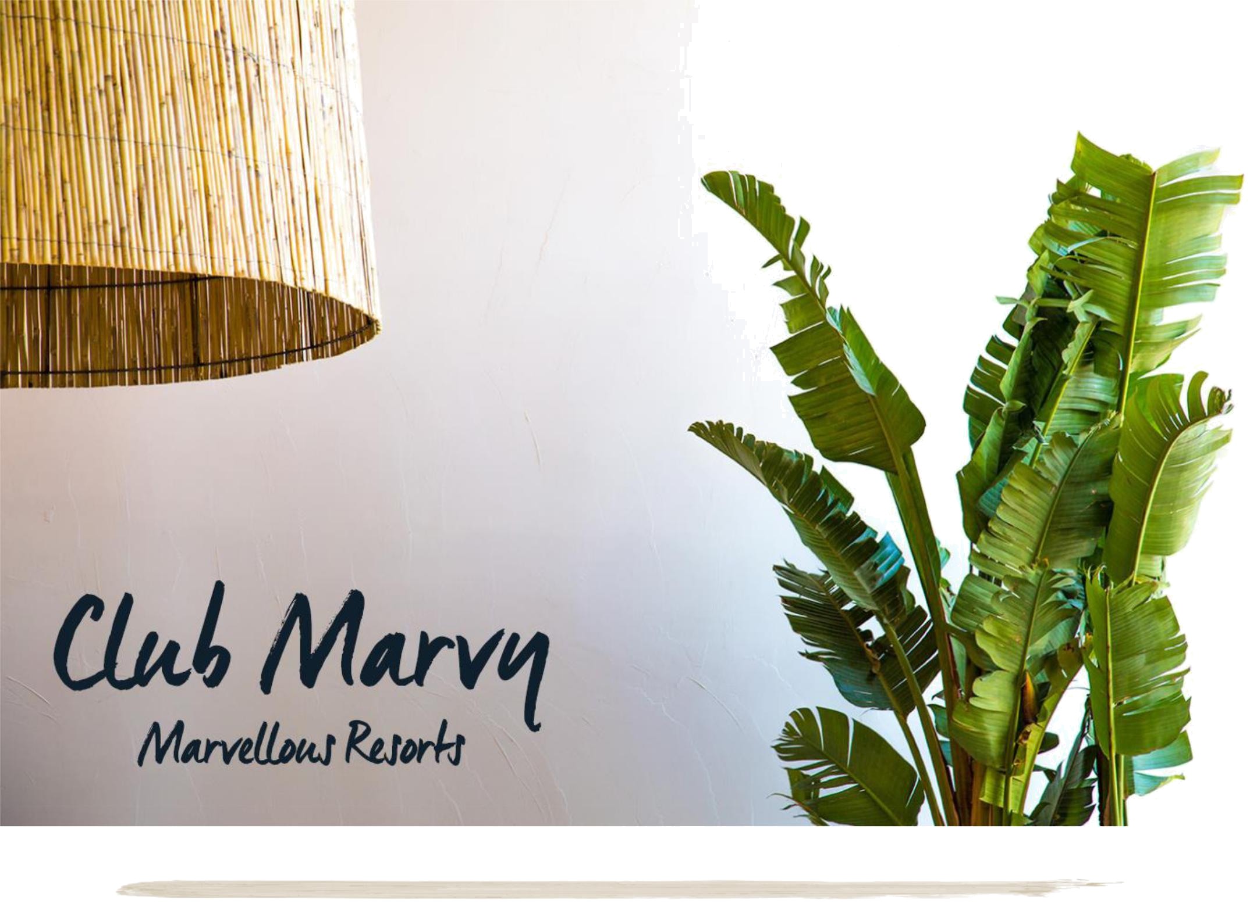
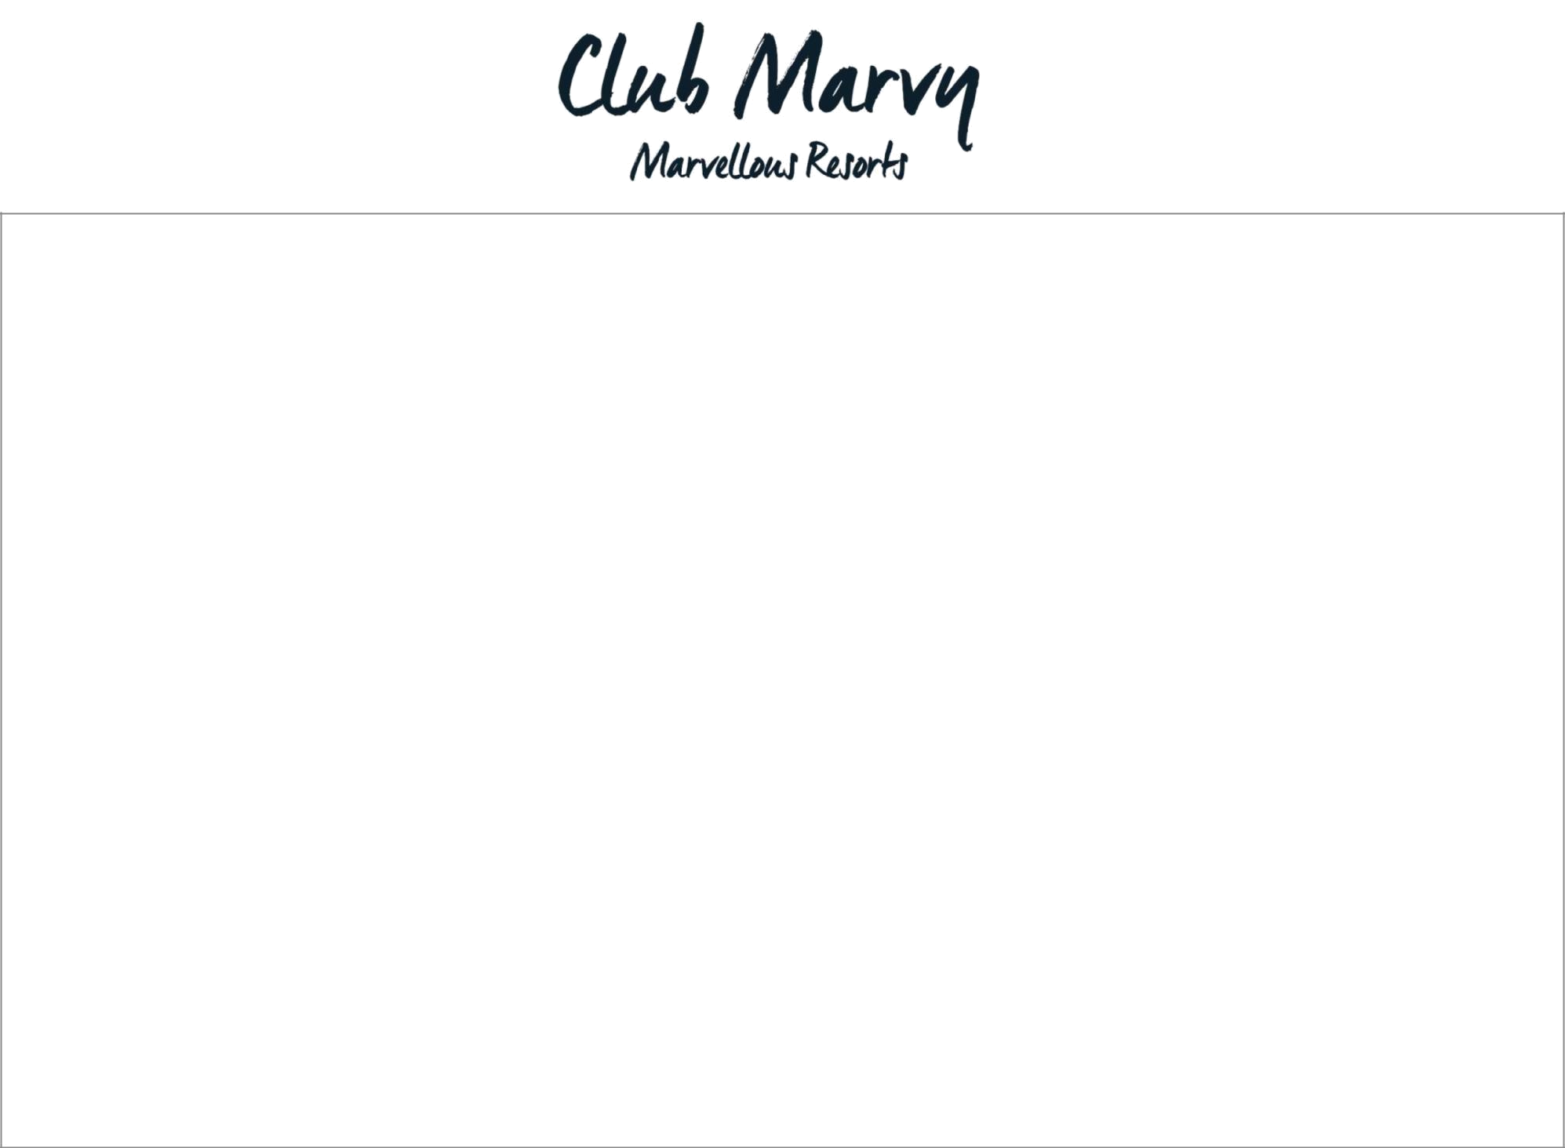

Club Marvy, a brand new discovery for modern luxury bohemian travellers, opens in the summer 2017 in Kesre Bay, İzmir which is one of the most beautiful fisherman villages of Turkey.

Club Marvy is Turkey's first resort with bohemian chic character, addressing free spirits who love to explore new places. Club Marvy attracts attention as a new destination in the Aegean.

The design of the hotel is inspired from the coastal towns of Aegean and Mediterranean and architecture complements and respects the club’s natural setting and landscape. A totally new atmosphere is being created on its 180 acres of lush landscape by preserving its palm, olive and pine tress.

Club Marvy, with its breathtaking nature, is located on a private bay with two sandy beaches and crystal waters on Aegean Sea. Marvy targets to indulge the expectations of families, couples and singles with luxury, comfort and personal service.

The name, Marvy comes from “marvellous”. The ultimate aim of the Club Marvy is to make the guests feel marvellous. Club Marvy, will be the perfect embodiment of the ‘new’ destination for well travellers seeking for the inspirational and spiritual luxury.

We call ourselves a real Aegean; we value local products, local morals and artisanship. In short, we treasure our roots. The food and beverage offer is one of the most unique differentiator of Club Marvy. Its’ main restaurant is unlike any other resort. Every corner offers distinctive design and culinary experience
within an old town centre atmosphere. Each and every A’la Carte Restaurants’ exclusive design and distinctive menu is built on passion and dedication to
local fresh food and creating a unique culinary experience.

MAR SPA promises to deliver total wellness and a retreat to body, mind and soul with unconventional and sophisticated approach to wellbeing.

Atelier Marvy is another differentiator of Club Marvy that includes a gallery venue and the ‘Artist Residency’ program, where workshops by artists will be hosted in regular intervals. The aim of this program is to create a formation with continuity of contemporary art in the region.

Sustainability is in the DNA’s of Marvy, since we designed and operate in a manner that interfaces what is natural in existing culture and climate.

Club Marvy, a brand new Club for unique, unforgettable experiences with all shades of blue, green and grey.
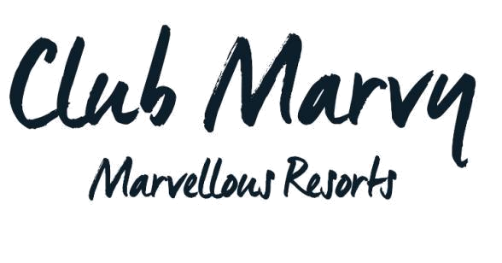
2018 Summer Concept

GENERAL INFORMATION |  |  |  |  | Accepted Credit cards: |  |  |  | CONTACT INFORMATION
Official Category | : 5 Star |  |  |  | Visa, Master Card, American |  |  |  | 3008 Sokak No:1 |  |  | - TR 35495
Catalogue Category | : 5 Star |  |  |  | Express |  |  |  | Kesre Koyu - Ozdere - Menderes / Izmir
Hotel Concept | : Full Board Plus |  |  |  | Pets: Not allowed |  |  |  | T+90 232 797 63 64 | F+90 232 797 63 13
Board with Supplement | : Ultra All Inclusive |  |  |  | Spoken Languages: |  |  |  | E-mail : info@clubmarvy.com | clubmarvy.com
Total Number of Rooms | : 339 |  |  |  | Spoken Languages: |  |  |  | Sales: sales@clubmarvy.com
Total Area | : 180.000 m² |  |  |  | Turkish, English, German,
Total Area | : 180.000 m² |  |  |  | Turkish, English, German, |  |  |  | Customer Relationship Management Department:
Season | : 1 Apr. – 31 Oct |  |  |  | French, Italian, Russian |  |  |  | crm@clubmarvy.com
 |  |  | DISTANCE AND TRANSPORTATION
Ozdere town center : 1,5 km |  | Kuşadası Town Center: 35 km |  |  |  | Izmir Airport : 50 km |  |  |  |  |  |  | Izmir City Center: 55 km



Transportation Options: VIP Transfer, TO Transfers, Taxi

Location: Directly on the beach with 2 separate private bays with sandy beach. One Beach is ADULTS ONLY (+16)

MARVY WELCOME
Marvy Cocktail for adults during check-in and special drinks for children
Marvy’s homemade sundried mandarins
Cold towel service in the lobby
Valet Service and parking
Accompanying all guests to the rooms
Umbrella service on rainy days
Appropriate arrangements for disabled guests in public areas
Table reservation in the main restaurant for disabled guests
Bottled water and refreshing towels delivered to guest’s car at check-out
2018 Summer Concept

OTHER SERVICES & FACILITIES
Free: Extra Charge:
-Games Room -Laundry & Dry Cleaning Service
-High Speed Wireless Internet in all rooms and public areas -24/7 Doctor / Nurse
-Changing Room with Lockers and Showers (for early c-in and late c-out) -Car Rental and Coiffeur Service
-Sunshades on the beach & sunbrellas by the pools, loungers with -Shops : Marvy Shop, Yerlim Organic Shop, Designers
cushions, beach towels Boutique, Manuk’s Fine Jewelery, Photographer, Men &

-Satellite TV with premium mix of leading sports and Women’s Hair Salon, Classical Turkish Barber, Market
entertainment content via 130 channels
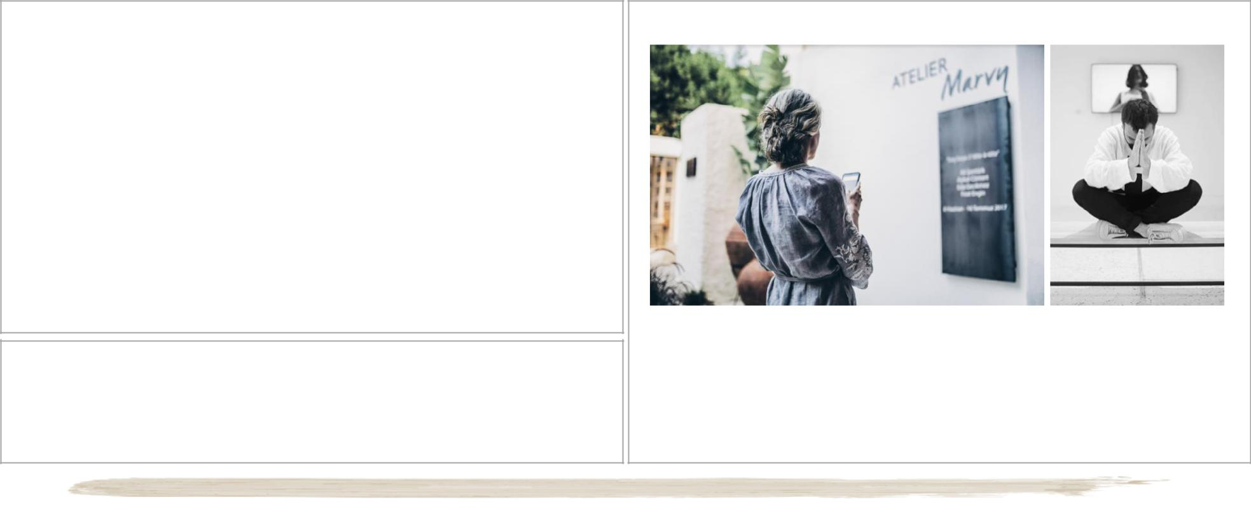

MARVY HONEYMOON Free Services
If the guests specify their contact details, honeymoon couples are called individually before arrival by our Guest Relations Team to find out any specific requests and whether they would like to arrange any surprises for each other, and free and extra services are provided accordingly.
Upgrade to upper room category (upon availability)
Early c/in and Late Check out (upon availability)
Candles in the bathroom
Special room decoration (special linen set, extra aminities, slippers and bothrope)
Fresh flower arrangement in the room
Fruit basket & a bottle of champagne served in the room 15% discount in MAR SPA

Priority reservations in A’la carte restaurants, special decorated table and glass of champagne service in one desired A’la carte restaurant.

MARVY HONEYMOON Extra Services
VIP Airport-Hotel-Airport transfer

Exclusive “honeymoon package” at the MAR SPA Private Candlelight Dinner

Atelier MARVY

Atelier Marvy is a unique differentiator of Club Marvy that includes a gallery venue and the ‘Artist Residency’ program, where workshops by artists are hosted in regular intervals. The aim of this program is to create a formation with continuity of contemporary art in the region.

2018 Summer Concept

ACCOMODATION

Club Marvy accommodation delivers on the promise of calming and relaxing feeling with uniquely sophisticated approach. The architecture of the rooms is modern and stylish yet functional and simple, using wisdom and allowing the guests to feel Aegean-Southern beach lifestyle.
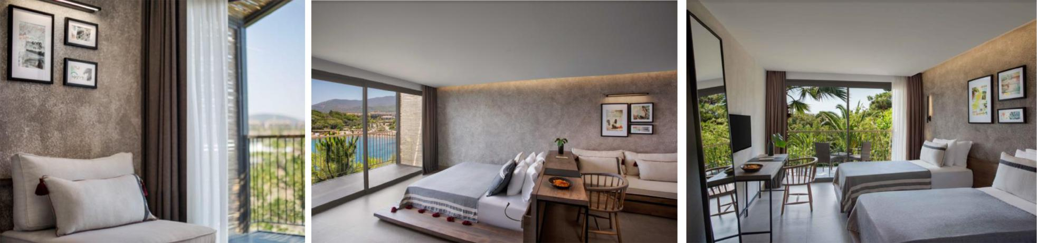

Room Description | M2 | Location | Number of | View | no of |  | Occupancy | chd reductions | 3rd & 4th Adult
Room Description | M2 | Location | Rooms | View | bathrooms |  | Occupancy | chd reductions | reductions
Comfort | 20 | main building | 18 | GV | 1 | max 2+1 (chd max 12 yrs) |  | 1st chd free | -
Comfort | 30 | bungalow | 89 | GV | 1 | max 2+2 (chd max 12 yrs) |  | 1 chd free 2nd chd %50 | 3rd adult 30%
Comfort | 30 | bungalow | 44 | PSV | 1 | max 2+1 (chd max 12 yrs) |  | 1st chd free | 3rd adult 30%
Premium Comfort Adult Only | 30 | bungalow | 64 | SV | 1 |  | max 3 |  | 3rd adult 30%
Family Comfort | 33 | bungalow | 16 | SV | 1 | max 2+2, 3 +1 (1st chd 12yrs, 2nd chd 12yrs) |  | 1 chd free 2nd chd %50 | 3rd adult 30%
Family Comfort Connection | 33+33 | bungalow | 8 | SV | 2 | max 6+2 (1st & 2nd kids free) |  | 3rd & 4th Chd %50 | 5th & 6th adult 30%
Junior Suite | 42 | main building | 10 | PSV | 1 |  | max 2 | N/A | N/A
 |  |  |  |  |  |  |  |  | 3rd adult free
Family Suite | 60 | main building | 4 | SV | 1 | max 2+2 , 4 (1st chd 12yrs, 2nd chd 12yrs) |  | 1 chd free 2nd 7-12 %50 | 4th adult 50%
Family Connection | 40 | main building | 39 | GV | 2 | max 2+3 , 4 +1 (1st chd 12yrs, 2nd chd 12yrs) |  | 1. & 2. & 3rd chd free | 3rd and 4th Adult free
 |  |  |  |  |  | max 3+3, | 4 + 2 , 4 +1 (1st chd 12yrs, 2nd |  | 3rd adult free
Premium Family Connection | 60 | bungalow | 23 | SSV | 2 |  | chd 12yrs) | 1st, 2nd, 3rd chd free | 4th adult 50%
 |  |  |  |  |  | max 3+3, | 4 + 2 , 4 +1 (1st chd 12yrs, 2nd |  | 3rd adult free
Premium Family Connection | 60 | bungalow | 24 | GV | 2 |  | chd 12yrs) | 1st, 2nd, 3rd chd free | 4th adult 50%
2018 Summer Concept

 |  |  | Comfort | Premium | Family | Family Comfort |  |  | Family | Premium
 | Comfort | Comfort |  |  |  |  | Junior Suite |  | Family | Family
Room Specifications | Comfort | Comfort | Partial | Comfort Adult | Comfort | Connection | Junior Suite | Family Suite | Connection | Family
Room Specifications | Main Building | Bungalow |  |  |  |  |  | Family Suite | Connection | Connection
 | Main Building | Bungalow | Sea Vew | Only |  |  |  |  |  | Connection
Marvyassistant | X | X | X | X | X | X | X | X | X | X
Telephones (extra) | X | X | X | X | X | X | X | X | X | X
Flat TV - Satellite | X | X | X | X | X | X | X | X | X | X
Hairdryer | X | X | X | X | X | X | X | X | X | X
WC | X | X | X | X | X | X | X | X | X | X
Walk-in Shower | X | X | X | X | X | X | X | X | X | X
Shaving and Make up | X | X | X | X | X | X | X | X | X | X
Mirror
Bathrobe & Slippers | X | X | X | X | X | X | X | X | X | X
Organic Shower Aminities | X | X | X | X | X | X | X | X | X | X
Kettle , Tea and Coffee Set | X | X | X | X | X | X | X | X | X | X
Mini Bar | X | X | X | X | X | X | X | X | X | X
Safe Box (f.o.c) | X | X | X | X | X | X | X | X | X | X
Central A/C & Heating | X | X | X | X | X | X | X | X | X | X
Feather Pillow | X | X | X | X | X | X | X | X | X | X
Twin or French Bed | X
French Bed |  | X | X | X |  | X | X
Twin and French Bed |  |  |  |  | X | X |  | X | X | X
Low French Bed |  | X | X | X | X | X | X | X |  | X
Sofa Bed | X |  |  |  |  |  |  |  | X | X
Day bed |  | X | X | X |  | X |  |  |  | X
2 Seperate Bedrooms |  |  |  |  |  | X |  | X | X | X
Seating Group | X | X | X | X |  | X | X | X | X | X
Living Room |  |  |  |  |  |  | X
Turndown service |  |  |  | X |  | X | X | X |  | X
milk for 0-6 year olds,
Nesquik drink for 7 – 12 |  |  |  |  | X | X |  | X | X | X
year olds
Room Service |  |  |  | X
2018 Summer Concept

MARVY FOOD & BEVERAGE
24-hour food and beverage service
Marvy Main Restaurant | 5 A’La Carte Restaurants | 6 Bars | Snack Restaurants | Others
 |  |  |  | Dedicated Kids Chef buffet at
 |  |  |  | the main restaurant. Kids Chef
 |  |  |  | also prepares special meals for
Breakfast | Bliss Lounge Bar & Restaurant | Lobby Bar (24 Hours) |  | children who have specific
Breakfast | Bliss Lounge Bar & Restaurant | Lobby Bar (24 Hours) |  | diertary needs
Late Breakfast | Degirmen Restaurant | Lobby Bar (24 Hours) |  | diertary needs
Late Breakfast | Degirmen Restaurant | Luvi |  | Artisan Coffee Shop at the
Lunch | İskele Meyhane | Family Pool Bar | 2 Snack Restaurants | Bazaar
Dinner | La Baia | Family Pool Bar |  | Rich Patisserie selection at
Dinner | La Baia | İskele Bar |  | Rich Patisserie selection at
Midnight Snacks | Boho Beach (Adults Olnly) | İskele Bar |  | 17h00
Midnight Snacks | Boho Beach (Adults Olnly) | Boho Beach Bar |  | 17h00
 |  | Boho Beach Bar |  | Ice Cream during Lunch ad
 |  | +1 |  | Ice Cream during Lunch ad
 |  | +1 |  | Dinner at the Main Restaurant
 |  |  |  | Cold fruits, refreshing beverages
 |  |  |  | and summer coolers served
 |  |  |  | around the pool and at the
 |  |  |  | beach at certain times

MARVY A’LA CARTE RESTAURANTS
Bliss Lounge Bar & Restaurant | Degirmen Restaurant | Iskele Meyhane | ITALIAN RESTAURANT | Boho Beach (Adults Only)
Bliss Lounge Bar & Restaurant is | A miniature of Yerlim’s legendary | Iskele Meyhane is located at the pier |  | The Boho Beach Club has the
located on the top floor of the | Restaurant is located in a historical windmill | with an endless horizon. Meyhane is a |  | soul of a gypsy, heart of a hippie
main building and features some | and offers a stunning view of the Bay. | Turkish version of a Tavern and |  | and spirit of a fairy. The very
of the best panoramic views of | Iconic specialties of local and traditional | typically there is no menu except a |  | cool beach club serves fresh
Kesre Bay. A real quality of | Aegean cuisine from Degırmen | wide selection of Raki menu. Selection |  | seafood specilities in the
signature cocktails are offered at | Restaurant’s menu is served with Yerlim® | of mezes, hot starters and main |  | evenings at the most romantic
its elegant bar for a nice chill out | Organic farm products. Degirmen | courses are served in small dishes. Up |  | bohemian setting.
before enjoying the | Restaurant is one of the best places to | to 20 varieties in small portions are
contemporary Mediterranean | watch the sunset and the colour of the sky | brought to the table and they may
cuisine at the terrace with a | while the sun is setting. | change daily depending on
sensational view. |  | seasonality or chef’s pleasure.
2018 Summer Concept

MARVY BEVERAGE CONCEPT

 | 24-hour beverage service |  | Large Selection of artisan coffees at the Bazaar
Local and imported branded alcoholic and non-alcoholic beverages. |  |  | Organic Table Wine and Private Reserve Wine served in Bars & Restaurants
 |  | Imported / Deluxe | Premium
Whisky |  | J&B, Johnnie Walker Red Label, Ballantines, | Johnnie Walker Black Label , Johnnie Walker Blue Label, Johnnie Walker
Whisky |  | White horse, Jameson (irish), Jack Daniels, | Gold, Johnnie Walker, Platinium, Bulleit Bourbon, Jim Beam Bourbon 12,
 |  | Ballantines, The Famous Grouse, Jim Beam, | Gentleman Jacks,
 |  | Chivas Regal 12 YO | Chivas Regal 18 YO ,Chivas Regal 25 YO, Royal Salute
Vodka |  | Smirnoff red, Absolut, Finlandia | Ketel One, Grey Goose, Belvedere, Beluga
Gins |  | Gordon’s, Beefeater, Bombay Sapphire | Tanqueray, Hendricks, Monkey 47, Sipsmith
Rum |  | Bacardi, Havana Club, Captain Morgan | Zacapa 23, Bacardi 8, Diplomatico
Tequila |  | Olmeca, Sierra, Mariachi | Don Julio, Patron
Cognac & Brandy |  | VS | V.S.O.P, XO, XXO
Apéritif, Liquors and Cordial |  | Martini Bianco, Martini Rosso, Martini Dry, | Jagermeister, Cointreau, Southern Comfor, Archer’s, Amaretto
 |  | Campari, Malibu, Baileys
Rakı |  | Yeni Raki, Tekirdag, Efe, Yeşil Efe, | Ala, Altınbaş, Tekirdağ Rakısı Altın Serisi, Efe Rakı Sarı Zeybek, Tekirdağ 10
Rakı |  | Yeni Raki, Tekirdag, Efe, Yeşil Efe, | Numara
Beer |  | Efes, Tuborg, Carlsberg, Miller | Corona, Heineken, Becks
Wine |  | Organic and Table Wine | Marvy Organic Private Reserve and Cellar
 |  | ****Premium Beverages are with extra charge for Ultra All Inclusive guests as well****
2018 Summer Concept

 | Board Descriptions | Marvy Full Board Plus |  | Marvy Ultra All Inclusive |  | Opening Hours
 | Board Descriptions | Included | Extra Charge | Included | Extra Charge | Opening Hours
 | Breakfast | X |  | X
 | Late Breakfast | X |  | X
Main Restaurant | Lunch | X |  | X
 | Dinner | X |  | X
 | Midnight Snacks | X |  | X
Fresh Orange Juice | at Breakfast – Water in Rooms and in all | X |  | X
Bars
At the main Restaurant |  | X |  | X
Organic and Table Wine, Local Beer, Water and Soft Drinks |  | X |  | X
All Other Beverages Import and Deluxe Category |  |  | X | X
All Other Beverages Premium Category |  |  | X |  | X
 | La Baia | X |  | X
Snacks
Snacks | Boho Beach Club (Adults Only) | X |  | X
 | Bliss Lounge Bar & Restaurant (+10 yrs old) | X |  | X
 | Degirmen Restaurant | X |  | X
A’La Cartes
A’La Cartes | İskele Meyhane | X |  | X
 | La Baia | X |  | X
 | Boho Beach (Adults Only) |  | X |  | X
Mini Bar |  |  | X | X
Kettle , Tea and Coffee Set |  | X |  | X
2018 Summer Concept

MAR FITNESS

Marvy offers an all-inclusive holiday who likes to keep fit by combining , organic and nutritional food at our restaurants along with personalized wellness and leisure activities. 400 m2 fitness centre is developed together with Technogym and equipped with their latest featured and trendy products.

MAR SPA

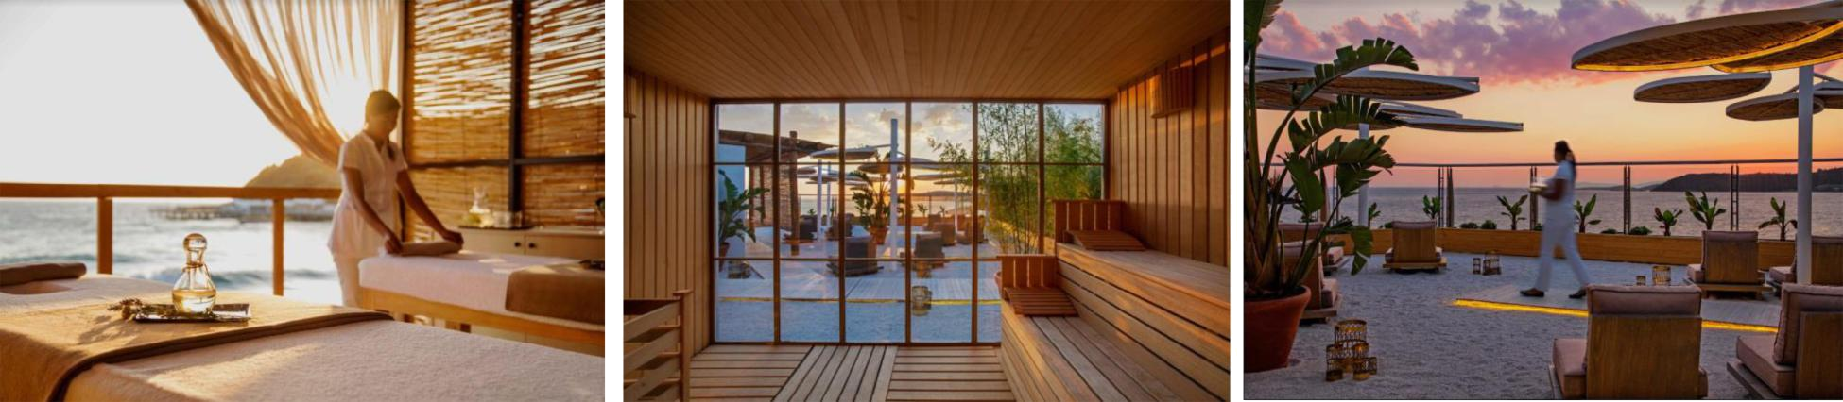

Body, mind, soul

With an incredible view of the beautiful Aegean sea, Marvy guests are able to experience an exceptional wellness area designed to ease the modern mind. Our unique seaview massage rooms, sauna and outdoor terrace area provides everlasting moments and a spa experience like no other. Calming tranquility of Marvy's blue seas and endless skies with the 180 degree sea view in the spa is a real treat.

Exquisitely designed Hammam brings together traditional Turkish and Roman bathing practices with the wisdom and gentleness of modern spa therapies.

Separately located day spa on the beach offers a magical ambiance for a luxurious wellness sanctuary and indulgence right on the beach with Aegean's best coastal views.

MAR SPA & FITNESS

Free | Sauna | Turkish Bath | Resting Area | Mar Fitness
Extra Charge | Hammam Treatments | Massages | Face & Body Treatments | SPA Boutique
2018 Summer Concept

MARVY SWIMMING POOLS & AQUA PARK & BEACHES
 | m³ | Depth | Features
Family Pool | 1600 m3 | 140 cm deep
Infınity Pool | 3000 m³ | 140 cm deep
Children's Pool 1 | 45 m3 | 40 cm deep
Children's Pool 2 | 45 m3 | 40 cm deep
Children’s activity |  |  | with multi-level play, tipping feature, octopus multi-level play and various
Pool | 600 m3 | 30 cm deep | children’s slides
Separate Toddler
area/ spray park -
Fresh Park | - | - | does not consist a pool but a soft play ground. Ideal for little children
Water Slides Pool | 350 m3 | 120 cm deep | with 7 waterslides
 |  |  | 5 Slides, Body Slide, Windigo, Combo (+16 years), Black Hole and a
Aqua Park | - | - | breath-taking Looping Rocket (+16 years).

Club Marvy is located on a private bay with two private sandy beaches. One Beach is dedicated for all guests and the other one is Adults Only where Boho Beach Club is located.

Sunshades on the beach & sunbrellas by the pools, loungers with cushions, beach towels are provided free of charge

Cold towel service is provided at the Boho Beach

Cold fruits, refreshing beverages and summer coolers served around the pool and at the beach at certain times

MARVY ENTERTAINMENT

Luvi Bar Street Concerts | Bohomian Beach Parties | Cinema Nights | Live Music Performances
Daily Tournaments | Evening Entertainment Shows | DJ Performances | Kids Shows
2018 Summer Concept

MARVY SPORTS & ACTIVITIES

 | Canoe | Aqua Gymnastics / Aqua Zumba | Wind Surfing (with Licence)
 | Yoga Classes | Fitness | Marvy Workshops
Free | Aquabiking | Beach volleyball | Basketball
 | Tennis Courts | Table Tennis | Aerobics / Gymnastics
 | Mini Golf | Workout Activities | Zumba
 | Parasailing | Motorised Water Sports | Water Ski
 | Banana | Jet Ski | Surf Lessons
Extra Charge | Ringo | Personal Traniner in MarFitness | Tennis Lessons
 | Marvy Sail | Adventure Park | Tennis Court floodlights


MARVY KIDS CLUB
Mini Club for kids between 04 – 12 years open daily from 10:00 - 22:00
13 – 16 years Youngster Club
Mini Club Reception welcoming all children, special registration cards.
Recording child’s name, surname and room number written on special designed badge.
Workshops
Special day & night activities
Mini Disco
Kids Cinema
Playground and Carousels
Special birthday celebrations weekly with the Kids Chef
Special shows for children (inflatibale games, magic-show –kids circus)
2018 Summer Concept

MARVY PREMIUM COMFORT ADULTS ONLY PACKAGE

64 Premium Seaview Rooms above Boho Beach Club is dedicated for Adults Only.

Private Check in area | Buggy Service
Private Guest Relations Team for 24h | 10% discount on airport transfer – Spa reservation and food &
 | beverage expenses
Welcome champagne with seasonal fruits during check in | Turndown Service ( 19:00 – 22:00)
Room Service 24h | Reservation privilege at A la Carte Restaurants and SPA ( except
 | if there is any special program at A la Carte restaurants & SPA)
Valet Service | Accompanying guests to the room

